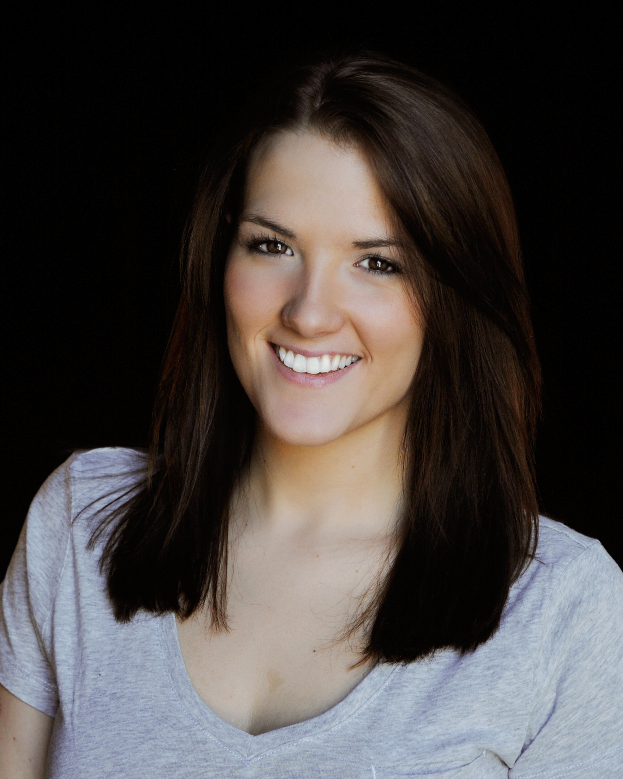
Rachel Jenack

(315) 212-7789

rjenack23@yahoo.com
Height: 5 ft .5 in.

Weight: 138 lbs

Eyes: Brown

Hair: Dark Brown

THEATER:

American College Theater Festival Irene Ryan Nominee UNH - Region 1

“So Tell Me About This Guy” Angie SUNY Potsdam

The Vagina Monologues SUNY Potsdam

“Transfigured Night” Valerie Radcliffe SUNY Potsdam

TV/RADIO SPOTS:
(List available upon request)

FILM:

“EXIT” Lead Don Mandigo

SPECIAL SKILLS:

Certified Bartender (RSA Certified – NSW Sydney, Australia); Basketball, Softball, Swimming (breaststroke, freestyle); Singing (soprano & alto); Tour Guide (New York Power Authority); Basketball Referee

EDUCATION:

SUNY Potsdam Major: Communications (Speech); Minor: Acting

New York Film Academy Acting Certificate Program Los Angeles, CA

Voice Training Garth Bardsley

