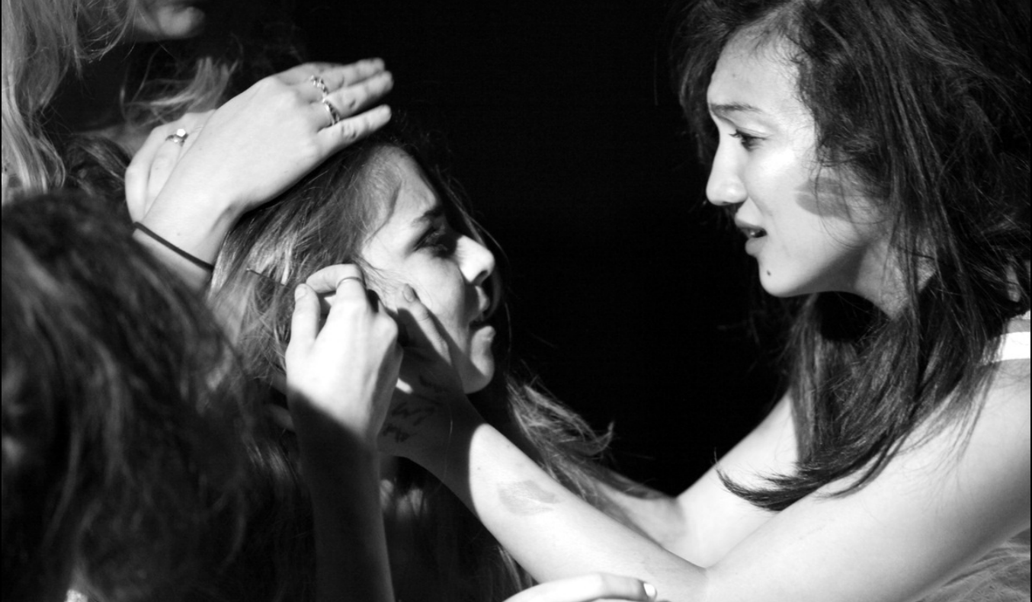
Dayna Li
Equity Member Candidate
(650) 380-7088 Photo Credits: Buck Lewis
daynamerrilli@gmail.com
Height: 5’2’’ Hair: Brown Eyes: Brown Age: 26

EXPERIENCE
Theater
Richard Nixon’s
Big Adventure Mr. News/Woman (principal) The Player’s Society - Chapman Bridget McConaughy
Balancing Act Rebekah Duckett (lead) Princeton Black Arts Company Morgan Jerkins
Dr. Faustus Narrator/Scholar (principal) Princeton Shakespeare Company Molly O’Neill
Cymbeline Cymbeline U/S, Philario (principal) Powerhouse Apprentice Company Brian McManamon
Wholly Joans Angel (principal) Powerhouse Apprentice Company John Moriarty
Untitled Puppeteer (principal) Powerhouse Apprentice Company Erin Ortman
American Tropical Suzie (principal) Princeton Theater Intime Mark Watter
Quilters Dana (lead) Castilleja School Kristin Walter
A Christmas Carol Tiny Tim (lead) Peninsula Youth Theater Elise Guerrero
Thoroughly Modern Ensemble Peninsula Youth Theater Elise Guerrero
Millie

Film
Stuck Erin (lead) Chapman Grad 321 Jasmine Siddall
Transcendence Adele (lead) Independent Nikhail Asnani
The Pretty People Claire (principal) Princeton Thesis Film Dayna Li
Carburetor Daisy (principal) Chapman Grad Cycle Alex Huang
The Precept Erin (principal) Princeton Student Entertainment Richard Gadsden
Home Nurse (featured) Chapman Grad Cycle Phumi Morare
Selda Aid Worker (featured) Chapman Grad Thesis Ragini Bhasin

Television
What Does Blue Want to Make? Steve’s Friend Blues Clues/Nick Jr.

TRAINING/EDUCATION
Chapman University (2017-2020): MFA in Film Production, Emphasis on Directing
Princeton University (2010-2014): BA in Comparative Politics, Certificates in Visual Arts (Film) and French

Classes/Programs
Sanford Meisner Center 2 year program (January 2019-present)
Lee Strasberg-Method, Acting for film (Summer 2014)
HB Studio- Acting, Directing (Summer 2014)
Princeton University – Intro Theater, French Theater I and II
New York Stage and Film Powerhouse Theater Apprentice Company at Vassar College (Summer 2011)
American Conservatory Theater (ACT) Summer Workshop (Summer 2007)
Voice: Private Coaching-Liz Hogen, Christina Dahlin (November 2016-present)

SPECIAL SKILLS
Screenwriting, Directing, Violin (15 years); Guitar; Editing with Final Cut Pro, Premier, Avid; Intermediate French and Chinese

