

Resume

Guide

Muhlenberg College

Career Center

Lower Level, Seegers Student Union

484-664-3170

careers@muhlenberg.edu

www.muhlenberg.edu/careercenter

Hours of Operation

Monday - Friday: 8:30 a.m. - 5:00 p.m.

Resume Guide

S | ince no two people have the exact same career-related experiences, no two individual resumes
S | are fully alike. However, there are guidelines we should all follow so that our various
S | accomplishments are featured in the best possible way.

Characteristics of a Good Resume


Brief Meticulous

Consistent Well Organized

Dynamic Targeted

rief (depending on field and experience level).


- Keep your resume to one page. Unless you have considerable work experience and/or advanced

degree(s), one page is appropriate. Later in your professional career, your resume can expand to two pages. High school information should be removed after your first year at Muhlenberg. Consistency is important. For example, if you abbreviate Pennsylvania (PA) in your contact information, continue to do so throughout the resume. Use action verbs to describe your duties and how you accomplished them when addressing your experiences. Spelling and/or grammatical errors should be non-existent in a resume. It is important that you carefully organize the information so that it demonstrates your strong points at-a-glance, while emphasizing your achievements and skills.

Action Verb List

Accounting |  | Administration |  |  | Analysis |  |  | Consulting |  |  |  | Counseling |  |  | Editing |  |  | Design |  |  | Finance
 |  |  |  |  |  |  |  |  |  |  |  | Facilitate |  |  |  |  | Organize |  |  |  | Analyze
Record |  |  | Monitor |  |  | Qualify |  | Troubleshoot |  |  |  |  |  |  | Review
Assess |  |  | Track |  |  | Clarify |  | Problem Solve |  |  |  | Listen |  | Analyze |  |  | Explore |  |  |  | Invest
Audit |  |  | Assess |  |  | Quantify |  |  | Assess |  |  | Sense |  |  | Check |  | Formulate |  |  |  | Budget
Prepare |  |  | Coordinate |  |  | Infer |  |  | Assist |  |  | Intuit |  | Compare |  |  |  | Sketch |  | Inventory
Maintain |  |  | Organize |  |  | Discover |  |  | Arrange |  |  | Assess |  | Comment |  |  |  | Draw |  | Evaluate
Forecast |  |  | Requisition |  | Conceptualize |  |  |  | Guide |  |  | Analyze |  |  | Correct |  |  | Draft |  | Appraise
Calculate |  |  | Access |  |  | Discern |  |  | Counsel |  |  | Assist |  | Rewrite |  |  |  | Layout |  | Construct
Estimate |  |  | Receive |  | Interpret |  |  |  | Survey |  |  | Align |  |  | Revise |  |  | Create |  |  | Develop
Figure |  |  | Process |  |  | Dissect |  |  | Serve |  |  | Help |  |  | Rework |  |  | Plan |  |  | Acquire
Appraise |  |  | Serve |  |  | Review |  |  | Contribute |  | Understand |  |  |  | Amend |  |  | Style |  |  | Deploy
Examine |  |  | Furnish |  |  | Observe |  |  | Motivate |  |  | Inform |  | Improve |  |  | Pattern |  |  |  | Manage
Measure |  |  |  |  |  | Assess |  |  | Train |  |  |  |  |  | Initiate |  |  | Build |  |  | Project
Verify |  |  |  |  |  |  |  |  |  |  |  |  |  | Investigate

Human Resources |  |  |  | Information |  |  |  | Innovating |  |  |  |  |  | Investigate |  |  |  |  |  | Leadership |  |  |  | Management |  |  |  |  | Marketing |  |  |  |  | Mechanical
 | Assess |  |  |  | Appraise |  |  |  |  | Create |  |  |  |  | Pursue |  |  |  |  |  | Create |  |  | Coordinate |  |  |  |  |  |  | Review |  |  |  |  | Analyze
 | Survey |  |  |  | Program |  |  |  |  | Modify |  |  |  | Interrogate |  |  |  |  |  |  | Lead |  |  |  | Facilitate |  |  |  |  |  | Assess |  |  |  | Construct
 | Screen |  |  |  | Link |  |  |  |  | Change |  |  |  |  | Question |  |  |  |  | Encourage |  |  |  |  | Plan |  |  |  |  |  | Survey |  |  |  |  | Craft
 | Analyze |  |  |  | Coordinate |  |  |  |  | Upgrade |  |  |  |  | Analyze |  |  |  |  |  | Manage |  |  |  | Schedule |  |  |  |  |  | Analyze |  |  | Troubleshoot
 | Interview |  |  |  | Manage |  |  |  |  | Improve |  |  |  |  |  | Intuit |  |  |  |  | Organize |  |  |  | Delegate |  |  |  |  |  | Quantify |  |  |  |  | Create
 | Select |  |  |  | Process |  |  |  |  | Design |  |  |  |  |  | Seek |  |  |  |  | Compare |  |  |  | Mediate |  |  |  |  |  | Identify |  |  |  |  | Design
 | Train |  |  |  | Document |  |  |  |  | Activate |  |  |  |  | Search |  |  |  |  |  | Inspire |  |  |  | Evaluate |  |  |  | Announce |  |  |  |  |  | Engineer
 | Mediate |  |  |  | Categorize |  |  | Restructure |  |  |  |  |  |  |  | Probe |  |  |  | Represent |  |  |  | Strategize |  |  |  |  |  |  | Promote |  |  |  |  | Repair
 | Appraise |  |  |  | Design |  |  |  | Establish |  |  |  |  | Coordinate |  |  |  |  |  |  | Govern |  |  |  | Develop |  |  |  |  |  | Advertise |  |  |  |  | Align
Coordinate |  |  |  |  | Structure |  |  |  | Stimulate |  |  |  |  |  | Explore |  |  |  |  |  | Direct |  |  |  | Listen |  |  |  |  |  | Advance |  |  |  | Coordinate
 | Align |  |  |  | Inventory |  |  |  | Implement |  |  |  |  |  |  |  |  |  |  |  | Advise |  |  |  | Counsel |  |  |  |  |  | Boost |  |  |  | Manipulate
 |  |  |  |  | Analyze |  |  |  | Transform |  |  |  |  |  |  |  |  |  |  |  |  |  |  |  |  |  |  |  |  |  | Improve |  |  |  | Examine
 | Organizing |  |  |  | Persuading |  |  |  |  | Program |  |  |  |  |  | Public |  |  |  | Research |  |  |  |  | Teaching |  |  |  |  |  | Technical |  |  |  | Writing
 | Simplify |  |  |  | Present |  |  | Development |  |  |  |  |  | Relations |  |  |  |  |  |  | Identify |  |  |  | Educate |  |  | Conceptualize |  |  |  |  |  |  | Conceive
 | Classify |  |  |  | Articulate |  |  |  |  | Analyze |  |  |  |  | Assess |  |  |  |  |  | Evaluate |  |  |  | Tutor |  |  |  |  |  | Design |  |  |  | Construct
 | Organize |  |  |  | Clarify |  |  |  |  | Design |  |  |  |  | Prepare |  |  |  |  |  | Review |  |  | Stimulate |  |  |  | Troubleshoot |  |  |  |  |  |  |  | Craft
 | Prioritize |  |  |  | Challenge |  |  |  | Construct |  |  |  |  | Coordinate |  |  |  |  |  |  | Assess |  |  |  | Inform |  |  |  |  |  | Inspect |  |  |  | Integrate
 | Maintain |  |  |  | Negotiate |  |  |  |  | Develop |  |  |  |  | Present |  |  |  |  |  | Test |  |  |  | Instruct |  |  |  |  |  | Locate |  |  |  | Interpret
 | Liaison |  |  |  | Inquire |  |  |  |  | Prepare |  |  |  |  | Negotiate |  |  |  |  |  | Compare |  |  |  | Facilitate |  |  |  |  |  | Edit |  |  |  |  | Capture
 | Assist |  |  |  | Reason |  |  |  | Strategize |  |  |  |  |  | Publicize |  |  |  |  |  | Analyze |  |  |  | Awaken |  |  |  |  |  | Analyze |  |  |  | Abstract
 | Support |  |  |  | Influence |  |  |  | Coordinate |  |  |  |  | Strengthen |  |  |  |  |  |  | Critique |  |  |  | Explore |  |  | Implement |  |  |  |  |  |  |  | Express
 | Arrange |  |  |  | Convince |  |  |  | Formulate |  |  |  |  |  | Promote |  |  |  |  |  | Explain |  |  |  | Advise |  |  |  |  |  | Construct |  |  |  |  | Inform

Resume Template

Y | our resume is usually your first impression with an employer. When viewed this way, it is crucial
Y | to make a positive impact with your document. A resume is used to show that you have the
Y | knowledge, experience and skills relevant to a particular job and to entice the employer to

interview you. Since most employers spend just a few seconds scanning a resume, the information must stand out. The basic resume format is below along with additional samples.

NAME
Address

Phone Number ● Email ● LinkedIn URL

EDUCATION

Muhlenberg College, Allentown, PA Graduation Month & Year

Major (track or emphasis if applicable):

Minor:

GPA: (3.0 or above ONLY)

OPTIONAL SECTIONS (AWARDS, STUDY ABROAD, RESEARCH, CLASS PROJECTS, ETC.) List accomplishments and dates.

WORK EXPERIENCE

Company/Institution/Organization Name, City, State Month Year - Month Year

Title of position

- Job description 1 (start with an action verb and highlight skills, achievements and results).

- Job description 2.

- Job description 3.

OPTIONAL SECTIONS (CAMPUS ACTIVITIES, COMMUNITY SERVICE, LEADERSHIP EXPERIENCE, ETC.)

Company/Institution/Organization, City, State Month Year - Month Year

Title of position

- Job description 1 (start with an action verb and highlight skills, achievements and results).

- Job description 2.

- Job description 3.

SKILLS (OPTIONAL)

List specific computer, language and technical skills.
First Year Student
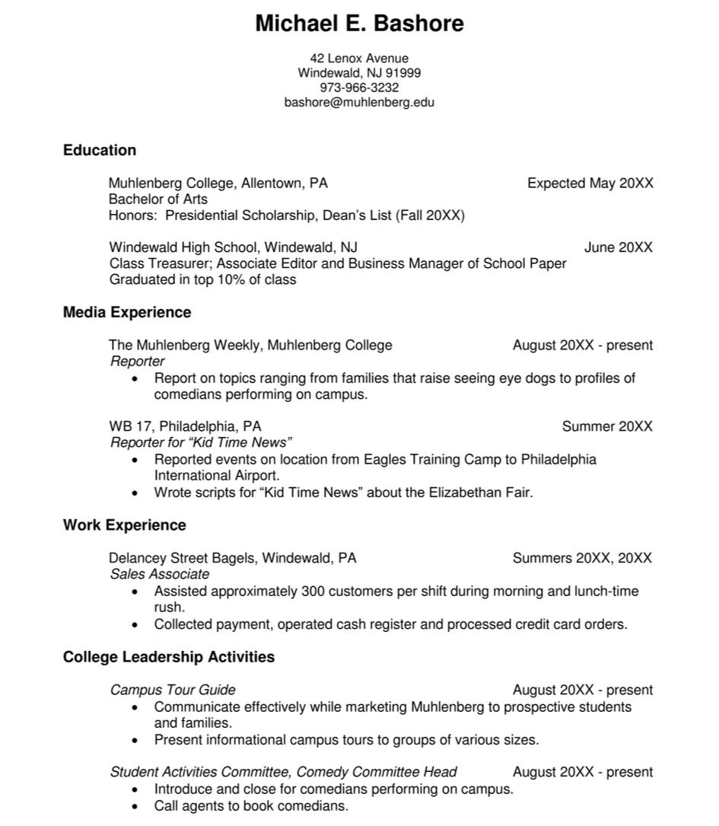
Education Resume
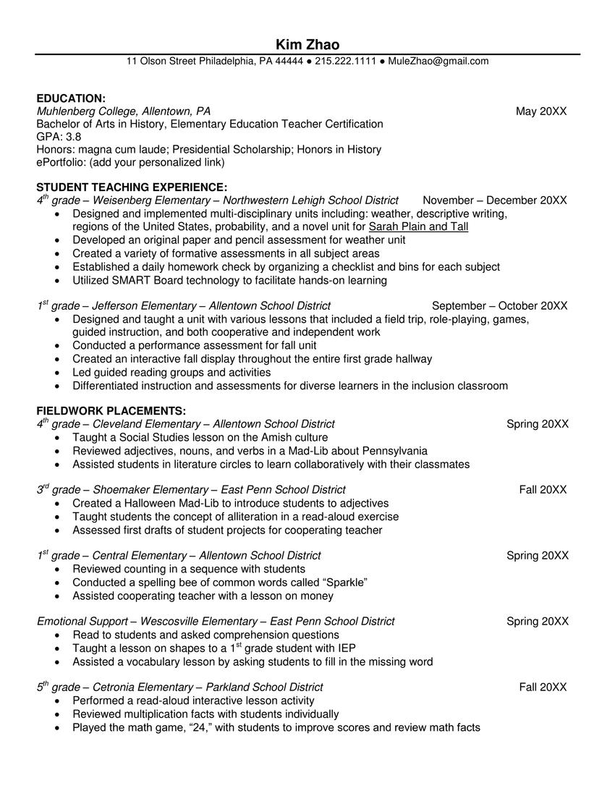
Education Resume
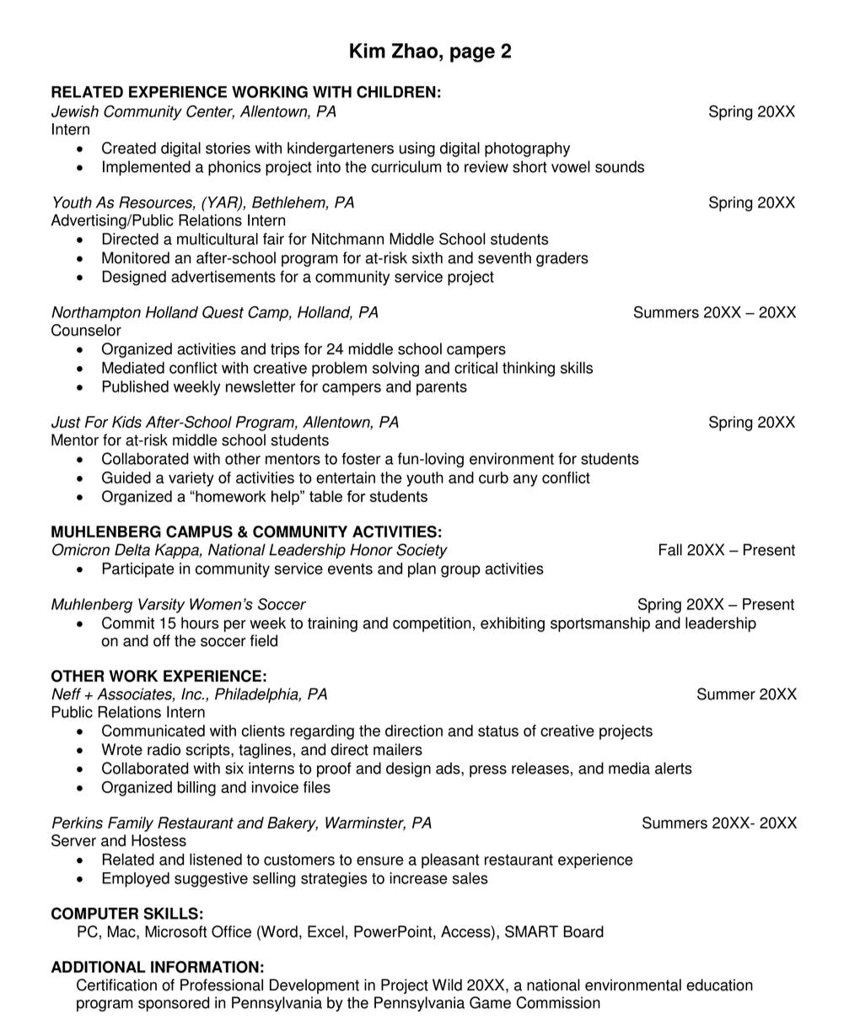
Finance Resume
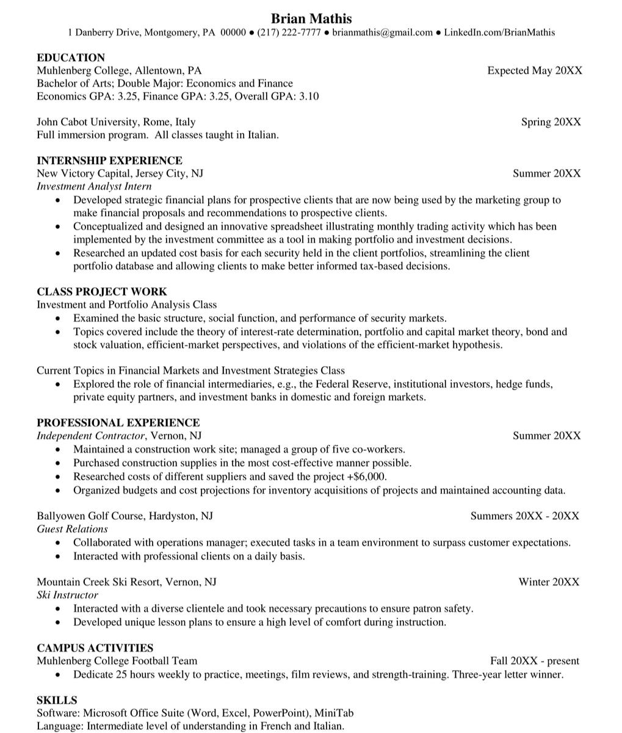
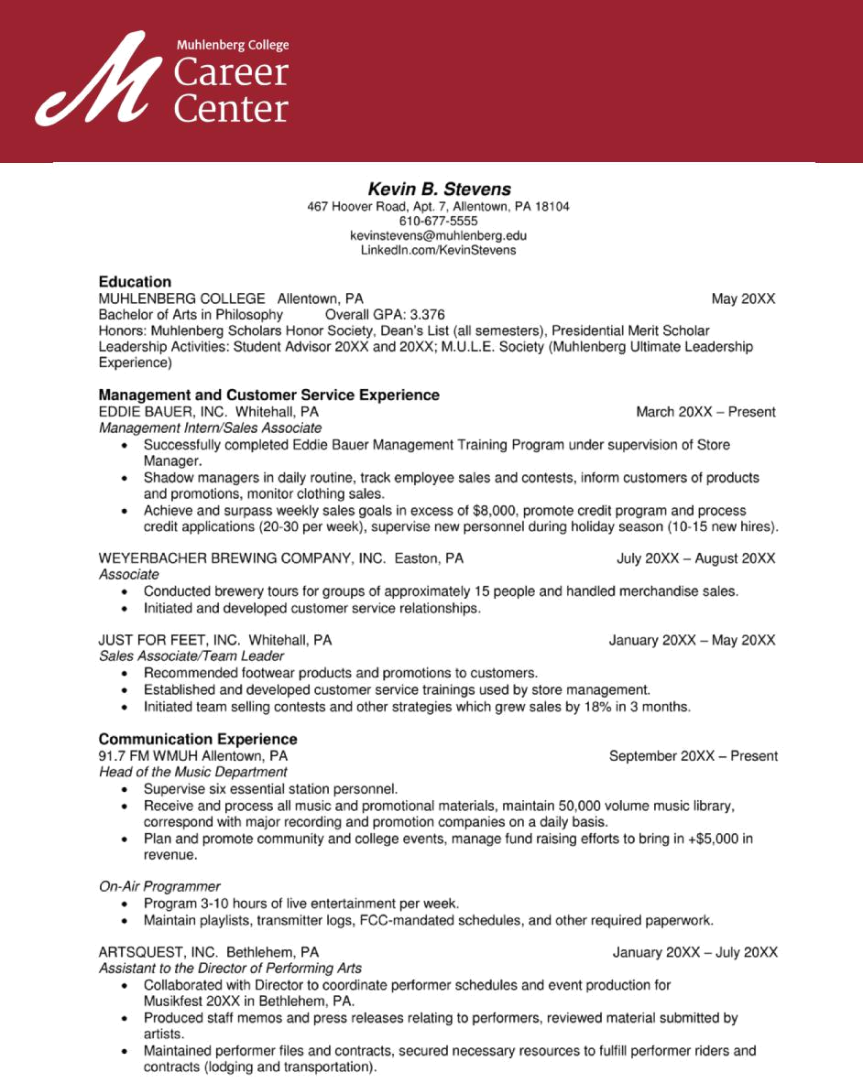
General Resume
Senior Resume
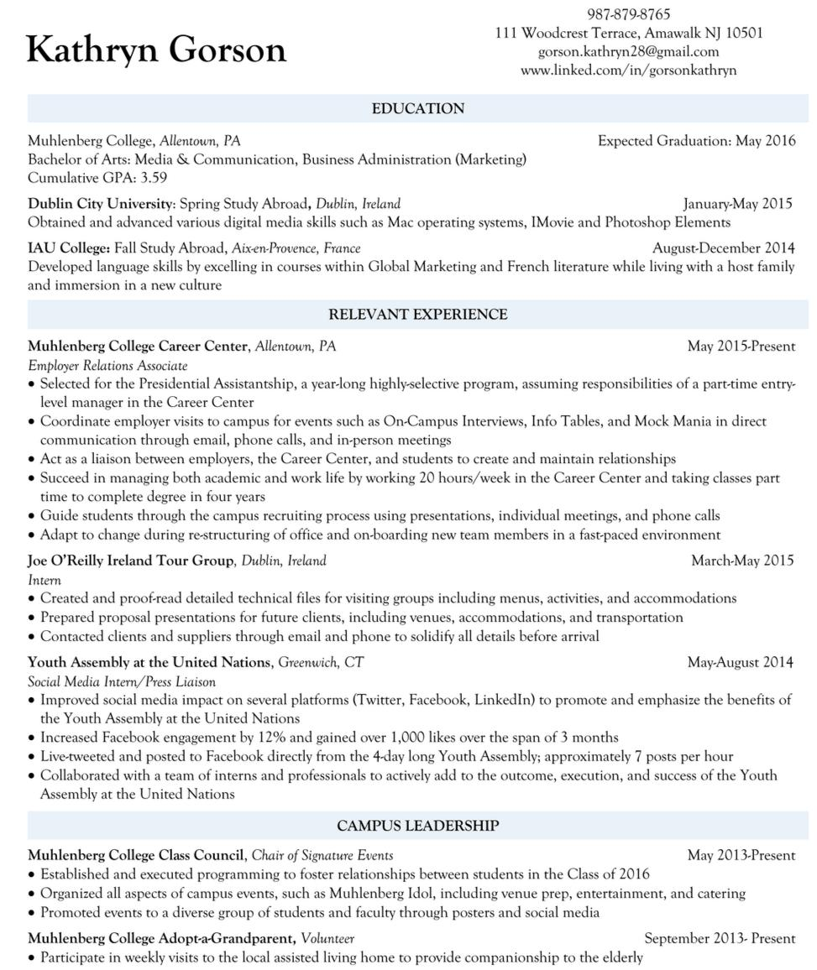
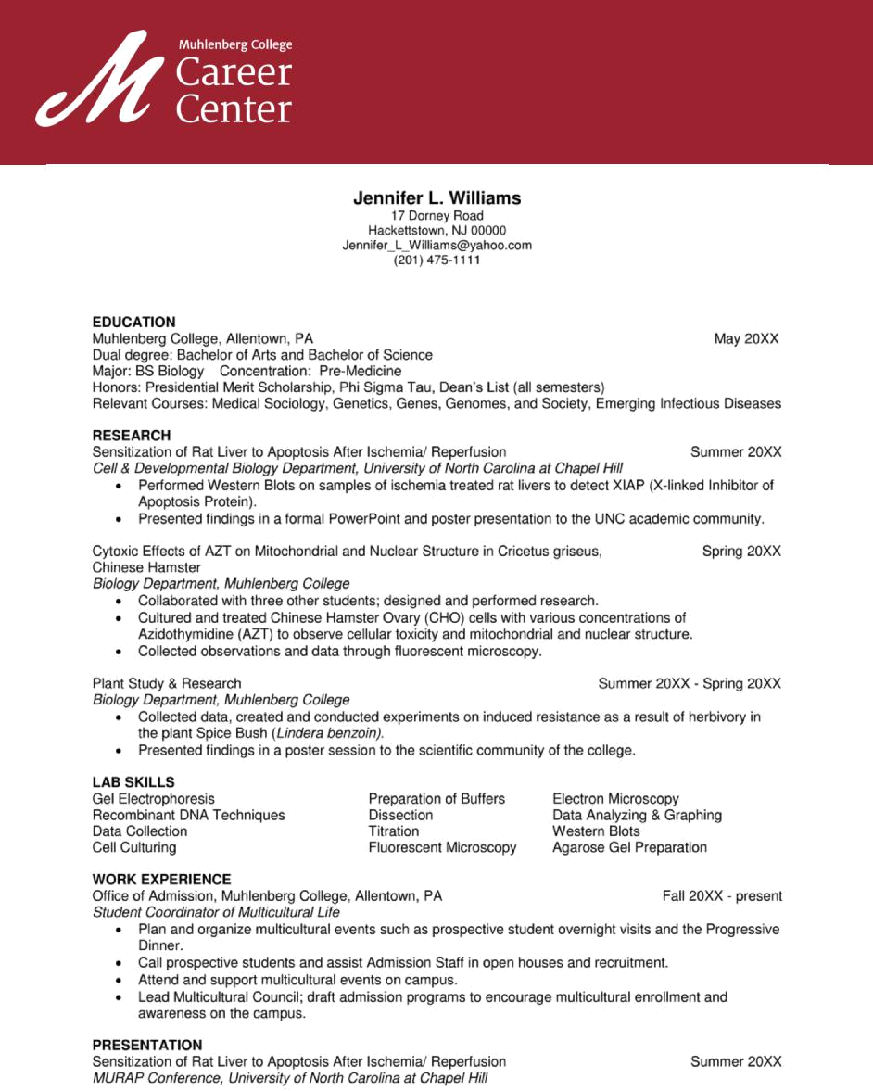
Science Resume
Alumni Resume
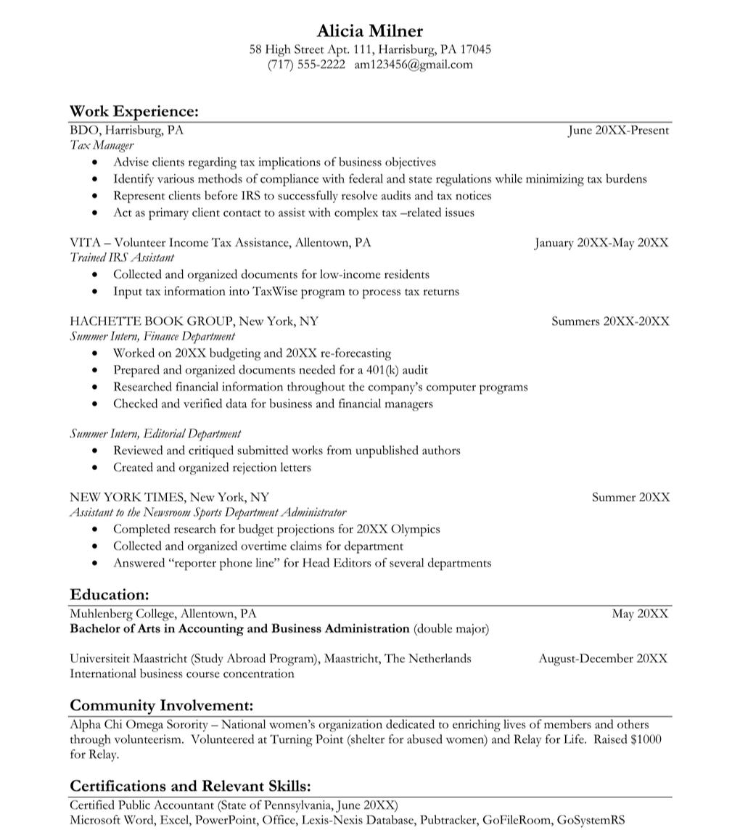
Performance Resume
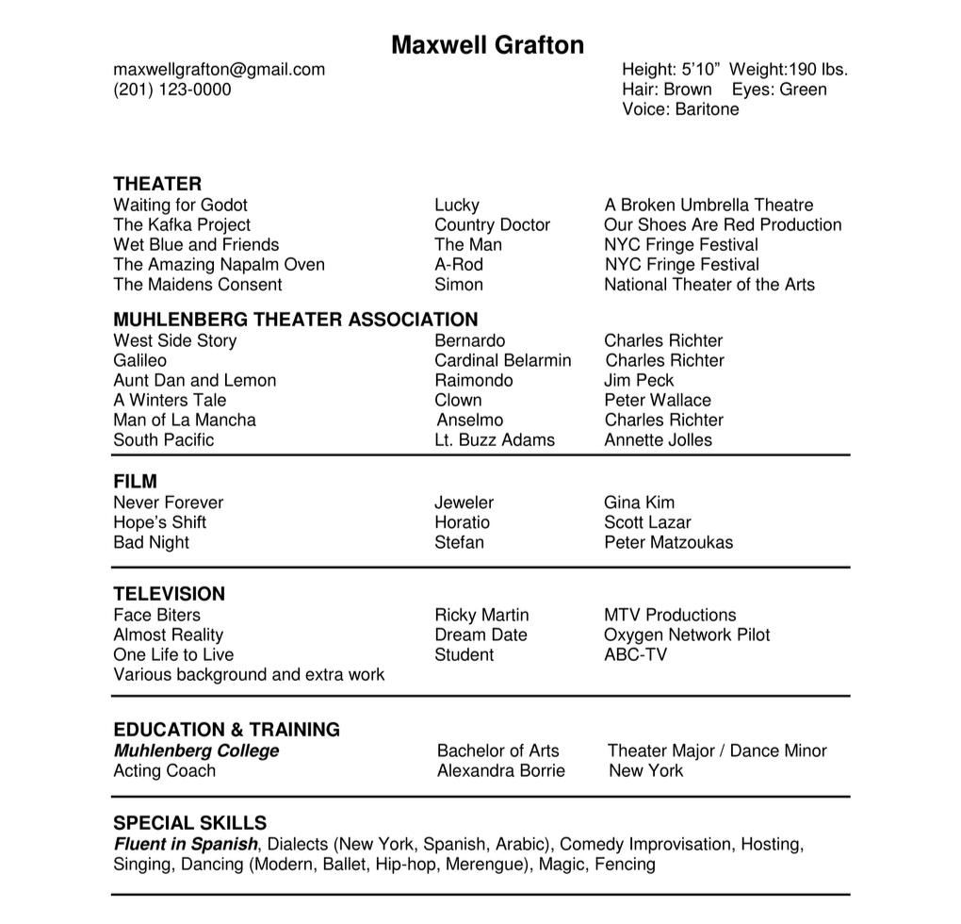
Resume Checklist


- show your background in a way that's informative and professional. Use this checklist as a guide to make sure your resume is on the right track.t'sadocumentthatisyourfirstimpression.Itis important that it has key elements that


Appearance & Format

 No spelling or grammatical errors!

Use space between sections, making it easy to read.

Use standard font styles such as Ariel, Cambria, Verdana (not cursive), Calibri and Times New Roman.
 Use 10-12pt size font.

Have consistent and balanced margins on all sides - between .5 and 1 inch wide.

Name (larger font size and bolded). | Header
Contact information (use one phone number and one
professional email).
Physical address and LinkedIn URL are optional.


Education Section


List full name of institution(s) and city, state.

Spell out degree fully and accurately (Bachelor of Arts or Bachelor of Science) and Major(s), Minor(s).

List month and year of expected graduation.

Optional: Include your GPA if 3.0 or above.

If you studied abroad it should be listed with explanation of what you did.


List company/organization name, city, state, job title and dates (month and year to month and year).

Start each job description with an action verb in proper tense; never use personal pronouns “I” and “my”.

 When using bullets, be consistent with periods or no periods at the end.


Be specific with relevant skills and accomplishments

— these statements answer: How? What? For whom?

Arrange each experience in reverse chronological order.

Work

Experience

Resume Checklist

he last sections of your resume should be well built and highlight other areas you want an

- employer to know about. These sections are also critical as they highlight many keywords that companies' applicant tracking systems will pick up.


Campus Involvement

Can be listed as community service, leadership experience, etc.
Format and arrange these sections similarly to “Work Experience” for consistency.


Include “hard” skills like specific computer, language (with level of fluency) or technical skills.

“Soft” skills like communication, organization, teamwork, etc. should be demonstrated through your experience sections — not listed here.


Skills

Section

Muhlenberg College

Career Center

Lower Level, Seegers Student Union

484-664-3170

careers@muhlenberg.edu

www.muhlenberg.edu/careercenter

Hours of Operation

Monday - Friday: 8:30 a.m. - 5:00p.m.

