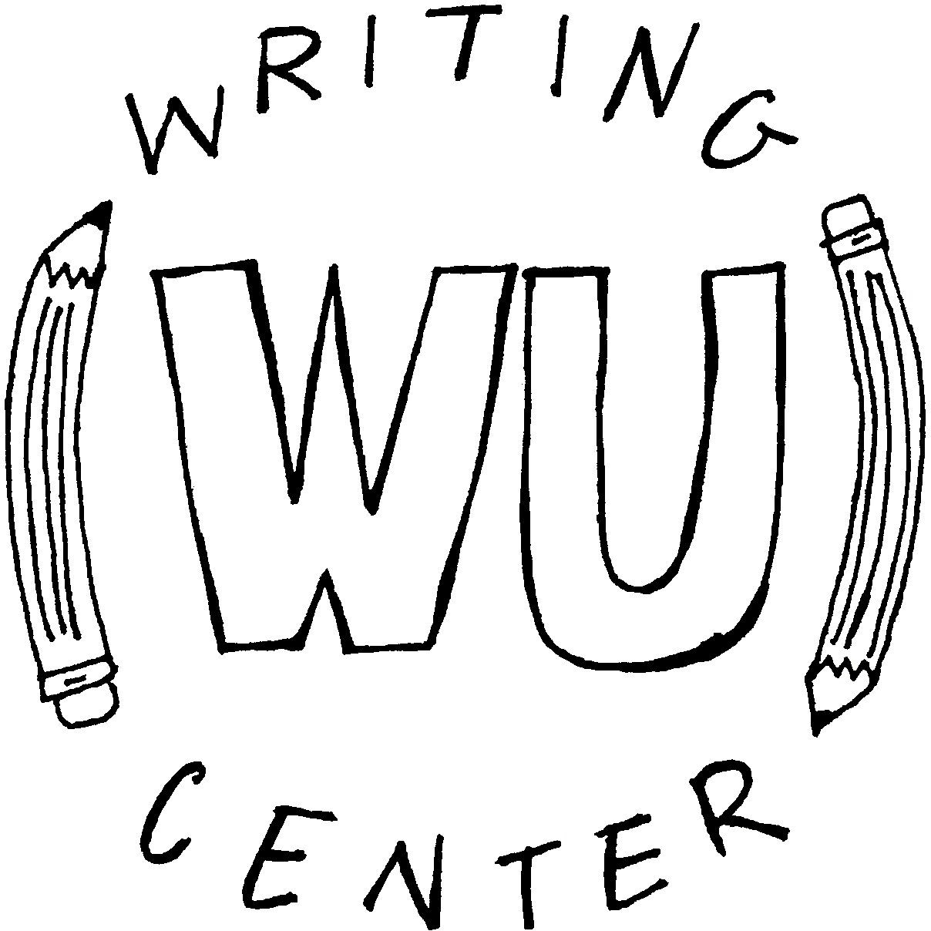

**Thesis Statements**

A thesis statement is the main idea or argument in a paper. Thesis statements provide writers with a focus for their paper, and they provide readers with a sense of direction.

While the structure of thesis statements can vary widely, the “although/I will

argue/because” structure is a helpful starting point until you feel more comfortable with this process!

**Although** (opposing argument) , **I will argue** (your argument) ,

**because** (your reasoning) .

**Example:**

**Although** some students believe that they are good writers and do not need any assistance from the Writing Center, **I will argue** that the Writing Center can provide a useful service to writers of any stage **because** having someone to bounce ideas off of can improve the overall quality of your paper.

**Ask yourself these questions while crafting a thesis:**

➔

Does your thesis answer a question, propose a solution to a problem, or take a position in a

debate?

Is the thesis complex enough to develop throughout an entire essay?

Is your thesis obvious? If you cannot come up with arguments that oppose your argument, consider revising the thesis.

Can you support your thesis with evidence?

Is my thesis interesting? Will it catch my audience’s attention?

➔

➔

➔

➔

**Tips for supporting a thesis statement:**

➔

**Write your thesis first** It is perfectly okay to free-write during the brainstorming stage of writing

without a thesis statement, but it is very helpful to have a thesis while working on the first draft of a paper!

**Outline** Before you begin writing your first draft, develop an outline that supports your thesis statement.

**Be flexible** When you developing your thesis statement initially, try to adopt the mindset that it is a “working thesis.” As you begin to write, it is likely that you will either take away or add support to your argument. When you have completed your first draft, go back to your thesis statement and make any necessary adjustments.

**Reverse Outlining** One of the best ways to make sure you fully developed your thesis statement is to make a reverse outline when you finish your first draft.

* Copy your thesis statement, topic sentences, and any major points you make in each paragraph (no more than a sentence each) and paste them into a new document.
* Read through the sentences you pulled from your draft in order to determine whether or not you followed your thesis throughout the paper.

➔

➔

➔