Shot List

Shot Cluster 1:
Location – 108 St Peters Rd, West Lynn, King’s Lynn, Norfolk
Description – this scene will be a very calm scene, there’s isn’t much dancing and it’s more sensually sexual poses and moves.

Shot Cluster 2:
Location - Old Hunstanton Beach, Norfolk, UK
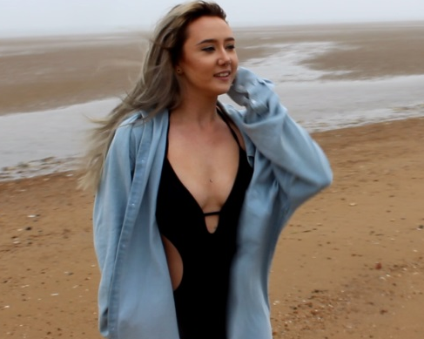
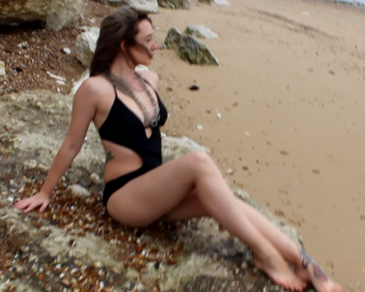
Description – Once again this scene is very sexual, much of the scene is shot in a bikini whilst the other is shot in a bikini with an over large denim button up. Some of the scene is filmed walking around the beach but a lot will be filmed on a rock, much of this will be feeling and groping herself.

OUTFIT NUMBER 2
OUTFIT NUMBER 1
Shot Cluster 3:
Location – King’s Lynn Wastewater, Treatment Works and Sludge Treatment Centre
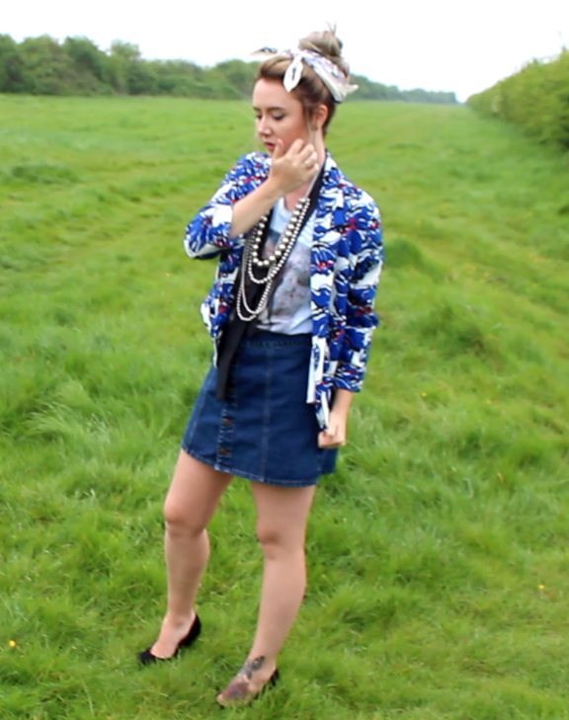
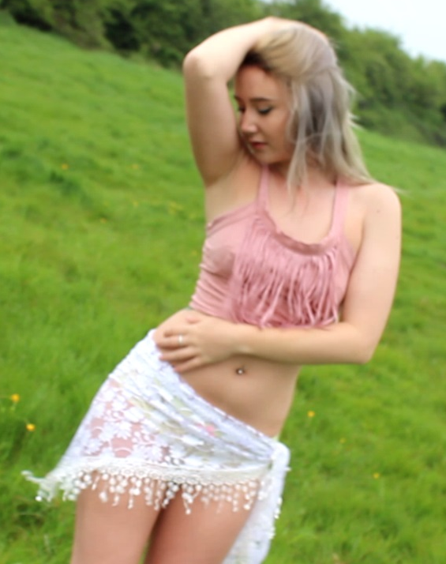
Description – During this scene I want it to be very sassy, I want my model to strut and act as if she is better than everybody. This scene will be shot with her walking towards the camera and the camera moving back, this will be shot as a close up. There is going to be 2 outfits during this scene, one is very retro and 50’s whereas the other is very skimpy.
OUTFIT NUMBER 2
OUTFIT NUMBER 1

