Shot list of photo-shoot

Image of shot | Shot type | Description/action of shot
 | Point of view shot of photographer taking photos | POV Shot of the shoot
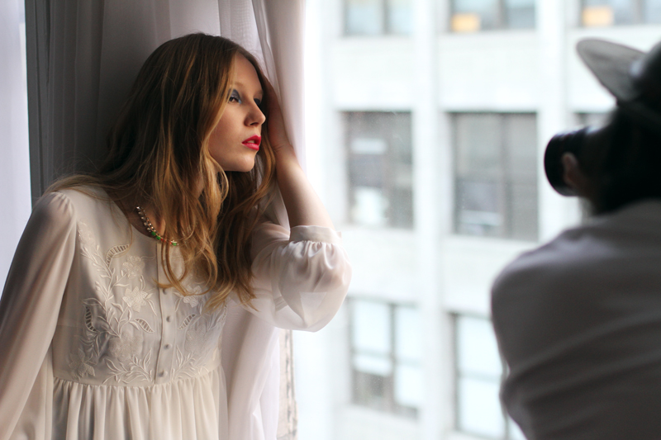 | Close up of photographer taking photos | Close up of the photo-shoot as photographer takes photos of the models
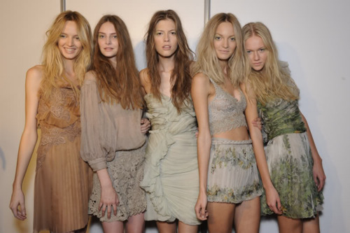 | Shot of all three models together | All the models in the photo-shoot together in one shot
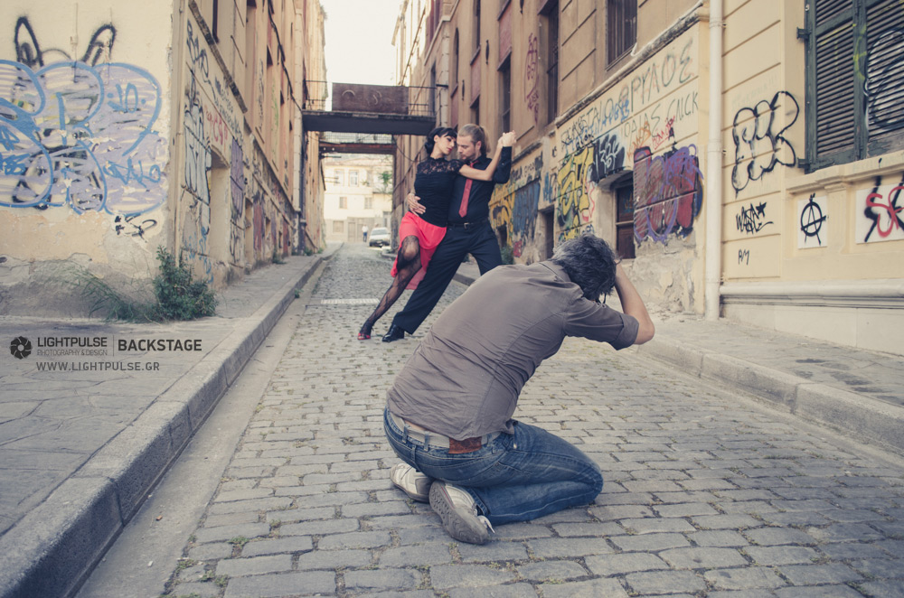 | Back shot of photographer taking photos | Back-shot of the photo-shoot
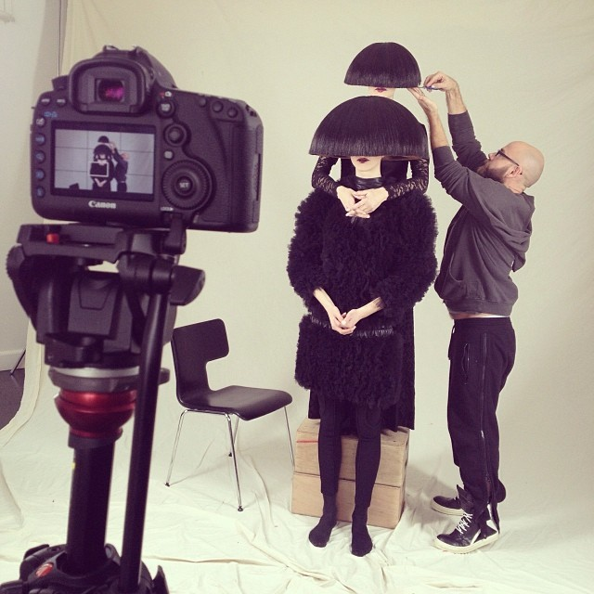 |  | Shot of the photographers camera on standby on the shot | This will show preparation before the photographer begins to shoot
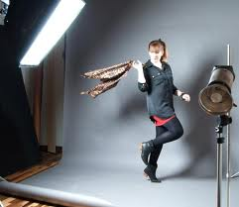 |  | Long shot of each model whilst they are being photographed | Long shots to show the models outfit, hair and makeup.
 |  | Shot of the models after shoot is done | The models will be talking with each other and discussing their hair
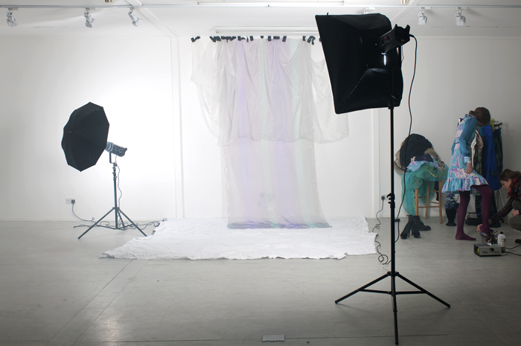 |  | Shot of equipment used on set and outdoor location | This will show lighting, camera and other equipment used in the shoot, as well as the location used Leake Street.
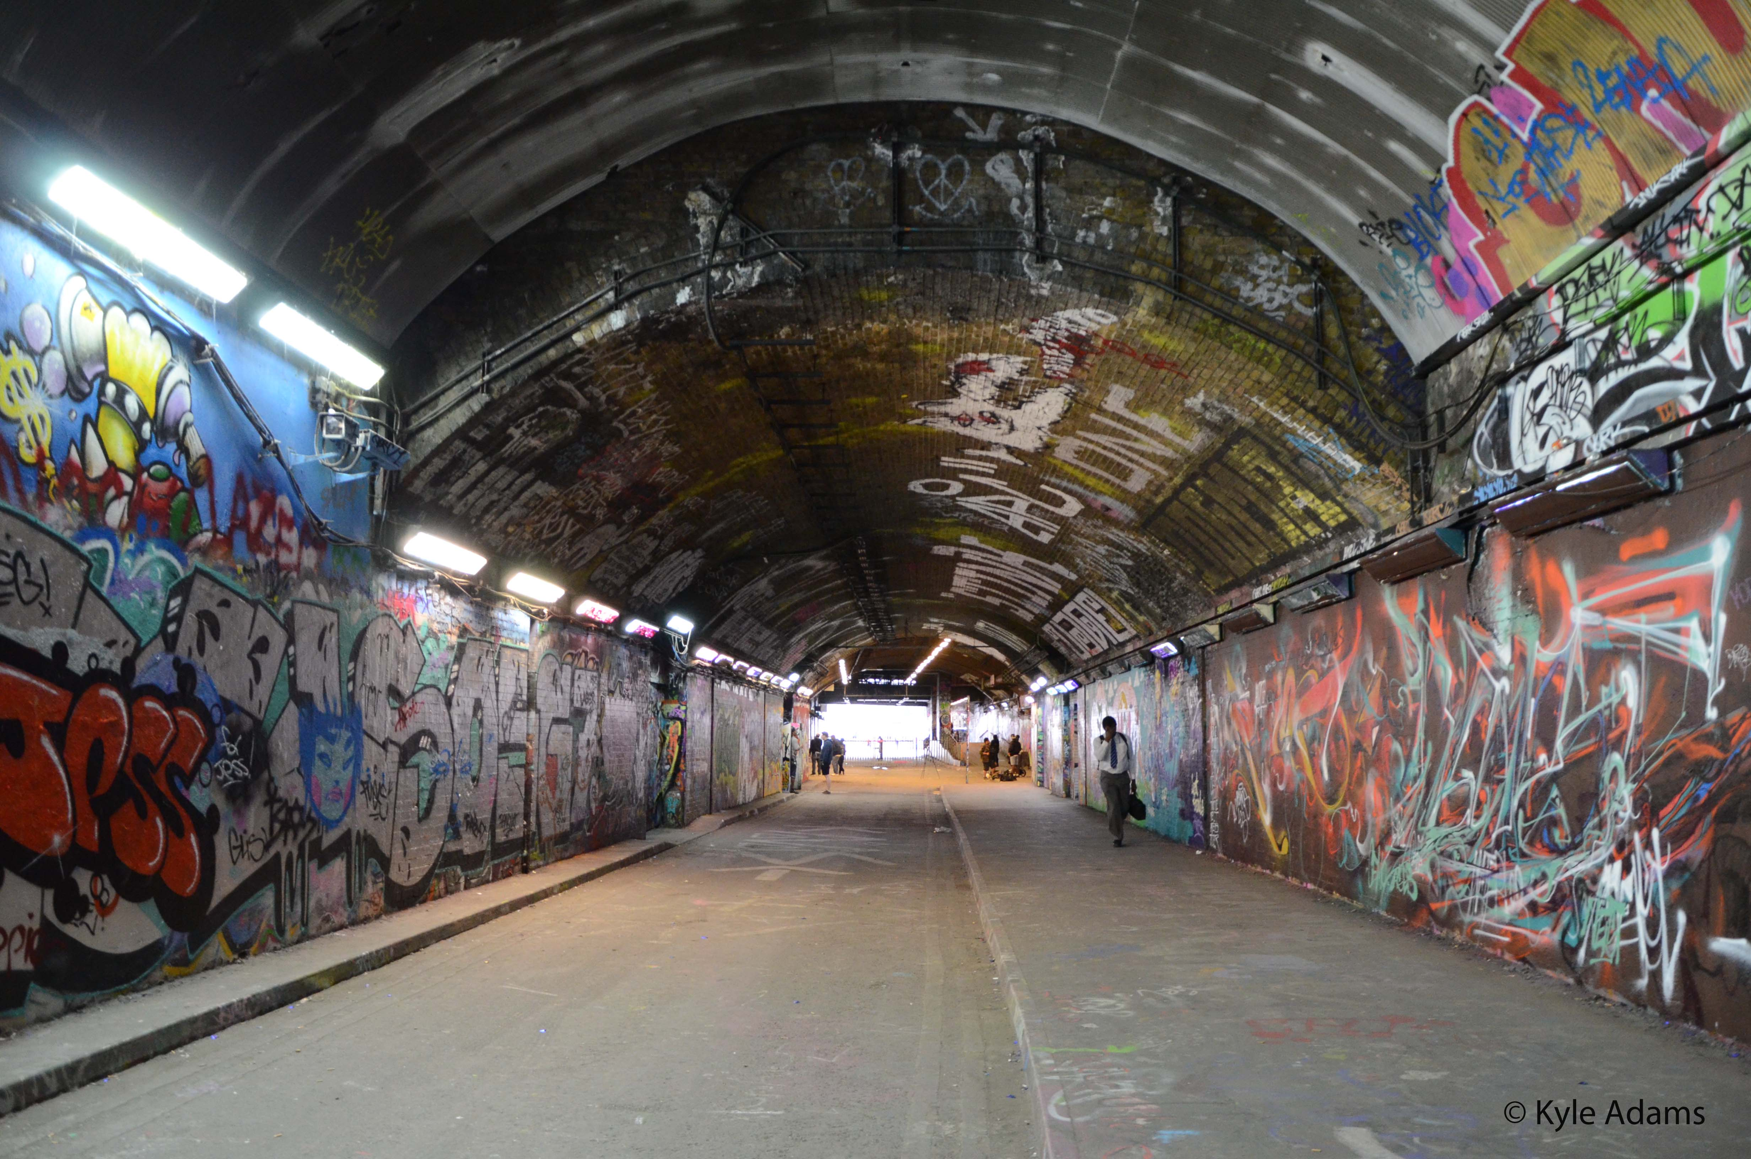 | Two point perspective shot of Leake Street Tunnel |  |  | Two Point perspective shot of the outdoor photo shoot

