FIRST WE EAT

SHOT LIST GUIDE

K E E PI N G Y O U R PH OTO P O S T S CO N S I S T E N T I N S T Y L E + S T R U C T U R E
FIRST WE EAT


So I’m Gonna Shoot a Blog Post...Where do I Start?

Hi guys!!! Thank you SO much for grabbing this nifty litle shot list! In it I’m going over the shots I make sure to take during photoshoots when I’m developing content for my instagram feed + blog. This structure applies to 100% of the food -based posts on my IG feed and AdventuresInCooking. com—it’s helped me create a signature style and feel for my images that comes through both on my blog and on my instagram feed, and I know it will for you, too!

I’d love to see some of these shots in action on your blogs or instagram feeds, I’ll be watching the #firstweeat hashtag for all the awesome photos you create! Would love to promote + share it.

N OW O N WA R D S , T O T H E S H OT S ! !

Copyright 2018

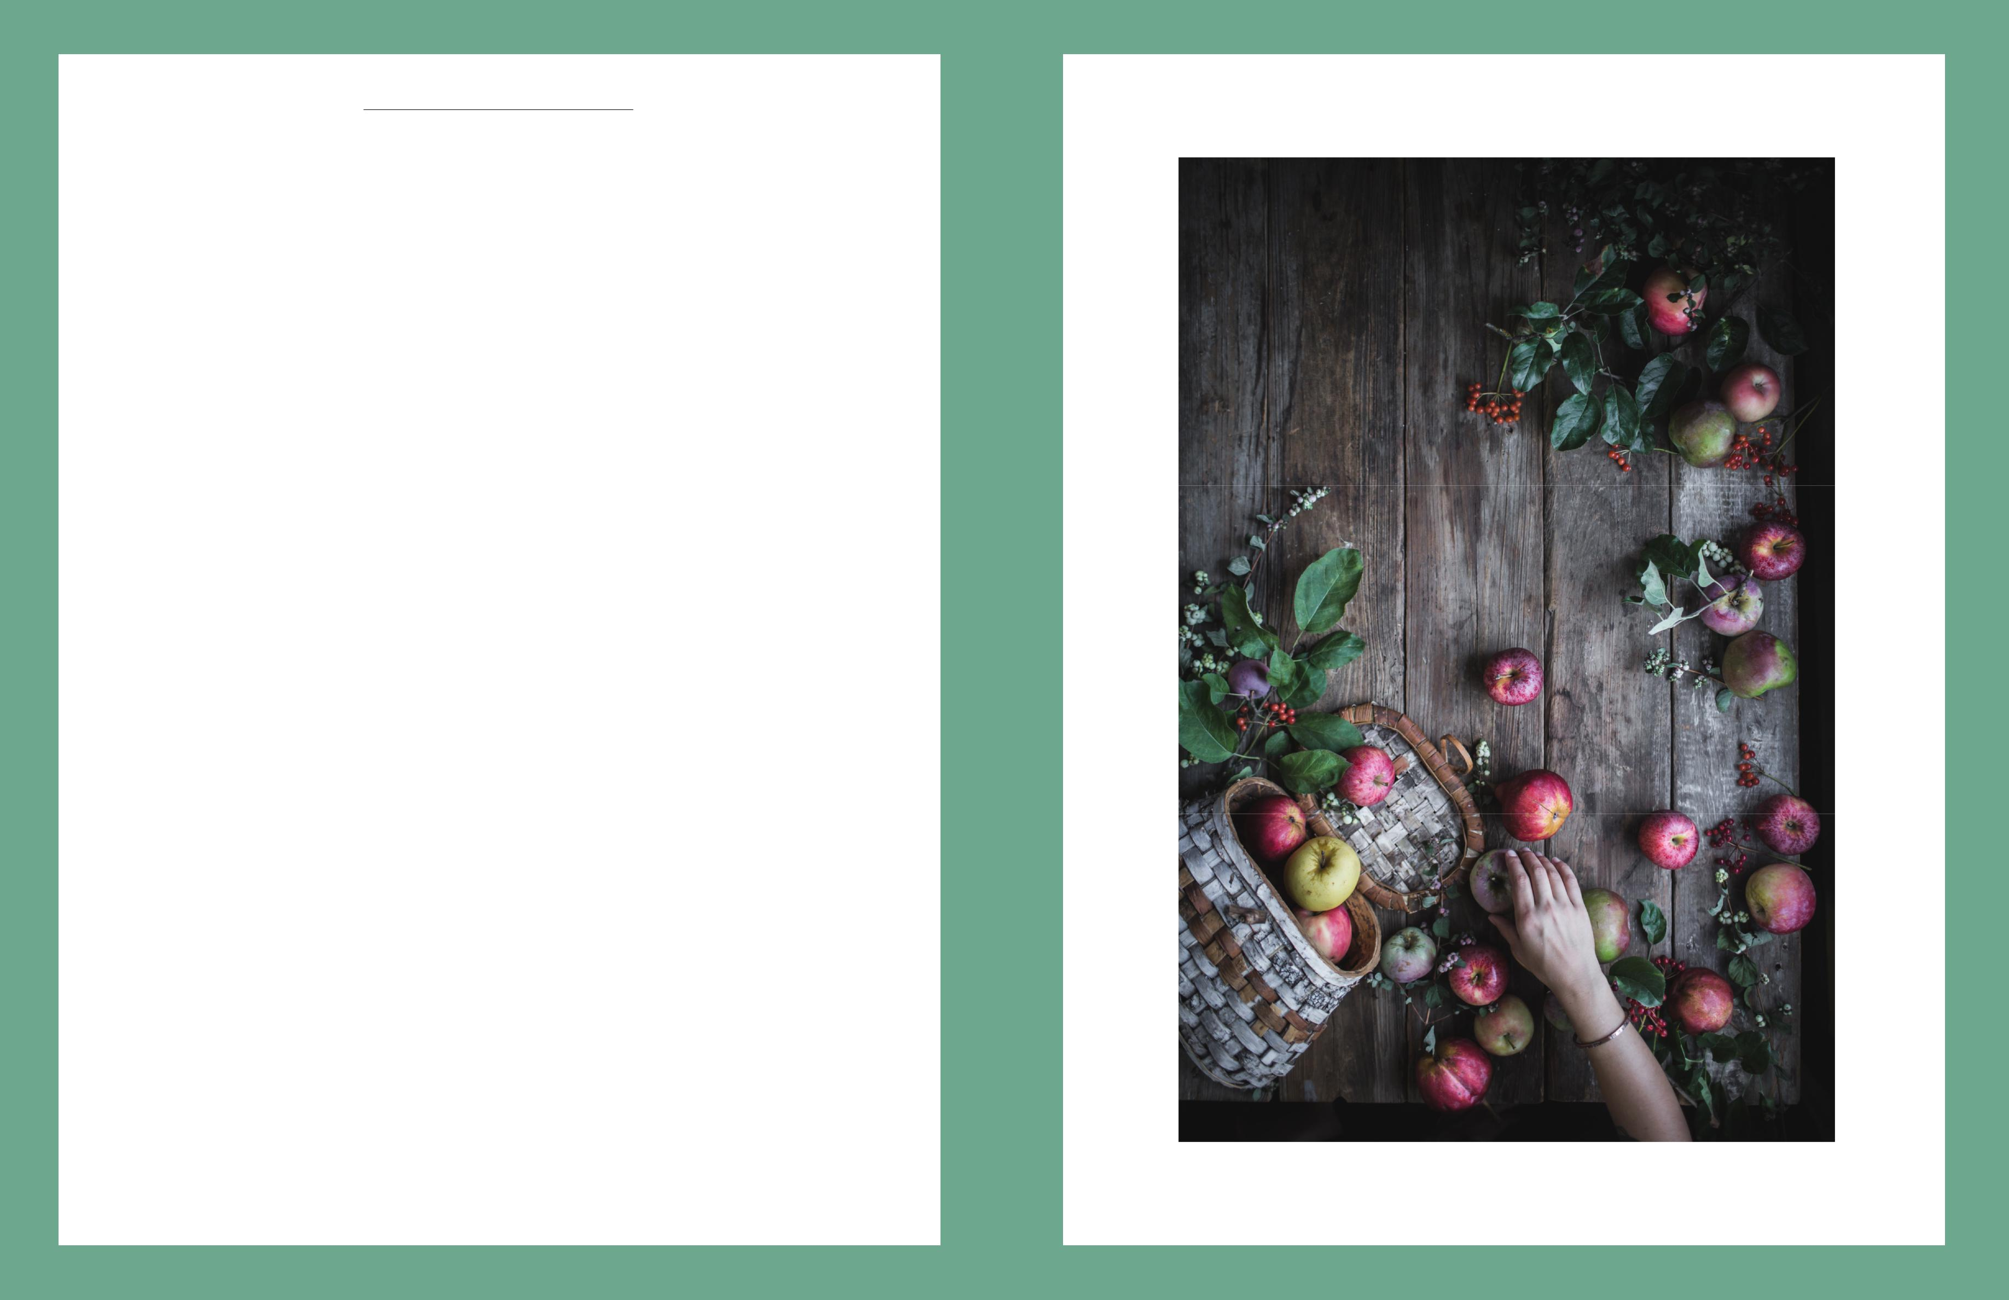
FIRST WE EAT

1

Ingredient Shot

I always include an ingredient shot to help the viewers become more familiar with what the ingredient looks like in its raw form. Usually, it’s a familiar ingredient that they’re already worked with, like apples or onions, etc. But if it’s something that’s possibly foreign to them, like amaranth, getting to see it in its raw form will make it a lot eas - ier for them when they’re out grocery shopping and trying to figure out what the heck that new ingredient looks like.

Typically, I like to shoot these from an overhead angle so I can do a really beautifully styled tablescape on top, and I tend to shoot these pretty wide because I like to fit a lot of ingredients in there, too.

If you can swing it with a tripod + remote shutter release or an ex-tra set of hands, this is a great place to use a hand shot of someone prepping or holding the ingredients. It just adds more life and vigor to what can otherwise be a very stagnant image.

And don’t be afraid to use lots of negative space here (and this goes for the other shots, as well). Negative space can act as a kind of highlighter that draws extra attention to what actually IS there. If you’re shooting with a DSLR, I recommend shooting this with either the 35mm 1.4 or the 24-70mm 2.8 zoom lens.

Copyright 2018

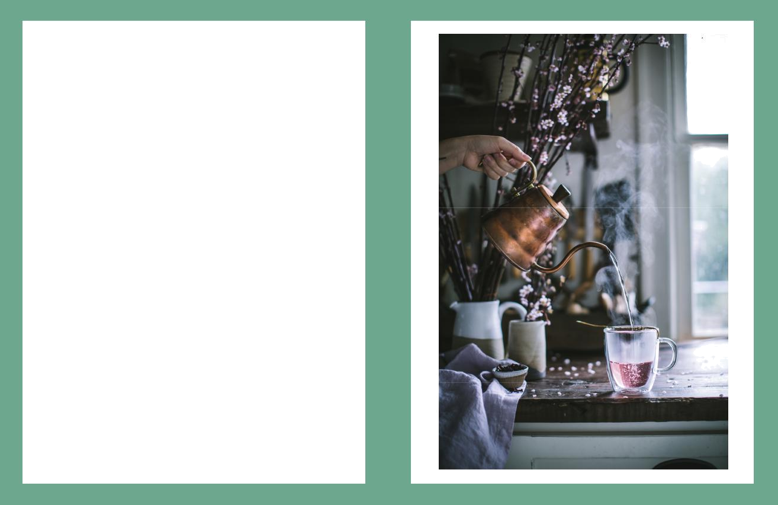
FIRST WE EAT

2

In-Process Shot

This image also provides another great opportunity for hands AND action. Showing a key step in the creating of the recipe—whether it’s steeping tea, creating a lattice pattern in a pie crust, or stirring a steaming pot of stew—makes the reader feel like they’re really there making the dish alongside you, and it also makes them feel like it’s more approachable and feasible since there is an image of what the dish looks like actually being made and created.

Not to mention that action shots are always very engaging and inter-esting on a visual level. So much of food photography is static, since the food doesn’t ever really move on its own, so any type of motion and movement that can be incorporated into the image will bring more life into the frame and draw in the viewer’s eye more effective-ly. What would you rather look at, a cup of tea just sitting on the counter with no steam or person nearby, or a half-full mug with wa-ter being poured into it from a kettle and billowing steam up above? One of these situations is *much* more intriguing than the other!

I typically shoot this with either my 50mm 1.2 or 85mm 1.2.

Copyright 2018

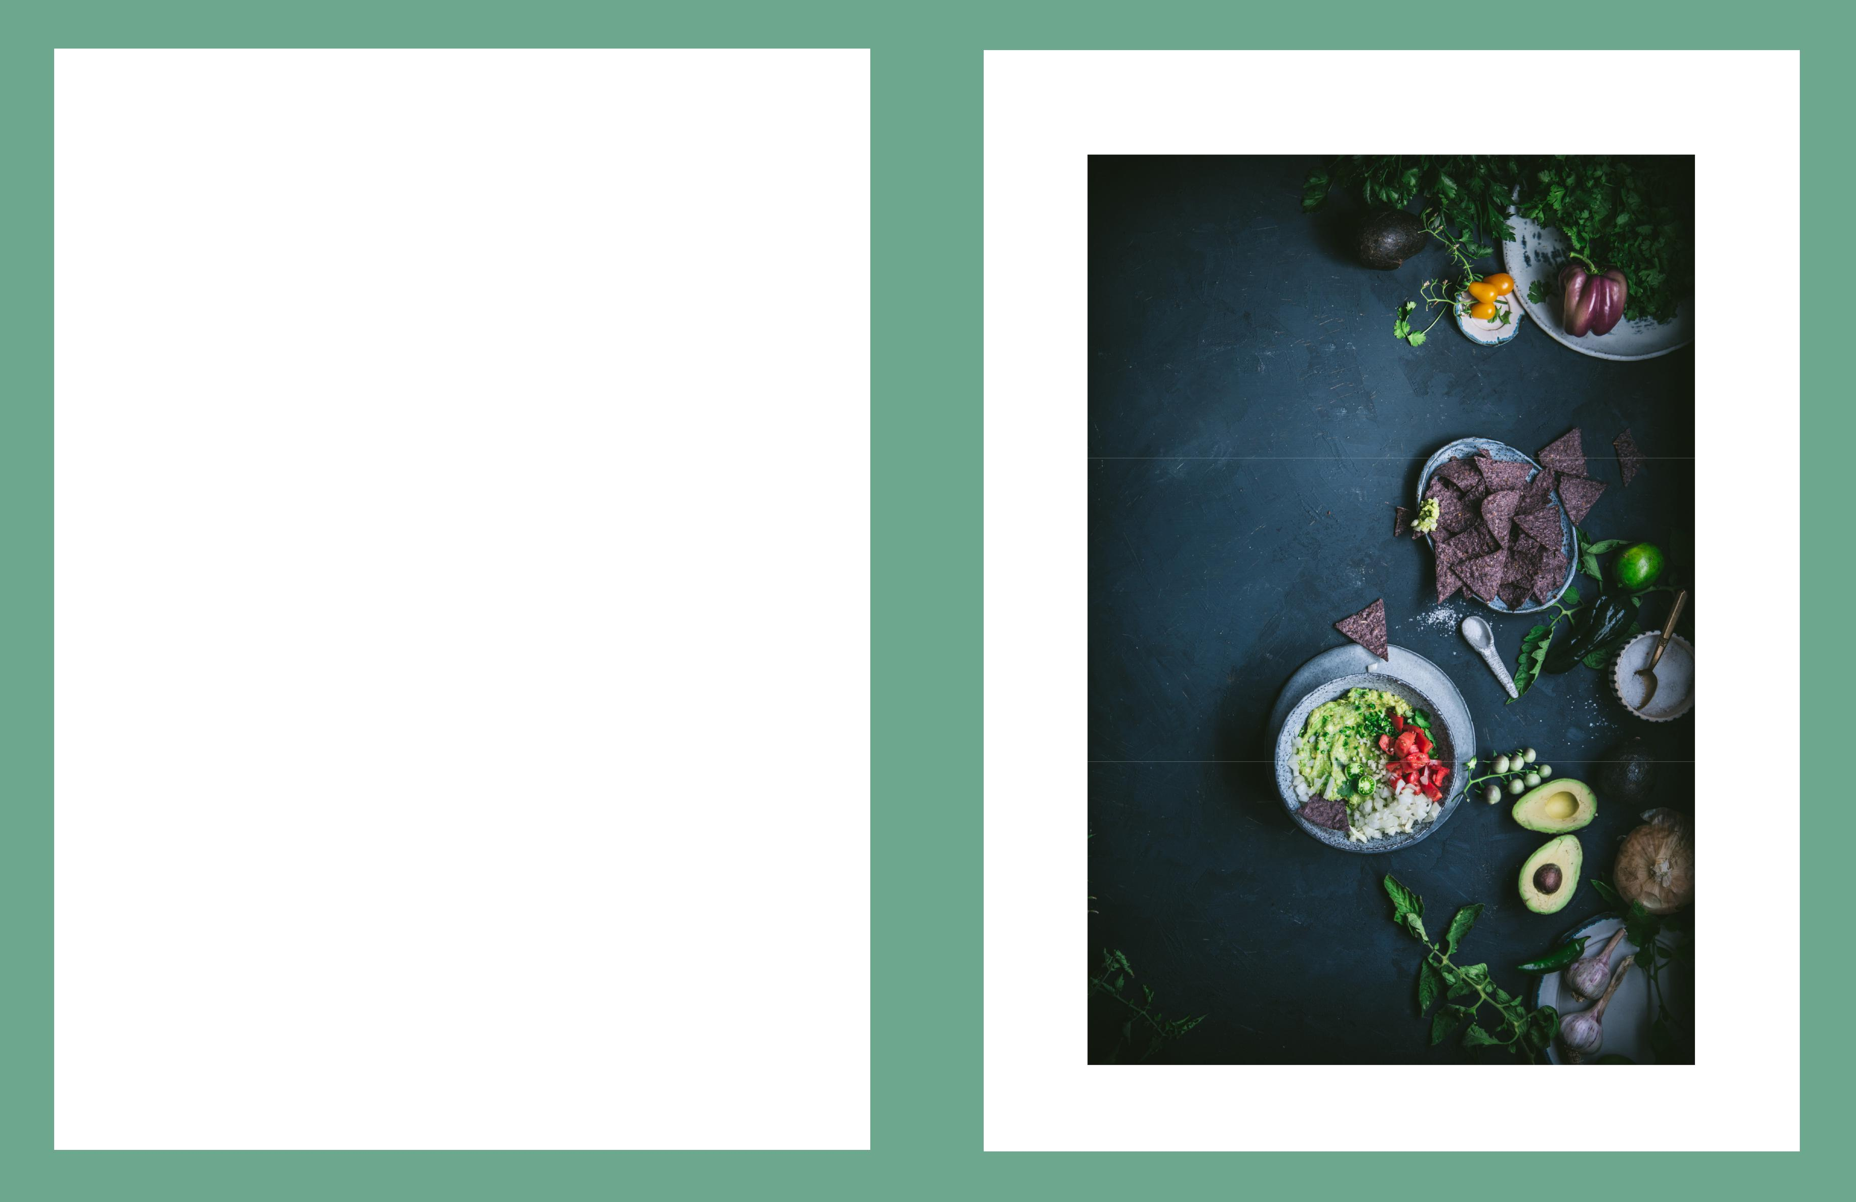
FIRST WE EAT

3

Finished Dish - Wide Overhead

Once the dish is finished, I always include a wide overhead shot of it alongside some of the raw ingredients that went into creating it. That way, if someone sees the photo floating around instagram or Pinterest and doesn’t read/look at the accompanying text or caption, it lets them know what’s inside of the dish right away at first glance.

It’s also a great opportunity to jazz up a dish that might be kinda bland/blobby/plain-looking otherwise. Take this guacamole, for ex-ample—it’s basically just a bowl of what looks like neon-green mush. But when you add a bunch of beautiful avocados, cilantro, brightly colored peppers, chopped tomatoes, and fun blue corn tortilla chips around it, all of a sudden it becomes much more attractive and ap-petizing.

This is also super helpful with dishes where the ingredients might be kind of a mystery, like a squash lasagna or a cake with a special layer of berry filling between the layers. Having some winter squash around the lasagna on the shooting surface hints at the tasty ingre-dients inside, and the same goes for having a colander full of berries near the finished cake. I usually shoot this with my 35mm 1.4.

Copyright 2018

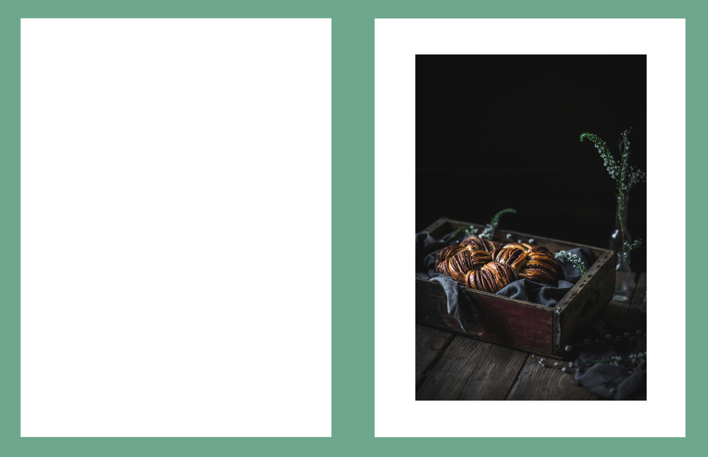
FIRST WE EAT

4

Finished Dish - Side Close-Up

I love the side close -up shot, it’s probably one of my favorites to shoot because I get to utilize the shallow depth of field to create a really moody, dreamy vibe for the photo, and I get to play more with things like height than I do in the overhead shots. Take this photo, for example, I added in a little bouquet of flowers because every-thing in frame felt very low and boring, and getting a little height in there helped break up the line across the middle of frame between the dark background and the warm wood shooting surface.

This is also the perfect opportunity to show some beautiful details of the dish, like a close-up on an intricate crust pattern on the top of a pie or a beautiful edible flower garnish on a salad. Take this shot as an opportunity to really hone in on the little things that make the dish so striking and beautiful that might otherwise not be visible from a wider shot or an overhead shot. This is the time when you want to show off the delicate bits that you notice when you’re really close to the food and about to dive into it. Cuing in these little de-tails will help make the viewer want to dive into the recipe, too!

And going back to the shallow depth of field, I always shoot these side close-ups with my 85mm 1.2. It opens up real wide, and it has THE. MOST. BEAUTIFUL. BOOKEH. EVER.

Copyright 2018

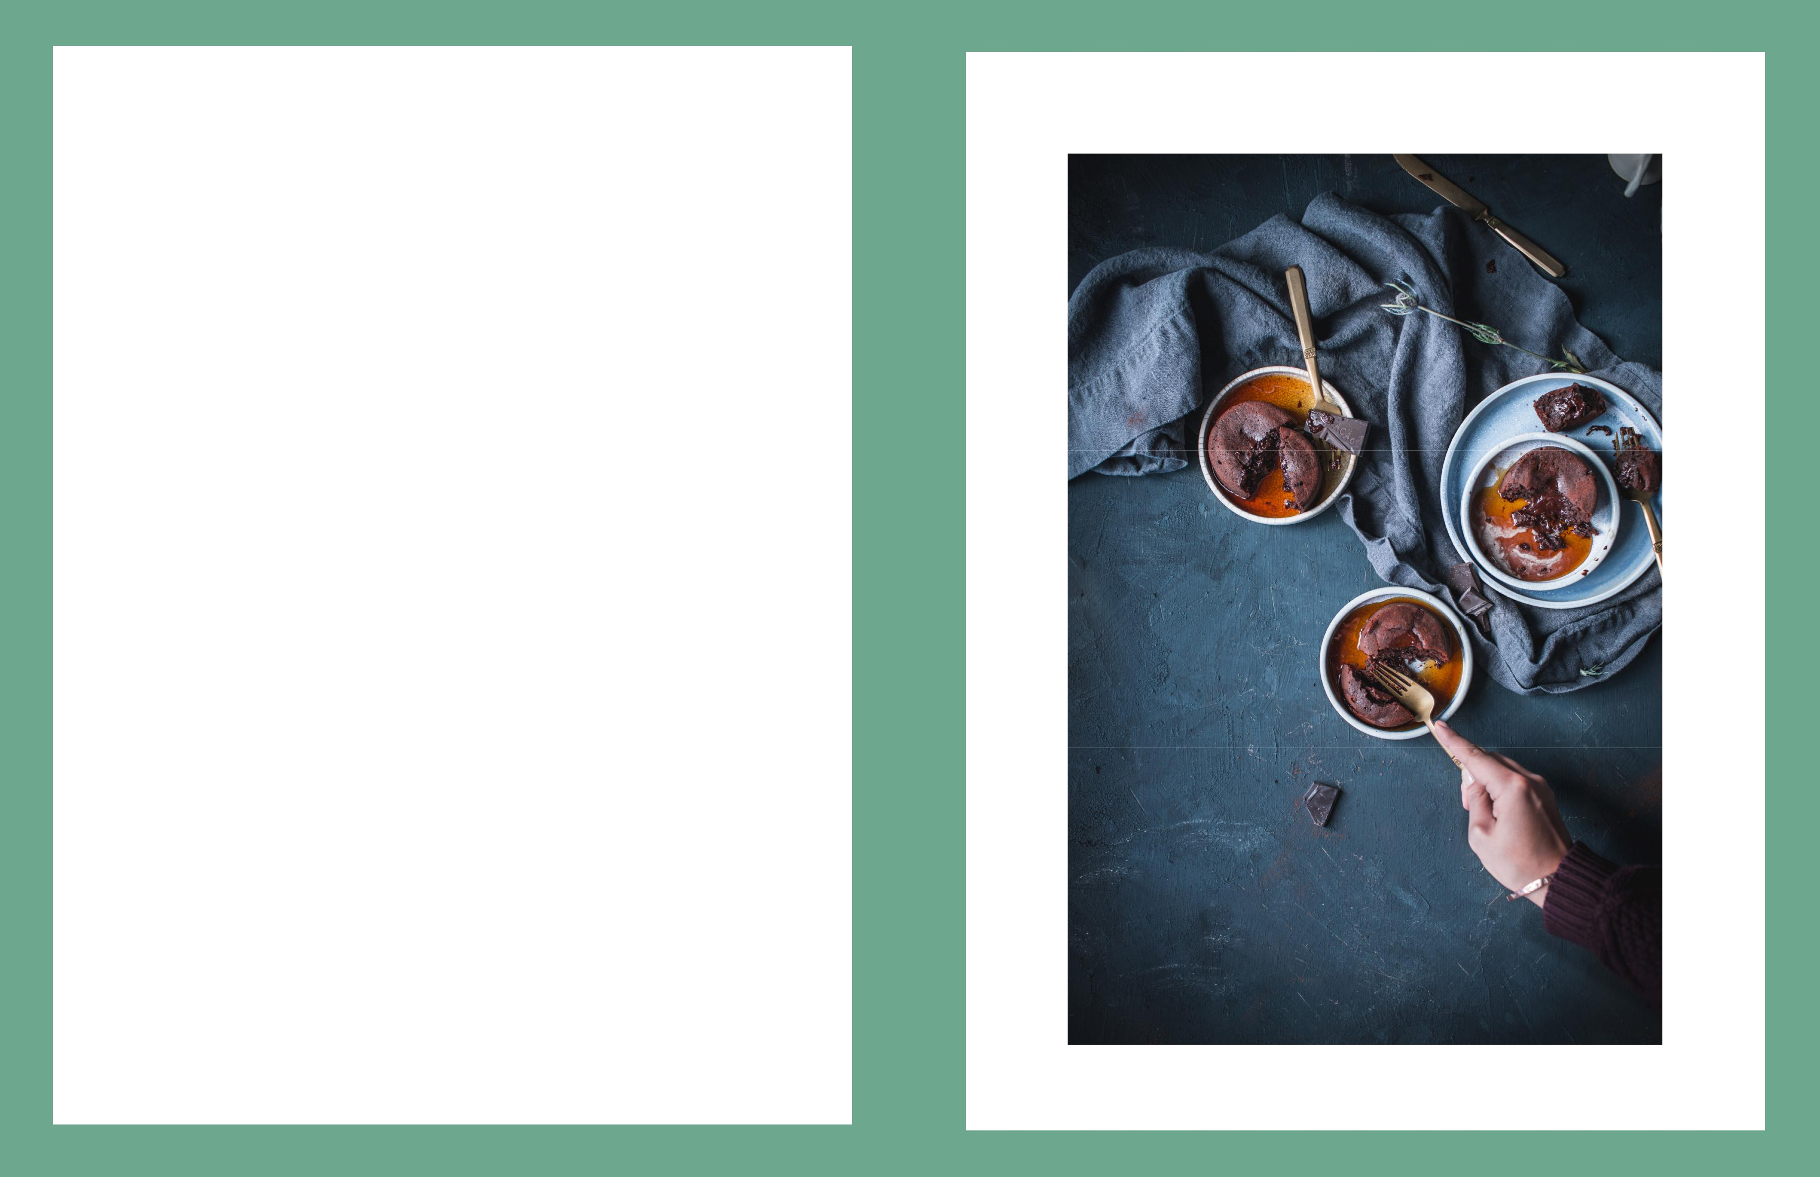
FIRST WE EAT

5

Finished Dish - Digging In

Now comes the part where you get to mess things up—YAY!!!!!! We all know that when you’re eating something, it doesn’t stay perfect for long, and it shouldn’t stay perfect in your photos, either. Diving in there and showing what the dish looks like when it’s in the pro-cess of being enjoyed helps make the viewer feel like they’re a part of the entire process, from cooking to eating, and again encourages them to want to dive in and have at it themselves.

Whether it’s bites taken out of a cookie, or a piece of pasta on a fork, or slices removed from a tart with crumbs all over the place, having shots of the food being eaten and enjoyed makes the setting seem more lived-in, real, relatable, and approachable. It also helps tell a story and captures a moment, much more so than a static per-fect shot of an untouched smoothie or pastry.

This shot is also another great opportunity to have some action or motion with hands in the frame (think a hand reaching in and tear-ing off a piece of a croissant, or soup being ladled out of the serving pot and into a bowl, etc.) I shoot this with any of the previously mentioned lenses, it just depends on what angle I’m aiming for.

Copyright 2018

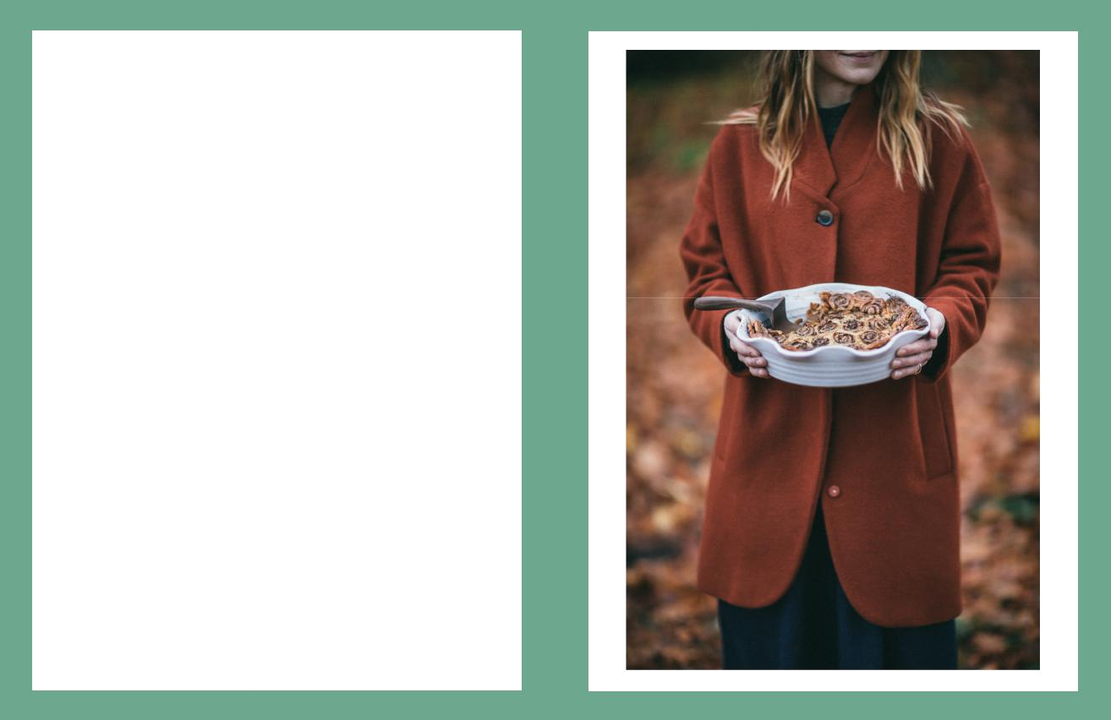
FIRST WE EAT

6

Finished Dish - Hand Held

I don’t know if you guys can tell, but I kiiiiiinda like having hands in photos of food, and there’s no more epic hand shot than of some-one just straight -up holding the finished dish. I love this shot be-cause it reminds me of someone presenting me with the dish they just made and are about to share with me—like when my mom used to carry out dinner to the table when I was a kid, and like I current-ly do when I’m sharing food with friends and family.

It feels like an invitation—an invitation to come join in on the fun, partake in the tasty dish, and become a part of the world in the pho-tograph. It’s basically me saying “hey! I made this for you. Now get your katush over here and let’s dive in!”

It’s also a great way to incorporate more of the setting and the scen-ery around the food and show a peek at where the food is being served. Take this photo, for example—I shot it with my friend Tif-fany from Oh Honey Bakes up at her home in Washington state. The ground was covered with autumn leaves, and you can see the warm tones of the leaves blurred out in the background. That, and her coat, give you the sense that it’s outdoors and it’s autumn. This set- up is a really great opportunity to tell more of the story behind the dish and the goings-ons around it. DSLR-wise, I usually shoot the hand held shots with my 85mm 1.2 for more of that sexy soft bookeh.

Copyright 2018


FIRST WE EAT

Giiiiiiiiirl I can see your photo brain growing already! I’m so excited to see all the awesome new photos and set-ups you create in your next IG + blog posts!!

For more goodies, check out the Resources at First We

Eat!

For freebies + tips + special offers, sign up for my

insider email!

To get in on the conversation, join our Facebook Group!

Thanks so much + have fun shooting!!

Warmly,

Eva

    - FIRSTWEEAT.CO

WWW. ADVENTURESINCOOKING.COM

WWW.SECRETSUPPER.CO

Copyright 2018

