Church Supported Missionary...

Paul & Tanya Gericke: Camp Falcon Rock Developers, ROMANIA
Please pray for our seniors who are residents at Mount View Lodge:
Helen Dyck, Madeline Hall, Helen Siemens, Erwin Standar
Sunrise Encore: Tillie Erickson, Alice Schafer, Jake Siemens, Dorothy Unger, Hilde Unger
April 21, 2019
“ To know Christ and to make him known”
East Olds Baptist Church

Email: rootsromania@gmail.com Please pray...
- for continued safety on the work site. There are multiple crews up at the camp each day working on different projects, which can lead to a crowded work site. Pray for safety and efficiency.
- for God to be at work in and through team member of Whitecourt Baptist.
- for funds to be provided for the main lodge project, which they hope to start this summer.
Church of the Week...
Century Meadows Baptist Church—Camrose, AB
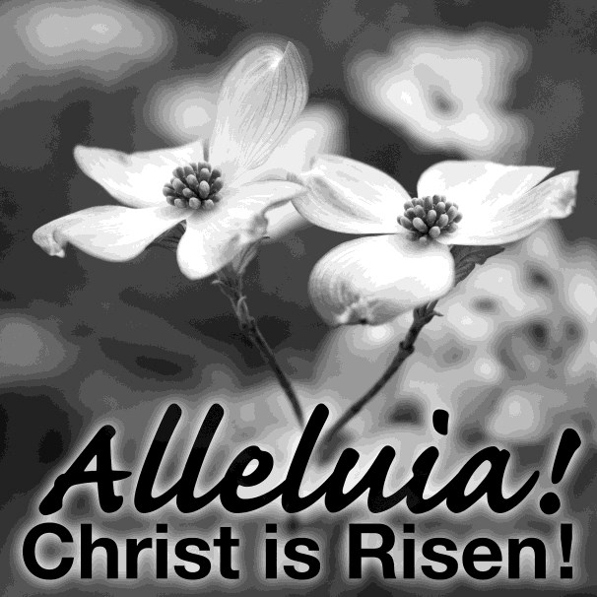
Senior Pastor: Ed Lehman (Alana)
Our church has FREE access to RIGHTNOW MEDIA for the next 3 months. Just scan this QR code and it will take you to their site.
Pastor of Adult Ministries: Jesse Schellenberg (Bradyn) Pastor of Youth Ministries: Brett McCarroll
NABC Missionary of the Week...

Lyndell Campbell-Réquia, NAB Missionary in Brazil
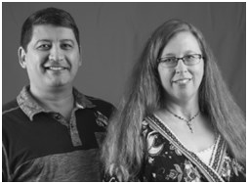

Lyndell serves at the Rio Grande Do Sul Baptist Theological Semi- nary in Porto Alegre. Much of her work involves the Pastoral
Formation program at the seminary. Her husband, Paulo, is an NAB partner missionary working with TeachBeyond. In November, NAB missionaries Brandon and Marci Jones and their three children arrived in country just in time for
Brandon to teach a two-week intensive course on Old Testament theology. Pray for the continued transition of the Jones family as they continue to make Porto Alegre their home. Pray for the continued strengthening and
healing of Lyndell’s back through physiotherapy. For more information, visit nabonmission.org/missionaries/lyndell-
campbell.

Why Easter Matters “Celebrating What is Finished” John 19:30
- Pastor James Rosenberger
East Olds Baptist Church
RR1 Site 5 Box 27 Olds, AB T4H 1P2
Phone: 556-2821 Fax: 556-3161 Church Email: eobc@xplornet.ca
Website: eastoldsbaptist.ca
Pastor: James Rosenberger 403-586-5086 (cell) eobcjames@xplornet.ca Youth Pastor: Chris Luchies 403-501-4705 eobcyouth@xplornet.com Church Office Hours: Tuesday and Friday 9-12am

If you’ve missed a Sunday, view the church bulletin and listen to the sermon
on our website: eastoldsbaptist.ca

Welcome to East Olds Baptist Church
Are you visiting with us?
Please fill out a Visitor WELCOME Card found in the pew.
Coffee is available… Enjoy!
Worship in Song: Barry Weiss Welcome & Announcements Worship in Giving
Worship in Song Special Music: Toni Newsham Little Kid’s Time: ages 3-Gr.4
Message
- Pastor James Rosenberger
Benediction
Our greeters today are Kevin and Rhonda Schmidt. A supervised nursery is available for children 0-3yrs in
KidZone(Rm3)—Snuggle Room for moms & babies
Women’s Ministries...
  - Friday, May 10th: 7pm, Ladies Spring Event—Dessert Night, “Reach for the Sky” - Bring your
- New Adult S.S. class taught by Albert Poulsen,
Apr .28th: “A Survey of Church History AD 100-600”
- Sun. May 5th: 6:30pm, Awana Closing Program—
everyone welcome!
- If you are interested in helping plan a church picnic
for June 23rd, please talk to Ken or Edith Ryning.
Children & Family Ministries...
favorite dessert Guest Speaker: Toni Newsham (Arborist)

ALL ladies welcome!
Youth Ministries—7-9:30PM...
  - WHITE CROSS: This is the final week for any donations. Please return sewing projects, glasses bandages, etc. to the church. Thanks to ALL of you who partici- pated. It is so much appreciated!
Experience Youth Group...
- Fri . Apr.26th: Lazar Tag! Invite friends!
- Fri. May 3rd: Talent Show
- Fri. May 10th: Movie Night at the church

EOBC...a place to grow together!
Today...
FINANCIAL UPDATE
March 2019
Income: $18,531.78 Expense: $14,228.67 Net: $ 4,303.11
Just a reminder regarding
Gifts and Tithes
⇒ please make your cheques payable to EOBC.
Designate General Fund, Gleanings OR
Building Fund on your envelop.
CONGRATULATIONS to
Adam & Elyse Carew on the birth of their son, Ty Allan Victor Carew, born April 10th,
weighing 9lbs 5oz!
God bless you as you raise your little family!
- A huge THANK YOU to the Sunday School Committee (Anjoli Rice & Venda Weiss) for organizing the delicious Easter Brunch this morning!
This Week...

Church Office Hours: 9am-12pm, Tuesday & Friday
- Monday… Pastor’s day off
- Tuesday… NO Awana Clubs—Spring Break
- Wednesday… 7:30am, Men’s Prayer Time
…...8pm, Young Adults Bible Study at Rudd’s home
- Friday… 7pm, Youth Event
- Saturday……….Church Cleaning: B Winter

………...Gleanings Community Bottle Drive
- Sunday… 10am Sunday School, 11am Family Worship with Pastor James
Greeters: T&L Gardner Coffee: M Unger Nursery: N Wearmouth
LKT: V Weiss, N VanGinkel, Joas S, A Snoek

Coming Up...
- Saturday, May 4th: 8:30-noon, Annual Highway Clean-up (sign up sheet at back)
- Sunday, May 5th: 6:30pm, Awana Closing Ceremony & Program—everyone welcome
- Friday, May 10th: 7pm, Ladies Spring Event

Family of the Week: Kees, Miranda, Simon, Robin & Nicole Verhoef
PRAYER CHAIN: If anyone has a prayer request and wants it on the Prayer Chain, call Madeline Hall at 403-559-2332

Pray for our senior shut-ins and those of our church family dealing with health concerns—Helen Dyck, Madeline Hall, Jake Siemens, Erwin Standar,
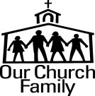

Prayer & Praise...
Interested in BAPTISM? Please talk to Pastor James. Sign up sheet on the back table
Verna Unger, Andy & Marlene Wipf

- Pray for the health of our seniors. PTL that Verna Unger is feeling much better. She wishes to thank you all for your cards, visits and especially your prayers.
- Pray for renewed strength for Marlene Wipf who is very weak in hospital after taking a fall.
- Pray for Courtney Schafer who is studying in Paris, France.
Pray for all our post secondary students who are completing their semesters at school and preparing for summer work.

