Sunday, May 20, 2012

What We Believe

A Worshiping Community
Compassion, Peace & Justice
Education & Serving Others
Evangelism & Church Growth
Men’s & Women's Ministries
Special Offerings
Stewardship
World Missions

Our Focus FAITH HOPE LIFE LOVE

General Info Pastors / Staff Ministries

970 Bishop Lane Frank Fort, Sr. Pastor Bible Classes
Palm Desert, CA 90716 Albert McManis, Pastor Youth Group
Office: (619) 482-6117 Cynthia Mills, Secretary Young Married
E-Mail: info@pdnpc.org Scott Nuberg, Youth Pastor Single Moms & Dads
Website: pdnpc.org Grace Able, Event Coord. Senior Assets

Worship Services Sunday Morning 9:00 am
Nursery 8:30 am
Sunday School 9:00 am
Mid-morning 11:00 am
Nursery 10:30 am
Sunday Evening 6:00 pm

Join Us for Friendly Fellowship
Immediately following 11:00 am Worship

Mid-week Services Wednesday Bible Study 7:00 pm
Wednesday Youth Bible Study 7:00 pm
Thursday Men’s & Women’s 6:00 pm
Thursday New Believers Class 6:00 pm

John 3:17
“For God did not send His Son into the world to condemn the world,
but that the world through Him might be saved.”

Scripture Discussion
How does your faith effect others? How often do you share your faith with unbelievers?

Prayer Request
We welcome your prayer requests for any area of your life.

Praise Reports
Share a positive testimony on how you believe your faith in God is causing you to overcome the challenges of everyday life.

Giving Update
Our church is growing! The following reflects giving for April 2012

Church Growth | Evangelism | Missions | Outreach

"This month shall be your beginning of months; it shall be the first month of the year to you. Exodus 12:2

May 2012

 |  | 1 | 2 | 3 | 4 | 5
6 | 7 | 8 | 9 | 10 | 11 | 12
13 | 14 | 15 | 16 | 17 | 18 | 19
20 | 21 | 22 | 23 | 24 | 25 | 26
27 | 28 | 29 | 30 | 31

For more information on the calendar, please call the church office, (619) 482-6117 or e-mail us at: office@pdnpc.org

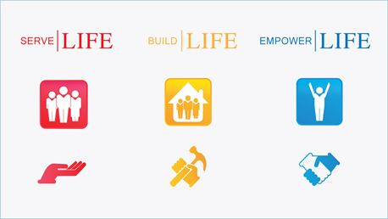
Do you have a special event to share? An anniversary, birthday, engagement or marriage? News about our community?

We want to hear from you!

Water Baptism Preparation
Have you been baptized? Would you like to learn more about the Biblical relevance of water baptism? Contact Pastor Al McManis for info on upcoming baptismal services here at Palm Desert New Presbyterian Church.

Results of Recent Outreach
The Men’s & Women’s Ministries of Palm Desert New Presbyterian Church recently sponsored a drive to help those in need in our communities called “Basic Elements.” New items of food, clothing and toiletries were gathered and delivered to churches and shelters throughout San Bernardino County.

Single Mother’s Summer Fashion Show
Our church is sponsoring a fundraising fashion show to provide assistance for single parent families. Saturday, June 15th at 3:00 pm in the Fellowship Hall. Contact Grace Able for more information about this exciting event!

Nursery Participants & Volunteers
If you love children and can share some time to minister to them on Sundays and Wednesdays, you are needed in the nursery. Please contact the church office for more information about this special ministry to our children.

Forty Days of BREAKTHROUGH Faith May 27th through July 5th

This Sunday our church is sponsoring 40 Days of Breakthrough Faith! Everyone is invited to share in this time of prayer, praise and giving thanks to God for our families, friends, our city and community. On July 5th we will conclude with a celebration in the sanctuary. Check out the bulletin for weekly updates on this special event!
“When the Day of Pentecost had fully come, they were all with one accord in one place.”
Acts 2:1

