University of Maryland College Park, MD www.umd.edu

Elizabeth Tobey, [PhD, Art History & Archaeology, University of Maryland (2005)]

Race to the Finish The palio banner
Introduction
San Giovanni Battista, or Saint John the Baptist, was adopted by the city of Florence, Italy as its patron saint in the
thirteenth century. Each year on the saint’s day (June 24), festivities & processions are held in St. John’s honor.

- Festival once included horse race ( palio)
- Prize for race was a silk palio banner
- Florence is a renowned center for textiles

The finish of the St. John palio race (right) in Florence’s Piazza San Pier Maggiore. Jockeys pilot their horses (barberi) towards the cart bearing the prize palio banner.
Image and detail on right: Giovanni Toscani, Palio in Florence, 1418, tempera and panel on wood, Cleveland Museum of Art, ArtStor.
The palio banner was displayed on a cart bearing city officials at the finish (left). The first horse and rider to reach the palio was declared the victor.
- Made from gold or red brocade silk and velvet fabric
- Lined with a thousand fur pelts
- Embroidered
- Expensive to produce
- City of Florence spent lavish
amounts annually on the
palio banner
- Officials, guilds, and confraternities constructed floats for the procession
- Culminating event— traditional horse race with winner receiving palio
- In 1563, Grand Duke Cosimo I de’ Medici added a Roman- style chariot race in Piazza Santa Maria Novella

Image: Florin Coin with image of St. John the Baptist, 15th c., gold, Museo nazionale del Bargello (Florence, Italy), ArtStor.

On the money
St. John the Baptist, a Christian saint, was celebrated by Florence from the 13th c. onwards during a period of economic growth and prosperity. St. John appeared on the
The Festival as a
Display of Wealth
During the late Middle Ages, Florence emerged as a major economic power in Europe in banking as well as production of luxury silk woven textiles.
Originating as a religious procession to the Baptistery on the saint’s day, the festival of St. John the Baptist became an opulent annual spectacle in which the whole city participated.
The Palio Cart
The palio banner was transported on a special horse-drawn cart or carro (left). The banner’s luxury fur lining (fodera) is visible draped across the
cart’s edge.
Image on left: Cart of the Palio of St. John the Baptist, fol. 39r in L. Chiari, Priorista, c. 1630- 1640, Biblioteca Nazionale, Florence (reproduced in Pastori, La festa di San Giovanni, 122, fig. 28.

Woven gold
Silk fabric (left) was often interwoven with gold thread.
- In 1478, 220 gold florins spent on the palio (twice the cost of an altarpiece!)
- Banners recycled to make clothing and altar cloths
- Gold thread embroidery on luxury fabrics (right) sometimes commissioned from nuns at area convents

city’s currency, the florin, or gold coin.

Research Sources
Research conducted in 2002-2004 in the following collections:
- Archivio di Stato (State Archives), Florence, Italy
- Biblioteca Nazionale Centrale, Florence
- Museo Nazionale del Bargello, Florence
- Uffizi Gallery, Florence
Images (left to right): "Baptistery (San Giovanni), exterior, with the Campanile (Giotto's Tower) at right," Florence, ArtStor; Detail and full image of Rossello di J. Franchi’s Festa di S. Giovanni (Feast of St. John), 1430, tempera on panel, Museo nazionale del Bargello, Florence, ArtStor; (Detail photographed by Elizabeth Tobey with permission of museum).
Images (left & right): Silk velvet, Italian, 15th c., Victoria & Albert Museum, London, from Stanley, Palace and Mosque, 124. Paliotto (Altarcloth), Venetian, 15th c., Museo Poldi Pezzoli, Milan, from Landini, Velluti e Moda tra XV e XVII secolo, 51-52.

Presenting tributes to the Baptistery
Conclusions
- Festival of St. John the Baptist was not only a religious observance but a display of civic wealth
- High expenditures recorded for festival art (palio banners, floats, and costumes)
- Italian society valued festival art as much as painting, sculpture, architecture
This 15th-century painting (above) shows citizens presenting palii (tribute banners) to the 11th-century Baptistery of San Giovanni (far left). The main palio banner (awarded to the winner of the horse race) is depicted in front of the façade of the duomo (cathedral of Santa Maria del Fiore) (left).

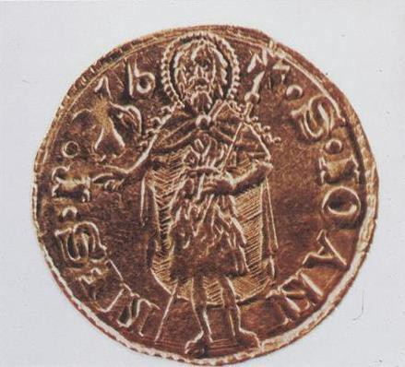
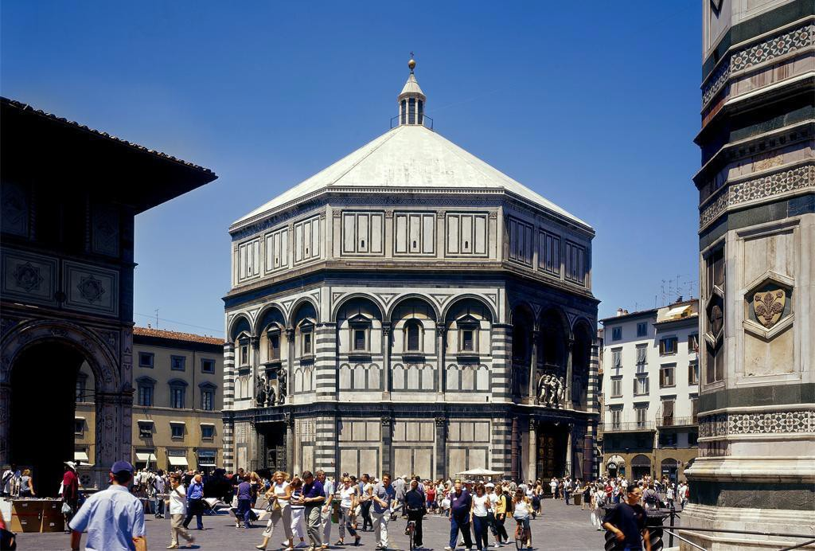
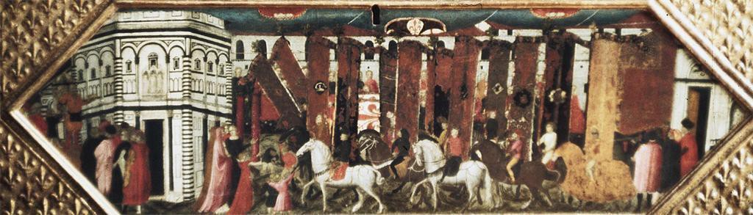
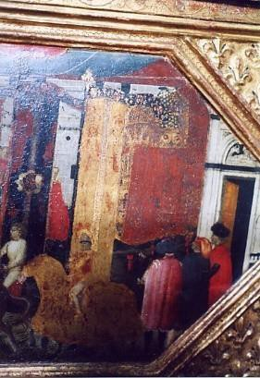
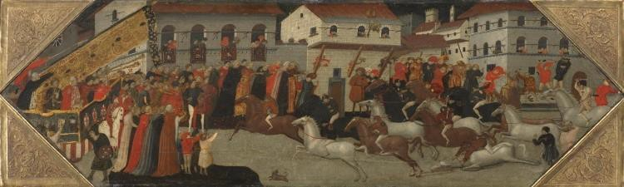
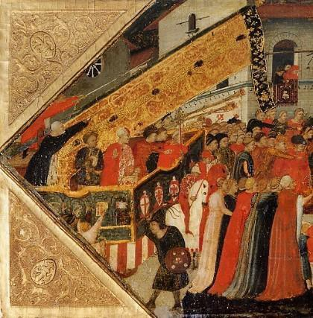
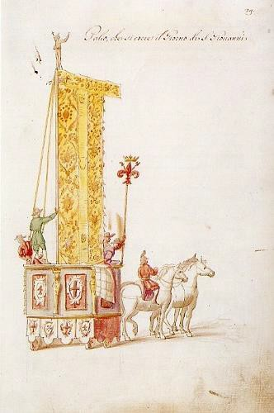
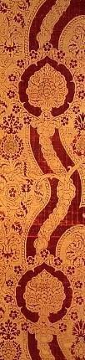
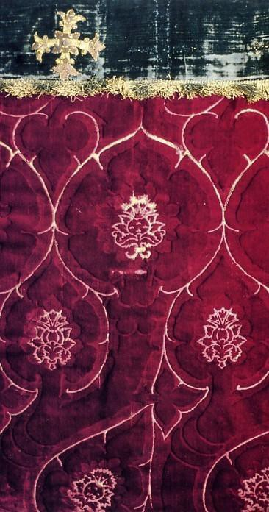

Selected literature cited
Tamara Boccherini and Paola Marabelli, eds. Sopra Ogni Sorta di Drapperia…” Tipologie decorative e techniche tessili nella produzione fiorentina del Cinquecento e Seicento. Florence: Maria Cristina de Montemayor Editore, 1993.
Chretien, Heidi L. The Festival of San Giovanni: Imagery and Political
Power in Renaissance Florence. American University Studies IX. Vol. 138. New York: Peter Lang, 1994.
Landini, Roberta Orsi. Velluti e Moda tra XV e XVII secolo, Museo Poldi Pezzoli. Milan: Skira Editore, 1999.
Pastori, Paolo, ed. La festa di San Giovanni nella storia di Firenze.
Rito, istituzione e spettacolo. Florence: Edizioni Polistampa, 1997.
Stanley, Tim. Palace and Mosque: Islamic Art from the Victoriaand Albert Museum. Washington: National Gallery of Art, 2004.
Trexler, Richard. Public Life in Renaissance Florence. 1980; Ithaca, NY: Cornell Paperbacks, 1996.

Acknowledgments
Poster template adapted from Colin Purrington blog, http://colinpurrington.com/tips/academic/posterdesign.

Images downloaded from ArtStor (http://library.artstor.org/) through the University of Maryland Libraries’ Research Port unless otherwise noted.

Further information

Created by Elizabeth Tobey (etobey@verizon.net) in January 2015 as an example of poster design for the Maryland Center for Undergraduate Research (MCUR) at the University of Maryland (www.ugresearch.umd.edu). The content is based upon Tobey’s
doctoral dissertation, “The Palio in Italian Renaissance Art, Thought, and Culture” (University of Maryland, 2005).

