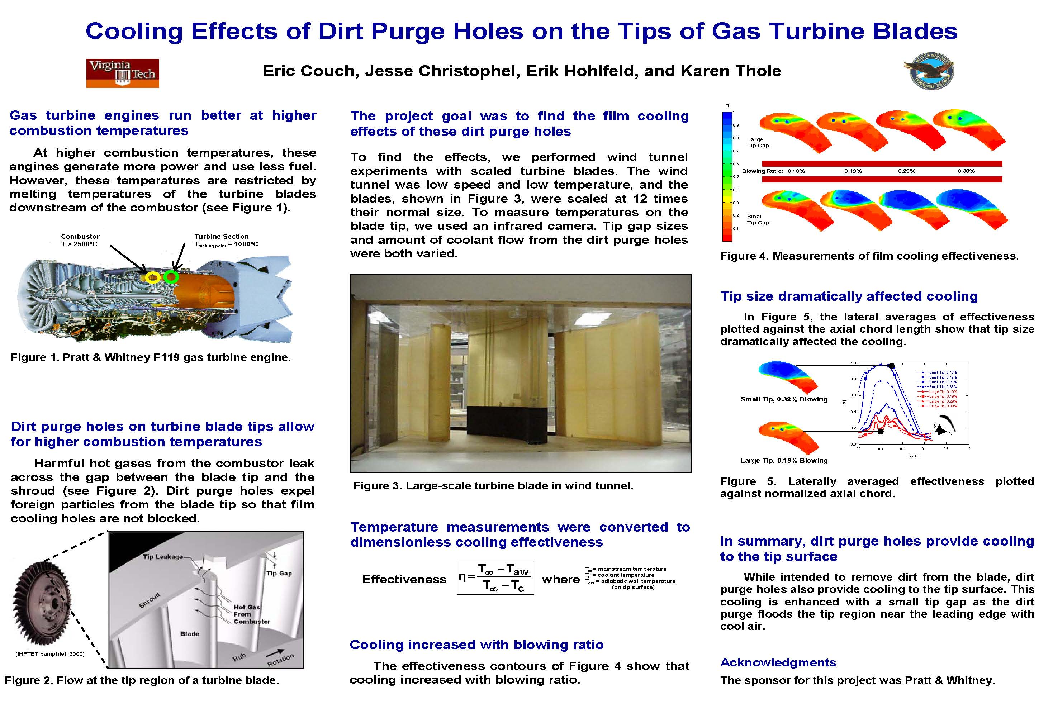

In summary, dirt pure holes provide cooling to the tip surface while intended to remove dirt from the blade, dirt purge holes also provide cooling to the tip surface. This cooling is enhanced with a small tip gap as the dirt purge floods the tip region near the leading edge with cool air.

**Acknowledgments**

The sponsor for this project was Pratt & Whitney.

In summary, dirt pure holes provide cooling to the tip surface while intended to remove dirt from the blade, dirt purge holes also provide cooling to the tip surface. This cooling is enhanced with a small tip gap as the dirt purge floods the tip region near the leading edge with cool air.

Acknowledgments

The sponsor for this project was Pratt & Whitney.

Dirt purge holes on turbine blade tips allow for higher combustion temperatures Harmful hot gases from the combustor leak across the gap between the blade tip and the shroud (see Figure 2). Dirt purge holes expel foreign particles from the blade tip so that film cooling holes are not blocked.

Dirt purge holes on turbine blade tips allow for higher combustion temperatures Harmful hot gases from the combustor leak across the gap between the blade tip and the shroud (see Figure 2). Dirt purge holes expel foreign particles from the blade tip so that film cooling holes are not blocked.

Dirt purge holes on turbine blade tips allow for higher combustion temperatures Harmful hot gases from the combustor leak across the gap between the blade tip and the shroud (see Figure 2). Dirt purge holes expel foreign particles from the blade tip so that film cooling holes are not blocked.

Gas turbine engines run better at hi her combustion temperatures At higher combustion temperatures, these engines generate more power and use less fuel. However, these temperatures are restricted by melting temperatures of the turbine blades downstream of the combustor (see Figure 1).

Academic Poster

Cooling increased with blowing ratio the effectiveness contours of Figure 4 show that cooling increased with blowing ratio.

You can add additional text here according to your requirement. You can add additional text here according to your requirement. You can add additional text here according to your requirement. You can add additional text here according to your requirement. You can add additional text here according to your requirement. You can add additional text here according to your requirement. You can add additional text here according to your requirement. You can add additional text here according to your requirement. You can add additional text here according to your requirement. You can add additional text here according to your requirement. You can add additional text here according to your requirement. You can add additional text here according to your requirement. You can add additional text here according to your requirement. You can add additional text here according to your requirement. You can add additional text here according to your requirement. You can add additional text here according to your requirement.

You can add additional text here according to your requirement. You can add additional text here according to your requirement. You can add additional text here according to your requirement. You can add additional text here according to your requirement. You can add additional text here according to your requirement. You can add additional text here according to your requirement. You can add additional text here according to your requirement. You can add additional text here according to your requirement.

You can add additional text here according to your requirement. You can add additional text here according to your requirement. You can add additional text here according to your requirement. You can add additional text here according to your requirement. You can add additional text here according to your requirement. You can add additional text here according to your requirement. You can add additional text here according to your requirement. You can add additional text here according to your requirement.

You can add additional text here according to your requirement. You can add additional text here according to your requirement. You can add additional text here according to your requirement. You can add additional text here according to your requirement. You can add additional text here according to your requirement. You can add additional text here according to your requirement. You can add additional text here according to your requirement. You can add additional text here according to your requirement.

**Eric Couch, Jesse Christophel, Erik Hohlfeld, and Karen Thole**

**Cooling Effects of Dirt Purge Holes on the Tips of Gas Turbine Blades**

***Academic Poster***