Type your question here (statement of the problem)

- Type your answer / solution here
- Write hypothesis before you begin the experiment
- This should be your best educated guess based on your research
6 Chart Title

5

4

3

2

1

0
Category 1 Category 2 Category 3 Category 4
Series 1 Series 2 Series 3

Type a brief overview or summary of your project. (Click the Bullets button on the Home tab to remove the bullets.)

Step 1

Describe this step in your experiment

Step 2

Describe this step in your experiment

Step 3

Describe this step in your experiment

Step 4
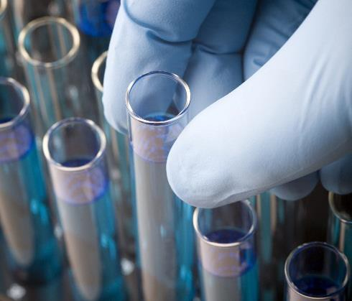

Describe this step in your experiment

- Include results based on your experiments
Item | Amount
Item | Amount
Item | Amount
Item | Amount
Item | Amount
Item | Amount
Item | Amount

- Result 2
- Result 3

- Brief summary of what you discovered based on results
- Indicate and explain whether or not the data supports your hypothesis

Your name | Teacher’s name | School

Science Project Title

  - Observation 1
  - Observation 2
  - Observation 3
These are kept the same throughout your experiments

Controlled variables
The one variable you purposely change and test

Independent variable
The measure of change observed because of independent variable
Decide how you will measure the change

Dependent variable

    - Include print and electronic sources in alphabetical order

