Heading

Name of School/Department/Unit
Title of the Research Project
Names of Presenters, Associates and Collaborators
This research poster template can be edited to suit your presentation needs. Please note that it is built to the most common poster size, 48x36”. Please check with presentation organizers to ensure that this size will be accepted.

This is a Long Heading That Goes Over Two Lines
To use this template, please type in your information. Feel free to move, add or delete elements as needed.

Remember that effective posters utilize succinct copy, and display it in large type that is easy to read from a distance. You should be able to read the information from at least one metre away. To see this poster in final size in order to check your

This is a Long Heading That Goes Over Two Lines
To ensure that your poster is legible, we recommend using a light coloured background and darker coloured fonts and graphics. Avoid using patterns, gradients or images as backgrounds, as these can make the poster more difficult to read.

Heading
Lists are a useful way to present your information in a condensed, easy-to-read format:
- Item one
- Item two
- Item three
- Item four
- Item five
- Item six

Heading
If you are using images, ensure that you have proper rights to reproduce the image. Make sure that the size of the image is large enough that it will not appear distorted when printed.

The best file types for images are .jpegs and
.pngs.

To make a picture larger or smaller without distorting the proportions, take one of the corners of the image, and hold down the the “shift” key while pulling the corner in (for smaller images) or out (for larger images).

Graph or Image Title
Captions for a graph or image can be smaller than the rest of the text on your poster. If you are using another person’s image or graph, ensure that you have rights to reproduce it. If

This is a Long Heading That Goes Over Two Lines
Lists are a useful way to present your information in a condensed, easy-to-read format:
- Item one
- Item two
- Item three
- Item four
- Item five

Heading
We hope that this poster template will assist you with your presentation. If you have any questions about the template, or any suggestions about improvements to the template, please visit http://brand.ubc.ca/support/ and send a support ticket to UBC Communications and Marketing.

type size, set your “zoom” settings to 100%.

Organize your information so that it reads in a Graph or Image Title

needed, give acknowledgement to the original source of the
material.

Reference / Bibliography
- Add your references in this section. Ensure that you are

logical manner from the top left of the poster to the bottom right.

Keep in mind that “less is more” when it comes to presenting your research in poster form. Avoid overwhelming your audience with unnecessary text or data.
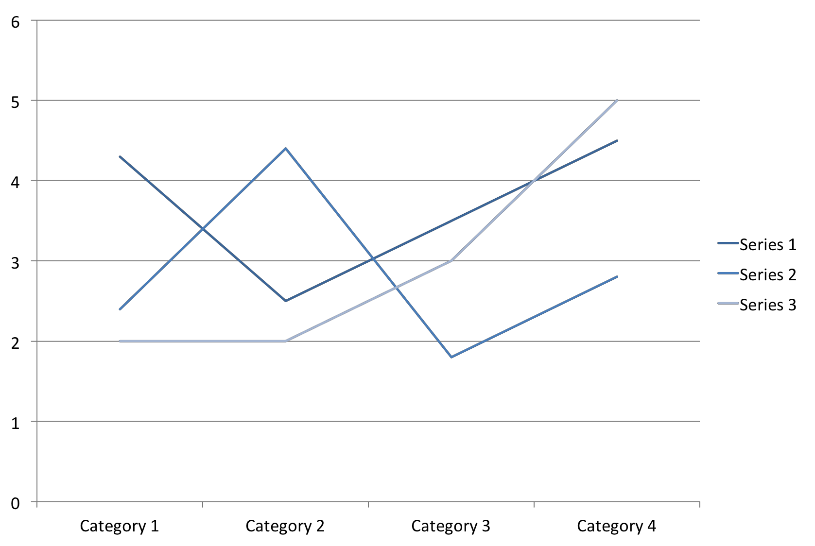

Be sure to spell check and edit your poster before printing. For extra insurance, ask a colleague to also check over your text and data. For general writing and editing tips, visit http://brand.ubc.ca/brand-toolkit/writing/
Captions for a graph or image can be smaller than the rest of the text on your poster. If you are using someone else’s image or graph, ensure that you have rights to reproduce it. If needed, give acknowledgement to the original source of the material.
using the correct reference format.
- Add your references in this section. Ensure that you are using the correct reference format.
- Add your references in this section. Ensure that you are using the correct reference format.
- Add your references in this section. Ensure that you are using the correct reference format.

Acknowledgement
Photo credit: Don Erhardt
Give acknowledgement to any partners that assisted with your research.

Partners
Delete shape and insert partner logo (if applicable)
Delete shape and Insert partner logo (if applicable)
Delete shape and Insert partner logo (if applicable)

