Fiction Stories
*using ordinal words
Name

First

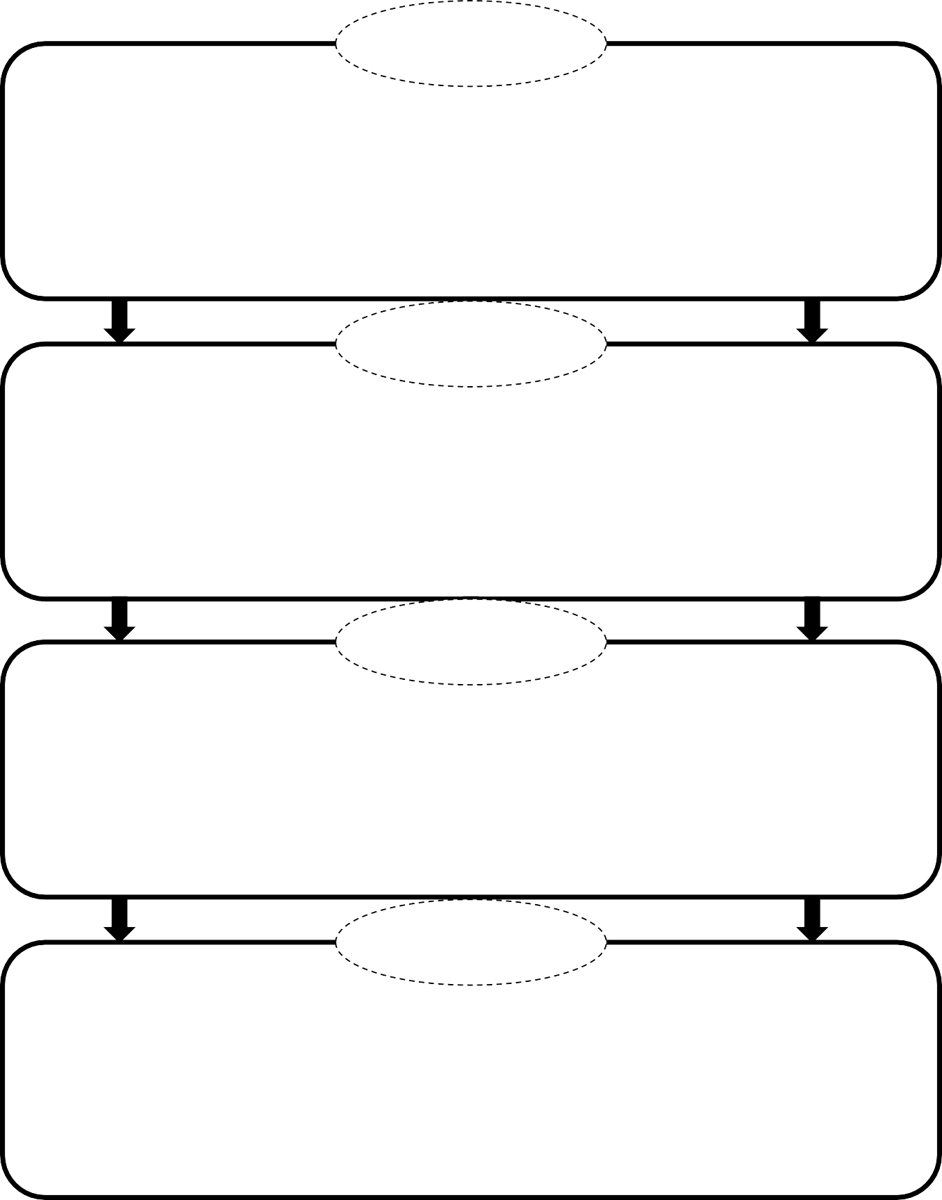

next

then

last

© JD’s Rockin’ Readers

