Basic Story Map
Title: Author:
Characters:

Instructions: Fill in the boxes to show how your story developed.
Setting:
Name:

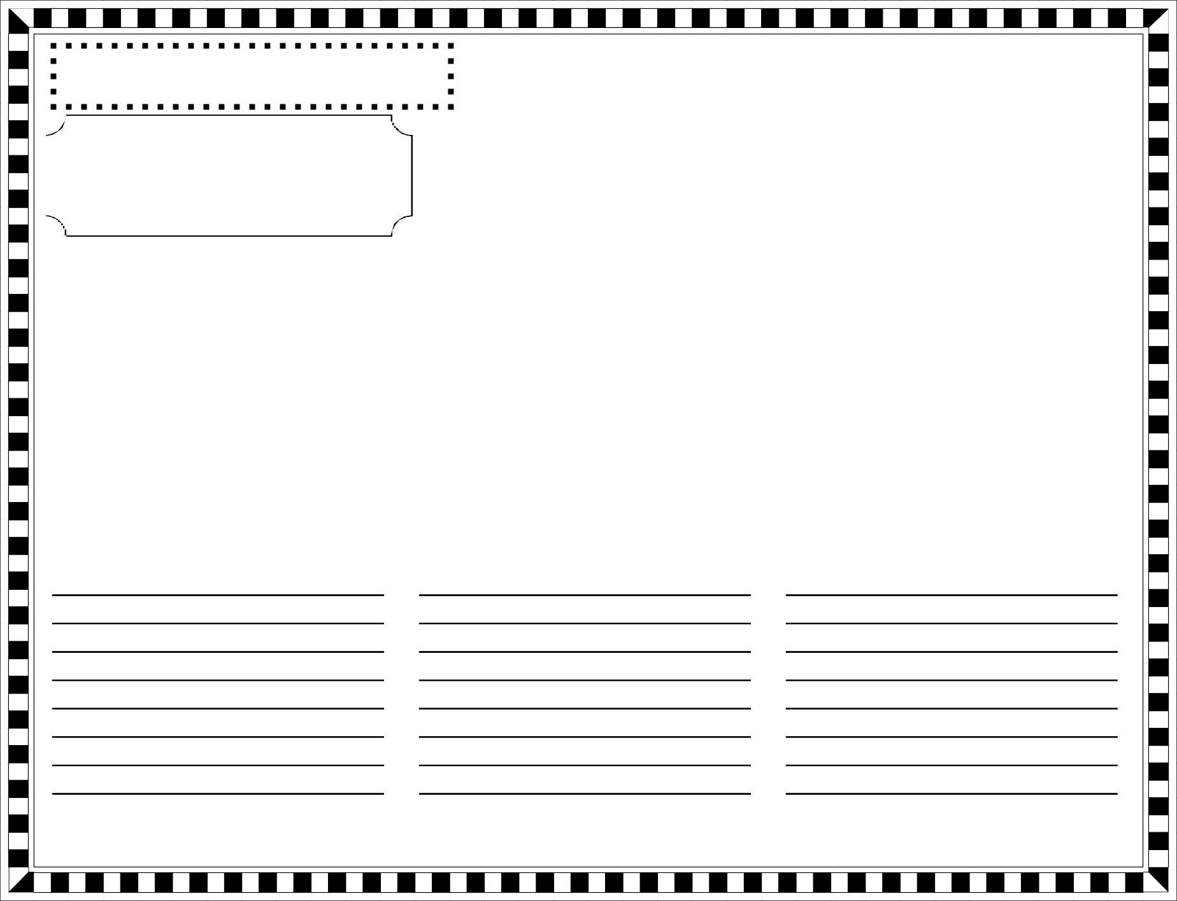

Beginning:
Middle:
End:

