National Aeronautics and Space Administration

Mars InSight Launch Press Kit

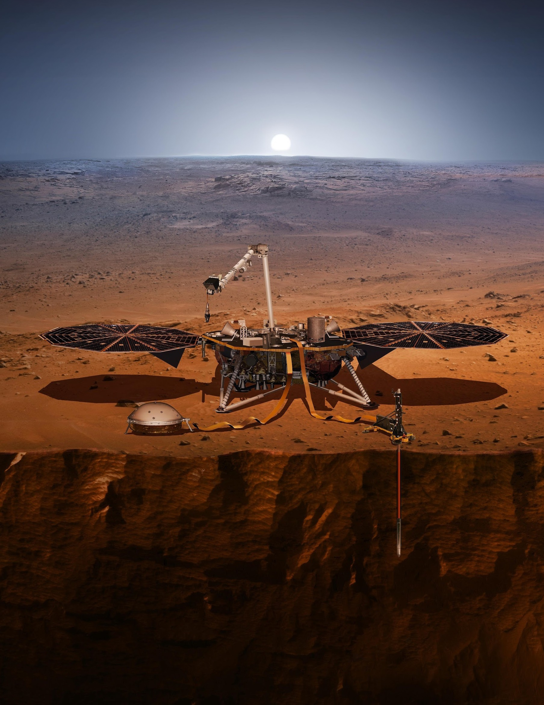
MAY 2018
Introduction

1
www.nasa.gov

Table of Contents

Table of Contents
Introduction 4
Media Services 8
Quick Facts: Launch Facts 12
Quick Facts: Mars at a Glance 16
Mission: Overview 18
Mission: Spacecraft 30
Mission: Science 40
Mission: Landing Site 53
Program & Project Management 55
Appendix: Mars Cube One Tech Demo 56
Appendix: Gallery 60
Appendix: Science Objectives, Quantified 62
Appendix: Historical Mars Missions 63
Appendix: NASA’s Discovery Program 65

Mars InSight Launch Press Kit

Introduction
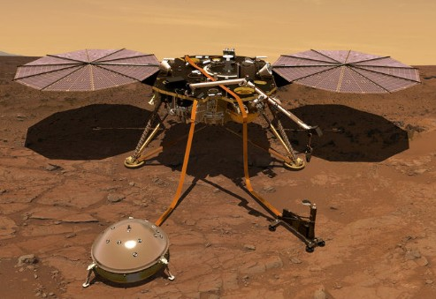

NASA’s next mission to Mars -- InSight -- will launch from Vandenberg Air Force Base in California as early as May 5, 2018. It is expected to land on the Red Planet on Nov. 26, 2018. InSight is a mission to Mars, but it is more than a Mars mission. It will help scientists understand the formation and early evolution of all rocky planets, including Earth.

A technology demonstration called Mars Cube One (MarCO)
will share the launch with InSight and fly separately to Mars.

Six Ways InSight Is Different
NASA has a long and successful track record at Mars. Since 1965, it has flown
by, orbited, landed and roved across the surface of the Red Planet.

None of that has been easy. Only about 40 percent of the missions ever sent to Mars by any space agency have been successful. The planet’s thin atmosphere makes landing a challenge; its extreme temperature swings make it difficult to operate on the surface.

But if a spacecraft survives the trip, there’s a bounty of science to be collected. What can InSight do that hasn’t been done before?

InSight is the first mission to study the deep interior of Mars
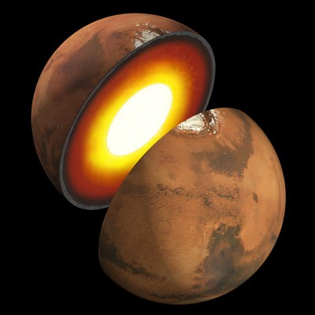

A dictionary definition of “insight” is to see the inner nature of something. InSight (Interior Exploration using Seismic Investigations, Geodesy and Heat Transport) will do just that. InSight will take the “vital signs” of Mars: its pulse (seismology), its temperature (heat flow), and its reflexes (radio science). It will be the first thorough check-up since the planet formed
4.5 billion years ago.
The mission is led by NASA’s Jet Propulsion Laboratory in Pasadena, Calif.

InSight will teach us about the interior of planets like our own
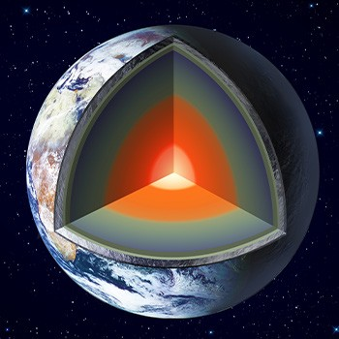

InSight’s team hopes that by studying the deep interior of Mars, we can learn how other rocky worlds, including Earth and the Moon, formed. Our home planet and Mars were molded from the same primordial stuff more than 4.5 billion years ago, but then became quite different.
Why didn’t they share the same fate?
When it comes to rocky planets, we’ve only studied one in detail: Earth. By comparing Earth’s interior to that of Mars, InSight’s team members hope to better understand our solar system. What they learn might even aid the search for Earth-like exoplanets, narrowing down which ones might be able to support life. So while InSight is a Mars mission, it’s also much more than a Mars mission.

InSight will try to detect marsquakes for the first time
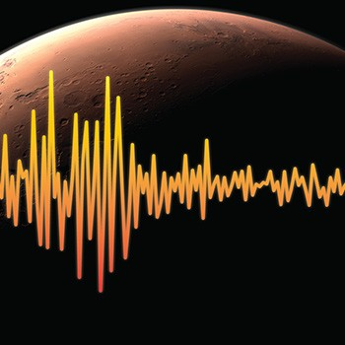

One key way InSight will peer into the Martian interior is by studying motion underground
-- what we know as marsquakes. NASA hasn’t attempted to do this kind of science since the Viking mission. Both Viking landers had their seismometers on top of the spacecraft,
where they produced noisy data. InSight’s seismometer will be placed directly on the Martian surface, which will provide much cleaner data.
Scientists have seen a lot of evidence suggesting Mars has quakes. But unlike quakes on Earth, which are mostly caused by tectonic plates moving around, marsquakes would be caused by other types of tectonic activity, such as volcanism and cracks forming in the planet’s crust. In addition, meteor impacts can create seismic waves, which InSight
will try to detect.
Each marsquake wll be like a flashbulb that illuminates the structure of the planet’s interior. By studying how seismic waves pass through the different layers of the planet (the crust, mantle and core), scientists can deduce the depths of these layers and what they’re made of. In this way, seismology is like taking an X-ray of the interior of Mars.
Scientists think it’s likely they’ll see between a dozen and a hundred marsquakes over the course of two Earth years. The quakes are likely to be no bigger than a 6.0 on the Richter scale, which would be plenty of energy for revealing secrets about the planet’s interior.

First interplanetary launch from the West Coast
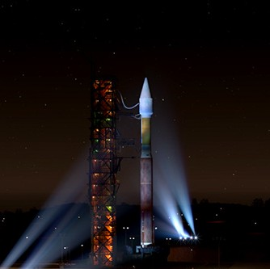

All of NASA’s interplanetary launches to date have been from Kennedy Space Center in Cape Canaveral, Florida, in part because the physics of launching off the East Coast are better for journeys to other planets. But InSight will break the mold by launching from Vandenberg Air Force Base in Central California. It will be the first launch to another planet from the West Coast. InSight will ride on top of a powerful Atlas V 401 rocket, which allows for a planetary trajectory to Mars from either coast. Vandenberg was ultimately chosen because it had more availability during InSight’s launch period.
A whole new region will get to see an interplanetary launch when InSight rockets into the sky. In a clear, pre-dawn sky, the launch may be visible in California from
Santa Maria to San Diego.

InSight could teach us how Martian volcanoes were formed
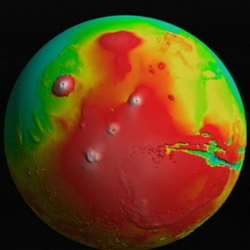

Mars is home to some impressive volcanic features. That includes Tharsis -- a plateau with some of the biggest volcanoes in the solar system. Heat escaping from deep within the planet drives the formation of these types of features, as well as many others on rocky planets. InSight includes a self-hammering heat probe that will burrow up to 16 feet (5 meters) into the Martian soil to measure the heat flow from the planet’s interior for the first time. Combining the rate of heat flow with other InSight data will reveal how energy within the planet drives changes on the surface.

Mars is a time machine
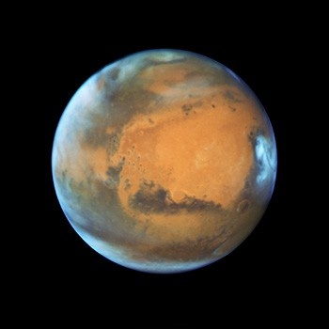

Studying Mars lets us travel to the ancient past. While Earth and Venus have tectonic systems that have destroyed most of the evidence of their early history, much of the Red Planet has remained static for more than 3 billion years. Because Mars is just one-third the size of Earth and Venus, it contains less energy to power the processes that change a planet’s structure. That makes it a fossil planet in many ways, with the secrets of our solar system’s early history locked deep inside.

What Makes Mars Cube One Different
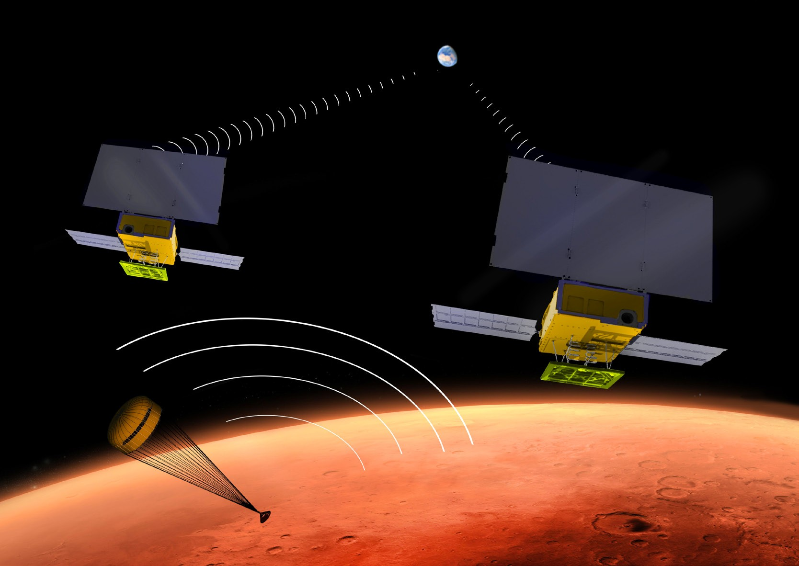

MarCO is the first CubeSat mission to deep space
The rocket that will loft InSight beyond Earth will also launch a separate NASA technology experiment: two mini-spacecraft called Mars Cube One, or MarCO. These briefcase-sized CubeSats will fly on their own path to Mars behind InSight.
Their goal is to test new miniaturized deep space communication equipment and, if the MarCOs make it to Mars, may relay back InSight data as it enters the Martian atmosphere and lands. This will be a first test of miniaturized CubeSat technology at another planet, which researchers hope can offer new capabilities to future missions.
If successful, the MarCOs could represent a new kind of communication capability to Earth. InSight’s success is independent of its CubeSat tag-alongs.

Media Services

Media Contacts

Policy/Program Management InSight Mission

Headquarters, Washington NASA Jet Propulsion Laboratory | Pasadena, California

Dwayne Brown
202-358-1726
dwayne.c.brown@nasa.gov

Launch

Kennedy Space Center, Florida

Tori McLendon
321-867-9165
tori.n.mclendon@nasa.gov

JoAnna Wendel
202-358-1003
joanna.r.wendel@nasa.gov

D.C. Agle
818-393-9011
818-653-6297 (cell)
agle@jpl.nasa.gov

Jia-Rui Cook
818-354-0724
626-524-6483 (cell)
jccook@jpl.nasa.gov

Spacecraft

Andrew Good
818-393-2433
626-840-4291 (cell)
andrew.c.good@jpl.nasa.gov

Lockheed Martin Space | Denver, Colorado

Launch Vehicle and Operations
United Launch Alliance | Cape Canaveral, Florida

Heather Mowad
321-730-4353
heather.m.mowad@ulalaunch.com

Dani Hauf
303-932-4360
danielle.m.hauf@lmco.com

Launch Site

Vandenberg Air Force Base | Central, California

NASA Discovery Program
Marshall Space Flight Center | Huntsville, Alabama

Molly Porter
256-544-0034
molly.a.porter@nasa.gov

Lt. Amy Rasmussen
805-606-3595
amy.rasmussen@us.af.mil

Science Payload Instruments Technology Demonstration

Seismic Experiment for Interior Structure Mars Cube One

Centre National d’Études Spatiales (CNES) Paris, France
NASA Jet Propulsion Laboratory | Pasadena, California

Andrew Good

Claire Dramas
011-33-6-78-10-91-78
Claire.Dramas@cnes.fr

Nathalie Journo
011-33-5-61-27-39-11
Nathalie.Journo@cnes.fr
818-353-2433
626-840-4291 (cell)
andrew.c.good@jpl.nasa.gov

Heat Flow and Physical Properties Package Deutsches Zentrum für Luft- und Raumfahrt (DLR) Berlin, Germany

Manuela Braun
011-49-2203-601-3882
Manuela.Braun@dlr.de

Products and Events

News Releases, Features and Status Reports
Mission news, updates and feature stories about InSight will be available at:
nasa.gov/insight, and mars.nasa.gov/insight.

Video and Images
An InSight media reel is available at: vimeo.com/261856765

A Mars Cube One media reel is available at: vimeo.com/265040492

Video and images related to the InSight mission are available at:
vimeo.com/jplraw, go.usa.gov/xnUXj and go.nasa.gov/2mp2KsJ

The NASA image use policy is available at: nasa.gov/multimedia/guidelines/index.html

The JPL image use policy is available at: jpl.nasa.gov/imagepolicy

Media Events
The most up-to-date information about upcoming InSight media events and where they may be viewed can be found on the InSight Launch Page at: mars.nasa.gov/insight/mission/timeline/launch/ More information on NASA TV and streaming channels can be found below in the press kit’s “how to watch” section.

Briefings
A news conference presenting an overview of the mission will take place at NASA’s Jet Propulsion Laboratory in Pasadena, Calif., on March 29, 2018, at 5 p.m.

EDT (2 p.m. PDT).

If a May 5 launch attempt is still planned, a pre-launch briefing open to accredited news media and NASA Social participants is scheduled on May 3, 2018, at 1 p.m. PDT (4
p.m. EDT) at Vandenberg Air Force Base. This program will be broadcast and streamed. A post-launch news conference at Vandenberg Air Force Base may begin approximately two to three hours after launch.

Media Opportunity
U.S. media are invited to view the InSight lander Friday, April 6, at Vandenberg Air Force Base in California, where it undergoes final tests for its May launch. Media planning to attend this event must send their driver’s license number and state of issue, date of birth, and name of their media outlet and editor’s contact information, to 2nd Lt. Amy Rasmussen at amy.rasmussen@us.af.mil no later than noon PDT (3 p.m. EDT), Friday, March 30. Due to space restrictions, only two representatives from each media outlet will be allowed to participate. More information will be provided to registered media regarding access, arrival and event times as details are finalized.

Live Launch Feed
A live video feed of key launch activities and commentary from the mission control room at Vandenberg Air Force Base will be broadcast. If a May 5 launch attempt is still planned, it is expected to be broadcast starting at 3:30 a.m. PDT (6:30 a.m. EDT). The first launch opportunity begins at 4:05 a.m. PDT (7:05 a.m. EDT) on May 5 and lasts for two hours.

The first launch opportunity begins at 4:05 a.m. PDT (7:05
a.m. EDT) on May 5 and lasts for two hours.

On-Site Media Logistics
News media representatives who would like to cover the InSight launch and pre-launch media briefings in person at Vandenberg Air Force Base must be accredited through Vandenberg. Journalists may contact Lt. Amy Rasmussen at 805-606-3595 or amy.rasmussen@us.af.mil for more information.

Non-U.S. journalists must apply for credentials by Monday, April 2, 12:00 p.m. PDT (3:00 p.m. EDT);
U.S. journalists by Wednesday, April 18, 12:00 p.m. PDT (3:00 p.m. EDT).

Interviews in the Vandenberg area may be arranged by calling a JPL media representative at 626-864-0552 or 626-773-0370.

Public Viewing Locations
On May 5, there will be two official public viewing sites in Lompoc (one at the Lompoc Airport and the other at St. Mary’s Episcopal Church) that are open to all. More information on these sites is available at: mars.nasa.gov/insight/mission/timeline/launch/watch-in-person.

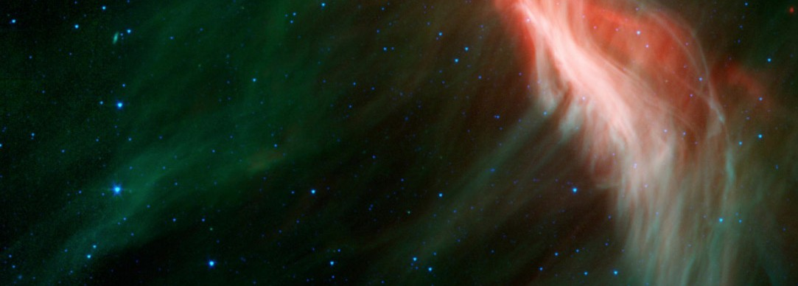
How to Watch (Live and On Demand)

News briefings and launch commentary will be streamed on NASA TV, NASA.gov/live, YouTube.com/NASAJPL/ live and Ustream.tv/NASAJPL. (On-demand recordings will also be available after the live events have finished on the YouTube and Ustream pages.) Any additional feeds or streams will be listed in the “Watch Online” section of mars.nasa.gov.

NASA TV channels are digital C-band signals carried by QPSK/DVB-S modulation on satellite Galaxy-13, transponder 11, at 127 degrees west longitude, with a downlink frequency of 3920 MHz, vertical polarization, data rate of 38.80 MHz, symbol rate of 28.0681 Mbps and 3/4 FEC. A Digital Video Broadcast-compliant Integrated Receiver Decoder is needed for reception.

Audio Only
Audio only of launch coverage will be carried on the NASA “V” circuits, which may be accessed by dialing
321-867-1220, -1240, -1260 or 7135. On launch day, “mission audio,” the launch conductor’s countdown activities
without NASA TV launch commentary, will be carried on 321-867-7135.

Eyes on the Solar System
As soon as the InSight spacecraft separates from the second stage of its rocket and begins flying on its own, the public can begin following InSight’s path to Mars in real-time through NASA’s Eyes on the Solar System.

Eyes is available on the Web at eyes.nasa.gov/.

Additional Resources on the Web Social Media

Online and PDF versions of this press kit are available at: jpl.nasa.gov/news/press_kits/insight/launch/

Additional detailed information about InSight is available at: mars.jpl.nasa.gov/insight
Join the conversation and get mission updates from InSight, JPL and NASA via these accounts:

Twitter: @NASAInSight, @NASAJPL, @NASA Facebook: @NASAInSight, @NASAJPL, @NASA

Instagram @NASAJPL, @NASA

Quick Facts: Launch Facts

Mission Firsts
InSight is the first Mars mission dedicated to studying the planet’s deep interior. InSight is the first mission to place a seismometer directly on the Martian surface. InSight will try to detect quakes for the first time on another planet.
InSight is the first to use a self-hammering mole to burrow deep into the crust of Mars, going
15 times deeper than any previous Mars mission, to a depth of 10 to 16 feet (3 to 5 meters).
InSight is the first interplanetary launch from the West Coast.
InSight is the first spacecraft to use a robotic arm to grasp instruments on another planet. InSight’s magnetometer is the first ever used on the surface of Mars.
MarCO is the first mission to test CubeSats in deep space.

Mission Name
The long form of the mission’s name is Interior Exploration using Seismic Investigations, Geodesy and Heat Transport, which includes the three main research techniques to be used by the InSight stationary lander. A dictionary definition of “insight” is to see the inner nature of something.

Spacecraft
InSight cruise vehicle dimensions (cruise stage and aeroshell with lander inside): Height: 5 feet, 9 inches (1.76 meters); aeroshell diameter: 8 feet, 8 inches (2.64 meters); wingspan of cruise solar arrays: 11 feet, 2 inches (3.40 meters)

InSight Lander Dimensions Mars Cube One (MarCO) Dimensions

Height range (after its legs compress a still-to-be- determined amount during impact): between 33 to 43 inches (83 to 108 centimeters) from the bottom of the legs to the top of the deck; Span with solar arrays deployed: 19 feet,
8 inches (6.00 meters); width of deck: 5 feet, 1 inch (1.56 meters); length of robotic arm: 5 feet, 11 inches (1.8 meters)
Twin spacecraft, each 14.4 inches (36.6 centimeters) by 9.5
inches (24.3 centimeters) by 4.6 inches (11.8 centimeters)

Mass
About 1,530 pounds (694 kilograms) total of InSight spacecraft at launch. The spacecraft includes the lander, which is about 790 pounds (358-kilograms), the 418-pound (189-kilogram) aeroshell, 174-pound (79-kilogram) cruise stage and 148 pounds (67 kilograms) of loaded propellant and pressurant. Mass of each MarCO spacecraft:
30 pounds (13.5 kilograms). Total payload mass on the rocket: 1,590 pounds (721 kilograms)

Power
Solar panels and lithium-ion batteries on both InSight and MarCO. On InSight, the two solar array panels together provide about 1,800 watts on Earth on a clear day. On Mars, they provide 600-700 watts on a clear day, or just enough to power a household blender. They’re estimated to provide 200- 300 watts on a dusty day, even with dust covering the panels.

InSight Science Payload
About 110 pounds (50 kilograms), including Seismic Experiment for Interior Structure, Heat Flow and Physical Properties Package, Auxiliary Payload Sensor Suite, Instrument Deployment System and Laser Retroreflector. (The Rotation and Interior Structure Experiment uses the lander’s telecommunications system.)

Cameras
One camera on InSight’s robotic arm and one camera on the spacecraft’s lander deck, both capable of producing color images of 1,024 pixels by 1,024 pixels. On each MarCO: a wide-field camera (primarily to confirm high-gain antenna deployment). On MarCO-B: a narrow-field camera. Each kind of camera on MarCO is capable of color images 752 x 480 pixels in resolution.

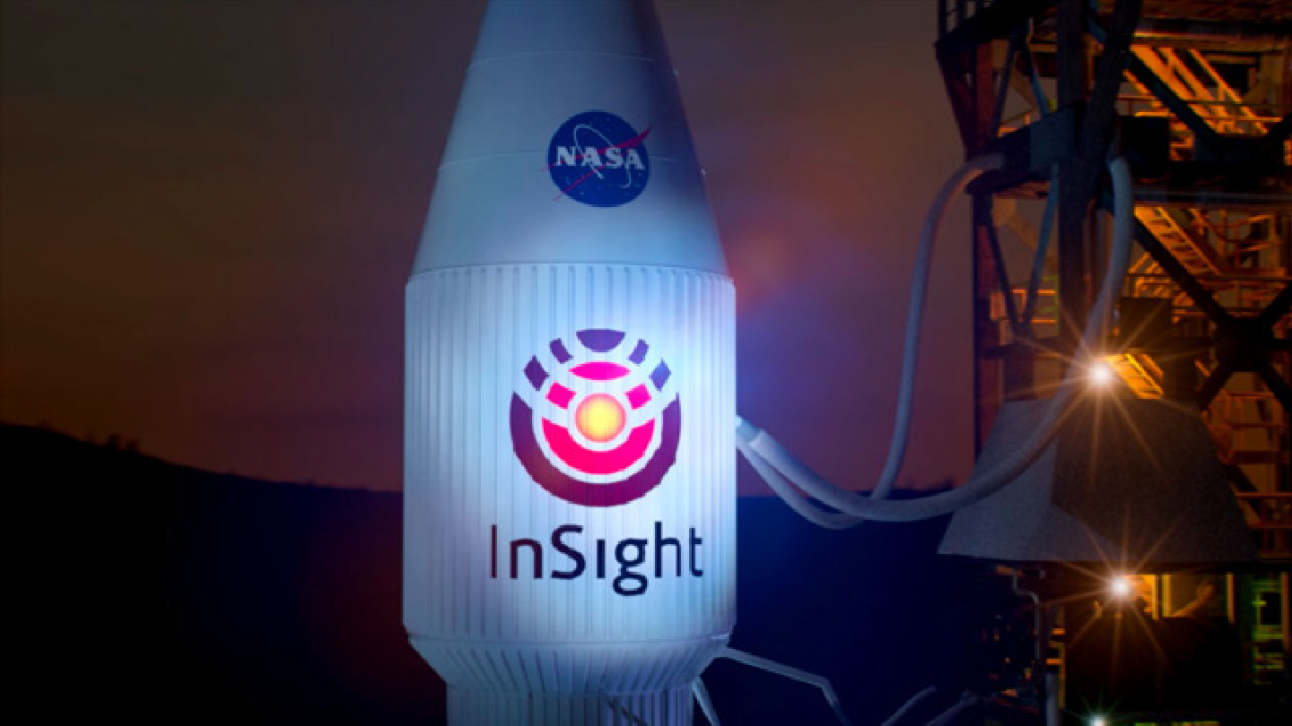
Launch Vehicle
Type: Atlas V 401
Height with payload: 188 feet (57.3 meters)

Mission
Launch period: May 5 through June 8, 2018
Launch windows: May 5 window opens at 4:05 a.m. PDT (7:05 a.m. EDT; 11:05 UTC) and lasts for two hours. On subsequent dates, the window opens a few minutes earlier each day, to 1:30 a.m. PDT (4:30 a.m. EDT) by June 8, and remains open for up to two hours
Launch site: Space Launch Complex 3, Vandenberg Air Force Base, California
Earth-Mars distance on May 5, 2018: 75 million miles (121 million kilometers)
Travel distance, Earth to Mars (May 5 launch): About 301 million miles (485 million kilometers) Mars landing: Nov. 26, 2018, about noon PST (3 p.m. EST; 20:00 UTC). At the Mars landing site, this will be mid-afternoon on a winter day
Landing site: About 4.5 degrees north latitude, 135.9 degrees east longitude, in Elysium Planitia
Earth-Mars distance on Nov. 26, 2018: 91 million miles (146 million kilometers)

One way radio transit time, Mars to Earth, on Nov. 26, 2018: 8.1 minutes
Mission: One Martian year plus 40 Martian days (nearly 2 Earth years), until Nov. 24, 2020 Expected near-surface atmospheric temperature range at landing site during primary mission: minus 148 F to minus 4 Fahrenheit (minus 100 Celsius to minus 20 Celsius)

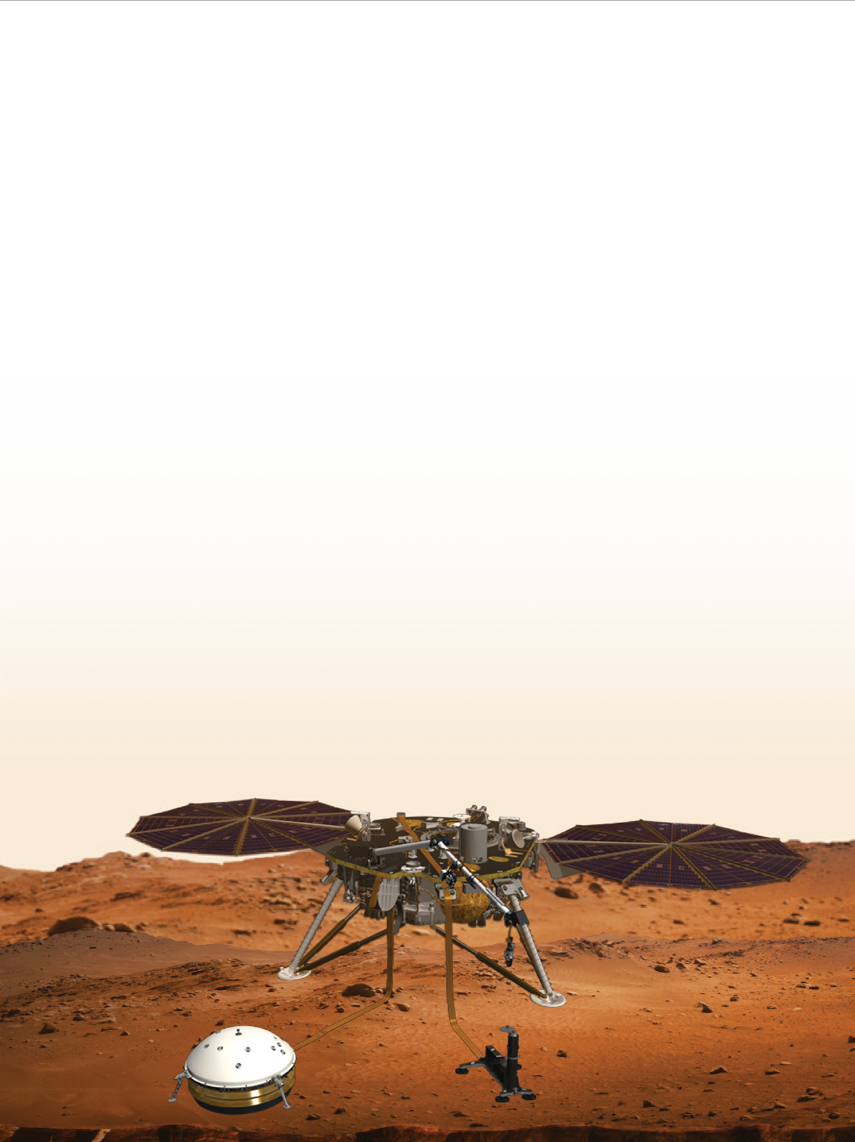

Program
U.S. investment in InSight mission is $813.8 million, including about $163.4 million for launch vehicle and launch services, and the rest for the spacecraft and operations through the end of the prime mission. In addition, France and Germany, the major European participants, have invested about $180 million in InSight’s investigations, primarily the seismometer investigation (SEIS) and heat flow investigation (HP3). JPL and NASA are investing about $18.5 million for the Mars Cube One technology.

Quick Facts: Mars at a Glance
Quick Facts: Mars at a Glance

General
- One of five planets known to ancients; Mars was the Roman
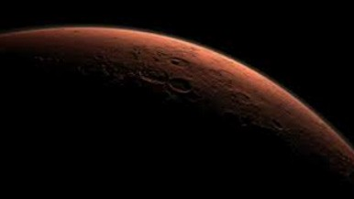

god of war, agriculture and the state
- Yellowish brown to reddish color; occasionally the third- brightest object in the night sky after the Moon and Venus

Orbit
Physical Characteristics
- Average diameter 4,212 miles (6,780 kilometers);
about half the size of Earth, but twice the size of Earth’s Moon
- Same land area as Earth, reminiscent of a cold, rocky desert
- Mass 1/10th of Earth’s; gravity only 38 percent as strong as Earth’s
- Density 3.9 times greater than water (Earth’s density is 5.5 times greater than water)
- No planet-wide magnetic field detected; only localized ancient remnant fields in various regions

  - Fourth planet from the Sun, the next beyond Earth
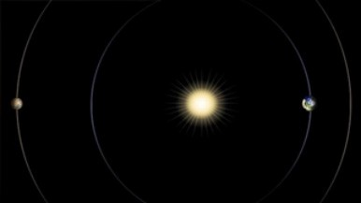

  - About 1.5 times farther from the Sun than Earth
  - Orbit elliptical; distance from the Sun varies from a minimum of 128.4 million miles (206.7 million kilometers) to a maximum of 154.8 million miles (249.2 million kilometers); average is
141.5 million miles (227.7 million kilometers)
  - Revolves around the Sun once every 687 Earth days
  - Rotation period (length of day) is 24 hours, 39 minutes, 35 seconds (1.027 Earth days)
  - Pole is tilted 25 degrees, creating seasons similar to those on Earth

Quick Facts: Mars at a Glance

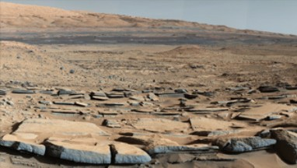

Features
Environment
- Atmosphere composed chiefly of carbon dioxide (95.3%), nitrogen (2.7%) and argon (1.6%)
- Surface atmospheric pressure less than 1/100th that of Earth’s average
- Surface winds of 0 to about 20 mph (0 to about 10 meters per second), with gusts to about 90 mph (more than 140 kilometers per hour)
- Local, regional and global dust storms; also whirlwinds called dust devils
- Surface temperature averages minus 64 Fahrenheit (minus 53 Celsius); varies from minus 199 Fahrenheit (minus 128 Celsius) during polar night to 80 Fahrenheit (27 Celsius) at the equator during midday, at its closest point in orbit to the Sun

  - Highest point is Olympus Mons, a huge shield volcano about 16 miles (26 kilometers) high and 370 miles (600 kilometers) across; has about the same area as Arizona
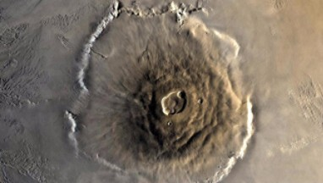

  - Canyon system of Valles Marineris is largest and deepest known in solar system; extends more than 2,500 miles (4,000 kilometers) and has 3 to 6 miles (5 to 10 kilometers) of relief from floors to tops of surrounding plateaus

Moons
    - Two irregularly shaped moons, each only a few miles (kilometers) wide
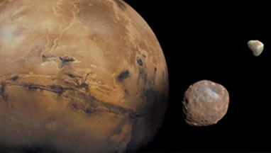

    - Larger moon named Phobos (“fear”); smaller is Deimos (“terror”), named for attributes personified in Greek mythology as sons of the god of war

Mission: Overview

InSight will launch in May or June 2018 from Central California. If skies are clear, the pre-dawn launch will likely be visible from much of coastal Southern California, including the Los Angeles and San Diego metropolitan areas.

The InSight spacecraft will fly for about six months to hit a target point at the top of the Martian atmosphere at about six times the speed of a high-velocity bullet; decelerate enough in seven minutes for a safe touchdown on Mars by a three-legged lander; use a robotic arm for the first time to
grasp science instruments and then place them directly onto the surface of Mars over the course of a few weeks; pound a probe deeper into the Martian ground than ever before; then collect clues about the planet’s interior until November 2020.
The Mars Cube One (MarCO) technology demonstration will
share InSight’s launch and fly separately to Mars.

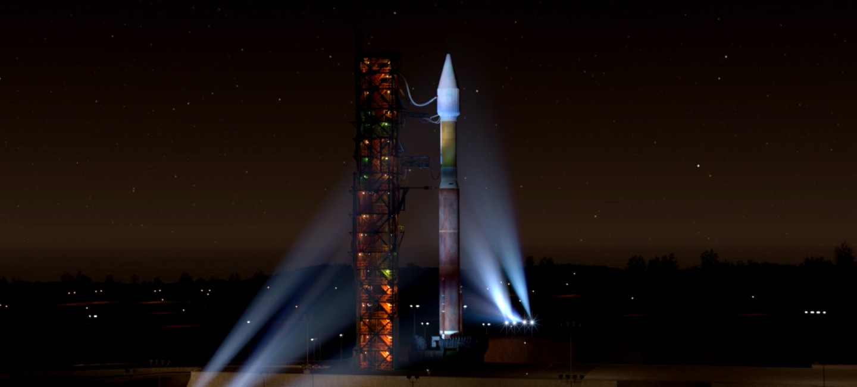
Key activities of the InSight mission are launch, cruise, arrival (also known as entry, descent and landing) and Mars surface operations.

Illustration of InSight at launch

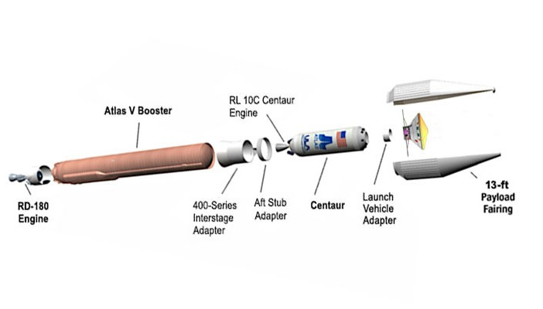
Launch Vehicle

Atlas V 401 launch vehicle, expanded view
A two-stage Atlas V 401 launch vehicle will lift the InSight spacecraft from Space Launch Complex 3 of Vandenberg Air Force Base, on Central California’s Pacific coast.

The vehicle and launch services are provided by United Launch Alliance, Centennial, Colorado, a joint venture of Boeing Co. and Lockheed Martin Corp. The three numbers in the 401 designation signify a payload fairing
-- or nose cone -- that is about 13 feet (4 meters) in diameter; zero sol-
id-rocket boosters supplementing the main booster, and one engine on the upper stage. NASA selected an Atlas V 401 as InSight’s launch vehicle in December 2013.

This launch vehicle’s first stage is the common core booster with its fuel and liquid-oxygen tanks. This main booster is 107 feet (32.5 meters) long, with a diameter of 12.5 feet
(3.8 meters). It has a throttleable RD-180 engine from a joint venture of United Technologies Corporation’s Pratt & Whitney Division, East Hartford, Connecticut, and NPO
Energomash, Moscow. Thermally stable kerosene fuel (type RP-1) and liquid oxygen will be loaded shortly before launch into cylindrical fuel tanks that make up about half of the total height of the vehicle. The common core booster can provide thrust of up to about 850,000 pounds (3.8 million newtons) at full throttle, controlled by an avionics system that provides guidance and sequencing functions.

Two interstage adapters connect the first stage of the Atlas with its Centaur upper stage. The Centaur is 41.7 feet (12.7 meters) long and 10.2 feet (3.1 meters) in diameter, with a restartable RL-10C engine from Aerojet Rocketdyne,
Sacramento, California. This engine uses liquid hydrogen and liquid oxygen and can provide up to about 22,890 pounds (101,820 newtons) of thrust. The Centaur can control its orientation precisely, which is important for managing the direction of thrust while its engine is firing. It carries its own flight control computer and can release its payload with the desired attitude and spin rate.

The Centaur’s aft bulkhead carrier holds the CubeSat deployment system that will contain the MarCO-A and MarCO-B CubeSats during the launch and release them after leaving Earth orbit. The interstage adapter attached to the Centaur encloses the aft bulkhead carrier while the stages are linked. At the other end of the upper stage, the Centaur’s forward adapter provides structural and electronic interfaces with the InSight spacecraft.

The InSight spacecraft will ride into the pre-dawn sky inside a protective payload fairing atop the Centaur stage. The fairing is 40 feet (12.2 meters) long, with a diameter of 13.8 feet (4.2 meters) at the widest part, tapering to the top of the cone.
It will be jettisoned shortly after ignition of the Centaur’s
engine, when the vehicle has climbed high enough to have escaped most of Earth’s atmosphere.

With the payload fairing on top, the Atlas V 401 ready for launch will stand approximately 188 feet (57.3 meters) tall.

Previous Atlas Launches

The first Atlas V was launched in August 2002. In- Sight’s launch is scheduled to be the 62nd Atlas V launch. An Atlas V 401 sent NASA’s Mars Reconnais- sance Orbiter on its way to Mars on Aug. 12, 2005; an Atlas V 541 launched NASA’s Mars Science Laboratory spacecraft, including the Curiosity rover, on Nov. 26, 2011; and an Atlas V 401 launched NASA’s Mars Atmo- sphere and Volatile Evolution (MAVEN) orbiter on Nov. 18, 2013. Other NASA deep space missions with Atlas V launches have included New Horizons (to Pluto)
in 2006, Juno (to Jupiter) in 2011, and Origins, Spec- tral Interpretation, Resource Identification, Security, Regolith Explorer (OSIRIS-REx asteroid sample-return mission) in 2016.

Launch Scheduling and Location
As Earth and Mars race around the Sun, with Earth on the inside track, Earth laps Mars about once every 26 months. Launch opportunities to Mars occur at the same frequency, when the planets are positioned so that a spacecraft launched from Earth will move outward and intersect Mars in its orbit several months later. This planetary clockwork, plus the launch vehicle’s power, the spacecraft’s mass, and the desired geometry and timing for the landing on Mars are all factors in determining the range of possible launch dates.
InSight’s launch period is May 5 through June 8, 2018, with multiple launch opportunities over windows of approximately

two hours each date. Launch opportunities are set five minutes apart during each date’s window. The first launch opportunity will begin at 4:05 a.m. PDT (7:05 a.m. EDT / 11:05 UTC) on May 5.

Whichever date the launch occurs, InSight’s landing on Mars is planned for Nov. 26, 2018, around noon PST (3 p.m. EST / 20:00 UTC).

Vandenberg Air Force Base is near Lompoc, California, about one-third of the way from Los Angeles to San Francisco on the Pacific Coast. The base is headquarters of the 30th Space Wing, U.S. Air Force Space Command.

InSight is the first interplanetary launch from the West Coast. Most launches from Vandenberg put Earth satellites into near-polar orbits. Examples include NASA Earth science missions Soil Moisture Active Passive, launched in 2015, and Orbiting Carbon Observatory 2, launched in 2014.
The most recent Atlas V liftoff from Vandenberg was the Sept. 24, 2017, launch of a National Reconnaissance Office spacecraft. For safety, launches are directed seaward.

All previous NASA interplanetary missions have launched from Florida’s Atlantic coast, at either Cape Canaveral Air Force Station or the adjacent NASA Kennedy Space Center. Launching toward the east adds the momentum of Earth’s eastward rotation to the launch vehicle’s own thrust. For InSight, the Atlas V 401 offers enough performance to enable launching a Mars mission southward from Vandenberg, mitigating a more-crowded launch schedule in Florida.

Visibility

If the weather is clear, the InSight launch could be visible from as far north as Bakersfield, California, to perhaps as far south as Rosarito, Mexico.

Launch Sequences
The launch time, called “T Zero,” is when the engine is ready and 1.1 seconds before liftoff. Ignition of the Atlas V-401 first-stage common core booster is at 2.7 seconds before T Zero, or 3.8 seconds before liftoff.

After a short vertical rise away from the pad, the launch vehicle will begin a maneuver to travel in its prescribed direction (southward). The common core booster engine of the first stage will continue to burn until about 244 seconds after T Zero, ending with “booster engine cutoff,” or BECO.

About six seconds after booster engine cutoff, the first stage will be jettisoned from the Centaur upper stage. It will fall into the Pacific Ocean. At the separation of the two stages, the interstage adapters will also fall away, exposing the
Centaur’s aft bulkhead carrier where the twin MarCO spacecraft ride inside their CubeSat dispensers. Approximately 10 seconds after separation of the two stages, the Centaur engine will begin the first of its two burns. The launch vehicle will jettison the payload fairing eight seconds later, uncovering InSight. The first burn of the Centaur’s engine, lasting about nine minutes, will insert the combined upper stage and spacecraft into a parking orbit. The end of this burn is called “main engine cutoff one,” or MECO1, at about 13 minutes after lift-off.

The shape of the parking orbit is nearly circular at an altitude of 115 miles (185 kilometers). However, the spacecraft
will not complete even one orbit. After the Centaur main engine’s first burn, the Centaur-spacecraft stack will coast

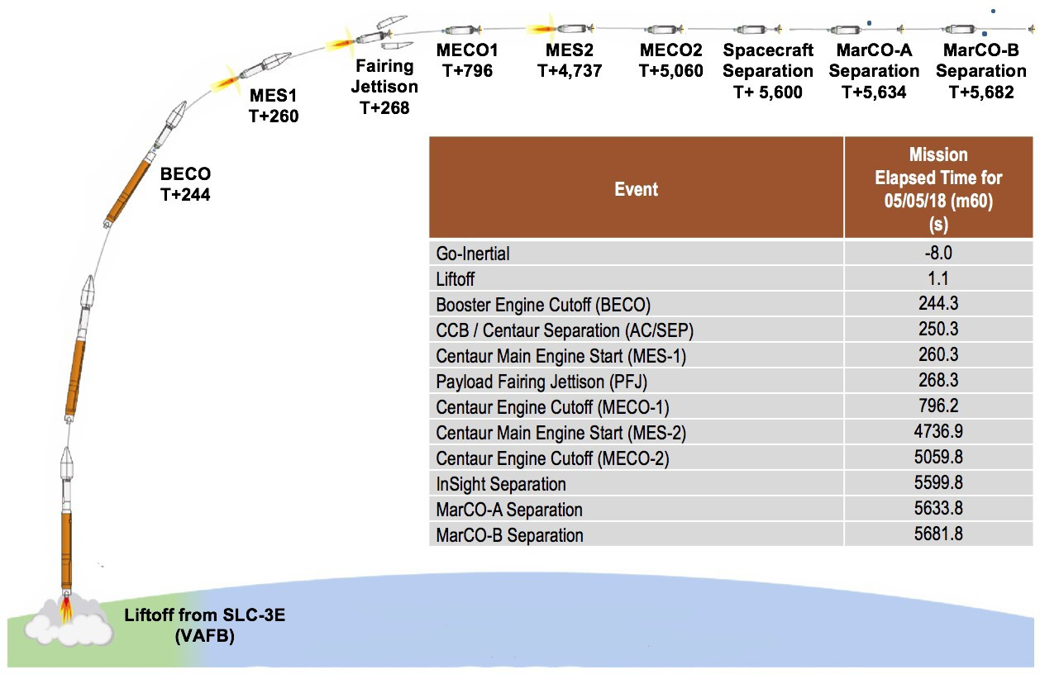
in the parking orbit until it reaches the proper position for start of the second Centaur burn. This coasting will last 59 to 66 minutes, depending on the date and time of the launch. About when the Centaur-spacecraft stack begins passing over Antarctica, it will exit Earth’s shadow and enter sunshine. The Centaur will maintains a slow roll while in the parking orbit -- about 1.5 degrees
per second -- to balance the thermal load of exposure to
direct sunlight. Profile of InSight launch events, for launch at first opportunity on May 5, 2018, from Space
Launch Complex 3E at Vandenberg Air Force Base in California. The “T Zero” time is 1.1 seconds before liftoff. Times of other launch events are given in number of seconds after T Zero.

The second Centaur burn, continuing for about five minutes as the stack passes close to the North Pole, will loft the spacecraft out of Earth orbit and on its way toward Mars. The burn ends with “main engine cutoff two,” (MECO2). Nine minutes after that cutoff, actuators and push-off springs
on the second stage of the Atlas will release the InSight spacecraft with a separation velocity sufficient to avoid re-contact with the upper stage. Spacecraft separation will occur about 90 minutes after liftoff for the first May 5
launch opportunity as the spacecraft is approximately over the Alaska-Yukon region.

Shortly after the release of InSight, the Centaur will begin an avoidance maneuver taking itself out of the spacecraft’s flight path to avoid hitting either the spacecraft or Mars.

Acquisition of Signal

The radio signal transmitted by InSight could be first detected at any time from momentarily after spacecraft separation to about 14 minutes after
spacecraft separation. This puts expected “acquisition of signal,” or AOS, no later than about 107 minutes after launch (around 6 a.m. PDT, if the launch is at the first opportunity at 4:05 a.m. PDT on May 5). The initial acquisition is expected to be by an antenna at the
Shortly after InSight separation, MarCO-A will be released by its CubeSat dispenser, the Centaur will roll 180 degrees, MarCO-B will be released, and then the Centaur will complete its avoidance maneuver.

Throughout the launch sequence, radio transmissions from the Atlas to NASA’s Tracking and Data Relay Satellite
System will enable ground controllers to monitor critical events and the status of the launch vehicle and the spacecraft. Neither InSight nor MarCO can begin their own transmissions until after they have been released. The solar array on the cruise stage of the InSight spacecraft was built to fit fully extended inside the fairing, with no need for deployment action after the spacecraft’s release. Separation from the launch vehicle triggers InSight to acquire information about its orientation from its attitude control system and then slew to correct its attitude for communication.

Goldstone, California, station of NASA’s Deep Space Network (DSN), followed by the DSN station at Canberra, Australia.

MarCO-A and MarCO-B, after their release from the Centaur, will deploy solar arrays and then execute a “detumble” maneuver to stabilize attitude and point their solar arrays at the sun. Because the MarCOs’ batteries were last charged several months before launch, the priority after pointing their solar arrays is recharging their batteries to enable a full communications session. That session is expected to happen with the Canberra DSN station approximately seven hours after separation for MarCO-A (about 12:30 p.m. PDT or 3:30 p.m. EDT if the launch occurs the first launch opportunity) and 8 ½ hours after separation for MarCO-B (about 2 p.m. PDT or 5 p.m. EDT if the launch occurs at the first launch opportunity).

If the battery charge level is high and all other activities have gone as planned, the MarCOs could each attempt a short five-minute burst of data transmission after solar array deployment and before going out of sight of the Goldstone DSN station. This could happen within about an hour and a half after separation -- or about three hours after launch. (If
launch occurs at the first opportunity, the bursts could occur by around 7 a.m. PDT [10 a.m. EDT]). However, these bursts will only happen if the team is lucky and the antennas on both spacecraft and the ground are able to point towards each other so soon after separation. The five-minute burst may give a hint of how the MarCOs are doing.

Data received from InSight in the minutes after the initial acquisition will enable an evaluation of the spacecraft’s health. The flight team will be looking for confirmations that the cruise-stage solar arrays are producing electricity and that temperatures measured at many locations on InSight are within expectations. Once the spacecraft is confirmed to be in good health with stable temperatures and power, transition to cruise phase activities can begin on the day after launch.

Interplanetary Cruise and Approach to Mars
If launch is at the start of the launch period, May 5, the trip to Mars will take 205 days. If launch is at the end of the launch period, June 8, the trip will take 171 days. The use of a constant arrival date -- Nov. 26, 2018 -- for any launch date helped simplify operations planning. This interplanetary flight is called InSight’s cruise phase, with the final 60 days before arrival at Mars designated the approach subphase of cruise. The cruise phase will end three hours before InSight enters the Martian atmosphere.

Key activities during cruise will include checkouts and calibrations of spacecraft subsystems and science instruments, tracking of the spacecraft, attitude adjustments for changes in pointing of the solar array and antennas, and maneuvers to adjust the spacecraft’s trajectory. Six trajectory correction maneuvers are scheduled, plus two back-up or contingency opportunities for maneuvers.

InSight’s mission design uses what is called a Type 1 trajectory to Mars, meaning the spacecraft will fly less than halfway
around the Sun while in transit from one planet to the other.

During cruise, the InSight lander will remain tucked inside its aeroshell, with the aeroshell attached to the cruise stage. The InSight spacecraft is not designed to use spin for stability during cruise, as some previous Mars spacecraft have. It will maintain three-axis stability by monitoring its attitude and firing thrusters intermittently to keep within prescribed bands of

orientation for each axis. For monitoring its attitude, the InSight spacecraft will use a star tracker and a gyroscope-containing inertial measurement unit, backed up by Sun sensors.

Eight thrusters in all will be used during cruise. They are mounted on the lander and extend through cutouts in the back shell. The larger four -- called trajectory correction maneuver thrusters -- will be used for maneuvers to adjust the spacecraft’s flight path, with the smaller four -- called reaction control system thrusters -- controlling roll of the spacecraft during those maneuvers and providing attitude control throughout cruise.
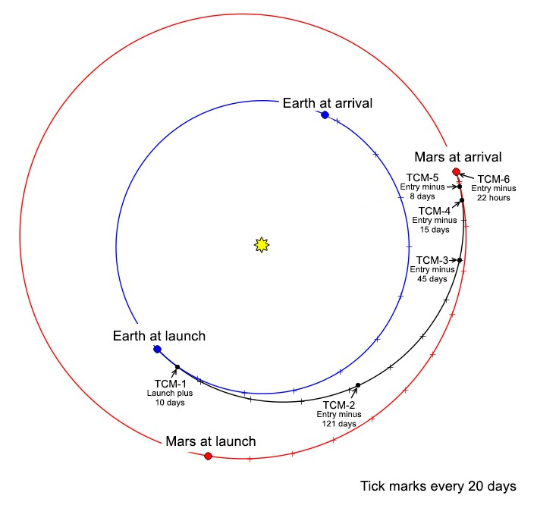

Shaping the Trajectory to Mars
InSight’s first trajectory correction maneuver is scheduled for 10 days after launch. The second is scheduled for July 28, 2018, (121 days before
landing). These two will be used to remove the launch- day trajectory’s intentional offset from Mars. That intentional offset is built into launch planning as a planetary protection precaution to avoid the possibility of the launch vehicle’s upper stage reaching Mars without having been cleaned to the standards of a Mars-landing spacecraft. The spacecraft will spend the first 10 days of cruise on a trajectory that would miss Mars by hundreds of thousands of miles or kilometers.

Schematic view of InSight cruise phase from Earth to Mars, for May 5, 2018, launch. Possible launch dates are May 5 through June 8. The date of arrival and atmospheric entry at Mars will be Nov. 26, 2018. Six trajectory maneuvers (TCMs) are scheduled. Dates are given relative to launch or entry.

Additional trajectory correction maneuvers are scheduled for Oct. 12, Nov. 11, Nov. 18, and Nov. 25 (45 days, 15 days, eight days and 22 hours before landing). The purpose of these is to refine the flight path for hitting the targeted entry point at the top of the Martian atmosphere on landing day. Nov. 21 will be a back-up opportunity if a Nov. 18 maneuver is not performed as planned. A contingency opportunity is on the schedule for eight hours before landing, if needed.
Tracking During Cruise

Planning for each trajectory correction maneuver will combine assessments of the spacecraft’s trajectory with calculations of how to use the thrusters on the cruise stage to alter the trajectory. Navigators’ assessments of the spacecraft’s trajectory use three types of tracking information from deep-space antennas at multiple locations on Earth. One method is ranging, which measures the distance to the spacecraft by timing precisely how long it takes for a radio signal to travel to the spacecraft and back. Another is Doppler, which measures the spacecraft’s speed relative to Earth by the amount of shift in the pitch of a radio signal from the craft. The third method, called delta differential one-way

range measurement, adds information about the location of the spacecraft in directions perpendicular to the line of sight. For this method, pairs of antennas on different continents simultaneously receive signals from the spacecraft, and then the same antennas observe natural radio waves from a known celestial reference point, such as a quasar, which serves as a navigation reference point.

For communication and navigational tracking during cruise, InSight will use NASA’s Deep Space Network antenna stations at Goldstone, California; near Madrid, Spain, and near Canberra, Australia, augmented with support being provided by the European Space Agency’s Deep Space Antenna 3 at Malargüe, Argentina, and Deep Space Antenna 1 at New Norcia, Australia.

The final 15 days of the approach phase include activities in preparation for the spacecraft’s arrival at Mars, or its atmospheric entry, descent and landing. The schedule during this period includes six opportunities to update parameters for the on-board software that will autonomously control events during the entry, descent and landing.

Entry, Descent and Landing
If launch is at the start of the launch period, May 5, the trip to Mars will take 205 days. If launch is at the end of the launch
period, June 8, the trip will take 171 days. The use of a constant arrival date -- Nov. 26, 2018 -- for any launch date helped simplify operations planning. This interplanetary flight is called InSight’s cruise phase, with the final 60 days before arrival at Mars designated the approach subphase of cruise. The cruise phase will end three hours before InSight
enters the Martian atmosphere.

Key activities during cruise will include checkouts and calibrations of spacecraft subsystems and science instruments, tracking of the spacecraft, attitude adjustments for changes in pointing of the solar array and antennas, and maneuvers to adjust the spacecraft’s trajectory. Six trajectory correction maneuvers are scheduled, plus two back-up or contingency opportunities for maneuvers.

InSight’s mission design uses what is called a Type 1 trajectory to Mars, meaning the spacecraft will fly less than halfway
around the Sun while in transit from one planet to the other.

During cruise, the InSight lander will remain tucked inside its aeroshell, with the aeroshell attached to the cruise stage. The InSight spacecraft is not designed to use spin for stability during cruise, as some previous Mars spacecraft have. It will maintain three-axis stability by monitoring its attitude and firing thrusters intermittently to keep within prescribed bands of orientation for each axis. For monitoring its attitude, the InSight spacecraft will use a star tracker and a gyroscope-containing inertial measurement unit, backed up by Sun sensors.

Eight thrusters in all will be used during cruise. They are mounted on the lander and extend through cutouts in the back shell. The larger four -- called trajectory correction maneuver thrusters -- will be used for maneuvers to adjust the spacecraft’s flight path, with the smaller four -- called reaction control system thrusters -- controlling roll of the spacecraft during those maneuvers and providing attitude control throughout cruise.

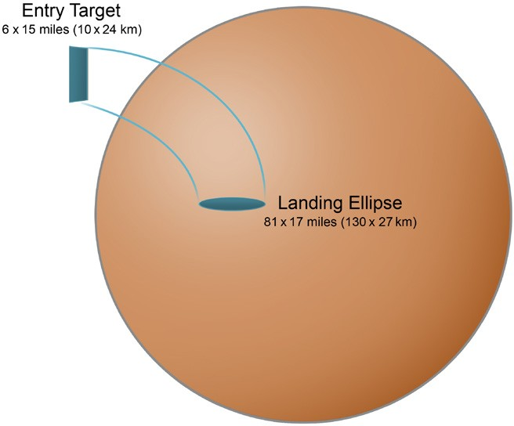
Navigators’ target at the top of Mars’ atmosphere is smaller than the ellipse covering the area in which the spacecraft has a 99 percent chance of touching down after passing through that target. Dispersion factors include aerodynamic uncertainties and atmospheric variability. This concept illustration is not to scale.

Preparing for Entry
About 47 minutes before entry, heaters will be turned on for catalyst beds of thrusters on the lander.

Up through this point during approach to Mars, radio transmission from InSight will come via the medium gain antenna on the cruise stage. Seven minutes before entry, the spacecraft will jettison the cruise stage. The remaining spacecraft after this separation is called the “entry vehicle” and consists of the aeroshell (back shell plus heat shield) and lander. Moments after the separation, InSight will begin transmitting a carrier-only (no data) signal from an omni-directional antenna on the back shell, called the wrap- around patch antenna.

About 30 seconds after cruise stage separation, the entry vehicle will begin turning toward the orientation required for atmospheric entry, with the heat shield facing forward. The turn will take about 90 seconds. Shortly before

entry, the wrap-around patch antenna will begin transmitting data at eight kilobits per second, in the ultrahigh frequency (UHF) radio band.

Listening for InSight
NASA’s Mars Reconnaissance Orbiter (MRO) is expected to be in position to receive the transmissions during InSight’s entry, descent and landing. MRO, passing over InSight’s landing region on Mars, will record the data for transmitting to Earth during a later orbit.

After carrying out a number of risky communication and navigation flight experiments, the twin MarCO spacecraft may be in position to receive transmissions during InSight’s entry, descent and landing as well. If all goes well, the MarCOs may be able to relay data to Earth almost immediately.

On Earth, two radio telescopes will be listening for a very basic indicator of InSight’s status: They may be able to confirm that InSight is transmitting during descent and after landing. They are the Max Planck Institute for Radio Astronomy’s facility at Effelsberg, Germany, and the National Science Foundation’s Green Bank Observatory in Green Bank, West Virginia.

NASA’s Mars Odyssey orbiter is expected to provide information about InSight after the landing because it is scheduled
to fly over InSight after the entry, descent and landing process.

Like Phoenix, But Heavier
The engineering for InSight’s entry, descent and landing system draws heavily on the technology of NASA’s Phoenix Mars Lander. The system that performed successfully for the Phoenix landing in 2008 weighs less than the landing systems with airbag or “sky crane” features used by NASA’s Mars rover missions. The lean hardware helps give InSight, like Phoenix, a high ratio of science-instrument payload to total launch mass, compared with rovers.

Compared with Phoenix, though, InSight’s landing presents four significant challenges:
InSight will enter the atmosphere at lower velocity -- 12,300 miles per hour (5.5 kilometers per second) vs. 12,500 miles per hour (5.6 kilometers per second).
InSight will have more mass entering the atmosphere
-- about 1,340 pounds (608 kilograms) vs. 1,263
pounds (573 kilograms).
InSight will land at an elevation about 4,900 feet (1.5 kilometers) higher than Phoenix did, so it will have less atmosphere to use for deceleration.
InSight will land during a Martian season (early winter in the northern hemisphere) when dust storms have grown to global proportions in some prior Martian years.

Times given in the following description of events from entry to touchdown may be changed before November 2018.
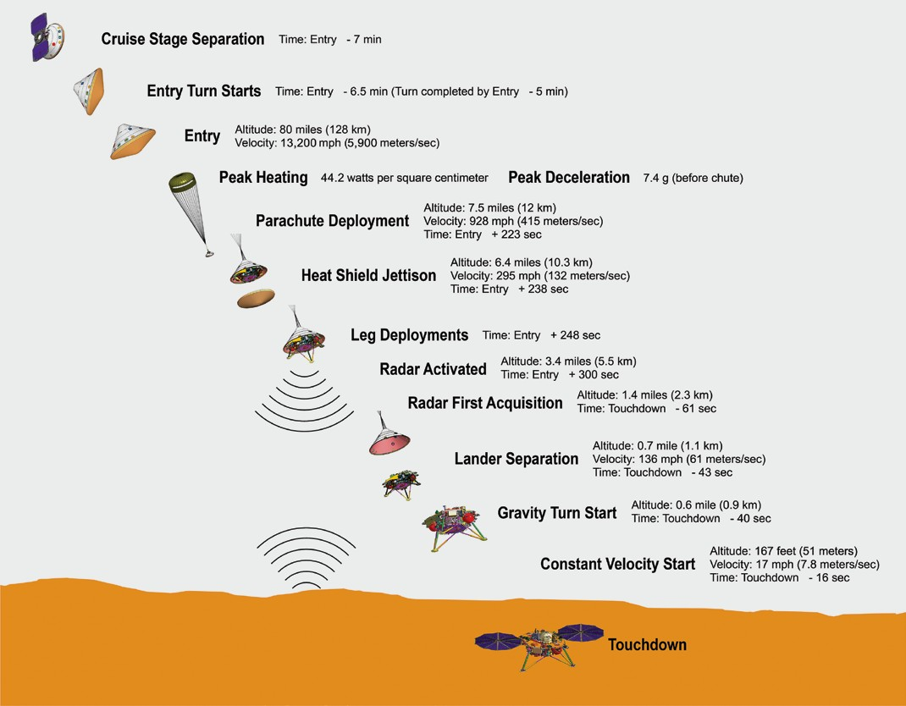

This description, from planning before launch, is an example of a possible timeline. Some of the timeline will be an estimate until after the landing because certain key events, such as parachute deployment, can be responsive to atmospheric conditions during descent, rather than clock-driven.
Some changes in InSight’s entry, descent and landing system, compared to the one used by Phoenix, are:
InSight will use a thicker heat shield, to handle the possibility of being sandblasted by a dust storm.
InSight’s parachute will open at higher speed.
InSight will use stronger material in parachute suspension lines.

Profile of InSight entry, descent and landing events on Nov. 26, 2018, for one typical case. Exact timing will be affected by atmospheric conditions on landing day.

Into the Atmosphere
Five minutes after completing the pivot to put its heat shield facing forward, InSight will start sensing the top of the atmosphere. Friction between the atmosphere and the heat shield during roughly 3.5 minutes before parachute deployment will take about nine-tenths of the velocity out of descent. Peak heating will occur approximately 1.5 minutes after atmospheric entry. The temperature at the external surface of the heat shield will reach about 2,700 degrees Fahrenheit (about 1,500 degrees Celsius). Deceleration will peak about 17 seconds later, at up to 7.4 g (about seven times the equivalent of acceleration due to gravity at Earth’s surface). Ionization of gas around the spacecraft from the intense heating may cause a temporary gap in receipt of radio transmission from InSight.

Deployment of InSight’s parachute from the top of the back shell may be triggered by either velocity or deceleration level and is expected at approximately 3.5 minutes after entry, at about 7.5 miles (12 kilometers) above ground level, at a velocity of about 930 miles per hour (about 415 meters/sec). The anticipated load on the parachute when it first opens is about 12,500 pounds of force (55,600 newtons). Approximately 10 seconds after parachute deployment, electronics of the spacecraft’s landing radar will be powered on to warm up, and an auxiliary battery will be activated to supplement the lander’s main battery during critical current-drawing events of the next few minutes.

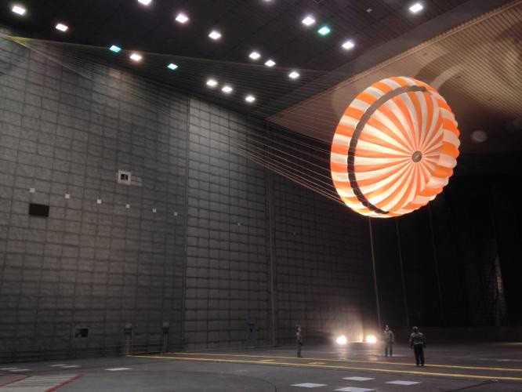
Parachute testing for InSight, conducted inside world’s largest wind tunnel, at NASA Ames Research Center, Moffett Field, California.

The spacecraft will descend on the parachute for about three minutes. During the first 25 seconds of that period, InSight will jettison its heat shield and extend its three legs. About 75 seconds after the parachute opens and 130 seconds before landing, the spacecraft will start using its radar to sense the distance to the ground.

Descent speed will have slowed to about 134 miles per hour (60 meters per second) by the time the lander separates from the back shell and parachute, about three-fourth of
a mile (1.2 kilometers) above the ground and about 45 seconds before touchdown. By design, the separation is triggered by radar sensing of altitude and velocity.
A brief pause in communication is anticipated as data transmission shifts from the wrap-around antenna on the back shell to a helical UHF transmitter on the lander.

Slowing for Touchdown
Half a second after lander separation, the 12 descent engines on the lander will begin firing. Guidance software onboard for
the terminal descent will provide commands for aligning the direction of thrust to the direction the spacecraft is moving, so the thrust will counter horizontal movement as well as decelerating the descent. If the spacecraft senses that its horizontal speed is below a threshold set in the software, it will also perform a maneuver to avoid the back shell that is still descending on its parachute. This maneuver would adjust the direction of thrust to reduce the chance that the back shell and parachute could land too close to the lander after the lander’s touchdown. The spacecraft will rotate to land in the desired orientation: with solar arrays extending east and west from the deck and the robotic arm’s work area on the south side of the lander.

At about 164 feet (50 meters) above the ground InSight will begin a transition to a constant descent velocity of 5.4 miles per hour (2.4 meters per second), the velocity at which it will touch down less than half a minute later.

The local solar time at the landing site in the Elysium Planitia area of Mars will be about 2 p.m. at touchdown (which will be about 12 noon in California). If it is a relatively clear day -- no dust storm -- the forecast calls for air temperature at the height of the lander deck to reach about 18 degrees above zero Fahrenheit (minus 8 Celsius) that afternoon and plummet to about minus 140 F (minus 96 C) overnight. The time of year in Mars’ northern hemisphere will be about midway between the autumn equinox and winter solstice.

The Martian day, or sol, of the landing will count as Sol Zero of InSight’s Mars surface operations.

Mars Surface Operations
InSight’s surface operations phase will start one minute after touchdown. The prime mission will operate on the surface for one Martian year plus 40 Martian days, or sols, until Nov. 24, 2020. Some science data will be collected beginning the first week after landing, but the mission’s main focus during that time is preparing to set InSight’s instruments directly on the Martian ground.

Placement of instruments onto the ground is expected to take about 10 weeks. Sinking the heat probe to full depth is expected to take about seven weeks further. After that, the lander’s main job will be to sit still and continue collecting data from the instruments.

InSight will rely on battery-stored energy as it descends through the atmosphere and until the lander’s solar arrays can be opened after touchdown, so deploying the arrays is a crucial early activity. However, the lander will first wait about 16 minutes to let any dust from the landing settle, in order to avoid having the dust settle onto the arrays’ photovoltaic cells. During those minutes, the motors for unfurling the arrays will begin
warming in preparation. The two arrays will take a few minutes to fully deploy, beginning
about 25 minutes after touchdown to allow sufficient warming of the motors.

Tasks on landing day will be programmed to be performed autonomously, without any need for the lander to receive communication from the InSight team on Earth. The landing-day activities other than deploying the solar arrays will include checking the lander’s health indicators, taking a wide-angle image toward the south, and powering down to “sleep” mode for the first night on Mars.

First Weeks

In the first week, InSight will continue to characterize the landing site, the payload instruments, the robotic arm and other onboard systems, and begin stereo imaging
of the ground within reach of the arm on the south side of the lander. During the next two weeks, InSight will return additional images of the arm’s work space, for use by the InSight team in selecting the best locations to place the seismometer (SEIS) and heat probe (HP3) onto the ground. Stereo pairs of images will provide three- dimensional information.

The seismometer will be the first instrument lifted from the deck and placed on the ground. The transfer will require several sols to verify steps such as the robotic arm’s good grasp on the instrument before proceeding to the next step, especially since this will be the first time a robotic arm has ever grasped anything on another planet. Next, the InSight team will use the robotic arm to place the wind and thermal shield over the seismometer. With that shield in place, the mission will begin monitoring Mars for seismic activity. Deployments will continue with placement of HP3 onto the ground. After it is in place, the instrument will release its self-hammering mole. As the mole burrows downward during the next few weeks, it will pause at intervals to allow heat from the hammering action to dissipate for two or three sols and it will then measure thermal conductivity before proceeding deeper.

Phoning Home

Throughout its surface operations, InSight will relay its science data to Earth via NASA’s Mars Reconnaissance Orbiter and Mars Odyssey orbiter. The orbiters will receive UHF-band transmissions from InSight and subsequently forward the data to Earth via X-band transmissions to NASA’s Deep Space Network antenna complexes at Goldstone in California’s Mojave Desert, near Madrid, Spain, and near Canberra, Australia. At any point in Earth’s daily rotation, at least one of these three sites will have Mars in view for radio communication.
Each complex is equipped with one antenna 230 feet (70 meters) in diameter, at least two antennas 112 feet (34 meters) in diameter, and smaller antennas. All three complexes communicate directly with the Space
Flight Operations Facility hub at NASA’s Jet Propulsion Laboratory, Pasadena, California.

During the weeks until both the seismometer and heat probe have been placed onto the ground, the orbiter will provide relay opportunities an average of twice per sol. This will enable the InSight team, on most days, to use results from each sol’s activities for planning the next sol’s activities, including arm movements. The
mission will use X-band transmission of daily commands directly from Earth to the lander most Martian mornings during this period, to provide more daily planning time compared to relaying commands via the orbiter. Once the deployments using the arm have been completed, planning activity will become simpler and commanding can become less frequent.

Mission: Spacecraft

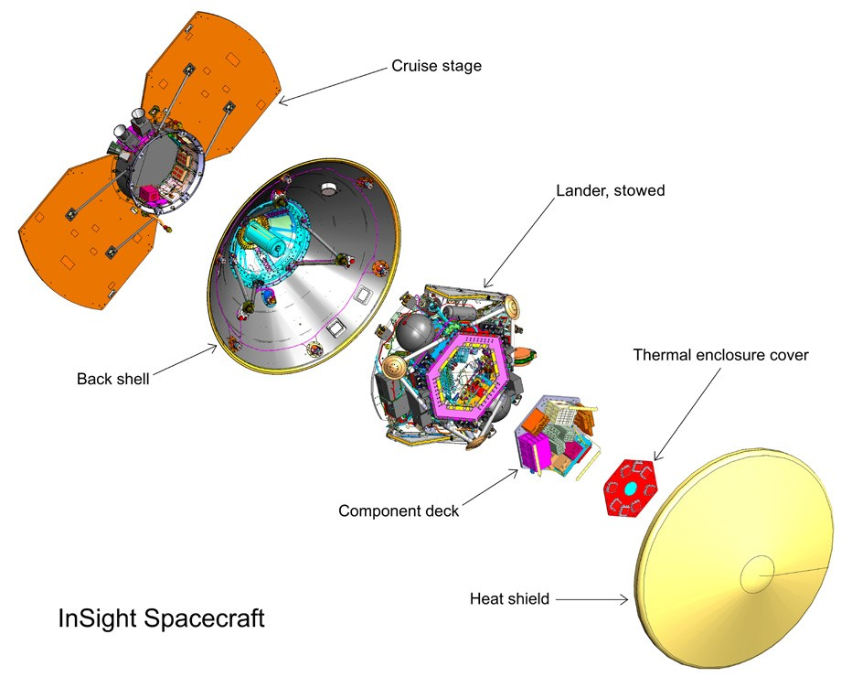
The lander is the core of the InSight spacecraft. Not only will it be the element carrying out all of the activity on Mars, its computer also
controls functions of the three secondary elements of the flight system:
the cruise stage, back shell and heat shield.

The InSight spacecraft is based on the design of NASA’s 2007-2008 Phoenix Mars Lander, with updates to accommodate InSight’s unique science payload and new mission requirements. Some key functions and features of the InSight spacecraft are power, communications, command and data handling, propulsion, guidance and thermal control.

Lockheed Martin Space, Denver, designed, built and tested the InSight spacecraft. Lockheed Martin Space previously delivered the Phoenix spacecraft and all three NASA orbiters currently active at Mars: Mars Odyssey, Mars Reconnaissance Orbiter and Mars Atmosphere and Volatile Evolution (MAVEN).

The InSight flight system comprises the lander, with its component deck and thermal enclosure cover, encapsulated in the aeroshell formed by the back shell and heat shield, and topped by the cruise stage.

Lander
The InSight lander will face south, in the sense that the mission’s workspace of ground within reach of the robotic arm will be on the south side of the lander. Because the site is north of the equator, this will prevent the lander’s shadow from passing over deployed instruments. The lander’s two solar arrays will extend like circular wings east and west from the central deck, with a wingspan of 19 feet, 8 inches (6 meters). Front to back, the lander is 8 feet, 10 inches (2.7 meters) deep. The top of the deck will be 33 to 43 inches (83 to 108 centimeters) above Martian ground level, depending on the lengths of the three shock- absorbing legs after the landing. The lander with its solar panels deployed is about the size of a big 1960s convertible.

The lander’s panels are based on the design of the panels flown on NASA’s Phoenix lander, though InSight’s were made slightly larger for more power output and to increase structural strength. These changes were required to to support the two-year landed prime science mission with sufficient margins (two Earth years, one Mars year).

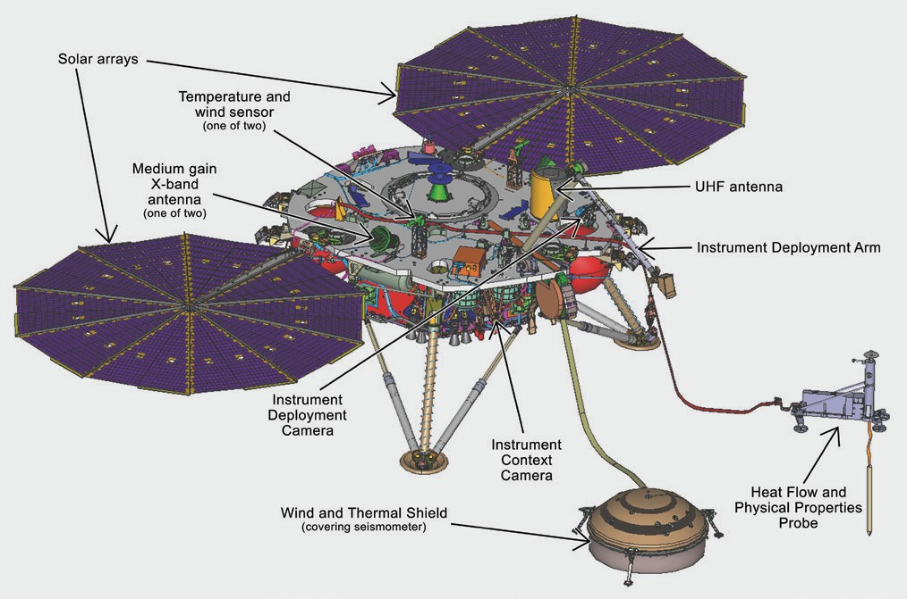
Hardware on top of the deck just after landing includes the robotic arm, two dedicated science instruments and their accessories, a laser reflector, a helical UHF antenna and two X-band antennas (which are also used as part of a science experiment). In the weeks after landing, the arm will lift the seismometer, its wind-and-thermal shield and the thermal probe from the deck and place them onto the Martian surface.

In this illustration of the InSight lander’s deployed configuration, south would be toward lower right at the Martian work site, with tethered instruments on the ground and the heat probe’s mole underground.

The lander’s avionics are mounted to a component deck located within a thermally protective enclosure. The suite of electronics in this enclosure consists of the flight computer, the electrical power system, the landed telecommunications system, the payload electronics and the harness. Other components, such as the inertial
measurement units, radiometer, magnetometer and landing radar, are externally mounted under the science deck.
Thrusters extend from the sides of the lander.

Instrument Deployment System: One Arm and Two Cameras
The lander’s Instrument Deployment System (IDS) has a robotic arm for moving instruments from the deck onto the ground and two color cameras for finding the best place to put them and documenting the process. One of the cameras is mounted on the arm; the other on the front of the lander, beneath the south edge of the deck.

The Instrument Deployment Arm (IDA) includes a grapple for grasping each piece of hardware the arm will lift. The grapple’s five mechanical fingers can close around a handle that resembles a ball on top of a stem. Each of the three items the arm will lift has one of these handles. The three items are the Seismic Experiment for Interior Structure, the Heat Flow and Physical Properties Probe, and the seismometer’s Wind and Thermal Shield.

The arm is 5.9 feet (1.8 meters) long, with shoulder, elbow and wrist joints and four motors. The grapple is at the end of the arm. The arm-mounted camera is between the elbow and wrist.

The camera on the arm is called the Instrument Deployment Camera (IDC). The lander’s other camera, the Instrument Context Camera (ICC), is mounted just below the deck, on the edge of the lander facing the workspace, which is the area of ground within reach of the arm. Both are modified versions of engineering cameras on NASA’s Mars rovers Opportunity and Curiosity, with full-color capability added. Each has a square charge-coupled device (CCD) detector 1,024 pixels by 1,024 pixels.

The IDC’s field of view is 45 degrees wide and tall. Movement of the arm is used to point the camera. The IDC will image the workspace in detail to support selection of the best specific locations for the deployed instruments. It will also image hardware to verify key steps are accomplished in the deployment process before proceeding to the next step. By moving the camera’s position between exposures, the IDC can create stereo views that provide three-dimensional information about the surrounding area. The camera can be pointed in any direction, so it can take images to be combined into a 360-degree panorama of the lander’s surroundings.

The ICC has a “fisheye” field of view of 120 degrees. It will provide wide-angle views of the entire workspace.

The basic structure of the robotic arm was originally built for a Mars lander planned for launch in 2001, but cancelled before launch. JPL refurbished and modified the arm for InSight, including the additions of grapple and camera. JPL also developed the software for controlling the arm and built both of the Instrument Deployment System’s cameras.

Science Experiments
InSight will be using its science experiments to take the “vital signs” of Mars: its pulse (seismology), temperature (heat flow) and its reflexes (radio science).

The Seismic Experiment for Interior Structure (SEIS), a seismometer that measures ground motions in a range of frequencies, features six sensors of two different types. Those sensors are mounted on a three-legged precision leveling structure inside a remote warm enclosure box. That combination will be set directly onto the ground, connected to the lander by a flexible tether containing power and data lines. Then an additional protective cover -- the Wind and Thermal Shield -- will be placed over it.
The SEIS electronics box remains on the lander.

France’s national space agency, Centre National d’Études Spatiales (CNES), Paris, leads the consortium that provided SEIS.

InSight’s second dedicated science instrument, Heat Flow and Physical Properties Probe (HP3, pronounced “H-P cubed”), will provide the first precise determination of the amount of heat escaping from the planet’s interior. InSight’s robotic arm will place the instrument on the ground, where a self-hammering mechanical mole will burrow to a depth of 10 to 16 feet (3 to 5 meters) over the course of about 30 days. InSight’s heat probe will penetrate more than 15-fold deeper beneath the surface than any previous hardware on Mars.

A science tether with temperature sensors connects the upper end of the mole to the HP3 support structure, which is on the Martian surface. An engineering tether connects HP3 support structure to the instrument’s back-end electronics box on the lander.

The HP3 investigation also includes a radiometer to measure ground-surface temperature near the lander based on its infrared brightness.

The German Aerospace Center (Deutsches Zentrum für Luft- und Raumfahrt, or DLR), headquartered in Cologne, provided
InSight’s Heat Flow and Physical Properties Probe.

A third science experiment, the Rotation and Interior Structure Experiment (RISE) does not have its own dedicated science instrument; instead, it uses InSight’s direct radio connection with Earth to assess perturbations of Mars’ rotation axis, which can provide information about the planet’s core. The tools for RISE are the X-band radio on the InSight lander and the large dish antennas of NASA’s Deep Space Network. The lander’s radio link to Earth will provide precise tracking of the location of one site on the surface as the planet rotates, throughout the course ofa full Mars year.

Auxiliary Payload Sensor Subsystem

Sensors that measure the local magnetic field, wind, and atmospheric temperature and pressure are attached to the lander deck. Together, these are called the Auxiliary
Payload Sensor Subsystem (APSS). The primary reason for including these instruments in the mission’s payload is to aid interpretation of seismometer data by tracking changes in the magnetic field or atmosphere that could cause ground movement otherwise mistaken for a seismic event. However, they can also serve on their own for other Mars science investigations.

Your Name Is on Its Way to Mars
Laser Retroreflector for Mars

A dome-shaped device, affixed to the top of the InSight lander’s deck, holds an array of eight special reflectors. This is the Laser Retroreflector for InSight, or LaRRI, which is not part of the InSight mission’s own science investigations, but may passively provide science value for a future Mars orbiter mission with a laser altimeter making extremely precise measurements of the lander’s location.

For more in-depth information on InSight’s science payload and goals, go to the Science section.

Another special feature on the deck of the lander is a pair of silicon chips etched with names of approximately 2.4 million people worldwide who participated in online “send your name to Mars” activities in August 2015 and 2017. Such activities are among many opportunities offered online for participation in Mars exploration. These chips are affixed near the northern edge of InSight’s deck.

Cruise Stage
InSight’s cruise stage will provide vital functions during the flight from Earth to Mars, and then will be jettisoned before the rest of the spacecraft enters Mars’ atmosphere. The core of the cruise stage is a short cylinder about 3 feet (0.95 meters) in diameter, with two fixed-wing solar panels extending out from the cylinder 180 degrees apart, for an overall wingspan of about 11 feet (3.4 meters), which is slightly larger than the biggest condor’s wingspan.

Equipment on the cruise stage includes low-gain and medium-gain antennas, an X-band transponder, two solid-state power
amplifiers, two Sun sensors and two star trackers.

Back Shell and Heat Shield
The spacecraft’s back shell and heat shield together form the aeroshell that encapsulates the InSight lander from launch to the time the spacecraft is suspended on its parachute on its way to the Martian surface. The lander and aeroshell together, after separation from the cruise stage, are the entry vehicle. The back shell and heat shield are each conical in shape, meeting where the diameter is 8.66 feet (2.64 meters). The aeroshell’s height -- about 5.4 feet (1.6 meters) -- is about one-third heat shield and two-thirds back shell.

The spacecraft’s parachute and its deployment mechanism are stowed at the apex of the back shell. The parachute has a disk- gap-band configuration and a diameter of 38 feet, 9 inches (11.8 meters). Once deployed during descent, it will extend about 85 feet (26 meters) above the back shell. Pioneer Aerospace Corp., South Windsor, Connecticut, made the parachute.
A UHF antenna for use during descent is wrapped around the top end of the back shell. At four locations around the back shell near its largest circumference, cutaways expose thrusters mounted on the lander. These are the eight thrusters used during the cruise from Earth to Mars. Each of the four cutaways accommodates one trajectory correction maneuver thruster and
one reaction control system thruster. The heat shield is covered with material that ablates away during the period of high- temperature friction with the Mars atmosphere, protecting the encapsulated lander from heat that is expected to rise as high as 2,700 degrees Fahrenheit (1,500 degrees Celsius). This thermal protective system for InSight uses a material called SLA- 561, with the acronym standing for super lightweight ablator.

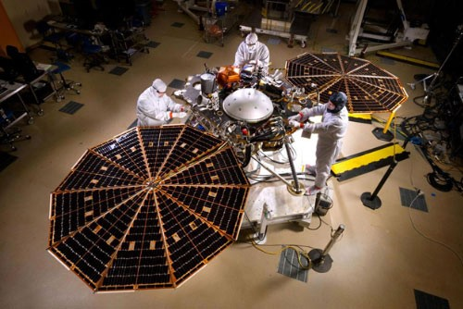
A pair of rechargeable, 25 amp-hour lithium-ion batteries located on the lander will provide energy storage. The
Electrical Power

InSight will use electrical power from solar panels, with batteries for storage, during cruise and after landing.

The fixed-wing photovoltaic panels on the cruise stage were built by Lockheed Martin in Sunnyvale, California, with triple-junction photovoltaic cells from SolAero Technologies Corp., Albuquerque, New Mexico.

The solar arrays on NASA’s InSight lander are deployed in this test in a clean room at Lockheed Martin Space, Denver, in April 2015. Each of the two arrays is 7.05 feet (2.15 meters) in diameter.

The lander will deploy two nearly circular, 10-sided solar arrays, each 7.05 feet (2.15 meters) in diameter, extending from opposite sides of the lander. The two arrays combined have almost as much surface area as a pingpong table. Before landing, these are stowed in a radially folded configuration similar to a folded fan.
After they have been deployed, the lander’s two arrays will together generate up to about 3,000 watt hours per Martian day. The UltraFlex panels are from Orbital ATK- Goleta, in Goleta, California, with photovoltaic cells from SolAero.
lithium-ion batteries are from the Yardney Division of EaglePicher Technologies, East Greenwich, Rhode Island. In addition, a single-use, non-rechargeable thermal battery will supplement the main batteries during entry, descent and landing.

Telecommunications
During the cruise from Earth to Mars, InSight will communicate with Earth using X-band
antennas on the cruise stage. The cruise stage has a medium-gain, directional antenna and two low-gain antennas -- one for transmitting and the other for receiving. The spacecraft has one
X-band small deep space transponder (SDST) on the lander and one on the cruise stage.

InSight, like all other NASA interplanetary missions, will rely on NASA’s Deep Space Network to track and communicate with the spacecraft. The network has groups of dish antennas at three locations: California, Spain and Australia. Additional communications support will be provided by the European Space Agency’s deep space antennas in Argentina and Australia while InSight is flying from Earth to Mars.
As InSight descends through the Martian atmosphere, it will be transmitting a signal in the ultrahigh frequency (UHF) radio band. The signal is generated by a UHF transceiver on the lander. That signal is transmitted by, first, a wrap-around patch antenna on the back shell, and, later, after the lander separates from the back shell, by a helical UHF antenna on the lander deck. The Mars Reconnaissance Orbiter will be listening for the UHF transmissions from InSight during the critical minutes of entry, descent and landing. In a technology-demonstration mission accompanying InSight, two miniature spacecraft, CubeSats named MarCO-A and MarCO-B, may also be listening for these UHF transmissions if they make it to Mars. The orbiter will relay the InSight data to Earth after a delay. The CubeSats may relay the data almost immediately.

From the surface of Mars, InSight will use both X-band and UHF communications.

The primary method for sending data to Earth from the landing site will be via UHF relay to an orbiter, through the lander’s helical antenna. Mars Reconnaissance Orbiter and Mars Odyssey each will pass in the sky over InSight twice per Martian day. NASA’s MAVEN orbiter and the European Space Agency’s Trace Gas Orbiter and Mars Express can serve as backup relay assets for InSight. Orbiters will receive transmissions from InSight via UHF and relay the InSight data to Earth via X-band.

The lander’s own X-band communications will use a pair of medium-gain horn antennas on the deck, communicating directly with Deep Space Network antennas on Earth. In the
planned orientation for the lander -- with the instrument workspace to the south for instrument deployment -- one X-band antenna faces eastward and the other westward. Viewing Earth from Mars is like viewing Venus from Earth: In either case, the inner planet is a morning or evening “star,” above the eastern horizon in morning or above the western horizon in the evening. The main uses for InSight’s X-band radio are the Rotation and Interior Structure Experiment (RISE) and for receiving commands directly from Earth.

Computer and Software
InSight’s system for command and data handling has
avionics derived from NASA’s Mars Atmosphere and Volatile Evolution (MAVEN) and Gravity Recovery and Interior Laboratory (GRAIL) missions. The system has two redundant computers -- one active at all times and the other available as backup. The computer’s core is a radiation-hardened central processor with PowerPC 750 architecture called RAD 750. This processor operates at
115.5 megahertz speed, compared with 20 megahertz speed of the RAD6000 processor used on Mars Phoenix.

A payload interface card handles the processor’s interaction with InSight’s various science instruments and robotic arm. It provides 64 gigabits of flash memory for non-volatile storage of science data.

Flight software, written in C and C++ within the VxWorks operating system, monitors the status and health of
the spacecraft during all phases of the mission, checks for the presence of commands to execute, performs communication functions and controls spacecraft activities. It will protect the spacecraft by checking commands for faults and being ready to take corrective steps when it detects irregularities in commanding or spacecraft health.

Propulsion
The propulsion for pushing InSight from Earth to Mars
comes from the launch vehicle rather than the spacecraft itself, but the spacecraft carries 20 thrusters to control its orientation in space, to adjust trajectory as it coasts from Earth to Mars and to slow its final descent to the surface of Mars. The 20 thrusters are of three different sizes: four reaction control system (RCS) thrusters, each providing
1 pound (4.4 newtons) of force; four trajectory correction maneuver (TCM) thrusters, each providing 5 pounds (22 newtons) of force; and 12 descent engines, each providing 68 pounds (302 newtons) of force.

All of the thrusters are on the lander. The eight used while the lander is encapsulated inside the aeroshell extend out through cutouts in the back shell. One “rocket engine module” with one RCS thruster and one TCM thruster is at each of four cutouts around the back shell, to allow maneuvers in any direction. The descent engines are
on the underside of the lander, to be used for control of the lander’s descent during the last minute before
touchdown. All of the thrusters use hydrazine, a propellant that does not require an oxygen source. Hydrazine is
a corrosive liquid compound of nitrogen and hydrogen that decomposes explosively into expanded gases when exposed to a heated catalyst in the thrusters.

Guidance, Navigation and Control
InSight will remain oriented as it travels to Mars by using redundant pairs of star trackers and Sun sensors mounted on the cruise stage. A star tracker takes pictures of the sky and performs internal processing to compare the images with a catalog of star positions and recognize which part of the sky it is facing.

Thermal Control
InSight’s thermal control subsystem is a passive design
supplemented with heaters. It uses multi-layer insulation blanketing, other insulation, painted radiator surfaces, temperature sensors, heat pipes and redundant heaters controlled by thermostats. An enclosure for key electronics is designed to maintain component temperatures between 5 degrees Fahrenheit (minus 15 degrees Celsius) and 104 degrees F (40 degrees C).

Science-payload components are thermally isolated from the lander and provide their own thermal control.
During its descent through Mars’ atmosphere, the spacecraft’s knowledge of its movement and position will come from an inertial measurement unit, which senses changes in velocity and direction, and a downward-pointing radar to assess the distance and velocity relative to the Martian surface. The inertial measurement unit includes accelerometers to measure changes in the spacecraft’s velocity in any direction, and ring-laser gyroscopes to measure how fast the spacecraft’s orientation is changing.

Planetary Protection
When sending missions to Mars, precautions must be taken to avoid introduction of microbes from Earth by robotic spacecraft. This is consistent with United States obligations under the 1967 Outer Space Treaty, the international agreement stipulating that exploration must be conducted in a manner that avoids harmful contamination of celestial bodies. “Planetary protection” is the discipline responsible for development of rules and practices used to avoid biological contamination in the process of exploration. NASA has a planetary protection office responsible for establishing and enforcing planetary protection regulations. Each spacecraft mission is responsible for implementing measures to comply with the regulations. In compliance with the treaty and NASA regulations, InSight flight hardware has been designed and built to meet planetary protection requirements.

NASA’s primary strategy for preventing contamination of Mars with Earth organisms is to be sure that all hardware going to the planet is clean.
One of the requirements for the InSight mission is that the exposed interior and exterior surfaces of the landed system, which includes the lander, parachute and back shell, must not carry a total number of bacterial spores greater than 300,000. The average spore density must not exceed 300 spores per square meter (about 11 square feet) of external surfaces, nor 1,000 per square meter of enclosed, interior surfaces, so that the biological load is not concentrated in one place.
Spore-forming bacteria have been the focus of planetary protection standards because these bacteria can survive harsh conditions for many years as inactive spores.

Planetary protection engineers with expertise in microbiology and spacecraft materials have developed three primary methods for reducing the number of spores on the spacecraft: precision cleaning, dry heat microbial reduction and protection behind high-efficiency filters. The strategy also emphasizes prevention of re-contamination, in the clean- room facilities, clothing, equipment and processes used.

Technicians assembling the InSight spacecraft and preparing it for launch have routinely cleaned surfaces by wiping them with alcohol or other solvent. Components tolerant of high temperature were heated to reduce spore burden according to NASA specification. This dry heat treatment held components at temperatures from 110 to 155 degrees Celsius (230 to 311 degrees Fahrenheit) for durations from 14 to 258 hours for external surfaces and durations of 97 to 1,290 hours for enclosed surfaces. The planetary protection team carefully sampled the surfaces and performed microbiological tests to demonstrate that
the spacecraft meets requirements for biological cleanliness. Whenever possible, hardware was contained within a sealed container vented through high-efficiency filters.

The standard of cleanliness is higher for hardware that will touch parts of Mars judged to have the potential for sustaining life, such as
subsurface environments with liquid or frozen water. The near-equatorial region of InSight’s landing site, Elysium Planitia, is one of the driest places on Mars. Still, the mission is taking all the necessary planetary- protection precautions. This work has included analysis of planned subsurface deployment of the Heat Flow and Physical Properties Probe. At the mission’s landing site, this probe could not get deep enough to reach environmental conditions warranting additional precautions.

Another way of making sure InSight doesn’t transport Earth life to Mars is to ensure that any hardware not meeting cleanliness standards does not go to Mars accidentally. When the Atlas launch vehicle’s Centaur stage separates from the spacecraft, the two objects are traveling on nearly identical trajectories. To prevent the possibility of the Centaur hitting Mars, the shared flight path is deliberately set so that the spacecraft would miss Mars if not for its first two trajectory correction maneuvers -- one scheduled for 10 days after launch and the other for 149 days before arrival. By design, the Centaur is never aimed at Mars. For hardware expected to impact Mars, such as the cruise stage after lander separation, a detailed thermal analysis was conducted to make sure that plunging through Mars’ atmosphere gets it sufficiently hot such that few to no spores survive.

Mission: Science

A dictionary definition of “insight” is to see the inner nature of something. The mission of InSight is to see inside Mars and learn what makes it tick. So while InSight is the first Mars mission dedicated to studying the planet’s deep interior, it is more than a Mars mission, because information about the layers of Mars today will advance understanding about the formation and early evolution of all rocky planets, including Earth. Although Mars and Earth formed from the same primordial stuff more than 4.5 billion years ago, they became quite different. InSight will help explain why.
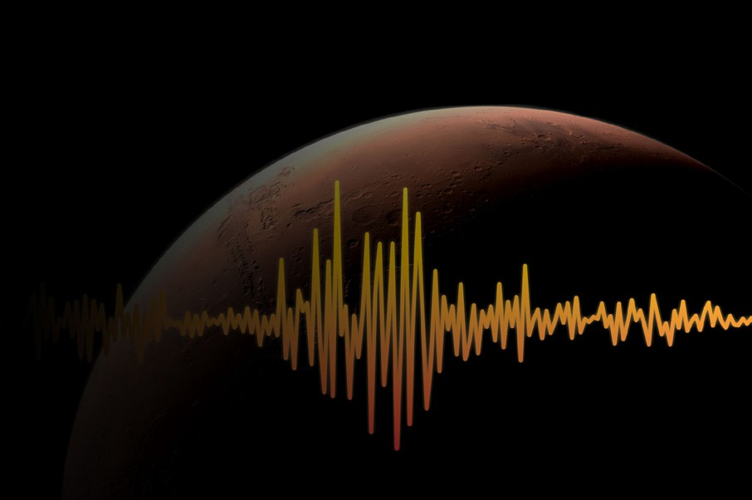

A planet’s deep interior holds evidence related to details of the planet’s formation that set the stage for what happens on the surface. The interior heat engine drives the processes that lift some portions of the surface higher than others, resulting in a landscape’s elevation differences. The interior is the source of most of a planet’s atmosphere, its surface rocks, water and ice, and its magnetic field. It provides many of the conditions that determine whether a planet will have environments favorable for the existence of life.

What’s In a Name?

The long form of the mission’s
name is Interior Exploration using Seismic Investigations, Geodesy and Heat Transport, which tells the three main research techniques to be used by the InSight stationary lander. These techniques allow scientists to take the “vital signs” of Mars:
Seismic investigations study vibrations of the ground set off by marsquakes (the Mars equi-
valent to earthquakes) and meteorite impacts, including the analysis of how these vibrations pass through interior materials and bounce off boundaries between layers. For this research technique, InSight will deploy a seismometer provided by France. Seismic investigations can be compared to how physicians use sonograms and X-rays to see inside a body.

Geodesy is the study of a planet’s exact shape and its orientation in space, including variations in the speed of rotation and wobbles of its axis of rotation. The axis of rotation is very sensitive to conditions deep inside Mars. For this research technique, the lander’s radio link to Earth will provide precise tracking of a fixed location on the surface as the planet rotates, throughout the course of a full Mars year. This investigation of the planet’s motion can be compared to examining a patient’s reflexes during a medical check-up.

Study of heat transport is a way to assess a planet’s interior energy and its dissipation. For this research technique, InSight will sink a German-made probe more than 3 meters (10 feet) into the ground to measure how well the ground conducts heat and how much heat is rising toward the surface. This investigation can be compared to how a physician reads a patient’s temperature as an indicator of internal health.

Other components of the InSight lander’s science payload are auxiliary instruments for monitoring the environment to aid the primary investigations, and a deployment system with a robotic arm and two cameras for the task of placing the main instruments onto the ground.

Some of these additional sensors will monitor wind, variations in magnetic field and changes in atmospheric pressure because these factors could affect seismometer readings. Others will monitor air temperature and ground-surface temperature, which will help in subtracting effects of those temperatures from heat probe and seismometer data. These supplemental instruments will also enable additional investigations, such as magnetic soundings of the Martian interior by the magnetometer and weather monitoring by the atmospheric sensors.

The auxiliary sensors and the two color cameras will provide information about the environment surrounding the InSight lander on the surface of a broad Martian plain near the equator, but for this mission, the science emphasis is to learn about depths that cannot be seen.

Science Objectives
InSight has two official overarching science goals:
- Understand the formation and evolution of terrestrial planets through investigation of the interior structure and processes of Mars;

- Determine the present levels of tectonic activity and meteorite-impact activity on Mars.

To get to these goals, NASA has determined these more specific science objectives:

Determine the thickness and structure of the crust Determine the composition and structure of the mantle
Determine the size, composition, and physical state of the core Determine the thermal state of the interior
Measure the rate and geographic distribution of seismic activity Measure the rate of meteorite impacts on the surface

For additional detail on these objectives see: Appendix: Science Objectives, Quantified

Why This Kind of Investigation of Mars?
Several reports setting scientific priorities for planetary science have stressed the importance of investigating the interior of Mars. While the Mars Viking missions of the 1970s were still active, a report by the National Research Council’s Committee of Planetary and Lunar Exploration,
Strategy for Exploration of the Inner Planets: 1977-1987, said, “Determination of the internal structure of Mars, including thickness of a crust and the existence and size of a core, and measurement of the location, size and temporal dependence of Martian seismic events, is an objective of the highest importance.”

In ensuing decades, several missions for investigating Mars’ interior were proposed, though none flew successfully. The National Research Council’s most recent decadal study of planetary-science priorities, Vision and Voyages for Planetary Science in the Decade 2013-2022, said, “Insight into the composition, structure and history of Mars is fundamental
to understanding the solar system as a whole, as well as providing context for the history and processes of our own planet. …Unfortunately, there has been little progress made toward a better understanding of the martian interior and the processes that have occurred.”

A stationary lander capable of placing sensitive instruments directly onto the surface and monitoring them for many months is a mission design exactly suited to studying the interior of Mars. InSight will be the first Mars mission to
use a robotic arm to grasp objects (in this case, scientific instruments) and permanently deploy instruments onto the ground. The mission has no need for a rover’s mobility. The heat probe and seismometer stay at a fixed location after deployment. The precision of the geodesy investigation gains from keeping the radio in one place.

Building on Heritage

InSight uses many aspects of a stationary-lander mission design already proven by NASA’s Phoenix Mars lander mission, which investigated ice, soil and atmosphere at a site in the Martian arctic in 2008. The
robotic arm for InSight, rather than scooping up samples for laboratory analysis as Phoenix did, will hoist the
heat probe, seismometer and a protective shelter for the seismometer one at a time from the lander deck and place them onto the ground.

The first time a seismometer was placed on a world other than Earth was during the Apollo 11 moon landing in 1969. The only seismometers previously used on Mars stayed on the decks of two Viking landers in 1976.
Those were much less sensitive and more exposed to wind effects than InSight’s seismometer will be.
Nearly 50 years after Apollo, InSight will be the first
seismometer placed directly on the surface of the Mars.

InSight’s science payload and science team draw heavily on international collaboration and shared expertise. The national space agencies of France and Germany are providing the two main instruments. Austria, Belgium, Canada, Italy, Poland, Spain, Switzerland and the United Kingdom are also participating.

InSight is part of NASA’s Discovery Program of competitively selected missions for exploring our solar system. The Discovery Program enables scientists to use innovative approaches to answering fundamental questions about our solar system. Bruce Banerdt of NASA’s Jet Propulsion Laboratory, Pasadena, California, now the principal investigator for InSight, led the team that prepared the mission proposal -- originally called Geophysical Monitoring Station, or GEMS -- submitted in September 2010. That proposal and 27 other proposals for missions to various destinations throughout the solar system were evaluated in a competition for the 2016 launch opportunity of the Discovery Program.
InSight was selected in August 2012.

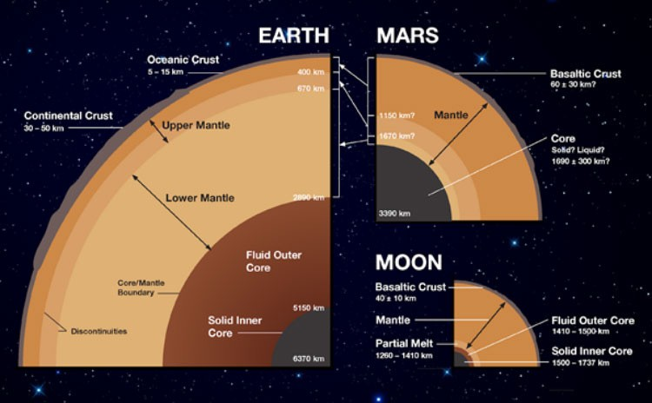
How Does Mars Tell Us About Other Planets?
The four inner planets of the solar system, plus Earth’s Moon, are called terrestrial worlds because they share a closer kinship with each other, including Earth, than with the worlds farther from the Sun. Diverse as they are, they each have rocky surfaces; they are also called the rocky planets. They each have high density -- the ratio of volume to mass -- indicating their interiors have even denser ingredients than their surface rocks.

All of the terrestrial planets have a three-part layered structure:
At the center is a metallic, iron-rich core, part of which may be molten.
Above the core is a thick middle layer called the mantle, rich in silicon, making up most of the bulk of the planet.
Above the mantle is a relatively thin crust of less- dense rocky material.

Schematic of similarities and differences in the interiors of Earth, Mars and Earth’s Moon.

Some of the ever-increasing number of exoplanets identified around stars other than our Sun may be similarly rocky and layered, though Earthlike worlds are smaller than the giant exoplanets whose size makes them easiest to find.

A key challenge in planetary science half a century into the Space Age is to understand factors that affect how newly forming planets with the same starting materials evolve into worlds as diverse as the terrestrial planets. As a particularly interesting corollary: What does it take to make a planet as special as Earth?

Planets start as growing coagulations of primordial particles in a disc-shaped swarm around a formative star -- the proto-Sun in the case of our solar system. Meteorites provide information about composition of the planet-forming raw material. Earth formed from the same material as its neighboring planets, but none of the planets now matches the mineral composition of those starting ingredients. They evolved.

As the forming planets grew larger, they heated inside, with energy from pieces coming together and natural radioactivity. Melting due to the heat enabled enough mobility for heavier ingredients to sink toward the center. Temperature and pressure affected the chemistry of the ingredients. Cooling caused some minerals to crystallize out of the melt at different temperatures than others. Multiple models have been proposed for the steps in how different minerals were produced and stratified as Earth’s evolution proceeded. Each of these models of terrestrial planet evolution fits the evidence known from studying Earth. Gaining knowledge of a different case -- Mars -- should rule out some of the models. Achieving that will yield both a better understanding of why Earth turned out the way it did and a conceptual framework for studying rocky planets of other stars.

Mars as a Model
The most accessible world for studying terrestrial planets is Earth. In the past century, research using InSight’s main methods -- seismology, geodesy and heat transport -- has substantially rewritten humans’ understanding of Earth’s interior and planetary history. But Mars offers advantages making it the right choice for a mission seeking to learn more about the formation and early evolution of terrestrial planets.

The major process in Earth that geological science has elucidated in the past century is plate tectonics, a recycling of crust driven by convection in the mantle as heat moves out from the core. The mantle has been vigorously stirred by convective motion driven by warmed material rising and cooled material sinking. The rising generates fresh crust at mid-ocean ridges; the sinking drags downward at some plate edges. The churning has erased from both crust and mantle most structural evidence of the first several tens of millions of years of Earth’s history after the planet formed about 4.5 billion years ago.

Mars lacks plate tectonics. Likely because of its smaller size, compared to Earth, that process has not churned the mantle and crust of Mars. Therefore, its interior could provide clues unavailable on Earth about the accretion and early evolution of Earth, Mars and other rocky planets. For example, the mantle of Mars may retain differences in composition at different depths, which convection has blended together on Earth.

Investigations of the Earth’s Moon, including analysis of lunar rocks returned to Earth, indicate that, although the Moon followed many of the same evolutionary steps as Earth, the path of its evolution was distinctly different because of its much smaller size. For example, it never underwent certain geochemical changes related to the greater interior pressure of the Earth.

Unlike the Moon, Mars is big enough to have undergone most of the same processes as early Earth. Unlike Earth, it is small enough not to have erased as much evidence of its early activity. Compared to Venus and Mercury, Mars provides a more accessible destination and less harsh surface environment for sensitive robotic hardware to operate for many months of data collection.

As added benefits, knowledge about the surface and atmosphere of Mars that has been gained from a series of successful missions there will help researchers interpret information InSight adds about the deep interior, and InSight’s findings will improve context for understanding those missions’ results.

Science Experiments

Seismic Experiment for Interior Structure
The Seismic Experiment for Interior Structure (SEIS) is a six-sensor seismometer combining two types of sensors to measure ground motions over a wide range of frequencies. In each set of three sensors, the sensors are mounted at angles to each other to detect motion in any direction. One set is an ultra-sensitive “very broad band” instrument enclosed in a vacuum vessel. It will measure ground oscillations of medium-to-low frequencies (from a few cycles per second to less than one one-thousandth of a cycle per second). The other is a short-period instrument, adding capability for higher- frequency vibrations (up to 50 cycles per second).

That combination will be set directly onto the ground, connected to the lander by a flexible tether containing power and data lines. Then an additional protective cover -- the Wind and Thermal Shield -- will be placed over it. The SEIS electronics box remains on the lander.

Seismometers are best known as devices to detect, locate and measure the magnitude of earthquakes. One set of goals for SEIS is to provide such information about quakes on Mars, called “marsquakes,” and other sources of ground motion, such as meteorite impacts and faint gravitational effects of Mars’ moon Phobos.

A ground-shaking event sets off some waves that move through a planet’s interior -- body waves -- and others that spread across the surface -- surface waves. Two types of body waves, called “p” and “s” for primary and secondary,

llustration of InSight’s SEIS instrument with some key components labeled

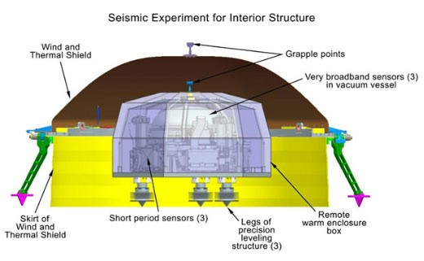
have distinctively different directions of ground motion and travel at different velocities. The time gap between arrival of p waves and arrival of s waves is an indicator of the distance they traveled from their origin to the seismometer, though other factors in the ground also affect their speed. Surface waves travel at different speeds from body waves, and also on a different path, along the ground surface.

SEIS can measure wave frequencies from more than 10 minutes between waves to about 50 waves per second. To gain information from faint or distant sources of ground movement, it has a sensitivity capable of detecting displacements of smaller distance than the diameter of a hydrogen atom. With that extreme sensitivity, many types of motion other than seismic waves could add noise to the desired data, so InSight carries countermeasures. Some protection comes from features of the SEIS instrument itself, such as its vacuum vessel and the wind and thermal shield. In addition, InSight’s auxiliary sensors will monitor variables such as wind, atmospheric pressure and magnetic field so that their effects can be accounted for in interpretation of data from the seismometer.

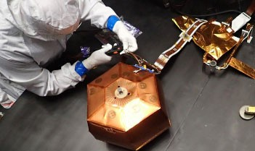
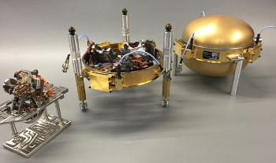
France’s national space agency, Centre National d’Études Spatiales (CNES), Paris, leads the consortium that provided SEIS. Other organizations in France, the United Kingdom, Switzerland, Germany and the United States collaborated in building the instrument. The principal investigator for SEIS is Philippe Lognonné of the Institute of Earth Physics of Paris (Institut de Physique du Globe de Paris, or IPGP). SEIS development benefited from design of a similar instrument developed for a European multi-lander mission to Mars that was planned for a 2005 launch but canceled before completion.

IPGP supplied the very broad band sensors. Imperial College, London, made the short period sensors. The Swiss Federal Institute of Technology (Eidgenössische Technische Hochschule, or ETH), Zurich, provided the data-acquisition electronics. The Max Planck Institute for Solar System Research (Max-Planck-Institut für Sonnensystemforschung, or MPS), Göttingen, Germany, supplied the leveling system. NASA’s Jet Propulsion Laboratory, Pasadena, California, made
the tether and the Wind and Thermal Shield, which includes a skirt of chainmail to accommodate uneven ground beneath a rigid dome. The chainmail comes from MailleTec Industries, Swift Current, Saskatchewan, Canada.

SEIS in preparation for thermal vacuum testing, before being covered by Wind and Thermal Shield
Some SEIS components before final assembly: a very broad band sensor, three-legged leveling fixture to hold sensors, vacuum vessel

Heat Flow and Physical Properties Probe
InSight’s Heat Flow and Physical Properties Probe (HP3, pronounced “H-P cubed”) will use a self-hammering mechanical mole burrowing to a depth of 10 to 16 feet (3 to 5 meters). Measurements by sensors on the mole and on a science tether from the mole to the surface will yield the first precise determination of the amount of heat escaping from the planet’s interior.

Heat flow is a vital sign of a planet. It carries information about the interior heat engine that drives the planet’s geology. Heat is the energy that powers planetary evolution, shaping the mountains and canyons of the surface. A planet’s interior heat affects how primordial ingredients of planetary formation form layers and how volatile components, such as water molecules, are released to the surface or atmosphere. Determining modern temperature flux will help scientists discriminate between models for how the interior of Mars has evolved over time.

Heat flow also foretells the destiny of a planet: the pace at which its core energy is diminishing.

InSight’s heat probe will penetrate more than 15-fold deeper beneath the surface than any previous hardware on Mars. The current record was achieved by the scoop of NASA’s Phoenix Mars lander digging to a depth of about 7 inches (18 centimeters), though radar instruments on Mars orbiters have revealed details of features much deeper, down to a few miles or kilometers.

The depth of the heat probe’s emplacement will get it away from most effects of daily and seasonal temperature changes at the surface. On Earth, experiments to measure heat flow from the planet’s interior must go deeper because water movement in the ground extends the effects of surface-temperature variations, but 10 feet (3 meters) is calculated as deep enough for useful measurement of heat flowing outward from the interior of Mars.

The instrument’s mole is expected to use thousands of hammering strokes of a spring-loaded tungsten block, over the course of about 30 days, to reach its full depth. The total number of strokes needed is expected to be between 5,000 and 20,000, depending on characteristics of the ground the device is traveling through, such as how compacted the soil is. The mole is about 1 inch (2.7 centimeters) in diameter and about 16 inches (40 centimeters) long -- about the diameter of a U.S. quarter and the length of a forearm. The exterior is an aluminum cylinder with the downward end tapered to a point, making it the shape of a finishing nail.

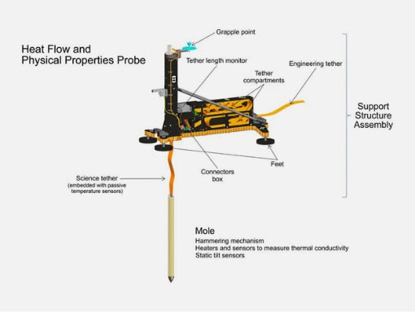
Illustration of InSight’s HP3 instrument with some key components labeled
The mole carries sensors and heaters to determine the thermal conductivity of the ground around it. The thermal conductivity experiment measures how long it takes heat released from the surface of the probe to reach temperature sensors at a known distance away. The conductivity information is combined with information from sensors about ground temperature at different depths -- the thermal gradient -- to determine heat flux. The HP3 sensors can measure temperature differences as small as about two one-hundredths of a degree Fahrenheit (about one one- hundredth of a degree Celsius).

The mole also contains the hammering mechanism and tilt sensors. A motor attached to a gearbox slowly compresses

and then quickly releases a spring that drives the tungsten hammer against the interior of the mole tip, at a pace of one stroke every 3.6 seconds. The tilt sensors provide information about how much of the mole’s motion is net downward penetration and how much is lateral, out of total burrowing motion determined by monitoring the length of science tether pulled into the ground.

The science tether connects the upper end of the mole to the HP3 support structure, which InSight’s robotic arm will place directly onto the Martian surface. The support structure remains connected the lander by an engineering tether. Both tethers carry data and electricity. The science tether has 14 temperature sensors embedded along it, at distance intervals that increase farther from the mole. The two closest to the mole are 9 inches (23 centimeters) apart; the two farthest from it are twice that far apart. These sensors will continue monitoring the thermal gradient beneath the surface after the mole has reached full depth.

The engineering tether connects the HP3 support structure to the instrument’s back-end electronics box on the lander. This box provides the interfaces to the lander’s power system and main computer. It includes half a gigabyte of non-volatile memory, enough to hold all HP3 data from the mission.

The probe’s digging phase is designed to last about 30 to 40 days after the mission’s initial phase when instruments are deployed from the deck onto the ground. After about each 6 inches (15 centimeters) of burrowing, the hammering will pause for about four days, while temperatures equilibrate and thermal conductivity measurements are collected. After completion of the

digging phase, the probe will continue to make temperature measurements for the rest of the mission.

The HP3 investigation also includes a radiometer to measure ground-surface temperature near the lander based on its infrared brightness. Data from the radiometer will help account for effects that changes in ground-surface temperature may have on temperatures beneath the surface.

The German Aerospace Center (Deutsches Zentrum für Luft- und Raumfahrt, or DLR), headquartered in Cologne, provided InSight’s Heat Flow and Physical Properties Probe. The principal investigator for HP3 is Tilman Spohn, of DLR’s Institute of Planetary Research (Institut für Planetenforschung), Berlin, who also is principal investigator for an instrument suite with a similar heat probe on the European Space Agency’s Rosetta mission to comet Churyumov-Gerasimenko.

Astronika, Warsaw, and the Polish Academy of Sciences’ Space Research Center (Centrum Badan Kosmicznych, or CBK), Warsaw, built the hammering mechanism for the HP3 mole, which was designed by Astronika.
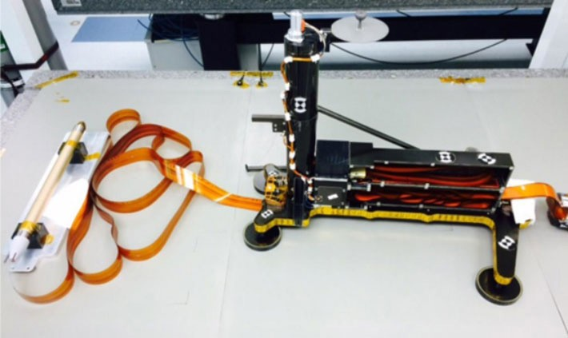

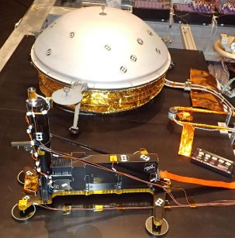

From left to right: HP3 investigation’s mole, science tether, support structure
and engineering tether.
HP3 (foreground) and domed Wind and Thermal Shield (covering SEIS) in preparation for thermal vacuum testing.

Rotation and Interior Structure Experiment

One of InSight’s three main investigations -- the geodesy study -- does not require its own dedicated science instrument: The Rotation and Interior Structure Experiment (RISE) will use InSight’s direct radio connection with Earth to assess perturbations of Mars’ rotation axis. These measurements can provide information about the planet’s core.

The perturbations resemble the wobble of a spinning top, and occur on two time scales. The longer wobble takes about 165,000 years and is the same as the process that makes a top wobble, called precession. The speed of this precession is directly related to the proportion of the body’s mass that is close to the center, in the iron-rich core. The shorter-period
wobbles, called nutations, occur on time scales of less than a year and are extremely small. Their cause is unrelated to a toy top’s wobble. A closer analogy is the traditional method for determining whether an egg is hard-boiled by spinning it. An egg

with a solid center spins easily. The liquid center of a raw egg perturbs the spin.

With InSight as the marker for a specific point on the Martian surface, radio tracking will monitor the location of that point in space to within a less than 4 inches (10 centimeters). This will provide information about how much the rotation axis of Mars sways with motion that is an indicator about the size of the core.

Radio tracking of the location of NASA’s Mars Pathfinder lander for three months in 1997, combined with tracking data from the Viking Mars landers in the 1970s, provided information about long-term changes (precession) in Mars’ spin axis. Researchers were able to confirm that Mars has a very dense core. A different radio-science investigation, analyzing gravitational effects of Mars on NASA’s Mars Global Surveyor orbiter, indicated some portion of the planet’s outer core is molten, based on how much Mars bulges from tidal pull of the Sun.

A longer tracking period with a stationary lander is the next step for measuring nutations to determine the core’s exact size and density, and how much of the core is molten. This is not an experiment suited to Mars rovers, because they change their locations on the planet.

The tools for the RISE investigation are the X-band radio on the InSight lander and the large dish antennas of NASA’s Deep Space Network at stations in California, Australia and Spain. This is the same direct radio link by which the spacecraft will receive commands and can return data, though it will use relayed radio links through Mars orbiters for most of its data return.

The lead investigator for RISE is William Folkner of JPL, who led the 1997 investigation of Mars’ core using the radio link
between Earth and NASA’s Mars Pathfinder.

Auxiliary Payload Sensor Subsystem
InSight carries a suite of environmental-monitoring instruments, called the Auxiliary Payload Sensor Subsystem (APSS), to measure the local magnetic field, wind, and atmospheric temperature and pressure. The primary reason for including these instruments in the mission’s payload is to aid interpretation of seismometer data by tracking changes in the magnetic field or atmosphere that could cause ground movement or sensor readings that might otherwise be mistaken for a seismic event. However, they can also serve on their own for other Mars science investigations.

InSight’s magnetometer will be the first ever used on the surface of Mars. Researchers will use it to investigate variations in the magnetic field, which may be induced at the surface by the variations resulting from interaction of the solar wind with Mars’ ionosphere. Effects of the planet’s metallic core on the induced magnetic field at the surface could provide information about the size of the core.

The University of California, Los Angeles, provided InSight’s fluxgate magnetometer. UCLA has previously provided magnetometers for other NASA missions, including the Galileo mission to Jupiter and the Space Technology 5 mission. The instrument can determine both the magnitude and direction of the local magnetic field.

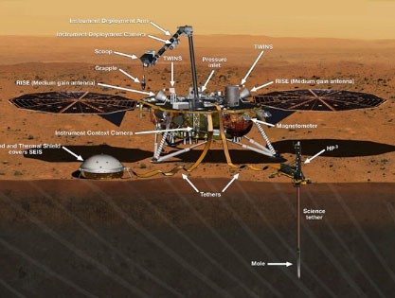
Two finger-size booms mounted on short vertical supports on InSight’s deck will monitor atmospheric temperature and the direction and velocity of the wind. The booms face outward in roughly opposite sides of the lander, so that wind from any direction reaches at least one of them before the lander itself perturbs the wind much. Together, they make up the Temperature and Wind for InSight (TWINS) instrument. Each of the booms holds a sensors for recording air temperature and detecting air movement in three dimensions.

Spain’s Center for Astrobiology (Centro de Astrobiología, or CAB), Madrid, provided TWINS. The instrument’s booms are refurbished flight spares from the CAB-provided weather station on NASA’s Curiosity Mars rover, called the Rover Environmental Monitoring Station.

InSight’s atmospheric pressure sensor sits inside the lander, with access to the atmosphere via an inlet on the lander deck. Tavis Corp., Mariposa, California, built it. The device has more than ten-fold greater sensitivity to pressure variations at seismic frequencies than similar pressure sensors on NASA’s Viking and Mars Pathfinder landers.

JPL provided the control and data-acquisition electronics shared by the APSS instruments.

Though not formally part of the APSS, the HP3 radiometer and the color cameras of InSight’s Instrument Deployment Subsystem can similarly be used to study the Mars environment. The radiometer can track daily and seasonal changes in ground temperature. The cameras can be used for monitoring changes at the landing site, such as the effect of wind on dust over the course of many months.

Labeled illustration of InSight with its science payload deployed. Many of the investigation tools are labeled. SEIS is the Seismic Experiment for Interior Structure. HP3 is the Heat Flow and Physical Properties
Probe. RISE is the Rotation and Interior Structure Experiment, which uses the lander’s two medium gain antennas. TWINS is the Temperature and Wind for InSight instrument, part of the mission’s Auxiliary Payload Sensor Subsystem, which also includes
the magnetometer, the pressure sensor (out of view beneath the pressure inlet). Locations of the lander’s radiometer and laser retroreflector are out of sight, on the other side of the deck.

Laser Retroreflector for Mars
A dome-shaped device about 2 inches (5 centimeters) in diameter and 0.8 inch (2 centimeters) high, affixed to the top of the InSight lander’s deck, holds an array of eight special reflectors. This is the Laser Retroreflector for InSight, or LaRRI, which is not part of the InSight mission’s own science investigations, but may passively provide science value for many years to come.

The national space agency of Italy (ASI, for Agenzia Spaziale Italiana) provided LaRRI to be used by a possible future Mars orbiter mission with a laser altimeter making extremely precise measurements of the lander’s location. Each of the eight reflectors uses three mutually perpendicular mirrors, joining at one point like an inner corner of a box. This gives it the property of returning any incoming light directly back toward its source.
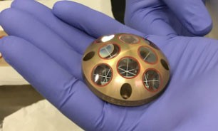

Apollo astronauts on the Moon placed larger arrays of similar “corner cube reflectors” at several lunar landing sites more than 45 years ago. These have served ever since in experiments that use precisely timed laser pulses sent from Earth and reflected back, for purposes such as determining the rate of change in the Moon’s distance from Earth and testing Einstein’s general theory of relativity. Scientists plan to use LaRRI -- plus similar retroreflectors on future missions to land on Mars -- for experiments that
use reflection of laser pulses emitted by orbiters. Besides providing precise

location information for experiments about gravity and planetary motion, such studies could include investigations of the Martian atmosphere and advances in using laser as an alternative to radio for communications.
Laser Retroreflector for InSight (LaRRI)

InSight Principal
InSight Science Team
SEIS Principal Investigator Philippe Lognonné of the Institute of Earth Physics of

Investigator Bruce Banerdt and InSight Deputy Principal Investigator Sue Smrekar, both of JPL, lead
Paris (Institut de Physique du Globe de Paris, or IPGP) leads the seismic study.

HP3 Principal Investigator is Tilman Spohn, of the German Aerospace Center (Deutsches Zentrum für Luft- und Raumfahrt, or DLR), Berlin, leads the heat- transport study.

the mission’s international

science team.
RISE Principal Investigator William Folkner of JPL leads the geodesy study.

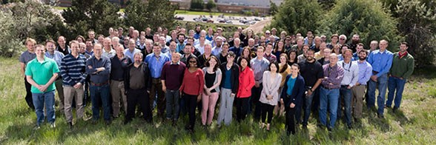

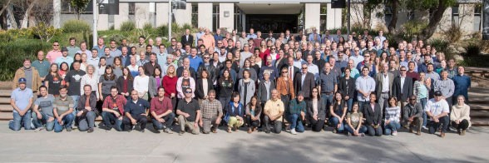

Sami Asmar
JPL

Véronique Dehant
Renee Weber
NASA Marshall Space Flight Center, Huntsville, Alabama

Chris Russell
UCLA

Mark Wieczorek

Royal Observatory of Belgium, Brussels Don Banfield
Cornell University, Ithaca, New York

Domenico Giardini
University of Nice

Ulrich Christensen
Max Planck Institute for Solar System

Swiss Federal Institute of Technology (Eidgenössische Technische Hochschule), Zurich

Troy Hudson
JPL

Günter Kargl
Austrian Academy of Sciences Space Research Institute (Oesterreichische Akademie der Wissenschaften Institut für Weltraumforschung), Graz

Antoine Mocquet
University of Nantes, France

Tom Pike
Imperial College, London

Brigitte Endrun-Knapmeyer
MPS

Matt Golombek
JPL

Catherine Johnson
University of British Columbia, Vancouver, Canada

Justin Maki
JPL

Paul Morgan
Colorado Geological Survey and Colorado School of Mines

Jeroen Tromp
Princeton University, Princeton, New Jersey
Research (Max-Planck-Institut für Sonnensystemforschung, or MPS), Göttingen, Germany

Raphael Garcia
National Higher School of Aeronautics and Space (École Nationale Supériere de l’Aéronautique et de l’Espace, or ISAE), Toulouse, France

Matthias Grott
DLR

David Mimoun
ISAE

Mark Panning
JPL

Mission: Landing Site
Mission: Landing Site

InSight’s purpose is to study the interior of Mars, not
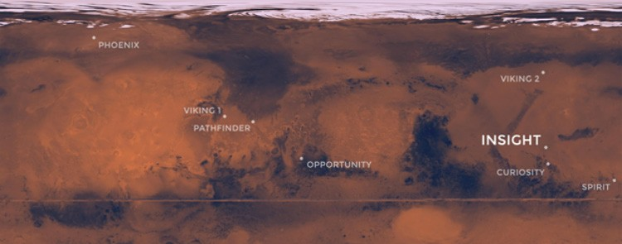

the surface. Still, location matters. The landing site, a smooth expanse of lava plains called Elysium Planitia, was carefully selected for its safety and sunlight, among other attributes.

The camera on InSight’s arm will take images to make a 360-degree panorama of the surroundings after landing. The panorama is expected to look much the same in all directions: flat, no big hills nearby and few large rocks in view. That expectation is based on many high-resolution images taken from orbit, as the site was evaluated.

The site lies in the western portion of Elysium Planitia, centered at about 4.5 degrees north latitude and 135.9 degrees east longitude. The spacecraft has a better than 99 percent chance of coming down within a “landing ellipse” surrounding the targeted center of the site. InSight’s landing ellipse is about 81 miles (130 kilometers) west-to-east and about 17 miles (27 kilometers) north-to-south.

Planitia is Latin for a flat surface, geometric plane or geographical plain. Elysium is from the ancient Greek name for an afterlife paradise, usually referred to in English as the Elysian Fields.

InSight has several very specific requirements for its landing location. One is being close enough to the equator for the lander’s solar array to have adequate power at all times of the year, and another is to have the right conditions for keeping the spacecraft’s electronics warm. That
combination constrains eligible sites to a band just north of the equator, between 5 degrees north latitude and 3 degrees north latitude.

Also, the elevation must be low enough to have sufficient atmosphere above the site for a safe landing, because the spacecraft will rely on the atmosphere for deceleration with a parachute during descent. The safety criterion for elevation of the site is at least 8,200 feet (2.5 kilometers) lower than a reference zero elevation that is used as Mars’ equivalent of “sea level.”

Only three areas on Mars meet these basic engineering constraints for InSight. Besides Elysium Planitia, the only other two areas are Isidis Planitia and Valles Marineris.

The Context Camera (CTX) and High Resolution Imaging Science Experiment (HiRISE) cameras on NASA’s Mars Reconnaissance Orbiter played important roles in evaluating candidate landing sites on Mars. HiRISE images revealed individual rocks down to the size of about 3 feet (1 meter) across and CTX images provided regional context. Stereo pairs of images provided three-dimensional information used for evaluating the steepness of slopes. HiRISE took about 150 images of candidate InSight landing sites.

Mission: Landing Site

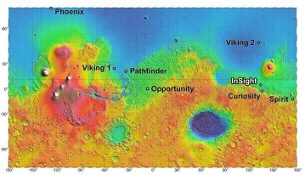
The landing site for InSight, in relation to landing sites for seven previous missions, is shown on a topographic map of Mars.
Rockiness and slope are factors in landing safety and are also important in determining whether InSight can succeed in its mission after landing. An overly steep nearby slope could foil the robotic arm’s access to a sufficiently large work area beside the lander. A steep slope in the wrong direction could jeopardize adequate power output from the solar arrays. A large enough rock at the landing site could block one of the solar arrays from opening. Rocks and steep slopes could also prevent placing the seismometer and heat-flow probe on the surface.

Isidis Planitia and Valles Marineris were assessed as too rocky and windy. Valles Marineris also lacks any swath of flat ground large enough for a safe landing. That left Elysium. For the first time ever, the site evaluation for this Mars mission also extended beneath the ground surface. For mission success, the ground in the lander’s workspace must be penetrable by InSight’s heat-flow probe. The probe was designed to hammer itself into the soil to a depth 10 to 16 feet (3 to 5 meters).

Key evidence showing that the ground in Elysium will be loose material suitable for burrowing, rather than solid bedrock, came from an assessment by the Thermal Imaging System (THEMIS) on NASA’s Mars Odyssey orbiter. Observations by this camera show how quickly the ground cools at night or warms in sunlight. (Solid rock changes temperature more slowly than softer ground.)
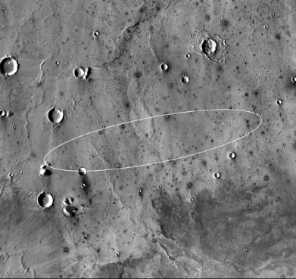

In workshops in 2013, 2014 and 2015, an initial list of 22 candidate landing ellipses in Elysium was narrowed to four
finalists. The final site was judged to be the safest and most likely to lead to mission success.

Elevation within the selected ellipse averages about 8,700 feet (2,650 meters) lower than the reference zero elevation.

Smooth, flat ground dominates InSight’s landing ellipse in the Elysium Planitia region of Mars. The ellipse is about 81 miles (130 kilometers) long, generally west to east, and about 17 miles (27 kilometers) wide, covering the area where the spacecraft has about 99 percent chance of landing. The base map is a mosaic of thermal infrared images from the Thermal Emission Imaging System
(THEMIS) camera on NASA’s Mars Odyssey orbiter. Thermal images can be used to infer surface properties. For example, the dark halos around small craters indicate rocky material ejected from them. The ellipse shown here is for launch on the first possible date: May 5, 2018. For launches later during the five-week launch period, the ellipse rotates clockwise, to about 12 degrees of rotation for launch at the latest opportunity.

Program & Project Management
Program & Project Management

The InSight project is managed by the Jet Propulsion Laboratory, Pasadena, California, for NASA’s Science Mission Directorate, Washington. JPL is a division of Caltech, Pasadena.

The InSight mission was competitively chosen and funded as part of the NASA Discovery
Program. As a complement to NASA’s larger “flagship” planetary science explorations, the Discovery Program’s goal is to achieve outstanding results by launching many smaller missions using fewer resources and shorter development times.

More information on NASA’s Discovery Program can be found in the Appendix and at: planetarymissions.nasa.gov.
At NASA Headquarters, Washington, the Discovery Program is managed by the Science Mission Directorate. Thomas Zurbuchen is associate administrator for the Science Mission Directorate. Jim Green is director of NASA’s Planetary Division. Ramon DePaula is program executive for InSight and Robert Fogel is the program scientist.

Discovery Program class missions are managed for NASA’s Planetary Science Division by the Planetary Missions Program Office at Marshall Space Flight Center in Huntsville, Alabama. At Marshall, Brian Key is the acting program manager of the Planetary Missions Program Office and Rick Turner is Planetary Missions Program Office mission manager.

At JPL, for InSight, Bruce Banerdt is the principal investigator, Tom Hoffman is project manager, Sue Smrekar is deputy principal investigator, Chuck Scott is flight system manager and Rick Welch is mission manager.

Lockheed Martin Space, Denver, built the InSight spacecraft and collaborates with JPL in mission operations. Stu Spath is InSight program manager at Lockheed Martin.

Joel Krajewski of JPL is project manager for Mars Cube One (MarCO). JPL built MarCO.

Appendix: Mars Cube One Tech Demo
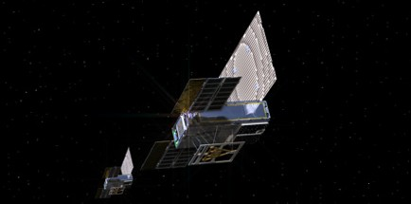
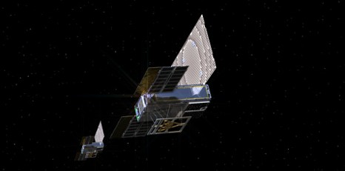

A technology demonstration called Mars Cube One (MarCO) will be the first deep space use of miniature, modular “CubeSat” spacecraft design. The pair of briefcase-size spacecraft -- MarCO-A and B -- will launch on the same rocket as InSight and carry out a number of risky communication and navigation flight experiments.
If successful, the twins, MarCO-A and MarCO-B, will fly separately towards Mars and potentially pass the planet at about 2,175 miles (3,500 kilometers) away just as InSight is landing. One could potentially receive transmissions from InSight and relay status information to Earth about the lander’s descent and touchdown.

All previous CubeSats have orbited the Earth. MarCO is the first attempt to go to another planet. By verifying that the technologies for interplanetary missions are
feasible and can be developed on a short timeline, this test mission could lead to many other SmallSat applications for exploring our solar system. Some could provide similar support functions as “carry your own” relay providers.
Others could have primary scientific research functions of their own, such as radio transmissions through planetary atmospheres, imaging with small cameras, observations with other miniaturized instruments, or in-place measurements of space environments.
The success of the InSight mission does not depend on MarCO’s performance. NASA’s Mars Reconnaissance Orbiter (MRO) and large radio telescopes on Earth are also expected to receive transmissions from InSight during descent and landing. MRO will hold that data for more than an hour while circling Mars before transmitting it to Earth. The radio telescopes will only be able to
listen for “aliveness.” However, should a MarCO CubeSat make it all the way to Mars, each has the capability to relay a substantive amount of data almost immediately, transmitting status information on an 8.7-minute, speed- of-light trip to Earth across about 97.5 million miles (157 million kilometers) between the two planets.

The reason for flying two identical MarCO spacecraft is
redundancy in case either one does not operate as planned.

CubeSats are a class of spacecraft based on a standardized small size and modular use of off-the-shelf technologies.
Many have been made by university students, and hundreds have been launched into Earth orbit using extra payload mass available on launches of larger spacecraft.

The basic CubeSat unit is a box roughly 4 inches (10 centimeters) square. Larger CubeSats are multiples of that

unit. MarCO’s design is a six-unit CubeSat. Each of the two spacecraft has a stowed size of about 14.4 inches (36.6 centimeters) by 9.5 inches (24.3 centimeters) by 4.6 inches
(11.8 centimeters).

The spring-loaded CubeSat deployment system for MarCO is on the aft bulkhead carrier of the Centaur upper stage of InSight’s Atlas V launch vehicle. That is near the base of the Centaur, not inside the fairing that encloses the main spacecraft. At launch and until the Centaur upper stage separates from the first stage of the Atlas V, the aft bulkhead carrier is sheltered within an inter-stage adaptor between the launch vehicle and the second, or upper, stages.

After the Centaur upper stage has released the InSight spacecraft on course toward Mars, it will do a short roll, then release MarCO-A, roll 180 degrees further and release MarCO-B.

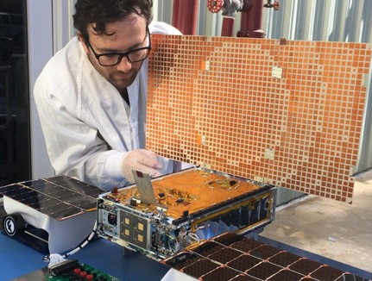

JPL engineer Joel Steinkraus works with one of the MarCO CubeSats during an outdoor test of its solar arrays.

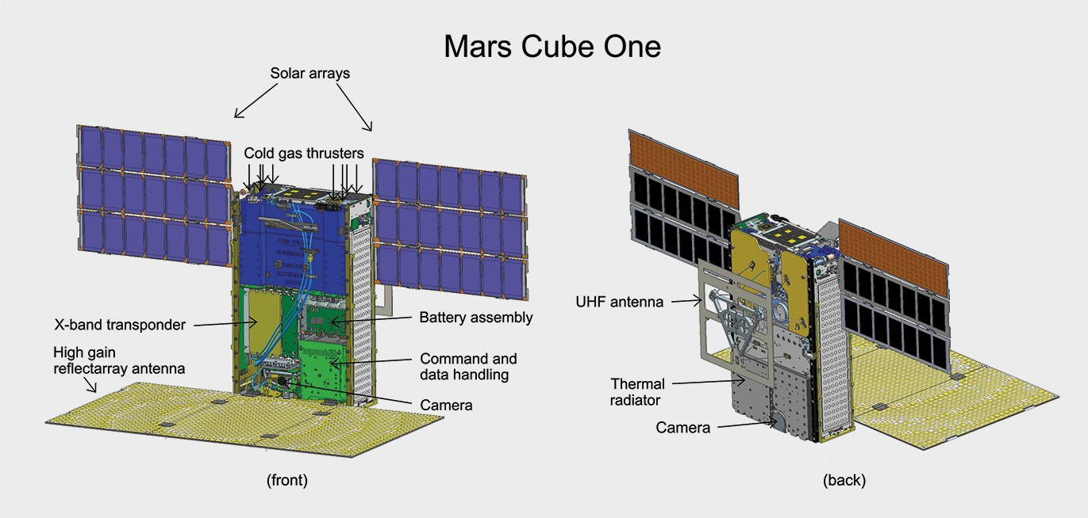

Illustration of one of the twin MarCO spacecraft with some key components labeled. Front cover is left out to show some internal components. Antennas and solar arrays are in deployed configuration.
If all goes according to plan, within about 10 minutes after separation from the Centaur, each MarCO will begin to deploy its solar panels. Each MarCO generates electric power with a pair of photovoltaic panels, and each panel has an area of about 12 inches by 12 inches (30 centimeters by 30 centimeters). Combined, these panels can provide each spacecraft about 35 watts when near Earth and 17 watts when near Mars. The power system also will use rechargeable lithium-ion battery cells, crucial for operations when spacecraft orientation for communication prevents the solar arrays from facing the Sun.

After the solar arrays are deployed, the MarCO control team will acquire radio contact with each CubeSat, one at a time, via NASA’s Deep Space Network. Early tasks will be to establish that the spacecraft are healthy, stable and commandable.

During the flight to Mars, the MarCO twins will each attempt to deploy a high-gain X-band antenna that is a flat “reflectarray” panel engineered to direct radio waves the way a parabolic dish antenna does. This will allow MarCO to transmit data to Earth from as far away as Mars without needing much power, if the spacecraft works as planned.
Two smaller X-band antennas on each spacecraft -- one
low-gain and one medium-gain -- work without needing to be deployed. These will serve for transmissions earlier in the flight and will also receive radioed commands from Earth.

The other deployed antenna is for the MarCO ultra-high frequency (UHF) radio receiver. InSight will be transmitting in UHF during its descent through the Martian atmosphere and from the surface of Mars. Both of the deployed antennas on each MarCO will be in fixed positions after deployment, with the high-gain antenna and UHF antenna facing different directions 90 degrees apart. The MarCOs will also test new technology using a softball-size radio, called “Iris.” This radio provides both UHF (receive only) and X-band (receive and transmit) functions capable of immediately relaying information received over UHF, at 8 kilobits per second.

A color wide-field engineering camera on each MarCO will be used to confirm high-gain antenna deployment. The wide-field camera has a 138-degree diagonal field of view and produces images 752 by 480 pixels in resolution.
Each MarCO was also designed with a color narrow-field camera with a 6.8-degree diagonal field of view pointed in the direction of the UHF antenna (the opposite direction from the high-gain antenna). (MarCO-A’s narrow-field camera was found to be inoperable prior to launch.) Both kinds of cameras can produce images 752 by 480 pixels in resolution.

The team will navigate MarCO-A and MarCO-B separately to Mars with course adjustments along the way. The first of five opportunities for MarCO trajectory correction maneuvers will come about a week after launch.

Each MarCO’s attitude-control system combines a star tracker, Sun sensors, gyroscopes and three-axis
reaction wheels for monitoring and adjusting orientation. Accelerating a reaction wheel rotates the spacecraft in the opposite direction from the direction the wheel is spinning.

MarCO’s propulsion system uses compressed R236FA gas, a common propellant in fire extinguishers. Each MarCO has eight thrusters that can release this cold-gas propellant in different directions from a single, shared tank. The thrusters will operate for trajectory adjustments and for desaturating the reaction wheels. MarCO is pioneering CubeSat use of propellant for desaturating attitude-control reaction wheels; Earth-orbiting CubeSats typically control attitude with electromagnet devices that “push” against Earth’s magnetic field, an option not available to MarCO in deep space.

The “cruise” period of flying from Earth to Mars will be
used to complete the communication and navigation technology demonstration objectives. They will also include checkouts of MarCO’s temperatures, power levels and other onboard subsystems. Each MarCO carries heaters, multiple temperature sensors, thermal blanketing and two radiators for thermal control.
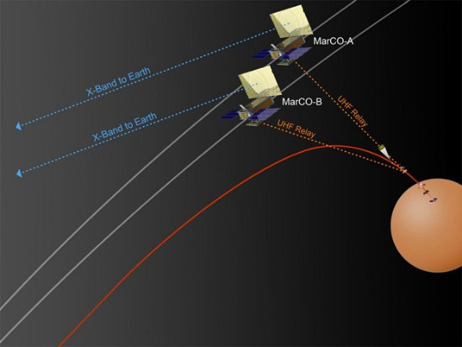

MarCO will relay data from InSight to Earth during InSight’s descent through Mars’ atmosphere and touchdown on the surface. NASA’s Mars Reconnaissance Orbiter will also receive these data from InSight.

If all goes well, on Nov. 26, 2018, MarCO-A and MarCO-B could be flying past Mars during the critical minutes when InSight enters the Martian atmosphere, descends toward the surface and touches down. Each MarCO will maintain an orientation with the UHF antenna pointed down toward InSight as it lands on Mars, and the high-gain X-band antenna pointed back toward Earth. In this orientation, the solar panels will not face the Sun, so MarCO will be operating on battery power. InSight will be transmitting its status information at 8 kilobits per second over UHF. Each MarCO will attempt to receive that data stream, format it and relay it Earthward in near-real-time to NASA’s Deep Space Network. Since MarCO adds formatting information, as well as a small amount of spacecraft information, to the datastream, the delay is expected to increase as more data are sent from InSight.

The delay, however, is not expected to be more than a few minutes. Earth will be oriented so that the information relayed via MarCO will go to the Madrid, Spain, station of the Deep Space Network, from which it will be routed to the InSight mission operations team.

NASA’s Jet Propulsion Laboratory, Pasadena, California, which manages both InSight and MarCO for NASA, built the two MarCO spacecraft in JPL’s CubeSat assembly clean room. At JPL, Joel Krajewski is MarCO’s project manager and Andrew Klesh is MarCO’s project engineer.

Technology suppliers for MarCO include: Blue Canyon Technologies of Boulder, Colorado, for the attitude-control system; VACCO Industries of South El Monte, California, for the cold-gas thrusters; AstroDev of Ann Arbor, Michigan, for electronics; MMA Design LLC, also of Boulder, for solar arrays; and Tyvak Nano-Satellite Systems Inc., a Terran Orbital Company in San Luis Obispo, California, for the CubeSat dispenser system. United Launch Alliance, Centennial, Colorado, is providing the Atlas V and launch services.

Appendix: Gallery
Appendix: Gallery

Images
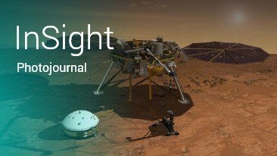

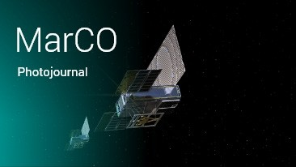

InSight images on Planetary Photojournal https://go.usa.gov/xnUXj
MarCO images on Planetary Photojournal https://go.usa.gov/xQBV7

InSight images on InSight website
https://go.usa.gov/xQBV6

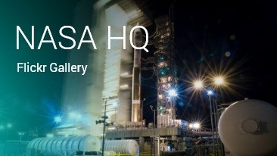

NASA Headquarters Flickr feed
https://bit.ly/1ArkQtd

Latest spacecraft processing images
https://bit.ly/2I07UoS

Web Videos
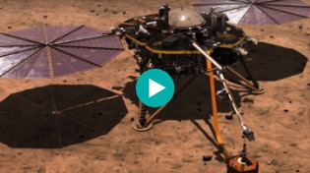

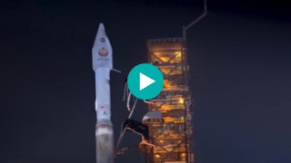

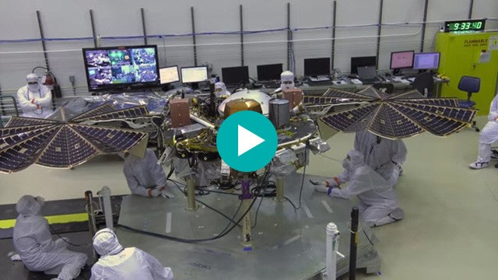

Overview of the InSight mission
https://youtu.be/LKLITDmm4NA
Watching the First Interplanetary Launch from America’s West Coast https://youtu.be/AuNfBRaywU4

InSight spreads its solar wings
https://youtu.be/Z3twtYCXxNo

Appendix: Gallery
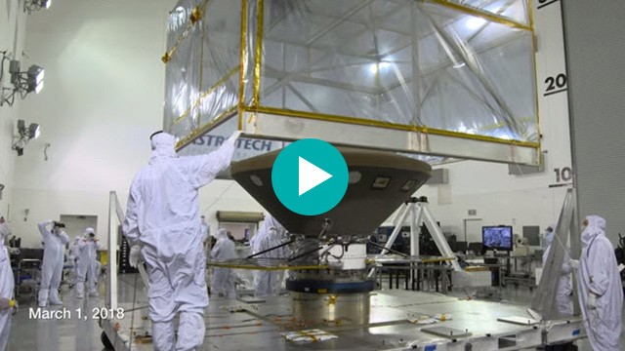

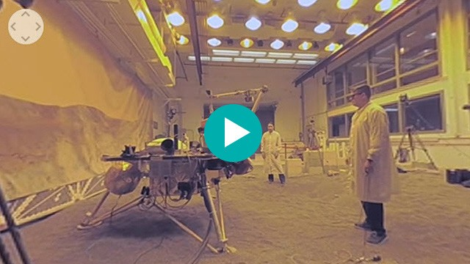

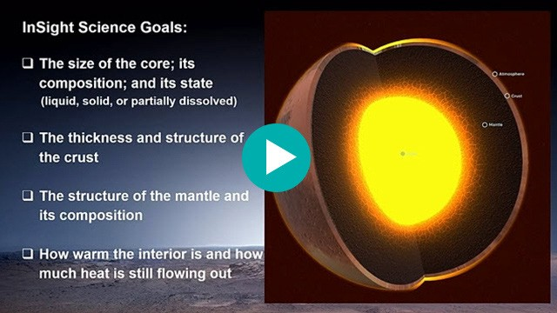

InSight arrives at Vandenberg Air Force Base https://youtu.be/FQtjra0uEnc

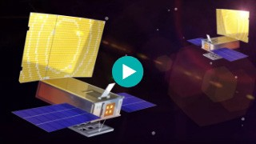

Overview of the MarCO mission
https://youtu.be/P_8ZEAPrrHQ
Engineering For Mars: NASA InSight Mission Test Lab (360 Video) https://youtu.be/ZSXnw-fJbGk

“Crazy Engineering” video on CubeSats such as MarCO https://youtu.be/7RrWZJHkREI

“Looking Deep: The InSight Mission to Mars” -- a public lecture at JPL by Troy Hudson, member of the InSight science team and instrument systems engineer for the heat flow instrument
https://youtu.be/kqTR0mrIIEc

Animations and Raw Video
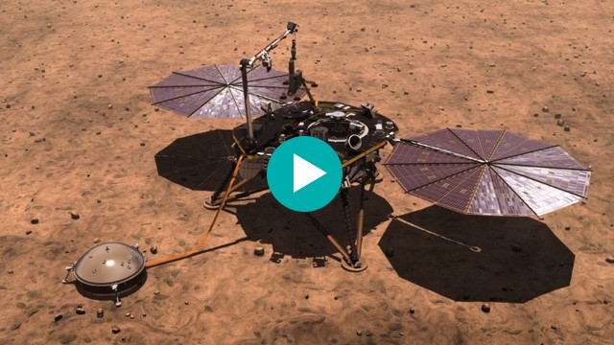

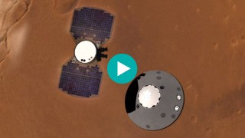

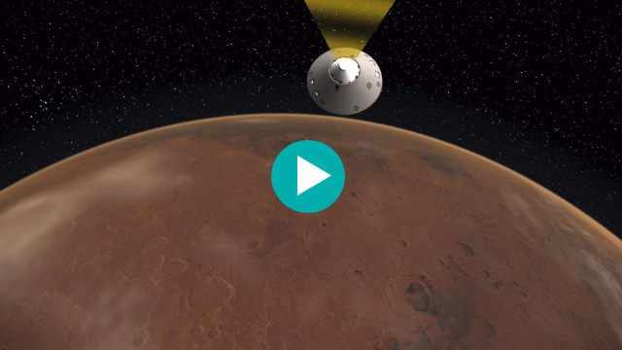

Insight Media Reel
https://vimeo.com/261856765

Mars InSight:
NASA’s Next Mission to Red Planet
https://vimeo.com/262314021

MarCO Media Reel
https://vimeo.com/265040492

Appendix: Science Objectives, Quantified
Appendix: Science Objectives, Quantified
These are the quantifiable success criteria that have been
set for accomplishing InSight’s science objectives:
Determine the thickness and structure of the crust
Determine the crustal thickness with a precision of plus or minus 10 kilometers (6.2 miles). The pre-InSight state of knowledge is that the crust is about 65 kilometers (40 miles) thick, plus or minus 35 kilometers (22 miles).
Resolve crustal layers with a thickness of 5 kilometers (3 miles) or greater. Prior to InSight, there is no certain knowledge about crustal layering.

Determine the composition and structure of the mantle
Determine the velocities of seismic waves in the upper 600-kilometer (373-mile) of the mantle to a precision of plus or minus 0.25 kilometer per second (560 miles per hour). Mantle composition can be inferred from seismic velocities. The pre-InSight state of knowledge is that velocity of seismic waves through the mantle is about 8 kilometers per second (about 18,000 miles per hour) with an uncertainty of plus or minus 1 kilometer per second (about 2,200 miles per hour).

Determine the size, composition and physical state of the core
Positively distinguish between a liquid and solid outer core.
Determine the radius of the core to a precision of plus or minus 200 kilometers (124 miles). Current estimates are that the core radius is about 1,700 kilometers (about 1,050 miles) plus or minus 300 kilometers (186 miles).
Determine the core’s density to a precision of plus or minus 450 kilograms per cubic meter (28 pounds per cubic foot). Core composition can be inferred from density. The pre-InSight state of knowledge is that the core density is about 6,400 kilograms per cubic meter (400 pounds per cubic foot) plus or minus 1,000 kilograms per cubic meter (62 pounds per cubic foot).

Determine the thermal state of the interior
Determine the heat flux from the planet’s interior at the landing site to a precision of plus or minus 5 milliwatts per square meter (one-half milliwatt per square foot). Pre-InSight estimates are that the heat flux from the Martian interior is about 30 milliwatts per square meter (3 milliwatts per square foot) plus or minus 2.5 milliwatts per square meter (2.5 milliwatts per square foot).

Measure the rate and geographic distribution of seismic activity
Determine the rate of seismic activity to within a factor of two; determine the distance to the epicenter of a seismic event to within 25 percent; and determine the azimuth (compass direction) to the epicenter to within 20 degrees. None of these values have previously been measured.

Measure the rate of meteorite impacts on the surface
Determine the meteorite impact rate on Mars to within a factor of two. Current estimates are within a factor of about six.

Appendix: Historical Mars Missions
Appendix: Historical Mars Missions

History
*Mission: Country, Launch Date, Purpose, Results

Marsnik 1: USSR, 10/10/60, Mars flyby, did not reach Earth orbit Marsnik 2: USSR, 10/14/60, Mars flyby, did not reach Earth orbit Sputnik 22: USSR, 10/24/62, Mars flyby, achieved Earth orbit only
Mars 1: USSR, 11/1/62, Mars flyby, radio failed at 65.9 million miles (106 million kilometers)
Sputnik 24: USSR, 11/4/62, Mars flyby, achieved Earth orbit only
Mariner 3: U.S., 11/5/64, Mars flyby, shroud failed to jettison
Mariner 4: U.S. 11/28/64, first successful Mars flyby 7/14/65, returned 21 photos
Zond 2: USSR, 11/30/64, Mars flyby, passed Mars but radio failed, returned no planetary data
Mariner 6: U.S., 2/24/69, Mars flyby 7/31/69, returned 75 photos Mariner 7: U.S., 3/27/69, Mars flyby 8/5/69, returned 126 photos Mars 1969A: USSR, 3/27/69, Mars orbiter, did not reach Earth orbit Mars 1969B: USSR, 4/2/69, Mars orbiter, failed during launch Mariner 8: U.S., 5/8/71, Mars orbiter, failed during launch
Kosmos 419: USSR, 5/10/71, Mars lander, achieved Earth orbit only
Mars 2: USSR, 5/19/71, Mars orbiter/lander arrived 11/27/71, no useful data, lander burned up due to steep entry Mars 3: USSR, 5/28/71, Mars orbiter/lander, arrived 12/3/71, lander operated on surface for 20 seconds before failing Mariner 9: U.S., 5/30/71, Mars orbiter, operated in orbit 11/13/71 to 10/27/72, returned 7,329 photos
Mars 4: USSR, 7/21/73, failed Mars orbiter, flew past Mars 2/10/74
Mars 5: USSR, 7/25/73, Mars orbiter, arrived 2/12/74, lasted a few days
Mars 6: USSR, 8/5/73, Mars flyby module and lander, arrived 3/12/74, lander failed due to fast impact
Mars 7: USSR, 8/9/73, Mars flyby module and lander, arrived 3/9/74, lander missed the planet
Viking 1: U.S., 8/20/75, Mars orbiter/lander, orbit 6/19/76-1980, lander 7/20/76-1982
Viking 2: U.S., 9/9/75, Mars orbiter/lander, orbit 8/7/76-1987, lander 9/3/76-1980; combined, the Viking orbiters and landers returned more than 50,000 photos
Phobos 1: USSR, 7/7/88, Mars orbiter and Phobos lander, lost 8/88 en route to Mars Phobos 2: USSR, 7/12/88, Mars orbiter and Phobos lander, lost 3/89 near Phobos Mars Observer: U.S., 9/25/92, Mars orbiter, lost just before Mars arrival 8/21/93
Mars Global Surveyor: U.S., 11/7/96, Mars orbiter, arrived 9/12/97, high-detail mapping through 1/00, third extended mission completed 9/06, last communication 11/2/06
Mars 96: Russia, 1/16/96, orbiter/two landers/two penetrators, launch vehicle failed
Mars Pathfinder: U.S., 12/4/96, Mars lander/rover, landed 7/4/97, completed prime mission and began extended mission 8/3/97, last transmission 9/27/97
Nozomi: Japan, 7/4/98, Mars orbiter, failed to enter orbit 12/03
Mars Climate Orbiter: U.S., 12/11/98, lost upon arrival 9/23/99
Mars Polar Lander/Deep Space 2: U.S., 1/3/99, lander/two penetrators, lost on arrival 12/3/99
Mars Odyssey: U.S., 3/7/01, Mars orbiter, arrived 10/24/01, completed prime mission 8/25/04, currently conducting extended mission of science and communication relay

Appendix: Historical Mars Missions

Mars Express/Beagle 2: European Space Agency, 6/2/03, Mars orbiter/lander, orbiter completed prime mission 11/05, currently in extended mission; lander lost on arrival 12/25/03
Mars Exploration Rover Spirit: U.S., 6/10/03, Mars rover, landed 1/4/04 for three-month prime mission inside Gusev Crater, completed several extended missions, last communication 3/22/10
Mars Exploration Rover Opportunity: U.S., 7/7/03, Mars rover, landed 1/25/04 for three-month prime mission in Meridiani Planum region, currently conducting extended mission
Mars Reconnaissance Orbiter: U.S., 8/12/05, Mars orbiter, arrived 3/12/06, completed prime mission 9/26/10, currently conducting extended mission of science and communication relay
Phoenix Mars Lander: U.S., 8/4/07, Mars lander, landed 5/25/08, completed prime mission and began extended mission 8/26/08, last communication 11/2/08
Phobos-Grunt/Yinghuo 1: Russia/China, 11/8/11, Phobos lander with sample return and Mars orbiter, achieved Earth orbit only Curiosity rover (Mars Science Laboratory): U.S., 11/26/11, Mars rover, landed 8/6/12, completed prime mission, currently conducting extended science mission
Mars Atmosphere and Volatile Evolution Mission (MAVEN): U.S., 11/18/13, Mars orbiter, arrived 9/21/14, completed prime mission, currently conducting extended science mission
Mars Orbiter Mission (Mangalyaan): India, 11/5/13, Mars orbiter, arrived 9/14/14, completed prime mission, currently conducting extended mission
ExoMars 2016: European Space Agency, 3/14/16, orbiter and landing-demonstration module, Trace Gas Orbiter arrived 10/19/16, currently conducting prime mission; unsuccessful Mars impact of Schiaparelli module 10/19/16

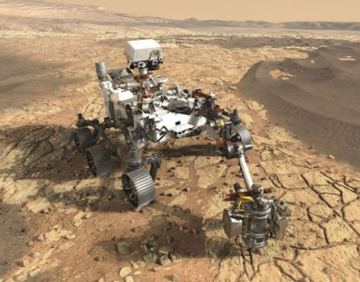

Future
NASA’s next mission to Mars, following InSight, will be the Mars 2020 mission, which is in development to launch in the summer of 2020. It will land a Curiosity-size rover in February 2021 to seek signs of past microbial life at a carefully selected site, using capabilities to examine rocks’ composition and texture at microscopic scale and to collect and seal drilled rock cores for possible future return to Earth. The rover will also test extraction of oxygen from the carbon dioxide in Mars’ atmosphere, as a useful technology for future astronauts on Mars.

Appendix: NASA’s Discovery Program
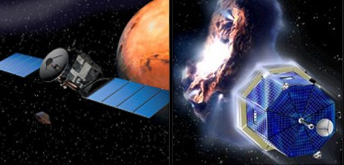
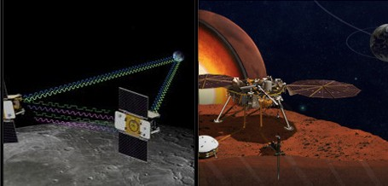
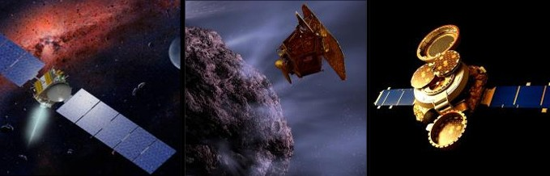
Appendix: NASA’s Discovery Program

In complementing NASA’s larger “flagship” missions, the Discovery Program’s main objective is to enhance our understanding of the solar system by exploring the
planets, their moons and small bodies such as comets and asteroids. The program also seeks to improve performance through the use of new technology and to broaden university and industry participation in NASA missions.

Discovery Program missions are designed and led by a principal investigator, who assembles a team of scientists and engineers, to address key science questions about the solar system.

Previous Discovery Program Missions
*Mission: Launch Date, Description

Near-Earth Asteroid Rendezvous (NEAR): 2/17/96, first spacecraft to orbit and land on an asteroid, entered orbit
around asteroid Eros 2/14/00
Mars Pathfinder: 12/4/96, demonstrated a low-cost method of delivering a set of science instruments and the first
rover to the surface of Mars, landed on Mars 7/4/97
Lunar Prospector: 1/6/98, enabled scientists to create detailed maps of the gravity, magnetic properties and chemical composition of the Moon’s entire surface
Stardust: 2/7/99, collected interstellar dust and comet dust during a close encounter with comet Wild 2 and returned the particles to Earth on 1/15/06 for analysis
Genesis: 8/8/01, spent two years collecting atoms of solar wind before returning them to Earth on 9/8/04 for analysis
Comet Nucleus Tour (CONTOUR): 7/3/02, intended to visit and study two comets, but contact lost 8/15/02 Mercury Surface, Space Environment, Geochemistry and Ranging (MESSENGER): 8/3/04, first Mercury orbiter, examined Mercury from orbit from 3/18/11 to 4/30/15
Deep Impact: 1/12/05, propelled a projectile into comet Tempel 1 on 7/4/05, creating a crater and yielding information about the internal composition and structure of a comet.
Dawn: 9/27/07, orbited protoplanet Vesta and dwarf planet Ceres, largest bodies in the main asteroid belt, to study conditions and processes at the dawn of our solar system
Kepler: 3/6/09, used a unique telescope to find more than 1,000 planets around stars beyond our solar system,
spacecraft repurposed as K2 mission in 2014
Gravity Recovery and Interior Laboratory (GRAIL), 9/10/11, put twin satellites into orbit around the Moon 12/31/11 to study the Moon’s interior and its thermal history

Appendix: NASA’s Discovery Program

Future
Lucy, expected to launch 10/21, will visit a main belt asteroid and six Jupiter Trojan asteroids (asteroids trapped by Jupiter’s gravity in two swarms that share the planet’s orbit, one leading and one trailing)

Psyche, expected to launch 10/23, will explore the intriguing asteroid, known as 16 Psyche, which is thought to be comprised mostly of metallic iron and nickel, similar to Earth’s core.

Missions of Opportunity
The Discovery Program also includes “missions of opportunity” that enable the U.S. science community to participate in non-NASA missions or to use an existing NASA spacecraft for a new investigation. Five missions of opportunity selected by the Discovery Program are the Analyzer of Space Plasma and Energetic Atoms instrument on the European Space Agency’s Mars
Express mission; The Moon Mineralogy Mapper on India’s Chandrayan-1 mission; the EPOXI mission repurposing the Deep Impact spacecraft; the Stardust New Exploration of Tempel 1 mission using the Stardust spacecraft; and the Strofio spectrometer instrument on the European Space Agency’s Bepi Colombo mission to Mercury.

