DATE_________________NAME________________

DATE_________________NAME________________

DATE_________________NAME________________

DATE_________________NAME________________

1. | Which of the following contain the /ch-/ sound: | EXITTICKET
2. | something else so you are not recognized. | EXITTICKET
2. | Write the vocabulary word that means to look like
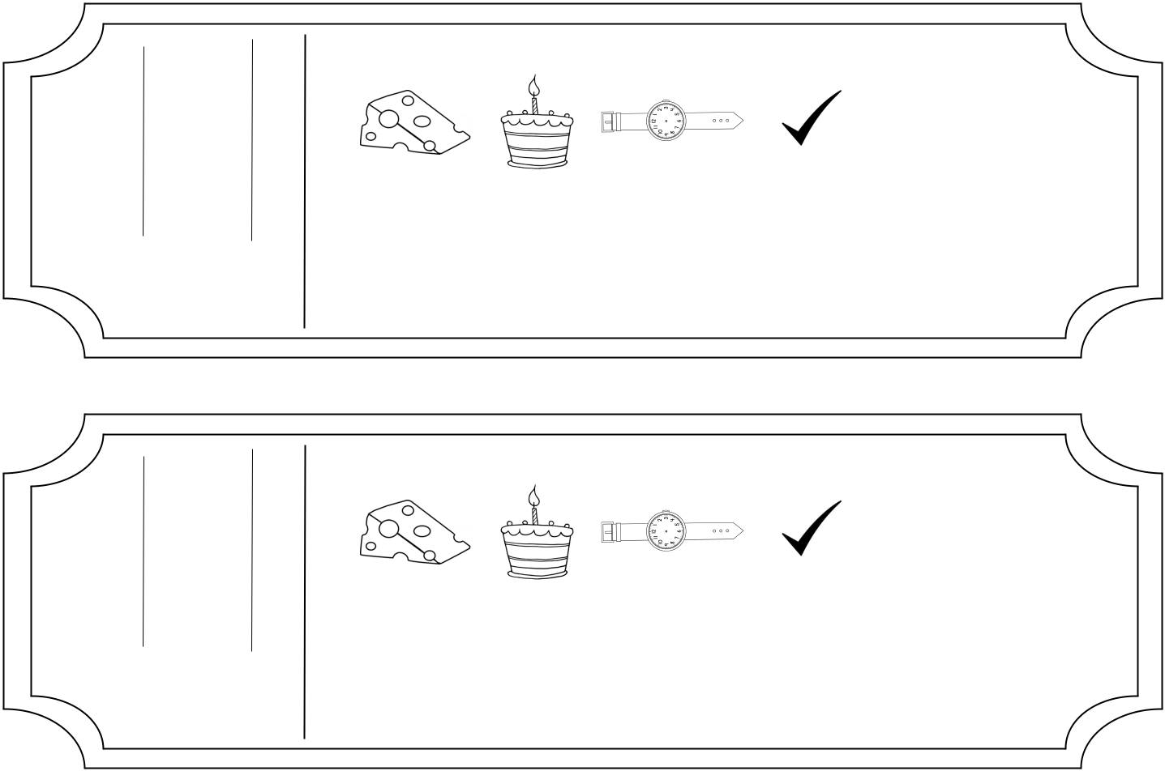

1. | Which of the following contain the /ch-/ sound: | EXITTICKET
2. | something else so you are not recognized. | EXITTICKET
2. | Write the vocabulary word that means to look like
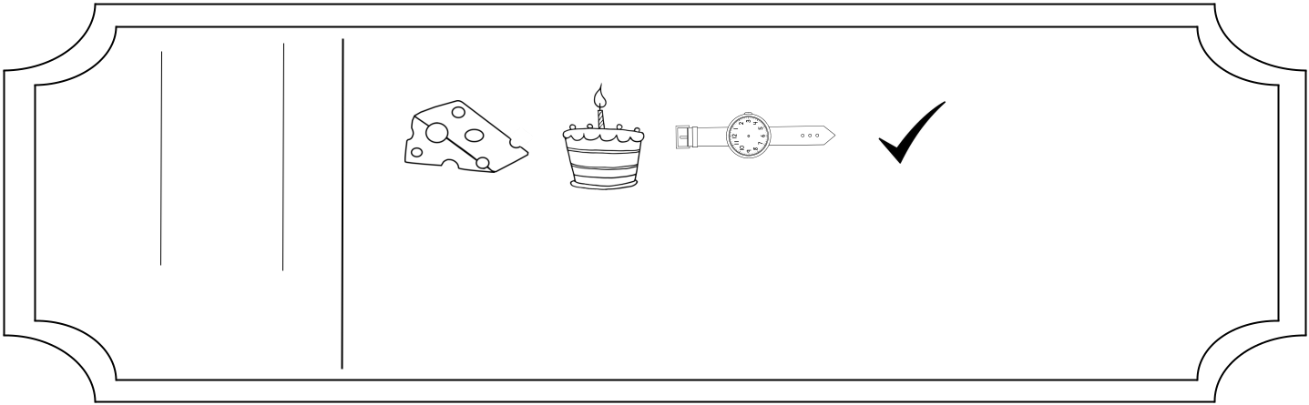

1. | Which of the following contain the /ch-/ sound: | EXITTICKET
2. | something else so you are not recognized. | EXITTICKET
2. | Write the vocabulary word that means to look like
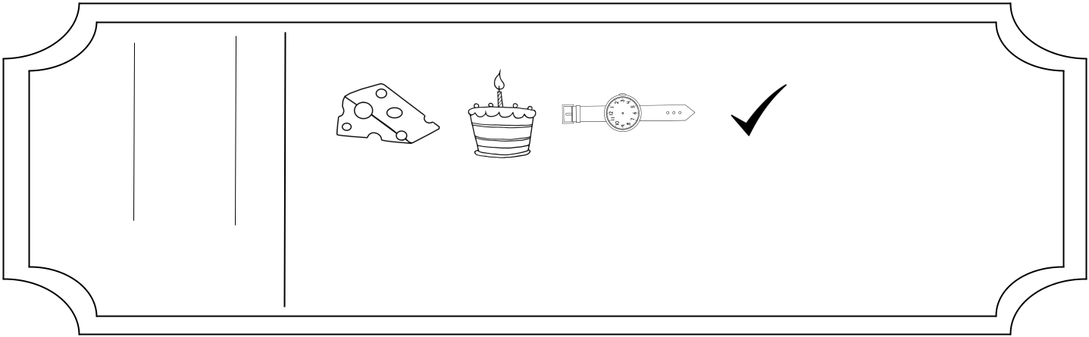

1. | Which of the following contain the /ch-/ sound: | EXITTICKET
2. | something else so you are not recognized. | EXITTICKET
2. | Write the vocabulary word that means to look like

DATE_________________NAME________________

DATE_________________NAME________________

DATE_________________NAME________________

DATE_________________NAME________________

1. Circle the following that contain r controlled vowels.
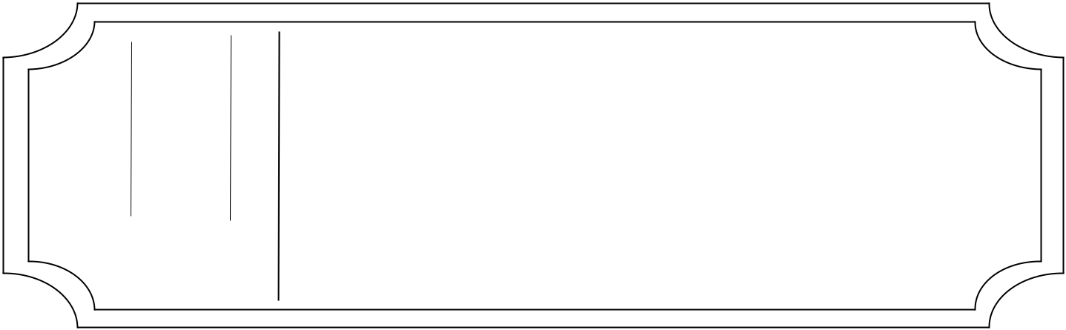

birdharp hurt thorn

- Write the vocabulary word that means forcing people to accept something.

1. Circle the following that contain r controlled vowels.

birdharp hurt thorn

- Write the vocabulary word that means forcing people to accept something.

1. Circle the following that contain r controlled vowels.

birdharp hurt thorn

- Write the vocabulary word that means forcing people to accept something.

1. Circle the following that contain r controlled vowels.

birdharp hurt thorn

- Write the vocabulary word that means forcing people to accept something.

EXITTICKET

EXITTICKET

EXITTICKET

EXITTICKET

DATE_________________NAME________________

DATE_________________NAME________________

DATE_________________NAME________________

DATE_________________NAME________________

1. Circle the following that contain the -st blend.
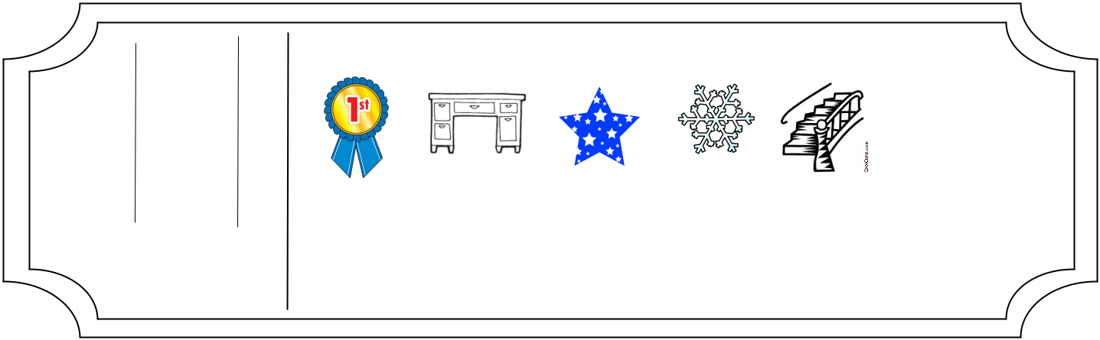

2. Write the vocabulary word that means very | EXIT | TICKET
different than normal.
1. Circle the following that contain the -st blend. |  |  | TICKET
2. Write the vocabulary word that means very | EXIT |  | TICKET
different than normal.
1. Circle the following that contain the -st blend. |  |  | TICKET
2. Write the vocabulary word that means very | EXIT |  | TICKET
different than normal.
1. Circle the following that contain the -st blend. |  | EXITTICKET
2. Write the vocabulary word that means very
different than normal.
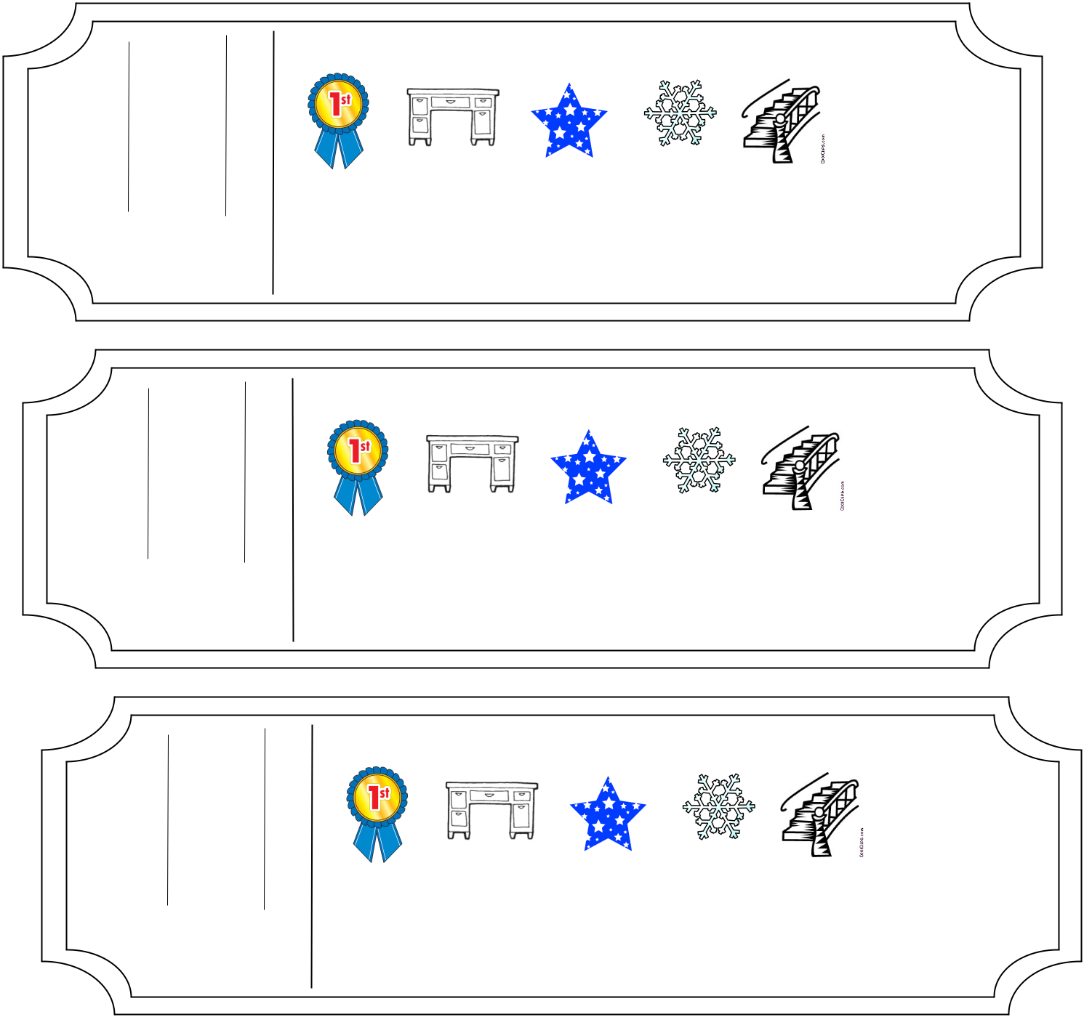
DATE_________________NAME________________

DATE_________________NAME________________

DATE_________________NAME________________

DATE_________________NAME________________

- Circle the following that contain the all chunk.

- Write the vocabulary word that means very different than normal.
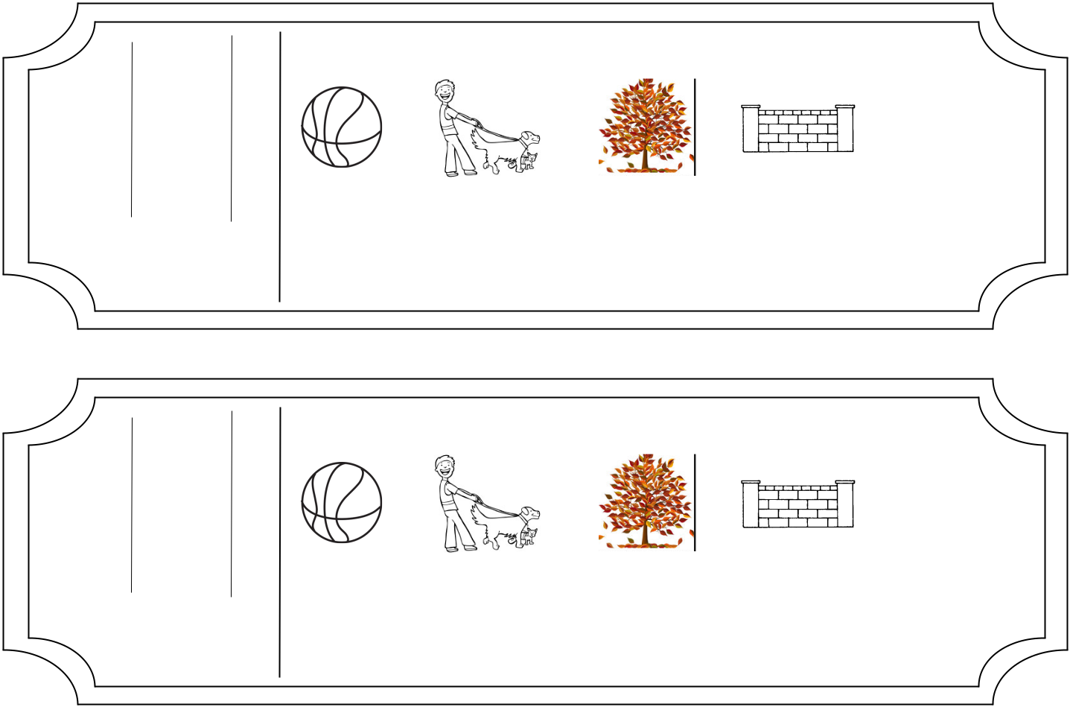

- Circle the following that contain the all chunk.

- Write the vocabulary word that means very different than normal.
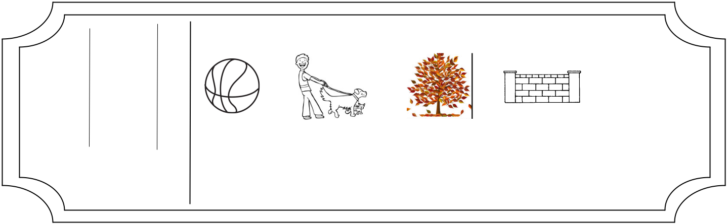

- Circle the following that contain the all chunk.

- Write the vocabulary word that means very different than normal.

- Circle the following that contain the all chunk.

- Write the vocabulary word that means very different than normal.

EXITTICKET

EXITTICKET

EXITTICKET

EXITTICKET

