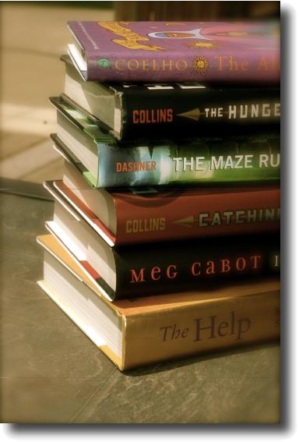

Creative

Assignments

to use with ANY Novel

These assignments and handouts can be used with any novel and for most grade levels. They are meant to be creative supplements for additional assessment. These are great for the kids who are reluctant readers who like hands-on projects and for advanced students who need additional stimulation and motivation.
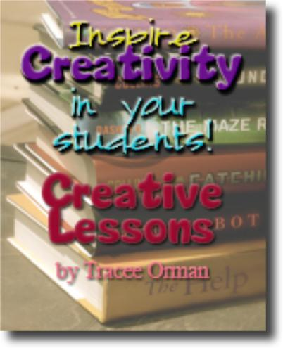

If you enjoy these assignments and find them useful, please take a moment to leave positive feedback. If you have any questions, find errors, or have any concerns, please feel free to email me directly at torman@erie1.info or orman3@mchsi.com. Thank you!

www.teacherspayteachers.com/Store/Tracee-Orman

Creative Assignments to use with ANY Novel © 2009, T. Orman

Creative Assignments to use with ANY Novel

- Make a bookmark for the book. Include one or more of the following: a quote from chapter one, a picture of one of the characters that you drew yourself, a map of the town/city or setting, a scene from chapter one, or the title & author in a creative font. (templates on page 8)

- Re-enact a scene from one of the chapters. Give students a list of characters. They must write a script based on the dialogue of that scene/chapter (or provide a script for them).

- Compare two characters by using a “scattergories”* analogy, such as:

Character A is like a ____________(game kids play) because __________________.

Character B is like a ____________(type of fruit) because _____________________.

- Do the “If I were _______, I would...” activity. Have the students choose one of the characters to “be” and write what they would do if they were that character. (Handout for this on page 10)

- Write an advertising slogan for an item that is a symbol in the book. Examples of popular slogans are:

Nike: Just do it. Visa: Itʼs everywhere you want to be.

Volkswagen: Driverʼs wanted. KFC: Itʼs finger-licking good.

Bounty: The quicker-picker-upper. Puffs: A nose in need deserves Puffs, indeed.

Pringles: Once you pop, you wonʼt stop. Mountain Dew: Do the Dew!

- Write a country-western song that summarizes the chapter.

- Write a rap song that summarizes the chapter.

- Write a poem that summarizes the chapter.

- Write an Ode to a character or object from the novel. An “Ode” is a poem dedicated to that person or object. They are usually titled “Ode to a _________” or “Ode for _____.”

Sample student ode (another example on page 15):
Ode to Tornadoes by Ronaldo B.

O spinning around, you are the wind blowing in my face. A light gray line reaching up to the heavens. A giant chimp twisting

in the flow of the wind. I love your strength

for blowing things away and destroying everything in your path.

- Write an event or scene from the novel as if you are a newspaper reporter. Interview characters who witnessed it first hand and include their quotes in your story. In addition, draw a picture to go along with your story or find a picture from your photo library or from the internet to include with your story.


Creative Assignments to use with ANY Novel © 2009, T. Orman

Creative Assignments to use with ANY Novel

- Give characters nick-names that would fit with their personalities or actions. For example, a character whose name is Frank and wears an eye patch could have a nickname like “Ol’ One-Eyed Frank.”

- Choose a character and write a journal entry as if you are that character. What are you thinking and feeling right now? What are your deepest (and perhaps darkest) thoughts? What secrets do you have that you want to spill?

- Choose a character and answer the following:

Character A reminds me of ______________ because __________________.

- Create a timeline of events from the novel using large poster board. Use different colors to represent different events or things happening to different characters.

- Predict what will happen in the next chapter of the book. Draw it or write a paragraph.

- Write a haiku for one of the characters or about a scene from the book. Haiku format

is: 1st line, 5 syllables; 2nd line, 7 syllables; 3rd line 5 syllables

- Write a news headline for one (or more) of the chapters. Headlines are one line (and may have a sub-heading); they are not complete sentences--they just give the readers the subject & verb to draw the reader in. Headlines often answer the questions Who? and What?, but may answer When?, Where?, Why?, or How?.

- Create an alternative cover for the novel. Who or what would you include. If you do not wish to draw or create the cover on a computer, describe your new cover in writing.

- If you were to interview the author, what questions would you ask? How would he/she respond?

- Create a Facebook or Myspace profile for one of the characters (a fake one). You can let the students create their own template, or use one I made. (Links to my free template on page 7)

- Write Facebook “status updates” or Twitter “tweets” for one of the characters throughout the novel.

- You are the director of the movie version of this novel. You must cast actors for each of the characters. Who would you cast for each role and why? Make a collage with pictures or do in writing.

- Research the internet to find references to this book. Can you find any products, music bands, stores, etc. that were named after a character or the title? Are there any fan-based web sites dedicated to any characters or the author? Report what you find to the class.

- Create a web podcast using any of the following topic ideas: -A book talk or review of the book

-A rework of the ending, in which you read a new ending to the novel -A reenactment of one of the scenes

-Fake interview with the author
-Fake interview with one or more of the characters

Creative Assignments to use with ANY Novel © 2009, T. Orman

Creative Assignments to use with ANY Novel

- If this novel had a playlist (or soundtrack), which songs would be included and why? Put together a soundtrack or iTunes playlist. Burn it on a CD and create the CD cover. Make sure to have an explanation for why each song was included. (see handout, page 21)

- Finish the following:

-I realize ______________ (the author) titled the book _________________because… -One thing I like about the book is __________ because…

-One thing I do not like about the book is ___________ because… -The character I will never forget is _____________ because…

- Write a bio poem for one of the characters (see directions on page 15 & handouts on pages 16-17).

- Character postcards: Have one character send another character a post card. What would he/she write on the card? What would the “picture” side have on it? (handout included on pages 13-14; copy front-to-back)

- Make a horoscope for the main character explaining his sign and his future.

- Pretend you're one character and introduce the other characters to your class.

- As an interior decorator, how would you decorate a character's bedroom and why?

- Draw a comic strip of your book. (see blank comic strip on page 12)

- Write an obituary for one character.

- Invite one character to dinner and write a note of explanation to your mother.

- Invite three celebrities to a party for the main character and explain your choice.

- Make up five interview questions (with answers) for the main character.

- Explain where the main character would prefer to vacation and why.

- Explain what the main character would prefer for dinner and why.

- Make a map of your book.

- Create paper dolls for your characters, complete with outfits. What types of clothing/ fashion does the main character like or wear?

- Make a "WANTED" poster for the main character.

- Create a poster for your book. Promote it to your classmates.

- Write an ad for the novel or story.

- Write a TV commercial for your book.

- Write a different ending to the novel.
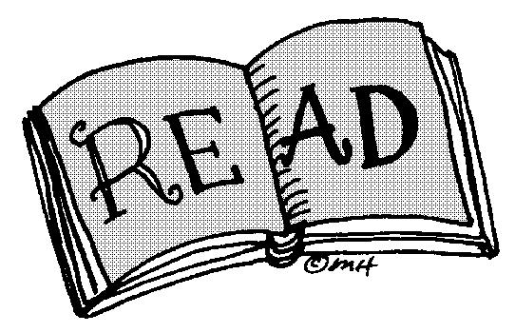

Creative Assignments to use with ANY Novel © 2009, T. Orman

Creative Assignments to use with ANY Novel

- Create a parody of a scene or the novel, in general. Act it out, film it, and present it to the class. If time is a challenge, look on YouTube to see if there are parodies or related videos to the novel or author. Bookmark them and present them to the class.

- Find a famous quote that applies to the novel and tell how it relates and why you chose it.

- Create a crossword puzzle of vocabulary words (using the definitions as clues) from the novel. Students can create crosswords here: http://www.puzzle-maker.com/CW/ For more online vocabulary practice, try Quizlet.com.

- Create a character crossword puzzle (using either quotes, actions, or descriptions from the characters as clues).

- Create a word find or other puzzle.

Create other puzzles here: http://puzzlemaker.discoveryeducation.com/

- From the yellow pages of a phone book, pick out businesses you think the main character would be interested in and explain why.

- Author Collage: Find a picture of the author and create a collage of pictures and words that represent the novel and the author’s life. (For example, find a picture or logo for the author’s college/alma mater to use in the collage.)

- Write to the author and explain your reaction to his/her book.

- Pretend you're the author and describe the part that was most fun to write.

- The prequel: Tell what you think happened before the story began.

- If your story took place one hundred years earlier, how would your main character act? OR If your main character is from the past, how would he act if the book took place today?

- Based on the TV show “Punk’d” (or “Candid Camera”), describe one of the characters getting “punk’d” or caught on hidden camera. What prank would be pulled on them? How would they react? If possible, act it out or film for the class to see.

- Describe what you think happened to the main character after the book ended.

- Explain why your book should be included in a time capsule to be dug up in one hundred years. OR If one of the characters were to make a time capsule, what would they include in it and why?

- Create a board game relating to the novel. Things to think about: materials for pawns, challenge cards, what is the object of the game, how will the pawns move around the board (spinner, roll dice, draw card, etc.).

- Compare your book with another book you've read. Which is better and why?

- Research and plan a field trip related to the novel. Explain how each of the places you would visit relate to the story or characters.

- You are a seller on eBay. What items from the novel would you list for sale? Create a fake listing, complete with description, of the item. Do you think anyone would buy? Why or why not? (Great for teaching symbolism of items.)

Creative Assignments to use with ANY Novel © 2009, T. Orman

Creative Assignments to use with ANY Novel

- Create a test over the book for a classmate. Include multiple choice, true/false, matching, short-answer essay, fill-in-the-blank. Make sure to include the answer key!

- Find and make recipes pertaining to the book (and share with the class, of course!). Explain why you chose the items and how they pertained to the story. You may provide background or historical information about the food in that particular setting and why it may (or may not) be of importance to the characters.

- Create a recipe book of foods and drinks relating to the story. For each recipe, add a paragraph description relating it to one of the characters or its importance in the story.

- Write a scene that could have happened in the book but didn’t. After you have written the scene, explain how it would have changed the outcome of the book.

- Create a model of one of the landmarks or scenery from the book.

- Start an online book review blog. Write your own review for the book and invite others to comment. (Good websites for this are: http://www.goodreads.com/ or http://www.teenreads.com/)

- Which magazines would each character subscribe to and why? Choose at least one magazine for three of the characters.

- Character’s Cell Phone: What kind of cell phone would the main character have? Who would be in his/her contact list? If he/she were to text another character, what would the text message say? How would the other character respond?

- If the characters were competing in the Olympics (either summer or winter), which events would they be in and why?

- What does each character have hiding under their bed or in their closet? Why? (If a character is a neat-freak, perhaps they have nothing...including dust!)

- Which character would you like to play? Why? Would you want to switch places with any character? Why or why not?

- What would the main character’s (or any of the characters’) web site look like? Draw it out or create it on the computer.

- Three Square Reflection: Write three quotes you think are important, three key facts you think are important, and three connections to your personal world. (see handout on page 9)

- Play character charades with your classmates: See if they can guess the characters based on your acting (silent acting, like a mime).

- Create trading cards for at least three of the characters from the novel or story. Use index cards & make sure to write/draw on both sides. Include information such as name, nick names, occupation, height, weight, eye color, personality traits, skills, specialties, friends, hobbies, honors/awards, notable quotes, etc. (see page 25 for template).

- What’s Hot? What’s Not? Use the catch-phrase to have students summarize the good points/bad points in a chapter or for characterization in novel (or popular/unpopular viewpoints; good/bad events; good/bad choices by a character; funny/not funny quotes, etc.). (p. 28 template)

Creative Assignments to use with ANY Novel © 2009, T. Orman

If you liked the ideas I’ve presented, you may want to check out these other products related to some of the ideas:

- FREE Bookmark Templates: http://www.teacherspayteachers.com/Product/Bookmark-Templates-PDF-Printables-Reading

- Vocabulary Scattergories (FREE shorter version): http://www.teacherspayteachers.com/ Product/Vocabulary-Categories-FREE-Activity-for-ANY-Subject-Even-Math
Full version: http://www.teacherspayteachers.com/Product/Vocabulary-Scattergories-Categories-Comparison-Activity-ANY-Class

- Facebook Profile (FREE shorter version): http://www.teacherspayteachers.com/Product/ Facebook-Profile-Character-Sketch-Any-Novel-Activity
Full version (PDF): http://www.teacherspayteachers.com/Product/Facebook-Character-Sketch-Lesson-Any-Novel-Full-Version-PDF

Full version (Word): http://www.teacherspayteachers.com/Product/Facebook-Character-Sketch-Lesson-Any-Novel-Full-Version-1

- Download ALL of my literature resources for ONE low price: http:// www.teacherspayteachers.com/Product/Literature-Activities-for-ANY-Novel-or-Story-100-Handouts/Summary

- eBay Listing Template: http://www.teacherspayteachers.com/Product/eBay-Character-Sketch-Lesson-or-Term-Concept-Review-for-Any-Subject

- Character Olympics Activity: http://www.teacherspayteachers.com/Product/Character-Olympics-Reading-Literature-Lesson-Activity

- Character Tags: http://www.teacherspayteachers.com/Product/Character-Tags-LitNovel-Activity-Family-Guy-Twilight-Superhero

- Reading Log Comprehension Bookmarks & Journal: http://www.teacherspayteachers.com/ Product/Reading-Log-Comprehension-Questions-Bookmarks-Journal-Page

- Poetry Resource Bundle (for reading & writing poetry): http:// www.teacherspayteachers.com/Product/Poetry-Resources-Bundle-for-Writing-Reading-Understanding-Poetry

- Need a new novel for class? (Or three?) This trilogy is guaranteed to have your students begging to read each day: The Hunger Games by Suzanne Collins. Buy it from Scholastic for $7. Use it as a read-aloud, or if you want to teach the unit, find all you’ll need right here: http://www.teacherspayteachers.com/Product/Hunger-Games-Unit-Lessons-QA-Tests-Activities-Quiz-Vocab-Maps-Key

www.teacherspayteachers.com/Store/Tracee-Orman

Thank you for your purchase!
Continue on for templates and handouts

to assist students for some of the activities.

Creative Assignments to use with ANY Novel © 2009, T. Orman

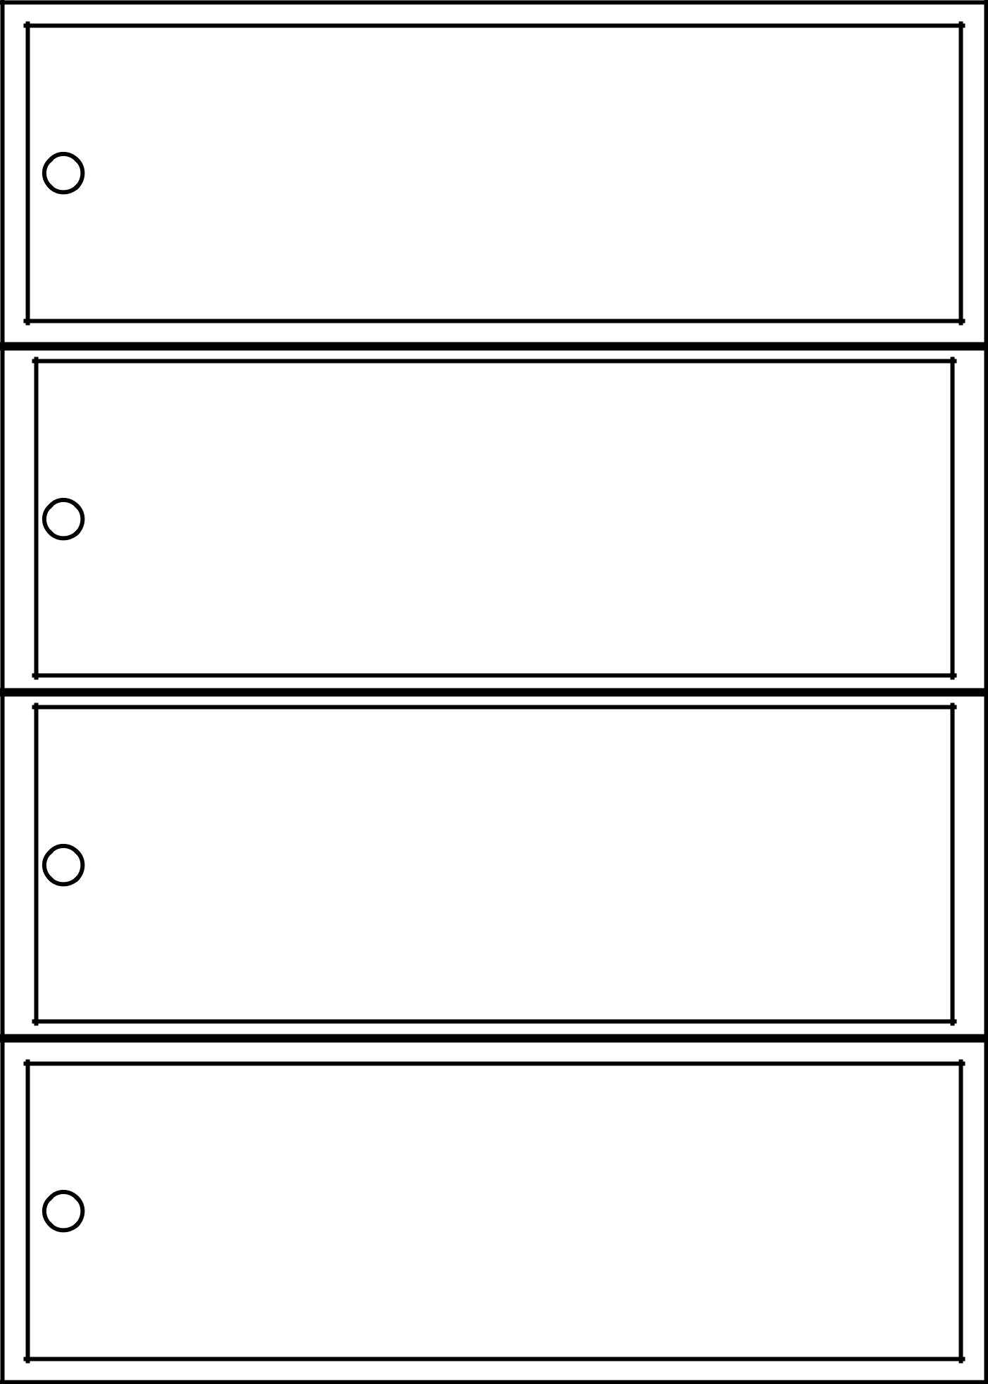

Creative Assignments to use with ANY Novel © 2009, T. Orman
Three Square Reflection

Your Name: __________________________________________________________

Assigned Reading: _____________________________________________________


Directions: After Reading the assigned text, complete the following steps.

Step One: Write down THREE quotes from the text that you believe are important.

1.

2.

3.

Step Two: Write down THREE key facts that you learned from this section.

1.

2.

3.

Step Three: Write down THREE connections to your personal world that you found or can make based on your reading of this selection.

1.

2.

3.

Creative Assignments to use with ANY Novel © 2009, T. Orman

If I Were… Assignment Name: ____________________________

If I were _______________________________________, I would…

Creative Assignments to use with ANY Novel © 2009, T. Orman

Find a… Name: ___________________________

Find a picture that represents each one of the following themes from the novel:
- Friendship
- Racism
- Family Values
- Stereotypes

(These are just example themes from one novel. Insert your own themes for students below.)

------------------------------------------------------------------------------------------------------------------

Find a… Name: ___________________________

Find a picture that represents each one of the following themes from the novel:

1._________________________________________________________________

2._________________________________________________________________

3._________________________________________________________________

4._________________________________________________________________

5. _________________________________________________________________

Find a… Name: ___________________________

Find a picture that represents each one of the following themes from the novel:

1._________________________________________________________________

2._________________________________________________________________

3._________________________________________________________________

4._________________________________________________________________

5. _________________________________________________________________

Creative Assignments to use with ANY Novel © 2009, T. Orman

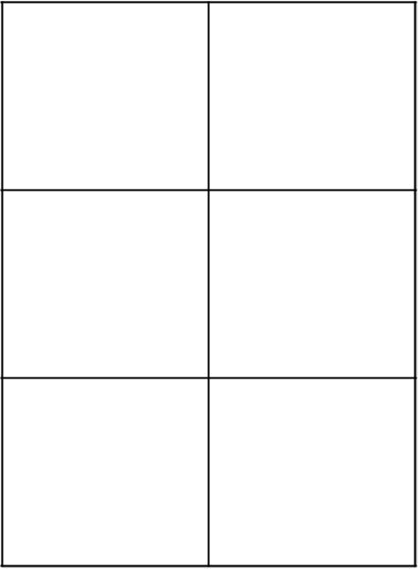
Title of Comic Strip: ____________________________________________

________________________

Name: Chapter or Pages: __________ .

Creative Assignments to use with ANY Novel © 2009, T. Orman
Front of Postcard


Front of Postcard


Creative Assignments to use with ANY Novel © 2009, T. Orman

Back of Postcard
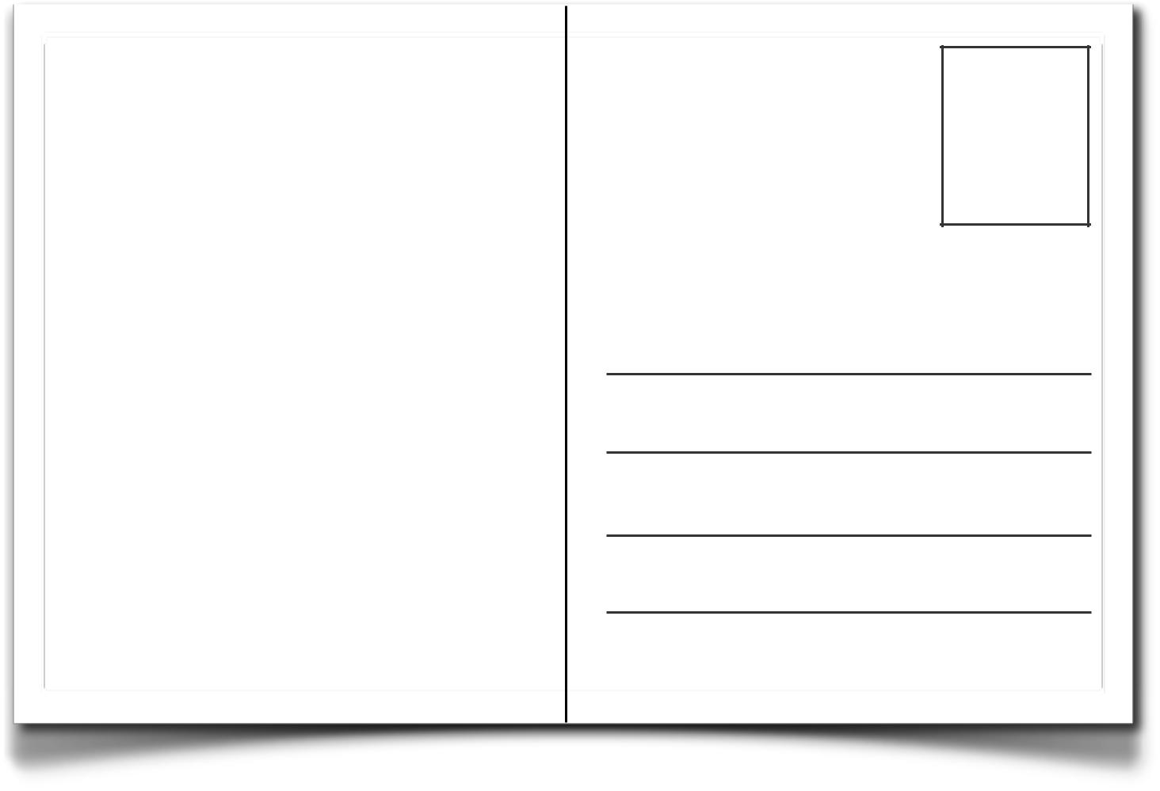

Novel Postcards © 2001, Tracee Orman

Back of Postcard
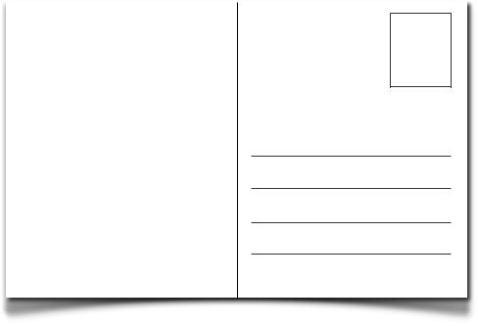

Novel Postcards © 2001, Tracee Orman

Creative Assignments to use with ANY Novel © 2009, T. Orman

EXAMPLES OF BIO POEMS

SUBSTITUTE “YOU” FOR ONE OF THE CHARACTER’S NAMES

- I AM… POEM

Method for I Am…
I am (two special characteristics)
I wonder (something you are actually curious about) I hear (an imaginary sound)

I see (an imaginary sight) I want (an actual desire)

I am (the first line of the poem restated)

I pretend (something you actually pretend to do)

I feel (a feeling about something imaginary)
I touch (an imaginary touch)
I worry (something that really bothers you)
I cry (something that makes you very sad)

I am (the first line of the poem repeated)

I understand (something you know is true)

I say (something you believe in)
I dream (something you actually dream about)
I try (something you really make an effort about)
I hope (something you actually hope for)
I am (the first line of the poem repeated)
Student Example:
I am the wine and the future

I wonder how many ripples I will have to swim I hear the trickle of time in a bitter bottle
I see the translucent red drain from the wine

I want the sweet satin liquid to stain my tongue I am the wine and the future.

I pretend to entertain the glowing embers

I feel the dew that sours the grapes
I touch the vine that grows new life
I worry the drunkard may speak the truth
I cry the dewdrop tears on the winery walls I am the wine and the future.

I understand the dust on the bottle

I say it only makes it sweeter with time
I dream the sponge cork may never be replaced by lips I try to glimmer the crack in my glass container

I hope the sun-faded label never creases for lost identity I am the wine and the future.

--Katie Reilly (Grade 10)

See handout on the next page for use with a character from any book/novel.

- BIO POEM (Variation) Format:
(first name)
(four words that describe you) Relative of (list close family members) Resident of (place where you live)

Who reads (four books, magazines, and or newspapers) Who likes (three things you like)

Who loves (three things you love) Who fears (three things)

Who wishes (three things) Who admires (three)

Who needs (three things you need) Who aspires to (at least two aspirations) (last name)

- AUTOBIOGRAPHICAL:

Write a poem about yourself using this form or another poetry form.
Line 1: __ Your name
Line 2: _, _, _ 3 personal characteristics or physical traits
Line 3: Brother or sister of__ or son/daughter of
Line 4: Who loves__, __, and __ 3 people, things, ideas
Line 5: Who feels__ about__1 emotion about 1 thing
Line 6: Who needs__, __, and __ 3 things you need
Line 7: Who gives __, __, and __3 objects you share
Line 8: Who fears__, __, and __3 items
Line 9: Who'd like to see, __1 place, or person
Line 10: Who dreams of __ 1 item or idea
Line 11: A student of__ your school or teacher's name

Line 12: __ Nickname or repeat your first name

Another example of an Ode:

An Ode is a poem praising and glorifying a person, place or thing.
Example:
An Ode To Dreamers
When dreamers dream
And lovers love
Do they receive their visions
From heaven above?
Or do they originate
Where all things start
Within our minds
Within our hearts?
I know not all
But what I do know is this
You cannot build a Kingdom
Upon a flimsy wish
So believe in your dreams
Follow them blind
Lest you lose them all,
To the hands of time.
Copyright © 2000 B. R. Jording

Creative Assignments to use with ANY Novel © 2009, T. Orman

Character Bio Poem Name: _________________________

Characterʼs First

Name:

Four words that

describe

character:

Relative of:

Resident of:

Who reads (list

four things):

Who likes (list

three things):

Who loves (list

three things):

Who fears (list

three things):

Who wishes (list

three wishes):

Who admires (list

three):

Who needs (three

things):

Who aspires to

(list at least two

things character

aspires):

Characterʼs Last

Name:

Creative Assignments to use with ANY Novel © 2009, T. Orman

Character Bio Poem Name: _________________________

Line 1: (Character’s Name): _______________________________________________

Line 2: (Three words describing): __________________________________________

Line 3: Who lives with: ___________________________________________________

Line 4: Who loves: ______________________________________________________

Line 5: Who feels: ______________________________________________________

Line 6: Who needs: _____________________________________________________

Line 7: Who gives: ______________________________________________________

Line 8: Who fears: ______________________________________________________

Line 9: Who'd like to see: _________________________________________________

Line 10: Who dreams of: _________________________________________________

Line 11: A student of: ____________________________________________________

Line 12: (Nickname or repeat character’s first name): ___________________________

Creative Assignments to use with ANY Novel © 2009, T. Orman

Character Acrostic Poem Name: _______________________________

Using the first letters of one of the characters’ names, write an acrostic poem. Each letter should represent something about that character, such as his/her personality, actions from the novel, thoughts, goals, likes/dislikes, what he/she looks like, etc.


Creative Assignments to use with ANY Novel © 2009, T. Orman

Setting Map Name: _______________________________

Draw a depiction of the setting (either map it out or draw a landscape view of the character’s surroundings).


Creative Assignments to use with ANY Novel © 2009, T. Orman

Character Depiction Name: _______________________________

Draw a picture of one of the characters from the story or novel.


______________________________________________________________________

(Character & Title)

Creative Assignments to use with ANY Novel © 2009, T. Orman

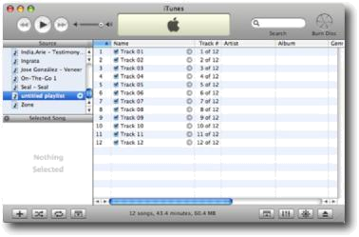
♬The Playlist.... Name: _______________

Create a playlist or soundtrack that would be appropriate for the story. Explain why each song was included.

Track 1: ______________________________________________________

________________________________________________________________

Track 2: _____________________________________________________

________________________________________________________________

Track 3: _____________________________________________________

________________________________________________________________

Track 4: _____________________________________________________

________________________________________________________________

Track 5: _____________________________________________________

________________________________________________________________

Track 6: _____________________________________________________

________________________________________________________________

Track 7: _____________________________________________________

________________________________________________________________

Track 8: _____________________________________________________

________________________________________________________________

Track 9: _____________________________________________________

________________________________________________________________

Track 10: _____________________________________________________

________________________________________________________________


Create a CD jewel case with the track names and the title of your soundtrack. Optional: Burn the CD and share with the class.

Creative Assignments to use with ANY Novel © 2009, T. Orman

 tweet Name: _______________________________

Novel/Story: ___________________________________________________________

Character chosen: _____________________________________________________

Chapter/section: ___________________

What would this character “tweet” at the end of this chapter or section? Write

it as though you are that character using Twitter. Maximum length of a “tweet” on Twitter is 140 characters.

______________________________________________________________________

______________________________________________________________________

______________________________________________________________________

______________________________________________________________________

--------------------------------------------------------------------------------------------------------------------

tweet Name: _______________________________

Novel/Story: ___________________________________________________________

Character chosen: _____________________________________________________

Chapter/section: ___________________

What would this character “tweet” at the end of this chapter or section? Write it as though you are that character using Twitter. Maximum length of a “tweet”

on Twitter is 140 characters.

______________________________________________________________________

______________________________________________________________________

______________________________________________________________________

______________________________________________________________________

Creative Assignments to use with ANY Novel © 2009, T. Orman

Character Playlist Name: __________________________
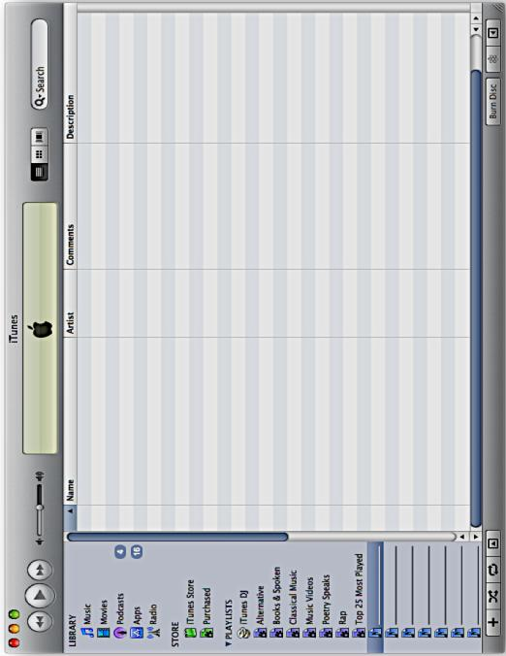

_______________________________________ | 1 | 2 | 3 | 4 | 5 | 6 | 7 | 8 | 9 | 10 | 11 | Bonus Track
Character:

Creative Assignments to use with ANY Novel © 2009, T. Orman

Character Tags Name: ____________________________

Pretend you must “tag” one of these Looney Toons™ characters to each character in the novel or story. Justify your selections based on the character’s personality, actions, thoughts, dialogue, etc.
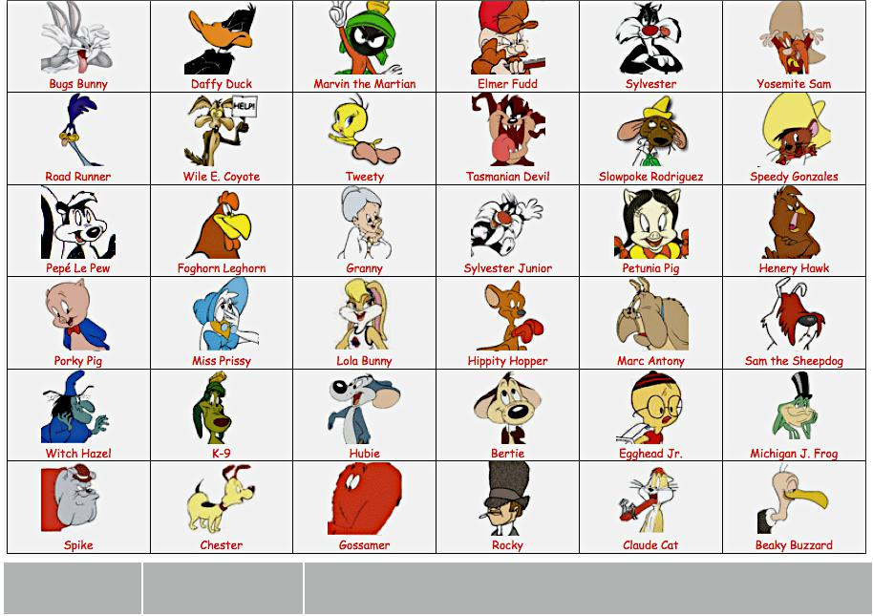

Character | Looney Toons™ | Reason for tagging to this cartoon character.
 | Character

Creative Assignments to use with ANY Novel © 2009, T. Orman

Character Trading Cards Template - Example of Character Card

 | FRONT OF CARD
 | Picture of Character
(could be cut from a magazine/newspaper,
drawn, or image from the internet)
 | Character Name | ATTICUS FINCH
Nickname, Slogan, Occupation, |  | ATTICUS FINCH
 | or other Tagline | Lawyer, Father, Hero
Title of Novel and Author |  | To Kill a Mockingbird by Harper Lee
 | BACK OF CARD | Name: ATTICUS FINCH
 | BACK OF CARD | Nick Name: Ole One-Shot Finch
FORMAT & INFORMATION CAN VARY |  | Nick Name: Ole One-Shot Finch
 |  | Height: 6’1” Weight: 185 lbs.
Smaller Picture of Character |  | Occupation: Lawyer
 |  | Hometown: Maycomb, Alabama
Name: |  | Family: Children Jeremy & Jean-Louise;
Nick names: |  | spouse deceased; siblings Alexandra &
Nick names: |  | John (Jack)
Height: | Weight: | Friends: Atticus is friendly to everyone.
Height: | Weight: | Personality traits: Serious, intelligent, kind, fair, dry
Eye color: | Hair Color: | sense of humor, believes in doing the right thing and
Hometown: |  | treating everyone with respect, formal, great listener.
Hometown: |  | Skills: Excellent orator and defender for the innocent,
Occupation: |  | fair negotiator in domestic disputes, skilled marksman
Occupation: |  | (though he will only use his skill if necessary),
Family: |  | (though he will only use his skill if necessary),
Family: |  | looking at all perspectives or viewpoints before
Friends: |  | passing judgement
Friends: |  | Hobbies: Reading the daily paper with children,
Personality traits: |  | walking to work each day, playing checkers.
Skills: |  | Honors/awards: “Greatest Hero in American Film” -
Skills: |  | American Film Institute, 2003; “Citizen Most Likely to Do
Specialties: |  | our Dirty Work for Us” - Nominated by Miss Maudie
Specialties: |  | Atkinson; “Defender of All God’s Children” - Nominated
Hobbies: |  | by Rev. Sykes
Honors/awards: |  | Notable Quote: If you can learn a simple trick, Scout, you'll
 |  | get along a lot better with all kinds of folks. You never really
Notable Quotes: |  | understand a person until you consider things from his point of
 |  | view, until you climb inside of his skin and walk around in it.
Other:
Other: |  | Creative Assignments to use with ANY Novel © 2009, T. Orman
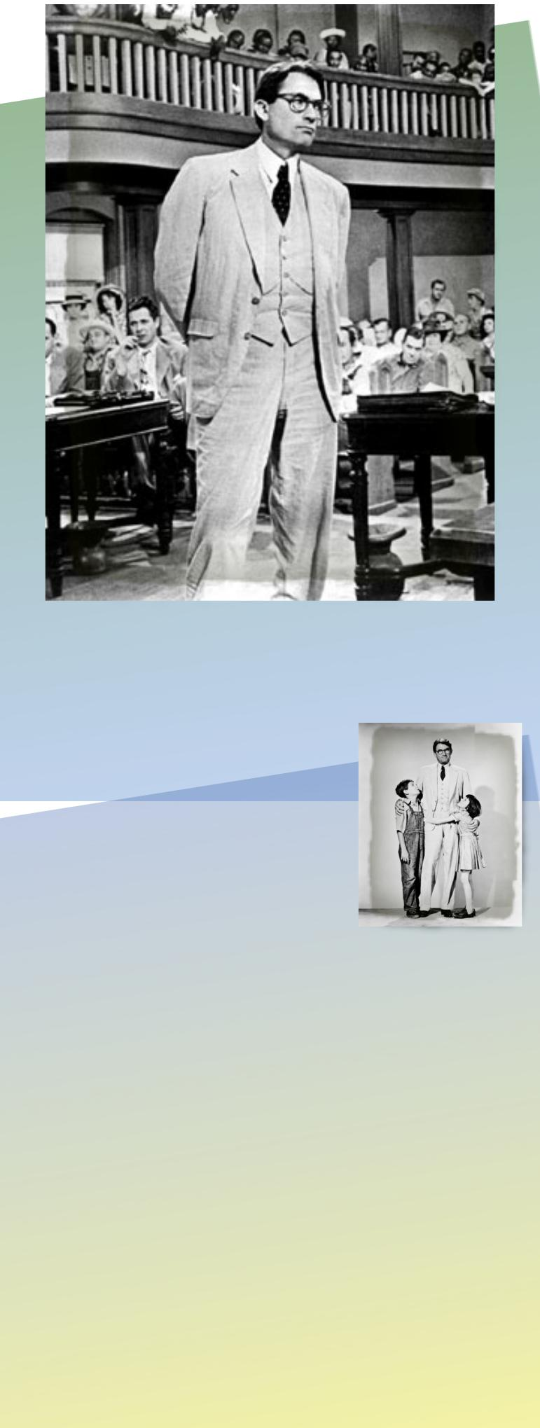
Character Trading Cards Template - Front
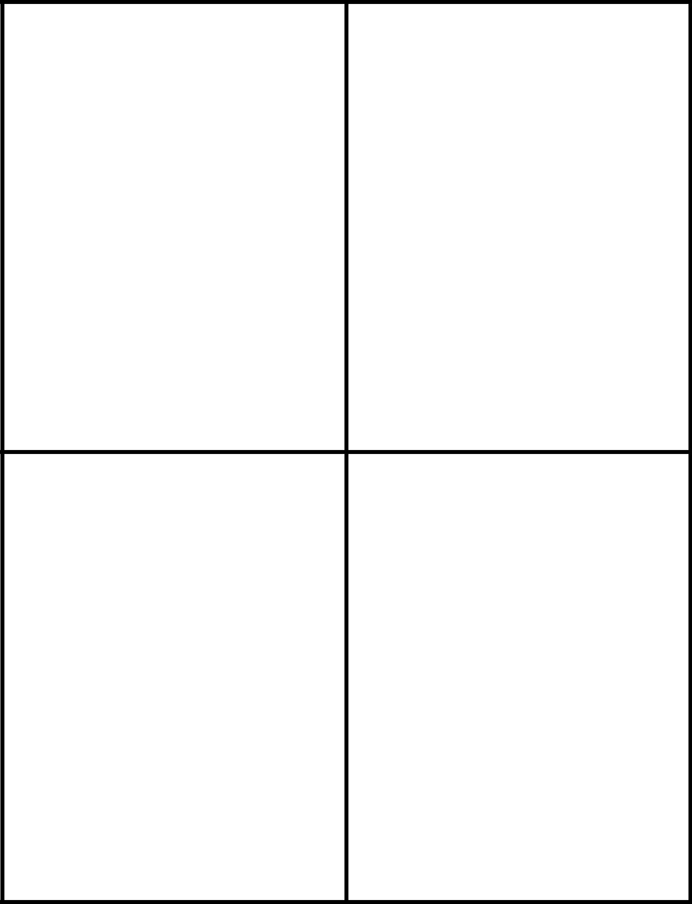

Creative Assignments to use with ANY Novel © 2009, T. Orman

Character Trading Cards Template - Back

Creative Assignments to use with ANY Novel © 2009, T. Orman

What’s Hot? What’s Not? Template (Download the full version for free here: http:// www.teacherspayteachers.com/Product/Whats-Hot-Whats-Not-Classroom-Activity-for-any-Content-Area)

What’s Hot? | What’s Not?


Creative Assignments to use with ANY Novel © 2009, T. Orman

