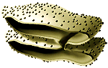 | 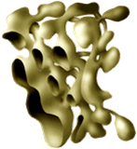 | 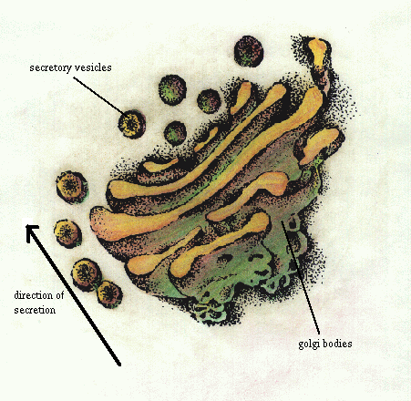
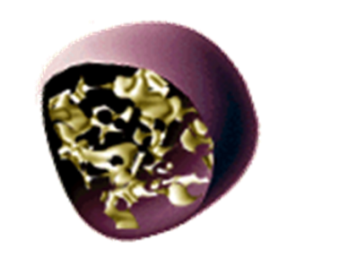 | 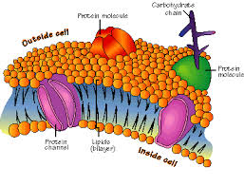 | 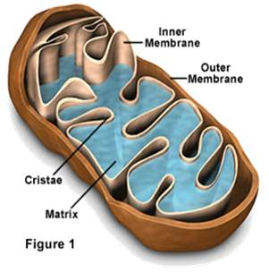
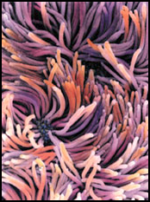 | 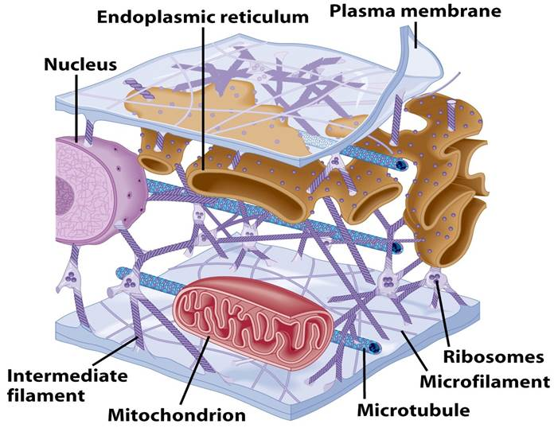 | 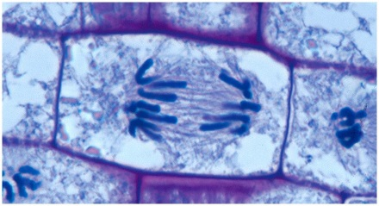
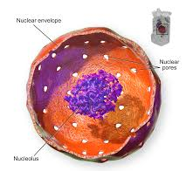 | 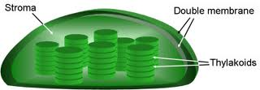 | 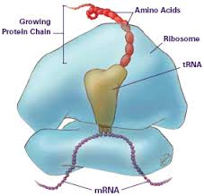
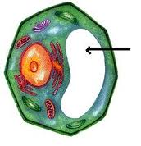 | 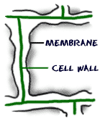 | 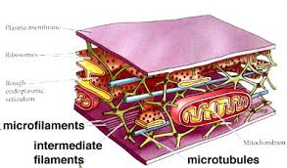
CELL ORGANELLE TRADING CARD PROJECT
Your assignment is to make a “trading card” for each of the 14 cell organelles listed below. Each trading card will feature a picture of the organelle on one side and information about it on the other. Then, you will compare the organelle to something from everyday life that has the same function.

The trading card should include:
On the front:
- A picture of the organelle on the front.
- There will be two pictures for endoplasmic reticulum.

On the back:
- The name of the organelle
- Which type of cell it is found in (plant or animal)
- It’s function in the cell
- Something from everyday life that performs the same function
- Any other important or interesting facts
- Use the template provided to complete your cards

Organelles
Plasma membrane Nucleus Chloroplasts Vacuole Lysosome Mitochondria Cytoplasm Ribosomes Endoplasmic Reticulum
Golgi Apparatus Cell Wall Centriole Cilia Cytoskeleton

You also need an additional card with the following:
A cell theory card in which the three principles are listed on the back of the card and the importance of the microscope.

You will have a total of 15 cards. Be sure to put your name on them in case they get lost!
Use pages 191 - 200 in your book for help.

FRONT OF CARD BACK OF CARD

PICTURE
OF
ORGANELLE
Name of organelle
Function: What does it do for the cell?
Location: Would you find it in a plant cell, animal cell, or both?
Analogy: Real life thing that functions in the same way
Other Facts: Any other important details

Example
FRONT OF CARD BACK OF CARD

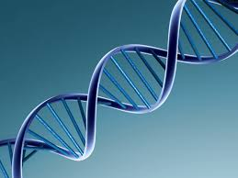
DNA
Function: The DNA of a cell provides the cell with directions for its specific function

Location: Found in both plant and animal cells

Analogy: Compass, Map, Manual

Other Facts: DNA is a twisted ladder. The sides are made up of phosphate and deoxyribose. The rungs of the ladder are made up of four nitrogen bases, thymine, guanine, cytosine, and adenine.

Rubric
Category | 4 | 3 | 2 | 1 | TOTAL
Content | All facts on every card are accurate | At least 3 accurate facts are on each card | At least 2 accurate facts are on each card | Less than 2 accurate facts on each card | x5
Requirements | All cards had all required elements. | All but 1 of the required elements are included on each card. | All but 2 of the required elements are included on each card. | 3 or more required elements were missing on each card. | x5
Completion | All cards were completed | 10 or fewer cards completed. | 5 or fewer cards completed. | 4 or fewer cards completed. | x5
Attractiveness | The project is exceptionally attractive in terms of design, layout, and neatness | The project is attractive in terms of design, layout and neatness. | The project is acceptably attractive though it may be a bit messy. | The project is distractingly messy or very poorly designed. It is not attractive | x5
Use of Class Time/Expectations | All instructions and expectations were met. Used time well during the period. Focused on getting the project done and did not distract others. | Most instructions and expectations were met. Used time well during the period. Usually focused on getting the project done and never distracted others. | Some instructions and expectations were met. Used some of the time well during the period. There was some focus on getting the project done, but occasionally distracted others. | Contributed no effort to the task and demonstrates no understanding. Did not use class time to focus on the project and often distracted others. | x5

CELL THEORY  1.  2.  3.  Job of the microscope: | __________________________________  Function: _________________________________  ___________________________________________  ___________________________________________  ___________________________________________  ___________________________________________  Location: PLANT ANIMAL BOTH  Analogy: _________________________________  ___________________________________________  ___________________________________________  Other Facts: ______________________________  ___________________________________________  ___________________________________________  ___________________________________________  ___________________________________________

__________________________________  Function: _________________________________  ___________________________________________  ___________________________________________  ___________________________________________  ___________________________________________  Location: PLANT ANIMAL BOTH  Analogy: _________________________________  ___________________________________________  ___________________________________________  Other Facts: ______________________________  ___________________________________________  ___________________________________________  ___________________________________________  ___________________________________________ | __________________________________  Function: _________________________________  ___________________________________________  ___________________________________________  ___________________________________________  ___________________________________________  Location: PLANT ANIMAL BOTH  Analogy: _________________________________  ___________________________________________  ___________________________________________  Other Facts: ______________________________  ___________________________________________  ___________________________________________  ___________________________________________  ___________________________________________

