SAMPLE BOOKLET

Design possibilities with LIGEO
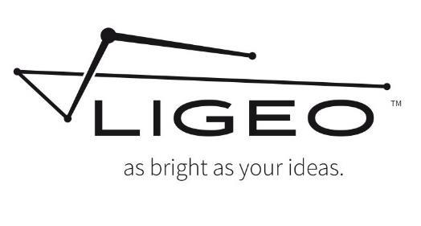

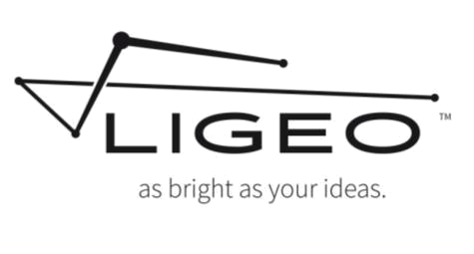

3 x 12inch/30cm LIGEOTM Light Bars
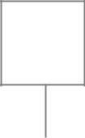
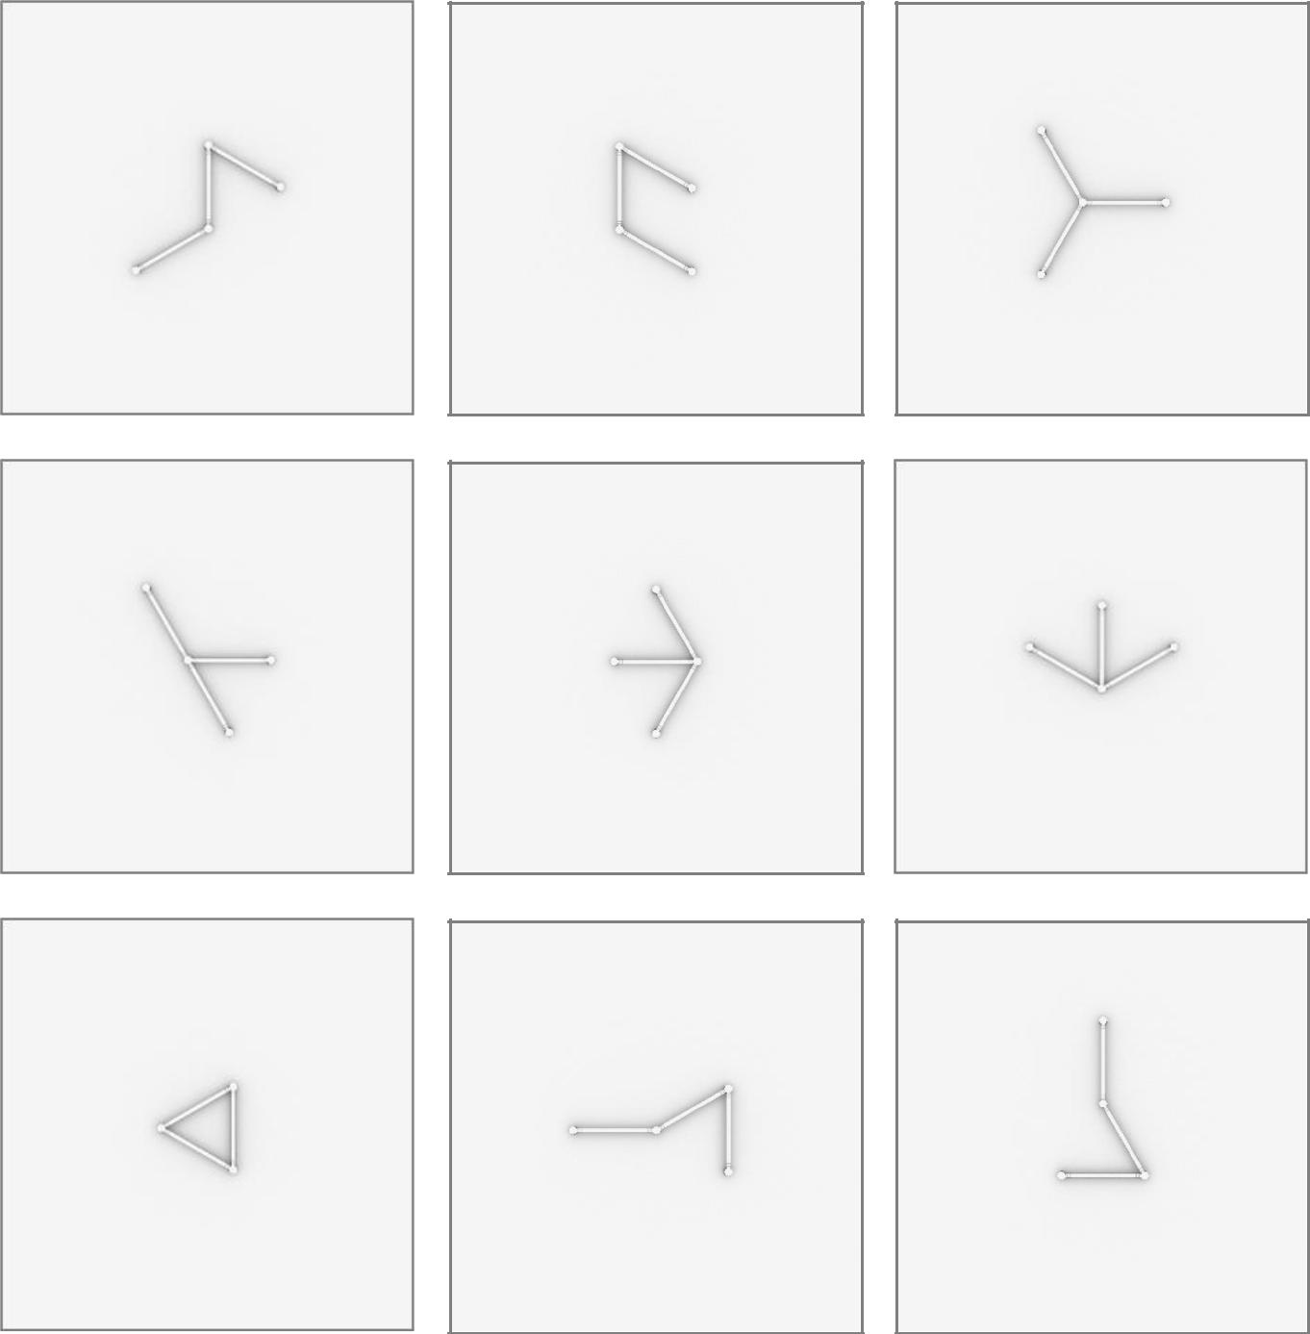

1
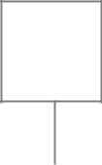
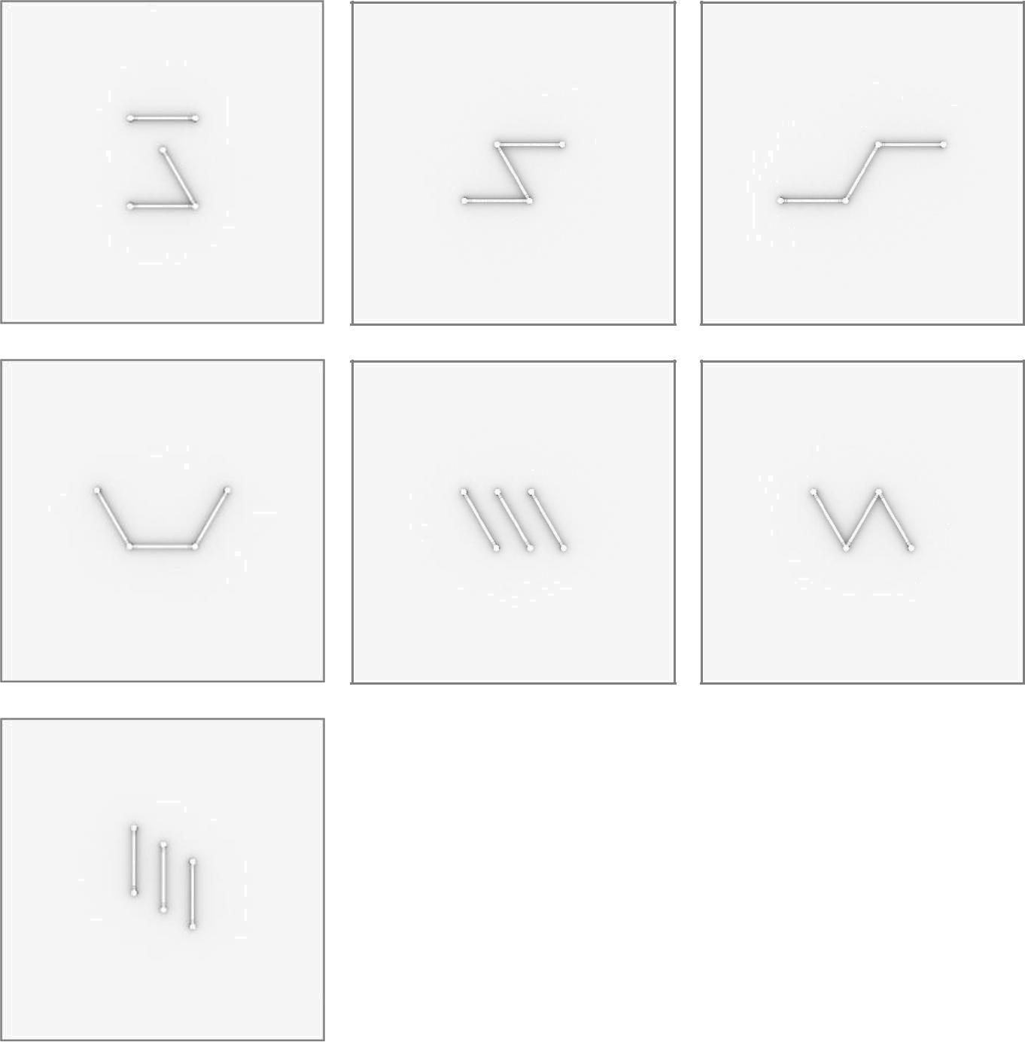

2

6 x 12inch/30cm LIGEOTM Light Bars
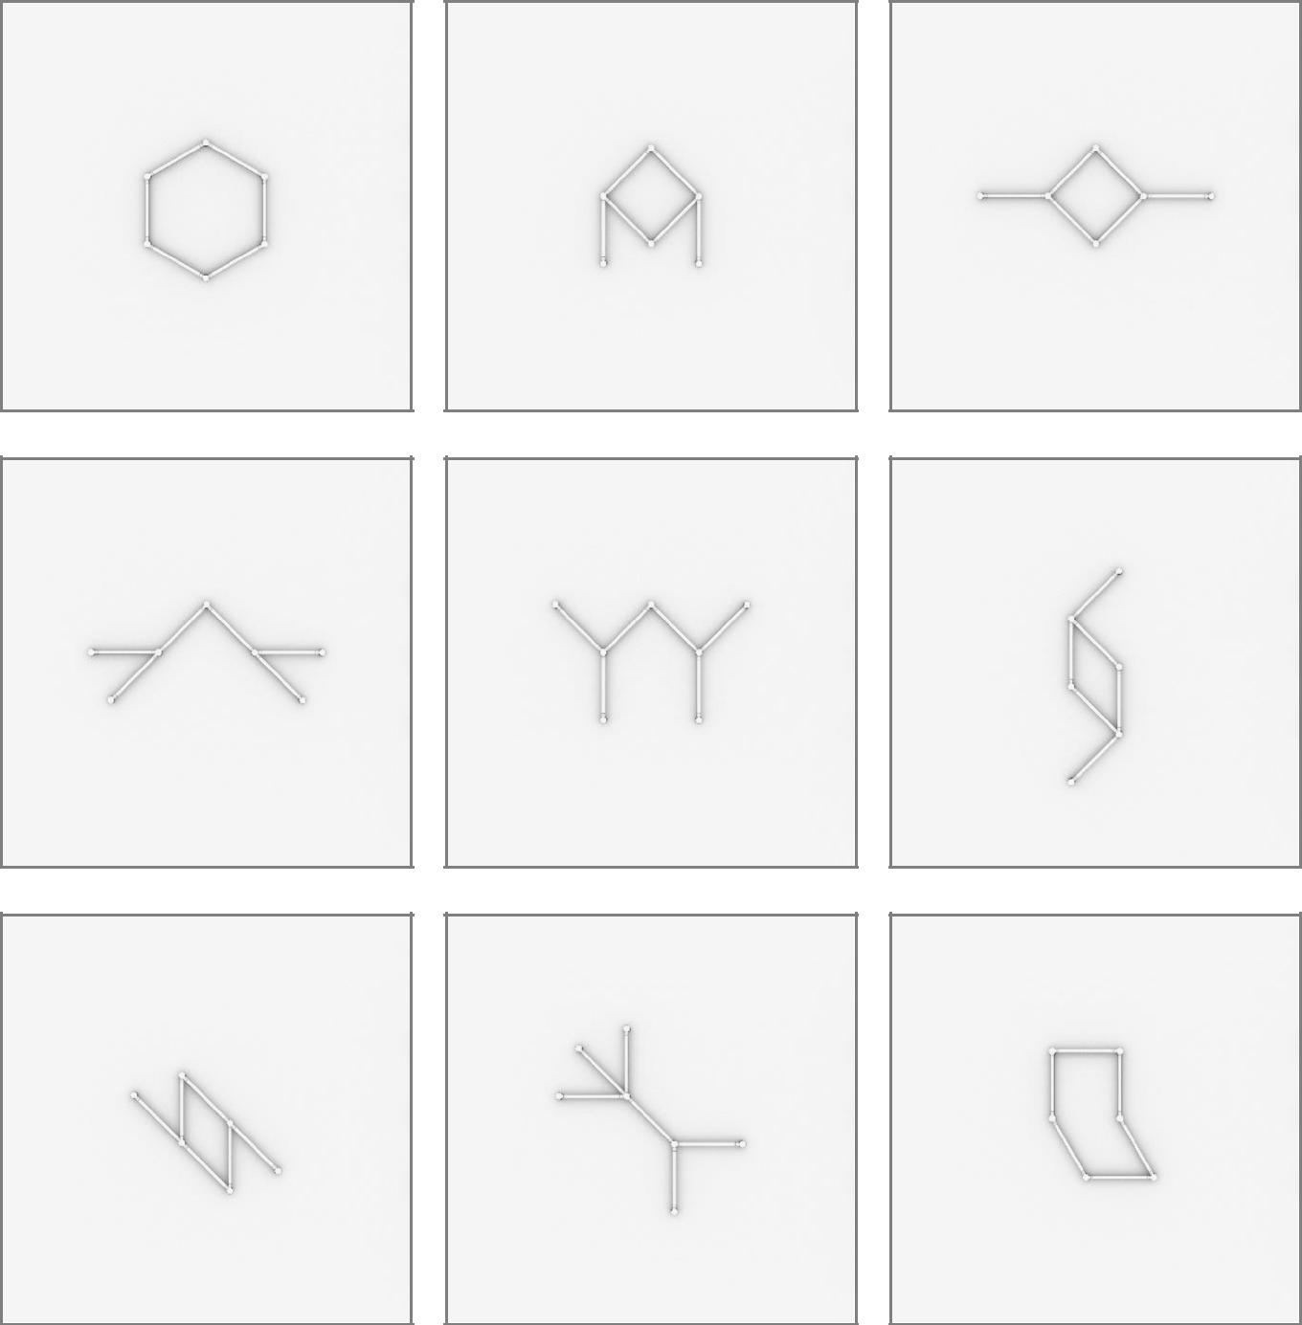

3
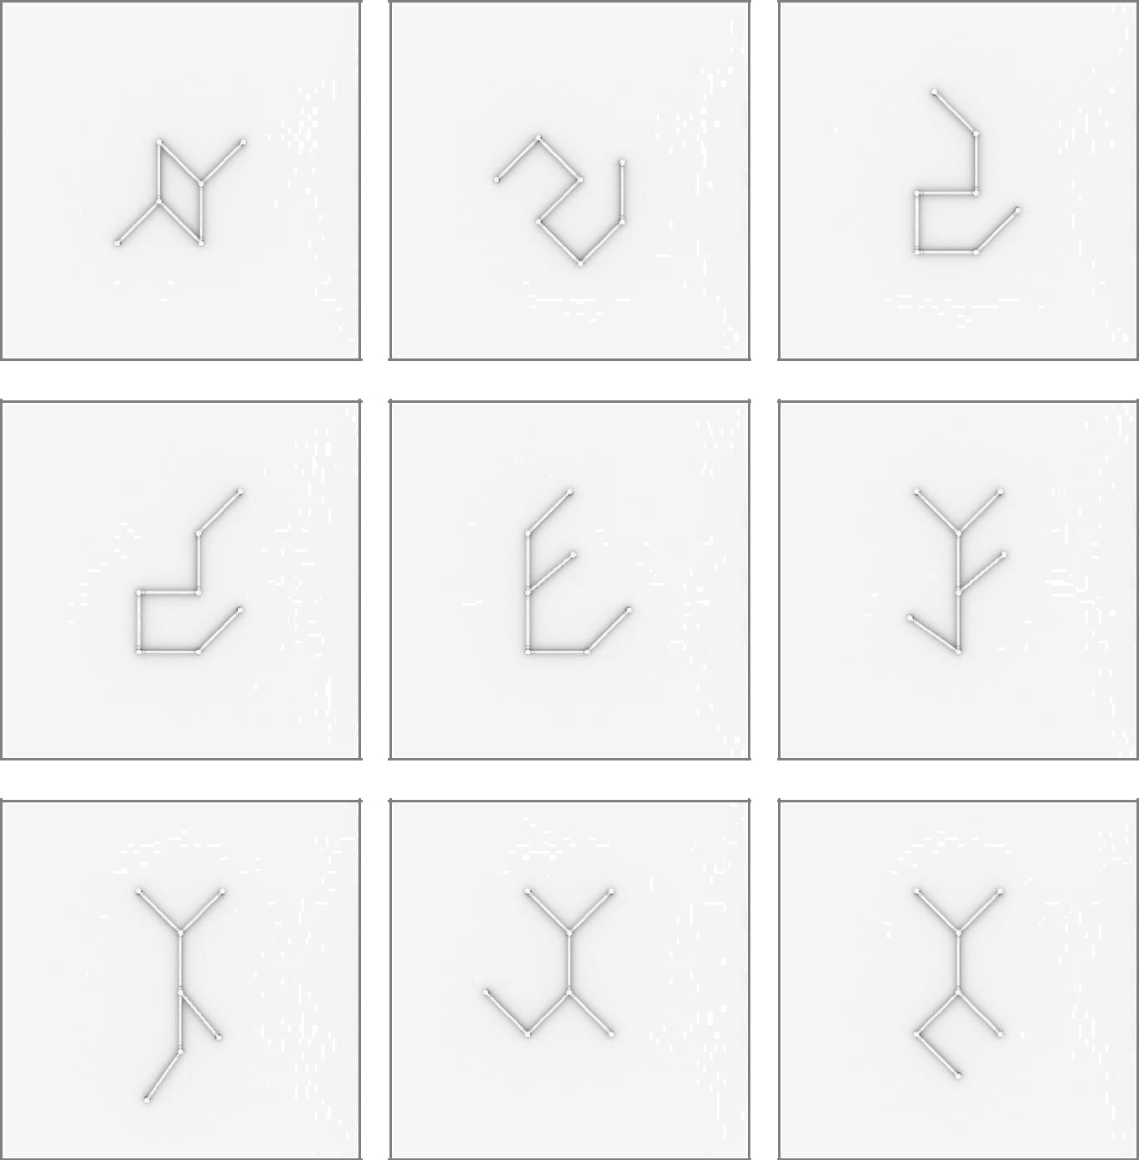

4
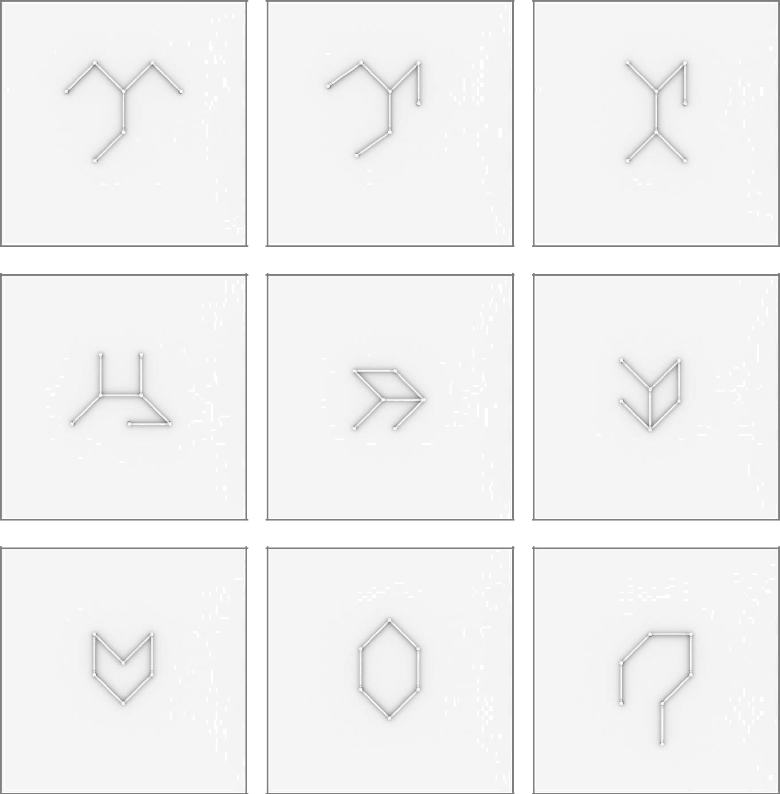

5
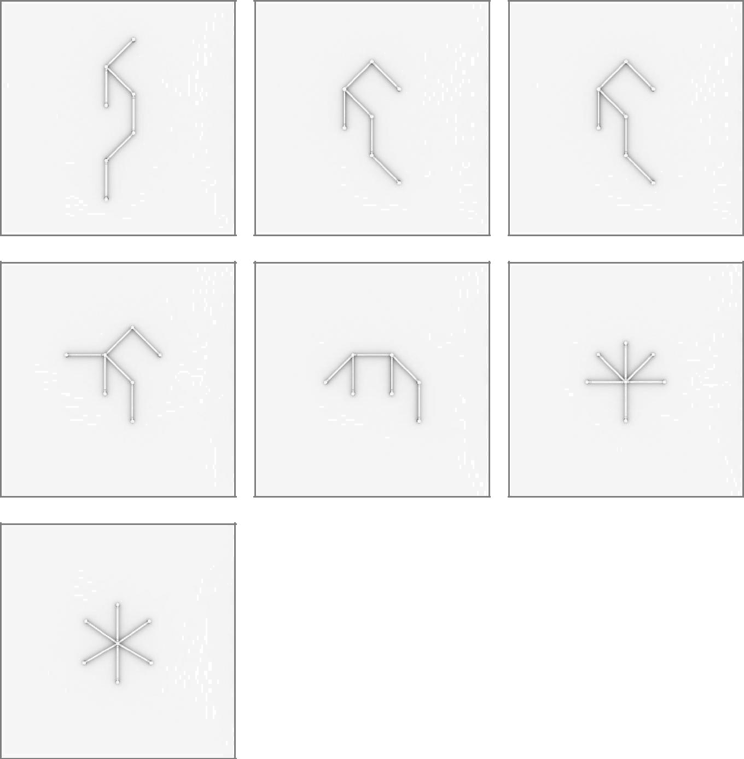

6

9 x 12inch/30cm LIGEOTM Light Bars
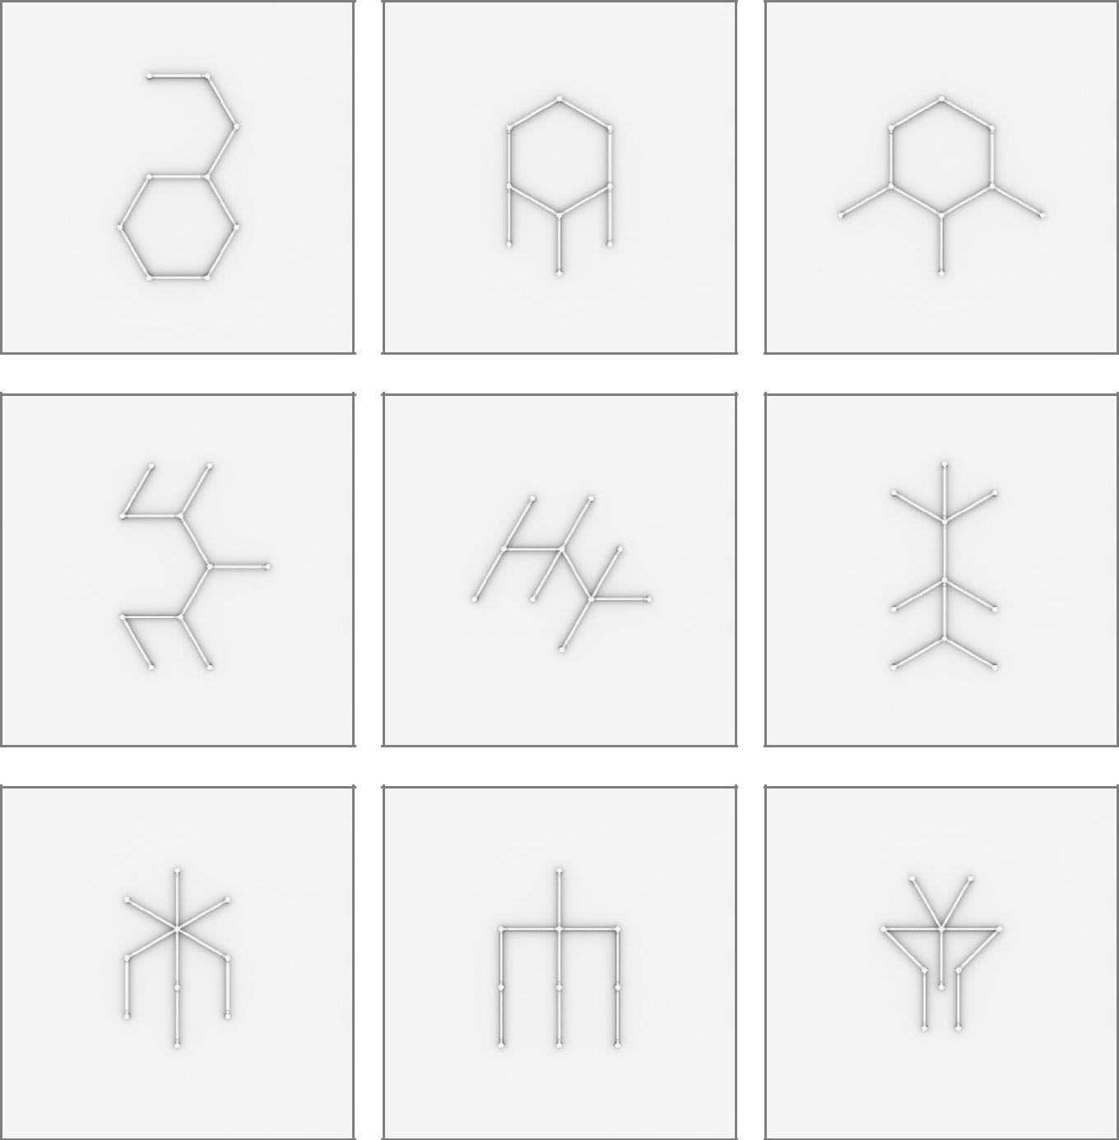

7
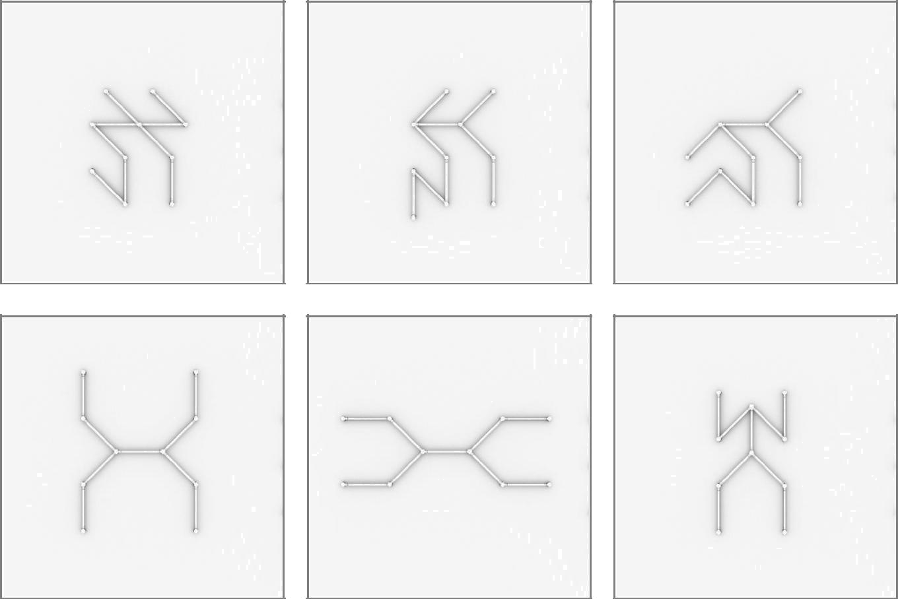

8

12 x 12inch/30cm LIGEOTM Light Bars
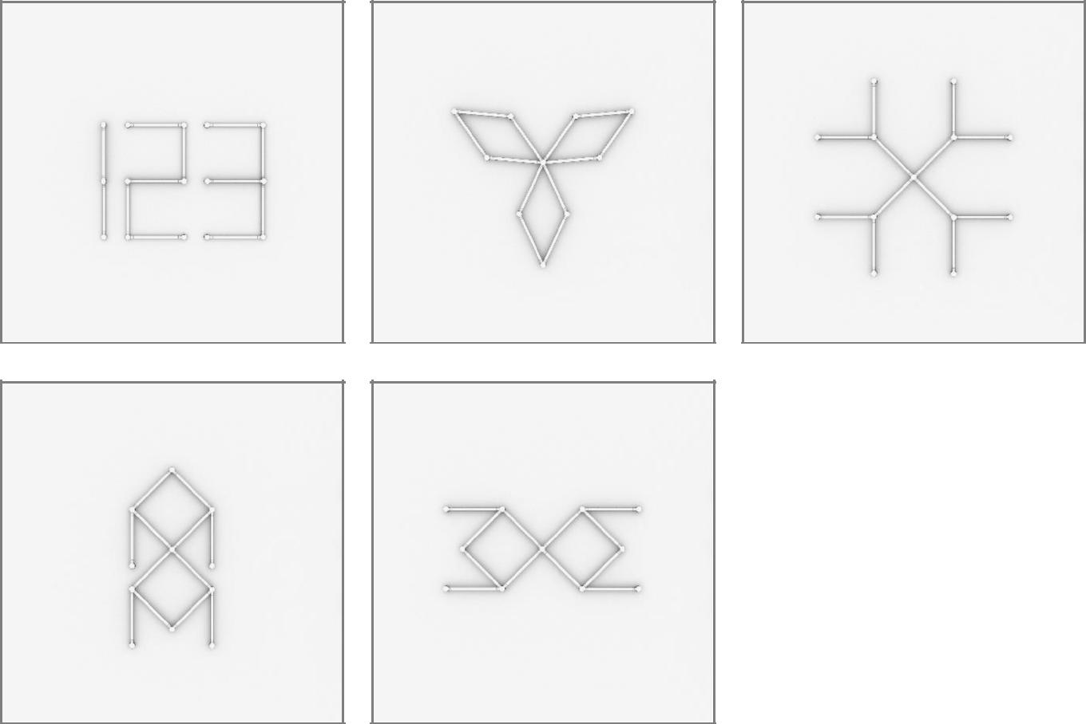

9

15 x 12inch/30cm LIGEOTM Light Bars
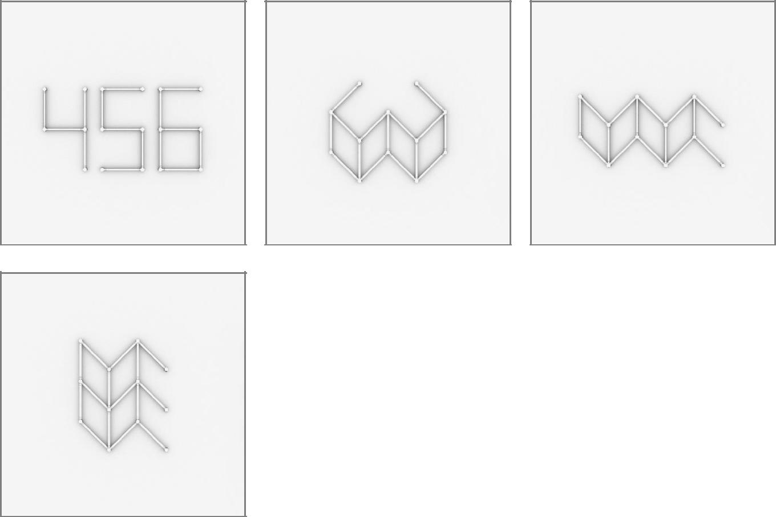

10

16 x 12inch/30cm LIGEOTM Light Bars
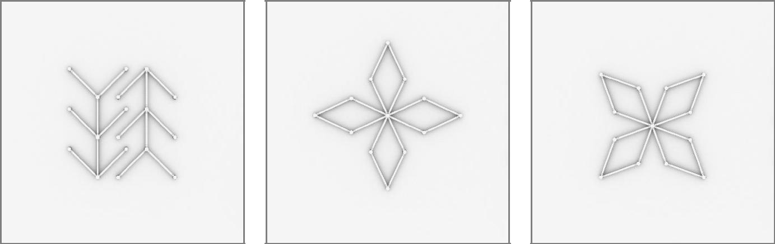

11

3 x 24inch/60cm LIGEOTM Light Bars
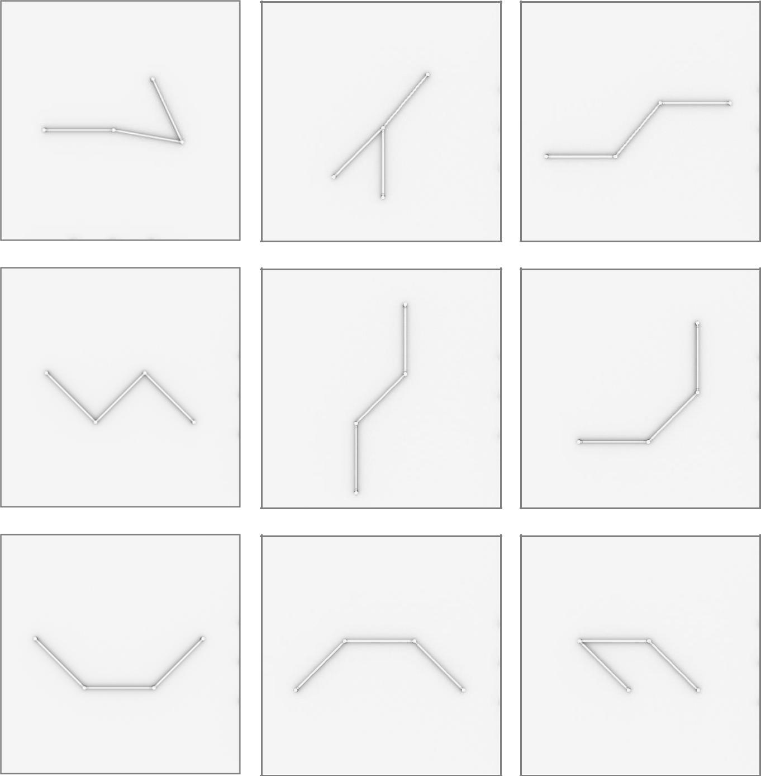

12
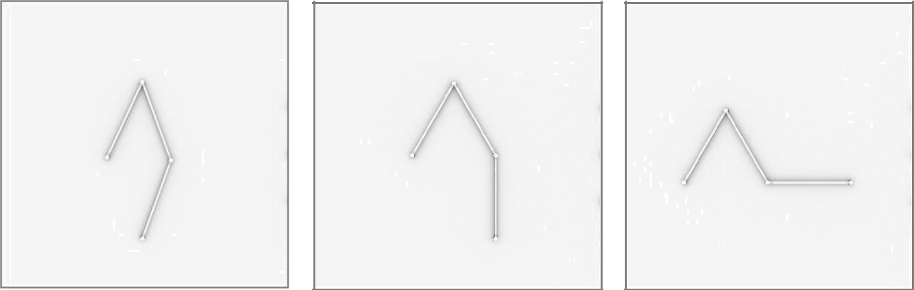

13

6 x 24inch/60cm LIGEOTM Light Bars
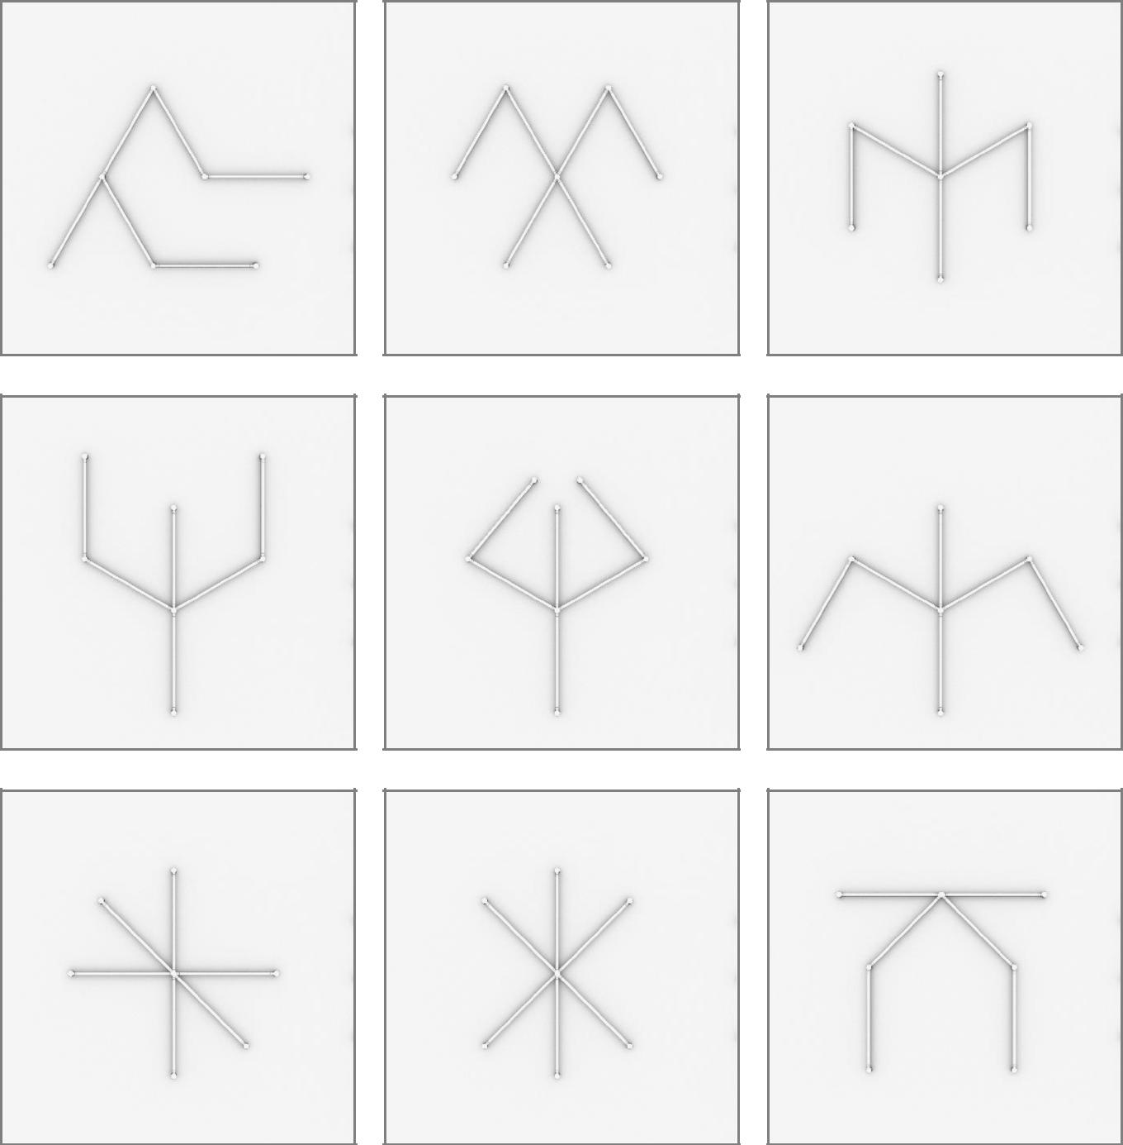

14
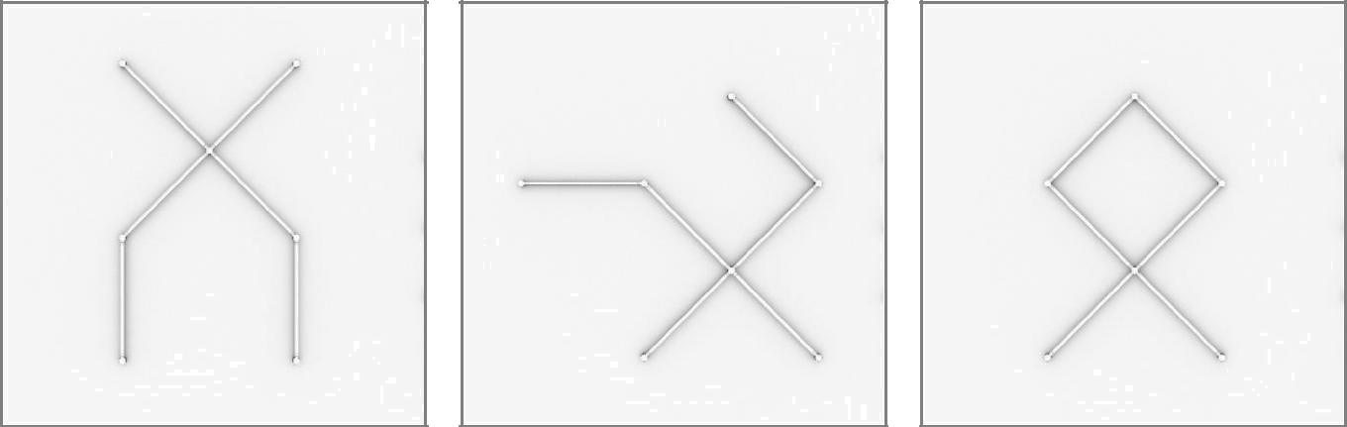

15

9 x 24inch/60cm LIGEOTM Light Bars
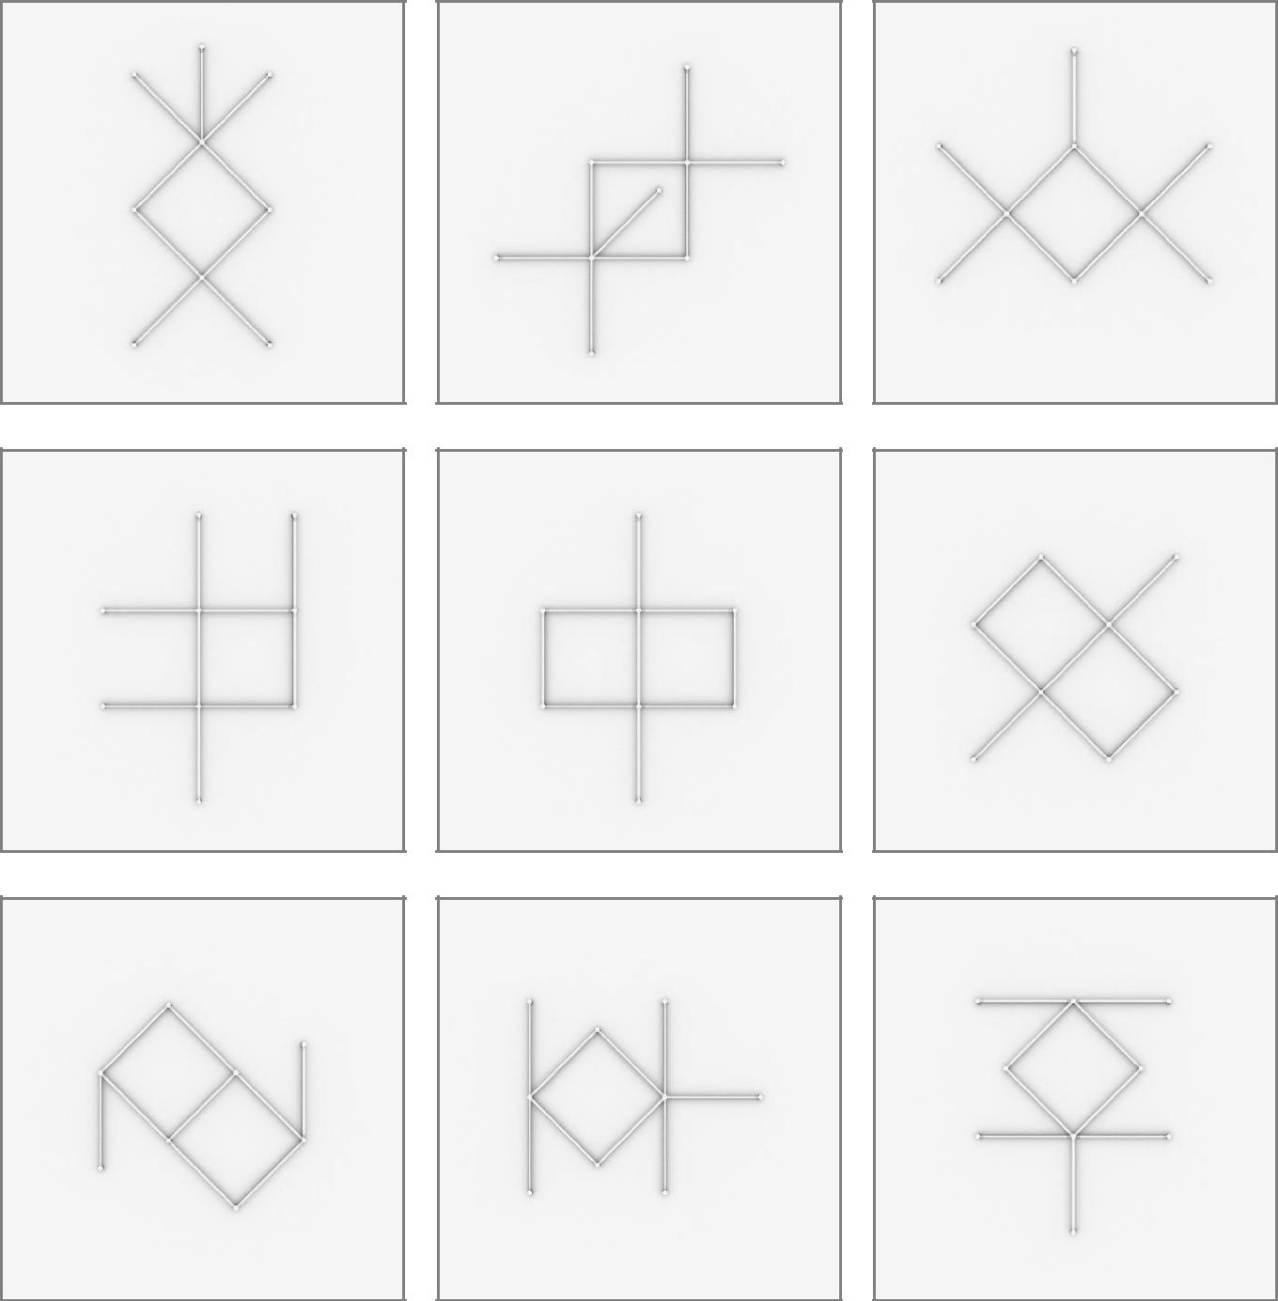

16
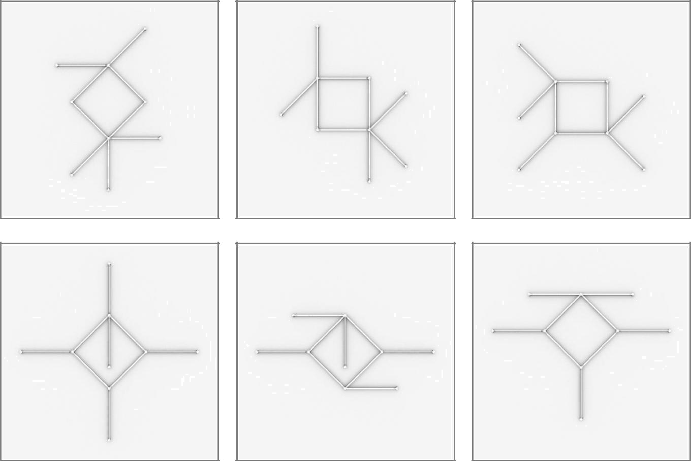

17

12 x 24inch/60cm LIGEOTM Light Bars
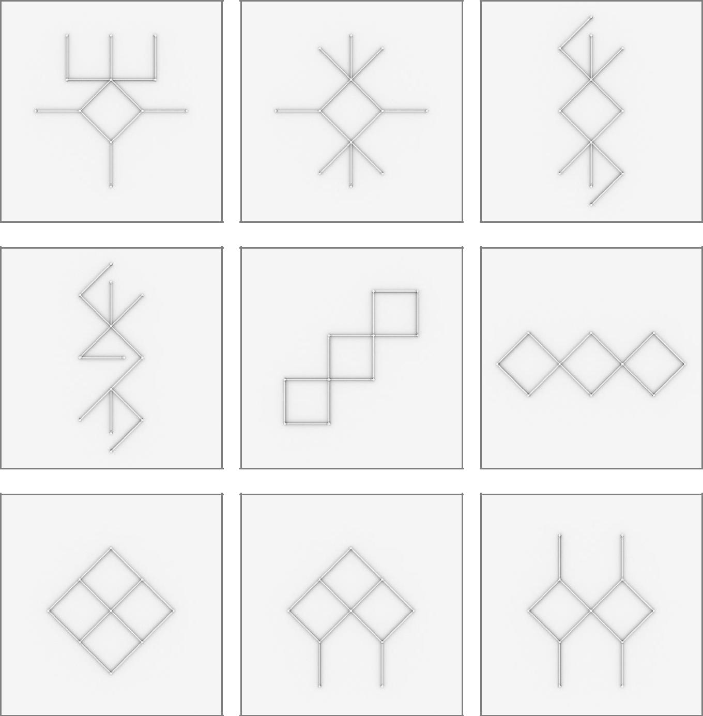

18
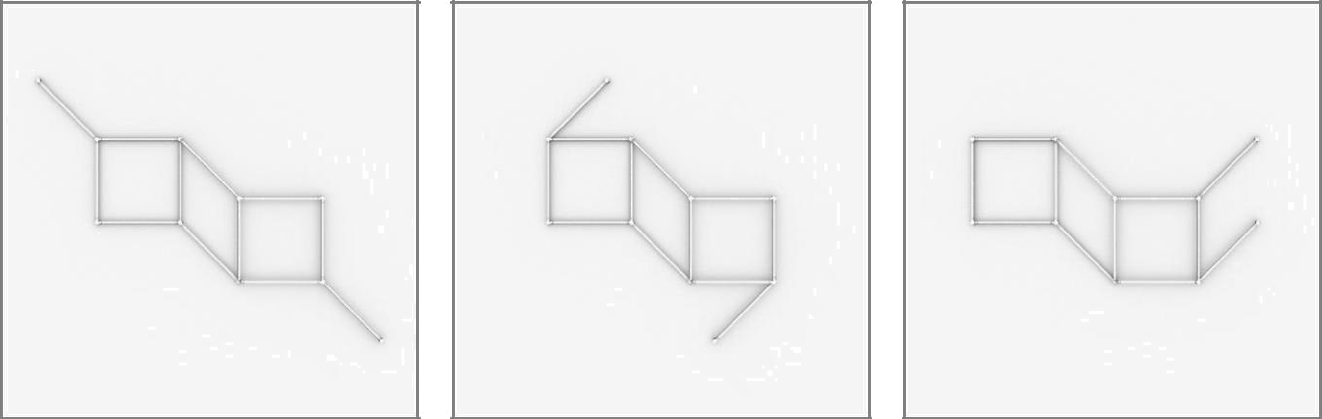

19

3 x 36inch/90cm LIGEOTM Light Bars
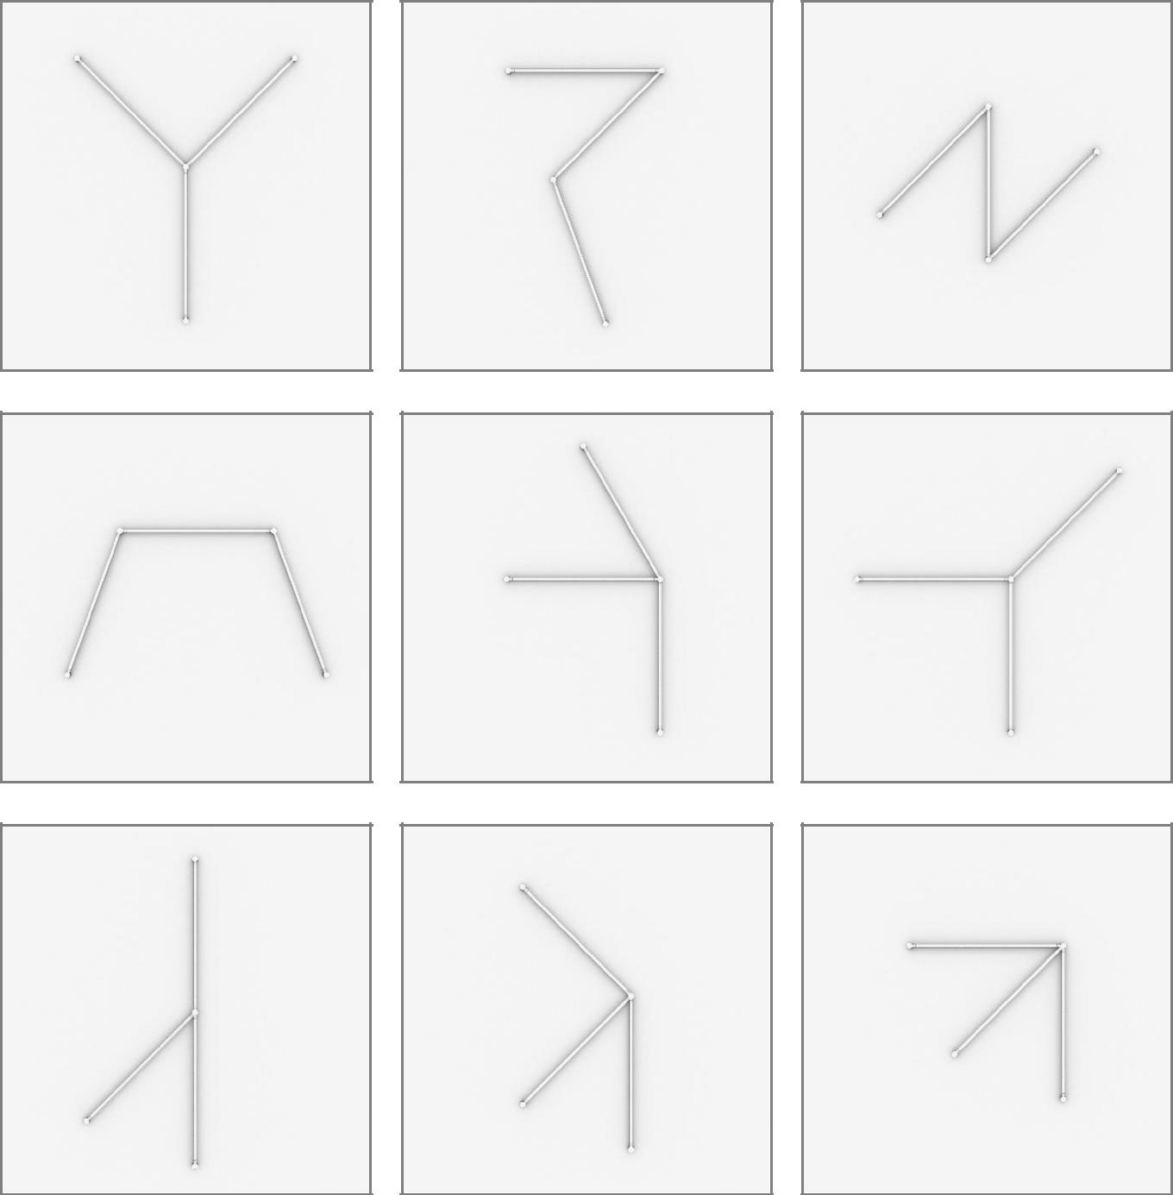

20
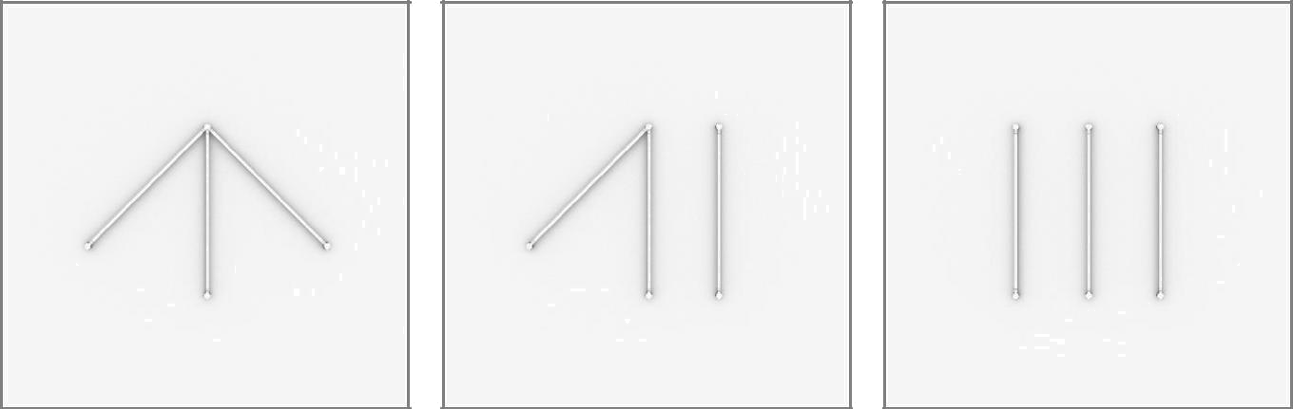

21

6 x 36inch/90cm LIGEOTM Light Bars
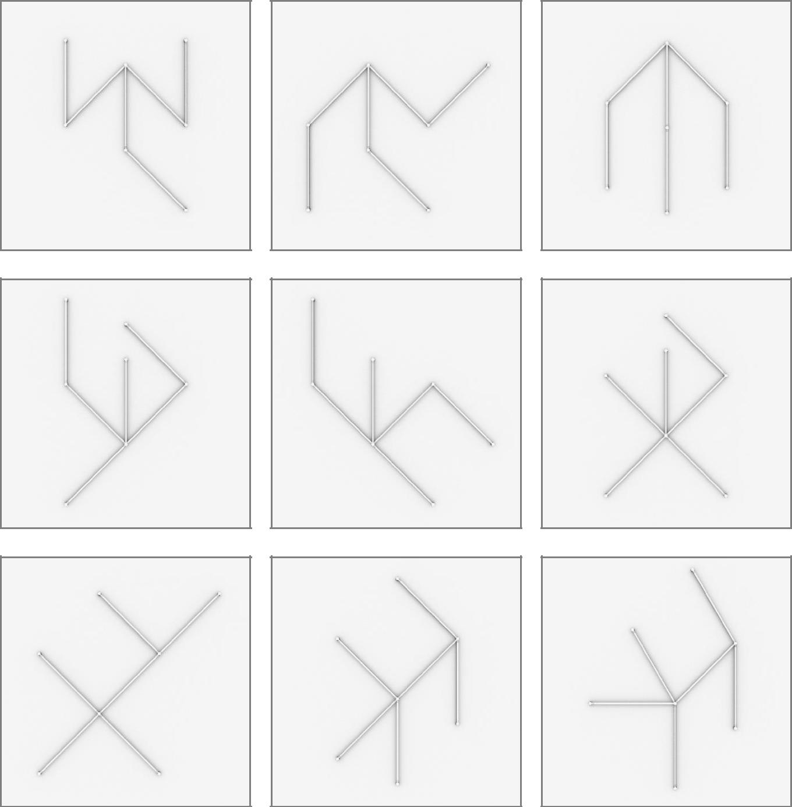

22
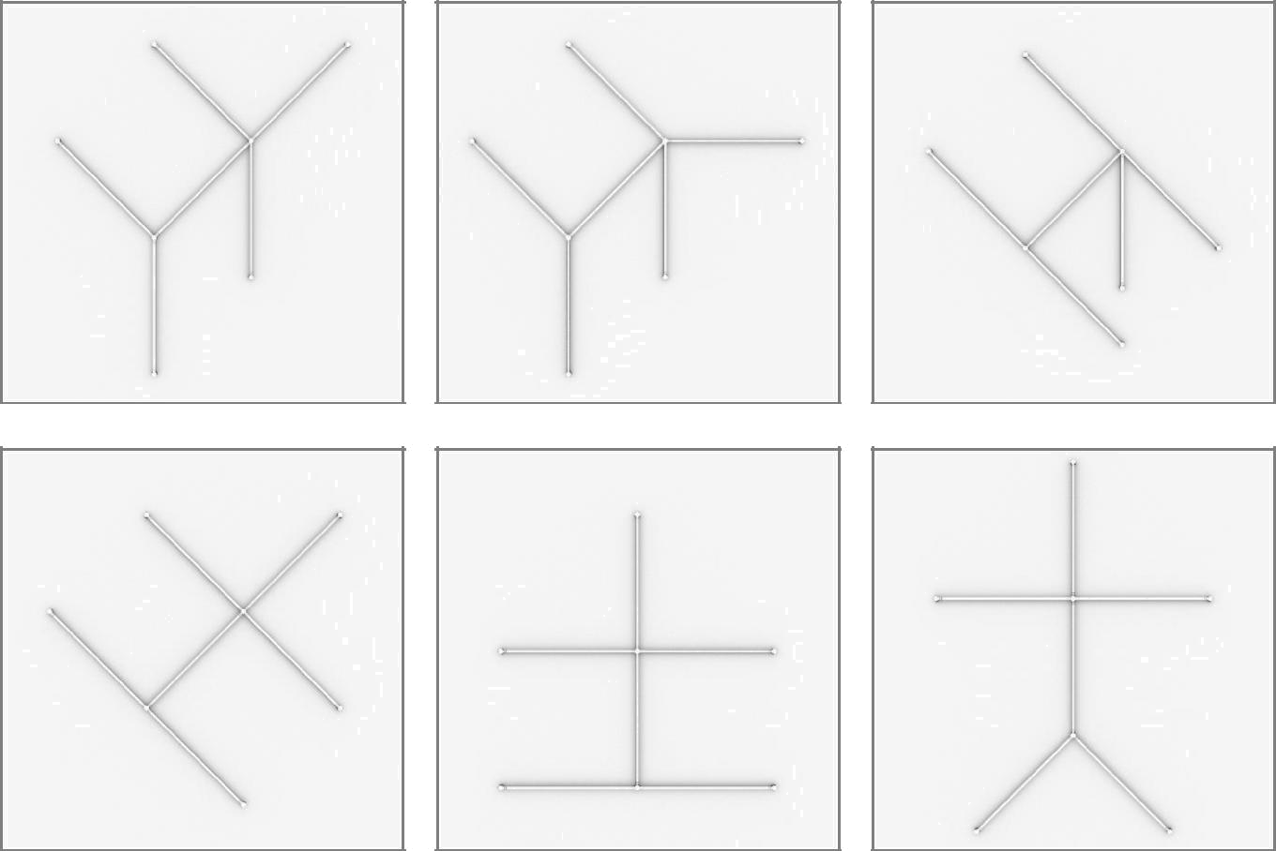

23

9 x 36inch/90cm LIGEOTM Light Bars
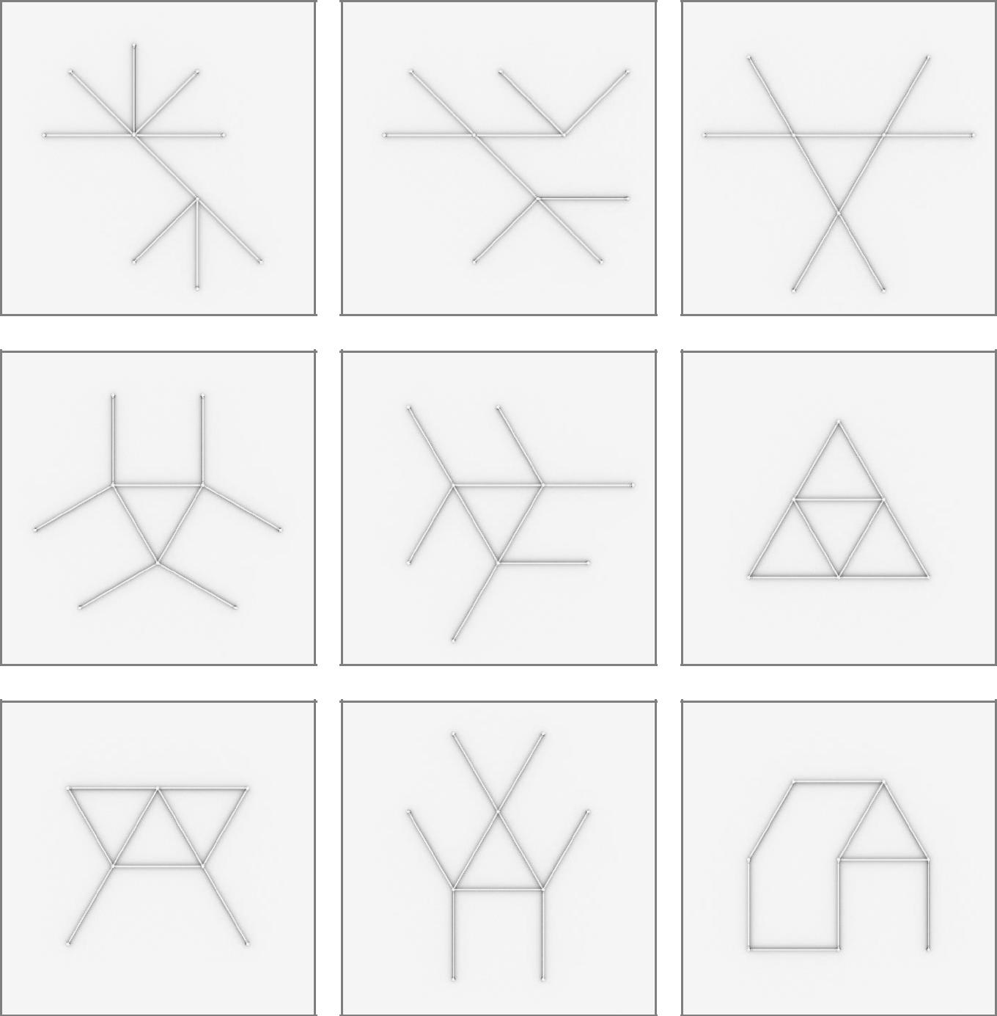

24
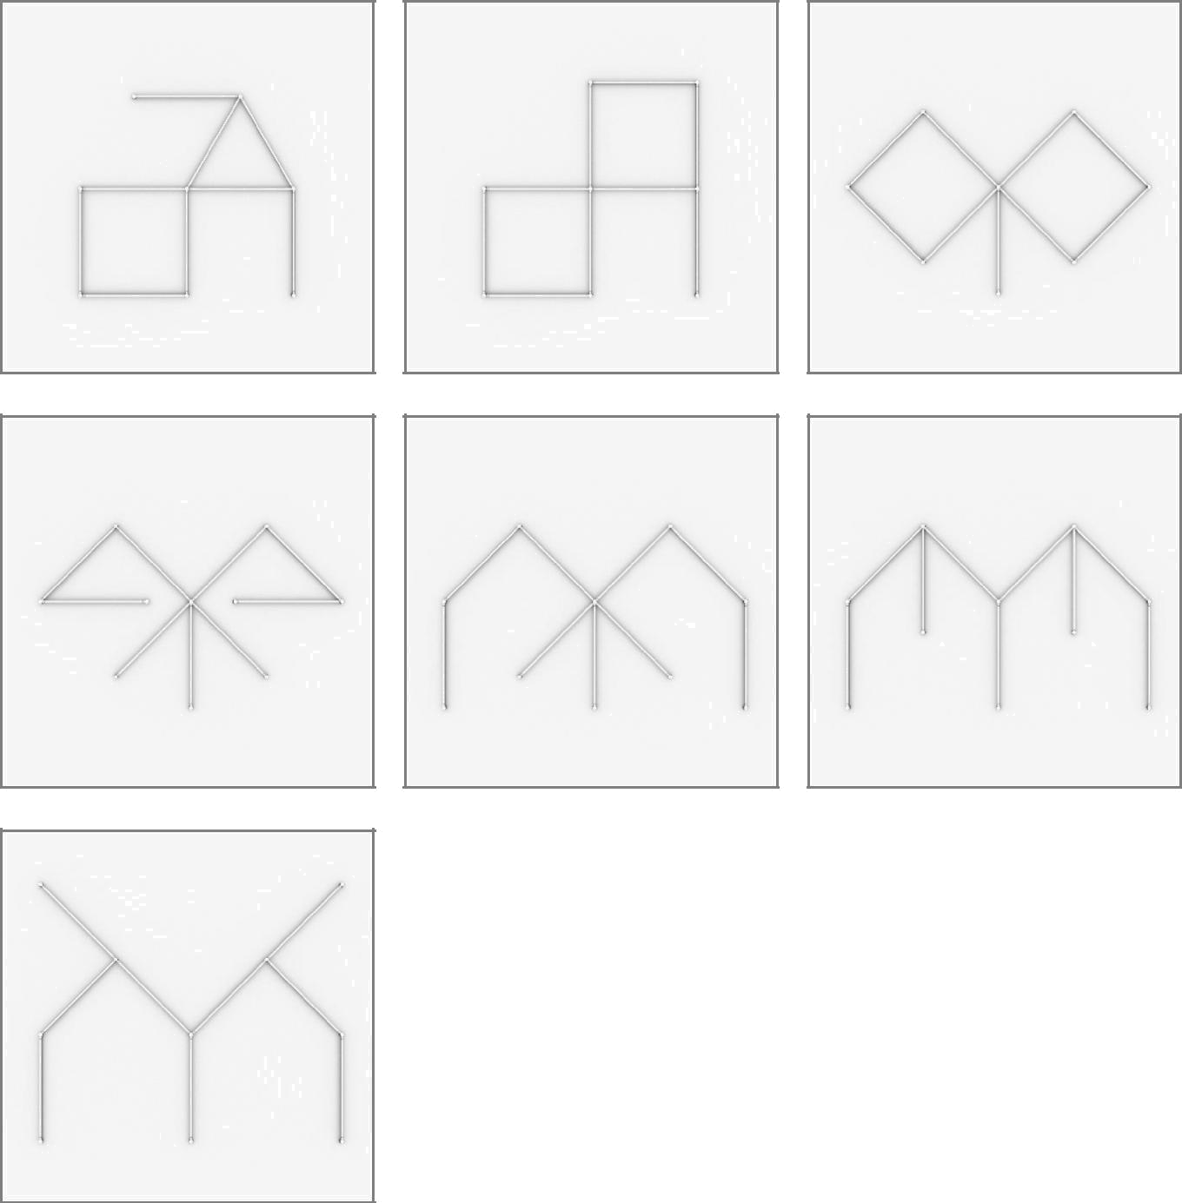

25

12 x 36inch/90cm LIGEOTM Light Bars
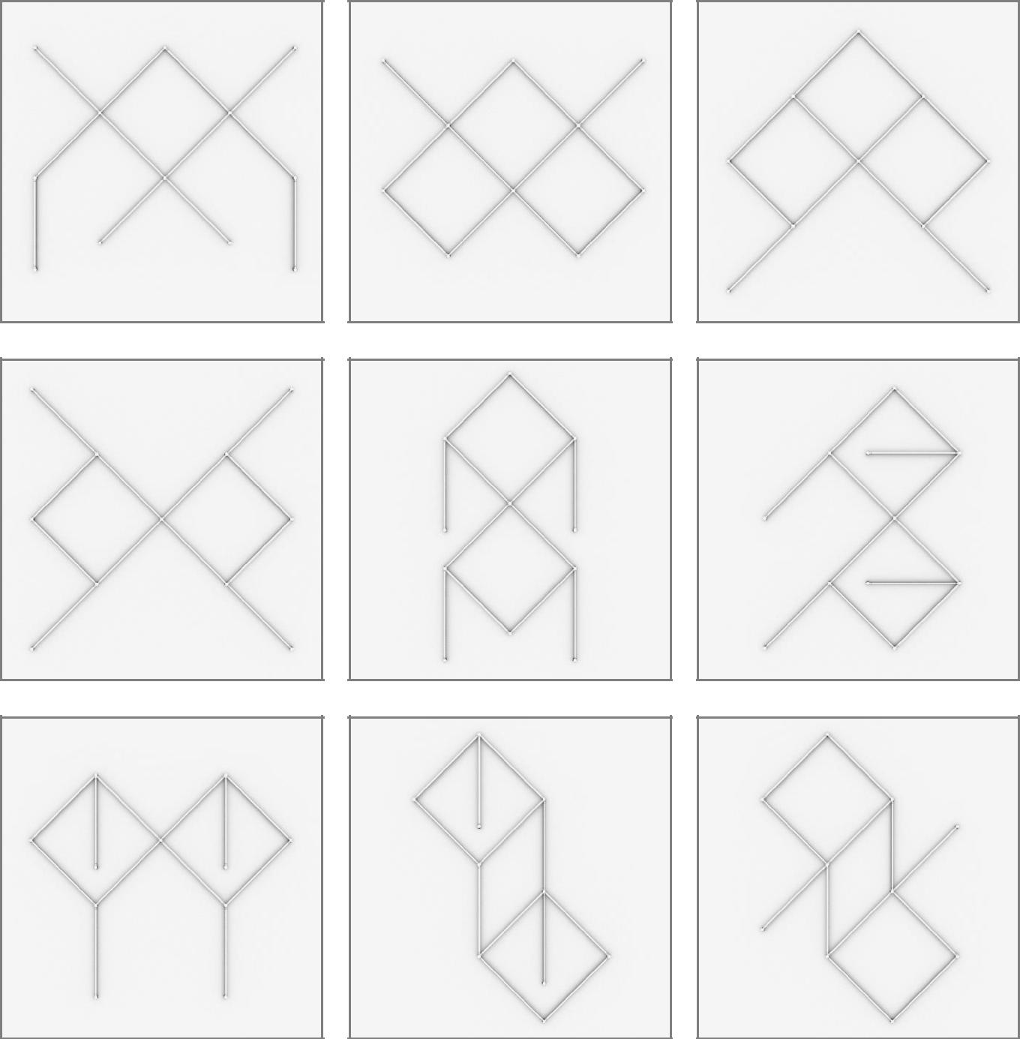

26
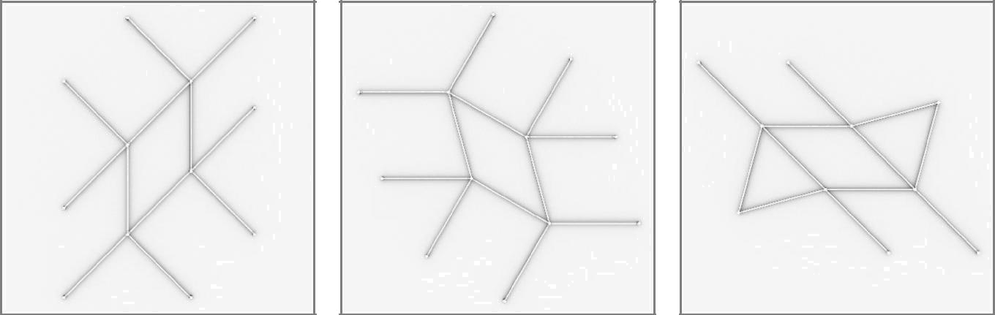

27

3 x 12inch/30cm & 3 x 24inch/60cm LIGEOsTM
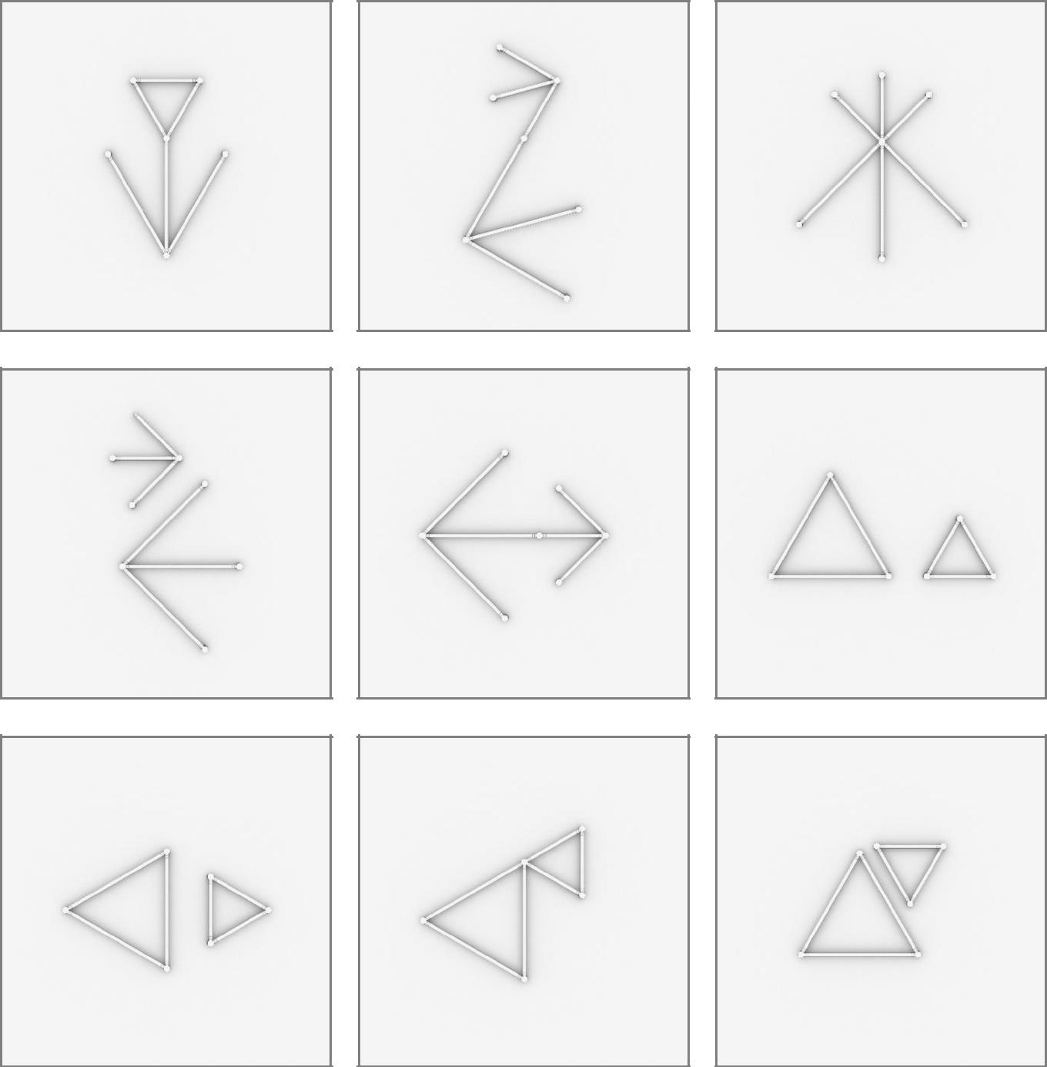

28
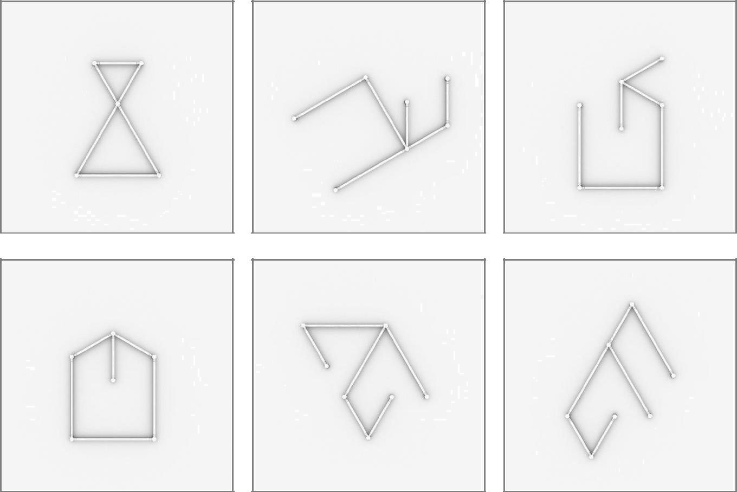

29

3 x 12inch/30cm & 3 x 36inch/90cm LIGEOsTM
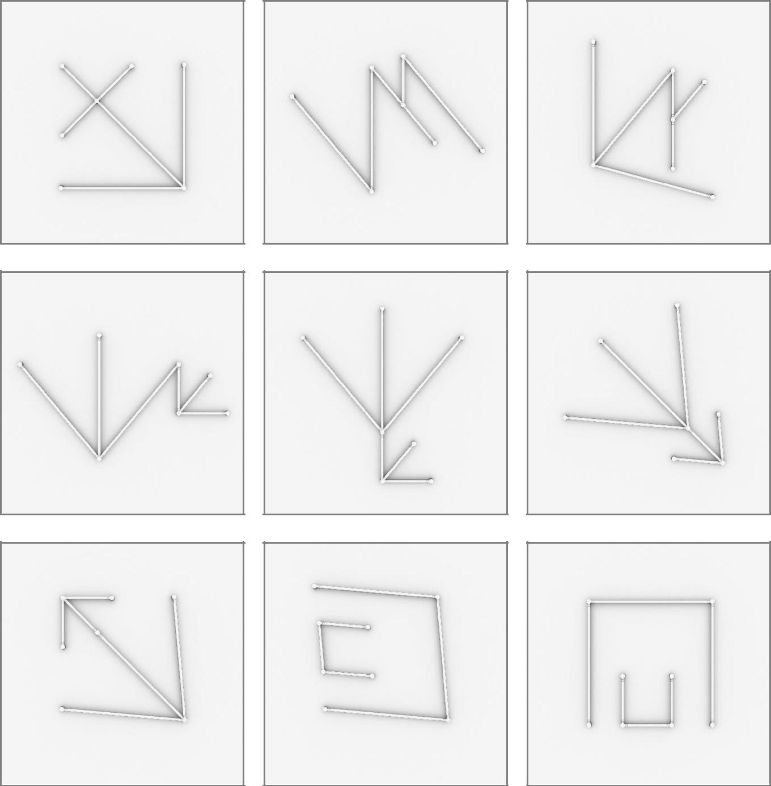

30
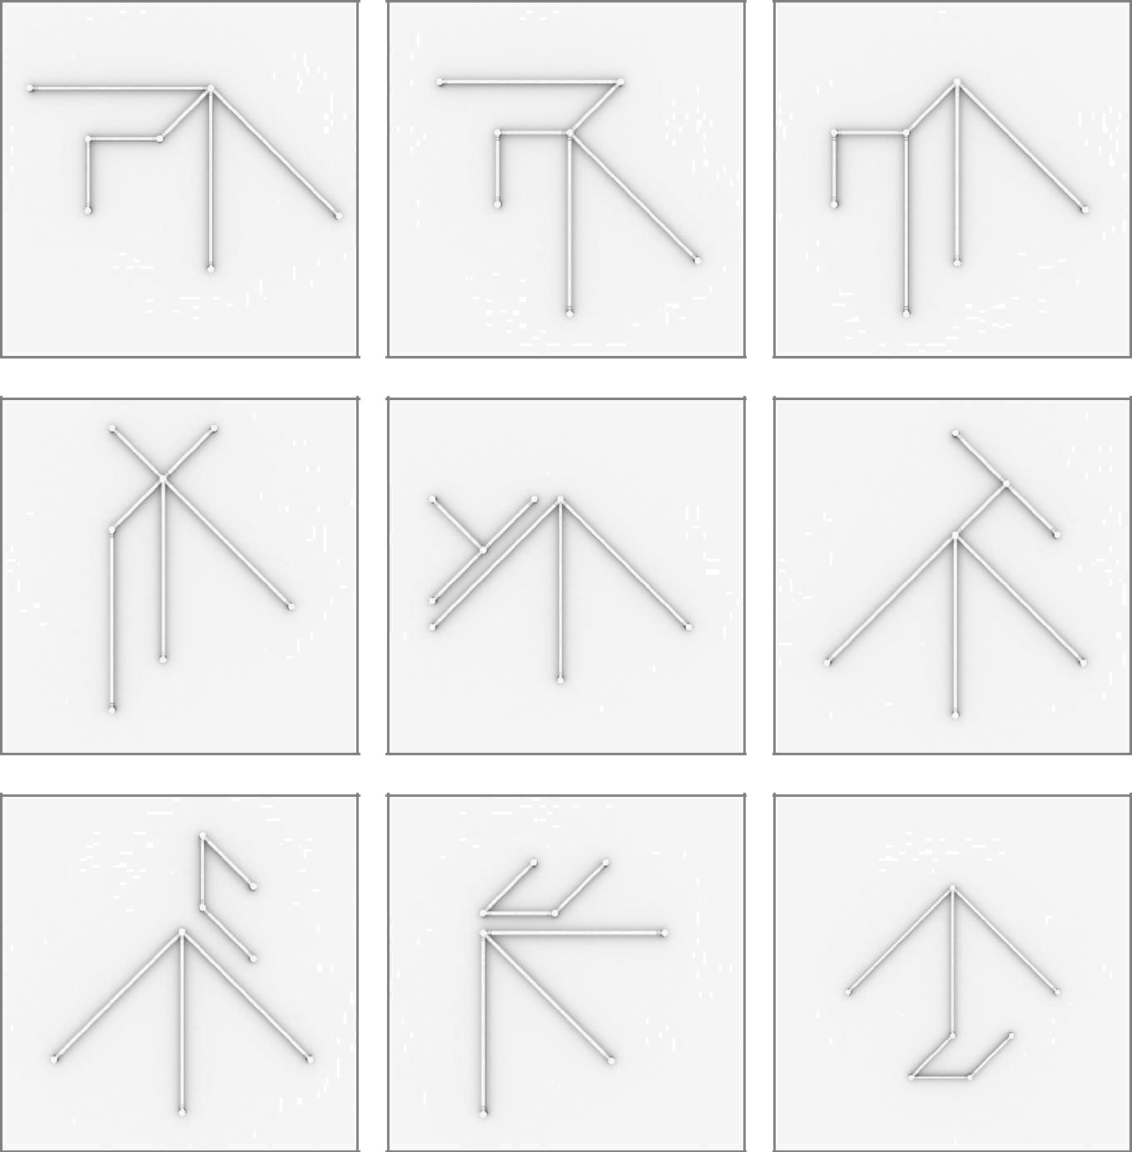

31
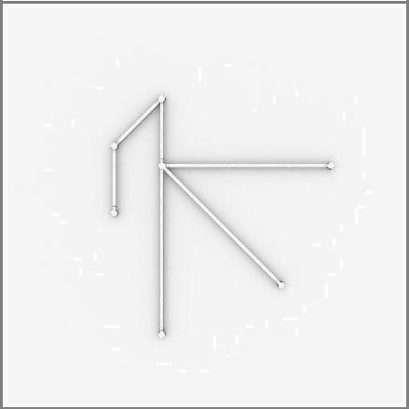

32

3 x 24inch/60cm & 3 x 36inch/90cm LIGEOsTM
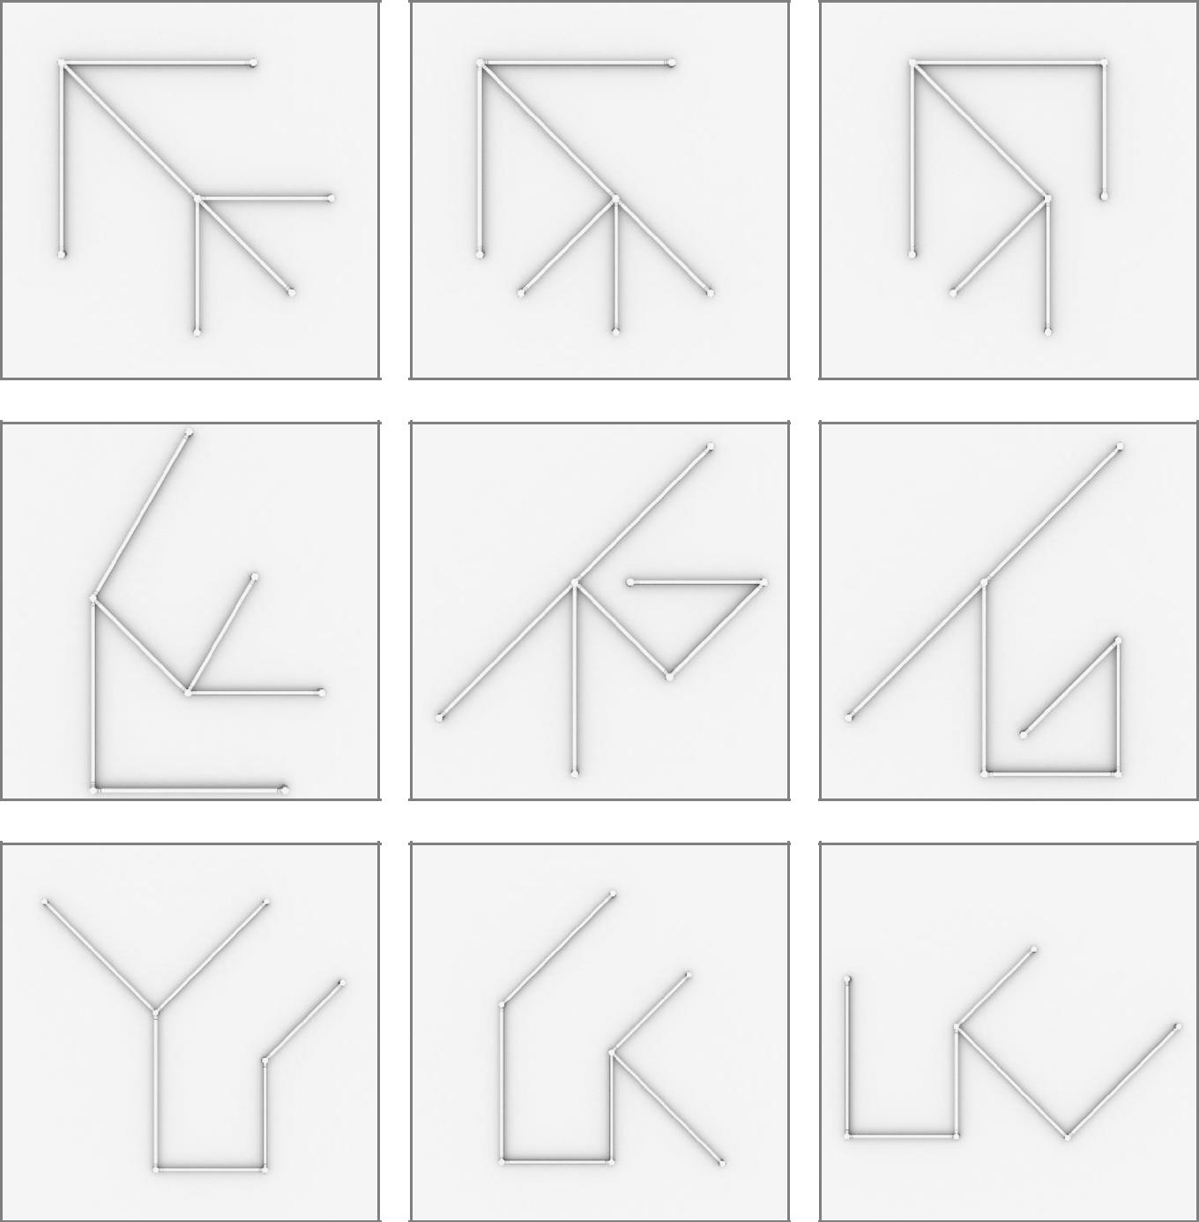

33


34

4 x 12inch/30cm & 4 x 24inch/60cm LIGEOsTM
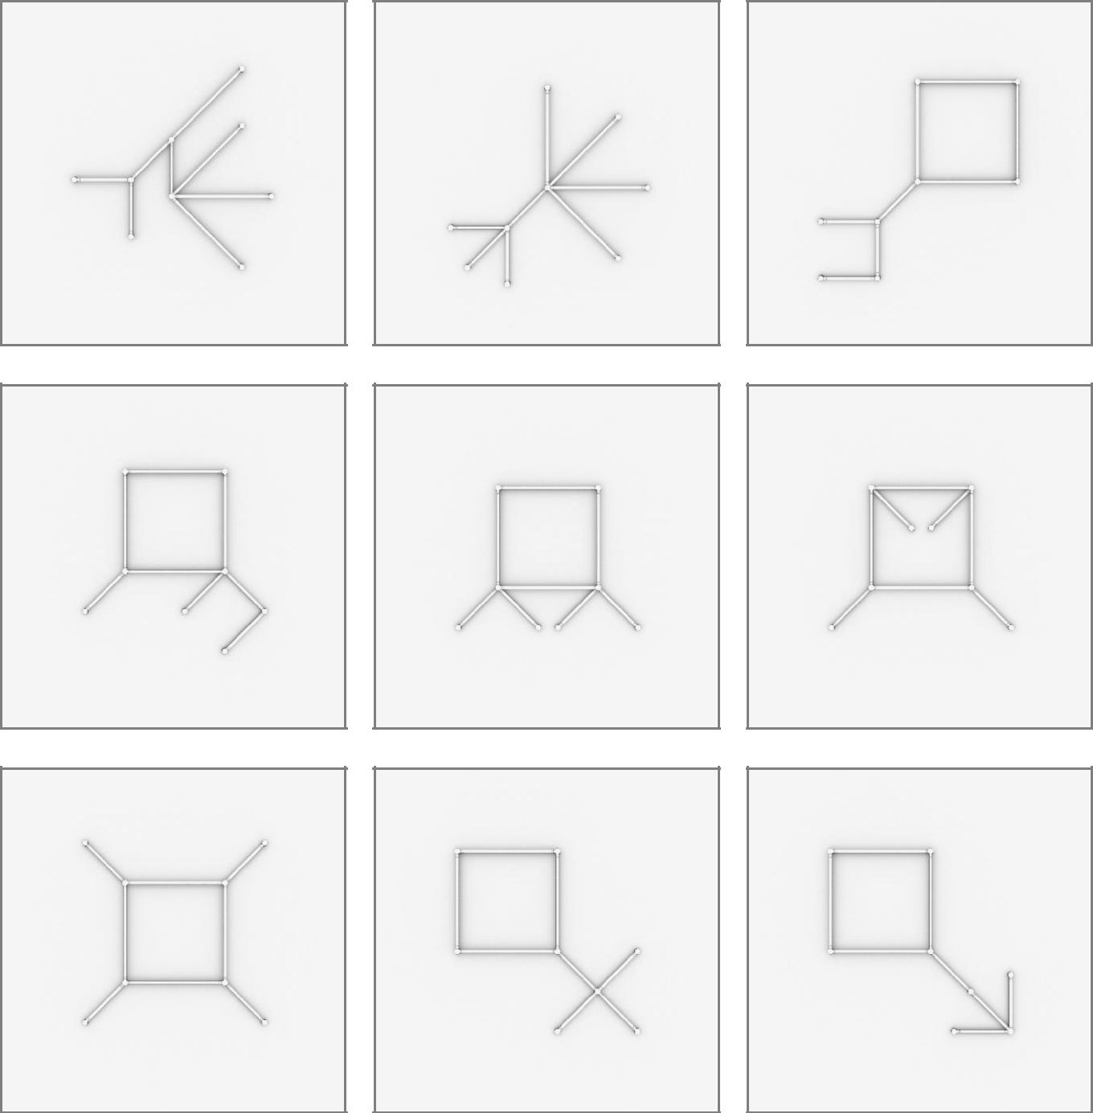

35
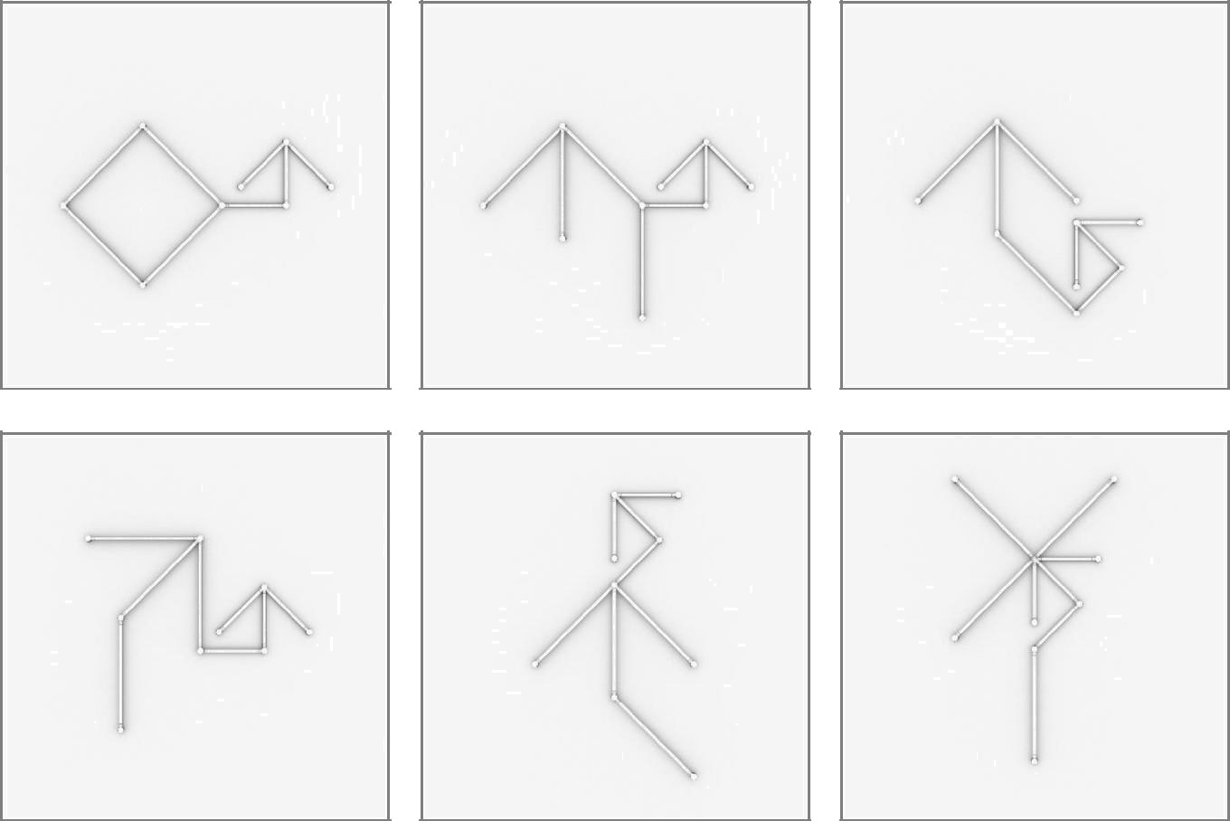

36

6 x 12inch/30cm & 3 x 24inch/60cm LIGEOsTM
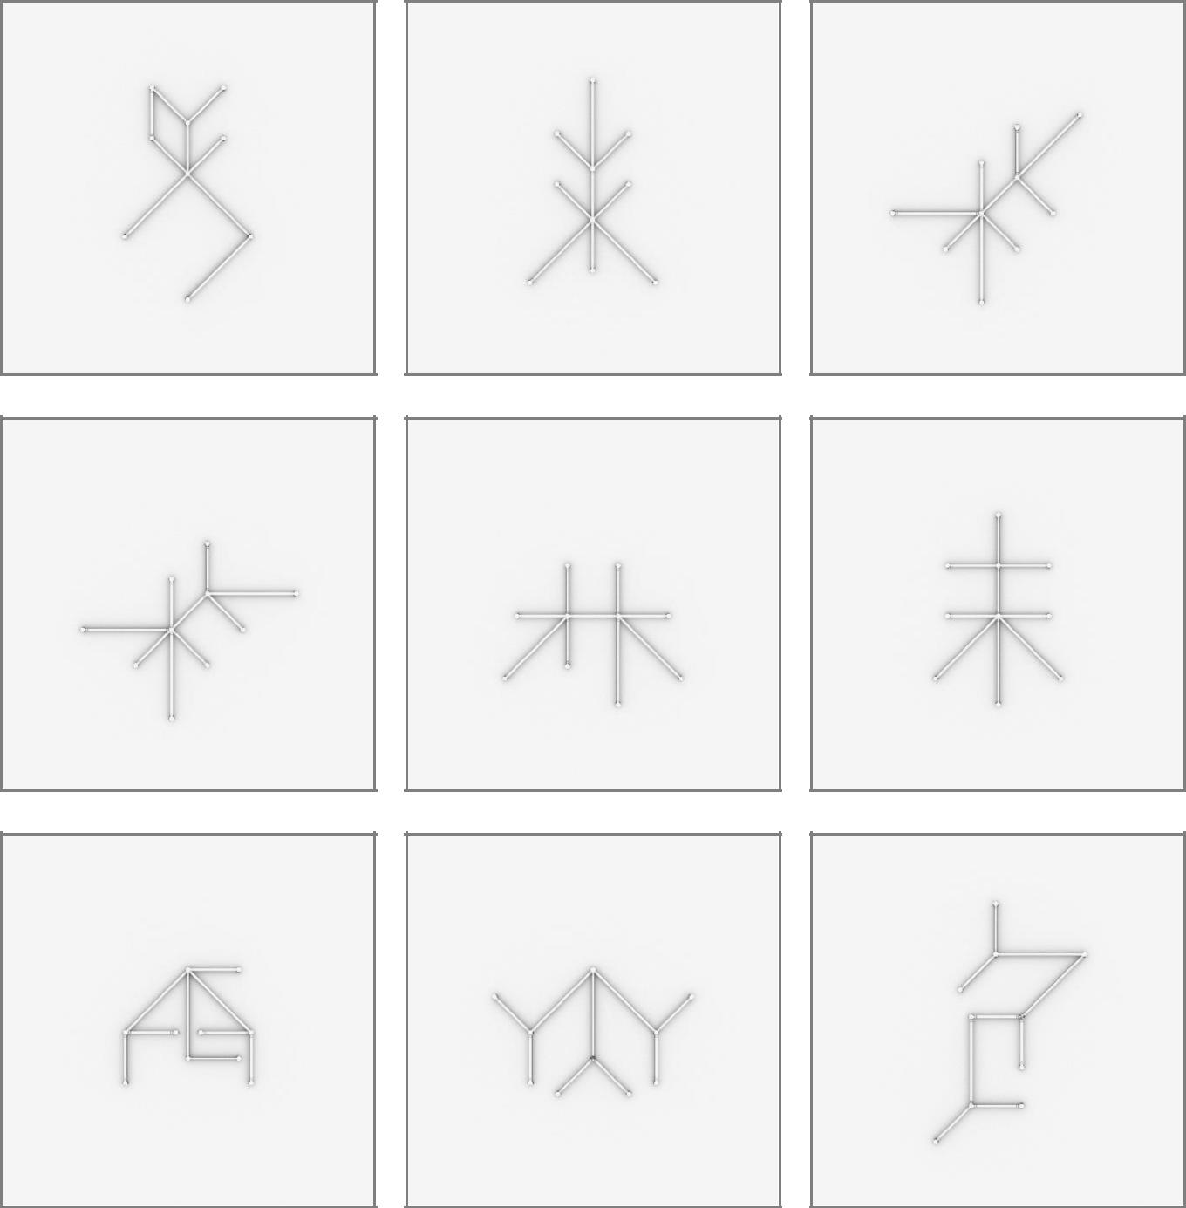

37
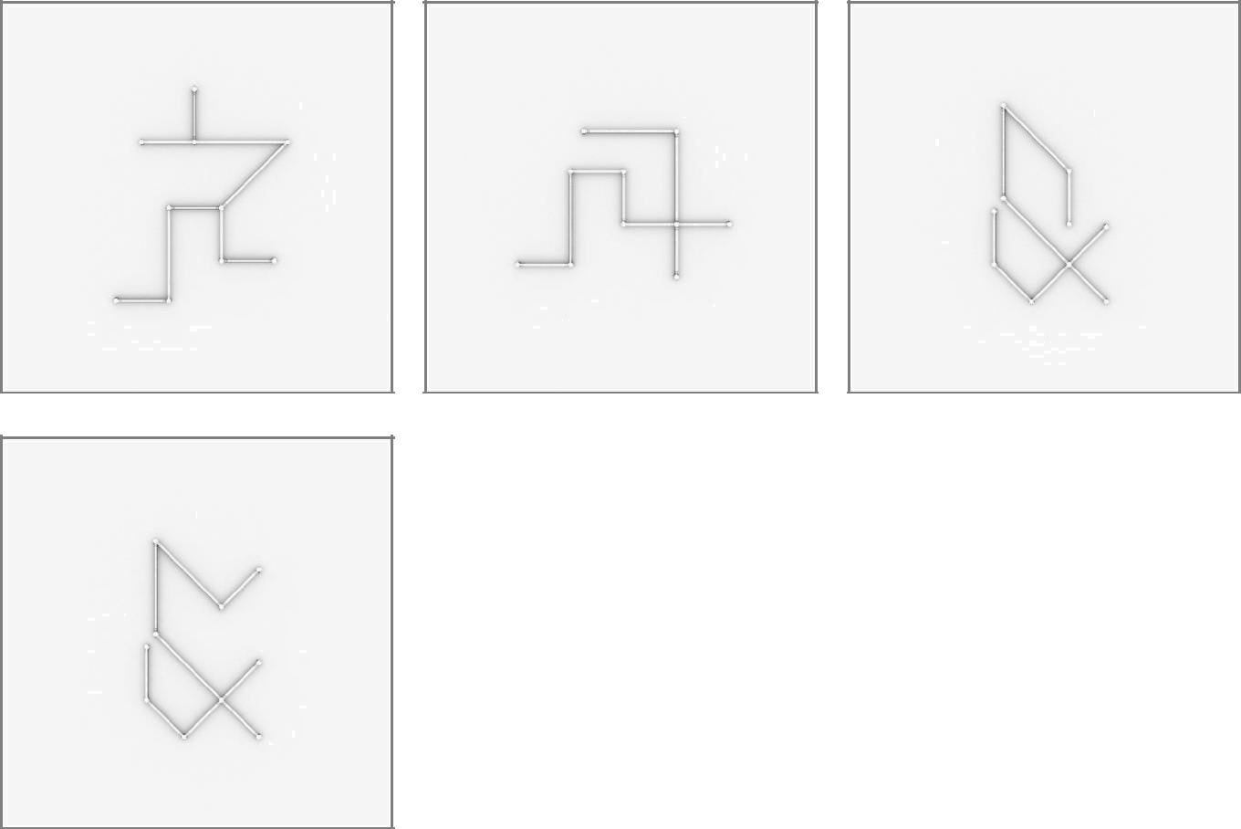

38

6 x 12inch/30cm & 3 x 36inch/90cm LIGEOsTM
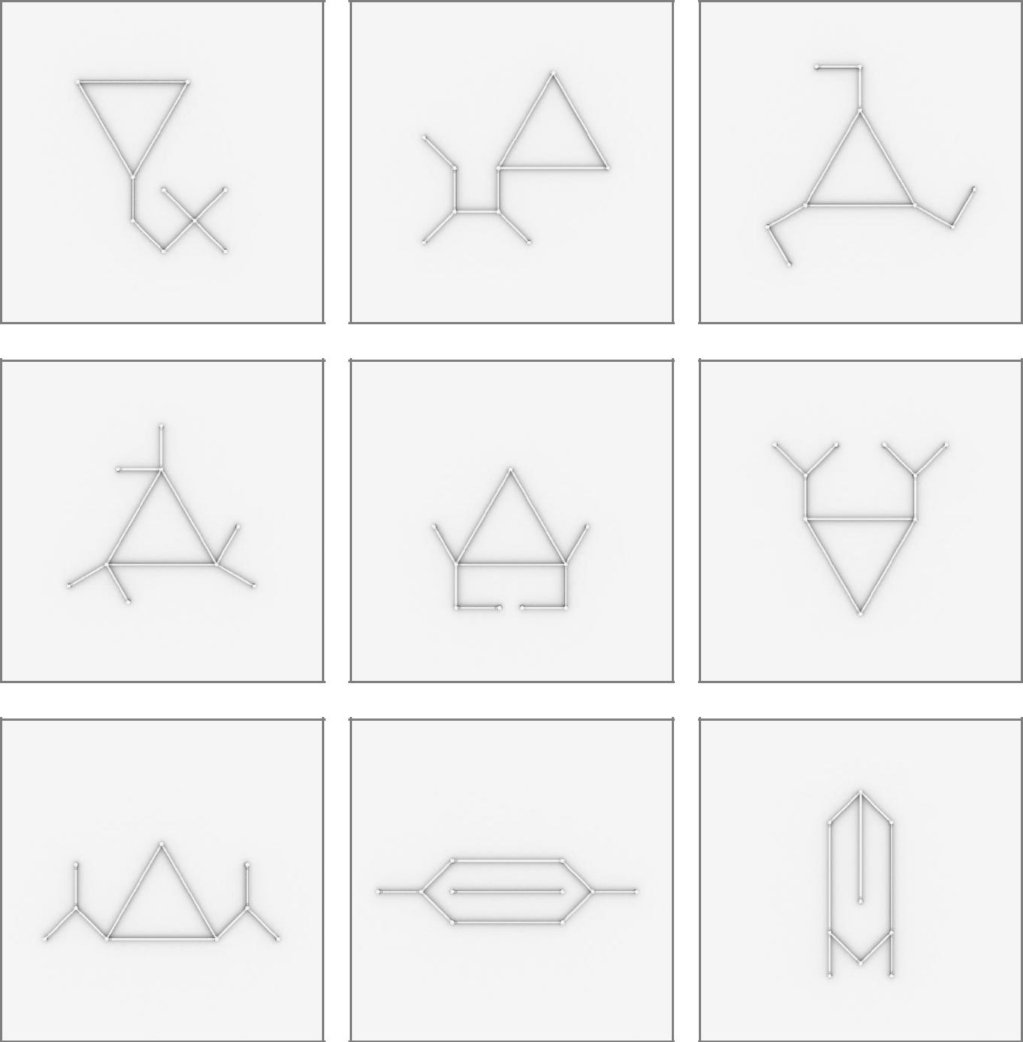

39
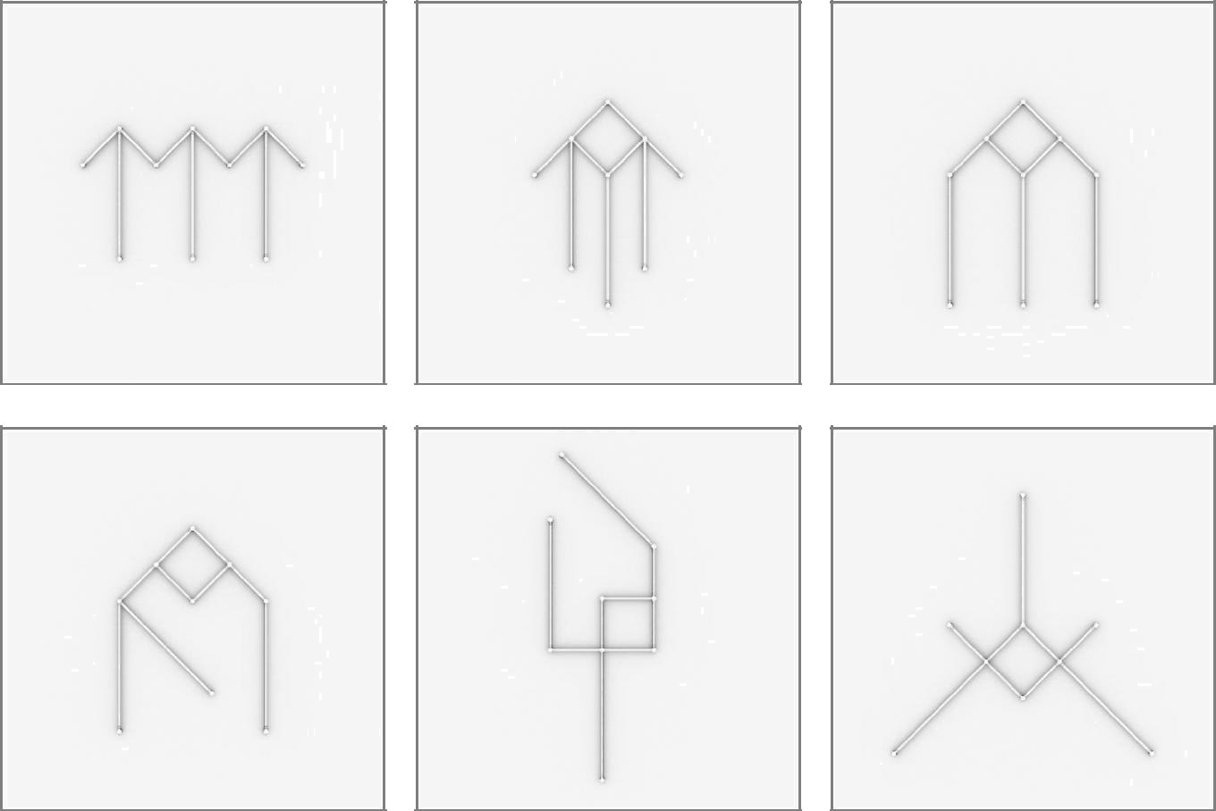

40

8 x 12inch/30cm & 4 x 24inch/60cm LIGEOsTM
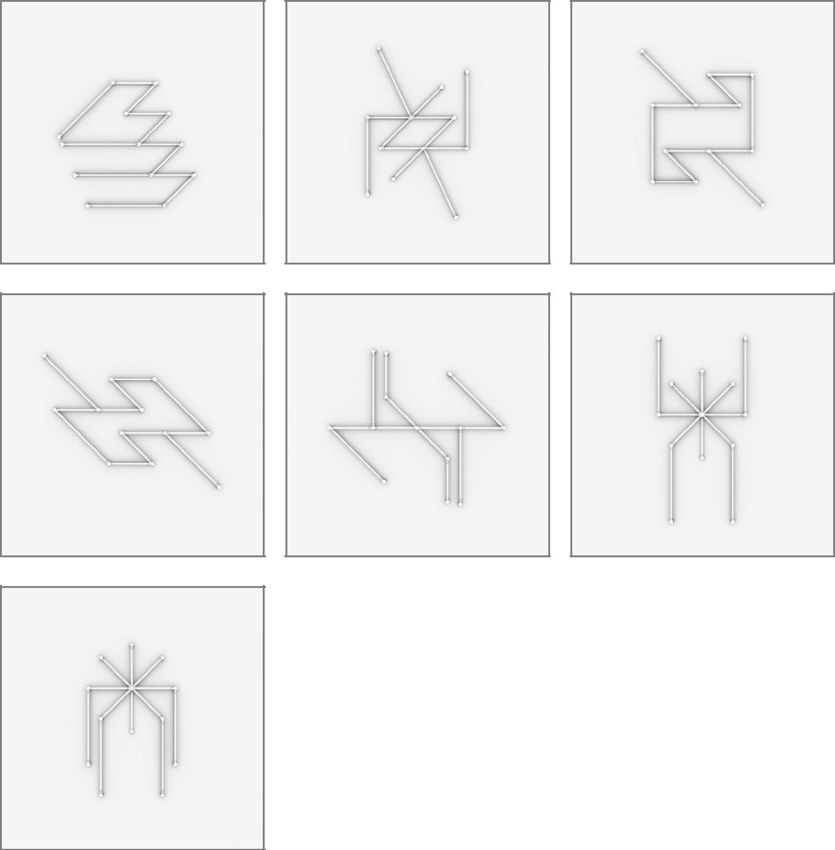

41

8 x 12inch/30cm & 3 x 24inch/60cm &

3 x 36inch/90cm LIGEOsTM
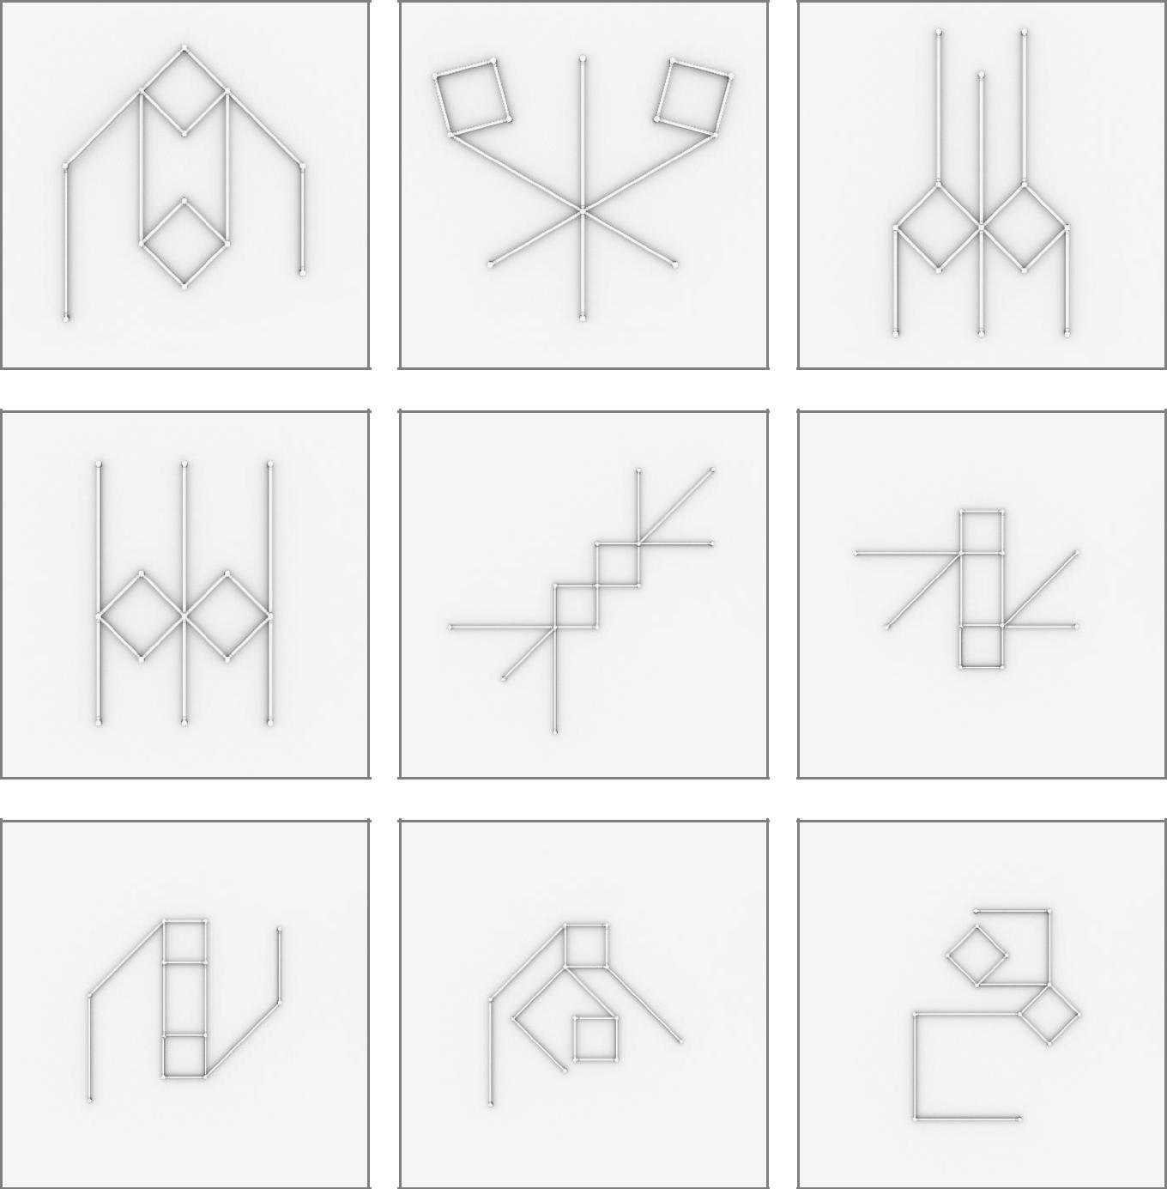

42

8 x 12inch/30cm & 4 x 24inch/60cm &

4 x 36inch/90cm LIGEOsTM
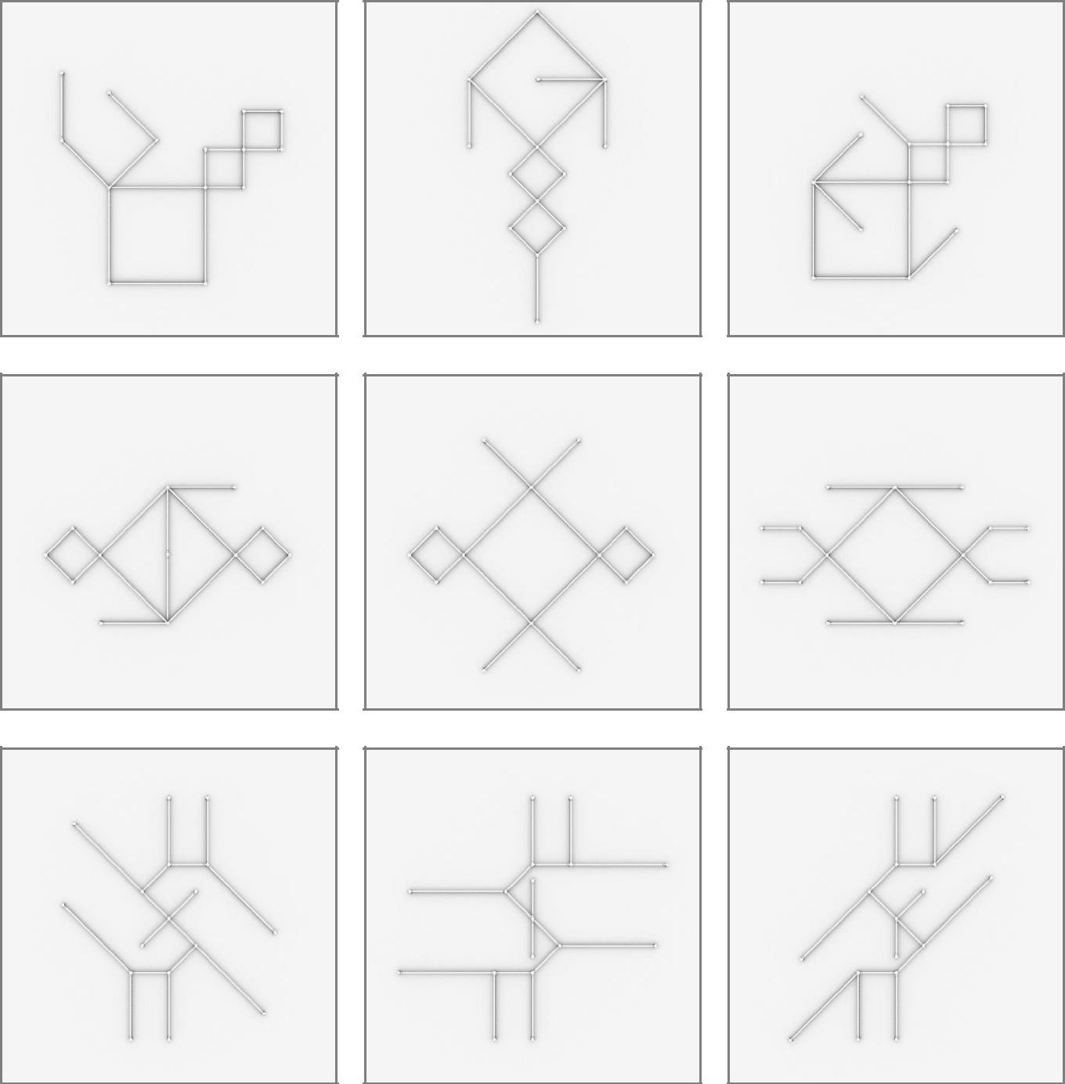

43
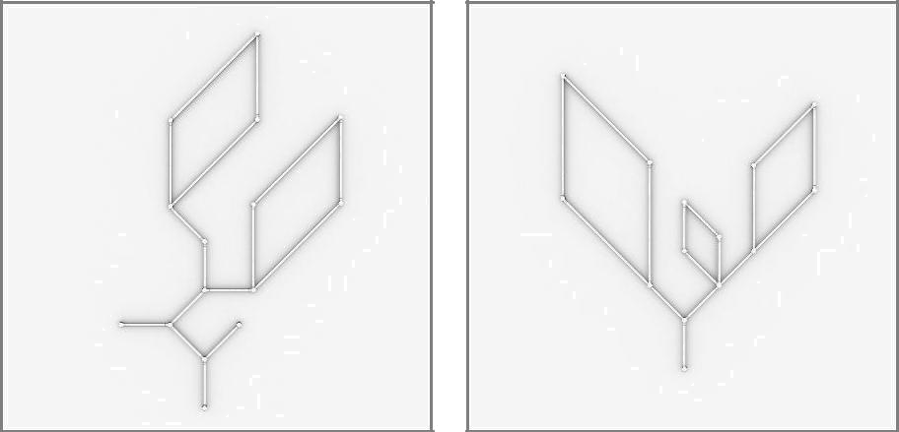

44

12 x 12inch/30cm & 6 x 24inch/60cm &

4 x 36inch/90cm LIGEOsTM
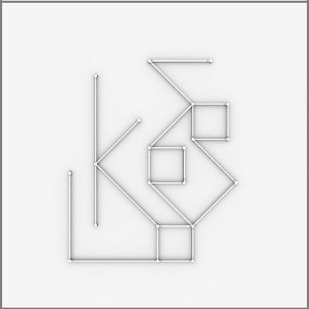

45

12 x 12inch/30cm & 8 x 24inch/60cm &

4 x 36inch/90cm LIGEOsTM
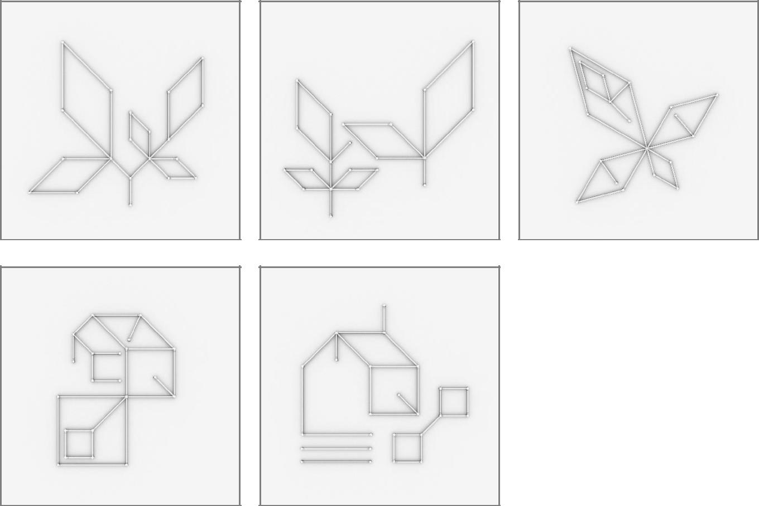

46

24 x 12inch/30cm & 8 x 24inch/60cm &

8 x 36inch/90cm LIGEOsTM
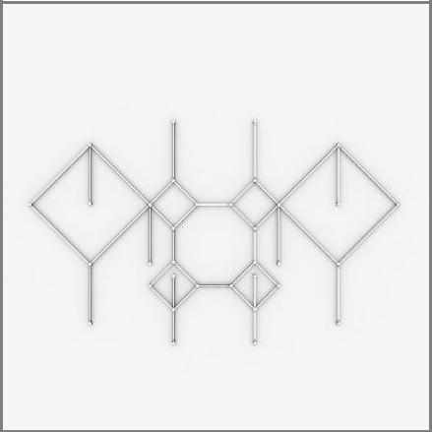

47

LIGEOTM Numbers
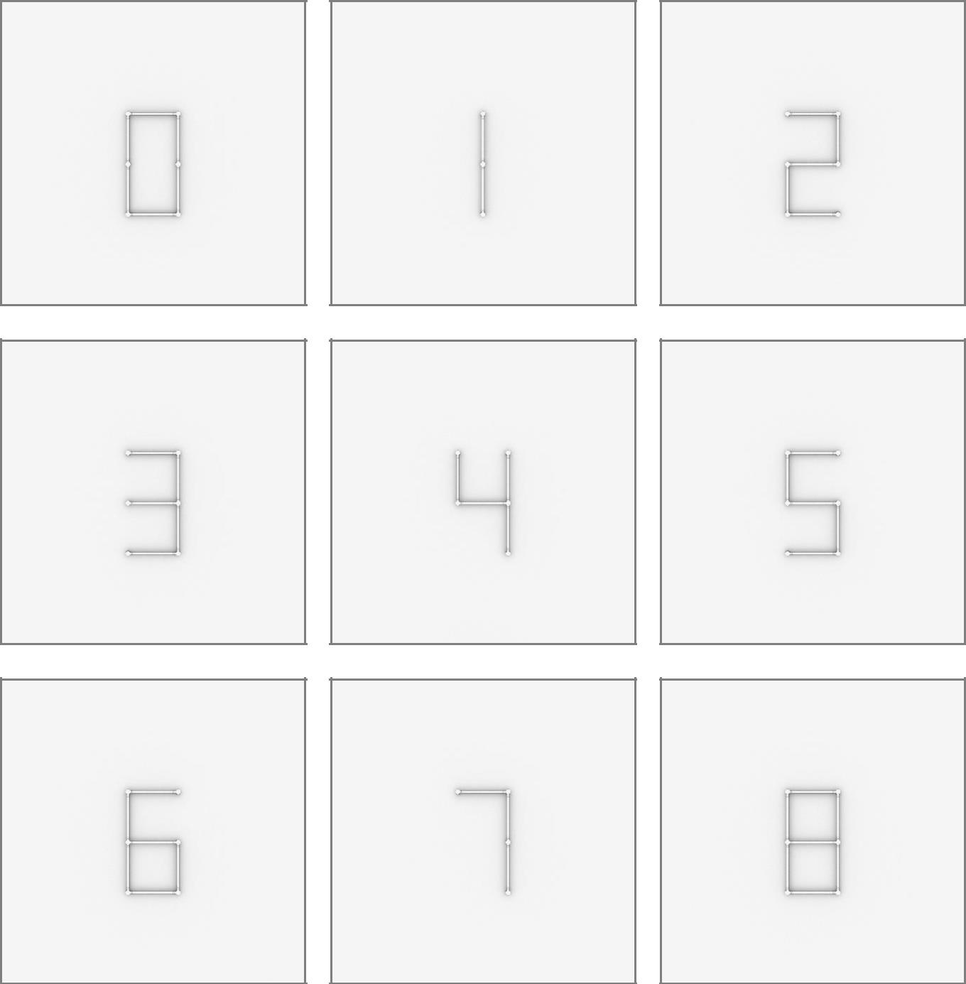

48
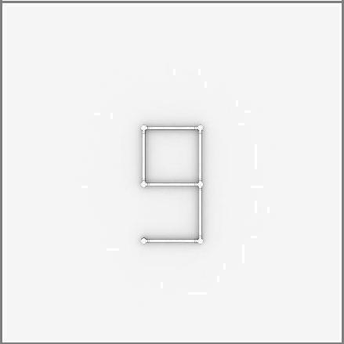

49

