

**YEAR 10**

**GETTING READY FOR THE YEAR 10 EXAMS**

**INDEPENDENT STUDY SKILLS**

**BOOKLET**

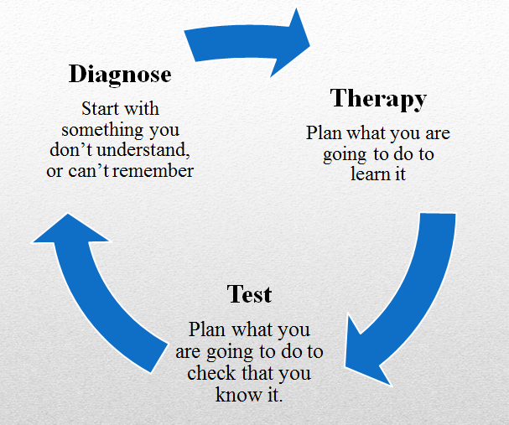

Dear Year 10 student

This booklet contains information and resources to support you in your journey to become effective independent learners. It breaks down the revision process into three parts that are connected in a continuous cycle.



**Diagnosis – What do I need to know?**

**Therapy –How can I learn it?**

**Test – What have I learnt?**

By using this independent study cycle your revision will become more effective and your progress will improve.

During the Year 10 workshop you will find out about each part of the cycle and will have the opportunity to try out some of the ideas. All of the templates included in this booklet are on the school website and can be downloaded so that you can reuse them again and again in your independent studying. To access the template use the following link:

[www.becketonline.co.uk/parent-information/independence](http://www.becketonline.co.uk/parent-information/independence)

Have a go at home trying out the different ideas and see which ones suit you better. This is the time to experiment and build up your independent learning skills in preparation for your Year 11 exams.

To support you in your diagnosis of what you need to learn you can also find all of the Personal Learner Checklists (PLCs) on the school website as well. These are for the whole of the GCSE course but you can select the topics that you have studied so far. Again these all can be downloaded and used in your independent study. To access these PLCs follow the link below and then choose the subject followed by year 11 assessment tab.

<https://www.becketonline.co.uk/parent-information/subject/>

All the best in your independent study

Mrs Shenton

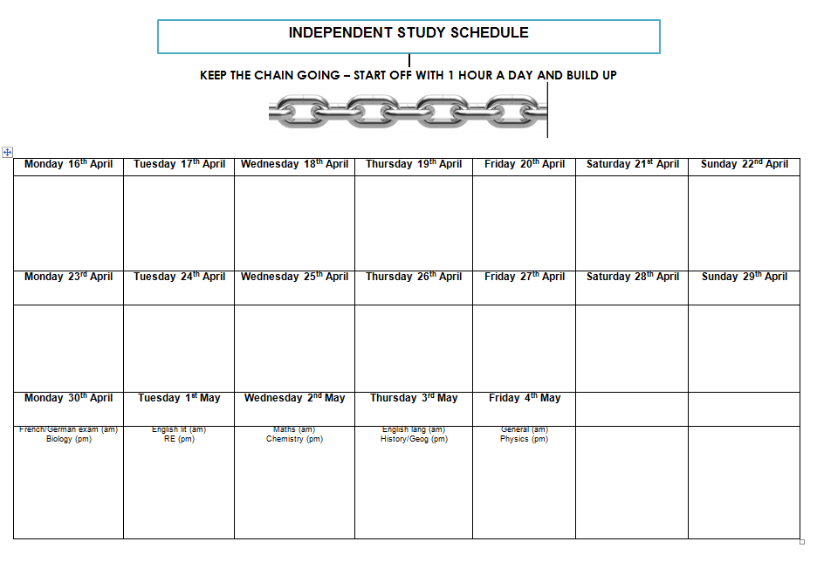

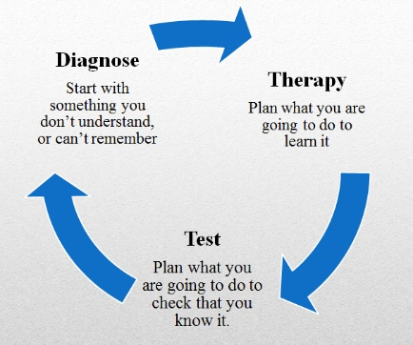

**INDEPENDENT DIAGNOSIS: FIRST, THEN AND NEXT**

## name: class:

## subject:

Be clear about what you know and what you don’t know before you begin.

**First,** use the personal learner checklist or contents page of a revision guide, or a topic list for the subject you are going to revise.

**Then,** fill in the following table – the topics, and how well you know them.

**Next,** prioritise. Which topics will you revise first? Spend time studying the topics which will make the biggest difference to your results.

|  |  |  |
| --- | --- | --- |
| Topic | Knowledge | Priority |
|  | Know it/Sort of know it/Don’t know it |  |
|  | Know it/Sort of know it/Don’t know it |  |
|  | Know it/Sort of know it/Don’t know it |  |
|  | Know it/Sort of know it/Don’t know it |  |
|  | Know it/Sort of know it/Don’t know it |  |
|  | Know it/Sort of know it/Don’t know it |  |
|  | Know it/Sort of know it/Don’t know it |  |
|  | Know it/Sort of know it/Don’t know it |  |
|  | Know it/Sort of know it/Don’t know it |  |
|  | Know it/Sort of know it/Don’t know it |  |
|  | Know it/Sort of know it/Don’t know it |  |
|  | Know it/Sort of know it/Don’t know it |  |

­­­­­­­

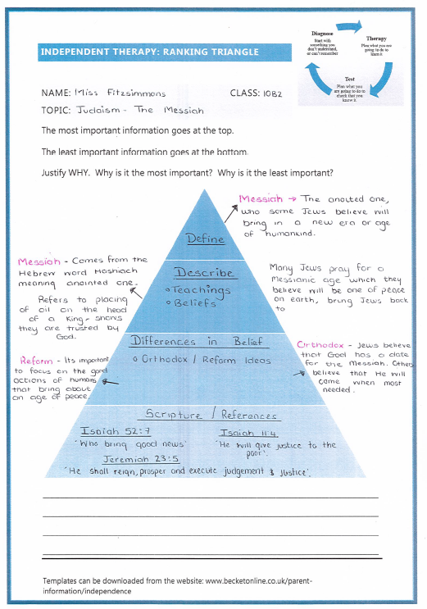



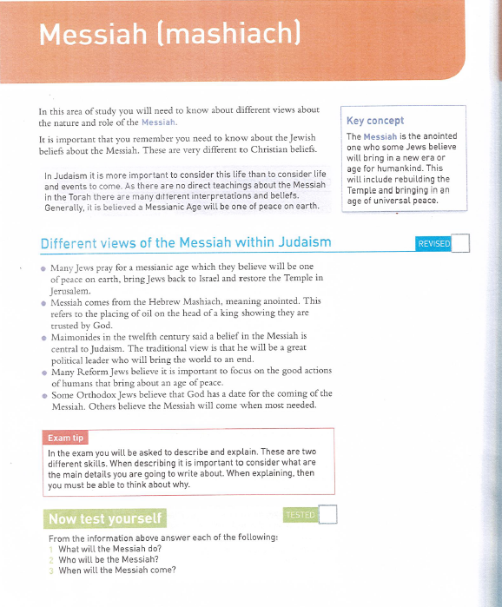

**independenT THERAPY: quizzing**

name: class:

topic:

Read the text and transform it into 10 questions to ask someone.

|  |  |  |
| --- | --- | --- |
|  | Question | Answer |
| 1 |  |  |
| 2 |  |  |
| 3 |  |  |
| 4 |  |  |
| 5 |  |  |
| 6 |  |  |
| 7 |  |  |
| 8 |  |  |
| 9 |  |  |
| 10 |  |  |

Question stems:

State …. Describe …. Discuss …… Explain ….. Evaluate …..

Suggest ….. To what extent ….. Give reasons …… Compare ….



**Aerobic Respiration**

Think back to the 7 processes of life (MRS GREN), respiration is one of the ‘R’s in that acronym. There are 2 types of respiration aerobic and anaerobic, both of which produce different amounts of energy.

Aerobic respiration means in the presence of oxygen. This oxygen comes from the air we breathe. The second thing that aerobic respiration requires is glucose, this is a type of sugar, and comes from the food we eat. Through reactions the oxygen and glucose are converted into two products and energy. These products are carbon dioxide and water. In aerobic respiration more energy is produced than in anaerobic respiration (38 ATP molecules from 1 glucose molecule). Respiration is a process that is continuously occurring in all living cells. The energy transferred supplies all the energy needed for living processes. Aerobic respiration takes place in organelles in cells called mitochondria.

**Anaerobic Respiration**

Anaerobic respiration produces less energy than aerobic respiration. During exercise the human body reacts to the increased demand for energy. The heart rate, breathing rate and breath volume increase during exercise to supply the muscles with more oxygenated blood. If insufficient oxygen is supplied, anaerobic respiration takes place in muscles. The incomplete oxidation of glucose causes a build-up of lactic acid and creates an oxygen debt. During long periods of vigorous activity muscles become fatigued and stop contracting efficiently. Blood flowing through the muscles transports the lactic acid to the liver where it is converted back into glucose. Oxygen debt is the amount of extra oxygen the body needs after exercise to react with the accumulated lactic acid and remove it from the cells. High concentration of lactic acid can cause cramp . This process occurs in the cytoplasm.

**independenT THERAPY: pictionary**

name: class:

topic:

Transform the material into 6 pictures – one per paragraph or one per key piece of information. The pictures should represent the information so that they can act as a reminder of what the text said. After turn the pictures back into text and write your thinking underneath, without looking at the text.

|  |  |  |
| --- | --- | --- |
| 1. | 2. | 3. |
|  |  |  |
| 4. | 5. | 6. |
|  |  |  |



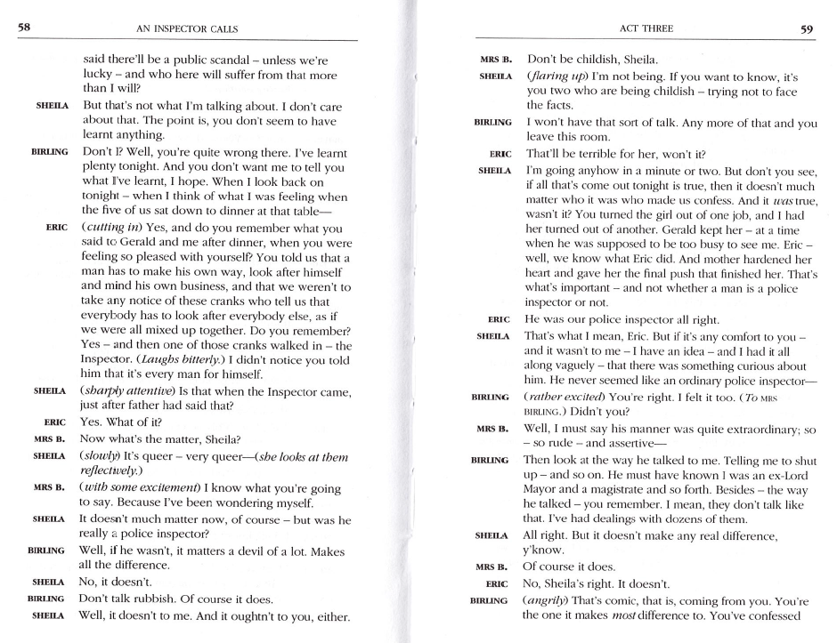

**independenT THERAPY: Linking keywords**

name: class:

topic:

Write the keywords for a topic on a piece of paper, spread them out. You could even use an A3 spread. You may get the keywords from your revision guide, a glossary you have in your exercise book/textbook or from your classwork. Write a correct sentence that links two or more of the keywords together. Repeat until you have covered all of the keywords.

**Geography Topic Coasts**

**History Topic American West**

Cattle ranching

Vaqueros

Mexicans

Texans

Civil war

Open range

Sioux

Refrigeration

Cattle barons

Great Plains

Dry farming

Thresher teams

Timber culture Act

Sheffis

Destructive waves

Constructive waves

Hydraulic action

Abrasion

Attrition

Longshore drift

Hard engineering

Soft engineering

Stack

Beach

Spit

Headland

Bay



# **independence THERAPY: boxing up**

## name: class:

## topic:

Take a section of text. Read it and put your thoughts about the text into different boxes.

|  |
| --- |
| **Needs a boost:** 3 things I did not know: |
| **Almost there:** 3 things I understand better now: |
| **I’ve got these:** 3 things I already knew: |



# **independence THERAPY: Text into a flowchart**

## name: class:

## topic:

Transform some text into a flow chart. This is good if you need to sequence something e.g. a series of events or how something works.

**independenT THERAPY: Look, Cover, write, check**

## name: class:

## topic:

Cover a list of key words, a key piece of text or a diagram. Write them down. Check which ones or bits you have right. Repeat until you get them all right.

**Key words/diagram/explanation you need to know**

**What I can duplicate when covered?**

**What is missing/inaccurate?**

**independenT THERAPY: PRIORITISE, REDUCE, CATEGORISE, EXTEND**

## name: class:

## topic:

Take a section of text and do the following:

|  |
| --- |
| **Prioritise:** write out the three most important sentences. Rank 1-3 in terms of importance. Justify your decision. |
| **Reduce:** reduce the key information to 20 words. |
| **Categorise:** sort out the information into three categories. Give each category a  title which sums up the information. |
| **Extend**: write down three questions you would like to ask an expert in this subject. |



**TEST**

**Idea 1**

At the end of your study session, write down questions that you could be asked to check your understanding.

These could be

A number of short questions – STATE, WHAT, NAME, LIST…

One or two bigger questions – DESCRIBE, EXPLAIN, EVALUATE

**Idea 2**

Complete questions in a revision guide/textbook. Could access online resources that generate quizzes/tests for you.

**Idea 3**

Complete a past exam question.