

Media production at its best Spec sheets and templates
Inhalt Contents

!

Audio

DVD

Vinyl

Datenaufbereitung und Druckvorgaben | 3 | Preparation of data and printing demands | 3
CD Label 120 mm | 4 | Audio Label 120 mm | 4
CD Label 80 mm | 5 | Audio Label 80 mm | 5
CD Booklet doppelseitig | 6 | Audio Booklet double page layout | 6
CD Covercard | 7 | Audio Covercard | 7
CD Inlaycard | 8 | Audio Inlaycard | 8
CD Inlaycard Superjewelbox | 9 | Audio Inlaycard Superjewelbox | 9
CD Maxicard with Flap | 10 | Audio Maxicard with Flap | 10
CD Kartonstecktasche | 11 | Audio Cartonsleeve | 11
CD Booklet 6-seitig Wickelfalz | 12 | Audio Folded Booklet 6 pp Rollfold | 12
CD Booklet 8-seitig Wickelfalz | 13 | Audio Folded Booklet 8 pp Rollfold | 13
CD Booklet 8-seitig Dreibruch-Fensterfalz | 14 | Audio Folded Booklet 8 pp Gatefold | 14
CD Booklet 8-seitig Parallelfalz | 15 | Audio Folded Booklet 8 pp Parallelfold | 15
CD Poster 8-seitig Zweibruch-Kreuzfalz | 16 | Audio Poster 8 pp Crossfold | 16
CD Booklet 10-seitig Wickelfalz | 17 | Audio Folded Booklet 10 pp Rollfold | 17
CD Poster 12-seitig Kreuzbruch-Wickelfalz | 18 | Audio Poster 12 pp Cross Rollfold | 18
CD Poster 12-seitig Zickzack-Kreuzbruchfalz | 19 | Audio Poster 12 pp Leporello Crossfold | 19
CD DigiPac 4-seitig 1 Tray | 20 | Audio DigiPac 4 pp 1 Tray | 20
CD DigiPac 4-s. 1 Tray diagonal geschlitzt (1 mm) | 21 | Audio DigiPac 4 pp 1 Tray diagonal Slot (1 mm) | 21
CD DigiPac 4-s. 1 Tray diagonal geschlitzt (2 mm) | 22 | Audio DigiPac 4 pp 1 Tray diagonal Slot (2 mm) | 22
CD DigiPac 4-s. 1 Tray horiz. geschlitzt (1 mm) | 23 | Audio DigiPac 4 pp 1 Tray horizontal Slot (1 mm) | 23
CD DigiPac 4-s. 1 Tray horiz. geschlitzt (2 mm) | 24 | Audio DigiPac 4 pp 1 Tray horizontal Slot (2 mm) | 24
CD DigiPac 4-s. 1 Tray Bookletfach (1 mm) | 25 | Audio DigiPac 4 pp 1 Tray Booksleeve (1 mm) | 25
CD DigiPac 4-s. 1 Tray Bookletfach (2 mm) | 26 | Audio DigiPac 4 pp 1 Tray Booksleeve (2 mm) | 26
CD DigiPac 6-s. 1 Tray | 27 | Audio DigiPac 6 pp 1 Tray | 27
CD DigiPac 6-s. 1 Tray Platzierung Mitte | 28 | Audio DigiPac 6 pp 1 Tray on center panel | 28
CD DigiPac 6-s. 1 Tray diagonal geschlitzt (1 mm) | 29 | Audio DigiPac 6 pp 1 Tray diagonal Slot (1 mm) | 29
CD DigiPac 6-s. 1 Tray diagonal geschlitzt (2 mm) | 30 | Audio DigiPac 6 pp 1 Tray diagonal Slot (2 mm) | 30
CD DigiPac 6-s. 1 Tray horiz. geschlitzt (1 mm) | 31 | Audio DigiPac 6 pp 1 Tray horizontal Slot (1 mm) | 31
CD DigiPac 6-s. 1 Tray horiz. geschlitzt (2 mm) | 32 | Audio DigiPac 6 pp 1 Tray horizontal Slot (2 mm) | 32
DVD Label 120 mm | 33 | DVD Label 120 mm | 33
DVD Einlegeblatt für Amaray Box | 34 | DVD Inlaysheet for Amaray Box | 34
DVD Booklet | 35 | DVD Booklet | 35
12“ LP Label | 36 | Vinyl Label for 12“ LP | 36
12“ LP Label (Picture Disc) | 37 | Vinyl Label for 12“ (Picture Disc) LP | 37
12“ LP Innenhülle | 38 | Vinyl Inner Sleeve for 12“ LP | 38
12“ LP Maxitasche | 39 | Vinyl Discobag for 12“ LP | 39
12“ LP Kastentasche | 40 | Vinyl Outer Sleeve for 12“ LP | 40
12“ Schuber für eine/zwei LPs (5 mm) | 41 | Vinyl Slip Case for one/two 12“ LPs (5 mm) | 41
12“ Schuber für zwei/drei LPs (7 mm) | 42 | Vinyl Slip Case for two/three 12“ LPs (7 mm) | 42
12“ LP Schlauchalbum (beide Seiten offen) | 43 | Vinyl Outer Sleeve Gatefold for 12“ LP | 43
12“ LP Schlauchalbum (1 Seite geschlossen) | 44 | Vinyl Outer Sleeve Gatefold 12“ LP (1 p closed) | 44
7“ LP Label . . . . . . . . . . . . . . . . . . . . . . . | . 45 | Vinyl Label for 7“ LP | 45
7“ LP Maxitasche | 46 | Vinyl Discobag for 7“ LP | 46
7“ LP Kastentasch | 47 | Vinyl Outer Sleeve for 7“ LP | 47
10“ LP Label | 48 | Vinyl Label for 10“ LP | 48
10“ LP Maxitasche | 49 | Vinyl Discobag for 10“ LP | 49
10“ LP Kastentasche | 50 | Vinyl Outer Sleeve for 10“ LP | 50


!

Audio

DVD

Vinyl

2

Daten- | Preparation
aufbereitung | of data

UNTERSTÜTZUNG

Wir übernehmen gerne das Finishing oder die Umsetzung Ihrer Tonträ - gerdesigns (gegen Gebühr), z. B. die Erstellung maßgetreuer Layouts, Farbkonvertierungen, Druckdatenerstellung etc. Liefern Sie uns dazu bitte EPS - und/oder Photoshop- Dateien mit editierbaren Ebenen, ver-wendete Schriften und Grafiken und informieren Sie uns über spezielle Farb- oder Veredelungswünsche.

SUPPORT

If you’d like we design or finish your artwork (charged by an hourly fee), e. g. perfect layouts, conversion of colours, building printable PDF files … just send us your designs or ideas as editable eps-files and/or photoshop files with workable layers (ensure that all graphics, images and fonts are combined and inform us about the colours and scales you prefer being used).

DRUCKDATENFORMAT |  |  | FORMAT OF PRODUCTION DATA
PDF-X v. 1.3 mit Farbprofil gemäß ISO 12647-2 2013 (Download). |  |  | PDF-X v. 1.3; colour profile corresponding to ISO 12647-2 2013 (Download).
BILDER – AUFLÖSUNG, FARBRAUM, FORMATE |  |  | IMAGE – RESOLUTION, COLOUR MODE, FORMATS

Strichzeichnungen: 1200 dpi min.; Graustufen- und Farbbilder (CMYK,

Duplex, Triplex): 300 dpi min.; RGB oder LAB-Farbräume müssen in CMYK gewandelt werden. TIFF: Unkomprimiert speichern; JPEG: Mit höchster Qualitätsstufe (und der Option Baseline Standard) speichern.

Line drawing: 1200 dpi min.; Grey scale and colour images (CMYK, Duplex,

Triplex): 300 dpi min.; RGB or LAB data must be transfered into CMYK

mode. TIFF: Saved with no data compression or source coding; JPEG:

Saved with maximum quality (with format option Baseline Standard).

MASSE UND VORLAGEN

Benutzen Sie ausschließlich die in diesem Katalog zur Verfügung gestellten Vorlagen (weitere erhalten Sie auf Anfrage).

MEASUREMENTS AND TEMPLATES

Please use the templates provided within this catalogue (others on request).

DATENÜBERMITTLUNG DATA TRANSFER

FTP-Server: Host ftp://fourmanufacturing.com, Benutzer ftp1006980- FTP server: Host ftp://fourmanufacturing.com, User ftp1006980-grafik,

grafik, Passwort fmsgrafikfms. Alternative: Cloud-Speicher. Password fmsgrafikfms. Alternative: cloud storage service.

LABELDRUCK

OFFSET: Bis zu 6 Farben (1. Weiß, 2. CMYK, 3. optional Matt- oder Glanz-lack). Farbechtheit ist nur mit weißer Vollfläche zu erreichen. (Farb auftrag 320 % max.; Punktzunahme 22 %; Schriftgröße Positiv 5 Punkt min., Negativ 6 Punkt min.; Linien 0,15 mm/0,35 Punkt min.; Überfüllung 0,144 Punkt Standard/Aussparen; Passermarken werden benötigt.)

SIEBDRUCK: Bis zu 6 Farben, Spotfarben sind möglich, Pantone C. (Tonwertumfang 15 % min. bis 85 % max. Farbauftrag 320 % max.; Schriftgröße Positiv 5 Punkt min., Negativ 6 Punkt min.; Linien 0,15 mm/0,35 Punkt min.; Überfüllung 0,144 Punkt Standard/Aussparen; Passermarken werden benötigt.)

AUF PAPIER/KARTON: Farbauftrag 350 % max.; Schriftgröße Positiv 5 Punkt min., Negativ 6 Punkt min.; Linien 0,15 mm/
0,35 Punkt min.; Überfüllung 0,144 Punkt Standard/Aussparen; Passermarken werden benötigt.

ÜBERDRUCKEN | AUSSPAREN | ÜBER-/UNTERFÜLLUNG

- sind vom Grafiker korrekt anzulegen, um Passerprobleme zu vermeiden (bei sehr feinen Schriften < 5 pt und serifenbetonten Fonts können dennoch Passerprobleme auftreten). Prüfen Sie bitte entsprechende Druck-PDFs anhand der Ausgabevorschau!


 | Contact |  | us for further |  | information
 |  |  |  | -500
3 | Phone | +49 |  | 711 18420
3 | Phone |  |  | .com
 | fourmanufacturing

LABEL PRINTING
OFFSET PRINTING: Up to 6 colours (1. White, 2. CMYK, 3. Matte or gloss
finish as an option). To ensure colour fastness a white base must be used
(Colour application 320 % max; Dot discrepancy 22 %; Font size positive
5 dot min., negative 6 dot min.; Lines 0,15 mm/0,35 dot min.; Trapping
Standard 0,144 dot, use trapping option; Register marks needed).
SCREEN PRINTING: Up to 6 colours, spot colours available, Pantone C
(Tonal value 15 % min./85 % max. Colour application 320 % max.; Font
size positive 5 dot min., negative 6 dot min.; Lines 0,15 mm/0,35 dot
min.; Trapping Standard 0,144 dot, use trapping option; Register marks
needed).
PRINTING ON PAPER/CARD: Colour application 350 % max.; Font size
positive 5 dot min., negative 6 dot min.; Lines 0,15 mm/0,35 dot min.;
Trapping Standard 0,144 dot, use trapping option; Register marks
needed.
ADJUSTMENT: OVERPRINTING | OVER-/UNDER-FILLING
These adjustments have to be made by the data-producer and not
at the printer (nevertheless at very small < 5 p and at serif-stressed | 01.0300180.
letters disalignment may appear). Please preview your relevant | 01.0300180.

production data and PDFs according to the printing demands!

Audio Label 120 mm Specification F
Code: ALF12001 | Bleed (min. 3mm)
Screenprint up to 6 Pantone colors, | Design Area
Screenprint up to 6 Pantone colors, | Cutting line
Picture (CMYK) screenprint, Offset (CMYK) | Cutting line
Picture (CMYK) screenprint, Offset (CMYK) | Folding line

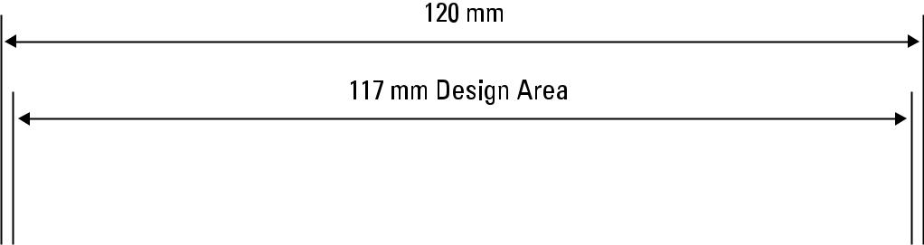

23 mm – No Printing Area – do not cut out!
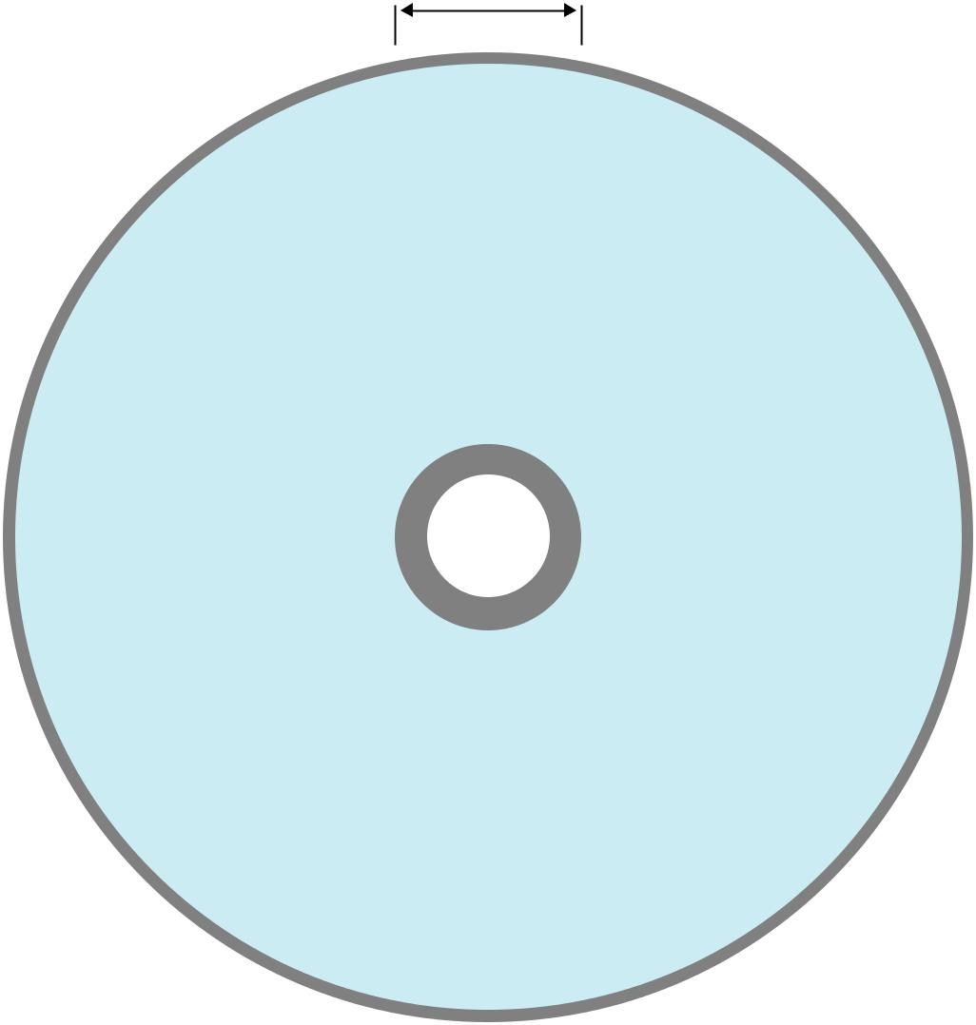

- mm Centre Hole


Download

full scale

template


 | ATTENTION: please ensure the Filecode is ad-
 | ded and clearly visible on your HiRes PDF (out-
 | side of print area). Alternatively you can upload
4 | the Template PDF as part of your package.


Audio Label 80 mm Specification F
Code: ALF08001 | Bleed (min. 3mm)
Screenprint up to 6 Pantone colors, | Design Area
Screenprint up to 6 Pantone colors, | Cutting line
Picture (CMYK) screenprint, Offset (CMYK) | Cutting line
Picture (CMYK) screenprint, Offset (CMYK) | Folding line

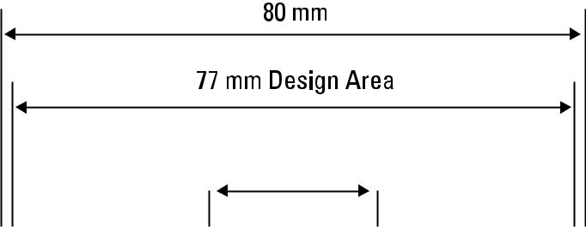

23 mm – No Printing Area – do not cut out!


- mm Centre Hole

Download

full scale

template

 | ATTENTION: please ensure the Filecode is ad-
 | ded and clearly visible on your HiRes PDF (out-
 | side of print area). Alternatively you can upload
5 | the Template PDF as part of your package.

Audio Booklet – double page layout

Code: ABLDP001 | Bleed (min. 3mm)
Coverpages: 150–170 gsm glossy artpaper | Design Area
Coverpages: 150–170 gsm glossy artpaper | Cutting line
Innerpages: 90–100 gsm glossy artpaper | Cutting line
Innerpages: 90–100 gsm glossy artpaper | Folding line
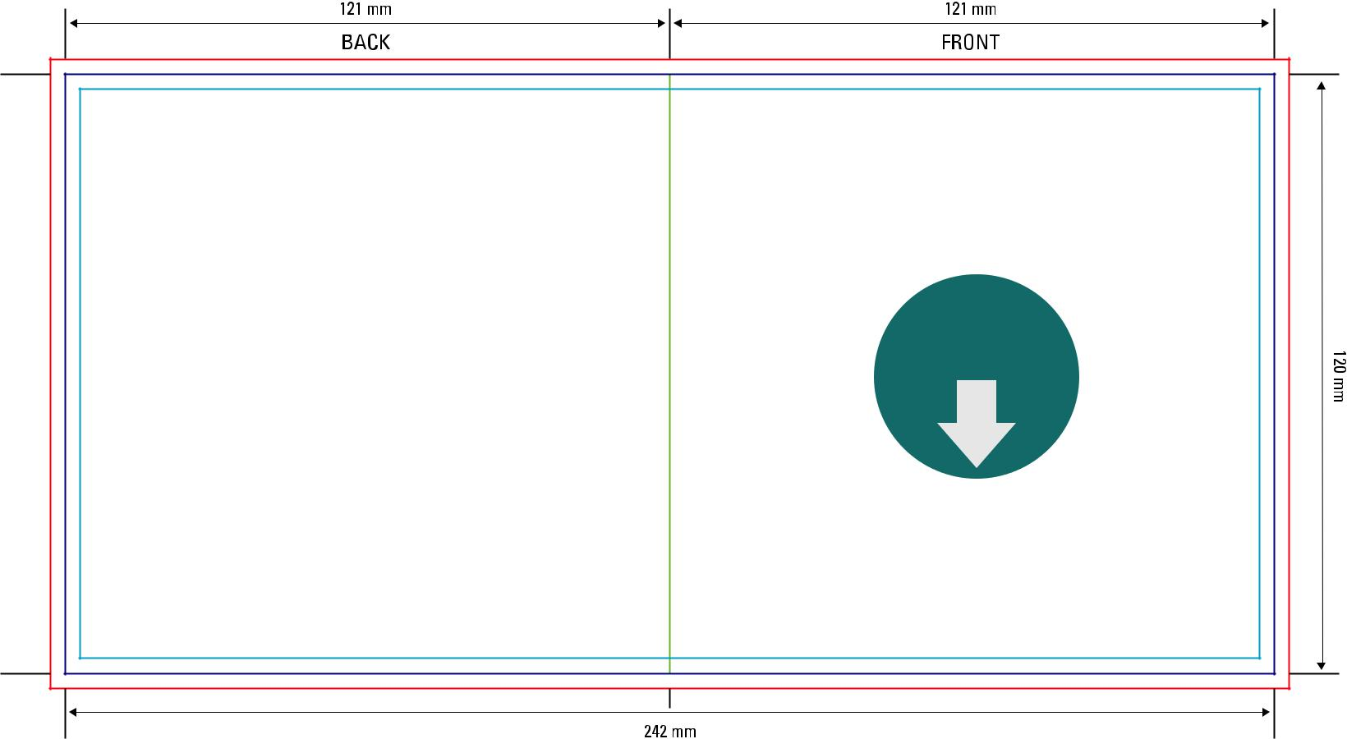

Download

full scale

template

Imposition layout
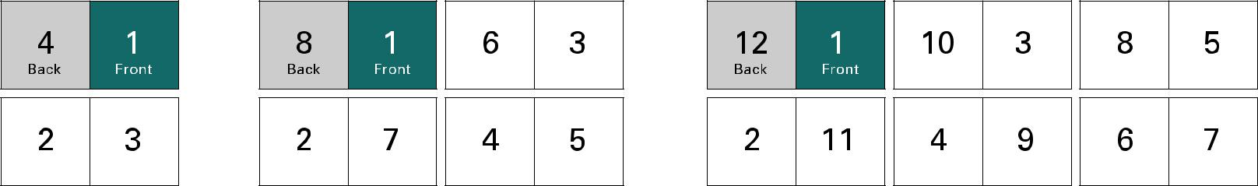


 | ATTENTION: please ensure the Filecode is ad-
 | ded and clearly visible on your HiRes PDF (out-
 | side of print area). Alternatively you can upload
6 | the Template PDF as part of your package.



Audio Covercard 2pp
Code: ACC00001 |  |  |  |  |  |  |  | Bleed (min. 3mm)
170 gsm glossy artpaper |  |  |  |  |  |  |  | Design Area
 |  |  |  |  |  |  |  | Cutting line
 |  |  |  |  |  |  |  | Folding line

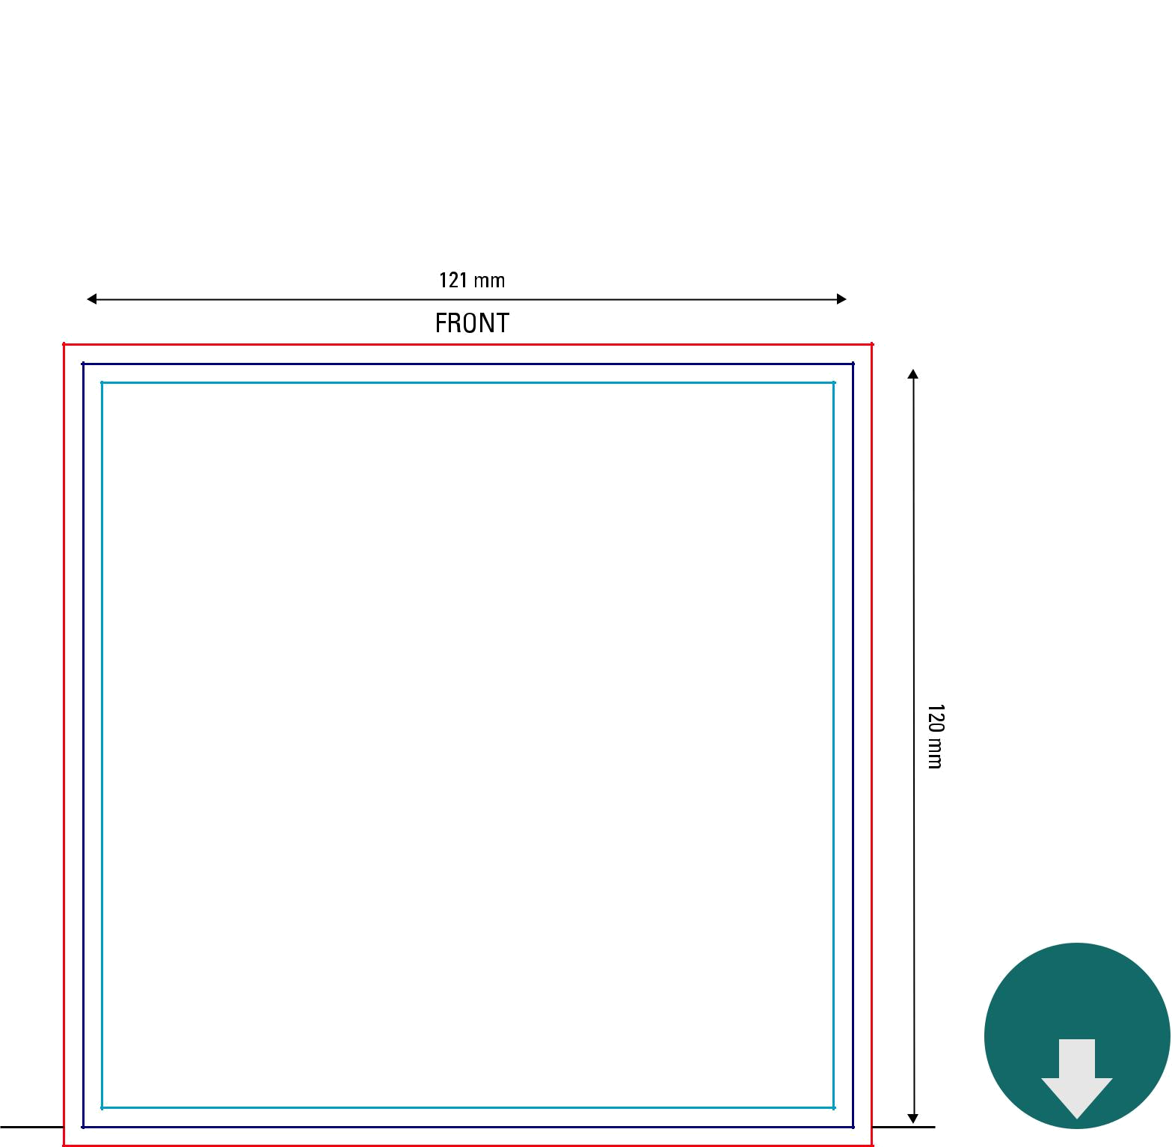

Download

full scale

template

 | ATTENTION: please ensure the Filecode is ad-
 | ded and clearly visible on your HiRes PDF (out-
 | side of print area). Alternatively you can upload
7 | the Template PDF as part of your package.


Audio Inlaycard

Code: AIS00001

170 gsm glossy artpaper
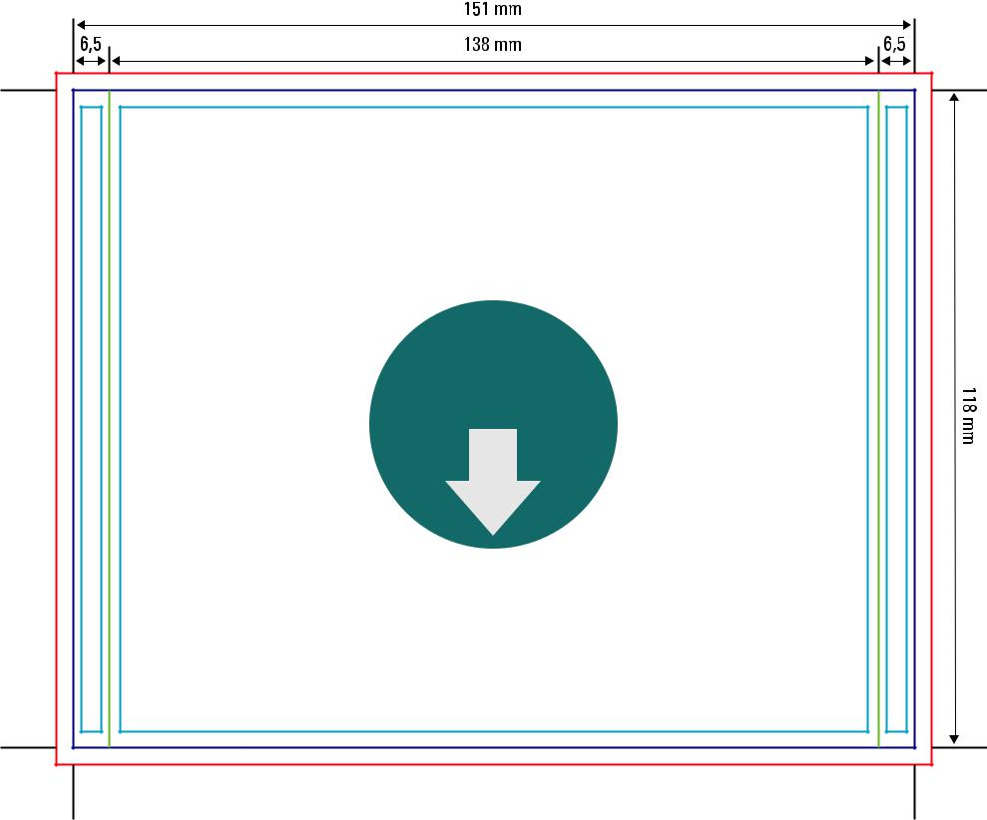

Outerpage

Download

full scale

template
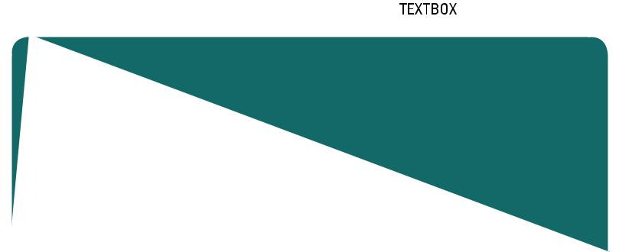

Bleed (min. 3mm)

Design Area

Cutting line

Folding line
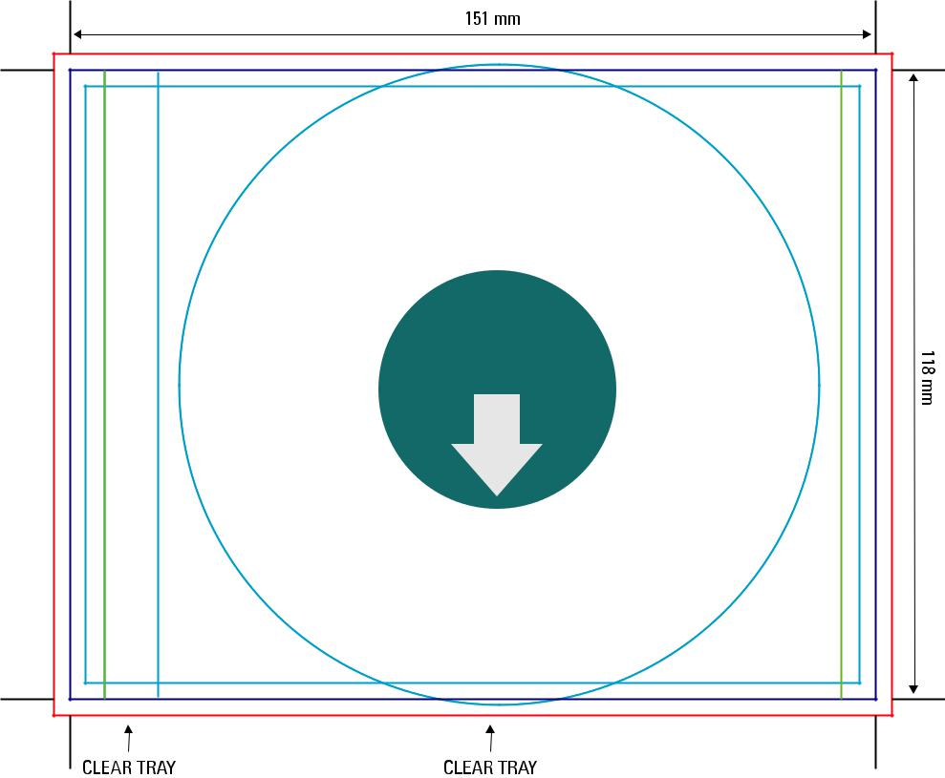

Innerpage

Download

full scale

template

 | ATTENTION: please ensure the Filecode is ad-
 | ded and clearly visible on your HiRes PDF (out-
 | side of print area). Alternatively you can upload
8 | the Template PDF as part of your package.


Audio Inlaycard Superjewelbox

Code: AISSA001 | Bleed (min. 3mm)
170 gsm glossy artpaper | Design Area
170 gsm glossy artpaper | Cutting line
 | Folding line
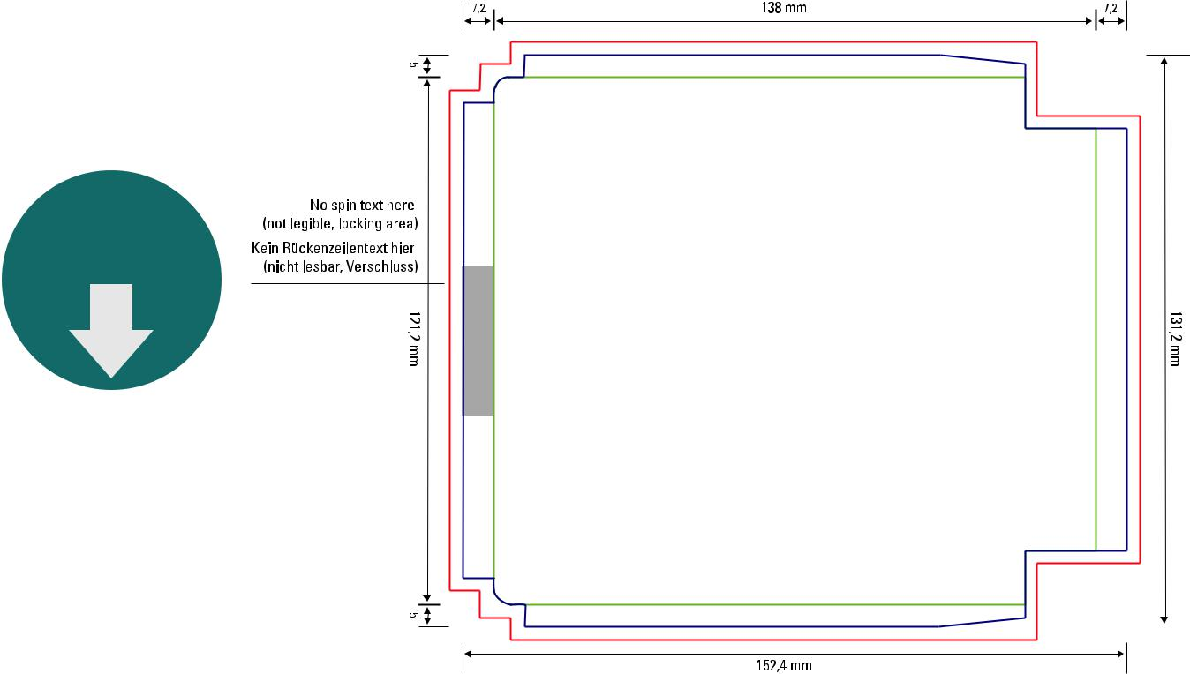

Download

full scale

template
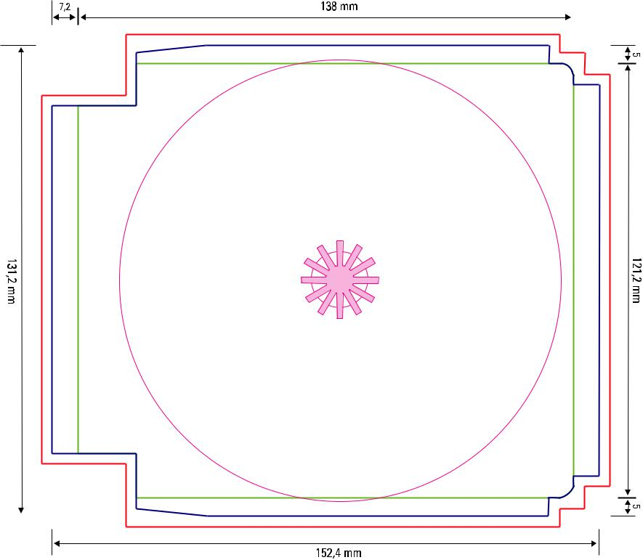

Outerpage
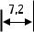

Innerpage


Download

full scale

template

 | ATTENTION: please ensure the Filecode is ad-
 | ded and clearly visible on your HiRes PDF (out-
 | side of print area). Alternatively you can upload
9 | the Template PDF as part of your package.


Audio Maxicard with Flap

Code: AMX00002

170 gsm glossy artpaper

Outerpage
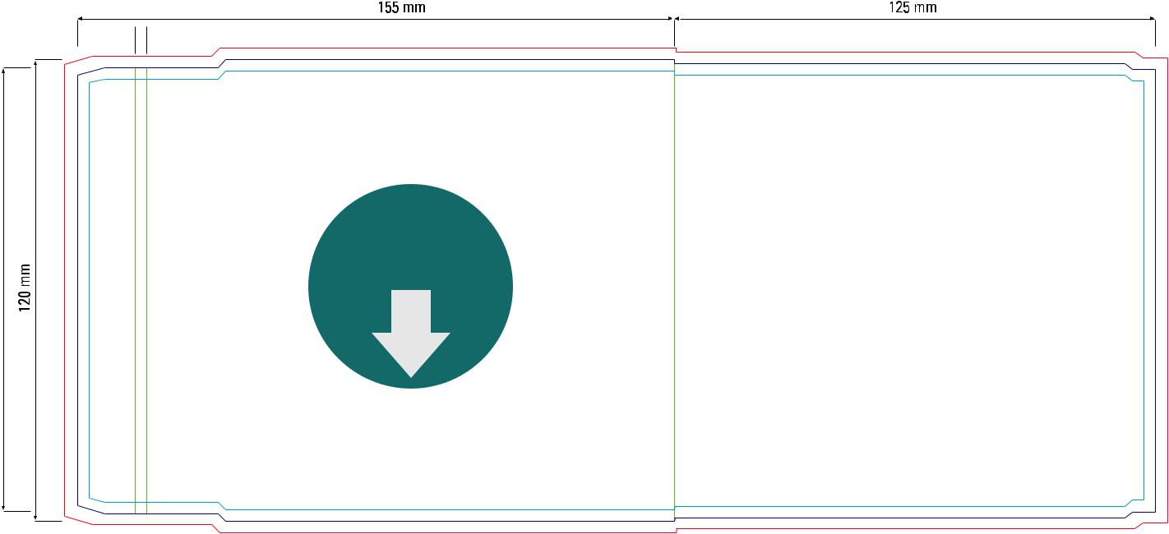

Download

full scale

template
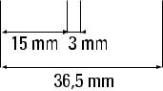

Innerpage
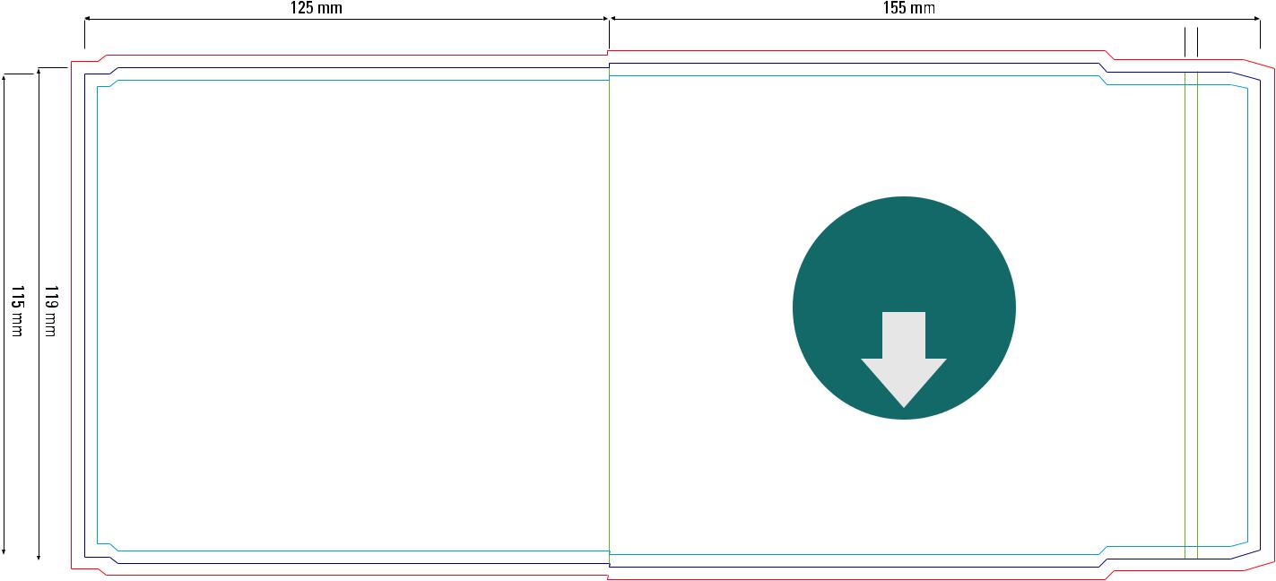

Download

full scale

template
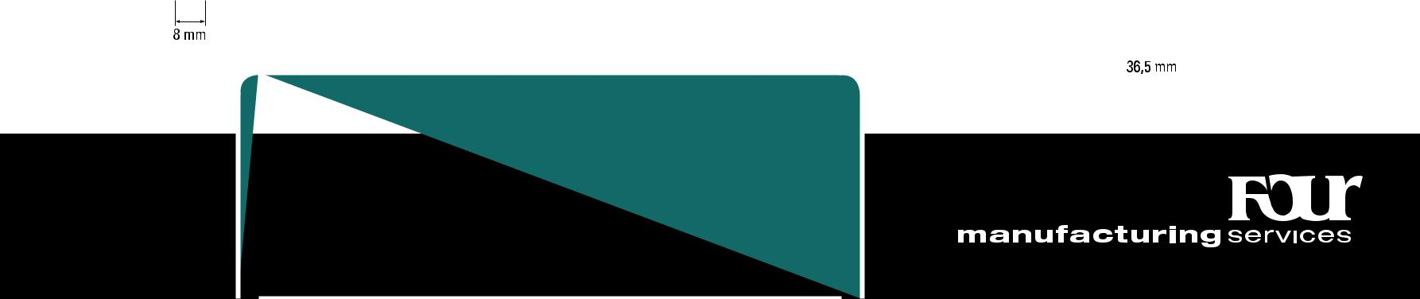

 | ATTENTION: please ensure the Filecode is ad-
 | ded and clearly visible on your HiRes PDF (out-
 | side of print area). Alternatively you can upload
10 | the Template PDF as part of your package.

Bleed (min. 3mm) Design Area Cutting line Folding line
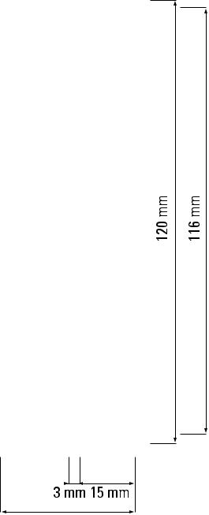
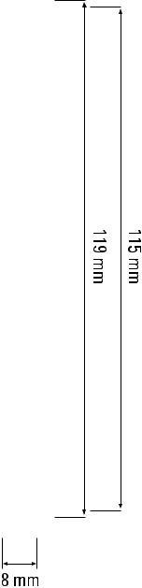

 | Audio Cartonsleeve
 | Code: ACS12001 |  |  |  | Bleed (min. 3mm)
 | 200 gsm cardboard |  |  |  | Design Area
 |  |  |  |  | Cutting line
 |  |  |  |  | Folding line

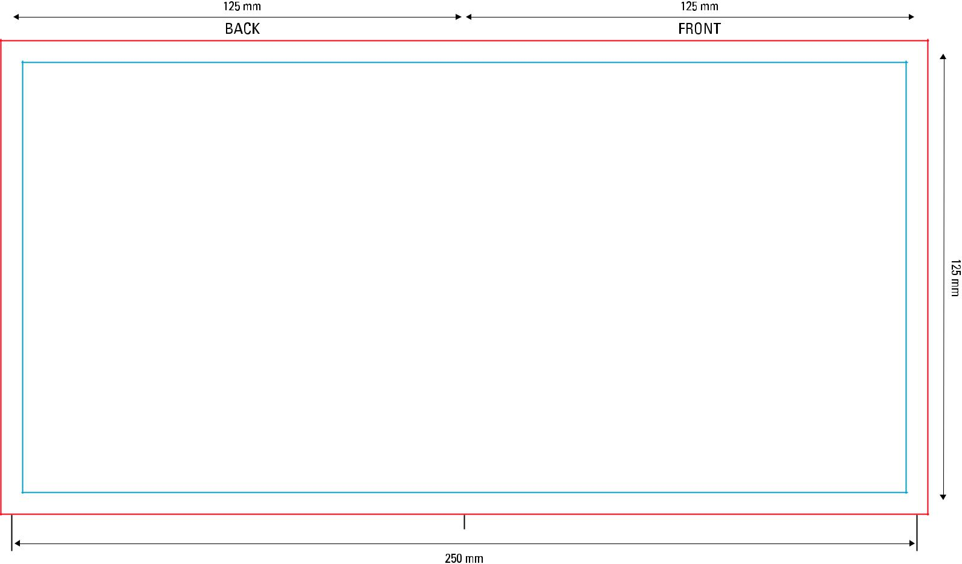

Download

full scale

template

 | ATTENTION: please ensure the Filecode is ad-
 | ded and clearly visible on your HiRes PDF (out-
 | side of print area). Alternatively you can upload
11 | the Template PDF as part of your package.

Audio Folded Booklet 6pp Rollfold

Code: AFB06001 | Bleed (min. 3mm)
150–170 gsm glossy artpaper | Design Area
150–170 gsm glossy artpaper | Cutting line
 | Folding line

Outerpage
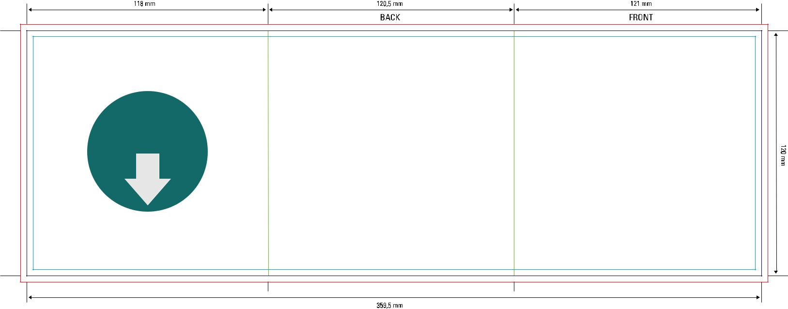

Download

full scale

template

Innerpage
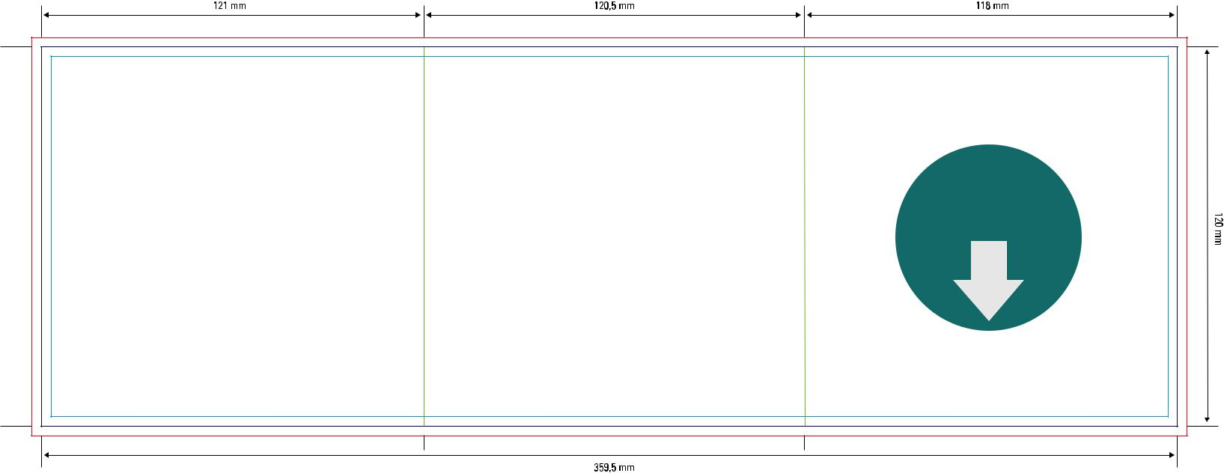

Download

full scale

template

 | ATTENTION: please ensure the Filecode is ad-
 | ded and clearly visible on your HiRes PDF (out-
 | side of print area). Alternatively you can upload
12 | the Template PDF as part of your package.

Audio Folded Booklet 8pp Rollfold

Code: AFB08002 | Bleed (min. 3mm)
150–170 gsm glossy artpaper | Design Area
150–170 gsm glossy artpaper | Cutting line
 | Folding line

Outerpage

117 mm |  |  | 119 mm |  |  |  | 121 mm |  |  |  |  | 121 mm
 |  |  |  |  |  |  | BACK |  |  |  |  | FRONT
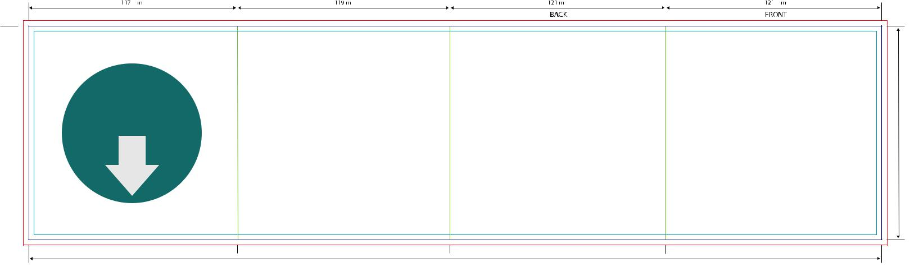

Download

full scale

template

120 mm

- mm

Innerpage

121 mm |  |  | 121 mm |  |  | 119 mm |  |  | 117 mm
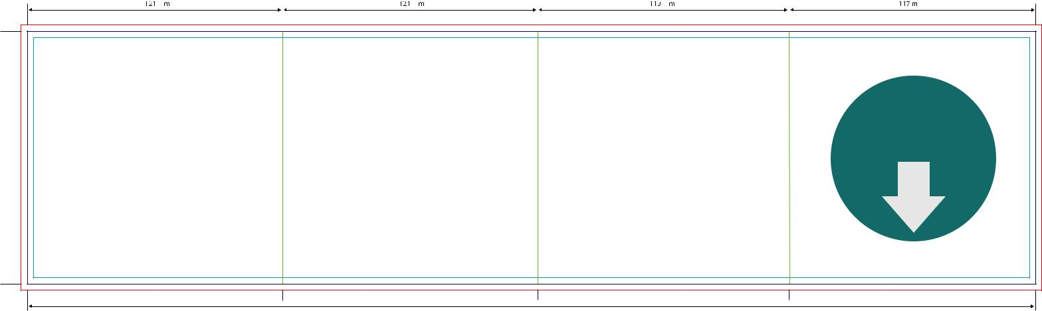

Download

full scale

template

120 mm


478 mm

 | ATTENTION: please ensure the Filecode is ad-
 | ded and clearly visible on your HiRes PDF (out-
 | side of print area). Alternatively you can upload
13 | the Template PDF as part of your package.


Audio Folded Booklet 8pp Gatefold

Code: AFB08004 | Bleed (min. 3mm)
150–170 gsm glossy artpaper | Design Area
150–170 gsm glossy artpaper | Cutting line
 | Folding line

Outerpage

 | 119 mm |  |  |  |  |  | 121 mm |  |  |  |  |  |  | 121 mm |  |  |  |  |  | 119 mm
 |  |  |  |  |  |  | BACK |  |  |  |  |  |  | FRONT
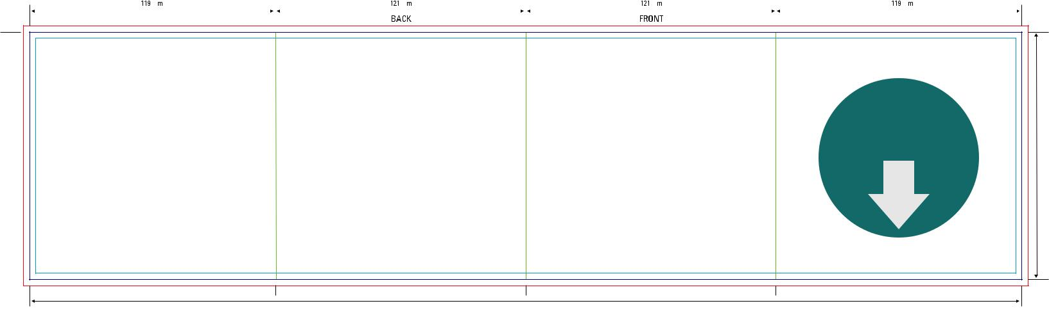

Download

full scale

template

120 mm

480 mm

Innerpage

 | 119 mm |  |  |  |  | 121 mm |  |  |  |  | 121 mm |  |  |  |  | 119 mm
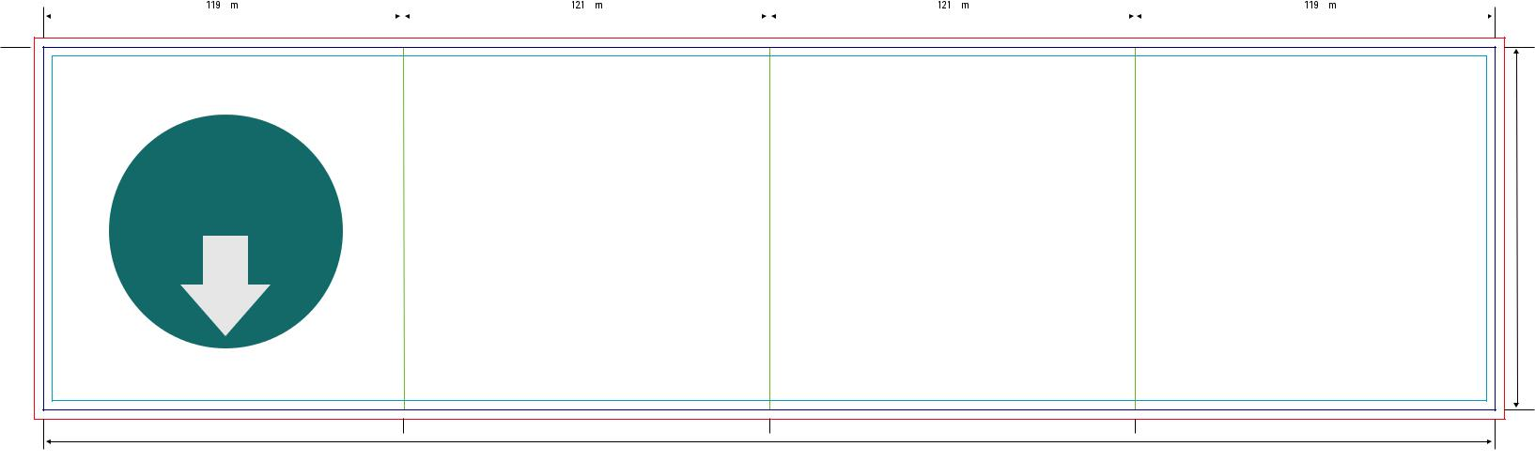

Download

full scale

template

120 mm

480 mm

 | ATTENTION: please ensure the Filecode is ad-
 | ded and clearly visible on your HiRes PDF (out-
 | side of print area). Alternatively you can upload
14 | the Template PDF as part of your package.


Audio Folded Booklet 8pp Parallelfold

Code: AFB08001 |  | Bleed (min. 3mm)
150–170 gsm glossy artpaper |  | Design Area
150–170 gsm glossy artpaper |  | Cutting line
 |  | Folding line

Outerpage

 | 119 mm |  |  |  |  | 120,5 mm |  |  |  |  |  | 120,5 mm |  |  |  |  |  |  | 121 mm
 |  |  |  |  |  |  |  |  |  |  |  | BACK |  |  |  |  |  |  | FRONT
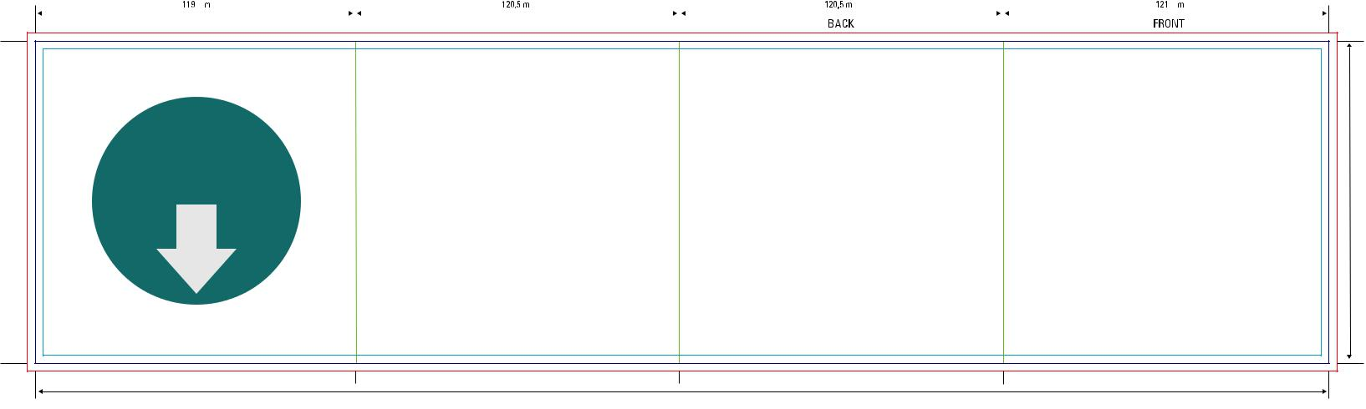

Download

full scale

template

120 mm

- mm

Innerpage

 | 121 mm |  |  |  |  | 120,5 mm |  |  |  |  | 120,5 mm |  |  |  |  | 119 mm
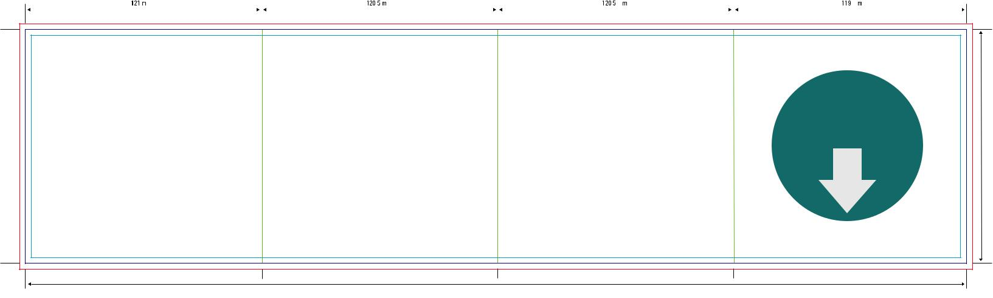

Download

full scale

template

120 mm

481 mm

 | ATTENTION: please ensure the Filecode is ad-
 | ded and clearly visible on your HiRes PDF (out-
 | side of print area). Alternatively you can upload
15 | the Template PDF as part of your package.

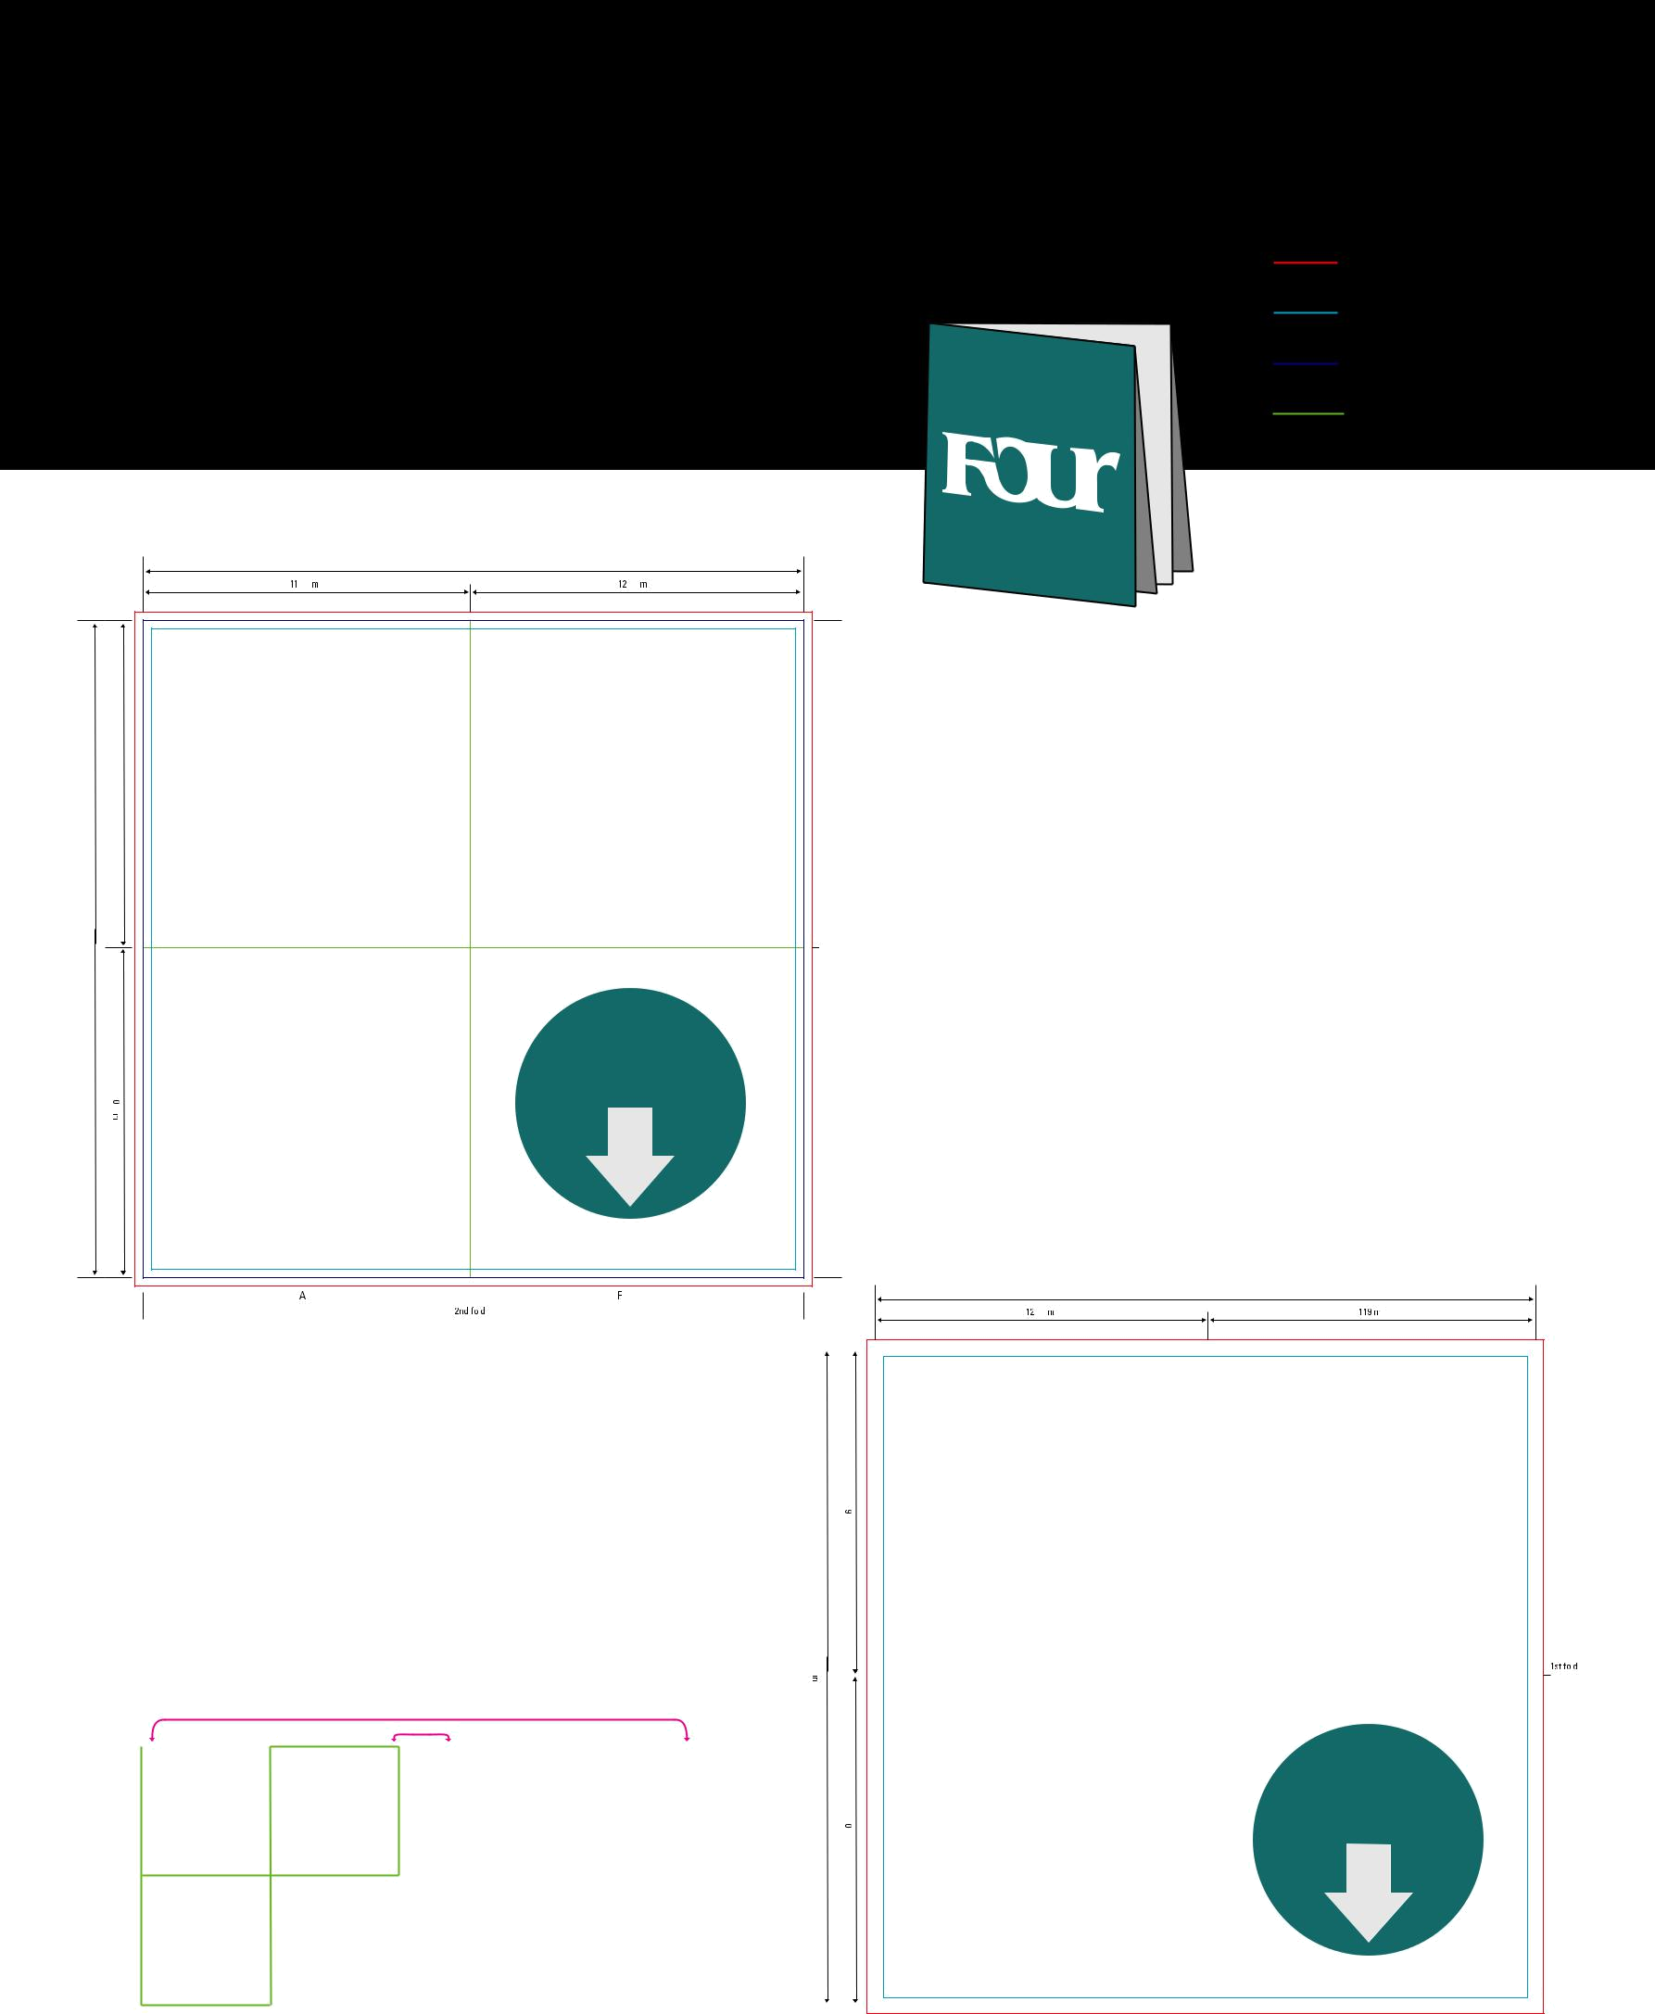
Audio Poster 8pp Crossfold

Code: APO08001

150–170 gsm glossy artpaper

Outerpage

240 mm

119mm 121 mm

119 mm

239 mm
 |  | Download
 |  | full scale
 |  | template
mm120 |  | template

BACK |  |  |  |  | FRONT
 |  | 2nd fold

PRINTING SCHEMA

OUTERPAGE INNERPAGE

BACK | FRONT |  | Inside of | Inside of
BACK | FRONT |  | Frontpage | Backpage

Bleed (min. 3mm)

Design Area

Cutting line

Folding line

1st

fold

Innerpage

- mm

121mm 119 mm

 |  |  | mm119
239
 |  |  |  |  |  |  |  |  |  | 1st
mm |  |  |  |  |  |  |  |  |  | fold
 |  |  |  |  |  |  | Download
 |  |  |  |  |  |  | full scale
 |  |  | 120 |  |  |  | template
 |  |  | mm |  |  |  | template

Inside of Frontpage |  |  |  |  | Inside of Backpage
Inside of Frontpage |  | 2nd fold |  |  | Inside of Backpage

 | ATTENTION: please ensure the Filecode is ad-
 | ded and clearly visible on your HiRes PDF (out-
 | side of print area). Alternatively you can upload
16 | the Template PDF as part of your package.


Audio Folded Booklet 10pp Rollfold

Code: AFB10001 | Bleed (min. 3mm)
150–170 gsm glossy artpaper | Design Area
150–170 gsm glossy artpaper | Cutting line
 | Folding line

Outerpage

 |  | 1st | fold |  |  |  | 2nd | fold |  |  |  | 3rd | fold |  |  |  |  |  |  | 4th | fold
115 mm |  |  |  |  | 117 mm |  |  |  |  | 119 mm |  | 3rd | fold |  |  | 121 mm |  |  |  | 4th | fold |  |  | 121 mm
 |  |  |  |  |  |  |  |  |  |  |  |  |  |  |  | FRONT |  |  |  |  |  |  |  | BACK
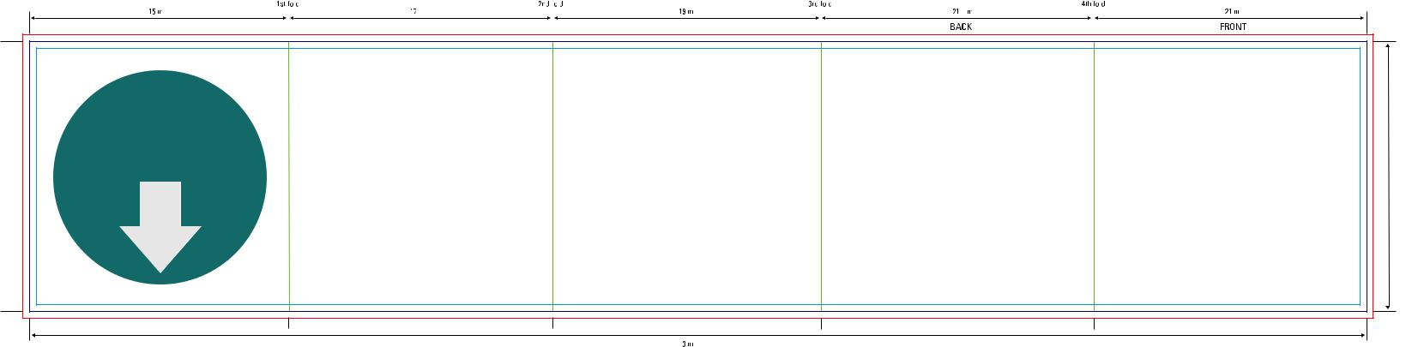

Download

full scale

template

593 mm

120 mm

Innerpage

 | 121 mm |  |  |  | 121 mm |  |  | 119 mm |  |  | 117 mm |  |  | 115 mm
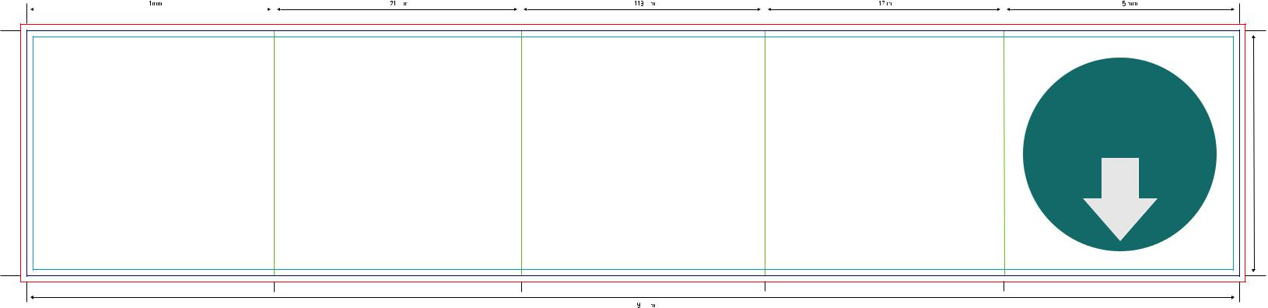

Download

full scale

template

120 mm

593mm

 | ATTENTION: please ensure the Filecode is ad-
 | ded and clearly visible on your HiRes PDF (out-
 | side of print area). Alternatively you can upload
17 | the Template PDF as part of your package.


Audio Poster 12pp Cross Rollfold

Code: APO12001

130 gsm glossy artpaper

Outerpage

 |  |  | 359 mm
118 mm |  |  | 120 mm
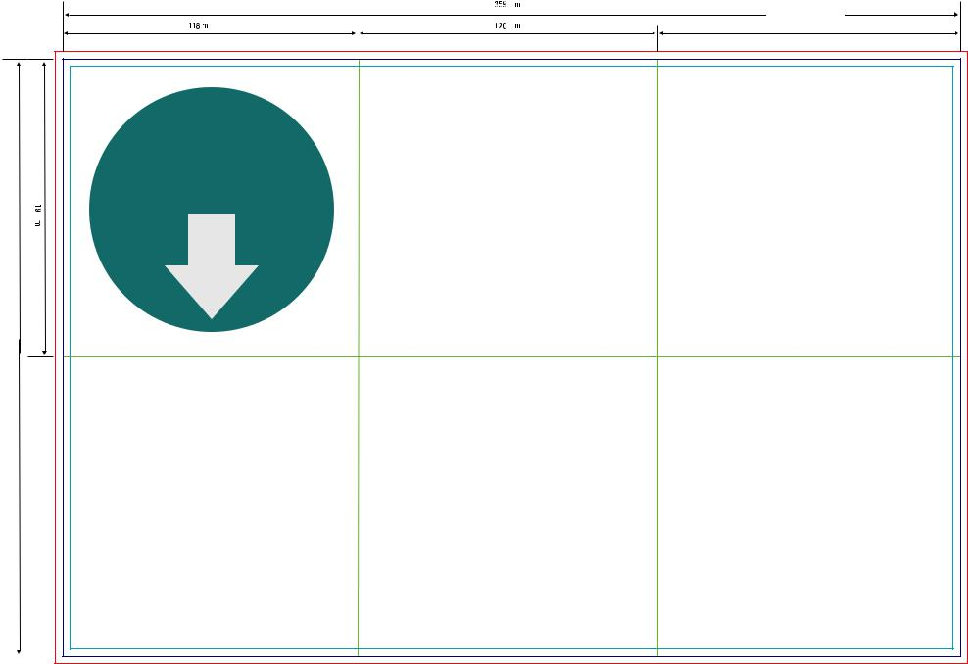

Bleed (min. 3mm)

Design Area

Cutting line

Folding line

121mm

 |  | Download
 |  | full scale
 |  | template
mm119 |  | template

239 mm


120 mm

2nd fold

BACK

3rdfold

1st

fold

FRONT

Innerpage

- mm
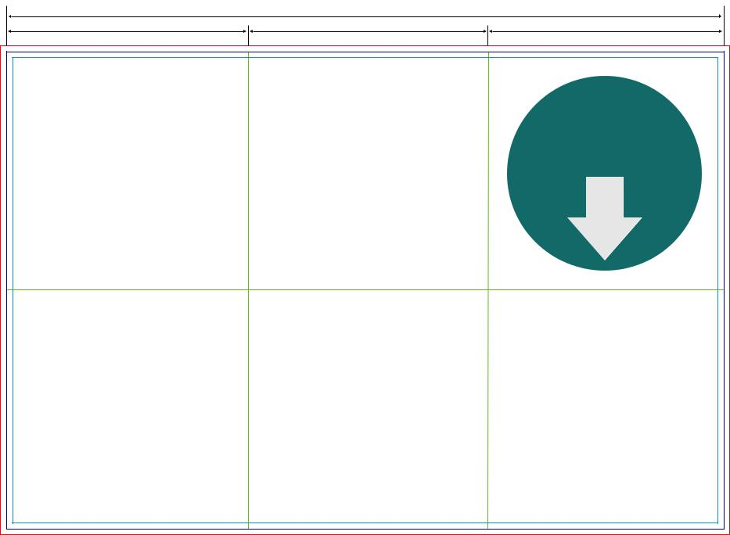

PRINTING SCHEMA

OUTERPAGE
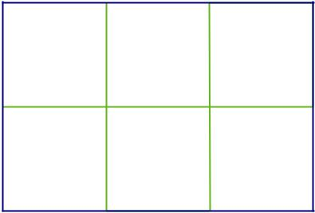

121 mm | 120 mm | 118 mm

BACK FRONT

INNERPAGE

Inside of | Inside of
Frontpage | Backpage

 |  |  |  | Download
 |  |  |  | full scale
 |  |  |  | template
 |  | mm119
239
239 |  |  |  |  | 1st
mm |  |  |  |  | fold
 |  | mm120


 | Inside of Frontpage |  |  |  |  | Inside of Backpage
 | Inside of Frontpage |  | 3rd fold |  |  | Inside of Backpage |  | 2nd fold

 | ATTENTION: please ensure the Filecode is ad-
 | ded and clearly visible on your HiRes PDF (out-
 | side of print area). Alternatively you can upload
18 | the Template PDF as part of your package.


Audio Poster 12pp Leporello Crossfold

Code: APO12002 | Bleed (min. 3mm)
130 gsm glossy artpaper | Design Area
130 gsm glossy artpaper | Cutting line
 | Folding line

Outerpage Innerpage

 |  |  |  |  | 241 mm
 |  |  |  |  | 3rd | fold
 | 120 mm |  |  |  | 3rd |  |  |  |  |  |  |  | 121 mm
 | BACK |  |  |  |  |  |  |  |  |  |  |  | FRONT
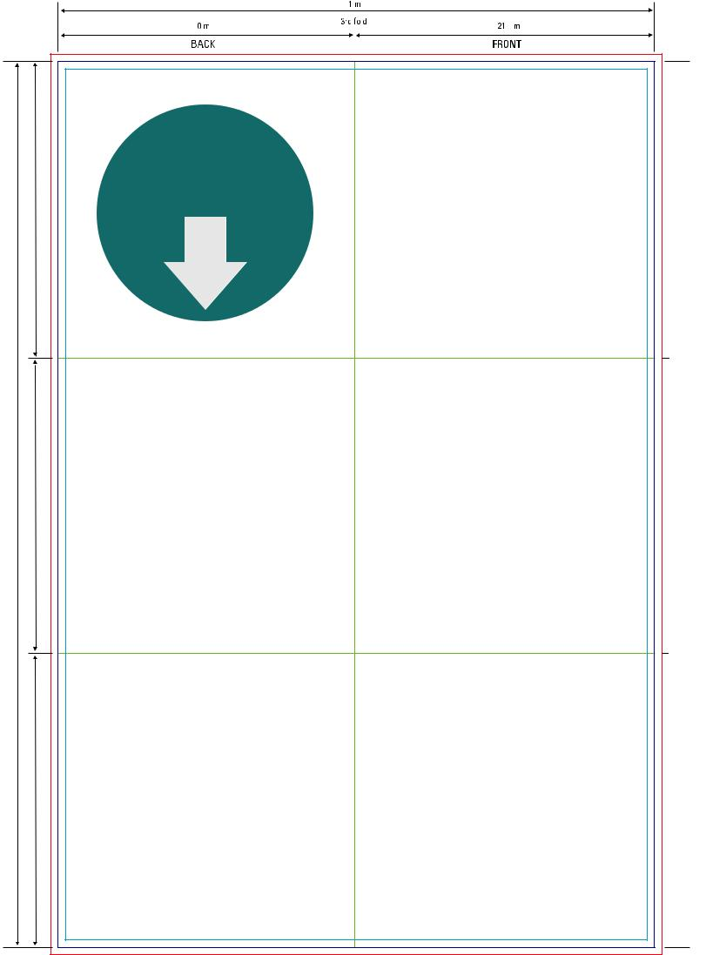

241 mm
121 mm 3rd fold 120mm
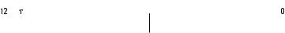
InsideofFrontpage InsideofBackpage

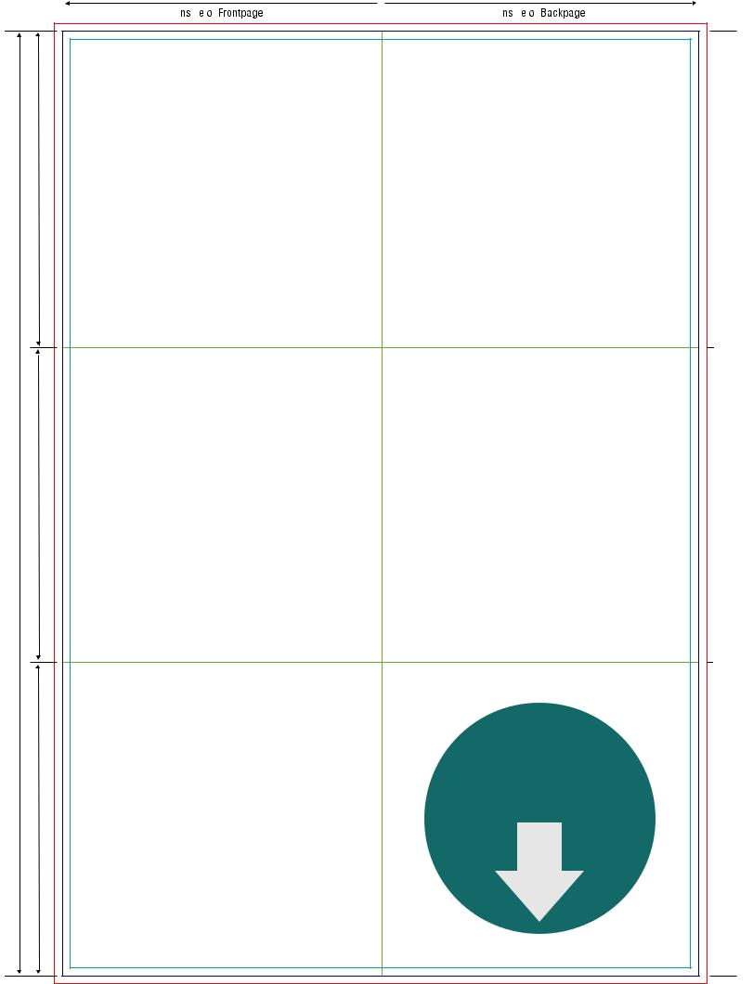

120 mm

119 mm 358 mm

119 mm

Download

full scale

template

120 mm

2nd

fold

119 mm 358 mm

1st

fold

119 mm

2nd

fold

1st

fold

Download

full scale

template

 | ATTENTION: please ensure the Filecode is ad-
 | ded and clearly visible on your HiRes PDF (out-
 | side of print area). Alternatively you can upload
19 | the Template PDF as part of your package.


Audio DigiPac 4pp 1 Tray
Code: ADP04001 | Bleed (min. 3mm)
300 gsm cardboard | Design Area
300 gsm cardboard | Cutting line
 | Folding line
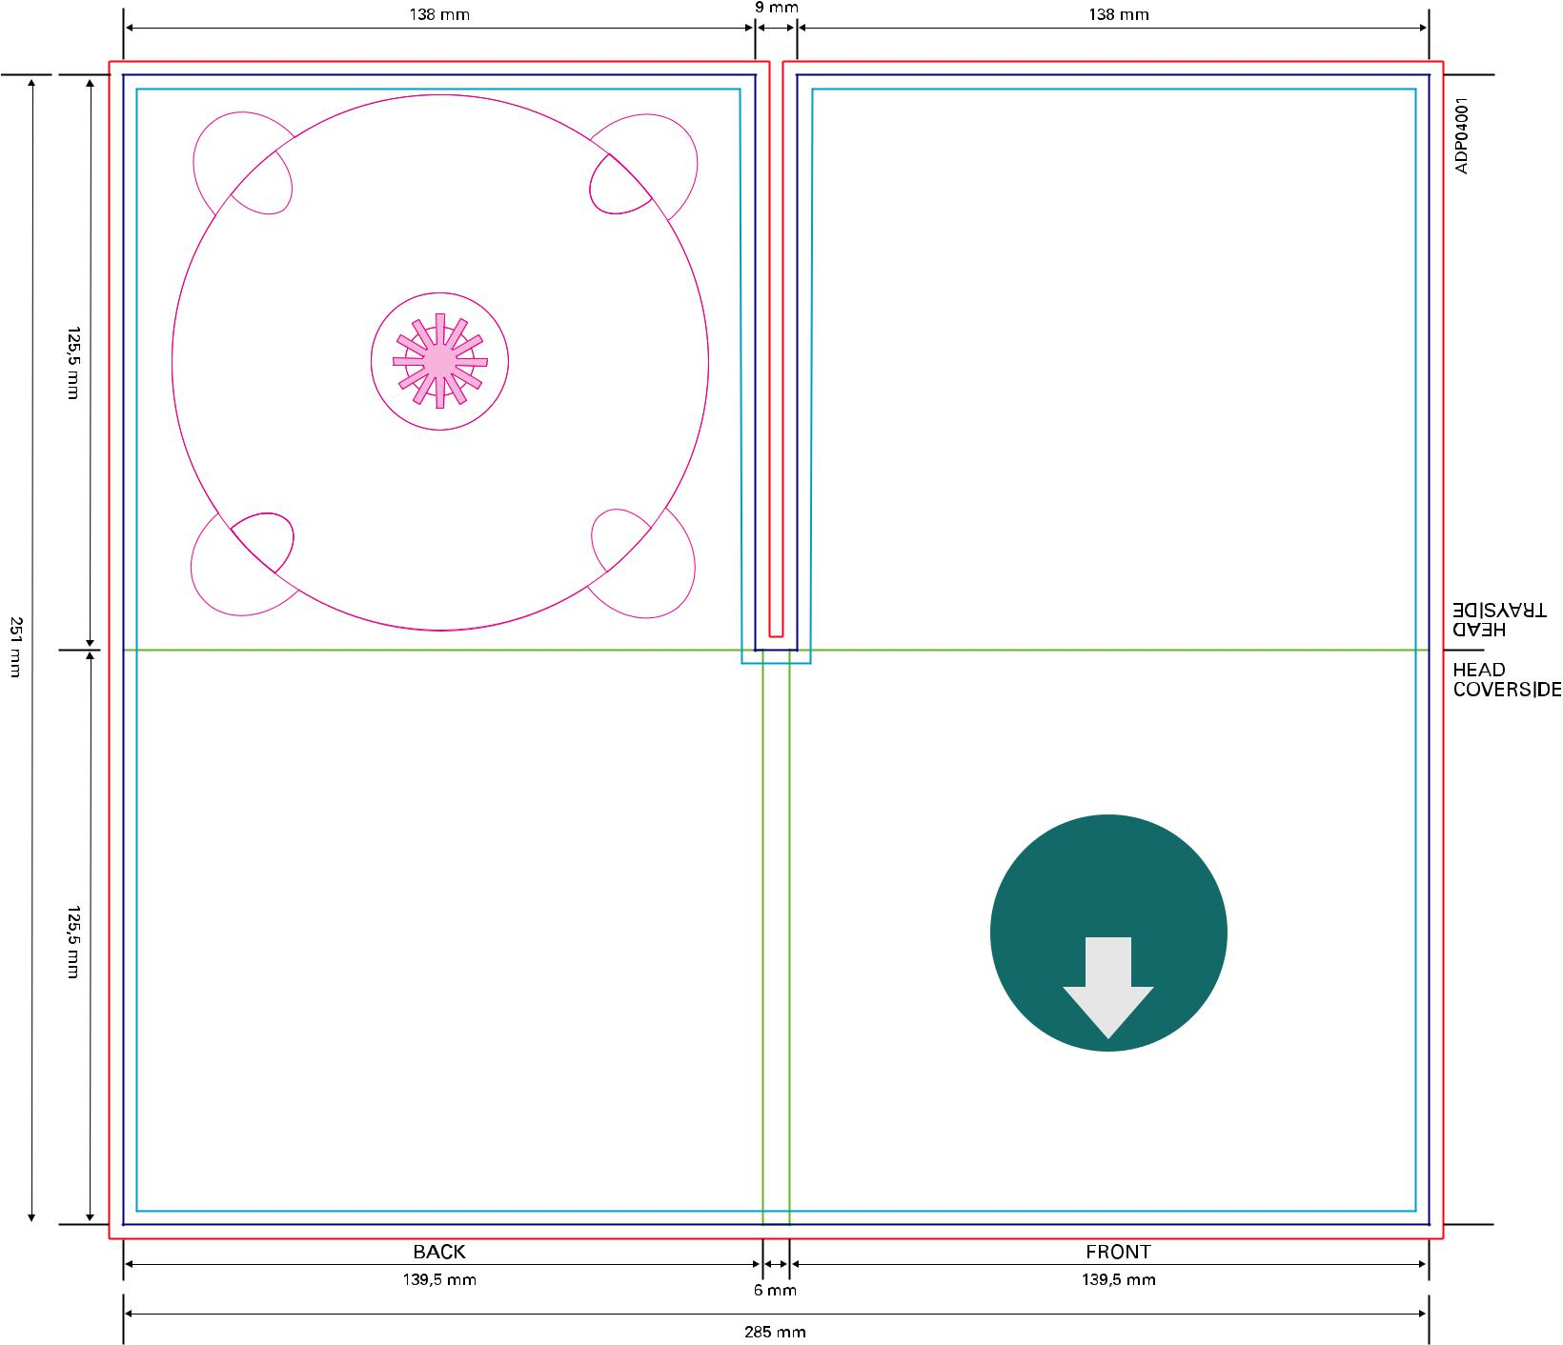

Download

full scale

template

 | ATTENTION: please ensure the Filecode is ad-
 | ded and clearly visible on your HiRes PDF (out-
 | side of print area). Alternatively you can upload
20 | the Template PDF as part of your package.

Audio DigiPac 4pp 1 Tray diagonal Slot (1 mm)

Code: ADP04005 | Bleed (min. 3mm)
Diagonal Slot for Booklet up to 1 mm (20 pp | Design Area
Diagonal Slot for Booklet up to 1 mm (20 pp | Cutting line
on 150/90 gsm artpaper) 300 gsm cardboard | Cutting line
on 150/90 gsm artpaper) 300 gsm cardboard | Folding line
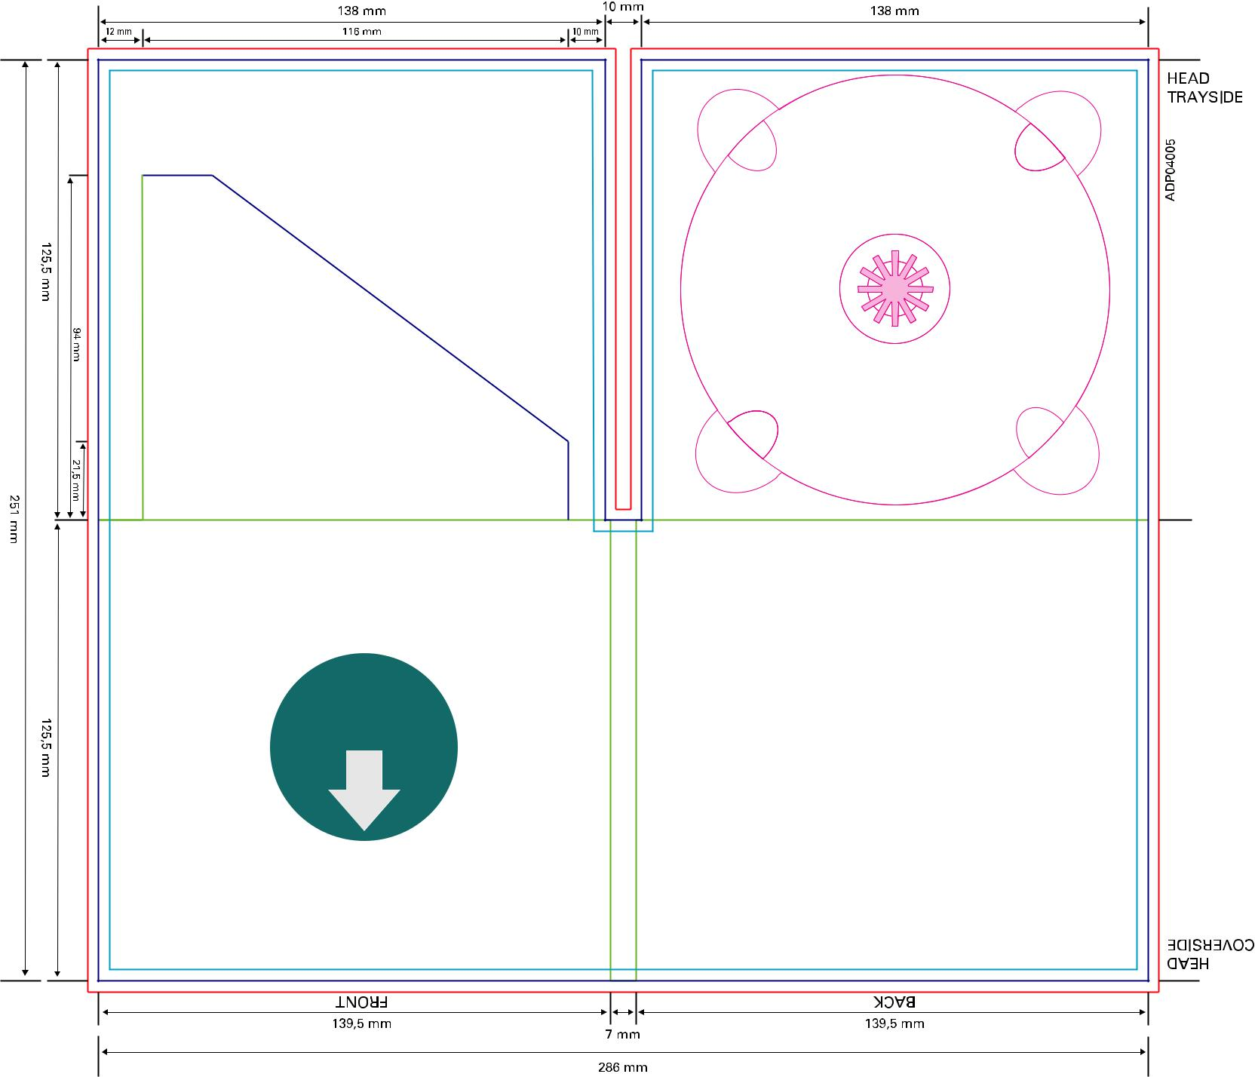

Download

full scale

template

 | ATTENTION: please ensure the Filecode is ad-
 | ded and clearly visible on your HiRes PDF (out-
 | side of print area). Alternatively you can upload
21 | the Template PDF as part of your package.
Audio DigiPac 4pp 1 Tray diagonal Slot (2 mm)

Code: ADP04006 | Bleed (min. 3mm)
Diagonal Slot for Booklet up to 2 mm (40 pp | Design Area
Diagonal Slot for Booklet up to 2 mm (40 pp | Cutting line
on 150/90 gsm artpaper) 300 gsm cardboard | Cutting line
on 150/90 gsm artpaper) 300 gsm cardboard | Folding line
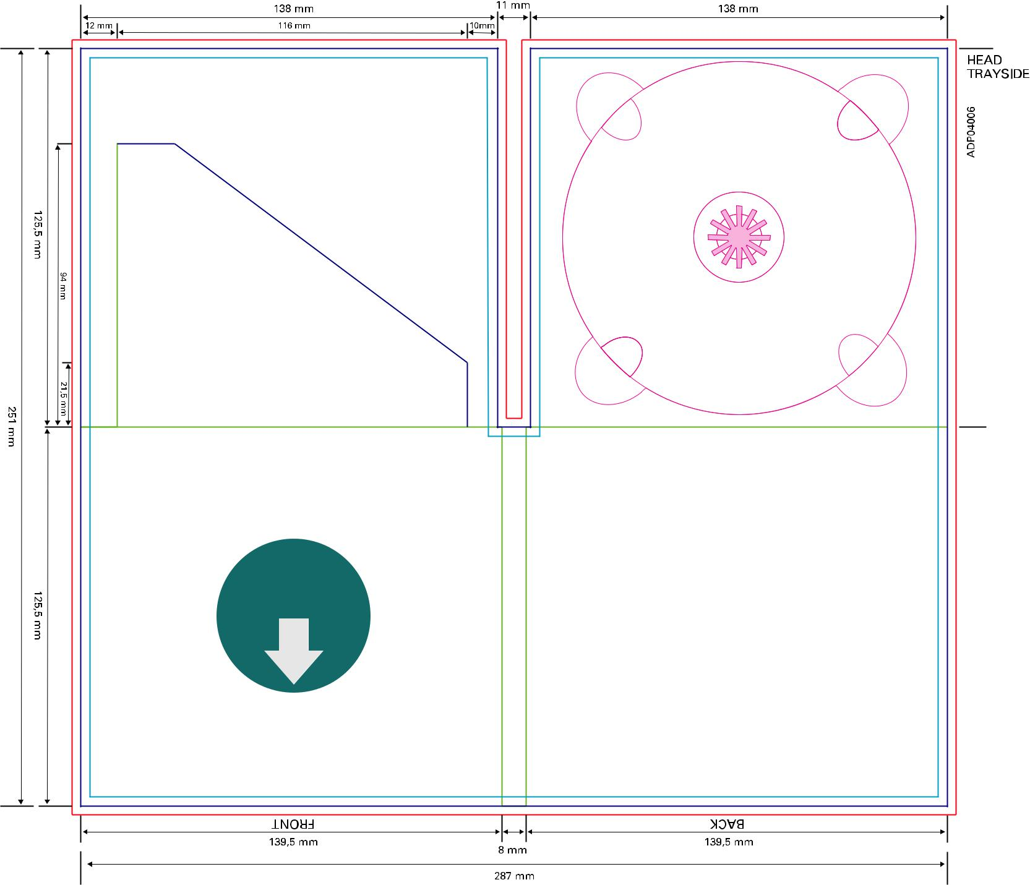

Download

full scale

template

 | ATTENTION: please ensure the Filecode is ad-
 | ded and clearly visible on your HiRes PDF (out-
 | side of print area). Alternatively you can upload
22 | the Template PDF as part of your package.

Audio DigiPac 4pp 1 Tray horizontal Slot (1 mm)

Code: ADP04007 | Bleed (min. 3mm)
Slot for Booklet up to 1 mm (20 pp on | Design Area
Slot for Booklet up to 1 mm (20 pp on | Cutting line
150/90 gsm) 300 gsm cardboard artpaper | Cutting line
150/90 gsm) 300 gsm cardboard artpaper | Folding line
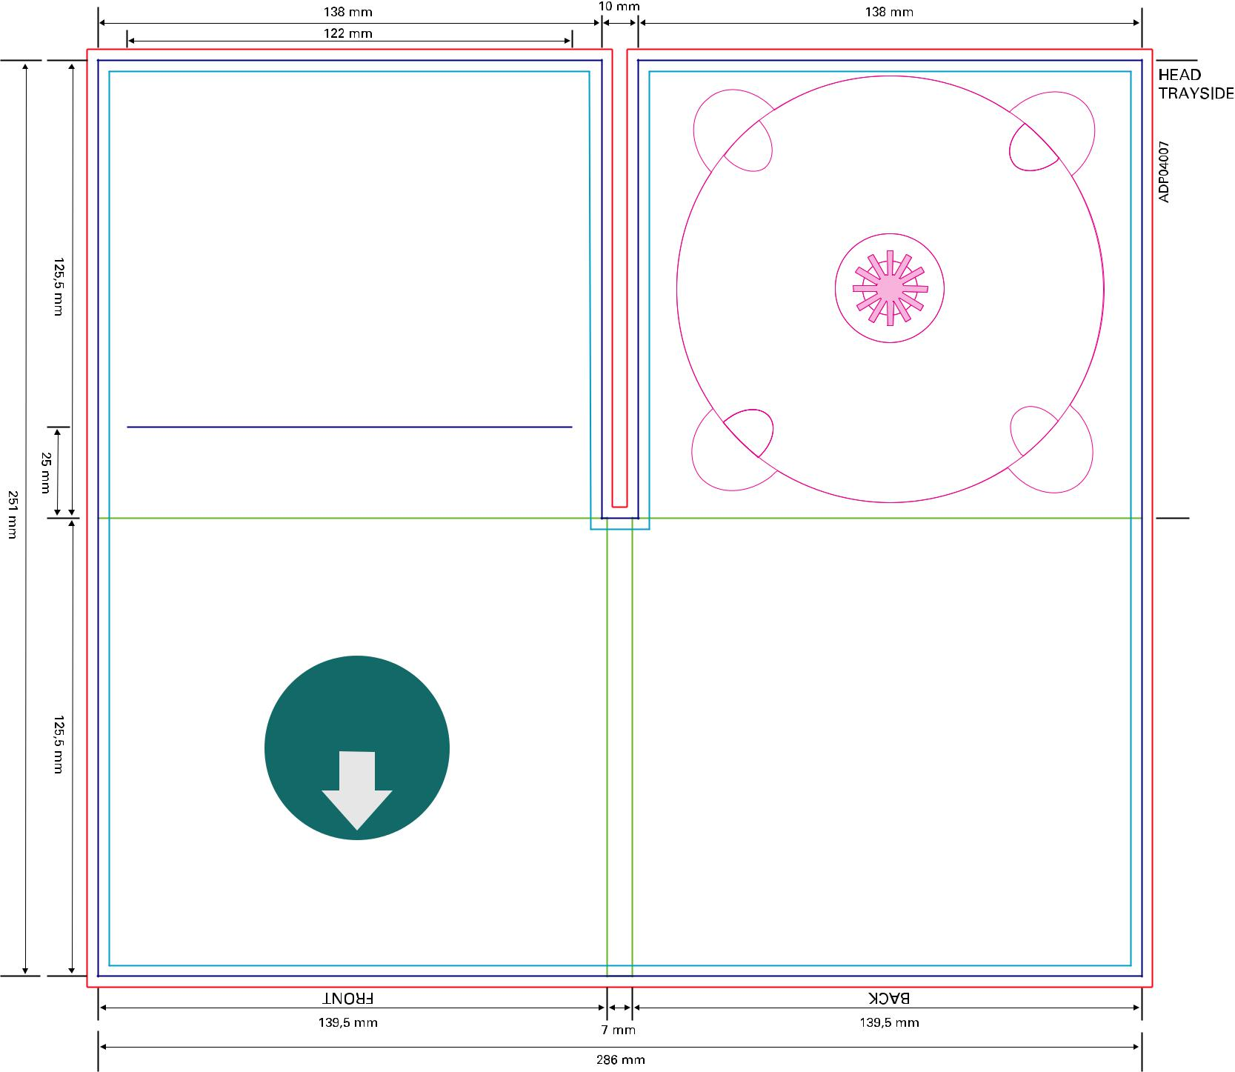

Download

full scale

template

 | ATTENTION: please ensure the Filecode is ad-
 | ded and clearly visible on your HiRes PDF (out-
 | side of print area). Alternatively you can upload
23 | the Template PDF as part of your package.
Audio DigiPac 4pp 1 Tray horizontal Slot (2 mm)

Code: ADP04008 | Bleed (min. 3mm)
Slot for Booklet up to 2 mm (40 pp on | Design Area
Slot for Booklet up to 2 mm (40 pp on | Cutting line
150/90 gsm) 300 gsm cardboard artpaper | Cutting line
150/90 gsm) 300 gsm cardboard artpaper | Folding line
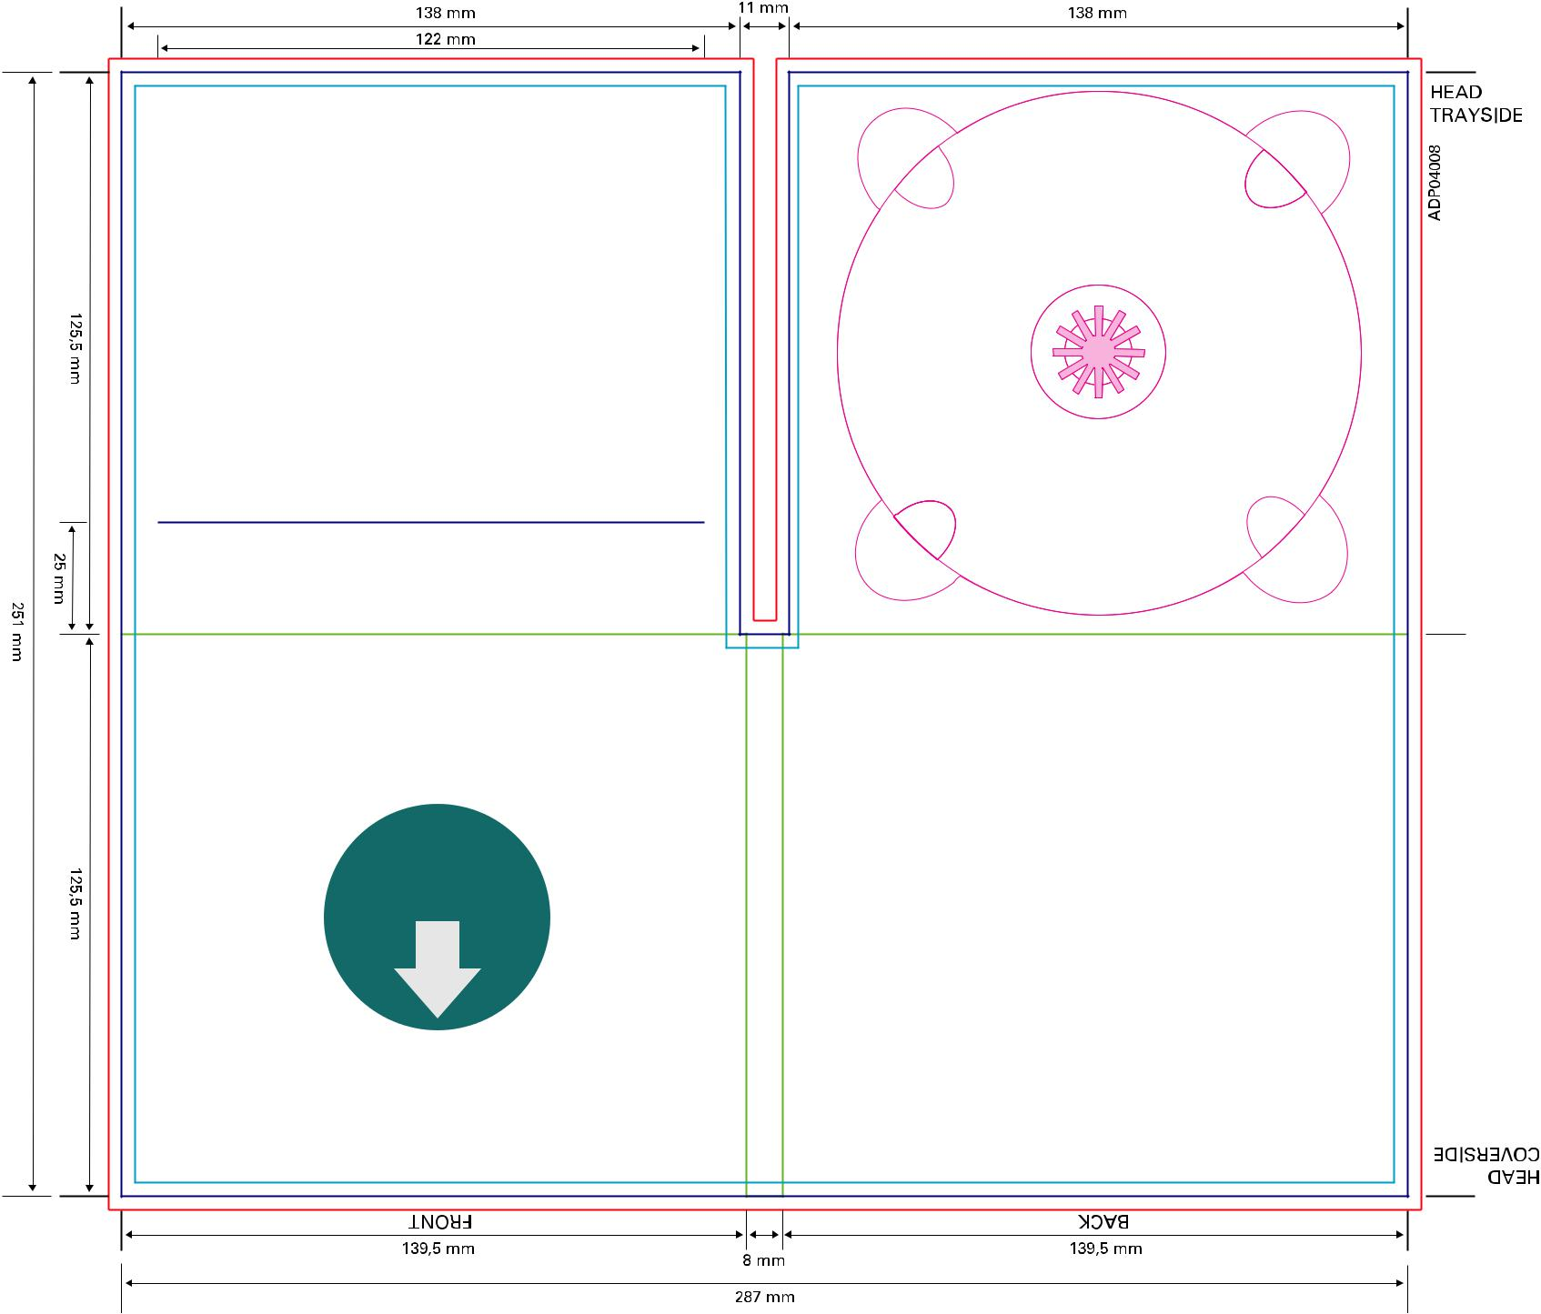

Download

full scale

template

 | ATTENTION: please ensure the Filecode is ad-
 | ded and clearly visible on your HiRes PDF (out-
 | side of print area). Alternatively you can upload
24 | the Template PDF as part of your package.

Audio DigiPac 4pp 1 Tray Booksleeve (1 mm)

Code: ADP04004 | Bleed (min. 3mm)
Booksleeve for Booklet up to 1 mm (20 pp on | Design Area
Booksleeve for Booklet up to 1 mm (20 pp on | Cutting line
150/90 gsm artpaper) 300 gsm cardboard | Cutting line
150/90 gsm artpaper) 300 gsm cardboard | Folding line
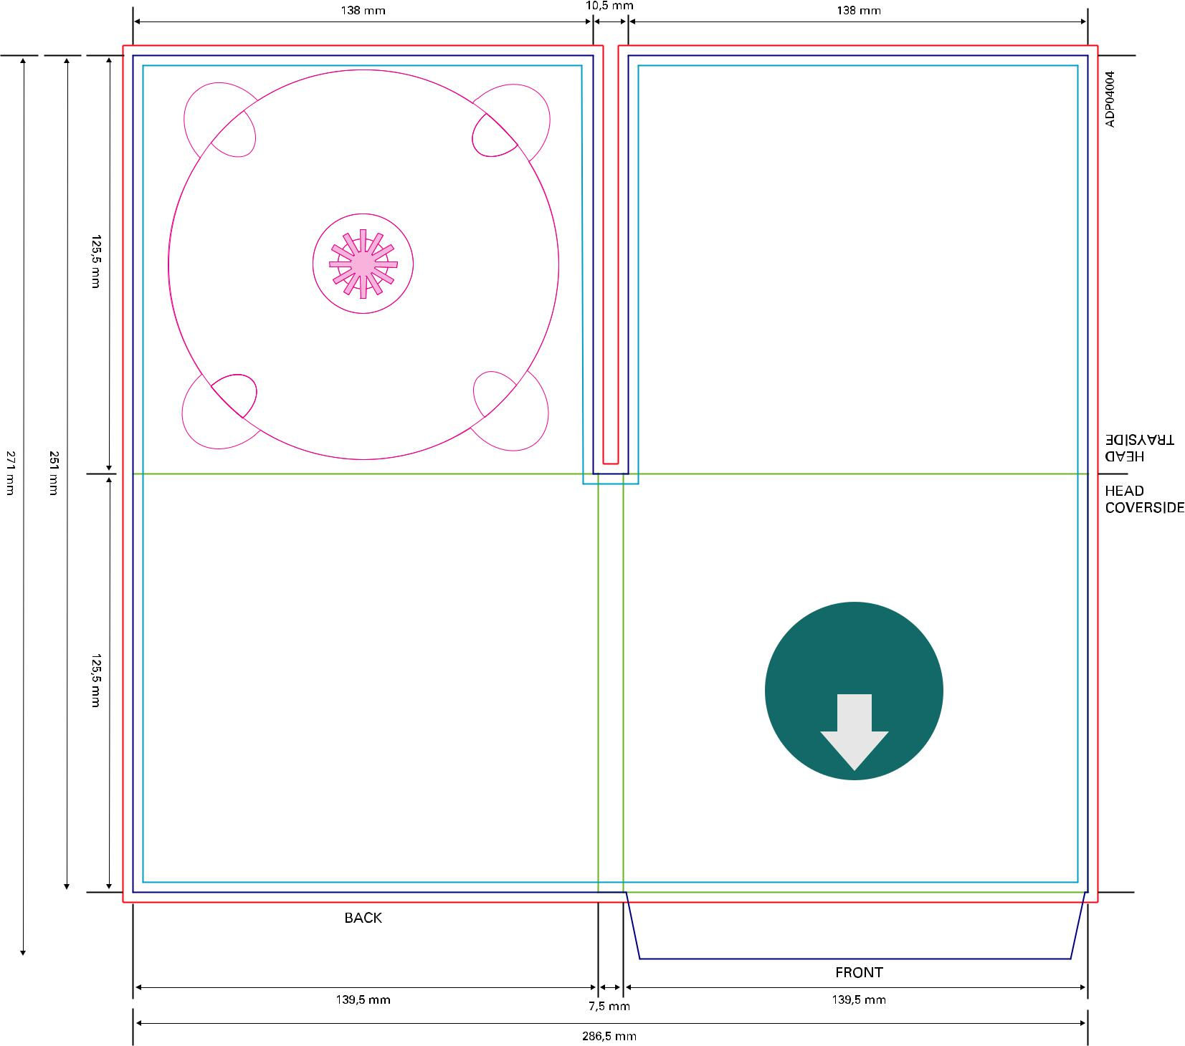

Download

full scale

template

 | ATTENTION: please ensure the Filecode is ad-
 | ded and clearly visible on your HiRes PDF (out-
 | side of print area). Alternatively you can upload
25 | the Template PDF as part of your package.

Audio DigiPac 4pp 1 Tray Booksleeve (2 mm)

Code: ADP04010 | Bleed (min. 3mm)
Booksleeve for Booklet up to 2 mm (32 pp on | Design Area
Booksleeve for Booklet up to 2 mm (32 pp on | Cutting line
150/90 gsm artpaper) 300 gsm cardboard | Cutting line
150/90 gsm artpaper) 300 gsm cardboard | Folding line
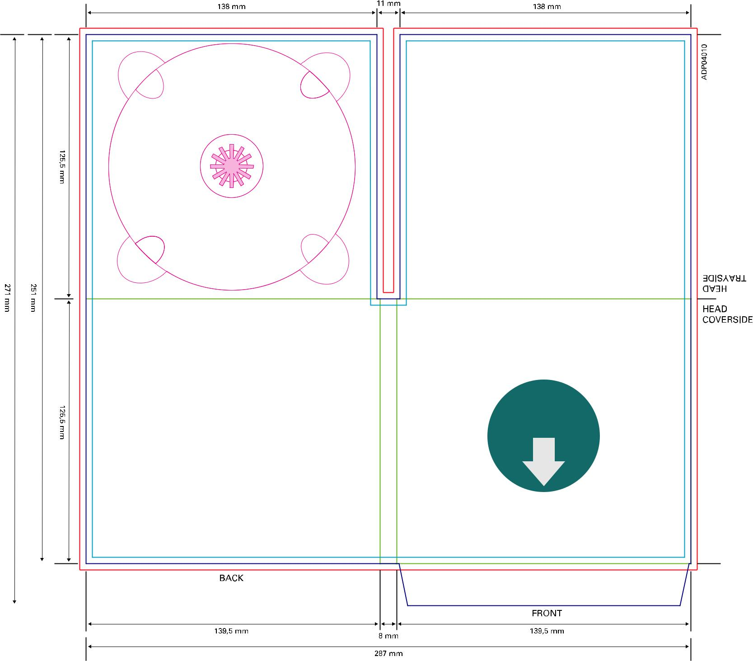

Download

full scale

template

 | ATTENTION: please ensure the Filecode is ad-
 | ded and clearly visible on your HiRes PDF (out-
 | side of print area). Alternatively you can upload
26 | the Template PDF as part of your package.
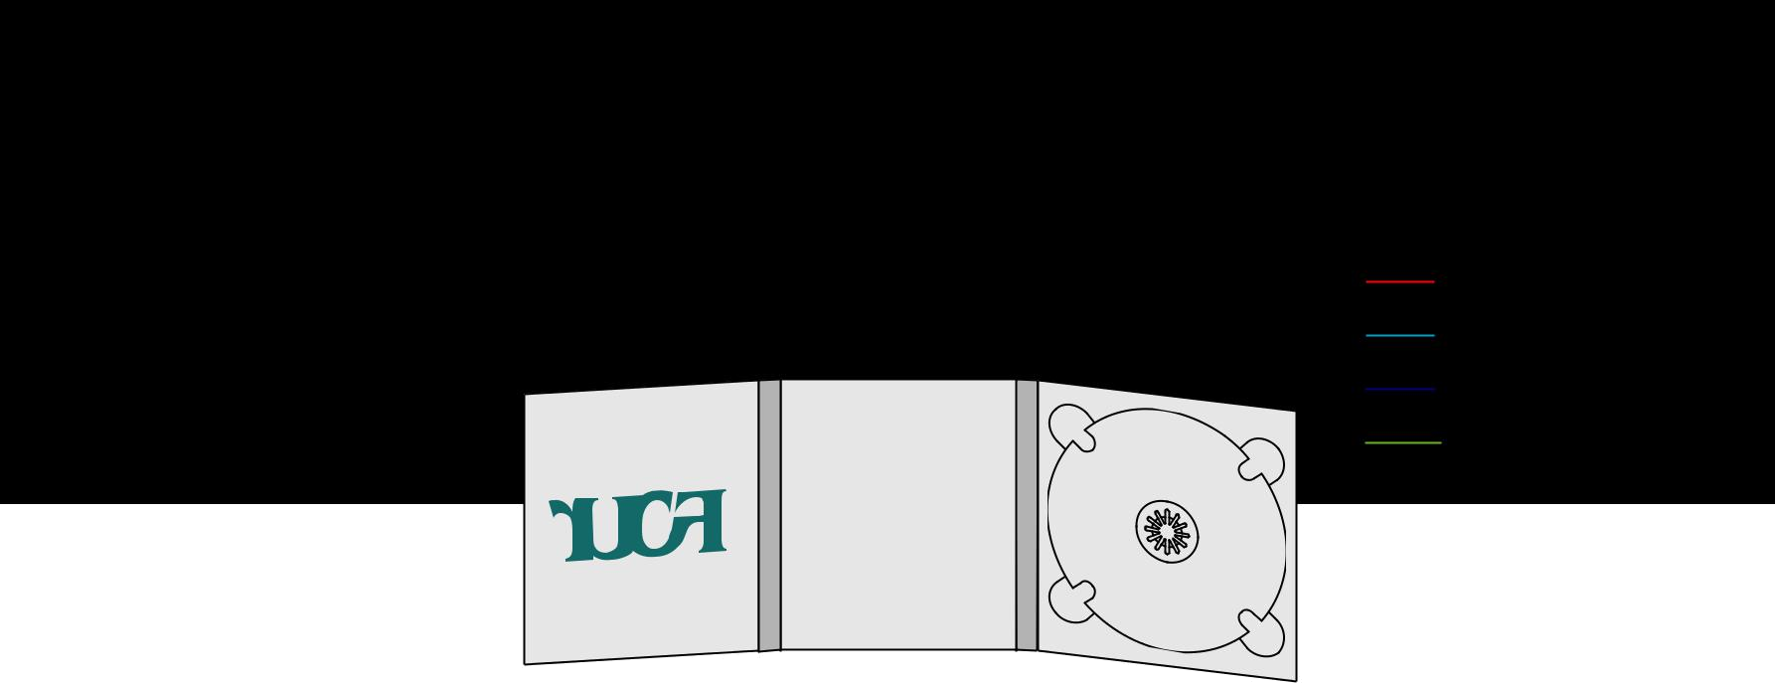
Audio DigiPac 6pp 1 Tray
Code: ADP06002 | Bleed (min. 3mm)
300 gsm cardboard | Design Area
300 gsm cardboard | Cutting line
 | Folding line

125,5 mm

251 mm

125,5 mm

 |  | 9 mm |  |  |  |  |  | 10,5 mm
137 mm |  |  |  |  |  | 136,5 mm |  |  |  |  |  | 138 mm
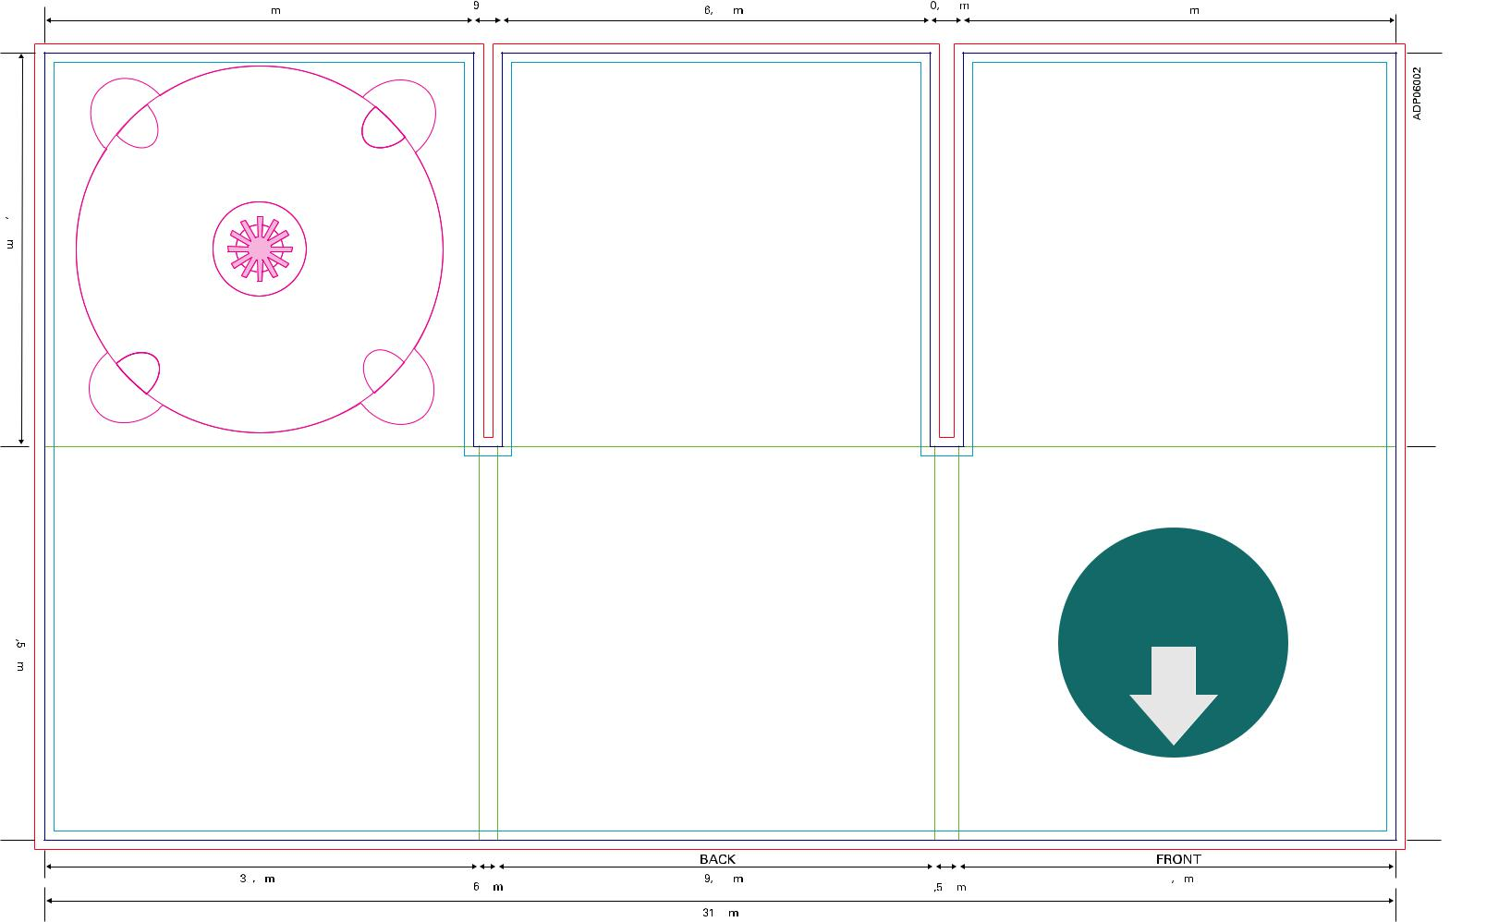

TRAYSIDE

HEAD

HEAD

COVERSIDE

Download

full scale

template

 |  |  |  |  |  |  | BACK |  |  |  |  |  |  |  | FRONT
138,5 mm |  |  |  |  |  |  | 139,5 mm |  |  |  |  |  |  |  | 139,5 mm
138,5 mm |  | 6 mm |  |  |  |  | 139,5 mm |  |  | 7,5 mm |  |  |  |  | 139,5 mm
 |  |  |  |  |  |  | 431 mm

 | ATTENTION: please ensure the Filecode is ad-
 | ded and clearly visible on your HiRes PDF (out-
 | side of print area). Alternatively you can upload
27 | the Template PDF as part of your package.


Audio DigiPac 6pp 1 Tray on center panel

Code: ADP06001 |  |  | Bleed (min. 3mm)
300 gsm cardboard |  |  | Design Area
300 gsm cardboard |  |  | Cutting line
 |  |  | Folding line

125,5 mm

251 mm

125,5 mm

 |  | 9 mm |  |  |  |  |  | 10,5 mm
137 mm |  |  |  |  |  | 136,5 mm |  |  |  |  |  | 138 mm
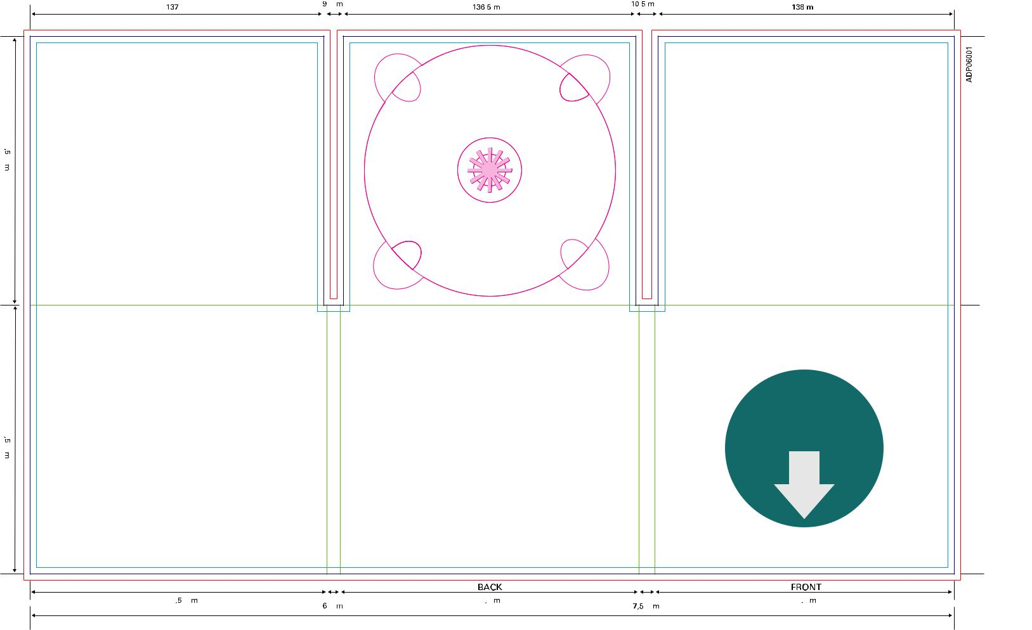

TRAYSIDE

HEAD

HEAD

COVERSIDE

Download

full scale

template

 |  |  |  |  |  |  | BACK |  |  |  |  |  |  |  | FRONT
138,5 mm |  | 6 mm |  |  |  |  | 139,5 mm |  |  | 7,5 mm |  |  |  |  | 139,5 mm
 |  |  |  |  |  |  | 431 mm

 | ATTENTION: please ensure the Filecode is ad-
 | ded and clearly visible on your HiRes PDF (out-
 | side of print area). Alternatively you can upload
28 | the Template PDF as part of your package.

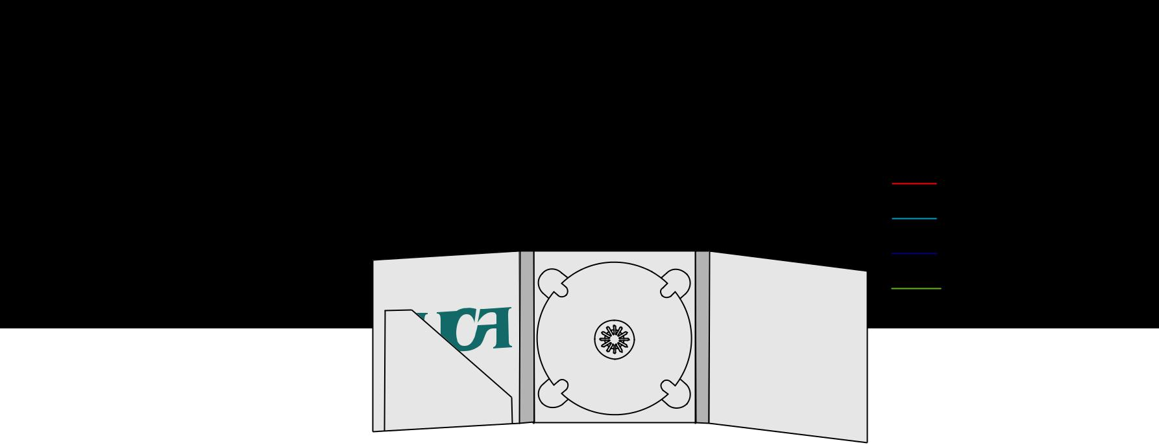
Audio DigiPac 6pp 1 Tray diagonal Slot (1 mm)

Code: ADP06007 | Bleed (min. 3mm)
Diagonal slot for Booklet up to | Design Area
Diagonal slot for Booklet up to | Cutting line
1 mm (20 pp on 150/90 gsm | Cutting line
1 mm (20 pp on 150/90 gsm | Folding line
artpaper) 300 gsm cardboard | Folding line

 |  | mm125,5
 |  | mm125,5 |  |  |  | 94
 |  |  |  |  |  | mm
 |  |  |  |  |  |  | 21,6
251
mm

125,5 mm

 |  | 11,5 mm |  |  |  | 9 mm
138 mm |  | 11,5 mm |  | 136,5 mm |  | 9 mm |  | 137 mm
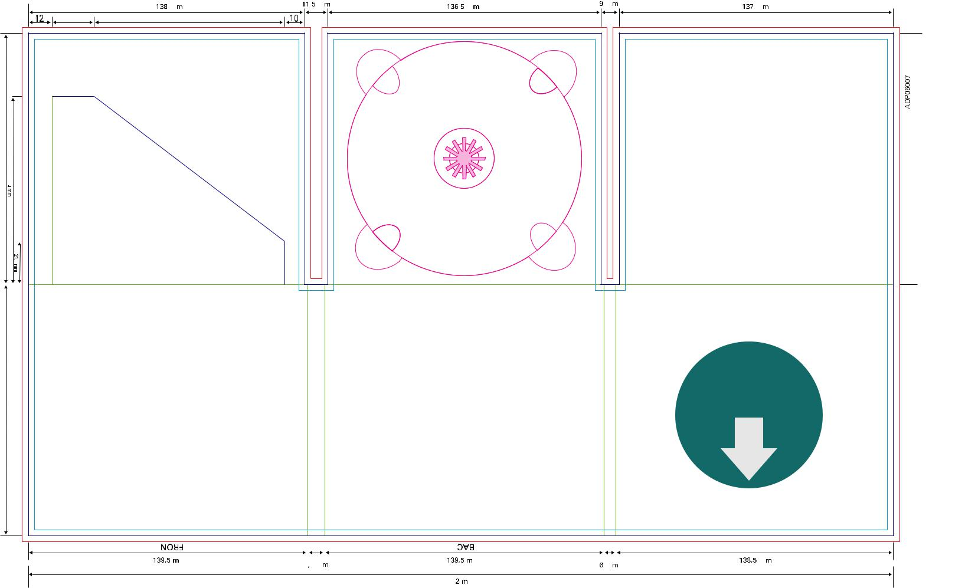
21mm 95mm

HEAD

TRAYSIDE

Download

full scale

template

COVERSIDE

DHEA

 | FRONT |  |  |  |  |  |  |  |  | BACK
 | 139,5 mm |  |  |  |  |  |  |  |  | 139,5 mm |  |  |  |  |  |  |  |  |  |  |  |  |  | 138,5 mm
 | 139,5 mm |  |  | 8,5 mm |  |  |  |  |  |  |  |  |  |  |  |  | 6 mm
 |  |  |  |  |  |  |  |  |  | 432 mm

 | ATTENTION: please ensure the Filecode is ad-
 | ded and clearly visible on your HiRes PDF (out-
 | side of print area). Alternatively you can upload
29 | the Template PDF as part of your package.

Audio DigiPac 6pp 1 Tray diagonal Slot (2 mm)

Code: ADP06037 | Bleed (min. 3mm)
Diagonal slot for Booklet up to | Design Area
Diagonal slot for Booklet up to | Cutting line
2 mm (40 pp on 150/90 gsm | Cutting line
2 mm (40 pp on 150/90 gsm | Folding line
artpaper) 300 gsm cardboard | Folding line

mm125,5
94
mm
21,6
251
mm

125,5 mm

 |  | 12,5 mm |  |  |  | 9 mm
138 mm |  | 12,5 mm |  | 136,5 mm |  | 9 mm |  | 137,5 mm
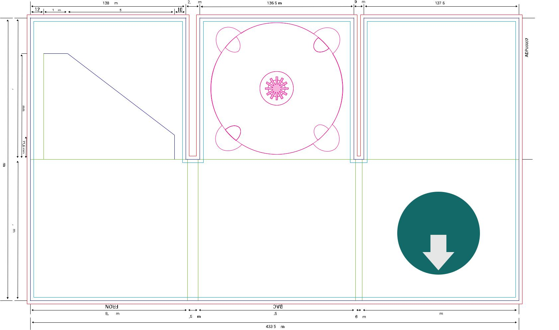
21 mm |  |  |  | 95 mm

HEAD

TRAYSIDE

Download

full scale

template

COVERSIDE

HEAD

 | FRONT |  |  |  |  |  |  |  |  | BACK
 | 139,5 mm |  |  |  |  |  |  |  |  | 139,5 mm |  |  |  |  |  |  |  | 139 mm
 | 139,5 mm |  |  | 9,5 mm |  |  |  |  |  | 139,5 mm |  |  |  | 6 mm |  |  |  | 139 mm
 |  |  |  |  |  |  |  |  |  | 433,5 mm

 | ATTENTION: please ensure the Filecode is ad-
 | ded and clearly visible on your HiRes PDF (out-
 | side of print area). Alternatively you can upload
30 | the Template PDF as part of your package.


Audio DigiPac 6pp 1Tray horizontal Slot (1 mm)

Code: ADP06028 | Bleed (min. 3mm)
Slot for Booklet up to 1 mm | Design Area
Slot for Booklet up to 1 mm | Cutting line
(20 pp on 150/90 gsm artpaper) | Cutting line
(20 pp on 150/90 gsm artpaper) | Folding line
300 gsm cardboard | Folding line

125,5 mm

mm25
251
mm

125,5 mm

 |  | 11,5 mm |  |  |  | 10 mm
138 mm |  | 11,5 mm |  | 136,5 mm |  | 10 mm |  | 137 mm
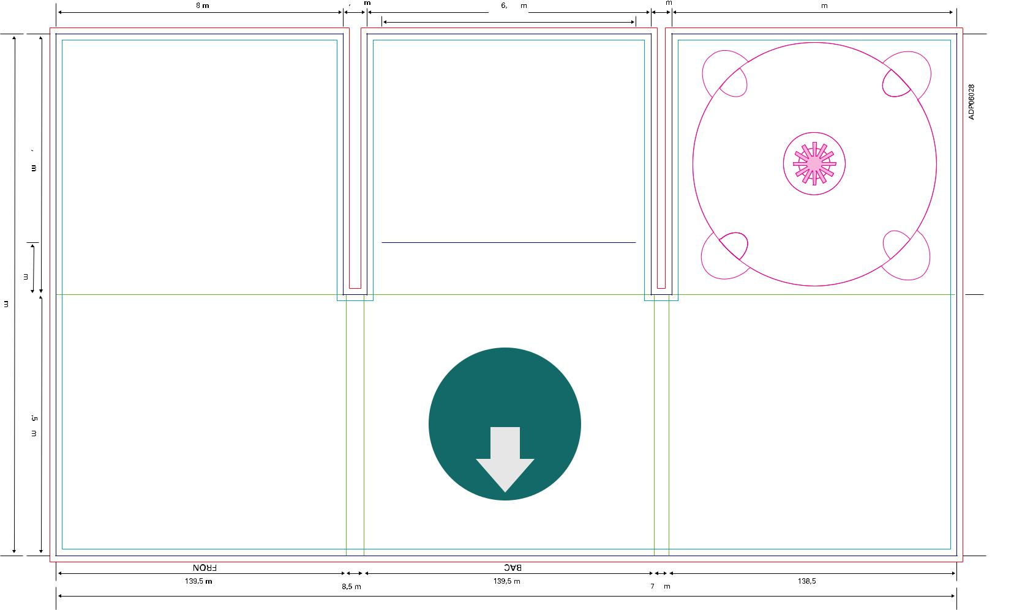

122 mm

HEAD

TRAYSIDE

Download

full scale

template

COVERSIDE

HEAD

 | FRONT |  |  |  |  |  |  |  | BACK
 | 139,5 mm |  |  |  |  |  |  |  | 139,5 mm |  |  |  |  |  |  | 138,5 mm
 | 139,5 mm |  |  | 8,5 mm |  |  |  |  | 139,5 mm |  |  | 7 mm |  |  |  | 138,5 mm

- mm

 | ATTENTION: please ensure the Filecode is ad-
 | ded and clearly visible on your HiRes PDF (out-
 | side of print area). Alternatively you can upload
31 | the Template PDF as part of your package.

Audio DigiPac 6pp 1Tray horizontal Slot (2 mm)

Code: ADP06029 | Bleed (min. 3mm)
Slot for Booklet up to 2 mm | Design Area
Slot for Booklet up to 2 mm | Cutting line
(40 pp on 150/90 gsm artpaper) | Cutting line
(40 pp on 150/90 gsm artpaper) | Folding line
300 gsm cardboard | Folding line

125,5 mm

mm25
251
mm

125,5 mm

 |  | 12,5 mm
138 mm |  |  |  |  |  |  | 136,5 mm |  |  |  | 11 mm |  |  |  | 137 mm
 |  |  |  |  |  |  |  | 122 mm
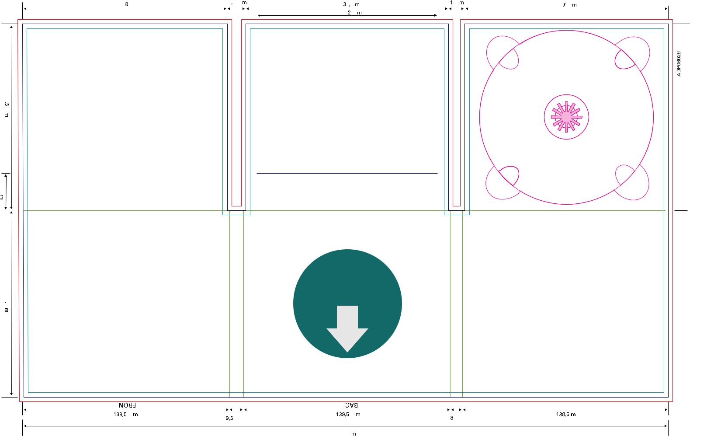

HEAD

TRAYSIDE

Download

full scale

template

COVERSIDE

DHEA

 | FRONT |  |  |  |  |  |  |  |  | BACK
 | 139,5 mm |  |  |  |  |  |  |  |  | 139,5 mm |  |  |  |  |  |  |  |  |  |  |  |  |  | 138,5 mm
 | 139,5 mm |  |  | 9,5 mm |  |  |  |  |  |  |  |  |  |  |  | 8 mm
 |  |  |  |  |  |  |  |  |  | 435 mm

 | ATTENTION: please ensure the Filecode is ad-
 | ded and clearly visible on your HiRes PDF (out-
 | side of print area). Alternatively you can upload
32 | the Template PDF as part of your package.

 | DVD Label 120 mm Specification F
 | Code: DLF12001 |  |  |  |  |  |  |  |  | Bleed (min. 3mm)
 | Screenprint up to 6 Pantone colors, |  |  |  |  |  |  |  |  | Design Area
 |  |  |  |  |  |  |  |  |  | Cutting line
 | Picture (CMYK) screenprint, Offset (CMYK) |  |  |  |  |  |  |  |  | Cutting line
 |  |  |  |  |  |  |  |  |  | Folding line


- mm Centre Hole

Download

full scale

template

 | ATTENTION: please ensure the Filecode is ad-
 | ded and clearly visible on your HiRes PDF (out-
 | side of print area). Alternatively you can upload
33 | the Template PDF as part of your package.

DVD Inlaysheet for Amaray Box
Code: DISAB001 |  |  |  |  |  |  |  | Bleed (min. 3mm)
150 gsm glossy artpaper |  |  |  |  |  |  |  | Design Area
 |  |  |  |  |  |  |  | Cutting line
 |  |  |  |  |  |  |  | Folding line
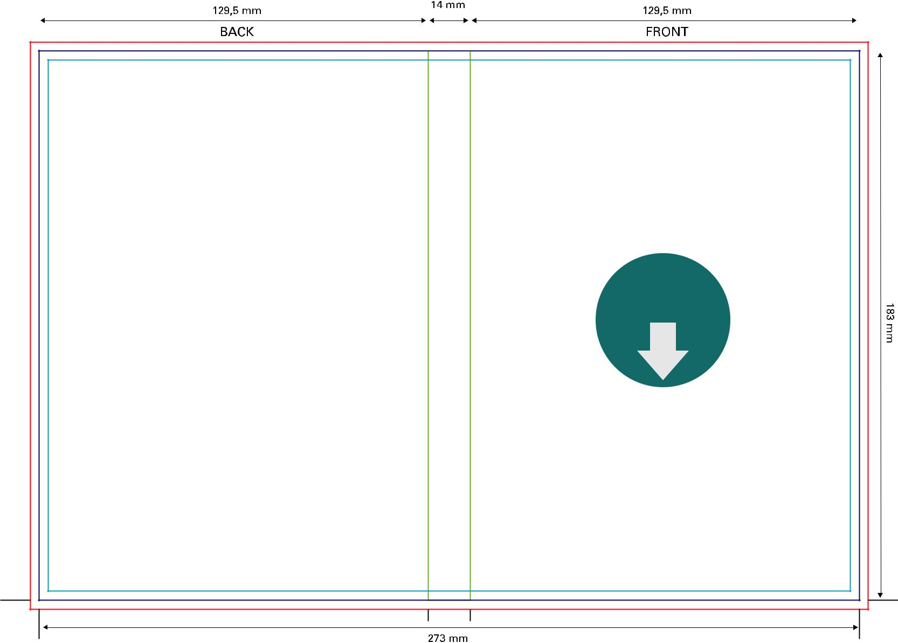

Download

full scale

template

 | ATTENTION: please ensure the Filecode is ad-
 | ded and clearly visible on your HiRes PDF (out-
 | side of print area). Alternatively you can upload
34 | the Template PDF as part of your package.

DVD Booklet – double page layout

Code: DBLDP001 |  |  | Bleed (min. 3mm)
Coverpages: 150 –170 gsm glossy artpaper |  |  | Design Area
 |  |  | Cutting line
Innerpages: 90 –100 gsm glossy artpaper
 |  |  | Folding line
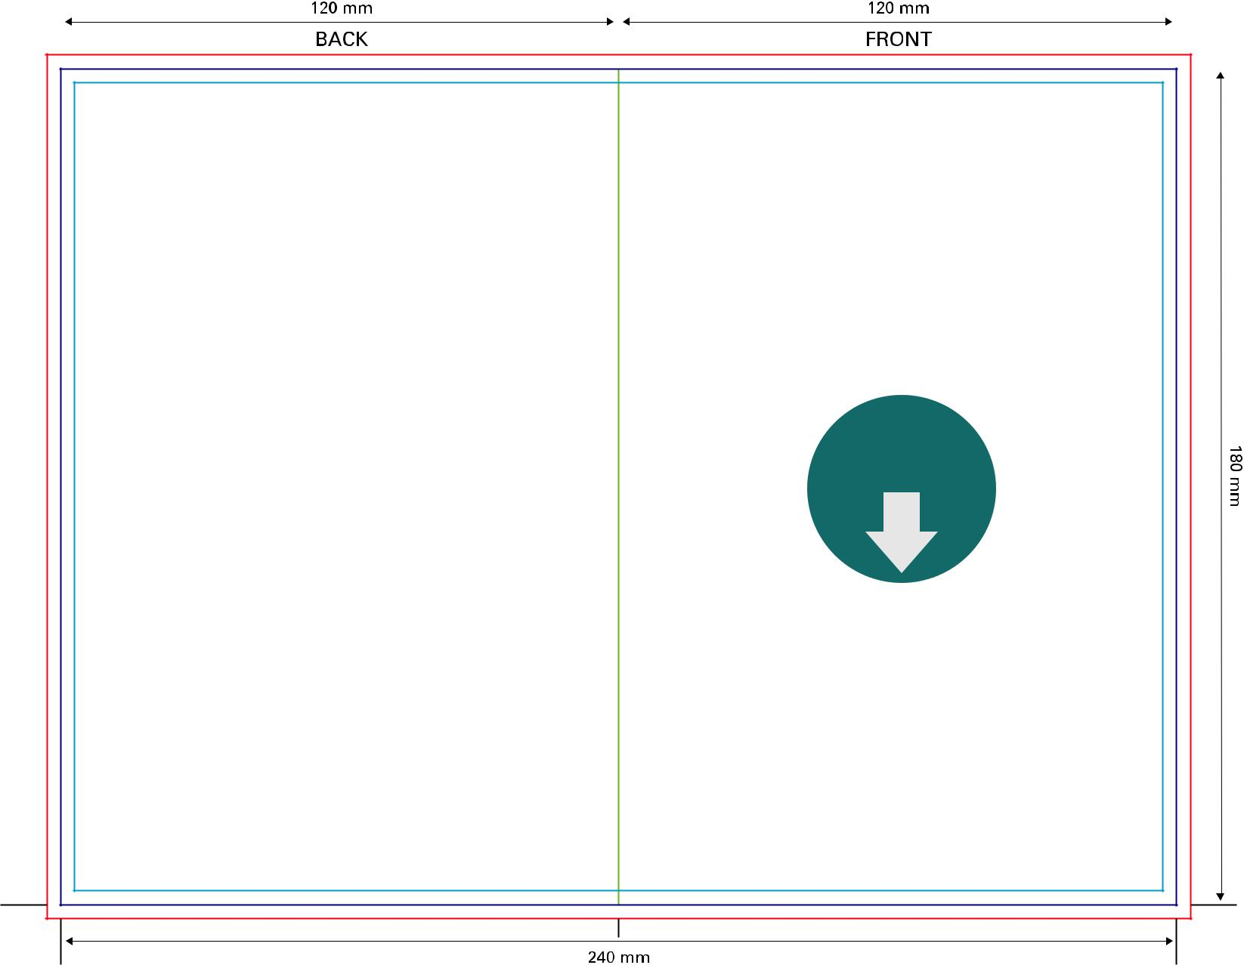

Download

full scale

template
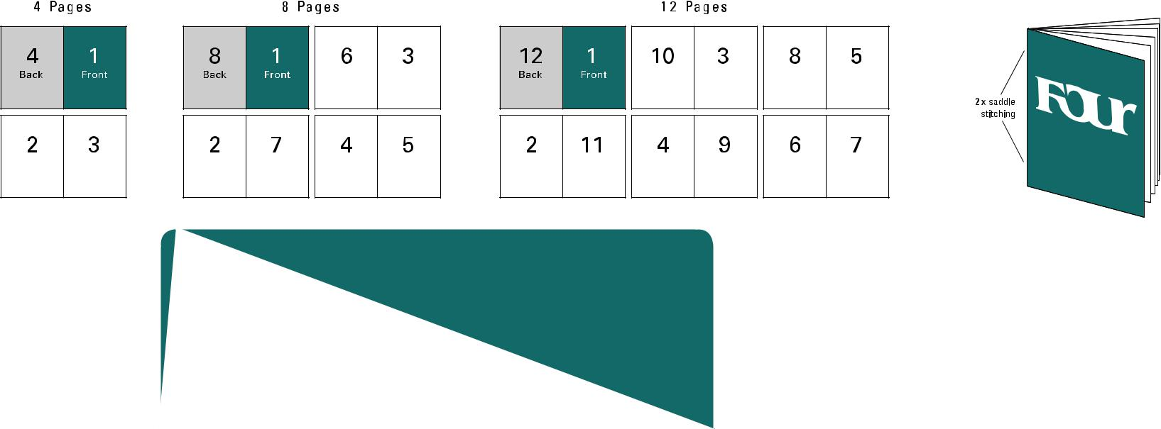

 | ATTENTION: please ensure the Filecode is ad-
 | ded and clearly visible on your HiRes PDF (out-
 | side of print area). Alternatively you can upload
35 | the Template PDF as part of your package.

Vinyl Label for 12” LP

Code: VLA120000

Print up to 4 Colors (CMYK, PMS)
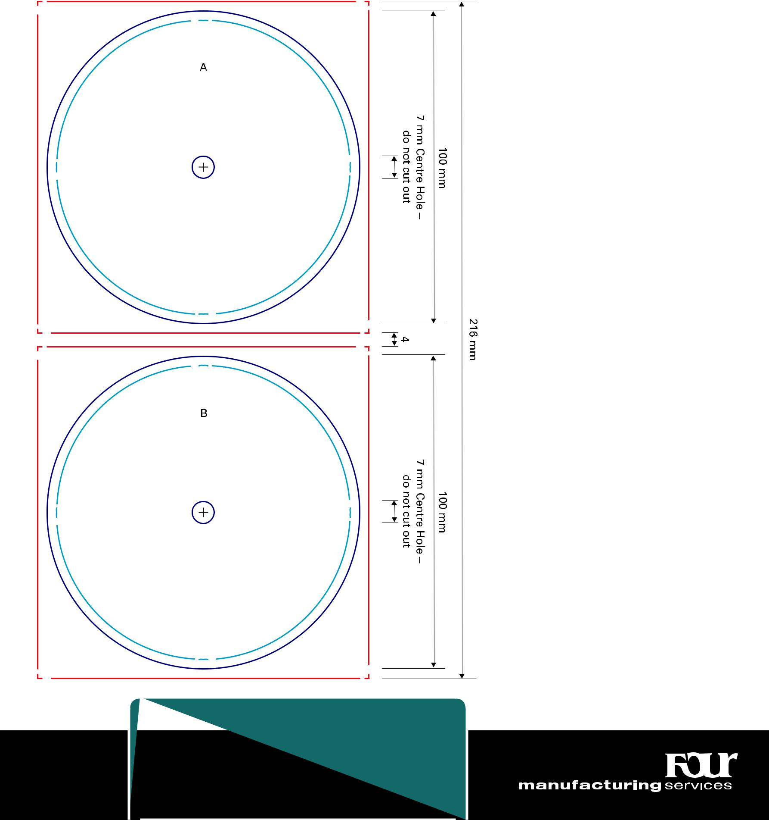

 | ATTENTION: please ensure the Filecode is ad-
 | ded and clearly visible on your HiRes PDF (out-
 | side of print area). Alternatively you can upload
36 | the Template PDF as part of your package.

Bleed (min. 3mm)

Design Area

Cutting line


CAUTION: during the process of production, record labels are exposed to strong heat. As a result the colours on the labels turn yellow. Especially the lighter shades, for example Pantone colours with 50 % or more lucent-white are prone to strong alternations – through the influence of heat they will turn darker. (e. g. Pantone 102 C = Pantone yellow 50 %; Pantone Trans. Wt. 50 %)


DON’T MISS: a 3 mm small cross-sign to mark the position of the cutout in the center of your artwork (only needed if you’re going to build your own template/layout)


Download

full scale

template

Vinyl Label for 12” (Picture Disc) LP

Code: VLA1200PD | Bleed (min. 3mm)
Print up to 4 Colors (CMYK, PMS)
Print up to 4 Colors (CMYK, PMS) | Design Area
 | Cutting line
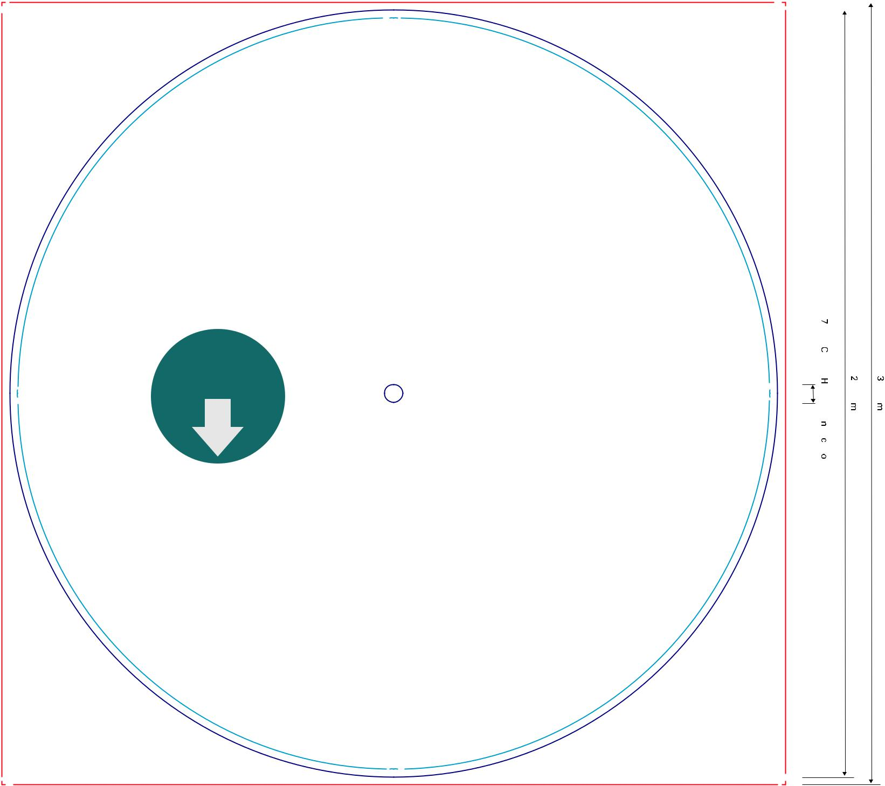

Download

full scale

template

do–HoleCentremm7
do–HoleCentremm7 |  |  | mm295 |  | mm301
outcutnot

 | ATTENTION: please ensure the Filecode is ad-
 | ded and clearly visible on your HiRes PDF (out-
 | side of print area). Alternatively you can upload
37 | the Template PDF as part of your package.


Vinyl Inner Sleeve for 12” LP (opening top)

Code: VSL121031 | Bleed (min. 3mm)
150 gsm matte artpaper | Design Area
150 gsm matte artpaper | Cutting line
 | Folding line

 |  |  | 304 mm
304 mm |  |  | 304 mm
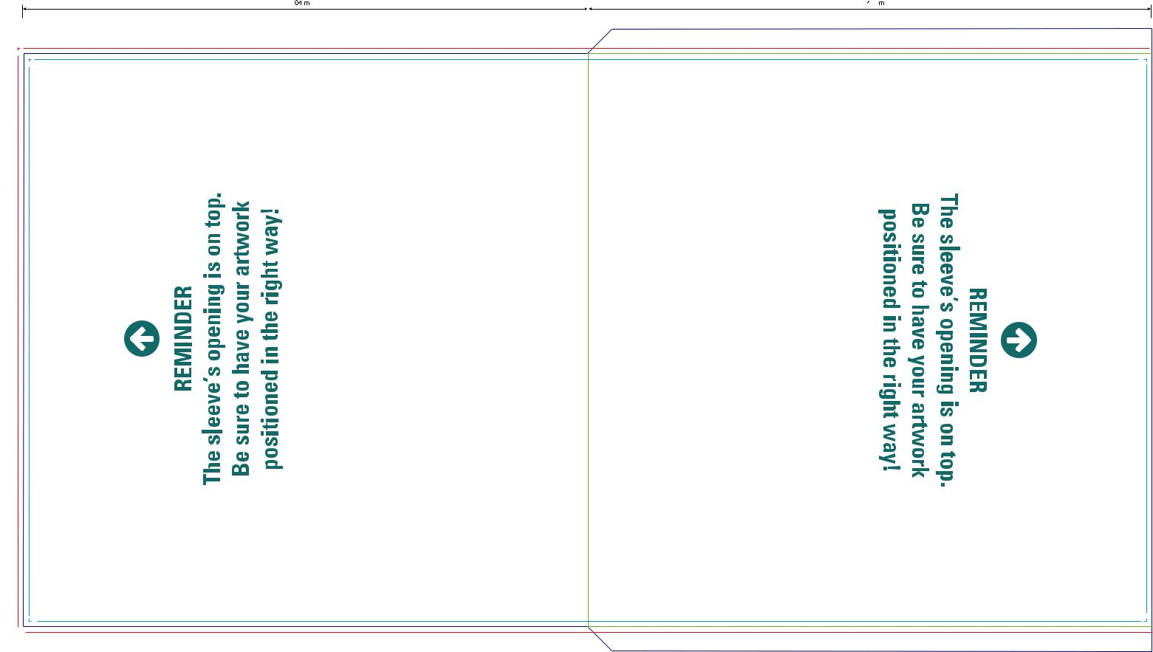

BACK

608 mm


Download

full scale

template


 | ATTENTION: please ensure the Filecode is ad-
 | ded and clearly visible on your HiRes PDF (out-
 | side of print area). Alternatively you can upload
38 | the Template PDF as part of your package.

13,5

336 mm 309 mm FRONT

13,5


Vinyl Discobag for 12” LP (no spine, opening right)

Code: VSL121034 | Bleed (min. 3mm)
300 gsm cardboard | Design Area
300 gsm cardboard | Cutting line
 | Folding line

 | 304 mm |  |  |  |  |  | 304 mm
 |  |  |  |  |  |  | FRONT
 | BACK
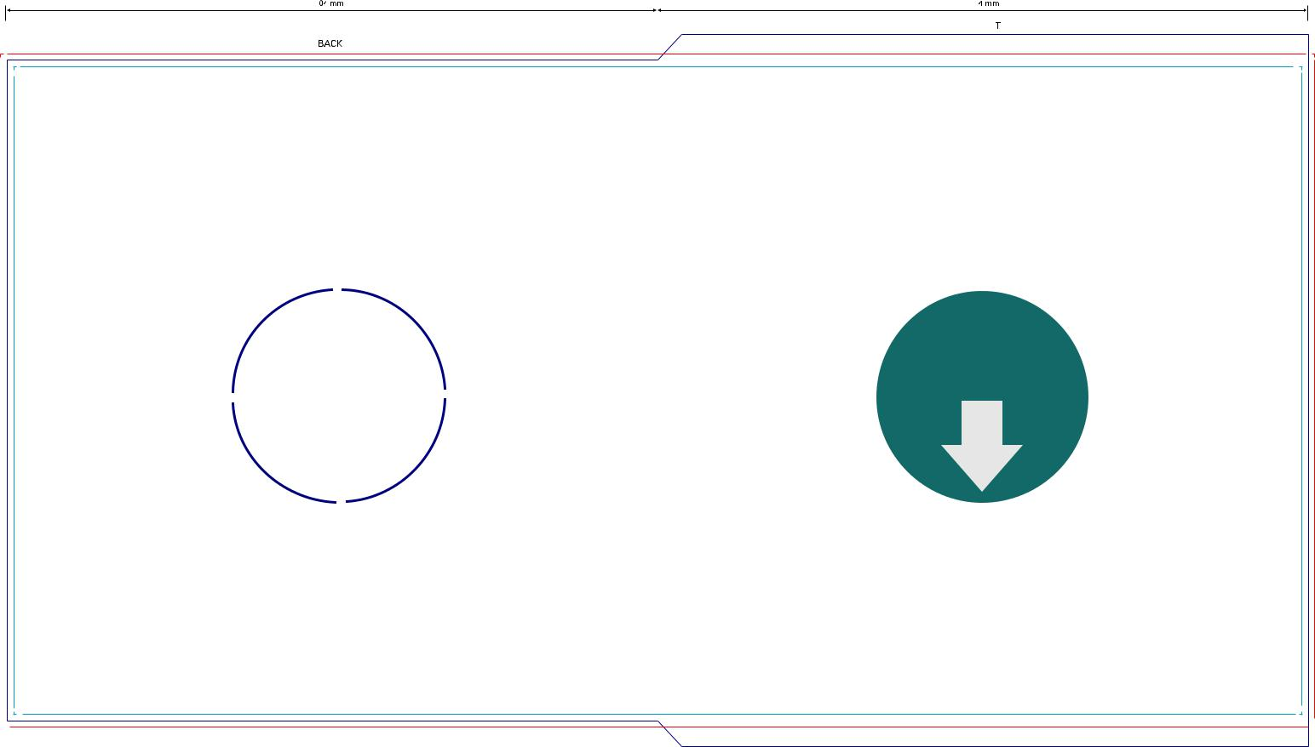

Holes possible – | Download
Holes possible – | full scale
please let us know | template
if you’re interested
(don’t sketch it in
the template!)


12

333 mm 309 mm

12

608 mm

 | ATTENTION: please ensure the Filecode is ad-
 | ded and clearly visible on your HiRes PDF (out-
 | side of print area). Alternatively you can upload
39 | the Template PDF as part of your package.

Vinyl Outer Sleeve for 12” LP (opening right)

Code: VSL121037 | Bleed (min. 3mm)
300 gsm cardboard | Design Area
300 gsm cardboard | Cutting line
 | Folding line

315 mm |  | 3 mm |  | 315 mm

BACK

FRONT
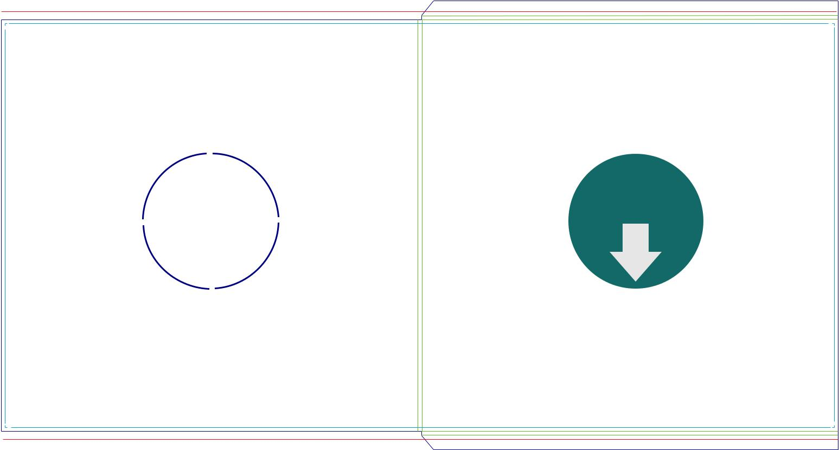

11 3

Holes possible – | Download
Holes possible – | full scale
please let us know | template
if you’re interested
(don’t sketch it in
the template!)

633 mm

340 mm 312 mm

3 11

 | ATTENTION: please ensure the Filecode is ad-
 | ded and clearly visible on your HiRes PDF (out-
 | side of print area). Alternatively you can upload
40 | the Template PDF as part of your package.


Vinyl Slip Case for 12” LPs (5 mm spine)

Code: VSL121040 | Bleed (min. 3mm)
300 gsm cardboard | Design Area
300 gsm cardboard | Cutting line
 | Folding line

315 mm |  | 5 mm |  |  |  |  |  |  | 315 mm
 |  |  |  |  |  |  |  |  | FRONT
BACK
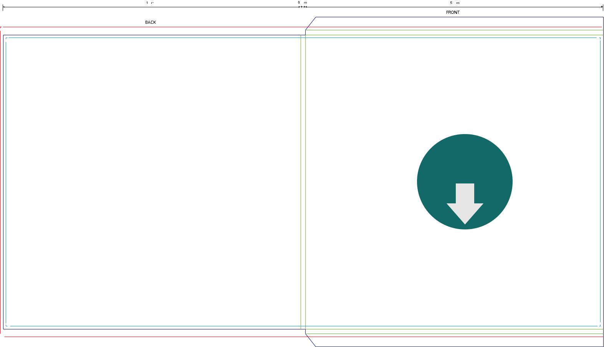

14 5

Download

full scale

template

350 mm 312 mm

5 14

635 mm

 | ATTENTION: please ensure the Filecode is ad-
 | ded and clearly visible on your HiRes PDF (out-
 | side of print area). Alternatively you can upload
41 | the Template PDF as part of your package.

Vinyl Slip Case for 12” LPs (7 mm spine)

Code: VSL121041 | Bleed (min. 3mm)
300 gsm cardboard | Design Area
300 gsm cardboard | Cutting line
 | Folding line

 |  | 7 mm
315 mm |  |  |  |  |  |  |  | 315 mm
 |  |  |  |  |  |  |  | FRONT
BACK
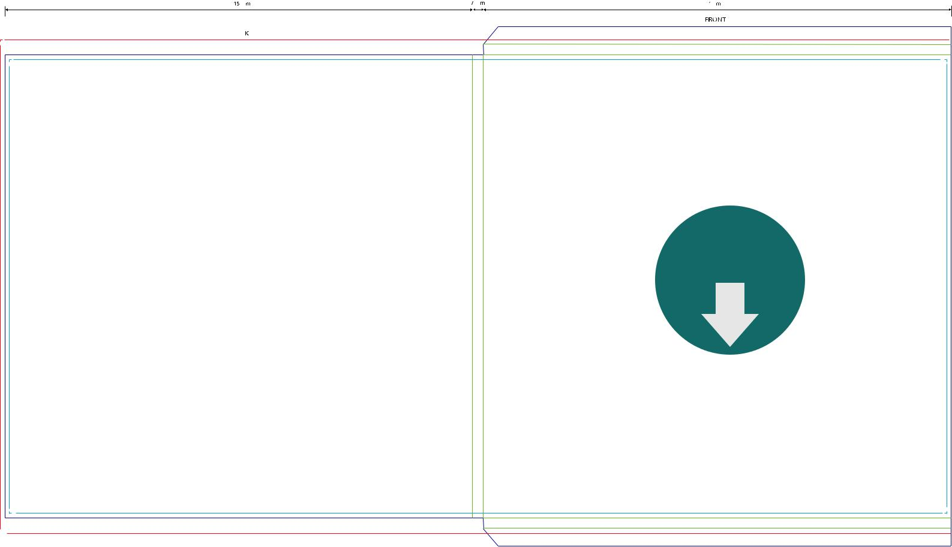

Download

full scale

template

12 7

350 mm 312 mm

7 12

637mm

 | ATTENTION: please ensure the Filecode is ad-
 | ded and clearly visible on your HiRes PDF (out-
 | side of print area). Alternatively you can upload
42 | the Template PDF as part of your package.


Vinyl Outer Sleeve Gatefold for 12” LP

Code: VSL121043 | Bleed (min. 3mm)
300 gsm cardboard | Design Area
300 gsm cardboard | Cutting line
 | Folding line

315 mm |  |  | 6 |  |  | 315 mm
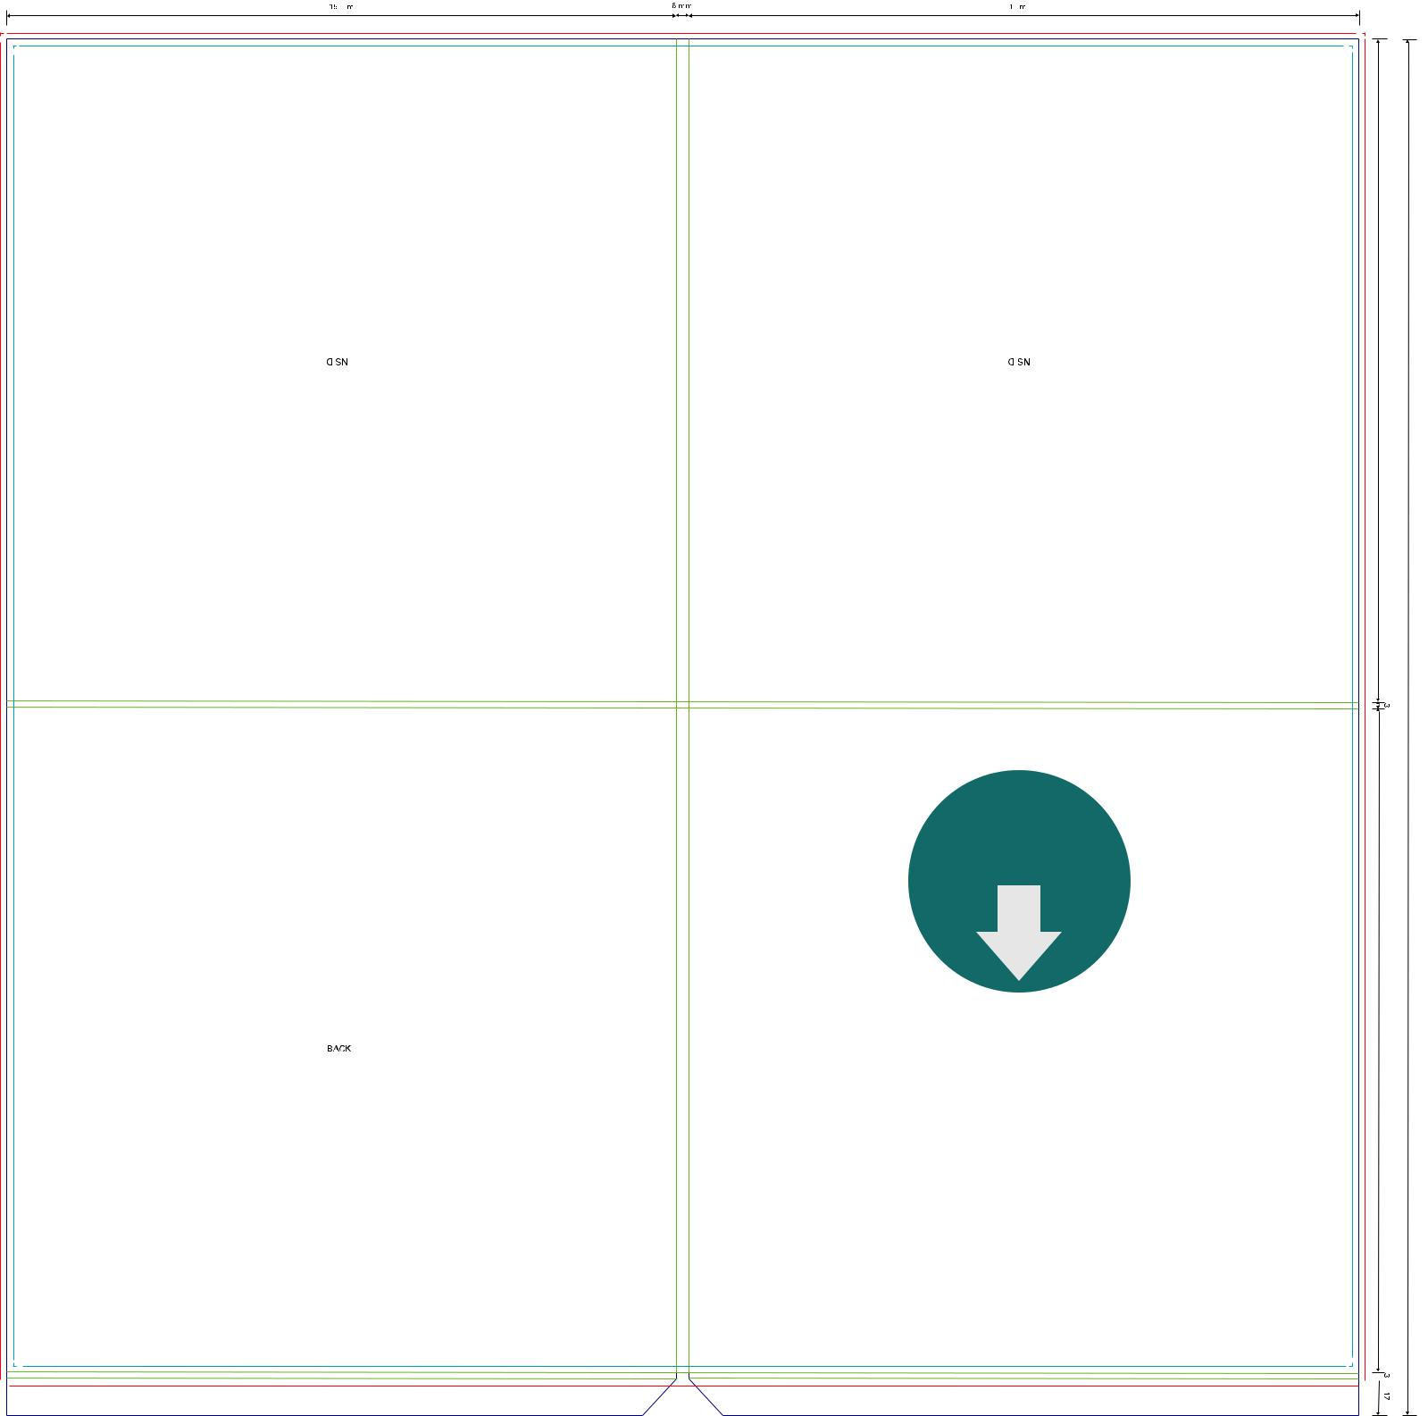

INSIDE |  | INSIDE

312 mm

647
mm 3

Spine
BACK

 |  | 636 mm
 | ATTENTION: please ensure the Filecode is ad-
 | ded and clearly visible on your HiRes PDF (out-
 | side of print area). Alternatively you can upload
43 | the Template PDF as part of your package.

Download

full scale

template

FRONT

312 mm

3 17


Vinyl Outer Sleeve Gatefold 12”LP (front page closed)

Code: VSL121042 | Bleed (min. 3mm)
300 gsm cardboard | Design Area
300 gsm cardboard | Cutting line
 | Folding line

315 mm |  |  | 6 |  |  | 315 mm
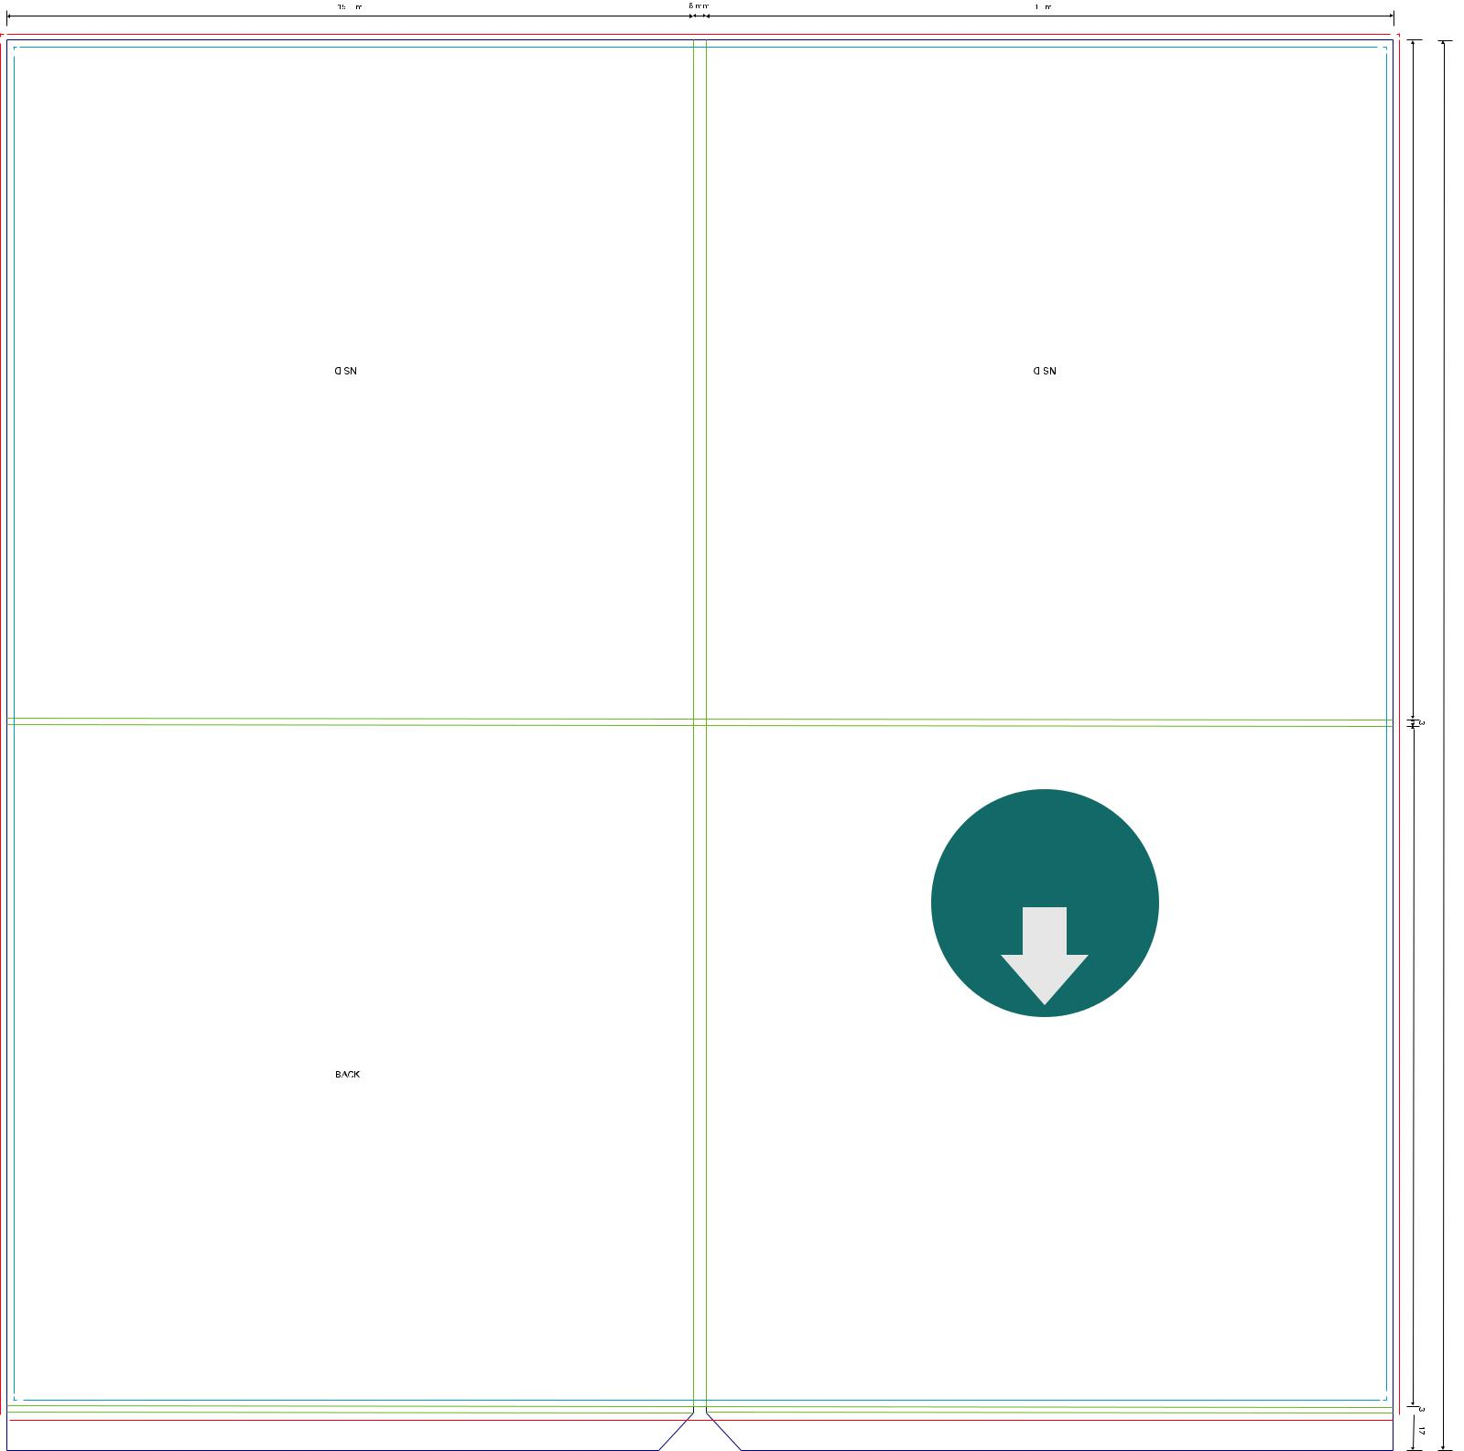

INSIDE |  | INSIDE

312 mm

647
mm 3

Spine
BACK

 |  | 636 mm
 | ATTENTION: please ensure the Filecode is ad-
 | ded and clearly visible on your HiRes PDF (out-
 | side of print area). Alternatively you can upload
44 | the Template PDF as part of your package.

Download

full scale

template

FRONT

312 mm

3 17


Vinyl Label for 7” LP

Code: VLA070000

Print up to 4 Colors (CMYK, PMS)
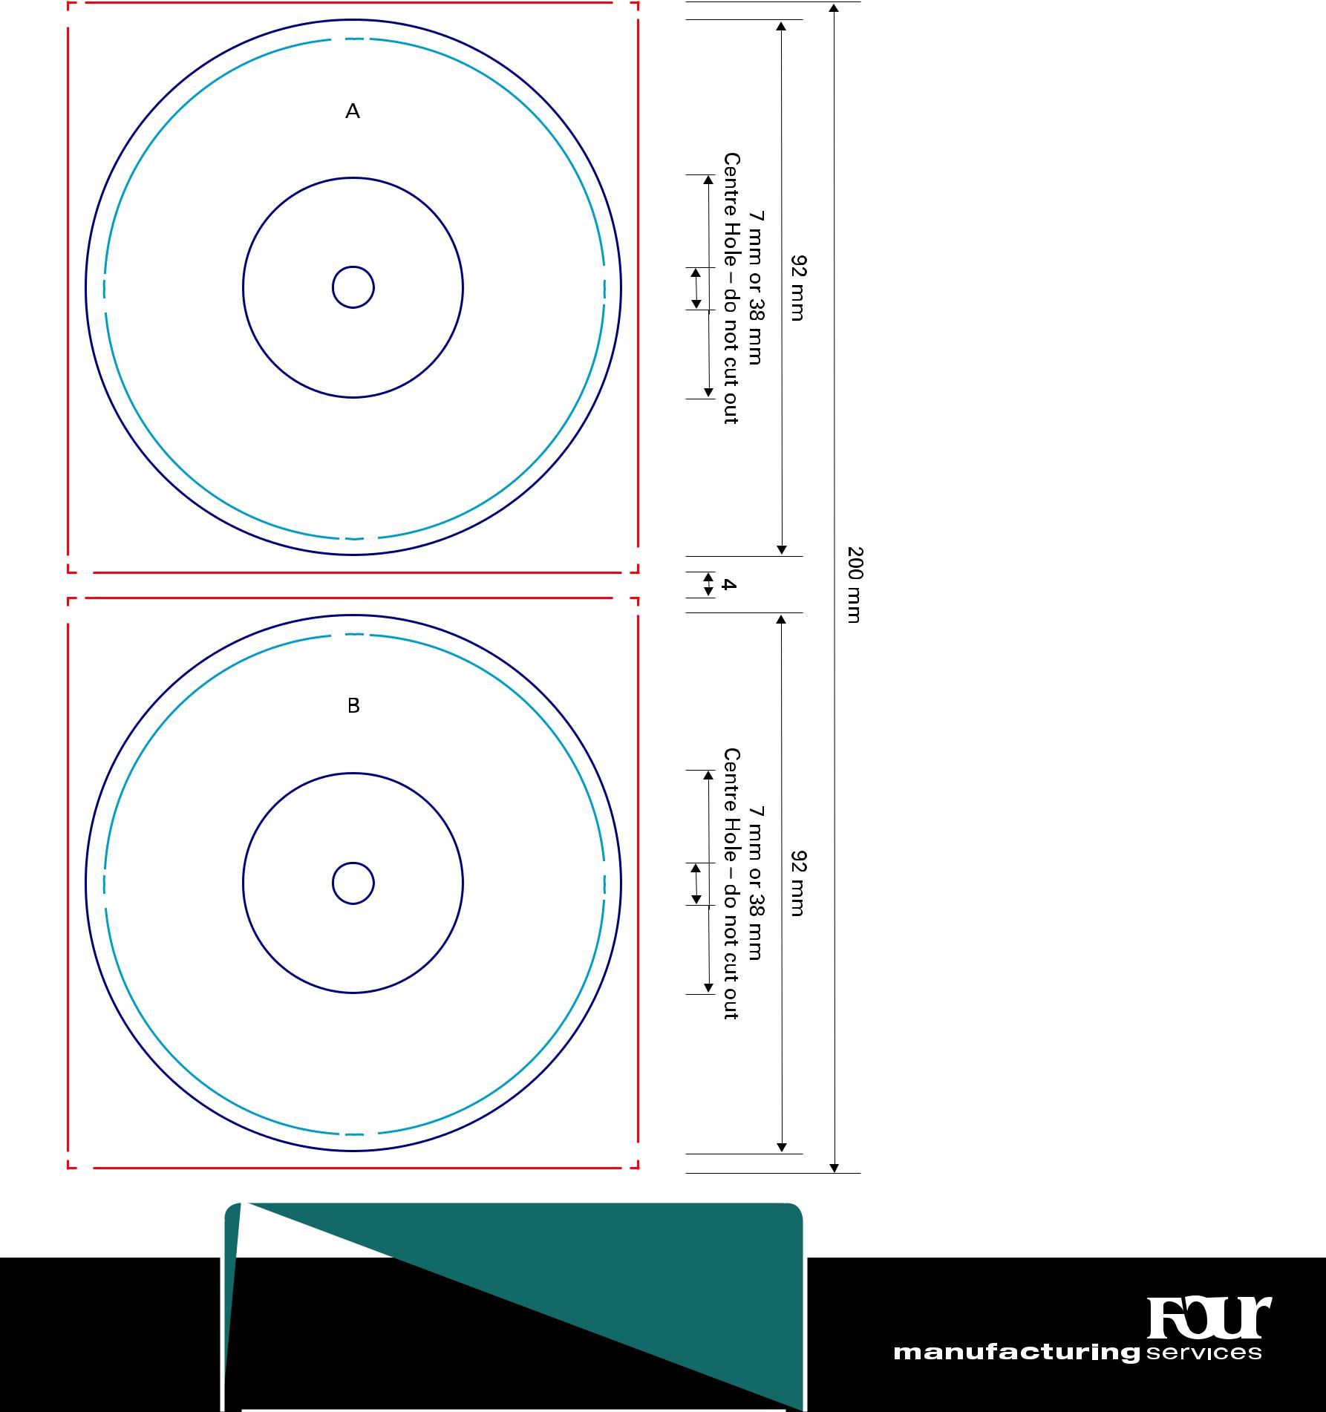

 | ATTENTION: please ensure the Filecode is ad-
 | ded and clearly visible on your HiRes PDF (out-
 | side of print area). Alternatively you can upload
45 | the Template PDF as part of your package.

Bleed (min. 3mm)

Design Area

Cutting line

CAUTION: during the process of production, record labels are exposed to strong heat. As a result the colours on the labels turn yellow. Especially the lighter shades, for example Pantone colours with 50 % or more lucent-white are prone to strong alternations – through the influence of heat they will turn darker. (e. g. Pantone 102 C = Pantone yellow 50 %; Pantone Trans. Wt. 50 %)

Download

full scale

template
Vinyl Discobag for 7” LP (no spine, opening top)

Code: VSL071034 | Bleed (min. 3mm)
250 gsm cardboard | Design Area
250 gsm cardboard | Cutting line
 | Folding line

180 mm |  |  | 180 mm
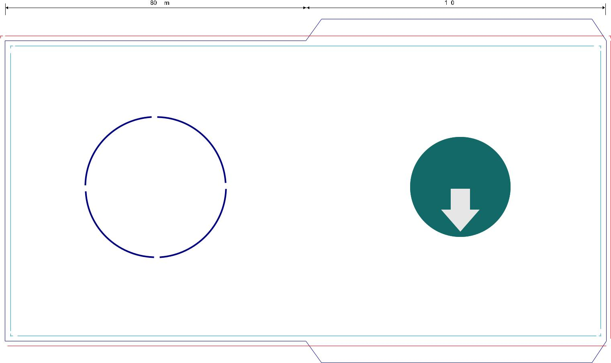

 |  |  | Download
 |  | Holes possible – | full scale
 | BACK | please let us know | template
 | BACK | if you’re interested
 |  | (don’t sketch it in
 |  | the template!)



360 mm

 | ATTENTION: please ensure the Filecode is ad-
 | ded and clearly visible on your HiRes PDF (out-
 | side of print area). Alternatively you can upload
46 | the Template PDF as part of your package.

13

FRONT |  | mm180 |  | mm206

13

Vinyl Outer Sleeve for 7” LP (opening top)

Code: VSL071037 | Bleed (min. 3mm)
250 gsm cardboard | Design Area
250 gsm cardboard | Cutting line
 | Folding line

BACK

185 mm | 3 mm | 185 mm
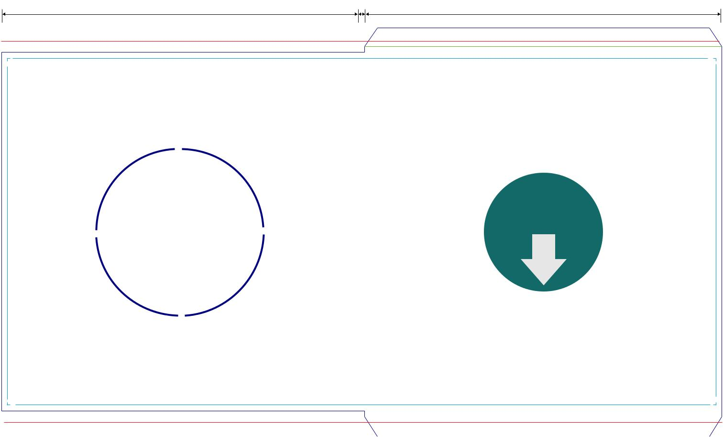

 |  | Download
Holes possible – |  | full scale
please let us know |  | template
if you’re interested
(don’t sketch it in
the template!)

373 mm

10 3
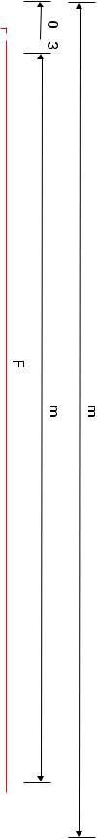

FRONT |  | mm185 |  | mm211

3 10


 | ATTENTION: please ensure the Filecode is ad-
 | ded and clearly visible on your HiRes PDF (out-
 | side of print area). Alternatively you can upload
47 | the Template PDF as part of your package.


Vinyl Label for 10” LP

Code: VLA100000

Print up to 4 Colors (CMYK, PMS)
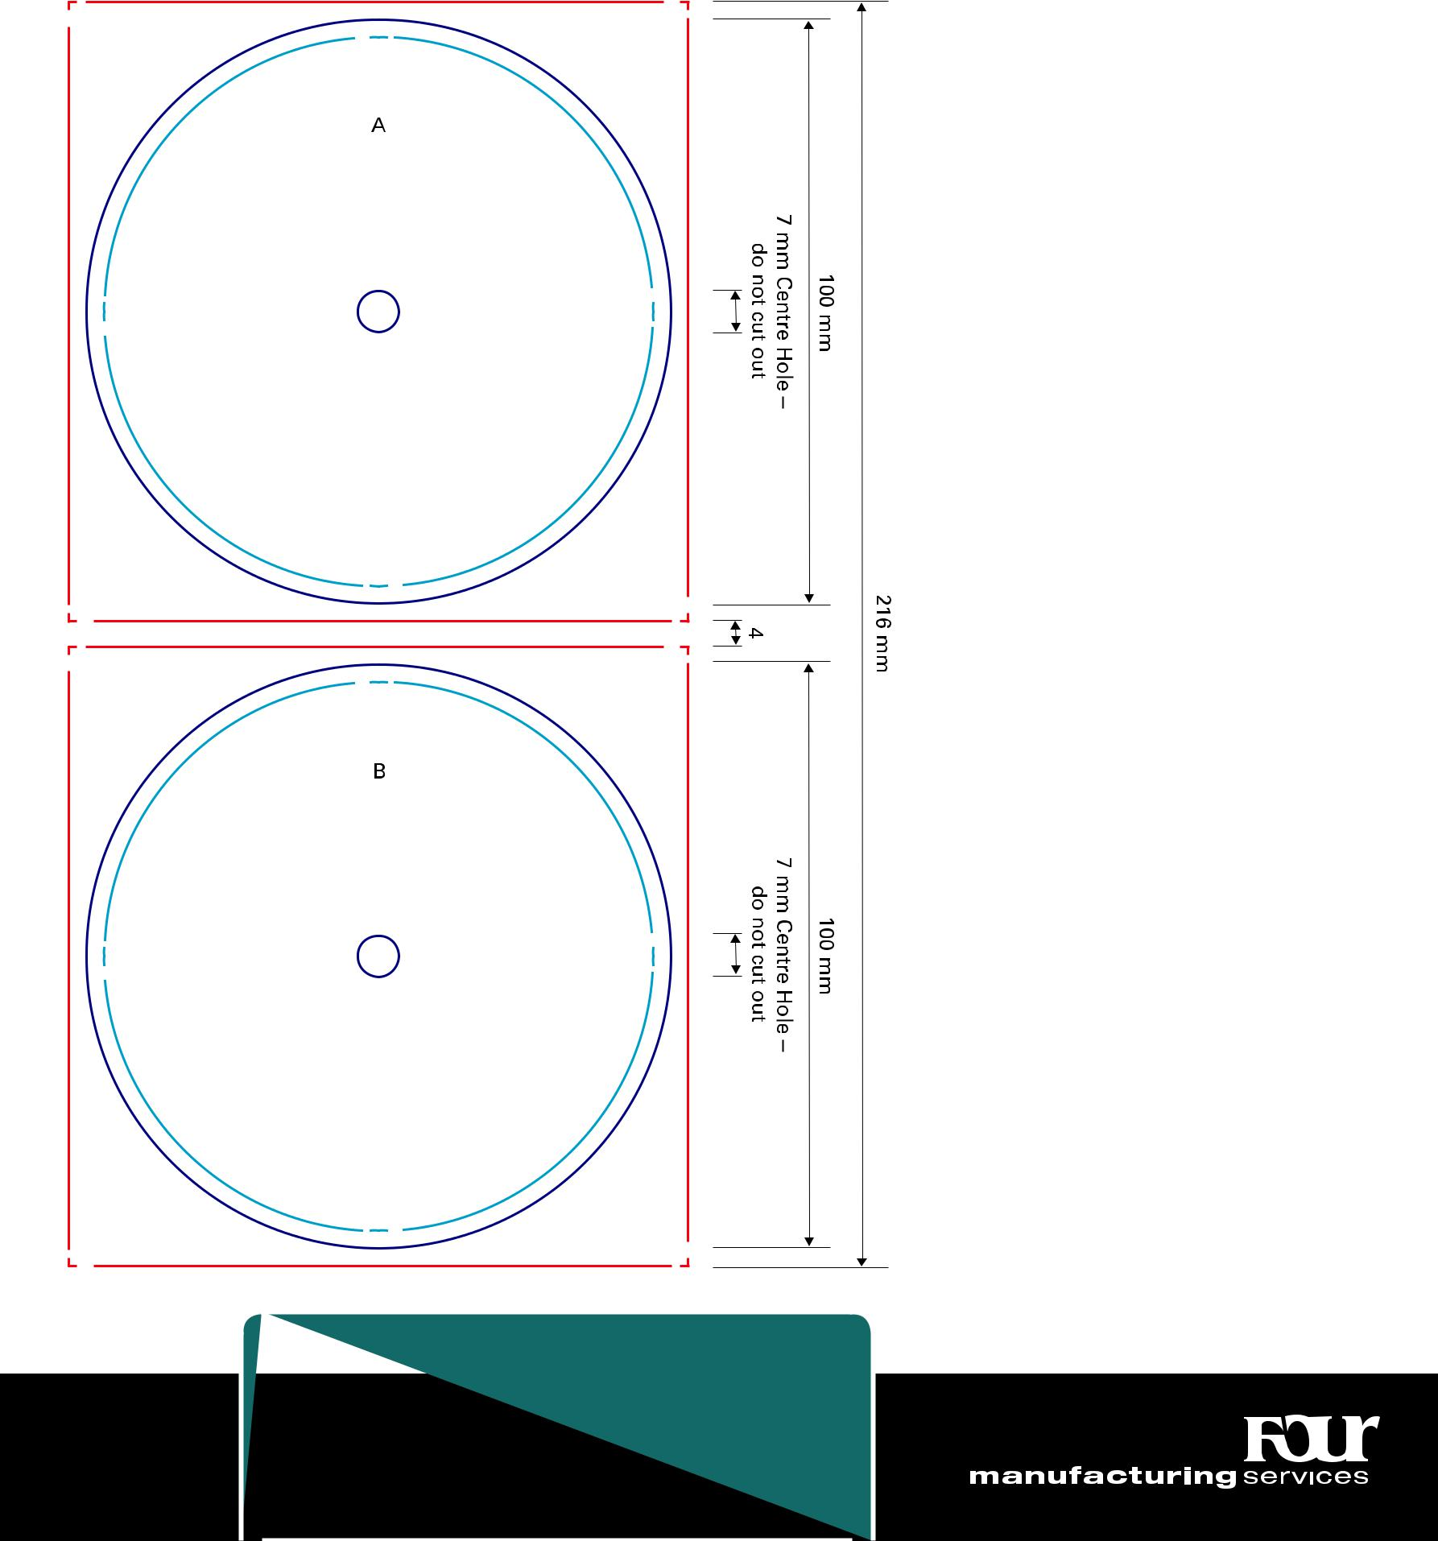

 | ATTENTION: please ensure the Filecode is ad-
 | ded and clearly visible on your HiRes PDF (out-
 | side of print area). Alternatively you can upload
48 | the Template PDF as part of your package.

Bleed (min. 3mm)

Design Area

Cutting line

CAUTION: during the process of production, record labels are exposed to strong heat. As a result the colours on the labels turn yellow. Especially the lighter shades, for example Pantone colours with 50 % or more lucent-white are prone to strong alternations – through the influence of heat they will turn darker. (e. g. Pantone 102 C = Pantone yellow 50 %; Pantone Trans. Wt. 50 %)

Download

full scale

template
Vinyl Discobag for 10” LP (no spine, opening right)

Code: VSL101034 | Bleed (min. 3mm)
280 gsm cardboard | Design Area
280 gsm cardboard | Cutting line
 | Folding line

 | 260 mm |  |  |  |  | 260 mm
 |  |  |  |  |  | FRONT
 | BACK
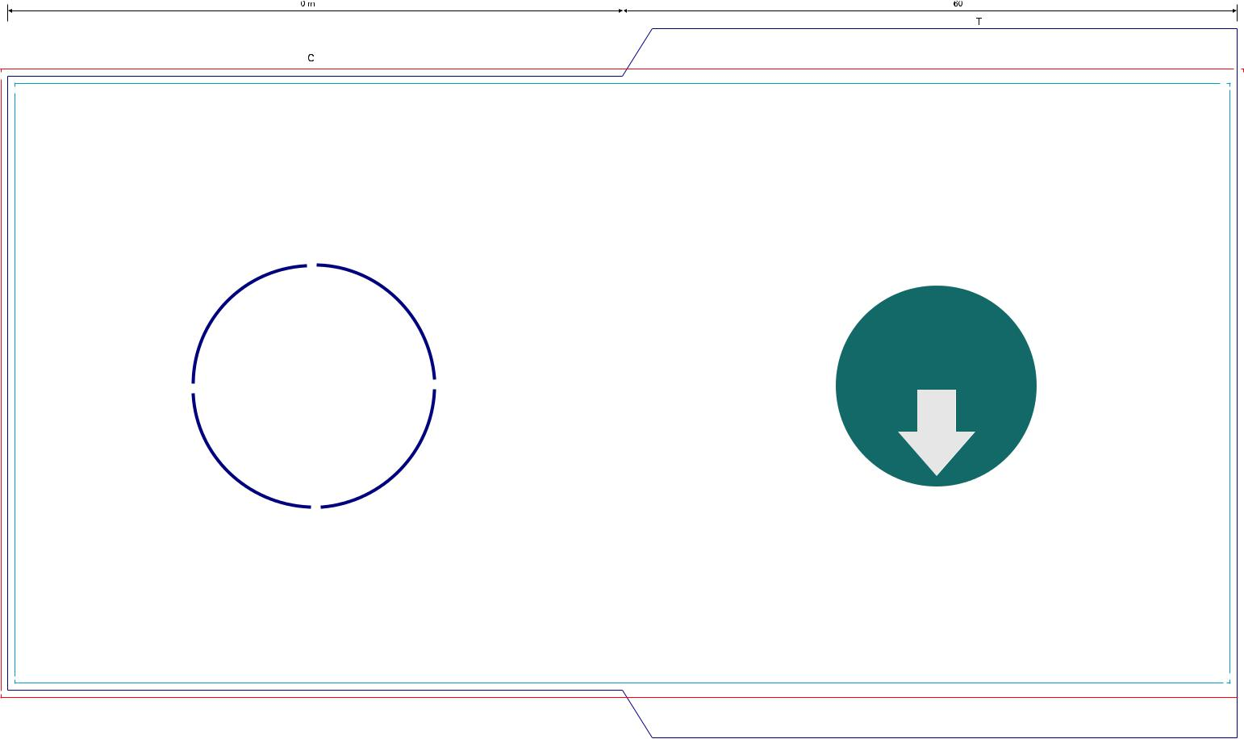

Holes possible – | Download
Holes possible – | full scale
please let us know | template
if you’re interested
(don’t sketch it in
the template!)


- mm

 | ATTENTION: please ensure the Filecode is ad-
 | ded and clearly visible on your HiRes PDF (out-
 | side of print area). Alternatively you can upload
49 | the Template PDF as part of your package.

20 mm

mm260 |  | mm300

20 mm

Vinyl Outer Sleeve for 10” LP (opening right)

Code: VSL101037 | Bleed (min. 3mm)
280 gsm cardboard | Design Area
280 gsm cardboard | Cutting line
 | Folding line

265 mm ^{3mm} 265 mm
FRONT
BACK
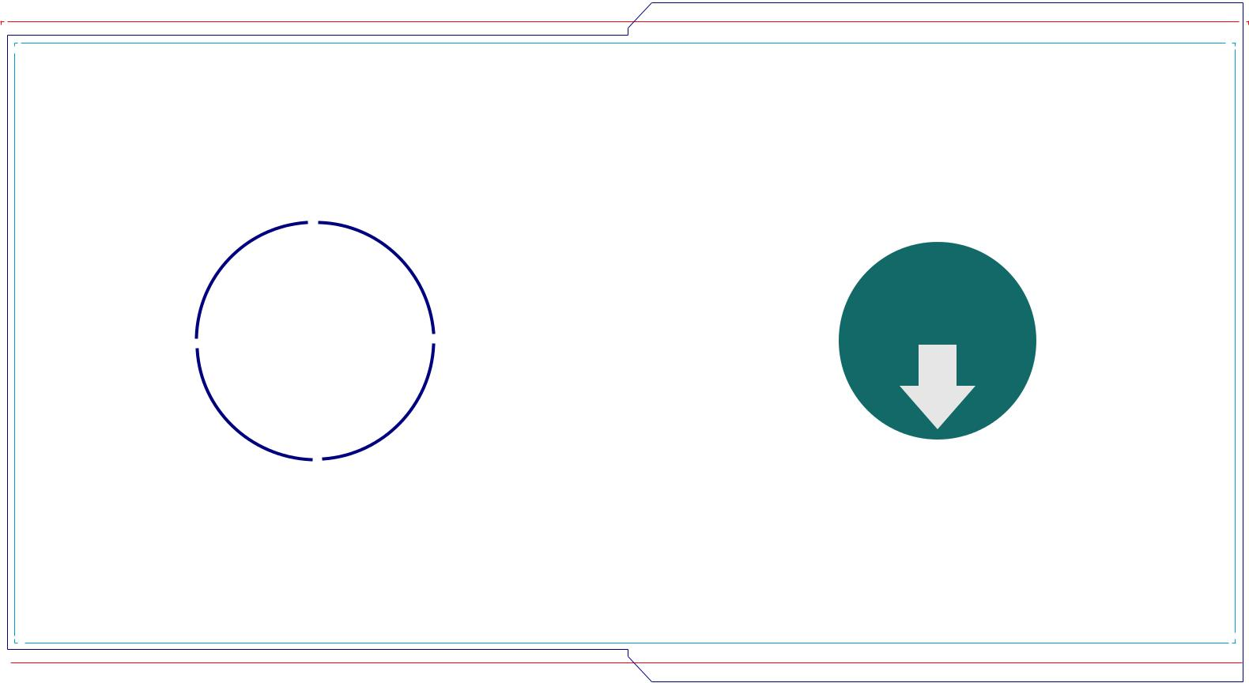

Holes possible – |  | Download
Holes possible – |  | full scale
please let us know |  | template
if you’re interested
(don’t sketch it in
the template!)



- mm

11 3

mm265 |  | mm293

3 11

 | ATTENTION: please ensure the Filecode is ad-
 | ded and clearly visible on your HiRes PDF (out-
 | side of print area). Alternatively you can upload
50 | the Template PDF as part of your package.

