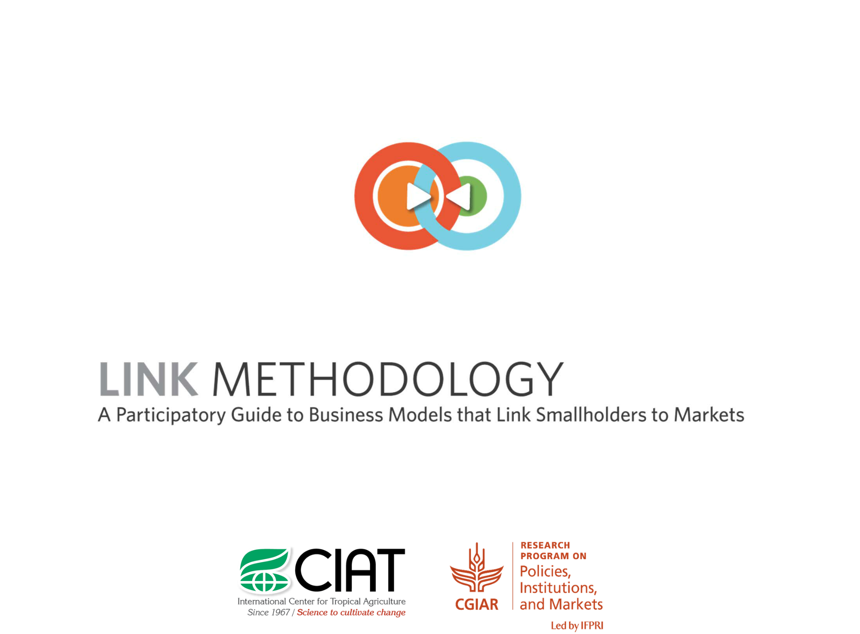
What’s in it?

Each of the proposed tools focuses on improving the inclusion of small-scale farmers. In order to get the most out of the toolkit, “users” should select, utilise and combine these tools in accordance with their own context, needs, budget, and variable starting points in the process.
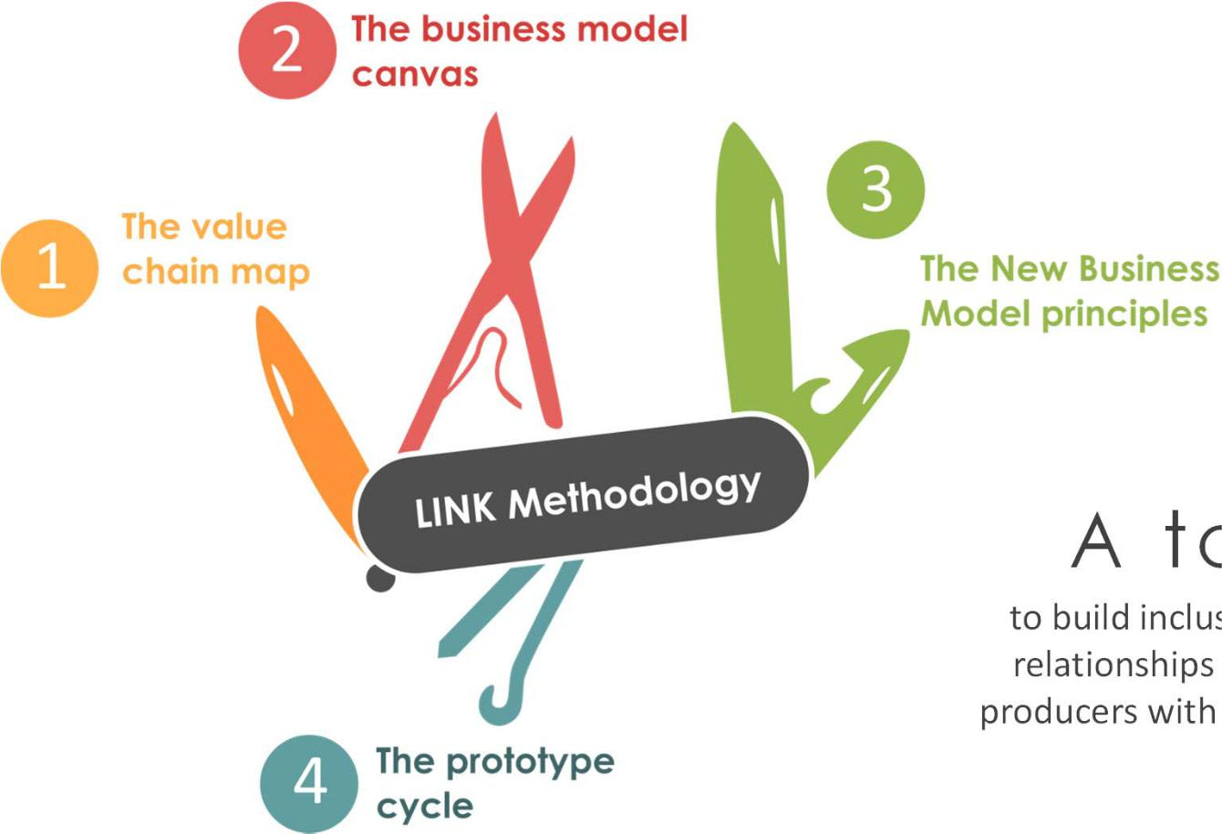

A toolkit

to build inclusive commercial

relationships which link rural
producers with modern markets.

Origins

- Link’s heart “the new business model principles” initially arose from expert discussions between CIAT, IIED and the Sustainable Foodlab and were tested in a 24-case study carried out in Latin America, Asia and Africa and thereupon distilled into the current six themes.

- The base on which these principles built up on are drawn from Alexander Osterwalder’s Business Model Generation which has been adapted to rural and agricultural purposes.

- LINK is a Prototype itself and currently in its third revision (since 2012), thus constantly evolving constructing upon new insights and lessons learnt.

What is LINK’s value proposition?


- Nailing down inclusive business: Despite its increasing popularity there is a lack of practical and concrete approaches on how to operationalize and monitor inclusive business. The diversity of conceptual frameworks further complicates this issue.

- Provide a methodology attractive to both producer organizations and private sector partners by simple and accessible language and novel business tools.

- Offer concrete entry points for private sector actors to make supplier relationships more inclusive.

- Facilitate exchange and mutual understanding between business partners.

Inclusive business:

Commercial relationship between a private company and a group (formal or informal) of producers whereby both the buyer and seller generate social, economic and environmental value in order to sustain long-term profitable interdependence.

LINK’s (simplified) Theory of Change

Outcome(s)

Output

Uptake by NGOs, public sector

_{LINK} actors and companies.

Methodology

Intended Impacts


Trading

relationships with:
- Increased stability

- Mutual satisfaction

- Durability

- Resilience

- Frequent and effective communication

- Transparent governance

- Joint innovation

- Stable and profitable returns

Increased mutual understanding (PO: business orientation, Buyer: Smallholder farmer
context)

Key features
Introduction

What is LINK?

- LINK is not carved into stone but “users” should select, utilise and combine the tools in accordance with their own context, needs, budget, and variable starting points in the process.

- A good portion of common sense is advised.

- The information provided is addressed at facilitators.

- LINK is a combination between comprehensible theoretical background information and detailed exercises including tips and tricks for facilitators.

- LINK does not intend to replace other tools or to double workload, therefore the complementary use to other methodologies and of already existing information is recommended.

- Inclusion is not the end but a mean to achieve increased performance:
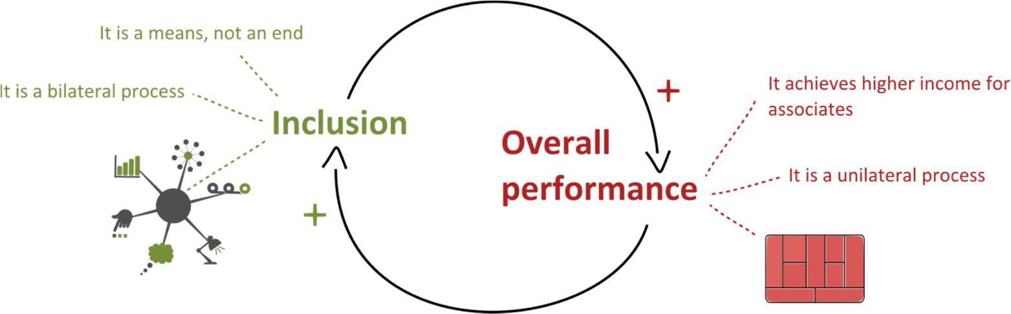

Tool 1: The value chain map
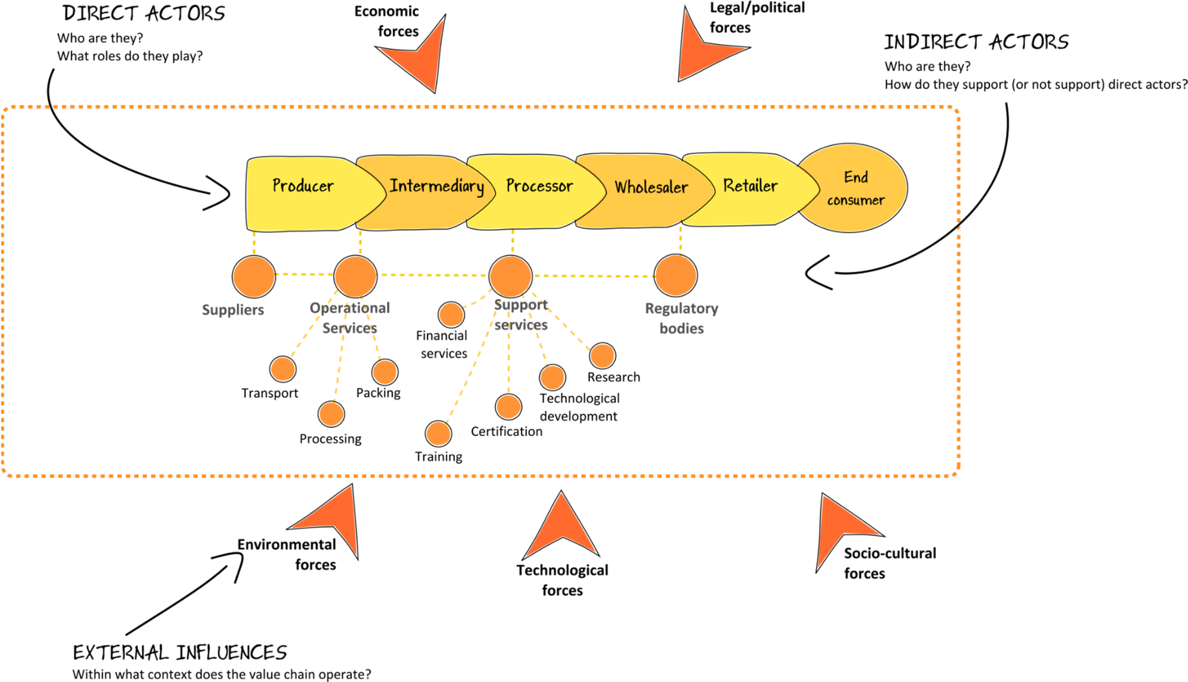

From value chain to business model
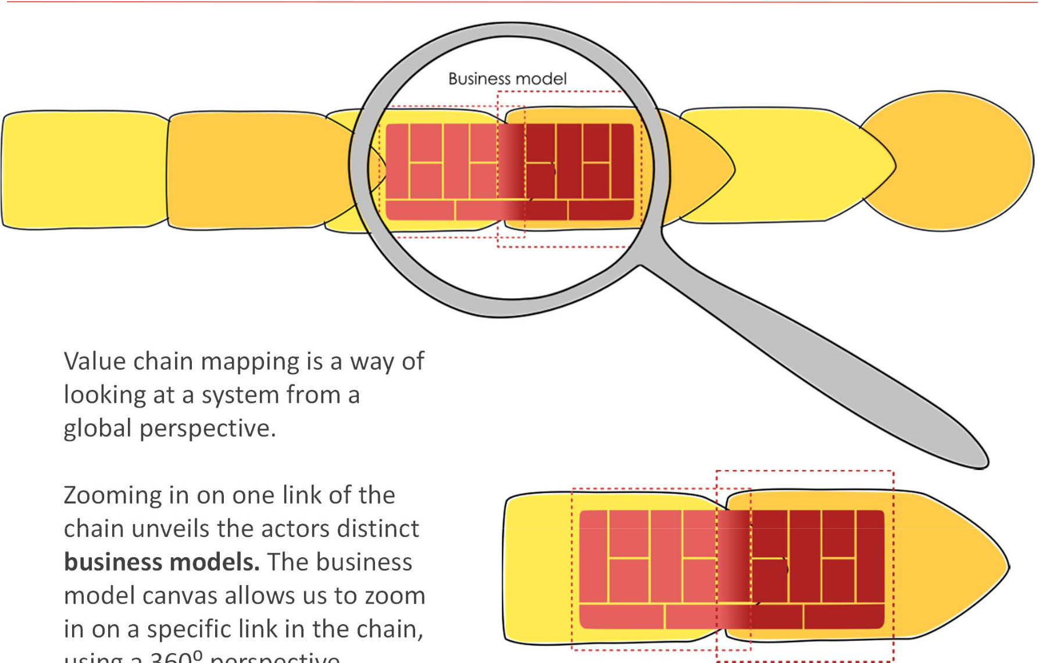

Value chain mapping is a way of

looking at a system from a
global perspective.

Zooming in on one link of the

chain unveils the actors distinct
business models. The business

model canvas allows us to zoom
in on a specific link in the chain,
using a 360⁰ perspective.
Key tool #2

The Business Model Canvas

8

Tool 2: The business model canvas
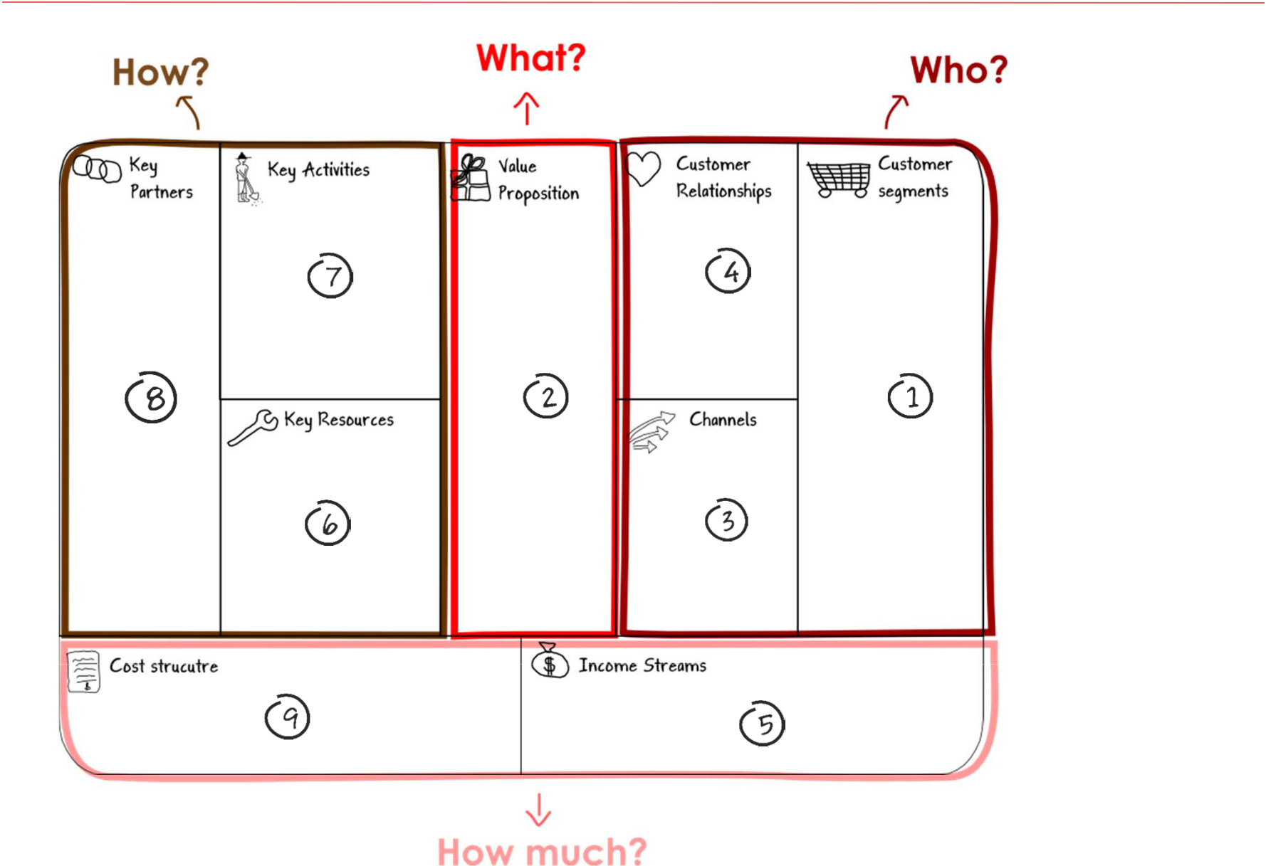
Key tool #2

The Business Model Canvas

9

Adapted from: Osterwalder, A., Pigneur, Y., 2010, Business Model Generation

Connecting business models
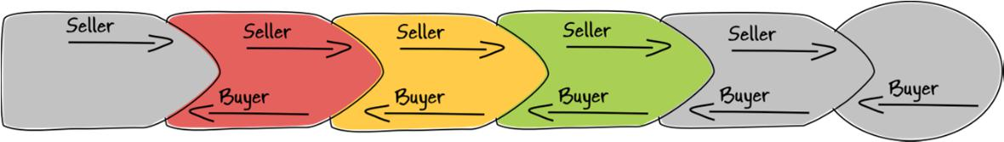
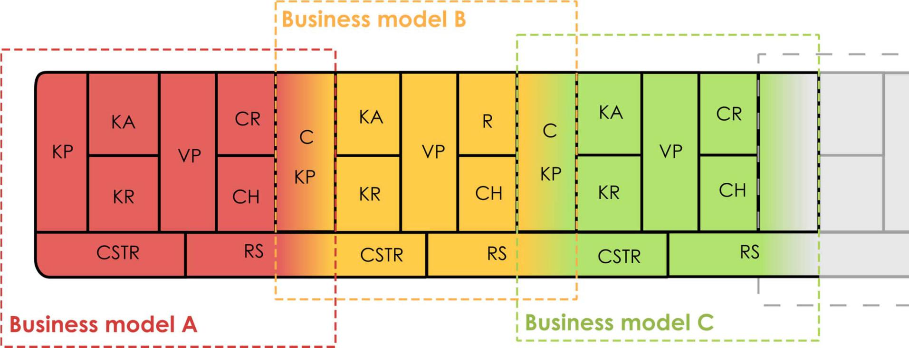
Key tool #2

The Business Model Canvas

10

The double-facing value proposition
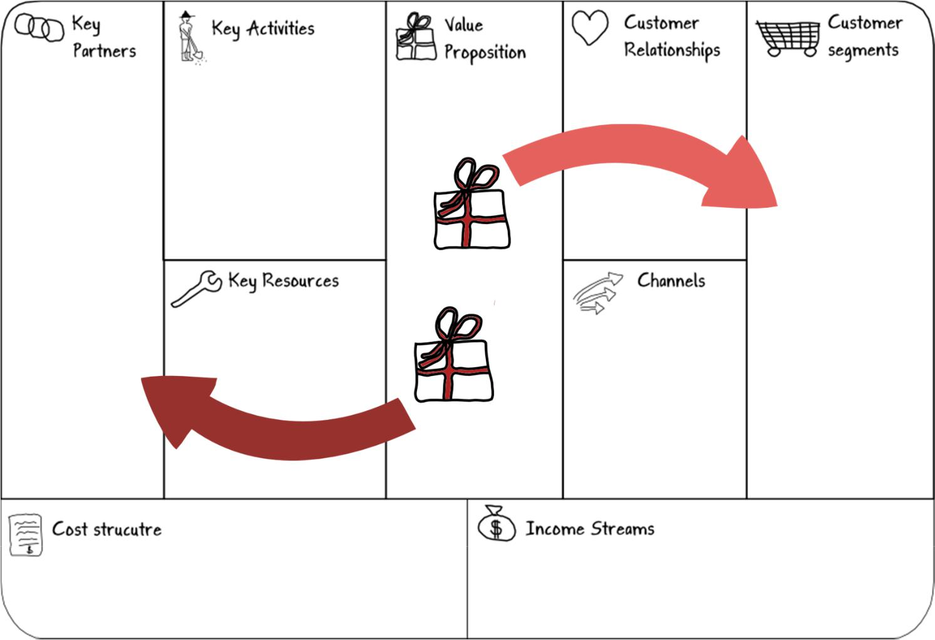
Key tool #2

The Business Model Canvas
Example: Customer facing Business Model of Agroaguadas (Bleckberries) in Colombia
Profit margin: COP$400/kg
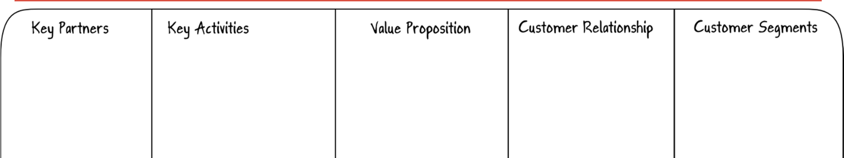

Blackberry producers

- 65 associates

- 42 are members of Productive Alliances

Other providers (for payments and blackberry shipment container):
- AGROAGUADAS producer organization distribution center

Indirect partners:

- OGR

- Aguadas City Hall

- Caldas local government
- SENA

- ICA

- Trainings in Good Agricultural Practices (BPA, in Spanish)

- Crop census to determine potential production
- Participation in tools and crop management trainings with Alpina and SENA.

- Leaf removal

- Refrigerated transport

- Permanent agronomist

- Constant accompaniment in crop management
- Blackberry transport containers

- Blackberries with 5 or 6 degrees Brix

- No contaminants

- No residual chemicals

- Consistent quality

- Consistent quantity

- Certified by Good Agricultural Practices (BPA, in Spanish)

- Leaf- free blackberries (despitonada)
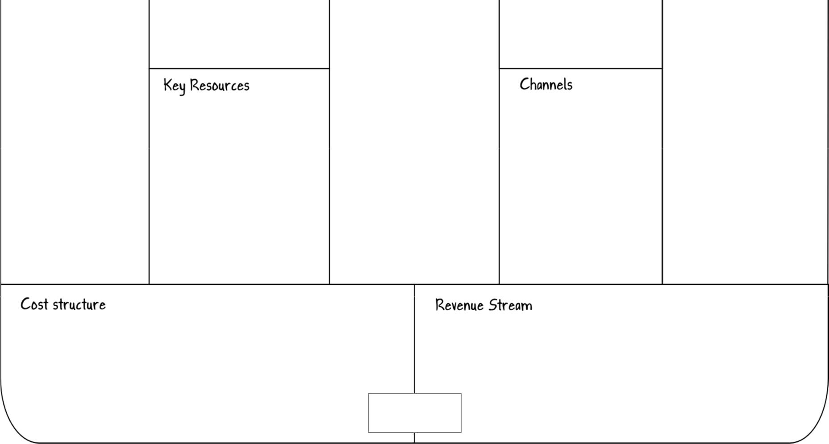

Alpina:

Trustworthy, stable,
consistent, benefits both
parties

Other clients:

Unreliable, unpredictable, weak, intermittent

Alpina:

Weekly delivery to plant in Chinchiná – Caldas

Other clients:

Sporadic delivery

High quality market:

Alpina
- Commercialized since 2000
- Commercialization agreement
- Provies technical assistance and training

Secondary quality market:

(Other clients)
Casa Luker

- Commercialization since 2010.

- Manizales

Juice producers

- Commercialization since 2010

- Tuluá

Blackberry purchases

- Purchase price: COP$ 1200/kg

- Purchases (2013): COP$ 466152000

- Purchases (2013): 388kg

- Transfer payments to beneficiary’s personal accounts after delivery.

Other costs:

- Cost of leaf removal by personnel: COP$ 500/kg

- Collection center energy and maintenance costs: COP$800.000/week
- Transport: COP$ 400.000/week

- Type of price: Fixed 1600/kg

- Tons sold: (2013): 379tons

- Sales(2013): COP$ 606531200

- Consignment payment between 15 – 30 days after delivery

Example: Producer facing Business Model of Agroaguadas (Bleckberries) in Colombia

Blackberry producers

- 65 associates

- 42 members of Productive Alliances

Other providers (for payments and blackberry shipment container):
- AGROAGUADAS producer organization warehouse

Indirect partners:

- OGR

- Aguadas City Hall

- Caldas local government
- SENA

- ICA

- Meetings with associates
- Meetings with financial entities

- Meetings with SENA, City Hall and local government of Caldas

- Working capital

- Institutional support

- Distribution center located in Aguadas
- Rotating fund valued at COP$ 210.000.000 as of December 2013

- Insured commercialization
- Technology transfers

- Social events

- Credit loans

- Technical training services
- Agropecuario services

- Market information

- Support in applying for and receiving bank credits with rural capitalization incentives
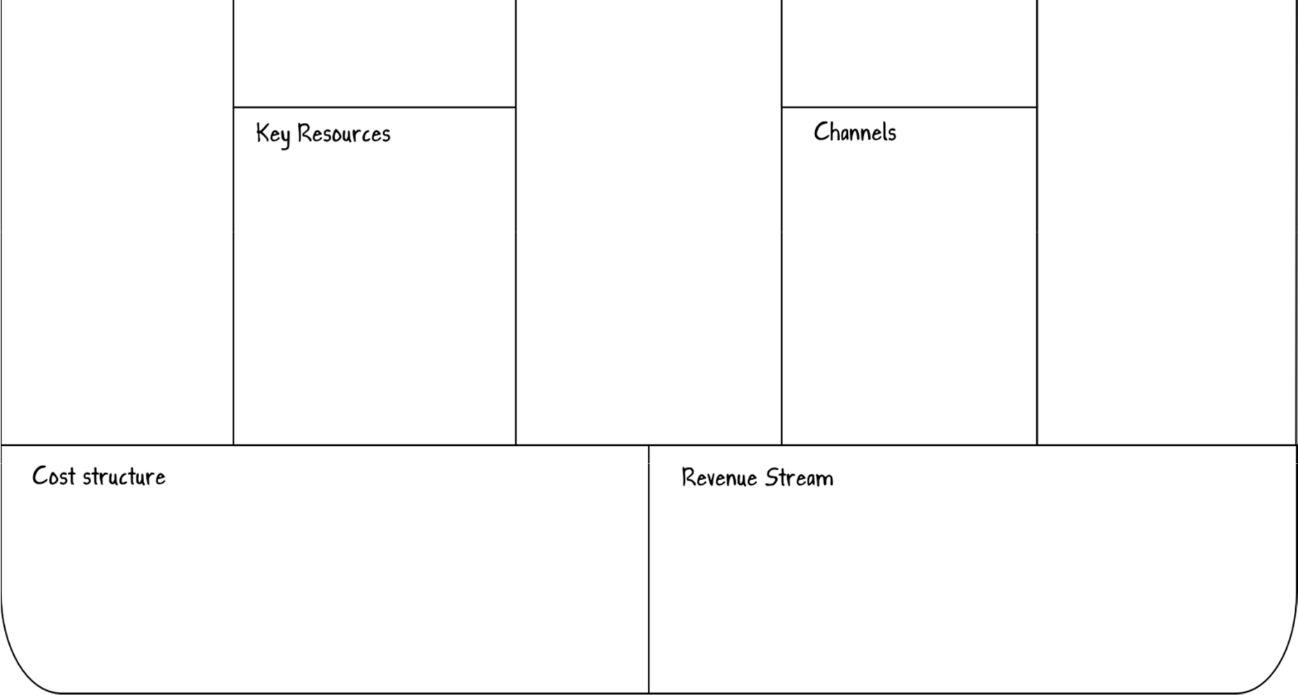

Daily personal mobile |  | Mercado de Alta Calidad:
phone communication. |  | Alpina
 |  | • | Business partners since
Relationship attributes: |  | • | 2000
• | Constant | • | Commercialization
• | Stable | • | agreement
• | Strong | • | Technical support and
• | Beneficial for both |  | training provided
 | parties | Secondary quality market
 |  | Casa Luker
 |  | • | Commercialization since
 |  | • | 2010
• | Local meetings | • | Manizales
• | Workshops in |  | Juice producers
 | distribution center | • | Juice producers
 |  | • | Commercialization since
 |  | • | 2010
 |  | • | Tuluá

- Displacement COP$ 2.000.000

- De-leafing tours COP $1.400.000 (18 women)

- Distribution center training (COP$ 100.000)

- Technical assistance (COP$ 1.000.000 por finca/ medio tiempo)

- Social events (COP$ 5.000.000 120 personas/al año)

- Personnel costs (COP$ 1.848.000 mensuales para tres operarios)

- Distribution center management (COP$ 800.000/mes)

- Executive Expenses, OP (COP$ 3.000.000/mes)

- Monthly membership fee of COP$ 3.000

- Affiliation fee of COP$ 5.000

- Single donation from Caldas government (cold storage room) COP$ 40.000.000
- Single donation from ICA (BPA ceritification) COP$ 50.000.000

Key questions



Key tool #3

The New Business Model principles




- Chain-wide collaboration

_______________

- Effective market linkages

_______________

3. Fair and 4. Equitable

transparent access to
governance services
_______________ _______________

- Inclusive innovation

_______________

- Measurement of outcomes

_______________

Do actors share the same goals?

Do actors exchange information regularly?

Are there structures in place to motivate collaboration or shared problem solving?

Is there one or more “champions” who will lead the process of co-innovation?

Do all actors understand and acknowledge the interdependence of the trading relationship?

Are trading relations stable?

Are trading relations profitable?

Do actors take advantage of market opportunities?

Do actors respond quickly enough to the changing needs of clients?

Are sale/purchase volumes and prices communicated clearly?

Are quality standards clear and consistent across the chain?

Are risks understood and shared proportionately along the chain?

Are trading relationships based on formal contracts or clear informal agreements?

Do producers have access to technical support services provided by the buyer or an indirect actor?

Do producers have timely access to market information provided by the buyer or an indirect actor?

Do producers have access to financial services provided by the buyer or an indirect actor?

Are innovation processes carried out collaboratively?

Who participates and why?

If innovation is evident, who gains from the results?

Are there profit-sharing mechanisms in place?

Are small-scale producers encouraged to participate in inclusive innovation?

Have indicators been established that will measure the success of the business relationship?

Are the results of the

business relationship
measured frequently?

Are there feedback loops in place to guarantee effective chain-wide management and decision-making?

14

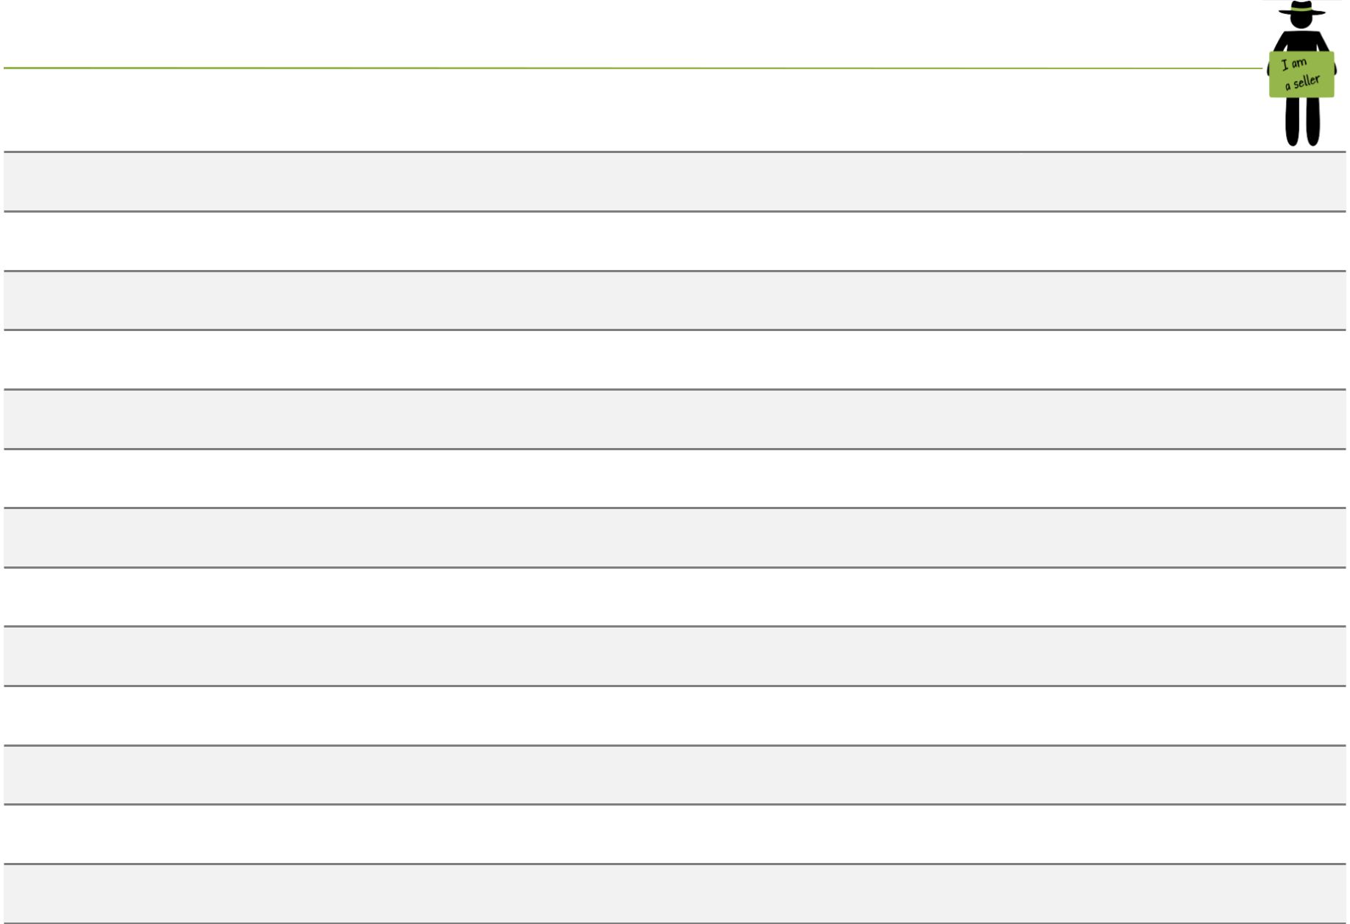
Scorecard for sellers

Principle 1: Chain-wide collaboration

- We frequently exchange information formally* with our customer.

- We frequently exchange information informally* with our customer.

- We are aware of the effects our decisions have on our customer.

- Our commercial goals* are aligned with those of our customer.

- Our social goals * are aligned with those of our customer.

- Our environmental goals are aligned with those of our customer.

- We work closely with our customer to resolve problems.

We are able to respond quickly to problems that may occur to do with
8
customer relations.
We recognise and value the interdependence* between ourselves and
9
our customer.

- Our activities and roles complement those of our customer.

Incentives* (financial and non-financial) exist to enhance collaborative
11
behaviour with our customer.
Champions have been identified to lead the collaboration process with
12
our customer.
We use information and communication technology (ICT)* to enhance
13
collaboration with our customer.

Total points =

Average score = Total points ÷ (13 – Number of criteria marked N/A) =

 |  | Key tool #3
 |  | The New Business Model principles
Strongly | Strongly
agree | disagree | N/AWhy?
⑤④③②①⓪ |  | ⃝
⑤④③②①⓪ |  | ⃝
⑤④③②①⓪ |  | ⃝
⑤④③②①⓪ |  | ⃝
⑤④③②①⓪ |  | ⃝
⑤④③②①⓪ |  | ⃝
⑤④③②①⓪ |  | ⃝
⑤④③②①⓪ |  | ⃝
⑤④③②①⓪ |  | ⃝
⑤④③②①⓪ |  | ⃝
⑤④③②①⓪ |  | ⃝
⑤④③②①⓪ |  | ⃝
⑤④③②①⓪ |  | ⃝
______________________
______________________ |  |  | 15

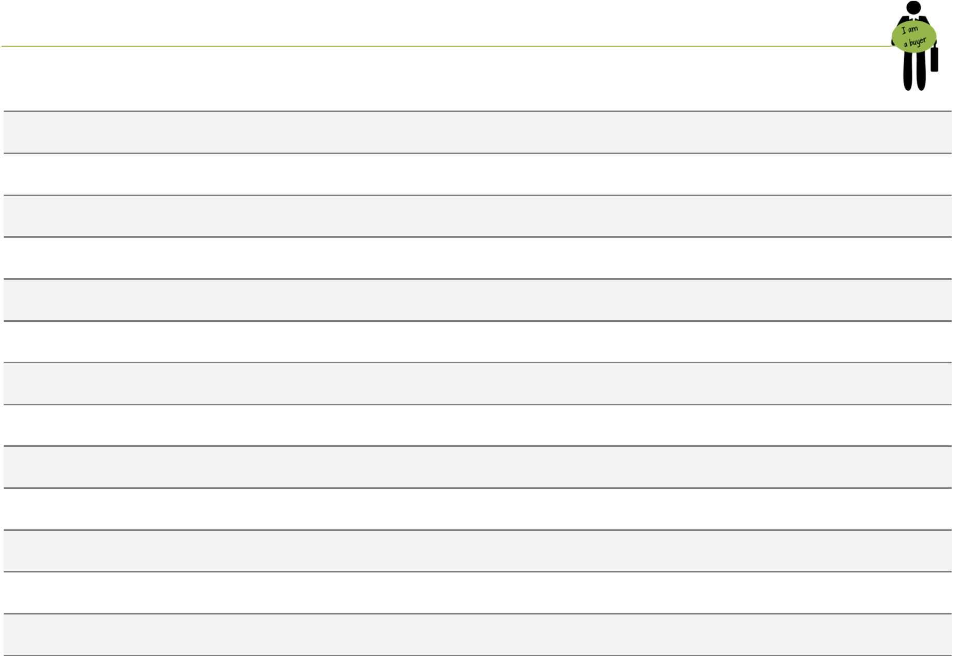
Scorecard for buyers (cont’d)

Principle 1: Chain-wide collaboration

- We frequently exchange information formally* with our provider.

- We frequently exchange information informally* with our provider.

- We are aware of the effects our decisions have on our provider.

- Our commercial goals* are aligned with those of our provider.

- Our social goals * are aligned with those of our provider.

- Our environmental goals are aligned with those of our provider.

- We work closely with our provider to resolve problems.

We are able to respond quickly to problems that may occur to do with
8
our provider.
We recognise and value the interdependence between ourselves and our
9
provider.

- Our activities and roles complement well those of our provider.

Incentives* (financial and non-financial) exist to enhance collaborative
11
behaviour with our provider.
Champions have been identified to lead the collaboration process with
12
our provider.
We use information and communication technology (ICT)* to enhance
13
collaboration with our provider.

Total points =

Average score = Total points ÷ (13 – Number of criteria marked N/A) =
Key tool #3
The New Business Model principles

Strongly | Strongly
agree | disagree | N/A | Why?
⑤④③②①⓪ |  | ⃝
⑤④③②①⓪ |  | ⃝
⑤④③②①⓪ |  | ⃝
⑤④③②①⓪ |  | ⃝
⑤④③②①⓪ |  | ⃝
⑤④③②①⓪ |  | ⃝
⑤④③②①⓪ |  | ⃝
⑤④③②①⓪ |  | ⃝
⑤④③②①⓪ |  | ⃝
⑤④③②①⓪ |  | ⃝
⑤④③②①⓪ |  | ⃝
⑤④③②①⓪ |  | ⃝
⑤④③②①⓪ |  | ⃝
______________________
______________________ |  |  | 16

Case example: REOPA and Colryt, Peru

Herramienta clave #3

Los principios para modelos de negocio incluyentes

Colruyt, a Belgian supermarket chain, purchases asparagus from REOPA, a Peruvian smallholder farmer organization. REOPA receives support from the Belgian NGO Veco Andino, which also facilitated the application of LINK Methodology with other supply chain actors Glandules (canned asparagus) and Scano Noliko (imports asparagus to Belgium).


Producer
Processor
^{Organization} (Peru) _{Importer (Belgium)} Supermarket (Belgium)
(Peru)

Principle # 1: Chain-wide collaboration

Currently established:

- NOLIKO heads up collaboration

- Clear roles among actors

- Common objective to add value to product
- Focus on problem-solving

To improve in the future:

- Contribute to REOPA’s stable income

- Work to share social goals with Gandules
- Improve regularity of information flow

Chain-wide

collaboration

4.0
3.0 | Effective Market
 | Linkages
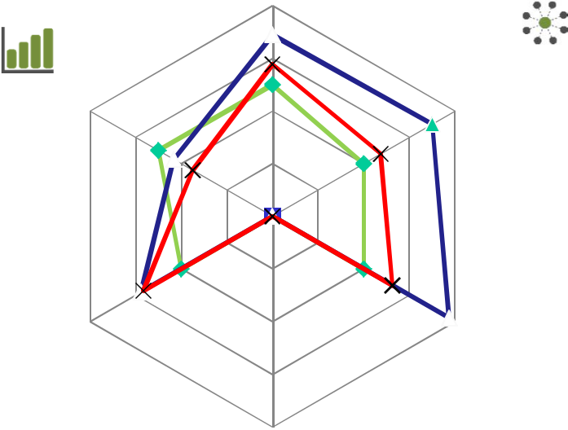
Measurement of | 2.0
resutls | 2.0
 | 1.0
 | 0.0



^{Inclusive} Fair & Transparent
^{Innovation} Governance


Equitable access

to services
Note: Veco Andino did not apply Principle 4: Equitable access to

_{services} REOPA Gandules SAC Scana Noliko Colruyt

What is the prototype cycle?
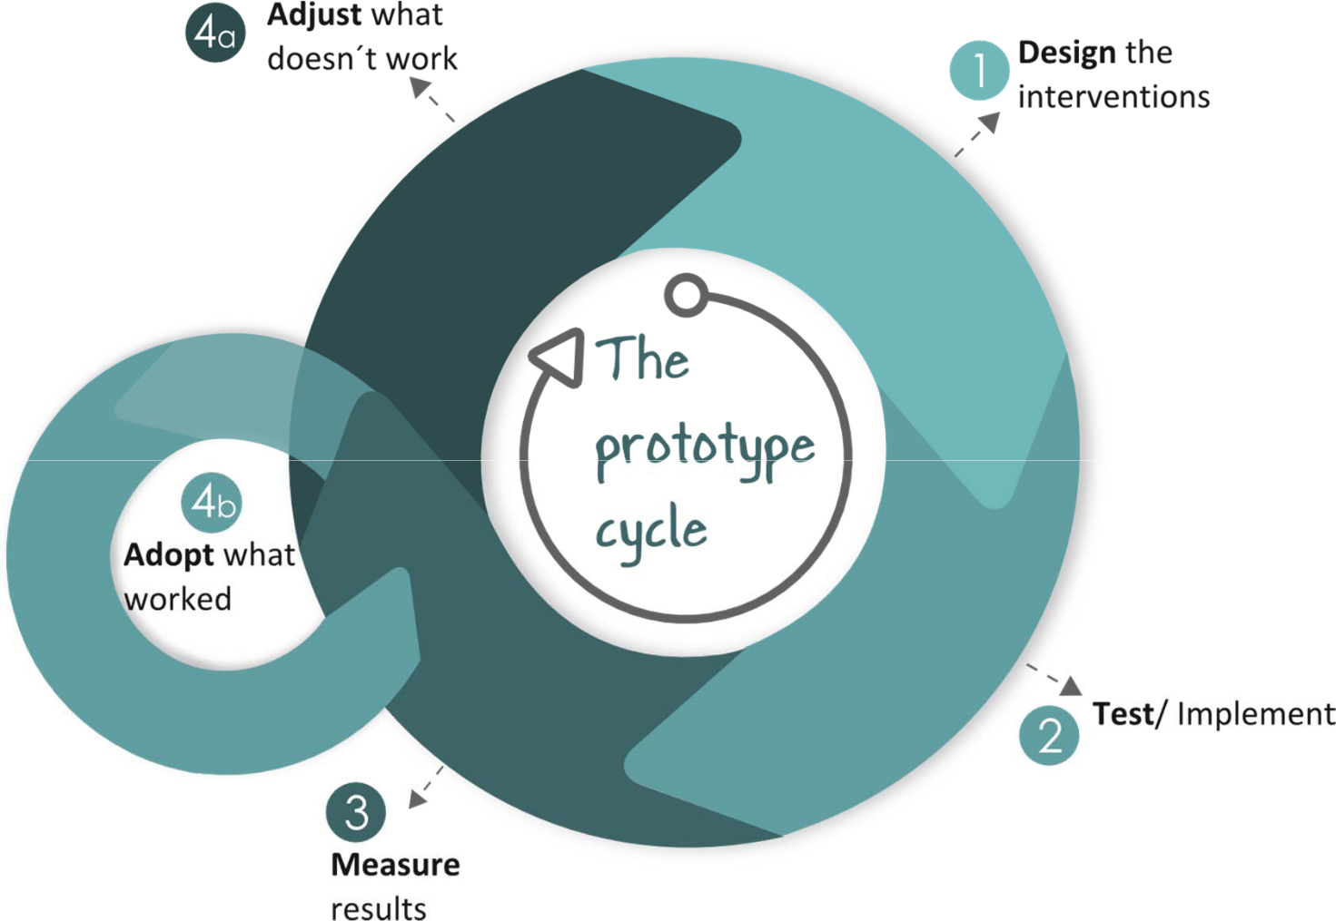
Key tool #4

The Prototype Cycle

18

How to develop a prototype
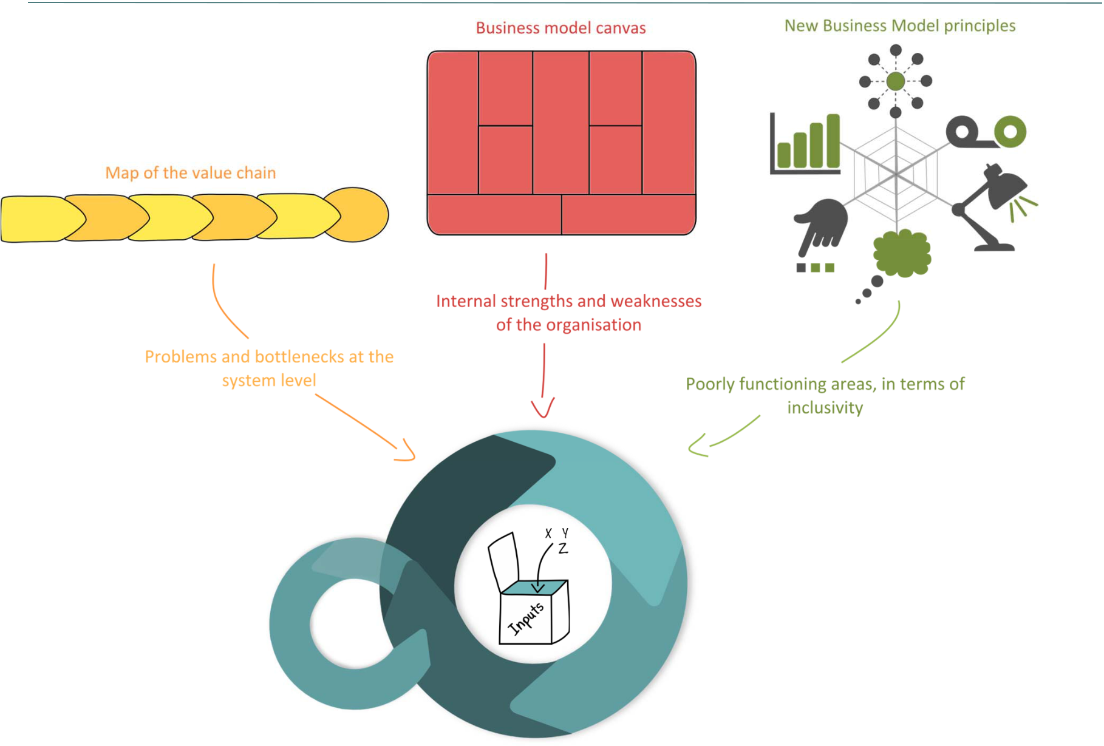
Key tool #4

The Prototype Cycle

How do I package the results of the previous exercises into a prototype cycle?

19

Lessons learnt


- Theory: Less is more

- Practice: More is more

- Positive uptake from NGOs (i.e. Veco, CRS, Swisscontact, CATIE, IICA, Practical Action, Prisma) and companies (i.e. Unilever, Walmart, Colruyt, )

- For communities, much confusion is generated by the multitude of different definitions and concept around inclusive business and the variety of approaches promoted by development actors. Needs streamlining.

- The LINK facilitator needs a certain level of expertise and experience in participatory facilitation and business approaches

- The management of the facilitating NGO needs to be ‘on board’

CIAT provides training/guidance to 14 case studies that are currently underway in Latin America

Partial implementation of selected tools of LINK Methodology in 13 cases in Colombia is completed

Other cases are/were being implemented in Indonesia (Veco), Ethiopia Kenya and Uganda (Ford Foundation)

For more information…

Alexandra Amrein

a.amrein@cgiar.org

Mark Lundy

m.lundy@cgiar.org

Download LINK Methodology www.dapa.ciat.cgiar.org/methodologies-to-make-market-linkages-work/

21

