

Business
Model
_{Canvas} WORKSHOP

With

SOCIAL IMPACT MEASUREMENT


Presented by:
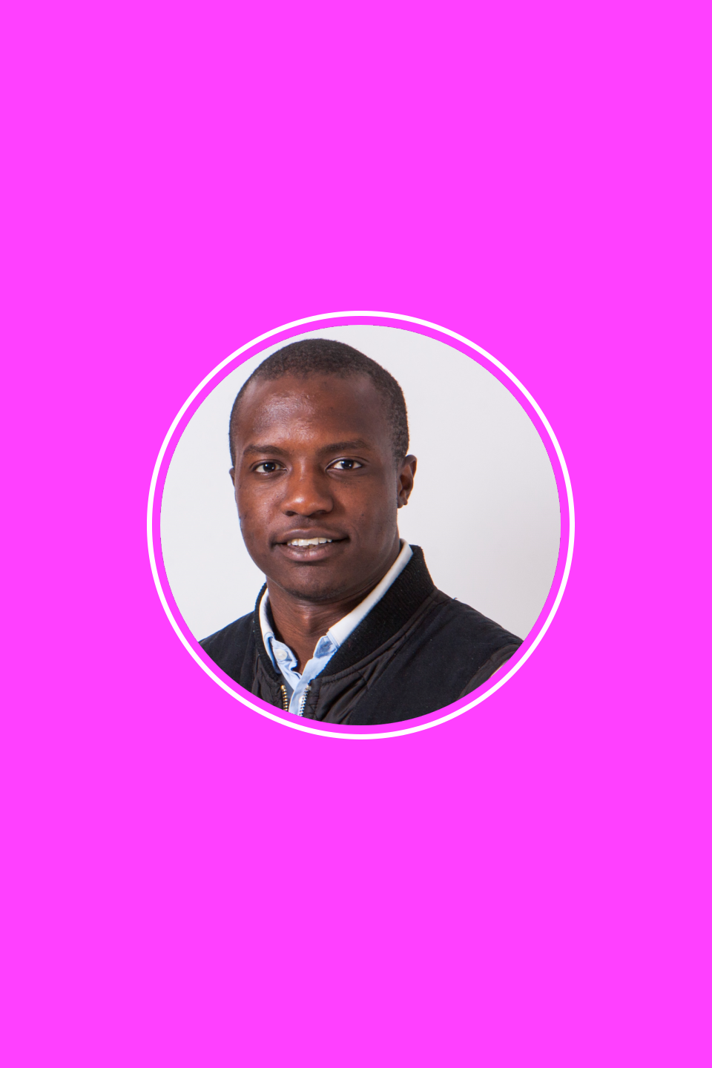

About

Founder of Quartal Partner to Impact Hub Entreprenuer & Diversity Consultant

Kenneth Odwar

Business Developer

Presented by:

- Use the business model canvas to describe a social business model
OBJECTIVES

2. Think innovatively

about a traditional

business model

Presented by:


Max 5 ppl. per group

GROUPS

Presented by:

- Welcome

- Intro to the Business Model Canvas

- Group Work on Canvas

- The Pitch

- Thanks!

Presented by:

AGENDA


TIME MANAGEMENT

- Intro to the Business Model Canvas – 10 min

- Group Work on Canvas – 30 min

3. The Pitch – 10 min

Presented by:

Time is precious



There’s No Substitute for a Great Value Proposition

Disclaimer

Presented by:


A Business model can be described in nine elements, enabling explicit dialog about choices, alternatives, & opportunities

Insight

Presented by:
Business Model Canvas
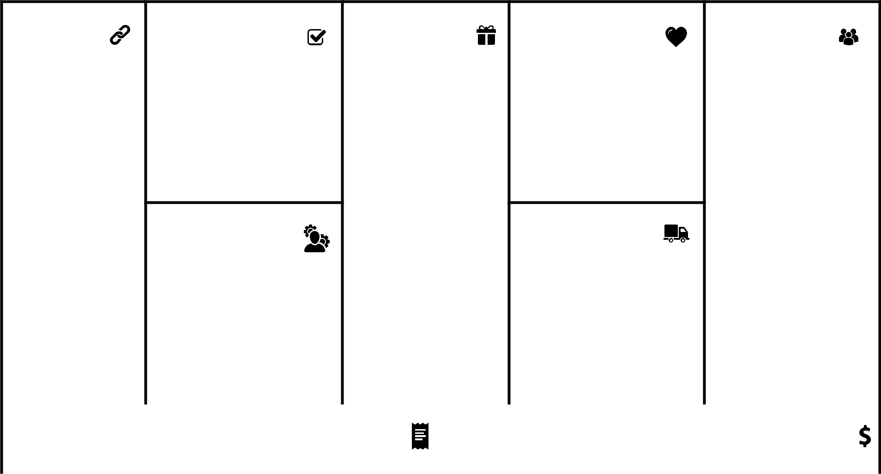

Key Partners | Key | Value | Customer | Customer
 | Activities | Propositions | Relationships | Segments

Key | Channels
Resources

Cost Structure | Revenue Streams

Social Impact Measurement

Social & Environmental Cost Social & Environmental Benefit

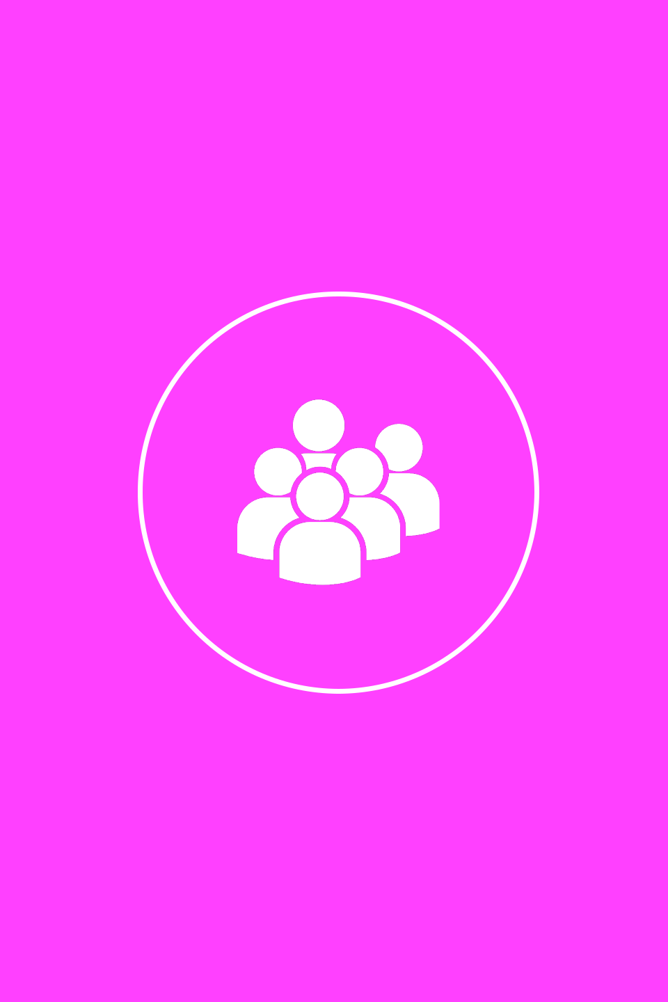
- For whom are we creating value?

- Who are our most important constituents?

Example:
B2B, B2C, B2G,
Mass Market, Niche Market Customer Segments

Multi-Sided Platforms

Presented by:

• What value do we deliver to

our customers?

• Which of our customer’s

problems are we helping to

solve?

• What bundles of products and services are we offering to each customer?

• Which customer needs are

we satisfying?

Example:

Price, Exclusive, Design, Accessibility

etc.

Value Propositions

Presented by:

- What type of relationship does each of our Customer Segments expect us to establish and maintain with them?

- Which ones have we established?

- How are they integrated with the rest of our business model?

- How costly are they?

Example:

Communities, Automated Services,

Self-Service, Co-creation

Presented by:

Customer


Relationships
- Through which Channels do our Customers want to be reached?

- How are we reaching them now?

- How are our Channels integrated?

- Which ones work best?

- Which are most cost-efficient?

- How are we integrating them with our customer’s routines?

Example:

Awareness, Information, Evaluation, Purchase, Delivery, After Sales etc.

Presented by:

Channels
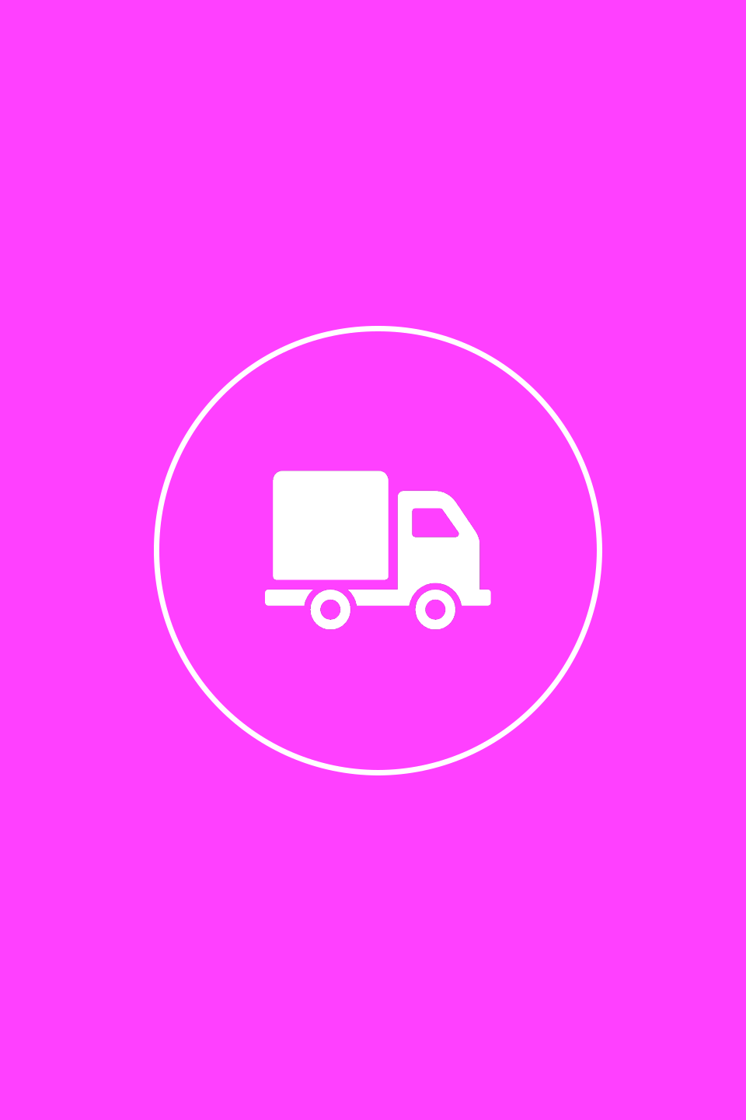
- For what value are our customers really willing to pay?

- For what do they currently pay?

- How are they currently paying?

- How would they prefer to pay?

- How much does each Revenue Stream contribute to overall revenues?

Types:

Meeting fees, Usage fee, Subscription fees, List price, Volume dependent, Negotiated etc.

Presented by:

Revenue Streams


- What Key Activities do our Value Propositions require?

- Our Distribution Channels?

- Customer Relationships? Revenue Streams?

Categories:

Production

Problem Solving

Platform / Network

Presented by:

Key Activities

- What Key Resources do our Value Propositions require?

- Our Distribution Channels?

- Customer Relationships?

- Revenue Streams?

Types of Resources:

Physical

Intellectual (brand patents, copyrights,

data)

Human

Financial

Presented by:

Key Resources

- Who are our Key Partners?

- Who are our key suppliers?

- What Key Resources are we acquiring from them?

- What Key Activities do partners perform?

Partner Candidates:

Contractors

Service providers

Gov. institutions

Motivations for Partnerships:

Promoting the Ecosystem

Optimization and economy

Presented by:

Key Partners

- What are the most important costs inherent in our business model?

- Which Key Resources are most expensive?

- Which Key Activities are most expensive?

Is our business more:

Cost-Driven (leanest cost structure, low-price value proposition) Value Driven (focused on value creation, premium value proposition)

Sample Characteristics:

Fixed Costs (salaries, rents, utilities)

Variable costs, Economies of scale,

Economies of scope

Presented by:

Cost Structures


- What is the social and environmental cost of the business?

- What is the social and environmental cost long term and short term?

- What is the social and environmental cost directly and indirectly?

Presented by:

Social & Enviromental Cost
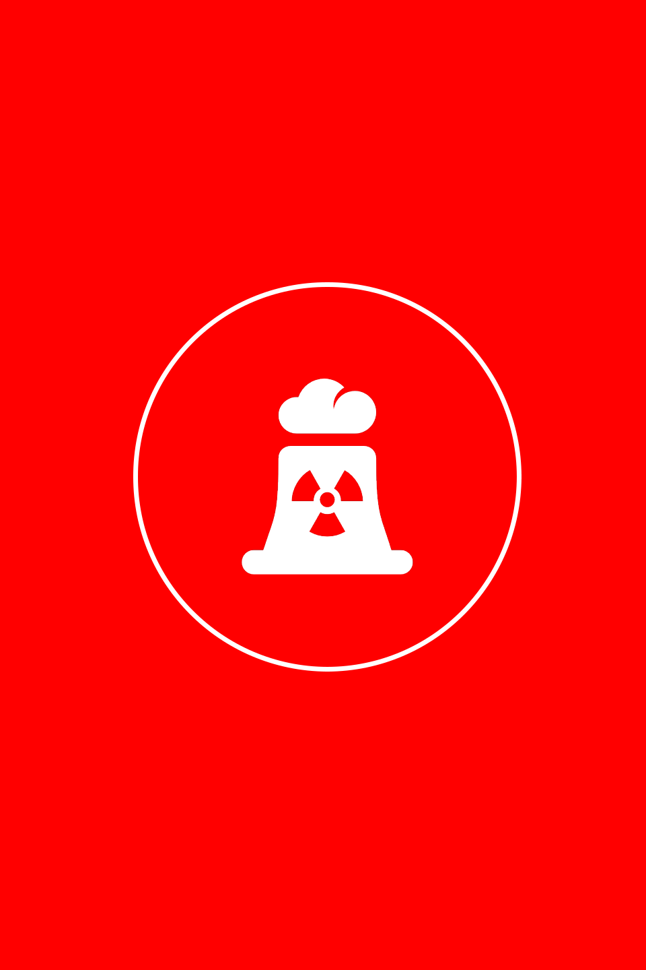

- How will you show that you are creating social impact?

- How is the business creating social impact long term and short term?

- How is the business creating social impact direct and indirect?

Presented by:

Social & Enviromental Benefit

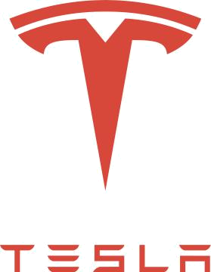

"to accelerate the advent of sustainable transport and electric technology.” - Elon Musk, Tesla Motors Inc.

Presented by:
Business Model Canvas
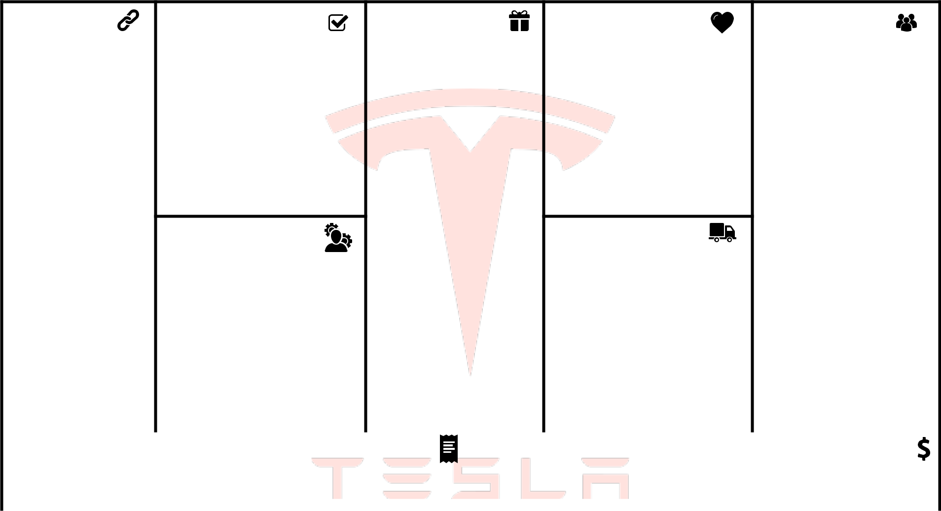

Key Partners

Panasonic (Batteries, partner for gigafactory)

Over 150 suppliers worldwide

Powerstation

partners

(Gasstation, hotels

etc.)

Key

Activities

Engineering (Energy, motors, design, assemble)

Sales

Supply Chain Management

Key

Resources

Supercharger network Patents (Open Source) Silicon Valley Location Digital platform

Value

Propositions

Performance (High speed, high battery capability, fast charging station)

Connectivity (Station navigation, connected cars, infotainment)

Convenience (Free charging stations, battery swap, auto-driven cars)

Recognition (High-end)

Accessibility (Model 3)

Customer | Customer
Relationships | Segments
Personal assistance | Niche market (Started
Automated services | with high-end, Roadster)
 | Mass market (Model S,
Communities | X and 3)

Channels

Online stores

Dedicated physical Tesla

stores

Cost Structure | Revenue Streams
Supercharger network, cloud-based software update, | Carsales & Leasing, Battery Sales, License,
car manufacturing, distribution network | Battery Sales (OEM non car manufacturer), Subsidies

Social Impact Measurement

Social & Environmental Cost

Mining of rare metals, manufacturing with toxic chemicals high carbon emissoin in manufacturing, high recycling cost.

Social & Environmental Benefit

No carbon emission, clean energy (Powerpack recharging from solarpanel)

Thank you!


Contacts:

kenneth@quartal.se

www.quartal.se

