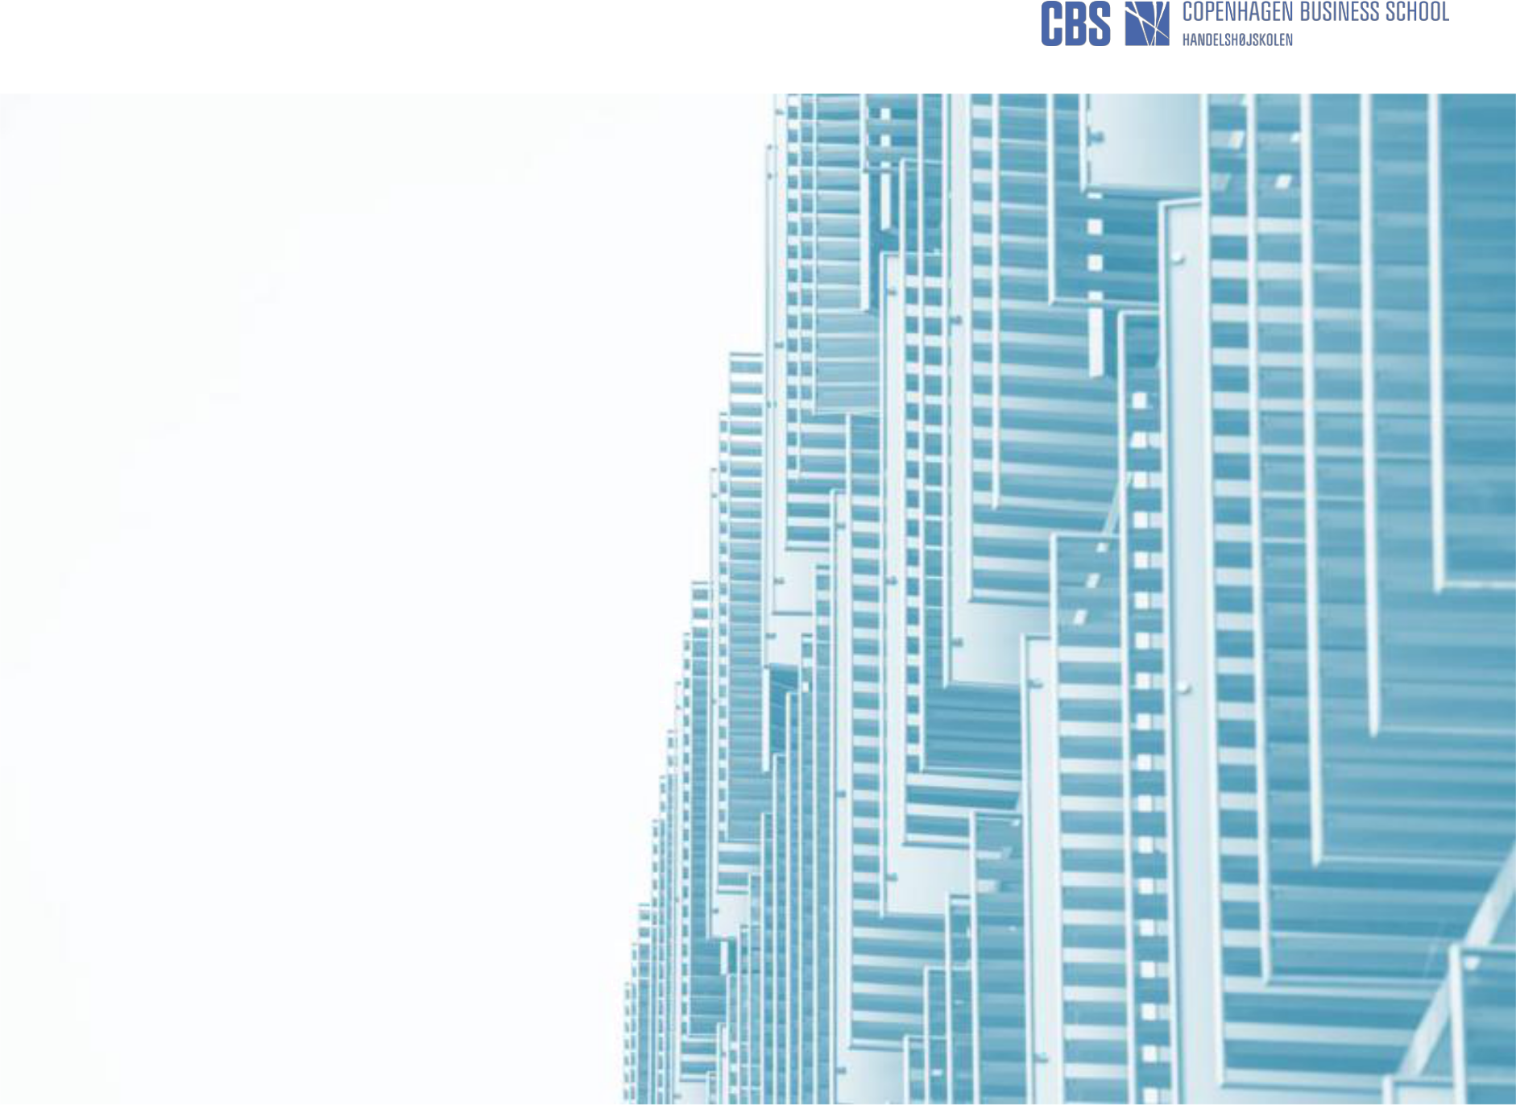

Shared Value and
Food Waste

- Enourmous Opportunities, Inherent Tensions

Esben Rahbek Gjerdrum Pedersen

Professor (mso)/

Copenhagen Business School Centre for | 1
Corporate Social Responsibility | 1


What is Shared Value?
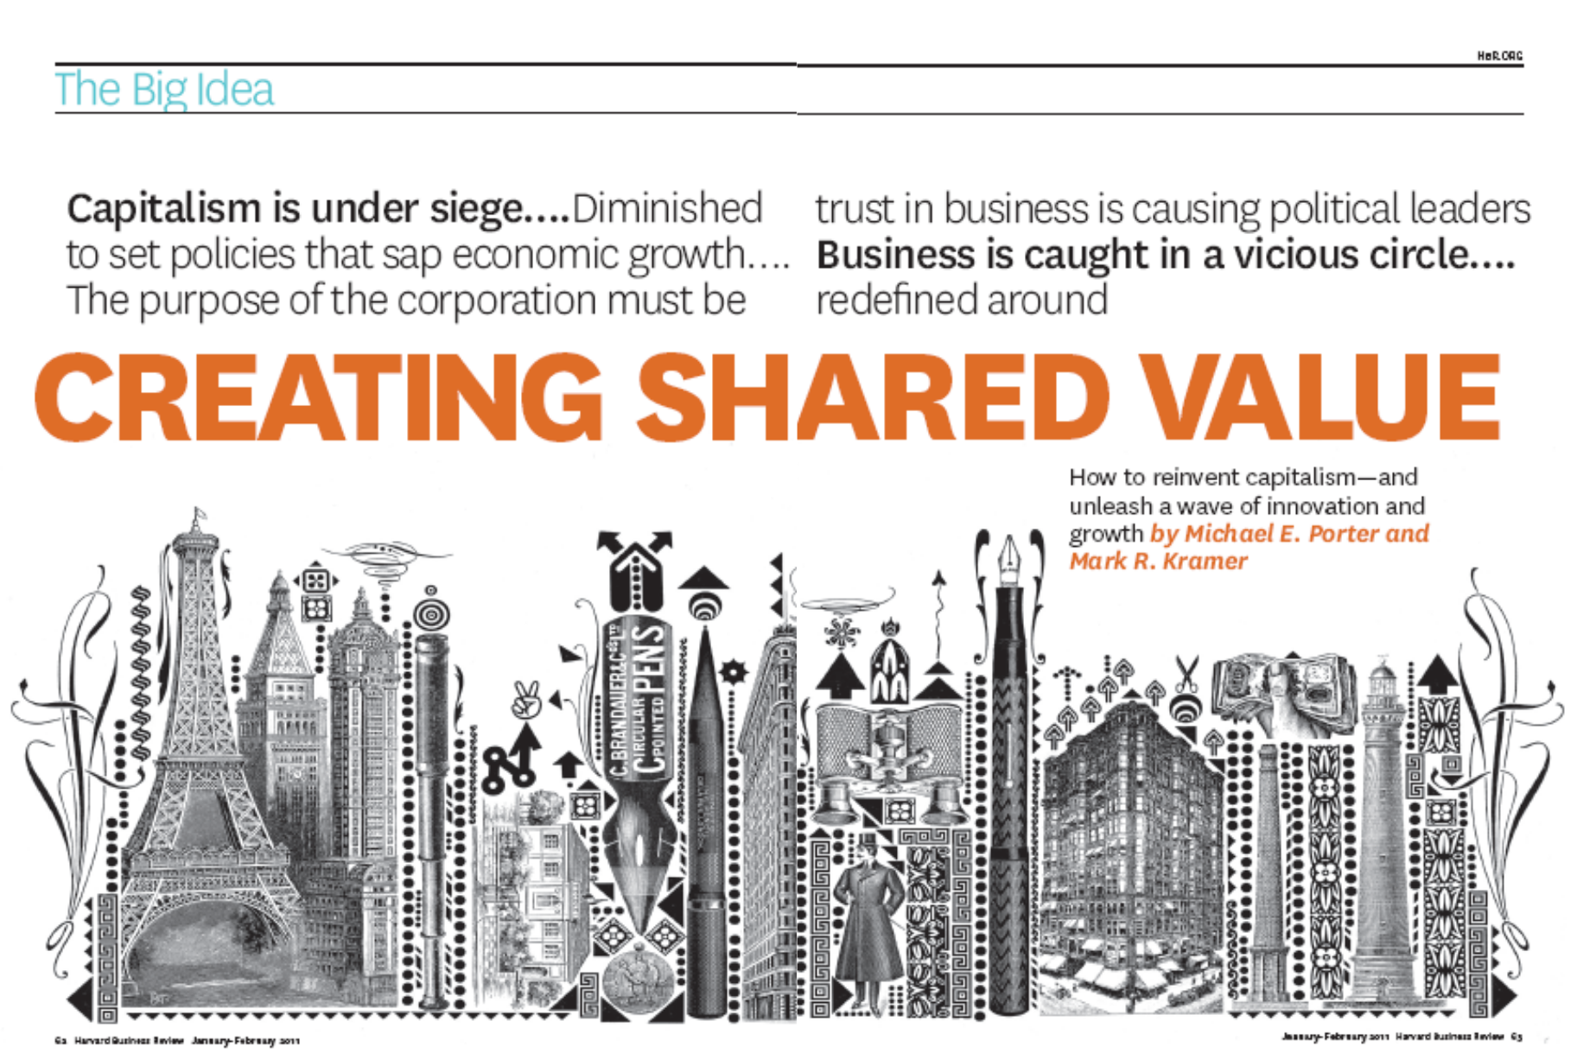

2

What is Shared Value?
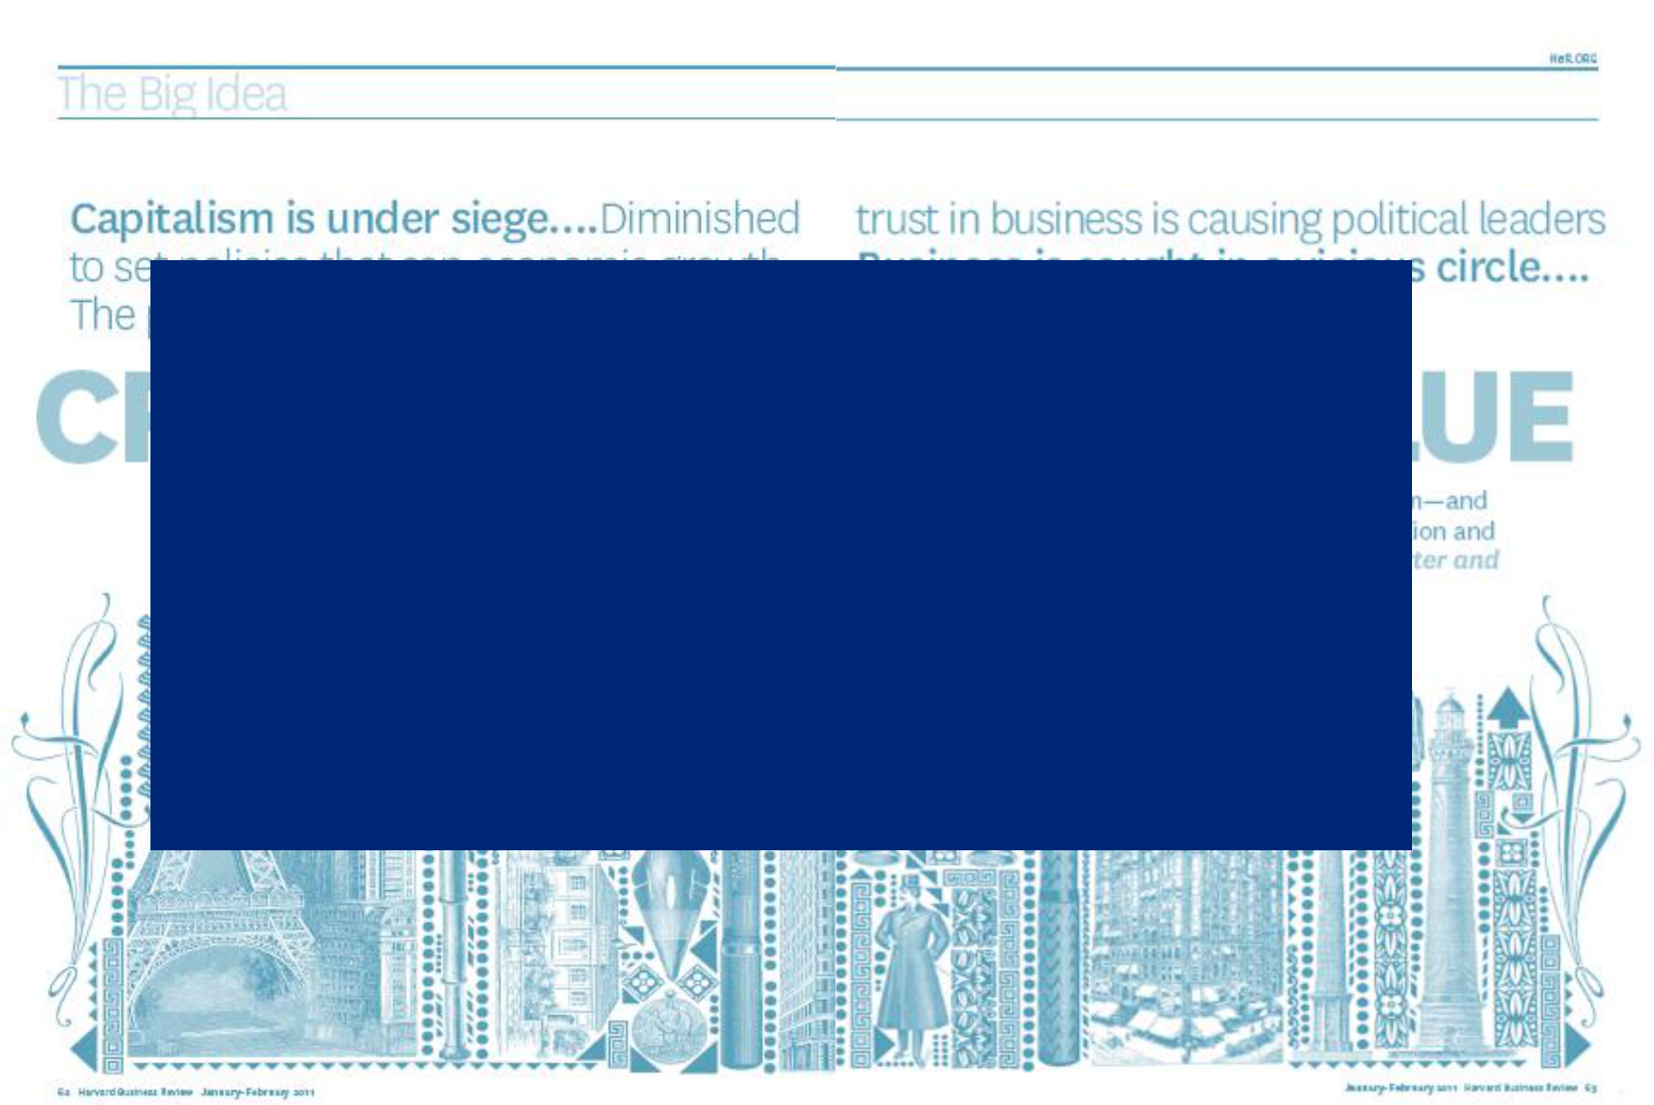

“(…) policies and operating practices that enhance the competitiveness of a company while simultaneously advancing the economic and social conditions in the communities in which it operates”

(Porter and Kramer, 2011, p. 66)

3

The Conventional View

Business | Society



4
The Conventional View

Business | Society
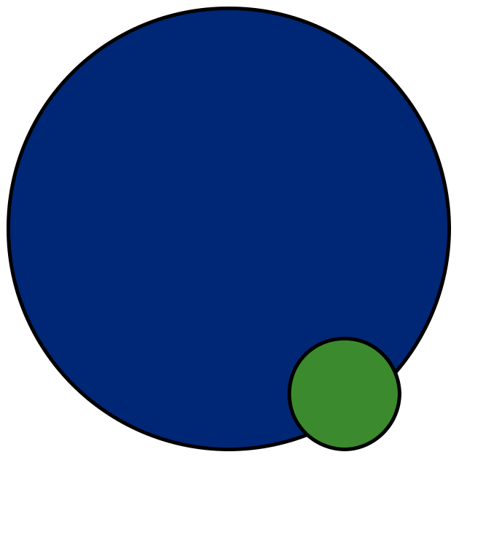

CSR

5
The Conventional View

Business | Society


CSR | CSR

6
Shared Value

Business Society
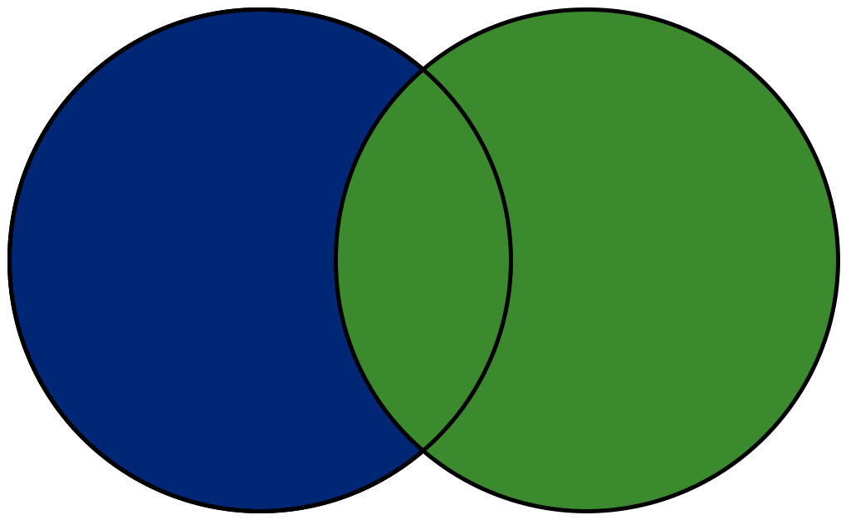

7

Shared Value

Business Society
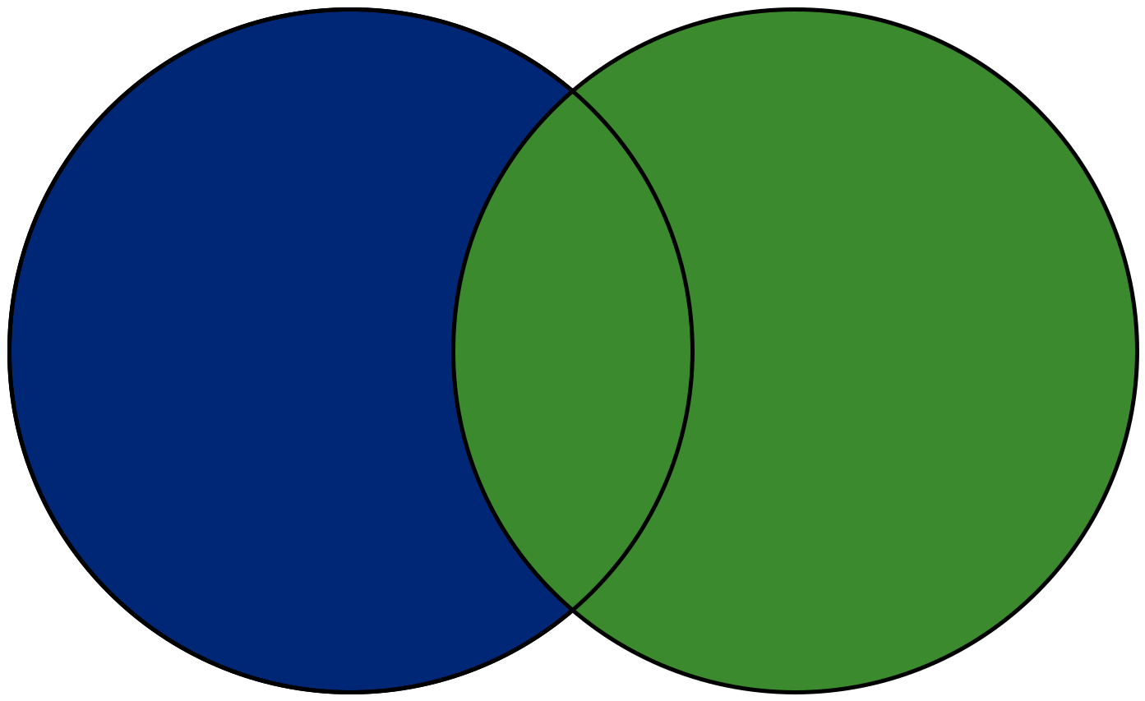

8

Shared Value in Context
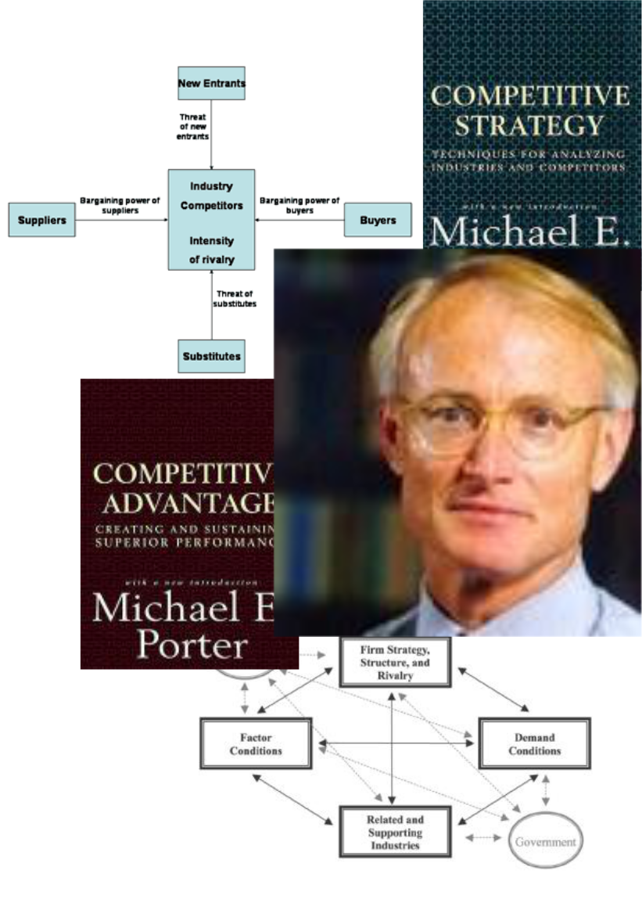

1995: Green and Competitive:
Ending the Stalemate.

2002: The Competitive Advantage of Corporate Philantrophy

2006: Strategy and Society: The Link between Competitive Advantage and Corporate Social Responsibility

2011: Creating Shared Value: How to Reinvent Capitalism – and Unleash a Wave of Innovation and Growth

9

Shared Value and Food Waste..

 | Shared Value | Solutions |  | Food Waste
• | Reconceive products |  | • One third of all food is
 | and markets. |  |  | wasted.
• | Redefine | ? | • Wasted food take up
 | productivity in the | ? |  | land, water, fertilizers,
 | value chain. |  |  | energy etc.
• | Enable local cluster |  | • | Food waste incur costs
 | development. |  |  | for agriculture,
 |  |  |  | industry, trade, and
 |  |  |  | consumers
 |  |  |  | http://www.stopspildafmad.dk/
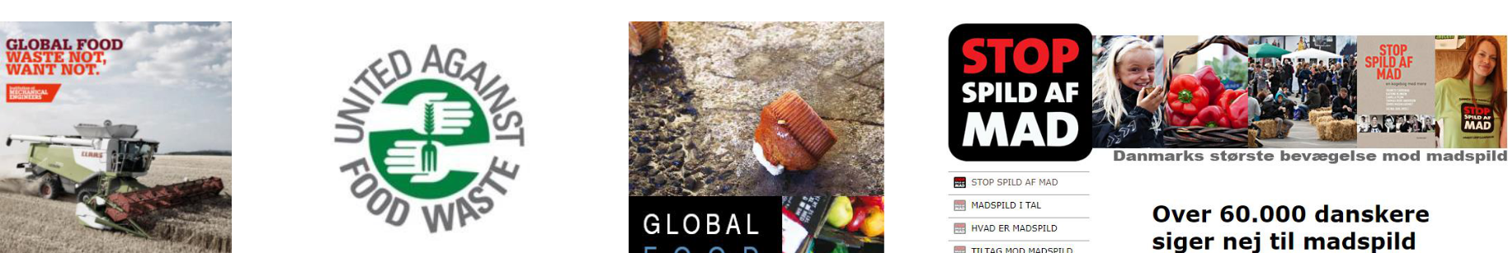

10
How to Create Shared Value?
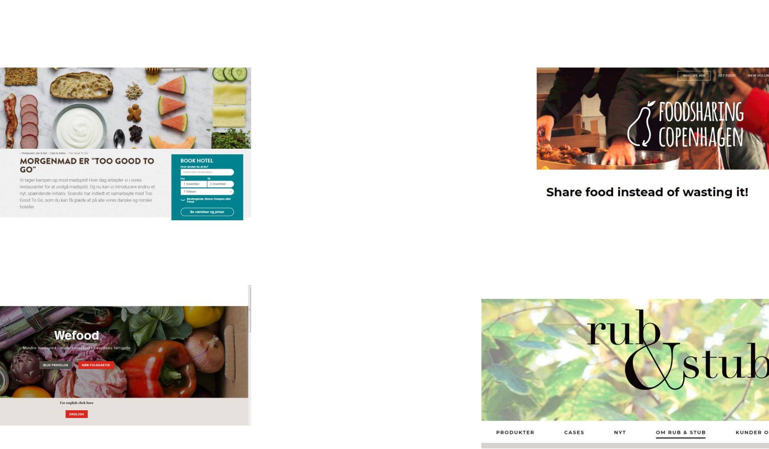

Shared Value |  | Examples | Food Waste
 | • | Consumer education.
 | • | Food planning
 |  | systems.
 | • | Food alliances and
 |  | partnerships.
 | • | Better coordination
 |  | between actors.
 | • | Reducing defects in
https://www.scandichotels.dk/restaurant-bar- |  | the supply chain. | http://www.foodsharingcph.org/
fest/mad-og-drikke/too-good-to-go |  | the supply chain. | http://www.foodsharingcph.org/
fest/mad-og-drikke/too-good-to-go | • | Food sharing
 |  | platforms.
 | • | Better food
 |  | infrastructure.
 | • | Upcycling, recycling,
 |  | downcycling etc.
 |  | And so on…

https://www.noedhjaelp.dk/vaer-med/wefood-danmarks-foerste-butik-med- ¹¹
overskudsmad?utm_source=google&utm_campaign=Wefood&utm_medium=cpc&utm_content=aa http://spisrubogstub.dk/ rhus-landing-page
EXAMPLE
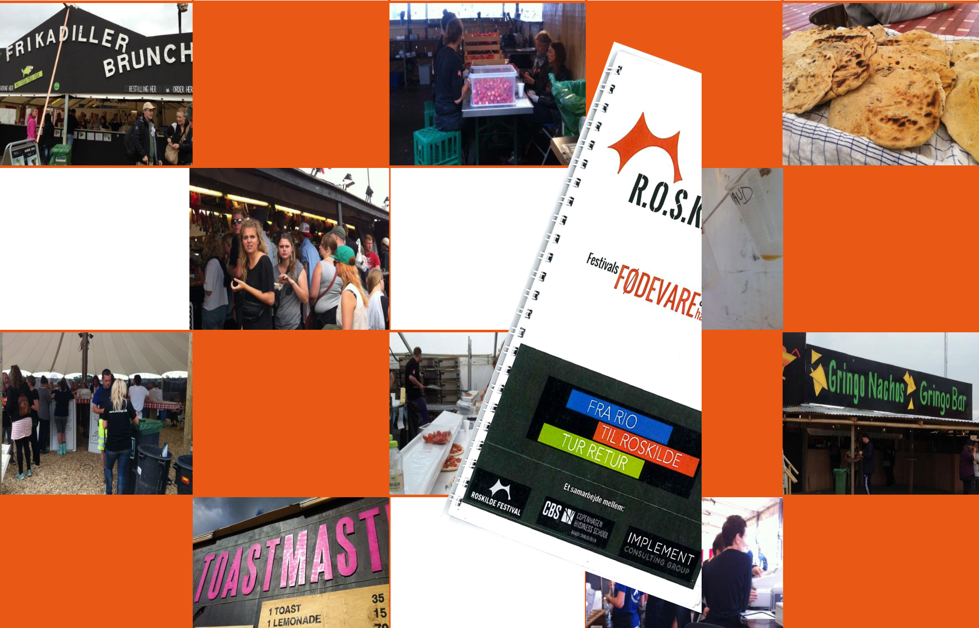

EXAMPLE: Disasters in the |  |  |  | Poor
 |  | Poor
 |  | management
Fashion industry |  |  |  | processes
 |  | and control
• .
Lack of |  |  | Unpredictable |  | Poor design of
standardi- |  |  | Unpredictable |  | Poor design of
standardi- |  |  | demand |  | menus
sation |  |  | demand |  | menus
 |  | Lack of |  | Lack of
 |  | Lack of |  | collaboration
 |  | knowledge
 |  | knowledge |  | between
 |  | sharing
 |  | sharing |  | actors

Poor planning |  |  |  | Poor
Poor planning |  | Trade-offs | 12 | 12
of purchases |  | Trade-offs | 12 | coordination
of purchases |  |  |  | of excess food

The Critique of Shared Value..
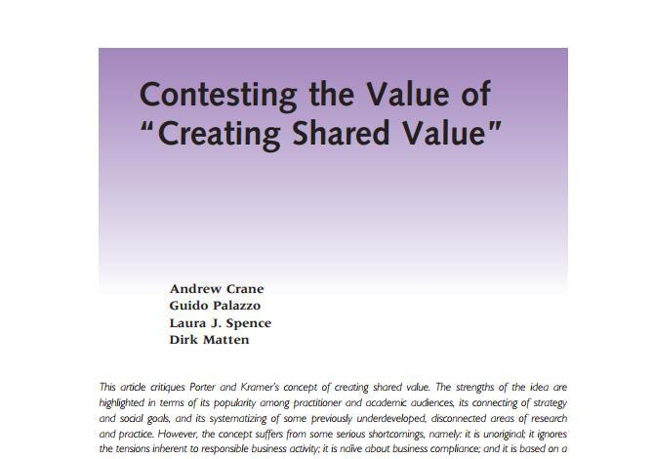

Matten, Dirk. | 2, p130-15
Laura J.; | 56 Issue
Source: Crane, Andrew; Palazzo, Guido; Spence, | California Management Review. Winter2014, Vol.

13

The Critique of Shared Value..
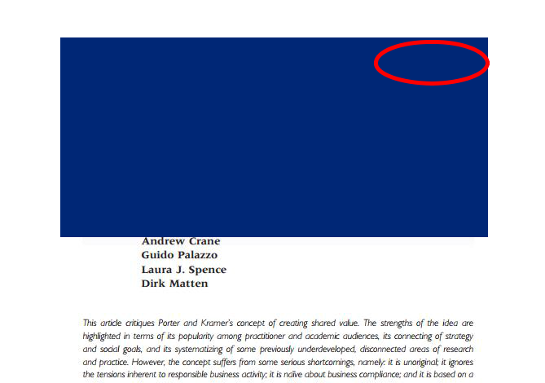

“(…) it is unoriginal; it ignores the tensions inherent to responsible business activity; it is naïve about business compliance; and it is based on a shallow conception of the

corporation’s role in society”

(Crane et al., 2014, p. 130)

Matten, Dirk. | 2, p130-15
Laura J.; | 56 Issue
Source: Crane, Andrew; Palazzo, Guido; Spence, | California Management Review. Winter2014, Vol.

14

About Tensions….

Area |  | Continuum
Mission | Social/environmental | ↔ | Commercial
Business Model | Unified | ↔ | Complex
Organization | Centralization | ↔ | Decentralization
Ethics | Global standards | ↔ | Local standards
Stakeholders | Primary | ↔ | Secondary
Relationships | Competition | ↔ | Cooperation
Innovation | Exploitation | ↔ | Exploration
Time horizon | Short-term | ↔ | Long-term
Responsiveness | Resistance | ↔ | Opportunity-seeking
Performance | Non-financial | ↔ | Financial
Identity | High-plurality | ↔ | Low-Plurality
Values | Flexibility | ↔ | Control
Management | Top-down | ↔ | Bottom-up
Governance | Hierarchy | ↔ | Market
Control | Informal | ↔ | Formal

15
Tensions and Food Waste?
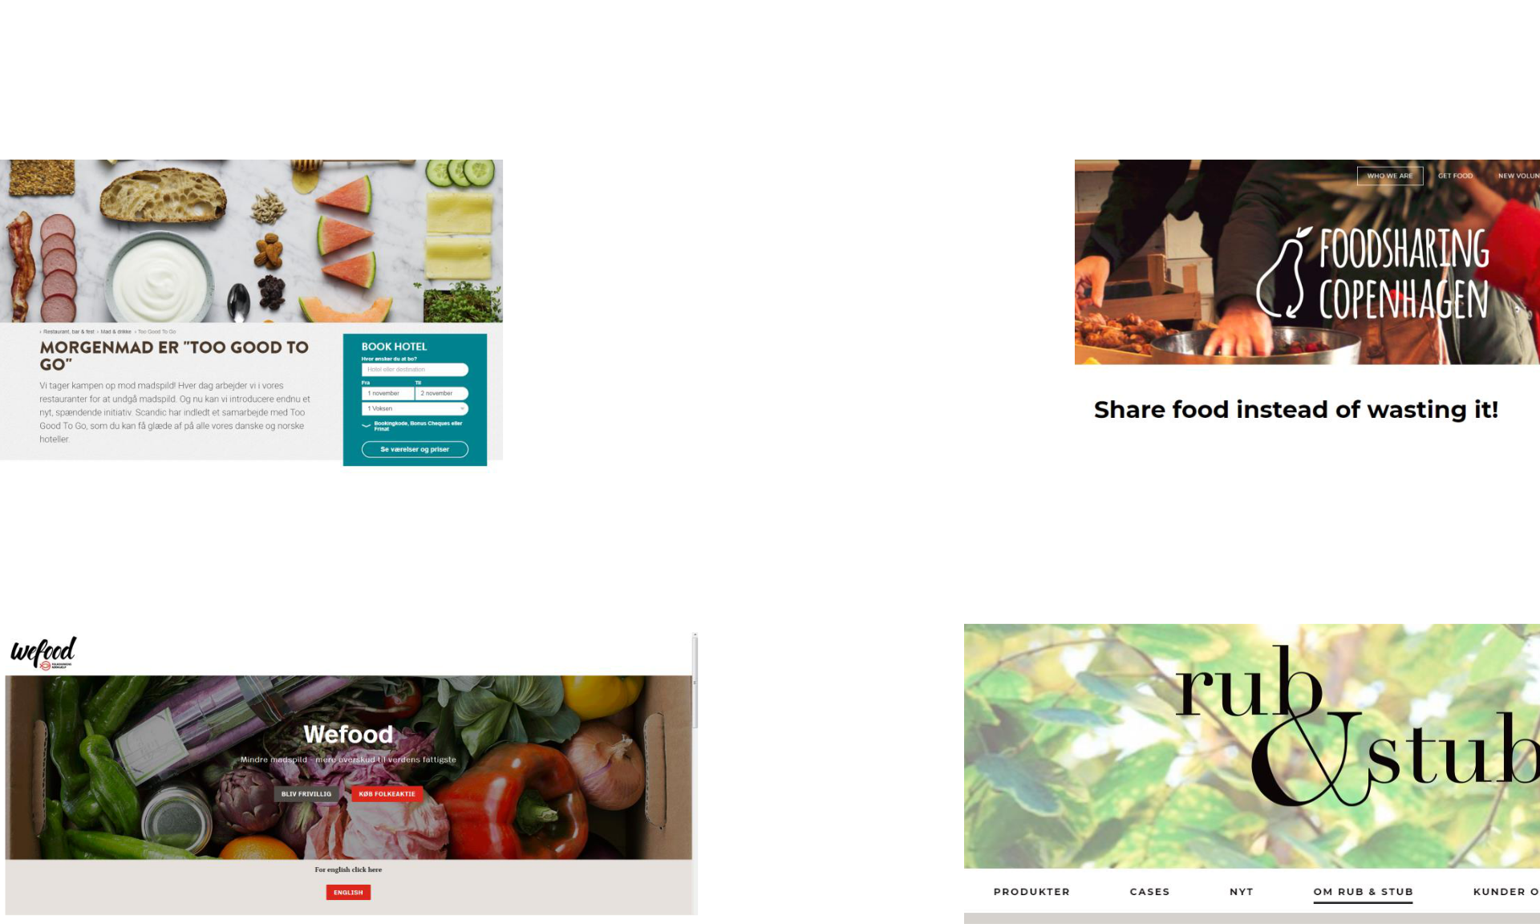

 | Shared Value |  | Tensions | Food Waste
 |  | • | Costs and benefits
 |  |  | may be unevenly
 |  |  | distributed.
 |  | • | Competing priorities
 |  |  | and investments.
 |  | • | Individual vs.
 |  |  | collective.
 |  | • | Tangible vs. Intangible
 | https://www.scandichotels.dk/restaurant-bar- |  | benefits.
 | https://www.scandichotels.dk/restaurant-bar- | • | Long term benefits vs. | http://www.foodsharingcph.org/
fest/mad-og-drikke/too-good-to-go |  | • | Long term benefits vs. | http://www.foodsharingcph.org/
 |  |  | Short term costs.

https://www.noedhjaelp.dk/vaer-med/wefood-danmarks-foerste-butik-med- ¹⁶
overskudsmad?utm_source=google&utm_campaign=Wefood&utm_medium=cpc&utm_content=aa http://spisrubogstub.dk/ rhus-landing-page
EXAMPLE…
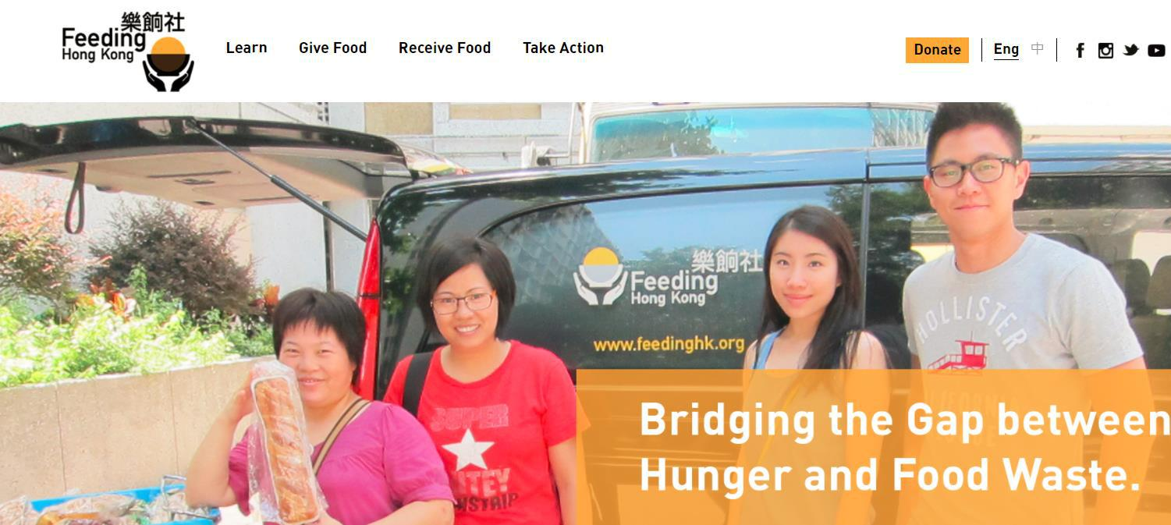

https://www.feedinghk.org/

17

Thank you for your Attention!
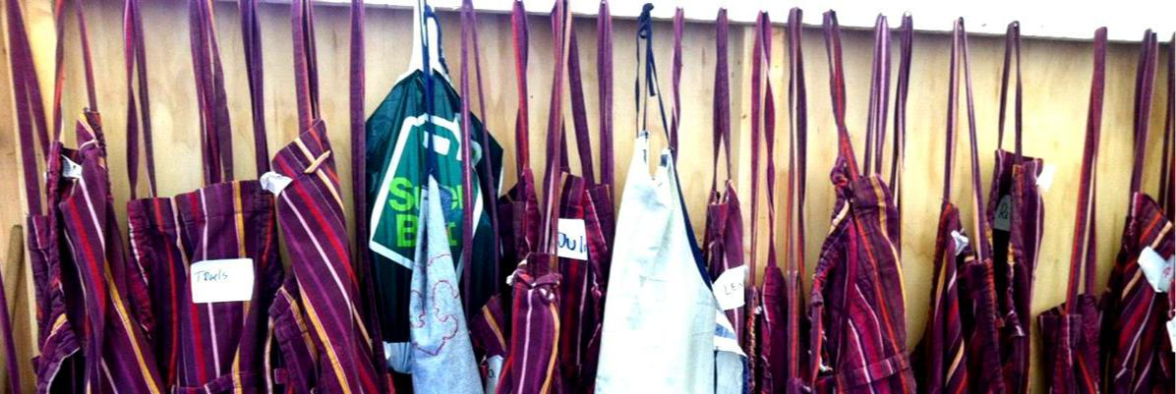

18

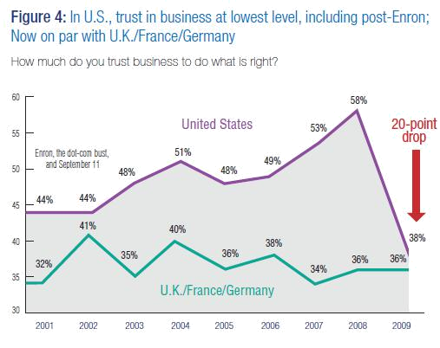

19

Source: 2009 Edelman Trust Barometer, www.edelman.com

Trust in Business Today…
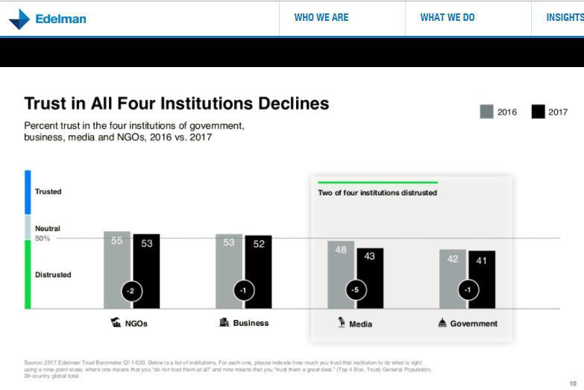

https://www.edelman.com/global-results/
20

Who Trust a CEO Today?
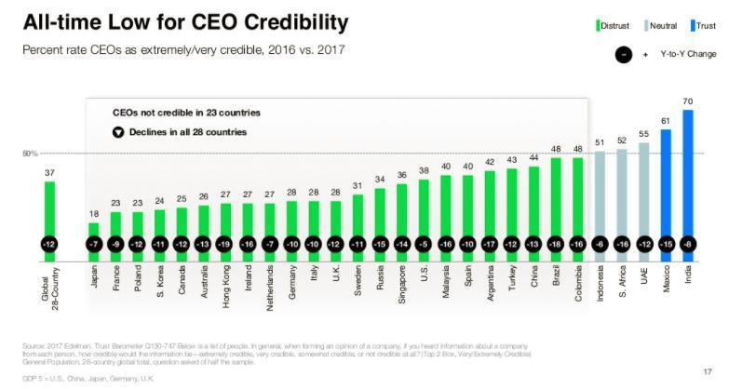

https://www.edelman.com/global-results/

21

Context:Trust Crisis
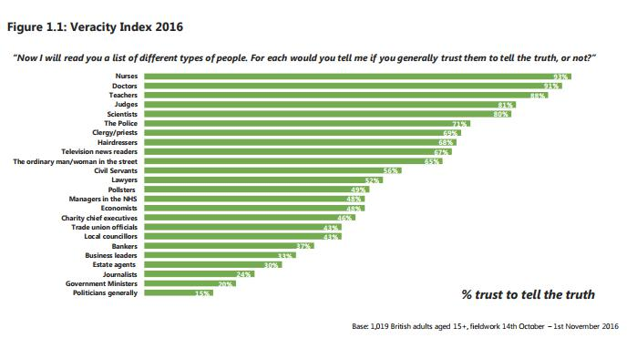

https://www.ipsos.com/sites/default/files/2017-04/Mumsnet-trust-report-FINAL.pdf

22

Mintzberg’s Idea of Disruptive Wedges in the Socioeconomic Fabric


RISING TIDE OF PROSPERITY

- Wedge of disparity

LEAN, MEAN ORGANIZATION

- Wedge of discontinuity

HEROIC LEADERSHIP

- Wedge of disconnection

SHAREHOLDER VALUE

- Wedge of disengagement

ECONOMIC MAN

- Wedge of distrust

Society

23

EXAMPLE
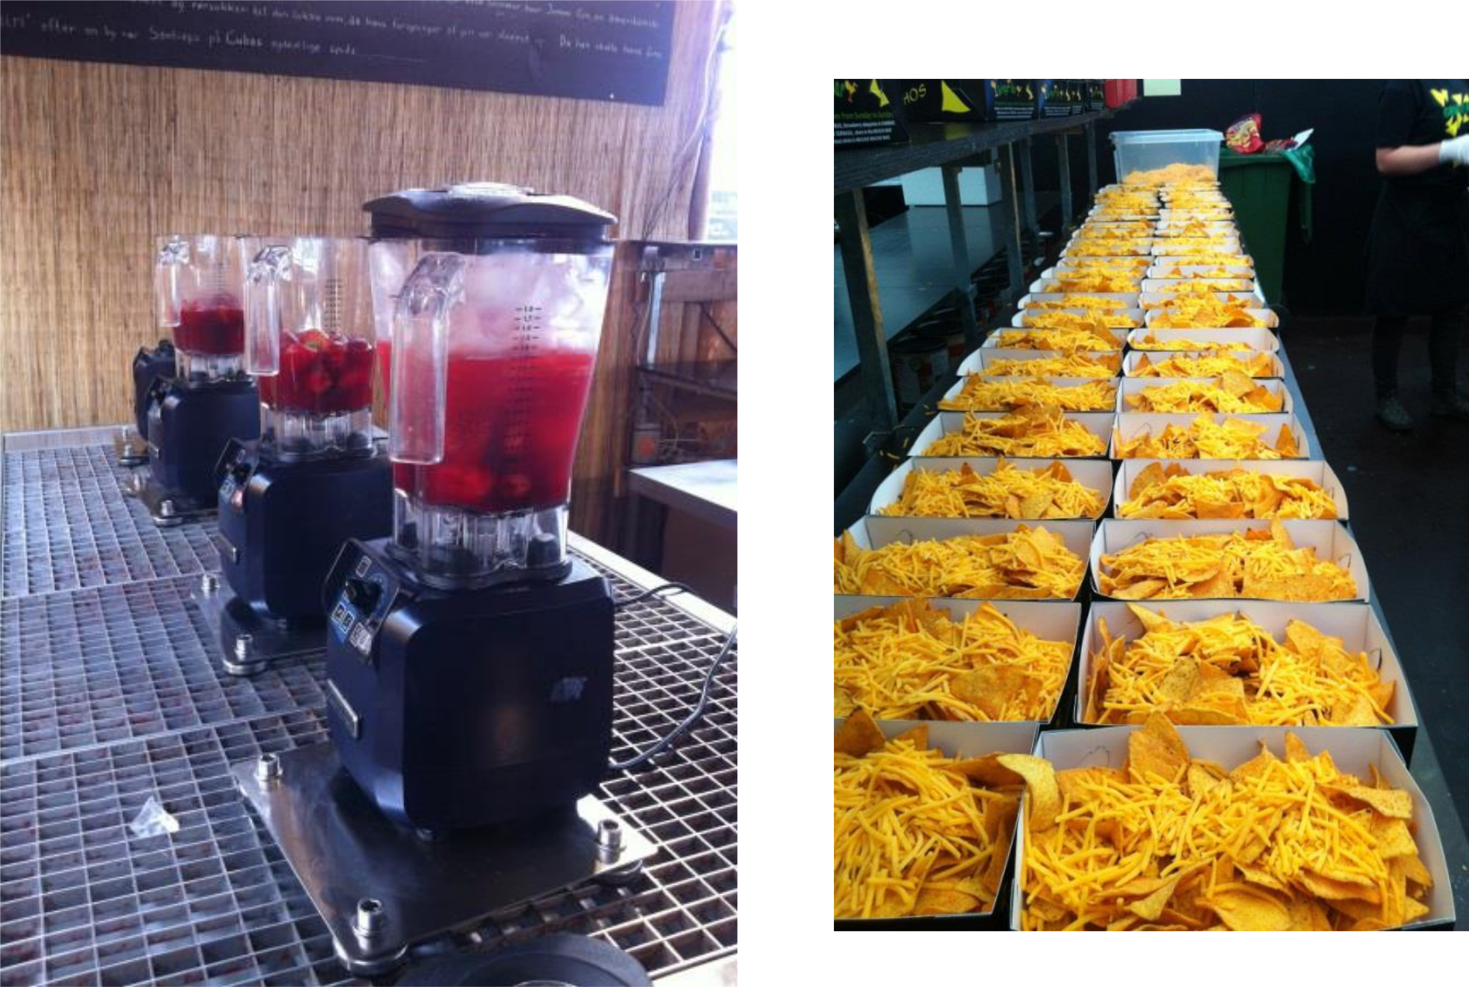

24

Example: Response strategies among Fashion Companies
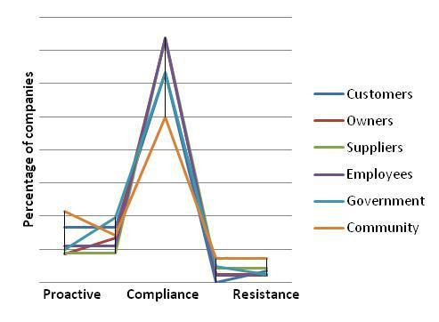

Source: Pedersen and Gwozdz (2014)
25

Examples of Tensions

26

About Innovation…

Types of Innovation:

- Existing and new products.

- Existing and new processes.

- Existing and new customers.

- Existing and new markets.

- Existing and new partners.

- Existing and new channels.

- Existings and new materials/inputs.

Success on the market?

New to the firm, new to the industry, new to the world?

First mover, fast second?

Do we need innovation?

Souice: Sawhney, Mohanbir; Wolcott, Robert C.; Arroniz, Inigo. The 12 Different Ways for Companies to Innovate. MIT Sloan Management Review. Spring2006, Vol. 47 Issue 3, p75-81.
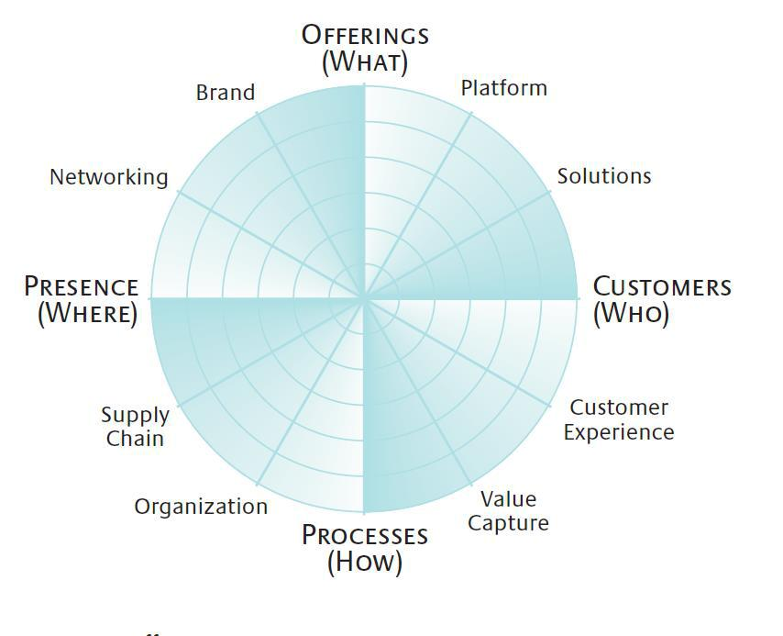

27

Key Partners | Key activities | Value | Customer | Customer
 |  | proposition | relationships | segments

Key | Revenue
resources | channels

Cost structure | Revenue streams

28

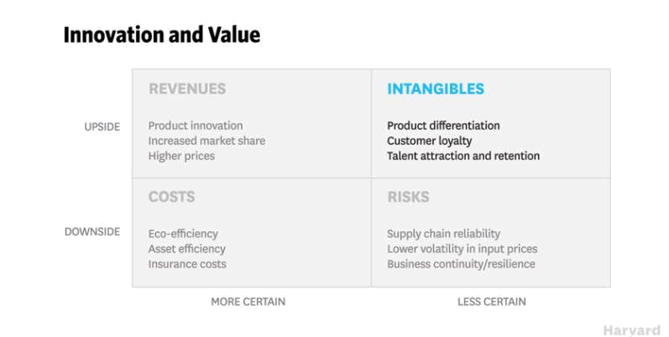

https://hbr.org/video/5415413929001/whiteboard-session-the-business-case-for-sustainability

29

Model of Sustainability Innovation
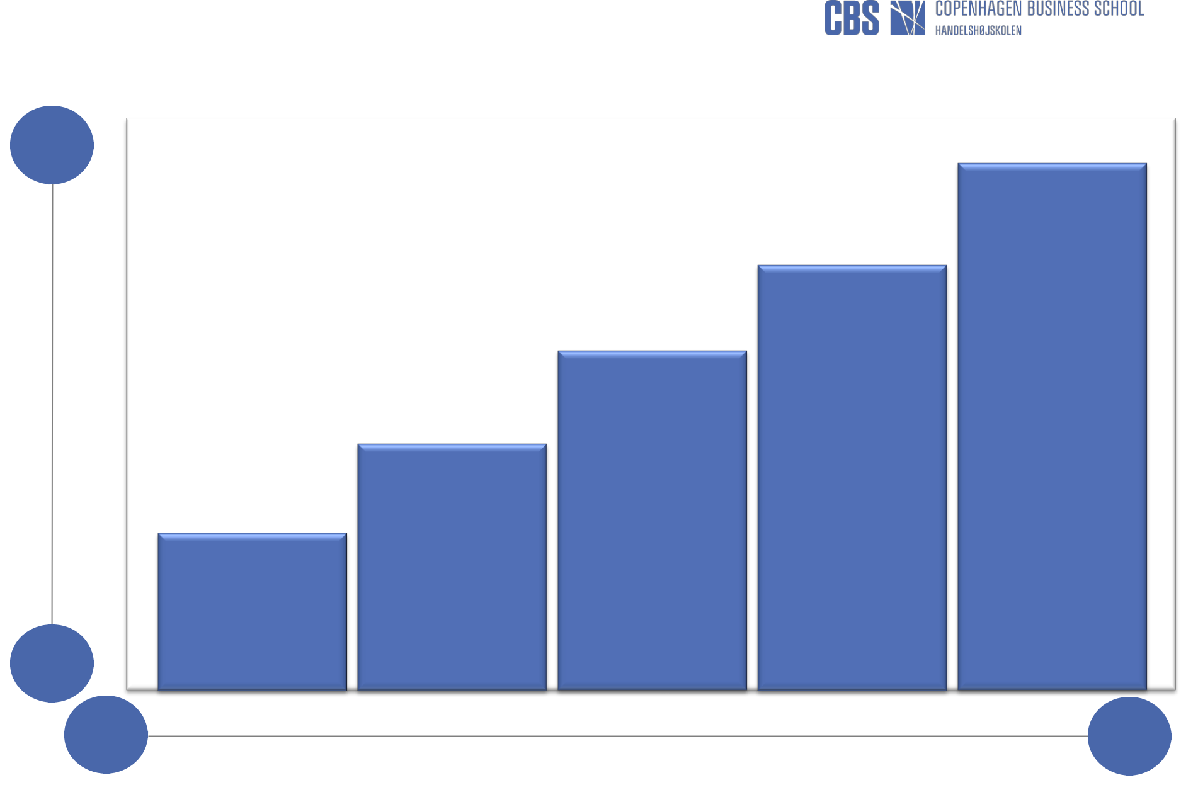

Syste-

mic

Degree of change

Incre-

mental

Project member | Competences

 |  |  |  |  | Create next-
 |  |  |  |  | practice
 |  |  |  | Change the | platforms by
 |  |  |  | basis of | questioning the
 |  |  | Develop new, | competition by | dominant logic
 |  |  | Develop new, | developing new | of business
 |  |  | sustainable | developing new | of business
 |  |  | sustainable | ways to deliver | today
 |  | Increase | offerings or | ways to deliver | today
 |  | Increase | offerings or | and capture
 |  | Increase | redesign | and capture
 |  | efficiencies | redesign | value
 |  | efficiencies | existing ones | value
 | View | throughout the | existing ones
compliance as |  | value chain
opportunity

Present Future

Time dimension

Source: Nidumolu, R., Prahalad, C.K., & Rangaswami, M.R. (2009), Why Sustainability is Now the Key Driver of Innovation, Harvard Business Review, 87(9): 57-64, and
CSCP (2009), Partnerships for Sustainable Consumption, Centre on Sustainable Consumption and Production (CSCP), UNEP/Wuppertal Institute Collaborating | 30

Business Models

Def: ”A business model describes the rationale of how an organization creates, delivers, and captures value”

(Osterwalder & Pigneur, 2010, p. 14).

• The infrastructure (partners,
•
resources, activities, etc.).

- The value proposition

- The customer interface (segmentation, relationship,

- channels etc.).

- The financial system (cost and revenue streams).

- The whats, whos, hows…

“Technology by itself has no

single objective value.

The economic value of a technology remains latent until it is commercialized in some way via a business

model”.

(Chesbrough 2010, p. 354)

31
Sustainable Business Model Innovation

- Emerging literature on sustainable business model innovation and related concepts:

Green business models
Social Business Models
Triple layered business models
Shared value business models
Circular business models
Flourishing business models

Core characteristics:
- Broader understanding of value.

- Broader understanding of stakeholders.

- System perspective.
- Long-term orientation.
- Circular thinking?

“Business models are often

perceived from a value creation

perspective that focuses on satisfying customer needs, economic return and compliance. For sustainability thinking, this focus is too narrow and raises the need for a more holistic view of value that integrates social and environmental goals, to ensure balancing or ideally alignment of all stakeholder interests to deliver “sustainable value” creation”.

(Bocken et al., 2015, p. 70)

32

Business Model Canvas

Key | Key activi- | Value | Customer | Customer
Partners | ties | proposi- | relation- | segments
 |  | tion | ships

Key | Channels
resources

Cost structure | Revenue streams

Source: Osterwalder & Pigneur (2010), www.businessmodelgeneration.com

33

Business Model Canvas
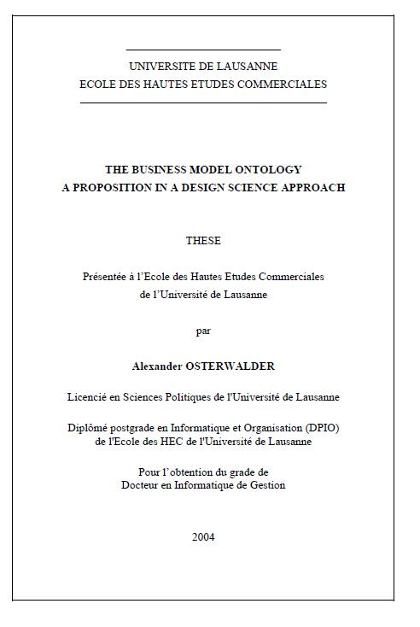

- Nine ”building blocks to describe how an organisation creates value for itself and its customers (and potentially also other stakeholders).

- Development of PhD.

- Tool to visualise, analyse and test business concepts.

- Other models.

- Sustainability?

34
Business Model Canvas

- Nine ”building blocks to describe how an organisation creates value for itself and its customers (and potentially also other stakeholders).

- Development of PhD.

- Tool to visualise, analyse and test business concepts.

- Other models.

- Sustainability?
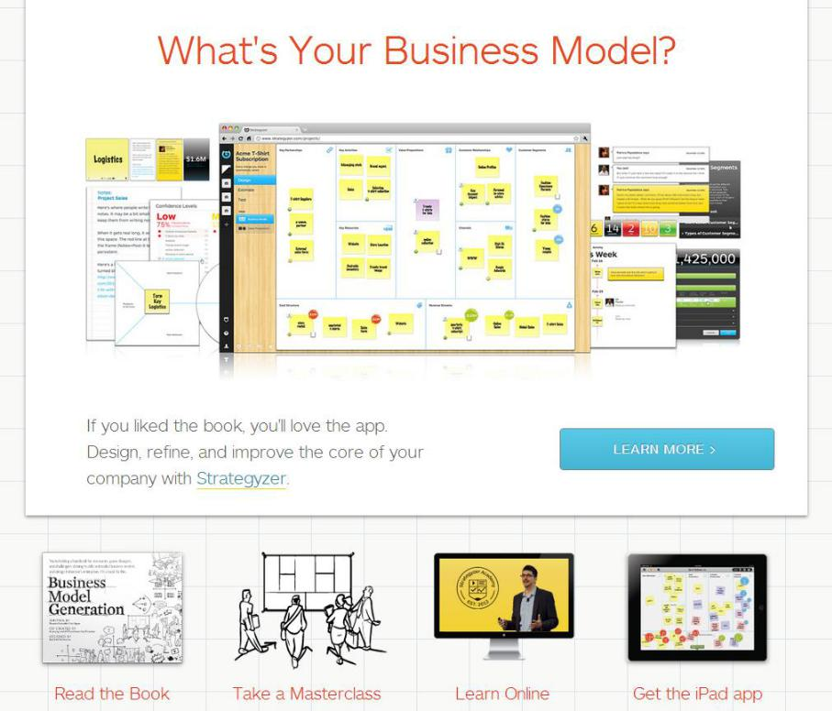

35
Business Model Canvas

- Nine ”building blocks to describe how an organisation creates value for itself and its customers (and potentially also other stakeholders).

- Development of PhD.

- Tool to visualise, analyse and test business concepts.

- Other models.

- Sustainability?
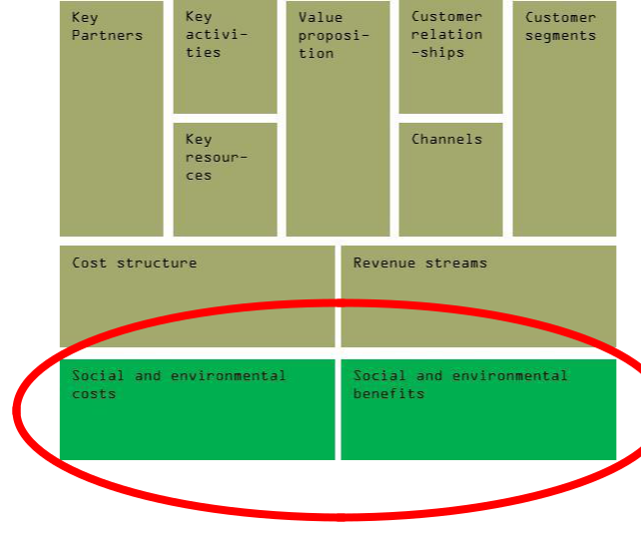

Osterwalder, A. and Pigneur, Y. (2010), Business Model | 36
Generation, John Wiley and Sons, Inc. | 36
http://www.businessmodelgeneration.com/

Business Model Canvas

- Nine ”building blocks to describe how an organisation creates value for itself and its customers (and potentially also other stakeholders).

- Development of PhD.

- Tool to visualise, analyse and test business concepts.

- Other models.

- Sustainability?
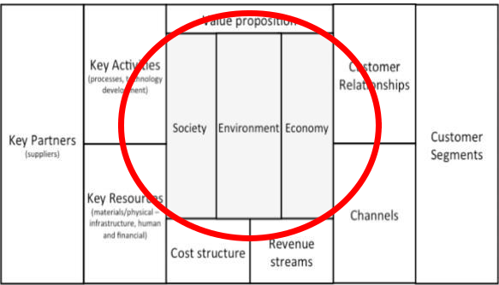

http://nancybocken.com/

37
Business Model Canvas
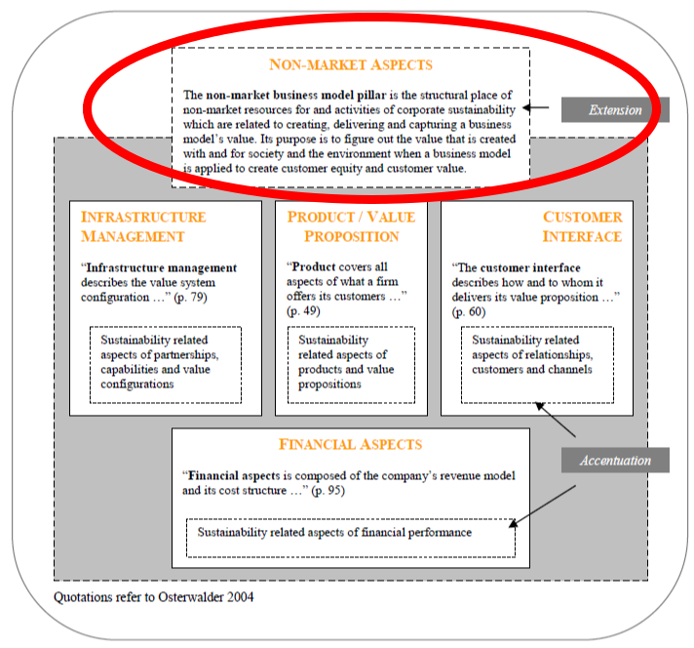

- Nine ”building blocks to describe how an organisation creates value for itself and its customers (and potentially also other stakeholders).

- Development of PhD.

- Tool to visualise, analyse and test business concepts.

- Other models.

- Sustainability?

38
http://www2.leuphana.de/umanagement/csm/content/nama/downloads/download_publikationen/FlorianLuedeke_Freund_Business_Mo

del_Concepts_in_Corporate_Sustainabilty_Context.pdf
Concluding Remarks

• Overlap between categories.
• What is sustainable fashion, anyway?

Towards Industry Transformation…?

• Who are the (profitable) customers?

• How to cope with limited resources?

• What is the value proposition?

• How to generate revenue?

• What collections to choose?

• Picking the right partners?

• Need for a new mindset?
Social and environmental performance 

Emerging

Davids

Greening

Goliaths

Market Share

• First Mover and Fast Second…

Source: Hockerts & Würstenhagen (2010, p. 488)

39

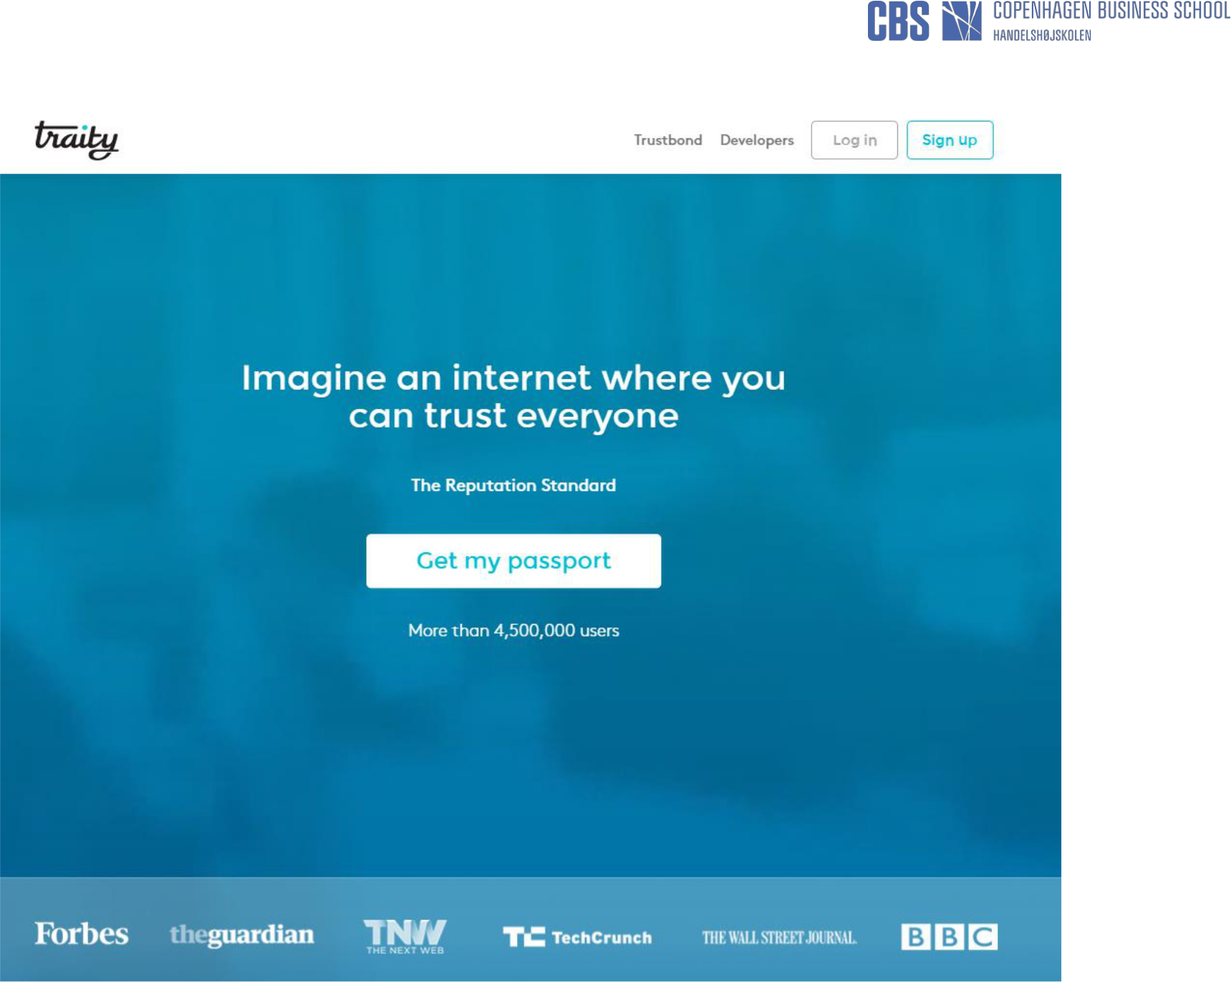
https://traity.com/

40

”Firms isolate and publicize their ”sustainability” efforts, while in fact keeping their primary focus on generating economic value. For instance, the makers of single-use disposable coffee pods publicize their efforts to recycle a small number of their pods, but do nothing to address the issue of their business model’s reliance on a single-use disposable pod in the first place (…)” (Montabon et al., 2016, p. 14).

41

42
Towards Closed Loop Thinking
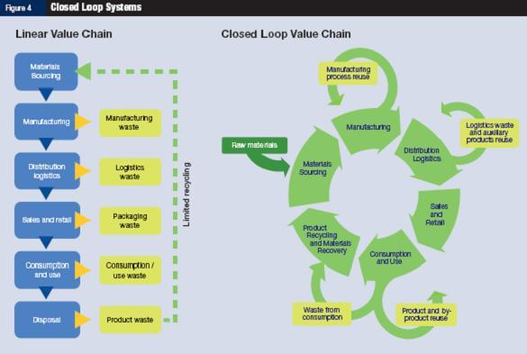

43

Source: http://growglobally.org/?category_name=market-bus-planning&paged=2

CSR in all Corporate Subsystems
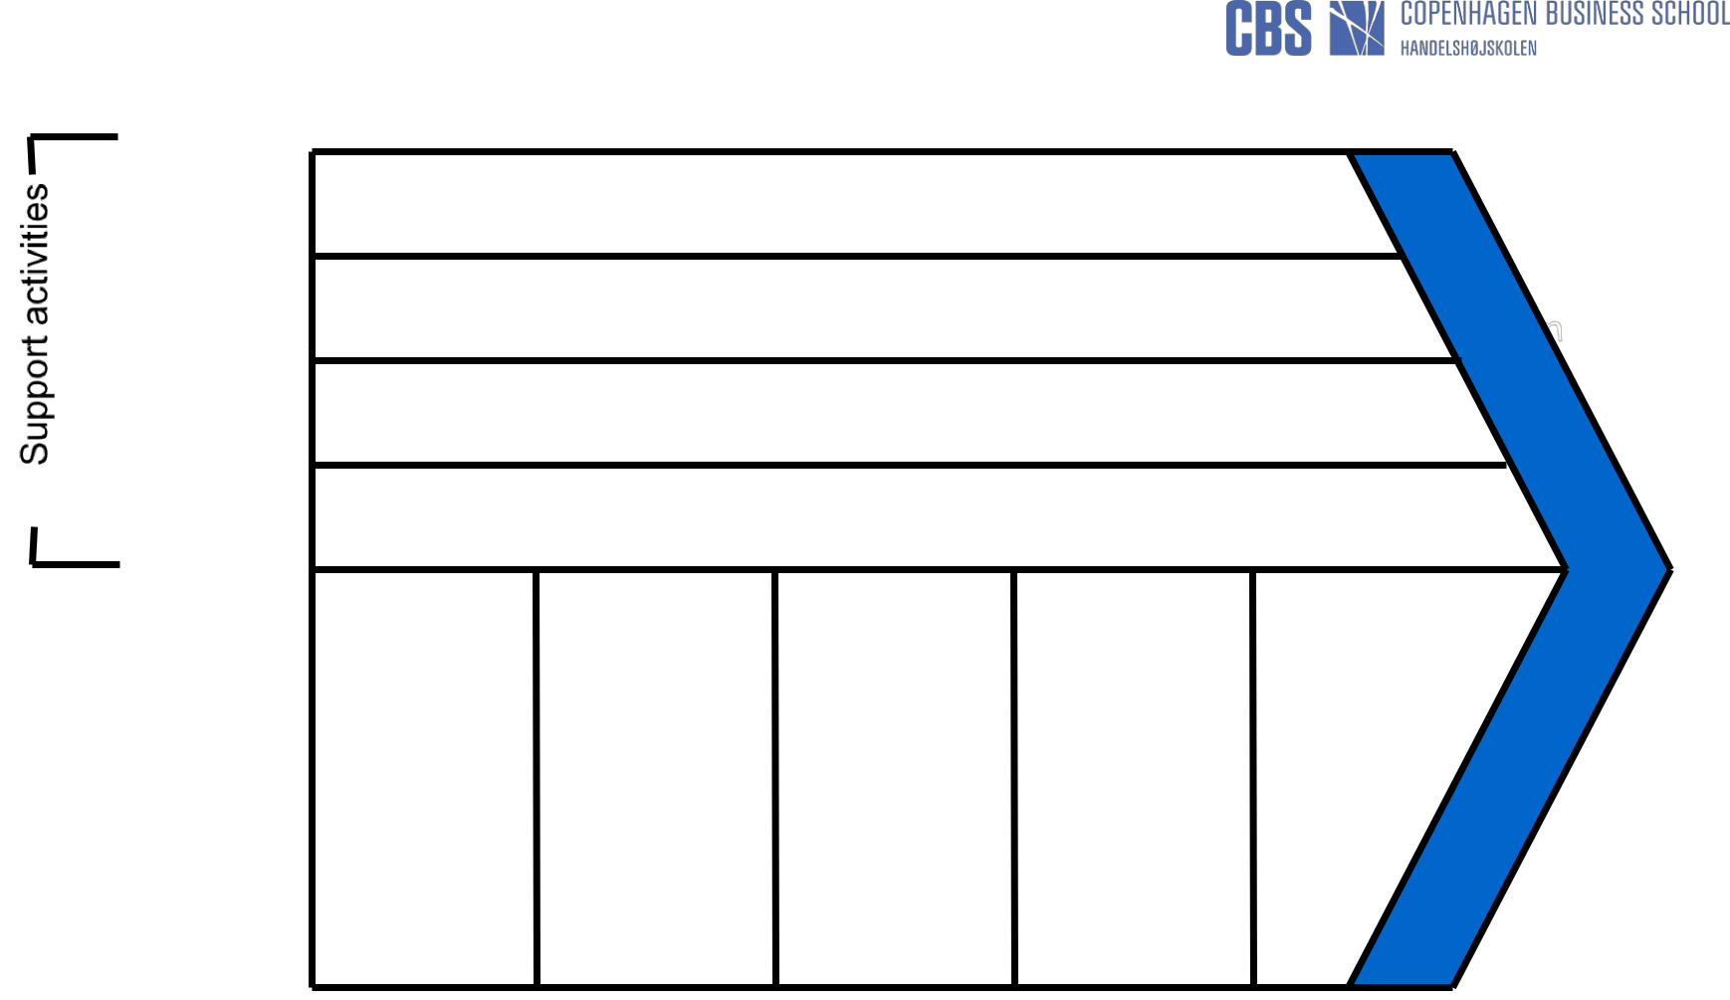

Firm

infrastructure

HRM

Technology development

Procurement

  - Measuring social and environmental issues

  - Sustainability databases (e.g. life-cycle analysis etc.).

- CSR recruitment policies

- CSR training and education

- Developing CSR awareness and culture

  - Develop cleaner processes

  - CSR innovation

- Choose socially responsible suppliers

- Less harmful materials

- Social and environmental procurement policies

• Storage | • Minimise | • Transpor- | •CSR | •Product
• Transpor- | waste | tation | campaigns. | take-back
tation | • Cleaner | • Storage | •Promote | •Recycling
 | technology | • Waste | CSR in
 | •H&S | disposal | products and
 | standards | • Packaging | services
 |  |  | •CSR
 |  |  | reporting

Margin

Inbound Operations Outbound Marketing After-Sale

logistics logistics and sales Services

Primary activities

44

Source: Epstein (2008, p. 91)

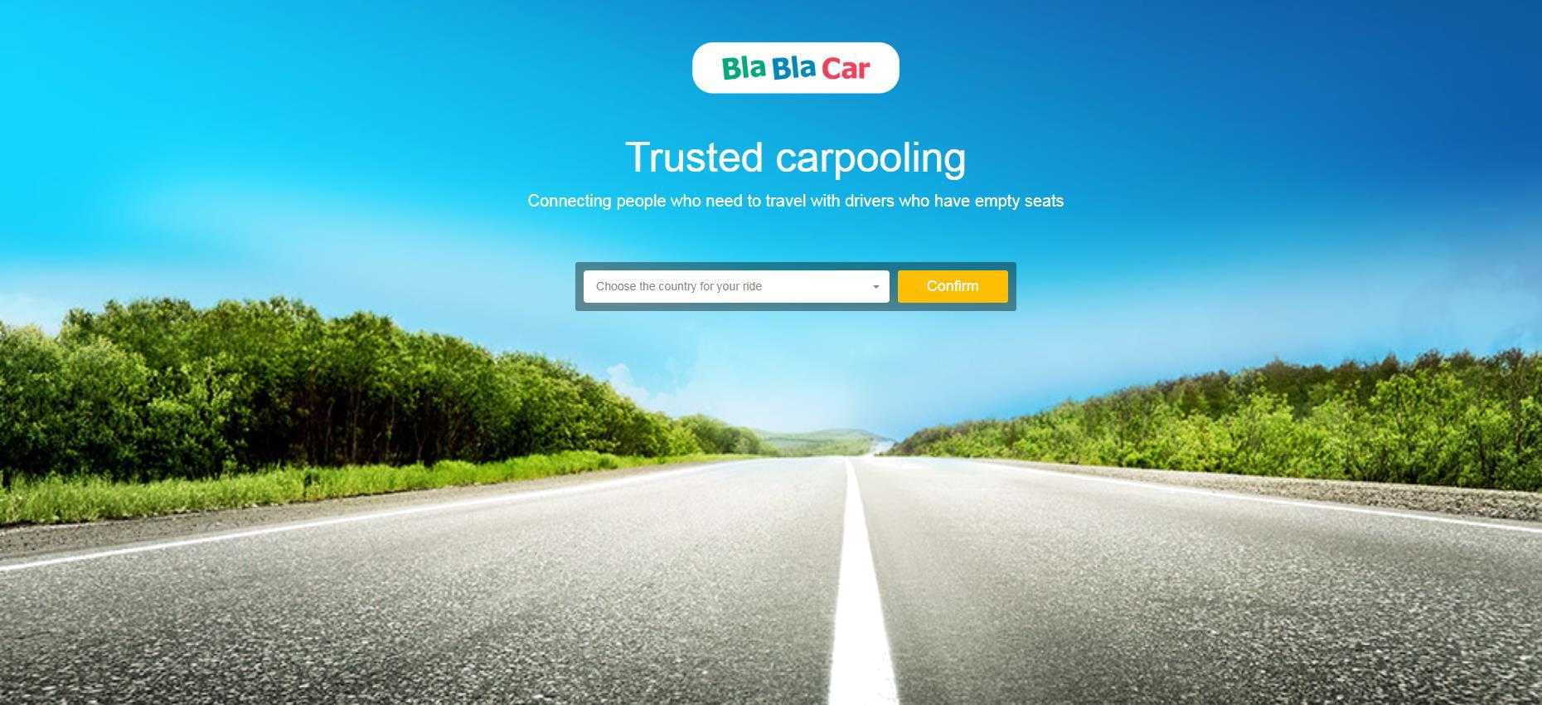

https://www.blablacar.com/

45

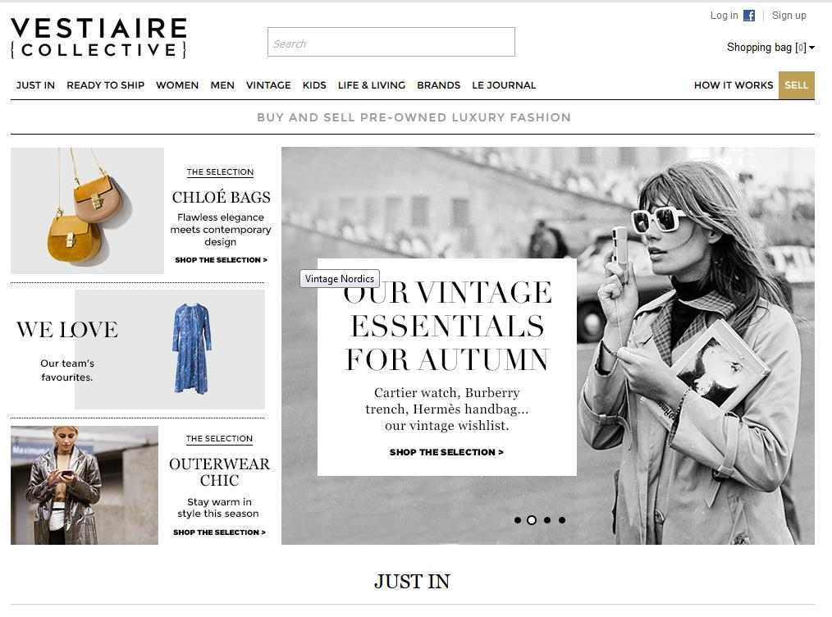

46

https://www.vestiairecollective.com/

Kan man lave Steen og Lauras model

47

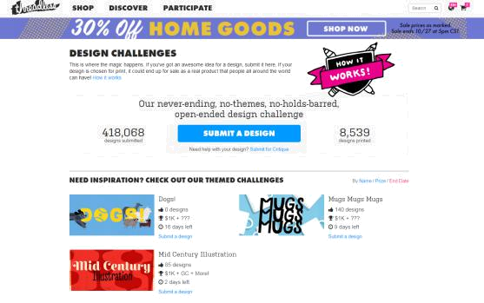

https://www.threadless.com/make/submit/

48

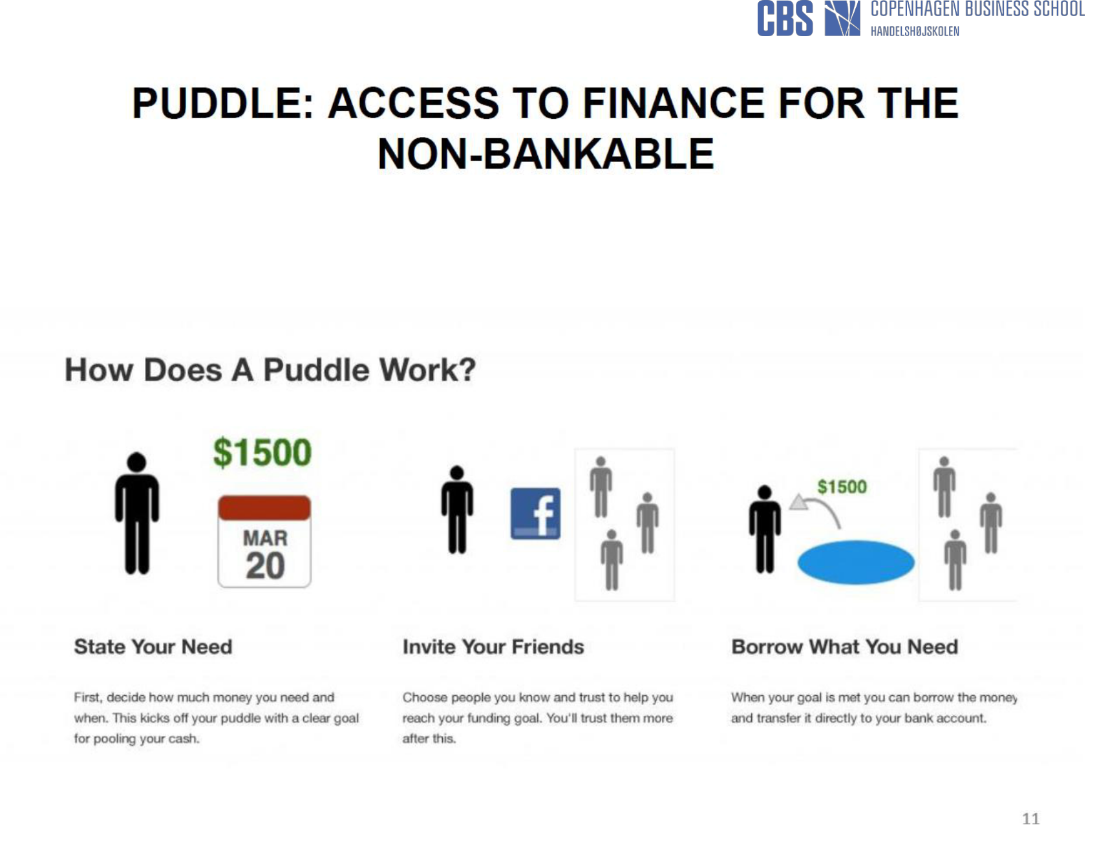

49
EXAMPLE: Too GOOD To Go
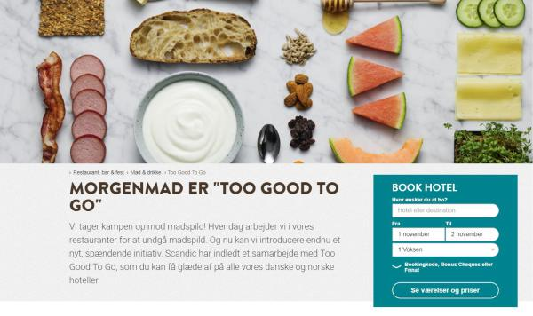

https://www.scandichotels.dk/restaurant-bar-fest/mad-og-drikke/too-good-to-go

50
Foodsharing

51

52


“In conclusion we would point

out that business cannot serve

only itself. It is thoroughly

intertwined in almost every

aspect of contemporary life”

(Duska 2000)

53

”(…) previous research has noted that an instrumental logic dominated by economics, especially as manifested as profit, is antithetical to humanity’s well-being (…)” (Montabon et al., 2016, p. 11)

54

  ”The solution lies in the | ”One banking CEO opined
 | that his company wasn’t hurt
principle of shared | much by the sub-prime
value, which involves | mortgage crisis because they
creating economic | just didn’t see how lending
value in a way that also | their customers money that
creates value for | they couldn’t really afford to
society by addressing | pay back, did anyone any
its needs and | good”.
challenges”.
(Porter & Kramer, | (Freeman, 2009, p. 22)
2011, p. 38)

”’As David Packard, co-founder of Hewlett Packard, wisely put it: ’ Why are we here? Many

people assume, wrongly, that a company exists solely to make money. People get together and exist as a company so that they are able to accomplish something collectively that they could not accomplish separately – they make a contribution to society”.

(Visser, 2010, p. 38)

55

The Dangers of Commercialisation?

Ideology Commercialisation

Academics Practitioners

Business ethics/ Corporate citizenship/

Corporate social Corporate social

Responsibility (CSR1) Responsiveness (CSR2)

Stakeholder Stakeholder

theory management

Normative Instrumental

Moral conduct Wealth creation

56



“to be ethical as a business because it may increase your profits is to do so for entirely the wrong reason. The ethical business must be ethical because it wants to be ethical”

(Andrew Stark, in Wilenius 2004, p. 139)

57



“In conclusion we would point

out that business cannot serve

only itself. It is thoroughly

intertwined in almost every

aspect of contemporary life”

(Duska 2000)

58

Stakeholder Criticism: Stakeholder theory will inevitably undermine business accountability “because a business that is accountable to all, is actually accountable to none" (Sternberg 2000: 51f).”

Stakeholder Response: “[N]o small measure of managerial opportunism has occurred in the name of shareholder wealth maximization. In addition to the debacles at Enron and WorldCom, one need only consider the now dethroned king of shareholder wealth Al Dunlap for an illustration. Dunlap grossly mismanaged at least two companies to his own significant financial gain. And every move he made was in the name of share-

holder wealth (…). There is little reason to believe that stakeholder theory will provide any more or less justification for the opportunistic manager.”

59

The Separation Thesis….

Separation thesis: - the idea that it is possible to separate the economic from the social, business from ethics, etc.
CSR/stakeholder theory believes that it is problematic to:
- carve up the world in economic, social, political etc.

- separate the organisation from its environment

- divide stakeholders into generic groups and faceless abstractions.
- see the company solely as a command and control system.

“(…) there is no such thing as a purely economic strategic decision in big business. Every one is also social (or, if you prefer, political). Only a conceptual ostrich, with his head deeply burried in economic theory, could possibly use the distinction between economic and social goals to dismiss social responsibility”.


(Mintzberg 1983, p. 12).

60

THANK YOU

FOR YOUR

ATTENTION!

61

