

Business Model Canvas Workshop
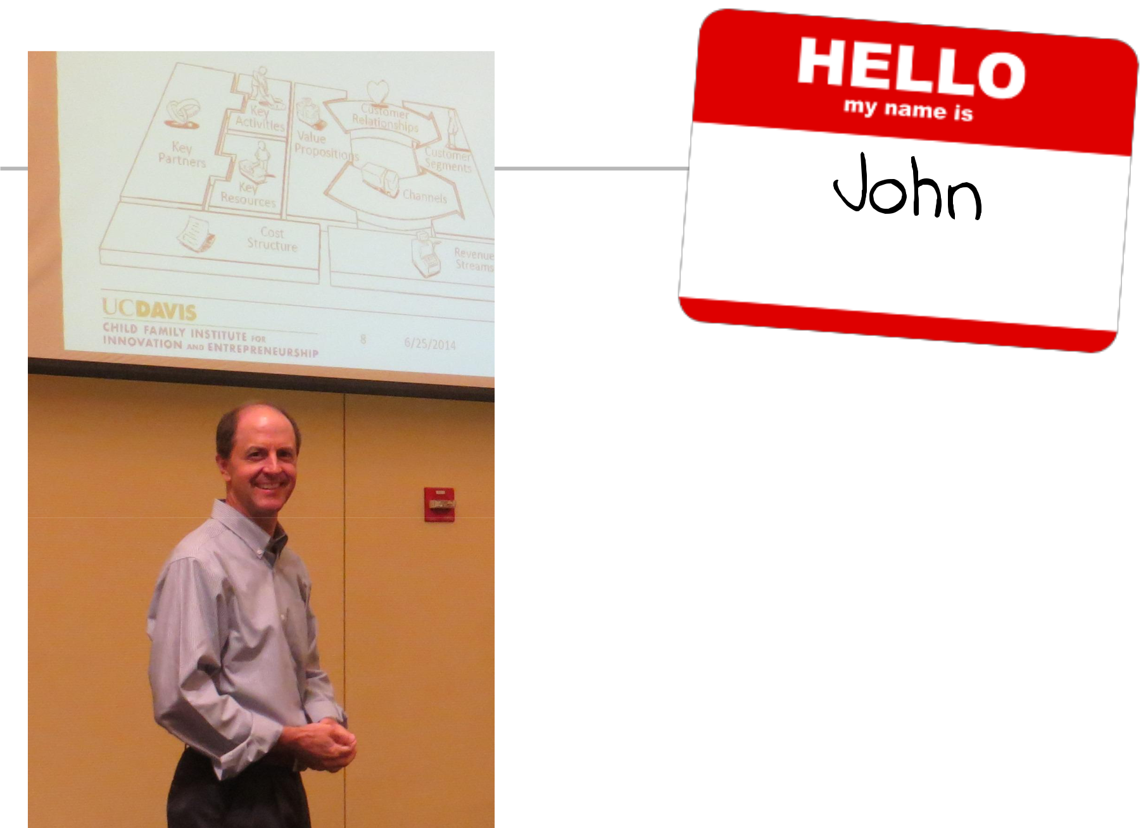

- Angel Investor; former Tech Exec

- Mentor, Guest Lecturer

– Entrepreneurship – Sac State, UC Davis

- Three children and a dog, in Folsom, CA
Thanks!

Objectives

- Use the business model canvas to describe a business model

- Think innovatively about a traditional business model

Groups!

5 or Less Per Group
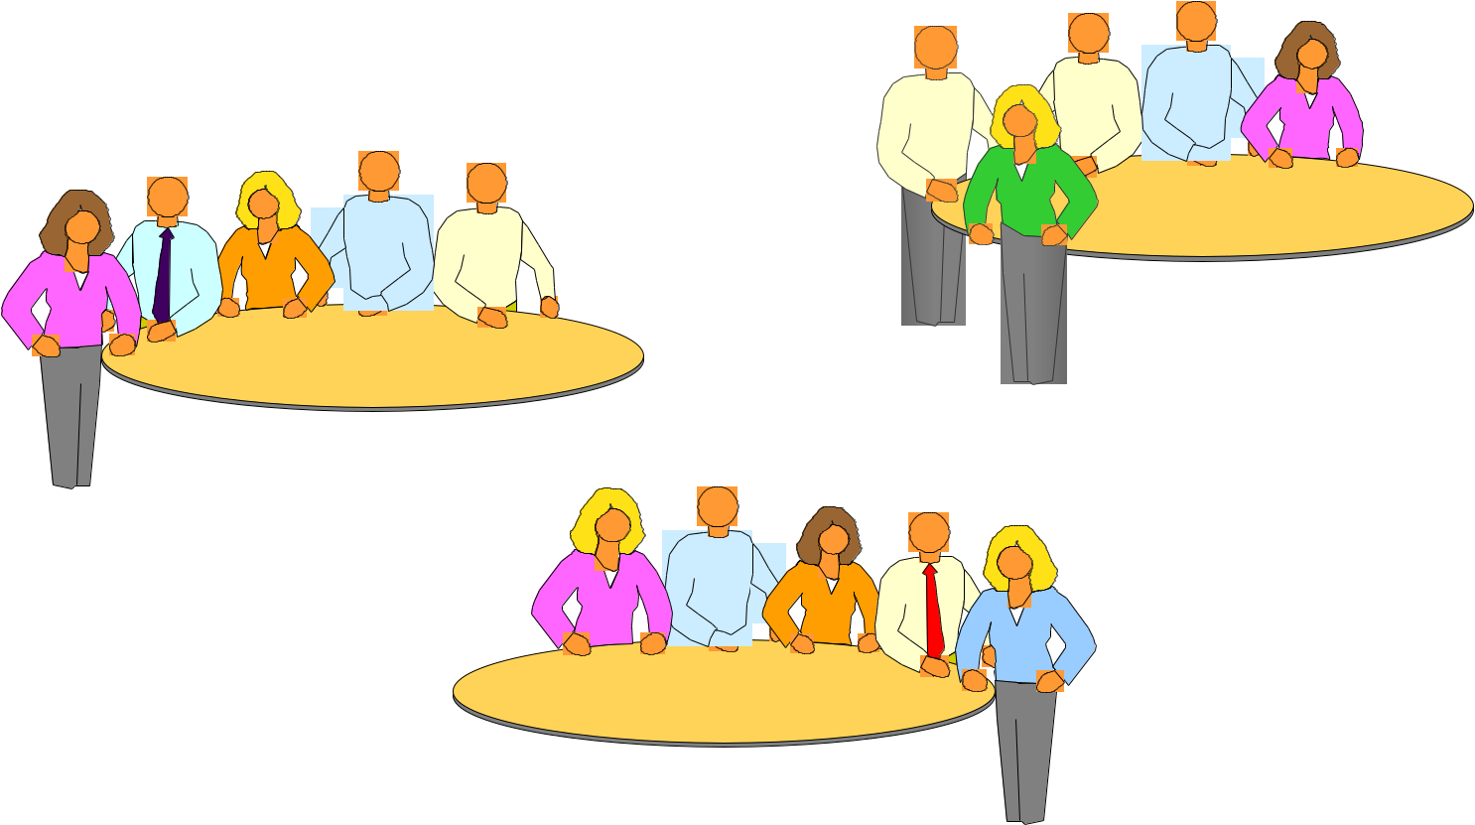

Agenda

- Welcome

- Intro to the Business Model Canvas

- Group Work on Canvas *

- Guest Entrepreneur

Time is a precious thing...
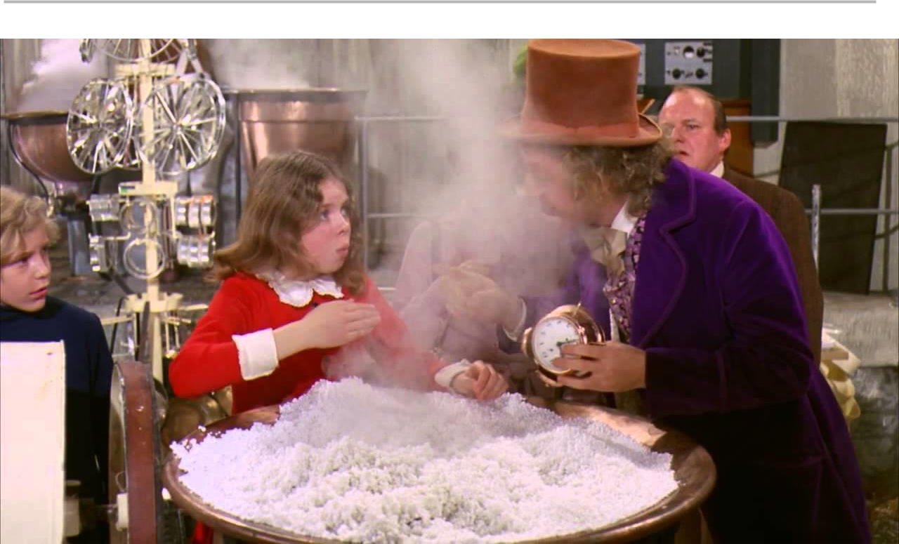
Disclaimer


There’s No Substitute

for a Great

Value Proposition
Insight: A Business model can be described in nine elements, enabling explicit dialog about choices, alternatives, & opportunities.
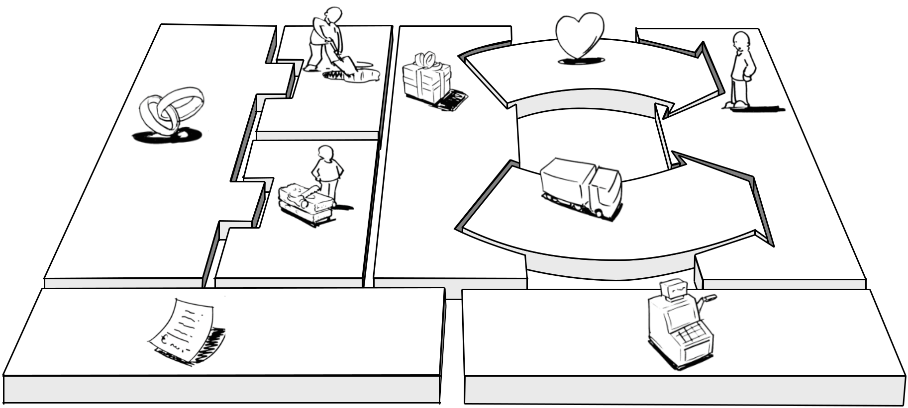

Customer Relationships
Key Activities _{Value} | Customer
Propositions | Segments

Key Partners

 | Channels
Key Resources
Cost | Revenue
Cost | Streams
Structure | Streams

Adapted from ‘Business Model Generation’, Alexander Osterwalder, Wiley 2012.

www.businessmodelgeneration.com
Licensed under a Creative Commons Attribution-ShareAlike 3.0 Unported License.
Customer Segments
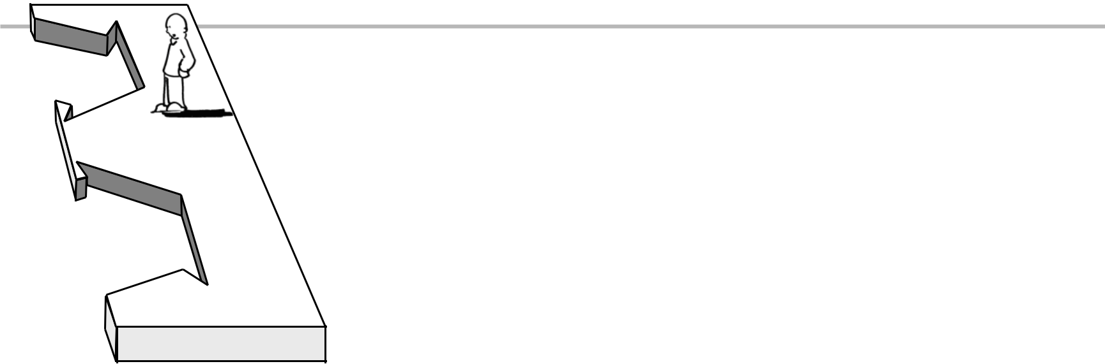

Customer
Segments

For whom are we creating value?
Who are our most important constituents?

Examples: Health-Care:
- Established Hospital Health Systems
- Smaller Health Clinics

- Private Practice Physicians

- Emerging Med-Tech Researchers

- Established Medical Device Manufacturers

- Ambulance Service Providers
Variations:
Business-to-Consumer; Bus.-to-Bus.; Bus.-to-Gov’t
Mass Market / Niche Market
Segmented; Diversified
Multiple Decision-Makers:

Economic Buyers, Gatekeepers, Actual Users Multi-Sided Platforms

Adapted from ‘Business Model Generation’, Alexander Osterwalder, Wiley 2012.
www.businessmodelgeneration.com
Licensed under a Creative Commons Attribution-ShareAlike 3.0 Unported License.

Value Propositions
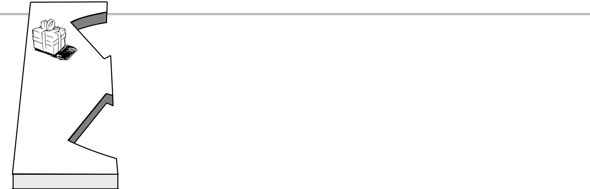

Value
Propositions

What value do we deliver to our customers?

Which of our customer’s problems are we helping to solve?

What bundles of products and services are we offering to each customer?
Which customer needs are we satisfying?

Characteristics: |  | • | Brand/Status
• | Newness | • | Price
• | Performance | • | Cost Reduction
• | Customization | • | Risk Reduction
• “Getting the Job Done” |  | • | Accessibility
• | Design | • | Convenience / Usability

Adapted from ‘Business Model Generation’, Alexander Osterwalder, Wiley 2012.
www.businessmodelgeneration.com
Licensed under a Creative Commons Attribution-ShareAlike 3.0 Unported License.

Customer Relationships
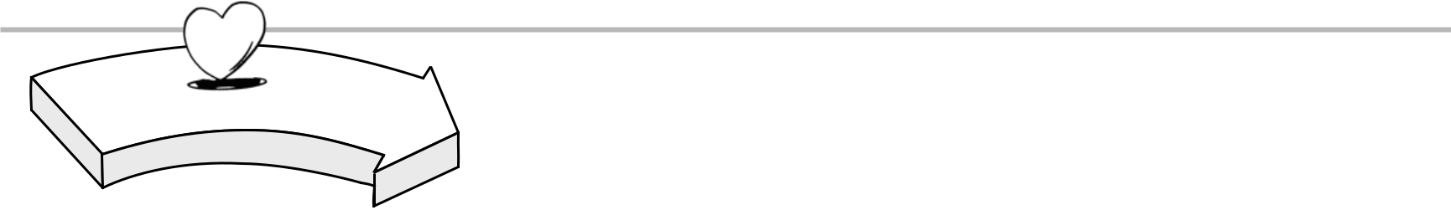

Customer Relationships | What type of relationship does each
Customer Relationships | of our Customer Segments
expect us to establish and
maintain with them?
Which ones have we established?

How are they integrated with the rest of our business model?
How costly are they?

Examples: • Communities
- Automated Services

- Self-Service

- Co-creation

- Personal assistance – Mentorship

- Dedicated Personal Assistance – Assigned Mentors

Adapted from ‘Business Model Generation’, Alexander Osterwalder, Wiley 2012.
www.businessmodelgeneration.com
Licensed under a Creative Commons Attribution-ShareAlike 3.0 Unported License.
Channels
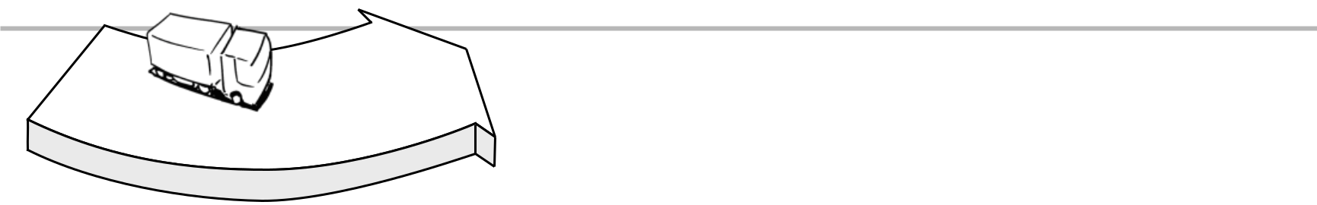

Channels | Through which Channels do our
Customers want to be reached?
How are we reaching them now?
How are our Channels integrated?
Which ones work best?
Which are most cost-efficient?

How are we integrating them with our customer’s routines?

Channel Phases: • Awareness
- Information

- Evaluation

- Purchase

- Delivery

- After Sales

Adapted from ‘Business Model Generation’, Alexander Osterwalder, Wiley 2012.
www.businessmodelgeneration.com
Licensed under a Creative Commons Attribution-ShareAlike 3.0 Unported License.
Revenue Streams


Revenue
Streams

For what value are our customers really

willing to pay?

For what do they currently pay? How are they currently paying? How would they prefer to pay?

How much does each Revenue Stream contribute to overall revenues?
Types: | Fixed Pricing | Dynamic Pricing
Meeting fees | List Price | Negotiation (bargaining)
Usage fee | Volume dependent | Yield Management
Subscription fees | Product feature dependent | Real-time-Market
Licensing | Customer segment dependent
Lending/Renting/Leasing
Brokerage fees
Advertising

Adapted from ‘Business Model Generation’, Alexander Osterwalder, Wiley 2012.
www.businessmodelgeneration.com
Licensed under a Creative Commons Attribution-ShareAlike 3.0 Unported License.

Key Activities
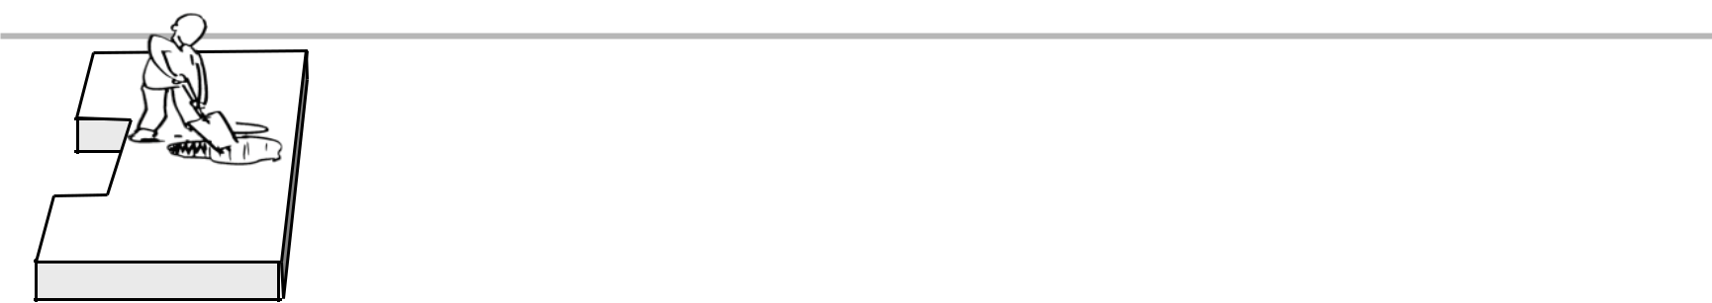

Key Activities

What Key Activities do our Value Propositions require?
Our Distribution Channels?
Customer Relationships?
Revenue Streams?

Categories:
- Production

- Problem Solving
- Platform / Network

Adapted from ‘Business Model Generation’, Alexander Osterwalder, Wiley 2012.
www.businessmodelgeneration.com
Licensed under a Creative Commons Attribution-ShareAlike 3.0 Unported License.

Key Resources
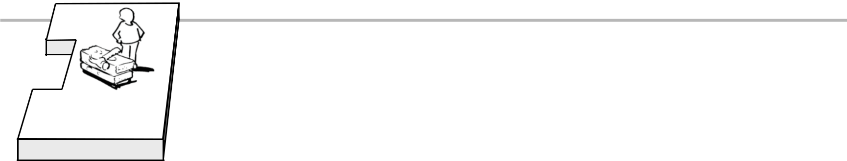

Key Resources

What Key Resources do our Value Propositions require?
Our Distribution Channels?
Customer Relationships?
Revenue Streams?

Types of Resources:
- Physical

- Intellectual (brand patents, copyrights, data)
- Human

- Financial

Adapted from ‘Business Model Generation’, Alexander Osterwalder, Wiley 2012.
www.businessmodelgeneration.com
Licensed under a Creative Commons Attribution-ShareAlike 3.0 Unported License.

Key Partners
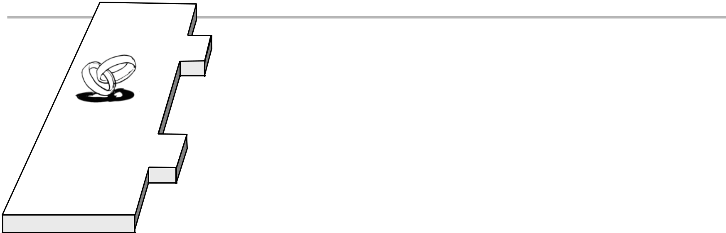

Key Partners

Who are our Key Partners? Who are our key suppliers? What Key Resources are we acquiring from them?

What Key Activities do partners perform?

Partner Candidates:
- Established Medical Firms

- Established Health Systems

- Ecosystem Service Providers

Motivations for Partnerships:
- Promoting the Ecosystem

- Optimization and economy

- Reduction of risk and uncertainty

- Acquisition of particular resources and activities

Adapted from ‘Business Model Generation’, Alexander Osterwalder, Wiley 2012.
www.businessmodelgeneration.com
Licensed under a Creative Commons Attribution-ShareAlike 3.0 Unported License.

Cost Structures
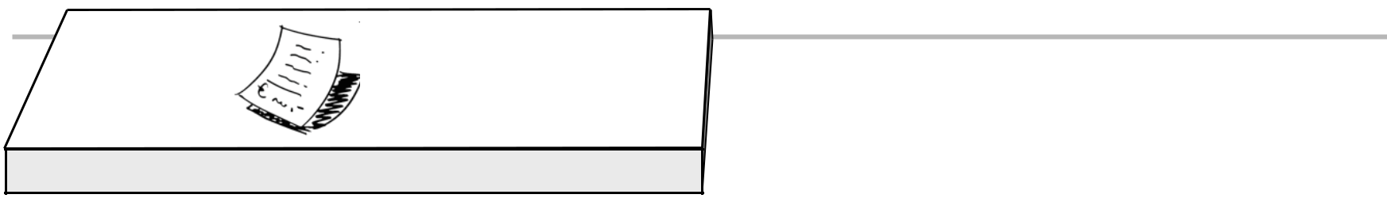

Cost
Structure

What are the most important costs

inherent in our
business model?
Which Key Resources are most expensive?
Which Key Activities are most expensive?

Is our business more:
- Cost-Driven (leanest cost structure, low-price value proposition)

- Value Driven (focused on value creation, premium value proposition)

Sample Characteristics:
- Fixed Costs (salaries, rents, utilities)

- Variable costs

- Economies of scale

- Economies of scope

Adapted from ‘Business Model Generation’, Alexander Osterwalder, Wiley 2012.
www.businessmodelgeneration.com
Licensed under a Creative Commons Attribution-ShareAlike 3.0 Unported License.

 | Designed for: |  |  | Designed by: | On:
Business Model Canvas |  |  |  |  | Iteration: | 1
Key Partners | Key Activities | Value Propositions |  | Customer Relationships | Customer Segments
 | Key Resources |  |  | Channels
Cost Structure |  |  | Revenue Streams
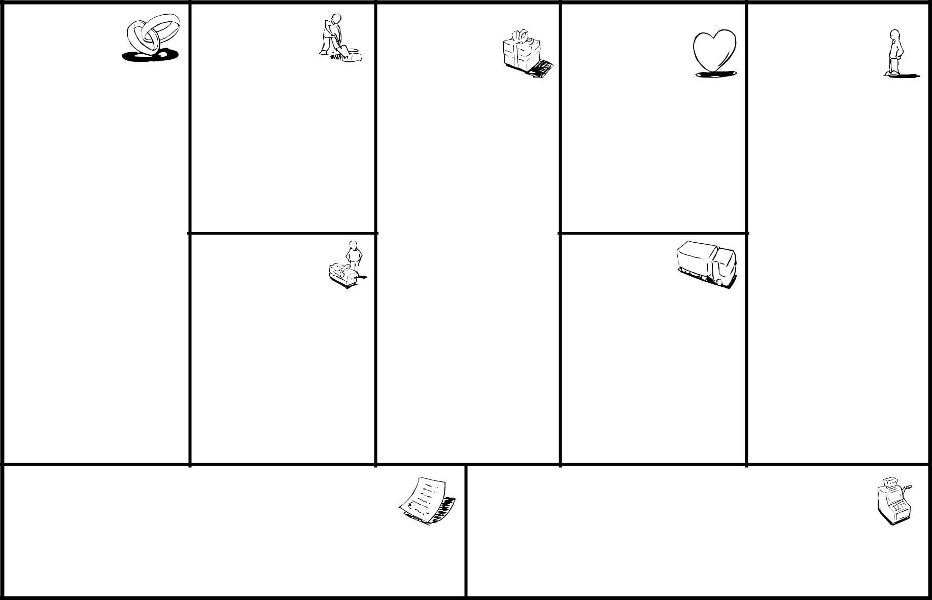

Template is licensed under the Creative Commons
Attribution-Share Alike 3.0 Unported License.
www.businessmodelgeneration.com



(DVDs by Mail)

Netflix (DVDs by Mail)
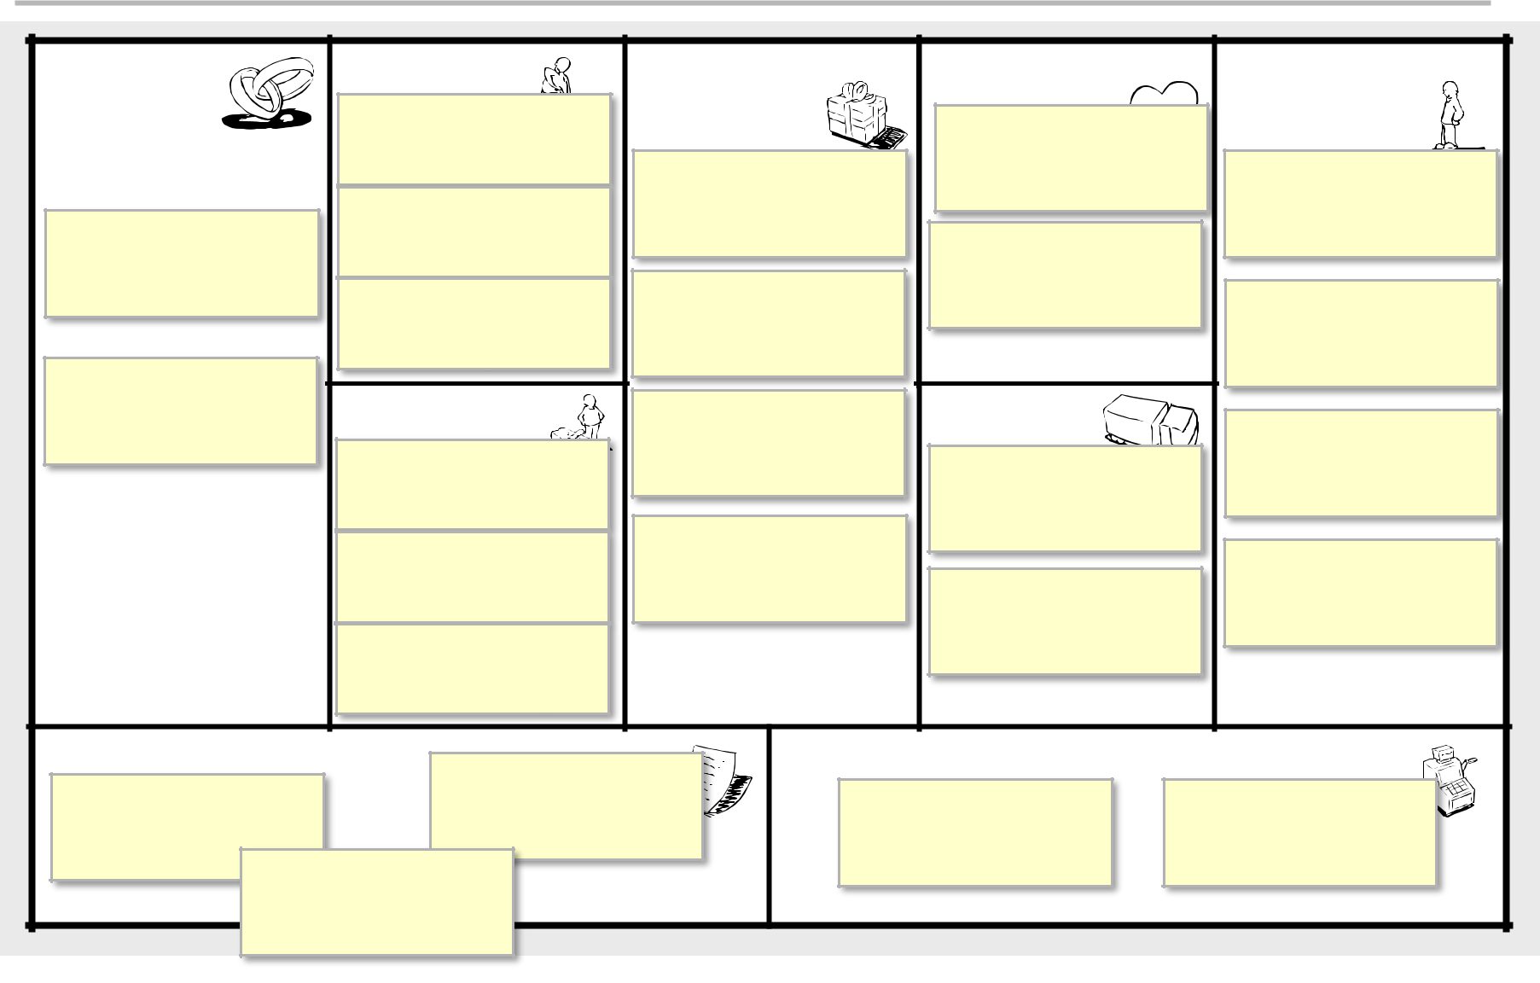

Key Partners | Key Activities | Value Propositions |  | Customer Relationships |  | Customer Segments
 | DVD |  |  | Subscriber
 | Operations |  |  | Subscriber
 | Operations |  |  | relationship |  | USA
 | Purchasing / |  | Convenience | relationship |  | USA
 | Purchasing / |  | Convenience |  |  | Households
Postal Service | Negotiation |  |  | Self-service / |  | Households
 | Algorithm |  | No Late Fees | Automated |  | Film Buffs
 | Development |  | No Late Fees |  |  | Film Buffs
Film / TV | Key Resources |  |  | Channels
Studios | Key Resources |  | Suggestions | Channels
Studios | Distribution |  | Suggestions |  |  | Families
 | Distribution |  |  | Netflix.com |  | Families
 | Contracts |  |  | Netflix.com
 | Suggestion |  | Large Library |  |  | Mainstream
 | Algorithm |  | Large Library | Mailbox / DVD |  | Mainstream
 | Algorithm |  |  | Mailbox / DVD |  | Moviegoers
 | DVD |  |  | sleeves |  | Moviegoers
 | Inventory
Cost Structure | Inventory |  | Revenue Streams
Facilities & |  |  |  | Monthly |  | Envelope
Facilities & | Purchasing |  |  | Monthly |  | Envelope
Staff |  |  | Subscriptions |  | Advertising
Shipping &
 | Postage

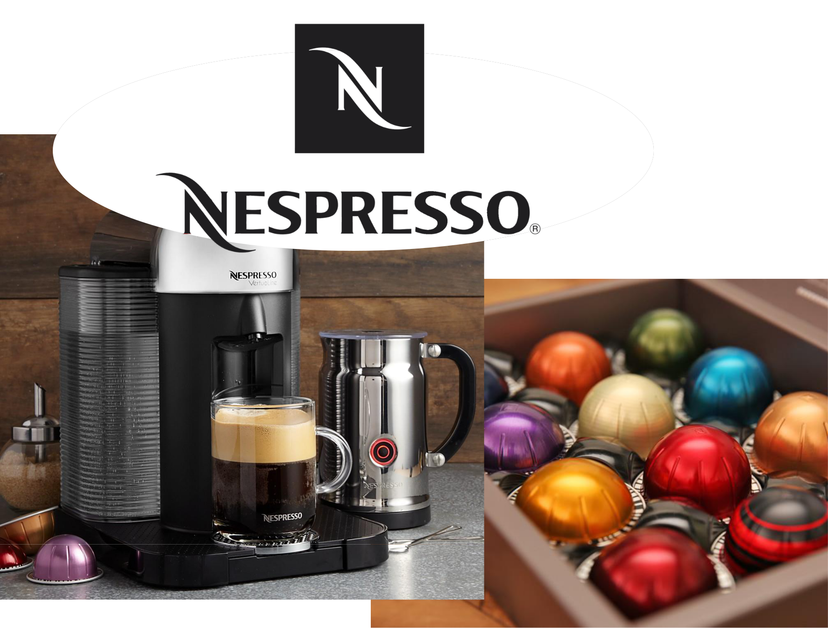

Nespresso

- Use Post-its to fill out canvas

- Use only one color Post-it

Please don’t write on the canvas!


10 Minutes

Share and Compare
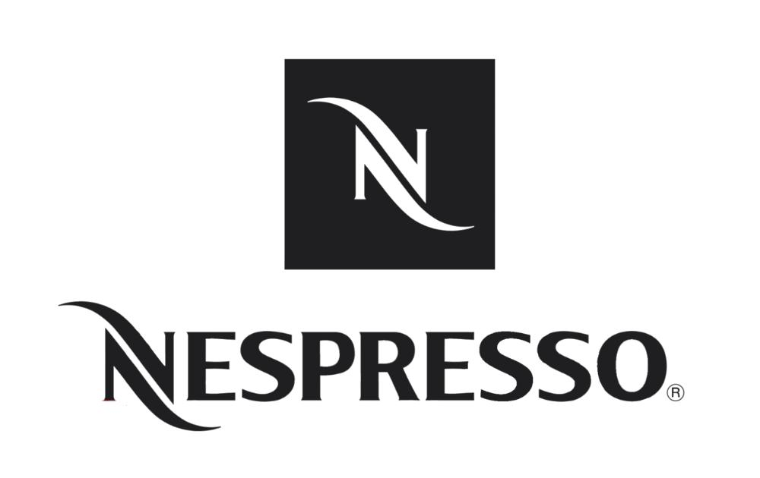
Innovate & Adjust
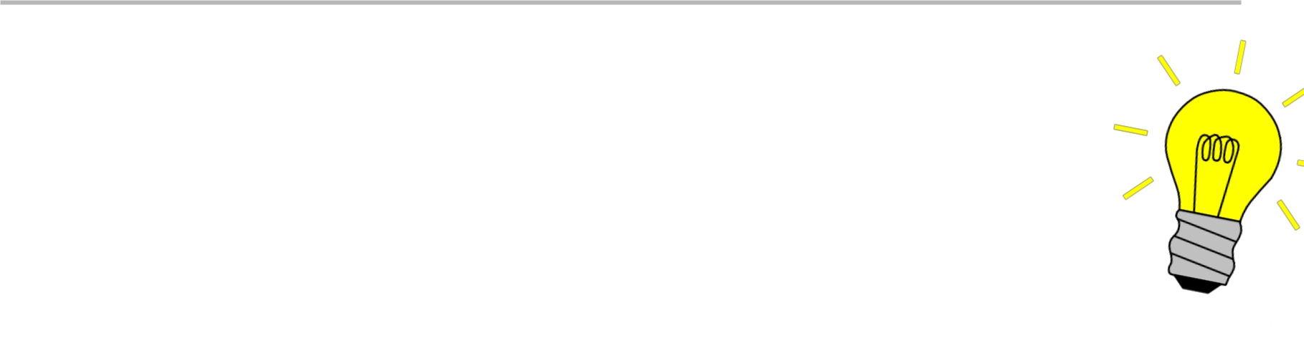

- Pick a box as a team (10 sec)

- What changes are needed to support your innovation?

- Use a different color Post-it

10 Minutes

 | Nespresso
Key Partners | Key Activities | Value Propositions |  | Customer Relationships |  | Customer Segments
 | Production |  |  | Acquire &
Machine | Marketing | Nespresso |  | Lock-in |  | Households
Machine | Marketing | Machines |  |  |  | Households
Manufacturers |  |  |  | Nespresso
 | Distribution | Nespresso |  | Club
Coffee |  |  |  |  |  | Businesses
Coffee | Key Resources |  | Pods | Channels |  | Businesses
Growers |  |  |  | Nespresso
 | Patents |  |  | Nespresso
 | Patents |  |  | Stores
 | Brand |  |  | Phone / Mail /
 | Brand |  |  | Website
 | Production |  |  | Retailers
 | Facilities |  |  | Retailers
Cost Structure |  |  | Revenue Streams
Production | Marketing & |  | Subscription |  | Retail Sales
Production | Branding |  |  | Sales
 | Distribution
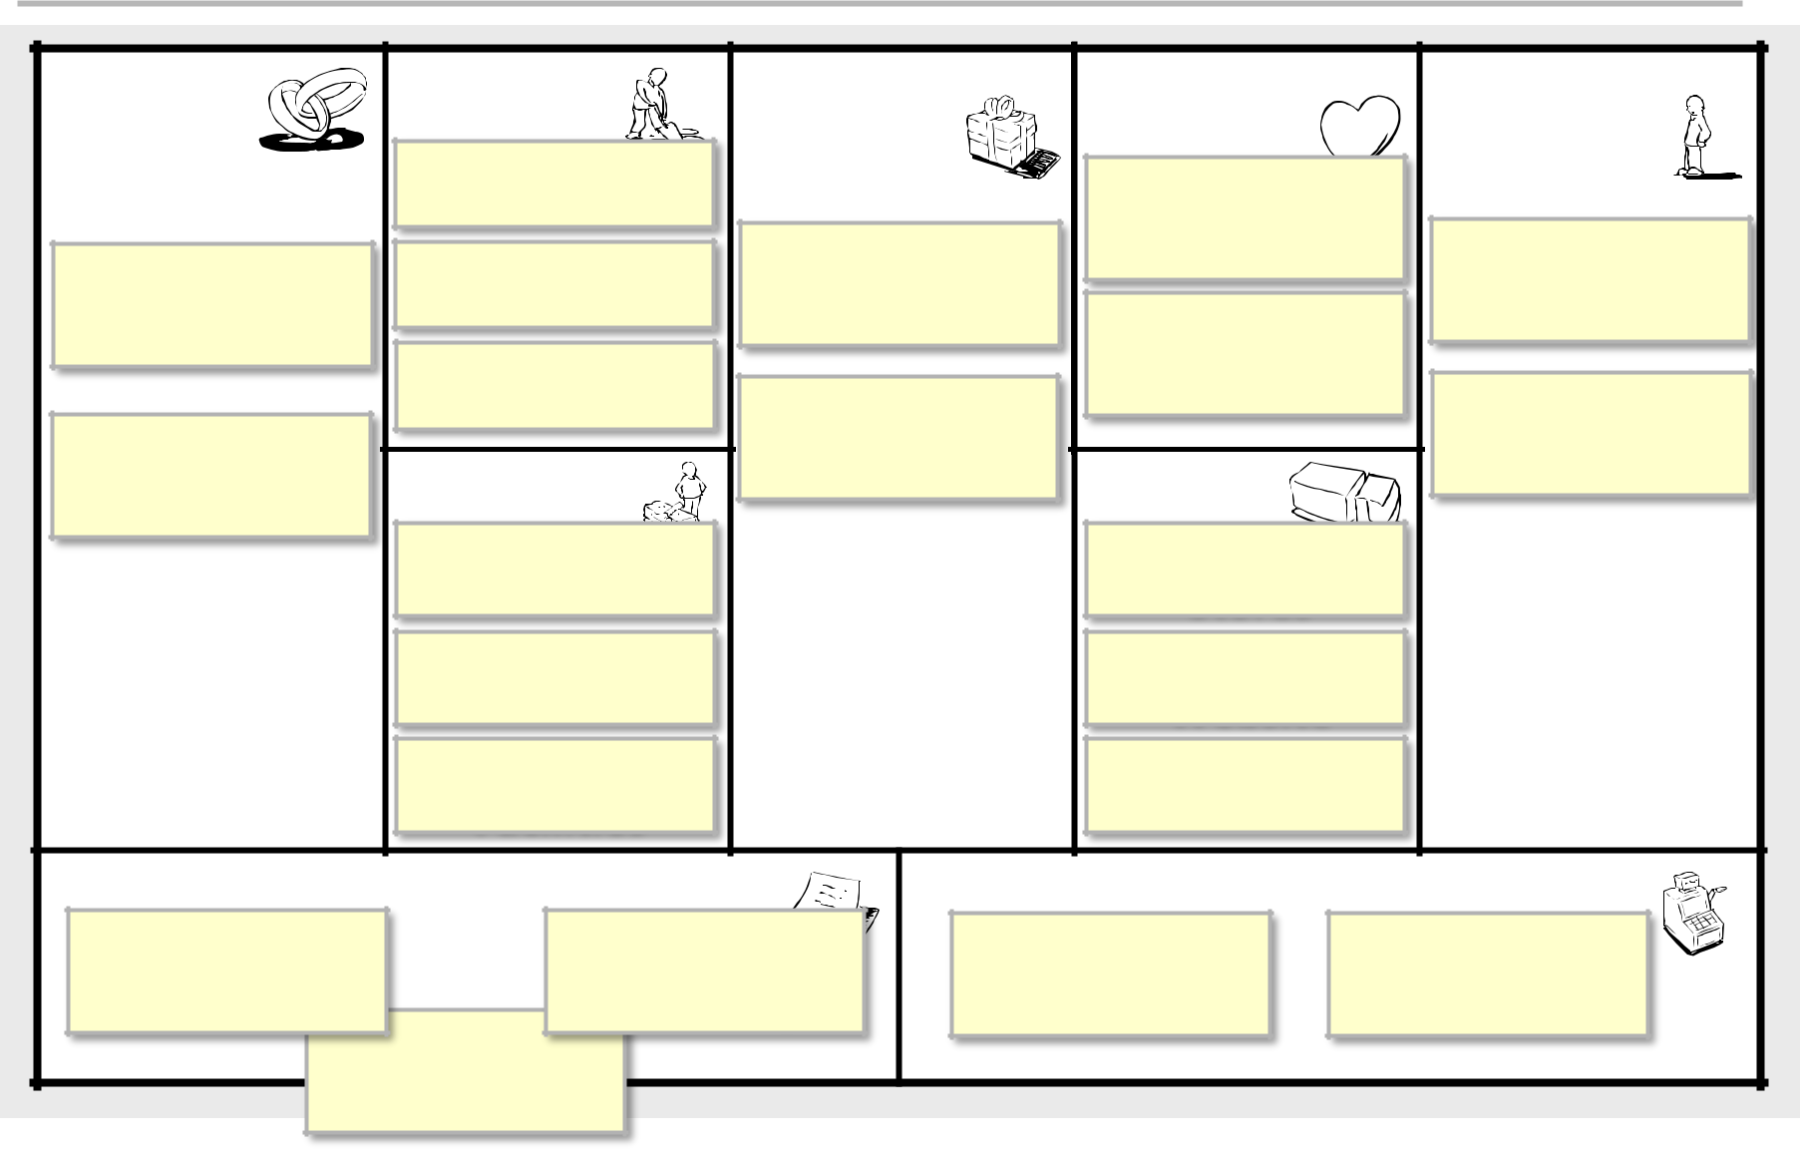
Share Your Innovation

Volunteers?

- What was your innovation?

- What adjustments were needed?

 | Designed for: |  | Designed by: | On:
Business Model Canvas |  |  |  | Iteration: | 1
Key Partners | Key Activities | Value Propositions | Customer Relationships | Customer Segments
 | Key Resources |  | Channels
Cost Structure |  | Revenue
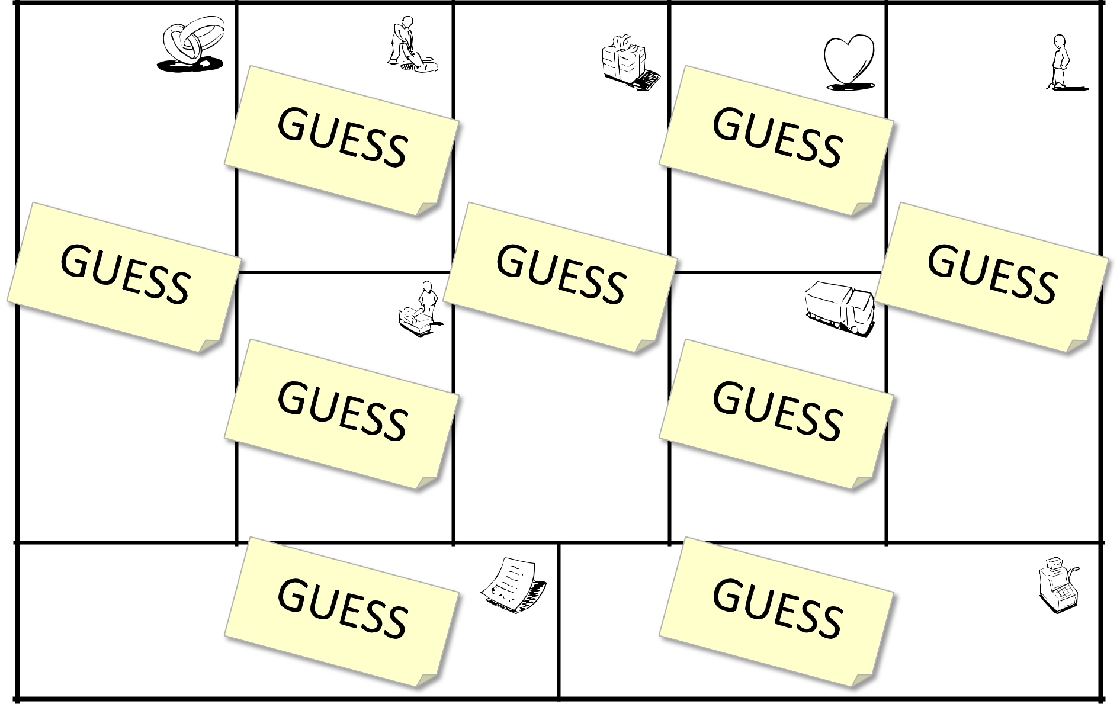

Template is licensed under the Creative Commons
Attribution-Share Alike 3.0 Unported License.
www.businessmodelgeneration.com

 | Designed for: |  | Designed by: | On:
Business Model Canvas |  |  |  | Iteration: | 1
Key Partners | Key Activities | Value Propositions | Customer Relationships | Customer Segments


Guesses need to be

validatedKeyResourcswith CustomersChannels –

Get out of the Building!

Cost Structure Revenue

Template is licensed under the Creative Commons
Attribution-Share Alike 3.0 Unported License.
www.businessmodelgeneration.com

Break!
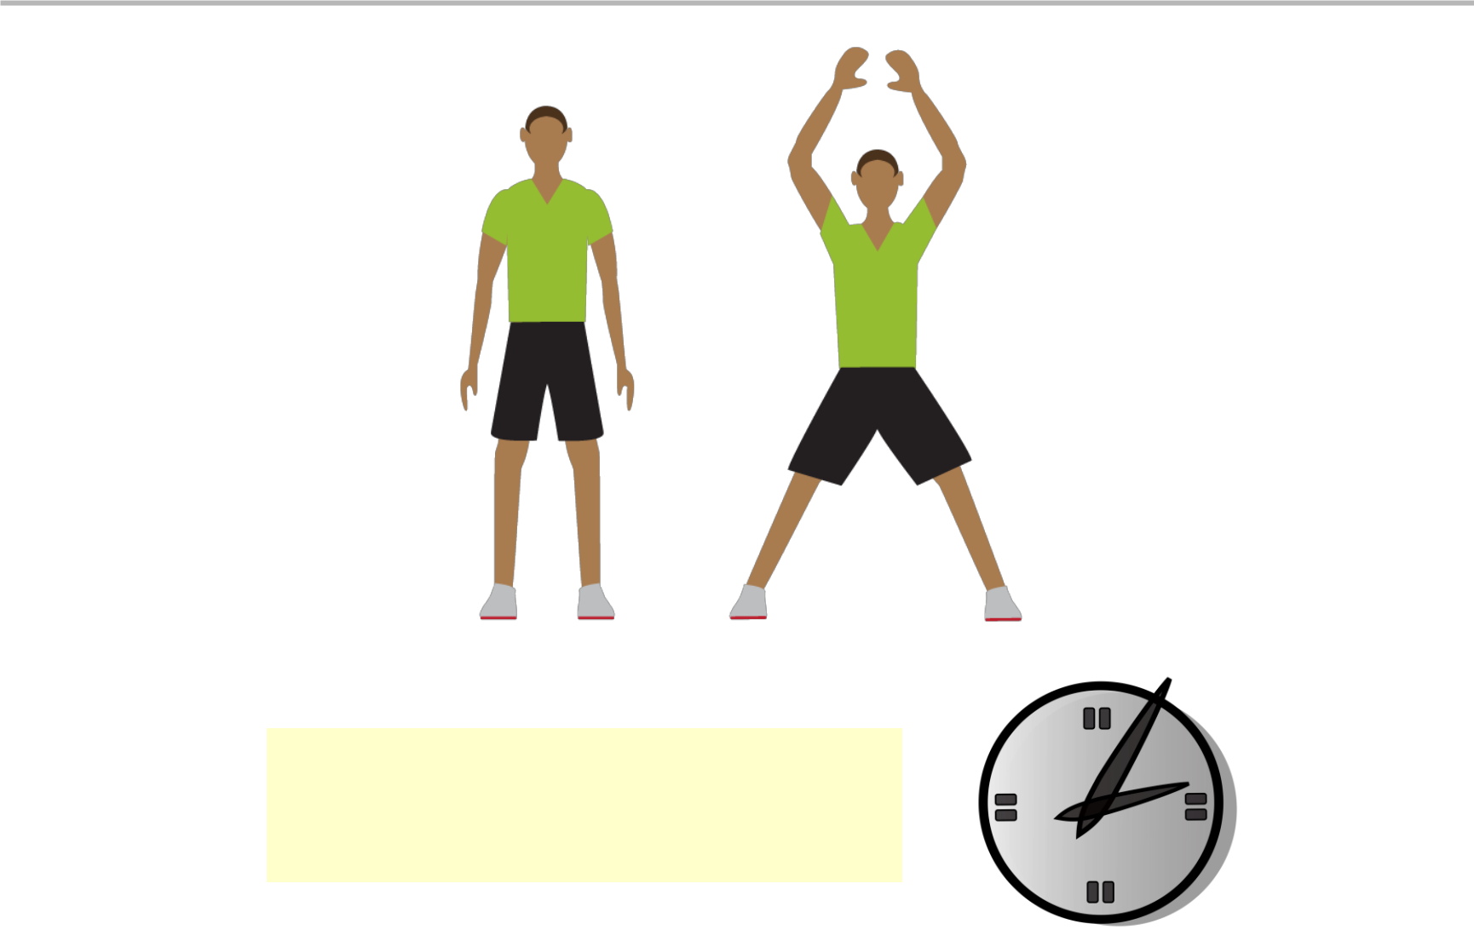

5 Minutes

Resource Sheet!

More info available
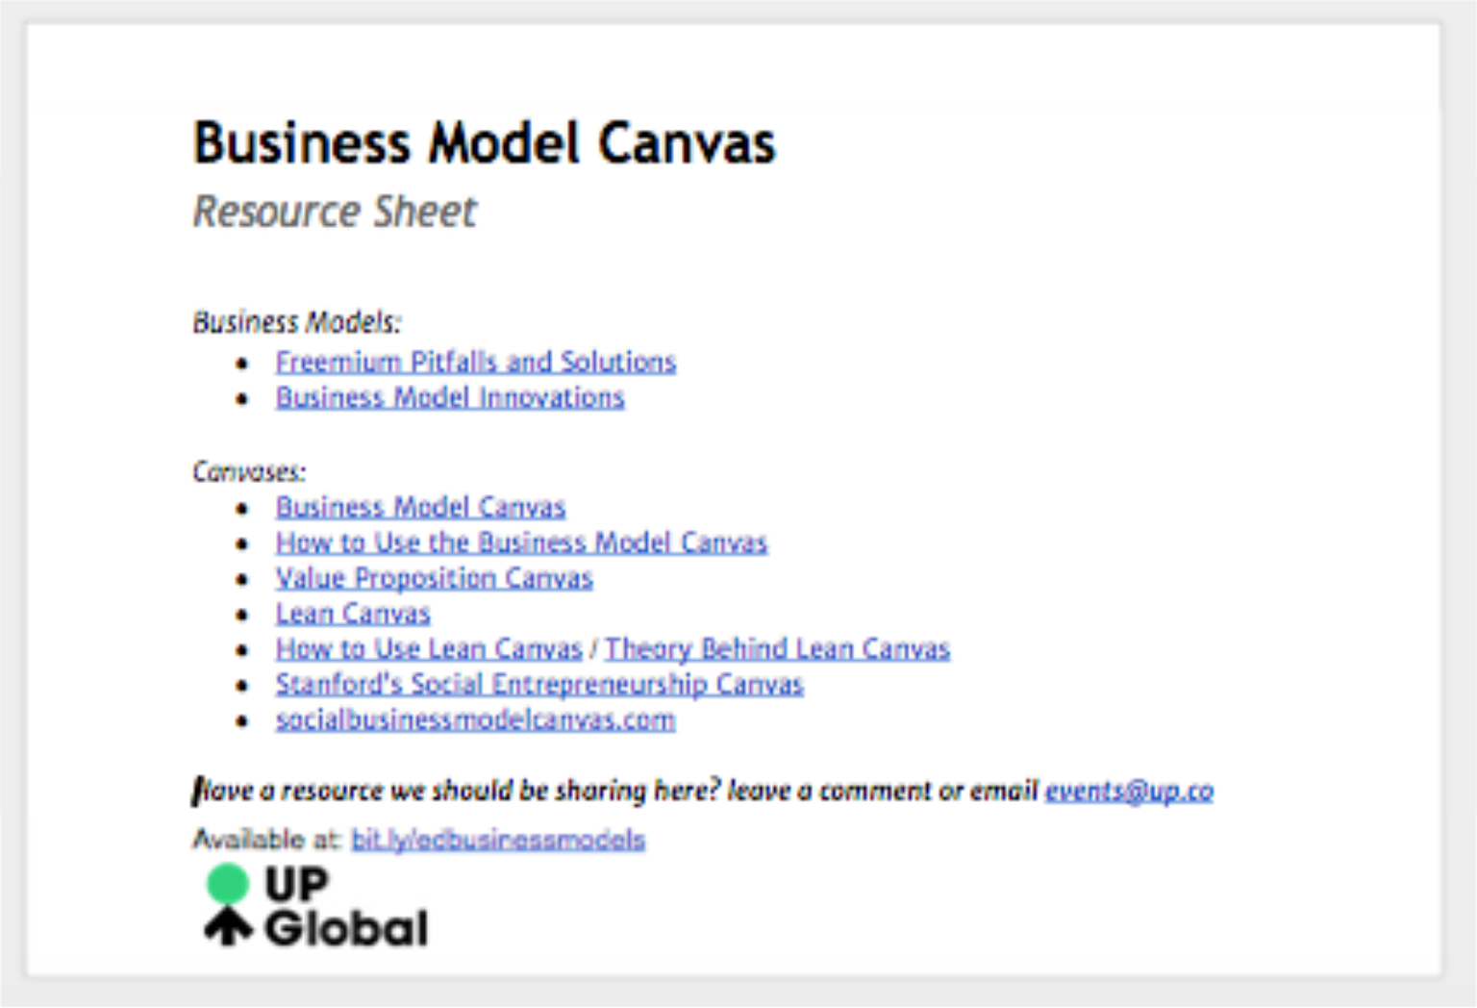
bit.ly/bmcresources
Survey

Last Page
Tear off and leave


