BUSINESS MODEL CANVAS

Arvydas Bložė



Origins


Alexander Osterwalder, PhD

Business Model Ontology, PhD thesis published in 2008

Business Model Generation, gorgeous visual book published in 2010

(would recommend to read into a story about this book was published)

Business Model Canvas was accepted to a lean startup framework

2

Business plan


Set of documents prepared by a firm's management to summarize its operational and financial objectives for the near future (usually one to three years) and to show how they will be achieved

3

Business model

Describes the rationale of how an organization CREATES, DELIVERS, and CAPTURES value, in economic, social, cultural or other contexts.

4

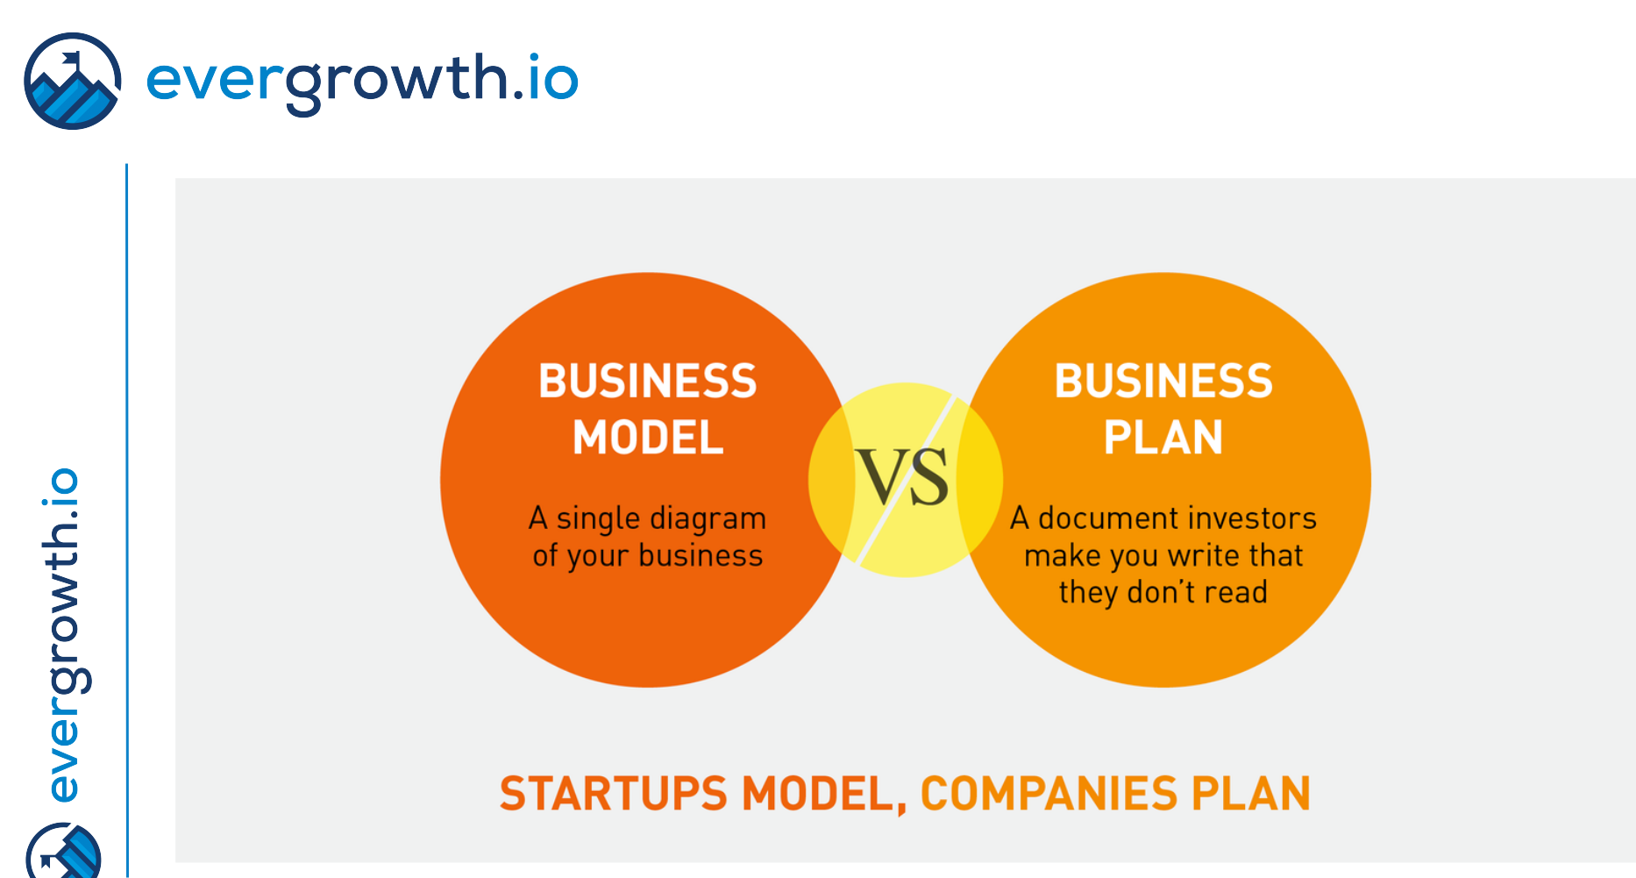

5
Business plan: startup angle

There is a problem with business plan and early stage startups. It can be by the case, that by time you finish the document, it might be already irrelevant. Or after one month in execution, your fundamental assumptions might be proven to be wrong.

6

Business model: startup angle

Business model also need to be tested You do not need a product to test it

Business model can differ according to customer segments

Prove that you are learning from failure and build once you know it is working

7

Business model canvas

A single reference model based on the similarities of a wide range of business model conceptualizations. With his business model design template, an enterprise can easily describe their business model.

Built on nine pillars:

- Value Propositions

- Customer Segments

- Channels

- Customer Relationships

- Revenue Streams

- Key Partners

- Key Resources

- Key Activities

- Cost Structure

8

Business model canvas

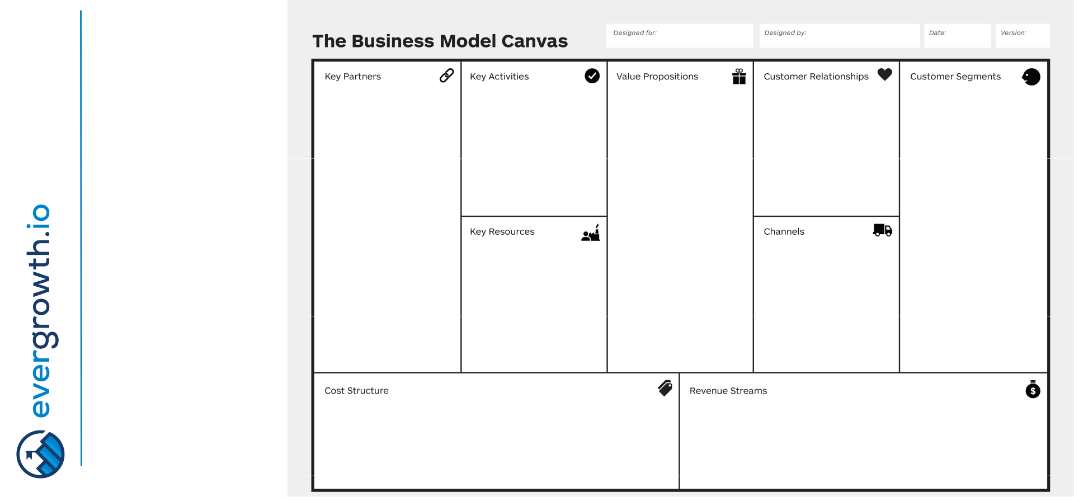

9

BMC: Value proposition

What is the client’s
problem, how
frequent and painful
it is for the client
How you alleviate
the pain and what is
the meaning that
you make, what
value do you create | BENEFIT
How can it be
measured, can you
calculate ROI for
your client
“Cheaper” is not a
sufficient value
proposition
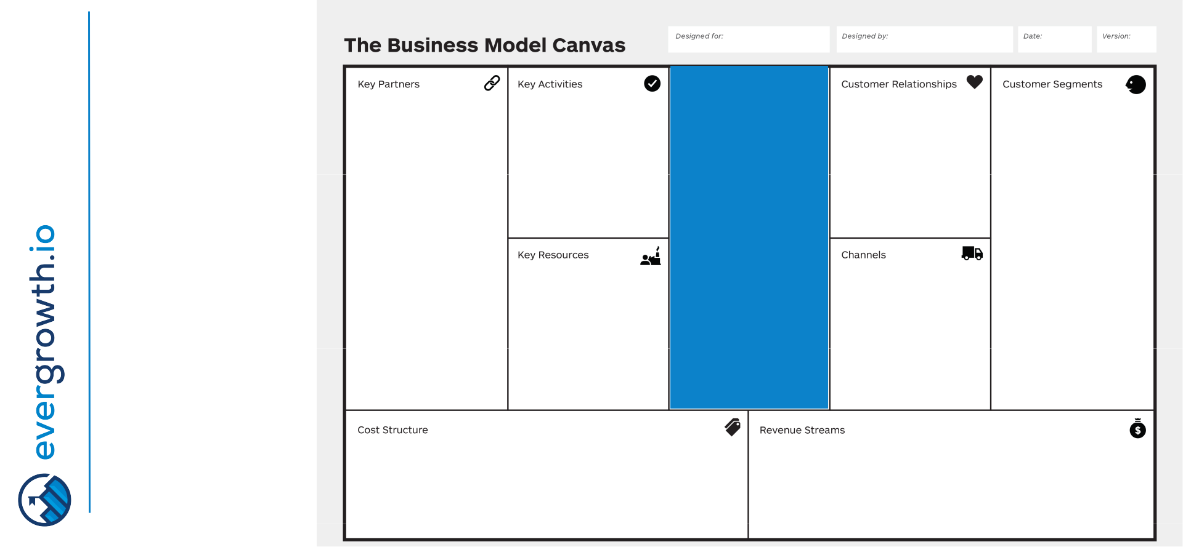

Not to focus on

- product or service, no feature pitch
BMC: Customer Segments
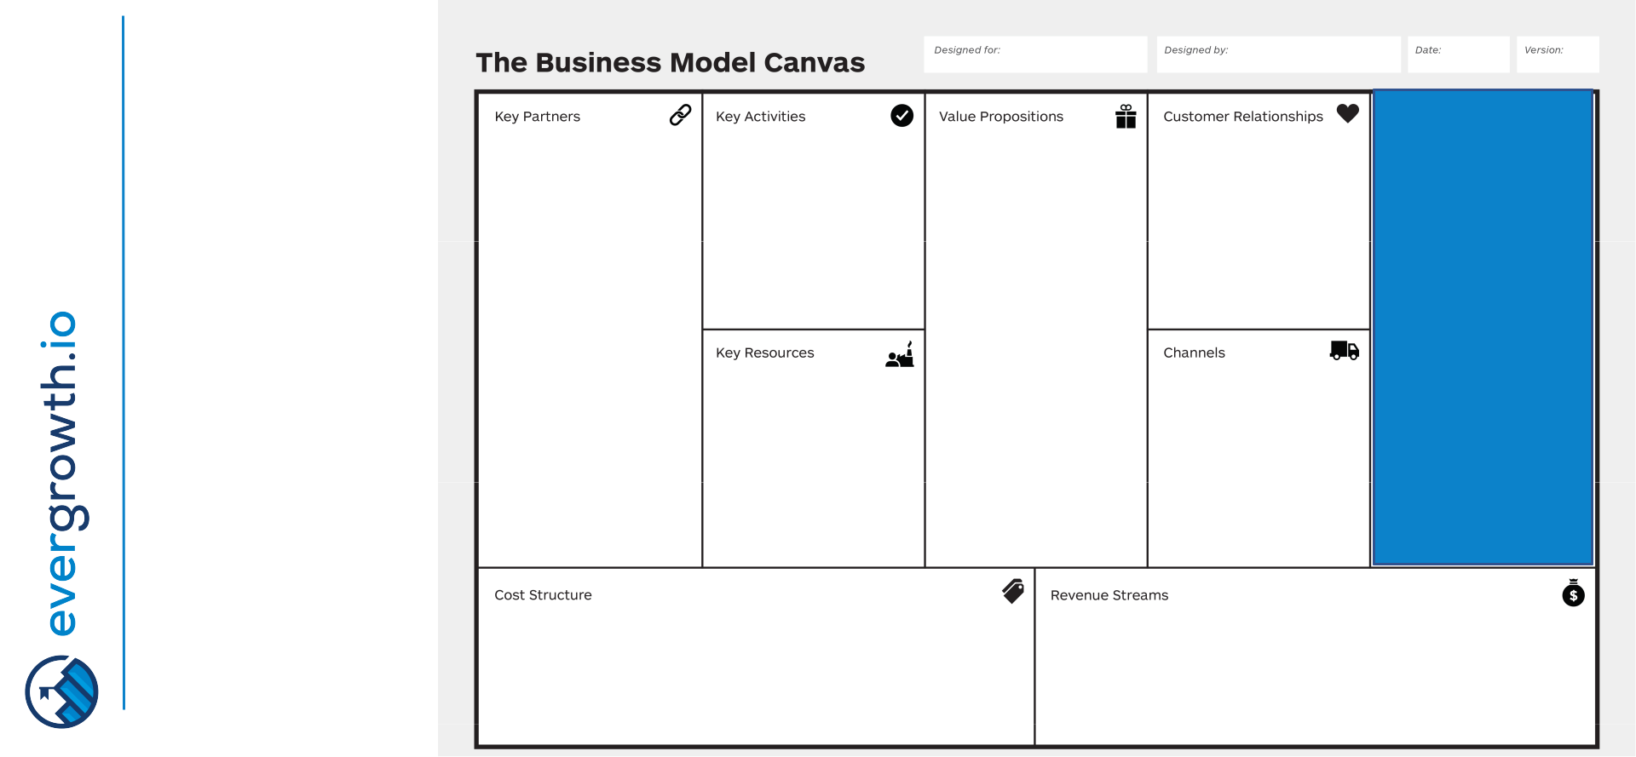

For whom are you creating value?

Who has the

problem?

Who is willing to pay?

BENEFIT WHO

Provide attributes for customers, different profiles (size, vertical, geography, size, operations, etc)

11

BMC: Channels
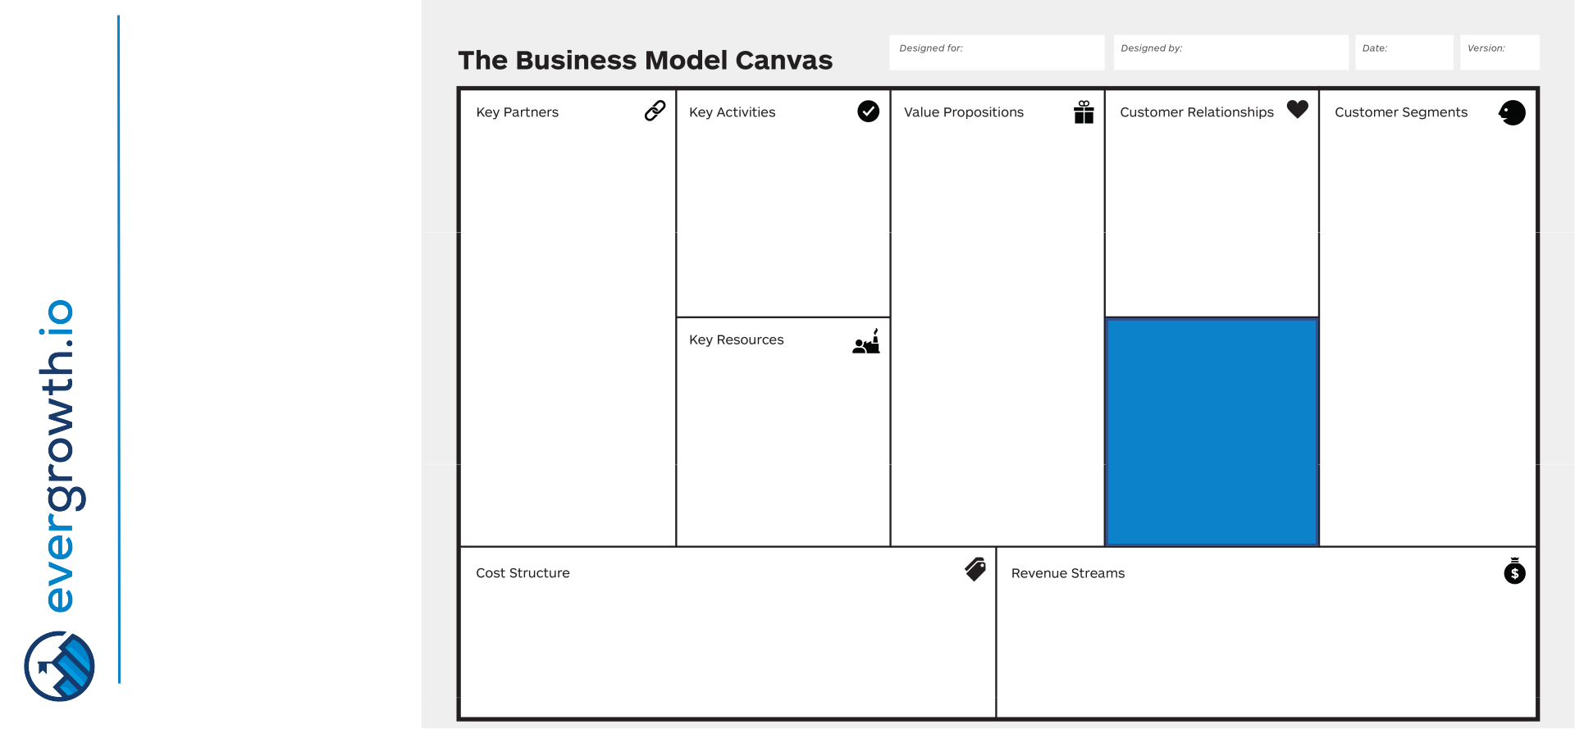

12

How the customers will get to know about your value proposition? What are the touch-points?

Direct / indirect

Which channels work best, which are cost-efficient? How are you integrating with customer routines?

Map out value chain of the market with all stakeholders. Who can be your agents, distributors, etc?

BENEFIT WHO

INTERACTION

BMC: Customer relationships
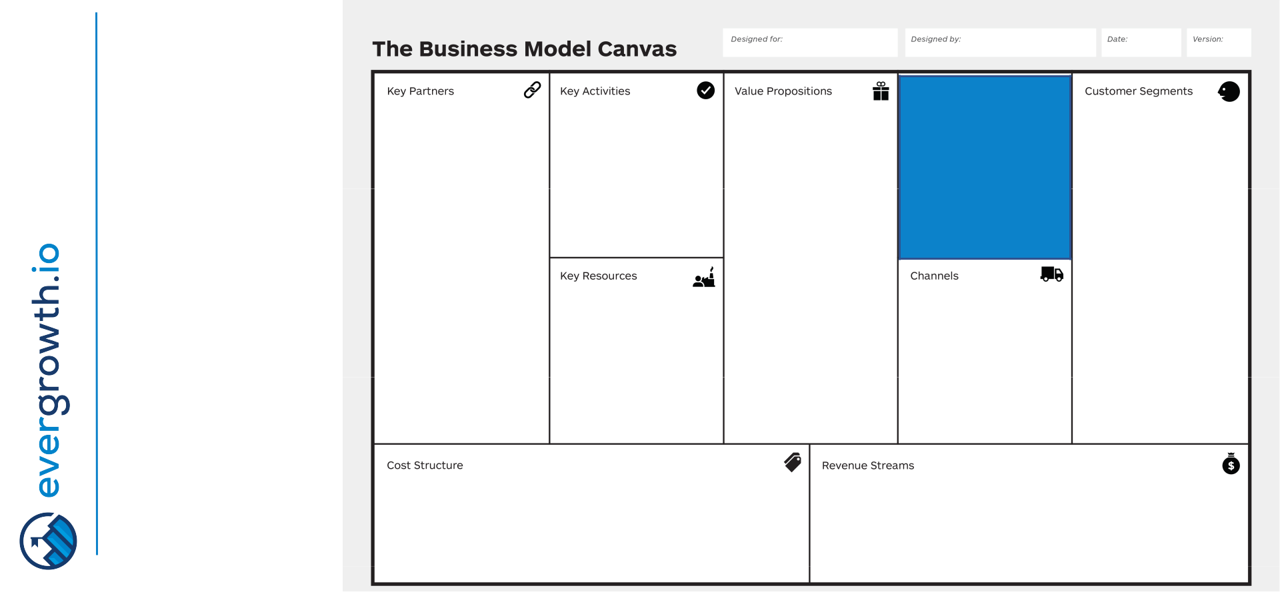

What kind of relationship does any customer segment expect us to establish?

Transactional / Long-

Term / Personal

assistance / Self-

service / Automated

Service /

Communities / Co-

creation / Switching

costs

Relationships are established through Channels

Aim to acquire,
- retain or boost sales

RELATIONSHIP

BENEFIT WHO

INTERACTION

BMC: Revenue streams
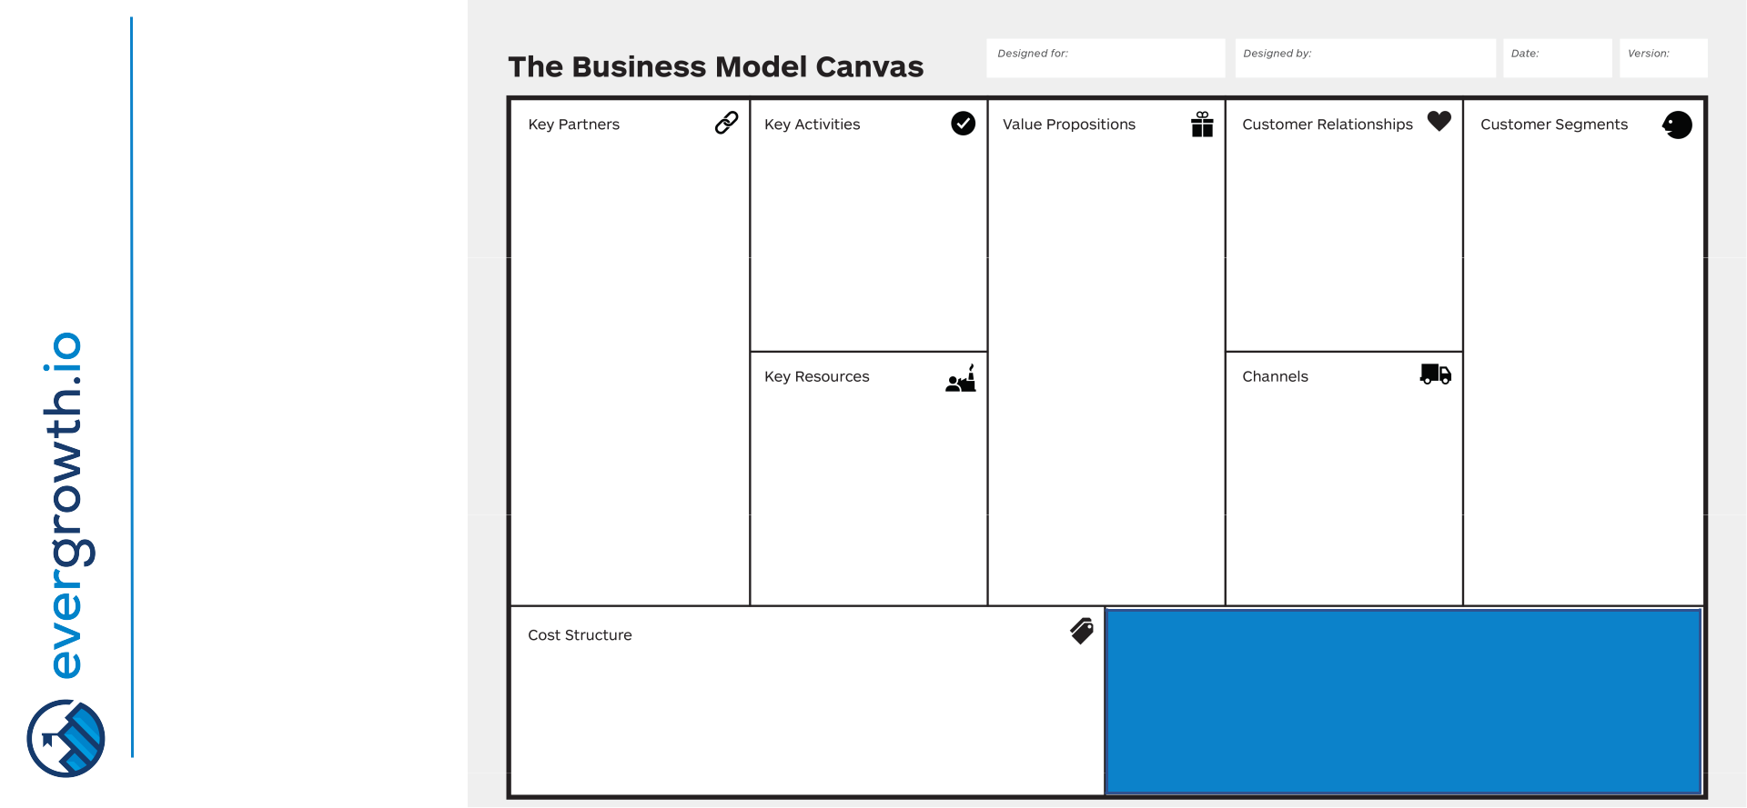

For what value customers are willing to pay? Potential for product packaging

Revenue streams, pricing mechanisms

Asset sale / Usage fee / Subscription / Lending, Renting, Leasing / Licensing / Brokerage fees / Advertising

14

RELATIONSHIP

BENEFIT WHO

INTERACTION

GETTING PAID

BMC: Front vs Back office
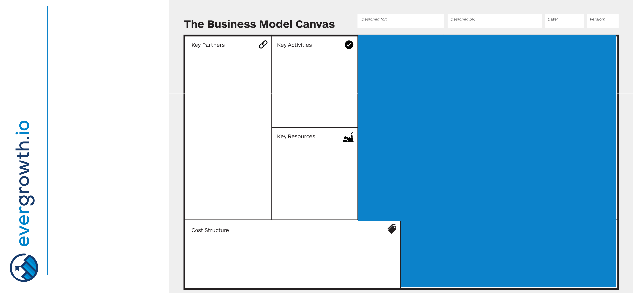

15

BMC: Front vs Back office

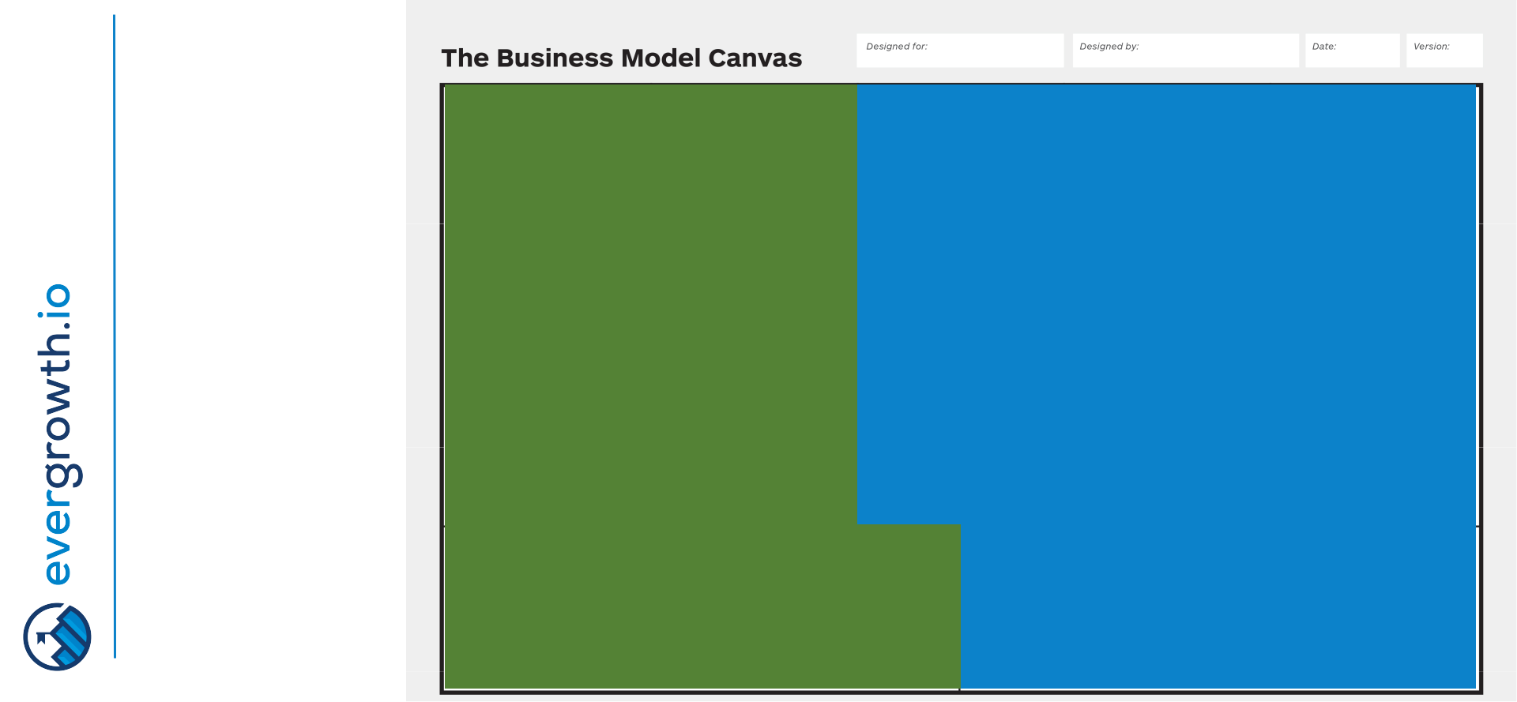

THE

FRONT

OFFICE

16

BMC: Key activities
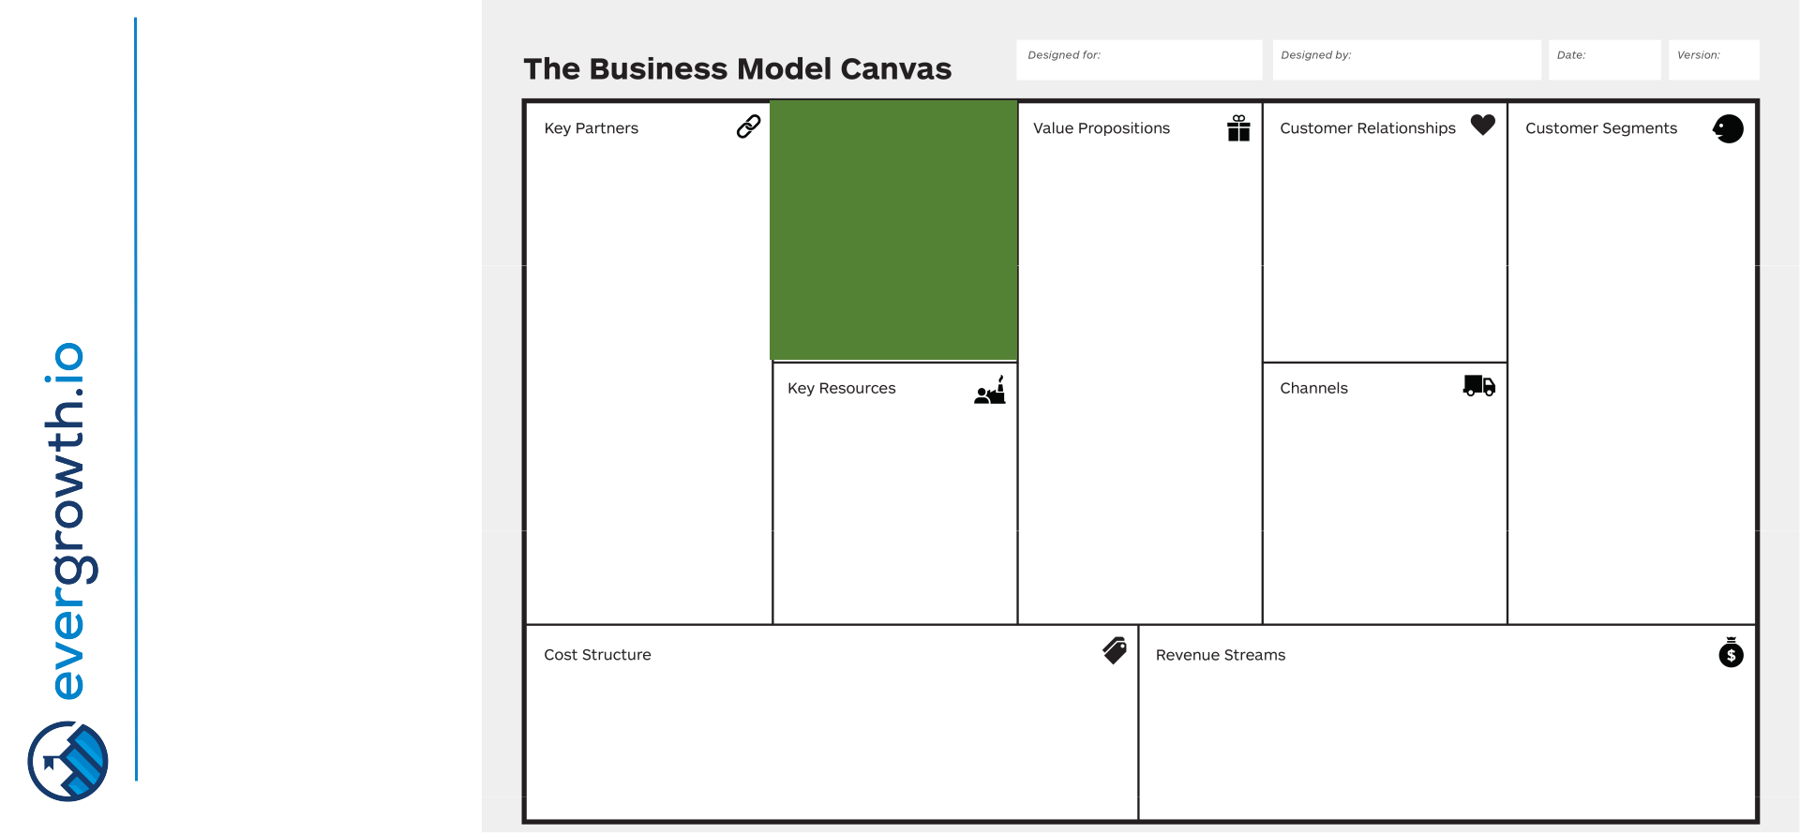

What key activities | DO | RELATIONSHIP
required by our
value proposition,
distribution | BENEFIT | WHO
channels, customer | BENEFIT | WHO
relationships,
revenue streams? |  | INTERACTION
Production / |  | INTERACTION
Problem Solving /
Platform or Network

GETTING PAID

17

BMC: Key resources
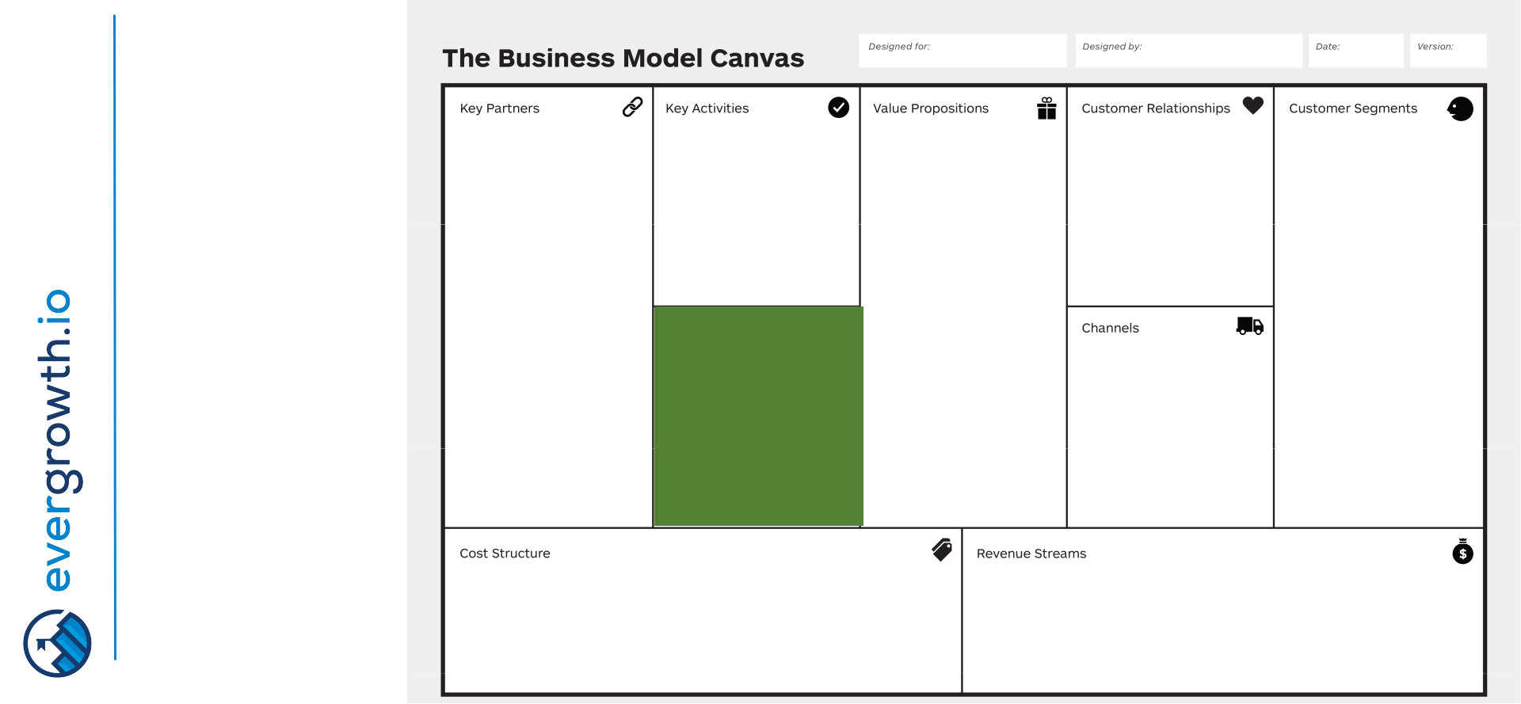

What key resources | DO |  | RELATIONSHIP
required by our | DO |  | RELATIONSHIP
value proposition,
distribution |  | BENEFIT | WHO
channels, customer |  | BENEFIT | WHO
relationships,
revenue streams?
Physical / | HAVE |  | INTERACTION
IP /
Human /
Financial
 |  |  | GETTING PAID

18

BMC: Key partners
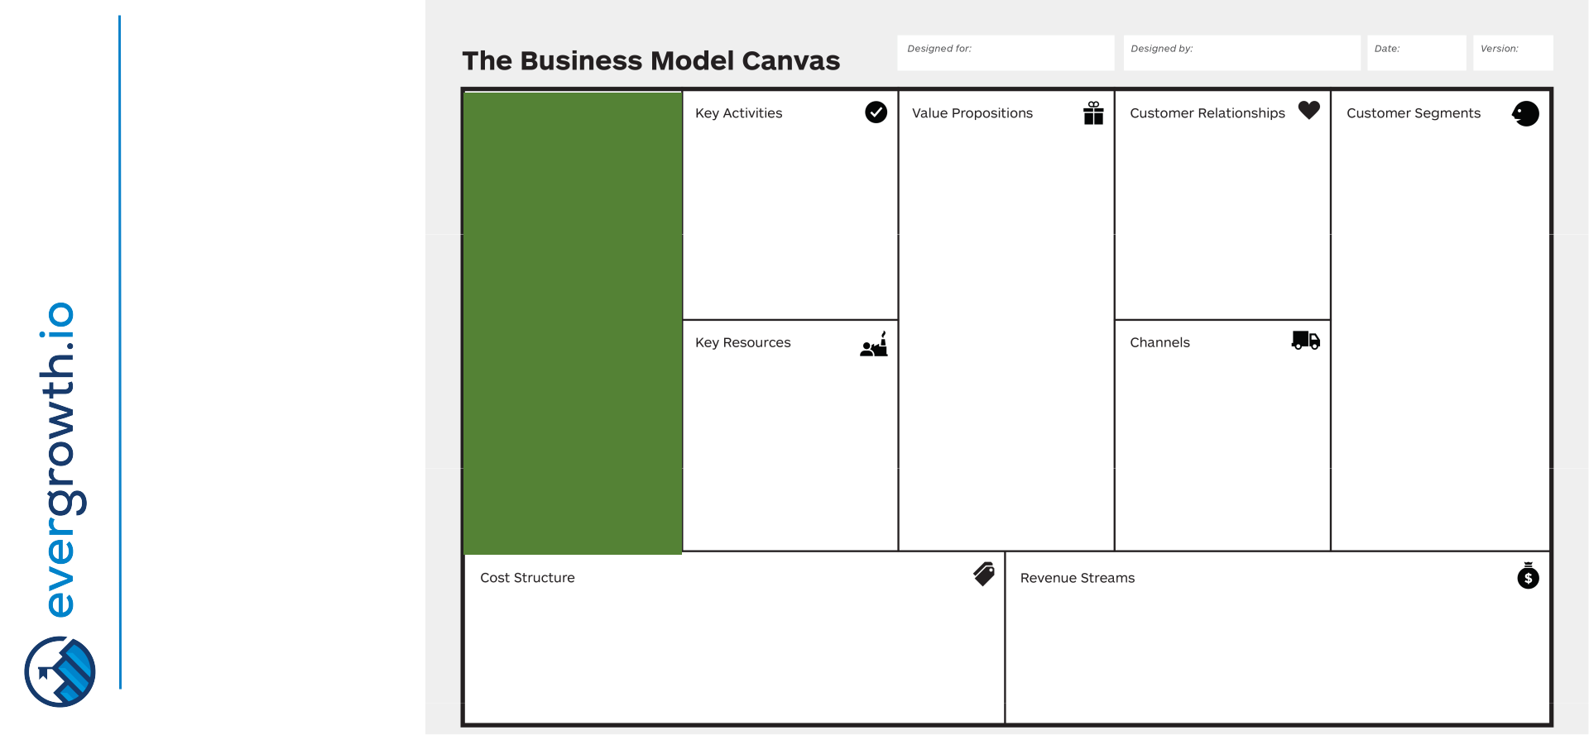

Network of suppliers
and partners to
make business
model work | DO |  | RELATIONSHIP
What key resources | DO |  | RELATIONSHIP
are we acquiring
from suppliers, what | HELP | BENEFIT | WHO
key activities are | HELP | BENEFIT | WHO
partners performing
for us? | HAVE |  | INTERACTION
Optimization and | HAVE |  | INTERACTION
economies of scale /
Reduction of risk and
uncertainty /
Acquisition of
particular resource |  |  | GETTING PAID
and activities |  |  | GETTING PAID

19

BMC: Cost structure
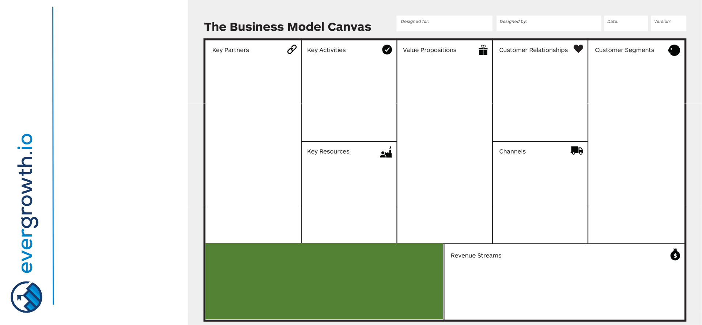

Most important
inherent costs | DO |  | RELATIONSHIP
What key resources | DO |  | RELATIONSHIP
are most expensive?
What key partners are | HELP | BENEFIT | WHO
most expensive?

Cost or value driven?

Economies of scale /

Economies of scope /

Fixed costs /

Variable costs

^{HAVE} INTERACTION

PAYING GETTING PAID

20

BMC: Closing remarks

Exercise and | DO |  | RELATIONSHIP
discussion between
team members should
be very detailed but | HELP | BENEFIT | WHO
end result should be | HELP | BENEFIT | WHO
high level
Iterate, search and | HAVE |  | INTERACTION
validate before
building

PAYING GETTING PAID

21

Business model canvas
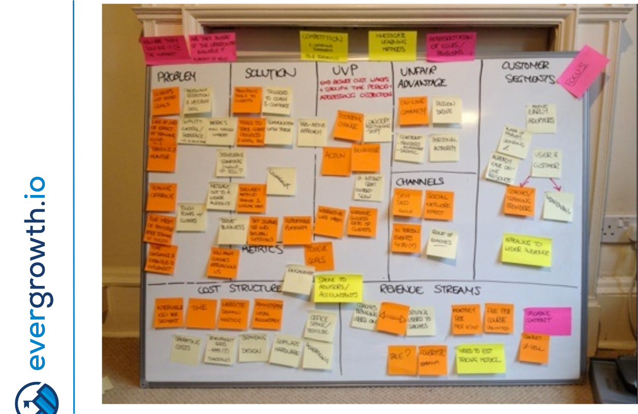

22

