Concealed

closer series

Product selection guide

The concealed LCN closers feature a modern design for concealment in either the head frame or top rail of the door. This guide is based on the desired mounting of the closer.

EXTERIOR
DOOR

 |  | CONCEALED |  |  |  |  |  |  |  |  |  |  | CONCEALED IN
 |  | IN FRAME |  |  |  |  |  |  |  |  |  |  | TUBE FRAME
 | DOUBLE |  |  |  |  |  |  | SINGLE |  |  |  | DOUBLE |  |  |  |  |  | SINGLE
 | LEVER ARM |  |  |  |  |  | LEVER ARM |  |  |  |  | LEVER ARM |  |  |  |  |  | LEVER ARM
5010 |  |  |  |  |  | 2010 2210** |  |  |  |  | 5030 |  |  |  |  |  | 2030 |  |  | 6030

INTERIOR
DOOR

 |  | CONCEALED |  |  |  |  |  |  |  |  |  |  | CONCEALED IN |  |  |  |  |  |  |  |  |  |  |  | CONCEALED
 |  | IN FRAME |  |  |  |  |  |  |  |  |  |  | TUBE FRAME |  |  |  |  |  |  |  |  |  |  |  | IN DOOR
 | DOUBLE |  |  |  |  |  |  | SINGLE |  |  |  | DOUBLE |  |  |  |  |  | SINGLE |  |  |  |  |  | DOUBLE |  |  |  |  |  | SINGLE
 | LEVER ARM |  |  |  |  |  | LEVER ARM |  |  |  |  | LEVER ARM |  |  |  |  |  | LEVER ARM |  |  |  |  |  | LEVER ARM |  |  |  |  |  | LEVER ARM
5010 |  |  |  |  |  | 2010 2210** |  |  |  |  | 5030 |  |  |  |  |  | 2030 |  |  | 6030 |  |  | 3030 |  |  |  |  |  | 3130 |  |  | 3130SE***

- INDICATES HIGH SECURITY CLOSER, DOOR POSITION SWITCH OPTIONAL. REFER TO HIGH SECURITY SECTION OF THE CATALOG.

- INDICATES FIRE LIFE SAFETY CLOSER. REFER TO FIRE LIFE SAFETY SECTION.

Product comparison

This chart shows a basic comparison of LCN concealed closers. Refer to the specific closer chapter for complete details.

 |  |  |  |  |  |  | CONCEALED
 |  |  |  |  |  |  | MOUNTING |  | FINISH | CYLINDER |  |  | ARM | *ARM FUNCTION
 |  |  |  | -3/4˝ |  | TUBE |  | COAT |  |  | ACTION |  |  | (SINGLE)
CLOSER |  | FRAME |  |  |  |  | DOOR | POWDERPLATED | HANDEDSIZED | DELAYED |  | EXPOSED | STANDARD | -OPEN
CLOSER | IN | FRAME |  |  | IN |  |  |  |  |  |  | EXPOSED | STANDARD | HOLD
 | IN | IN |  |  |  |  |  | POWDERPLATED | HANDEDSIZED | DELAYED |  | EXPOSED | STANDARD | HOLD
SERIES |  |  | 1
SERIES |  |  |  |  |  |  |  |  |  |  |  |  | 180° | 110°
2010 |  |  |  |  |  |  |  |  |  |  |  |  | 180° | 110°
2030 |  |  |  |  |  |  |  |  |  |  |  |  | 180° | 110°
3030 |  |  |  |  |  |  |  |  |  |  |  |  | 180° | 140°
3130 |  |  |  |  |  |  |  |  |  |  |  |  | 140° | 100°
5010 |  |  |  |  |  |  |  |  |  |  |  |  | 180° | 100°
5030 |  |  |  |  |  |  |  |  |  |  |  |  | 180° | 100°
6030 |  |  |  |  |  |  |  |  |  |  |  |  | 95° | 95°
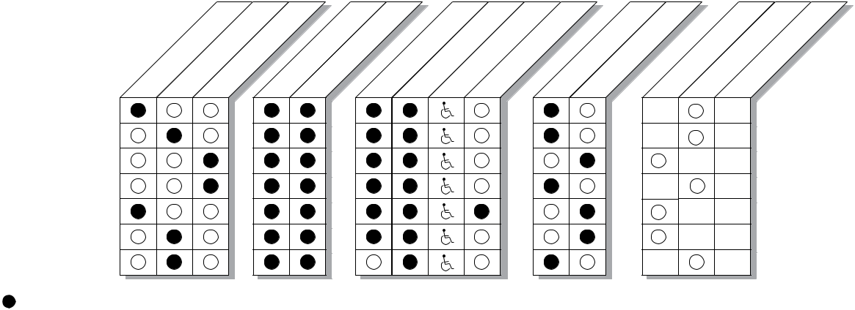

AVAILABLE | Closer available with less than 5.0 lbs. opening force on 36˝ door.
NOT AVAILABLE
NOT AVAILABLE | * Maximum opening/hold-open point with standard template. See individual closer series for degrees of opening per
 | installation.
 |  | D1
 | LCN Door Control Catalog | D1


phone: 877-671-7011 n fax: 800-248-1460 n www.allegion.com/us n 009426 rev. 11/16

Concealed

closer series

APPLICATIONS
- For aluminum, hollow metal, or wood doors and frames.

- Can be used with hinge or pivot mounted door.

- Closers for 4˝ or minimum 1-3/4˝ head frame or 4˝ top rail.

- Mounting clips for wood frames and other installation accessories available for unusual conditions.
- For concealed in door closers consult factory for installations with pivots.

FEATURES COMMON TO CONCEALED CLOSERS

- Mountings for head frame or door top rail.

- Handed for right or left swinging doors. (except 6030)

- Closers to meet ADA reduced opening force requirements.

- Adjustable hydraulic backcheck cushions opening swing prior to 90°.

- Separate regulation of general closing speed and latching speed.

- Joints in arm and shoe adapt to uneven trim. (for double lever arms)

DESIGN ASSISTANCE

LCN has been providing reliable solutions to unique door control problems since 1925. Design and specification assistance are only a phone call away. Contact LCN for assistance or technical information at 877-671-7011

or FAX 800-248-1460 (Order Entry), Fax 815-879-1495 for Product Support.

WARRANTY

15 year limited warranty. See General Information Section for complete warranty details.

SPECIFICATIONS

Refer to “SPECIFICATIONS”section for suggested architectural specifications.

MATERIALS

(Closers concealed in the door or frame)

- High strength cast iron cylinder.

- Forged steel main arms (except 6030).

- One piece forged steel piston.

- All weather fluid in overhead concealed models performs to temperature ranges from 120°F (49°C) to -30°F (-35°C) without any seasonal adjustment.

- High efficiency, full complement, low friction bearings.

- Tamper resistant regulating screws.

- Full rack and pinion hydraulic action.

- Quiet, low friction track and roller combination for all single lever (standard) arm closers.

FINISHES
- Available in six standard or a wide selection of optional custom powder coat finishes to blend with door and frame.
- LCN’s powder coat finishes surpass 100 hours of salt spray which is over four times the ANSI standard for corrosion resistance.
- For installations where a higher level of corrosive resistance is required, LCN offers an optional special rust inhibiting (SRI) pre-treatment. Closers that combine the exclusive LCN powder coat finish and the SRI pre-treatment exceed the ANSI standard for corrosion resistance even further.

- Plated finishes are available as an option to accent door and frame. (SRI not available with plated finishes)

LISTINGS & APPROVALS

UL listed for self-closing doors without hold-open under “SWINGING DOOR CLOSERS” (GVEV) file R 1943.

Tested and certified under ANSI Standard A156.4. Consult factory for details.

Consult factory for other listings such as; cUL, California State Fire Marshal, Bureau of Standards and Appeals.
POSITIVE PRESSURE 
LCN closers have been certified for three hours by UL to be in compliance with UL 10 C. Contact LCN for specific details on door closer fire ratings.
FASTENERS

Standard WOOD and MACHINE SCREW (WMS) pack contains phillips head wood and machine screws to install the closer. TORX machine screws are available for some closers.

Note 1: Phillips head, metric machine screws are available, please specify.

MAINTENANCE

Closers mounted according to LCN installation instructions require no periodic maintenance or adjustments.

^{D2} LCN Door Control Catalog

phone: 877-671-7011 n fax: 800-248-1460 n www.allegion.com/us n 009426 rev. 11/16

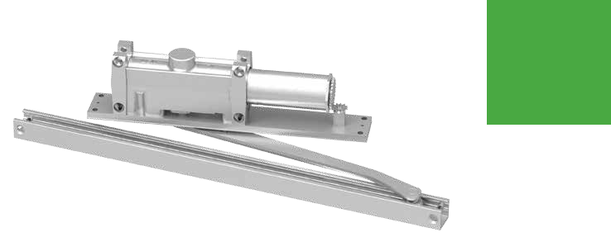
2010

Series

Features

The concealed 2010 Series is a heavy duty closer designed to provide complete concealment. The single lever arm and roller assembly provide smooth, quiet door control and the choice of finishes and track functions meet virtually all architectural requirements.

Certifications | Grade 1 - ANSI A156.4, UL 10 C, ADA, 100 Hour
 | Salt Spray, Meets BAA - Buy American Act
Body Construction | n | Cast Iron Body
 | n | Full Complement Bearing
 | n | 1-1/2˝ Diameter Piston
 | n | 11/16˝ Diameter Double Heat Treated
 |  | Pinion Journal
Fluid | All Weather Fluid
Handing | Handed
Size | Sized 1-6
Warranty | 15 years

Fasteners | Wood and Machine Screw Pack
Mounting | Concealed (in frame); aluminum frame
 | requires minimum 4˝ x 4˝ (102 mm) tube
Arms | Standard arm and track
Finishes/Colors/ | n | Aluminum (689)
Powder Coat | n | Statuary Bronze (690)
 | n | Light Bronze (691)
 | n | Black (693)
 | n | Dark Bronze (695)
 | n | Brass (696)
 | n | Custom colors optional
 | n | Optional SRI primer - powder coat only
 | n | Optional plated finishes

Special Customized installation templates or products may be available to solve unusual applications.

Templates Contact LCN Product Support for assistance.

 |  |  |  | CONCEALED
 |  |  |  | MOUNTING |  | FINISH | CYLINDER |  |  | ARM | *ARM FUNCTION
 | -3/4˝ |  | TUBE |  | COAT |  |  | ACTION |  |  | (SINGLE)
 |  |  |  | DOOR |  |  |  |  |  |  | -OPEN
IN | FRAME 1 | IN |  | DOOR | POWDERPLATED | HANDEDSIZED | DELAYED |  | EXPOSED | STANDARD | HOLD
IN | IN |  |  |  | POWDERPLATED | HANDEDSIZED | DELAYED |  | EXPOSED | STANDARD | HOLD
 |  |  |  |  |  |  |  |  |  | 180° | 110°
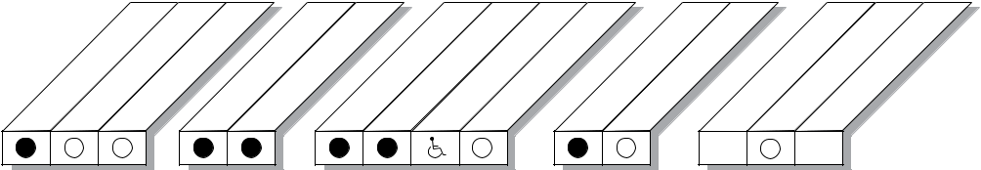

AVAILABLE | Closer available with less than 5.0 lbs. opening force on 36˝ door.
NOT AVAILABLE
NOT AVAILABLE | * Maximum opening/hold-open point with standard template. See individual closer series for
 | degrees of opening per installation.
 |  | D3
 | LCN Door Control Catalog | D3

phone: 877-671-7011 n fax: 800-248-1460 n www.allegion.com/us n 009426 rev. 11/16

2010

Series

Mounting details
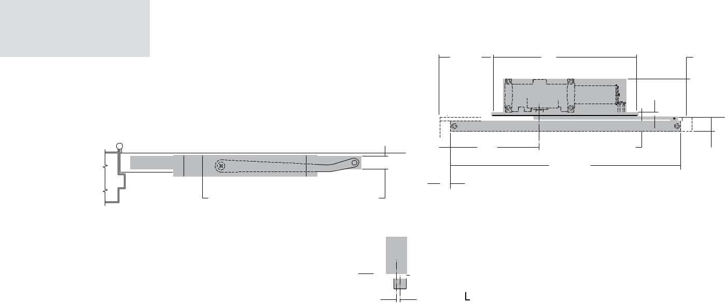

Concealed
Mounting

 |  | 5-5/16" | 14" |  | 3-5/8"
 |  | 135 mm | 14" |  | 92 mm
 |  | 135 mm | 356 mm |  | 92 mm
 |  |  |  |  | 3/8"
 |  |  |  |  | 10 mm
 |  | 10" |  | 1-1/16"
 |  | 254 mm |  | 27 mm | 1-3/8"
 |  |  | 22-1/2" |  | 35 mm
 |  | 1" | 572 mm
2-1/16" | 1-1/4" | 25 mm
52 mm | 32mm

1/4"
6mm

of Track
to of Closer

Butt Hinges | Should not exceed 5˝ (127 mm) in width
Auxiliary Stop | n | Recommended where a door cannot swing 180°
 | n | Optional track bumper assembly assists backcheck in cushioning the opening swing of the door (not intended to
 |  | replace an auxiliary stop).
Top Rail | n | 1-3/8˝ (35 mm) mortise required
 | n | With Fire Shield, 1-13/32˝ (36 mm) mortise required
 | n | 5/16˝ (8 mm) cutout required at top of the door, stop face only
Door Thickness | 1-3/4˝ (44 mm) minimum
Hollow Metal Frame | Consult factory for installation instructions
Maximum opening | n | Butt hinge template allows 180°, trim permitting
 | n | Limited to 110° when optional bumper is installed
 | n | Adjustable hold-open points from 85° to 110°, with hold-open track
 | n | Offset pivot template allows 110°, trim permitting
 | n | Limited to 95° when optional bumper is installed
 | n | Adjustable hold-open points from 75° to 95°, with hold-open track
 | n | Center pivot template allows 120°, trim permitting
 | n | Limited to 95° when optional bumper is installed
 | n | Adjustable hold-open points from 75° to 95°, with hold-open track

Notes:

- For interior or exterior doors

- Single acting cylinder in head frame

- Concealed arm and track in door top rail

D4


LCN Door Control Catalog

phone: 877-671-7011

n fax: 800-248-1460

n www.allegion.com/us

n 009426 rev. 11/16

2010

Series

Accessories
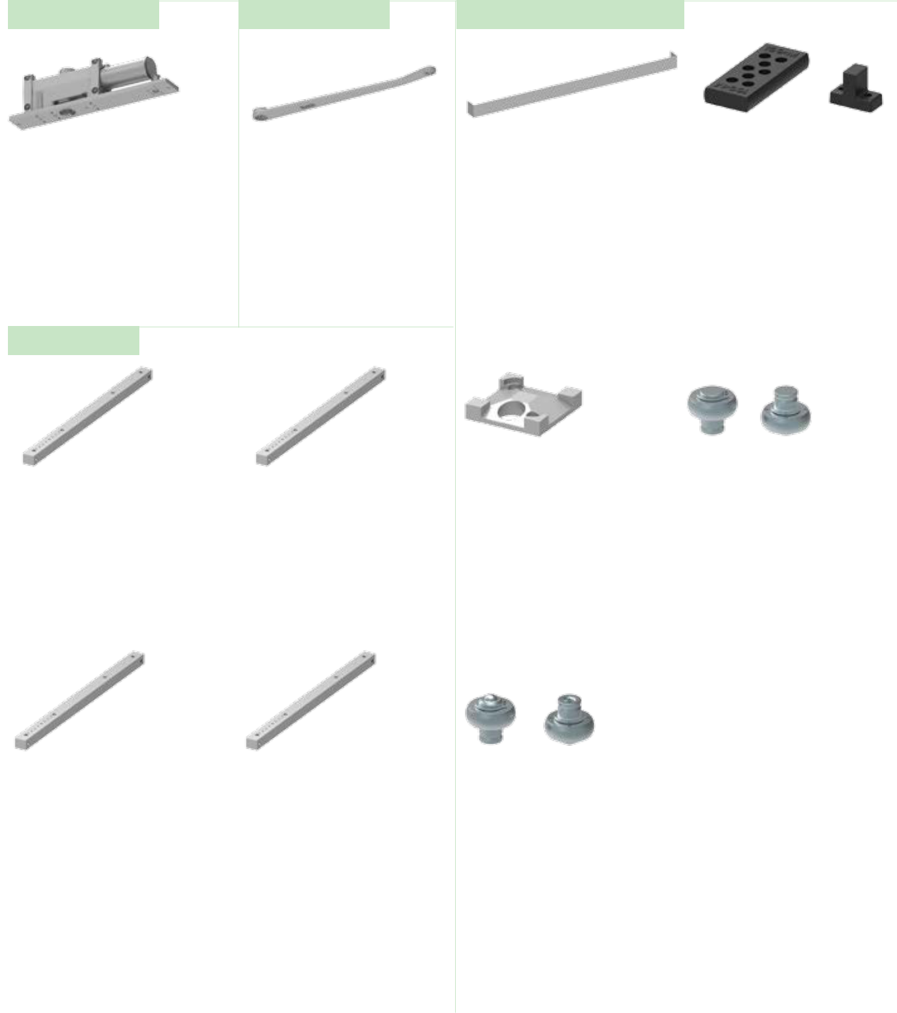

Cylinders

Arm

Installation Accessories

2011(3)(4)(5)(6)-3071 Cast Iron Cylinder Assembly

- Handed

- With mounting plate

- Standard

2010-3077T
Standard Arm

- Handed

- Track roller not included with arm

2010-420
Fire Shield

- 22 gauge steel liner mounts in the track mortise of the door’s top rail for 20 minute labeled wood doors

2010-169
Track Bumper

- Mounts in track to assist backcheck

- Limits maximum opening

- Consists of bumper, bumper post, and mounting screw

NOTE: Track bumper does not replace auxiliary stop.

Tracks

2010-3038
Standard Track

- Non-handed

- Non hold-open

- Will accept hold-open clip and/or bumper assembly.

- Standard

2010-3038H
Hold-Open Track

- Non-handed

- Will accept bumper assembly

- Optional

2010-3038B
Standard Track with Bumper

- Non-handed

- Non hold-open

- Will accept hold-open clip

- Optional

2010-3038HB
Hold-Open Track with Bumper

- Non-handed

- Optional

2010-3054
Hold-Open Clip

- Mounts in track to provide hold-open function

- Hold-open point controlled by clip location

- Requires 2010-3034H

2010-3034H
Hold-Open Track Roller

- Quiet, low friction roller assembly

- Shoulder dimension “X” = 1/16˝ (2mm)

2010-3034
Track Roller

- Quiet, low friction roller assembly

- Shoulder dimension “X” = 1/16˝ (2mm)

LCN Door Control Catalog | D5
phone: 877-671-7011 n fax: 800-248-1460 n www.allegion.com/us n 009426 | rev. 11/16

2010

Series

Ordering Information

How-to-order 2010 Series closers
 |  |  | Closer will be shipped with:
Table of sizes |  |  | - Standard cylinder with finish plate
n | Select closer based on width of door. |  | - Standard arm
n | 2010 Series cylinders available in size 1, 3, 4, 5, or 6. |  | - Standard track
n | Closing power of all 2010 Series closers may be increased 15%. |  | - Wood and machine screw pack
n | Specify next higher size closer where strong drafts exist. |  | unless options listed below are selected.

Select cylinder size | Select hand
2011 | RH
2013 | LH
2014 | Specify finish
2015 | Specify finish
2016 | Standard Powder Coat __________
 | Aluminum, Dark Bronze, Statuary, Light Bronze, Black, Brass.
Closer options
Tracks | Installation accessories
Standard with Bumper (BUMPER) | Fire Shield, 2010-420
Hold-open (H)
Hold-open with Bumper (HBUMPER)
Finishes
Custom Powder Coat (RAL)_____________
Plated Finish, US ______________

SRI primer (use with powder coat finishes only)

Screw pack | Special template
TORX Machine Screw (TORX) | ST- ________

Exterior (and Vestibule) door width Interior door width
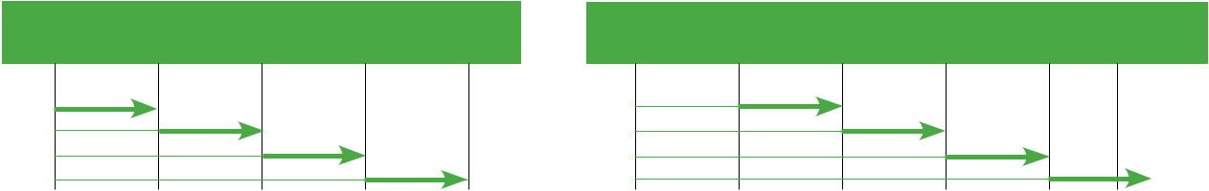

28˝ | 30˝ | 36˝ |  | 42˝ | 48˝ | 28˝ | 34˝ | 38˝ | 48˝ | 54˝ | 60˝
711mm | 762mm | 914mm | 1067mm |  | 1219mm | 711mm | 864mm | 965mm | 1219mm | 1372mm | 1524mm
2013 | size 3 | size 4 | size 5 | size 6 |  | 2013 | size 3 | size 4 | size 5 | size 6
2014 |  |  |  |  |  | 2014
2015 |  |  |  |  |  | 2015
2016 |  |  |  |  |  | 2016

Minimum door width |  | Minimum door width
 |  | Indicates recommended range of door width for closer size.


Reduced opening force 2010 Series closers

CAUTION ! Any manual door closer, including those certified by BHMA to conform to ANSI Standard A156.4, that is selected, installed and adjusted based on ADA or other reduced opening force requirements may not provide sufficient power to reliably close and latch a door.

Refer to POWER OPERATORS section for information on systems that meet reduced opening force requirements without affecting closing power.

* Maximum opening force.

DOOR WIDTH | 36˝ | 42˝ | 48˝
8.5* lbs. | 2014 | 2014 | 2015
5.0* lbs. | 2011 | 2011 | 2013

^{D6} LCN Door Control Catalog

phone: 877-671-7011 n fax: 800-248-1460 n www.allegion.com/us n 009426 rev. 11/16

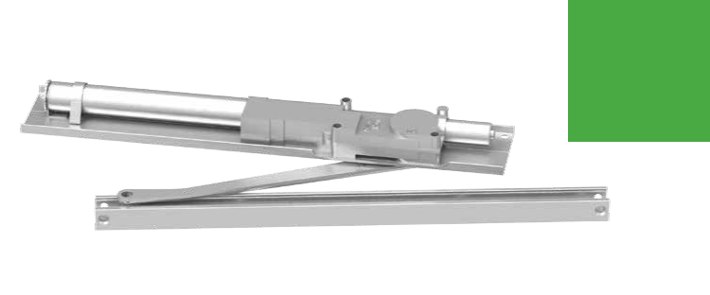
2030 Series

Features

The concealed 2030 Series PACER® is a heavy duty closer designed to fit in a narrow, minimum 1-3/4˝ aluminum transom. The single lever arm and roller assembly provide smooth, quiet door control and the choice of finishes and track functions meet virtually all architectural requirements.

Certifications | Grade 1 - ANSI A156.4, UL 10 C, ADA, 100 Hour
 | Salt Spray, Meets BAA - Buy American Act
Body Construction | n | Cast Iron Body
 | n | Full Complement Bearing
 | n | 1 1/8˝ Diameter Piston
 | n | 11/16˝ Diameter Double Heat Treated
 |  | Pinion Journal
Fluid | All Weather Fluid
Handing | Handed
Size | Sized 1-5
Warranty | 15 years

Fasteners | Wood and Machine Screw Pack
Mounting | Concealed (in tube); aluminum frame
 | requires minimum 1-3/4˝ (44 mm) x
 | 4˝ (102) mm) tube
Arms | Standard arm and track
Finishes/Colors/ | n | Aluminum (689)
Powder Coat | n | Statuary Bronze (690)
 | n | Light Bronze (691)
 | n | Black (693)
 | n | Dark Bronze (695)
 | n | Brass (696)
 | n | Custom colors optional
 | n | Optional SRI primer - powder coat only
 | n | Optional plated finishes

Special Customized installation templates or products may be available to solve unusual applications.

Templates Contact LCN Product Support for assistance.
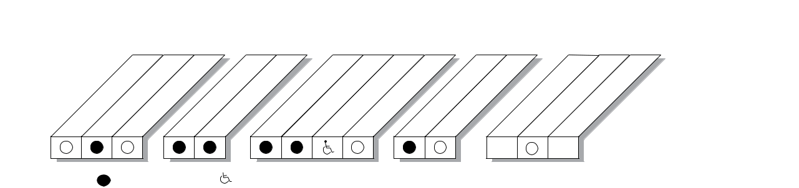

 |  |  |  | CONCEALED
 |  |  |  | MOUNTING |  | FINISH | CYLINDER |  |  | ARM | *ARM FUNCTION
 | -3/4˝ |  | TUBE |  | COAT |  |  | ACTION |  |  | (SINGLE)
 |  |  |  | DOOR |  |  |  |  |  |  | -OPEN
IN | FRAME 1 | IN |  | DOOR | POWDERPLATED | HANDEDSIZED | DELAYED |  | EXPOSED | STANDARD | HOLD
IN | IN |  |  |  | POWDERPLATED | HANDEDSIZED | DELAYED |  | EXPOSED | STANDARD | HOLD
 |  |  |  |  |  |  |  |  |  | 180° | 110°

AVAILABLE | Closer available with less than 5.0 lbs. opening force on 36˝ door.
NOT AVAILABLE | * Maximum opening/hold-open point with standard template. See individual closer series for degrees of opening per
 | installation.
 |  | D7
 | LCN Door Control Catalog | D7

phone: 877-671-7011 n fax: 800-248-1460 n www.allegion.com/us n 009426 rev. 11/16

2030

Series

Mounting details

Concealed
Mounting

5-13/16" |  | 21-7/8"
148 mm |  |  | 556 mm | 1-5/8"
 |  |  |  | 41 mm
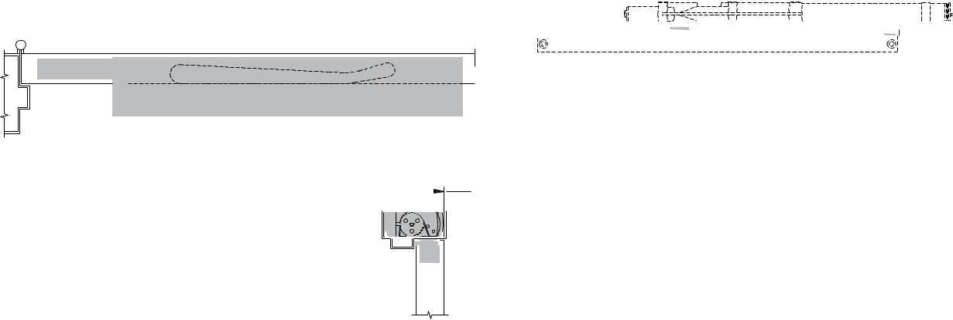

 | 10" | 1-1/16" | 1-3/8"
 | 254 mm | 27 mm | 35 mm
 |  | 22-1/2"
1-1/4" | 1" | 572 mm
32 mm | 1"
32 mm | 25 mm
3-23/32" | 25 mm
94 mm

9/64"
4 mm

Butt Hinges | Should not exceed 5˝ (127 mm) in width
Auxiliary Stop | n | Recommended where a door cannot swing 180°
 | n | Optional track bumper assembly assists backcheck in cushioning the opening swing of the door (not intended to
 |  | replace an auxiliary stop).
Top Rail | n | 1-3/8˝ (35 mm) mortise required
 | n | With Fire Shield, 1-13/32˝ (36 mm) mortise required
 | n | 5/16˝ (8 mm) cutout required at top of the door, stop face only
Door Thickness | 1-3/4˝ (44 mm) minimum
Hollow Metal Frame | Consult factory for installation instructions
Wood Frame | Installation simplified by WOOD MOUNTING CLIP SET 2030-416 for center pivoted or 2030-417 for offset pivoted and
 | butt hung installations. Consult factory for preparation details.
Maximum opening | n | Butt hinge template allows 180°, trim permitting
 | n | Limited to 110° when optional bumper is installed
 | n | Adjustable hold-open points from 85° to 110°, with hold-open track
 | n | Consult factory if door will be held open at 180°
 | n | Offset pivot template allows 115°, trim permitting. Limited to 95° when optional bumper is installed
 | n | Hold-open point from 85°, with hold-open track
 | n | Center pivot template allows 120°, trim permitting
 | n | Limited to 100° when optional bumper is installed
 | n | Adjustable hold-open points from 85° to 100°, with hold-open track

Notes:

- For interior or exterior doors

- Single acting cylinder in head frame

- Concealed arm and track in door top rail

D8

LCN Door Control Catalog

phone: 877-671-7011

n fax: 800-248-1460

n www.allegion.com/us

n 009426 rev. 11/16

2030

Series

Accessories
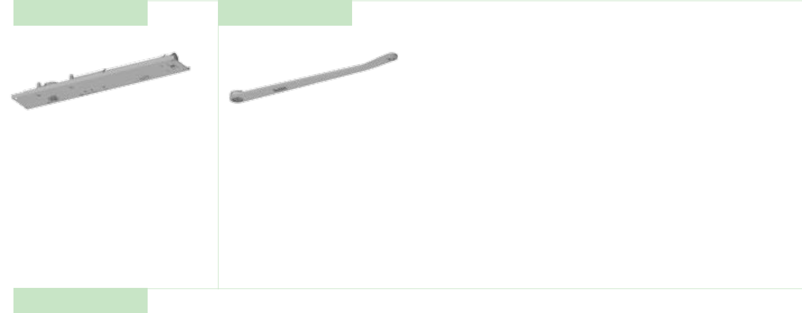

Cylinders Arm

2031(2)(3)(4)(5)-3071 |  | 2030-3077T
Cast Iron Cylinder Assembly |  | Standard Arm
n | Handed | n | Handed
n | With mounting plate | n | Track roller not included with arm

- Standard

TracksCylinders
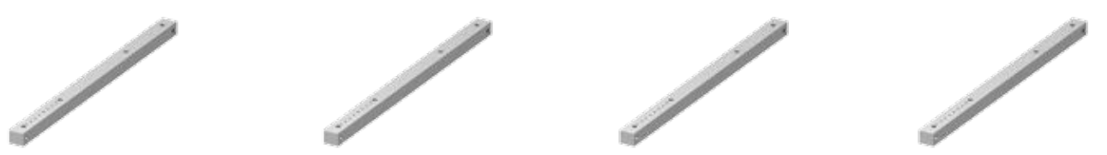

2030-3038
Standard Track

- Non-handed

- Non hold-open

- Will accept hold-open clip and/or bumper assembly

- Standard

2030-3038B |  | 2030-3038H |  | 2030-3038HB
Standard Track with Bumper |  | Hold-Open Track |  | Hold-Open Track with Bumper
n | Non-handed | n | Non-handed | n | Non-handed
n | Non hold-open | n | Will accept bumper assembly | n | Optional
n | Will accept hold-open clip | n | Optional

- Optional

LCN Door Control Catalog | D9
phone: 877-671-7011 n fax: 800-248-1460 n www.allegion.com/us n 009426 | rev. 11/16

2030

Series

Accessories

Installation Accessories
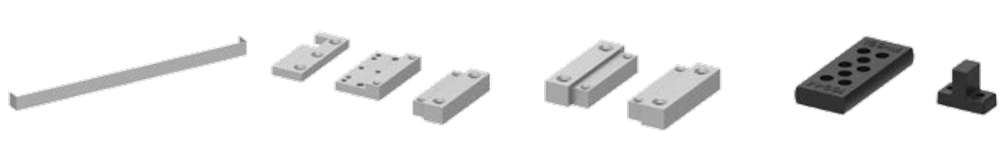

2030-420
Fire Shield

- 22 gauge steel liner mounts in the track mortise of the door’s top rail for 20 minute labeled wood doors
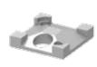

2030-3054
Hold-Open Clip

- Mounts in track to provide hold-open function

- Hold-open point controlled by clip location

- Requires 2030-3034H Hold-Open Track Roller

2030-416
Wood Mounting Clip Set

- Simplifies mounting center pivoted 2030 closer in wood frame

- Includes latch stile clip, hinge stile clip, and cover

- For use with Ives Series center pivots

- Consult factory for special template
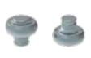

2030-3034
Track Roller

- Quiet, low friction roller assembly

- Shoulder dimension “X” = 1/16˝ (2mm)

2030-417
Wood Mounting Clip Set

- Simplifies mounting offset pivoted or butt hung 2030 closer in wood frame

- Includes two clips

- For use with offset pivots

- Consult factory for special template
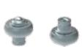

2030-3034H Hold-Open Track Roller

- Quiet, low friction roller assembly

- Shoulder dimension “X” = 1/16˝ (2mm)

2030-169
Track Bumper

- Mounts in track to assist backcheck. Limits maximum opening.

- Consists of bumper, bumper post, and mounting screw

NOTE: Track bumper does not replace auxiliary stop

^{D10} LCN Door Control Catalog

phone: 877-671-7011 n fax: 800-248-1460 n www.allegion.com/us n 009426 rev. 11/16

How-to-order 2030 Series closers
 |  |  | Closer will be shipped with:
Select cylinder size | Specify finish |  | - Standard cylinder with mounting plate
2031 | Standard Powder Coat __________ |  | - Standard arm
2032 | Aluminum, Dark Bronze, Statuary, |  | - Standard track
2033 | Light Bronze, Black, Brass |  | - Wood and machine screw pack
2034 |  |  | unless options listed below are selected.
2035

Select hand
RH

LH

2030

Series

Ordering Information

Closer options
Tracks | Installation accessories
Standard with Bumper (BUMPER) | Fire Shield, 2030-420
Hold-open (H) | Wood Clip Set, 2030-416
Hold-open with Bumper (HBUMPER) | Wood Clip Set, 2030-417
Finishes
Custom Powder Coat (RAL)_____________
Plated Finish, US ______________
SRI primer (use with powder coat finishes only)

Screw pack | Special template
TORX Machine Screw (TORX) | ST- ________

Table of sizes

- Select closer based on width of door.
- 2030 Series cylinders available in size 1, 2, 3, 4, or 5.
- Closing power of all 2030 Series closers may be increased 35%.
- Specify next higher size closer where strong drafts exist

Exterior (and Vestibule) door width


28˝ | 30˝ | 36˝ | 42˝
711mm | 762mm | 914mm | 1067mm
2033 | size 3 | size 4 | size 5
2034
2035

Minimum door width

Interior door width
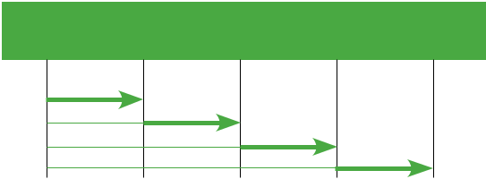

28˝ | 34˝ | 38˝ |  | 48˝ | 54˝
711mm | 864mm | 965mm |  | 1219mm | 1372mm
size 2 | size 3 |  | size 4 | size 5
2032
2033
2034
2035

Minimum door width

Indicates recommended range of door width for closer size.

Reduced opening force 2030 Series closers

CAUTION ! Any manual door closer, including those certified by BHMA to conform to ANSI Standard A156.4, that is selected, installed and adjusted based on ADA or other reduced opening force requirements may not provide sufficient power to reliably close and latch a door.

Refer to POWER OPERATORS section for information on systems that meet reduced opening force requirements without affecting closing power.

* Maximum opening force.

DOOR WIDTH | 36˝ | 42˝ | 48˝
8.5* lbs. | 2033 | 2033 | 2034
5.0* lbs. | 2031 | 2032 | 2032

LCN Door Control Catalog | D11
phone: 877-671-7011 n fax: 800-248-1460 n www.allegion.com/us n 009426 | rev. 11/16

Notes

__________________________________________________________________________________________________________________________________________________________________________________

__________________________________________________________________________________________________________________________________________________________________________________

__________________________________________________________________________________________________________________________________________________________________________________

__________________________________________________________________________________________________________________________________________________________________________________

__________________________________________________________________________________________________________________________________________________________________________________

__________________________________________________________________________________________________________________________________________________________________________________

__________________________________________________________________________________________________________________________________________________________________________________

__________________________________________________________________________________________________________________________________________________________________________________

__________________________________________________________________________________________________________________________________________________________________________________

__________________________________________________________________________________________________________________________________________________________________________________

__________________________________________________________________________________________________________________________________________________________________________________

__________________________________________________________________________________________________________________________________________________________________________________

__________________________________________________________________________________________________________________________________________________________________________________

__________________________________________________________________________________________________________________________________________________________________________________

__________________________________________________________________________________________________________________________________________________________________________________

__________________________________________________________________________________________________________________________________________________________________________________

__________________________________________________________________________________________________________________________________________________________________________________

__________________________________________________________________________________________________________________________________________________________________________________

__________________________________________________________________________________________________________________________________________________________________________________

__________________________________________________________________________________________________________________________________________________________________________________

__________________________________________________________________________________________________________________________________________________________________________________

__________________________________________________________________________________________________________________________________________________________________________________

__________________________________________________________________________________________________________________________________________________________________________________

__________________________________________________________________________________________________________________________________________________________________________________

__________________________________________________________________________________________________________________________________________________________________________________

__________________________________________________________________________________________________________________________________________________________________________________

D12

LCN Door Control Catalog

phone: 877-671-7011

n fax: 800-248-1460

n www.allegion.com/us

n 009426 rev. 11/16

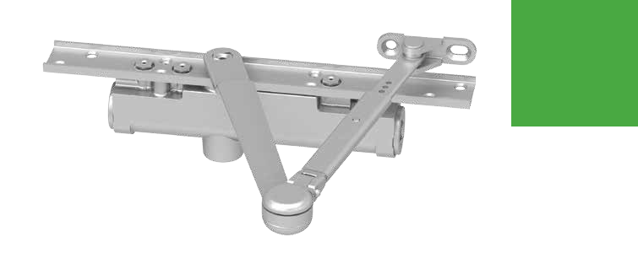
3030

Series

Features

The concealed 3030 Series is designed to mount in a 1-3/4˝ interior door. The double lever arm provides superior door control and the choice of finishes and arm functions meet virtually all architectural requirements.

Certifications | Grade 1 - ANSI A156.4, UL 10 C, ADA, 100 Hour
 | Salt Spray, Meets BAA - Buy American Act
Body Construction | n | Cast Iron Body
 | n | Full Complement Bearing
 | n | 1 -1/8˝ Diameter Piston
 | n | 1/2˝ Diameter Double Heat Treated
 |  | Pinion Journal
Fluid | All Weather Fluid
Handing | Handed
Size | Sized 1-4
Warranty | 15 years

Fasteners | Wood Screws and Torx Security Screws
 | (optional)
Mounting | Concealed (in door); consult factory for
 | installations with pivots
Arms | Regular arm
Finishes/Colors/ | n | Aluminum (689)
Powder Coat | n | Statuary Bronze (690)
 | n | Light Bronze (691)
 | n | Black (693)
 | n | Dark Bronze (695)
 | n | Brass (696)
 | n | Custom colors optional
 | n | Optional SRI primer - powder coat only
 | n | Optional plated finishes

Special Customized installation templates or products may be available to solve unusual applications.

Templates Contact LCN Product Support for assistance.

CONCEALED

MOUNTING FINISH CYLINDER ARM *ARM FUNCTION
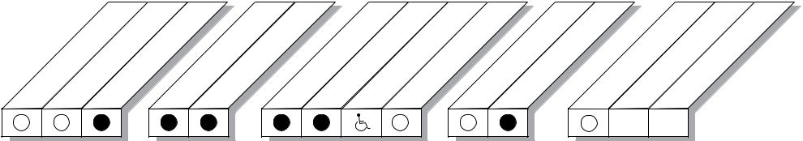

 |  |  | TUBE |  | COAT |  |  | ACTION |  |  | (SINGLE)
IN | -3/4˝ |  |  | DOOR | POWDER PLATED | HANDEDSIZED | DELAYED |  | EXPOSED | STANDARD | -OPEN
IN | IN | IN |  |  |  |  |  |  | EXPOSED | STANDARD | HOLD
 | FRAME 1 |  |  | DOOR
 |  |  |  |  |  |  |  |  |  | 180° | 140°

AVAILABLE | Closer available with less than 5.0 lbs. opening force on 36˝ door.
NOT AVAILABLE | * Maximum opening/hold-open point with standard template. See individual closer series for
 | degrees of opening per installation.
 |  | D13
 | LCN Door Control Catalog | D13

phone: 877-671-7011 n fax: 800-248-1460 n www.allegion.com/us n 009426 rev. 11/16

3030

Series

Mounting details

Concealed
Mounting

A


 |  | B | 2-11/16" | 3/4" | 15/16"
 |  | B | 68 mm | 3/4" | 24 mm
 |  | B | 68 mm | 19 mm | 24 mm
 | 1-3/8" | 3"
 | 1-3/8" | 76 mm
 | 35 mm | 76 mm
8-3/4" |  | 5/16" | 3-3/4"
222 mm |  | 8 mm | 95 mm
11-3/4" |  | 4-7/8" |  |  | 2-15/16"
298 mm |  | 124 mm | 1-1/4" dia. |  | 2-15/16" | 3-3/16"
 |  |  | 32 mm | 9/16" | 75 mm | 81 mm
 |  | 1-1/2" | 8-3/4" | 14 mm
 |  | 38 mm | 222 mm
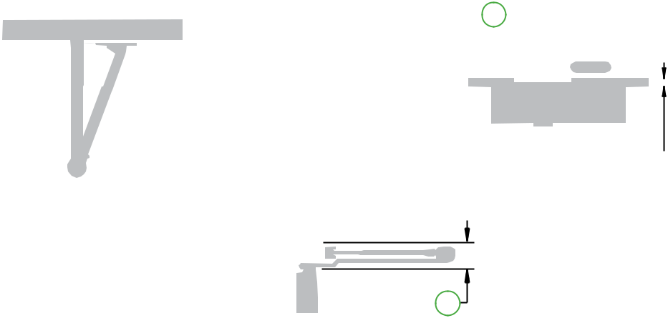

C

Butt Hinges | Should not exceed 5˝ (127 mm) in width
Auxiliary Stop | Recommended at hold-open point or where a door cannot swing 180°
Top Rail | Minimum 4˝ (102 mm) required
Door Thickness | n | 1-3/4˝ (44 mm) minimum
 | n | Please consult the door manufacturer to assure that the door integrity and warranty is maintained after installing
 |  | the 3030 Series door closer in a 1-3/4˝ thick wood door
Maximum opening | Can be templated for
 | 100°: |  | A = 3-5/8˝ (92 mm)
 |  |  | B = 10-1/4˝ (260 mm)
 | 130°: |  | A = 2-5/8˝ (67 mm)
 |  |  | B = 9-1/4˝ (235 mm)
 | 180°: |  | A = 1-5/8˝ (41 mm)
 |  |  | B = 8-1/4˝ (210 mm)

- Hold-open points up to maximum opening or 140°, whichever is less, with hold-open arm.

Arm clearance above door

C = 1-1/4˝ (32 mm) minimum

Notes:

- For interior or exterior doors

- Single acting cylinder in top rail of door

- Exposed arm on hinge side of door

^{D14} LCN Door Control Catalog

phone: 877-671-7011 n fax: 800-248-1460 n www.allegion.com/us n 009426 rev. 11/16

3030

Series

Accessories
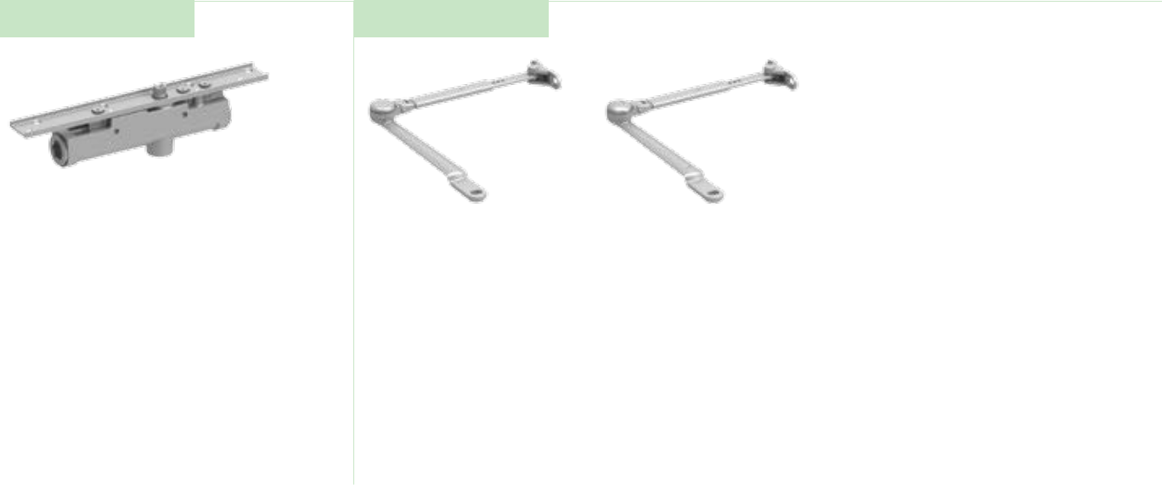

Cylinder Arms

3031(2)(3)(4)-3071 |  | 3030-3077 | 3030-3049
Cast Iron Cylinder Assembly |  | Regular arm | Hold-open arm
n | Handed | n Non-handed | n | Handed
n | With mounting plate |  | n | Provides hold-open function,
n | Standard |  |  | adjustable at elbow
 |  |  | n | Optional

LCN Door Control Catalog | D15
phone: 877-671-7011 n fax: 800-248-1460 n www.allegion.com/us n 009426 | rev. 11/16

3030

Series

Ordering Information

How-to-order 3030 Series closers
How-to-order 3030 Series closers |  | Closer will be shipped with:
Select cylinder size |  | - Standard cylinder with mounting bracket
3031 |  | - Regular arm
3032 |  | - Wood and machine screw pack
3033 |  | unless options listed below are selected.
3034
Select hand
RH
LH

Specify finish
Standard Powder Coat __________

Aluminum, Dark Bronze, Statuary, Light Bronze, Black, Brass.

Closer options |  | Screw pack
Arm |  | Screw pack
Hold-open (H) |  | TORX Machine Screw (TORX)
Finishes
Custom Powder Coat (RAL)___________ |  | Special template
Plated Finish, US ______________ |  | ST- ________
SRI primer (use with powder coat finishes only)

Table of sizes

- Select closer based on width of door
- 3030 Series cylinders available in size 1, 2, 3, or 4
- Closing power of all 3030 Series closers may be increased 15%

Interior door width


24˝ | 34˝ | 38˝ | 48˝
610mm | 864mm | 965mm | 1219mm
3032 | size 2 | size 3 | size 4
3033
3034

Minimum door width

Indicates recommended range of door width for closer size.

Reduced opening force 3030 Series closers

CAUTION ! Any manual door closer, including those certified by BHMA to conform to ANSI Standard A156.4, that is selected, installed and adjusted based on ADA or other reduced opening force requirements may not provide sufficient power to reliably close and latch a door.

Refer to POWER OPERATORS section for information on systems that meet reduced opening force requirements without affecting closing power.

* Maximum opening force.

DOOR WIDTH | 36˝ | 42˝ | 48˝
8.5* lbs. | N/A | N/A | N/A
5.0* lbs. | 3031 | 3031 | 3032

^{D16} LCN Door Control Catalog

phone: 877-671-7011 n fax: 800-248-1460 n www.allegion.com/us n 009426 rev. 11/16

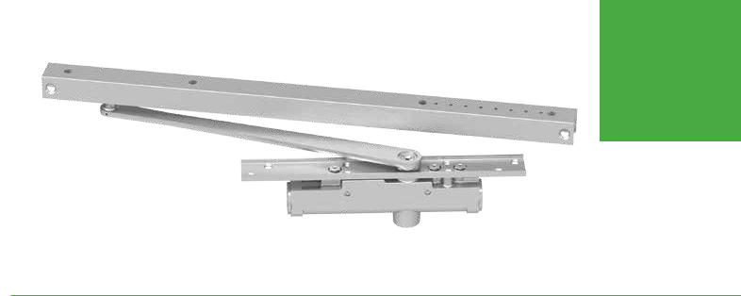
3130

Series

Features

The concealed 3130 Series is designed to mount in a 1-3/4˝ interior door. The single lever arm and roller assembly provides complete concealment and the choice of finishes and track functions meet virtually all architectural requirements.

Certifications | Grade 1 - ANSI A156.4, UL 10 C, ADA, 100 Hour
 | Salt Spray, Meets BAA - Buy American Act
Body Construction | n | Cast Iron Body
 | n | Full Complement Bearing
 | n | 1-1/8˝ Diameter Piston
 | n | 1/2˝ Diameter Double Heat Treated
 |  | Pinion Journal
Fluid | All Weather Fluid
Handing | Handed
Size | Sized 1-3
Warranty | 15 years

Fasteners | Wood Screws and Torx Security Screws
 | (optional)
Mounting | Concealed (in door); consult factory for
 | installation with pivots
Arms | Standard arm and track
Finishes/Colors/ | n | Aluminum (689)
Powder Coat | n | Statuary Bronze (690)
 | n | Light Bronze (691)
 | n | Black (693)
 | n | Dark Bronze (695)
 | n | Brass (696)
 | n | Custom colors optional
 | n | Optional SRI primer - powder coat only
 | n | Optional plated finishes

Special Customized installation templates or products may be available to solve unusual applications.

Templates Contact LCN Product Support for assistance.
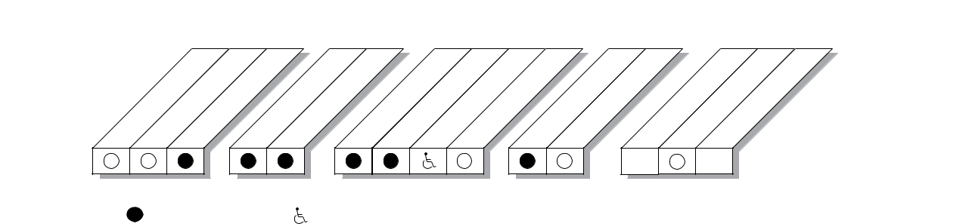

CONCEALED

MOUNTING FINISH CYLINDER ARM *ARM FUNCTION

 |  |  | TUBE |  | COAT |  |  | ACTION |  |  | (SINGLE)
IN | -3/4˝ |  |  | DOOR | POWDER PLATED | HANDEDSIZED | DELAYED |  | EXPOSED | STANDARD | -OPEN
IN | IN | IN |  |  |  |  |  |  | EXPOSED | STANDARD | HOLD
 | FRAME 1 |  |  | DOOR
 |  |  |  |  |  |  |  |  |  | 140° | 100°

AVAILABLE | Closer available with less than 5.0 lbs. opening force on 36˝ door.
NOT AVAILABLE | * Maximum opening/hold-open point with standard template. See individual closer series for
 | degrees of opening per installation.
 |  | D17
 | LCN Door Control Catalog | D17

phone: 877-671-7011 n fax: 800-248-1460 n www.allegion.com/us n 009426 rev. 11/16

3130

Series

Mounting details

Concealed
Mounting

11-3/4"
298 mm

1-3/8" | 1-1/4"
35 mm | 32 mm

 |  |  | 2" | 1-1/16"
 |  |  | 50 mm | 22-1/2" | 27 mm
 |  |  |  | 572 mm
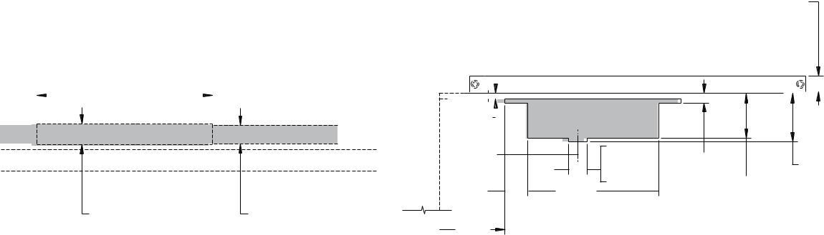

3/8"
10 mm
4-7/8" | 1-1/4" dia. | 5/8" |  | 3-1/4"
124 mm | 1-1/4" dia. | 5/8" |  | 3-1/4"
1-1/2" | 32 mm | 16 mm | 3" | 83 mm
1-1/2" | 8-3/4" |  | 3"
38 mm | 8-3/4" |  | 76 mm
38 mm | 222 mm |  | 76 mm
4-3/8"
110 mm


Butt Hinges | Should not exceed 5˝ (127 mm) in width
Auxiliary Stop | n | Recommended at hold-open point or where a door cannot swing 140°
 | n | Optional track bumper assembly assists backcheck in cushioning the opening swing of the door. It is not intended to
 |  | replace an auxiliary stop
Top Rail | Minimum 4˝ (102 mm) required
Door Thickness | n | 1-3/4˝ (44 mm) minimum.
 | n | Please consult the door manufacturer to assure that the door integrity and warranty is maintained after installing
 |  | the 3130 Series door closer in a 1-3/4˝ thick wood door
Door Width | 2´2˝ (660 mm) minimum
Maximum opening | n | Templating allows 140°, trim permitting. 100° with optional bumper installed
 | n | Adjustable hold-open points from 85° to 100°, with hold-open track

Notes:

- For interior doors

- Single acting cylinder and standard arm in top rail of door

- Concealed track in head frame

- Consult factory for installations with pivots.

^{D18} LCN Door Control Catalog

phone: 877-671-7011 n fax: 800-248-1460 n www.allegion.com/us n 009426 rev. 11/16

3130

Series

Accessories
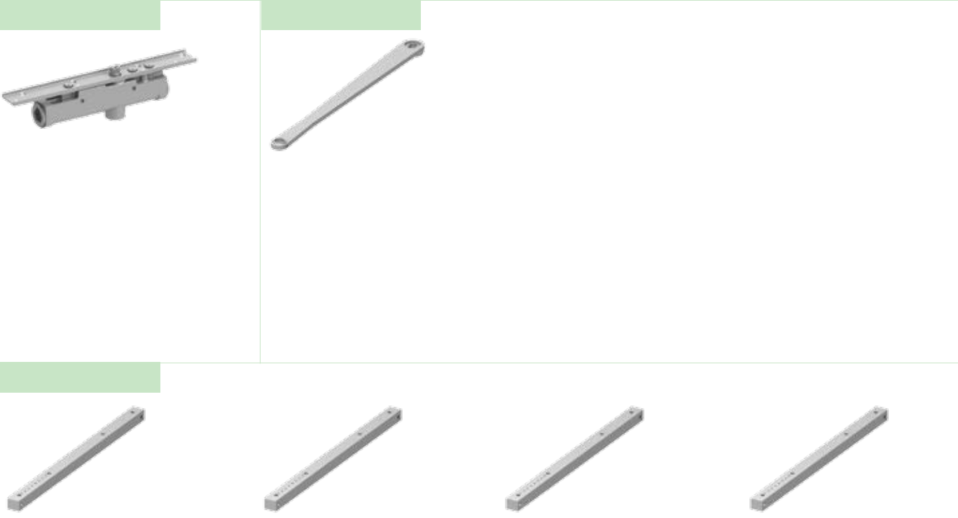

Cylinder Arm

3131(2)(3)-3071 |  | 3130-3077T
Cast Iron Cylinder Assembly |  | Standard Arm
n | Handed | n | Handed
n | With mounting plate | n | Track roller not included with arm
n | Standard | n | Standard

Tracks

3130-3038
Track

- Non-handed

- Non hold-open

- Will accept hold-open clip and/ or bumper assembly

- Standard

3130-3038B |  | 3130-3038H |  | 3130-3038HB
Standard Track with Bumper |  | Hold-Open track |  | Hold-Open Track with Bumper
n | Non-handed | n | Non-handed | n | Non-handed
n | Non hold-open | n | Will accept bumper assembly | n | Optional
n | Will accept hold-open clip | n | Optional

- Optional

Installation Accessories
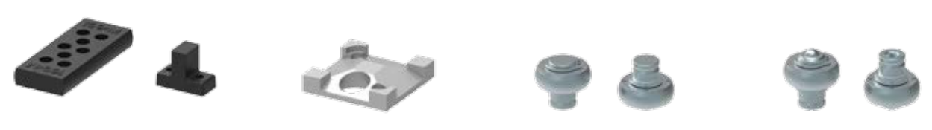

3130-169 |  | 3130-3054 |  | 3130-3034
Track Bumper |  | Hold-Open Clip |  | Track Roller
n | Mounts in track to assist | n | Mounts in track to provide hold- | n | Quiet, low friction roller
 | backcheck, does not replace |  | open function |  | assembly
 | auxiliary stop | n | Hold-open point controlled by | n | Shoulder dimension “X” =
n | Limits maximum opening |  | clip location |  | 1/8˝ (3mm)
n | Consists of bumper, bumper | n | Requires 3130-3034H Hold-
 | post, and mounting screw |  | Open Track Roller

3130-3034H
Hold-Open Track Roller

- Quiet, low friction roller assembly

- Shoulder dimension “X” = 1/8˝ (3mm)

LCN Door Control Catalog | D19
phone: 877-671-7011 n fax: 800-248-1460 n www.allegion.com/us n 009426 | rev. 11/16

3130

Series

Ordering Information

How-to-order 3130 Series closers | Closer will be shipped with:
Select cylinder size | - Standard cylinder with mounting bracket
3131 | - Standard arm wtih finish plate
3132 | - Standard track
3133 | - Wood and machine screw pack

Select hand | unless options listed below are selected.
RH
LH

Specify finish
Standard Powder Coat __________

Aluminum, Dark Bronze, Statuary, Light Bronze, Black, Brass.

Closer options
Track | Screw pack
Standard with Bumper (BUMPER) | TORX Machine Screw (TORX)
Hold-open (H)
Hold-open with Bumper (HBUMPER)
 | Special template
Finishes | ST- ________
Custom Powder Coat (RAL)___________
Plated Finish, US ______________
SRI primer (use with powder coat finishes only)

Table of sizes

- Select closer based on width of door.
- 3130 Series cylinders available in size 1, 2, or 3.
- Closing power of 3130 Series closers is not adjustable

Interior door width


26˝ | 34˝ | 38˝
660mm | 864mm | 965mm
3132 | size 2 | size 3
3133

Minimum door width

Indicates recommended range of door width for closer size.

Reduced opening force 3130 Series closers

CAUTION ! Any manual door closer, including those certified by BHMA to conform to ANSI Standard A156.4, that is selected, installed and adjusted based on ADA or other reduced opening force requirements may not provide sufficient power to reliably close and latch a door.

Refer to POWER OPERATORS section for information on systems that meet reduced opening force requirements without affecting closing power.

* Maximum opening force.

DOOR WIDTH | 36˝ | 42˝ | 48˝
8.5* lbs. | N/A | N/A | N/A
5.0* lbs. | 3131 | 3131 | 3132

^{D20} LCN Door Control Catalog

phone: 877-671-7011 n fax: 800-248-1460 n www.allegion.com/us n 009426 rev. 11/16

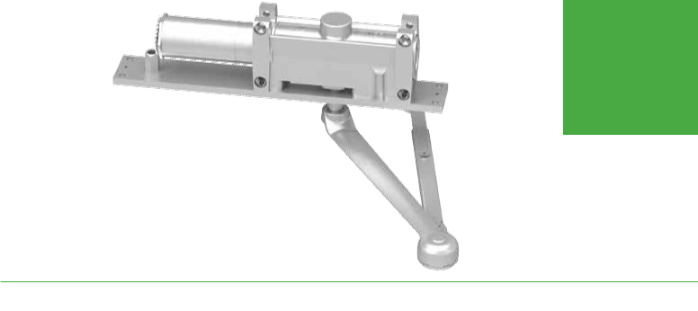
5010

Series

Features

The concealed 5010 Series is a heavy duty closer designed for institutional, high traffic, or other applications exposed to weather or abuse. The double lever arm provides superior door control and a choice of finishes, cylinder functions, and arm functions that meet virtually all architectural requirements.

Certifications | Grade 1 - ANSI A156.4, UL 10 C, ADA, 100 Hour
 | Salt Spray, Meets BAA - Buy American Act
Body Construction | n | Cast Iron Body
 | n | Full Complement Bearing
 | n | 1-1/8˝ Diameter Piston
 | n | 11/16˝ Diameter Double Heat Treated
 |  | Pinion Journal
Fluid | All Weather Fluid
Handing | Handed
Size | Sized 1-6
Warranty | 15 years

Fasteners | Wood Screws and Torx Security Screws
 | (optional)
Mounting | Concealed (in frame); aluminum frame
 | requires 4˝ (102 mm) x 4˝ tube
Arms | Regular Arm
Finishes/Colors/ | n | Aluminum (689)
Powder Coat | n | Statuary Bronze (690)
 | n | Light Bronze (691)
 | n | Black (693)
 | n | Dark Bronze (695)
 | n | Brass (696)
 | n | Custom colors optional
 | n | Optional SRI primer - powder coat only
 | n | Optional plated finishes

Special Customized installation templates or products may be available to solve unusual applications.

Templates Contact LCN Product Support for assistance.

CONCEALED

MOUNTING FINISH CYLINDER ARM *ARM FUNCTION
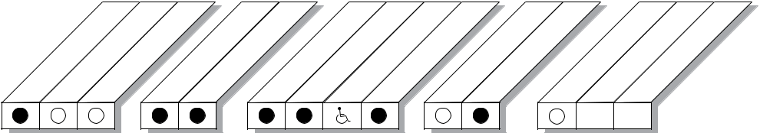

 |  |  | TUBE |  | COAT |  |  | ACTION |  |  | (SINGLE)
IN | -3/4˝ |  |  | DOOR | POWDER PLATED | HANDEDSIZED | DELAYED |  | EXPOSED | STANDARD | -OPEN
IN | IN | IN |  |  |  |  |  |  | EXPOSED | STANDARD | HOLD
 | FRAME 1 |  |  | DOOR
 |  |  |  |  |  |  |  |  |  | 180° | 100°

AVAILABLE | Closer available with less than 5.0 lbs. opening force on 36˝ door.
NOT AVAILABLE | * Maximum opening/hold-open point with standard template. See individual closer series for
 | degrees of opening per installation.
 |  | D21
 | LCN Door Control Catalog | D21

phone: 877-671-7011 n fax: 800-248-1460 n www.allegion.com/us n 009426 rev. 11/16

5010

Series

Mounting details

Concealed
Mounting

7/8"
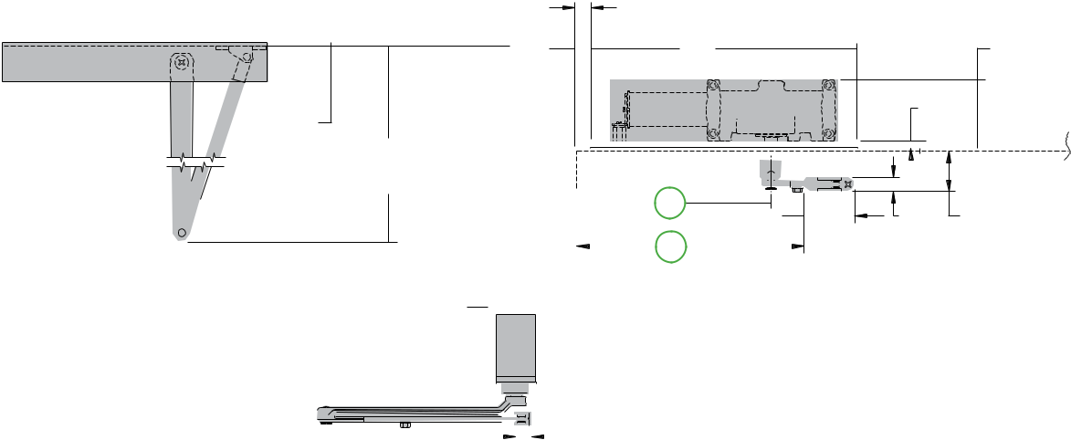
22 mm

14" |  |  | 3-5/8"
356 mm |  |  | 3-5/8"
356 mm |  |  | 92 mm
2-1/16" |  | 3/8"
2-1/16" |  | 10 mm
52 mm
11-1/2"
292 mm
A | 2-11/16" | 3/4" | 2-1/8"
B | 68 mm | 19 mm | 54 mm
3/4"
19 mm
2" MAX
51 mm

Butt Hinges | Should not exceed 6˝ (152 mm) in width
Auxiliary Stop | Recommended at hold-open point or where a door cannot swing 180°
Top Rail | Minimum 2-1/8˝ (54 mm) required
Delay Action | n | Add suffix “DEL” to selected cylinder (eg. 5014 DEL) (not available with 5016 cylinder)
 | n | Delays closing from maximum opening to approximately 70°
 | n | Delay time adjustable up to approximately 1 minute
Maximum opening | Butt hung doors can be templated for
 | 100°: |  | A = 10-3/16˝ (259 mm)
 |  |  | B = 12˝ (305 mm)
 | 180°: |  | A = 5-1/2˝ (140 mm)
 |  |  | B = 7-5/16˝ (186 mm) trim permitting
 | n | Hold-open points up to 100° only with hold-open arm
 | n | Center pivot mounting restricts opening to 140°
 | n | Offset pivot mounting allows up to 180°, trim permitting

Notes:

- For interior or exterior doors

- Single acting cylinder in head frame

- Exposed arm on hinge side of door

D22

LCN Door Control Catalog

phone: 877-671-7011

n fax: 800-248-1460

n www.allegion.com/us

n 009426 rev. 11/16

5010

Series

Accessories

Cylinder Arms

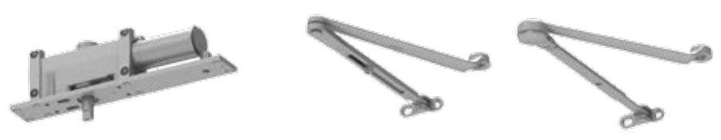

5011(2)(3)(4)(5)(6)-3071 |  | 5010-3077 | 5010-3049
Cast Iron Cylinder Assembly |  | Regular Arm | Hold-Open Arm
n | Handed | n Non-handed | n | Handed
n | With mounting plate |  | n | Provides hold-open function for
n | Standard |  |  | 100° Template, adjustment at
n | Standard |  |  | elbow
 |  |  | n | Optional

LCN Door Control Catalog | D23
phone: 877-671-7011 n fax: 800-248-1460 n www.allegion.com/us n 009426 | rev. 11/16
5010

Series

Ordering information
Ordering information | How-to-order 5010 Series closers
 | How-to-order 5010 Series closers |  | Closer will be shipped with:
 | Select cylinder size |  | - Standard cylinder with finish plate
 | 5011 |  | - Standard arm
 | 5012 |  | - Regular arm
 | 5013 |  | - Wood and machine screw pack
 | 5014 |  | unless options listed below are selected.
 | 5015

5016 (DEL not available)

Select hand | Specify finish
RH | Standard Powder Coat __________
LH | Aluminum, Dark Bronze, Statuary, Light Bronze, Black, Brass

Closer options
Cylinder function | Screw pack
Delayed Action (DEL) | TORX Machine Screw (TORX)
Arm
Hold-Open (H) | Special template
Finishes | ST- ________
Custom Powder Coat (RAL)_____________
Plated Finish, US ______________

SRI primer (use with powder coat finishes only)

Table of sizes

- Select closer based on width of door
- Series cylinders available in size 1, 2, 3, 4, 5, or 6
- Closing power of all 5010 Series closers may be increased 50%
- Specify next higher size closer where strong drafts exist
- Delayed action not available with 5016 cylinder

Exterior (and Vestibule) door width Interior door width
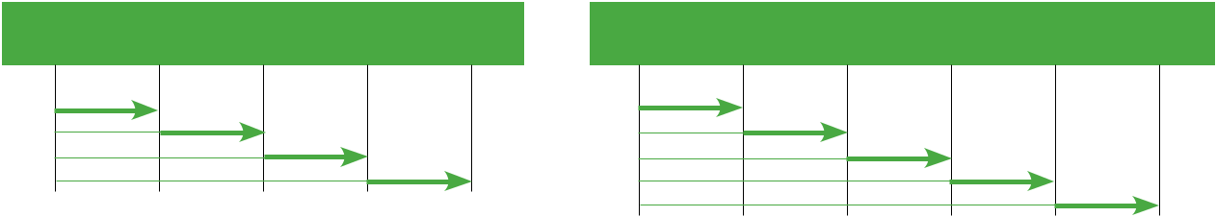

24˝ | 30˝ | 36˝ |  | 42˝ | 48˝ | 24˝ | 34˝ | 38˝ | 48˝ | 54˝ | 60˝
610mm | 762mm | 914mm | 1067mm |  | 1219mm | 610mm | 864mm | 965mm | 1219mm | 1372mm | 1524mm
 | size 3 | size 4 | size 5 | size 6 |  | size 2 | size 3 | size 4 | size 5 | size 6
5013 |  |  |  |  |  | 5012
5014 |  |  |  |  |  | 5013
5015 |  |  |  |  |  | 5014
5016 |  |  |  |  |  | 5015
Minimum door width |  |  |  |  |  | 5016
 |  |  |  |  |  | Minimum door width

Indicates recommended range of door width for closer size.

Reduced opening force 5010 Series closers

CAUTION ! Any manual door closer, including those certified by BHMA to conform to ANSI Standard A156.4, that is selected, installed and adjusted based on ADA or other reduced opening force requirements may not provide sufficient power to reliably close and latch a door.

Refer to POWER OPERATORS section for information on systems that meet reduced opening force requirements without affecting closing power.

* Maximum opening force.

DOOR WIDTH | 36˝ | 42˝ | 48˝
8.5* lbs. | 5012 | 5013 | 5013
5.0* lbs. | 5011 | 5011 | 5012

^{D24} LCN Door Control Catalog

phone: 877-671-7011 n fax: 800-248-1460 n www.allegion.com/us n 009426 rev. 11/16

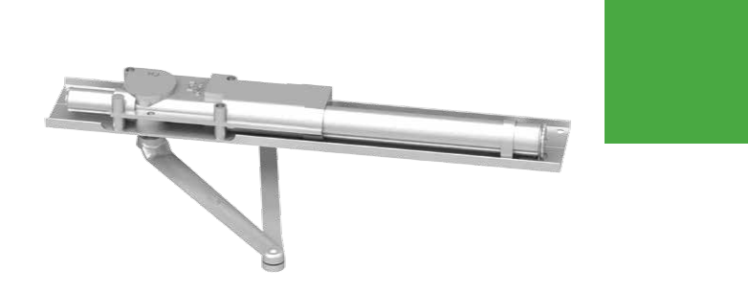
5030

Series

Features

The concealed 5030 Series PACER® is a heavy duty closer designed to fit in a narrow, minimum 1-3/4˝ aluminum transom. The double lever arm provides superior door control and the choice of finishes and arm functions meet virtually all architectural requirements.

Certifications | Grade 1 - ANSI A156.4, UL 10 C, ADA, 100 Hour
 | Salt Spray, Meets BAA - Buy American Act
Body Construction | n | Cast Iron Body
 | n | Full Complement Bearing
 | n | 1-1/8˝ Diameter Piston
 | n | 11/16˝ Diameter Double Heat Treated
 |  | Pinion Journal
Fluid | All Weather Fluid
Handing | Handed
Size | Sized 1; 3-6
Warranty | 15 years

Fasteners | Wood Screws and Torx Security Screws
 | (optional)
Mounting | Concealed (in tube); aluminum frame
 | requires minimum 1-3/4˝ (44 mm) x
 | 4-1/2˝ (114 mm) tube
Arms | Regular Arm
Finishes/Colors/ | n | Aluminum (689)
Powder Coat | n | Statuary Bronze (690)
 | n | Light Bronze (691)
 | n | Black (693)
 | n | Dark Bronze (695)
 | n | Brass (696)
 | n | Custom colors optional
 | n | Optional SRI primer - powder coat only
 | n | Optional plated finishes

Special Customized installation templates or products may be available to solve unusual applications.

Templates Contact LCN Product Support for assistance.

CONCEALED

MOUNTING FINISH CYLINDER ARM *ARM FUNCTION
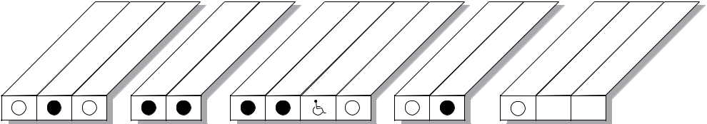

 | -3/4˝ |  | TUBE |  | COAT |  |  | ACTION |  |  | (SINGLE)
IN |  |  |  | DOOR | POWDERPLATED | HANDEDSIZED | DELAYED |  | EXPOSED | STANDARD | -OPEN
IN | IN | IN |  |  |  |  |  |  | EXPOSED | STANDARD | HOLD
 | FRAME 1 |  |  | DOOR
 |  |  |  |  |  |  |  |  |  | 180° | 100°

AVAILABLE | Closer available with less than 5.0 lbs. opening force on 36˝ door.
NOT AVAILABLE | * Maximum opening/hold-open point with standard template. See individual closer series for
 | degrees of opening per installation.
 |  | D25
 | LCN Door Control Catalog | D25

phone: 877-671-7011 n fax: 800-248-1460 n www.allegion.com/us n 009426 rev. 11/16

5030

Series

Mounting details

Concealed
Mounting
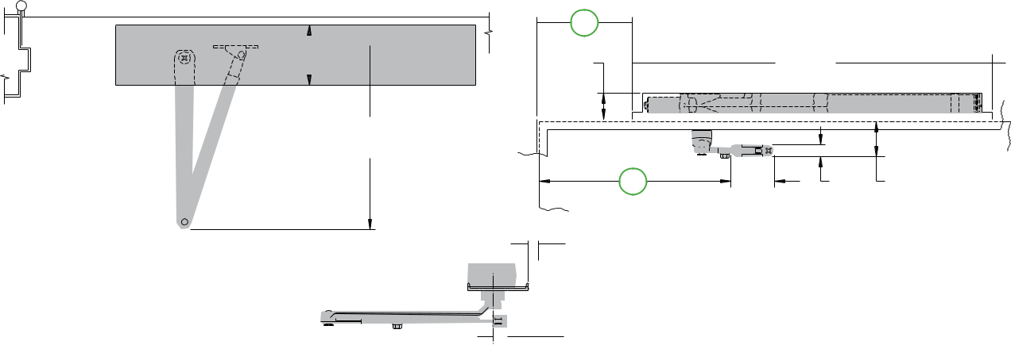

A

 | 1-5/8" |  | 21-7/8"
 | 41 mm |  | 556 mm
3-23/32" | 11-1/4"
94 mm | 11-1/4"
94 mm | 286 mm
 | B | 2-11/16" | 3/4" | 2-1/8"
 | B | 2-11/16" | 3/4" | 54 mm
 | B | 2-11/16" | 19 mm | 54 mm
 |  | 68 mm

19/32" dia.
15 mm

3/4" MIN.
19 mm

Butt Hinges | Should not exceed 6˝ (152 mm) in width
Auxiliary Stop | Recommended at hold-open point or where the door cannot swing 180°
Wood Frame | n | Installation simplified by WOOD MOUNTING CLIP SET 5030-416 for center pivoted or 5030-417 for offset pivoted
 |  | and butt hung installations
 | n | Consult factory for preparation details
Top Rail | Minimum 2-1/8˝ (54 mm) required
Door Thickness | Maximum 1-3/4˝ (44 mm), for doors thicker than 1-3/4˝ consult factory
Maximum opening | Butt hung doors can be templated for
 | 100°: |  | A = 5-13/16˝ (148 mm)
 |  |  | B = 11-13/16˝ (300 mm)
 | 180°: |  | A = 2-1/16˝ (52 mm)
 |  |  | B = 8-1/16˝ (205 mm)
 |  |  | trim permitting

- Hold-open points up to 100° only with hold-open arm

- Center pivot mounting restricts opening to 120°. Hold-open up to 120° with hold-open arm

- Offset pivot mounting allows up to 115°, trim permitting. Hold-open up to 115° with hold-open arm

Notes:

- For interior or exterior doors

- Single acting cylinder in head frame

- Exposed arm on push side of door

D26

LCN Door Control Catalog

phone: 877-671-7011

n fax: 800-248-1460

n www.allegion.com/us

n 009426 rev. 11/16

Cylinder Arms

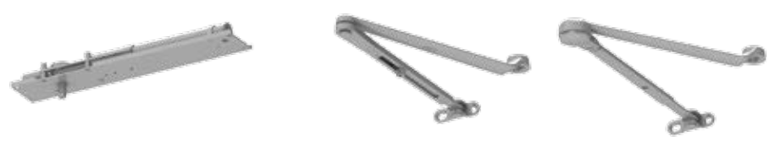

5031(3)(4)(5)(6)-3071 |  | 5030-3077 | 5030-3049
Cast Iron Cylinder Assembly |  | Regular Arm | Hold-Open Arm
n | Handed | n Non-handed | n | Handed
n | With mounting plate |  | n | Provides hold-open function for
n | Standard |  |  | 100° template, adjustable at
n | Standard |  |  | elbow
 |  |  | n | Optional

5030

Series

Accessories

Installation Accessories
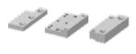

5030-416
Wood Mounting Clip Set

- Simplifies mounting center pivoted 5030 closer in wood frame

- Includes latch stile clip, hinge stile clip, and cover.

- For use with Ives Series center pivots

- Consult factory for special template

5030-417
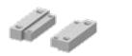
Wood Mounting Clip Set

- Simplifies mounting offset pivoted or butt hung 5030 closer in wood frame.

- Includes two clips.

- For use with offset pivots.

- Consult factory for special template.

LCN Door Control Catalog

phone: 877-671-7011 n fax: 800-248-1460 n www.allegion.com/us n 009426 rev. 11/16

D27

5030

Series

Ordering information
Ordering information | How-to-order 5030 Series closers
 | How-to-order 5030 Series closers |  | Closer will be shipped with:
 | Select cylinder size |  | - Standard cylinder with mounting plate
 | 5031 |  | - Regular arm
 | 5033 |  | - Wood and machine screw pack
 | 5034 |  | unless options listed below are selected.
 | 5035
 | 5036

Select hand | Specify finish
RH | Standard Powder Coat __________
LH | Aluminum, Dark Bronze, Statuary, Light Bronze, Black, Brass

Closer options
Arm | Installation accessories
Hold-Open (H) | Wood Clip Set, 5030-416
Finishes | Wood Clip Set, 5030-417
Custom Powder Coat (RAL)_____________
Plated Finish, US ______________

SRI primer (use with powder coat finishes only)

Screw pack | Special template
TORX Machine Screw (TORX) | ST- ________

Table of sizes

- Select closer based on width of door
- 5030 Series cylinders available in size 1, 2, 3, 4, 5 or 6
- Closing power of all 5030 Series closers may be increased 50%
- Specify next higher size closer where strong drafts exist

Exterior (and Vestibule) door width Interior door width


28˝ | 30˝ | 36˝ |  | 42˝ | 48˝ | 28˝ | 34˝ | 38˝ | 48˝ | 54˝ | 60˝
711mm | 762mm | 914mm | 1067mm |  | 1219mm | 711mm | 864mm | 965mm | 1219mm | 1372mm | 1524mm
5033 | size 3 | size 4 | size 5 | size 6 |  | 5033 | size 3 | size 4 | size 5 | size 6
5034 |  |  |  |  |  | 5034
5035 |  |  |  |  |  | 5035
5036 |  |  |  |  |  | 5036
Minimum door width |  |  |  |  |  | Minimum door width


Indicates recommended range of door width for closer size.

Note: Minimum door width 28˝ (711 mm).

Reduced opening force 5030 Series closers

CAUTION ! Any manual door closer, including those certified by BHMA to conform to ANSI Standard A156.4, that is selected, installed and adjusted based on ADA or other reduced opening force requirements may not provide sufficient power to reliably close and latch a door.

Refer to POWER OPERATORS section for information on systems that meet reduced opening force requirements without affecting closing power.

* Maximum opening force.

DOOR WIDTH | 36˝ | 42˝ | 48˝
8.5* lbs. | 5033 | 5033 | 5033
5.0* lbs. | 5031 | 5031 | 5033

^{D28} LCN Door Control Catalog

phone: 877-671-7011 n fax: 800-248-1460 n www.allegion.com/us n 009426 rev. 11/16

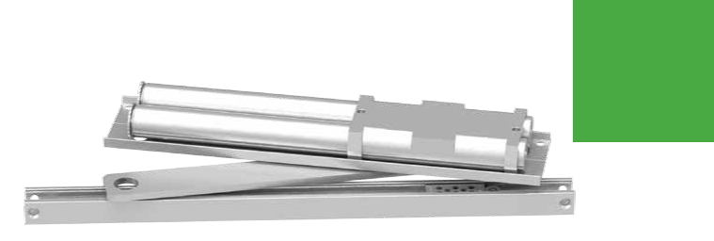
6030

Series

Features

The concealed 6030 Series PACER® is a heavy duty, double acting closer designed to fit in a narrow, minimum 1-3/4˝ header. The single lever arm and roller assembly provides smooth, quiet door control and the choice of finishes and track functions meet virtually all architectural requirements. Installation at left illustrated with center pivot set (not included).

Certifications | Grade 1 - ANSI A156.4, UL 10 C, ADA, 100 Hour
 | Salt Spray, Meets BAA - Buy American Act
Body Construction | n | Cast Iron Body
 | n | Full Complement Bearing
 | n | 1-1/8˝ Diameter Piston
 | n | 11/16˝ Diameter Double Heat Treated
 |  | Pinion Journal
Fluid | All Weather Fluid
Handing | Non-Handed
Size | Sized 1-5
Warranty | 15 years

Fasteners | Wood Screws and Torx Security Screws
 | (optional)
Mounting | Concealed (in tube); double acting
Arms | Standard arm with track
Finishes/Colors/ | n | Aluminum (689)
Powder Coat | n | Statuary Bronze (690)
 | n | Light Bronze (691)
 | n | Black (693)
 | n | Dark Bronze (695)
 | n | Brass (696)
 | n | Custom colors optional
 | n | Optional SRI primer - powder coat only
 | n | Optional plated finishes

Special Customized installation templates or products may be available to solve unusual applications.

Templates Contact LCN Product Support for assistance.

CONCEALED

MOUNTING FINISH CYLINDER ARM *ARM FUNCTION
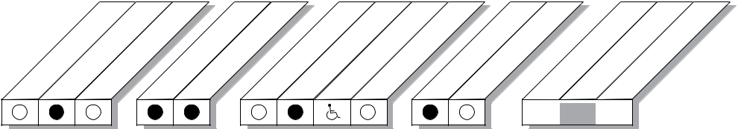

 | FRAME1 |  | TUBE |  | COAT |  | DELAYED | ACTION | EXPOSED
IN | FRAME1 | IN |  | DOOR | POWDER PLATED | HANDED SIZED | DELAYED |  | EXPOSED
IN | IN |  |  |  | POWDER PLATED | HANDED SIZED | DELAYED |  | EXPOSED
 | -3/4˝

STANDARD

95° 

(SINGLE) OPEN

HOLD-

95°

AVAILABLE | Closer available with less than 5.0 lbs. opening force on 36˝ door.
NOT AVAILABLE | * Maximum opening/hold-open point with standard template. See individual closer series for
 | degrees of opening per installation.
 |  | D29
 | LCN Door Control Catalog | D29

phone: 877-671-7011 n fax: 800-248-1460 n www.allegion.com/us n 009426 rev. 11/16

6030

Series

Mounting details

Concealed
Mounting
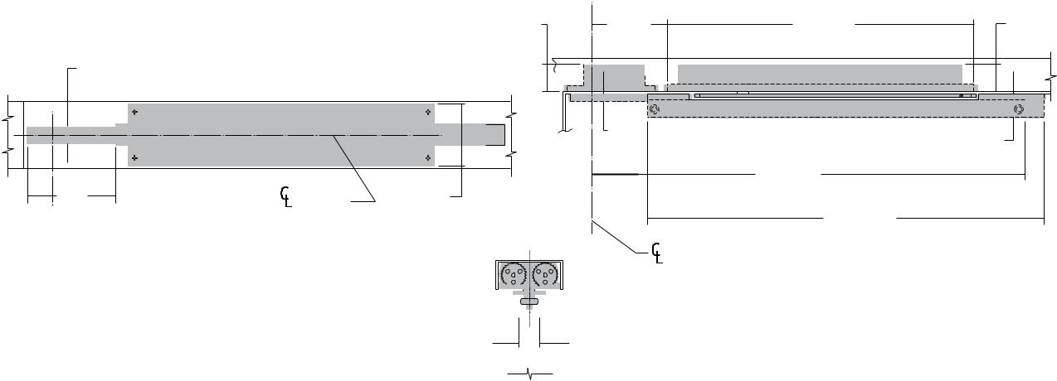

 |  |  | 1-5/8" | 4-1/2" | 18-1/4" |  | 1-5/8"
 |  |  | 41 mm | 115 mm | 464 mm |  | 41 mm
1"
25 mm
 |  |  |  | 1/2" |  |  | 1-7/16"
 |  |  |  | 13 mm |  |  | 1-7/16"
 |  |  |  | 13 mm |  |  | 37 mm
 |  |  |  |  | 22-1/2"
 | of Door |  | 3-23/32" |  | 572 mm
5-1/4" |  |  | 3-23/32"
5-1/4" |  |  | 95 mm
133 mm |  | 23-5/8"
 |  | 600 mm
 |  | of Pivot
 |  | 1-1/4"
 |  | 32 mm

Auxiliary Stop | Recommended where a door cannot swing 95°
Center Pivot Set | Must be used but ordered separately
Door Width | 30˝ (762 mm) minimum with 1-3/4˝ (44 mm) pivot centers
Top Rail | n | 1-7/16˝ (36 mm) mortise required
 | n | 3/8˝ (10 mm) cutout required at top of the door, both sides.
Door Thickness | 1-3/4˝ (44 mm) minimum
Centering Adjustment | Centering is provided by rotating the track roller to center the door in the opening.
Wood Frame | n | Installation simplified by WOOD MOUNTING CLIP SET, 6030-416
 | n | Consult product support for special template
Maximum opening | n | Center pivot template allows 95°
 | n | Adjustable hold-open points from 85° to 95°, with hold-open track

Notes:

- For interior or exterior doors

- Double acting cylinder in cased frame

- Concealed arm and track in door top rail

- Center pivots only

D30

LCN Door Control Catalog

phone: 877-671-7011

n fax: 800-248-1460

n www.allegion.com/us

n 009426 rev. 11/16

6030

Series

Accessories
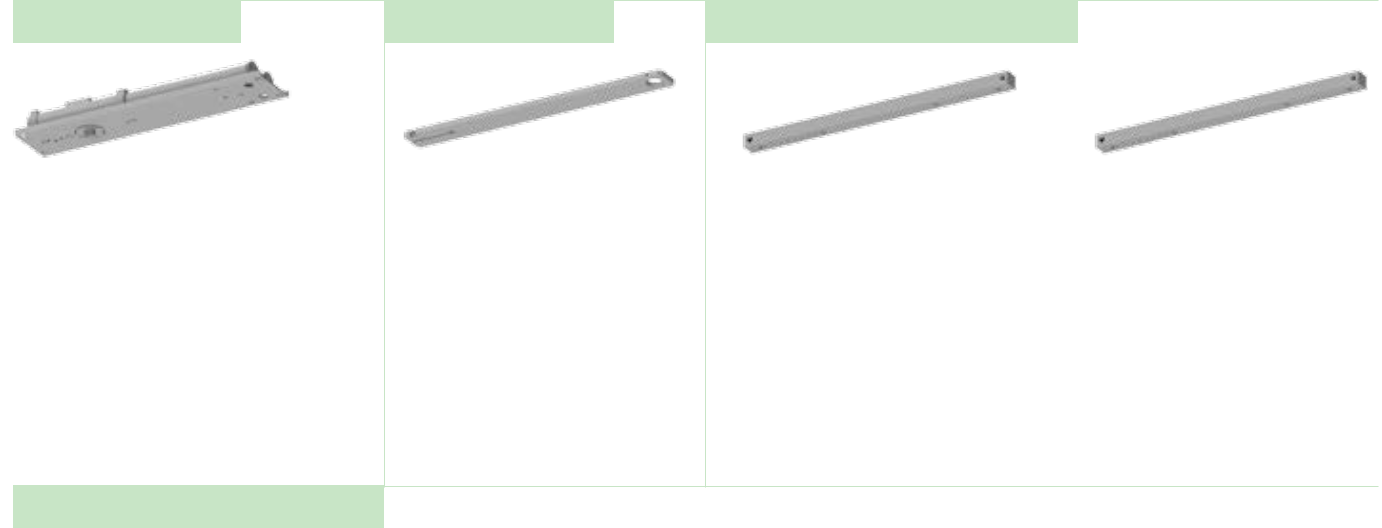

Cylinder

6031(2)(3)(4)(5)-3071 Cast Iron Cylinder Assembly

- Non-handed

- With mounting plate

- Standard

Arm

6030-3077T
Standard Arm

- Non-handed

- 5/16˝ (8 mm) thick arm

- Track roller not included with arm

Tracks

6030-3038B |  | 6030-3038HB
Standard Track with Bumper |  | Hold-Open Track with Bumper
n | Non-handed | n | Non-handed
n | Non hold-open | n | Optional

- Will accept hold-open clip

- Standard

Installation Accessories
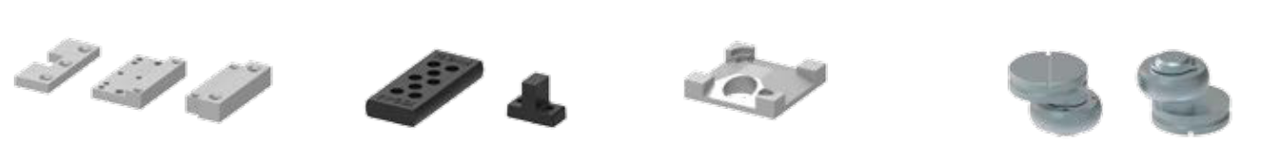

6030-416
Wood Mounting Clip Set

- Simplifies mounting closer in wood frame

- Includes latch stile clip, hinge stile clip, and cover

- For use with Ives Series center pivots

- Consult factory for special template
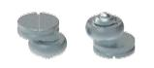

6030-3034H Hold-Open Track Roller

- Hold-open roller

- Quiet, low friction roller assembly

6030-169
Track Bumper

- Mounts in track to assist backcheck

- Limits maximum opening

- Consists of bumper, bumper post, and mounting screw

NOTE: Track bumper does not replace auxiliary stop.

6030-3054
Hold-Open Clip

- Mounts in track to provide hold-open function

- Hold-open point controlled by clip location

- Requires 6030-3034H Hold-Open Track Roller

6030-3034
Track Roller

- Quiet, low friction roller assembly includes eccentric with 3/4˝ (19 mm) adjustment to center 36˝ (914 mm) door

LCN Door Control Catalog | D31
phone: 877-671-7011 n fax: 800-248-1460 n www.allegion.com/us n 009426 | rev. 11/16

6030

Series

Ordering information
Ordering information | How-to-order 6030 Series closers
 | How-to-order 6030 Series closers |  | Closer will be shipped with:
 | Select cylinder size |  | - Standard cylinder with mounting plate
 | 6031 |  | - Standard arm
 | 6032 |  | - Standard track with bumper
 | 6033 |  | - Wood and machine screw pack
 | 6034 |  | unless options listed below are selected.
 | 6035
 | Specify finish
 | Standard Powder Coat __________
 | Aluminum, Dark Bronze, Statuary, Light Bronze, Black, Brass
 | Closer options

Track | Installation accessories
Hold-open with Bumper (HBUMPER) | Wood Clip Set, 6030-416
Finishes
Custom Powder Coat (RAL)_____________
Plated Finish, US ______________
SRI primer (use with powder coat finishes only)
Screw pack | Special template
TORX Machine Screw (TORX) | ST- ________

Table of sizes

- Select closer based on width of door
- 6030 Series cylinders available in size 1, 2, 3, 4, or 5
- Closing power of all 6030 Series closers may be increased 35%
- Specify next higher size closer where strong drafts exist

Exterior (and Vestibule) door width


30˝ | 34˝ | 36˝ | 42˝
762mm | 864mm | 914mm | 1067mm
6033 | size 3 | size 4 | size 5
6034
6035

Minimum door width

Interior door width


30˝ | 34˝ | 38˝ | 48˝ | 54˝
762mm | 864mm | 965mm | 1219mm | 1372mm
size 2 | size 3 | size 4 | size 5
6032
6033
6034
6035

Minimum door width


Indicates recommended range of door width for closer size.

Note: Minimum door width 28˝ (711 mm).

Reduced opening force 6030 Series closers

CAUTION ! Any manual door closer, including those certified by BHMA to conform to ANSI Standard A156.4, that is selected, installed and adjusted based on ADA or other reduced opening force requirements may not provide sufficient power to reliably close and latch a door.

Refer to POWER OPERATORS section for information on systems that meet reduced opening force requirements without affecting closing power.

* Maximum opening force.

DOOR WIDTH | 36˝ | 42˝ | 48˝
8.5* lbs. | 6033 | 6034 | 6035
5.0* lbs. | 6031 | 6032 | 6032

^{D32} LCN Door Control Catalog

phone: 877-671-7011 n fax: 800-248-1460 n www.allegion.com/us n 009426 rev. 11/16

