




® ®
®
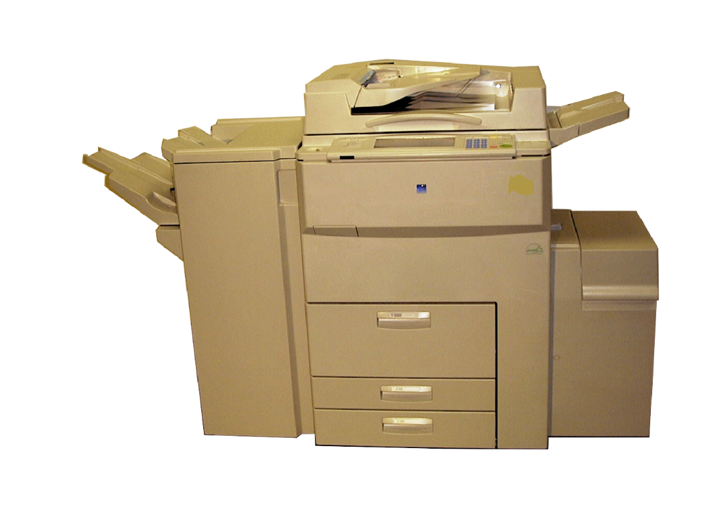

A292/A293/A292P/A293P B098

PARTS CATALOG

000929MIU

RICOH GROUP COMPANIES



®



®

PARTS CATALOG

A292/A293/A292P/A293P/B098

RICOH GROUP COMPANIES

A292/A293/A292P/A293P/B098

PARTS CATALOG

000929MIU

It is the reader's responsibility when discussing the information contained within this document to maintain a level of confidentiality that is in the best interest of Ricoh Corporation and its member companies.

NO PART OF THIS DOCUMENT MAY BE REPRODUCED IN ANY FASHION AND DISTRIBUTED WITHOUT THE PRIOR PERMISSION OF RICOH CORPORATION.

All product names, domain names or product illustrations, including desktop images, used in this document are trademarks, registered trademarks or the property of their respective companies.

They are used throughout this book in an informational or editorial fashion only and for the benefit of such companies. No such use, or the use of any trade name, or web site is intended to convey endorsement or other affiliation with Ricoh products.

2002 RICOH Corporation. All rights reserved.

LEGEND

PRODUCT CODE |  |  | COMPANY
 | GESTETNER |  | LANIER |  | RICOH | SAVIN
A292 | 3355 |  |  |  | Aficio 551 | 2055DP
A293 | 3370 |  |  |  | Aficio 700 | 2070DP
A292 w/G594 Controller | -- |  |  |  | Aficio 551P | --
A293 w/G594 Controller | -- |  |  |  | Aficio 700P | --
B098 | 5502 |  | LD055 |  | Aficio1055 | 2555
A698/B587 | Large Capacity Tray –RT37/RT44
B302 | 3,000 Sheet Finisher – SR810
B312/B586 | 3,000 Sheet Finisher – SR740/SR870
A763 | Booklet Finisher – SR750
B333/B476/B322 | Copy Tray Type 700/1075/ Connector Kit Type 700
A812 | Punch Unit Type 850
B375/B588 | LG Kit Type 700/1055
B337/B590 | Printer Controller Type 700/1055
G594 | EB70 Printer Controller

DOCUMENTATION HISTORY

REV. NO. | DATE | COMMENTS
* | 05/2000 | Original Printing
 | 10/2002 | B098 Addition

A292/A292/B098

TABLE OF CONTENTS

A292/A293/B098 PARTS LOCATION AND LIST |  | 30.PAPER RESISTRATION 2 (A292/A293/B098) ................. | 72
LOCATION OF UNIT................................................................ | 4 | 31.PAPER RESISTRATION 3 (A292/A293/B098) ................. | 74
1.EXTERIOR 1 (A292/A293/B098)........................................ | 14 | 32.TONER BOTTLE HOLDER (A292/A293/B098) ................ | 76
2.EXTERIOR 2 (A292/A293/B098)........................................ | 16 | 33.TONER HOPPER UNIT (A292/A293/B098)...................... | 78
3.OPERATION PANEL (A292/A293/B098)........................... | 18 | 34.DEVELOPMENT UNIT 1 (A292/A293/B098)..................... | 80
4.ARDF EXTERIOR (A292/A293/B098)................................ | 20 | 35.DEVELOPMENT UNIT 2 (A292/A293/B098)..................... | 82
5.ORIGINAL FEED SECTION 1 (A292/A293/B098) ............. | 22 | 36.PCU 1 (A292/A293/B098).................................................. | 84
6.ORIGINAL FEED SECTION 2 (A292/A293/B098) ............. | 24 | 37.PCU 2 (A292/A293/B098).................................................. | 86
7.ORIGINAL FEED SECTION 3 (A292/A293/B098) ............. | 26 | 38.PCU 3 (A292/A293/B098).................................................. | 88
8.ORIGINAL TRANSFER SECTION (A292/A293/B098) ...... | 28 | 39.PCU 4 (A292/A293/B098).................................................. | 90
9.ORIGINAL EXIT SECTION 1 (A292/A293/B098)............... | 30 | 40.TRANSFER SECTION 1 (A292/A293/B098)..................... | 92
10.ORIGINAL EXIT SECTION 2 (A292/A293/B098).............. | 32 | 41.TRANSFER SECTION 2 (A292/A293/B098)..................... | 94
11.ARDF DRIVE & ELECTRICAL 1 (A292/A293/B098) ........ | 34 | 42.FUSING UNIT 1 (A292/A293/B098) .................................. | 96
12.ARDF DRIVE & ELECTRICAL 2 (A292/A293/B098) ........ | 36 | 43.FUSING UNIT 2 (A292/A293/B098) .................................. | 98
13.ARDF FRAME SECTION (A292/A293/B098).................... | 38 | 44.FUSING UNIT 3 (A292/A293/B098) ................................. | 100
14.OPTICS SECTION 1 (A292/A293/B098)........................... | 40 | 45.INVERTOR & DUPLEX UNIT 1 (A292/A293/B098) ......... | 102
15.OPTICS SECTION 2 (A292/A293/B098)........................... | 42 | 46.INVERTOR & DUPLEX UNIT 2 (A292/A293/B098) ......... | 104
16.OPTICS SECTION 3 (A292/A293/B098)........................... | 44 | 47.INVERTOR & DUPLEX UNIT 3 (A292/A293/B098) ......... | 106
17.OPTICS SECTION 4 (A292/A293/B098)........................... | 46 | 48.INVERTOR & DUPLEX UNIT 4 (A292/A293/B098) ......... | 108
18.LASER UNIT (A292/A293/B098)....................................... | 48 | 49.INVERTOR & DUPLEX UNIT 5 (A292/A293/B098) ......... | 110
19.BY-PASS FEED SECTION (A292/A293/B098)................. | 50 | 50.PAPER EXIT 1 (A292/A293/B098) ................................... | 112
20.TANDEM LCT 1 (A292/A293/B098).................................. | 52 | 51.PAPER EXIT 2 (A292/A293/B098) ................................... | 114
21.TANDEM LCT 2 (A292/A293/B098).................................. | 54 | 52.PAPER EXIT 3 (A292/A293/B098) ................................... | 116
22.TANDEM LCT 3 (A292/A293/B098).................................. | 56 | 53.DRIVE SECTION 1 (A292/A293/B098) ............................ | 118
23.UNIVERSAL TRAY (A292/A293/B098)............................. | 58 | 54.DRIVE SECTION 2 (A292/A293/B098) ............................ | 120
24.PAPER TRAY (A292/A293/B098) ..................................... | 60 | 55.DRIVE SECTION 3 (A292/A293/B098) ............................ | 122
25.PAPER FEED SECTION 1 (A292/A293/B098) ................. | 62 | 56.DRIVE SECTION 4 (A292/A293/B098) ............................ | 124
26.PAPER FEED SECTION 2 (A292/A293/B098) ................. | 64 | 57.DRIVE SECTION 5 (A292/A293/B098) ............................ | 126
27.PAPER FEED SECTION 3 (A292/A293/B098) ................. | 66 | 58.ELECTRICAL SECTION 1 (A292/A293/B098)................. | 128
28.VERTICAL TRANSPORT SECTION (A292/A293/B098).. | 68 | 59.ELECTRICAL SECTION 2 (A292/A293/B098)................. | 130
29.PAPER RESISTRATION 1 (A292/A293/B098) ................. | 70 | 60.ELECTRICAL SECTION 3 (A292/A293/B098)................. | 132

61.ELECTRICAL SECTION 4 (A292/A293/B098) 134

62.FRAME SECTION 1 (A292/A293/B098) 136

63.FRAME SECTION 2 (A292/A293/B098) 138

64.FRAME SECTION 3 (A292/A293/B098) 140

65.I/O CONTROL BOARD (A292/A293) 142

66.I/O CONTROL BOARD (B098) 146

67.MCU BOARD (A292/A293) 150

68.MCU BOARD (B098) 154

69.BICU BOARD (A292/A293) 158

70.BICU BOARD (B098) 168

71.DECAL AND DOCUMENT (A292/A293) 178

72.SPECIAL TOOLS (A292/A293) 184

A292/A293/B098 PARTS INDEX

PARTS INDEX 3

LARGE CAPACITY TRAY RT37/RT44 A698/B587 PARTS

LOCATION AND LIST

1.EXTERIOR (A686/B587) 2

2.TRAY DRIVE SECTION (A686/B587) 4

3.PAPER FEED SECTION 1(A686/B587) 6

4.PAPER FEED SECTION 2(A686/B587) 8

5.ELECTRICAL SECTION (A686/B587) 10

6.FRAME SECTION (A686/B587) 12

7.DECAL AND DOCUMENT (A686/B587) 14

LARGE CAPACITY TRAY A698/B587 RT37/RT44 PARTS

INDEX

PARTS INDEX 2

3,000 SHEET FINISHER SR810 B302 PARTS LOCATION

AND LIST

LOCATION OF UNIT 2

1.EXTERIOR (B302) 6

2.STAPLE TRAY 1 (B302) 8

3.STAPLE TRAY 2 (B302) 10

4.STAPLE TRAY 3 (B302)................................................... |  |  | 12
5.STAPLE TRAY 4 (B302)................................................... |  |  | 14
6.STAPLER UNIT (B302) .................................................... |  |  | 16
7.STAPLE TRANSPORT 1 (B302) ...................................... |  |  | 18
8.STAPLE TRANSPORT 2 (B302) ...................................... |  |  | 20
9.STAPLE TRANSPORT 3 (B302) ...................................... |  |  | 22
10.STAPLE TRANSPORT 4 (B302) ..................................... |  |  | 24
11.TRANSPORT SECTION 1 (B302)................................... |  |  | 26
12.TRANSPORT SECTION 2 (B302)................................... |  |  | 28
13.PAPER EXIT SECTION | 1 | (B302).................................... | 30
14.PAPER EXIT SECTION | 2 | (B302).................................... | 32
15.PAPER EXIT SECTION | 3 | (B302).................................... | 34
16.DRIVE SECTION (B302) ................................................. |  |  | 36
17.ELECTRICAL SECTION (B302)...................................... |  |  | 38
18.FRAME SECTION 1 (B302)............................................. |  |  | 40
19.FRAME SECTION 2 (B302)............................................. |  |  | 42
20.DECAL AND DOCUMENT (B302)................................... |  |  | 44
3,000 SHEET FINISHER SR810 B302 PARTS INDEX
PARTS INDEX....................................................................... |  |  | 47
3,000 SHEET FINISHER SR740/SR870 B312/B586 PARTS
LOCATION AND LIST
LOCATION OF UNIT................................................................ |  |  | 2
1.EXTERIOR (B312/B586) | ..................................................... |  | 6
2.STAPLE TRANSPORT 1 (B312/B586)................................ |  |  | 8
3.STAPLE TRANSPORT 2 (B312/B586)............................... |  |  | 10
4.STAPLE TRANSPORT 3 (B312/B586)............................... |  |  | 12
5.STAPLE TRAY 1 (B312/B586) ........................................... |  |  | 14
6.STAPLE TRAY 2 (B312/B586) ........................................... |  |  | 16
7.STAPLER UNIT (B312/B586)............................................. |  |  | 18
8.TRANSPORT SECTION | 1 | (B312/B586) ............................ | 20
9.TRANSPORT SECTION | 2 | (B312/B586) ............................ | 22
10.PAPER EXIT SECTION | 1 | (B312/B586) ............................ | 24
11.PAPER EXIT SECTION | 2 | (B312/B586) ............................ | 26
12.FRAME SECTION (B312/B586) ........................................ |  |  | 28

13.DRIVE SECTION (B312/B586) 30

14.ELECTRICAL SECTION (B312/B586) 32

15.DECAL AND DOCUMENT (B312/B586) 34

BOOKLET FINISHER SR750 A763 PARTS LOCATION

AND LIST

LOCATION OF UNIT 2

1.EXTERIOR 1 (A763) 8

2.EXTERIOR 2 (A763) 10

3.EXTERIOR 3 (A763) 12

4.EXTERIOR 4 (A763) 14

5.ENTRANCE GUIDE SECTION 1 (A763) 16

6.ENTRANCE GUIDE SECTION 2 (A763) 18

7.STAPLE TRAY GUIDE UNIT (A763) 20

8.UPPER EXIT UNIT (A763) 22

9.JOGGER SECTION (A763) 24

10.LOWER EXIT UNIT (A763) 26

11.TRANSPORT SECTION 1 (A763) 28

12.TRANSPORT SECTION 2 (A763) 30

13.TRANSPORT SECTION 3 (A763) 32

14.FINISHER STAPL UNIT (A763) 34

15.TRAY DRIVE SECTION (A763) 36

16.FINISHER DRIVE SECTION (A763) 38

17.BOOKLET TRANSPORT SECTION 1 (A763) 40

18.BOOKLET TRANSPORT SECTION 2 (A763) 42

19.BOOKLET PAPER GUIDE 1 (A763) 44

20.BOOKLET PAPER GUIDE 2 (A763) 46

21.BOOKLET STAPLE UNIT (A763) 48

22.PAPER FOLDER UNIT 1 (A763) 50

23.PAPER FOLDER UNIT 2 (A763) 52

24.BOOKLET DRIVE SECTION (A763) 54

25.BOOKLET EXIT SECTION (A763) 56

BOOKLET FINISHER SR750 A763 PARTS INDEX

PARTS INDEX 2
COPY TRAY TYPE 700/1075/CONNECTOR KIT TYPE 700

B322/B333/B476 PARTS LOCATION AND LIST

1.COPY TRAY/CONNECTOR KIT (B322/B333/B476) 2

COPY TRAY TYPE 700/1075/CONNECTOR KIT TYPE 700

B322/B333/B476 PARTS INDEX

PARTS INDEX 2

PUNCH UNIT TYPE 850 A812 PARTS LOCATION AND LIST

1.PUNCH UNIT (A812) 2

PUNCH UNIT TYPE 850 A812 PARTS INDEX

PARTS INDEX 2

LG KIT TYPE 700/1055 B375/B588 PARTS LOCATION

AND LIST

1.8 1/2x14 Paper Size Tray Unit (B375/B588) 2

LG KIT TYPE 700/1055 B375/B588 PARTS

PARTS INDEX 2

PRINTER CONTROLLER TYPE 700/1050 B337/B590

PARTS LOCATION AND LIST

1.PRINTER CONTROLLER (B337/B590) 2

PRINTER CONTROLLER TYPE 700/1050 B337/B590

PARTS INDEX

PARTS INDEX 2

PRINTER CONTROLLER EB70 G594 PARTS LOCATION

AND LIST

1.PRINTER CONTROLLER TYPE B (G594) 2

PRINTER CONTROLLER EB70 G594 PARTS INDEX

PARTS INDEX 2

A292/A293/B098

PARTS LOCATION AND LIST

This section instructs you as to the numbers and names on parts on this machine.

LOCATIONS OF UNITS

1. EXTERIOR 1 (A292/A293/B098) 2. EXTERIOR 2 (A292/A293/B098) 3. OPERATION PANEL (A292/A293/B098)

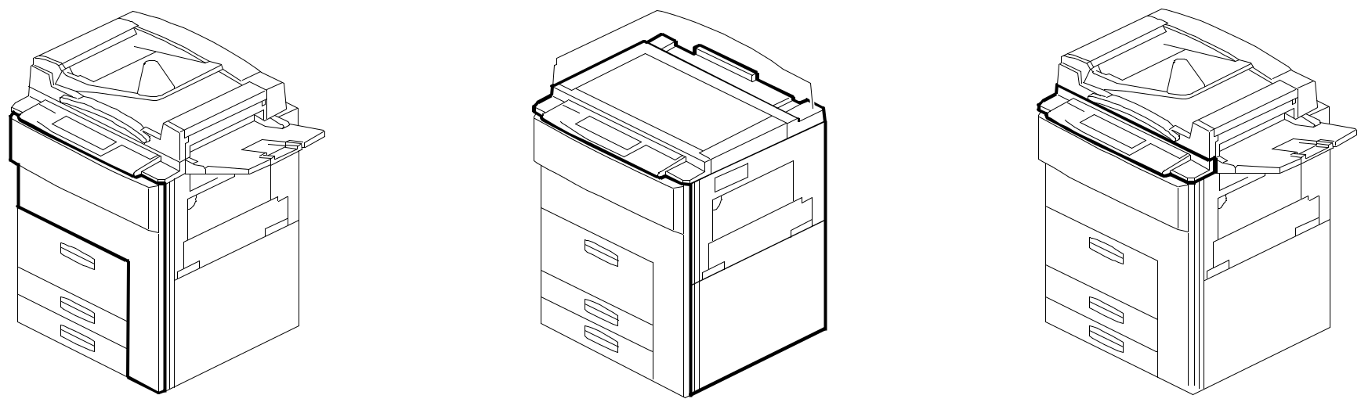

See Page 15 See Page 17 See Page 19

4. ARDF EXTERIOR (A292/A293/B098) 5. ORIGINAL FEED SECTION 1 6. ORIGINAL FEED SECTION 2

(A292/A293/B098) (A292/A293/B098)
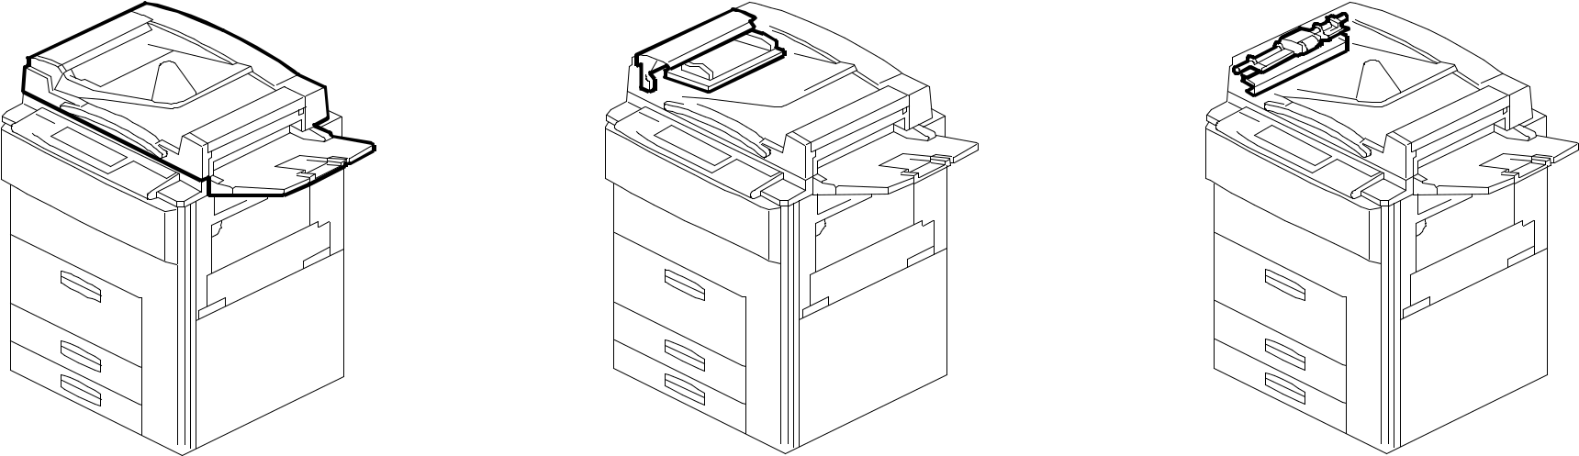

See Page 21 See Page 23 See Page 25

A292/A293/B098 3 Parts Location and List

LOCATIONS OF UNITS

7. ORIGINAL FEED SECTION 3 8. ORIGINAL TRANSFER SECTION 9. ORIGINAL EXIT SECTION 1

(A292/A293/B098) (A292/A293/B098) (A292/A293/B098)
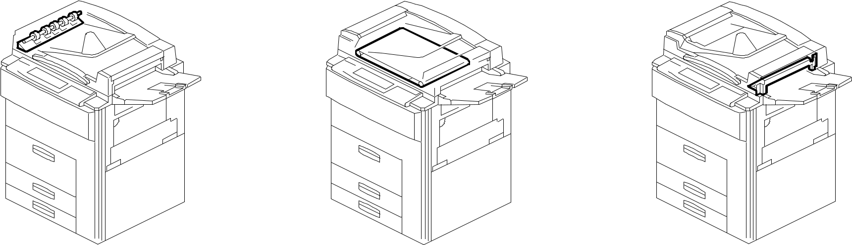

See Page 27 See Page 29 See Page 31

10. ORIGINAL EXIT SECTION 2 11. ARDF DRIVE & ELECTRICAL 1 12. ARDF DRIVE & ELECTRICAL 2

(A292/A293/B098) (A292/A293/B098) (A292/A293/B098)
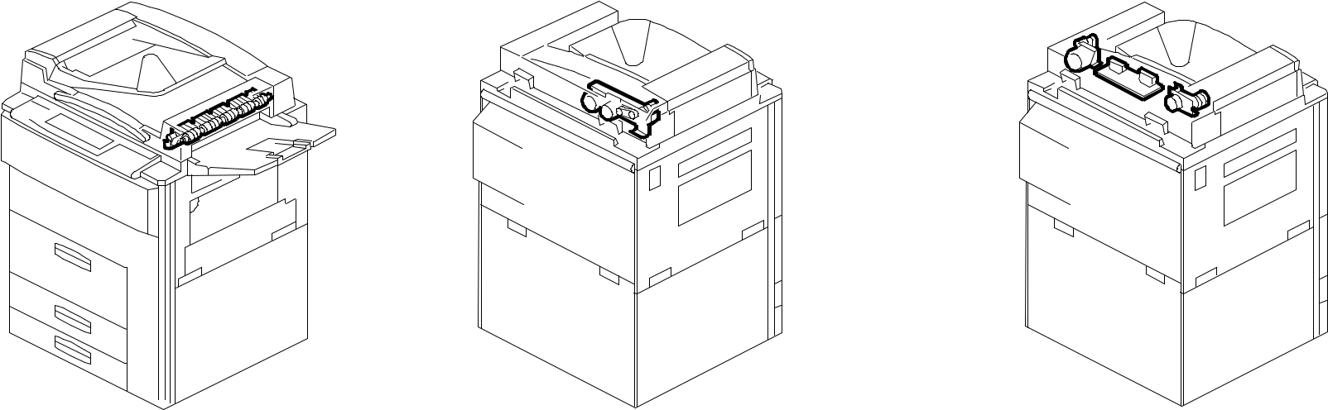

See Page 33 See Page 35 See Page 37

A292/A293/B098 4 Parts Location and List

LOCATIONS OF UNITS

13. ARDF FRAME SECTION 14. OPTICS SECTION 1 (A292/A293/B098) 15. OPTICS SECTION 2 (A292/A293/B098)

(A292/A293/B098)
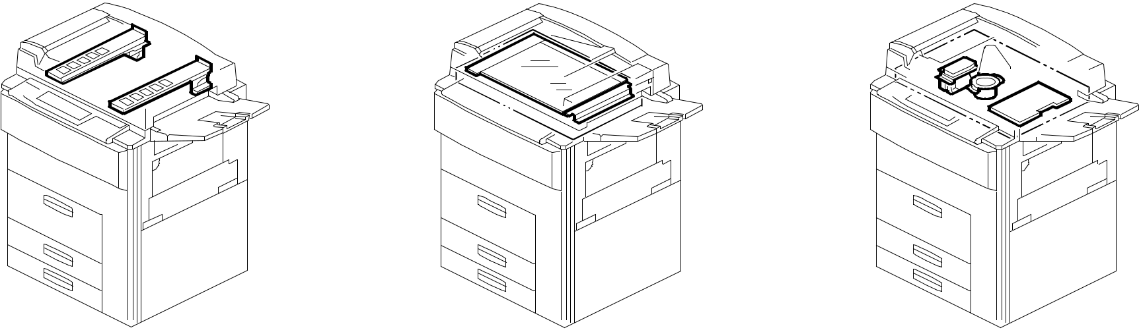

See Page 39 See Page 41 See Page 43

16. OPTICS SECTION 3 (A292/A293/B098) 17. OPTICS SECTION 4 (A292/A293/B098) 18. LASER UNIT (A292/A293/B098)

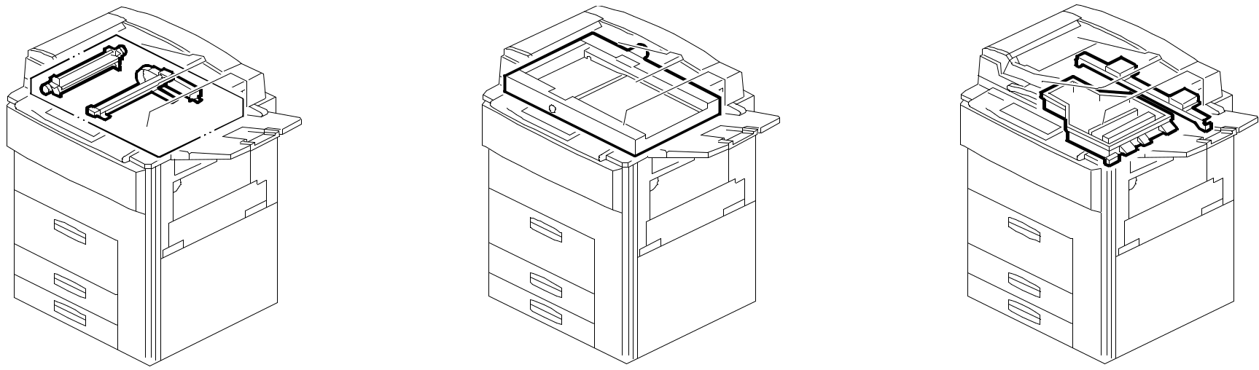

See Page 45 See Page 47 See Page 49

A292/A293/B098 5 Parts Location and List

LOCATIONS OF UNITS

19. BY-PASS FEED SECTION 20. TANDEM LCT 1 (A292/A293/B098) 21. TANDEM LCT 2 (A292/A293/B098)

(A292/A293/B098)

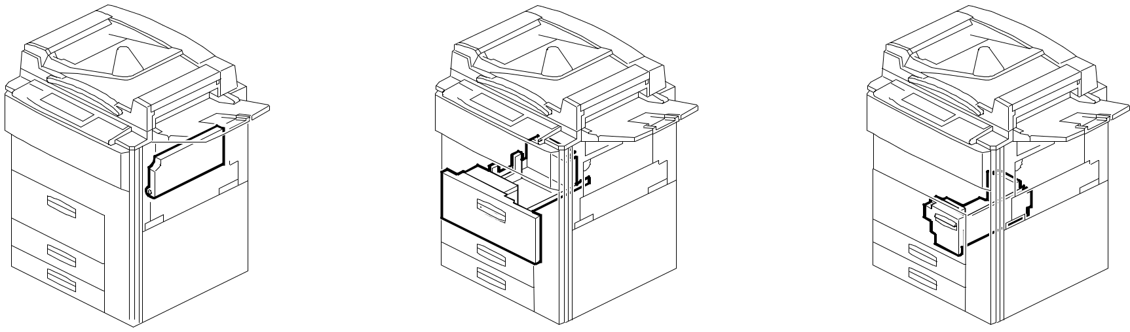

See Page 51 See Page 53 See Page 55

22. TANDEM LCT 3 (A292/A293/B098) 23. UNIVERSAL TRAY (A292/A293/B098) 24. PAPER TRAY (A292/A293/B098)

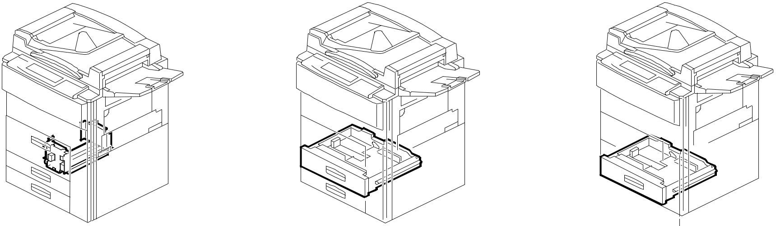

See Page 57 See Page 59 See Page 61

A292/A293/B098 6 Parts Location and List

LOCATIONS OF UNITS
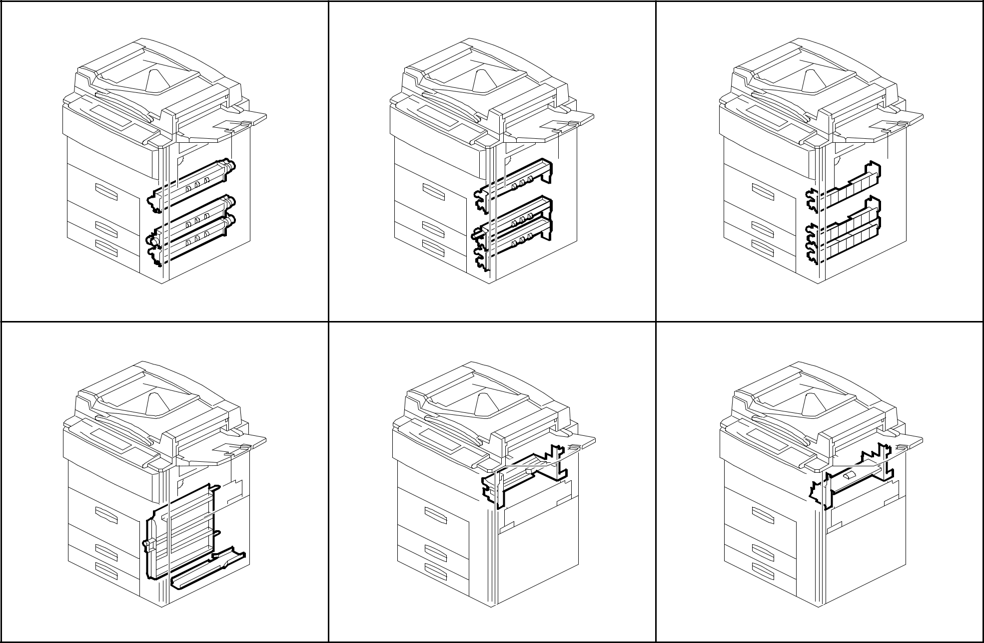

25. PAPER FEED SECTION 1 26. PAPER FEED SECTION 2 27. PAPER FEED SECTION 3

(A292/A293/B098) (A292/A293/B098) (A292/A293/B098)

See Page 63 See Page 65 See Page 67

28. VERTICAL TRANSPORT SECTION 29. PAPER RESISTRATION 1 30. PAPER RESISTRATION 2

(A292/A293/B098) (A292/A293/B098) (A292/A293/B098)

See Page 69 See Page 71 See Page 73

A292/A293/B098 7 Parts Location and List

LOCATIONS OF UNITS
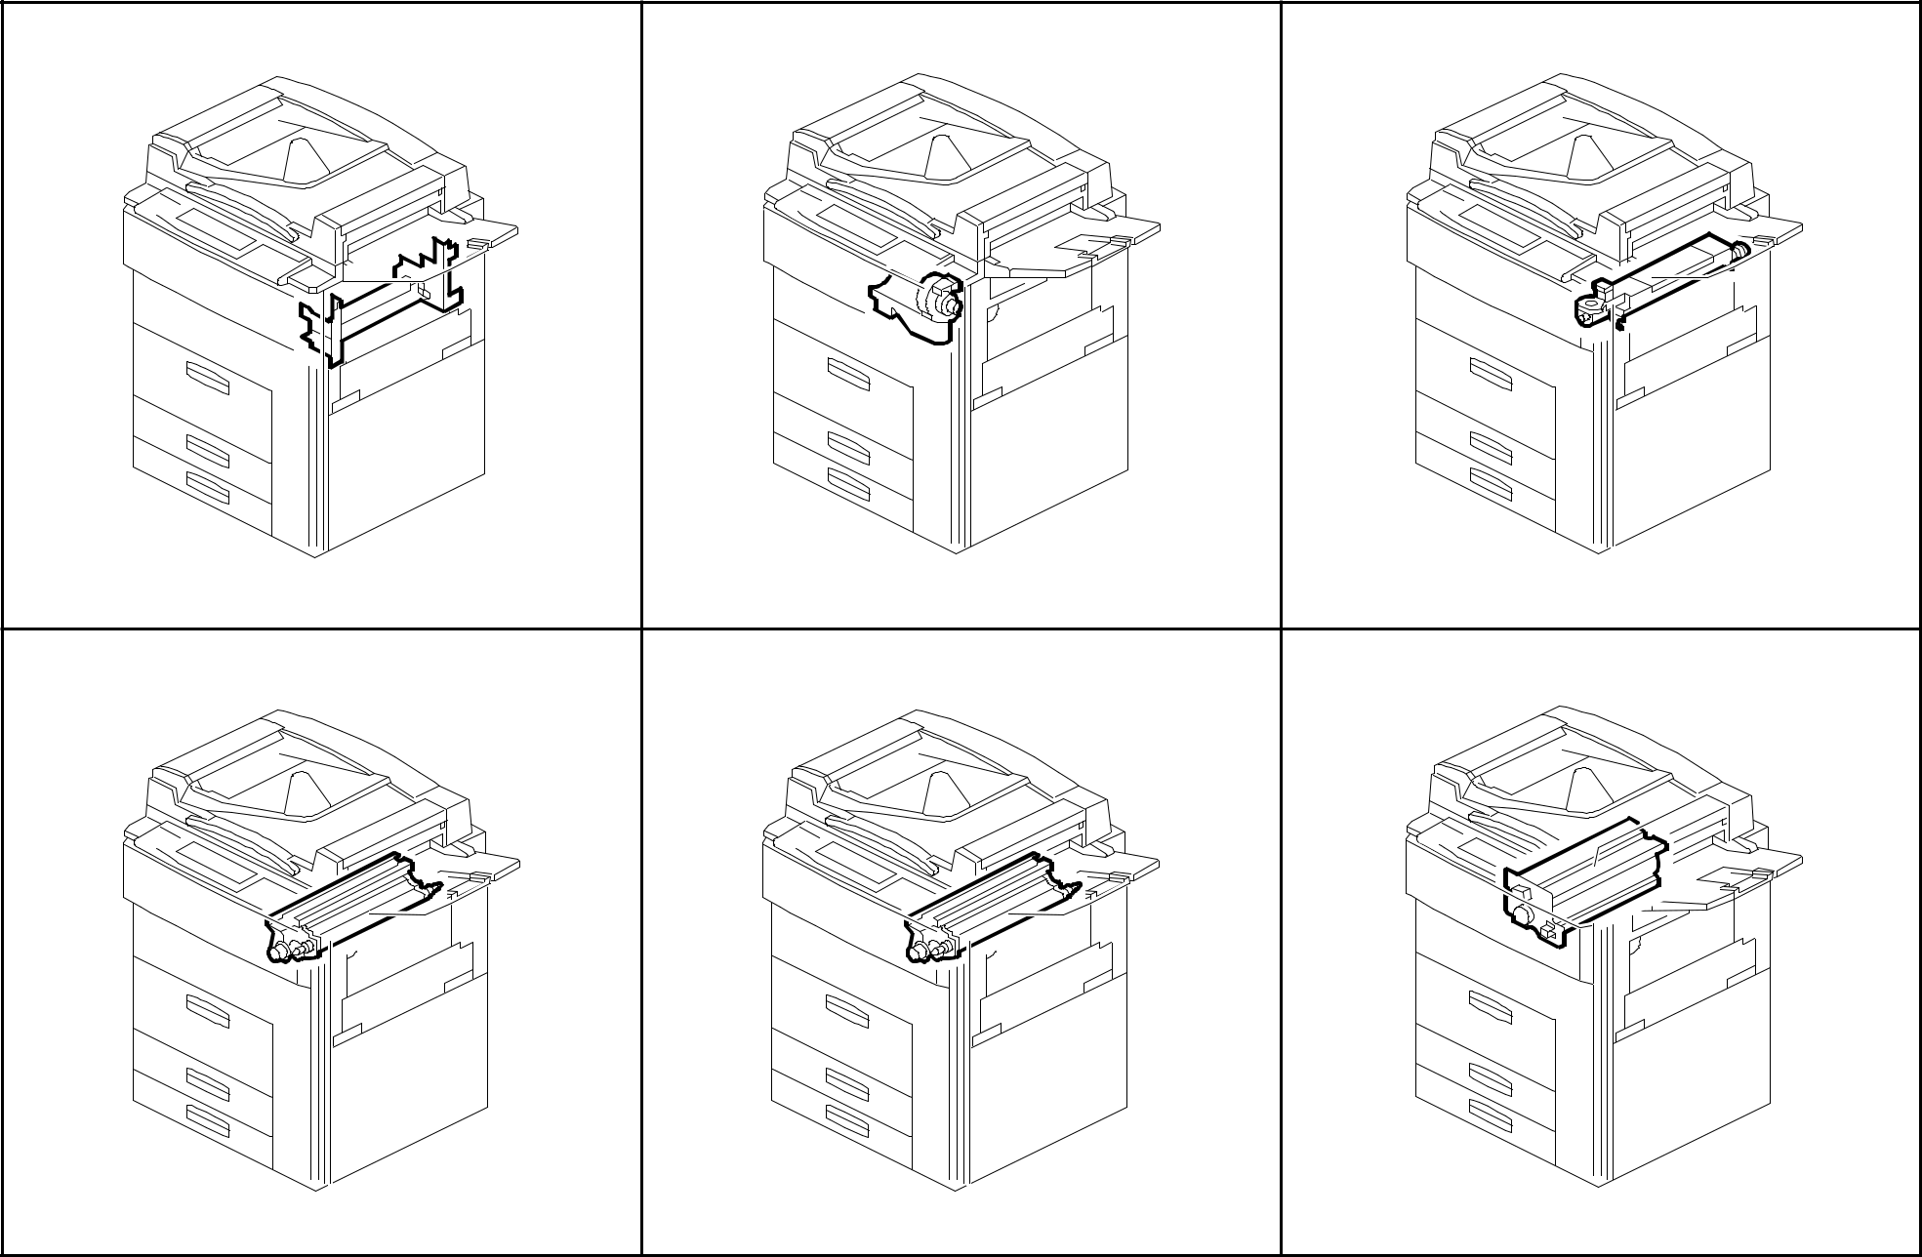

31. PAPER RESISTRATION 3 32. TONER BOTTLE HOLDER 33. TONER HOPPER UNIT

(A292/A293/B098) (A292/A293/B098) (A292/A293/B098)

See Page 75 See Page 77 See Page 79

34. DEVELOPMENT UNIT 1 35. DEVELOPMENT UNIT 2 36. PCU 1 (A292/A293/B098)

(A292/A293/B098) (A292/A293/B098)

See Page 81 See Page 83 See Page 85

A292/A293/B098 8 Parts Location and List

LOCATIONS OF UNITS
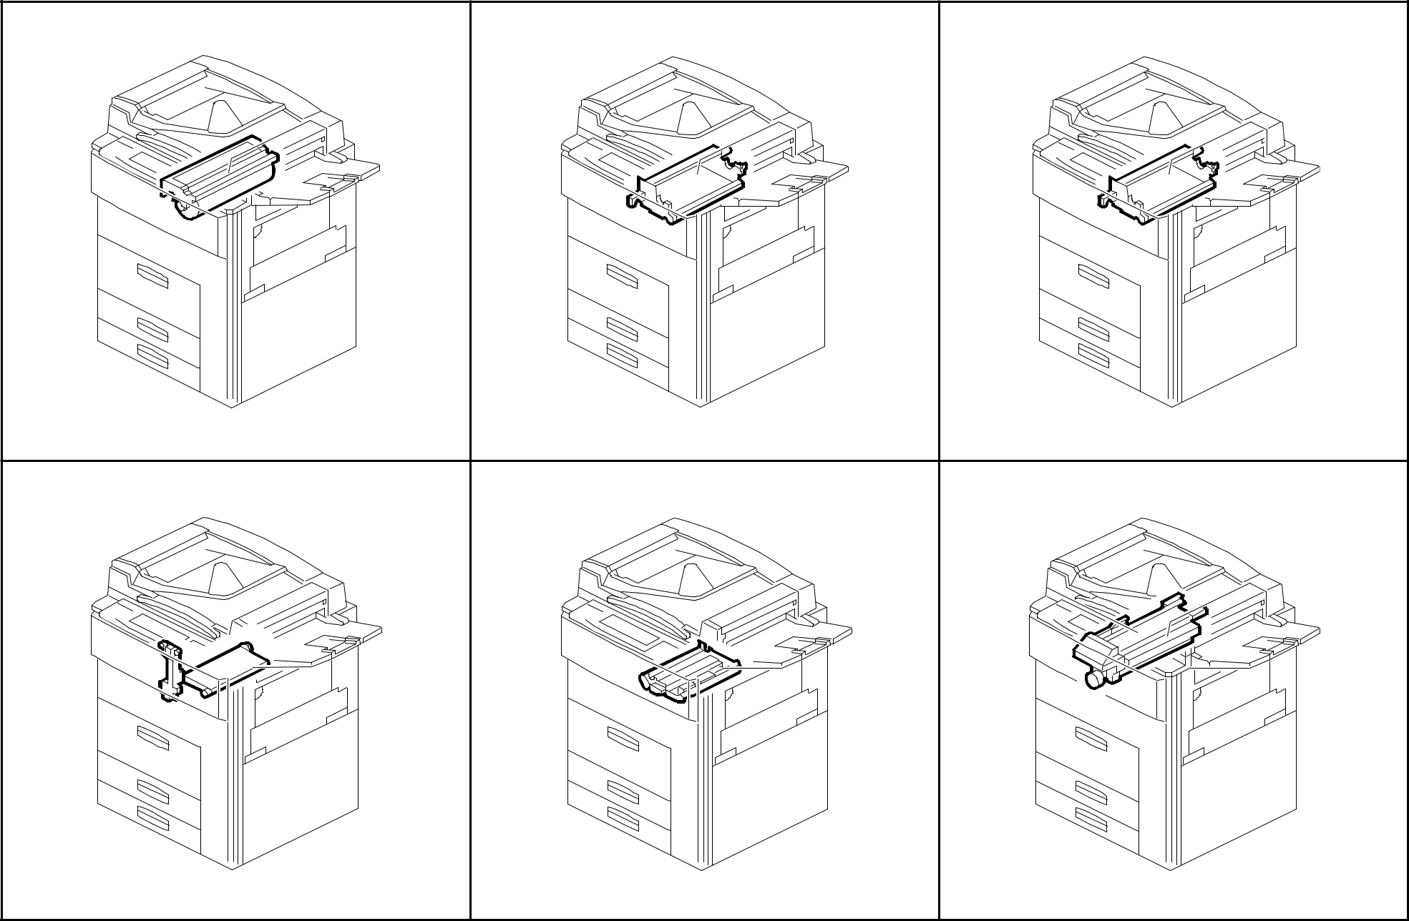

37. PCU 2 (A292/A293/B098) 38. PCU 3 (A292/A293/B098) 39. PCU 4 (A292/A293/B098)

See Page 87 See Page 89 See Page 91

40. TRANSFER SECTION 1 41. TRANSFER SECTION 2 42. FUSING UNIT 1 (A292/A293/B098)

(A292/A293/B098) (A292/A293/B098)

See Page 93 See Page 95 See Page 97

A292/A293/B098 9 Parts Location and List

LOCATIONS OF UNITS

43. FUSING UNIT 2 (A292/A293/B098) 44. FUSING UNIT 3 (A292/A293/B098) 45. INVERTOR & DUPLEX UNIT 1

(A292/A293/B098)

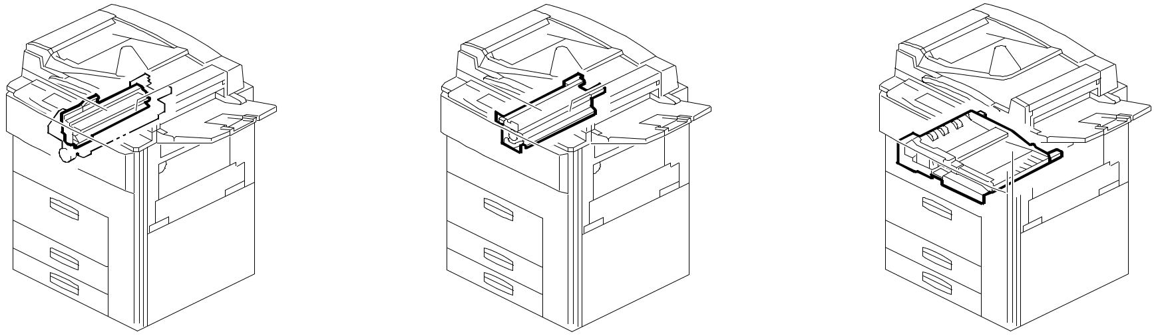

See Page 99 See Page 101 See Page 103

46. INVERTOR & DUPLEX UNIT 2 47. INVERTOR & DUPLEX UNIT 3 48. INVERTOR & DUPLEX UNIT 4

(A292/A293/B098) (A292/A293/B098) (A292/A293/B098)

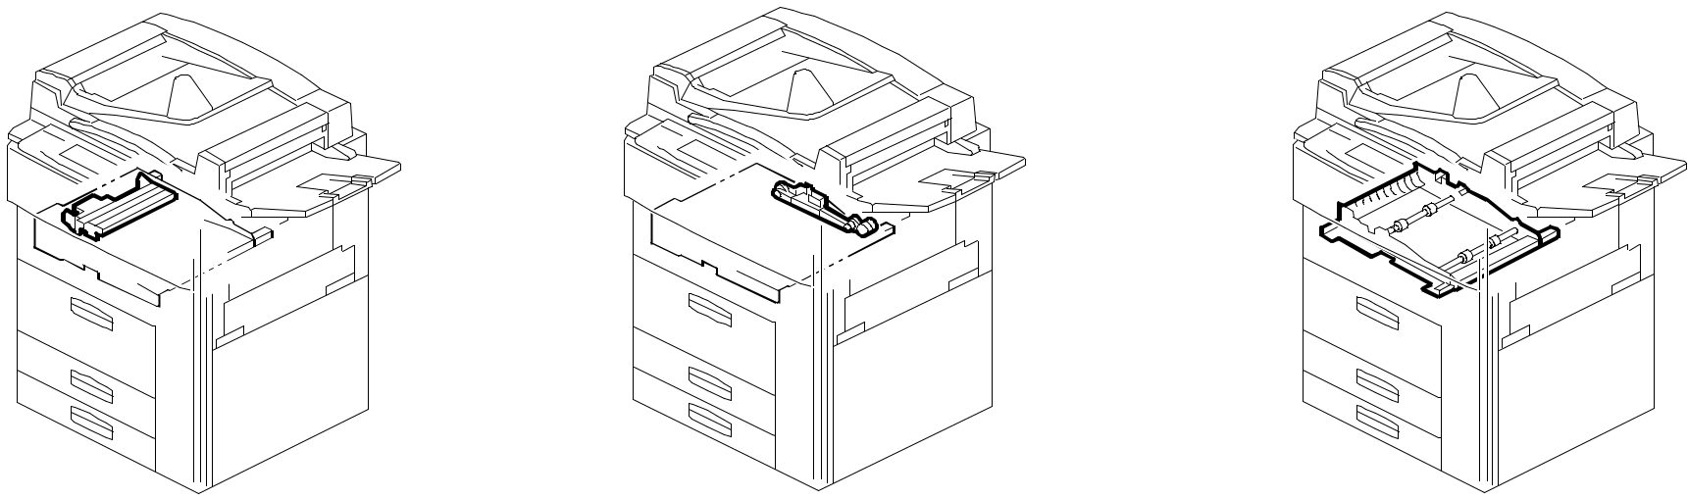

See Page 105 See Page 107 See Page 109

A292/A293/B098 10 Parts Location and List

LOCATIONS OF UNITS

49. INVERTOR & DUPLEX UNIT 5 50. PAPER EXIT 1 (A292/A293/B098) 51. PAPER EXIT 2 (A292/A293/B098)

(A292/A293/B098)

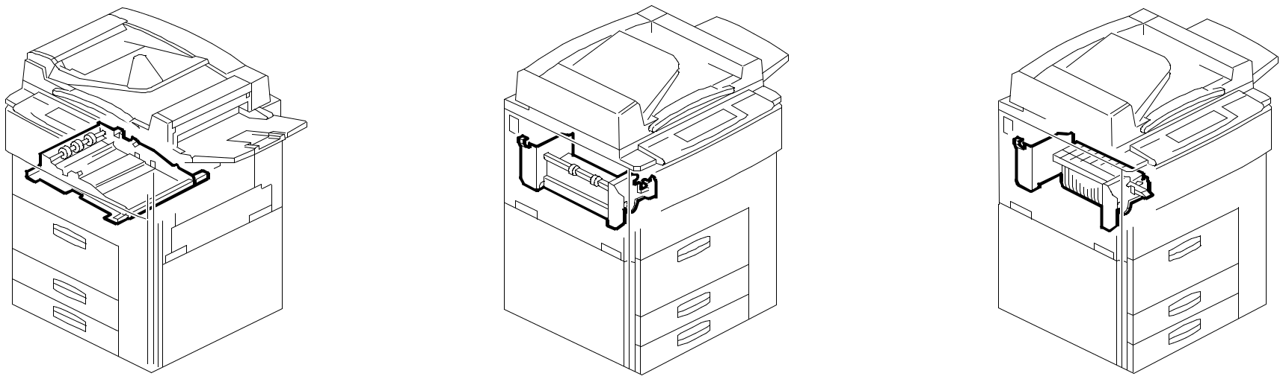

See Page 111 See Page 113 See Page 115

52. PAPER EXIT 3 (A292/A293/B098) 53. DRIVE SECTION 1 (A292/A293/B098) 54. DRIVE SECTION 2 (A292/A293/B098)

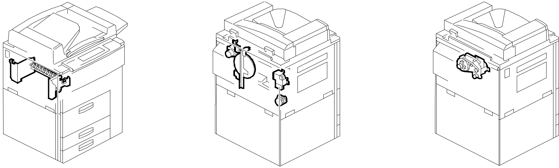

See Page 117 See Page 119 See Page 121

A292/A293/B098 11 Parts Location and List

LOCATIONS OF UNITS

55. DRIVE SECTION 3 (A292/A293/B098) 56. DRIVE SECTION 4 (A292/A293/B098) 57. DRIVE SECTION 5 (A292/A293/B098)
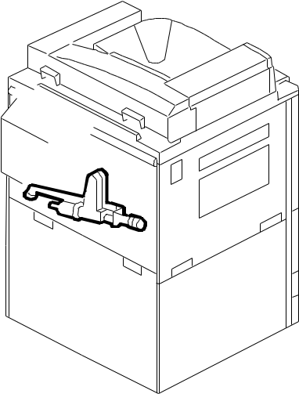
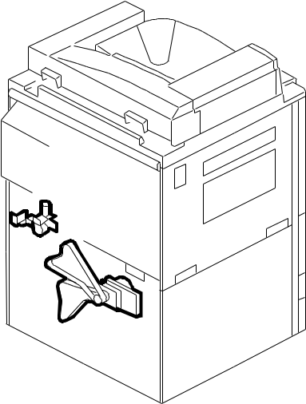
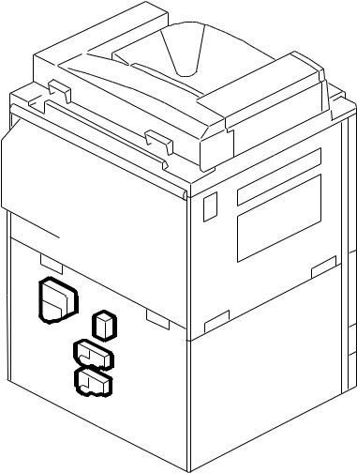

See Page 123 See Page 125 See Page 127

58. ELECTRICAL SECTION 1 59. ELECTRICAL SECTION 2 60. ELECTRICAL SECTION 3

(A292/A293/B098) (A292/A293/B098) (A292/A293/B098)
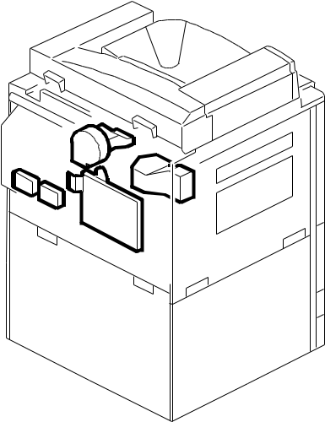
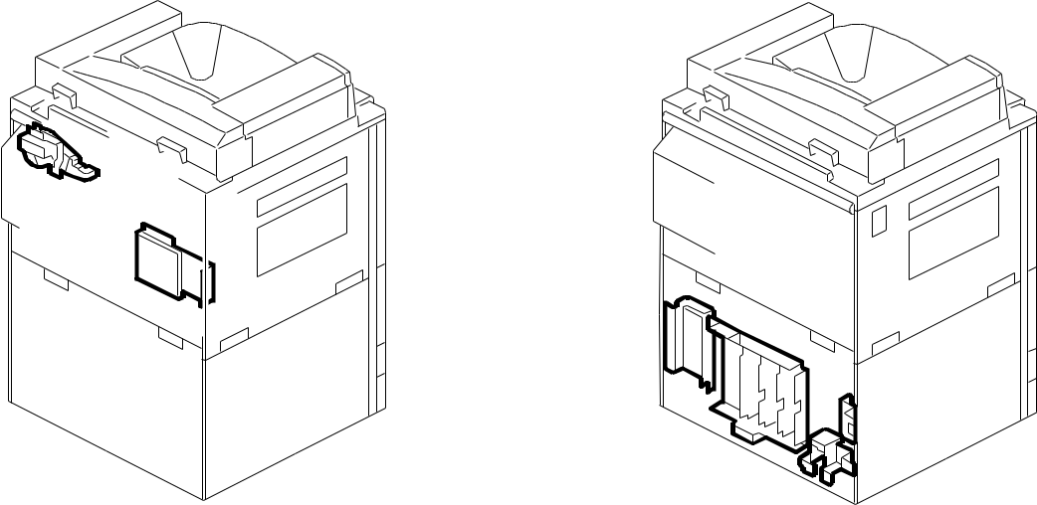

See Page 129 See Page 131 See Page 133

A292/A293/B098 12 Parts Location and List

LOCATIONS OF UNITS

61. ELECTRICAL SECTION 4 62. FRAME SECTION 1 (A292/A293/B098) 63. FRAME SECTION 2 (A292/A293/B098)

(A292/A293/B098)
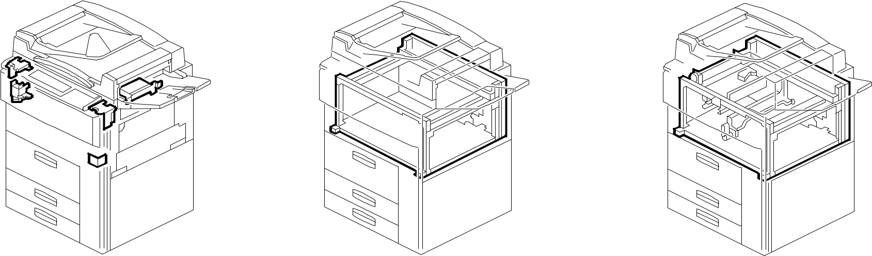

See Page 135 See Page 137 See Page 139

64. FRAME SECTION 3 (A292/A293/B098)
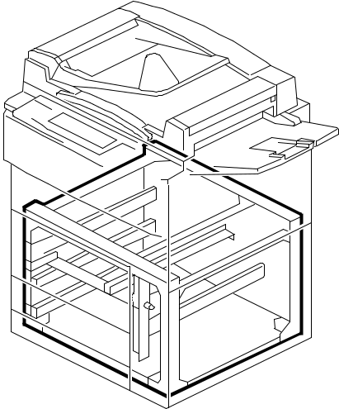

See Page 141

A292/A293/B098 13 Parts Location and List

1.EXTERIOR 1 (A292/A293/B098)
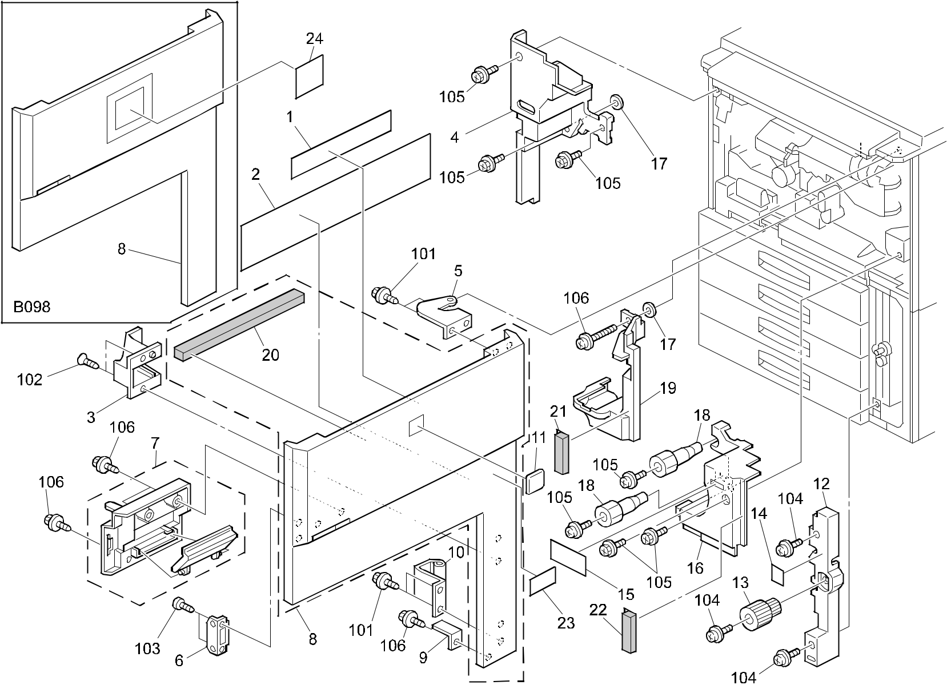

A292/A293/B098 14 Parts Location and List

1.EXTERIOR 1 (A292/A293/B098)

Index | Part No. | Description | Q’ty Per
No. | Part No. | Description | Assembly
1 | A293 1349 | Decal - Toner Supply (A292/A293) | 1
1 | B098 1349 | Decal: Toner Supply (B098) | 1
2 | A293 1350 | Decal - Misfeed Removal (A292/A293) | 1
2 | B098 1350 | Decal: Misfeed Removal: Main (B098) | 1
3 | A229 1275 | Guide Plate Lever | 1
4 | A229 1321 | Safty Switch Inner Cover (A292/A293) | 1
4 | B098 1324 | Inner Cover: Main Switch (B098) | 1
5 | A229 1342 | Upper Hinge (A292/A293) | 1
5 | B098 1342 | Hinge: Upper (B098) | 1
6 | AG07 0004 | Magnetic Catch | 1
7 | A229 1257 | Door Grip Ass'y (A292/A293) | 1
7 | B098 1257 | Grip: Door:Ass'y (B098) | 1
8 | A292 1273 | Front Door (A292 RIC) | 1
8 | A292 1278 | Front Door (A292 INF) | 1
8 | A293 1273 | Front Door (A293 RIC) | 1
8 | A293 1276 | Front Door (A292/A293 NRG) | 1
8 | A293 1278 | Front Door (A293 INF) | 1
8 | A293 1312 | Front Door (A292/A293 SVN/LAN) | 1
8 | B098 1273 | Door: Exp:Sub-ass'y (B098) | 1
9 | A229 1355 | Micro Switch Lever | 1
10 | A229 1259 | Lower Hinge (A292/A293) | 1
10 | B098 1259 | Hinge:Right Lower:Ass'y (B098) | 1
11 | A134 1383 | Emblem (RIC)(A292/A293) | 1
11 | A229 7016 | Support Cover (INF)(A292/A293) | 1
12 | A096 6184 | Bank Inner Cover | 1
13 | AG05 0067 | Knob - Transport Roller (A292/A293) | 1
13 | AG05 0093 | Knob:Misfeed Removal (B098) | 1
14 | AA00 0540 | Decal - Misfeed Removal (A292/A293) | 1
14 | AA00 3204 | Decal:Misfeed Removal (B098) | 1
15 | A232 1381 | Decal - Total Counter (A292/A293) | 1
15 | A294 1378 | Decal - Total Counter (B098) | 1
16 | A229 1320 | Right Lower Inner Cover (A292/A293) | 1
16 | B098 1323 | Inner Cover:Right Lower (B098) | 1
17 | AA10 0006 | Nut - M3.6 | 2
18 | A060 2512 | Registration Roller Knob | 2

Index | Part No. | Description | Q’ty Per
No. | Part No. | Description | Assembly
19 | A229 3291 | Right Inner Cover | 1
20 | AA15 3127 | Seal - 485mm | 1
21 | A293 1171 | Seal - 224mm | 1
22 | A293 1172 | Seal - 153mm | 1
23 | A229 7015 | Model Name Plate -170x60 | 1
 |  | (A292/A293 NRG)
23 | A292 7010 | Model Name Plate - SVN 2055DP (A292) | 1
23 | A292 7012 | Model Name Plate - GES 3355 (A292) | 1
23 | A292 7014 | Model Name Plate - NSA D555 (A292) | 1
23 | A292 7016 | Model Name Plate - REX 2955 (A292) | 1
23 | A292 7018 | Model Name Plate - LAN 5455 (A292) | 1
23 | A293 7010 | Model Name Plate - SVN 2070DP (A293) | 1
23 | A293 7012 | Model Name Plate - GES 3370 (A293) | 1
23 | A293 7014 | Model Name Plate - NSA D555 (A293) | 1
23 | A293 7016 | Model Name Plate - REX 2955 (A293) | 1
23 | A293 7018 | Model Name Plate - LAN 5470 (A293) | 1
24 | B098 7010 | Model Name Plate:RIC:EXP (B098) | 1
24 | B098 7011 | Model Name Plate:NAS (B098) | 1
24 | B098 7012 | Model Name Plate:REX (B098) | 1
24 | B098 7013 | Model Name Plate:GES (B098) | 1
24 | B098 7014 | Model Name Plate:INF (B098) | 1
24 | B098 7015 | Model Name Plate:LAN (B098) | 1

- 0450 4008B Tapping Screw - 4x8

- 0802 5124 Tapping Screw - M3x8

- 0434 0082W Tapping Screw - M4x8

- 0951 4006B Philips Screw With Washer - M4x6

- 0451 4008B Philips Tapping Screw - M4x8

- 0450 3008B Tapping Screw - M3x8

A292/A293/B098 15 Parts Location and List

2.EXTERIOR 2 (A292/A293/B098)
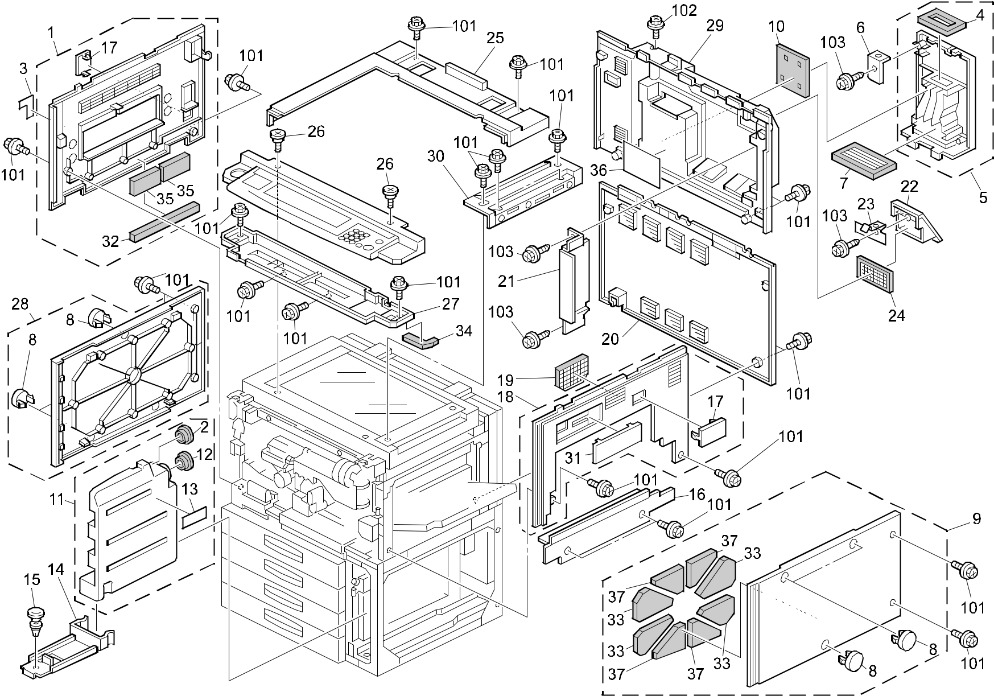

A292/A293/B098 16 Parts Location and List

2.EXTERIOR 2 (A292/A293/B098)

Index | Part No. | Description | Q’ty Per
No. | Part No. | Description | Assembly
1 | A293 1265 | Upper Left Cover (A292/A293) | 1
1 | B098 1265 | Cover:Left Upper:Ass'y (B098) | 1
2 | AA15 2315 | Tank Seal | 1
3 | A229 1360 | Decal - Main Switch (120V A292/A293) | 1
3 | A229 1361 | Decal - Main Switch (230V A292/A293) | 1
3 | B098 1360 | Decal:Main Switch:NA (120V B098) | 1
3 | B098 1362 | Decal:Main Switch:EU (230V B098) | 1
4 | AA15 2696 | Duct Seal | 1
5 | A293 1285 | Duct (A292/A293) | 1
5 | B098 1285 | Duct:Cover:Exhaust:Adhesion (B098) | 1
6 | A293 1332 | Duct Holder | 1
7 | AA01 0108 | Ozone Filter (A292/A293) | 1
7 | AA01 0116 | Ozone Filter:Rear (B098) | 1
8 | A247 1318 | Cap - 17 (A292/A293) | 6
8 | B098 1318 | Cap:ÏÙ17 (B098) | 1
9 | A293 1269 | Lower Right Cover (A292/A293) | 1
9 | B098 1269 | Cover:Right Lower:Ass'y (B098) | 1
10 | AA15 2697 | Shield - Duct Cover | 1
11 | AA03 2041 | Tonner Collection Bottle | 1
12 | A007 3751 | Large Cap - Toner Collection Tank | 1
13 | AA00 0059 | Caution Decal - English | 1
14 | A096 3711 | Collection Tank Holder | 1
15 | A096 3712 | Ratch | 1
16 | A229 1304 | Large Capacity Tray Cover (A292/A293) | 1
16 | B098 1304 | Cover:Large Capacity Tray (B098) | 1
17 | A229 1332 | Coupling Cap (A292/A293) | 2
17 | B065 1342 | Coupling Cap (B098) | 2
18 | A229 1260 | Upper Right Cover (A292/A293) | 1
18 | B098 1260 | Cover:Right Upper:Ass'y (B098) | 1
19 | A229 1262 | Optics Dust Filter (A292/A293) | 1
19 | B098 1262 | Filter:Ass'y (B098) | 1
20 | A229 1309 | Rear Lower Cover (A292/A293) | 1
20 | B098 1309 | Cover:Rear Lower (B098) | 1
21 | A293 1359 | Printer Controller Cover (A292/A293) | 1
21 | B098 1359 | Shadeing Plate:Control Unit (B098) | 1

Index | Part No. | Description | Q’ty Per
No. | Part No. | Description | Assembly
22 | A293 1335 | Louver (A292/A293) | 1
22 | B098 1335 | Louver:Filter (B098) | 1
23 | A293 1336 | Spring Plate - Louver | 1
24 | A293 1098 | Vacuum Filter | 1
25 | A293 1310 | Upper Cover (A292/A293) | 1
25 | B098 1310 | Cover:Upper (B098) | 1
26 | AA14 3416 | Stepped Screw - M4x3 | 2
27 | A293 1327 | Operation Panel Upper Cover (A292/A293) | 1
27 | B098 1327 | Inner Cover:Operation Sub-unit (B098) | 1
28 | A293 1270 | Lower Left Cover (A292/A293) | 1
28 | B098 1270 | Cover:Left Lower:Ass'y (B098) | 1
29 | A293 1306 | Rear Cover (A292/A293) | 1
29 | B098 1306 | Cover:Rear Upper (B098) | 1
30 | A229 1311 | Upper Right Cover (A292/A293) | 1
30 | B098 1311 | Cover:Upper:Right (B098) | 1
31 | A229 1331 | Key Counter Cap (A292/A293) | 1
31 | B070 1331 | Cap:Key Counter:C2 (B098) | 1
32 | AA15 3121 | Sponge 1 - Upper Left Cover | 1
33 | AA15 3120 | Sponge 2 - Lower Right Cover | 4
34 | AA15 3128 | Upper Cover Seal | 1
35 | AA15 3124 | Sponge 4 - Upper Left Cover | 2
36 | A293 1334 | Insulating Mayler (A292/A293) | 1
36 | B098 1334 | Insulating Sheet:Harness:IOB (B098) | 1
37 | AA15 3119 | Sponge 1 - Lower Right Cover | 4

- 0451 4008H Tapping Screw - 4x8

- 0451 3012H Tapping Screw - 3x12

- 0450 3008B Tapping Screw - M3x8

A292/A293/B098 17 Parts Location and List

3.OPERATION PANEL (A292/A293/B098)
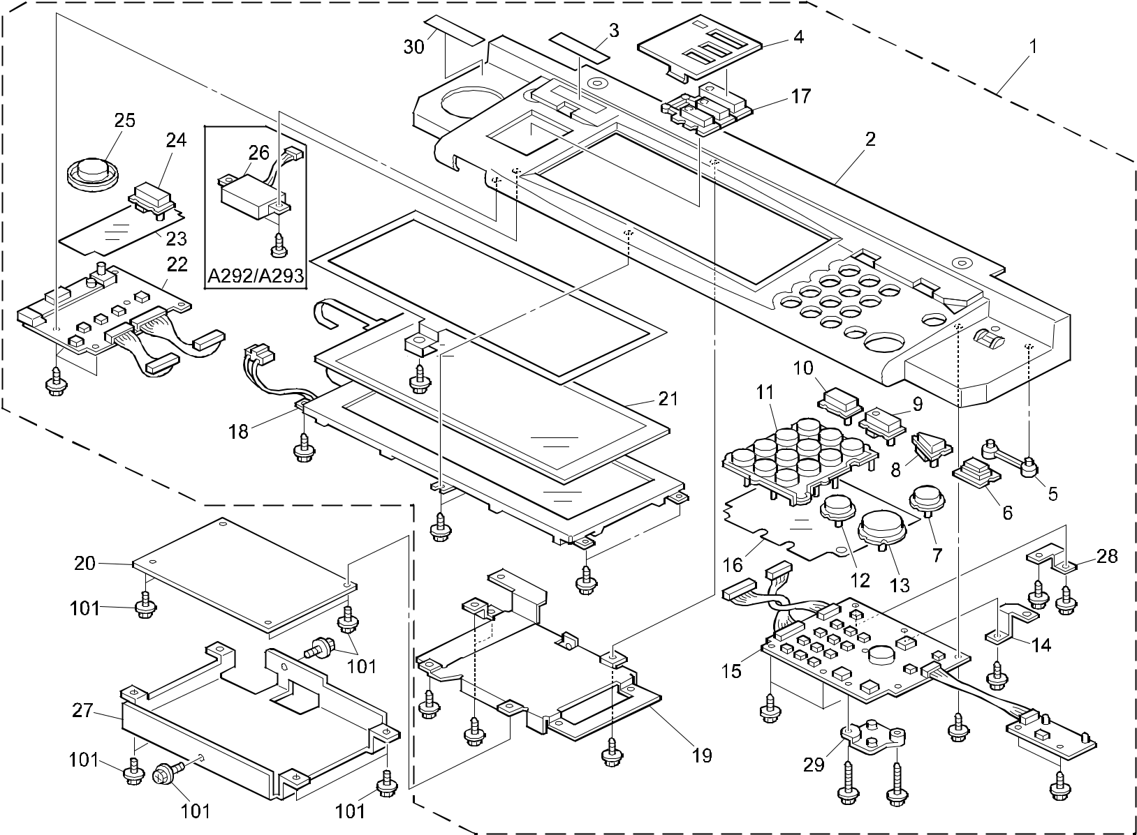

A292/A293/B098 18 Parts Location and List

3.OPERATION PANEL (A292/A293/B098)

Index | Part No. | Description | Q’ty Per
No. | Part No. | Description | Assembly
1 | A293 1412 | Operation Panel Ass'y - LT (A292/A293) | 1
1 | A293 1414 | Operation Panel Ass'y - A4 (A292/A293) | 1
1 | B098 1412 | Operation Panel:C2:NA:Ass'y (B098) | 1
1 | B098 1414 | Operation Panel:C2:EU:Ass'y (B098) | 1
2 | A293 1441 | Operation Panel Case - LT (A292/A293) | 1
2 | A293 1442 | Operation Panel Case - A4 (A292/A293) | 1
2 | B098 1441 | Case:Operation Panel:NA (B098) | 1
2 | B098 1442 | Case:Operation Panel:EU (B098) | 1
3 | A229 1466 | Guidance Sheet (A292/A293) | 1
3 | B098 1466 | Sheet:Guidance (B098) | 1
4 | A293 1461 | Application Cap (A292/A293) | 1
4 | B098 1461 | Cap:Application:Moj (B098) | 1
5 | A229 1465 | LED Guide | 1
6 | A229 1459 | Keytop - Power Source | 1
7 | A229 1457 | Keytop - Check (A292/A293) | 1
7 | B098 1457 | Keytop:Check (B098) | 1
8 | A229 1456 | Keytop - Interrupt (A292/A293) | 1
8 | B098 1456 | Keytop:Interrupt (B098) | 1
9 | A229 1475 | Key-top - Standby (A292/A293) | 1
9 | B098 1475 | Keytop:Preheat:Exp (B098) | 1
10 | A229 1455 | Keytop - Program (A292/A293) | 1
10 | B098 1455 | Keytop:Block Diagram (B098) | 1
11 | A229 1451 | Keytop - 10key (A292/A293) | 1
11 | B098 1451 | Keytop:10key (B098) | 1
12 | A229 1453 | Keytop - Clear/Stop (A292/A293) | 1
12 | B098 1453 | Keytop:Clear/Stop (B098) | 1
13 | A229 1452 | Keytop - Start (A292/A293) | 1
13 | B098 1452 | Keytop:Start (B098) | 1
14 | A229 1464 | Ground Plate - 10key | 1
15 | A293 1462 | 10key Board | 1
16 | A229 1468 | 10key Sheet | 1
17 | A293 1477 | Keytop - Copy - LT (A292/A293) | 1
17 | A293 1478 | Keytop - Copy - A4 (A292/A293) | 1
17 | B098 1477 | Keytop:Copy:Moj:NA (B098) | 1
17 | B098 1478 | Keytop:Copy:Moj:EU (B098) | 1

Index | Part No. | Description | Q’ty Per
No. | Part No. | Description | Assembly
18 | A293 5215 | LCD HVGA U95 | 1
19 | A293 1431 | Bracket - LCDC | 1
20 | A293 5200 | LCDC Board (A292/A293) | 1
20 | B098 5200 | PCB:LCDC (B098) | 1
21 | A229 1425 | Touch Panel Ass'y | 1
22 | A293 1463 | Application Board | 1
23 | A229 1467 | Application Sheet | 1
24 | A229 1458 | Keytop - Tool (A292/A293) | 1
24 | B098 1458 | Keytop:Tool (B098) | 1
25 | A229 1460 | Dial - Contrast | 1
26 | AW01 0079 | Optics Sensor (A292/A293) | 1
27 | A229 1433 | LCDC Cover | 1
28 | A293 1468 | LCD Ground Plate | 1
29 | A229 1472 | Support Plate - Operation Panel | 1
30 | A153 6409 | Decal - Keytop Cover (GES)(A292/A293) | 1
30 | C225 2866 | Decal - Keytop Cover (REX)(A292/A293) | 1
30 | C225 2867 | Decal - Keytop Cover (NSA)(A292/A293) | 1

101 0451 3006B Tapping Screw - M3x6

A292/A293/B098 19 Parts Location and List

4.ARDF EXTERIOR (A292/A293/B098)
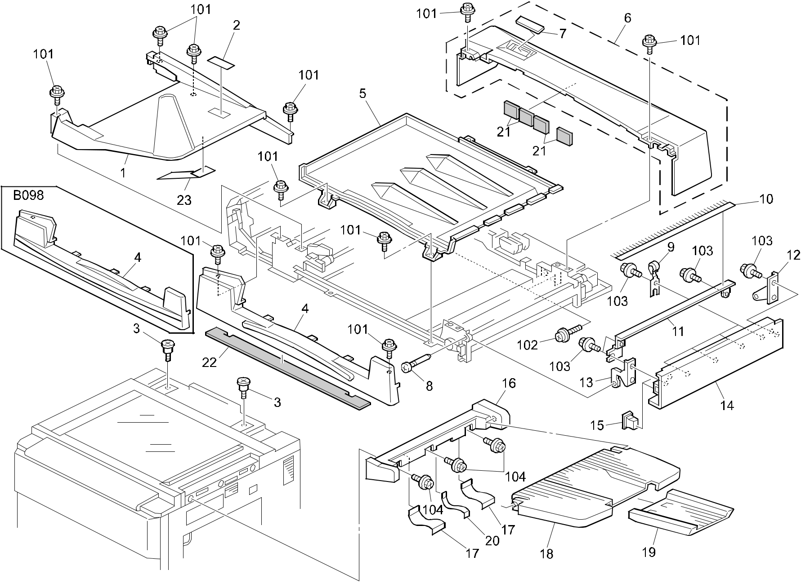

A292/A293/B098 20 Parts Location and List

4.ARDF EXTERIOR (A292/A293/B098)

Index | Part No. | Description | Q’ty Per
No. | Part No. | Description | Assembly
* | A294 7005 | ARDF Ass'y (A292/A293) | 1
* | B070 7000 | ARDF:Ass'y (B098) | 1
1 | A806 1821 | Original Table (A292/A293) | 1
1 | B301 1826 | Original Table:Printing (B098) | 1
2 | A610 6051 | Decal - Document Set (A292/A293) | 1
2 | B477 4431 | Decal - Original Table (B098) | 1
3 | A859 7211 | Stepped Screw | 2
4 | A806 1712 | Front Cover (A292/A293) | 1
4 | B301 1716 | Cover:Front (B098) | 1
5 | A806 1792 | Original Table Cover (A292/A293) | 1
5 | B301 1796 | Cover:Original Table:Lower (B098) | 1
6 | B301 1721 | Rear Cover (A292/A293) | 1
6 | B301 1726 | Cover:Rear:Ass'y (B098) | 1
7 | A806 4341 | Display Panel | 1
8 | 5446 2824 | Screw - Duplex Guide Plate | 2
9 | A548 1241 | Driven Roller Ass'y | 4
10 | AA12 0032 | Antistatic Brush | 2
11 | A806 3266 | Discharge Brush Bracket | 1
12 | A806 3261 | Inner Back Cover Bracket | 1
13 | A806 3251 | Exit Cover Bracket | 1
14 | A806 1781 | Exit Cover (A292/A293) | 1
14 | B301 1786 | Cover:Exit (B098) | 1
15 | G012 1531 | Magnet | 2
16 | A229 1393 | Exit Tray Holder (A292/A293) | 1
16 | B098 1393 | Tray:Exit:Machine Or Copier (B098) | 1
17 | A229 1395 | Mylar - Large | 2
18 | A229 1394 | Exit Tray (A292/A293) | 1
18 | B098 1394 | Tray:Exit (B098) | 1
19 | A666 2421 | Sub - Shift Tray (A292/A293) | 1
19 | B098 2421 | Tray:Slide (B098) | 1
20 | A229 1396 | Mylar - Small | 1
21 | B301 4425 | Noise Reduction Pad | 4
22 | B301 4411 | Noise Reduction Pad | 1
23 | B301 1835 | Original Holder | 1

Index | Part No. | Description | Q’ty Per
No. | Part No. | Description | Assembly

- 0451 3008B Tapping Screw - M3x8

- 0951 5010B Philips Screw With Washer - M5x10

- 0450 4012B Tapping Screw - M4x12

- 0451 4008H Tapping Screw - 4x8

A292/A293/B098 21 Parts Location and List

5.ORIGINAL FEED SECTION 1 (A292/A293/B098)
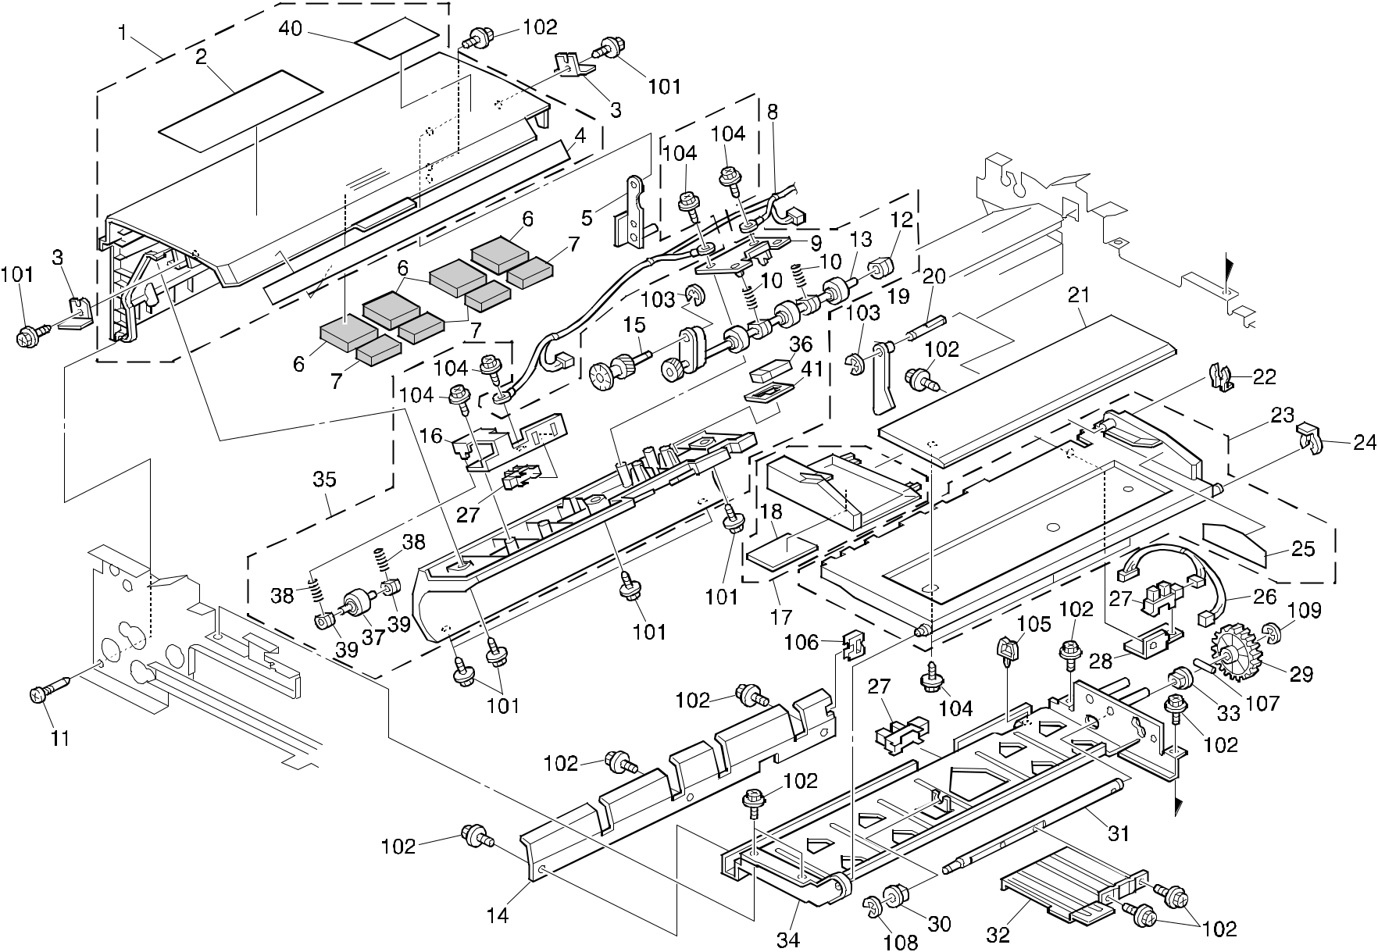

A292/A293/B098 22 Parts Location and List

5.ORIGINAL FEED SECTION 1 (A292/A293/B098)

Index | Part No. | Description | Q’ty Per
No. | Part No. | Description | Assembly
1 | B301 1751 | Paper Feed Cover (A292/A293) | 1
1 | B301 1756 | Cover:Paper Feed:Ass'y (B09817) | 1
2 | A806 4311 | Decal - Misfeed Removal (A292/A293) | 1
2 | B301 4316 | Decal:Misfeed Removal (B09817) | 1
3 | A806 1371 | Magnet Catch - Paper Feed Cover | 2
4 | A806 4331 | Decal - Original Size (A292/A293) | 1
4 | B301 4336 | Decal:Size:Original (B098) | 1
5 | A806 1361 | Cover Bracket | 1
6 | B301 4421 | Noise Reduction Pad - Right | 4
7 | B301 4422 | Noise Reduction Pad - Left | 4
8 | B301 5405 | DC Relay Harness | 1
9 | A806 1181 | Pressure Roller Bracket - Pull Out | 1
10 | B301 4211 | Spring | 2
11 | 5446 2824 | Screw - Duplex Guide Plate | 1
12 | A680 1661 | Bushing - 4mm | 1
13 | B301 1191 | Pull-out Driven Roller | 1
14 | A806 1335 | Original Table Guide Plate | 1
15 | B301 1195 | Gear - 19Z | 1
16 | B301 1188 | Sensor Bracket | 1
17 | A806 1871 | Side Fence (A292/A293) | 1
17 | B301 1876 | Side Fence:Table:Ass'y (B098) | 1
18 | A376 4599 | Side Fence Pad | 1
19 | B301 1351 | Original Feeler | 1
20 | A806 1353 | Feeler Stud | 1
21 | A680 4151 | Side Fence Guide (A292/A293) | 1
21 | G564 4151 | Rail - Side Fence (B098) | 1
22 | 5206 2686 | Snap Ring | 1
23 | A806 1852 | Original Table Base (A292/A293) | 1
23 | B301 1856 | Base:Original Table:Ass'y (B098) | 1
24 | 5215 2621 | Snap Ring - M6 | 1
25 | A806 4321 | Decal - Original Stack Hight (A292/A293) | 1
25 | B477 4311 | Decal - Original Base (B098) | 1
26 | A806 5790 | Original Sensor Harness | 1
27 | AW02 0075 | Photointerruptor | 3
28 | A806 1356 | Original Sensor Bracket | 1

Index | Part No. | Description | Q’ty Per
No. | Part No. | Description | Assembly
29 | A806 2281 | Gear - Z47 | 1
30 | 5053 0447 | Bushing - 6mm | 1
31 | A806 1346 | Base Shaft | 1
32 | A806 1342 | Base Lever | 1
33 | 5053 0223 | Bushing - 8mm | 1
34 | A806 1331 | Original Table Stay | 1
35 | B301 1170 | Turn Guide Plate | 1
36 | AW01 0093 | Photo Reflection Sensor - PS-17ND1 | 1
37 | B301 1198 | Pull-out Driven Roller - Front | 1
38 | B301 4222 | Spring | 2
39 | B301 1192 | Bushing - 4x6x6 | 2
40 | B301 4351 | Caution Decal | 1
41 | A806 4251 | Grounding Plate | 1

- 0450 4008B Tapping Screw - 4x8

- 0451 4008B Philips Tapping Screw - M4x8

- 0720 0030B Retaining Ring - M3

- 0452 4008B Binding Self Tapping Screw - M4x8

- 1105 0230 Clamp

- 1105 0328 Harness Clamp - ES-0505

- 0632 0140G Parallel Pin

- 0720 0040B Retaining Ring - M4

- 0720 0060B Retaining Ring - M6

A292/A293/B098 23 Parts Location and List

6.ORIGINAL FEED SECTION 2 (A292/A293/B098)
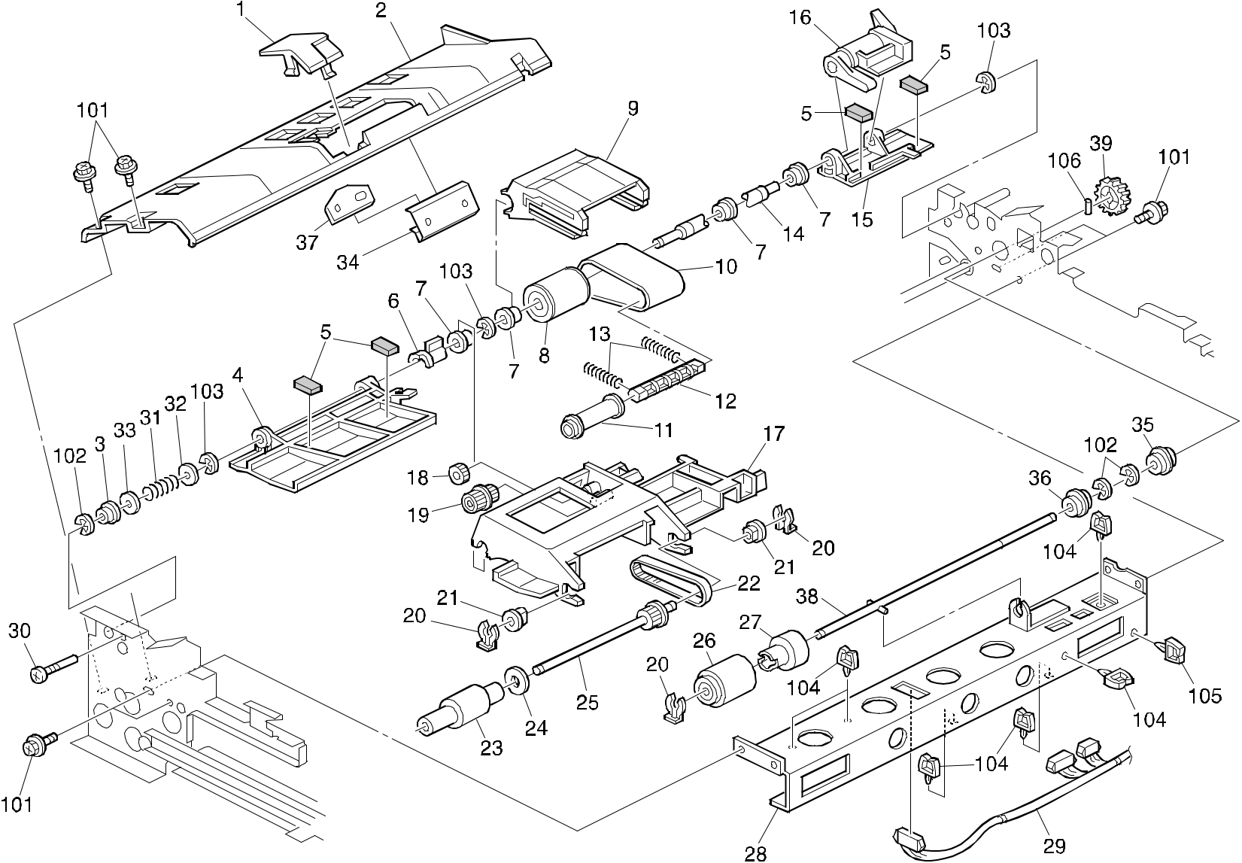

A292/A293/B098 24 Parts Location and List

6.ORIGINAL FEED SECTION 2 (A292/A293/B098)

Index | Part No. | Description | Q’ty Per
No. | Part No. | Description | Assembly
1 | A806 1152 | Upper Guide Plate | 1
2 | A806 1153 | Upper Guide Plate | 1
3 | B301 1286 | Bushing - 6x10x6 | 1
4 | A806 1161 | Entrance Guide Plate - Front | 1
5 | A806 1163 | Guide Plate Cushion | 4
6 | A680 1621 | Feed-in Unit Stopper | 1
7 | A628 1225 | Bushing - 8mm | 4
8 | A806 1293 | Feed Belt Drive Roller | 1
9 | A806 1292 | Feed Belt Bracket | 1
10 | A806 1295 | Feed Belt | 1
11 | A806 1294 | Feed Belt Driven Roller | 1
12 | A806 1298 | Transport Belt Roller Shaft | 1
13 | A806 4261 | Spring Belt Guide Roller | 2
14 | A806 1282 | Separation Drive Shaft | 1
15 | A806 1162 | Entrance Guide Plate - Inner | 1
16 | A806 1328 | Release Lever | 1
17 | B301 1314 | Pick-up Roller Bracket | 1
18 | A806 2271 | Gear - Z18 | 1
19 | A806 2151 | Timing Pulley - T19/Z23 S2M/M0.6 | 1
20 | 5447 2681 | Snap Ring | 3
21 | 5053 0447 | Bushing - 6mm | 2
22 | A806 4118 | Timing Belt - B40S2M148 | 1
23 | A806 1321 | Pickup Roller | 1
24 | AA13 2171 | Spacer - 6x20x1 | 1
25 | A806 2153 | Timing Pulley - T27 S2M | 1
26 | A859 2241 | Reverse Roller | 1
27 | A247 2900 | Torque Limiter - 53mnxm | 1
28 | A806 1141 | Reverse Roller Stay | 1
29 | A806 5745 | Paper Siz Sensor Harness | 1
30 | 5415 4145 | Stud | 1
31 | AA06 3315 | Spring - Belt Drive Shaft | 1
32 | AA13 2013 | Spacer | 1
33 | A418 1158 | Spacer - M6.5x1 | 1
34 | B301 1156 | Separation Pad Holder | 1
35 | A232 3562 | Ball Bearing - 6x12x4mm | 1

Index | Part No. | Description | Q’ty Per
No. | Part No. | Description | Assembly
36 | A232 3565 | Ball Bearing - 6x10x3mm | 1
37 | B301 1155 | Separation Support Pad | 1
38 | B301 2511 | Reverse Roller Shaft | 1
39 | B301 2221 | Gear - 31Z | 1

- 0451 3008B Tapping Screw - M3x8

- 0720 0040B Retaining Ring - M4

- 0720 0060B Retaining Ring - M6

- 1105 0230 Clamp

- 1105 0199 Clamp

- 0632 0120G Parallel Pin - 2x12

A292/A293/B098 25 Parts Location and List

7.ORIGINAL FEED SECTION 3 (A292/A293/B098)
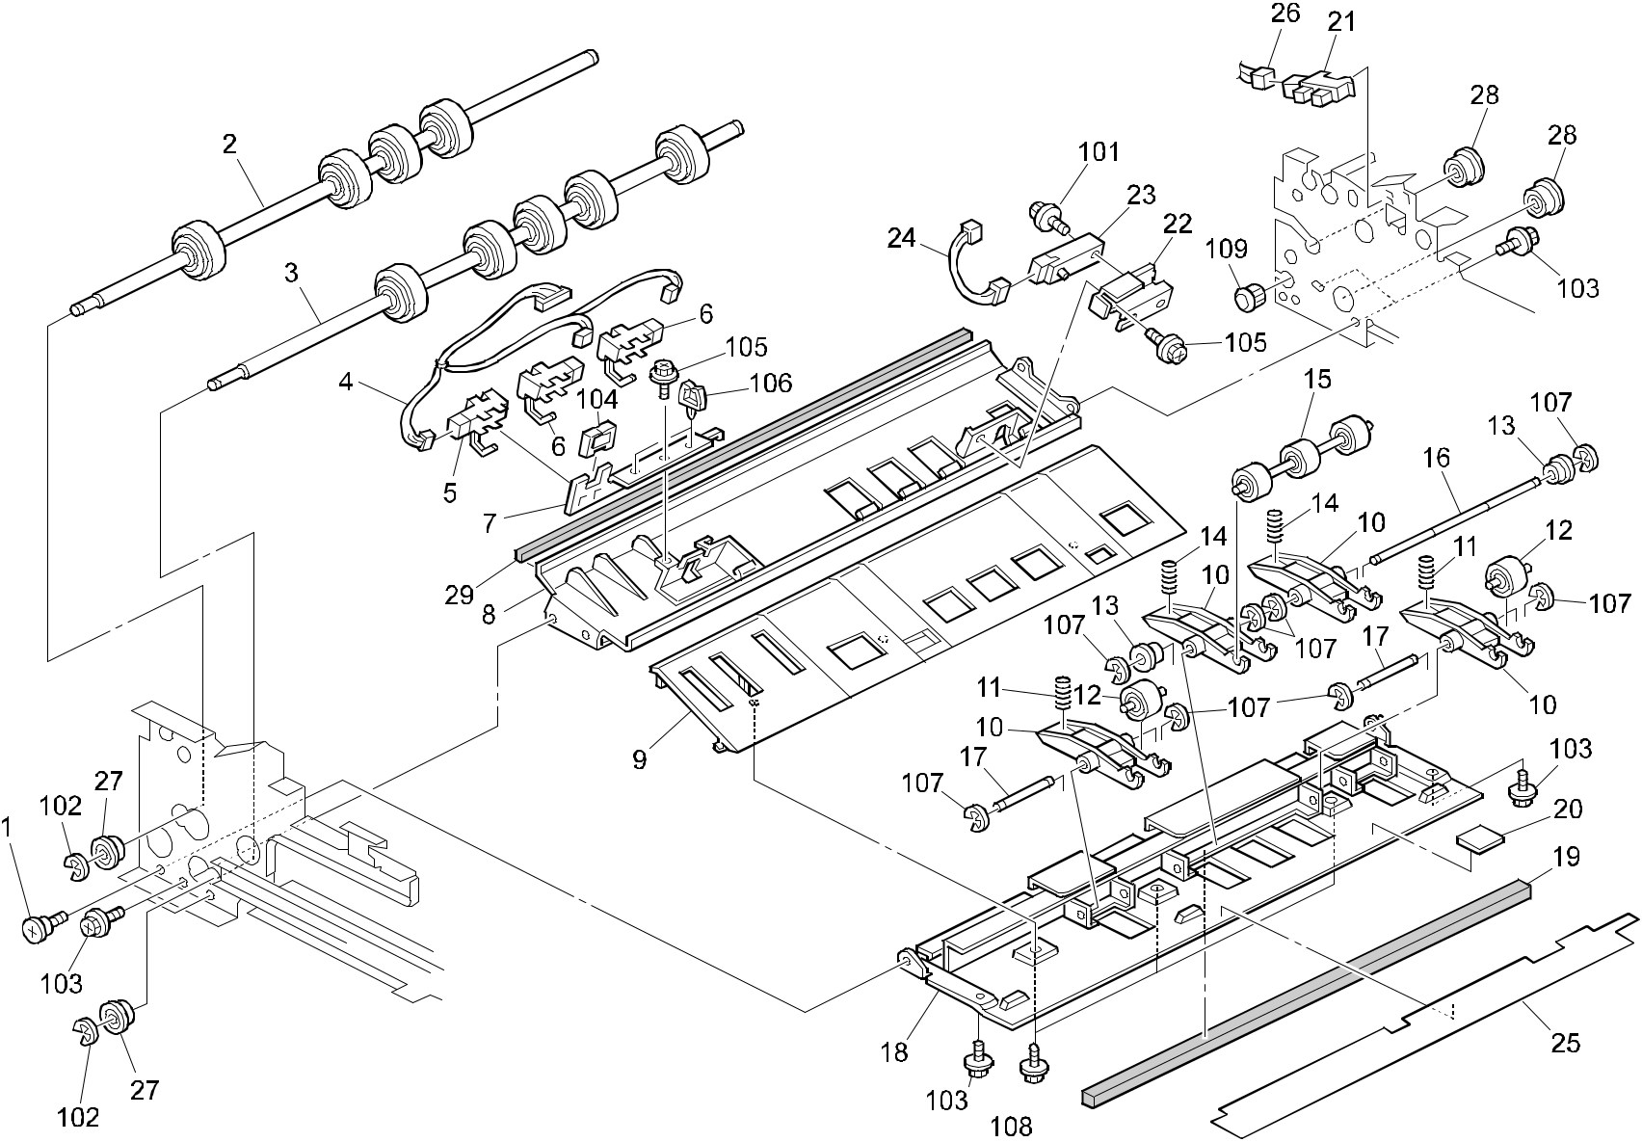

A292/A293/B098 26 Parts Location and List

7.ORIGINAL FEED SECTION 3 (A292/A293/B098)

Index | Part No. | Description | Q’ty Per
No. | Part No. | Description | Assembly
1 | AA14 3074 | Stepped Screw - M4x5 | 1
2 | A806 1271 | Pull Out Drive Roller | 1
3 | A806 1276 | Transport Drive Roller | 1
4 | A806 5745 | Paper Siz Sensor Harness | 1
5 | AW02 0104 | Photointerruptor | 1
6 | AW02 0095 | Photointerruptor | 2
7 | A806 1226 | Paper Size Sensor Bracket | 1
8 | A806 1211 | Middle Guide Plate | 1
9 | A806 1241 | Lower Guide Plate | 1
10 | A806 1251 | Transport Roller Arm | 4
11 | B301 4226 | Spring | 2
12 | A806 1266 | Driven Roller | 2
13 | 5324 1658 | Bushing- 4x8x4.5mm | 4
14 | A806 4221 | Compression Spring | 2
15 | A806 1261 | Middle Driven Roller | 1
16 | A806 1256 | Middle Shaft - Roller Arm | 1
17 | A806 1257 | Roller Arm Shaft | 2
18 | A806 1231 | Paper Feed Base | 1
19 | B301 4413 | Noise Absorbing Pad | 2
20 | A422 1063 | Seal - 0.7x13x20 | 1
21 | AW02 0075 | Photointerruptor | 1
22 | A806 1221 | Registration Sensor Bracket | 1
23 | AW01 0093 | Photo Reflection Sensor - PS-17ND1 | 1
24 | A806 5740 | Registration Sensor Harness | 1
25 | B301 1247 | Entrance Guide | 1
26 | B301 5310 | DC Relay Harness | 1
27 | A232 3562 | Ball Bearing - 6x12x4mm | 2
28 | A232 3566 | Ball Bearing - 8x16x5 | 2
29 | G020 3897 | Discharge Brush - Transport | 1

Index | Part No. | Description | Q’ty Per
No. | Part No. | Description | Assembly

- 0451 3012B Tapping Screw With Washer - M3x12

- 0720 0040B Retaining Ring - M4

- 0451 3008B Tapping Screw - M3x8

- 1105 0328 Harness Clamp - ES-0505

- 0451 3006B Tapping Screw - M3x6

106 1105 0199 Clamp

- 0720 0030B Retaining Ring - M3

- 0450 3008B Tapping Screw - M3x8

- 1106 0193 Bushing - 7.9mm

A292/A293/B098 27 Parts Location and List

8.ORIGINAL TRANSFER SECTION (A292/A293/B098)
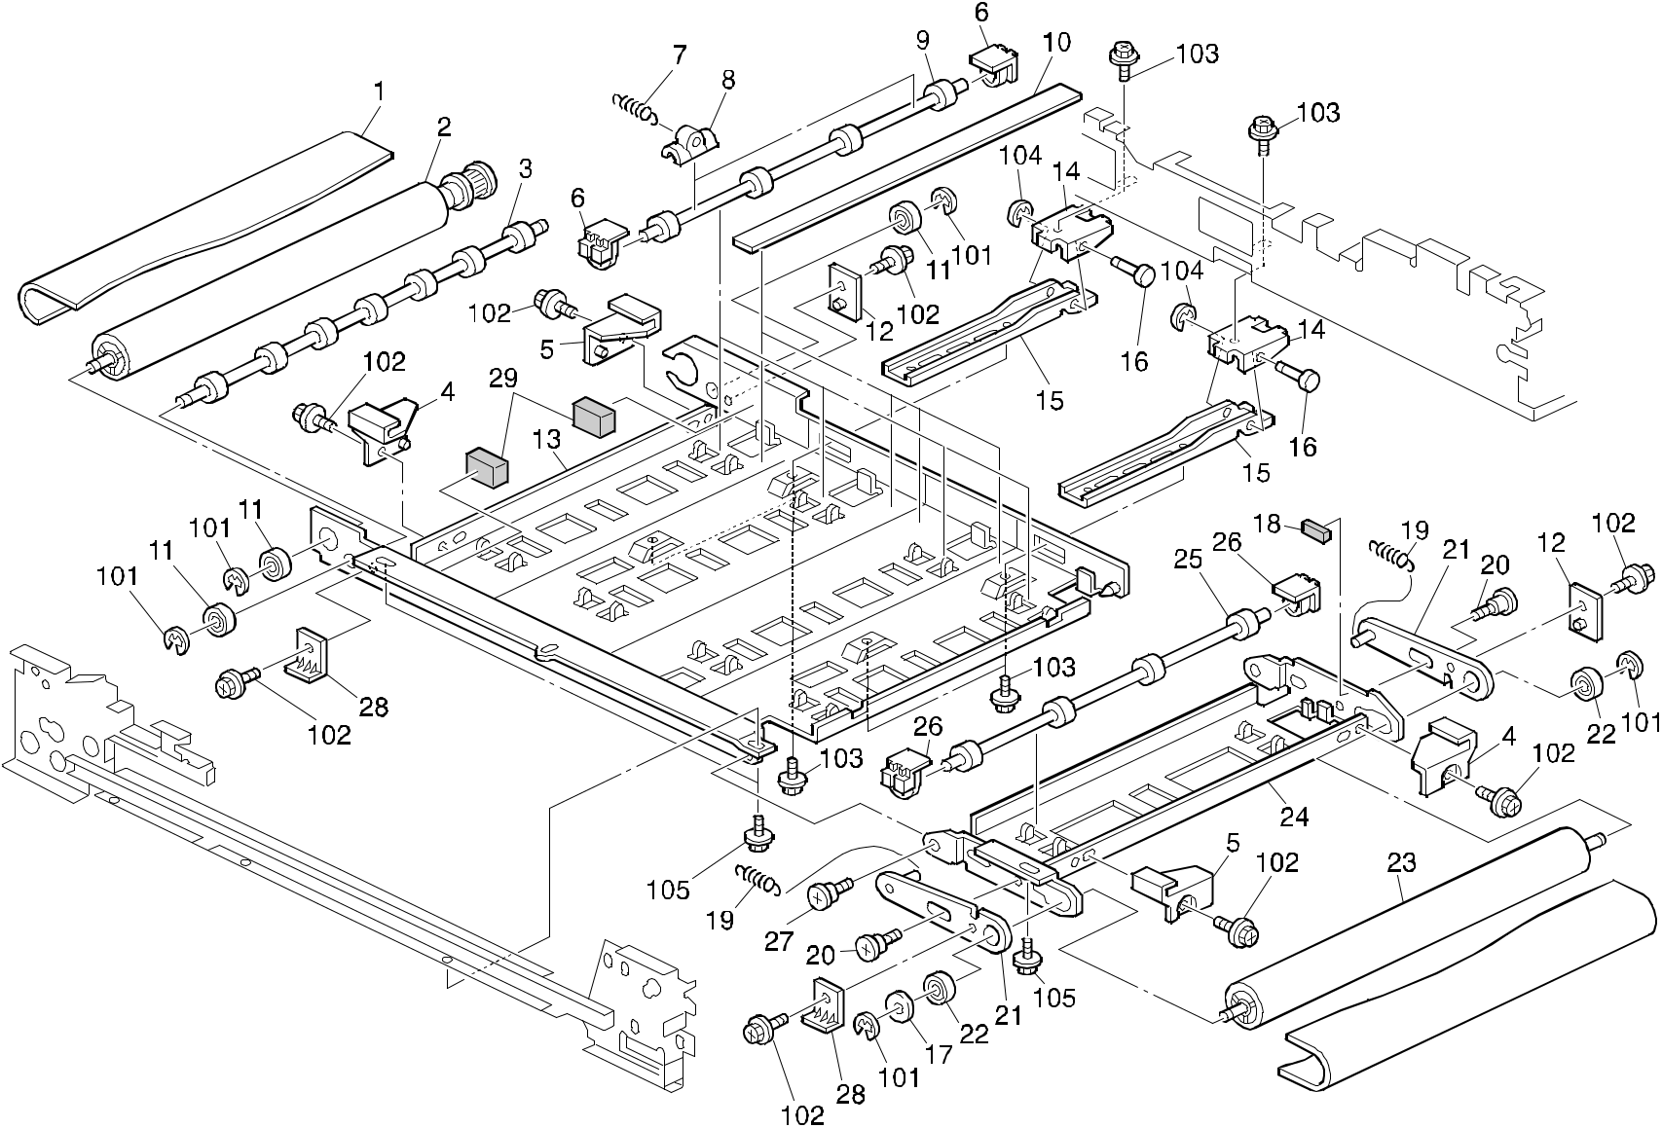

A292/A293/B098 28 Parts Location and List

8.ORIGINAL TRANSFER SECTION (A292/A293/B098)

Index | Part No. | Description | Q’ty Per
No. | Part No. | Description | Assembly
1 | B301 1441 | Transport Belt | 1
2 | B301 1432 | Belt Drive Roller | 1
3 | B301 1451 | Belt Pressure Roller | 1
4 | B301 1443 | Transport Belt Stopper - Front | 2
5 | B301 1444 | Transport Belt Stopper - Rear | 2
6 | A610 2136 | Bushing | 8
7 | A610 2133 | Tension Spring | 8
8 | A610 2132 | Pressure Bushing | 8
9 | B301 1481 | Belt Pressure Roller | 4
10 | B301 4431 | Vibration Absorbing Pad | 4
11 | A232 3565 | Ball Bearing - 6x10x3mm | 3
12 | B301 1445 | Rear Spacer | 2
13 | B301 1412 | Transport Belt Plate | 1
14 | A680 1446 | Transport Unit Arm | 2
15 | A548 1442 | Transport Arm | 2
16 | A680 1443 | Arm Shaft | 2
17 | A028 7878 | Arm Spacer | 1
18 | AA16 1138 | Cushion - 1.1 | 1
19 | B301 1427 | Spring | 2
20 | B301 1447 | Stepped Screw | 2
21 | B301 1491 | Tension Bracket | 2
22 | A232 3562 | Ball Bearing - 6x12x4mm | 2
23 | B301 1436 | Transport Belt Roller | 1
24 | B301 1422 | Transport Stay | 1
25 | A610 2161 | Belt Pressure Roller - 24 | 1
26 | A610 2137 | Pressure Roller Bushing | 2
27 | A498 3118 | Stepped Screw - M4 | 1
28 | B301 1449 | Front Spacer | 2
29 | B301 1141 | Rubber Cushion | 2

Index | Part No. | Description | Q’ty Per
No. | Part No. | Description | Assembly

- 0720 0040B Retaining Ring - M4

- 0451 3008B Tapping Screw - M3x8

- 0451 4006B Tapping Screw - 4x6

- 0720 0030B Retaining Ring - M3

- 0451 3006B Tapping Screw - M3x6

A292/A293/B098 29 Parts Location and List

9.ORIGINAL EXIT SECTION 1 (A292/A293/B098)
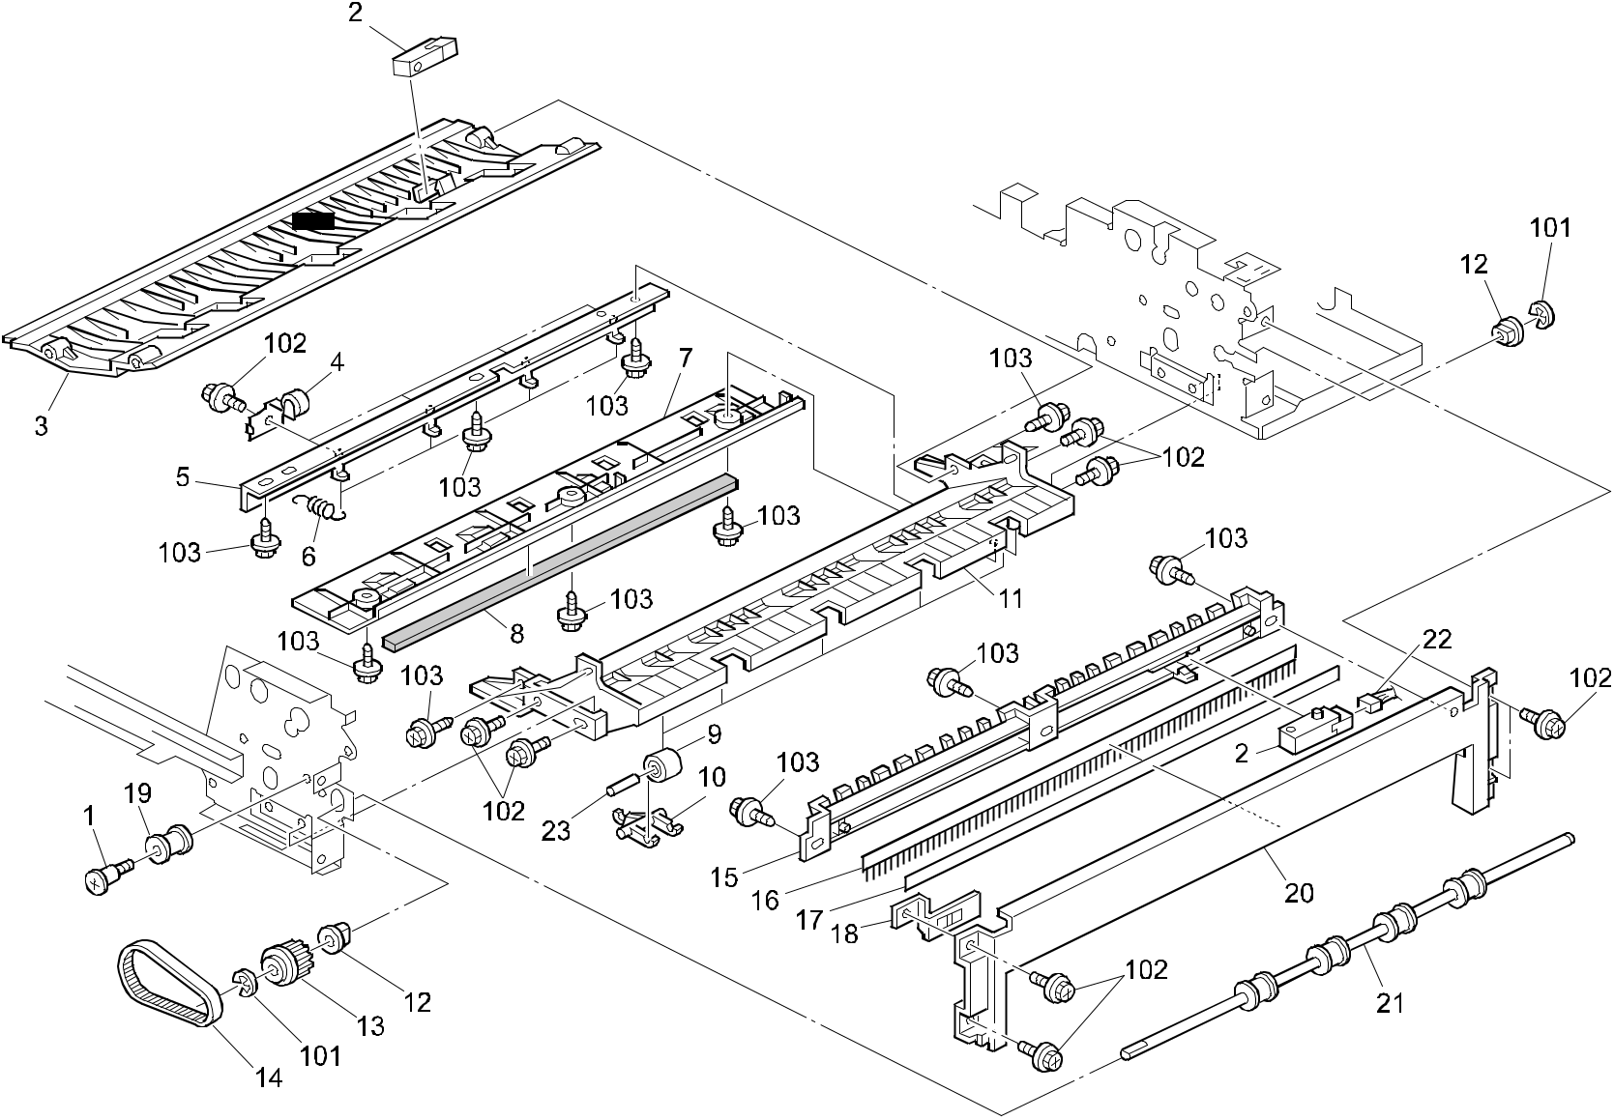

A292/A293/B098 30 Parts Location and List

9.ORIGINAL EXIT SECTION 1 (A292/A293/B098)

Index | Part No. | Description | Q’ty Per
No. | Part No. | Description | Assembly
1 | AA14 3020 | Stepped Screw - M4 | 1
2 | AW01 0093 | Photo Reflection Sensor - PS-17ND1 | 2
3 | B301 3161 | Left Exit Guide | 1
4 | A806 3151 | Driven Exit Roller | 4
5 | A806 3142 | Guide Plate Bracket | 1
6 | B301 3135 | Spring | 4
7 | A806 3171 | Lower Exit Cover | 1
8 | B301 4413 | Noise Absorbing Pad | 1
9 | B301 3184 | Reverse Driven Roller | 5
10 | A548 1234 | Driven Roller Arm | 5
11 | B301 3132 | Lower Guide Plate | 1
12 | 5053 0447 | Bushing - 6mm | 2
13 | A806 3281 | Timing Pulley - T14 S3M | 1
14 | AA04 3548 | Timing Belt - B40S3M150 | 1
15 | A806 3211 | Right Exit Guide Plate | 1
16 | AA12 0032 | Antistatic Brush | 1
17 | A806 3222 | Seal | 1
18 | A806 3221 | Exit Ground Plate | 1
19 | A351 3459 | Idler | 1
20 | A806 1921 | Right Cover (A292/A293) | 1
20 | B301 1926 | Cover:Right (B098) | 1
21 | A806 3111 | Drive Exit Roller | 1
22 | B301 5455 | DC Relay Harness | 1
23 | B301 3185 | Driven Roller Shaft | 9

Index | Part No. | Description | Q’ty Per
No. | Part No. | Description | Assembly

- 0720 0040B Retaining Ring - M4

- 0451 3008B Tapping Screw - M3x8

- 0450 3008B Tapping Screw - M3x8

A292/A293/B098 31 Parts Location and List

10.ORIGINAL EXIT SECTION 2 (A292/A293/B098)
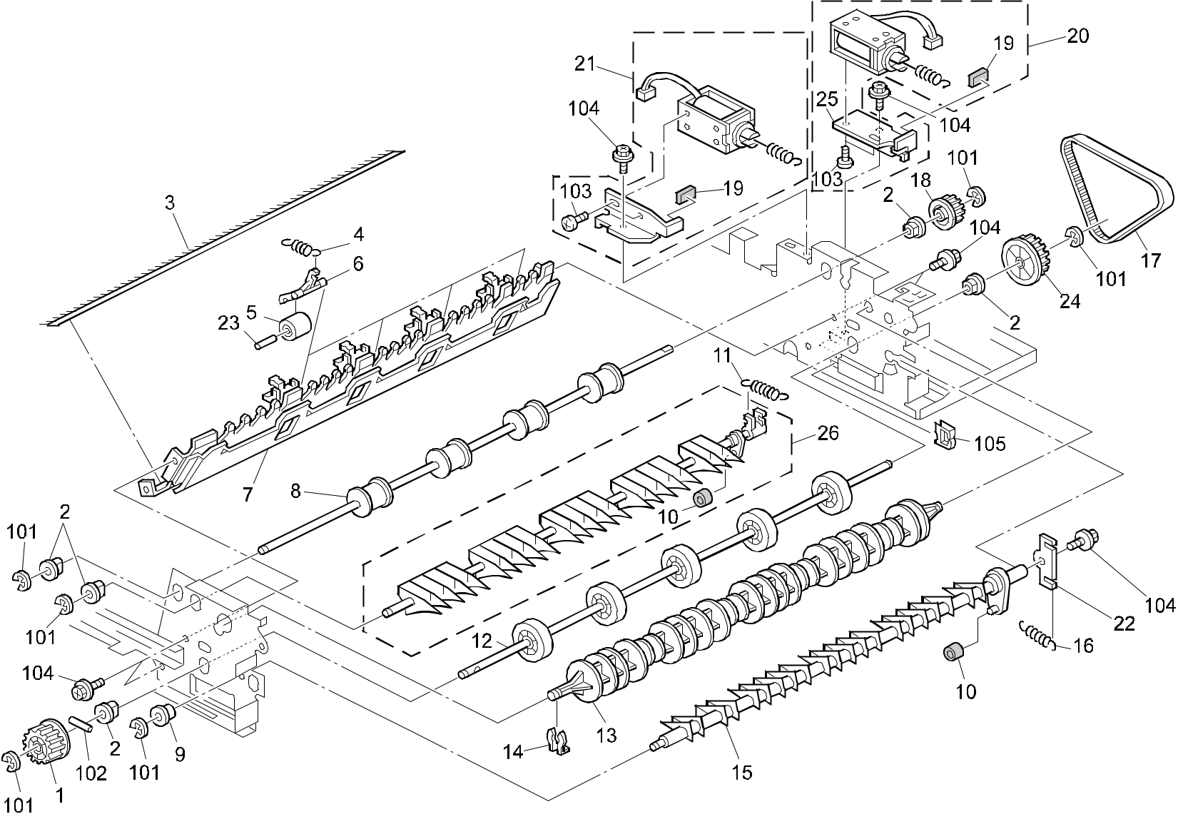

A292/A293/B098 32 Parts Location and List

10.ORIGINAL EXIT SECTION 2 (A292/A293/B098)

Index | Part No. | Description | Q’ty Per
No. | Part No. | Description | Assembly
1 | A680 2321 | Pulley - 30T | 1
2 | 5053 0447 | Bushing - 6mm | 5
3 | A548 1217 | Antistatic Brush - Paper Exit | 1
4 | B301 3186 | Spring | 4
5 | B301 3184 | Reverse Driven Roller | 4
6 | A548 1234 | Driven Roller Arm | 4
7 | B301 3181 | Invertor Guide Plate | 1
8 | A548 1261 | Exit Roller | 1
9 | 5324 1658 | Bushing- 4x8x4.5mm | 1
10 | A548 1317 | Lever Cushion | 2
11 | A806 4232 | Tension Spring | 1
12 | B301 3271 | Reverse Drive Roller | 1
13 | A548 1231 | Guide Roller | 1
14 | 5215 2621 | Snap Ring - M6 | 1
15 | B301 3191 | Exit Junction Gate | 1
16 | A806 4231 | Spring | 1
17 | AA04 3547 | Timing Belt - B40S3M213 | 1
18 | A548 2137 | Timing Pulley - 18Z | 1
19 | A469 3113 | Rubber Seal - 1x6x10mm | 2
20 | A806 3311 | Invertor Solenoid Assembly | 1
21 | A680 1384 | Solenoid - Lower Inverter Gate | 1
22 | B301 3192 | Lever - Exit Junction Gate | 1
23 | B301 3185 | Driven Roller Shaft | 4
24 | B301 3286 | Pulley - 30Z | 1
25 | A806 3312 | Solenoid Bracket | 1
26 | A548 1320 | Inverter Gate Plate | 1

Index | Part No. |  | Description | Q’ty Per
No. |  |  | Description | Assembly
101 | 0720 | 0040B | Retaining Ring - M4
102 | 0632 | 0120G | Parallel Pin - 2x12
103 | 0353 | 0030B | Philips Truss Head Screw - M3x3
104 | 0451 | 3008B | Tapping Screw - M3x8
105 | 1105 | 0230 | Clamp

A292/A293/B098 33 Parts Location and List

11.ARDF DRIVE & ELECTRICAL 1 (A292/A293/B098)
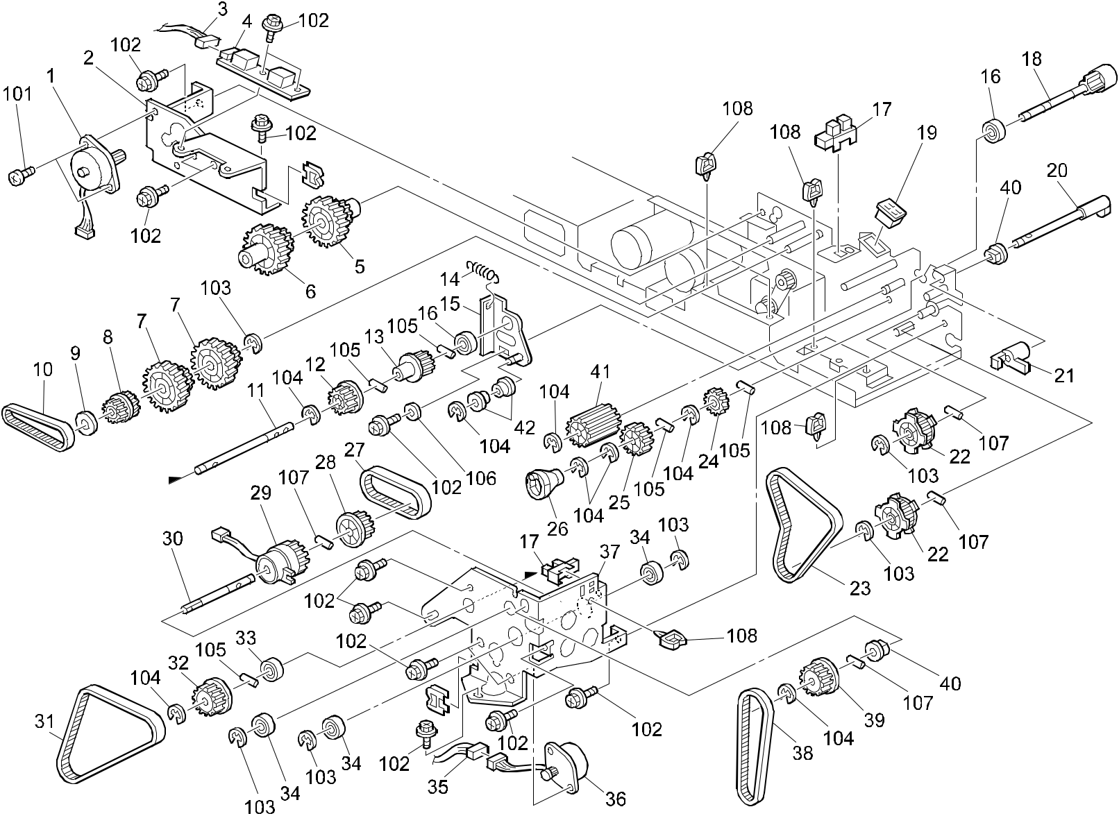

A292/A293/B098 34 Parts Location and List

11.ARDF DRIVE & ELECTRICAL 1 (A292/A293/B098)

Index | Part No. | Description | Q’ty Per
No. | Part No. | Description | Assembly
1 | A806 2911 | Stepper Motor Ass'y | 1
2 | B301 2367 | Motor Bracket | 1
3 | A806 5705 | Display Harness | 1
4 | 5936 5231 | Indicator Board | 1
5 | A806 2285 | Gear - Z20/Z47 | 1
6 | A806 2287 | Gear - Z20/Z47 | 1
7 | A806 2283 | Gear - Z20/Z47 | 2
8 | A806 2161 | Timing Pulley - T30/Z20 S2M/M0.8 | 1
9 | AA13 2152 | Spacer - 8x20x1 | 1
10 | A806 4117 | Timing Belt - B40S2M158 | 1
11 | B301 2122 | Shaft | 1
12 | B301 2213 | Pulley - 20Z | 1
13 | B301 2211 | Pulley - 20/19Z | 1
14 | AA06 0590 | Pressure Spring | 3
15 | B301 2281 | Tension Bracket | 1
16 | A232 3562 | Ball Bearing - 6x12x4mm | 1
17 | AW02 0075 | Photointerruptor | 2
18 | B301 2242 | Shaft | 1
19 | A680 1181 | Magnetic Catch | 1
20 | B301 2422 | Cam - Pick-up Roller | 1
21 | A680 2262 | Feeler - Pick-up Roller Cam | 1
22 | B301 2261 | Pulley - 36Z | 2
23 | AA04 3536 | Timing Belt - B60S3M279 | 1
24 | B301 2244 | Gear - 23Z | 1
25 | B301 2243 | Gear - 29Z | 1
26 | A806 2244 | Separation Shaft Stopper | 1
27 | AA04 3535 | Timing Belt - B60S3M195 | 1
28 | B301 2273 | Pulley - 32Z | 1
29 | AX20 0173 | Magnetic Clutch | 1
30 | B301 2271 | Shaft | 1
31 | AA04 3534 | Timing Belt - B60S3M216 | 1
32 | B301 2123 | Pulley - 24Z | 1
33 | A859 2230 | Ball Bearing - 6x13x5 | 1
34 | A232 3566 | Ball Bearing - 8x16x5 | 3
35 | A806 5715 | Pick Up Motor Harness | 1

Index | Part No. | Description | Q’ty Per
No. | Part No. | Description | Assembly
36 | AX04 0096 | Stepping Motor - DC 18W | 1
37 | B301 2336 | Side Plate | 1
38 | AA04 3537 | Timing Belt - B40S2M206 | 1
39 | B301 2141 | Pulley - 39Z | 1
40 | 5053 0447 | Bushing - 6mm | 2
41 | B301 2222 | Gear - 20Z | 1
42 | A232 3565 | Ball Bearing - 6x10x3mm | 2

- 0353 0050B Philips Truss Head Screw - M3x5

- 0451 3008B Tapping Screw - M3x8

- 0720 0060B Retaining Ring - M6

- 0720 0040B Retaining Ring - M4

- 0632 0120G Parallel Pin - 2x12

- 0701 0030B Flat Washer - M3

- 0632 0160G Parallel Pin-m2x16

108 1105 0199 Clamp

A292/A293/B098 35 Parts Location and List

12.ARDF DRIVE & ELECTRICAL 2 (A292/A293/B098)
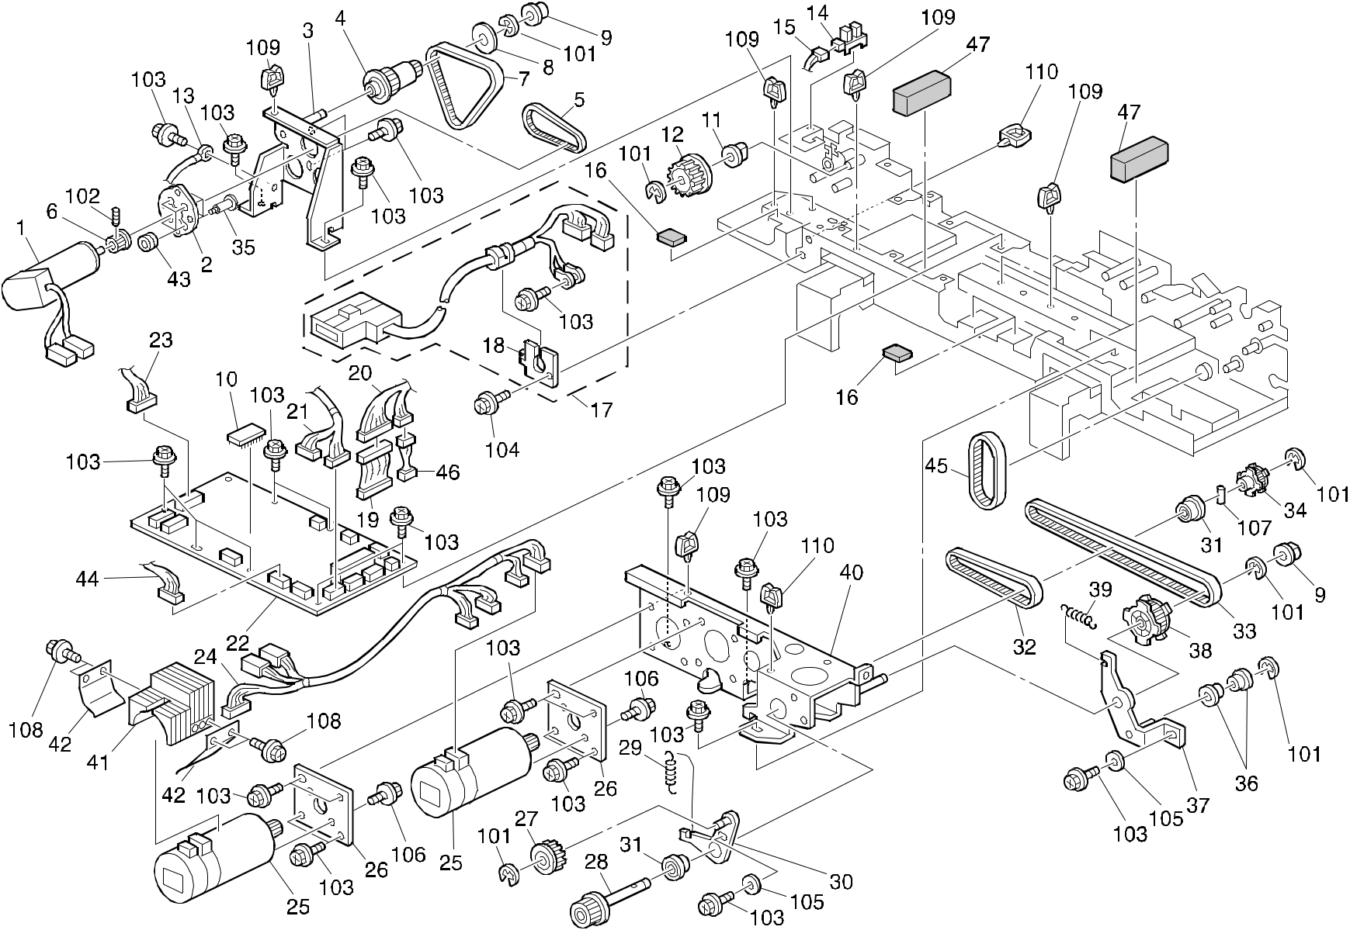

A292/A293/B098 36 Parts Location and List

12.ARDF DRIVE & ELECTRICAL 2 (A292/A293/B098)

Index | Part No. | Description | Q’ty Per
No. | Part No. | Description | Assembly
1 | AX06 0121 | DC Motor - 27W | 1
2 | B301 3345 | Exit Motor Guide Plate | 1
3 | B301 3341 | Exit Motor Bracket | 1
4 | A680 2311 | Pulley - 18T/32T | 1
5 | AA04 3539 | Timing Belt - B40S2M104 | 1
6 | A610 3532 | Timing Pulley - 18Z | 1
7 | AA04 3547 | Timing Belt - B40S3M213 | 1
8 | A300 3812 | Spacer - 6x22x1.5 | 1
9 | 5936 2321 | Rubber Bushing - Vibration Damper | 1
10 | B301 5562 | IC - UVEPROM 27C 1M X8 120NS | 1
11 | 5053 0447 | Bushing - 6mm | 1
12 | A548 2137 | Timing Pulley - 18Z | 1
13 | B301 5475 | Grounding Wire | 1
14 | AW02 0075 | Photointerruptor | 1
15 | B301 5460 | DC Relay Harness | 1
16 | B301 1141 | Rubber Cushion | 4
17 | B301 5340 | DF Harness | 1
18 | A680 1171 | Harness Holder | 1
19 | B301 5385 | Relay Harness | 1
20 | B301 5400 | DC Harness | 1
21 | B301 5430 | DC Harness | 1
22 | B301 5520 | ADF Main Control Board | 1
23 | B301 5450 | DC Harness | 1
24 | B301 5370 | DC Harness | 1
25 | B301 5600 | DC Motor - 54W | 2
26 | B301 2172 | Cushion | 2
27 | AB03 0354 | Pulley - 20T | 1
28 | B301 2113 | Pulley - 19Z | 1
29 | AA06 0590 | Pressure Spring | 3
30 | B301 2327 | Holder Bracket | 1
31 | B301 2610 | Bearing - 6x15x5 | 2
32 | AA04 3533 | Timing Belt - B0S2M256 | 1
33 | AA04 3546 | Timing Belt - B60S2M474 | 1
34 | B301 2111 | Pulley - 30Z | 1
35 | AA14 3379 | Stepped Screw | 4

Index | Part No. | Description | Q’ty Per
No. | Part No. | Description | Assembly
36 | A232 3565 | Ball Bearing - 6x10x3mm | 2
37 | B301 2376 | Tension Bracket | 1
38 | B301 2231 | Pulley - 58/20Z | 1
39 | AA06 0590 | Pressure Spring | 3
40 | B301 2371 | Motor Bracket | 1
41 | B301 2319 | Heat Sink - DC Motor | 1
42 | B301 2320 | Heat Sink Holder | 2
43 | B301 3246 | Motor Bushing - 4x9x5.2 | 4
44 | B301 5480 | Df Position Sensor Harness | 1
45 | AA04 3538 | Timing Belt - B60S3M174 | 1
46 | B301 5390 | Relay Harness | 1
47 | B301 4414 | Acoustic Material | 3

- 0720 0040B Retaining Ring - M4

- 0574 0050E Hexagon Headless Set Screw - M4x5

- 0451 3008B Tapping Screw - M3x8

- 0451 4008B Philips Tapping Screw - M4x8

- 0701 0030B Flat Washer - M3

- 0451 4006B Tapping Screw - 4x6

- 0632 0120G Parallel Pin - 2x12

- 0451 3005B Tapping Screw - M3x5

109 1105 0230 Clamp

110 1105 0199 Clamp

A292/A293/B098 37 Parts Location and List

13.ARDF FRAME SECTION (A292/A293/B098)
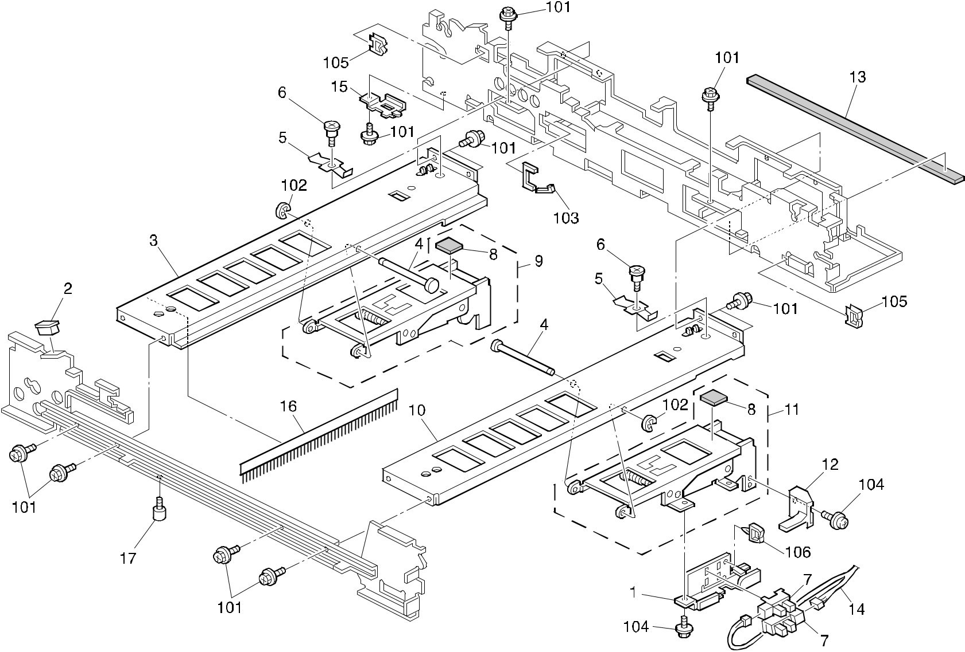

A292/A293/B098 38 Parts Location and List

13.ARDF FRAME SECTION (A292/A293/B098)

Index | Part No. | Description | Q’ty Per
No. | Part No. | Description | Assembly
1 | B301 1543 | Sensor Bracket | 1
2 | A680 1181 | Magnetic Catch | 1
3 | B301 1631 | Rear Side Plate | 1
4 | A806 1135 | Contact Point Shaft | 2
5 | B301 1136 | Spring Plate - 0.4mm | 2
6 | AA14 3039 | Spring Holder | 2
7 | AW02 0075 | Photointerruptor | 2
8 | A351 4281 | Anti-vibration Cushion | 2
9 | B301 1510 | Left Hinge | 1
10 | B301 1633 | Right Stay | 1
11 | B301 1520 | Right Hinge | 1
12 | A548 1531 | Safety Switch Feeler | 1
13 | B301 4412 | Acoustic Material | 1
14 | B301 5480 | DF Position Sensor Harness | 1
15 | B301 1137 | Pulley Cover | 1
16 | B301 1134 | Anti-static Brush | 1
17 | 5410 1291 | Pin | 1

Index | Part No. | Description | Q’ty Per
No. | Part No. | Description | Assembly

- 0450 3008B Tapping Screw - M3x8

- 0720 0030B Retaining Ring - M3

- 1105 0334 Edge - 17

- 0451 4006B Tapping Screw - 4x6

- 1105 0328 Harness Clamp - ES-0505

- 1105 0230 Clamp

A292/A293/B098 39 Parts Location and List

14.OPTICS SECTION 1 (A292/A293/B098)
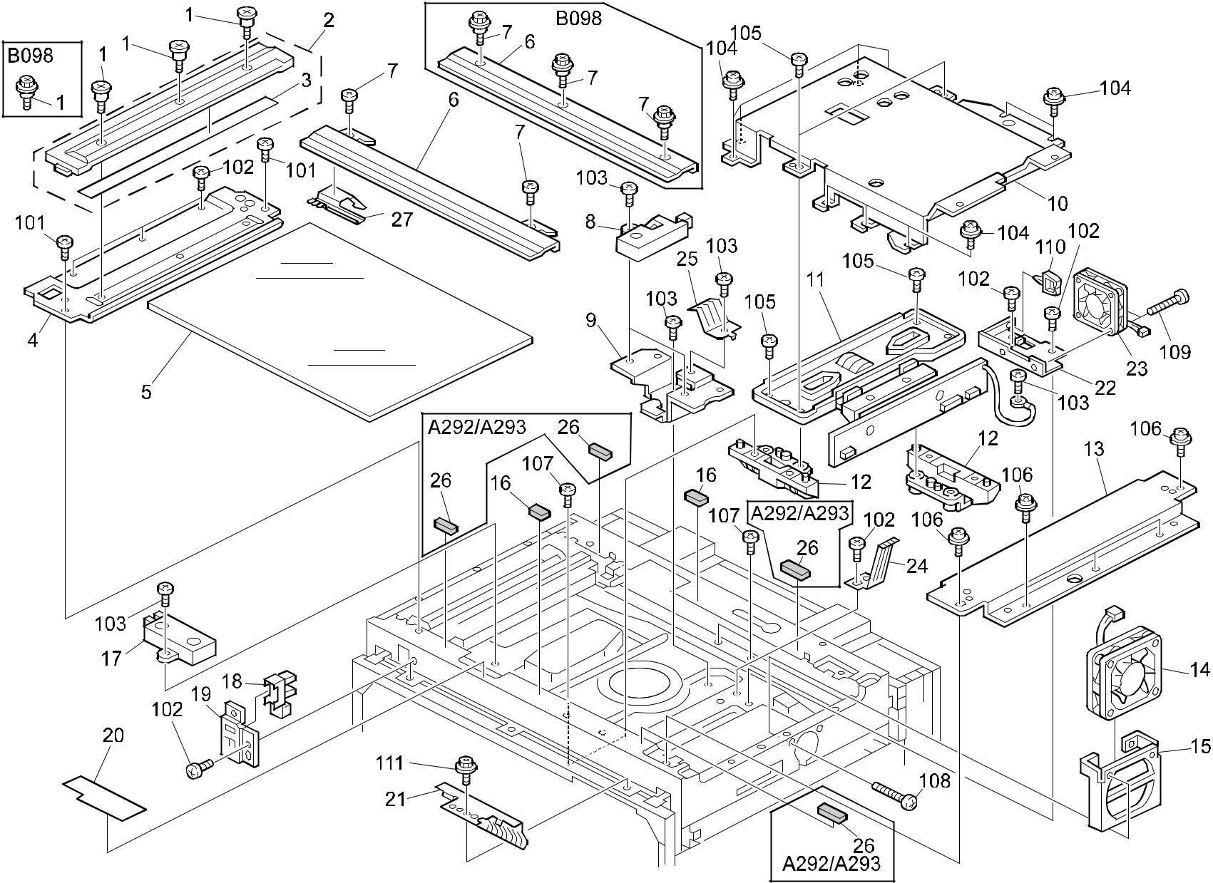

A292/A293/B098 40 Parts Location and List

14.OPTICS SECTION 1 (A292/A293/B098)

Index | Part No. | Description | Q’ty Per
No. | Part No. | Description | Assembly
1 | 5206 2684 | Shoulder Screw - M3 (A292/A293) | 3
1 | AA14 3520 | Shoulder Screw - M3 (B098) | 3
2 | A294 1794 | Left Scale (A292/A293) | 1
2 | B098 1791 | Scale:Left:Ass'y (B098) | 1
3 | A293 1793 | Left Scale Sheet | 1
4 | A293 1775 | Left Scale Bracket (A292/A293) | 1
4 | B098 1775 | Bracket:Scale:Left (B098) | 1
5 | AC01 2065 | Exposure Glass - A3 T-3.2 | 1
6 | A294 1795 | Right Scale (A292/A293) | 1
6 | B098 1781 | Scale:Rear:Ass'y (B098) | 1
7 | AA14 3417 | Shoulder Screw - M4x4 (A292/A293) | 2
7 | AA14 3520 | Shoulder Screw - M3 (B098) | 3
8 | A294 1843 | Photosensor With Filter - H50 | 2
9 | A293 1826 | Width Sensor Bracket | 1
10 | A293 1819 | BICU Cover (A292/A293) | 1
10 | B098 1819 | Inner Cover:Bicu:Peen (B098) | 1
11 | A293 1797 | Scanner Lens Unit (A292/A293) | 1
11 | B098 1797 | Image Scanning Board:ass'y (B098) | 1
12 | A293 1687 | Lends Block Holder | 2
13 | A229 1785 | Right Stay (A292/A293) | 1
13 | B098 1785 | Stay:Right (B098) | 1
14 | AX64 0083 | Cooling Fan (A292/A293) | 1
14 | AX64 0123 | Fan Motor - DC1.68W (B098) | 1
15 | A229 1831 | Fan Bracket (A292/A293) | 1
15 | B098 1831 | Bracket:Fan (B098) | 1
16 | AA16 1137 | Cushion - 0.5 | 2
17 | AW01 0034 | Original Width Sensor | 1
18 | AW02 0056 | Photointerrupter - EE-SX4235A-P1 | 1
19 | A229 1825 | Home Position Sensor Bracket | 1
20 | AA15 0704 | Seal - 90x29.5x0.2 | 1
21 | A229 1832 | Front Grounding Plate | 1
22 | A293 1828 | CCD Fan Bracket | 1
23 | AX64 0110 | Axial Fan - MM40 24V (A292/A293) | 1
23 | AX64 0128 | Fan Motor - DC 24V 1.44W(B098) | 1
24 | A293 1825 | Ground Plate - Lower Lens Stay | 1

Index | Part No. | Description | Q’ty Per
No. | Part No. | Description | Assembly
25 | A294 1838 | Ground Plate - Lens Stay | 1
26 | AA16 1138 | Cushion - 1.1 (A292/A293) | 4
27 | A293 1774 | Spacer - Rear Scale | 2

- 0353 0040B Screw - M3X4

- 0353 0060B Philips Pan Head Screw - M3x6

- 0353 0080B Screw - M3X8

- 0951 3006B Philips Screw With Flat Washer - M3x6

- 0354 0080B Screw - M4X8

- 0951 3008B Philips Screw With Flat Washer - M3x8

- 0314 0080B Philips Pan Head Screw - M4x8

- 0314 0300B Philips Pan Head Screw - M4x30

- 0313 0120B Philips Pan Head Screw - M3x12

110 | 1105 | 0199 | Clamp
111 | 0451 | 4008B | Philips Tapping Screw - M4x8

A292/A293/B098 41 Parts Location and List

15.OPTICS SECTION 2 (A292/A293/B098)
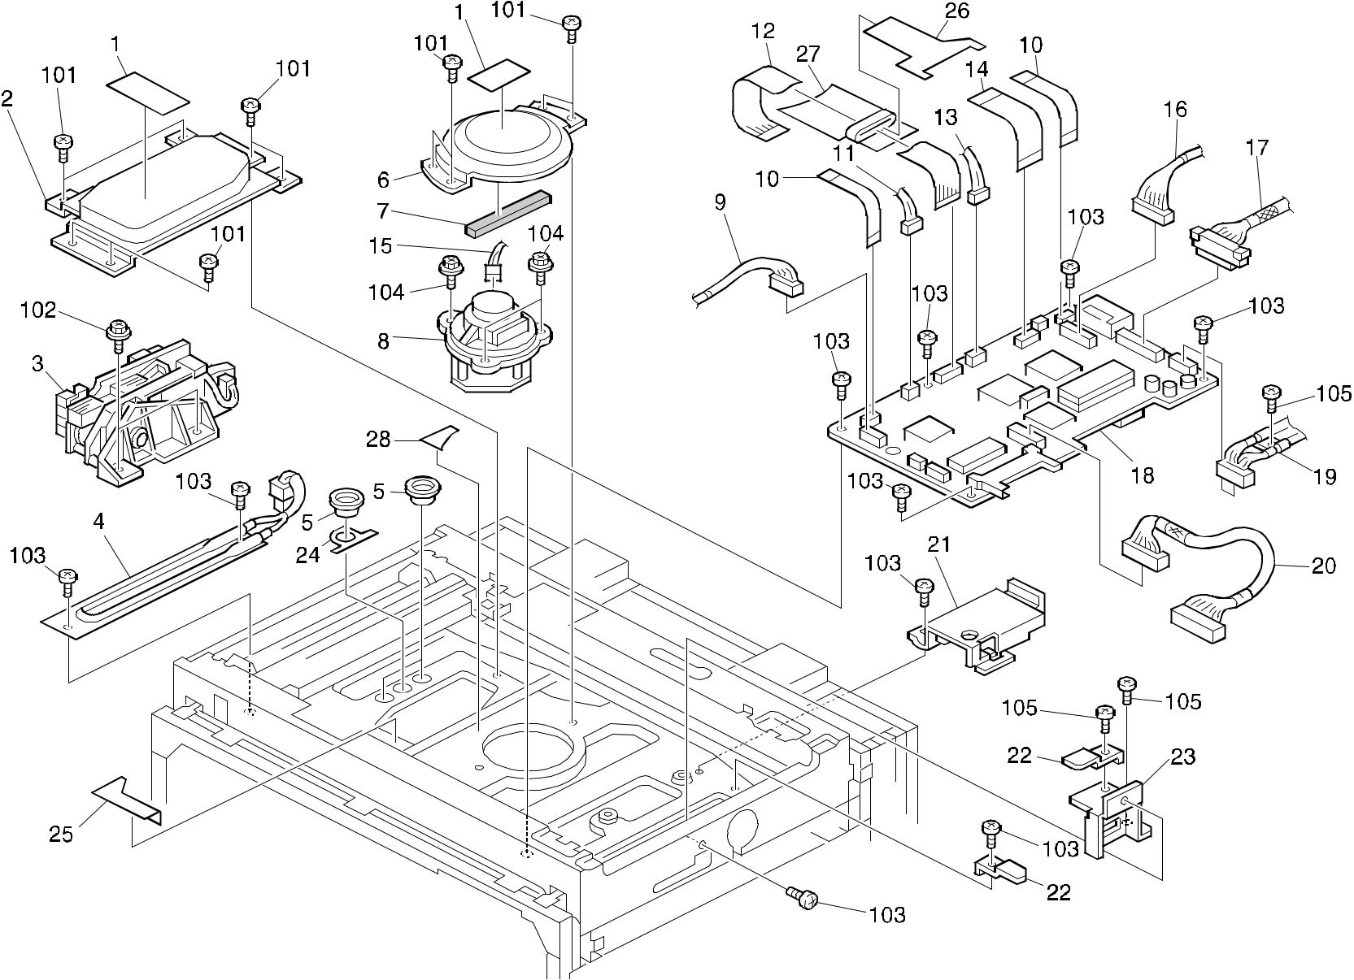

A292/A293/B098 42 Parts Location and List

15.OPTICS SECTION 2 (A292/A293/B098)

Index | Part No. | Description | Q’ty Per
No. | Part No. | Description | Assembly
1 | G029 1982 | Decal - LD | 2
2 | A293 1695 | Laser Diode Unit Cover | 1
3 | A293 8980 | Laser Diode Unit Ass'y (A292/A293) | 1
3 | B098 1970 | Laser Diode Unit:Ass'y (B098) | 1
4 | AX40 0063 | Anti Condensation Heater - 120V 9W | 1
4 | AX40 0064 | Anti Condensation Heater - 230V 9W | 1
5 | 5353 3283 | Insert Cap | 3
6 | A293 1691 | Polygon Mirror Motor Cover | 1
7 | A293 1693 | Seal - 60mm | 1
8 | AX06 0200 | Polygon Mirror Motor (A292/A293) | 1
8 | AX06 0257 | Polygon Mirror Motor:DC24V 24W (B098) | 1
9 | A293 5405 | LCDC Harness | 1
10 | A293 5471 | SBU Harness - 15wick (A292/A293) | 2
10 | B098 5471 | Harness:FFC:SBU:15WICK:80MM (B098) | 2
11 | A293 5430 | Inner Harness | 1
12 | A293 5426 | Laser Diode Control Harness | 1
13 | A293 5431 | Power Harness - Laser Diode | 1
14 | A293 5470 | SBU Harness - 40wick (A292/A293) | 1
14 | B098 5470 | Harness:FFC:SBU:40WICK:80MM (B098) | 1
15 | A229 5429 | Power Harness | 1
16 | A293 7604 | MCU Harness (LAN) (A292/A293) | 1
16 | A293 7607 | MCU Harness (A292/A293) | 1
16 | B098 7607 | Harness:IC:EXP (B098) | 1
16 | B098 7604 | Harness:IC:LAN (B098) | 1
17 | A293 5400 | BICU Cable (A292/A293) | 1
17 | B098 5400 | Interface Harness:BICU:IOB (B098) | 1
18 | A293 7552 | BICU Board (NA) (A292/A293) | 1
18 | A293 7562 | BICU Board (EU) (A292/A293) | 1
18 | B098 7552 | PCB:BICU:NA:Ass'y (B098) | 1
18 | B098 7562 | PCB:BICU:EU:Ass'y (B098) | 1
19 | A293 5507 | BICU Harness - DC Power | 1
20 | A293 5472 | HDD Harness | 1
21 | A293 1832 | Connecting Guide | 1
22 | A229 5872 | Harness Clamp | 2
23 | A293 1839 | Key Counter Bracket | 1

Index | Part No. | Description | Q’ty Per
No. | Part No. | Description | Assembly
24 | A229 1694 | Shielding Sheet | 1
25 | A293 1694 | Insulating Sheet | 1
26 | A293 1834 | Insulating Sheet - FFC-SBU (A292/A293) | 1
26 | B098 1834 | Insulating Sheet:FFC:SBU (B098) | 1
27 | A293 1835 | Insulating Sheet - FFC Ass'y (A292/A293) | 1
27 | B098 1835 | Insulating Sheet:FFC:Ass'y (B098) | 1
28 | A293 1838 | Insulating Sheet - FFC Small | 1

- 0353 0080B Screw - M3X8

- 0451 3012B Tapping Screw With Washer - M3x12

- 0353 0060B Philips Pan Head Screw - M3x6

- 0451 4010B Tapping Screw - 4x10

- 0354 0080B Screw - M4X8

A292/A293/B098 43 Parts Location and List

16.OPTICS SECTION 3 (A292/A293/B098)
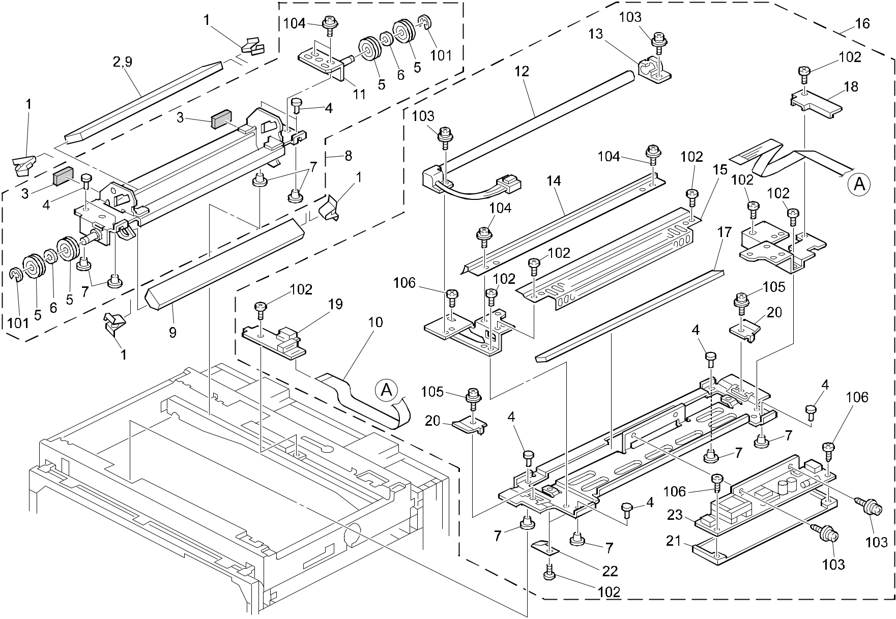

A292/A293/B098 44 Parts Location and List

16.OPTICS SECTION 3 (A292/A293/B098)

Index | Part No. | Description | Q’ty Per
No. | Part No. | Description | Assembly
1 | A293 1766 | 2nd Mirror Plate | 4
2 | A293 1765 | 2nd Mirror (A292/A293) | 1
3 | A294 1743 | Cushion - 5x20x4 | 2
4 | A096 1873 | Scanner Shoe Pin | 8
5 | AB03 2717 | Pulley - 26Z | 4
6 | AA13 2174 | Spacer - M8 | 2
7 | A069 1883 | Shoe - Scanner | 8
8 | A293 1751 | 2nd Scanner Ass'y | 1
9 | A293 1767 | 2nd Mirror (A292/A293) | 1
9 | B098 1740 | Mirror:No.2:Ass'y (B098) | 2
10 | A294 5500 | Harness - 1st Scanner | 1
11 | A293 1753 | Adjusting Pin - 2nd Scanner | 1
12 | AX50 0071 | Xenon Lamp - 7000 OLX | 1
13 | A294 1712 | Rear Holder - Lamp | 1
14 | A294 1707 | Reflector | 1
15 | A294 1705 | Cover - 1st Scanner | 1
16 | A293 1731 | 1st Scanner Unit (A292/A293) | 1
16 | B098 1731 | Carriage:No.1:Ass'y (B098) | 1
17 | A293 1735 | 1st Mirror (A292/A293) | 1
17 | B098 1735 | Mirror:No.1:Ass'y (B098) | 1
18 | A294 1710 | Holder - 1st Scanner Harness | 1
19 | A293 5330 | Interface Board | 1
20 | A294 1709 | Wire Clamp | 2
21 | A294 1708 | Invertor Insulator - 1 | 1
22 | AC03 5022 | Rear Mirror Clamp - 1st Mirror | 2
23 | AZ50 0054 | Inverter - Xenon Lamp | 1

Index | Part No. | Description | Q’ty Per
No. | Part No. | Description | Assembly

- 0720 0060E Retaining Ring - M6

- 0453 3006B Tapping Screw - M3x6

- 0954 3008B Philips Screw - M3x8

- 0951 3006B Philips Screw With Flat Washer - M3x6

- 0954 4008B Philips Screw - M4x8

- 0452 3006W Tapping Screw - 3x6

A292/A293/B098 45 Parts Location and List

17.OPTICS SECTION 4 (A292/A293/B098)
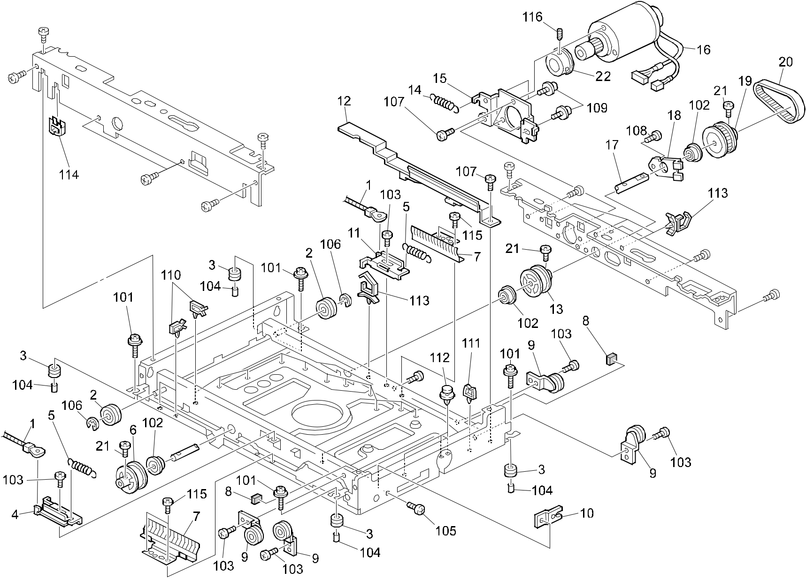

A292/A293/B098 46 Parts Location and List

17.OPTICS SECTION 4 (A292/A293/B098)

Index | Part No. | Description | Q’ty Per
No. | Part No. | Description | Assembly
1 | A293 1715 | Scanner Drive Wire (A292/A293) | 2
1 | B098 1715 | Drive Were:Scanner (B098) | 2
2 | AB03 2717 | Pulley - 26Z | 2
3 | AA16 1104 | Cushion - Motor | 4
4 | A293 1721 | Front Tension Bracket | 1
5 | AA06 0221 | Gripper Solenoid Spring | 2
6 | A294 1757 | Pulley - Front Drive | 1
7 | A229 1833 | Grounding Plate | 2
8 | A294 1688 | Cushion | 2
9 | A134 1698 | Idle Pulley | 4
10 | A229 1815 | Key Counter Bracket - Front | 1
11 | A293 1722 | Rear Tension Bracket | 1
12 | A293 1830 | Flexible Board Guide | 1
13 | A294 1758 | Pulley - Rear Drive | 1
14 | AA06 0763 | Tension Spring | 1
15 | A293 1706 | Bracket - Scanner Motor (A292/A293) | 1
15 | B098 1706 | Bracket:Dc Motor:Scanner (B098) | 1
16 | A293 1705 | DC Motor - 50W (A292/A293) | 1
16 | B098 1705 | DC Motor:38V 26W (B098) | 1
17 | A293 1711 | Drive Shaft | 1
18 | A134 1722 | Bracket - Drive Shaft | 1
19 | AB03 0657 | Timing Pulley - 65T | 1
20 | A293 1717 | Timing Belt - S2M274 | 1
21 | A293 1713 | Hexagonal Screw 3x6 | 3
22 | B098 1707 | Fly Wheel:Scanner (B098) | 1

Index | Part No. |  | Description | Q’ty Per
No. |  |  | Description | Assembly
101 | 0951 | 4010B | Philips Screw With Washer - M4x10
102 | 0805 | 3368 | Ball Bearing - 8x16x5mm
103 | 0354 | 0080B | Screw - M4X8
104 | 0707 | 4050B | Bushing - 4 X5
105 | 0313 | 0060B | Philips Pan Head Screw - M3x6
106 | 0720 | 0060B | Retaining Ring - M6
107 | 0353 | 0060B | Philips Pan Head Screw - M3x6
108 | 0354 | 0060B | Screw - M4X6
109 | 0951 | 4006B | Philips Screw With Washer - M4x6
110 | 1105 | 0290 | Harness Clamp - Horizontal
111 | 1105 | 0229 | Clamp
112 | 1105 | 0246 | Spacer

- 1105 0310 Harness Clamp - LWS-1S

- 1105 0113 Edge - P108

- 0314 0080B Philips Pan Head Screw - M4x8

- 0574 0040E Hexagon Headless Set Screw - M4x4 (B098)

A292/A293/B098 47 Parts Location and List

18.LASER UNIT (A292/A293/B098)
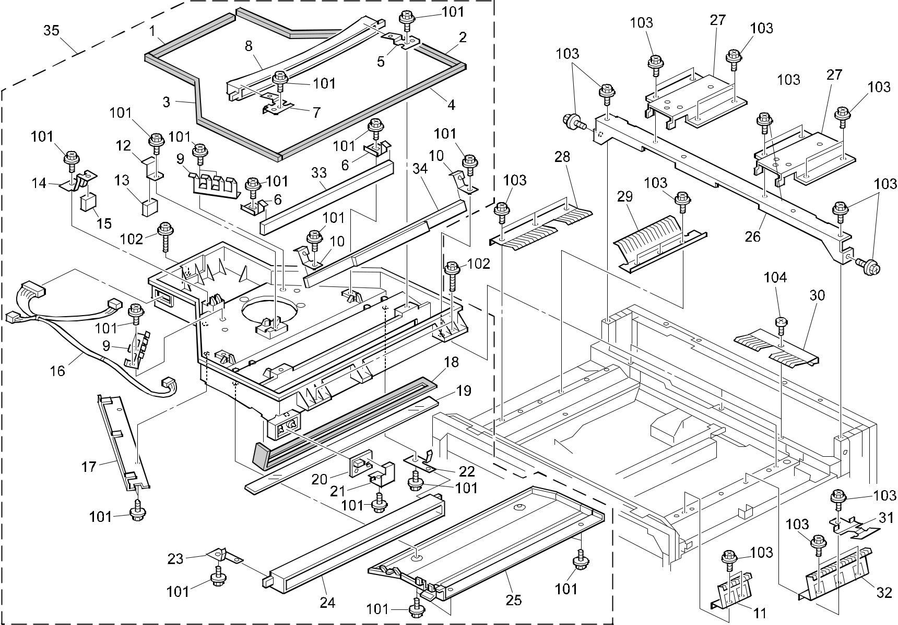

A292/A293/B098 48 Parts Location and List

18.LASER UNIT (A292/A293/B098)

Index | Part No. | Description | Q’ty Per
No. | Part No. | Description | Assembly
1 | A229 1960 | Shield 1 | 1
2 | A229 1961 | Shield 2 | 1
3 | A229 1962 | Seal - 6x364 | 1
4 | A229 1963 | Shield 4 | 1
5 | G020 1906 | Left Holder - F Theta Mirror | 1
6 | A229 1903 | Mirror Plate - No.1 | 2
7 | G020 1907 | Right Holder - F Theta Mirror | 1
8 | G020 1968 | F Theta Mirror | 1
9 | A229 1936 | Side Spring Plate | 2
10 | A293 1907 | 2nd Mirror Plate | 2
11 | A229 1752 | Ground Plate - Right Short | 1
12 | A229 1907 | Mirror Plate - No.3 | 1
13 | AC03 0113 | 3rd Mirror | 1
14 | A217 2103 | Cylindrical Lens Plate | 1
15 | A229 1916 | Cylindrical Lens | 1
16 | A293 5432 | Harness - Imaging Unit - Outer | 1
17 | A229 1958 | Harness Guide | 1
18 | A229 1934 | Shield - Shield Glass | 1
19 | AC01 5026 | Shield Glass | 1
20 | A293 5310 | Sync Detector Board | 1
21 | A229 1919 | Sync Detector Board Plate | 1
22 | G020 1904 | Left Holder - BTL Lens | 1
23 | G020 1903 | Right Holder - BTL Lens | 1
24 | A229 1925 | BTL Lens Ass'y | 1
25 | A229 1923 | Lower Cover | 1
26 | A229 1072 | Upper Middle Stay (A292/A293) | 1
26 | B098 1072 | Stay:Upper:Middle (B098) | 1
27 | A293 1093 | ADF Holder | 2
28 | A229 1753 | Ground Plate - Left Long | 1
29 | A229 1754 | Ground Plate - Left Short | 1
30 | A229 1750 | Ground Plate - Rear | 3
31 | A293 5879 | Ground Plate | 1
32 | A229 1751 | Ground Plate - Right Long | 1
33 | AC03 0111 | 1st Mirror | 1
34 | AC03 0114 | 2nd Mirror | 1

Index | Part No. | Description | Q’ty Per
No. | Part No. | Description | Assembly
35 | A293 1871 | Optical Housing Ass'y (A292/A293) | 1
35 | B098 1871 | Imaging Unit:Ass'y (B098) | 1

- 0451 3006B Tapping Screw - M3x6

- 0451 4010B Tapping Screw - 4x10

- 0451 4008B Philips Tapping Screw - M4x8

- 0354 0080B Screw - M4X8

A292/A293/B098 49 Parts Location and List

19.BY-PASS FEED SECTION (A292/A293/B098)
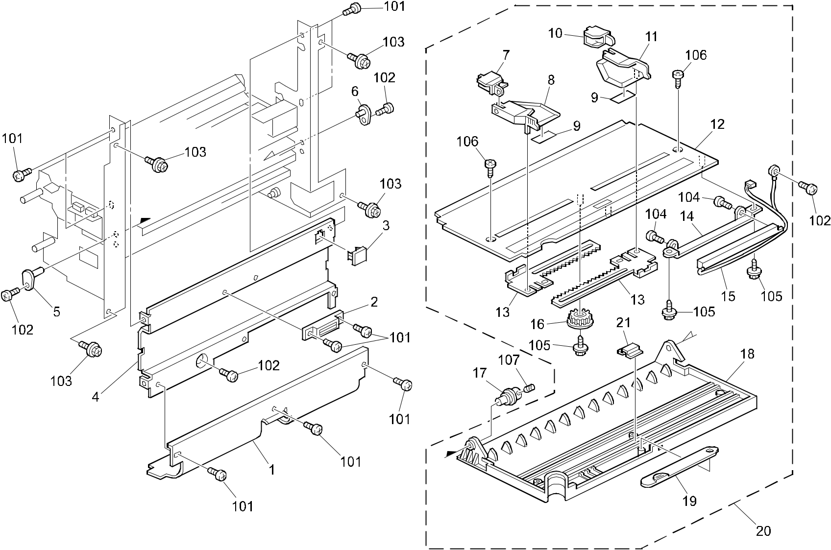

A292/A293/B098 50 Parts Location and List

19.BY-PASS FEED SECTION (A292/A293/B098)

Index | Part No. | Description | Q’ty Per
No. | Part No. | Description | Assembly
1 | A096 2707 | Upper Guide - By-pass (A292/A293) | 1
1 | B098 2707 | Guide Plate:Upper:Manual Feed (B098) | 1
2 | AA02 1025 | Magnet Catch | 1
3 | A293 2708 | Cap - By-pass Feed Cover (A292/A293) | 1
3 | B098 2708 | Cap:Cover:Manual Feed (B098) | 1
4 | A096 2706 | By-pass Feed Cover (A292/A293) | 1
4 | B098 2706 | Cover:Manual Feed (B098) | 1
5 | A053 2770 | Holder - Manual Feed Table | 1
6 | A229 2760 | By-pass Feed Table Shaft | 1
7 | A176 2761 | Front Sub Guide (A292/A293) | 1
7 | B098 2761 | Guide:Auxiliary:Front (B098) | 1
8 | A229 2866 | Front Side Fence (A292/A293) | 1
8 | B098 2742 | Side Fence:Manual Feed:Front (B098) | 1
9 | A229 2870 | Seal - 0.2x16x47 | 2
10 | A176 2771 | Rear Sub Guide (A292/A293) | 1
10 | B098 2771 | Guide:Auxiliary:Rear (B098) | 1
11 | A229 2868 | Rear Side Fence (A292/A293) | 1
11 | B098 2751 | Side Fence:Manual Feed:Rear (B098) | 1
12 | A229 2711 | By-pass Feed Table (A292/A293) | 1
12 | B098 2711 | Manual Feed Table (B098) | 1
13 | A096 2780 | Feed Guide Gear (A292/A293) | 2
13 | B098 2780 | Rack:Side Fence (B098) | 2
14 | A096 2782 | Size Switch Bracket | 1
15 | A096 5335 | Paper Size Switch | 1
16 | AB01 3492 | Gear - 16Z (A292/A293) | 1
16 | B098 3492 | Gear:Manual Feed Table (B098) | 1
17 | A053 2773 | Holder - Manual Feed Table (A292/A293) | 1
17 | B098 2773 | Shaft:Manual Feed Table (B098) | 1
18 | A229 2721 | By-pass Feed Cover (A292/A293) | 1
18 | B098 2721 | Cover:manual Feed (B098) | 1
19 | A229 2701 | By-pass Feed Table Guide (A292/A293) | 1
19 | B098 2701 | Guide:Paper:Manual Feed Table (B098) | 1
20 | A229 2708 | By-pass Feed Table Ass'y (A292/A293) | 1
20 | B098 2710 | Manual Feed Table:Ass'y (B098) | 1
21 | A229 2745 | By-pass Feed Table Stay | 1

Index | Part No. | Description | Q’ty Per
No. | Part No. | Description | Assembly

- 0314 0060B Philips Pan Head Screw - M4x6

- 0451 4006B Tapping Screw - 4x6

- 0451 4008B Philips Tapping Screw - M4x8

- 0313 0060B Philips Pan Head Screw - M3x6

- 0450 3008B Tapping Screw - M3x8

- 0452 3008Z Bind Tapping Screw - M3x8

- 0573 0040E Hexagon Headless Set Screw - M3x4

A292/A293/B098 51 Parts Location and List

20.TANDEM LCT 1 (A292/A293/B098)
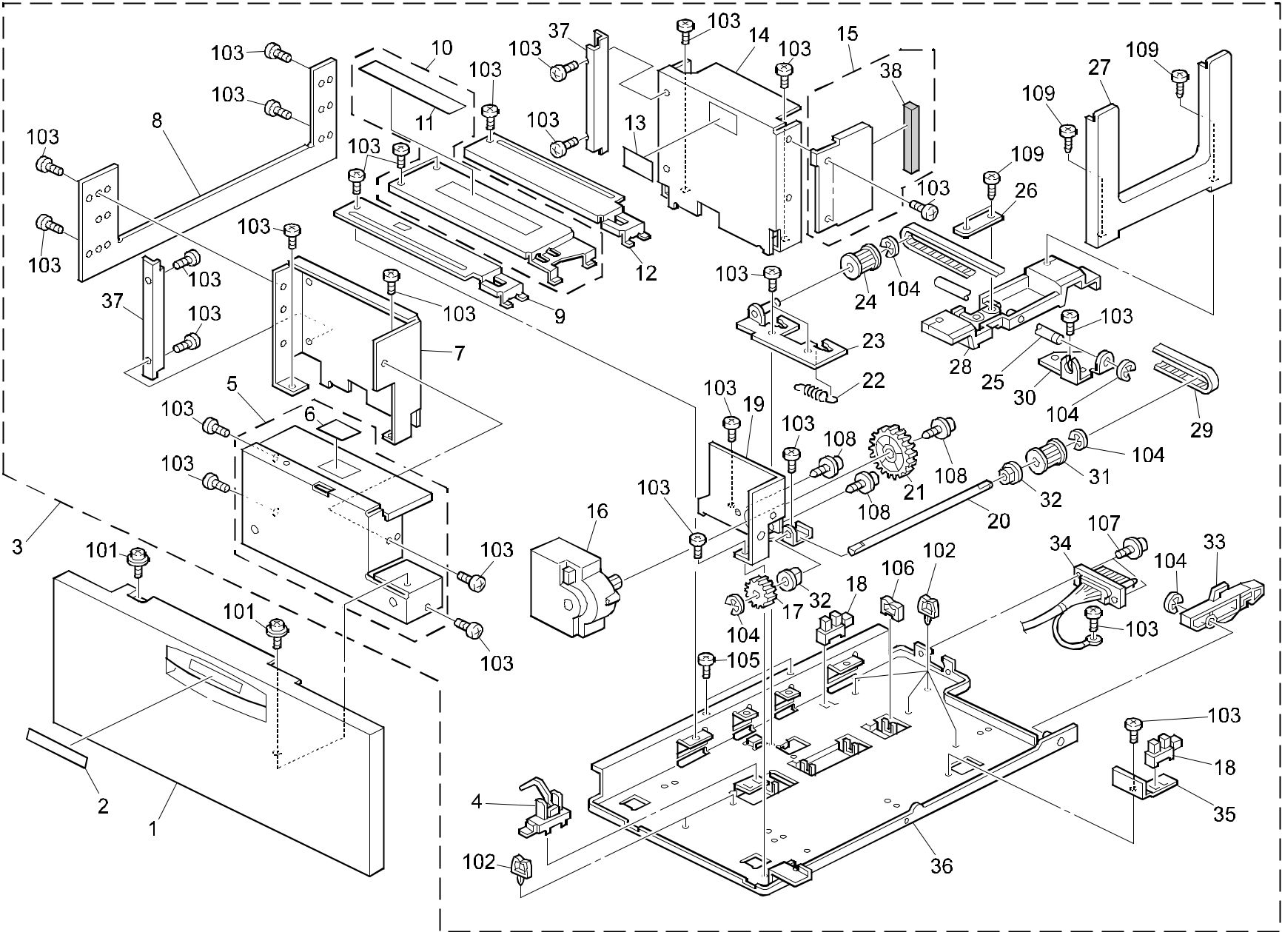

A292/A293/B098 52 Parts Location and List

20.TANDEM LCT 1 (A292/A293/B098)

Index | Part No. | Description | Q’ty Per
No. | Part No. | Description | Assembly
1 | A248 6804 | Tandem LCT Cover (A292/A293) | 1
1 | B098 6804 | Cover:Tandem LCT (B098) | 1
2 | AA00 2237 | Decal - Paper Tray No1 (A292/A293) | 1
2 | AA00 3201 | Decal:Cover:Paper Tray:No.1 (B098) | 1
3 | A293 6609 | Left Tandem LCT (A292/A293) | 1
3 | A293 6612 | Left Tandem LCT - A4 (A292/A293) | 1
3 | B098 6609 | Tandem LCT:Left:Ass'y (B098) | 1
3 | B098 6612 | Tandem LCT:Left:EU:Ass'y (B098) | 1
4 | AW02 0008 | Photointerruptor | 1
5 | A248 6632 | Bracket - Tandem LCT Cover (A292/A293) | 1
5 | B098 6632 | Bracket:Cover:Tandem LCT:Ass'y (B098) | 1
6 | AA00 2244 | Decal - Paper Set - Left | 1
7 | A293 6643 | Front Left Side Fence - Tandem LCT | 1
 |  | (A292/A293)
7 | B098 6643 | Side Fence:Tandem LCT:Left Front (B098) | 1
8 | A248 6645 | Side Plate - Left (A292/A293) | 1
8 | B098 6645 | Side Plate:Tandem LCT:Left Sideways (B098) | 1
9 | A293 6640 | Tray Bottom Plate - Left Front | 1
 |  | (A292/A293)
9 | B098 6640 | Tray Bottom Plate:Left Front (B098) | 1
10 | A248 6639 | Tray Bottom Plate - Left Middle | 1
 |  | (A292/A293)
10 | B098 6639 | Tray Bottom Plate:Left Middle:Ass'y (B098) | 1
11 | A096 6678 | Decal - Left Paper Set | 1
12 | A293 6642 | Tray Bottom Plate - Left Rear | 1
 |  | (A292/A293)
12 | B098 6642 | Tray Bottom Plate:Left Rear (B098) | 1
13 | AA00 2010 | Decal - Paper Level | 1
14 | A293 6644 | Rear Left Side Fence - Tandem LCT | 1
 |  | (A292/A293)
14 | B098 6644 | Side Fence:Tandem LCT:Left Rear (B098) | 1
15 | A293 6646 | Rear Cover - Tandem LCT (A292/A293) | 1
15 | B098 6649 | Cover:Rear:Tandem LCT:Ass'y (B098) | 1
16 | AX04 0107 | DC Motor - 19.2W | 1
17 | AB01 3798 | Gear - Z18 | 1

Index | Part No. | Description | Q’ty Per
No. | Part No. | Description | Assembly
18 | AW02 0056 | Photointerruptor - EE-SX4235A-P1 | 2
19 | A248 6636 | DC Motor Bracket | 1
20 | AA14 0686 | Shaft - Timing Pulley | 1
21 | AB01 9475 | Gear - 48T | 1
22 | AA06 0759 | Tension Spring | 1
23 | A248 6616 | Bracket - Driven Pulley | 1
24 | AB03 3085 | Timing Pulley - 15T Driven | 1
25 | AA14 0685 | Shaft - Back Fence Slider | 1
26 | A248 6627 | Timing Belt Cover | 1
27 | A248 6624 | Left Back Fence | 1
28 | A248 6623 | Slider - Left Back Fence | 1
29 | AA04 3271 | Timing Belt S3M 196T | 1
30 | A248 6619 | Bracket - Drive Pulley | 1
31 | AB03 3084 | Timing Pulley - 15T - Drive | 1
32 | 5053 0447 | Bushing - 6mm | 2
33 | A248 6615 | Coupling Lever - Left | 1
34 | A247 5428 | DC Harness - Left | 1
35 | A293 6620 | Sensor Bracket | 1
36 | A248 6618 | Base - Left Tandem LCT (A292/A293) | 1
36 | B065 6827 | Tandem LCT Base (B098) | 1
37 | A293 6647 | Support Bracket - End Fence (A292/A293) | 2
37 | B098 6647 | End Fence:Auxiliary (B098) | 1
38 | A293 6649 | Rear Cover Cushion - Tandem LCT | 1

- 0951 4008B Philips Screw With Washer - M4x8

- 1105 0230 Clamp

- 0434 0060B Pan Head Self-tapping Screw - M4x6

- 0720 0040B Retaining Ring - M4

- 0801 0146 Screw - M4X4

- 1105 0328 Harness Clamp - ES-0505

- 0313 0080B Philips Pan Head Screw - M3x8

- 0965 3008W Tapping Screw With Flat Washer - M3x8

- 0452 4008B Binding Self Tapping Screw - M4x8

A292/A293/B098 53 Parts Location and List

21.TANDEM LCT 2 (A292/A293/B098)
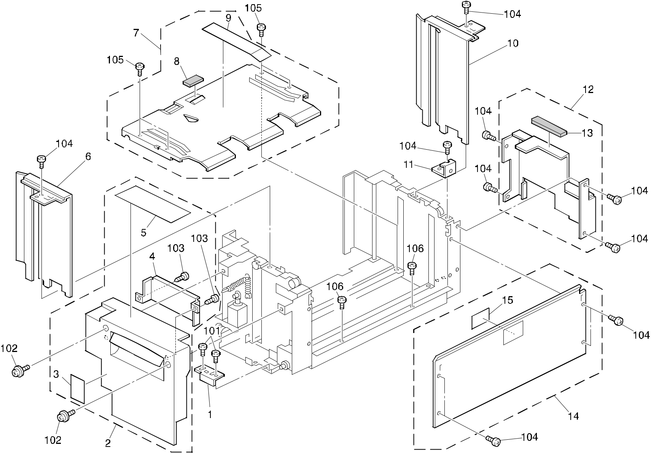

A292/A293/B098 54 Parts Location and List

21.TANDEM LCT 2 (A292/A293/B098)

Index | Part No. | Description | Q’ty Per
No. | Part No. | Description | Assembly
* | A293 6607 | Right Tandem LCT - A4 (A292/A293) | 1
* | A293 6608 | Right Tandem LCT - LT (A292/A293) | 1
* | B098 6608 | Tandem LCT:Right:Ass'y (B098) | 1
* | B098 6607 | Tandem LCT:Right:EU:Ass'y (B098) | 1
1 | A248 6659 | Right Stopper | 1
2 | A248 6744 | Inner Cover - Tandem LCT (A292/A293) | 1
2 | B098 6744 | Inner Cover:Tandem LCT:Ass'y (B098) | 1
3 | AA00 2246 | Decal - Caution | 1
4 | A248 6741 | Protection - Inner Cover | 1
5 | AA00 2245 | Decal - Paper Set - Right (A292/A293) | 1
5 | AA00 2260 | Decal:Paper Set:Tandem Tray(B098) | 1
6 | A293 6736 | Side Fence - Right Front (A292/A293) | 1
6 | B098 6736 | Side Fence:Tandem Lct:Right Front (B098) | 1
7 | A294 6670 | Base - Right Tandem Tray (A292/A293) | 1
7 | B098 6670 | Base:Tandem LCT:Right:Ass'y (B098) | 1
8 | 5201 2858 | Friction Pad | 1
9 | A096 6677 | Decal - Right Paper Set | 1
10 | A248 6738 | Side Fence - Right Rear (A292/A293) | 1
10 | B098 6738 | Side Fence:Tandem LCT:Right Rear (B098) | 1
11 | A176 6695 | Misfeed Removal Guide | 1
12 | A293 6739 | Inner Cover - Right Rear (A292/A293) | 1
12 | B098 6739 | Supporting Plate:Tandem:Right Rear (B098) | 1
13 | AA15 3063 | Seal - 4x10x70 | 1
14 | A248 6666 | Side Plate (A292/A293) | 1
14 | B098 6666 | Side Plate:Side:Ass'y (B098) | 1
15 | AA00 2010 | Decal - Paper Level | 1
16 | AA15 3138 | Inner Cover Cushion - Right Rear | 1
 |  | (Not Shown)

Index | Part No. | Description | Q’ty Per
No. | Part No. | Description | Assembly

- 0314 0060B Philips Pan Head Screw - M4x6

- 0951 4008B Philips Screw With Washer - M4x8

- 0452 4008B Binding Self Tapping Screw - M4x8

- 0434 0060B Pan Head Self-tapping Screw - M4x6

- 0951 4006B Philips Screw With Washer - M4x6

- 0801 0146 Screw - M4X4

A292/A293/B098 55 Parts Location and List

22.TANDEM LCT 3 (A292/A293/B098)
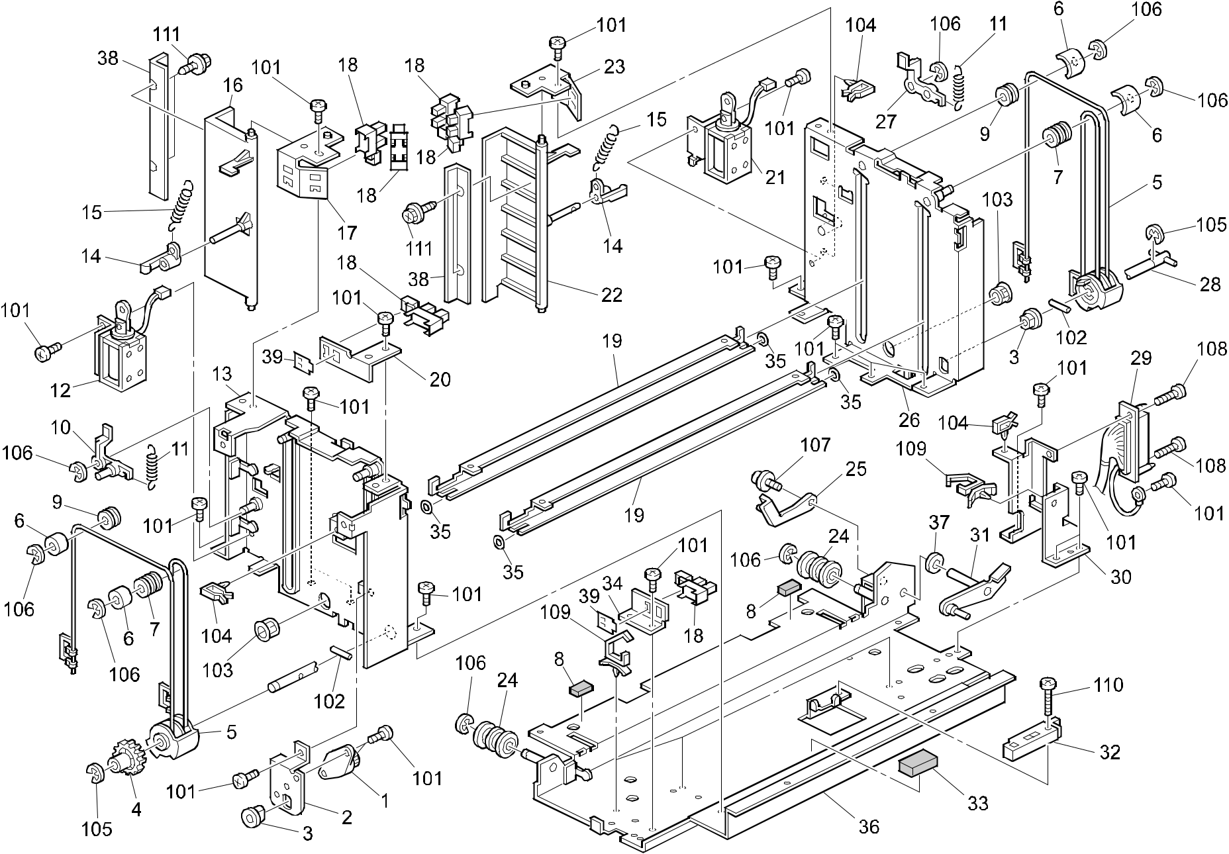

A292/A293/B098 56 Parts Location and List

22.TANDEM LCT 3 (A292/A293/B098)

Index | Part No. | Description | Q’ty Per
No. | Part No. | Description | Assembly
1 | A248 6701 | Oil Damper | 1
2 | A248 6703 | Bracket - Oil Damper | 1
3 | 5053 0223 | Bushing - 8mm | 2
4 | AB01 3781 | Gear - 30Z | 1
5 | A248 6684 | Pulley Drive Were Ass'y | 2
6 | A248 6695 | Guide - Pulley | 4
7 | AB03 2719 | Pulley - M10 | 2
8 | AA16 1130 | Cushion - Small | 2
9 | AB03 2058 | Wire Pulley - M10 | 2
10 | A248 6717 | Front Release Lever | 1
11 | AA06 0757 | Tension Spring - Long | 2
12 | A248 6714 | DC Solenoid - Front End Fence | 1
13 | A248 6674 | Side Plate - Front Right (A292/A293) | 1
13 | B065 6710 | Front Right Side Plate (B098) | 1
14 | A248 6713 | Hook - Tension Sprong | 2
15 | AA06 0758 | Tension Spring - Short | 2
16 | A293 6713 | Front End Fence | 1
17 | A248 6720 | Front Bracket - On/Off Detection | 1
18 | AW02 0056 | Photointerruptor - EE-SX4235A-P1 | 6
19 | A248 6682 | Stay - Right Base | 2
20 | A248 6708 | Bracket - Paper Volume Sensor | 1
21 | A248 6727 | DC Solenoid - Rear End Fence | 1
22 | A293 6714 | Rear End Fence | 1
23 | A248 6733 | Rear Bracket On/Off Detection | 1
24 | AF02 2105 | Roller - Slide Rail | 2
25 | A248 6753 | Lever - Small | 1
26 | A248 6678 | Side Plate - Right Rear (A292/A293) | 1
26 | B065 6811 | Side Plate - Right Rear (B098) | 1
27 | A248 6730 | Rear Release Lever | 1
28 | A248 6687 | Right Drive Shaft | 1
29 | A247 5429 | DC Harness - Right | 1
30 | A248 6743 | Connector Bracket | 1
31 | A248 6746 | Lever - Large | 1
32 | A010 5700 | Sensor | 1
33 | AA16 1129 | Cushion - Large | 1

 |  | Rev. 03/25/2003
Index | Part No. | Description | Q’ty Per
No. | Part No. | Description | Assembly
34 | A248 6706 | Sensor Bracket | 1
35 | A248 6694 | Spaser Ring | 4
36 | A248 6655 | Right Base - Tandem LCT (A292/A293) | 1
36 | B065 6851 | Right Base - Tandem LCT (B098) | 1
37 | AA13 2203 | Spacer - 6mm | 1
38 | B065 6712 | End Fence Guide (A292/A293) | 2
38 | B098 6712 | End Fence:Guide:A4 (B098) | 2
39 | A267 1820 | Sheet - Photointerrupter | 2

- 0434 0060B Pan Head Self-Tapping Screw - M4x6

- 0633 0200G Pin - M3x20

- 1106 0411 Bushing - 11.5mm

- 1105 0267 Harness Clamp - YMC-10-0

- 0720 0060B Retaining Ring - M6

- 0720 0040B Retaining Ring - M4

- 0951 3006B Philips Screw With Flat Washer - M3x6

- 0313 0080B Philips Pan Head Screw - M3x8

- 1105 0291 Harness Clamp - LWS-3S

- 0313 0120B Philips Pan Head Screw - M3x12

- 0452 3006B Tapping Screw - M3x6

A292/A293/B098 57 Parts Location and List

23.UNIVERSAL TRAY (A292/A293/B098)
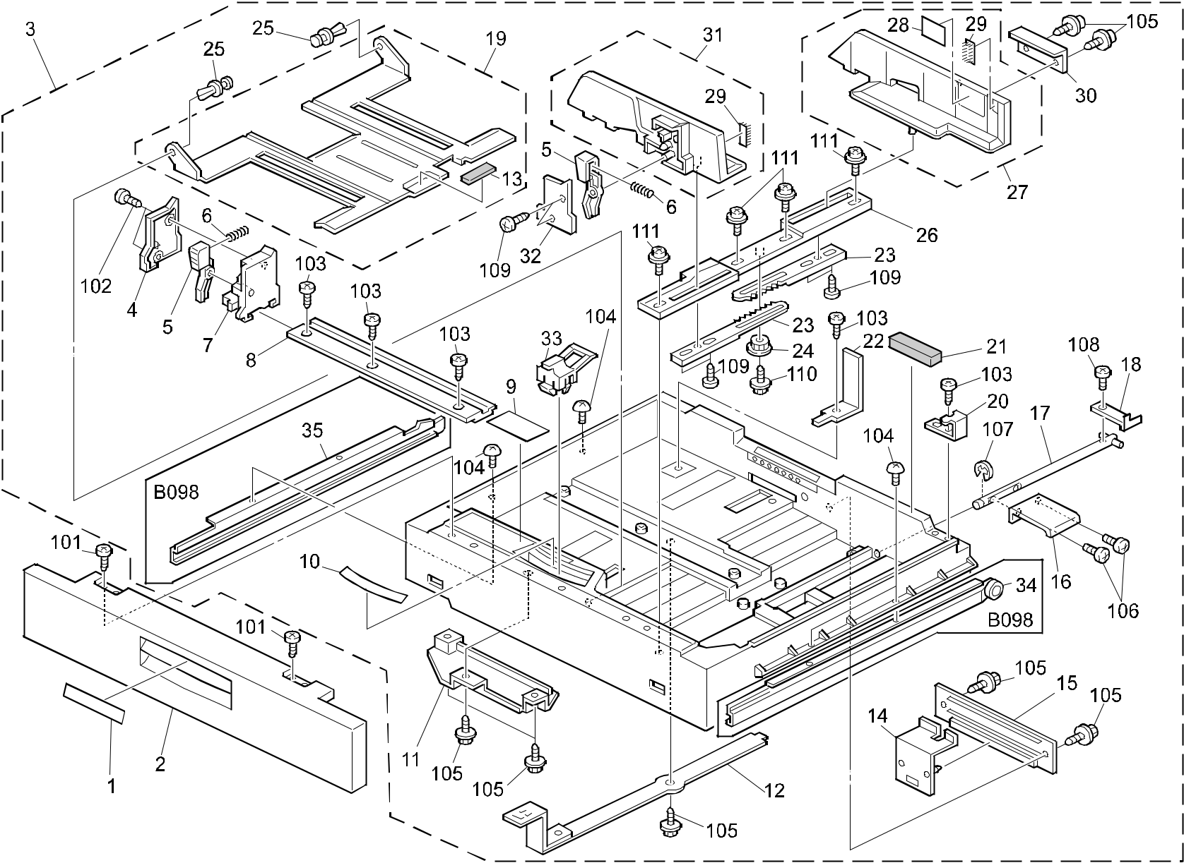

A292/A293/B098 58 Parts Location and List

23.UNIVERSAL TRAY (A292/A293/B098)

Index | Part No. | Description | Q’ty Per
No. | Part No. | Description | Assembly
1 | AA00 2238 | Decal - Cover No.2 (A292/A293) | 1
1 | AA00 3202 | Decal:Cover:Paper Tray:No.2 (B098) | 1
2 | A229 6589 | Paper Tray Front Cover (A292/A293) | 1
2 | B098 6589 | Cover:Paper Tray:Short (B098) | 1
3 | A293 6517 | Universal Tray - LT (A292/A293) | 1
3 | A293 6518 | Universal Tray - A4 (A292/A293) | 1
3 | B098 6517 | Paper Tray:Universal:NA:Ass'y (B098) | 1
3 | B098 6518 | Paper Tray:Universal:EU:Ass'y (B098) | 1
4 | A096 6563 | End Fence Cover (A292/A293) | 1
4 | B098 6563 | Cover:End Fence:Universal (B098) | 1
5 | A096 6537 | Stopper Lever (A292/A293) | 2
5 | B098 6537 | Lever:Stopper:Positioning (B098) | 2
6 | AA06 6551 | Stopper Spring - 24mm | 2
7 | A096 6562 | End Fence (A292/A293) | 1
7 | B098 6562 | End Fence:Universal (B098) | 1
8 | A096 6564 | End Fence Plate (A292/A293) | 1
8 | B098 6564 | Positioning Plate:End Fence (B098) | 1
9 | AA00 0213 | Decal - Universal Tray (A292/A293) | 1
9 | AA00 2261 | Decal - Universal Tray (B098) | 1
10 | AA00 2251 | Paper Size Decal - LT (A292/A293) | 1
10 | AA00 2252 | Paper Size Decal - A4 (A292/A293) | 1
10 | B098 6539 | Decal:Paper Size Sensor:NA (B098) | 1
10 | AA00 2259 | Decal:Paper Size Sensor:EU (B098) | 1
11 | A293 6579 | Link Guide | 1
12 | A293 6576 | Link - Paper Size Lever | 1
13 | AF01 3005 | Bottom Plate Pad | 2
14 | A293 6571 | Actuator - Paper Size Switch (A292/A293) | 1
14 | B098 6574 | Paper Size Sensor Board:Ass'y (B098) | 1
15 | A293 6574 | Actuator Guide | 1
16 | A096 6526 | Lift Lever | 1
17 | A096 6524 | Lift Shaft | 1
18 | A096 6527 | Paper Guide Feeler (A292/A293) | 1
18 | B098 6527 | Paper Guide Feeler (B098) | 1
19 | A229 6556 | Tray Bottom Plate (A292/A293) | 1
19 | B098 6557 | Tray Bottom Plate (B098) | 1

Index | Part No. | Description | Q’ty Per
No. | Part No. | Description | Assembly
20 | A176 6695 | Misfeed Removal Guide (A292/A293) | 1
20 | B098 6695 | Guide:Misfeed Removal:Paper Tray (B098) | 1
21 | AA15 3004 | Paper Guide Seal - 3 | 1
22 | AF01 6079 | Left Rear Side Fence (A292/A293) | 1
22 | B098 6079 | Side Fence:Left Rear (B098) | 1
23 | AB01 4132 | Side Fence Gear | 2
24 | AB01 4094 | Side Fence Gear | 1
25 | A048 2838 | Nylon Rivet | 2
26 | A229 6544 | Side Fence Plate - A4 (A292/A293) | 1
26 | A229 6545 | Side Fence Plate - LT (A292/A293) | 1
26 | A293 6545 | Positioning Plate - LT (B098) | 1
26 | A293 6544 | Positioning Plate - A4 (B098) | 1
27 | A229 6541 | Gear Side Fence | 1
28 | AA00 2010 | Decal - Paper Level | 4
29 | A096 6553 | Side Fence Pad | 2
30 | A176 6570 | Paper Stopper (A292/A293) | 1
30 | B098 6570 | Paper Stopper:Side Fence (B098) | 1
31 | A229 6534 | Front Side Fence | 1
32 | A096 6536 | Side Fence Cover (A292/A293) | 1
32 | B098 6536 | Cover:Side Fence:Universal:Front (B098) | 1
33 | A293 6585 | Paper Size Sensor Slider | 1
34 | B098 6275 | Stay:Paper Tray:Right:Ass'y (B098) | 1
35 | B098 6285 | Stay:Paper Tray:Left:Ass'y (B098) | 1

A292/A293/B098 59 Parts Location and List

Index | Part No. |  | Description | Q’ty Per
No. |  |  | Description | Assembly
101 | 0452 | 4008B | Binding Self Tapping Screw - M4x8
102 | 0413 | 0082B | Tapping Screw - M3x8
103 | 0414 | 0082B | Binding Self Tapping Screw - M4x8
104 | 0344 | 0050F | Philips Truss Head Screw - M4x5
 |  |  | (A292/A293)
- 0801 0192 Bind Screw - M4x8 (B098)

- 0450 4008B Tapping Screw - 4x8

- 0314 0060B Philips Pan Head Screw - M4x6

- 0720 0060B Retaining Ring - M6

- 0313 0060B Philips Pan Head Screw - M3x6

- 0452 3008B Tapping Screw - M3x8

- 0450 3006B Tapping Screw - M3x6

- 0951 3008B Philips Screw With Flat Washer - M3x8

Index | Part No. | Description | Q’ty Per
No. | Part No. | Description | Assembly

A292/A293/B098 59A Parts Location and List

24.PAPER TRAY (A292/A293/B098)
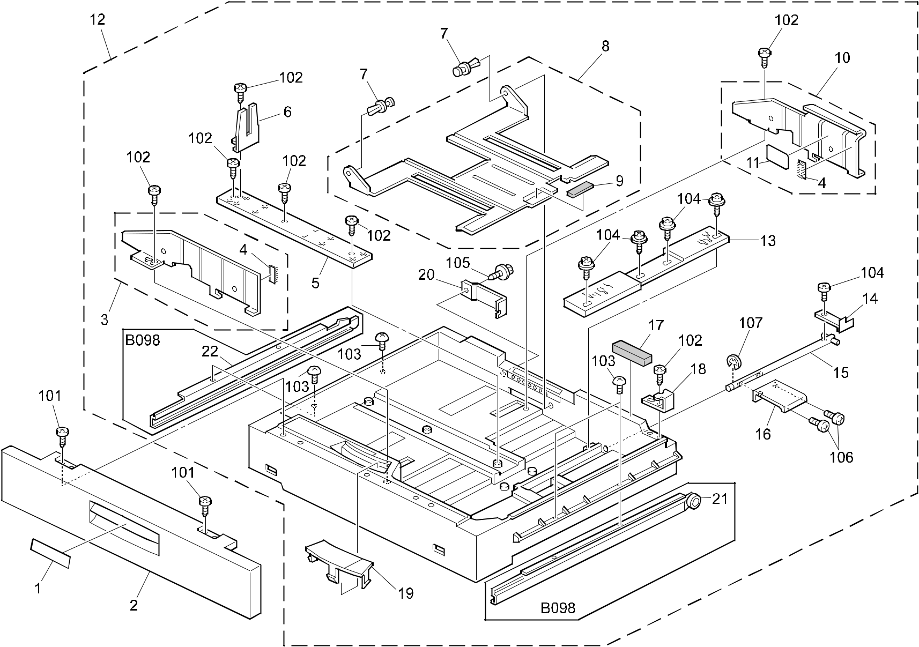

A292/A293/B098 60 Parts Location and List

24.PAPER TRAY (A292/A293/B098)

Index | Part No. | Description | Q’ty Per
No. | Part No. | Description | Assembly
1 | AA00 2239 | Decal - Cover No.3 (A292/A293) | 1
1 | AA00 3203 | Decal:Cover:Paper Tray:No.3 (B098) | 1
2 | A229 6589 | Paper Tray Front Cover (A292/A293) | 1
2 | A229 6620 | Tandem Tray Front Cover (A292/A293) | 1
2 | B098 6620 | Cover:Paper Tray:Long (B098) | 1
3 | A176 6549 | Front Side Fence Ass'y (A292/A293) | 1
3 | B098 6549 | Side Fence:Fix:Front:Ass'y (B098) | 1
4 | A096 6554 | Side Fence Pad | 2
5 | A096 6568 | Position Plate - End Fence (A292/A293) | 1
5 | B098 6568 | Positioning Plate:End Fence:Fix (B098) | 1
6 | AF01 7021 | End Fence (A292/A293) | 1
6 | AF01 7031 | End Fence:Fix (B098) | 1
7 | A048 2838 | Nylon Rivet | 2
8 | A096 6556 | Tray Bottom Plate (A292/A293) | 1
8 | B098 6556 | Tray Bottom Plate (B098) | 1
9 | AF01 3005 | Bottom Plate Pad | 1
10 | A176 6550 | Rear Side Fence Ass'y (A292/A293) | 1
10 | B098 6550 | Side Fence:Fix:Rear:Ass'y (B098) | 1
11 | AA00 2010 | Decal - Paper Level | 1
12 | A248 6515 | Paper Tray - DLT (A292/A293) | 1
12 | A176 6515 | Paper Tray - A3 (A292/A293) | 1
12 | B098 6515 | Paper Tray:Fix:DLT:Ass'y (B098) | 1
12 | B098 6516 | Paper Tray:Fix:A3:Ass'y (B098) | 1
13 | A096 6551 | Position Plate - Side Fence (A292/A293) | 1
13 | B098 6551 | Positioning Plate:Side Fence:Fix (B098) | 1
14 | A096 6527 | Paper Guide Feeler (A292/A293) | 1
14 | B098 6527 | Paper Guide Feeler (B098) | 1
15 | A096 6524 | Lift Shaft | 1
16 | A096 6526 | Lift Lever | 1
17 | AA15 3005 | Paper Guide Seal - 2 | 1
18 | A176 6695 | Misfeed Removal Guide | 1
19 | AF01 0073 | Paper Tray Cap | 1
20 | A293 6580 | Set Sensor Bracket - Paper Tray | 1
 |  | (A292/A293)

Index | Part No. | Description | Q’ty Per
No. | Part No. | Description | Assembly
20 | B098 6580 | Bracket:Set Sensor:Paper Tray | 1
 |  | (B098)
21 | B098 6275 | Stay:Paper Tray:Right:Ass'y (B098) | 1
22 | B098 6285 | Stay:Paper Tray:Left:Ass'y (B098) | 1

- 0452 4008B Binding Self Tapping Screw - M4x8

- 0414 0082B Binding Self Tapping Screw - M4x8

- 0344 0050F Philips Truss Head Screw - M4x5

(A292/A293)

- 0801 0192 Bind Screw - M4x8 (B098)

- 0951 3008B Philips Screw With Flat Washer - M3x8

- 0450 4008B Tapping Screw - 4x8

- 0314 0080B Philips Pan Head Screw - M4x8

A292/A293/B098 61 Parts Location and List

25.PAPER FEED SECTION 1 (A292/A293/B098)
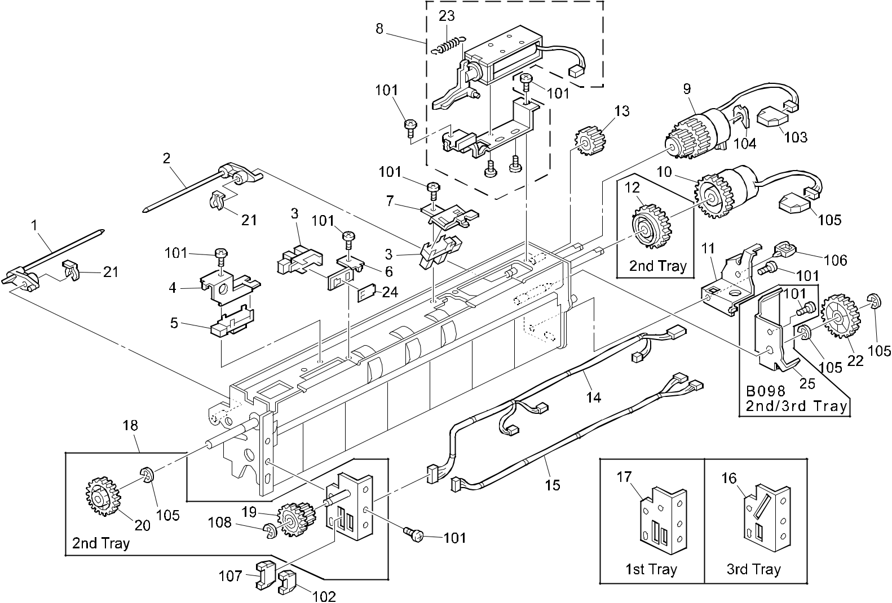

A292/A293/B098 62 Parts Location and List

25.PAPER FEED SECTION 1 (A292/A293/B098)

Index | Part No. | Description | Q’ty Per
No. | Part No. | Description | Assembly
* | A293 6200 | Paper Feed Unit - 2nd/4th Feed (A292/A293) | 1
* | A293 6210 | Paper Feed Unit - 3rd Feed (A292/A293) | 1
* | A293 6220 | Paper Feed Unit - 1st Tray (A292/A293) | 1
* | B098 6200 | Paper Feed Unit:Paper Bank:Ass'y (B098) | 1
* | B098 6210 | Paper Feed Unit:No.3:Ass'y (B098) | 1
* | B098 6220 | Paper Feed Unit:No.1:Ass'y (B098) | 1
1 | A096 6363 | Front Paper Flattener | 3
2 | A096 6360 | Paper Flattener | 3
3 | AW02 0056 | Photointerrupter - EE-SX4235A-P1 | 6
4 | A229 6353 | Photo Refiection Sensor Bracket | 3
5 | AW01 0049 | Photo Reflection Sensor | 3
6 | A229 6345 | Paper End Sensor Bracket | 3
7 | A229 6358 | Paper Sensor Bracket | 3
8 | A229 6355 | Pick-up Solenoid Ass'y | 3
9 | AX20 0202 | Magnetic Clutch - Feed | 3
10 | AX20 0147 | Magnetic Clutch | 3
11 | A229 6366 | Magnetic Clutch Arm | 3
12 | AB01 4069 | Drive Gear - Misfeed Removal | 1
13 | AB01 3000 | Idler Gear - 18Z | 3
14 | A229 5497 | Upper Harness | 3
15 | A229 5496 | Lower Harness | 3
16 | A229 6375 | Paper Feed Unit Stay - Universal | 1
17 | A229 6376 | Paper Feed Unit Stay - No.1 Ass'y | 1
18 | A229 6381 | Paper Feed Unit Stay Ass'y | 1
19 | AB01 3780 | Gear | 1
20 | AB01 3778 | Gear - 32Z | 1
21 | 5447 2681 | Snap Ring | 6
22 | AB01 3775 | Gear - 33Z | 3
23 | AA06 0577 | Release Spring | 3
24 | A267 1820 | Sheet - Photointerrupter | 1
25 | B098 6333 | Cover:Gear:Paper Feed Unit:Rear (B098) | 1

Index | Part No. |  | Description | Q’ty Per
No. |  |  | Description | Assembly
101 | 0434 | 0060B | Pan Head Self-tapping Screw - M4x6
102 | 1102 | 6249 | Relay Connector - 6P
103 | 1102 | 6259 | Connector - 2P
104 | 0805 | 0088 | Retaining Ring - M6
105 | 0720 | 0060B | Retaining Ring - M6
106 | 1105 | 0199 | Clamp

- 1102 6254 Connector - 11P

- 0720 0040B Retaining Ring - M4

A292/A293/B098 63 Parts Location and List

26.PAPER FEED SECTION 2 (A292/A293/B098)
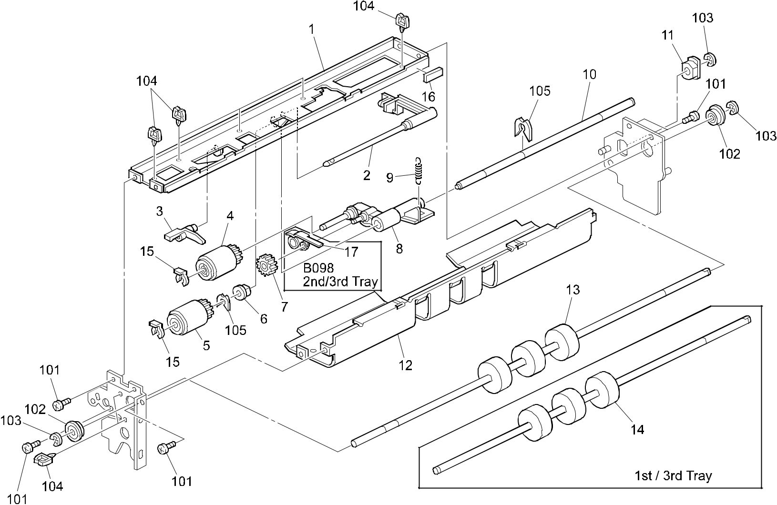

A292/A293/B098 64 Parts Location and List

26.PAPER FEED SECTION 2 (A292/A293/B098)

Index | Part No. | Description | Q’ty Per
No. | Part No. | Description | Assembly
1 | A229 6346 | Feed Stay (A292/A293) | 3
1 | B098 6346 | Stay:Feed:Ass'y (B098) | 3
2 | A229 6362 | Paper End Feeler | 3
3 | A096 6344 | Paper End Actuater | 3
4 | AF03 0040 | Pick-up Roller | 3
5 | AF03 1040 | Feed Roller | 3
6 | AA08 2070 | Bushing - 8x16x7 | 5
7 | 5447 2706 | Gear - 15T | 3
8 | A134 2860 | Pick-up Arm | 3
9 | AA06 0523 | Pick-up Pressure Sping | 3
10 | AA14 0675 | Feed Roller Shaft | 3
11 | AA08 3009 | Clutch Roller - 8x18x11 | 3
12 | A249 6339 | Feed Guide Plate (A292/A293) | 3
12 | B098 6339 | Guide Plate:Feed (B098) | 3
13 | AF02 0426 | Drive Transport Roller - LCT | 1
14 | AF02 0425 | Drive Transport Roller - Grip | 2
15 | 5447 2681 | Snap Ring | 6
16 | 5442 1924 | Exposure Glass Cushion | 2
17 | B098 6350 | Cover:Gear:Paper Feed Roller (B098) | 1

Index | Part No. | Description | Q’ty Per
No. | Part No. | Description | Assembly

- 0434 0060B Pan Head Self-tapping Screw - M4x6

- 0742 3808 Ball Bearing - 8x16x5

- 0720 0060B Retaining Ring - M6

104 | 1105 0199 | Clamp
105 | 0805 0088 | Retaining Ring - M6

A292/A293/B098 65 Parts Location and List

27.PAPER FEED SECTION 3 (A292/A293/B098)
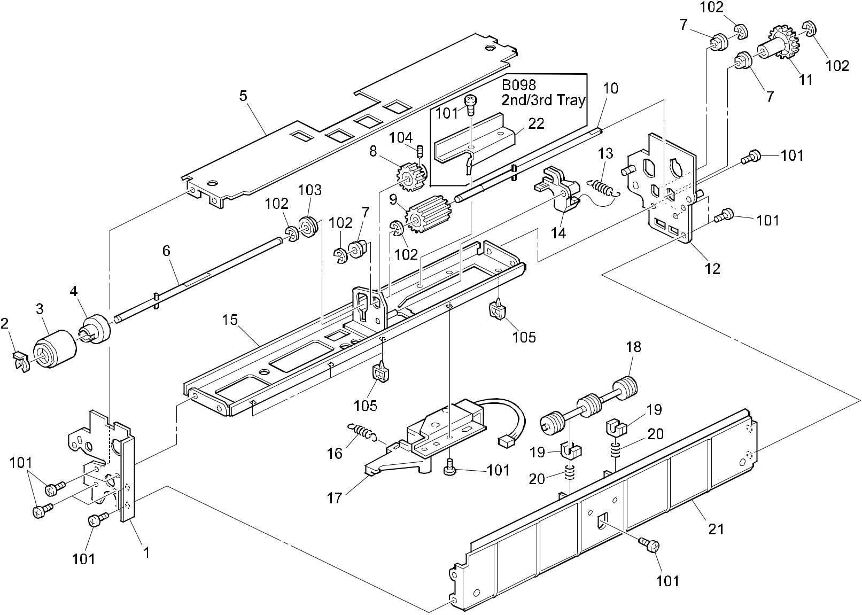

A292/A293/B098 66 Parts Location and List

27.PAPER FEED SECTION 3 (A292/A293/B098)

Index | Part No. | Description | Q’ty Per
No. | Part No. | Description | Assembly
1 | A229 6335 | Front Side Plate (A292/A293) | 3
1 | B098 6335 | Side Plate:Front:Ass'y (B098) | 3
2 | 5447 2681 | Snap Ring | 3
3 | AF03 2040 | Separation Roller | 3
4 | A293 6399 | Torque Limiter - Separator | 3
5 | A229 6338 | Reverse Guide Plate (A292/A293) | 3
5 | B098 6338 | Guide Plate:Reverse (B098) | 3
6 | A229 6307 | Reverse Driven Shaft | 3
7 | 5053 0447 | Bushing - 6mm | 9
8 | AB01 1391 | Driven Reverse Gear - 21Z | 3
9 | AB01 1392 | Drive Reverse Gear - 24Z | 3
10 | A229 6306 | Reverse Drive Shaft | 3
11 | AB01 3776 | Gear - 30Z | 3
12 | A229 6330 | Rear Side Plate (A292/A293) | 3
12 | B098 6330 | Side Plate:Rear:Paper Feed :Ass'y (B098) | 3
13 | AA06 0636 | Pressure Spring | 3
14 | A229 6309 | Reverse Pressure Lever | 3
15 | A229 6303 | Reverse Stay (A292/A293) | 3
15 | B098 6303 | Stay:Reverse:Ass'y (B098) | 3
16 | AA06 0575 | Release Spring | 3
17 | A229 6315 | Reverse DC Solenoid | 3
18 | AF02 0496 | Driven Roller | 3
19 | AA08 0156 | Bushing - M4 | 6
20 | AA06 3487 | Spring - 10mm | 6
21 | A229 6370 | Pape Guide Plate (A292/A293) | 3
21 | B098 6370 | Guide Plate:Vertical Transport (B098) | 3
22 | B098 6310 | Cover:Solenoid:Paper Feed:Lower (B098) | 1

Index | Part No. | Description | Q’ty Per
No. | Part No. | Description | Assembly

- 0434 0060B Pan Head Self-tapping Screw - M4x6

- 0720 0040B Retaining Ring - M4

- 0805 3145 Ball Bearing - 6x12x4mm

- 0573 0030E Hexagon Headless Set Screw - M3x3

- 1105 0199 Clamp

A292/A293/B098 67 Parts Location and List

28.VERTICAL TRANSPORT SECTION (A292/A293/B098)
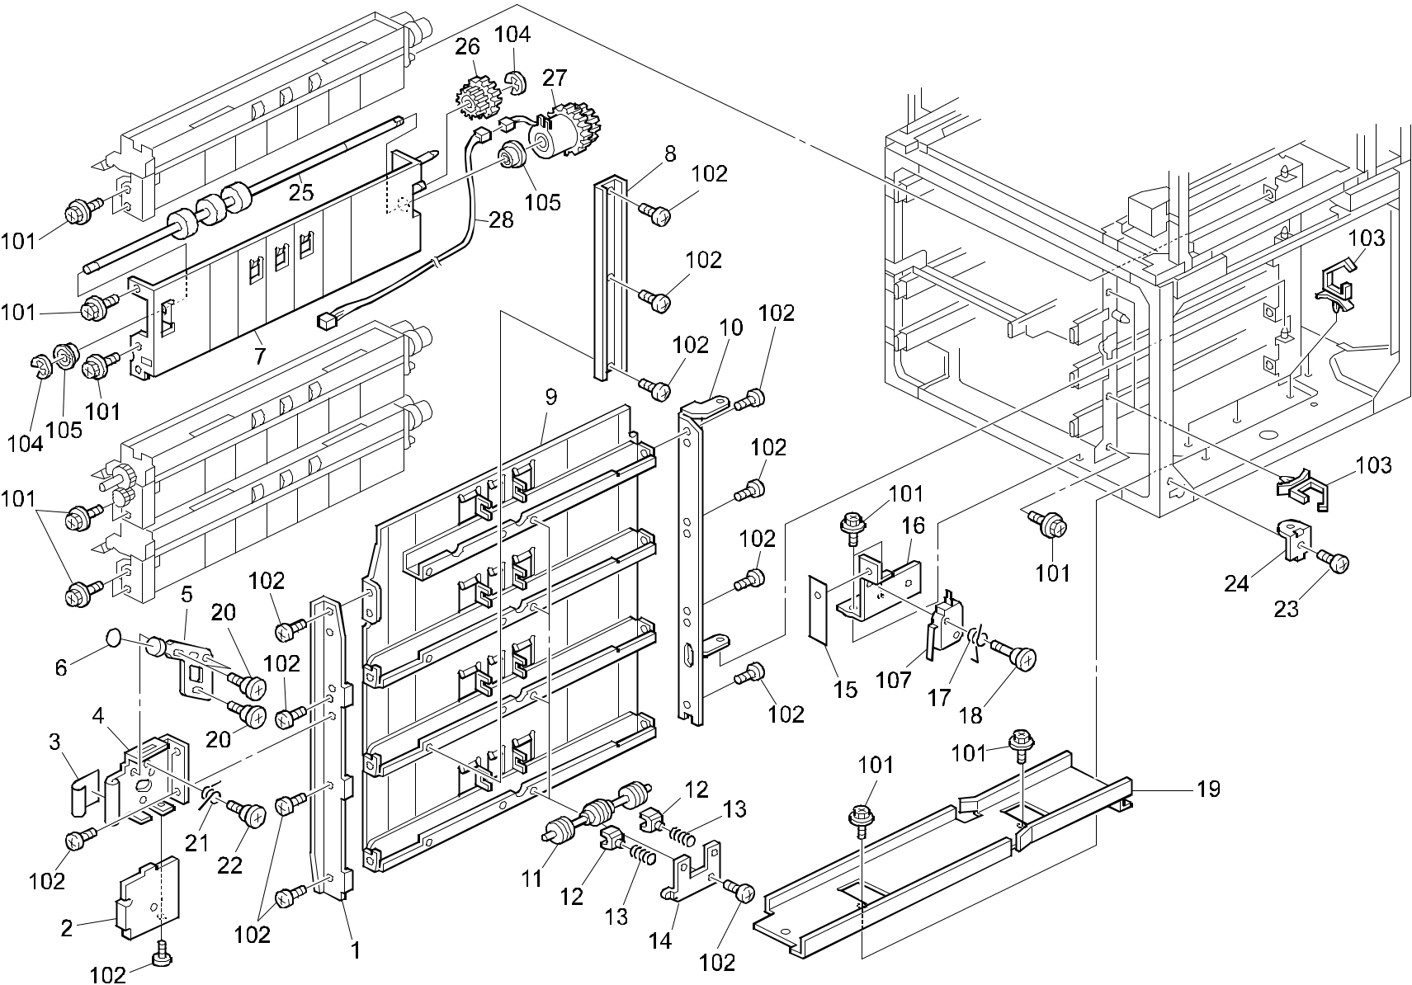

A292/A293/B098 68 Parts Location and List

28.VERTICAL TRANSPORT SECTION (A292/A293/B098)

Index | Part No. | Description | Q’ty Per
No. | Part No. | Description | Assembly
1 | A229 6403 | Front Side Plate (A292/A293) | 1
1 | B098 6403 | Side Plate:Front:Vertical Transport (B098) | 1
2 | A096 6413 | Release Lever Cover (A292/A293) | 1
2 | B098 6413 | Cover:Release:Vertical Transport (B098) | 1
3 | A029 2984 | Decal - Grip | 1
4 | A096 6411 | Release Lever Bracket (A292/A293) | 1
4 | B098 6411 | Lever:Release:Vertical Transport (B098) | 1
5 | A029 2858 | Release Lever | 1
6 | AA00 1326 | Decal - A1 | 1
7 | A293 6371 | Guide Plate - Paper Feed (A292/A293) | 1
7 | B098 6374 | Guide Plate:Joint Unit:Ass'y (B098) | 1
8 | A229 6409 | Pressure Stay | 1
9 | A229 6405 | Guide Plate - Vertical Transport (A292/A293) | 1
9 | B098 6405 | Guide Plate:Vertical Transport (B098) | 1
10 | A229 6404 | Rear Side Plate | 1
11 | AF02 0295 | Vertical Driven Roller | 4
12 | AA08 0241 | Bushing - M4 | 8
13 | AA06 3487 | Spring - 10mm | 8
14 | A096 6402 | Pressure Plate Driven Roller | 4
15 | A096 5528 | Micro Switch Sheet | 1
16 | A096 5529 | Micro Switch Bracket | 1
17 | A423 4433 | Spring | 1
18 | A423 4432 | Shoulder Screw - M2.5 | 1
19 | A096 3710 | Collection Tank Guide (A292/A293) | 1
19 | B065 3695 | Bottle Guide (B098) | 1
20 | 5201 1796 | Stepped Screw - M4 | 3
21 | 5446 2846 | Release Spring - Vertical Transport | 1
22 | 5403 6246 | Stepped Screw - Cleaning | 1
23 | AA14 3396 | Screw - M4X4 | 1
24 | A229 1344 | Hinge Guide Plate - Right Lower | 1
25 | AF02 0507 | Drive Transport Roller | 1
26 | AB01 4158 | Gear - 27/28Z | 1
27 | AX20 0207 | Magnetic Clutch | 1
28 | A293 5499 | Harness - Paper Feed | 1

Index | Part No. |  | Description | Q’ty Per
No. |  |  | Description | Assembly
101 | 0451 | 4008B | Philips Tapping Screw - M4x8
102 | 0434 | 0060B | Pan Head Self-tapping Screw - M4x6
103 | 1105 | 0291 | Harness Clamp - LWS-3S
104 | 0720 | 0060B | Retaining Ring - M6
105 | 0742 | 3808 | Ball Bearing - 8x16x5
107 | 1204 | 2355 | Micro Switch - AM51632A531

A292/A293/B098 69 Parts Location and List

29.PAPER RESISTRATION 1 (A292/A293/B098)
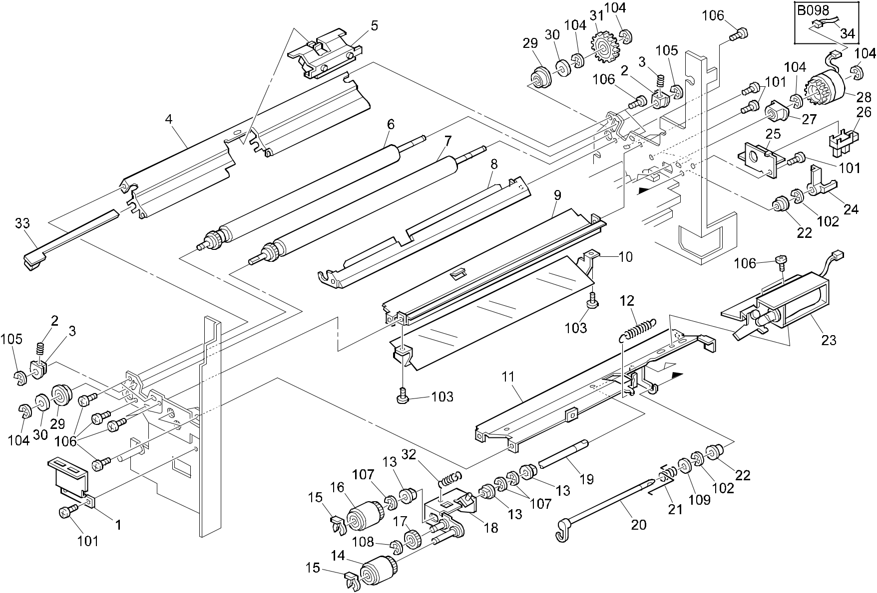

A292/A293/B098 70 Parts Location and List

29.PAPER RESISTRATION 1 (A292/A293/B098)

Index | Part No. | Description | Q’ty Per
No. | Part No. | Description | Assembly
1 | A096 2597 | Front Connector Bracket | 1
2 | 5442 2754 | Spring - Registration Roller | 2
3 | 5205 2697 | Bushing - Upper Registration Roller | 2
4 | A229 2619 | Sensor Board Guide | 1
5 | A096 2607 | Paper Dust Cleaner (A292/A293) | 1
5 | B098 2607 | Cleaner:Remove Paper Dust:Ass'y (B098) | 1
6 | A294 2616 | Registration Roller:Upper | 1
7 | A294 2617 | Registration Roller:Lower | 1
8 | A096 2612 | Lower Registration Guide (A292/A293) | 1
8 | B098 2612 | Guide Plate:Registration:Lower (B098) | 1
9 | A096 2626 | Front Upper Resistration Guide (A292/A293) | 1
9 | B098 2626 | Guide Plate:Regist:Front:Upper (B098) | 1
10 | A096 2622 | Front Lower Registration Guide (A292/A293) | 1
10 | B098 2622 | Guide:Registration:Front:Lower (B098) | 1
11 | A096 2687 | Upper Feed Stay | 1
12 | AA06 0517 | Pick-up Release Spring | 1
13 | 5053 0223 | Bushing - 8mm | 2
14 | AF03 0041 | Pick-up Roller - Bypass Feed | 1
15 | 5447 2681 | Snap Ring | 2
16 | AF03 1041 | Feed Roller - Bypass Feed | 1
17 | 5447 2706 | Gear - 15T | 1
18 | A096 2690 | Pick-up Roller Arm | 1
19 | AA14 0684 | Feed Shaft (A292/A293) | 1
19 | AA14 0835 | Shaft:Feed (B098) | 1
20 | A096 2697 | Paper End Feeler | 1
21 | AA06 6213 | Feeler Spring | 1
22 | 5443 2668 | Bushing - 4x6x7mm | 2
23 | A096 2692 | Pick-up Solenoid - By-pass | 1
24 | A096 2700 | Paper End Shutter | 1
25 | A229 2715 | Paper End Sensor Bracket | 1
26 | AW02 0056 | Photointerrupter - EE-SX4235A-P1 | 1
27 | A293 2900 | Bushing - Feed Roller Clutch | 1
28 | AX20 0205 | Magnetic Clutch (A292/A293) | 1
28 | B098 2588 | Magnetic Clutch:Manual Feed (B098) | 1
29 | A247 2800 | Ball Bearing - 8x12x5 | 2

Index | Part No. | Description | Q’ty Per
No. | Part No. | Description | Assembly
30 | AA13 2025 | Spacer - 1x8x12 | 2
31 | AB01 4077 | Registration Roller Gear | 1
32 | AA06 0518 | Pick-up Pressure Spring | 1
33 | A096 5200 | Registration Sensor Board | 1
34 | B098 5250 | Harness:Connecting:Manual Feed:CL (B098) | 1

- 0434 0060B Pan Head Self-tapping Screw - M4x6

- 0720 0030B Retaining Ring - M3

- 0313 0060B Philips Pan Head Screw - M3x6

- 0720 0060B Retaining Ring - M6

- 0720 0040B Retaining Ring - M4

- 0314 0060B Philips Pan Head Screw - M4x6

- 0720 0060E Retaining Ring - M6

- 0720 0050E Retaining Ring - M5

- 0701 0040B Flat Washer - M4

A292/A293/B098 71 Parts Location and List

30.PAPER RESISTRATION 2 (A292/A293/B098)
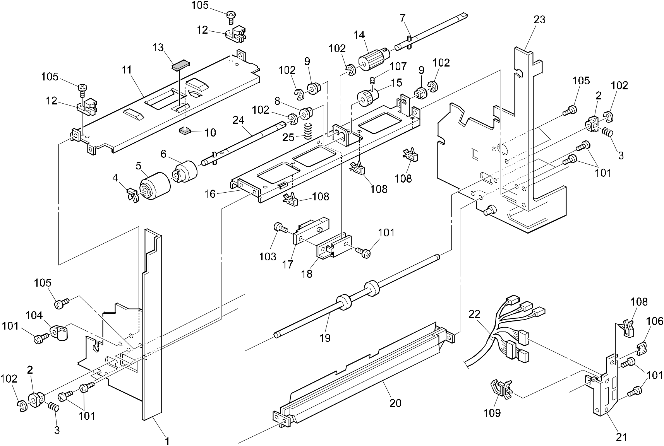

A292/A293/B098 72 Parts Location and List

30.PAPER RESISTRATION 2 (A292/A293/B098)

Index | Part No. | Description | Q’ty Per
No. | Part No. | Description | Assembly
1 | A229 2600 | Front Side Plate (A292/A293) | 1
1 | B098 2600 | Side Plate:Paper Feed:Front:Peen (B098) | 1
2 | 5205 2697 | Bushing - Upper Registration Roller | 2
3 | AA06 3254 | Driven Roller Spring | 2
4 | 5447 2681 | Snap Ring | 1
5 | AF03 2041 | Separation Roller - Bypass Feed | 1
6 | A293 6399 | Torque Limiter - Separator | 4
7 | A247 2682 | Drive Shaft - Separator | 1
8 | AA08 0037 | Bushing - 6mm | 1
9 | 5053 0447 | Bushing - 6mm | 2
10 | A229 2692 | Damping Insulation (A292/A293) | 1
10 | B098 2692 | Damping Insulation:Guide Plate (B098) | 1
11 | A096 2703 | Lower Guide - By-pass (A292/A293) | 1
11 | B098 2703 | Guide Plate:Lower:Manual Feed (B098) | 1
12 | A096 2704 | Guide Holder | 2
13 | A053 2916 | Friction Pad - B | 1
14 | AB01 3773 | Gear - 18Z | 1
15 | AB01 3729 | Gear - 18Z | 1
16 | A096 2682 | Separation Roller Bracket | 1
17 | AW01 0048 | Photo Sensor - GP2A28N1 | 1
18 | A229 2750 | Sensor Bracket | 1
19 | AF02 2110 | Transport Driven Roller | 1
20 | A096 2661 | Paper Bank Relay Guide (A292/A293) | 1
20 | B098 2661 | Guide Plate:Paper Bank:Connecting (B098) | 1
21 | A293 2609 | Connector Bracket | 1
22 | A293 5451 | Harness - By-pass Feed Unit | 1
23 | A293 2605 | Rear Side Plate (A292/A293) | 1
23 | B098 2605 | Side Plate:Paper Feed:Rear:Ass'y (B098) | 1
24 | A247 2683 | Reverse Roller Shaft | 1
25 | AA06 3164 | Spring - Pressure - Separator | 1

Index | Part No. | Description | Q’ty Per
No. | Part No. | Description | Assembly

- 0434 0060B Pan Head Self-tapping Screw - M4x6

- 0720 0040B Retaining Ring - M4

- 0314 0080B Philips Pan Head Screw - M4x8

- 1105 0005 Nylon Clamp - 3n

- 0314 0060B Philips Pan Head Screw - M4x6

- 1105 0328 Harness Clamp - ES-0505

- 0574 0040B Hexagon Headless Set Screw - M4x4

- 1105 0087 Clamp

109 1105 0291 Harness Clamp - LWS-3S

A292/A293/B098 73 Parts Location and List

31.PAPER RESISTRATION 3 (A292/A293/B098)
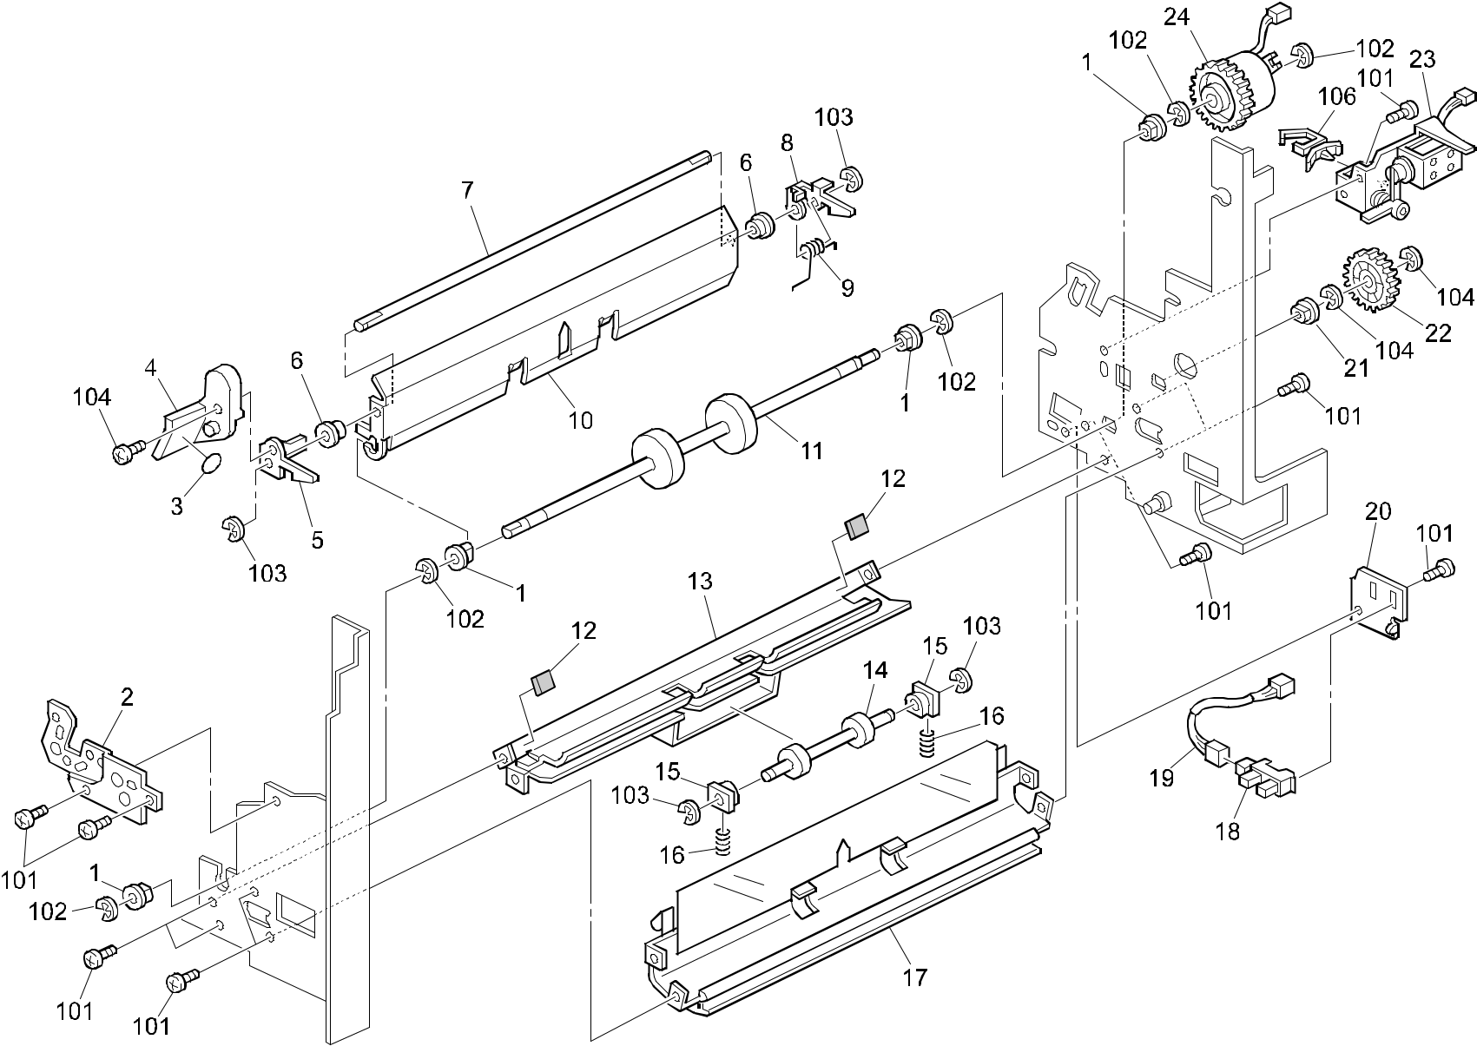

A292/A293/B098 74 Parts Location and List

31.PAPER RESISTRATION 3 (A292/A293/B098)

Index | Part No. | Description | Q’ty Per
No. | Part No. | Description | Assembly
1 | 5053 0223 | Bushing - 8mm | 4
2 | A096 2593 | Front Support Plate | 1
3 | AA00 1213 | Decal - B2 | 1
4 | A229 2717 | Lock Lever | 1
5 | A096 2633 | Front Lock (A292/A293) | 1
5 | B098 2633 | Pawl:Lock:Front (B098) | 1
6 | 5443 2668 | Bushing - 4x6x7mm | 2
7 | AA14 0486 | Lock Shaft | 1
8 | A229 2655 | Read Rock (A292/A293) | 1
8 | B098 2655 | Pawl:Lock:Rear (B098) | 1
9 | AA06 6211 | Rear Lock Spring | 1
10 | A229 2647 | Middle Guide Plate (A292/A293) | 1
10 | B098 2647 | Guide Plate:Open And Close:Middle (B098) | 1
11 | AF02 0422 | Drive Transport Roller | 1
12 | A469 2123 | Rubber Cushion - 1x10x10mm | 2
13 | A096 2672 | Duplex Exit Guide (A292/A293) | 1
13 | B098 2672 | Guide Plate:Duplex:Exit:Peen (B098) | 1
14 | A294 2678 | Roller - Duplex Exit | 1
15 | AA08 0034 | Bushing - 4x5x7 | 2
16 | AA06 3255 | Exit Roller Spring | 2
17 | A229 2651 | Guide Plate Ass'y (A292/A293) | 1
17 | B098 2651 | Guide Plate:Lct:Ass'y (B098) | 1
18 | AW02 0056 | Photointerrupter - EE-SX4235A-P1 | 1
19 | A096 5432 | Duplex Relay Harness | 1
20 | A229 2719 | Sensor Bracket | 1
21 | 5053 0447 | Bushing - 6mm | 1
22 | AB01 1128 | Gear - 40Z | 1
23 | A293 2660 | Guide Plate Solenoid (A292/A293) | 1
23 | B098 2660 | DC Solenoid:Guide Plate (B098) | 1
24 | AX20 0150 | Magnetic Clutch - 343mnxm | 1

Index | Part No. |  | Description | Q’ty Per
No. |  |  | Description | Assembly
101 | 0434 | 0060B | Pan Head Self-tapping Screw - M4x6
102 | 0720 | 0060B | Retaining Ring - M6
103 | 0720 | 0030B | Retaining Ring - M3
104 | 0720 | 0040B | Retaining Ring - M4
105 | 0313 | 0050B | Philips Pan Head Screw - M3x5
106 | 1105 | 0260 | Wire Saddle

A292/A293/B098 75 Parts Location and List

32.TONER BOTTLE HOLDER (A292/A293/B098)
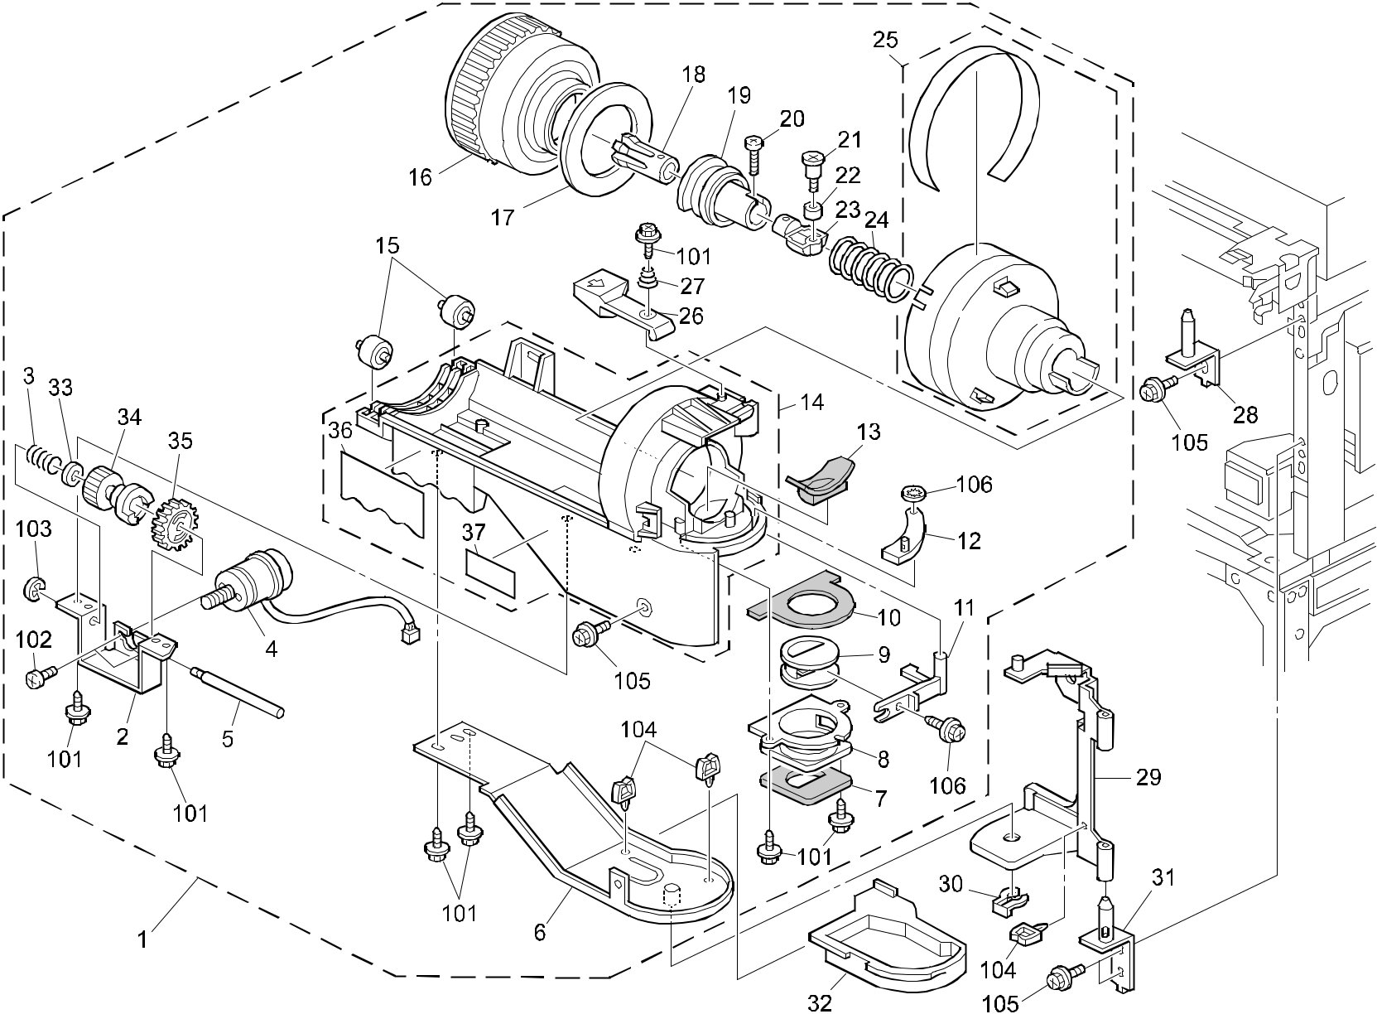

A292/A293/B098 76 Parts Location and List

32.TONER BOTTLE HOLDER (A292/A293/B098)

Index | Part No. | Description | Q’ty Per
No. | Part No. | Description | Assembly
1 | A293 3205 | Toner Bottle Holder Ass'y | 1
 |  | (NRG/SVN/RIC Asia)
1 | A293 3206 | Toner Bottle Holder Ass'y | 1
 |  | (RIC LT)(A292/A293)
1 | A293 3207 | Toner Bottle Holder Ass'y | 1
 |  | (RIC EU)(A292/A293)
1 | A293 3208 | Toner Bottle Holder Ass'y (INF) | 1
1 | A293 3209 | Toner Bottle Holder Ass'y (LAN) | 1
1 | B098 3206 | Bottle:Drive:GER:Ass'y (B098) | 1
2 | A229 3248 | Toner Bottle Bracket | 1
3 | AA06 0291 | Spring | 1
4 | A229 3240 | DC Motor | 1
5 | AA14 5817 | Idler Shaft - Toner Bottle | 1
6 | A229 3251 | Turn Bracket | 1
7 | A229 3263 | Outer Shutter Shield | 1
8 | A229 3261 | Outer Shutter | 1
9 | A229 3262 | Inner Shutter | 1
10 | A229 3266 | Upper Shutter Shield | 1
11 | A229 3264 | Shutter Lever (A292/A293) | 1
11 | B098 3264 | Lever:Shutter (B098) | 1
12 | A229 3285 | Shutter Cover | 1
13 | A229 3219 | Rubber Bushing - Toner Supply Unit | 1
14 | B065 3304 | Bottle Holder | 1
14 | A293 3237 | Bottle Holder (LAN) | 1
15 | A096 3224 | Bottle Roller (A292/A293) | 2
15 | B098 3224 | Roller:Turn:Bottle (B098) | 2
16 | A293 3215 | Toner Supply Gear (NRG) (A292/A293) | 1
16 | A293 3217 | Toner Bottle Gear (RIC LT) (A292/A293) | 1
16 | A293 3223 | Toner Bottle Gear (RIC A4) (A292/A293) | 1
16 | A293 3232 | Toner Bottle Gear (INF/LAN) (A292/A293) | 1
16 | B098 3218 | Gear:Toner Bottle:GER (B098) | 1
17 | A293 3234 | Shield Plate - Toner Bottle | 1
18 | A293 3230 | Toner Bottle Chuck | 1
19 | A293 3227 | Toner Slider | 1
20 | A134 3216 | Screw | 1

Index | Part No. | Description | Q’ty Per
No. | Part No. | Description | Assembly
21 | AA14 3758 | Setepped Screw | 1
22 | A229 3232 | Chuck Roller | 1
23 | A134 3179 | Chuck Shaft | 1
24 | AA06 3366 | Chuck Spring | 1
25 | A293 3220 | Toner Bottle Stopper | 1
26 | A293 3282 | Toner Bottle Pawl | 1
27 | AA06 3575 | Toner Bottle Spring | 1
28 | A229 3305 | Contact Point Stay | 1
29 | A229 3271 | Hinge Bracket | 1
30 | A222 2724 | External Circlip - MM8 | 1
31 | A096 3404 | Lower Hinge | 1
32 | A229 3258 | Toner Catchpan | 1
33 | AA13 2024 | Spacer - M6 | 8
34 | A229 3243 | Motor Joint Gear | 1
35 | A229 3242 | Toner Bottle Joint Gear | 1
36 | AA00 1394 | Decal - Toner Supply | 1
37 | A293 3238 | Decal:Toner Bottle (LAN) | 1

- 0450 3008B Tapping Screw - M3x8

- 0800 0072 Philips Pan Head Screw - M2.6x4

- 0720 0040B Retaining Ring - M4

104 | 1105 | 0229 | Clamp
105 | 0451 | 4008B | Philips Tapping Screw - M4x8
106 | 0805 | 0072 | CS Ring

A292/A293/B098 77 Parts Location and List

33.TONER HOPPER UNIT (A292/A293/B098)
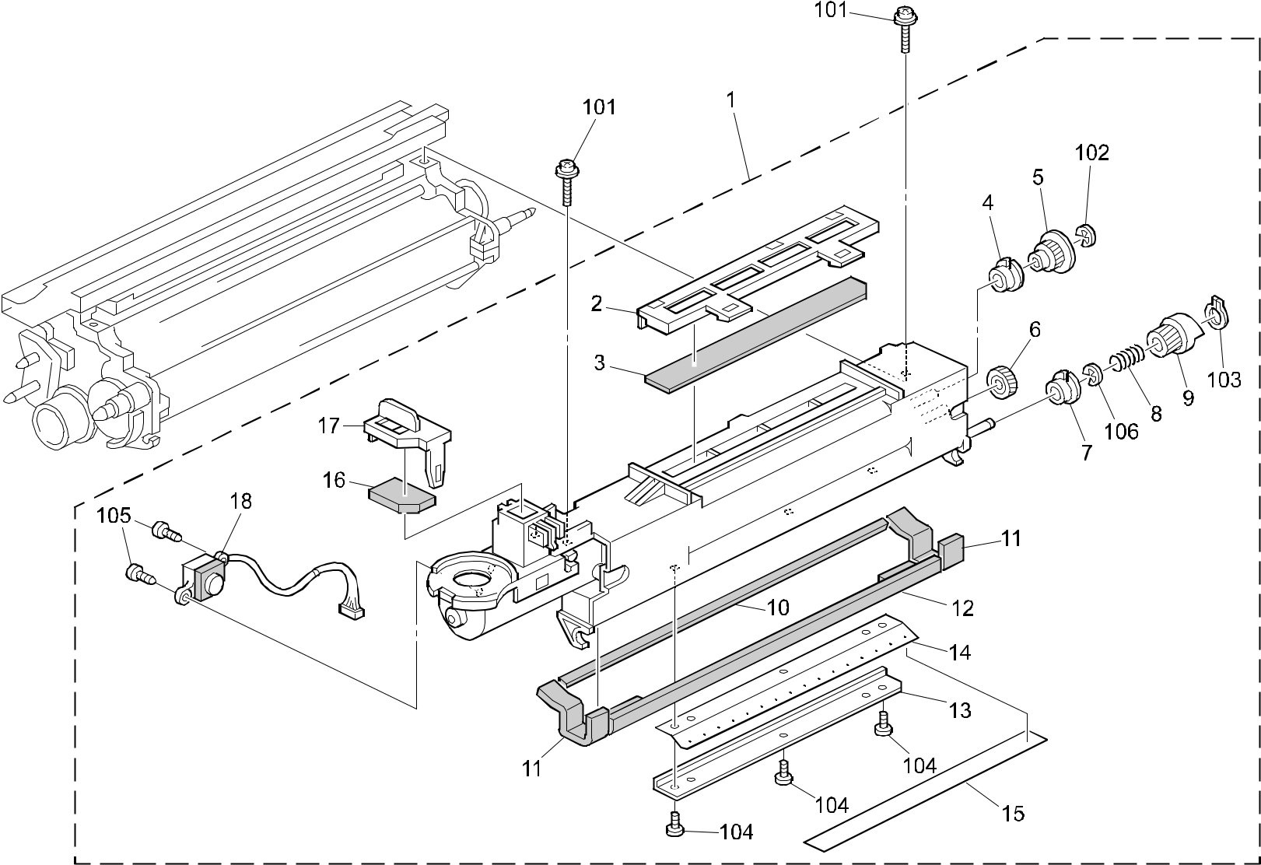

A292/A293/B098 78 Parts Location and List

33.TONER HOPPER UNIT (A292/A293/B098)

Index | Part No. | Description | Q’ty Per
No. | Part No. | Description | Assembly
1 | A293 3150 | Toner Supply Unit (A292/A293) | 1
1 | B098 3150 | Toner Supply Unit:Ass'y (B098) | 1
2 | A229 3183 | Filter Middle Holder (A292/A293) | 1
2 | B098 3183 | Holder:Filter:Middle (B098) | 1
3 | AA01 2104 | Air Filter - Large | 1
4 | A096 3176 | Bushing - 6x12x8.5 | 1
5 | AB01 3749 | Gear - 15Z | 1
6 | AB01 3747 | Gear - 16Z | 1
7 | A096 3175 | Bushing 8x14x8 | 1
8 | AA06 0291 | Spring | 2
9 | AB01 3748 | Joint Gear - 15Z | 1
10 | AA15 1794 | Seal - 3x5x322 | 1
11 | AA15 1792 | Seal - 3x15x85 | 2
12 | A294 3237 | Seal - 33x324x4 | 1
13 | A247 3123 | Plate Nut - Slitter | 1
14 | A096 3181 | Slitter | 1
15 | AA15 0361 | Slitter Cover Seal | 1
16 | AA01 2105 | Air Dust Filter - Small | 1
17 | A229 3184 | Filter Front Holder (A292/A293) | 1
17 | B098 3184 | Holder:Filter:Front (B098) | 1
18 | AW31 0003 | Toner End Sensor | 1

Index | Part No. | Description | Q’ty Per
No. | Part No. | Description | Assembly

- 0951 4006B Philips Screw With Washer - M4x6

- 0720 0040B Retaining Ring - M4

- 0727 0060B Retaining Ring C - 6

- 0451 4006B Tapping Screw - 4x6

- 0452 3008W Binding Self Tapping Screw - M3 X 8

- 0720 0060B Retaining Ring - M6

A292/A293/B098 79 Parts Location and List

34.DEVELOPMENT UNIT 1 (A292/A293/B098)
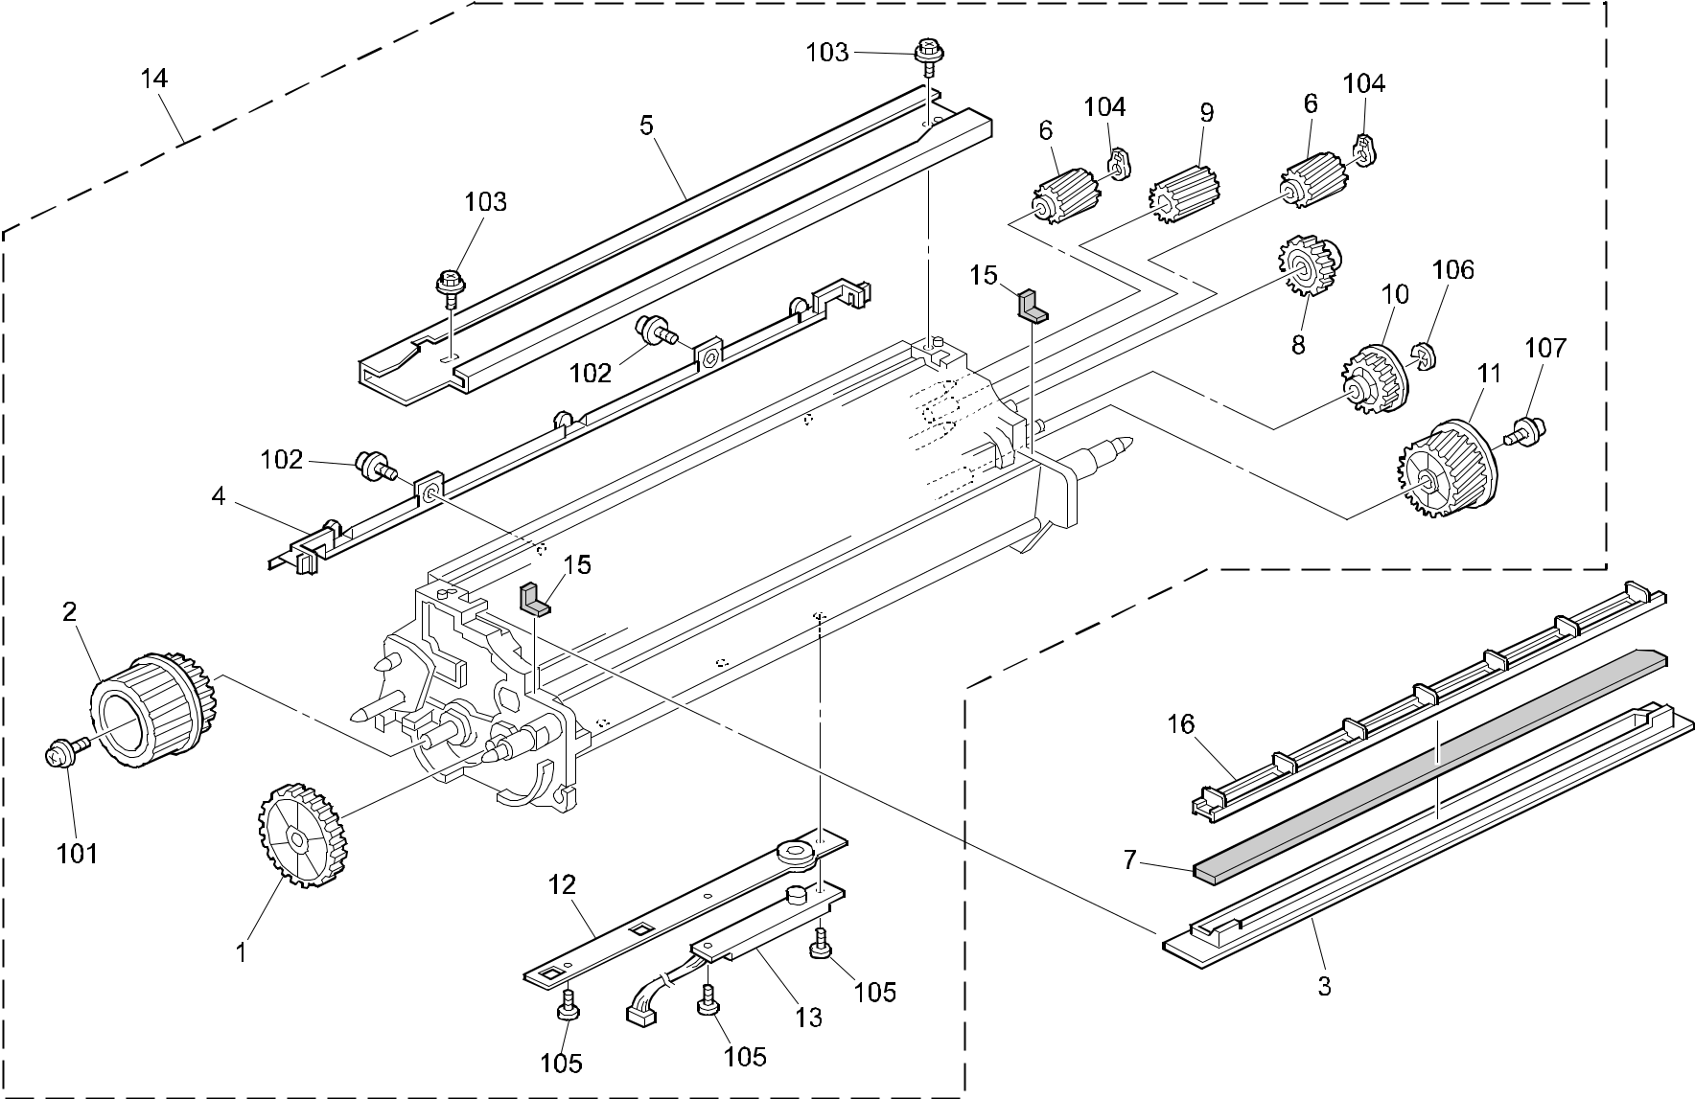

A292/A293/B098 80 Parts Location and List

34.DEVELOPMENT UNIT 1 (A292/A293/B098)

Index | Part No. | Description | Q’ty Per
No. | Part No. | Description | Assembly
1 | AB01 3785 | Gear - 43Z | 1
2 | A293 3075 | Development Knob | 1
3 | A096 3141 | Development Filter Case | 1
4 | A229 3091 | Entrance Seal | 1
5 | A096 3104 | Development Guide Rail | 1
6 | A247 3081 | Gear - 17Z | 2
7 | AA01 2060 | Development Filter | 1
8 | AB01 3788 | Gear - 23Z | 1
9 | AB01 3786 | Gear - 18Z | 1
10 | AB01 3790 | Gear - 25Z | 1
11 | A247 3074 | Gear - 34Z | 1
12 | A096 3059 | Toner Sensor Guide | 1
13 | AW23 0006 | Toner Density Sensor | 1
14 | A293 3050 | Development Unit | 1
15 | AA15 3099 | Lower Side Plate Seal | 2
16 | B065 3108 | Filter Plate (B098) | 1

Index | Part No. | Description | Q’ty Per
No. | Part No. | Description | Assembly

- 0951 3006B Philips Screw With Flat Washer - M3x6

- 0951 4008B Philips Screw With Washer - M4x8

- 0450 4008B Tapping Screw - 4x8

- 0727 0090E Retaining Ring C - M9

- 0313 0050B Philips Pan Head Screw - M3x5

- 0720 0030B Retaining Ring - M3

- 0951 4006B Philips Screw With Washer - M4x6

A292/A293/B098 81 Parts Location and List

35.DEVELOPMENT UNIT 2 (A292/A293/B098)
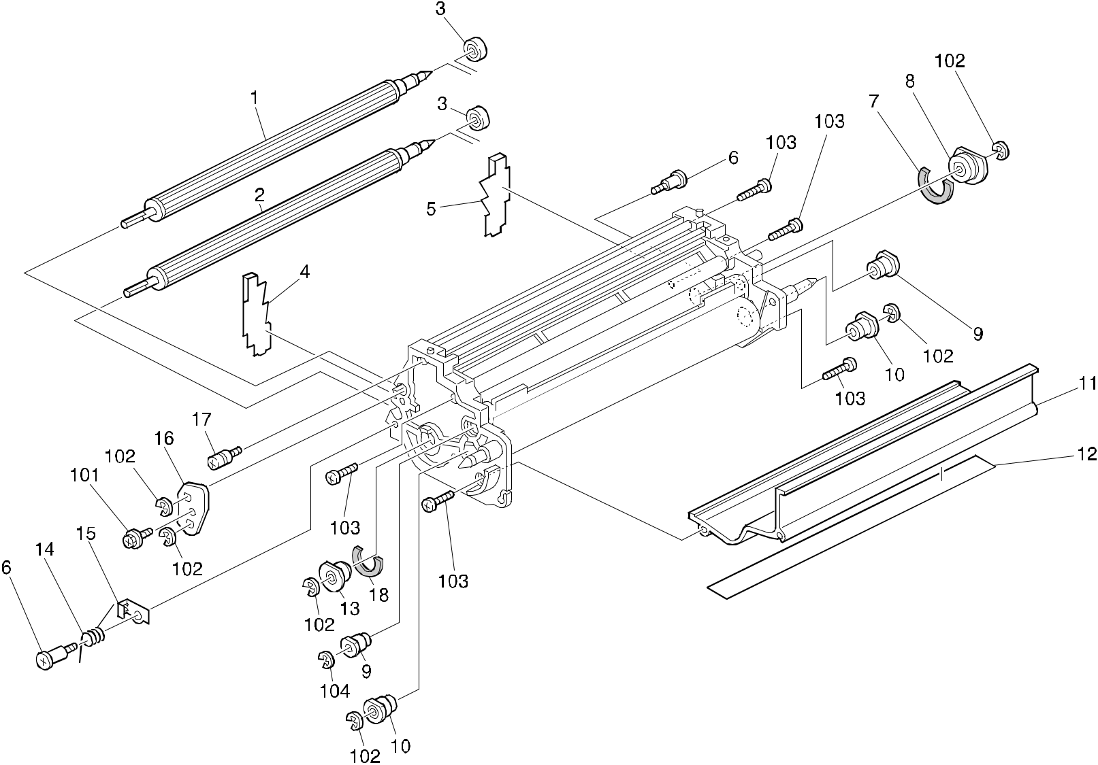

A292/A293/B098 82 Parts Location and List

35.DEVELOPMENT UNIT 2 (A292/A293/B098)

Index | Part No. | Description | Q’ty Per
No. | Part No. | Description | Assembly
1 | A247 3078 | Upper Development Roller | 1
2 | A247 3079 | Lower Development Roller | 1
3 | A247 3089 | Ball Bearing - 9x17x5 | 2
4 | A229 3055 | Front Drum Seal | 1
5 | A229 3056 | Rear Drum Seal | 1
6 | AA14 3426 | Stopped Screw - M4x17 | 2
7 | A294 3147 | Seal | 1
8 | A294 3145 | Ball Bearing Case - 8x19x6 | 1
9 | AA08 0152 | Bushing - 4x12x13 | 2
10 | A294 3150 | Bushing - 6x22x14 | 2
11 | A294 3121 | Lower Development Casing | 1
12 | A294 3127 | Lower Development Sheet | 1
13 | A294 3170 | Bushing - 6x22x14 | 1
14 | A294 3129 | Electrode Torsion Spring | 1
15 | A294 3126 | Casing Electrode | 1
16 | A247 3080 | Adjusting Plate | 1
17 | 5403 2819 | Spring Anchor - Reverse Roller | 1
18 | A294 3173 | Seal - M8 | 1

Index | Part No. | Description | Q’ty Per
No. | Part No. | Description | Assembly

- 0450 4008B Tapping Screw - 4x8

- 0720 0040B Retaining Ring - M4

- 0314 0080B Philips Pan Head Screw - M4x8

- 0720 0030B Retaining Ring - M3

A292/A293/B098 83 Parts Location and List

36.PCU 1 (A292/A293/B098)
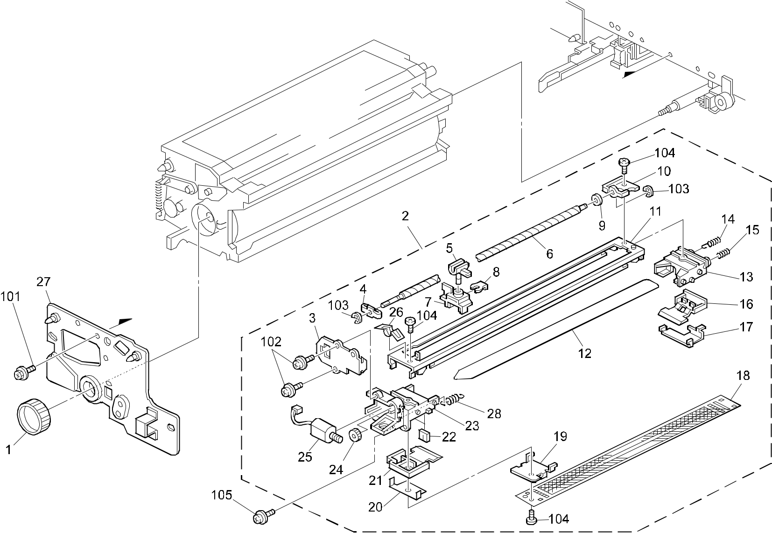

A292/A293/B098 84 Parts Location and List

36.PCU 1 (A292/A293/B098)

Index | Part No. | Description | Q’ty Per
No. | Part No. | Description | Assembly
1 | A096 2330 | Drum Shaft Knob | 1
2 | AD00 4091 | Charge Corona Unit (A292/A293) | 1
2 | AD00 4099 | Charge Corona:Ass'y (B098) | 1
3 | A096 2053 | Cleaner Motor Cover | 1
4 | AA08 0147 | Front Bushing | 1
5 | A096 2062 | Wire Cleaner Slider | 1
6 | A176 2061 | Screw Shaft | 1
7 | A096 2063 | Corona Wire Cleaner | 1
8 | A096 2065 | Slider Ring | 1
9 | AA16 1105 | Cleaner Cushion | 1
10 | AA08 0148 | Rear Bushing | 1
11 | AD02 3106 | Charge Corona Casing | 1
12 | AD02 0053 | Charge Corona Wire (A292/A293) | 1
12 | AD02 7022 | Wire:Charge Corona (B098) | 1
13 | AD02 2285 | Rear End Block | 1
14 | AA06 3248 | Charge Terminal Spring | 1
15 | AA06 3249 | Grid Terminal Spring | 1
16 | AD02 2307 | Cover - Rear End Block | 1
17 | A096 2051 | Rear Grid Anchor | 1
18 | A096 2057 | Charge Corona Grid | 1
19 | A096 2052 | Front Grid Anchor | 1
20 | A134 2363 | Terminal Plate | 1
21 | AD02 2306 | Cover - Front End Block | 1
22 | AA16 1119 | Cushion - Wire | 2
23 | AD02 2283 | Front End Block | 1
24 | AB01 0087 | Gear - 20Z | 1
25 | AX04 0061 | Cleaner Motor - DC 0.5W | 1
26 | A176 2054 | Grounding Plate | 1
27 | A294 2401 | Drum Stay Ass'y (A292/A293) | 1
27 | B098 2401 | Drum Stay:Drum:Ass'y (B098) | 1
28 | AA06 2284 | Pressure Spring | 1

Index | Part No. | Description | Q’ty Per
No. | Part No. | Description | Assembly

- 0451 4008B Philips Tapping Screw - M4x8

- 0965 3008B Tapping Screw With Washer - M3x8

- 0720 0025B Retaining Ring - M2.5

- 0971 4006A Philips Polycarbonate Screw - M4x6

- 0451 4006B Tapping Screw - 4x6

A292/A293/B098 85 Parts Location and List

37.PCU 2 (A292/A293/B098)
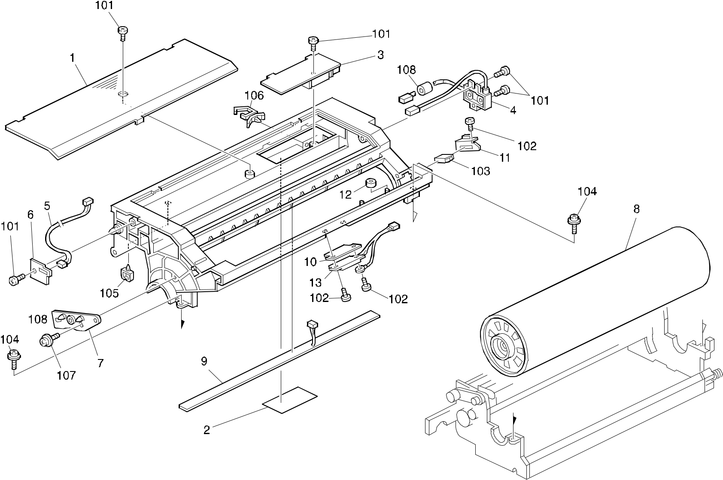

A292/A293/B098 86 Parts Location and List

37.PCU 2 (A292/A293/B098)

Index | Part No. | Description | Q’ty Per
No. | Part No. | Description | Assembly
* | A293 2380 | Upper Drum Unit | 1
1 | A293 2418 | Upper Unit Cover | 1
2 | AA15 0350 | Seal - 40x130 | 1
3 | AZ32 0087 | Power Pack | 1
4 | AD02 1128 | Charge Corona Receptacle | 1
5 | A096 5442 | Corona Cleaner Harness | 1
6 | A096 2281 | Connector Bracket | 1
7 | A096 2266 | Corona Unit Bracket | 1
8 | A294 9510 | OPC Drum | 1
9 | A096 5320 | Quenching Lamp | 1
10 | A096 2301 | Grounding Plate | 1
11 | A229 2401 | Connector Bracket | 1
12 | A153 3571 | Collar | 1
13 | AW33 0003 | Drum Potential Sensor | 1

Index | Part No. | Description | Q’ty Per
No. | Part No. | Description | Assembly

- 0452 3008B Tapping Screw - M3x8

- 0453 3006B Tapping Screw - M3x6

- 1102 6246 Relay Connector - 4P

- 0951 4010W Philips Screw With Flatwasher - M4x10

- 1105 0229 Clamp

- 1105 0310 Harness Clamp - LWS-1S

- 0965 3008W Tapping Screw With Flat Washer - M3x8

- 1607 1054 Ferrite Core Sc-18-10-13

A292/A293/B098 87 Parts Location and List

38.PCU 3 (A292/A293/B098)
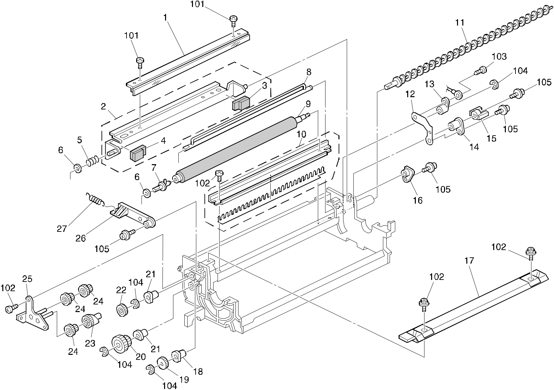

A292/A293/B098 88 Parts Location and List

38.PCU 3 (A292/A293/B098)

Index | Part No. | Description | Q’ty Per
No. | Part No. | Description | Assembly
* | A293 2320 | Lower Drum Unit (A292/A293) | 1
1 | AD04 1056 | Cleaning Blade | 1
2 | A247 3573 | Bracket - Cleaning Blade | 1
3 | A247 3574 | Rear Cleaning Seal | 1
4 | A247 3571 | Cleaning Seal | 1
5 | AA06 3610 | Blade Spring - Swivel 4060mn | 1
6 | AA13 2024 | Spacer - M6 | 2
7 | A096 3586 | Cleaning Brush Drive Shaft | 1
8 | AD03 9057 | Cleaning Agitator | 1
9 | AD04 2039 | Cleaning Brush | 1
10 | A294 3566 | Holder - Toner Collection Coil | 1
11 | AD04 3066 | Toner Collection Coil | 1
12 | A176 3527 | Grounding Plate | 1
13 | AA08 2059 | Agitator Bushing | 1
14 | AA08 2045 | Cleaning Brush Bushing | 1
15 | A294 3591 | Joint - Cleaning Drive | 1
16 | AA08 0154 | Rear Bushing | 1
17 | A294 3606 | Cleaning Seal - Ass'y | 1
18 | AA08 2094 | Bushing - Brush Roller | 1
19 | A096 3588 | Gear - 19Z | 1
20 | AB01 7296 | Gear - 30/47Z | 1
21 | AA08 2095 | Bushing - Toner Collection Coil | 2
22 | AB01 0340 | Gear - 30Z | 1
23 | AB01 7288 | Cam Gear - 35Z | 1
24 | A096 3661 | Gear - 15/35Z | 3
25 | A247 3656 | Bracket - Speed Reduction Gear | 1
26 | A247 3575 | Blade Release Lever | 1
27 | AA06 3591 | Cleaning Blade Spring | 1

Index | Part No. | Description | Q’ty Per
No. | Part No. | Description | Assembly

- 0314 0040B Philips Pan Head Screw - M4x4

- 0452 3008B Tapping Screw - M3x8

- 0452 3010B Tapping Bind Screw - M3x10

- 0720 0040B Retaining Ring - M4

- 0951 3006B Philips Screw With Flat Washer - M3x6

A292/A293/B098 89 Parts Location and List

39.PCU 4 (A292/A293/B098)
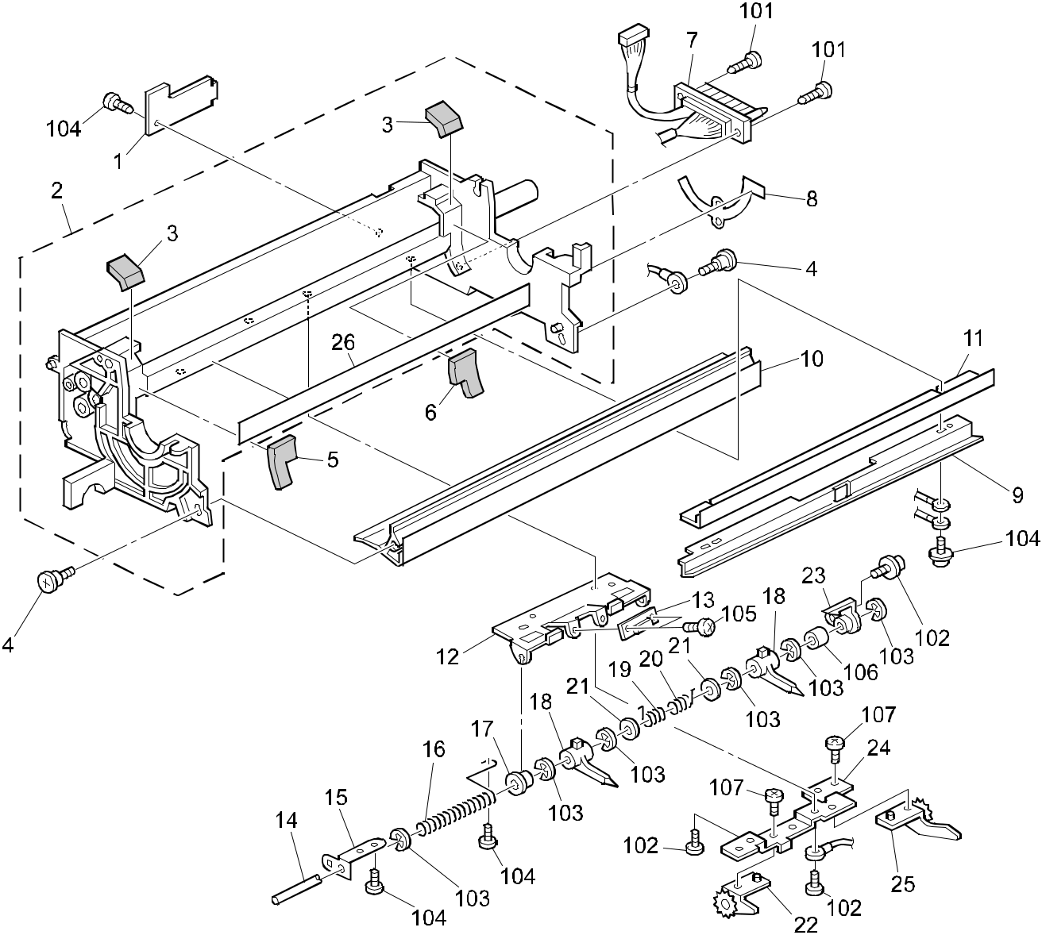

A292/A293/B098 90 Parts Location and List

39.PCU 4 (A292/A293/B098)

Index | Part No. | Description | Q’ty Per
No. | Part No. | Description | Assembly
1 | A096 3666 | Harness Cover | 1
2 | A293 2330 | Lower Frame | 1
3 | AA15 3085 | Inner Case Seal | 2
4 | AA14 3394 | Stepped Screw - M3x10 | 2
5 | AA15 2431 | Front Drum Seal | 1
6 | A294 3572 | Rear Drum Seal | 1
7 | A293 5411 | Drum Unit Harness | 1
8 | A229 2352 | Grounding Plate (A292/A293) | 1
8 | B098 2352 | Plate:Harness (B098) | 1
9 | A294 3556 | Entrance Seal Holder | 1
10 | A293 3596 | Upper Entrance Stay | 1
11 | A096 3621 | Entrance Seal | 1
12 | A096 3642 | Pick-off Pawl Bracket | 1
13 | A134 5251 | ID Sensor | 1
14 | A096 3646 | Pick-off Pawl Shaft | 1
15 | A096 3624 | Drum Grounding Plate | 1
16 | AA06 3384 | Pick-off Pawl Shaft Spring | 1
17 | 5324 1658 | Bushing- 4x8x4.5mm | 1
18 | AD02 5022 | Pick-off Pawl | 2
19 | AA06 6214 | Front Pawl Spring | 1
20 | AA06 6215 | Rear Pawl Spring | 1
21 | A352 2138 | Slide Collar - 0.6x4.5x6 | 2
22 | A048 2274 | Front Transport Guide | 1
23 | AA08 0155 | Rear Pawl Bushing | 1
24 | A097 3644 | Transport Guide Bracket | 1
25 | A048 2277 | Rear Transport Guide | 1
26 | AA15 3088 | Cleaning Entrance Seal - 3x345x2 | 1

Index | Part No. | Description | Q’ty Per
No. | Part No. | Description | Assembly

- 0452 3010B Tapping Bind Screw - M3x10

- 0951 3006B Philips Screw With Flat Washer - M3x6

- 0720 0030B Retaining Ring - M3

- 0452 3008B Tapping Screw - M3x8

- 0313 0050B Philips Pan Head Screw - M3x5

- 0807 3092 Spacer - 4x5x3

- 0452 3006B Tapping Screw - M3x6

A292/A293/B098 91 Parts Location and List

40.TRANSFER SECTION 1 (A292/A293/B098)
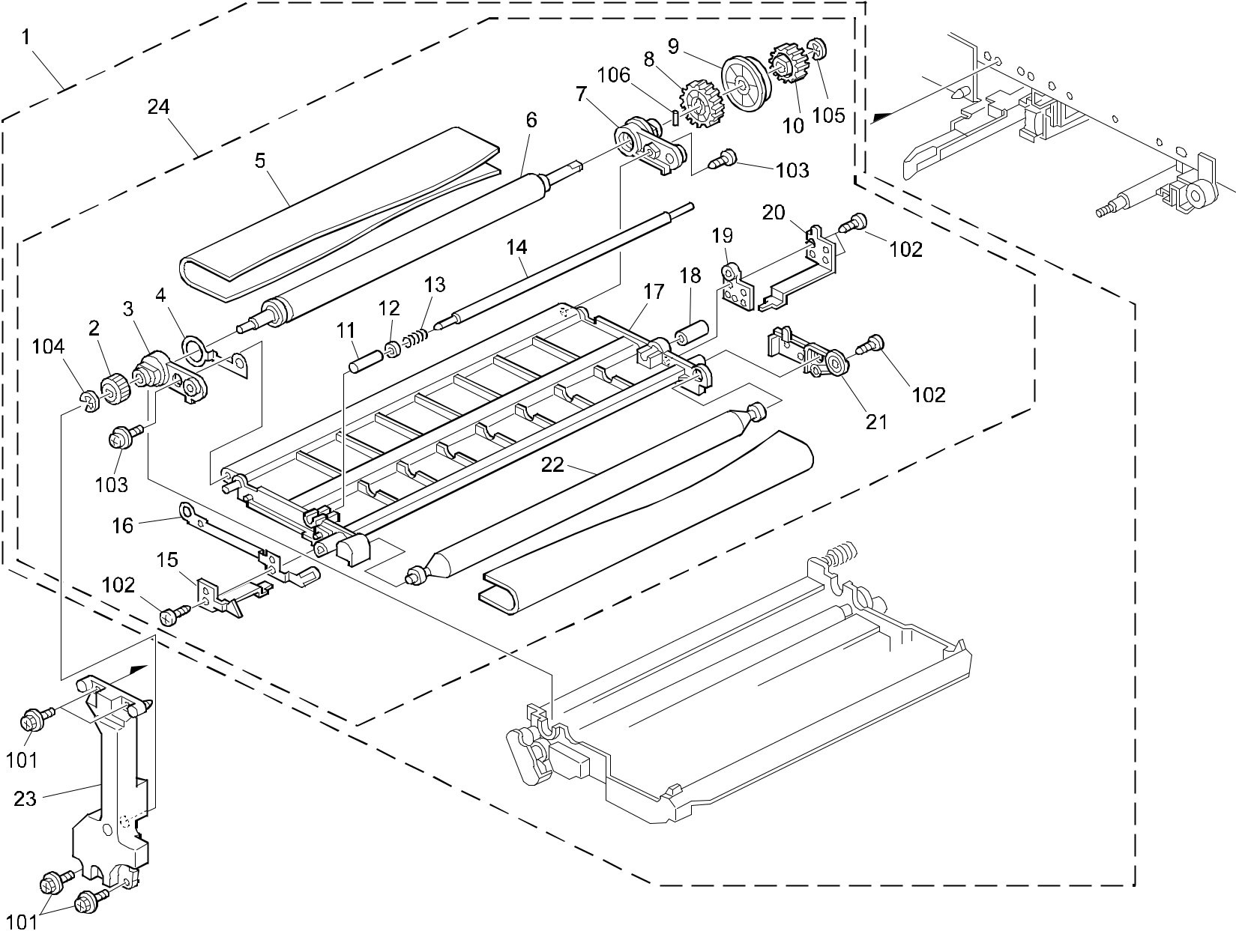

A292/A293/B098 92 Parts Location and List

40.TRANSFER SECTION 1 (A292/A293/B098)

Index | Part No. | Description | Q’ty Per
No. | Part No. | Description | Assembly
1 | A293 3810 | Transfer Unit (A292/A293) | 1
1 | B098 3810 | Transfer Unit:C2:Ass'y (B098) | 1
2 | AB01 0333 | Gear - 26Z | 1
3 | A229 3861 | Front Arm | 1
4 | A229 3875 | Drive Electrode | 1
5 | A293 3899 | Transfer Belt - Mojito Service | 1
6 | A229 3880 | Drive Roller | 1
7 | A229 3862 | Rear Arm | 1
8 | AB01 4175 | Gear - 50Z | 1
9 | A294 3869 | Rear Positioning Plate | 1
10 | A293 3871 | Gear - 20Z | 1
11 | A096 3867 | Front Bushing - 4.5x6x21 | 1
12 | A176 3863 | Spacer - 4x6x2 | 1
13 | AA06 3531 | Pressure Spring - 12mm | 1
14 | A096 3870 | Transfer Bias Roller | 1
15 | A229 3859 | Front Spring Plate | 1
16 | A229 3876 | Driven Electrode | 1
17 | A229 3853 | Transfer Belt Frame | 1
18 | A096 3868 | Rear Bushing - 4.5x6x13.5 | 1
19 | A096 3864 | Transfer Belt Terminal | 1
20 | A247 3855 | Rear Spring Plate | 1
21 | A096 3865 | Terminal Cover | 1
22 | A229 3865 | Transport Driven Roller | 1
23 | A096 3966 | Belt Unit Support Plate | 1
24 | A293 3851 | Transfer Belt Frame | 1

Index | Part No. | Description | Q’ty Per
No. | Part No. | Description | Assembly

- 0451 4008B Philips Tapping Screw - M4x8

- 0452 3008B Tapping Screw - M3x8

- 0951 3008B Philips Screw With Flat Washer - M3x8

- 0720 0040B Retaining Ring - M4

- 0720 0060E Retaining Ring - M6

- 0633 0140G Parallel Pin - 3x14

A292/A293/B098 93 Parts Location and List

41.TRANSFER SECTION 2 (A292/A293/B098)
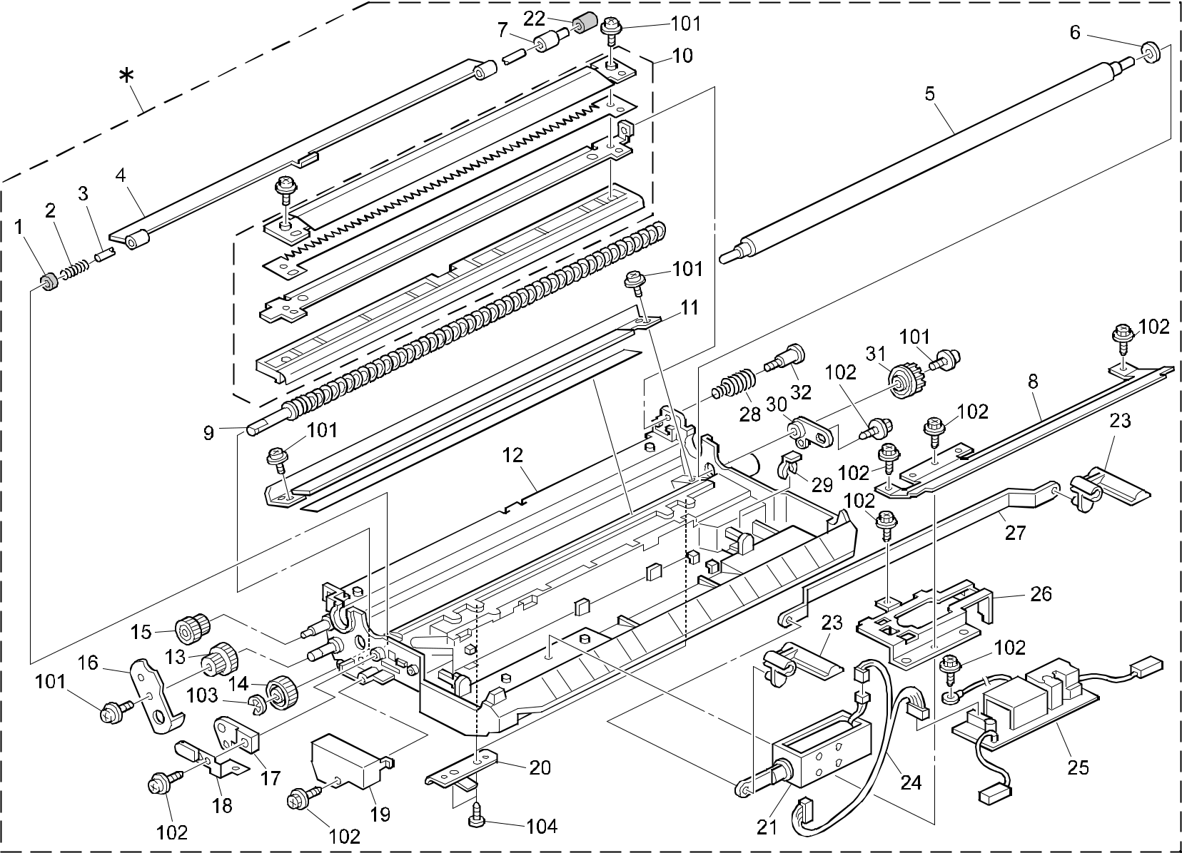

A292/A293/B098 94 Parts Location and List

41.TRANSFER SECTION 2 (A292/A293/B098)

Index | Part No. | Description | Q’ty Per
No. | Part No. | Description | Assembly
* | A293 3910 | Transfer Belt Casing (A292/A293) | 1
* | B098 3910 | Casing:Transfer Belt:C2:Ass'y (B098) | 1
1 | A229 3915 | Front Agitator Shield | 1
2 | AA06 3309 | Compression Spring | 1
3 | A293 3912 | Agitator Shaft | 1
4 | A229 3913 | Agitator | 1
5 | A293 3916 | Cleaning Roller - Transfer Belt | 1
6 | AA13 2024 | Spacer - M6 | 1
7 | A293 3911 | Agitator Slider | 1
8 | A293 3913 | Heat Sink - Transfer Unit | 1
9 | A293 3901 | Toner Collection Coil | 1
10 | A293 3940 | Guide Plate - Transfer Belt | 1
11 | A293 3918 | Transfer Belt Blade | 1
12 | A229 3924 | Transfer Belt Casing | 1
13 | AB01 0336 | Gear - 22/36Z | 1
14 | AB01 0334 | Gear - 34Z | 1
15 | AB01 0335 | Gear - 22/48Z | 1
16 | A096 3929 | Gear Cover (A292/A293) | 1
16 | B098 3929 | Cover:Gear (B098) | 1
17 | A229 3910 | Front Bushing | 1
18 | A229 3909 | Bias Terminal | 1
19 | A229 3917 | Electrode Cover | 1
20 | A293 3914 | Spring Plate - Casing | 2
21 | A293 3935 | DC Solenoid - On-Off | 1
22 | A229 3918 | Rear Agitator Shield | 1
23 | A096 3915 | Transfer Belt Lever | 2
24 | A229 5410 | Transfer Unit Harness | 1
25 | AZ30 0051 | Power Pack | 1
26 | A096 3922 | Soleniod Bracket | 1
27 | A096 3916 | Belt Lever Arm | 1
28 | AA06 3310 | Guide Plate Spring | 1
29 | 5447 2681 | Snap Ring | 1
30 | A229 3911 | Rear Bushing | 1
31 | AB01 4176 | Cam Gear - 37Z | 1
32 | H053 1150 | Stepped Screw - Locking | 1

Index | Part No. | Description | Q’ty Per
No. | Part No. | Description | Assembly

- 0951 3006B Philips Screw With Flat Washer - M3x6

- 0450 3008B Tapping Screw - M3x8

- 0720 0040B Retaining Ring - M4

- 0452 3006B Tapping Screw - M3x6

A292/A293/B098 95 Parts Location and List

42.FUSING UNIT 1 (A292/A293/B098)
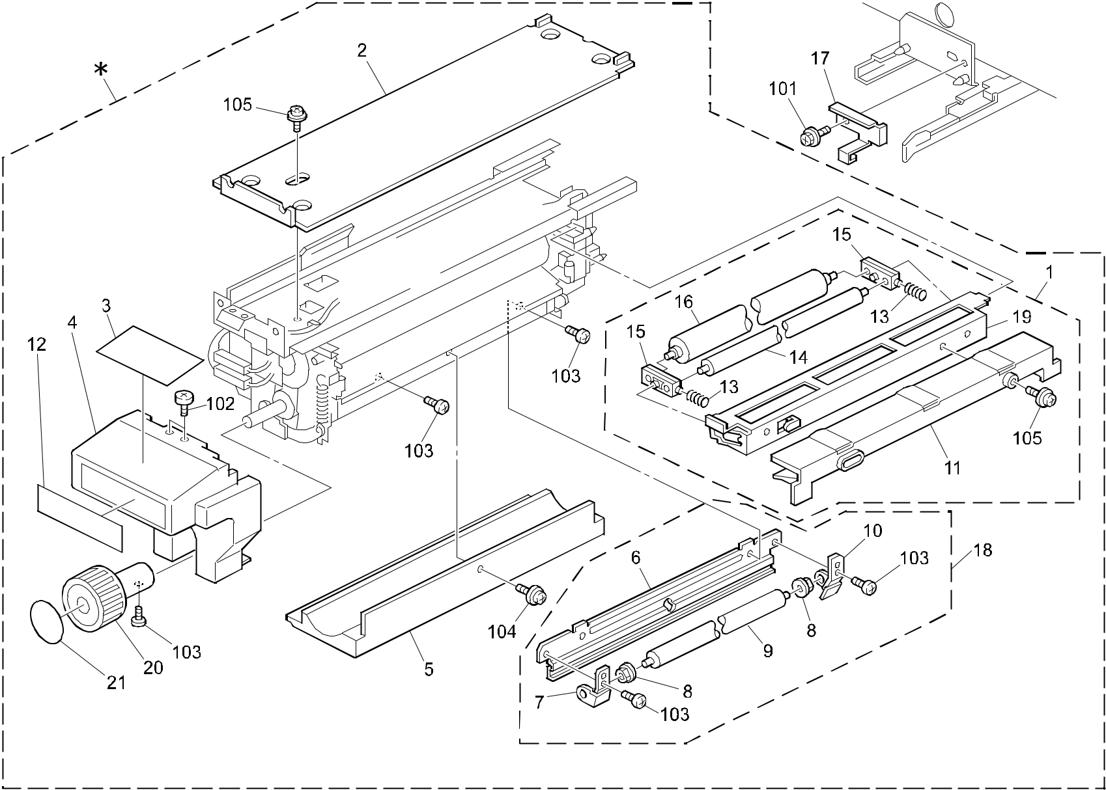

A292/A293/B098 96 Parts Location and List

42.FUSING UNIT 1 (A292/A293/B098)

Index | Part No. | Description | Q’ty Per
No. | Part No. | Description | Assembly
* | A293 4010 | Fusing Unit (LAN)(TWN) (A292/A293) | 1
* | A293 4015 | Fusing Unit (A292/A293 230V) | 1
* | A293 4018 | Fusing Unit (A292/A293 230V Asia) | 1
* | A293 4032 | Fusing Unit (KOREA)(A292/A293) | 1
* | A293 4050 | Fusing Unit (A292/A293 120V) | 1
* | B098 4050 | Fusing Unit:NA:Ass'y (B098) | 1
* | B098 4015 | Fusing Unit:EU:Ass'y (B098) | 1
1 | A229 4085 | Oil Supply Unit (A292/A293 120V) | 1
1 | A293 4085 | Oil Supply Unit (A292/A293 230V) | 1
1 | B098 4085 | Oil Supply Unit:Ass'y (B098) | 1
2 | A247 4155 | Rail Cover | 1
3 | A293 4156 | Decal - Confirm Paper (A292/A293) | 1
3 | B098 4157 | Decal:Confirm:Paper (B098) | 1
4 | A293 4152 | Fusing Cover - Large Grip | 1
5 | A096 4161 | Lower Fusing Cover (A292/A293) | 1
5 | A293 4161 | Lower Fusing Cover (A292/A293 -15/-17)(B098) | 1
6 | A097 4122 | Cleaning Roller Bracket | 1
7 | A294 4078 | Right Holder (A292/A293 120V) | 1
7 | A229 4175 | Right Holder (A292/A293 230V)(B098) | 1
8 | AE03 1024 | Bushing - M4x7 | 2
9 | AE04 2036 | Cleaning Roller:Pressure Roller:Ass | 1
 |  | (A292/A293 120V)(B098)
9 | AE04 2046 | Cleaning Roller - Pressure Roller | 1
 |  | (A292/A293 230V)
10 | A294 4077 | Left Holder (A292/A293 120V) | 1
10 | A229 4171 | Left Holder (A292/A293 230V)(B098) | 1
11 | A247 4131 | Upper Entrance Guide | 1
12 | A293 4165 | Decal- Misfeed Removal D/E (A292/A293) | 1
12 | B098 4165 | Decal:misfeed Removal:d/e:na (B098) | 1
13 | AA06 3294 | Pressure Spring | 2
14 | AE04 2035 | Oil Supply Cleaning Roller | 1
 |  | (A292/A293 120V)(B098)
14 | AE04 2045 | Oil Supply Cleaning Roller | 1
 |  | (A292/A293 230V)
15 | AE03 1025 | Bushing - Oil Supply Roller | 2

Index | Part No. | Description |  | Q’ty Per
No. | Part No. | Description | Assembly
16 | AE04 0016 | Oil Supply Roller (A292/A293) |  | 1
16 | AE04 0051 | Oil Supply Roller (B098) | 1<B>
17 | A096 4273 | Fusing Unit Stopper |  | 1
18 | A229 4090 | Lower Cleaning Roller Unit (A292/A293 120V) |  | 1
18 | A293 4095 | Lower Cleaning Roller Unit (A292/A293 230V) |  | 1
18 | B098 4095 | Lower Cleaning Roller Unit (B098) |  | 1
19 | A247 4141 | Oil Supply Roller Bracket |  | 1
20 | A293 4076 | Long Fushing Knob |  | 1
21 | A293 4077 | Decal - Rotation Direction Knob |  | 1

- 0451 4008B Philips Tapping Screw - M4x8

- 0453 4008Z Tapping Screw - M4x8

- 0314 0060B Philips Pan Head Screw - M4x6

- 0951 4006W Philips Screw With Flat Washer - M4x6

- 0951 4008W Philips Screw With Flat Washer - M4x8

A292/A293/B098 97 Parts Location and List

43.FUSING UNIT 2 (A292/A293/B098)
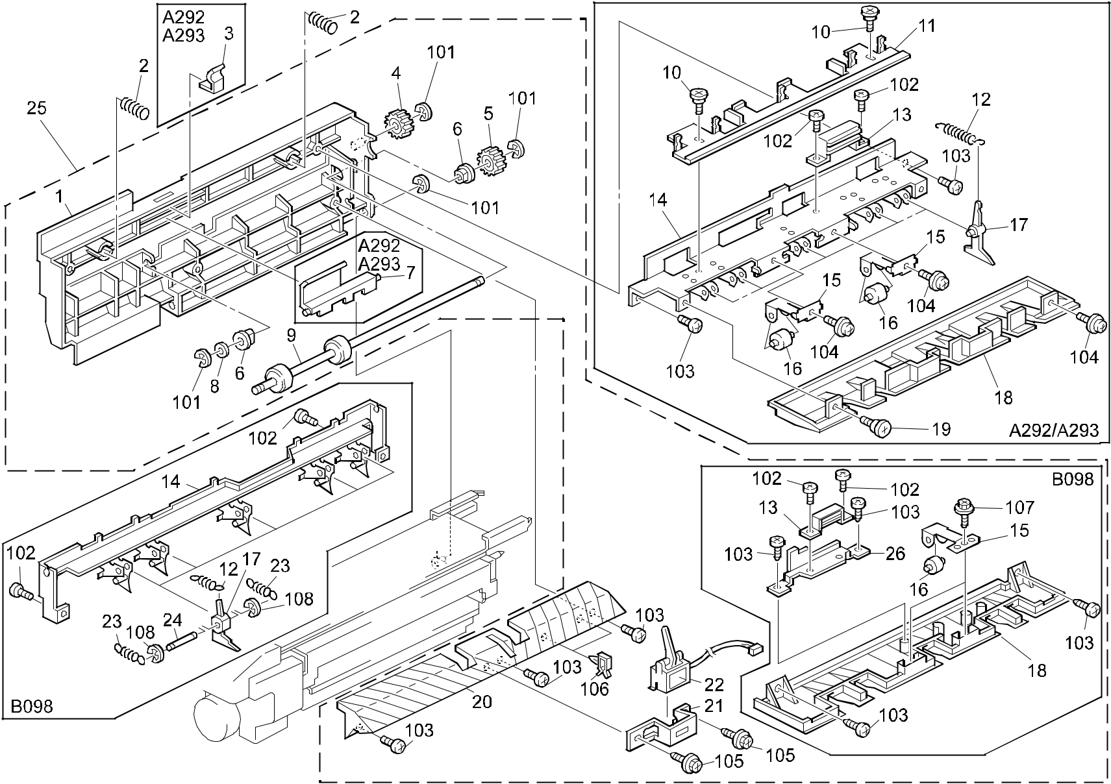

A292/A293/B098 98 Parts Location and List

43.FUSING UNIT 2 (A292/A293/B098)

Index | Part No. | Description | Q’ty Per
No. | Part No. | Description | Assembly
1 | A229 4301 | Fusing Exit Frame (A292/A293) | 1
1 | B098 4307 | Frame:Fusing Exit:Printing (B098) | 1
2 | G619 4028 | Slider Pressure Spring (A292/A293) | 2
3 | A096 4304 | Grip Spring Plate (A292/A293) | 1
4 | AB01 3793 | Gear - 19Z | 1
5 | AB01 3794 | Gear - Fusing Exit | 1
6 | AA08 0184 | Bushing - Fusing Exit | 2
7 | A096 4303 | Fusing Exit Grip (A292/A293) | 1
8 | AA13 2024 | Spacer - M6 | 1
9 | AF02 0302 | Lower Fusing Exit Roller | 1
10 | 5506 6111 | Stepped Screw - M4 (A292/A293) | 2
11 | A096 4316 | Stripper Release Slider (A292/A293) | 1
12 | AA06 0539 | Stripper Pawl Spring | 5
13 | AA02 1026 | Magnet Catch (A292/A293) | 1
14 | A096 4313 | Stripper Stay (A292/A293) | 1
14 | B098 4313 | Bracket:guide Plate:pickoff Pawl (B098) | 1
15 | A096 4319 | Exit Roller Holder (A292/A293) | 2
15 | B098 4319 | Holder:Exit Roller (B098) | 2
16 | AF04 0561 | Fusing Exit Roller - Upper | 2
17 | AE04 4019 | Hot Roller Stripper (A292/A293) | 5
17 | AE04 4043 | Hot Roller Stripper (B098) | 5
18 | A096 4322 | Upper Fusing Exit Guide (A292/A293) | 1
18 | B098 4322 | Guide Plate:Fusing Exit:Upper (B098) | 1
19 | AA14 3037 | Development Cover Screw (A292/A293) | 1
20 | A293 4309 | Lower Fusing Exit Guide | 1
21 | A293 4316 | Bracket - Fusinx Exit Sensor | 1
22 | AW20 0005 | Reed Switch | 1
23 | AA06 0914 | Stripper Pawls Spring (B098)
24 | AA14 9746 | Stripper Shaft (B098) | 1
25 | B098 4045 | Paper Exit:Ass'y (B098) | 1
26 | B098 4316 | Bracket:Fix:Guide Plate (B098) | 1

Index | Part No. | Description | Q’ty Per
No. | Part No. | Description | Assembly

- 0720 0040B Retaining Ring - M4

- 0314 0060B Philips Pan Head Screw - M4x6

- 0414 0082W Tapping Screw With Flat Washer - M4x8

(A292/A293)

- 0452 4008B Binding Self Tapping Screw-M4x8

(B098)

- 0951 4006W Philips Screw With Flat Washer - M4x6

- 0450 3008B Tapping Screw - M3x8

106 1105 0283 Clamp

- 0452 3006B Tapping Screw - M3x6

- 0720 0030E Retaining Ring - M3

A292/A293/B098 99 Parts Location and List

44.FUSING UNIT 3 (A292/A293/B098)
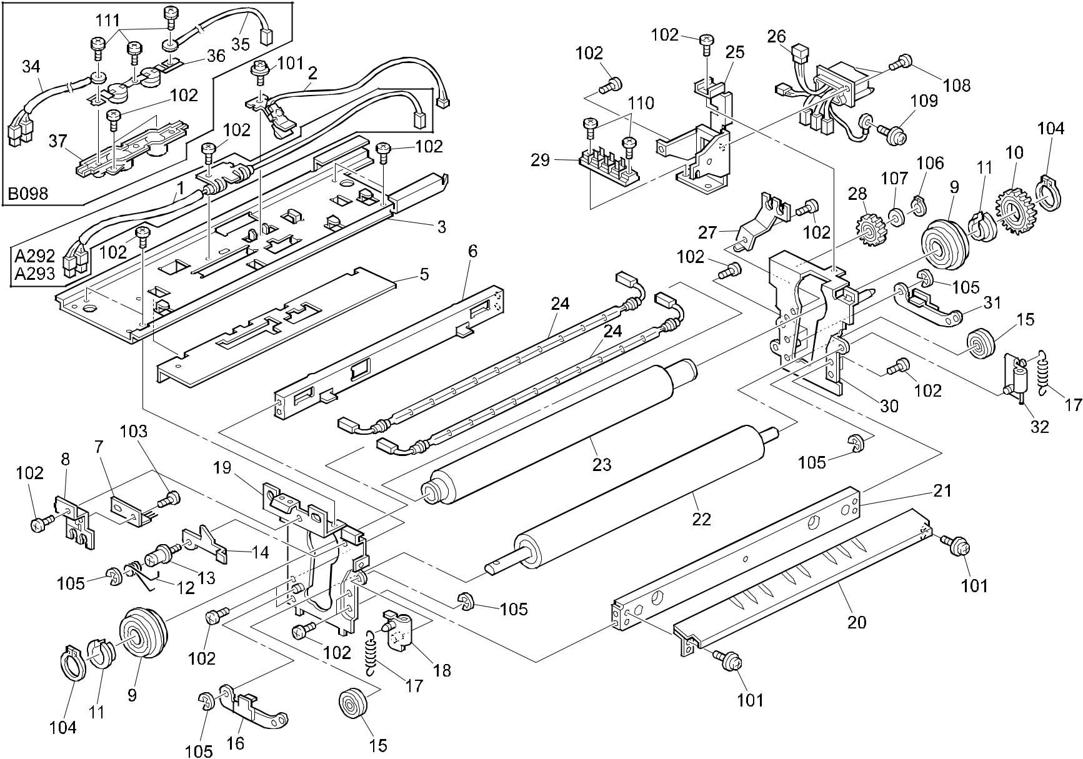

A292/A293/B098 100 Parts Location and List

44.FUSING UNIT 3 (A292/A293/B098)

Index | Part No. | Description | Q’ty Per
No. | Part No. | Description | Assembly
1 | A247 4225 | Thermofuse 172ßC (A292/A293) | 1
2 | A293 4131 | Thermistor - Fusing Ass'y | 1
3 | A096 4121 | Fusing Unit Rail (A292/A293) | 1
3 | B098 4121 | Rail:Fusing (B098) | 1
5 | AA17 2012 | Heat Shielding Sheet (A292/A293) | 1
6 | A293 4115 | Fusing Left Stay | 1
7 | A413 1670 | Antistatic Brush | 1
8 | A097 4170 | Front Heater Holder | 1
9 | AE03 0017 | Ball Bearing - 35x50x10 | 2
10 | AB01 3792 | Gear - 49Z (A292/A293) | 1
10 | AB01 2316 | Fusing Gear (B098) | 1
11 | AE03 2014 | Bushing - 30x35x13.5 | 2
12 | AA06 6232 | Lock Lever Spring | 1
13 | 5215 4444 | Pin | 1
14 | A097 4133 | Lock Lever | 1
15 | AE03 0018 | Ball Bearing - 12x28x8 | 2
16 | A096 4174 | Front Pressure Lever | 1
17 | AA06 0739 | Tension Spring (A292/A293) | 2
17 | AA06 0926 | Tension Spring:Pressure Roller:195n (B098) | 2
18 | A096 4181 | Front Release Bracket | 1
19 | A096 4101 | Front Fusing Bracket (A292/A293) | 1
19 | B098 4101 | Side Plate:Fusing:Front:Ass'y (B098) | 1
20 | A293 4135 | Fusing Entrance Guide | 1
21 | A097 4112 | Fusing Right Stay | 1
22 | AE02 2078 | Pressure Roller | 1
23 | AE01 1044 | Hot Roller (A292/A293) | 1
23 | AE01 1073 | Hot Roller:Mm50 (B098) | 1
24 | AX43 0034 | Fusing Lamp - 550W 230V | 2
24 | AX44 0109 | Fusing Lamp - 550W 115V | 2
25 | A096 4231 | Fusing Connector Bracket | 1
26 | A293 4141 | Fusing Unit Harness (A292/A293 120V) | 1
26 | A293 4143 | Fusing Unit Harness - 230V (A292/A293) | 1
26 | B098 4141 | Harness:Fusing Unit:Ass'y (B098 120V) | 1
26 | B098 4143 | Harness:Fusing Unit:EU:Ass'y (B098 230V) | 1
27 | A097 4173 | Rear Heater Holder | 1

Index | Part No. | Description | Q’ty Per
No. | Part No. | Description | Assembly
28 | AB01 7357 | Gear - 31Z (A292/A293) | 1
28 | AB01 2317 | Fusing Drive Gear (B098) | 1
29 | A247 4249 | Connector - 3P | 1
30 | A176 4105 | Rear Fusing Bracket (A292/A293) | 1
30 | B098 4105 | Side Plate:Rear:Fusing:Ass'y (B098) | 1
31 | A096 4176 | Rear Pressure Lever | 1
32 | A096 4185 | Rear Release Bracket | 1
34 | B098 4227 | Harness:Front (B098) | 1
35 | B098 4228 | Harness:Inner Back (B098) | 1
36 | G065 4106 | Thermostat (B098) | 1
37 | B070 4096 | Housing:Thermostat:Lower (B098) | 1

- 0951 4006W Philips Screw With Flat Washer - M4x6

- 0314 0060B Philips Pan Head Screw - M4x6

- 0313 0050B Philips Pan Head Screw - M3x5

- 0725 0300E Retaining Ring C - M30

- 0720 0040B Retaining Ring - M4

- 0727 0080G Retaining Ring - M8

- 0807 5056 Washer - 8.1mm

- 0314 0100B Philips Pan Head Screw - M4x10

- 0951 3005B Philips Screw With Flat Washer M3x5 (A292/A293)

- 0950 3005B Philips Screw With Sprin Washer (B098)

- 0314 0080B Philips Pan Head Screw - M4x8

- 0801 0149 Philips Pan Head Screw - M4x6

A292/A293/B098 101 Parts Location and List

45.INVERTOR & DUPLEX UNIT 1 (A292/A293/B098)
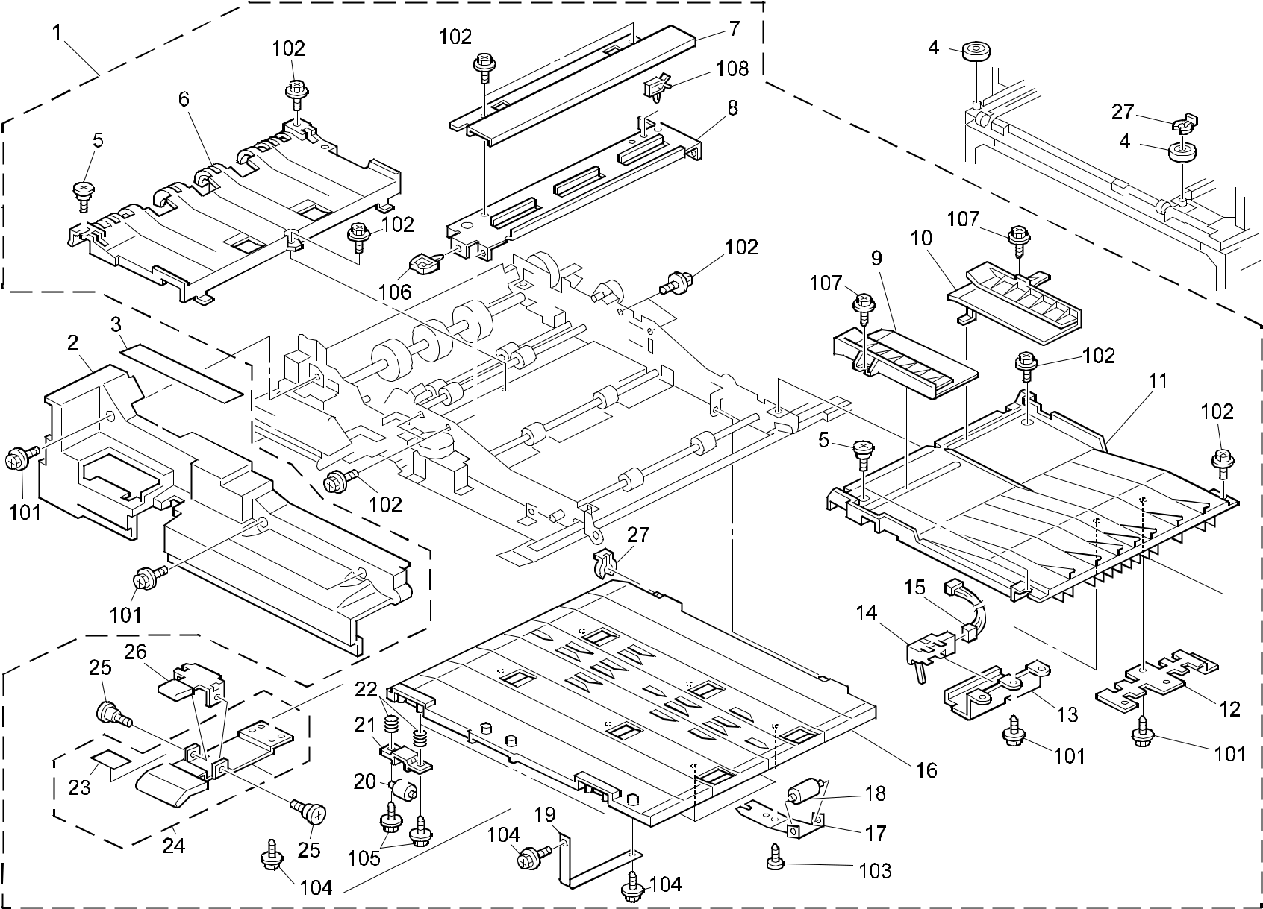

A292/A293/B098 102 Parts Location and List

45.INVERTOR & DUPLEX UNIT 1 (A292/A293/B098)

Index | Part No. | Description | Q’ty Per
No. | Part No. | Description | Assembly
1 | A293 4501 | Duplex Unit (A292/A293) | 1
1 | B098 4501 | Duplex Unit:Ass'y (B098) | 1
2 | A229 4820 | Duplex Inner Cover (A292/A293) | 1
2 | B098 4820 | Inner Cover:Duplex Unit (B098) | 1
3 | A229 4821 | Decal - Warning | 1
4 | A300 2134 | Guide Roller - B | 2
5 | AA14 3037 | Development Cover Screw | 3
6 | A293 4717 | Reverse Guide Plate - Left Lower | 1
 |  | (A292/A293)
6 | B098 4717 | Guide Plate:Reverse:Lower:Left (B098) | 1
7 | A229 4808 | Upper Harness Bracket | 1
8 | A229 4807 | Lower Harness Bracket | 1
9 | A229 4684 | Front Jogger Side Fence (A292/A293) | 1
9 | B098 4684 | Side Fence:Jogger:Front (B098) | 1
10 | A229 4687 | Rear Jogger Side Fence (A292/A293) | 1
10 | B098 4687 | Side Fence:Jogger:Rear (B098) | 1
11 | A229 4713 | Reverse Guide Plate - Right Lower | 1
 |  | (A292/A293)
11 | B098 4713 | Guide Plate:Reverse:Lower:Right (B098) | 1
12 | A229 4716 | Harness Plate Bracket | 1
13 | A229 4715 | Optics Sensor Right Bracket | 1
14 | AW02 0126 | Photointerruptor | 1
15 | A229 5442 | Duplex Connecting Harness | 1
16 | A229 4726 | Lower Transport Guide Plate | 1
17 | A229 4728 | Driven Roller Spring Plate | 6
18 | AF02 2077 | Driven Roller | 6
19 | A096 4928 | Guide Plate Band | 1
20 | AF02 2067 | Guide Stopper Roller (A292/A293) | 2
20 | AF02 2153 | Roller:Pressure:Guide:Horizontal (B098) | 2
21 | A229 4727 | Guide Plate Pressure Holder | 2
22 | AA06 3581 | Compression Spring | 4
23 | A229 4734 | Decal - Guide Plate Lever | 1
24 | A229 4729 | Guide Plate Lever | 1
25 | AA14 3307 | Stepped Screw - M3 | 2
26 | A096 4933 | Guide Plate Lever Hook (A292/A293) | 1

Index | Part No. | Description | Q’ty Per
No. | Part No. | Description | Assembly
26 | B098 4933 | Hook:Lever:Guide Plate:Ass'y (B098) | 1
27 | 5447 2681 | Snap Ring | 2

- 0451 4008B Philips Tapping Screw - M4x8

- 0451 4006B Tapping Screw - 4x6

- 0452 3006B Tapping Screw - M3x6

- 0450 4008B Tapping Screw - 4x8

- 0450 3006B Tapping Screw - M3x6

106 1105 0199 Clamp

- 0450 3008B Tapping Screw - M3x8

- 1105 0283 Clamp

A292/A293/B098 103 Parts Location and List

46.INVERTOR & DUPLEX UNIT 2 (A292/A293/B098)
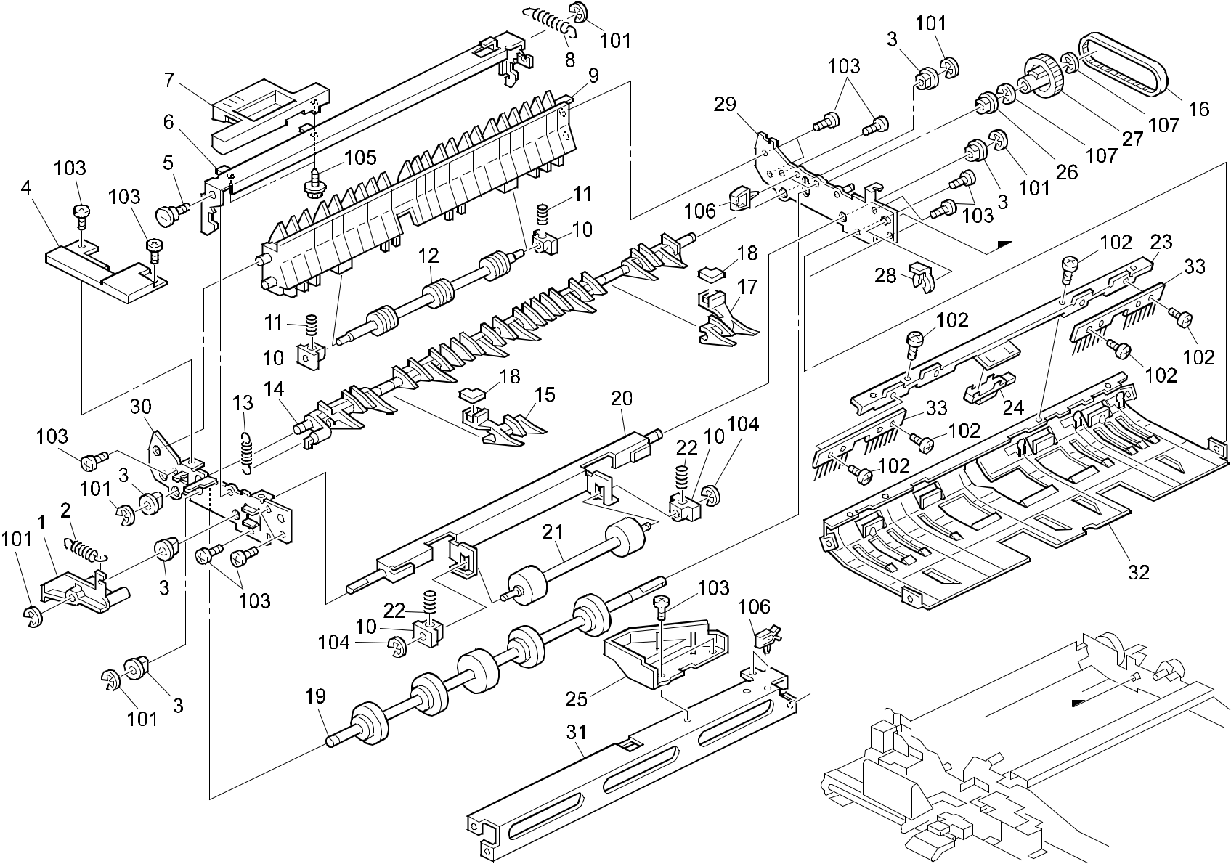

A292/A293/B098 104 Parts Location and List

46.INVERTOR & DUPLEX UNIT 2 (A292/A293/B098)

Index | Part No. | Description | Q’ty Per
No. | Part No. | Description | Assembly
1 | A229 4638 | Reversal Driven Roller Lever | 1
2 | AA06 0729 | Tension Spring | 1
3 | AA08 2046 | Bushing - 6x12x6 | 5
4 | A229 4655 | Reverse Unit Cover | 1
5 | AA14 3420 | Stepped Screw - M4x5 | 1
6 | A229 4643 | Grip Stay | 1
7 | A229 4647 | Reverse Unit Knob | 1
8 | AA06 0730 | Tension Spring | 1
9 | A229 4623 | Lower Entrance Guide Plate | 1
10 | AA08 0034 | Bushing - 4x5x7 | 4
11 | AA06 3579 | Compression Spring | 2
12 | A229 4624 | Duplex Driven Roller | 1
13 | AA06 0728 | Tension Spring | 1
14 | A293 4611 | Reverse Gae Pawl | 1
15 | A293 4613 | Front Gate Pawl | 1
16 | AA04 3487 | Timing Belt - Reverse Roller | 1
17 | A293 4614 | Rear Gate Pawl | 1
18 | A293 4615 | Spacer | 2
19 | AF02 0497 | Reverse Roller | 1
20 | A229 4640 | Reversal Bracket | 1
21 | AF02 0432 | Driven Roller | 1
22 | AA06 3580 | Compression Spring | 2
23 | A229 4616 | Photo Reflection Sensor Bracket | 1
24 | AW01 0058 | Photosensor | 1
25 | A229 4628 | Pressure Lever Cam | 1
26 | AA08 2070 | Bushing - 8x16x7 | 1
27 | AB03 0663 | Pulley | 1
28 | 5447 2681 | Snap Ring | 1
29 | A229 4603 | Rear Side Plate - Reverse Ass'y | 1
30 | A229 4602 | Front Side Plate | 1
31 | A229 4627 | Inverter Stay | 1
32 | A293 4619 | Upper Entrance Guide Plate | 1
33 | A229 4617 | Duplex Discharge Brush | 2

Index | Part No. | Description | Q’ty Per
No. | Part No. | Description | Assembly

- 0720 0040B Retaining Ring - M4

- 0313 0050B Philips Pan Head Screw - M3x5

- 0354 0060B Screw - M4X6

- 0720 0030B Retaining Ring - M3

- 0450 3008B Tapping Screw - M3x8

106 | 1105 | 0283 | Clamp
107 | 0720 | 0060B | Retaining Ring - M6

A292/A293/B098 105 Parts Location and List

47.INVERTOR & DUPLEX UNIT 3 (A292/A293/B098)
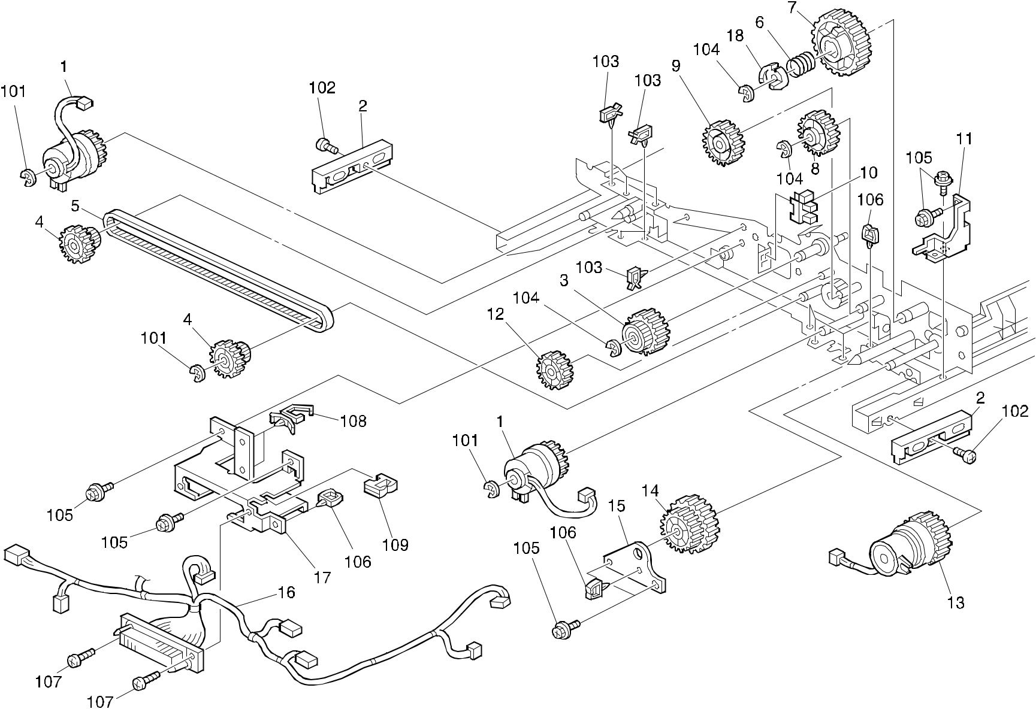

A292/A293/B098 106 Parts Location and List

47.INVERTOR & DUPLEX UNIT 3 (A292/A293/B098)

Index | Part No. | Description | Q’ty Per
No. | Part No. | Description | Assembly
1 | AX20 0206 | Magnetic Clutch (A292/A293) | 2
1 | B098 4533 | Magnetic Clutch:Transport:Duplex (B098) | 2
2 | A096 4595 | Duplex Guide (A292/A293) | 2
2 | B098 4595 | Guide:Duplex Unit:Right:Left (B098) | 2
3 | AB01 7468 | Idler Gear - 30Z | 1
4 | AB01 7469 | Timing Pulley Gear | 2
5 | AA04 3489 | Rear Timing Belt - Driven | 1
6 | AA06 3582 | Compression Spring | 1
7 | AB01 4078 | Drive Gear - 51Z | 1
8 | AB01 4081 | Idler Gear - 29Z | 1
9 | AB01 4082 | Reversal Idler Gear - 31Z | 1
10 | AW02 0056 | Photointerrupter - EE-SX4235A-P1 | 1
11 | A293 4678 | Support Bracket | 1
12 | AB01 4084 | Idler Gear - 31Z | 1
13 | AX20 0178 | Magnetic Clutch | 1
14 | AB01 4080 | Idler Gear - 28/40Z | 1
15 | A293 4679 | Positioning Pin Bracket | 1
16 | A293 5441 | Duplex Unit Harness | 1
17 | A293 4818 | Connector Bracket | 1
18 | A229 4740 | Drive Joint | 1

Index | Part No. | Description | Q’ty Per
No. | Part No. | Description | Assembly

- 0720 0040B Retaining Ring - M4

- 0434 0080 Tapping Screw - M4x8

- 1105 0283 Clamp

- 0720 0060B Retaining Ring - M6

- 0451 4006B Tapping Screw - 4x6

- 1105 0229 Clamp

- 0453 3008B Bind Tapping Screw - M3x8

- 1105 0310 Harness Clamp - LWS-1S

- 1105 0328 Harness Clamp - ES-0505

A292/A293/B098 107 Parts Location and List

48.INVERTOR & DUPLEX UNIT 4 (A292/A293/B098)
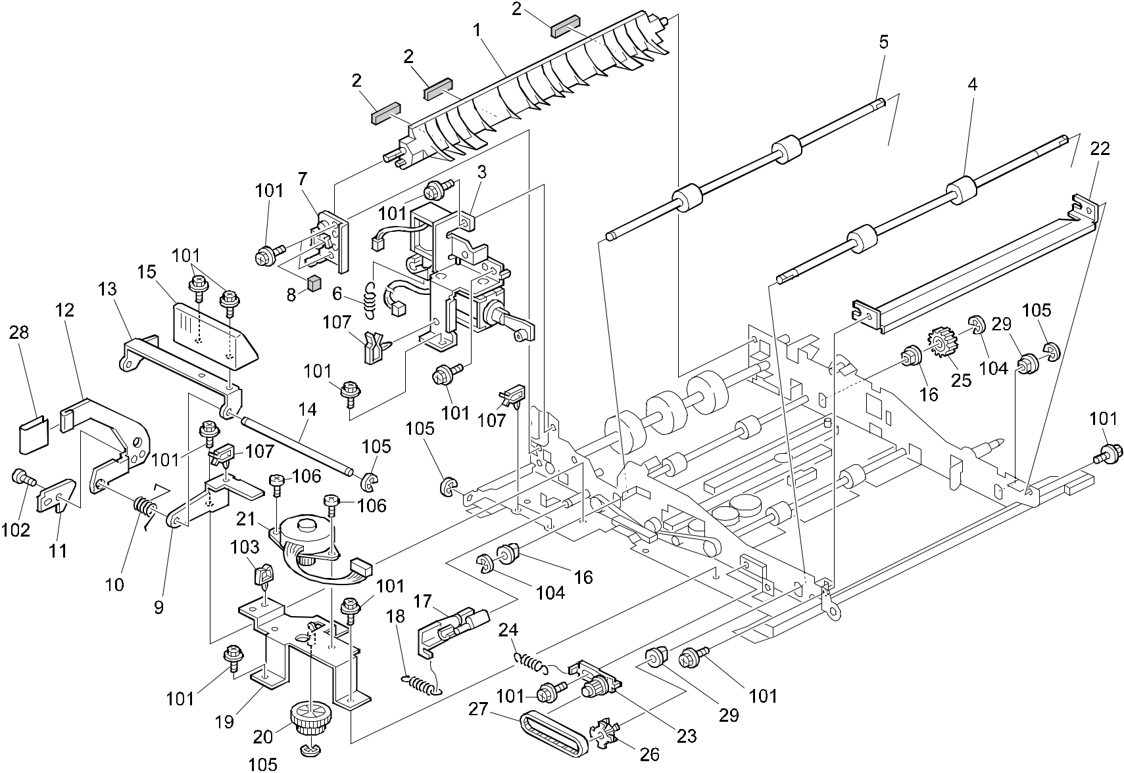

A292/A293/B098 108 Parts Location and List

48.INVERTOR & DUPLEX UNIT 4 (A292/A293/B098)

Index | Part No. | Description | Q’ty Per
No. | Part No. | Description | Assembly
1 | A229 4765 | Duplex Gate Pawl | 1
2 | A229 4766 | Damping Insulation | 3
3 | A293 4782 | DC Solenoid Ass'y | 1
4 | AF02 0435 | Drive Roller (A292/A293) | 1
4 | AF02 0580 | Roller:Drive:Left:Right (B098) | 1
5 | AF02 0494 | Reversal Drive Roller | 1
6 | AA06 0835 | Tension Spring | 1
7 | A229 4772 | Gate Pawl Bracket | 1
8 | A229 4773 | Gate Pawl Sound Proofing | 1
9 | A229 4804 | Lever Support Bracket | 1
10 | AA06 6223 | Grip Spring | 1
11 | A229 4802 | Lock Lever | 1
12 | A229 4812 | Lock Arm | 1
13 | A096 4882 | Release Bracket | 1
14 | AA14 0504 | Release Lever Shaft | 1
15 | A229 4806 | Release Lever (A292/A293) | 1
15 | B098 4806 | Lever:Release:Duplex Unit (B098) | 1
16 | AA08 0308 | Bushing - 8mm | 2
17 | A229 4793 | DC Solenoid Lever | 1
18 | AA06 0743 | Tension Spring | 1
19 | A229 4708 | Stepper Motor Bracket | 1
20 | AB01 4085 | Idler Gear - 18/52Z | 1
21 | A134 5291 | Jogger Drive Motor DC 6.48W | 1
22 | A229 4800 | Exit Guide Plate (A292/A293) | 1
22 | B098 4800 | Guide Plate:Duplex:Exit (B098) | 1
23 | A229 4487 | Exit Tightener | 1
24 | AA06 0764 | Tension Spring | 1
25 | AB01 4083 | Reversal Roller Gear - 23Z | 1
26 | AB03 0583 | Timing Pulley - 24Z | 1
27 | AA04 3390 | Timing Belt - 40S2M192 | 1
28 | A229 4813 | Arm Pad | 1
29 | 5053 0447 | Bushing - 6mm | 2

Index | Part No. | Description | Q’ty Per
No. | Part No. | Description | Assembly

- 0451 4006B Tapping Screw - 4x6

- 0434 0080B Pan Head Self-tapping Screw - M4x8

- 1105 0199 Clamp

- 0720 0060B Retaining Ring - M6

- 0720 0040B Retaining Ring - M4

- 0453 3006B Tapping Screw - M3x6

- 1105 0283 Clamp

A292/A293/B098 109 Parts Location and List

49.INVERTOR & DUPLEX UNIT 5 (A292/A293/B098)
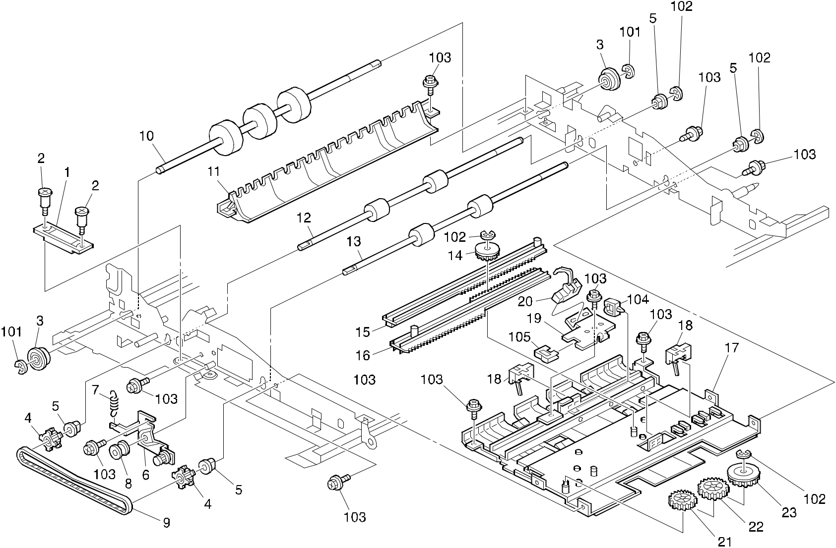

A292/A293/B098 110 Parts Location and List

49.INVERTOR & DUPLEX UNIT 5 (A292/A293/B098)

Index | Part No. | Description | Q’ty Per
No. | Part No. | Description | Assembly
1 | AA02 1025 | Magnet Catch | 1
2 | AA14 3183 | Stepped Screw | 2
3 | A232 3566 | Ball Bearing - 8x16x5 | 2
4 | AB03 0583 | Timing Pulley - 24Z | 2
5 | 5053 0447 | Bushing - 6mm | 4
6 | A229 4755 | Front Tightener | 1
7 | AA06 0742 | Tension Spring | 1
8 | AB03 0431 | Transport Pulley | 1
9 | AA04 3488 | Timing Belt - Front Drive | 1
10 | AF02 0533 | Duplex Roller | 1
11 | A229 4719 | Lower Duplex Guide Plate | 1
12 | AF02 0435 | Drive Roller | 1
13 | AF02 0436 | Middle Drive Roller | 1
14 | AB01 4089 | Side Fence Gear | 1
15 | A229 4688 | Rear Side Fence Rack | 1
16 | A229 4685 | Front Side Fence Rack | 1
17 | A293 4705 | Upper Transport Guide Plate (A292/A293) | 1
17 | B098 4705 | Stay:Guide Plate:Ass'y (B098) | 1
18 | AW02 0126 | Photointerruptor | 2
19 | A293 4725 | Sensor Bracket | 1
20 | AW02 0113 | Photointerruptor | 1
21 | AB01 4086 | Gear - 27Z | 1
22 | AB01 4087 | Gear - 31Z | 1
23 | AB01 4088 | Gear - 33Z | 1

Index | Part No. |  | Description | Q’ty Per
No. |  |  | Description | Assembly
101 | 0720 | 0060B | Retaining Ring - M6
102 | 0720 | 0040B | Retaining Ring - M4
103 | 0451 | 4006B | Tapping Screw - 4x6
104 | 1105 | 0229 | Clamp
105 | 1105 | 0328 | Harness Clamp - ES-0505

A292/A293/B098 111 Parts Location and List

50.PAPER EXIT 1 (A292/A293/B098)
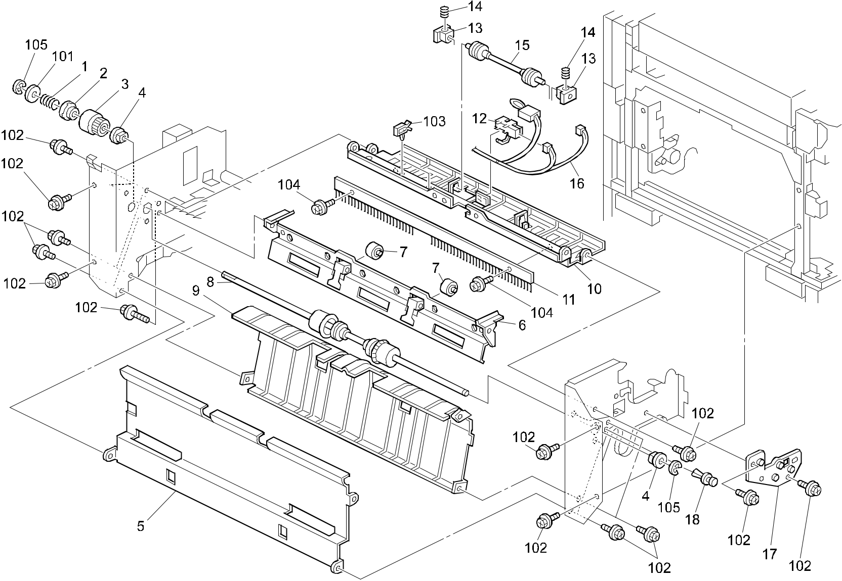

A292/A293/B098 112 Parts Location and List

50.PAPER EXIT 1 (A292/A293/B098)

Index | Part No. | Description | Q’ty Per
No. | Part No. | Description | Assembly
1 | A470 1704 | Spring - Lower Exit Roller | 1
2 | A470 1703 | Shift Clutch | 1
3 | AB03 0579 | Timing Pulley - 27Z | 1
4 | AA08 2058 | Bushing - 6x10x9mm | 2
5 | A293 4463 | Exit Cover (A292/A293) | 1
5 | B098 4463 | Cover:Exit (B098) | 1
6 | A229 4460 | Exit Roller Bracket (A292/A293) | 1
6 | B098 4460 | Bracket:Exit Roller:Ass'y (B098) | 1
7 | AF04 0031 | Driven Roller | 2
8 | AF02 0508 | Exit Drive Roller | 1
9 | A293 4456 | Reverse Guide Plate (A292/A293) | 1
9 | B098 4456 | Guide Plate:Reverse:Left (B098) | 1
10 | A229 4458 | Exit Guide Plate (A292/A293) | 1
10 | B098 4458 | Guide Plate:Exit:Exit (B098) | 1
11 | A229 4490 | Discharge Brush | 1
12 | AW02 0106 | Photointerruptor | 1
13 | AA08 0034 | Bushing - 4x5x7 | 2
14 | AA06 3577 | Compression Spring | 2
15 | AF02 2126 | Exit Roller - Driven | 1
16 | A293 5436 | Paper Exit Unit Harness | 1
17 | A229 4484 | Exit Drum Stay | 1
18 | A048 2838 | Nylon Rivet | 1

Index | Part No. |  | Description | Q’ty Per
No. |  |  | Description | Assembly
101 | 0807 | 4146 | Flat Washer - 6.3x18x1
102 | 0451 | 4008B | Philips Tapping Screw - M4x8
103 | 1105 | 0260 | Wire Saddle

- 0451 3006B Tapping Screw - M3x6

- 0720 0040B Retaining Ring - M4

A292/A293/B098 113 Parts Location and List

51.PAPER EXIT 2 (A292/A293/B098)
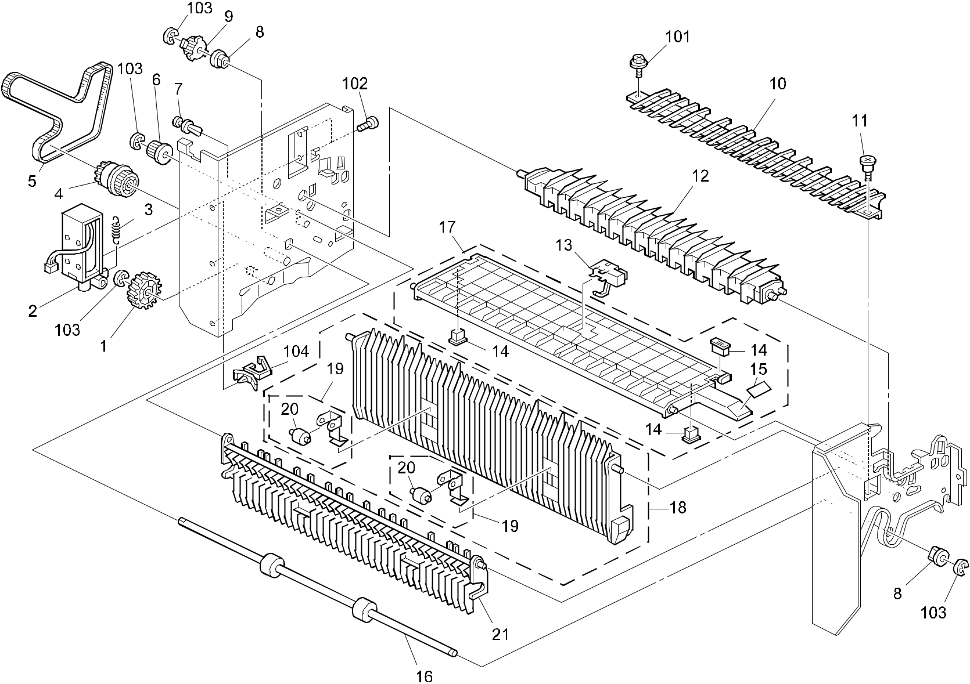

A292/A293/B098 114 Parts Location and List

51.PAPER EXIT 2 (A292/A293/B098)

Index | Part No. | Description | Q’ty Per
No. | Part No. | Description | Assembly
1 | AB01 4075 | Exit Gear - 29Z | 1
2 | A229 4469 | DC Solenoid | 1
3 | AA06 0717 | Tension Spring | 1
4 | AB01 7465 | Timing Pulley - 41Z 24Z | 1
5 | AA04 3270 | Timing Belt - 40DS2M420G | 1
6 | AB03 0577 | Timing Pulley - 20Z | 1
7 | A048 2838 | Nylon Rivet | 1
8 | AA08 2058 | Bushing - 6x10x9mm | 2
9 | AB03 0580 | Timing Pulley - 27Z | 1
10 | A229 4476 | Middle Guide Plate (A292/A293) | 1
10 | B098 4476 | Guide Plate:Exit:Middle (B098) | 1
11 | A077 4162 | Shoulder Screw - M3 | 1
12 | A229 4475 | Exit Gate Pawl (A292/A293) | 1
12 | B098 4475 | Gate Pawl:Exit (B098) | 1
13 | AW02 0106 | Photointerruptor | 1
14 | G012 1531 | Magnet | 3
15 | A229 4492 | Decal - Exit Guide | 1
16 | AF02 0429 | Drive Reverse Roller | 1
17 | A229 4472 | Exit Upper Guide Plate | 1
18 | A229 4478 | Right Invertor Guide | 1
19 | A229 4481 | Exit Holder - Roller Sub-Ass'y | 2
20 | AF04 0031 | Driven Roller | 2
21 | A229 4477 | Reverse Guide Plate | 1

Index | Part No. |  | Description | Q’ty Per
No. |  |  | Description | Assembly
101 | 0451 | 4008B | Philips Tapping Screw - M4x8
102 | 0353 | 0040B | Screw - M3X4
103 | 0720 | 0040B | Retaining Ring - M4
104 | 1105 | 0260 | Wire Saddle

A292/A293/B098 115 Parts Location and List

52.PAPER EXIT 3 (A292/A293/B098)
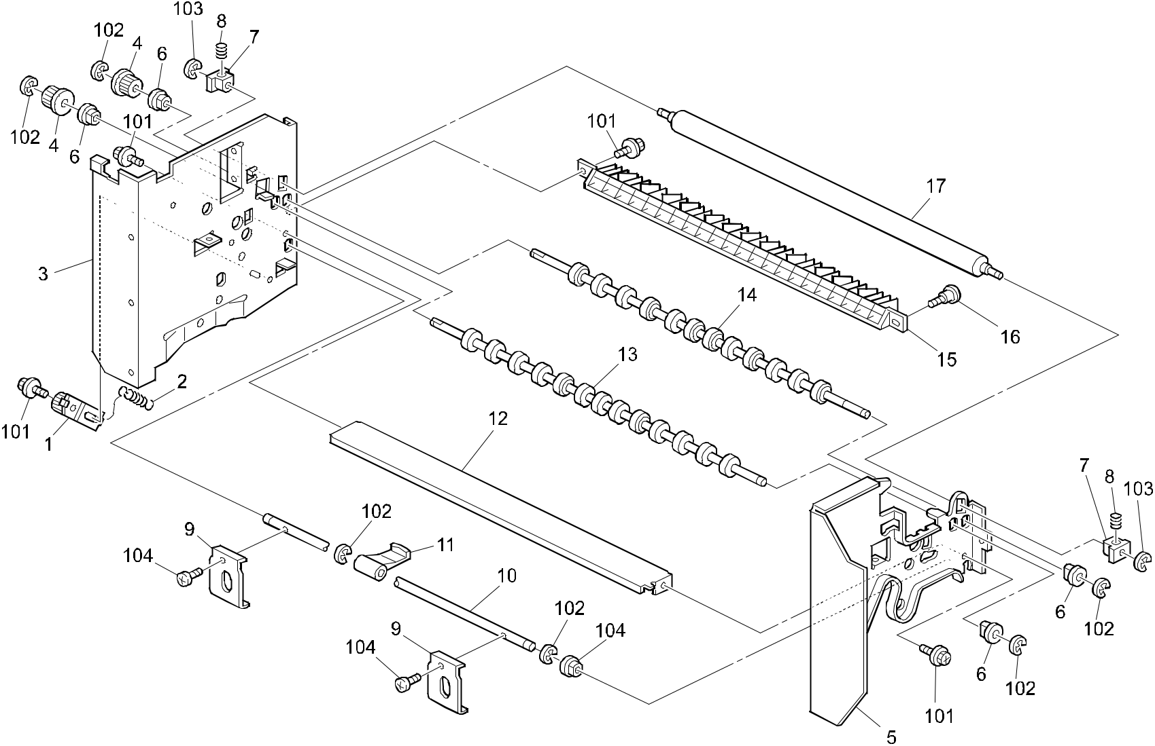

A292/A293/B098 116 Parts Location and List

52.PAPER EXIT 3 (A292/A293/B098)

Index | Part No. | Description | Q’ty Per
No. | Part No. | Description | Assembly
1 | A229 4487 | Exit Tightener | 1
2 | AA06 0718 | Tension Spring | 1
3 | A293 4451 | Exit Rear Side Plate (A292/A293) | 1
3 | B098 4451 | Side Plate:Rear:Exit:Ass'y (B098) | 1
4 | AB03 0578 | Timing Pulley - 18Z | 2
5 | A229 4453 | Exit Front Side Plate (A292/A293) | 1
5 | B098 4453 | Side Plate:Front:Exit:Ass'y (B098) | 1
6 | AA08 2058 | Bushing - 6x10x9mm | 4
7 | AA08 0240 | Bushing - Mm5 | 2
8 | AA06 3578 | Compression Spring | 2
9 | A229 4467 | Pressure Arm | 2
10 | A293 4466 | Pressure Shaft | 1
11 | A229 4468 | Guide Plate Lever | 1
12 | A229 4464 | Right Exit Stay | 1
13 | AF02 0428 | Exit Decura Roller | 1
14 | AF02 0427 | Entrance Decura Roller | 1
15 | A229 4474 | Exit Lower Guide Plate | 1
16 | A077 4162 | Shoulder Screw - M3 | 1
17 | A293 4469 | Decura Driven Roller | 1

Index | Part No. | Description | Q’ty Per
No. | Part No. | Description | Assembly

- 0451 4008B Philips Tapping Screw - M4x8

- 0720 0040B Retaining Ring - M4

- 0720 0030B Retaining Ring - M3

- 0353 0060B Philips Pan Head Screw - M3x6

A292/A293/B098 117 Parts Location and List

53.DRIVE SECTION 1 (A292/A293/B098)
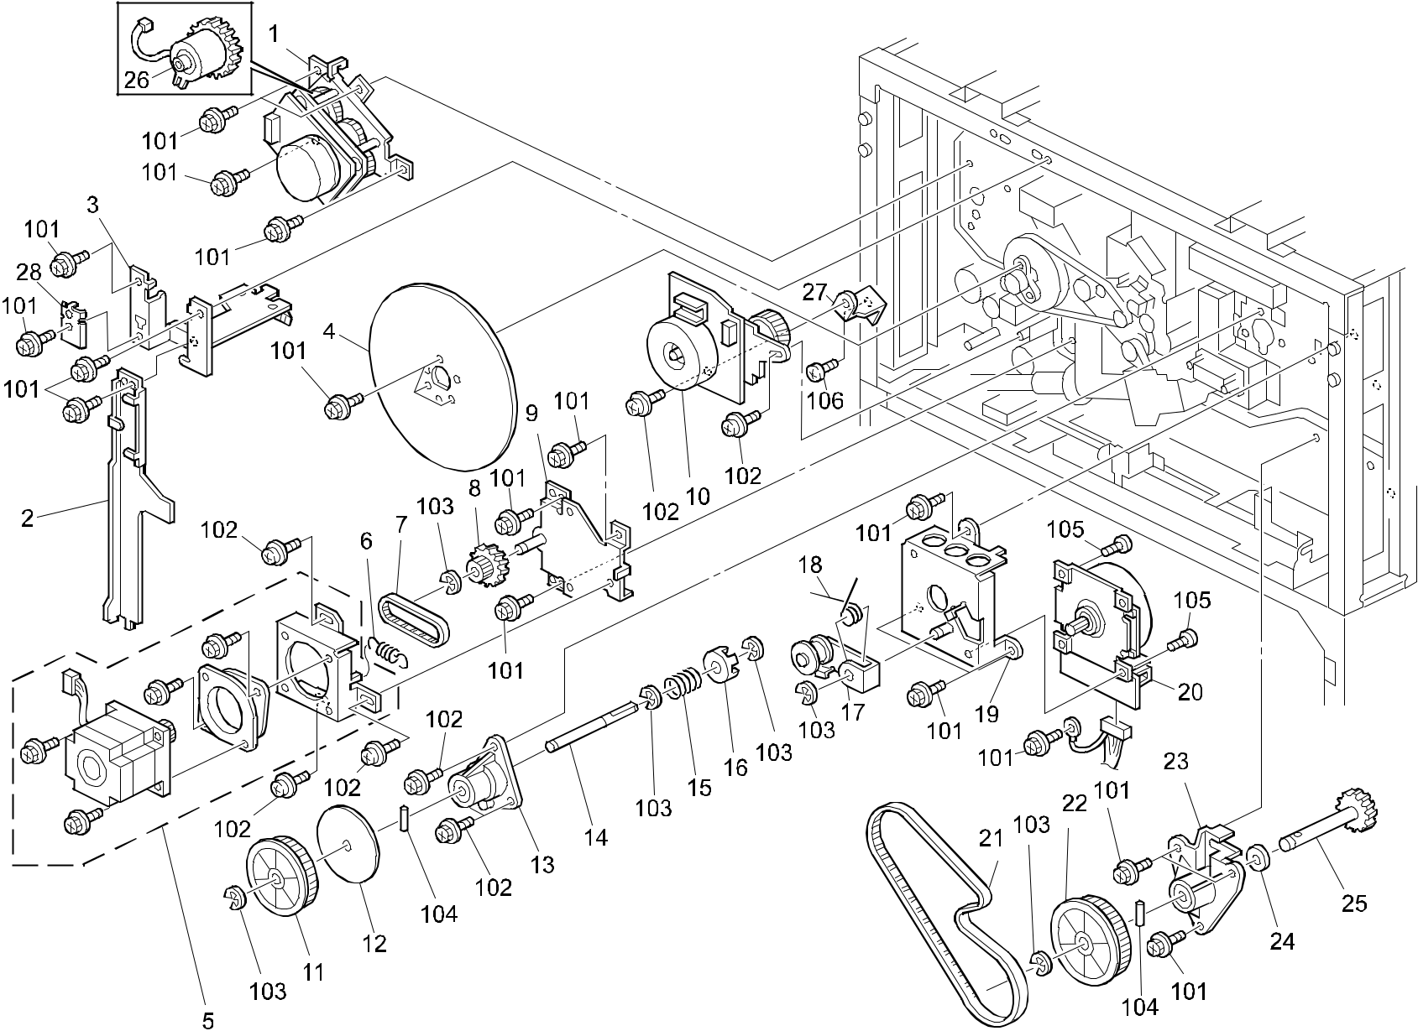

A292/A293/B098 118 Parts Location and List

53.DRIVE SECTION 1 (A292/A293/B098)

Index | Part No. | Description | Q’ty Per
No. | Part No. | Description | Assembly
1 | A293 5305 | DC Motor - 20.7W | 1
2 | A229 5865 | Harness Guide | 1
3 | A229 5891 | Main Harness Guide (A292/A293) | 1
3 | B098 5891 | Guide:Harness:Main:Ass'y (B098) | 1
4 | A134 1135 | Fly Wheel (A292/A293) | 1
4 | B098 1135 | Fly Wheel (B098) | 1
5 | A229 1026 | Stepper Motor Ass'y - DC14.1W | 1
6 | AA06 0720 | Tension Spring - 7.75N | 1
7 | AA04 3269 | Timing Belt - S2M114 | 1
8 | AB01 7449 | Gear - 21Z/24T | 1
9 | A229 1133 | Stepper Motor Base Ass'y | 1
10 | A293 2845 | DC Motor - 9W | 1
11 | AB03 0427 | Pulley - 81Z | 1
12 | A229 1135 | Ring - 55 | 1
13 | A096 1165 | Fusing Drive Bracket | 1
14 | A229 1136 | Fusing Drive Shaft | 1
15 | AA06 3490 | Spring - 21.6mm | 1
16 | A096 1173 | Fusing Drive Joint | 1
17 | A229 1139 | Tightener | 1
18 | AA06 6309 | Torsion Spring | 1
19 | A229 1122 | Motor Bracket | 1
20 | AX06 0188 | DC Motor - 32W | 1
21 | AA04 3277 | Timeng Belt - 656P2M6 | 1
22 | AB03 0573 | Pulley - 102Z (A292/A293) | 1
22 | AB03 0753 | Pulley:T81 (B098) | 1
23 | A293 1155 | Duplex Drive Bracket | 1
24 | A001 2582 | Spacer - 8x10x1.6mm | 1
25 | A293 1138 | Duplex Drive Shaft | 1
26 | AX20 0093 | Magnetic Clutch | 1
27 | A293 2666 | Bracket - By-pass Feed Motor | 1
28 | B098 5419 | Ground Plate:Control Board:Printer (B098) | 1

Index | Part No. | Description | Q’ty Per
No. | Part No. | Description | Assembly

- 0451 4008B Philips Tapping Screw - M4x8

- 0951 4008B Philips Screw With Washer - M4x8

- 0720 0060B Retaining Ring - M6

- 0623 0140E Spring Pin - 3x14mm

- 0354 0050B Bind Screw - M4x5

- 0951 4006B Philips Screw With Washer - M4x6

A292/A293/B098 119 Parts Location and List

54.DRIVE SECTION 2 (A292/A293/B098)
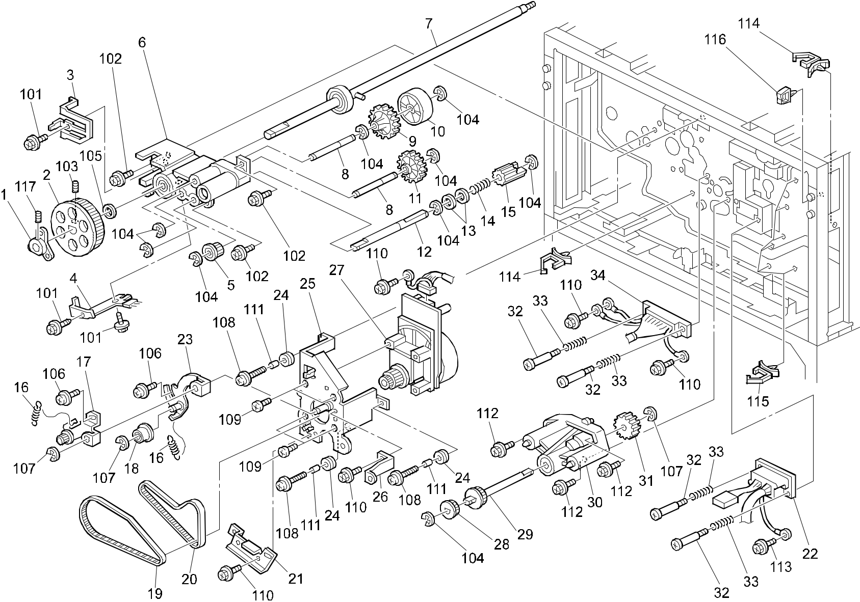

A292/A293/B098 120 Parts Location and List

54.DRIVE SECTION 2 (A292/A293/B098)

Index | Part No. | Description | Q’ty Per
No. | Part No. | Description | Assembly
1 | AA13 4092 | Flange - Fly Wheel | 1
2 | A096 2316 | Drum Pulley - 125Z (A292/A293) | 1
2 | B098 2316 | Pulley:Drum:Z125 (B098) | 1
3 | A247 2327 | Terminal Development Bias | 1
4 | A247 2341 | Electrode Plate - Drum Shaft | 1
5 | AB03 0644 | Pulley - Clening Drive | 1
6 | A294 3680 | Drum Shaft Stay | 1
7 | A229 1141 | Drum Drive Shaft (A292/A293) | 1
7 | B098 1141 | Shaft:Drum:Drive:Ass'y (B098) | 1
8 | AA14 8579 | Shaft - Transport Slide | 2
9 | AB01 7473 | Gear - 32Z | 1
10 | A294 3671 | Cam - Blade Slide | 1
11 | AB01 2002 | Gear - 13Z | 1
12 | AA14 8578 | Shaft - Cleaning Drive | 1
13 | AA13 2024 | Spacer - M6 | 2
14 | AA06 3604 | Pressure Spring | 1
15 | A294 3656 | Gear Joint - Z16 | 1
16 | AA06 0719 | Tension Spring - 9.34N | 2
17 | A096 1115 | Tightener | 1
18 | AB03 2716 | Idle Pulley - M18 | 1
19 | AA04 3267 | Timing Belt - 426P2M6 | 1
20 | AA04 3284 | Timing Belt - 300P3M6 | 1
21 | A293 1145 | Drum Shaft Stay | 1
22 | A293 5600 | AC Main Harness (120V) | 1
22 | A293 7651 | AC Main Harness - 230V | 1
23 | A229 1130 | Cleaning Tightener Ass'y | 1
24 | AA16 1104 | Cushion - Motor | 3
25 | A229 1120 | Main Motor Bracket | 1
26 | A293 5853 | Right Fix Bracket | 1
27 | AX06 0187 | DC Motor - 22.7W | 1
28 | AB03 0720 | Toner Recycling Pulley 50T | 1
29 | A293 1126 | Belt Drive Shaft | 1
30 | A096 1123 | Belt Drive Bracket | 1
31 | AB01 4163 | Drive Gear - Transfer Belt | 1
32 | 5446 5832 | Connector Guide Pin | 4

Index | Part No. | Description | Q’ty Per
No. | Part No. | Description | Assembly
33 | AA06 3068 | Spring Connector | 4
34 | A293 5415 | Process Control Harness | 1

- 0450 3008B Tapping Screw - M3x8

- 0951 4012B Philips Screw With Flat Washer

- 0574 0050E Hexagon Headless Set Screw - M4x5

(A292/A293)

- 0451 4012Z Tapping Screw M4x12 (B098)

- 0720 0040B Retaining Ring - M4

105 0807 7039 Spacer - M12

- 0951 4008B Philips Screw With Washer - M4x8

- 0720 0060B Retaining Ring - M6

- 0951 4010B Philips Screw With Washer - M4x10

- 0354 0050B Bind Screw - M4x5

- 0451 4008B Philips Tapping Screw - M4x8

- 0707 4050B Bushing - 4 X5

- 0451 4012B Tapping Screw - 4x12

- 0801 0149 Philips Pan Head Screw - M4x6

- 1105 0310 Harness Clamp - LWS-1S

- 1105 0290 Harness Clamp - Horizontal

116 | 1105 | 0230 | Clamp
117 | 0574 | 0040E | Hexagon Headless Set Screw - M4x4

A292/A293/B098 121 Parts Location and List

55.DRIVE SECTION 3 (A292/A293/B098)
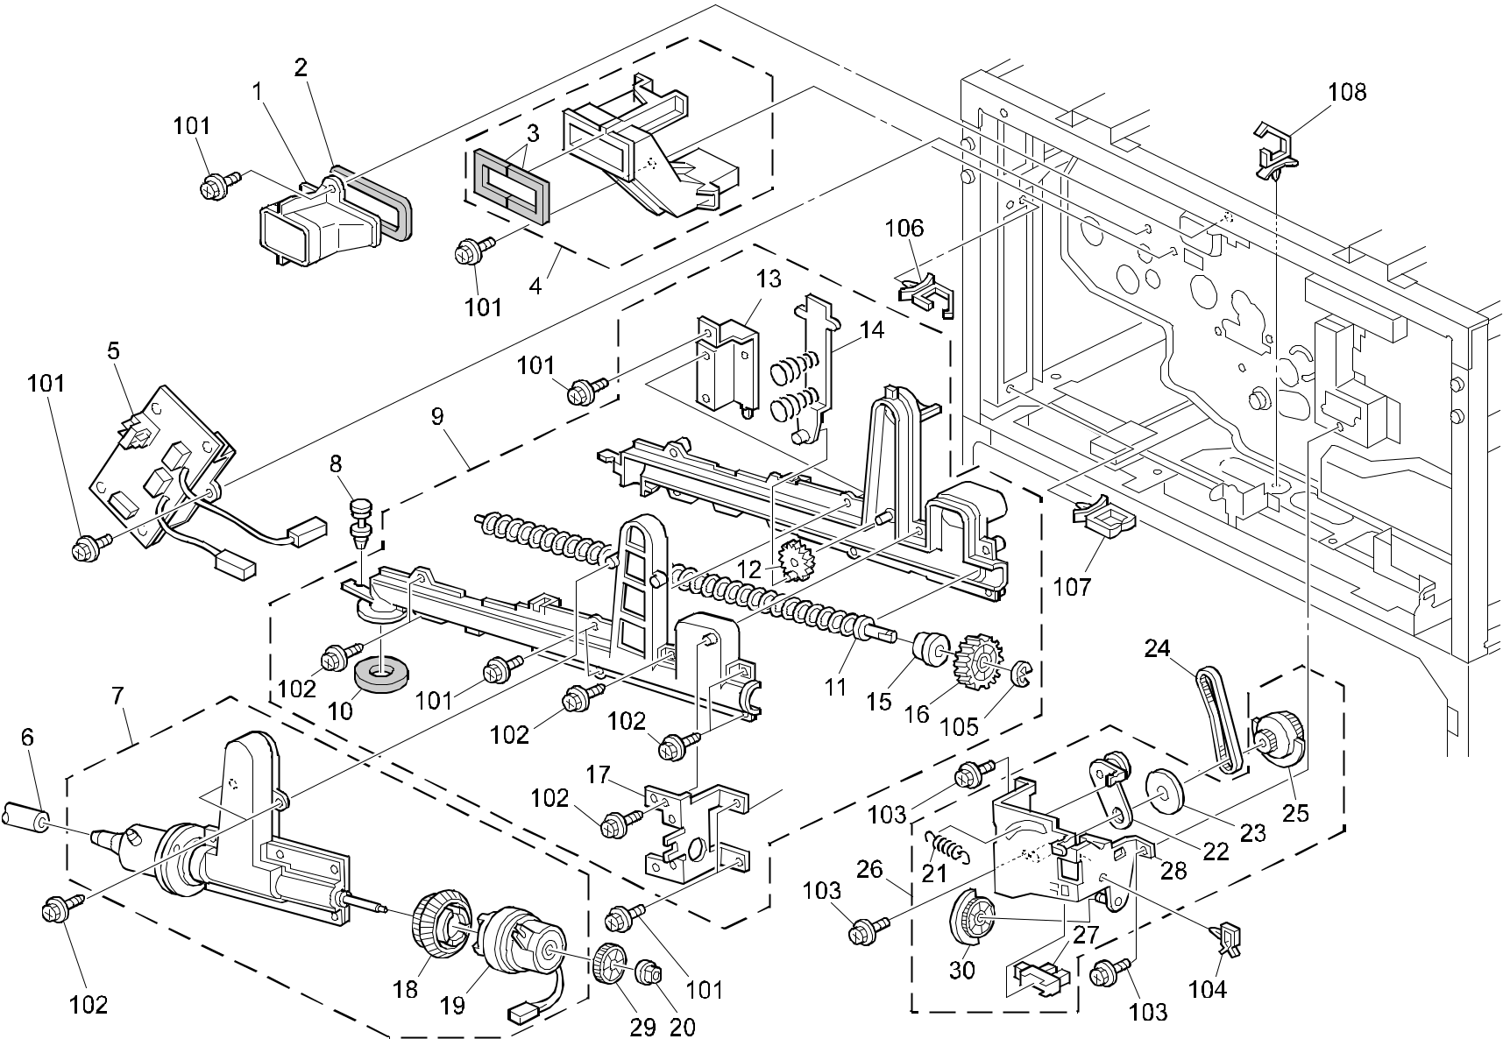

A292/A293/B098 122 Parts Location and List

55.DRIVE SECTION 3 (A292/A293/B098)

Index | Part No. | Description | Q’ty Per
No. | Part No. | Description | Assembly
1 | A096 2083 | Middle Duct (A292/A293) | 1
1 | B098 2083 | Duct:Vacuum:Middle:Sub-Ass'y (B098) | 1
2 | AA15 1770 | Middle Duct Seal | 1
3 | AA15 3115 | Sheal - Drum Cooling Duct | 1
4 | A293 1115 | Drum Cooling Duct (A292/A293) | 1
4 | B098 1115 | Duct:Cooling:Drum:Ass'y (B098) | 1
5 | A229 5016 | Power Pack Ass'y | 1
6 | A229 3555 | Toner Recycling Tube | 1
7 | A229 3551 | Toner Recycling Pump (A292/A293) | 1
7 | B098 3551 | Pump:Toner Recycling:Ass'y (B098) | 1
8 | A096 3697 | Ratch | 1
9 | A229 3554 | Toner Outlet Unit (A292/A293) | 1
9 | B098 3554 | Toner Outlet Unit:Ass'y (B098) | 1
10 | AA15 1814 | Joint Seal - 21x32x10 | 1
11 | AD04 3052 | Transport Screw | 1
12 | AB01 5014 | Toner Recycling Gear - 10Z | 1
13 | A229 3572 | Right Bracket | 1
14 | A229 3641 | Agitator Ass'y | 1
15 | AA08 0187 | Bushing - MM6 | 3
16 | AB01 3846 | Gear - 28Z | 1
17 | A229 3639 | Left Bracket | 1
18 | AB01 7466 | Gear - Z46/Z32 | 1
19 | AX20 0152 | Magnetic Clutch | 1
20 | H053 2208 | Bushing - M4 | 1
21 | AA06 0722 | Tension Spring | 1
22 | A229 3586 | Tightener | 1
23 | A017 2988 | Ring | 1
24 | AA04 3573 | Timing Belt - 240P2M3 | 1
25 | AB01 7467 | Gear - 31Z/30T | 1
26 | A229 3584 | Drive Sub-unit - Toner Recycling | 1
27 | AW02 0056 | Photointerrupter - EE-SX4235A-P1 | 1
28 | A229 3585 | Bracket - Toner Recycling Drive | 1
29 | AB01 2019 | Gear - 25Z | 1
30 | AB01 2020 | Gear - 28Z | 1

Index | Part No. |  | Description | Q’ty Per
No. |  |  | Description | Assembly
101 | 0451 | 4008B | Philips Tapping Screw - M4x8
102 | 0450 | 3008B | Tapping Screw - M3x8
103 | 0451 | 4008W | Tapping Screw - M4x8
104 | 1105 | 0267 | Harness Clamp - YMC-10-0
105 | 0720 | 0040B | Retaining Ring - M4
106 | 1105 | 0291 | Harness Clamp - LWS-3S
107 | 1105 | 0201 | Harness Clamp
108 | 1105 | 0316 | Clamp

A292/A293/B098 123 Parts Location and List

56.DRIVE SECTION 4 (A292/A293/B098)
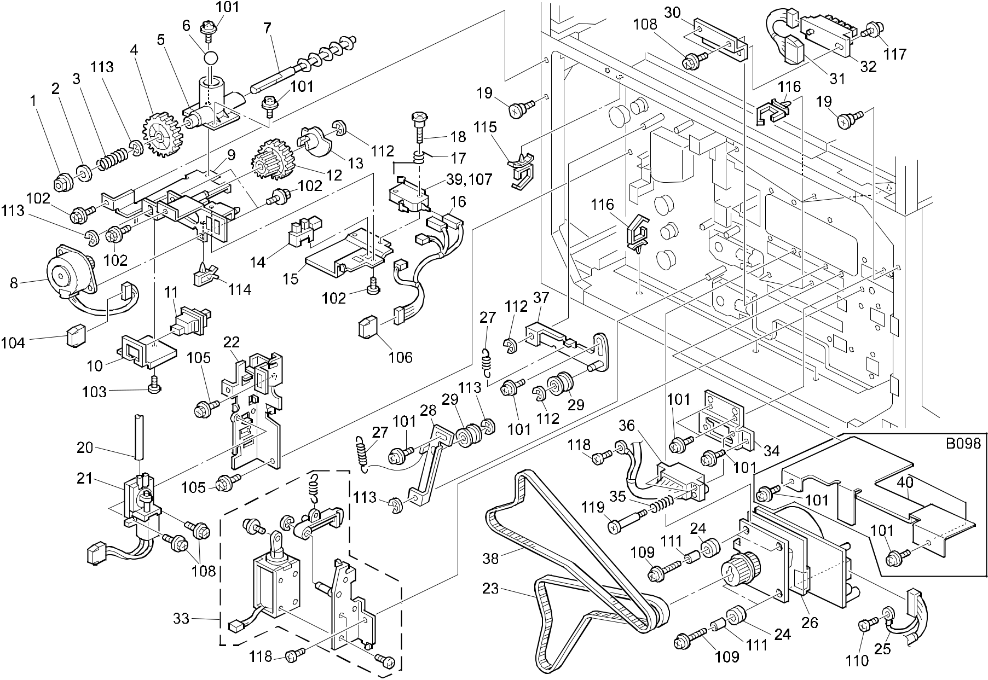

A292/A293/B098 124 Parts Location and List

56.DRIVE SECTION 4 (A292/A293/B098)

Index | Part No. | Description | Q’ty Per
No. | Part No. | Description | Assembly
1 | 5053 0709 | Bushing - 6x10x6mm | 1
2 | AA13 2024 | Spacer - M6 | 1
3 | AA06 3375 | Spring - 24.3mm | 1
4 | AB01 1129 | Gear - 45Z | 1
5 | A096 3729 | Toner Collection Joint (A292/A293) | 1
5 | B098 3729 | Case:toner Collection Coil:Ass'y (B098) | 1
6 | A096 3736 | Steel Ball - M11 | 1
7 | AD04 3032 | Toner Collection Coil | 1
8 | A096 5330 | Toner Collection Motor - 12W | 1
9 | A096 3722 | Toner Collection Bracket | 1
10 | A096 3763 | Push Switch Bracket | 1
11 | AW50 0012 | Push Switch | 1
12 | AB01 7289 | Gear - 17/45Z | 1
13 | A096 3752 | Shutter Plate | 1
14 | AW02 0056 | Photointerrupter - EE-SX4235A-P1 | 1
15 | A096 3742 | Sensor Bracket | 1
16 | A096 5414 | Toner Collection Harness | 1
17 | A423 4433 | Spring | 1
18 | A423 4432 | Shoulder Screw - M2.5 | 1
19 | 5919 2201 | Shoulder Screw - M4 | 1
20 | A229 3564 | Air Tube | 1
21 | A293 3624 | Pump Unit - DC24V SUB-Ass'y | 1
22 | A293 3623 | Pump Unit Bracket | 1
23 | AA04 3549 | Timing Belt - 660P3M6530 | 1
24 | AA16 1104 | Cushion - Motor | 4
25 | A293 7603 | Paper Feed Motor Harness | 1
26 | A293 6160 | DC Motor - 18W | 1
27 | AA06 0524 | Tension Spring - 24.8mm | 2
28 | A096 6186 | Lower Tightner - P/B | 1
29 | AB03 2721 | Pulley - M18 | 2
30 | A096 6177 | Paper Size Bracket (A292/A293) | 1
30 | B098 6177 | Bracket:Sensor:Paper Size Sensor (B098) | 1
31 | A096 5416 | Paper Size Harness | 1
32 | AW50 0010 | Push Switch (A292/A293) | 1
32 | AW50 0028 | Push Switch:Paper Size Sensor (B098) | 1

Index | Part No. | Description | Q’ty Per
No. | Part No. | Description | Assembly
33 | A248 6758 | DC Lock Solenoid | 1
34 | A248 6757 | Left Connector Bracket | 1
35 | AA06 3268 | Connector Spring | 2
36 | A293 7601 | Rear Paper Bank Harness | 1
37 | A248 6186 | Upper Tightener | 1
38 | AA04 3550 | Timing Belt - 756P3M6530 | 1
39 | H310 5071 | Micro Switch V-5F936DN (B098) | 1
40 | B098 6814 | Shielding Plate:Motor:Bank:Lower (B098) | 1

- 0951 4006B Philips Screw With Washer - M4x6

- 0314 0060B Philips Pan Head Screw - M4x6

- 0313 0060B Philips Pan Head Screw - M3x6

- 1102 6248 Connector - 5P

- 0434 0060B Pan Head Self-tapping Screw - M4x6

- 1102 6250 Connector - 7P

- 1204 2363 Microswitch - AH735454N (A292/A293)

- 0451 3008B Tapping Screw - M3x8

- 0951 4012W Philips Screw With Washer - M4x12

- 0451 4008B Philips Tapping Screw - M4x8

- 0707 4050B Bushing - 4 X5

- 0720 0060B Retaining Ring - M6

- 0720 0040B Retaining Ring - M4

114 1105 0087 Clamp

- 1105 0291 Harness Clamp - LWS-3S

- 1105 0310 Harness Clamp - LWS-1S

A292/A293/B098 125 Parts Location and List

57.DRIVE SECTION 5 (A292/A293/B098) Rev. 10/30/2002
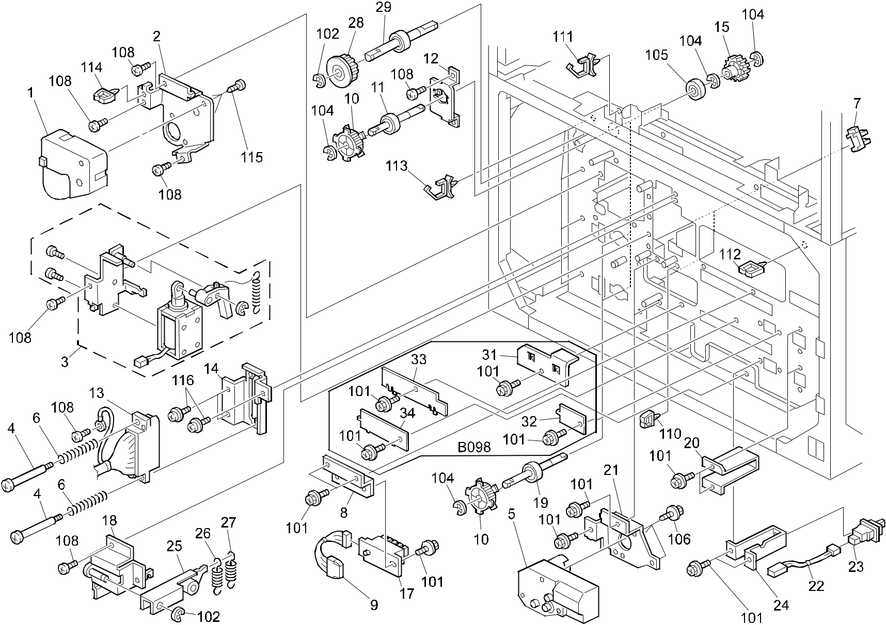

A292/A293/B098 126 Parts Location and List

57.DRIVE SECTION 5 (A292/A293/B098)

Index | Part No. | Description | Q’ty Per
No. | Part No. | Description | Assembly
1 | A248 6167 | DC Motor - 19.2W | 1
2 | A248 6168 | Bracket - Lift Motor | 1
3 | A248 6750 | DC Solenoid - Coupling | 1
4 | AA14 3452 | Connector Guide Pin | 2
5 | AX04 0123 | DC Motor - 1.7W | 2
6 | AA06 3880 | Spring | 2
7 | AW02 0056 | Photointerrupter - EE-SX4235A-P1 | 2
8 | A096 6177 | Paper Size Bracket | 1
9 | A096 5416 | Paper Size Harness | 1
10 | AB03 0667 | Timing Pulley - 32T | 3
11 | A229 6197 | Drive Shaft - 1st Feed | 1
12 | A247 6165 | Paper Support Plate | 1
13 | A293 7601 | Rear Paper Bank Harness | 1
14 | A248 6767 | Right Connector Bracket | 1
15 | AB01 3781 | Gear - 30Z | 3
17 | AW50 0010 | Push Switch | 1
18 | A293 6766 | Arm Bracket | 1
19 | A229 6199 | Lower Drive Shaft | 2
20 | A096 6158 | Paper Tray Stopper | 2
21 | A293 6168 | Lift Motor Bracket (A292/A293) | 2
21 | B098 6168 | Bracket:Lift Motor:Paper Tray (B098) | 2
22 | A096 5415 | Tray Set Harness | 1
23 | AW50 0012 | Push Switch | 2
24 | A096 6164 | Push Switch Bracket | 1
25 | A248 6792 | Lock Arm - Tandem Tray | 1
26 | AA06 2252 | Spring - Small | 1
27 | AA06 2251 | Spring - Large | 1
28 | AB03 0668 | Pulley - 34Z | 1
29 | A293 6199 | Drive Shaft | 1
30 | A267 1820 | Sheet – Photointerrupter (Not Shown) | 2
31 | B098 6813 | Cover:Lift Motor:Lower (B098) | 1
32 | B098 6812 | Cover:Side Plate:Rear:Sensor (B098) | 1
33 | B098 6811 | Cover:Side Plate:Rear:No.2 (B098) | 1
34 | B098 6810 | Cover:Side Plate:Rear:Lower (B098) | 1

 |  |  |  | Rev. 10/30/2002
Index | Part No. |  | Description | Q’ty Per
No. |  |  | Description | Assembly
101 | 0451 | 4008B | Philips Tapping Screw - M4x8
102 | 0720 | 0040B | Retaining Ring - M4
103 | 1102 | 6245 | Relay Connector - 2P
104 | 0720 | 0060B | Retaining Ring - M6
105 | 0740 | 3008 | Ball Bearing - 8x22x7
106 | 0450 | 4016B | Tapping Screw - 4x16
107 | 0313 | 0050B | Philips Pan Head Screw - M3x5
108 | 0434 | 0080B | Pan Head Self-tapping Screw - M4x8
109 | 0803 | 0058 | Stepped Screw
110 | 1105 | 0230 | Clamp

- 1105 0310 Harness Clamp - LWS-1S

- 1105 0229 Clamp

- 1105 0291 Harness Clamp - LWS-3S

- 1105 0199 Clamp

115 0414 0102B Tapping Screw M4 X 10

A292/A293/B098 127 Parts Location and List

58.ELECTRICAL SECTION 1 (A292/A293/B098)
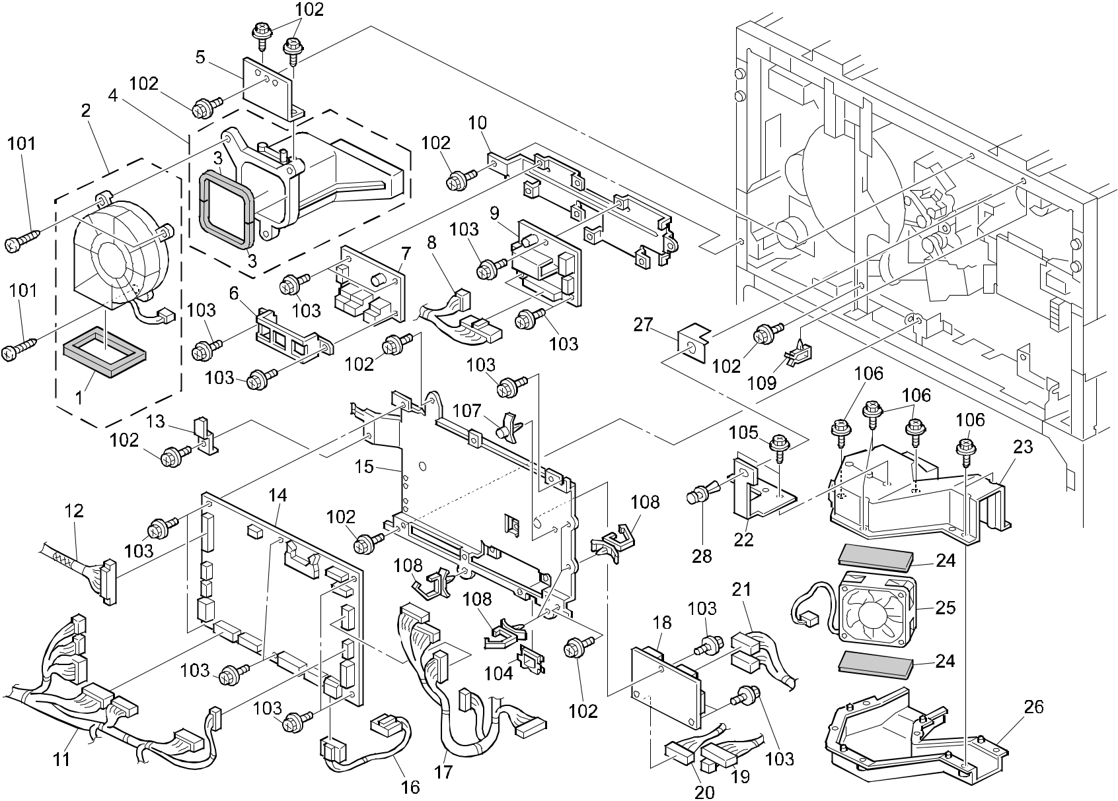

A292/A293/B098 128 Parts Location and List

58.ELECTRICAL SECTION 1 (A292/A293/B098)

Index | Part No. | Description | Q’ty Per
No. | Part No. | Description | Assembly
1 | AA15 1775 | Seal - Fan | 1
2 | A293 1097 | Fan Motor - DC 8.5W | 1
3 | AA15 3114 | Sheal - Rear Duct | 2
4 | A293 1125 | Rear Duct | 1
5 | A293 1134 | Rear Duct Bracket | 1
6 | A293 5871 | CSS Board Bracket | 1
7 | A265 5154 | CSS Board | 1
8 | A293 5419 | DRB Harness | 1
9 | A293 5150 | Driver Board | 1
10 | A293 5863 | Driver Board Bracket | 1
11 | A293 5416 | Right Harness | 1
12 | A293 5400 | BICU Cable | 1
13 | A229 5872 | Harness Clamp | 1
14 | A293 5120 | I/O Board (A292/A293) | 1
14 | B098 5120 | PCB:I/O (B098) | 1
15 | A293 5845 | Bracket - I/O Board | 1
16 | A293 5501 | Harness - CNB/IOB | 1
17 | A293 5417 | Left Harness (A292/A293) | 1
17 | B098 5417 | Harness:Machine Or Copier:Left (B098) | 1
18 | A293 5140 | Connector Board | 1
19 | A293 5420 | CNB Harness | 1
20 | A293 5421 | Safety Switch Harness | 1
21 | A293 5503 | Harness - CNB/ADF/FIN | 1
22 | A293 1133 | Exhaust Duct Bracket | 1
23 | A293 1131 | Upper Exhaust Duct (A292/A293) | 1
23 | B098 1131 | Duct:Exhaust:Upper (B098) | 1
24 | AA15 3110 | Duct Shield - Exhaust Fan | 2
25 | AX64 0082 | Fan Motor - DC24V 1.8W | 1
26 | A293 1132 | Lower Exhaust Duct (A292/A293) | 1
26 | B098 1132 | Duct:Exhaust:Lower (B098) | 1
27 | A293 1135 | Duct Spacer | 1
28 | A229 1192 | Rivet - 4mm | 1

Index | Part No. |  | Description | Q’ty Per
No. |  |  | Description | Assembly
101 | 0452 | 4016B | Tapping Bind Screw - M4x16
102 | 0451 | 4008B | Philips Tapping Screw - M4x8
103 | 0451 | 3008B | Tapping Screw - M3x8
104 | 1105 | 0243 | Wire Saddle

- 0450 4008B Tapping Screw - 4x8

- 0450 3008B Tapping Screw - M3x8

- 1106 0554 Locking Support

- 1105 0291 Harness Clamp - LWS-3S

- 1105 0267 Harness Clamp - YMC-10-0

A292/A293/B098 129 Parts Location and List

59.ELECTRICAL SECTION 2 (A292/A293/B098)
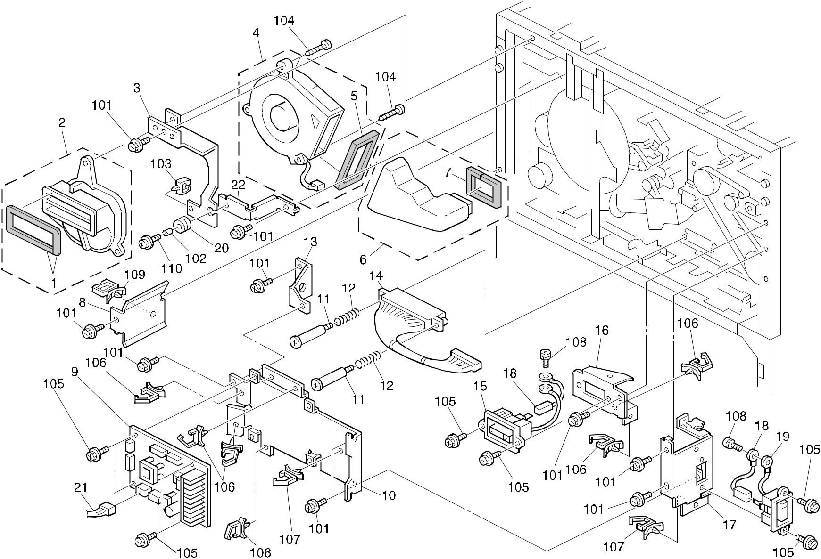

A292/A293/B098 130 Parts Location and List

59.ELECTRICAL SECTION 2 (A292/A293/B098)

Index | Part No. | Description | Q’ty Per
No. | Part No. | Description | Assembly
1 | AA15 3109 | Shield - Vacuum Fan Duct | 2
2 | A293 1120 | Vacuum Fan Duct | 1
3 | A293 1123 | Bracket - Vacuum Fan Duct | 1
4 | A293 1095 | Sirocco Fan - DC24V | 1
5 | AA15 1775 | Seal - Fan | 1
6 | A293 1119 | Vacuum Duct | 1
7 | AA15 1771 | Seal - 5x10x138 | 1
8 | A229 5867 | Plate Bracket | 1
9 | A293 5180 | MCU Board (A292/A293) | 1
9 | B070 5100 | PCB:MCU (B098) | 1
10 | A293 5859 | MCU Board Bracket | 1
11 | 5446 5832 | Connector Guide Pin | 2
12 | AA06 3068 | Spring Connector | 2
13 | A293 5870 | MCU Fixing Bracket | 1
14 | A293 5418 | Interface Harness - Duplex Unit | 1
15 | A293 5510 | ADF Interface Connector | 1
16 | A229 5861 | Plug Bracket - ADF | 1
17 | A293 5862 | Connector Bracket - Finisher Cable | 1
18 | A229 5505 | Interface Ground Wire | 2
19 | A229 5506 | Interface Harness | 1
20 | AA16 1104 | Cushion - Motor | 1
21 | A293 5468 | Interface Harness - Exposure Lamp | 1
22 | A293 1124 | Bracket - Vacuum Fan Duct | 1

Index | Part No. |  | Description | Q’ty Per
No. |  |  | Description | Assembly
101 | 0451 | 4008B | Philips Tapping Screw - M4x8
102 | 0707 | 4050B | Bushing - 4 X5
103 | 1105 | 0199 | Clamp

- 0452 4016B Tapping Bind Screw - M4x16

- 0451 3008B Tapping Screw - M3x8

- 1105 0310 Harness Clamp - LWS-1S

- 1105 0291 Harness Clamp - LWS-3S

- 0801 0149 Philips Pan Head Screw - M4x6

- 1105 0201 Harness Clamp

- 0951 4010B Philips Screw With Washer - M4x10

A292/A293/B098 131 Parts Location and List

60.ELECTRICAL SECTION 3 (A292/A293/B098)
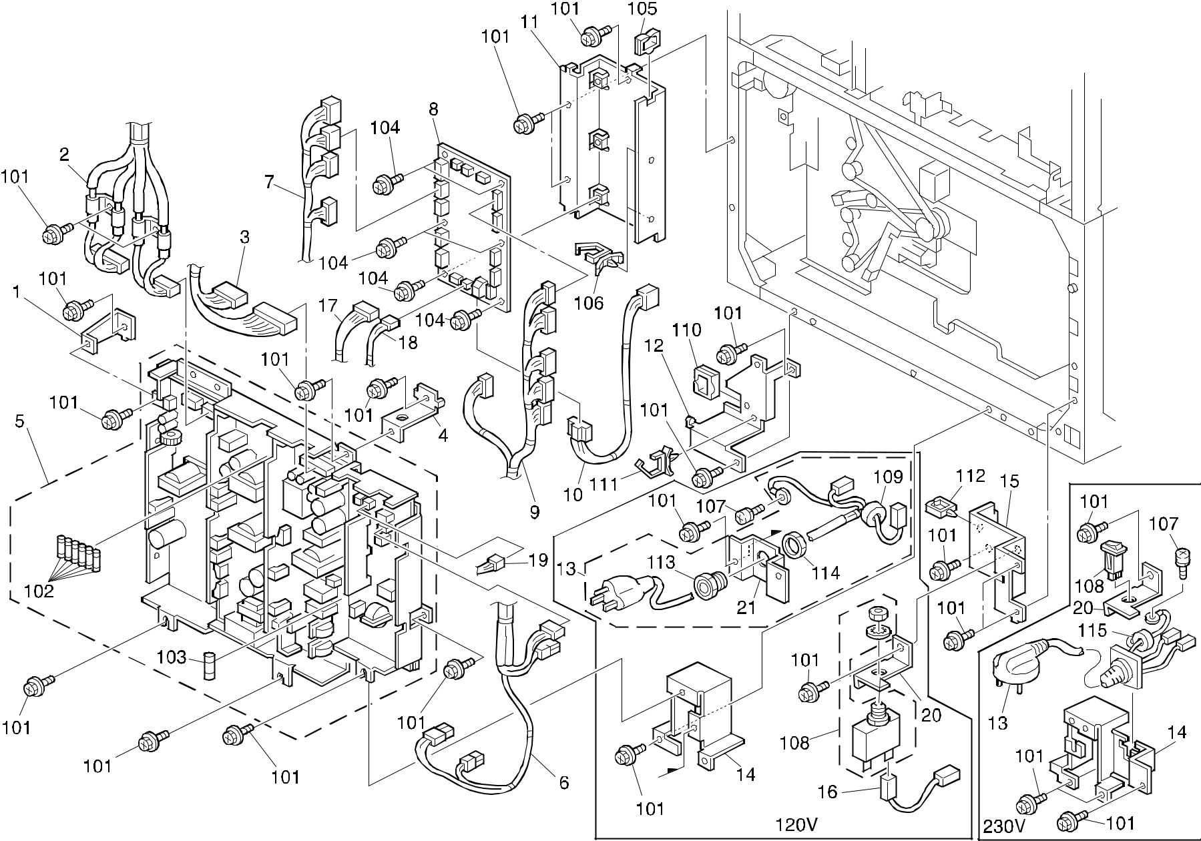

A292/A293/B098 132 Parts Location and List

60.ELECTRICAL SECTION 3 (A292/A293/B098)

Index | Part No. | Description | Q’ty Per
No. | Part No. | Description | Assembly
1 | A293 5876 | Right Fix Bracket | 1
2 | A293 5507 | BICU Harness - DC Power | 1
3 | A293 5508 | CNB Harness - DC Power | 1
4 | A229 5887 | Upper Fix Bracket | 1
5 | AZ24 0056 | Power Supply Unit - 120V (A292/A293) | 1
5 | AZ24 0057 | Power Supply Unit - 230V (A292/A293) | 1
5 | AZ24 0080 | Power Supply Unit:NA (B098) | 1
5 | AZ24 0081 | Power Supply Unit:EU (B098) | 1
6 | A293 5600 | AC Main Harness | 1
7 | A293 7602 | Front Paper Bank Harness | 1
8 | A293 7510 | Paper Feed Control Board | 1
9 | A293 7601 | Rear Paper Bank Harness | 1
10 | A293 5502 | Harness - DC Power Supply | 1
11 | A229 5873 | Paper Feed Control Board Bracket | 1
12 | A229 5874 | Fix Bracket (A292/A293) | 1
12 | B098 5874 | Bracket:Paper Feed Control Board (B098) | 1
13 | A293 7723 | Power Supply Cord - 120V (A292/A293) | 1
13 | AZ00 0070 | Power Supply Cord - 230V (A292/A293) | 1
13 | A293 7724 | Power Supply Cord:NA:Ass'y (B098) | 1
13 | A293 7717 | Power Supply Cord:EU:Ass'y (B098) | 1
14 | A229 5876 | Bracket - Power Supply Cord (230V) | 1
14 | A229 5883 | Bracket - Power Supply Cord (120V) | 1
15 | A229 5878 | Left Fix Bracket | 1
16 | A229 5602 | Circuit Breaker Harness | 1
17 | A293 7603 | Paper Feed Motor Harness | 1
18 | A229 5483 | Safety Switch Harness | 1
19 | A293 5423 | Relay Harness - Power Supply Unit | 1
20 | A229 5880 | Circuit Braker Bracket - 120V | 1
20 | A229 5881 | Circuit Braker Bracket - 230V | 1
21 | A229 5899 | Cord Holder (120V) | 1

Index | Part No. | Description | Q’ty Per
No. | Part No. | Description | Assembly

- 0451 4008B Philips Tapping Screw - M4x8

- 1107 0869 Fuse - 6.3A 125V

- 1107 0880 Fuse - 6.3A 250V

- 1107 0864 Fuse - 12A

- 0451 3008B Tapping Screw - M3x8

105 1105 0349 Edge Saddle

- 1105 0291 Harness Clamp - LWS-3S

- 0801 0149 Philips Pan Head Screw - M4x6

- 1107 0473 Circuit Breaker - 250V 10A (230V)

108 | 1107 0866 | Circuit Breaker - 250V 18A (120V)
109 | 1201 0045 | Ferrite Core
110 | 1105 0430 | Edging
- 1105 0310 Harness Clamp - LWS-1S

- 1105 0230 Clamp

- 1106 0823 Power Cord Bushing - ST-16 (120V)

- 1106 0824 Power Cord Bushing - GMP-16 (120V)

115 1607 0672 Ferrite Core

A292/A293/B098 133 Parts Location and List

61.ELECTRICAL SECTION 4 (A292/A293/B098)
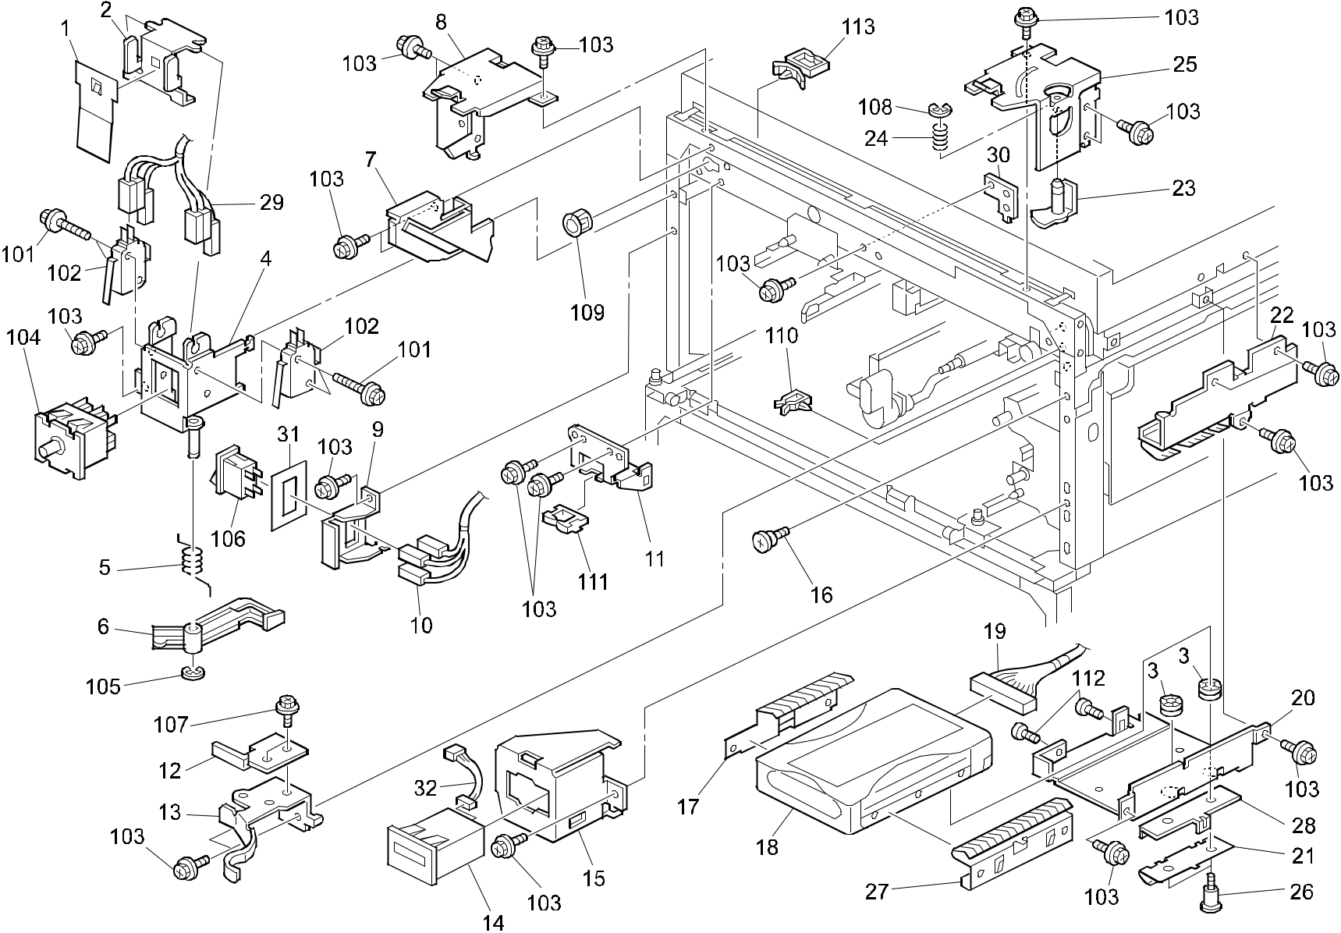

A292/A293/B098 134 Parts Location and List

61.ELECTRICAL SECTION 4 (A292/A293/B098)

Index | Part No. | Description | Q’ty Per
No. | Part No. | Description | Assembly
1 | A229 5869 | Safety Switch Damper | 1
2 | A229 5868 | Safety Switch Lever | 1
3 | AA16 1125 | Rubber Cushion | 2
4 | A229 5857 | Safety Switch Bracket | 1
5 | AA06 6306 | Lever Spring | 1
6 | A229 5860 | Upper Guide Plate Lever | 1
7 | A229 3322 | Toner Bottle Supporter | 1
8 | A229 1351 | Left Holder | 1
9 | A229 5856 | Main Switch Bracket (A292/A293) | 1
9 | B098 5856 | Bracket:Main Switch (B098) | 1
10 | A293 5600 | AC Main Harness (A292/A293) | 1
10 | B098 5600 | Harness:AC:Main:NA (B098) | 1
10 | B098 7651 | Harness:AC:Main:EU (B098) | 1
11 | A229 5886 | Front Bracket | 1
12 | A293 3314 | Inner Back Cam | 1
13 | A293 3309 | Toner Bottle Cam | 1
14 | AX31 0035 | Total Counter (A292/A293) | 1
14 | AX31 0039 | Total Counter - 7FIG 24V (B098) | 1
15 | A229 5871 | Total Counter Bracket | 1
16 | 5919 2201 | Shoulder Screw - M4 | 1
17 | A229 5843 | HDD Ground Plate | 1
18 | A294 5173 | HDD - ATA SU6 | 1
19 | A293 5472 | HDD Harness | 1
20 | A293 5865 | HDD Bracket | 1
21 | A293 5867 | HDD Ground Plate - C | 1
22 | A229 5888 | Right Earth Bracket | 1
23 | A096 1355 | Hinge Shaft | 1
24 | AA06 3052 | Turret Spring | 1
25 | A229 1341 | Upper Hinge Guide Plate | 1
26 | AA14 3499 | Stepped Screw | 2
27 | A293 5866 | HDD Ground Plate - A | 1
28 | A293 5868 | Ground Plate Bracket | 1
29 | A293 5428 | Switch Harness - Laser Diode | 1
30 | A229 1094 | Positioning Plate | 1
31 | B098 5857 | Shield:Switch (B098) | 1

Index | Part No. | Description | Q’ty Per
No. | Part No. | Description | Assembly
32 B098 5340 |  | Harness:Connecting:Total Counter (B098) | 1

- 0451 3014B Tapping Screw - M3-14

- 1204 2355 Micro Switch - AM51632A531

- 0451 4008B Philips Tapping Screw - M4x8

- 1204 2390 Interlock Switch - FA8L-AB24

- 0720 0040B Retaining Ring - M4

- 1204 2468 Switch - AC250/16A (A292/A293)

- 1204 2608 Rocker Switch:SDDJE33900 (B098)

- 0451 3006B Tapping Screw - M3x6

- 0720 0040B Retaining Ring - M4

- 1106 0200 Bushing - 19.44mm

- 1105 0267 Harness Clamp - YMC-10-0

111 1105 0113 Edge - P108

- 0801 0153 Bind Screw - M6x32

- 1105 0196 Harness Clamp

A292/A293/B098 135 Parts Location and List

62.FRAME SECTION 1 (A292/A293/B098)
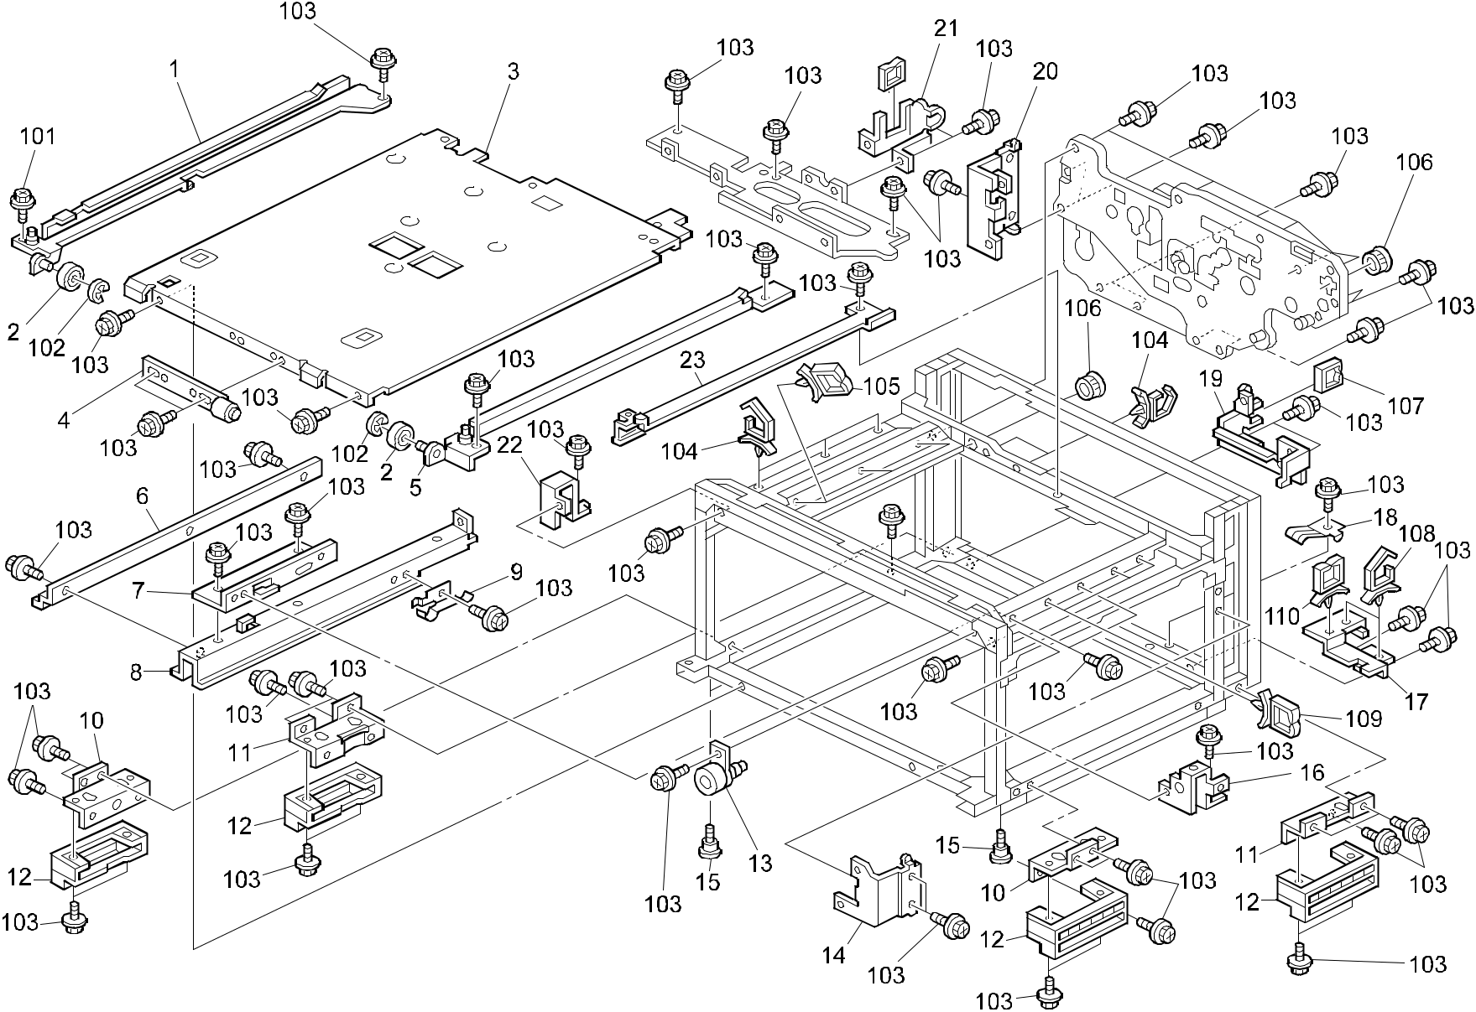

A292/A293/B098 136 Parts Location and List

62.FRAME SECTION 1 (A292/A293/B098)

Index | Part No. | Description |  | Q’ty Per
No. | Part No. | Description |  | Assembly
1 | A229 4835 | Left Rail |  | 1
2 | 6754 2866 | Roller - Positioning Guide |  | 2
3 | A229 1075 | Base Cover (A292/A293) |  | 1
3 | B098 1075 | Cover:Base (B098) |  | 1
4 | A229 4830 | Holder Bracket |  | 1
5 | A096 4591 | Right Duplex Rail |  | 1
6 | A096 1677 | Right Rail - Drum Unit (A292/A293) |  | 1
6 | B098 1677 | Rail:Around The Photoconductor:Right (B098) |  | 1
7 | A229 1185 | Development Unit Rail Bracket (A292/A293) |  | 1
7 | B098 1185 | Bracket:Rail:Development Unit (B098) |  | 1
8 | A229 1186 | Development Guide Rail (A292/A293) |  | 1
8 | B098 1186 | Rail:Development Unit (B098) |  | 1
9 | A096 1679 | Development Grounding Plate |  | 1
10 | A096 1095 | Front Grip Bracket |  | 2
11 | A096 1096 | Rear Grip Bracket |  | 2
12 | A096 1094 | Grip Base |  | 4
13 | A229 3553 | Toner Recycling Joint |  | 1
14 | A096 1077 | Right Fixing Plate |  | 1
15 | C201 5125 | Stepped Screw - M6 |  | 8
16 | A229 1091 | Right Adjusting Pin |  | 1
17 | A229 5866 | Slide Rail Guide |  | 1
18 | A229 6077 | Rear Upper Growunding Plate |  | 1
19 | A229 5852 | Left Fix Bracket |  | 1
20 | A229 1078 | Left Fixing Plate |  | 1
21 | A229 5851 | Right Fix Bracket |  | 1
22 | A229 1092 | Left Adjusting Pin |  | 1
23 | A229 1098 | Left Drum Rail |  | 1

Index | Part No. | Description | Q’ty Per
No. | Part No. | Description | Assembly

- 0434 0080B Pan Head Self-tapping Screw - M4x8

- 0720 0040B Retaining Ring - M4

- 0451 4008B Philips Tapping Screw - M4x8

- 1105 0310 Harness Clamp - LWS-1S

- 1105 0196 Harness Clamp

- 1106 0200 Bushing - 19.44mm

107 | 1105 0349 | Edge Saddle
108 | 1105 0316 | Clamp
- 1105 0291 Harness Clamp - LWS-3S

- 1105 0201 Harness Clamp

A292/A293/B098 137 Parts Location and List

63.FRAME SECTION 2 (A292/A293/B098)
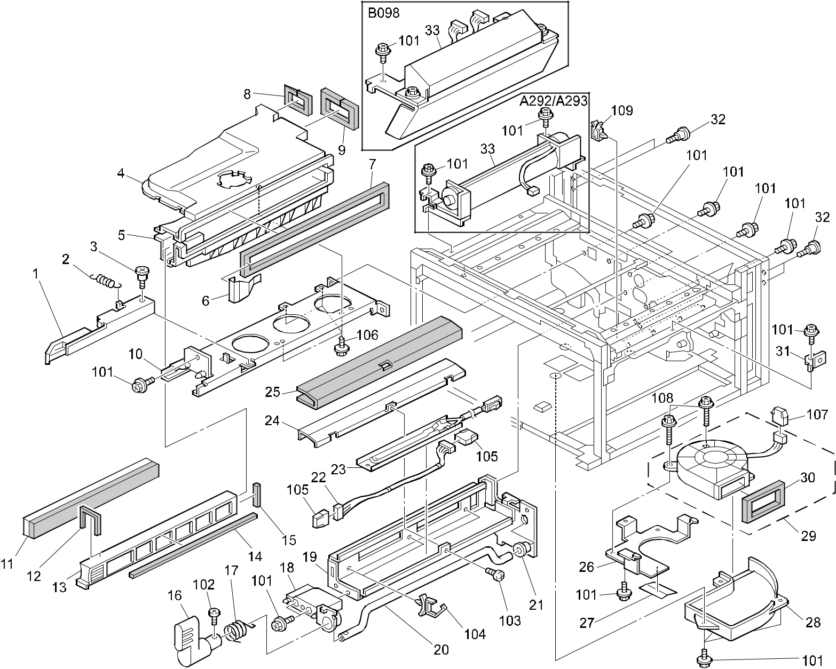

A292/A293/B098 138 Parts Location and List

63.FRAME SECTION 2 (A292/A293/B098)

Index | Part No. | Description | Q’ty Per
No. | Part No. | Description | Assembly
1 | A293 4260 | Fusing Lock Lever | 1
2 | AA06 0541 | Bushing Lock Spring | 1
3 | 5446 3648 | Stepped Screw - M4 | 1
4 | A293 1112 | Upper Duct | 1
5 | A293 1113 | Lower Duct | 1
6 | A229 1106 | Duct Shield Guide | 1
7 | AA15 3105 | Duct Seal | 1
8 | AA15 3108 | Seal - 128x8x5 | 1
9 | AA15 3107 | Seal - 241x8x5 | 1
10 | A096 4249 | Fusing Unit Rail (A292/A293) | 1
10 | B098 4249 | Rail:Fusing Unit:Ass'y (B098) | 1
11 | A293 1104 | Ozone Filter (A292/A293) | 1
11 | B098 1104 | Ozone Filter (B098) | 1
12 | AA15 3111 | Seal - 104x2x3 | 1
13 | A293 1114 | Ozone Filter Guide (A292/A293) | 1
13 | B098 1114 | Guide:Ozone Filter (B098) | 1
14 | AA15 3112 | Seal - 331x2x3 | 1
15 | AA15 3113 | Seal - 41x5x3 | 1
16 | A293 3960 | Belt Unit Knob | 1
17 | AA06 6218 | Unit Release Spring | 1
18 | A293 3915 | Front Holder | 1
19 | A293 3951 | Transfer Unit Guide Plate | 1
20 | A096 3959 | Release Arm | 1
21 | AA08 0158 | Bushing - 12x16x12.1 | 1
22 | A229 5412 | Transfer Connecting Harness | 1
23 | AX40 0047 | Anticondensation Heater - 115V 15W | 1
 |  | (A292/A293)
23 | AX40 0048 | Anticondensation Heater - 230V 15W | 1
 |  | (A292/A293)
23 | AX40 0162 | Heater:120V:15W (B098) | 1
23 | AX40 0163 | Heater:240V:15W (B098) | 1
24 | A096 3956 | Heater Cover | 1
25 | AA17 2013 | Heater Cover | 1
26 | A097 5550 | Fan Motor Bracket | 1
27 | A097 5552 | Fan Plate | 1

Index | Part No. | Description | Q’ty Per
No. | Part No. | Description | Assembly
28 | A097 5551 | Fan Motor Duct | 1
29 | A229 1195 | Cooling Fan Motor - DC24V 9.6W | 1
30 | AA15 1775 | Seal - Fan | 1
31 | A229 5884 | HDD Fix Bracket | 1
32 | 5919 2201 | Shoulder Screw - M4 | 4
33 | A229 1116 | Exit Cooling Fan - DC24V 5.8W (A292/A293) | 1
33 | B098 1126 | Fan:Cooling:Exit:DC24V 2.88W X 2 (B098) | 1

- 0451 4008B Philips Tapping Screw - M4x8

- 0314 0060B Philips Pan Head Screw - M4x6

- 0313 0050B Philips Pan Head Screw - M3x5

- 1105 0278 Harness Clamp - LWS-1S

- 1102 6252 Connector - 9P

- 0450 4008B Tapping Screw - 4x8

- 1102 6245 Relay Connector - 2P

- 0451 4014B Tapping Screw - M4x14

- 1105 0267 Harness Clamp - YMC-10-0

A292/A293/B098 139 Parts Location and List

64.FRAME SECTION 3 (A292/A293/B098)
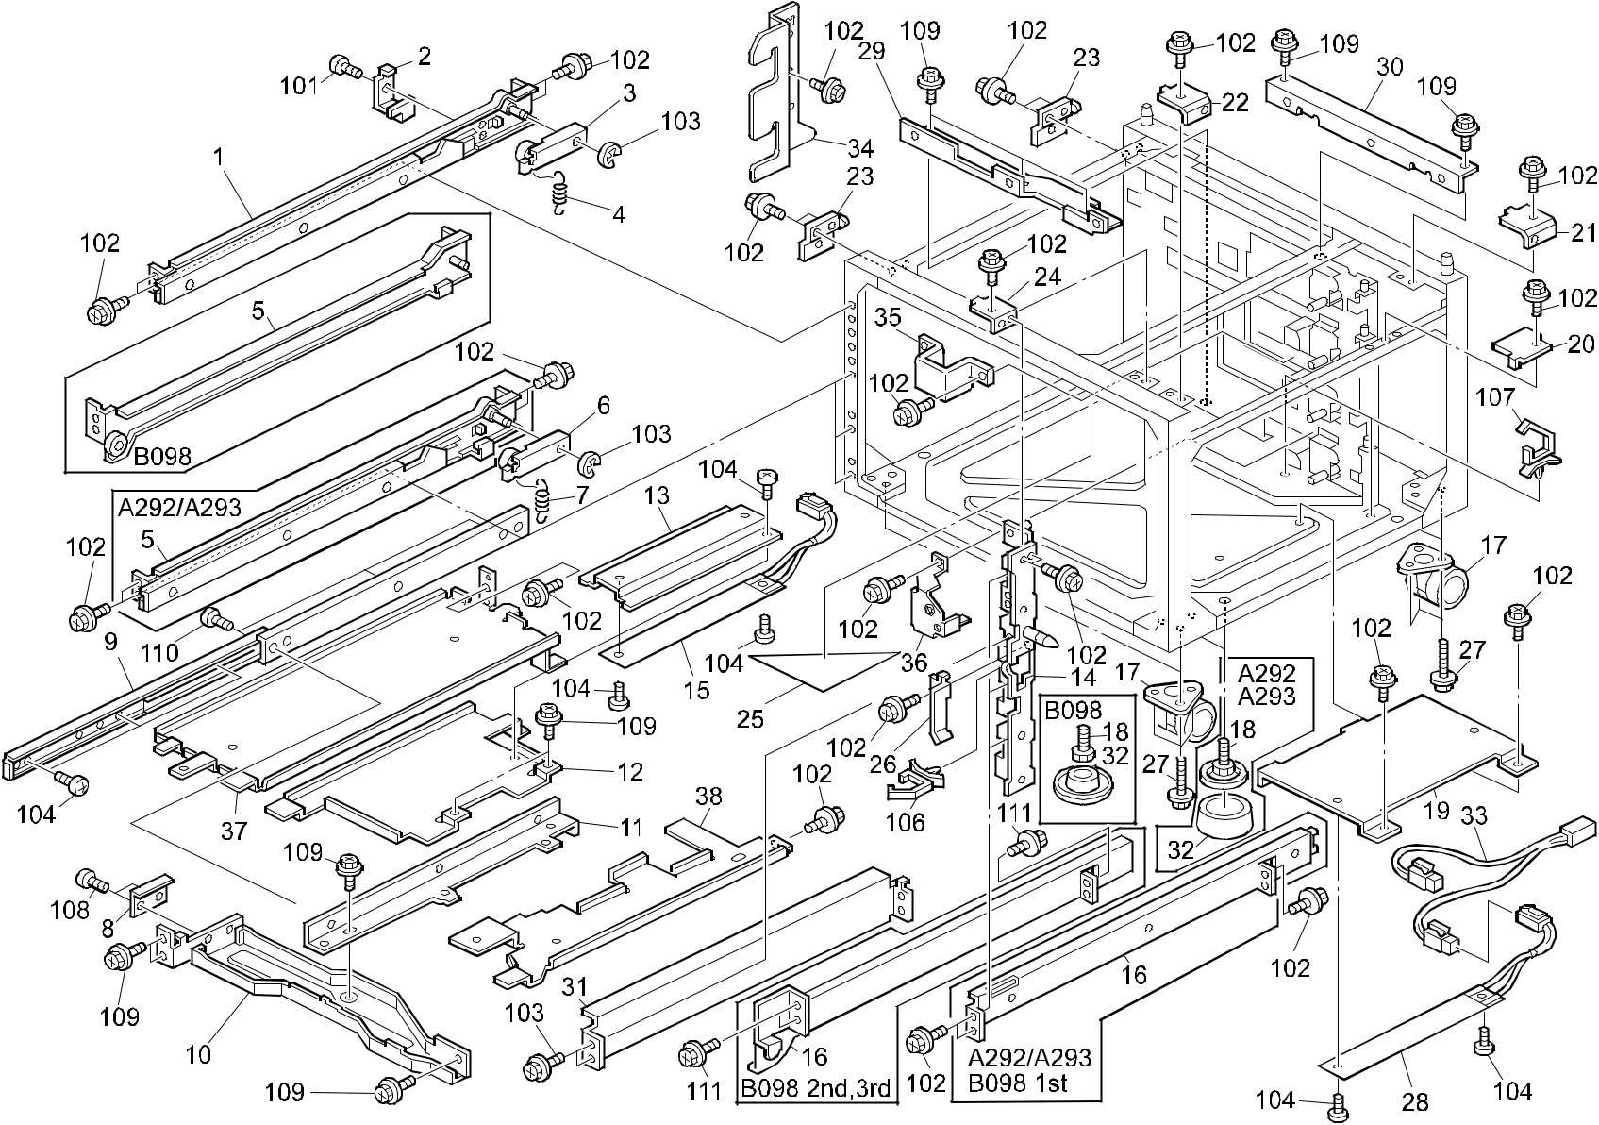

A292/A293/B098 140 Parts Location and List

64.FRAME SECTION 3 (A292/A293/B098)

Index | Part No. | Description | Q’ty Per
No. | Part No. | Description | Assembly
1 | A248 6241 | Left Rail - Tandem LCT | 1
2 | A096 6246 | Left Rail Bracket | 1
3 | A096 6247 | Lock Arm - Tandem Tray | 1
4 | AA06 0761 | Spring | 1
5 | A096 6261 | Left Rail (A292/A293) | 2
5 | B098 6279 | Rail:Paper Tray:Left:Ass'y (B098) | 2
6 | A096 6266 | Tray Lock Arm | 2
7 | AA06 0534 | Tray Lock Spring - 19mm | 2
8 | A248 6775 | Supporting Stay | 1
9 | AA07 0044 | Slide Rail - Tandem LCT | 1
10 | A293 6776 | Tandem LCT Stay (A292/A293) | 1
10 | B098 6776 | Stay:Tandem LCT (B098) | 1
11 | A248 6774 | Slide Rail Bracket | 1
12 | A248 6102 | Upper Heat Sink (A292/A293) | 1
12 | B065 6116 | Upper Heat Sink (B098) | 1
13 | A248 6103 | Guide Plate - Upper Heat Sink | 1
14 | A176 6181 | Front Side Plate - P/B (A292/A293) | 1
14 | B098 6181 | Side Plate:Front:Paper Bank:Ass'y (B098) | 1
15 | AX40 0111 | Anticondensation Heater - 230V 18W | 1
 |  | (A292/A293)
15 | AX40 0112 | Anticondensation Heater - 120V 18W | 1
 |  | (A292/A293)
15 | AX40 0166 | Heater:120V:18W:Upper (B098) | 1
15 | AX40 0167 | Heater:240V:18W:Upper (B098) | 1
16 | A096 6250 | Right Rail (A292/A293) | 3
16 | B098 6269 | Rail:Paper Tray:Right:Ass'y(B098) | 2
17 | AH01 2015 | Caster - 1470N (120V) | 4
17 | AH01 2016 | Caster - G60 (230V) | 4
18 | AH01 1004 | Screw Stand (120V)(A292/A293) | 2
18 | AH01 1006 | Stand Ass'y (230V)(A292/A293) | 2
18 | AH01 2029 | Caster:1470N (B098) | 2
19 | A096 6100 | Lower Heat Sink (A292/A293) | 1
19 | B065 6221 | Lower Heat Sink (B098) | 1
20 | A096 6081 | Collection Bottle Stopper | 1
21 | A096 6079 | Right Rear Frame Joint | 1

Index | Part No. | Description | Q’ty Per
No. | Part No. | Description | Assembly
22 | A096 6078 | Right Front Frame | 1
23 | A096 6080 | Left Frame Joint | 2
24 | A096 6077 | Upper Front Fixing Plate | 1
25 | A096 6693 | Paper Guide Sheet (A292/A293) | 1
25 | B098 6693 | Shield:Frame:Paper Bank:Upper (B098) | 1
26 | A176 6110 | Harness Cover | 1
27 | 5301 1662 | Hexagon Bolt | 12
28 | AX40 0070 | Anticondensation Heater - 115V 15W | 1
 |  | (A292/A293)
28 | AX40 0069 | Anticondensation Heater - 240V 18W | 1
 |  | (A292/A293)
28 | AX40 0164 | Heater:120V:18W (B098) | 1
28 | AX40 0165 | Heater:240V:18W (B098) | 1
29 | A096 6075 | Lower Rear Fixing Plate | 1
30 | A096 6076 | Upper Rear Fixing Plate | 1
31 | A293 6251 | Guide Stay | 1
32 | AH01 3008 | Leveling Foot Guide (A292/A293) | 1
32 | B023 1101 | Stand Holder (B098) | 1
33 | A293 7606 | Heater Harness | 1
34 | B098 6815 | Shielding Plate:Rear:Left Lower (B098) | 1
35 | B098 6817 | Cover:Solenoid:Tandem:Coupling (B098) | 1
36 | B098 6816 | Cover:Gear (B098) | 2
37 | B098 6111 | Shielding Plate:Tandem LCT:Left (B098) | 1
38 | B098 6112 | Shielding Plate:Tandem LCT:Right (B098) | 1

A292/A293/B098 141 Parts Location and List

Index | Part No. | Description | Q’ty Per
No. | Part No. | Description | Assembly

- 0313 0060B Philips Pan Head Screw - M3x6

- 0451 4008B Philips Tapping Screw - M4x8 (A292/A293)

- 0451 4008B Philips Tapping Screw - M4x8 (B098)

- 0720 0040B Retaining Ring - M4

- 0314 0060B Philips Pan Head Screw - M4x6

- 0951 4012W Philips Screw With Washer - M4x12

- 1105 0291 Harness Clamp - LWS-3S

- 1105 0310 Harness Clamp - LWS-1S

- 0951 4008B Philips Screw With Washer - M4x8

- 0434 0080B Pan Head Self-tapping Screw - M4x8

- 0314 0040B Philips Pan Head Screw - M4x4

- 0453 4008B Tapping Bind Screw - M4x8

Index | Part No. | Description | Q’ty Per
No. | Part No. | Description | Assembly

A292/A293/B098 141A Parts Location and List

65.I/O CONTROL BOARD (A292/A293)
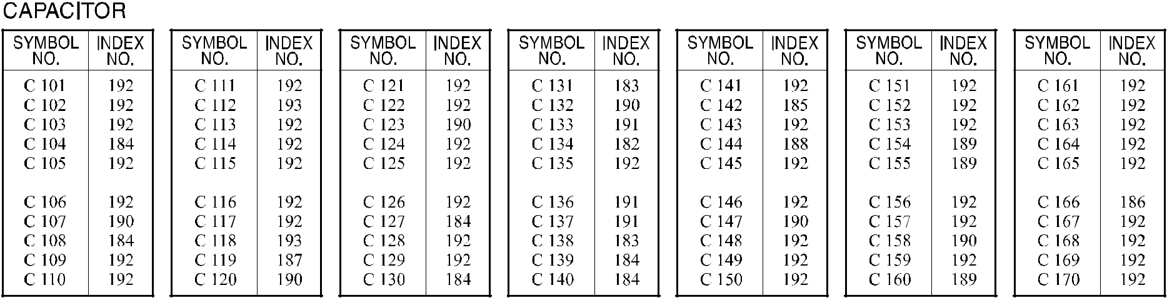
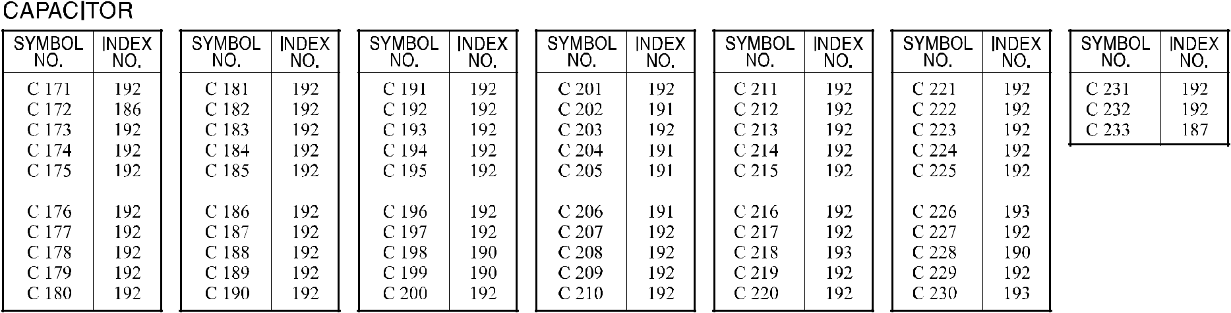

A292/A293/B098 142 Parts Location and List

65.I/O CONTROL BOARD (A292/A293)
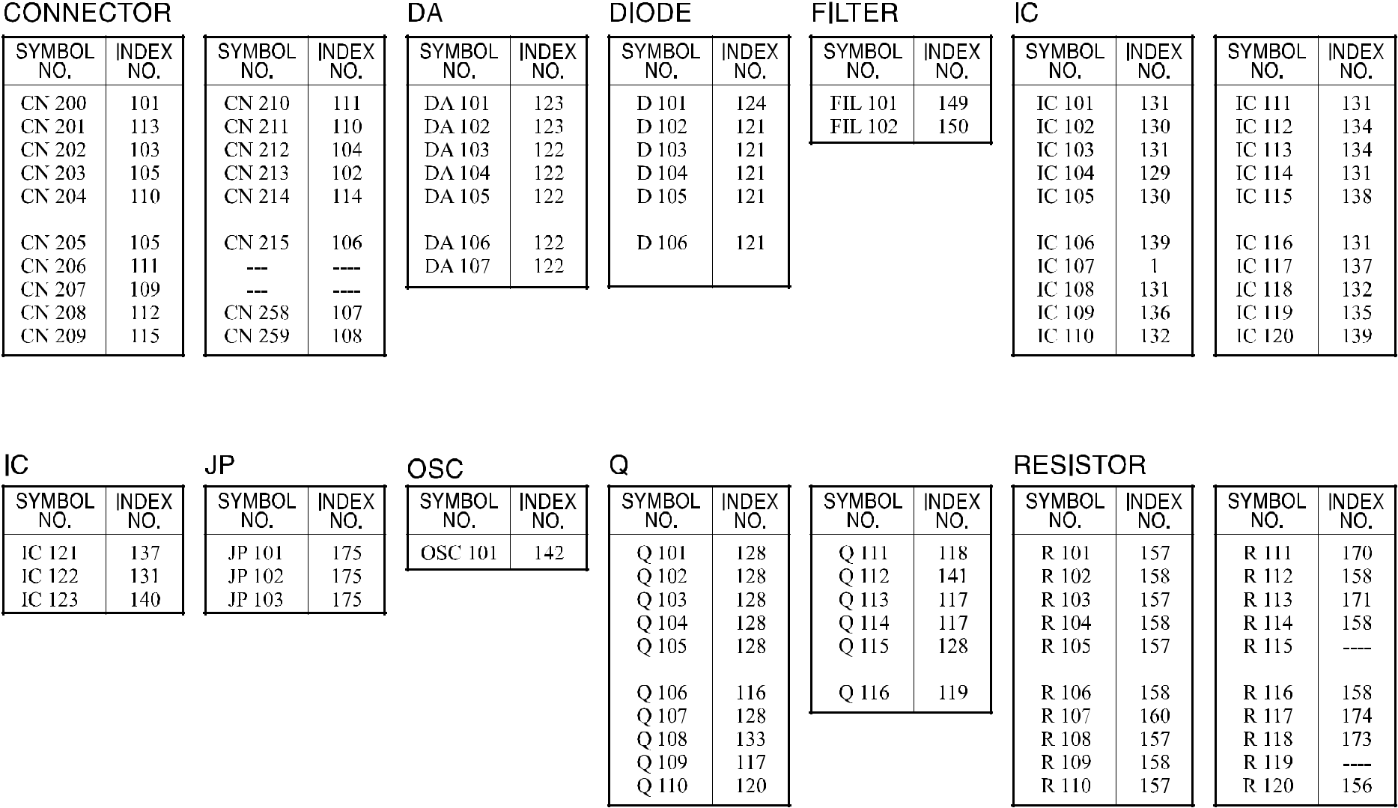

A292/A293/B098 143 Parts Location and List

65.I/O CONTROL BOARD (A292/A293)
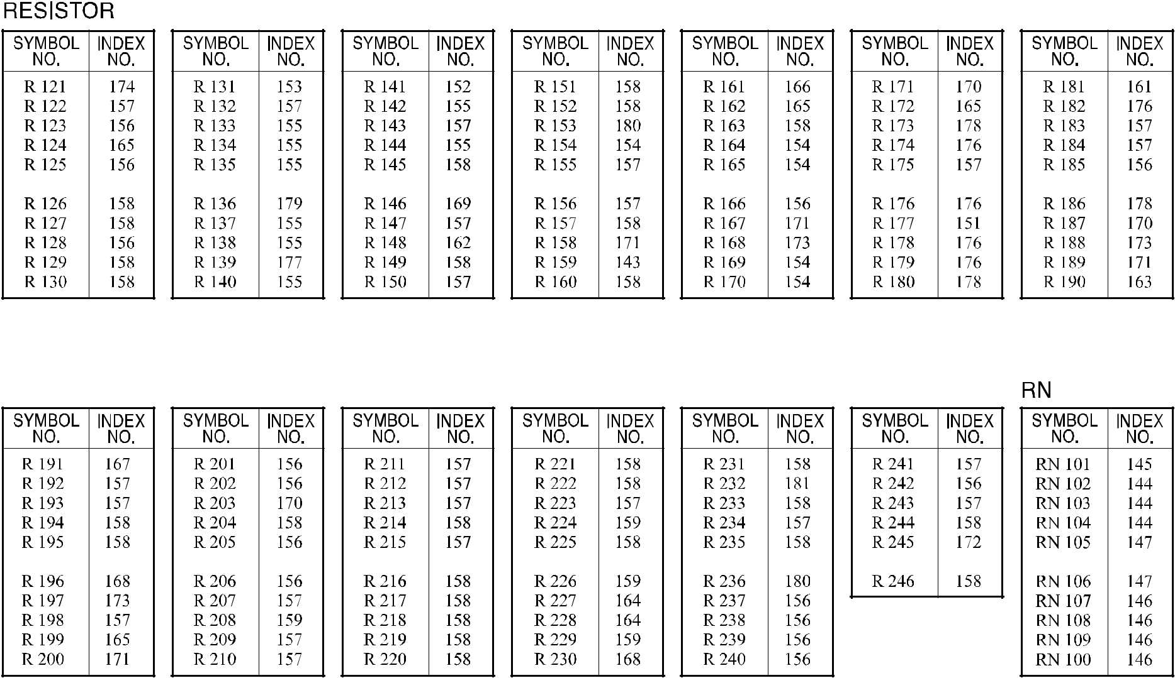

A292/A293/B098 143A Parts Location and List

65.I/O CONTROL BOARD (A292/A293)
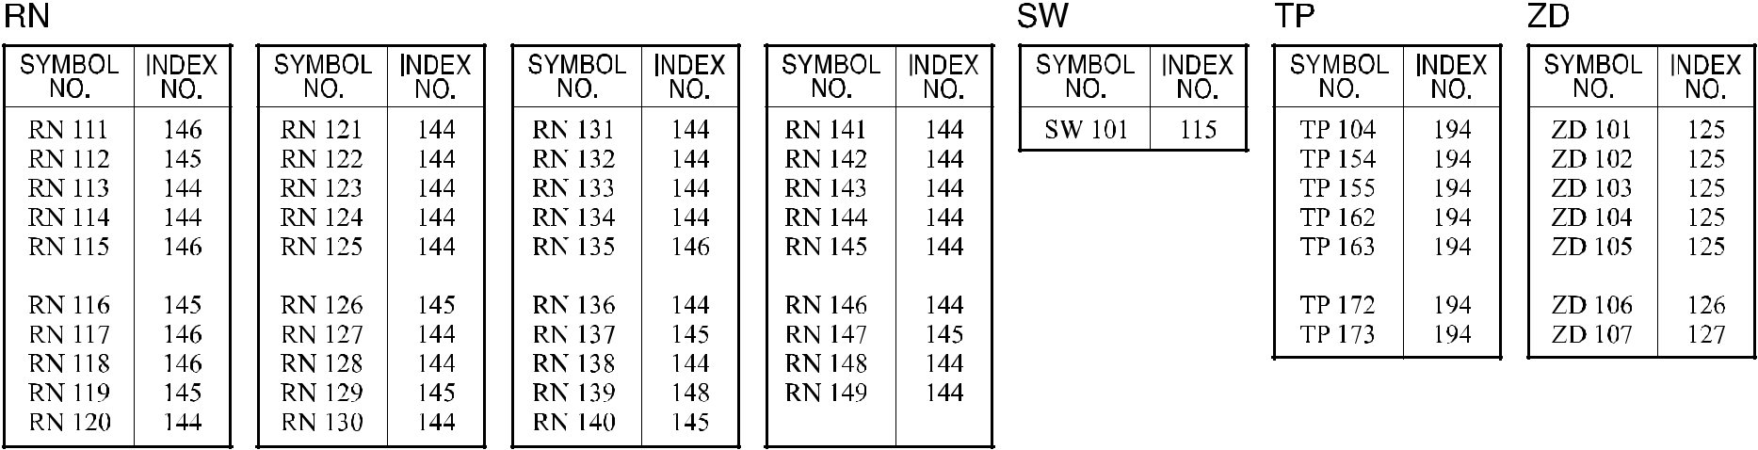

A292/A293/B098 144 Parts Location and List

65.I/O CONTROL BOARD (A292/A293)

Index | Part No. |  | Description | Q’ty Per
No. | Part No. |  | Description | Assembly
* | A293 5120 | I/O Board |  | 1
1 | A232 5355 | IC - GATEX |  | 1

Index | Part No. | Description | Q’ty Per
No. | Part No. | Description | Assembly

- 1102 5310 Connector - 5P

- 1102 6297 Connector - 4P

- 1102 6302 Connector - 9P

- 1102 6303 Connector - 10P

- 1102 6304 Connector - 11P

- 1102 6311 Connector - 4P

- 1102 6313 Connector - 6P

- 1102 6314 Connector - 7P

- 1102 6400 Connector - 24P

- 1102 6401 Connector - 26P

- 1102 6403 Connector - 30P

- 1102 6890 Connector - 40P

- 1102 7506 Connector - 8931E-050-178S

- 1103 1317 Connector

- 1204 2432 Dip Switch - DSS708

- 1400 0398 Transistor - 2SC2412K

- 1400 0619 Transistor - DTA143EKA

- 1400 0731 Transistor - 2SD1766

- 1401 0972 Transistor-2sb1260

- 1401 0986 Transistor - UPA1552H

- 1402 1112 Diode - ERA83-004

- 1402 1142 Diode Array - DAN217

- 1402 1326 Diode Array - DA227

- 1402 1336 Diode - 1SS355

- 1402 1378 Diode - PTZ12A

- 1402 1380 Diode - PTZ 6.2A

- 1402 1505 Diode - UDZS5.6B

- 1407 1535 IC - TD62308AP

- 1407 1596 TTLIC - SN74LS14NS

- 1407 1600 TTLIC - SN74LS244NS

- 1407 2187 TTLIC - SN74LS07NS

- 1407 2218 TTLIC - SN74LS06NS

- 1407 2219 IC - TD62003AP

- 1407 3290 IC - TC74HC02AF

- 1407 3357 Comparator - BA10393F

A292/A293/B098 144A Parts Location and List

Index | Part No. | Description | Q’ty Per
No. | Part No. | Description | Assembly

136 1407 4687 IC - TA8083F

- 1407 5085 IC - TC4066BF(N)

- 1408 0810 IC - BA10358F

- 1408 0826 IC - TA8428K

- 1408 1095 IC - BA10324AF

- 1408 1206 Transistor-array - TD62M4700F

- 1503 0865 Oscillator - 9.8304MHZ

- 1601 5319 Resistor-3.9 Ω ±5% 2w

- 1601 7752 Resistor Array - 10K Ω ±5%

- 1601 7781 Resistor - 10 Ω ±5%

- 1601 7791 Resistor Array - 1K Ω ±5%

- 1601 7814 Resistor 3.3k Ω ±5%

- 1601 7872 Resistor Array - 220 Ω ±5% 1/16W

- 1602 7029 Noise Filter - 22000pF

- 1607 0758 Filter - DSS710D223A12-22

- 1610 1374 Resistor - 2.2K Ω ±5% 1/2W

- 1630 1101 Resistor - 100 Ω 1/4W ±5%

- 1630 1121 Resistor - 120Ω±5% 1/8W

- 1630 1151 Resistor - 150 Ω ±5% 1/4W

- 1630 2221 Resistor - 220 Ω

- 1630 3100 Resistor - 10 Ω ±5% 1/10W

- 1630 3102 Resistor - 1KΩ 1/10W ±5%

- 1630 3103 Resistor - 10KΩ 1/10W ±5%

- 1630 3104 Resistor - 100K Ω 1/10W ±5%

- 1630 3105 Resistor - 1M Ω ±5% 1/10W

- 1630 3132 Resistor-1.3k Ω ±5% 1/10w

- 1630 3152 Resistor - 1.5kΩ - 1/10W

- 1630 3153 Resistor - 15K Ω ±5% 1/10W

- 1630 3154 Resistor - 150K 0HM ±5% 1/10W

- 1630 3222 Resistor - 2.2KΩ 1/10W ±5%

- 1630 3223 Resistor - 22kΩ - 1/10W

- 1630 3331 Resistor - 330 Ω ±5% 1/10W

- 1630 3332 Resistor - 3.3KΩ 1/10W ±5%

- 1630 3362 Resistor - 3.6K Ω ±5% 1/10W

- 1630 3391 Resistor - 390Ω 1/10W ±5%

Index | Part No. | Description | Q’ty Per
No. | Part No. | Description | Assembly

- 1630 3472 Resistor - 4.7KΩ 1/10W ±5%

- 1630 3473 Resistor - 47KΩ 1/10W ±5%

- 1630 3562 Resistor - 5.6K Ω +5% 1/10W

- 1630 3910 Resistor - 91 Ω ±5% 1/10W

- 1631 0000 Resistor - 0Ω 1/4W

- 1633 1003 Resistor - 100K Ω ±1% 1/10W

- 1633 1102 Resistor-11k Ω ±1% 1/10w

- 1633 1403 Resistor - 140K Ω ±1% 1/10W

- 1633 1542 Resistor - 15.4K Ω ±1%

- 1633 5231 Resistor - 5.23K Ω ±1% 1/10W

- 1633 5360 Resistor - 536 Ω ±1% 1/10W

- 1640 5100 Capacitor - 10µF+20% 50

- 1640 5101 Capacitor - 100µF±20% 50V

- 1640 5470 Capacitor - 47µF±20% 50V

- 1660 1100 Capacitor - 10pF 50V

- 1660 2220 Capacitor - 22pF ±20% 35V

- 1660 3101 Capacitor - 100pF 50V

- 1660 3121 Capacitor - 120pF 50V ±5% 50V

- 1660 3470 Capacitor - 47pF ±5% 50V

- 1660 3471 Capacitor - 470pF 50V

- 1660 5472 Capacitor - 4700pF 50V

- 1660 7103 Capacitor - 10000pF 50V

- 1660 7104 Capacitor - 100000pF 50V

A292/A293/B098 145 Parts Location and List

66.I/O CONTROL BOARD (B098) Rev. 01/31/2003
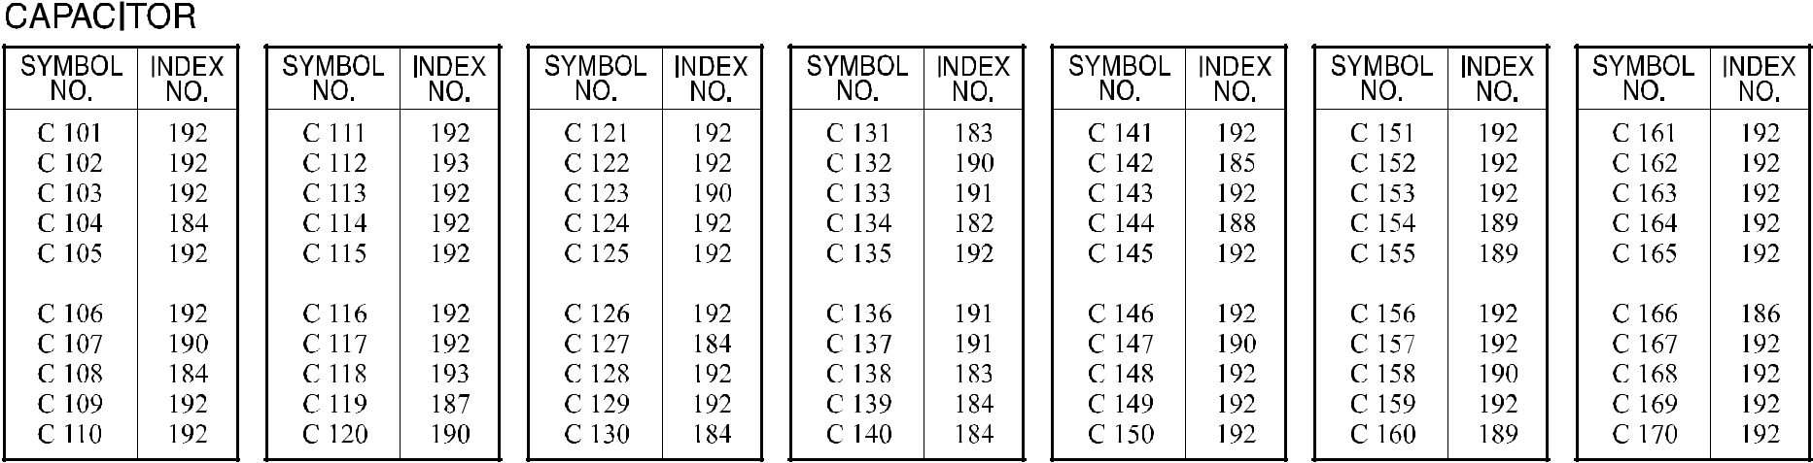
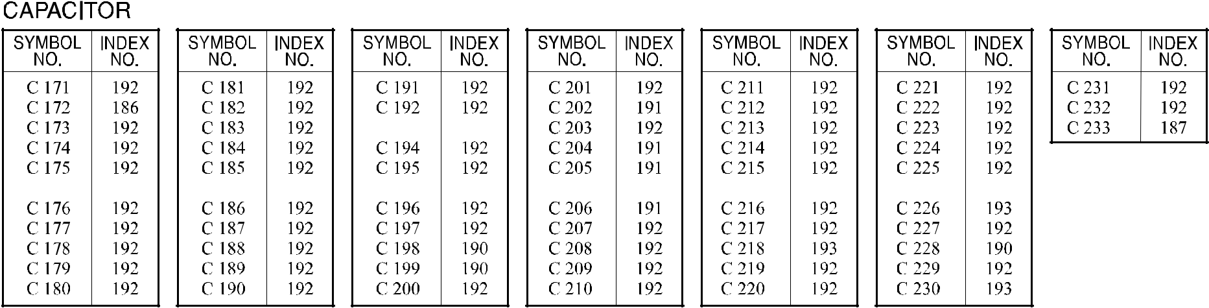

A292/A293/B098 146 Parts Location and List
66.I/O CONTROL BOARD (B098)
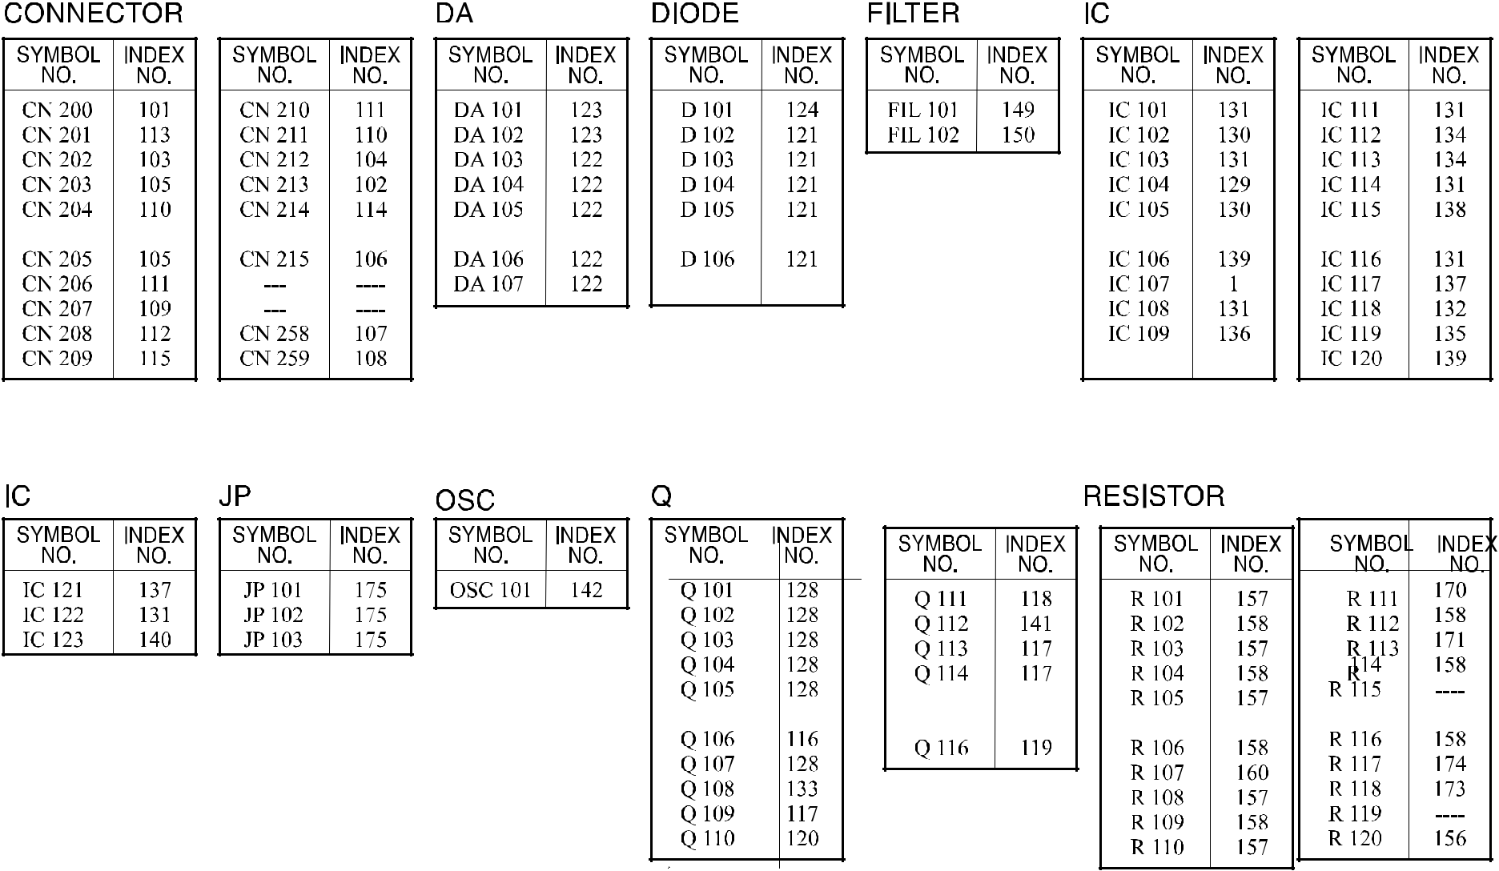

A292/A293/B098 147 Parts Location and List
66.I/O CONTROL BOARD (B098)

A292/A293/B098 147A Parts Location and List

66.I/O CONTROL BOARD (B098) Rev. 01/31/2003
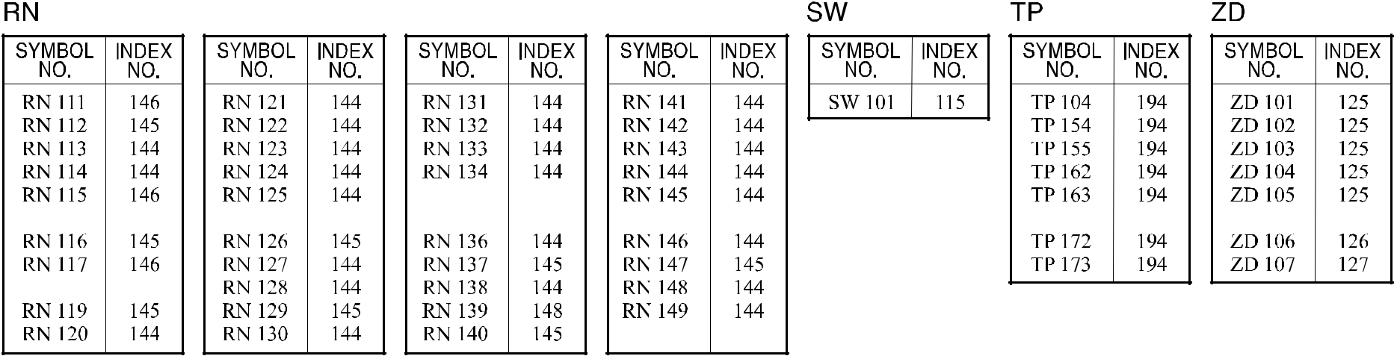

A292/A293/B098 148 Parts Location and List

66.I/O CONTROL BOARD (B098)

Index | Part No. | Description | Q’ty Per
No. | Part No. | Description | Assembly
* | B098 5120 | I/O Board (B098) | 1
1 | A232 5355 | IC - GATEX

 |  |  | Rev. 01/31/2003
Index | Part No. | Description | Q’ty Per
No. | Part No. | Description | Assembly
101 | 1102 5310 | Connector - 5P
102 | 1102 6295 | Connector - 2P
103 | 1102 6297 | Connector - 4P
104 | 1102 6303 | Connector - 10P
105 | 1102 6304 | Connector - 11P
106 | 1102 6311 | Connector - 4P
107 | 1102 6313 | Connector - 6P
108 | 1102 6314 | Connector - 7P
109 | 1102 6400 | Connector - 24P
110 | 1102 6401 | Connector - 26P
111 | 1102 6403 | Connector - 30P
112 | 1102 6890 | Connector - 40P
113 | 1102 7506 | Connector - 8931E-050-178S
114 | 1103 1317 | Connector
115 | 1204 1537 | DIP Switch

- 1400 0398 Transistor - 2SC2412K

- 1400 0619 Transistor - DTA143EKA

- 1400 0731 Transistor - 2SD1766

- 1401 0972 Transistor-2sb1260

- 1401 0986 Transistor - UPA1552H

- 1402 1112 Diode - ERA83-004

- 1402 1142 Diode Array - DAN217

- 1402 1326 Diode Array - DA227

- 1402 1336 Diode - 1SS355

- 1402 1505 Diode - UDZS5.6B

- 1402 1692 Diode: rd12fmb

- 1402 1695 Diode: rd6.2fmb

- 1407 1596 TTLIC - SN74LS14NS

- 1407 1600 TTLIC - SN74LS244NS

- 1407 2187 TTLIC - SN74LS07NS

- 1407 2219 IC - TD62003AP

- 1407 3290 IC - TC74HC02AF

- 1407 3357 Comparator - BA10393F

A292/A293/B098 148A Parts Location and List

Index | Part No. | Description | Q’ty Per
No. | Part No. | Description | Assembly

136 1407 4687 IC - TA8083F

- 1407 5085 IC - TC4066BF(N)

- 1408 0810 IC - BA10358F

- 1408 0826 IC - TA8428K

- 1408 1095 IC - BA10324AF

- 1408 1206 Transistor-array - TD62M4700F

- 1503 0865 Oscillator - 9.8304MHZ

- 1601 5319 Resistor-3.9 Ω ±5% 2w

- 1601 7752 Resistor Array - 10K Ω ±5%

- 1601 7781 Resistor - 10 Ω ±5%

- 1601 7814 Resistor - 3.3K Ω ±5%

- 1601 7872 Resistor Array - 220 Ω ±5% 1/16W

- 1602 7029 Noise Filter - 22000pF

- 1607 0758 Filter - Dss710d223a12-22

- 1610 1374 Resistor - 2.2K Ω ±5% 1/2W

- 1630 1101 Resistor - 100 Ω 1/4W ±5%

- 1630 1121 Resistor - 120Ω±5% 1/8W

- 1630 1151 Resistor - 150 Ω ±5% 1/4W

- 1631 0000 Resistor - 0Ω 1/4W

- 1640 5100 Capacitor - 10µF+20% 50

- 1640 5101 Capacitor - 100µF±20% 50V

- 1640 5470 Capacitor - 47µF±20% 50V

- 1650 2221 Resistor: 220Ω:±5%:1/4w

- 1650 3100 Resistor - 10 Ω ±5% 1/8W

- 1650 3102 Resistor: 1kΩ:±5%:1/8w:2125

- 1650 3103 Chip Resistor - 10kΩ ±5% 1/8w

- 1650 3104 Resistor: 100kΩ:±5%:1/8w

- 1650 3105 Resistor: 1.3kΩ:±5%:1/8w

- 1650 3152 Resistor: 1.5kΩ:±5%:1/8w

- 1650 3153 Resistor: 15kΩ:±5%:1/8w

- 1650 3154 Resistor: 150kΩ:±5%:1/8w

- 1650 3222 Resistor: 2.2kΩ:±5%:1/8w

- 1650 3223 Resistor: 22kΩ:±5%:1/8w

- 1650 3331 Resistor: 330Ω:±5%:1/8w

 |  |  | Rev. 01/31/2003
Index | Part No. | Description | Q’ty Per
No. | Part No. | Description | Assembly

- 1650 3332 Resistor: 3.3kΩ:±5%:1/8w

- 1650 3362 Resistor: 3.6kΩ:±5%:1/8w

- 1650 3391 Resistor: 390Ω ±5% 1/8W

- 1650 3472 Resistor: 4.7kΩ:±5%:1/8w

- 1650 3473 Resistor: 47kΩ:±5%:1/8w

- 1650 3562 Resistor: 5.6kΩ:±5%:1/8w

- 1650 3910 Resistor: 91Ω:±5%:1/8w

- 1653 1003 Resistor: 100kΩ:±1%:1/8w

- 1653 1102 Resistor: 11kΩ:±1%:1/8w

- 1653 1403 Resistor: 140kΩ:±1%:1/8w

- 1653 1542 Resistor: 15.4kΩ:±1%:1/8w

- 1653 5231 Resistor: 5.23kΩ:±1%:1/8w

- 1653 5360 Resistor: 536Ω:±1%:1/8w

- 1660 0100 Capacitor - 10PF ±0.5pF 50V

- 1660 2101 Capacitor - 100pF - ±10% - 50V

- 1660 2121 Capacitor - 120pF ±5% 50V

- 1660 2220 Capacitor - 22pF ±20% 35V

- 1660 2470 Capacitor - 47pF ±5% 50V

- 1660 2471 Capacitor - 470pF - ±5% - 50V

- 1660 4472 Capacitor - 4700pF±10% 50V

193 1660 8104 Capacitor - 0.1µF+80-20% 25V

A292/A293/B098 149 Parts Location and List

67.MCU BOARD (A292/A293)
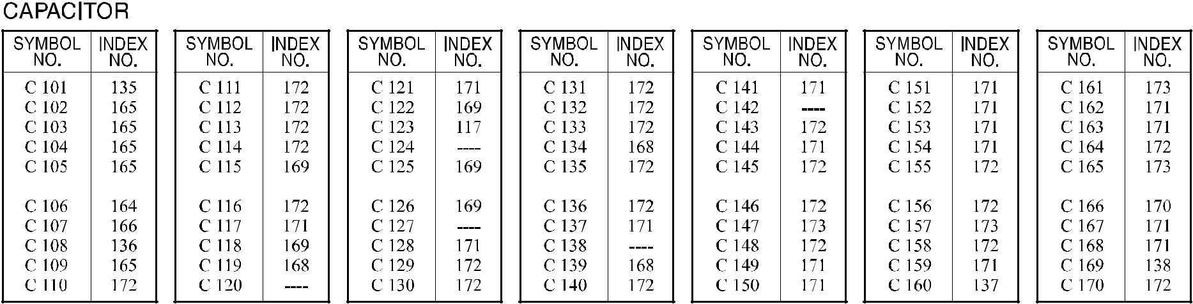
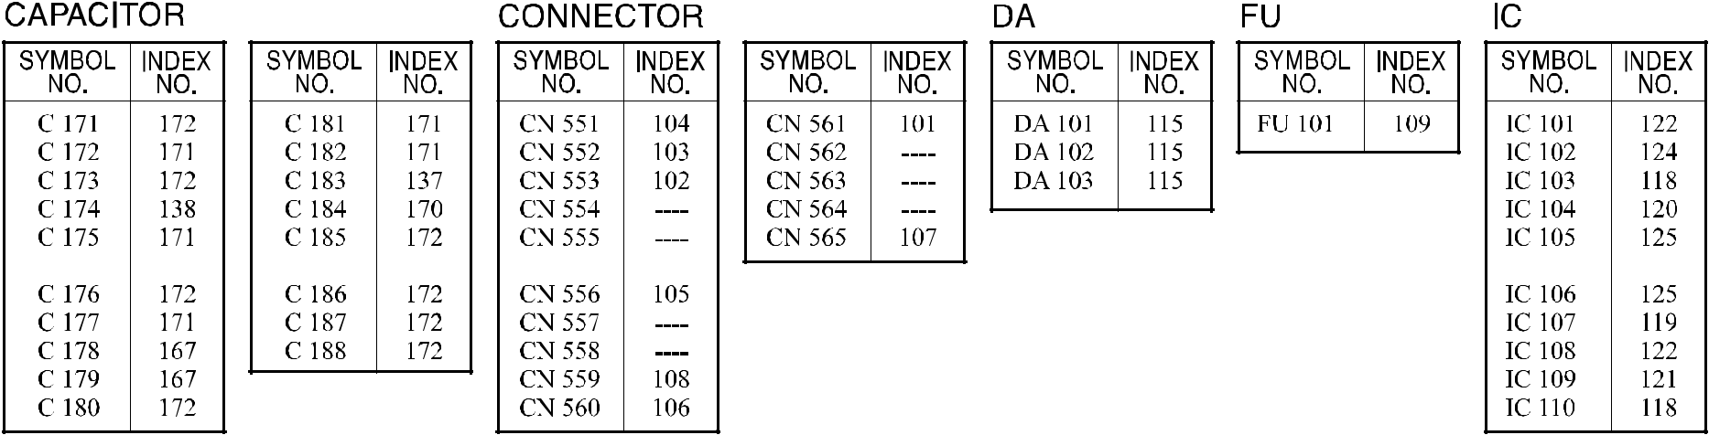

A292/A293/B098 150 Parts Location and List

67.MCU BOARD (A292/A293)
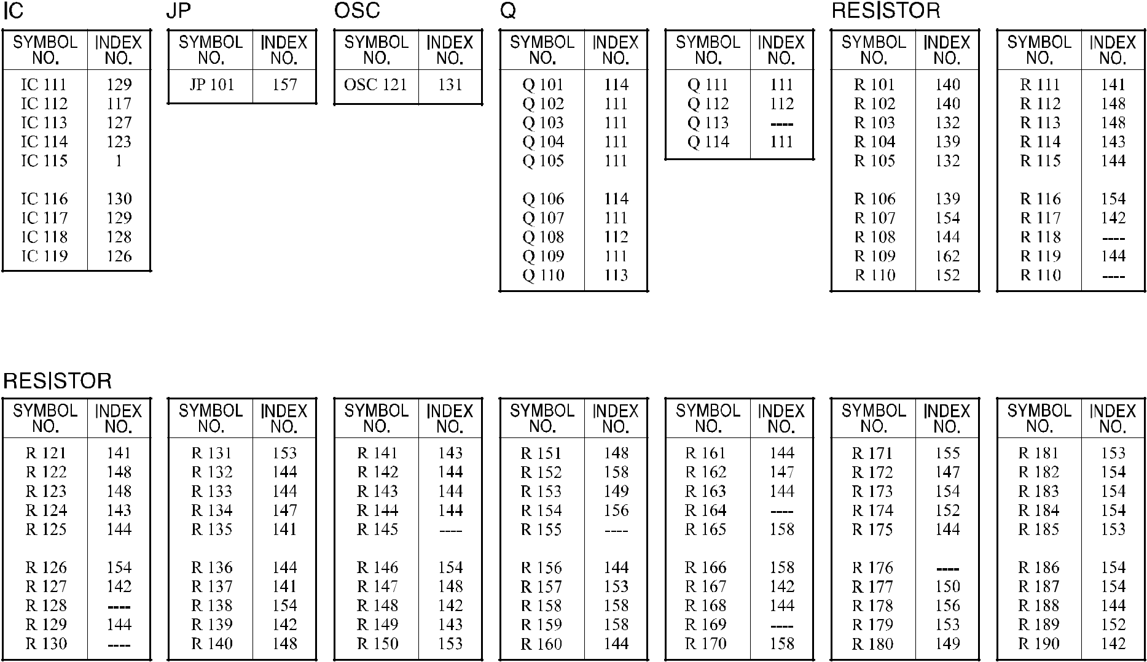

A292/A293/B098 151 Parts Location and List

67.MCU BOARD (A292/A293)
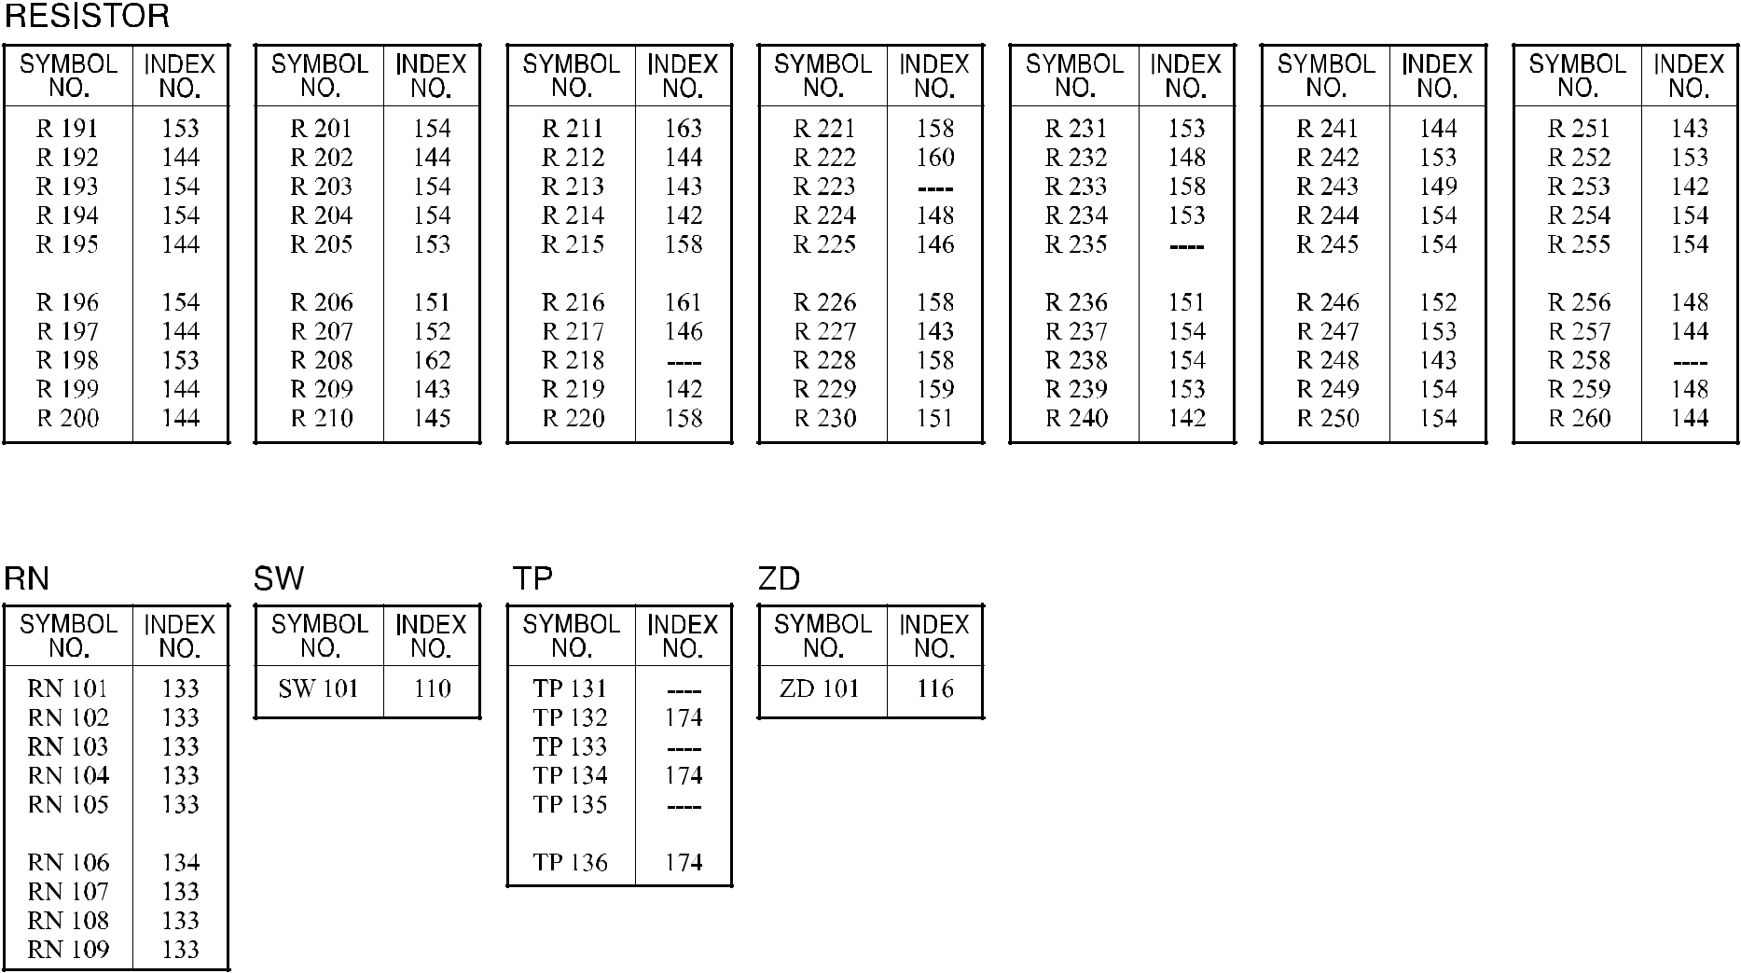

A292/A293/B098 152 Parts Location and List

67.MCU BOARD (A292/A293)

Index | Part No. | Description | Q’ty Per
No. | Part No. | Description | Assembly
* | A293 5180 | MCU Board | 1
1 | A294 5057 | IC - HD6433042SC34F | 1

Index | Part No. | Description | Q’ty Per
No. | Part No. | Description | Assembly

- 1102 5301 Connector - 2P

- 1102 5302 Connector - 3P

- 1102 5305 Connector - 6P

- 1102 5325 Connector - 2P

- 1102 6298 Connector - 5P

- 1102 6300 Connector - 7P

- 1102 6307 Connector - 14P

- 1102 6314 Connector - 7P

- 1109 0010 Fuse - 3.75A

- 1204 2368 Dip Switch - DSS804

- 1400 0398 Transistor - 2SC2412K

- 1401 0881 Transistor - 2SJ142

- 1401 0972 Transistor - 2SB1260

- 1401 1113 Transistor - 2SK2462

- 1402 1142 Diode Array - DAN217

- 1402 1380 Diode - PTZ 6.2A

- 1403 0954 Sensor - MA12-10V23

- 1407 1596 TTLIC - SN74LS14NS

- 1407 1741 TTL - SN74LS32NS

- 1407 1783 IC - 74LS02

- 1407 1880 TTLIC - SN74LS04NS

- 1407 1984 IC - SH74LS123NS

- 1407 2051 TTL - IC - SN74LS00NS

- 1407 2052 TTLIC - SN74LS74ANS

- 1407 2187 TTLIC - SN74LS07NS

- 1407 4137 IC - MM1035XF

- 1408 0565 IC - UPC311G

- 1408 0645 IC - UPC4570G

- 1408 0942 IC - BA4558F

- 1408 1065 Comparator BA10339F

- 1503 0817 Crystal Oscillator - 15.9744MHz

- 1600 1510 Resistor - 1.5K Ω ±5% 1W

- 1601 7759 Resistor Array-100k Ω ±5% 0.063W

- 1601 7791 Resistor Array - 1K Ω ±5%

- 1604 4734 Capacitor - 47µF±20% 25V

A292/A293/B098 152A Parts Location and List

Index | Part No. | Description | Q’ty Per
No. | Part No. | Description | Assembly

- 1604 4735 Capacitor - 1000µF±20% 50V

- 1605 0599 Capacitor - 0.1µF±10%

- 1605 0643 Capacitor - 0.1MICRO F

- 1611 9331 Resistor - 330 Ω ±5% 1/2W

- 1611 9621 Resistor - 620 Ω ±5% 1/2W

- 1630 4100 Resistor - 10 Ω ±5% 1/16W

- 1630 4102 Resistor - 1.0KΩ ±5% 1/16W

- 1630 4103 Resistor - 10KΩ ±5% 1/16W

- 1630 4104 Resistor - 100 Ω ±5% 1/16W

- 1630 4124 Resistor - 120K Ω ±5%1/16W

- 1630 4153 Resistor - 15KΩ ±5% 1/16W

- 1630 4161 Resistor - 160 Ω ±5% 1/16W

- 1630 4222 Resistor - 2.2K Ω ±5%

- 1630 4224 Resistor - 220K Ω ±5% 1/16W

- 1630 4242 Resistor - 2.4k Ω - ±5% - 1/16w

- 1630 4332 Resistor - 3.3K Ω ±5% 1/16W

- 1630 4470 Resistor - 470 Ω ±5% 1/16W

- 1630 4472 Resistor - 4.7KΩ ±5% 1/16W

- 1630 4511 Resistor - 510 Ω - ±5% - 1/16w

- 1630 4512 Resistor - 5.1k Ω - ±5% - 1/16w

- 1630 4562 Resistor - 5.6k Ω - ±5% - 1/16W

- 1634 0000 Resistor - 0 Ω 1/16W

- 1634 1002 Resistor - 10 Ω ±5% 1/16W

- 1634 2002 Resistor - 20K Ω ±1% 1/16W

- 1634 2402 Resistor - 24K Ω ±1% 1/16W

- 1634 2702 Resistor - 27KΩ ±1% 1/16W

- 1634 3903 Resistor - 390k Ω - ±1% - 1/16w

- 1634 4302 Resistor - 43K Ω ±1% 1/16W

- 1640 0101 Capacitor - 100µF10V

- 1640 2470 Capacitor - 47µF±20% 25V

- 1640 5101 Capacitor - 100µF±20% 50V

- 1660 0100 Capacitor - 10PF ±0.5pF 50V

- 1660 2101 Capacitor - 100pF - ±10% - 50V

- 1660 2471 Capacitor - 470pF - ±5% - 50V

- 1660 3102 Capacitor - 1000pF ±5% 50V

Index | Part No. | Description | Q’ty Per
No. | Part No. | Description | Assembly

- 1660 4102 Capacitor - 1000pF ±10% 50V

- 1660 6103 Capacitor - 10000pF - +80%-20%50V

- 1660 8104 Capacitor - 0.1µF+80-20% 25V

A292/A293/B098 153 Parts Location and List

68.MCU BOARD (B098)

A292/A293/B098 154 Parts Location and List

68.MCU BOARD (B098)

A292/A293/B098 155 Parts Location and List

68.MCU BOARD (B098)

A292/A293/B098 156 Parts Location and List

68.MCU BOARD (B098)

Index | Part No. | Description | Q’ty Per
No. | Part No. | Description | Assembly
* | B070 5100 | MCU Board (B098) | 1
1 | B070 5104 | Prom:ic

Index | Part No. | Description | Q’ty Per
No. | Part No. | Description | Assembly
101 | 1101 0328 | Connector Pin Contact
102 | 1102 5301 | Connector - 2P
103 | 1102 5302 | Connector - 3P
104 | 1102 5305 | Connector - 6P
105 | 1102 5325 | Connector - 2P
106 | 1102 6298 | Connector - 5P
107 | 1102 6300 | Connector - 7P
108 | 1102 6307 | Connector - 14P
109 | 1102 6309 | Connector - 2P
110 | 1102 6314 | Connector - 7P
111 | 1109 0010 | Fuse - 3.75a

- 1204 1422 DIP Switch - 51D-0401

- 1400 0775 Transistor - 2SC4081

- 1401 0881 Transistor - 2SJ142

- 1401 0972 Transistor-2sb1260

- 1401 1113 Transistor - 2SK2462

- 1402 1584 Diode - DAN217U

- 1402 1662 Diode: ptz6.2b

- 1403 1107 IC: la12-10v21

- 1407 1596 TTLIC - SN74LS14NS

- 1407 1741 TTL - SN74LS32NS

- 1407 1783 IC - 74LS02

- 1407 1880 TTLIC - SN74LS04NS

- 1407 1984 IC - SH74LS123NS

- 1407 2051 TTL - IC - SN74LS00NS

- 1407 2052 TTLIC - SN74LS74ANS

- 1407 2187 TTLIC - SN74LS07NS

- 1407 4137 IC - MM1035XF

- 1408 0565 IC - UPC311G

- 1408 0645 Ic-upc4570g

- 1408 0942 IC - BA4558F

- 1408 1065 Comparator - BA10339F

- 1503 0817 Crystal Oscillator - 15.9744M HZ

- 1600 1510 Resistor - 1.5K Ω ±5% 1W

- 1601 7759 Resistor Array - 100K Ω ±5% 0.06

A292/A293/B098 156A Parts Location and List

Index | Part No. | Description | Q’ty Per
No. | Part No. | Description | Assembly

- 1601 7791 Resistor Array - 1K Ω ±5%

- 1604 4734 Capacitor - 47µF±20% 25V

- 1604 4735 Capacitor - 1000µF±20% 50V

- 1605 1137 Capacitor - 470pF ±10% 50V

- 1605 1148 Capacitor - 0.1µF+80-20% 50V

- 1605 1228 Capacitor: 0.1uf:±10%:25v

- 1611 9331 Resistor - 330 Ω ±5% 1/2W

- 1611 9621 Resistor - 620 Ω ±5% 1/2W

- 1634 0000 Resistor - 0 Ω 1/16W

- 1640 0101 Capacitor - 100µF10V

- 1640 2470 Capacitor - 47µF±20% 25V

- 1640 5101 Capacitor - 100µF±20% 50V

- 1650 4100 Resistor - 10Ω ±5% 1/10W

- 1650 4102 Resistor - 1KΩ ±5% 1/10W

- 1650 4103 Resistor - 10KΩ ±5% 1/10W

- 1650 4104 Resistor - 100KΩ±5%1/10W

- 1650 4124 Resistor: 120kΩ:±5%:1/10w

- 1650 4153 Resistor - 15K Ω ±5% 1/10W

- 1650 4161 Resistor - 160Ω ±5% 1/10W

- 1650 4222 Resistor - 2.2KΩ±5%1/10W

- 1650 4224 Resistor: 220kΩ:±5%:1/10w

- 1650 4242 Resistor - 2.4K Ω ±5% 1/10W 1608

- 1650 4332 Resistor - 3.3KΩ±5%1/10W

- 1650 4470 Resistor - 47Ω±5%1/10W

- 1650 4472 Resistor - 4.7KΩ ±5% 1/10W

- 1650 4511 Resistor - 510Ω±5%1/10W

- 1650 4512 Resistor - 5.1KΩ±5%1/10W

- 1650 4562 Resistor - 5.6KΩ ±5% 1/10W

- 1654 1002 Resistor - 10KΩ±5%1/10W

- 1654 2002 Resistor - 20KΩ±1%1/10W

- 1654 2402 Chip Resistor: 24kΩ:±1%:1/10w

- 1654 2702 Resistor - 27KΩ±1%1/10W

- 1654 3903 Resistor - 390KΩ ±1% 1/10W

- 1654 4302 Resistor - 43KΩ ±1% 1/10W

- 1660 0100 Capacitor - 10PF ±0.5pF 50V

Index | Part No. | Description | Q’ty Per
No. | Part No. | Description | Assembly

- 1660 2101 Capacitor - 100pF - ±10% - 50V

- 1660 4102 Capacitor - 1000pF ±10% 50V

- 1660 6103 Capacitor - 10000pF - +80%-20%50V

- 1660 8104 Capacitor - 0.1µF+80-20% 25V

A292/A293/B098 157 Parts Location and List

69.BICU BOARD (A292/A293)
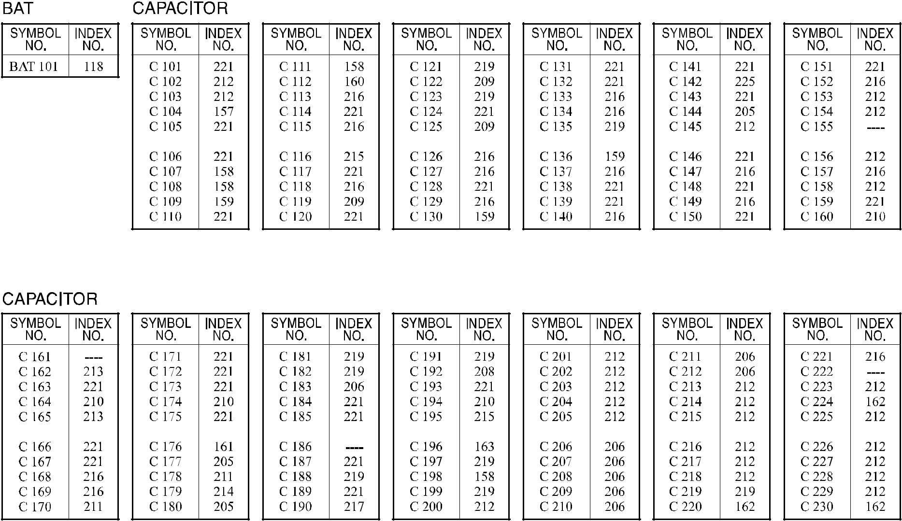

A292/A293/B098 158 Parts Location and List

69.BICU BOARD (A292/A293)
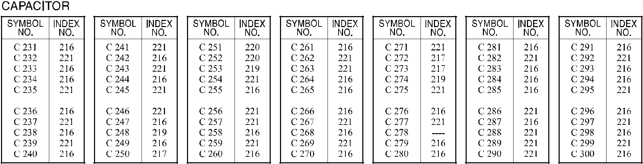
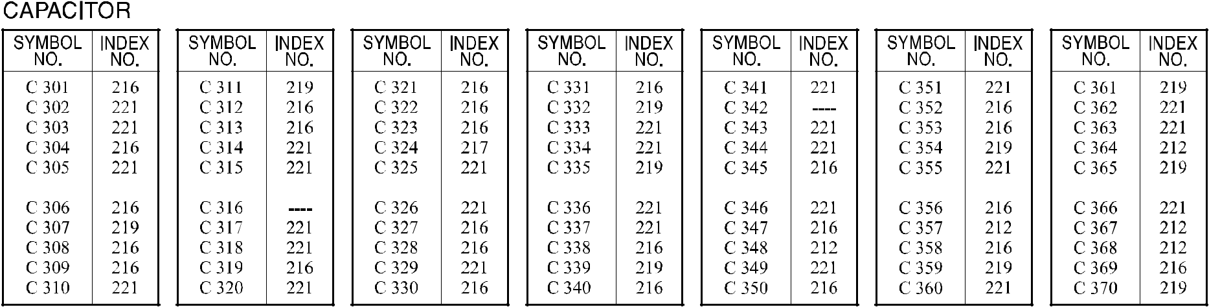

A292/A293/B098 159 Parts Location and List

69.BICU BOARD (A292/A293)
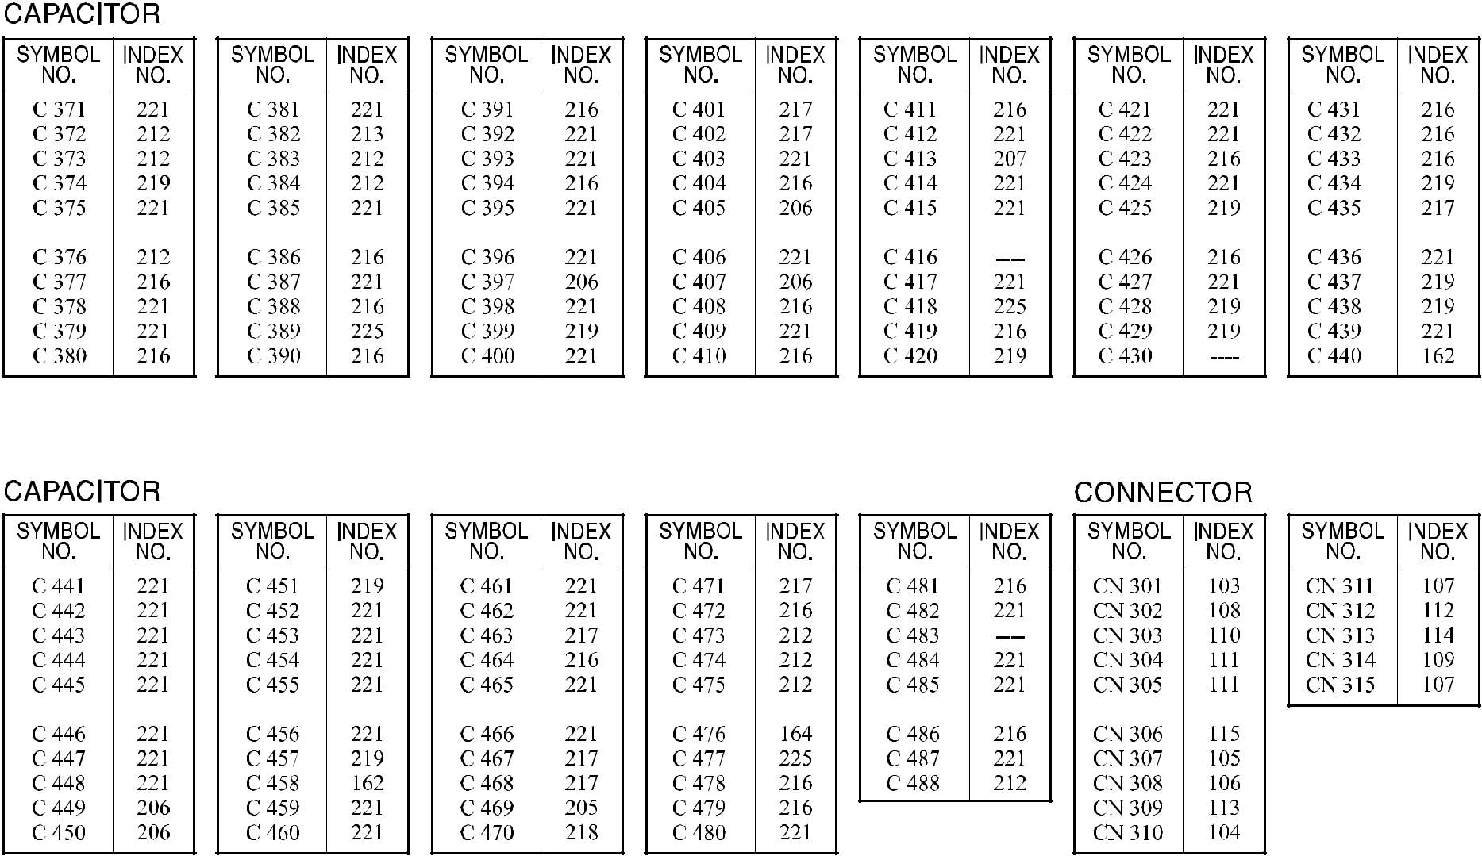

A292/A293/B098 160 Parts Location and List

69.BICU BOARD (A292/A293)
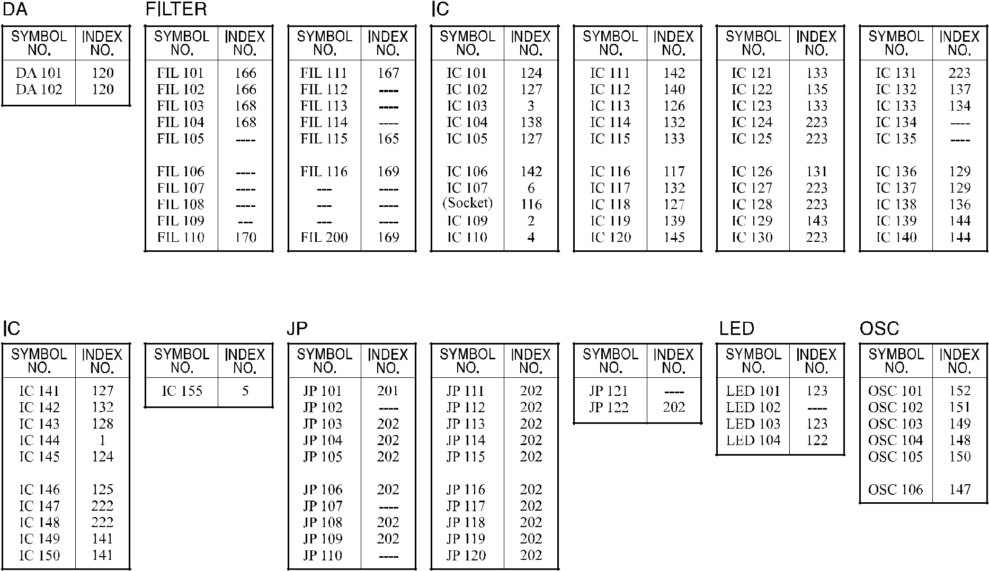

A292/A293/B098 161 Parts Location and List

69.BICU BOARD (A292/A293)
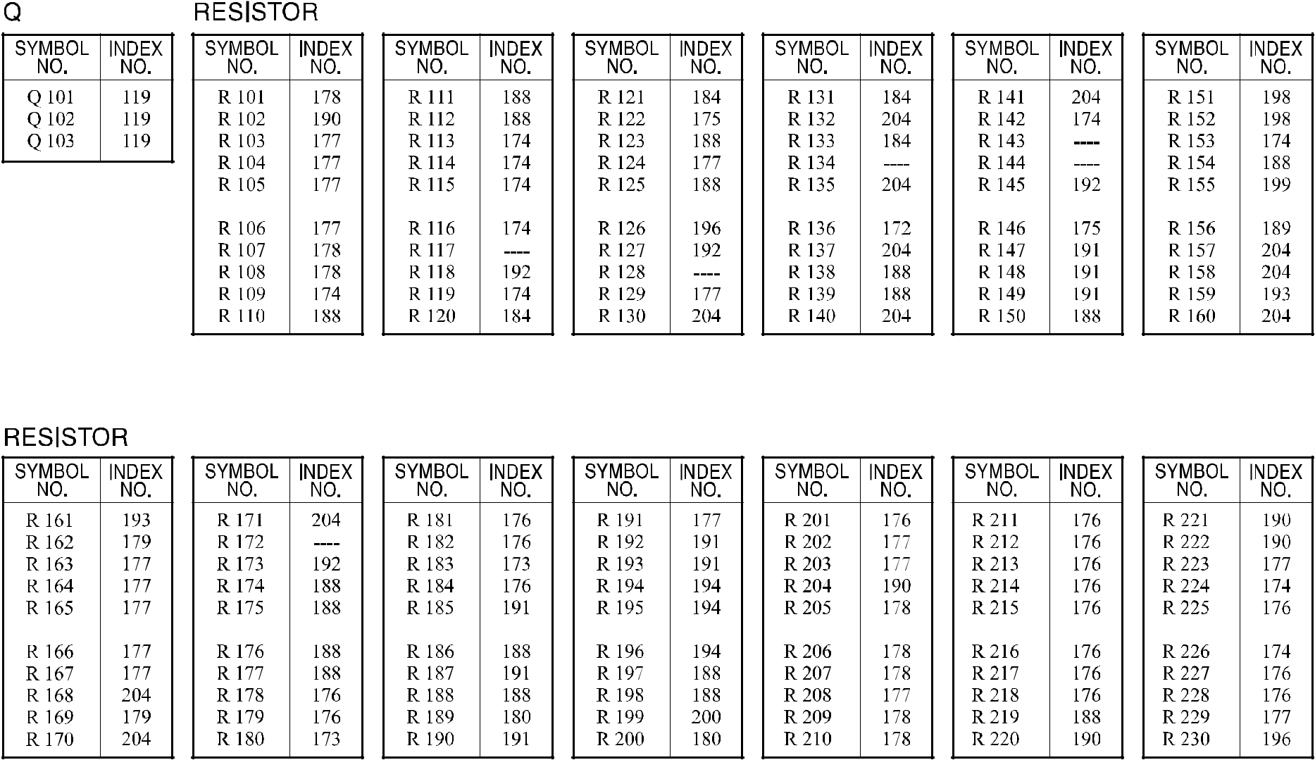

A292/A293/B098 162 Parts Location and List

69.BICU BOARD (A292/A293)
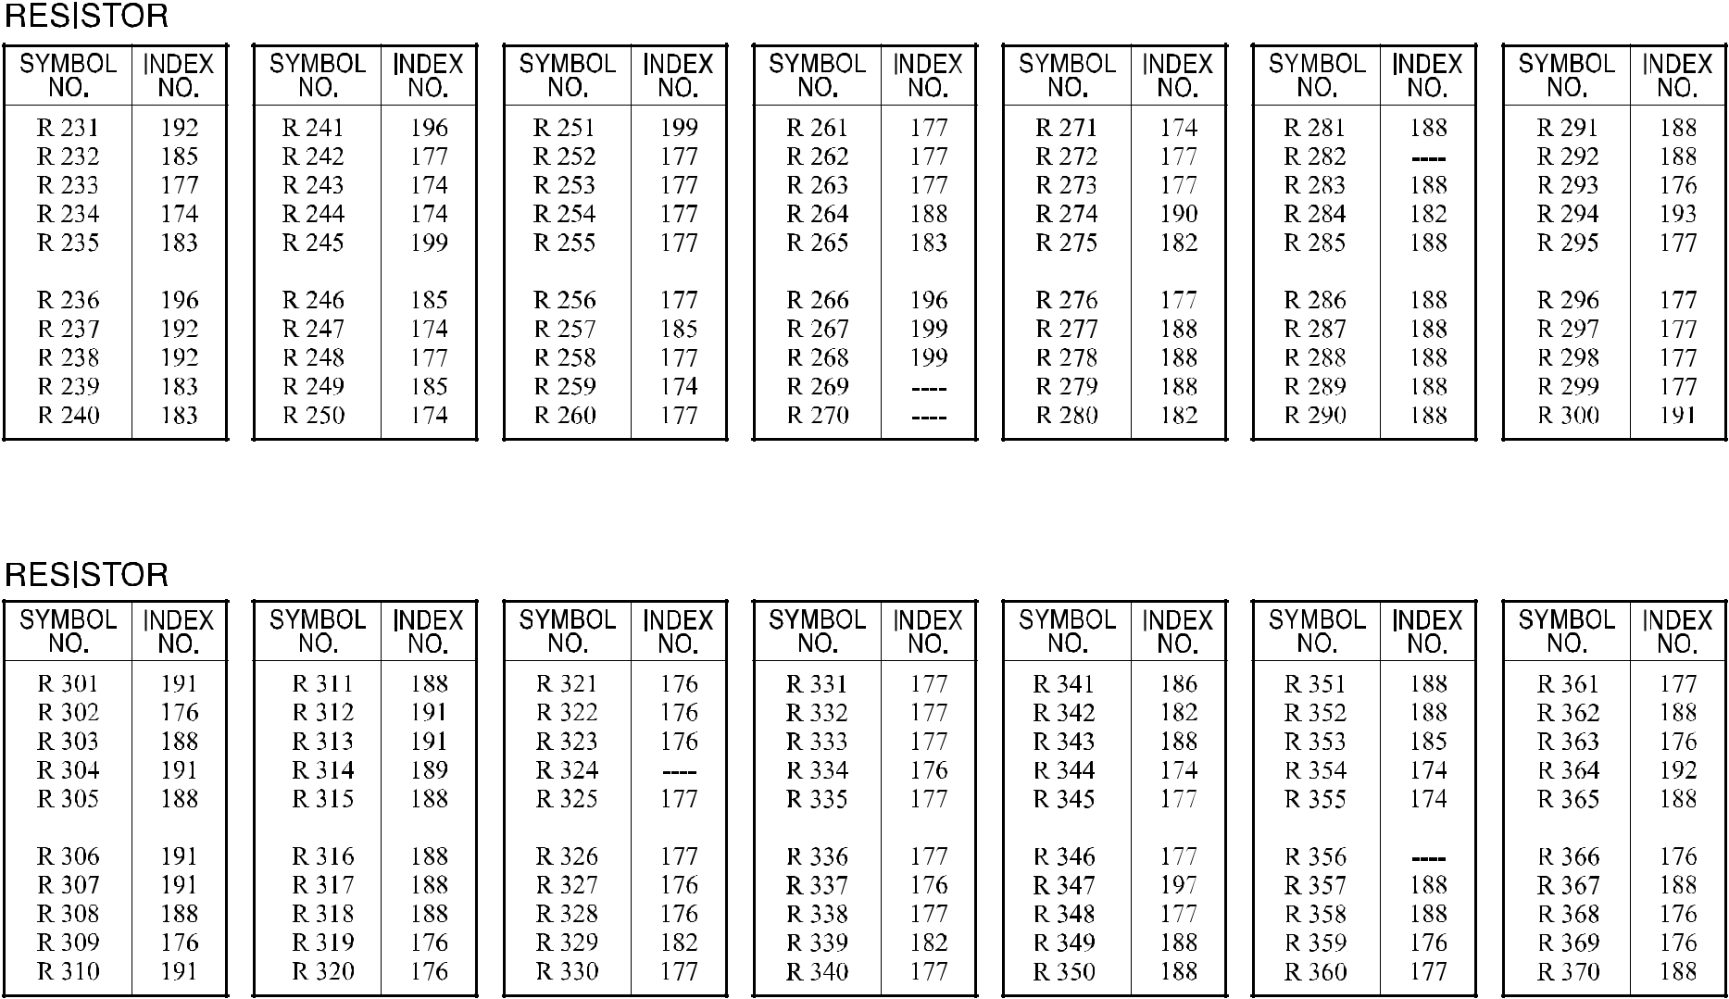

A292/A293/B098 163 Parts Location and List

69.BICU BOARD (A292/A293)
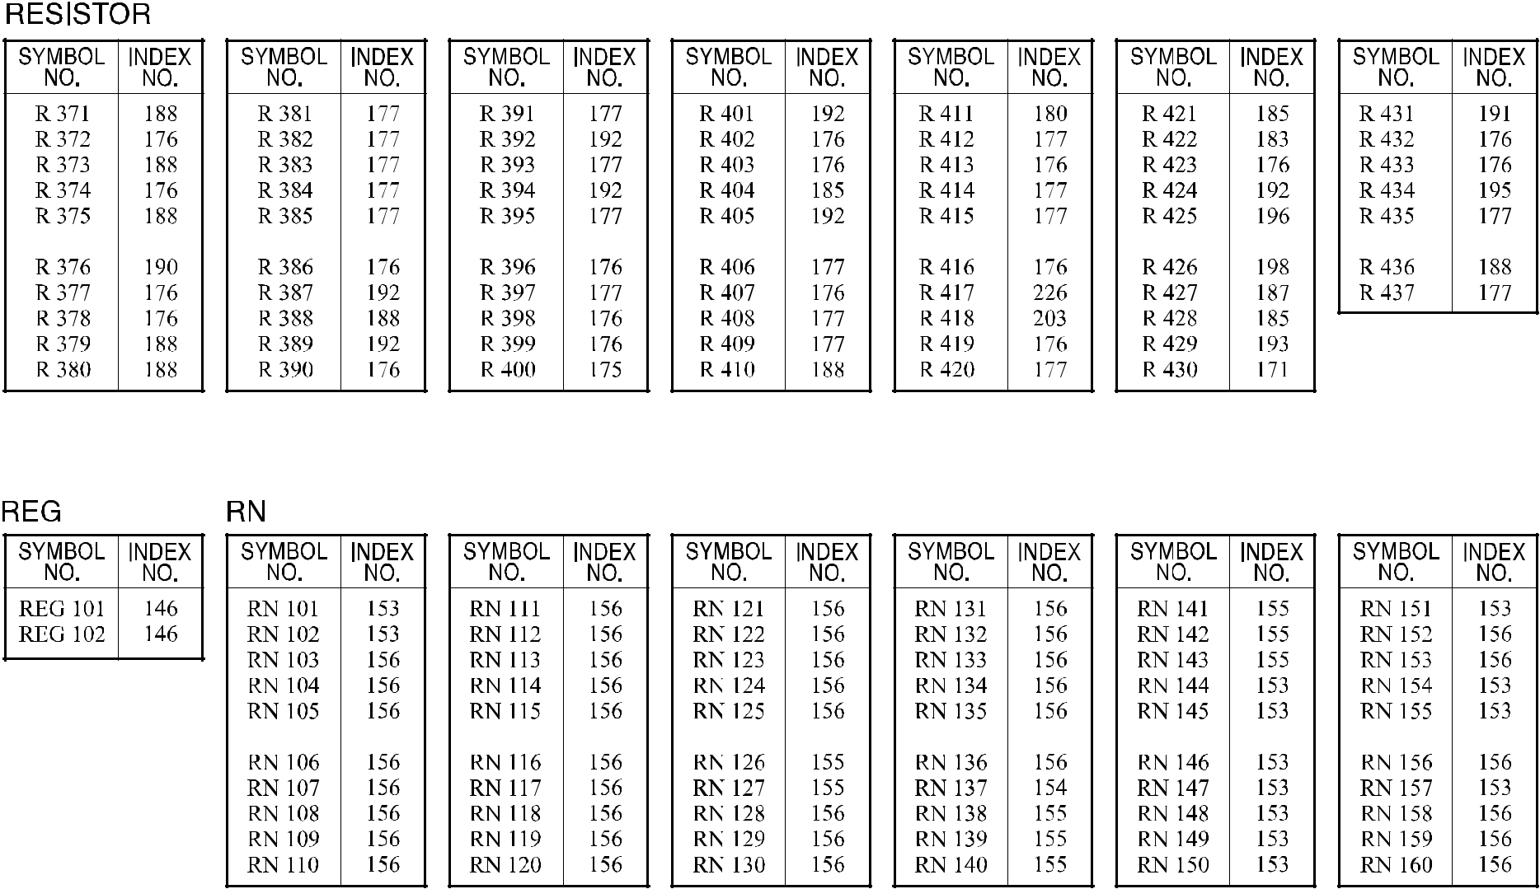

A292/A293/B098 163A Parts Location and List

69.BICU BOARD (A292/A293)
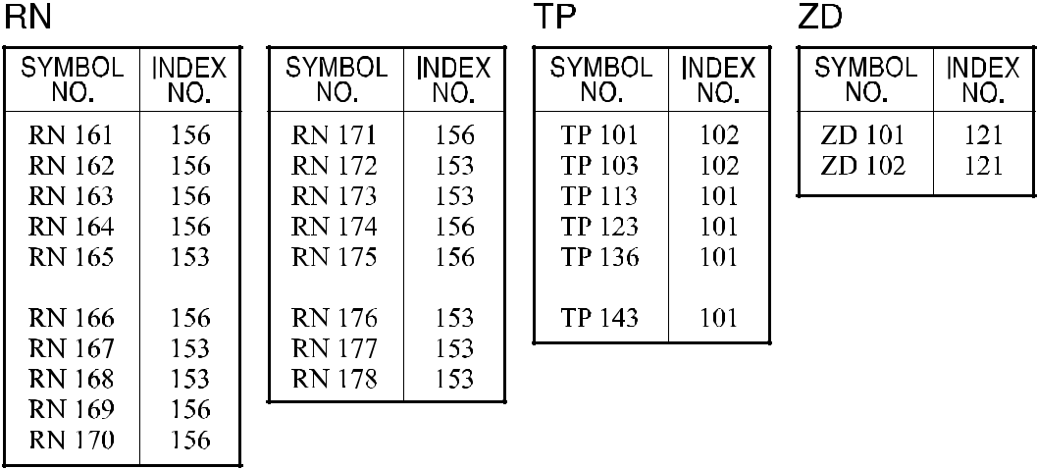

A292/A293/B098 164 Parts Location and List

69.BICU BOARD (A292/A293)

Index | Part No. | Description | Q’ty Per
No. | Part No. | Description | Assembly
* | A293 7552 | BICU Board (NA) | 1
* | A293 7562 | BICU Board (EU) | 1
1 | A232 5350 | IC - HG71C103FD | 1
2 | A294 5151 | IC - BIPU | 1
3 | A294 5153 | IC - IMACB RF5C589C | 1
4 | A294 5155 | IC - BIJU | 1
5 | A293 9099 | Nv-ram Minus Counter | 1

Index | Part No. | Description | Q’ty Per
No. | Part No. | Description | Assembly
102 | 1102 6760 | Connector -3p
103 | 1102 7029 | Connector - 8p - 53375-0810
104 | 1102 7095 | Connector - 40P
105 | 1102 7389 | Connector - FH12-50S-0.5SV
106 | 1102 7456 | Connector 176125-5
107 | 1102 7496 | Connector
108 | 1102 7508 | Connector

- 1102 8036 Connector - 68P

- 1102 8065 Connector - FH12-40S-0.5SV

- 1102 8067 Connector - FH12-15S-0.5SV

- 1102 8091 Connector - 53505-4010

- 1102 8095 Connector - 1-353520-1

- 1102 8104 Connector - FX8C-60P-SV6(21)

- 1102 8239 Connector - 1-353520-9

- 1104 0597 IC Socket - 64p - SN

- 1104 0766 IC Socket - 32P-2-382424-3

- 1206 0054 Lithium Cell - CR2032-1HS

- 1400 0392 Transistor - DTC114EK

- 1402 1142 Diode Array - DAN217

- 1402 1447 Diode - PTZ5.1B

- 1403 0828 Diode - SEC1901C

- 1403 0829 Diode - SEC1201C

- 1407 1596 TTLIC - SN74LS14NS

- 1407 2052 TTLIC - SN74LS74ANS

- 1407 2138 TTLIC - 74F139SJ

- 1407 2187 TTLIC - SN74LS07NS

- 1407 2218 TTLIC - SN74LS06NS

- 1407 2378 TTL - SN74ALS245ANS

- 1407 2464 TTL - IC - SN74ALS74ANS

- 1407 2947 IC - TC7S00F

- 1407 3008 TTL - SN74ALS244CNS

- 1407 3206 IC - TC7S32F

- 1407 3411 SN74ALS541NS

- 1407 3682 IC - TC7W00F

136 1407 3825 ALS-TTI SN74ALS244A-1NS

A292/A293/B098 165 Parts Location and List

Index | Part No. | Description | Q’ty Per
No. | Part No. | Description | Assembly

137 1407 4044 IC - 74ACT14

- 1407 4947 IC - 74LCX244

- 1407 4959 IC - MC68334GCFC20

- 1407 4962 IC - RTC-4563SB

- 1407 5039 IC - MBM29F016A-90pFTN

- 1407 5090 IC - DS90CF364MTD

143 1407 5177 IC - ABT244

144 1407 5178 IC - ABT245

- 1408 0575 IC - M51957BFP

- 1408 1461 IC - LM1086IS-3.3

- 1503 0758 Oscillator - MC-306 32.768MHz

- 1503 0885 Crystal Oscillator - 10MHz

- 1503 0900 Crystal Oscillator - 20.5MHz

- 1503 0901 Crystal Oscillator - 19.6608MHz

- 1503 0904 Ceramic Oscillator - 16MHz

- 1503 0907 Crystal Oscillator - 40MHz

- 1601 7752 Resistor Array - 10K Ω ±5%

- 1601 7753 Resistor - 47 Ω ±5%

- 1601 7814 Resistor 3.3k Ω ±5%

- 1601 7867 Resistor - 33 Ω ±5% 1/16W

- 1604 4355 Capacitor - 47µF±20% 25V

- 1604 4728 Capacitor - 100µF±20% 16V

- 1604 4729 Capacitor - 47µF±20% 16V

- 1604 4730 Capacitor - 47µF±20% 50V

- 1605 0769 Capacitor - 20pF ±5% 50V

- 1605 0928 Capacitor - 0.1uF 16V ±10%

- 1605 0943 Capacitor - 0.33µF+80 -20% 25V

- 1605 1055 Capacitor - 0.022µF±10% 25V

- 1607 0732 Noise Filter - AEF321825-470

- 1607 0758 Filter - DSS710D223A12-22

- 1607 0847 Data Line Filter - ACB1608H-300

- 1607 0852 Filter - BLM41P750SPB

- 1607 0950 Filter - ACB1608H-060

- 1607 1041 Filter - ACB1608M-300

- 1630 2331 Resistor - 330Ω 1/8W ±5%

Index | Part No. | Description | Q’ty Per
No. | Part No. | Description | Assembly

- 1630 3561 Resistor - 560 Ω ±5% 1/10W

- 1630 3751 Resistor - 750Ω±5% 1/10W

- 1630 4100 Resistor - 10 Ω ±5% 1/16W

- 1630 4101 Resistor - 100 Ω ±5% 1/16W

- 1630 4102 Resistor - 1.0KΩ ±5% 1/16W

- 1630 4103 Resistor - 10KΩ ±5% 1/16W

- 1630 4104 Resistor - 100 Ω ±5% 1/16W

- 1630 4105 Resistor - 1.0MΩ ±5% 1/16W

- 1630 4106 Resistor -10m Ω ±5% 1/16w

- 1630 4121 Resistor - 120 Ω ±5% 1/16W

- 1630 4150 Resistor - 15Ω ±5.00%,1/16W

- 1630 4161 Resistor - 160 Ω ±5% 1/16W

- 1630 4220 Resistor - 22 Ω ±5% 1/16W

- 1630 4222 Resistor - 2.2K Ω ±5%

- 1630 4223 Resistor - 22K Ω ±5% 1/16W

- 1630 4272 Resistor - 2.7k Ω - ±5% - 1/16W

- 1630 4330 Resistor - 33 Ω ±5% 1/8W

- 1630 4331 Resistor - 330 Ω ±5% 1/16W

- 1630 4332 Resistor - 3.3K Ω ±5% 1/16W

- 1630 4470 Resistor - 470 Ω ±5% 1/16W

- 1630 4472 Resistor - 4.7KΩ ±5% 1/16W

- 1630 4511 Resistor - 510 Ω - ±5% - 1/16W

- 1630 4514 Resistor 510kΩ ±5.00% 1/16W

- 1630 4561 Resistor - 5600Ω ±5% 1/16W

- 1630 4562 Resistor - 5.6k Ω - ±5% - 1/16W

- 1630 4563 Resistor - 56KΩ ±5% 1/16W

- 1630 4680 Resistor - 68 Ω ±5% 1/16W

- 1630 4820 Resistor - 82 Ω ±5% 1/16W

- 1630 4824 Resistor - 820k Ω ±5% 1/16W

- 1632 0000 Resistor - 0 Ω 1/8W

- 1634 0000 Resistor - 0 Ω 1/16W

- 1634 3921 Resistor - 3.92KΩ ±1% 1/1

- 1634 5109 Resistor - 51.0 Ω ±1% 1/16W

- 1660 0100 Capacitor - 10PF ±0.5pF 50V

- 1660 2101 Capacitor - 100pF - ±10% - 50V

A292/A293/B098 166 Parts Location and List

Index | Part No. | Description | Q’ty Per
No. | Part No. | Description | Assembly

- 1660 2151 Capacitor - 150pF ±20% 35V

- 1660 2180 Capacitor 18pF ±5% 50V

- 1660 2181 Capacitor - 180pF ±5% 50V

- 1660 2220 Capacitor - 22pF ±20% 35V

- 1660 2270 Capacitor - 27pF ±20% 35V

- 1660 2330 Capacitor - 33pF - ±5% - 50V

- 1660 2331 Capacitor - 330pF ±5% 50V

- 1660 2390 Ceramic Capacitor - 39pF 50V

- 1660 2470 Capacitor - 47pF ±5% 50V

- 1660 2471 Capacitor - 470pF - ±5% - 50V

- 1660 4103 Capacitor - 10000pF ±10% 50V

- 1660 4332 Capacitor - 3300pF - ±10% - 50V

- 1660 6103 Capacitor - 10000pF - +80%-20%50V

- 1660 6223 Capacitor 22000pF +80 -20% 50V

- 1660 8104 Capacitor - 0.1∝F+80-20% 25V

- 1902 0043 IC - 4MX8 70NS G2

- 1907 0007 SDRAM 64M 1MX16X4 100MHZ G3

Index | Part No. | Description | Q’ty Per
No. | Part No. | Description | Assembly

A292/A293/B098 167 Parts Location and List

70.BICU BOARD (B098)

A292/A293/B098 168 Parts Location and List

70.BICU BOARD (B098)

A292/A293/B098 169 Parts Location and List

70.BICU BOARD (B098)

A292/A293/B098 170 Parts Location and List

70.BICU BOARD (B098)

A292/A293/B098 171 Parts Location and List

70.BICU BOARD (B098)

A292/A293/B098 172 Parts Location and List

70.BICU BOARD (B098)

A292/A293/B098 173 Parts Location and List

70.BICU BOARD (B098)

A292/A293/B098 173A Parts Location and List

70.BICU BOARD (B098)

A292/A293/B098 174 Parts Location and List

70.BICU BOARD (B098)

Index | Part No. | Description | Q’ty Per
No. | Part No. | Description | Assembly
* | B098 7552 | BICU Board (NA) (B098) | 1
* | B098 7562 | BICU Board (EU) (B098) | 1
1 | A232 5350 | IC - HG71C103FD | 1
2 | A294 5151 | IC - BIPU | 1
3 | A294 5153 | IC - IMACB RF5C589C | 1
4 | A294 5155 | IC - BIJU | 1
6 | A294 5144 | IC - HDC | 1
7 | A293 5110 | IC - EPM 7064SLC-10 | 1

Index | Part No. | Description | Q’ty Per
No. | Part No. | Description | Assembly
101 | 1102 6760 | Connector -3p
102 | 1102 7029 | Connector - 8p - 53375-0810
103 | 1102 7095 | Connector - 40P
104 | 1102 7389 | Connector - FH12-50S-0.5SV
105 | 1102 7456 | Connector - 176125-5
106 | 1102 7496 | Connector
107 | 1102 7508 | Connector

- 1102 8036 Connector - 68P

- 1102 8065 Connector - FH12-40S-0.5SV

- 1102 8067 Connector - FH12-15S-0.5SV

- 1102 8091 Connector - 53505-4010

- 1102 8095 Connector - 1-353520-1

- 1102 8104 Connector - FX8C-60P-SV6(21)

- 1102 8239 Connector - 1-353520-9

- 1104 0589 DIP Socket - 32p

- 1104 0597 IC Socket - 64p - SN

- 1206 0054 Lithium Cell - CR2032-1HS

- 1400 0392 Transistor - DTC114EK

- 1402 1142 Diode Array - DAN217

- 1402 1365 Diode-rb751v-40

- 1402 1447 Diode - PTZ5.1B

- 1403 0828 Diode - SEC1901C

- 1403 0829 Diode - SEC1201C

- 1407 1596 TTLIC - SN74LS14NS

- 1407 2052 TTLIC - SN74LS74ANS

- 1407 2138 TTLIC - 74F139SJ

- 1407 2187 TTLIC - SN74LS07NS

- 1407 2218 TTLIC - SN74LS06NS

- 1407 2378 TTL - SN74ALS245ANS

130 1407 2947 IC - TC7S00F

- 1407 3008 TTL - SN74ALS244CNS

- 1407 3206 IC - TC7S32F

- 1407 3411 Sn74als541ns

- 1407 3682 IC - TC7W00F

135 1407 3825 Als-ttl Sn74als244a-1ns

A292/A293/B098 175 Parts Location and List

Index | Part No. | Description | Q’ty Per
No. | Part No. | Description | Assembly

136 1407 4044 IC - 74ACT14

- 1407 4947 IC - 74LCX244

- 1407 4959 IC - MC68334GCFC20

- 1407 5039 IC - MBM29F016A-90pFTN

- 1407 5090 IC - DS90CF364MTD

141 1407 5177 IC - ABT244

142 1407 5178 IC - ABT245

143 1407 5672 IC:rtc-4574sa

- 1408 0575 IC - M51957BFP

- 1408 1461 IC - LM1086IS-3.3

- 1503 0758 Oscillator - MC-306 32.768MHZ

- 1503 0885 Crystal Oscillator - 10MHZ

- 1503 0900 Crystal Oscillator - 20.5MHZ

- 1503 0901 Crystal Oscillator - 19.6608MHZ

- 1503 0904 Ceramic Oscillator - 16mhz

- 1503 0907 Crystal Oscilator-40mhz

- 1601 7752 Resistor Array - 10K Ω ±5%

- 1601 7753 Resistor - 47 Ω ±5%

- 1601 7814 Resistor - 3.3K Ω ±5%

- 1601 7867 Resistor - 33 Ω ±5% 1/16W

- 1604 4355 Capacitor - 47µF±20% 25V

- 1604 4728 Capacitor - 100µF±20% 16V

- 1604 4729 Capacitor - 47µF±20% 16V

- 1604 4730 Capacitor - 47µF±20% 50V

- 1605 0976 Capacitor - 1µF+80% -20% 10V

- 1605 1161 Capacitor - 0.33µF±10% 10V

- 1605 1187 Ceramic Capacitor 0.047µF±10% 50v

- 1605 1225 Capacitor - 0.1µF±10% 50V

- 1605 1266 Capacitor: 0.022µF: ±10%:50V

- 1607 0732 Noise Filter - Aef321825-470

- 1607 0758 Filter - Dss710d223a12-22

- 1607 0847 Data Line Filter - Acb1608h-300

- 1607 0852 Filter - Blm41p750spb

- 1607 0950 Filter - Acb1608h-060

- 1607 1041 Filter - Acb1608m-300

Index | Part No. | Description | Q’ty Per
No. | Part No. | Description | Assembly

- 1632 0000 Resistor - 0 Ω 1/8W

- 1634 0000 Resistor - 0 Ω 1/16W

- 1650 2331 Chip Resistor:330Ω:±5%:1/4w

- 1650 3561 Resistor - 560Ω ±5% 1/8W

- 1650 3751 Chip Resistor:750Ω:±5%:1/8w

- 1650 4100 Resistor - 10Ω ±5% 1/10W

- 1650 4101 Resistor - 100Ω±5%1/10W

- 1650 4102 Resistor - 1KΩ ±5% 1/10W

- 1650 4103 Resistor - 10KΩ ±5% 1/10W

- 1650 4104 Resistor - 100KΩ±5%1/10W

- 1650 4105 Resistor - 1MΩ ±5% 1/10W

- 1650 4106 Resistor - 10MΩ±5%1/10W

- 1650 4121 Resistor - 120Ω±5%1/10W

- 1650 4150 Resistor - 15Ω ±5% 1/10W

- 1650 4161 Resistor - 160Ω ±5% 1/10W

- 1650 4220 Chip Resistor - 22Ω ±5% 1/10w

- 1650 4222 Resistor - 2.2KΩ±5%1/10W

- 1650 4223 Resistor - 22KΩ±5%1/10W

- 1650 4272 Resistor - 2.7KΩ±5%1/10W

- 1650 4330 Chip Resistor - 33Ω ±5% 1/10w

- 1650 4331 Resistor - 330Ω±5%1/10W

- 1650 4332 Resistor - 3.3KΩ±5%1/10W

- 1650 4470 Resistor - 47Ω±5%1/10W

- 1650 4472 Resistor - 4.7KΩ ±5% 1/10W

- 1650 4511 Resistor - 510Ω±5%1/10W

- 1650 4514 Resistor - 510K Ω ±5% 1/10W

- 1650 4562 Resistor - 5.6KΩ ±5% 1/10W

- 1650 4563 Resistor - 56KΩ±5%1/10W

- 1650 4680 Resistor - 68Ω±5%1/10W

- 1650 4820 Resistor - 82Ω ±5% 1/10W

- 1650 4824 Resistor: 820kΩ:±5%:1/10w:1608

- 1654 1002 Resistor - 10KΩ±5%1/10W

- 1654 3921 Resistor: 3.92kΩ:±1%:1/10w:1608

- 1654 5109 Resistor: 51Ω:±1%:1/10w

- 1660 0100 Capacitor - 10PF ±0.5pF 50V

A292/A293/B098 176 Parts Location and List

Index | Part No. | Description | Q’ty Per
No. | Part No. | Description | Assembly

- 1660 2101 Capacitor - 100pF - ±10% - 50V

- 1660 2151 Capacitor - 150pF ±20% 35V

- 1660 2180 Capacitor 18pF ±5% 50v

- 1660 2181 Capacitor - 180pF ±5% 50V

- 1660 2220 Capacitor - 22pF ±20% 35V

- 1660 2270 Capacitor - 27pF ±20% 35V

- 1660 2330 Capacitor - 33pF - ±5% - 50V

- 1660 2331 Capacitor - 330pF ±5% 50V

- 1660 2390 Ceramic Capacitor - 39pF 50v

- 1660 2470 Capacitor - 47pF ±5% 50V

- 1660 2471 Capacitor - 470pF - ±5% - 50V

- 1660 4103 Capacitor - 10000pF - ±10% - 50V

- 1660 4332 Capacitor - 3300pF - ±10% - 50V

- 1660 6103 Capacitor - 10000pF - +80%-20%50V

- 1660 6223 Capacitor - 22000pF +80 -20% 50V

- 1660 8104 Capacitor - 0.1∝F+80-20% 25V

- 1902 0043 IC - 4MX8 70NS G2

- 1907 0007 SDRAM - 64k 1mx 16x4 100mhz G3

Index | Part No. | Description | Q’ty Per
No. | Part No. | Description | Assembly

A292/A293/B098 177 Parts Location and List

71.DECAL AND DOCUMENT (A292/A293)
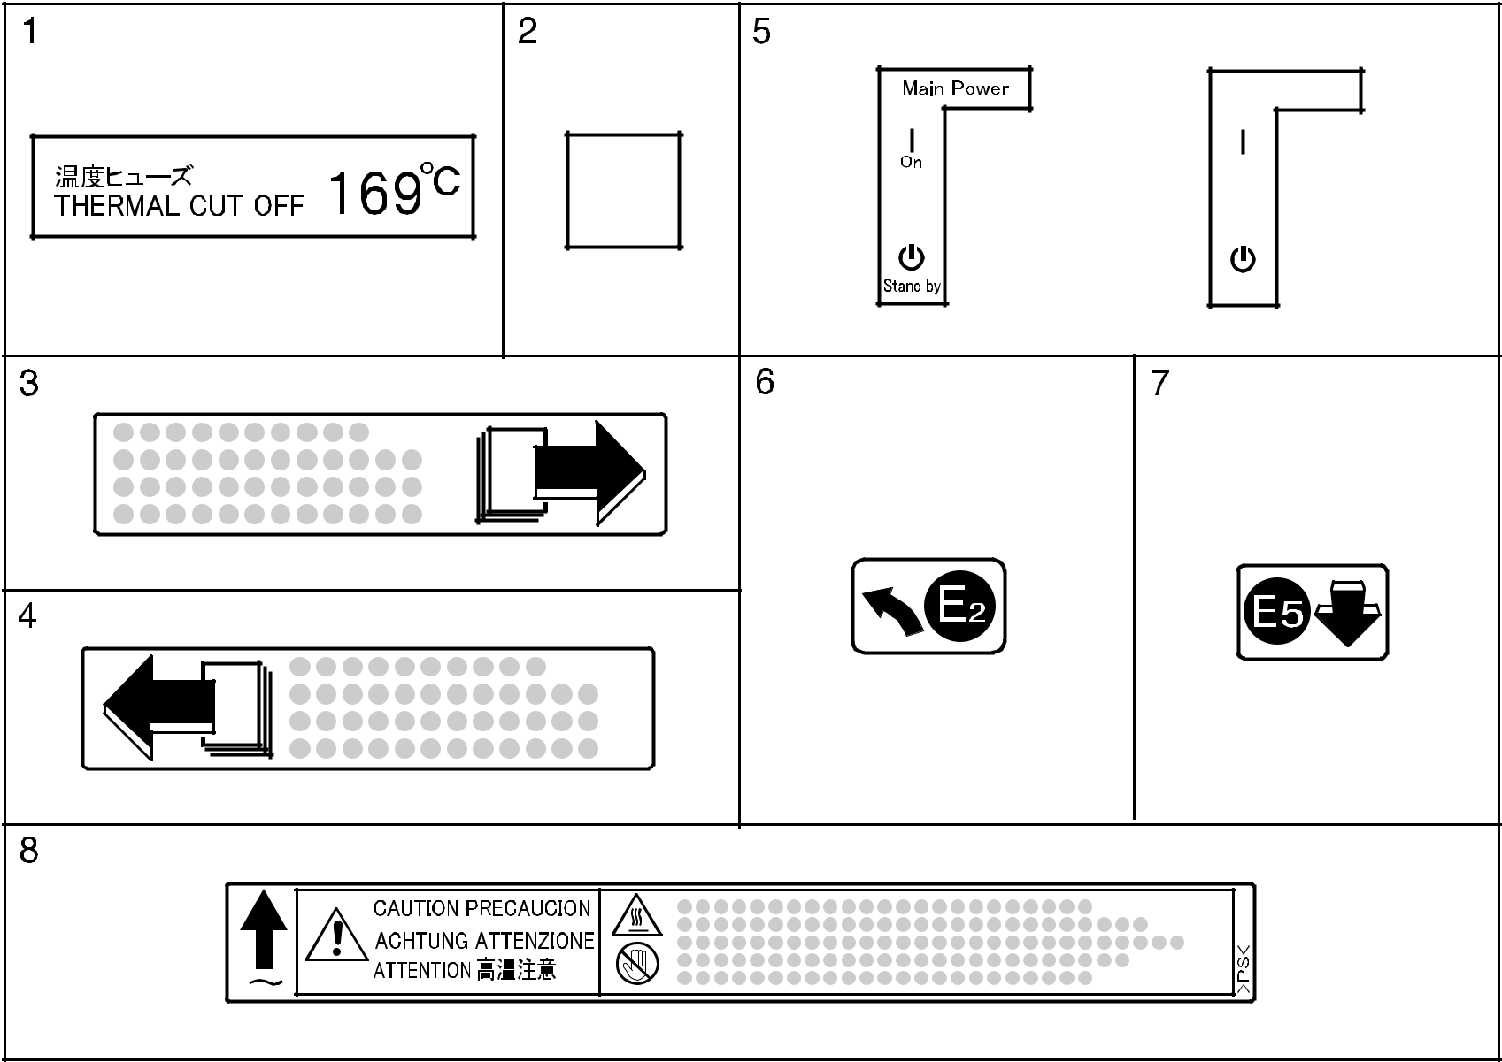

A292/A293/B098 178 Parts Location and List

71.DECAL AND DOCUMENT (A292/A293)
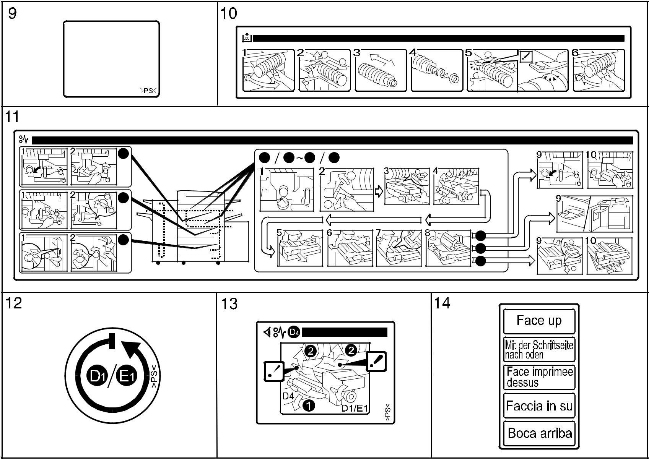

A292/A293/B098 179 Parts Location and List

71.DECAL AND DOCUMENT (A292/A293)
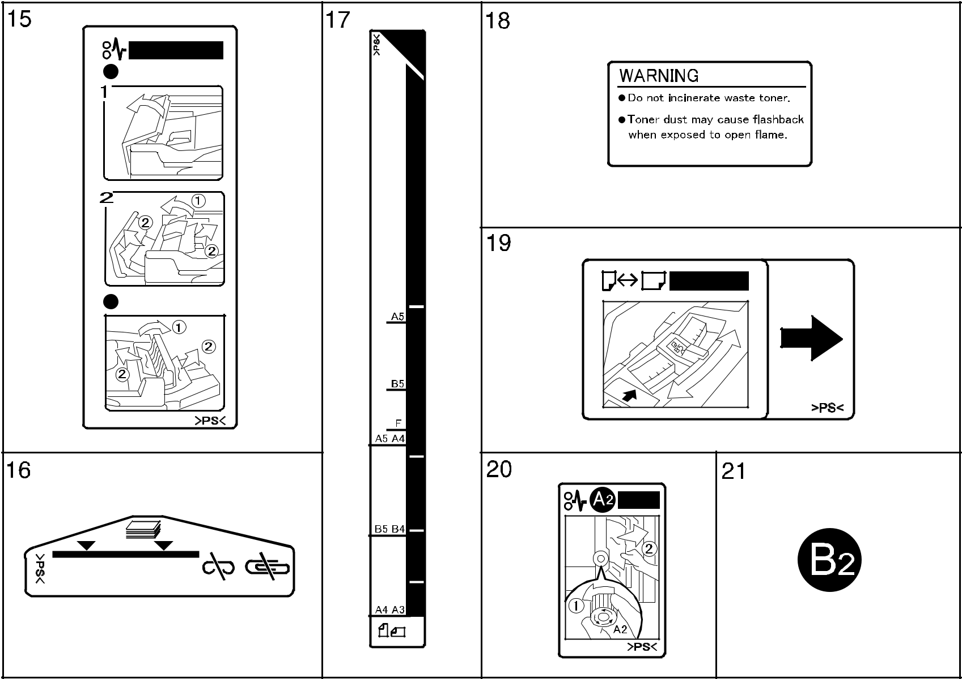

A292/A293/B098 180 Parts Location and List

71.DECAL AND DOCUMENT (A292/A293)
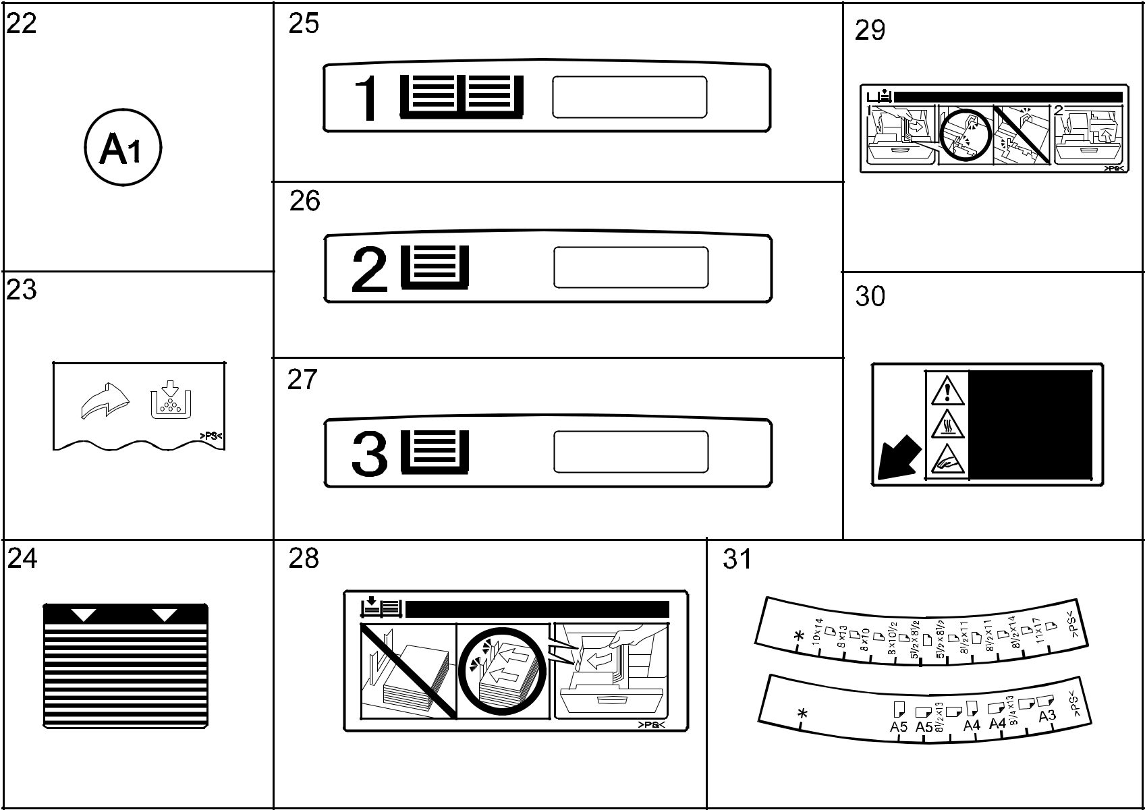

A292/A293/B098 181 Parts Location and List

71.DECAL AND DOCUMENT (A292/A293)
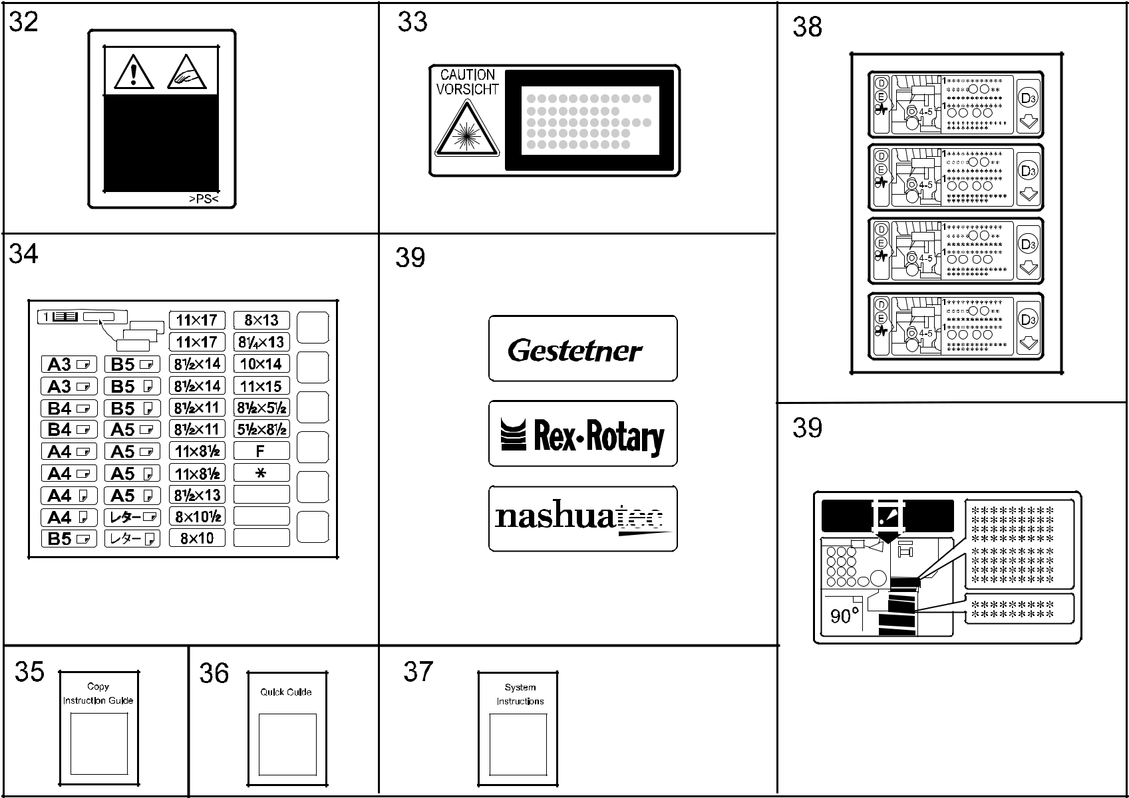

A292/A293/B098 182 Parts Location and List

71.DECAL AND DOCUMENT (A292/A293)

Index | Part No. | Description | Q’ty Per
No. | Part No. | Description | Assembly
2 | A029 2984 | Decal - Grip | 1
3 | A096 6677 | Decal - Right Paper Set | 1
4 | A096 6678 | Decal - Left Paper Set | 1
5 | A229 1360 | Decal - Main Switch (120V) | 1
5 | A229 1361 | Decal - Main Switch (230V) | 1
6 | A229 4492 | Decal - Exit Guide | 1
7 | A229 4734 | Decal - Guide Plate Lever | 1
8 | A229 4821 | Decal - Warning | 1
9 | A232 1381 | Decal - Total Counter | 1
10 | A293 1349 | Decal - Toner Supply | 1
11 | A293 1350 | Decal - Misfeed Removal | 1
12 | A293 4077 | Decal - Rotation Direction Knob | 1
13 | A293 4156 | Decal - Confirm Paper | 1
14 | A610 6051 | Decal - Document Set (A292/A293) | 1
14 | B477 4431 | Decal - Original Table (B098) | 1
15 | A806 4311 | Decal - Misfeed Removal | 1
16 | A806 4321 | Decal - Original Stack Height | 1
17 | A806 4331 | Decal - Original Size | 1
18 | AA00 0059 | Caution Decal - English | 1
19 | AA00 0213 | Decal - Universal Tray | 1
20 | AA00 0540 | Decal - Misfeed Removal | 1
21 | AA00 1213 | Decal - B2 | 1
22 | AA00 1326 | Decal - A1 | 1
23 | AA00 1394 | Decal - Toner Supply | 1
24 | AA00 2010 | Decal - Paper Level | 1
25 | AA00 2237 | Decal - Paper Tray No1 | 1
26 | AA00 2238 | Decal - Cover No.2 | 1
27 | AA00 2239 | Decal - Cover No.3 | 1
28 | AA00 2244 | Decal - Paper Set - Left | 1
29 | AA00 2245 | Decal - Paper Set - Right | 1
30 | AA00 2246 | Decal - Caution | 1
31 | AA00 2251 | Paper Size Decal - LT | 1
31 | AA00 2252 | Paper Size Decal - A4 | 1
32 | B301 4351 | Caution Decal | 1
33 | G029 1982 | Decal - LD | 1

Index | Part No. | Description | Q’ty Per
No. | Part No. | Description | Assembly
34 | AA00 2096 | Decal - Size Indication (A292/A293) | 1
34 | B070 1308 | Decal: Size Indication: Paper Tray (B098) | 1
35 | A293 7207 | Copy Instruction Guide - LT English (RIC) | 1
 |  | (A292/A293)
35 | A293 7208 | Copy Instruction Guide - A4 English (RIC) | 1
 |  | (A292/A293)
35 | A293 7260 | Copy Instruction Guide - A4 English (INF) | 1
 |  | (A292/A293)
35 | A293 7290 | Copy Instruction Guide - A4 English (NRG) | 1
 |  | (A292/A293)
35 | A293 7297 | Copy Instruction Guide - LT English | 1
 |  | (SVN/GES)(A292/A293)
35 | B098 7207 | Operating Instructions: Copy: English (B098) | 1
36 | A293 7307 | Quick Guide - LT English (RIC/SVN/GES) | 1
36 | A293 7308 | Quick Guide - A4 English (RIC) | 1
36 | A293 7390 | Quick Guide - A4 English (NRG/INF) | 1
37 | A293 8607 | System Instructions - LT English (RIC) | 1
 |  | (A292/A293)
37 | A293 8608 | System Instructions - A4 English (RIC) | 1
 |  | (A292/A293)
37 | A293 8660 | System Instructions - A4 English (INF) | 1
 |  | (A292/A293)
37 | A293 8690 | System Instructions - A4 English (NRG) | 1
 |  | (A292/A293)
37 | A293 8697 | System Instructions - LT English (SVN/GES) | 1
 |  | (A292/A293)
37 | B098 8607 | Operating Instructions: SYS: English (B098) | 1
38 | B098 4166 | Decal: Misfeed Removal: D/e:Multi (B098) | 1
39 | B098 3241 | Decal:Toner Supply: English (B098) | 1
40 | A292 9870 | Aficio 551/700 Parts Catalog (RIC) | 1
41 | A292 9850 | Aficio 551/700 Service Manual English(RIC) | 1
42 | B098 9870 | Aficio 551/700/1055 Parts Catalog (RIC) | 1

A292/A293/B098 183 Parts Location and List

72.SPECIAL TOOLS (A292/A293)
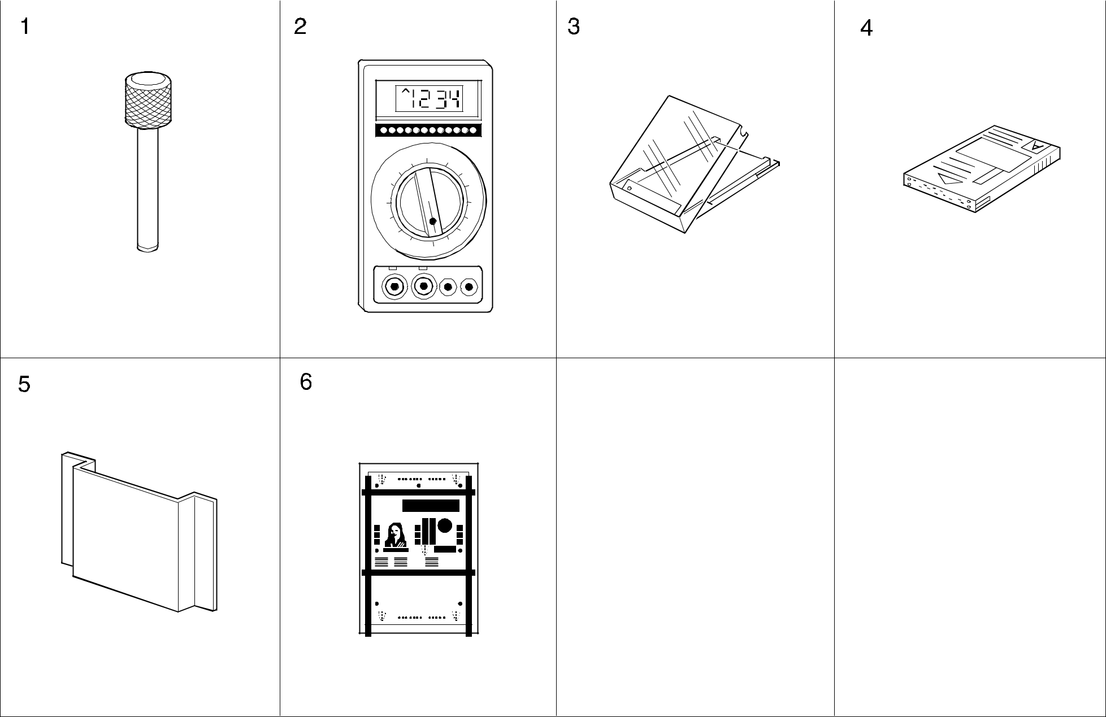

A292/A293/B098 184 Parts Location and List

72.SPECIAL TOOLS (A292/A293)

Index | Part No. | Description | Q’ty Per
No. | Part No. | Description | Assembly
1 | A006 9104 | Adjusting Scanner Pin (4pcs/set) | 1
2 | A029 9387 | Digital Multimeter - Fluke87 | 1
3 | N803 1000 | Case - Flash Memory Card | 1
4 | N803 6701 | Flash Memory Card-4Mb | 1
5 | A229 8521 | Operating Instructions Holder - A5 | 1
6 | A292 9500 | Test Chart - S5S (10 Pcs/set) (RIC) | 1
6 | 5420 9516 | Test Chart - OS - A3 (10psc/set)(OEM) | 1

Index | Part No. | Description | Q’ty Per
No. | Part No. | Description | Assembly

A292/A293/B098 185 Parts Location and List

A292/A293/B098

PARTS INDEX

This section instructs you as to the numbers and names of parts on this machine.
PM Parts Index


 | Section Name | Part No. | Description in Service Manual |  | Description in Parts Catalog |  |  | Q’ty Per | Page and
 |  |  |  |  |  |  |  | Assembly | Index No.
EXTERIOR 2 | AA01 0108 |  | Ozone Filter | Ozone Filter (A292/A293) |  | 1 | 17- 7
 |  | AA01 0116 | Ozone Filter |  | Ozone Filter: Rear |  | (B098) | 1 | 17- | 7
 |  | A229 1262 | Optics Dust Filter |  | Optics Dust Filter (A292/A293) |  |  | 1 | 17- 19
 |  | B098 1262 | Optics Dust Filter |  | Filter: Ass'y (B098) |  |  | 1 | 17- 19
 |  | A293 1098 | Filter: Vacuum |  | Vacuum Filter |  |  | 1 | 17- 24
ORIGINAL FEED SECTION 2 |  | A806 1295 | Feed Belt |  | Feed Belt |  |  | 1 | 25- 10
 |  | A806 1321 | Pickup Roller |  | Pickup Roller |  |  | 1 | 25- 23
 |  | A859 2241 | Separation Roller |  | Reverse Roller |  |  | 1 | 25- 26
ORIGINAL TRANSFER SECTION |  | B301 1441 | Transport Belt |  | Transport Belt |  |  | 1 | 29- 1
PAPER FEED SECTION 2 |  | AF03 0040 | Pick-up Roller |  | Pick-up Roller |  |  | 3 | 65- 4
 |  | AF03 1040 | Feed Roller |  | Feed Roller |  |  | 3 | 65- 5
PAPER FEED SECTION 3 |  | AF03 2040 | Separation Roller |  | Separation Roller |  |  | 3 | 67- 3
PAPER RESISTRATION 1 |  | AF03 0041 | Pick-up Roller |  | Pick-up Roller - Bypass Feed |  |  | 1 | 71- 14
 |  | AF03 1041 | Feed Roller |  | Feed Roller - Bypass Feed |  |  | 1 | 71- 16
PAPER RESISTRATION 2 |  | AF03 2041 | Separation Roller |  | Separation Roller - Bypass Feed |  |  | 1 | 73- 5
TONER HOPPER UNIT |  | AA01 2104 | Air Filter - Large |  | Air Filter - Large |  |  | 1 | 79- 3
 |  | AA01 2105 | Air Filter - Small |  | Air Dust Filter - Small |  |  | 1 | 79- 16
DEVELOPMENT UNIT 1 |  | AA01 2060 | Development Filter |  | Development Filter |  |  | 1 | 81- 7
PCU 1 (A292/A293/B098) |  | A096 2063 | Corona Wire Cleaner |  | Corona Wire Cleaner |  |  | 1 | 85- 7
 |  | AD02 0053 | Charge Corona Wire |  | Charge Corona Wire (A292/A293) |  |  | 1 | 85- 12
 |  | AD02 7022 | Charge Corona Wire |  | Wire:Charge Corona (B098) |  |  | 1 | 85- 12
 |  | A096 2057 | Charge Corona Grid |  | Charge Corona Grid |  |  | 1 | 85- 18
PCU 3 (A292/A293/B098) |  | AD04 1056 | Cleaning Blade |  | Cleaning Blade |  |  | 1 | 89- 1
 |  | AD04 2039 | Cleaning Brush |  | Cleaning Brush |  |  | 1 | 89- 9
TRANSFER SECTION 1 |  | A293 3899 | Transfer Belt |  | Transfer Belt - Mojito Service |  |  | 1 | 93- 5
TRANSFER SECTION 2 |  | A293 3918 | Cleaning Roller Cleaning Blade |  | Transfer Belt Blade |  |  | 1 | 95- 11
FUSING UNIT 1 (A292/A293/B098) |  | AE03 1024 | Bushing |  | Bushing - M4x7 |  |  | 2 | 97- 8
 |  | AE04 2036 | Cleaning Roller |  | Cleaning Roller: Pressure Roller: Ass |  |  | 1 | 97- | 9
 |  |  |  |  | (120V)(A292/A293)(B098)
 |  | AE04 2046 | Cleaning Roller |  | Cleaning Roller - Pressure Roller |  |  | 1 | 97- | 9
 |  |  |  |  | (230V)(B098)
FUSING UNIT 1 (A292/A293/B098) |  | AE04 2035 | Oil Supply Cleaning Roller |  | Oil Supply Cleaning Roller |  |  | 1 | 97- 14
 |  |  |  |  | (120V)(A292/A293)(B098)
 |  | AE04 2045 | Oil Supply Cleaning Roller |  | Oil Supply Cleaning Roller |  |  | 1 | 97- 14
 |  |  |  |  | (230V)(B098)

A292/A293/B098 2 Parts Index

  Section Name | Part No. | Description in Service Manual | Description in Parts Catalog | Q’ty Per | Page and
 |  |  |  | Assembly | Index No.
 | AE04 0016 | Oil Supply Roller | Oil Supply Roller (A292/A293) | 1 | 97- 16
 | AE04 0051 | Oil Supply Roller | Oil Supply Roller (B098) | 1 | 97- 16
FUSING UNIT 2 (A292/A293/B098) | AE04 4019 | Hot Roller Stripper | Hot Roller Stripper (A292/A293) | 5 | 99- 17
 | AE04 4043 | Hot Roller Stripper | Hot Roller Stripper (B098) | 5 | 99- 17
FUSING UNIT 3 (A292/A293/B098) | AE03 0017 | Hot Roller Bearings | Ball Bearing - 35x50x10 | 2 | 101- 9
 | AE03 0018 | Pressure Roller Bearings | Ball Bearing - 12x28x8 | 2 | 101- 15
 | AE02 2078 | Pressure Roller | Pressure Roller | 1 | 101- 22
 | AE01 1044 | Hot Roller | Hot Roller (A292/A293) | 1 | 101- 23
 | AE01 1073 | Hot Roller | Hot Roller:Mm50 (B098) | 1 | 101- 23
FRAME SECTION 2 (A292/A293/B098) | A293 1104 | Ozone Filter: PCU | Ozone Filter (A292/A293) | 1 | 139- 11
 | B098 1104 | Ozone Filter: PCU | Ozone Filter (B098) | 1 | 139- 11

A292/A293/B098 3 Parts Index

Parts Index

Part No. | Description | Page and
Part No. | Description | Index No.
A292 1273 | Front Door (A292 RIC) | 15 | - | 8
A292 1278 | Front Door (A292 INF) | 15 | - | 8
A292 7010 | Model Name Plate - SVN 2055DP (A292) | 15 | - 23
A292 7012 | Model Name Plate - GES 3355 (A292) | 15 | - 23
A292 7014 | Model Name Plate - NSA D555 (A292) | 15 | - 23
A292 7016 | Model Name Plate - REX 2955 (A292) | 15 | - 23
A292 7018 | Model Name Plate - LAN 5455 (A292) | 15 | - 23
A292 9500 | Test Chart - S5S (10 Pcs/set) (RIC) | 185 | - | 6
A292 9850 | Aficio 551/700 Service Manual English(RIC) | 183 | - 41
A292 9870 | Aficio 551/700 Parts Catalog (RIC) | 183 | - 40

Part No. | Description | Page and
Part No. | Description | Index No.
A001 2582 | Spacer - 8x10x1.6mm | 119 | - 24
A006 9104 | Adjusting Scanner Pin (4pcs/set) | 185 | - | 1
A007 3751 | Large Cap - Toner Collection Tank | 17 | - 12
A010 5700 | Sensor | 57 | - 32
A017 2988 | Ring | 123 | - 23
A028 7878 | Arm Spacer | 29 | - 17
A029 2858 | Release Lever | 69 | - | 5
A029 2984 | Decal - Grip | 183 | - | 2
A029 2984 | Decal - Grip | 69 | - | 3
A029 9387 | Digital Multimeter - Fluke87 | 185 | - | 2
A048 2274 | Front Transport Guide | 91 | - 22
A048 2277 | Rear Transport Guide | 91 | - 25
A048 2838 | Nylon Rivet | 59 | - 25
A048 2838 | Nylon Rivet | 61 | - | 7
A048 2838 | Nylon Rivet | 113 | - 18
A048 2838 | Nylon Rivet | 115 | - | 7
A053 2770 | Holder - Manual Feed Table | 51 | - | 5
A053 2773 | Holder - Manual Feed Table (A292/A293) | 51 | - 17
A053 2916 | Friction Pad - B | 73 | - 13
A060 2512 | Registration Roller Knob | 15 | - 18
A069 1883 | Shoe - Scanner | 45 | - | 7
A077 4162 | Shoulder Screw - M3 | 115 | - 11
A077 4162 | Shoulder Screw - M3 | 117 | - 16
A096 1077 | Right Fixing Plate | 137 | - 14
A096 1094 | Grip Base | 137 | - 12
A096 1095 | Front Grip Bracket | 137 | - 10
A096 1096 | Rear Grip Bracket | 137 | - 11
A096 1115 | Tightener | 121 | - 17
A096 1123 | Belt Drive Bracket | 121 | - 30
A096 1165 | Fusing Drive Bracket | 119 | - 13
A096 1173 | Fusing Drive Joint | 119 | - 16
A096 1355 | Hinge Shaft | 135 | - 23
A096 1677 | Right Rail - Drum Unit (A292/A293) | 137 | - | 6
A096 1679 | Development Grounding Plate | 137 | - | 9
A096 1873 | Scanner Shoe Pin | 45 | - | 4


A292/A293/B098 4 Parts Index

Part No. | Description | Page and
Part No. | Description | Index No.
A096 2051 | Rear Grid Anchor | 85 | - 17
A096 2052 | Front Grid Anchor | 85 | - 19
A096 2053 | Cleaner Motor Cover | 85 | - | 3
A096 2057 | Charge Corona Grid | 85 | - 18
A096 2062 | Wire Cleaner Slider | 85 | - | 5
A096 2063 | Corona Wire Cleaner | 85 | - | 7
A096 2065 | Slider Ring | 85 | - | 8
A096 2083 | Middle Duct (A292/A293) | 123 | - | 1
A096 2266 | Corona Unit Bracket | 87 | - | 7
A096 2281 | Connector Bracket | 87 | - | 6
A096 2301 | Grounding Plate | 87 | - 10
A096 2316 | Drum Pulley - 125Z (A292/A293) | 121 | - | 2
A096 2330 | Drum Shaft Knob | 85 | - | 1
A096 2593 | Front Support Plate | 75 | - | 2
A096 2597 | Front Connector Bracket | 71 | - | 1
A096 2607 | Paper Dust Cleaner (A292/A293) | 71 | - | 5
A096 2612 | Lower Registration Guide (A292/A293) | 71 | - | 8
A096 2622 | Front Lower Registration Guide (A292/A293) | 71 | - 10
A096 2626 | Front Upper Resistration Guide (A292/A293) | 71 | - | 9
A096 2633 | Front Lock (A292/A293) | 75 | - | 5
A096 2661 | Paper Bank Relay Guide (A292/A293) | 73 | - 20
A096 2672 | Duplex Exit Guide (A292/A293) | 75 | - 13
A096 2682 | Separation Roller Bracket | 73 | - 16
A096 2687 | Upper Feed Stay | 71 | - 11
A096 2690 | Pick-up Roller Arm | 71 | - 18
A096 2692 | Pick-up Solenoid - By-pass | 71 | - 23
A096 2697 | Paper End Feeler | 71 | - 20
A096 2700 | Paper End Shutter | 71 | - 24
A096 2703 | Lower Guide - By-pass (A292/A293) | 73 | - 11
A096 2704 | Guide Holder | 73 | - 12
A096 2706 | By-pass Feed Cover (A292/A293) | 51 | - | 4
A096 2707 | Upper Guide - By-pass (A292/A293) | 51 | - | 1
A096 2780 | Feed Guide Gear (A292/A293) | 51 | - 13
A096 2782 | Size Switch Bracket | 51 | - 14
A096 3059 | Toner Sensor Guide | 81 | - 12

Part No. | Description | Page and
Part No. | Description | Index No.
A096 3104 | Development Guide Rail | 81 | - | 5
A096 3141 | Development Filter Case | 81 | - | 3
A096 3175 | Bushing 8x14x8 | 79 | - | 7
A096 3176 | Bushing - 6x12x8.5 | 79 | - | 4
A096 3181 | Slitter | 79 | - 14
A096 3224 | Bottle Roller (A292/A293) | 77 | - 15
A096 3404 | Lower Hinge | 77 | - 31
A096 3586 | Cleaning Brush Drive Shaft | 89 | - | 7
A096 3588 | Gear - 19Z | 89 | - 19
A096 3621 | Entrance Seal | 91 | - 11
A096 3624 | Drum Grounding Plate | 91 | - 15
A096 3642 | Pick-off Pawl Bracket | 91 | - 12
A096 3646 | Pick-off Pawl Shaft | 91 | - 14
A096 3661 | Gear - 15/35Z | 89 | - 24
A096 3666 | Harness Cover | 91 | - | 1
A096 3697 | Ratch | 123 | - | 8
A096 3710 | Collection Tank Guide (A292/A293) | 69 | - 19
A096 3711 | Collection Tank Holder | 17 | - 14
A096 3712 | Ratch | 17 | - 15
A096 3722 | Toner Collection Bracket | 125 | - | 9
A096 3729 | Toner Collection Joint (A292/A293) | 125 | - | 5
A096 3736 | Steel Ball - M11 | 125 | - | 6
A096 3742 | Sensor Bracket | 125 | - 15
A096 3752 | Shutter Plate | 125 | - 13
A096 3763 | Push Switch Bracket | 125 | - 10
A096 3864 | Transfer Belt Terminal | 93 | - 19
A096 3865 | Terminal Cover | 93 | - 21
A096 3867 | Front Bushing - 4.5x6x21 | 93 | - 11
A096 3868 | Rear Bushing - 4.5x6x13.5 | 93 | - 18
A096 3870 | Transfer Bias Roller | 93 | - 14
A096 3915 | Transfer Belt Lever | 95 | - 23
A096 3916 | Belt Lever Arm | 95 | - 27
A096 3922 | Soleniod Bracket | 95 | - 26
A096 3929 | Gear Cover (A292/A293) | 95 | - 16
A096 3956 | Heater Cover | 139 | - 24

A292/A293/B098 5 Parts Index

Part No. | Description | Page and
Part No. | Description | Index No.
A096 3959 | Release Arm | 139 | - 20
A096 3966 | Belt Unit Support Plate | 93 | - 23
A096 4101 | Front Fusing Bracket (A292/A293) | 101 | - 19
A096 4121 | Fusing Unit Rail (A292/A293) | 101 | - | 3
A096 4161 | Lower Fusing Cover (A292/A293) | 97 | - | 5
A096 4174 | Front Pressure Lever | 101 | - 16
A096 4176 | Rear Pressure Lever | 101 | - 31
A096 4181 | Front Release Bracket | 101 | - 18
A096 4185 | Rear Release Bracket | 101 | - 32
A096 4231 | Fusing Connector Bracket | 101 | - 25
A096 4249 | Fusing Unit Rail (A292/A293) | 139 | - 10
A096 4273 | Fusing Unit Stopper | 97 | - 17
A096 4303 | Fusing Exit Grip (A292/A293) | 99 | - | 7
A096 4304 | Grip Spring Plate (A292/A293) | 99 | - | 3
A096 4313 | Stripper Stay (A292/A293) | 99 | - 14
A096 4316 | Stripper Release Slider (A292/A293) | 99 | - 11
A096 4319 | Exit Roller Holder (A292/A293) | 99 | - 15
A096 4322 | Upper Fusing Exit Guide (A292/A293) | 99 | - 18
A096 4591 | Right Duplex Rail | 137 | - | 5
A096 4595 | Duplex Guide (A292/A293) | 107 | - | 2
A096 4882 | Release Bracket | 109 | - 13
A096 4928 | Guide Plate Band | 103 | - 19
A096 4933 | Guide Plate Lever Hook (A292/A293) | 103 | - 26
A096 5200 | Registration Sensor Board | 71 | - 33
A096 5320 | Quenching Lamp | 87 | - | 9
A096 5330 | Toner Collection Motor - 12W | 125 | - | 8
A096 5335 | Paper Size Switch | 51 | - 15
A096 5414 | Toner Collection Harness | 125 | - 16
A096 5415 | Tray Set Harness | 127 | - 22
A096 5416 | Paper Size Harness | 125 | - 31
A096 5416 | Paper Size Harness | 127 | - | 9
A096 5432 | Duplex Relay Harness | 75 | - 19
A096 5442 | Corona Cleaner Harness | 87 | - | 5
A096 5528 | Micro Switch Sheet | 69 | - 15
A096 5529 | Micro Switch Bracket | 69 | - 16

Part No. | Description | Page and
Part No. | Description | Index No.
A096 6075 | Lower Rear Fixing Plate | 141 | - 29
A096 6076 | Upper Rear Fixing Plate | 141 | - 30
A096 6077 | Upper Front Fixing Plate | 141 | - 24
A096 6078 | Right Front Frame | 141 | - 22
A096 6079 | Right Rear Frame Joint | 141 | - 21
A096 6080 | Left Frame Joint | 141 | - 23
A096 6081 | Collection Bottle Stopper | 141 | - 20
A096 6100 | Lower Heat Sink (A292/A293) | 141 | - 19
A096 6158 | Paper Tray Stopper | 127 | - 20
A096 6164 | Push Switch Bracket | 127 | - 24
A096 6177 | Paper Size Bracket (A292/A293) | 125 | - 30
A096 6177 | Paper Size Bracket | 127 | - | 8
A096 6184 | Bank Inner Cover | 15 | - 12
A096 6186 | Lower Tightner - P/B | 125 | - 28
A096 6246 | Left Rail Bracket | 141 | - | 2
A096 6247 | Lock Arm - Tandem Tray | 141 | - | 3
A096 6250 | Right Rail (A292/A293) | 141 | - 16
A096 6261 | Left Rail (A292/A293) | 141 | - | 5
A096 6266 | Tray Lock Arm | 141 | - | 6
A096 6344 | Paper End Actuater | 65 | - | 3
A096 6360 | Paper Flattener | 63 | - | 2
A096 6363 | Front Paper Flattener | 63 | - | 1
A096 6402 | Pressure Plate Driven Roller | 69 | - 14
A096 6411 | Release Lever Bracket (A292/A293) | 69 | - | 4
A096 6413 | Release Lever Cover (A292/A293) | 69 | - | 2
A096 6524 | Lift Shaft | 59 | - 17
A096 6524 | Lift Shaft | 61 | - 15
A096 6526 | Lift Lever | 61 | - 16
A096 6526 | Lift Lever | 59 | - 16
A096 6527 | Paper Guide Feeler (A292/A293) | 61 | - 14
A096 6527 | Paper Guide Feeler (A292/A293) | 59 | - 18
A096 6536 | Side Fence Cover (A292/A293) | 59 | - 32
A096 6537 | Stopper Lever (A292/A293) | 59 | - | 5
A096 6551 | Position Plate - Side Fence (A292/A293) | 61 | - 13
A096 6553 | Side Fence Pad | 59 | - 29

A292/A293/B098 6 Parts Index

Part No. | Description | Page and
Part No. | Description | Index No.
A096 6554 | Side Fence Pad | 61 | - | 4
A096 6556 | Tray Bottom Plate (A292/A293) | 61 | - | 8
A096 6562 | End Fence (A292/A293) | 59 | - | 7
A096 6563 | End Fence Cover (A292/A293) | 59 | - | 4
A096 6564 | End Fence Plate (A292/A293) | 59 | - | 8
A096 6568 | Position Plate - End Fence (A292/A293) | 61 | - | 5
A096 6677 | Decal - Right Paper Set | 183 | - | 3
A096 6677 | Decal - Right Paper Set | 55 | - | 9
A096 6678 | Decal - Left Paper Set | 183 | - | 4
A096 6678 | Decal - Left Paper Set | 53 | - 11
A096 6693 | Paper Guide Sheet (A292/A293) | 141 | - 25
A097 3644 | Transport Guide Bracket | 91 | - 24
A097 4112 | Fusing Right Stay | 101 | - 21
A097 4122 | Cleaning Roller Bracket | 97 | - | 6
A097 4133 | Lock Lever | 101 | - 14
A097 4170 | Front Heater Holder | 101 | - | 8
A097 4173 | Rear Heater Holder | 101 | - 27
A097 5550 | Fan Motor Bracket | 139 | - 26
A097 5551 | Fan Motor Duct | 139 | - 28
A097 5552 | Fan Plate | 139 | - 27
A134 1135 | Fly Wheel (A292/A293) | 119 | - | 4
A134 1383 | Emblem (RIC)(A292/A293) | 15 | - 11
A134 1698 | Idle Pulley | 47 | - | 9
A134 1722 | Bracket - Drive Shaft | 47 | - 18
A134 2363 | Terminal Plate | 85 | - 20
A134 2860 | Pick-up Arm | 65 | - | 8
A134 3179 | Chuck Shaft | 77 | - 23
A134 3216 | Screw | 77 | - 20
A134 5251 | ID Sensor | 91 | - 13
A134 5291 | Jogger Drive Motor DC 6.48W | 109 | - 21
A153 3571 | Collar | 87 | - 12
A153 6409 | Decal - Keytop Cover (GES)(A292/A293) | 19 | - 30
A176 2054 | Grounding Plate | 85 | - 26
A176 2061 | Screw Shaft | 85 | - | 6
A176 2761 | Front Sub Guide (A292/A293) | 51 | - | 7

Part No. | Description | Page and
Part No. | Description | Index No.
A176 2771 | Rear Sub Guide (A292/A293) | 51 | - 10
A176 3527 | Grounding Plate | 89 | - 12
A176 3863 | Spacer - 4x6x2 | 93 | - 12
A176 4105 | Rear Fusing Bracket (A292/A293) | 101 | - 30
A176 6110 | Harness Cover | 141 | - 26
A176 6181 | Front Side Plate - P/B (A292/A293) | 141 | - 14
A176 6515 | Paper Tray - A3 (A292/A293) | 61 | - 12
A176 6549 | Front Side Fence Ass'y (A292/A293) | 61 | - | 3
A176 6550 | Rear Side Fence Ass'y (A292/A293) | 61 | - 10
A176 6570 | Paper Stopper (A292/A293) | 59 | - 30
A176 6695 | Misfeed Removal Guide | 61 | - 18
A176 6695 | Misfeed Removal Guide (A292/A293) | 59 | - 20
A176 6695 | Misfeed Removal Guide | 55 | - 11
A217 2103 | Cylindrical Lens Plate | 49 | - 14
A222 2724 | External Circlip - MM8 | 77 | - 30
A229 1026 | Stepper Motor Ass'y - DC14.1W | 119 | - | 5
A229 1072 | Upper Middle Stay (A292/A293) | 49 | - 26
A229 1075 | Base Cover (A292/A293) | 137 | - | 3
A229 1078 | Left Fixing Plate | 137 | - 20
A229 1091 | Right Adjusting Pin | 137 | - 16
A229 1092 | Left Adjusting Pin | 137 | - 22
A229 1094 | Positioning Plate | 135 | - 30
A229 1098 | Left Drum Rail | 137 | - 23
A229 1106 | Duct Shield Guide | 139 | - | 6
A229 1116 | Exit Cooling Fan - DC24V 5.8W (A292/A293) | 139 | - 33
A229 1120 | Main Motor Bracket | 121 | - 25
A229 1122 | Motor Bracket | 119 | - 19
A229 1130 | Cleaning Tightener Ass'y | 121 | - 23
A229 1133 | Stepper Motor Base Ass'y | 119 | - | 9
A229 1135 | Ring - 55 | 119 | - 12
A229 1136 | Fusing Drive Shaft | 119 | - 14
A229 1139 | Tightener | 119 | - 17
A229 1141 | Drum Drive Shaft (A292/A293) | 121 | - | 7
A229 1185 | Development Unit Rail Bracket (A292/A293) | 137 | - | 7
A229 1186 | Development Guide Rail (A292/A293) | 137 | - | 8

A292/A293/B098 7 Parts Index

Part No. | Description | Page and
Part No. | Description | Index No.
A229 1192 | Rivet - 4mm | 129 | - 28
A229 1195 | Cooling Fan Motor - DC24V 9.6W | 139 | - 29
A229 1257 | Door Grip Ass'y (A292/A293) | 15 | - | 7
A229 1259 | Lower Hinge (A292/A293) | 15 | - 10
A229 1260 | Upper Right Cover (A292/A293) | 17 | - 18
A229 1262 | Optics Dust Filter (A292/A293) | 17 | - 19
A229 1275 | Guide Plate Lever | 15 | - | 3
A229 1304 | Large Capacity Tray Cover (A292/A293) | 17 | - 16
A229 1309 | Rear Lower Cover (A292/A293) | 17 | - 20
A229 1311 | Upper Right Cover (A292/A293) | 17 | - 30
A229 1320 | Right Lower Inner Cover (A292/A293) | 15 | - 16
A229 1321 | Safty Switch Inner Cover (A292/A293) | 15 | - | 4
A229 1331 | Key Counter Cap (A292/A293) | 17 | - 31
A229 1332 | Coupling Cap (A292/A293) | 17 | - 17
A229 1341 | Upper Hinge Guide Plate | 135 | - 25
A229 1342 | Upper Hinge (A292/A293) | 15 | - | 5
A229 1344 | Hinge Guide Plate - Right Lower | 69 | - 24
A229 1351 | Left Holder | 135 | - | 8
A229 1355 | Micro Switch Lever | 15 | - | 9
A229 1360 | Decal - Main Switch (120V A292/A293) | 17 | - | 3
A229 1360 | Decal - Main Switch (120V) | 183 | - | 5
A229 1361 | Decal - Main Switch (230V A292/A293) | 17 | - | 3
A229 1361 | Decal - Main Switch (230V) | 183 | - | 5
A229 1393 | Exit Tray Holder (A292/A293) | 21 | - 16
A229 1394 | Exit Tray (A292/A293) | 21 | - 18
A229 1395 | Mylar - Large | 21 | - 17
A229 1396 | Mylar - Small | 21 | - 20
A229 1425 | Touch Panel Ass'y | 19 | - 21
A229 1433 | LCDC Cover | 19 | - 27
A229 1451 | Keytop - 10key (A292/A293) | 19 | - 11
A229 1452 | Keytop - Start (A292/A293) | 19 | - 13
A229 1453 | Keytop - Clear/Stop (A292/A293) | 19 | - 12
A229 1455 | Keytop - Program (A292/A293) | 19 | - 10
A229 1456 | Keytop - Interrupt (A292/A293) | 19 | - | 8
A229 1457 | Keytop - Check (A292/A293) | 19 | - | 7

Part No. | Description | Page and
Part No. | Description | Index No.
A229 1458 | Keytop - Tool (A292/A293) | 19 | - 24
A229 1459 | Keytop - Power Source | 19 | - | 6
A229 1460 | Dial - Contrast | 19 | - 25
A229 1464 | Ground Plate - 10key | 19 | - 14
A229 1465 | LED Guide | 19 | - | 5
A229 1466 | Guidance Sheet (A292/A293) | 19 | - | 3
A229 1467 | Application Sheet | 19 | - 23
A229 1468 | 10key Sheet | 19 | - 16
A229 1472 | Support Plate - Operation Panel | 19 | - 29
A229 1475 | Key-top - Standby (A292/A293) | 19 | - | 9
A229 1694 | Shielding Sheet | 43 | - 24
A229 1750 | Ground Plate - Rear | 49 | - 30
A229 1751 | Ground Plate - Right Long | 49 | - 32
A229 1752 | Ground Plate - Right Short | 49 | - 11
A229 1753 | Ground Plate - Left Long | 49 | - 28
A229 1754 | Ground Plate - Left Short | 49 | - 29
A229 1785 | Right Stay (A292/A293) | 41 | - 13
A229 1815 | Key Counter Bracket - Front | 47 | - 10
A229 1825 | Home Position Sensor Bracket | 41 | - 19
A229 1831 | Fan Bracket (A292/A293) | 41 | - 15
A229 1832 | Front Grounding Plate | 41 | - 21
A229 1833 | Grounding Plate | 47 | - | 7
A229 1903 | Mirror Plate - No.1 | 49 | - | 6
A229 1907 | Mirror Plate - No.3 | 49 | - 12
A229 1916 | Cylindrical Lens | 49 | - 15
A229 1919 | Sync Detector Board Plate | 49 | - 21
A229 1923 | Lower Cover | 49 | - 25
A229 1925 | BTL Lens Ass'y | 49 | - 24
A229 1934 | Shield - Shield Glass | 49 | - 18
A229 1936 | Side Spring Plate | 49 | - | 9
A229 1958 | Harness Guide | 49 | - 17
A229 1960 | Shield 1 | 49 | - | 1
A229 1961 | Shield 2 | 49 | - | 2
A229 1962 | Seal - 6x364 | 49 | - | 3
A229 1963 | Shield 4 | 49 | - | 4

A292/A293/B098 8 Parts Index

Part No. | Description | Page and
Part No. | Description | Index No.
A229 2352 | Grounding Plate (A292/A293) | 91 | - | 8
A229 2401 | Connector Bracket | 87 | - 11
A229 2600 | Front Side Plate (A292/A293) | 73 | - | 1
A229 2619 | Sensor Board Guide | 71 | - | 4
A229 2647 | Middle Guide Plate (A292/A293) | 75 | - 10
A229 2651 | Guide Plate Ass'y (A292/A293) | 75 | - 17
A229 2655 | Read Rock (A292/A293) | 75 | - | 8
A229 2692 | Damping Insulation (A292/A293) | 73 | - 10
A229 2701 | By-pass Feed Table Guide (A292/A293) | 51 | - 19
A229 2708 | By-pass Feed Table Ass'y (A292/A293) | 51 | - 20
A229 2711 | By-pass Feed Table (A292/A293) | 51 | - 12
A229 2715 | Paper End Sensor Bracket | 71 | - 25
A229 2717 | Lock Lever | 75 | - | 4
A229 2719 | Sensor Bracket | 75 | - 20
A229 2721 | By-pass Feed Cover (A292/A293) | 51 | - 18
A229 2745 | By-pass Feed Table Stay | 51 | - 21
A229 2750 | Sensor Bracket | 73 | - 18
A229 2760 | By-pass Feed Table Shaft | 51 | - | 6
A229 2866 | Front Side Fence (A292/A293) | 51 | - | 8
A229 2868 | Rear Side Fence (A292/A293) | 51 | - 11
A229 2870 | Seal - 0.2x16x47 | 51 | - | 9
A229 3055 | Front Drum Seal | 83 | - | 4
A229 3056 | Rear Drum Seal | 83 | - | 5
A229 3091 | Entrance Seal | 81 | - | 4
A229 3183 | Filter Middle Holder (A292/A293) | 79 | - | 2
A229 3184 | Filter Front Holder (A292/A293) | 79 | - 17
A229 3219 | Rubber Bushing - Toner Supply Unit | 77 | - 13
A229 3232 | Chuck Roller | 77 | - 22
A229 3240 | DC Motor | 77 | - | 4
A229 3242 | Toner Bottle Joint Gear | 77 | - 35
A229 3243 | Motor Joint Gear | 77 | - 34
A229 3248 | Toner Bottle Bracket | 77 | - | 2
A229 3251 | Turn Bracket | 77 | - | 6
A229 3258 | Toner Catchpan | 77 | - 32
A229 3261 | Outer Shutter | 77 | - | 8

Part No. | Description | Page and
Part No. | Description | Index No.
A229 3262 | Inner Shutter | 77 | - | 9
A229 3263 | Outer Shutter Shield | 77 | - | 7
A229 3264 | Shutter Lever (A292/A293) | 77 | - 11
A229 3266 | Upper Shutter Shield | 77 | - 10
A229 3271 | Hinge Bracket | 77 | - 29
A229 3285 | Shutter Cover | 77 | - 12
A229 3291 | Right Inner Cover | 15 | - 19
A229 3305 | Contact Point Stay | 77 | - 28
A229 3322 | Toner Bottle Supporter | 135 | - | 7
A229 3551 | Toner Recycling Pump (A292/A293) | 123 | - | 7
A229 3553 | Toner Recycling Joint | 137 | - 13
A229 3554 | Toner Outlet Unit (A292/A293) | 123 | - | 9
A229 3555 | Toner Recycling Tube | 123 | - | 6
A229 3564 | Air Tube | 125 | - 20
A229 3572 | Right Bracket | 123 | - 13
A229 3584 | Drive Sub-unit - Toner Recycling | 123 | - 26
A229 3585 | Bracket - Toner Recycling Drive | 123 | - 28
A229 3586 | Tightener | 123 | - 22
A229 3639 | Left Bracket | 123 | - 17
A229 3641 | Agitator Ass'y | 123 | - 14
A229 3853 | Transfer Belt Frame | 93 | - 17
A229 3859 | Front Spring Plate | 93 | - 15
A229 3861 | Front Arm | 93 | - | 3
A229 3862 | Rear Arm | 93 | - | 7
A229 3865 | Transport Driven Roller | 93 | - 22
A229 3875 | Drive Electrode | 93 | - | 4
A229 3876 | Driven Electrode | 93 | - 16
A229 3880 | Drive Roller | 93 | - | 6
A229 3909 | Bias Terminal | 95 | - 18
A229 3910 | Front Bushing | 95 | - 17
A229 3911 | Rear Bushing | 95 | - 30
A229 3913 | Agitator | 95 | - | 4
A229 3915 | Front Agitator Shield | 95 | - | 1
A229 3917 | Electrode Cover | 95 | - 19
A229 3918 | Rear Agitator Shield | 95 | - 22

A292/A293/B098 9 Parts Index

Part No. | Description | Page and
Part No. | Description | Index No.
A229 3924 | Transfer Belt Casing | 95 | - 12
A229 4085 | Oil Supply Unit (A292/A293 120V) | 97 | - | 1
A229 4090 | Lower Cleaning Roller Unit (A292/A293 120V) | 97 | - 18
A229 4171 | Left Holder (A292/A293 230V)(B098) | 97 | - 10
A229 4175 | Right Holder (A292/A293 230V)(B098) | 97 | - | 7
A229 4301 | Fusing Exit Frame (A292/A293) | 99 | - | 1
A229 4453 | Exit Front Side Plate (A292/A293) | 117 | - | 5
A229 4458 | Exit Guide Plate (A292/A293) | 113 | - 10
A229 4460 | Exit Roller Bracket (A292/A293) | 113 | - | 6
A229 4464 | Right Exit Stay | 117 | - 12
A229 4467 | Pressure Arm | 117 | - | 9
A229 4468 | Guide Plate Lever | 117 | - 11
A229 4469 | DC Solenoid | 115 | - | 2
A229 4472 | Exit Upper Guide Plate | 115 | - 17
A229 4474 | Exit Lower Guide Plate | 117 | - 15
A229 4475 | Exit Gate Pawl (A292/A293) | 115 | - 12
A229 4476 | Middle Guide Plate (A292/A293) | 115 | - 10
A229 4477 | Reverse Guide Plate | 115 | - 21
A229 4478 | Right Invertor Guide | 115 | - 18
A229 4481 | Exit Holder - Roller Sub-Ass'y | 115 | - 19
A229 4484 | Exit Drum Stay | 113 | - 17
A229 4487 | Exit Tightener | 117 | - | 1
A229 4487 | Exit Tightener | 109 | - 23
A229 4490 | Discharge Brush | 113 | - 11
A229 4492 | Decal - Exit Guide | 183 | - | 6
A229 4492 | Decal - Exit Guide | 115 | - 15
A229 4602 | Front Side Plate | 105 | - 30
A229 4603 | Rear Side Plate - Reverse Ass'y | 105 | - 29
A229 4616 | Photo Reflection Sensor Bracket | 105 | - 23
A229 4617 | Duplex Discharge Brush | 105 | - 33
A229 4623 | Lower Entrance Guide Plate | 105 | - | 9
A229 4624 | Duplex Driven Roller | 105 | - 12
A229 4627 | Inverter Stay | 105 | - 31
A229 4628 | Pressure Lever Cam | 105 | - 25
A229 4638 | Reversal Driven Roller Lever | 105 | - | 1

Part No. | Description | Page and
Part No. | Description | Index No.
A229 4640 | Reversal Bracket | 105 | - 20
A229 4643 | Grip Stay | 105 | - | 6
A229 4647 | Reverse Unit Knob | 105 | - | 7
A229 4655 | Reverse Unit Cover | 105 | - | 4
A229 4684 | Front Jogger Side Fence (A292/A293) | 103 | - | 9
A229 4685 | Front Side Fence Rack | 111 | - 16
A229 4687 | Rear Jogger Side Fence (A292/A293) | 103 | - 10
A229 4688 | Rear Side Fence Rack | 111 | - 15
A229 4708 | Stepper Motor Bracket | 109 | - 19
A229 4713 | Reverse Guide Plate - Right Lower | 103 | - 11
A229 4715 | Optics Sensor Right Bracket | 103 | - 13
A229 4716 | Harness Plate Bracket | 103 | - 12
A229 4719 | Lower Duplex Guide Plate | 111 | - 11
A229 4726 | Lower Transport Guide Plate | 103 | - 16
A229 4727 | Guide Plate Pressure Holder | 103 | - 21
A229 4728 | Driven Roller Spring Plate | 103 | - 17
A229 4729 | Guide Plate Lever | 103 | - 24
A229 4734 | Decal - Guide Plate Lever | 103 | - 23
A229 4734 | Decal - Guide Plate Lever | 183 | - | 7
A229 4740 | Drive Joint | 107 | - 18
A229 4755 | Front Tightener | 111 | - | 6
A229 4765 | Duplex Gate Pawl | 109 | - | 1
A229 4766 | Damping Insulation | 109 | - | 2
A229 4772 | Gate Pawl Bracket | 109 | - | 7
A229 4773 | Gate Pawl Sound Proofing | 109 | - | 8
A229 4793 | DC Solenoid Lever | 109 | - 17
A229 4800 | Exit Guide Plate (A292/A293) | 109 | - 22
A229 4802 | Lock Lever | 109 | - 11
A229 4804 | Lever Support Bracket | 109 | - | 9
A229 4806 | Release Lever (A292/A293) | 109 | - 15
A229 4807 | Lower Harness Bracket | 103 | - | 8
A229 4808 | Upper Harness Bracket | 103 | - | 7
A229 4812 | Lock Arm | 109 | - 12
A229 4813 | Arm Pad | 109 | - 28
A229 4820 | Duplex Inner Cover (A292/A293) | 103 | - | 2

A292/A293/B098 10 Parts Index

Part No. | Description | Page and
Part No. | Description | Index No.
A229 4821 | Decal - Warning | 103 | - | 3
A229 4821 | Decal - Warning | 183 | - | 8
A229 4830 | Holder Bracket | 137 | - | 4
A229 4835 | Left Rail | 137 | - | 1
A229 5016 | Power Pack Ass'y | 123 | - | 5
A229 5410 | Transfer Unit Harness | 95 | - 24
A229 5412 | Transfer Connecting Harness | 139 | - 22
A229 5429 | Power Harness | 43 | - 15
A229 5442 | Duplex Connecting Harness | 103 | - 15
A229 5483 | Safety Switch Harness | 133 | - 18
A229 5496 | Lower Harness | 63 | - 15
A229 5497 | Upper Harness | 63 | - 14
A229 5505 | Interface Ground Wire | 131 | - 18
A229 5506 | Interface Harness | 131 | - 19
A229 5602 | Circuit Breaker Harness | 133 | - 16
A229 5843 | HDD Ground Plate | 135 | - 17
A229 5851 | Right Fix Bracket | 137 | - 21
A229 5852 | Left Fix Bracket | 137 | - 19
A229 5856 | Main Switch Bracket (A292/A293) | 135 | - | 9
A229 5857 | Safety Switch Bracket | 135 | - | 4
A229 5860 | Upper Guide Plate Lever | 135 | - | 6
A229 5861 | Plug Bracket - ADF | 131 | - 16
A229 5865 | Harness Guide | 119 | - | 2
A229 5866 | Slide Rail Guide | 137 | - 17
A229 5867 | Plate Bracket | 131 | - | 8
A229 5868 | Safety Switch Lever | 135 | - | 2
A229 5869 | Safety Switch Damper | 135 | - | 1
A229 5871 | Total Counter Bracket | 135 | - 15
A229 5872 | Harness Clamp | 43 | - 22
A229 5872 | Harness Clamp | 129 | - 13
A229 5873 | Paper Feed Control Board Bracket | 133 | - 11
A229 5874 | Fix Bracket (A292/A293) | 133 | - 12
A229 5876 | Bracket - Power Supply Cord (230V) | 133 | - 14
A229 5878 | Left Fix Bracket | 133 | - 15
A229 5880 | Circuit Braker Bracket - 120V | 133 | - 20

Part No. | Description | Page and
Part No. | Description | Index No.
A229 5881 | Circuit Braker Bracket - 230V | 133 | - 20
A229 5883 | Bracket - Power Supply Cord (120V) | 133 | - 14
A229 5884 | HDD Fix Bracket | 139 | - 31
A229 5886 | Front Bracket | 135 | - 11
A229 5887 | Upper Fix Bracket | 133 | - | 4
A229 5888 | Right Earth Bracket | 135 | - 22
A229 5891 | Main Harness Guide (A292/A293) | 119 | - | 3
A229 5899 | Cord Holder (120V) | 133 | - 21
A229 6077 | Rear Upper Growunding Plate | 137 | - 18
A229 6197 | Drive Shaft - 1st Feed | 127 | - 11
A229 6199 | Lower Drive Shaft | 127 | - 19
A229 6303 | Reverse Stay (A292/A293) | 67 | - 15
A229 6306 | Reverse Drive Shaft | 67 | - 10
A229 6307 | Reverse Driven Shaft | 67 | - | 6
A229 6309 | Reverse Pressure Lever | 67 | - 14
A229 6315 | Reverse DC Solenoid | 67 | - 17
A229 6330 | Rear Side Plate (A292/A293) | 67 | - 12
A229 6335 | Front Side Plate (A292/A293) | 67 | - | 1
A229 6338 | Reverse Guide Plate (A292/A293) | 67 | - | 5
A229 6345 | Paper End Sensor Bracket | 63 | - | 6
A229 6346 | Feed Stay (A292/A293) | 65 | - | 1
A229 6353 | Photo Refiection Sensor Bracket | 63 | - | 4
A229 6355 | Pick-up Solenoid Ass'y | 63 | - | 8
A229 6358 | Paper Sensor Bracket | 63 | - | 7
A229 6362 | Paper End Feeler | 65 | - | 2
A229 6366 | Magnetic Clutch Arm | 63 | - 11
A229 6370 | Pape Guide Plate (A292/A293) | 67 | - 21
A229 6375 | Paper Feed Unit Stay - Universal | 63 | - 16
A229 6376 | Paper Feed Unit Stay - No.1 Ass'y | 63 | - 17
A229 6381 | Paper Feed Unit Stay Ass'y | 63 | - 18
A229 6403 | Front Side Plate (A292/A293) | 69 | - | 1
A229 6404 | Rear Side Plate | 69 | - 10
A229 6405 | Guide Plate - Vertical Transport (A292/A293) | 69 | - | 9
A229 6409 | Pressure Stay | 69 | - | 8
A229 6534 | Front Side Fence | 59 | - 31

A292/A293/B098 11 Parts Index

Part No. | Description | Page and
Part No. | Description | Index No.
A229 6541 | Gear Side Fence | 59 | - 27
A229 6544 | Side Fence Plate - A4 (A292/A293) | 59 | - 26
A229 6545 | Side Fence Plate - LT (A292/A293) | 59 | - 26
A229 6556 | Tray Bottom Plate (A292/A293) | 59 | - 19
A229 6589 | Paper Tray Front Cover (A292/A293) | 61 | - | 2
A229 6589 | Paper Tray Front Cover (A292/A293) | 59 | - | 2
A229 6620 | Tandem Tray Front Cover (A292/A293) | 61 | - | 2
A229 7015 | Model Name Plate -170x60 | 15 | - 23
A229 7016 | Support Cover (INF)(A292/A293) | 15 | - 11
A229 8521 | Operating Instructions Holder - A5 | 185 | - | 5
A232 1381 | Decal - Total Counter (A292/A293) | 15 | - 15
A232 1381 | Decal - Total Counter | 183 | - | 9
A232 3562 | Ball Bearing - 6x12x4mm | 25 | - 35
A232 3562 | Ball Bearing - 6x12x4mm | 27 | - 27
A232 3562 | Ball Bearing - 6x12x4mm | 29 | - 22
A232 3562 | Ball Bearing - 6x12x4mm | 35 | - 16
A232 3565 | Ball Bearing - 6x10x3mm | 25 | - 36
A232 3565 | Ball Bearing - 6x10x3mm | 29 | - 11
A232 3565 | Ball Bearing - 6x10x3mm | 35 | - 42
A232 3565 | Ball Bearing - 6x10x3mm | 37 | - 36
A232 3566 | Ball Bearing - 8x16x5 | 27 | - 28
A232 3566 | Ball Bearing - 8x16x5 | 111 | - | 3
A232 3566 | Ball Bearing - 8x16x5 | 35 | - 34
A232 5350 | IC - HG71C103FD | 175 | - | 1
A232 5350 | IC - HG71C103FD | 165 | - | 1
A232 5355 | IC - GATEX | 145 | - | 1
A232 5355 | IC - GATEX | 149 | - | 1
A247 1318 | Cap - 17 (A292/A293) | 17 | - | 8
A247 2327 | Terminal Development Bias | 121 | - | 3
A247 2341 | Electrode Plate - Drum Shaft | 121 | - | 4
A247 2682 | Drive Shaft - Separator | 73 | - | 7
A247 2683 | Reverse Roller Shaft | 73 | - 24
A247 2800 | Ball Bearing - 8x12x5 | 71 | - 29
A247 2900 | Torque Limiter - 53mnxm | 25 | - 27
A247 3074 | Gear - 34Z | 81 | - 11

Part No. | Description | Page and
Part No. | Description | Index No.
A247 3078 | Upper Development Roller | 83 | - | 1
A247 3079 | Lower Development Roller | 83 | - | 2
A247 3080 | Adjusting Plate | 83 | - 16
A247 3081 | Gear - 17Z | 81 | - | 6
A247 3089 | Ball Bearing - 9x17x5 | 83 | - | 3
A247 3123 | Plate Nut - Slitter | 79 | - 13
A247 3571 | Cleaning Seal | 89 | - | 4
A247 3573 | Bracket - Cleaning Blade | 89 | - | 2
A247 3574 | Rear Cleaning Seal | 89 | - | 3
A247 3575 | Blade Release Lever | 89 | - 26
A247 3656 | Bracket - Speed Reduction Gear | 89 | - 25
A247 3855 | Rear Spring Plate | 93 | - 20
A247 4131 | Upper Entrance Guide | 97 | - 11
A247 4141 | Oil Supply Roller Bracket | 97 | - 19
A247 4155 | Rail Cover | 97 | - | 2
A247 4225 | Thermofuse 172ßC (A292/A293) | 101 | - | 1
A247 4249 | Connector - 3P | 101 | - 29
A247 5428 | DC Harness - Left | 53 | - 34
A247 5429 | DC Harness - Right | 57 | - 29
A247 6165 | Paper Support Plate | 127 | - 12
A248 6102 | Upper Heat Sink (A292/A293) | 141 | - 12
A248 6103 | Guide Plate - Upper Heat Sink | 141 | - 13
A248 6167 | DC Motor - 19.2W | 127 | - | 1
A248 6168 | Bracket - Lift Motor | 127 | - | 2
A248 6186 | Upper Tightener | 125 | - 37
A248 6241 | Left Rail - Tandem LCT | 141 | - | 1
A248 6515 | Paper Tray - DLT (A292/A293) | 61 | - 12
A248 6615 | Coupling Lever - Left | 53 | - 33
A248 6616 | Bracket - Driven Pulley | 53 | - 23
A248 6618 | Base - Left Tandem LCT (A292/A293) | 53 | - 36
A248 6619 | Bracket - Drive Pulley | 53 | - 30
A248 6623 | Slider - Left Back Fence | 53 | - 28
A248 6624 | Left Back Fence | 53 | - 27
A248 6627 | Timing Belt Cover | 53 | - 26
A248 6632 | Bracket - Tandem LCT Cover (A292/A293) | 53 | - | 5

A292/A293/B098 12 Parts Index

Part No. | Description | Page and
Part No. | Description | Index No.
A248 6636 | DC Motor Bracket | 53 | - 19
A248 6639 | Tray Bottom Plate - Left Middle | 53 | - 10
A248 6645 | Side Plate - Left (A292/A293) | 53 | - | 8
A248 6655 | Right Base - Tandem LCT (A292/A293) | 57 | - 36
A248 6659 | Right Stopper | 55 | - | 1
A248 6666 | Side Plate (A292/A293) | 55 | - 14
A248 6674 | Side Plate - Front Right (A292/A293) | 57 | - 13
A248 6678 | Side Plate - Right Rear (A292/A293) | 57 | - 26
A248 6682 | Stay - Right Base | 57 | - 19
A248 6684 | Pulley Drive Were Ass'y | 57 | - | 5
A248 6687 | Right Drive Shaft | 57 | - 28
A248 6694 | Spaser Ring | 57 | - 35
A248 6695 | Guide - Pulley | 57 | - | 6
A248 6701 | Oil Damper | 57 | - | 1
A248 6703 | Bracket - Oil Damper | 57 | - | 2
A248 6706 | Sensor Bracket | 57 | - 34
A248 6708 | Bracket - Paper Volume Sensor | 57 | - 20
A248 6713 | Hook - Tension Sprong | 57 | - 14
A248 6714 | DC Solenoid - Front End Fence | 57 | - 12
A248 6717 | Front Release Lever | 57 | - 10
A248 6720 | Front Bracket - On/Off Detection | 57 | - 17
A248 6727 | DC Solenoid - Rear End Fence | 57 | - 21
A248 6730 | Rear Release Lever | 57 | - 27
A248 6733 | Rear Bracket On/Off Detection | 57 | - 23
A248 6738 | Side Fence - Right Rear (A292/A293) | 55 | - 10
A248 6741 | Protection - Inner Cover | 55 | - | 4
A248 6743 | Connector Bracket | 57 | - 30
A248 6744 | Inner Cover - Tandem LCT (A292/A293) | 55 | - | 2
A248 6746 | Lever - Large | 57 | - 31
A248 6750 | DC Solenoid - Coupling | 127 | - | 3
A248 6753 | Lever - Small | 57 | - 25
A248 6757 | Left Connector Bracket | 125 | - 34
A248 6758 | DC Lock Solenoid | 125 | - 33
A248 6767 | Right Connector Bracket | 127 | - 14
A248 6774 | Slide Rail Bracket | 141 | - 11

Part No. | Description | Page and
Part No. | Description | Index No.
A248 6775 | Supporting Stay | 141 | - | 8
A248 6792 | Lock Arm - Tandem Tray | 127 | - 25
A248 6804 | Tandem LCT Cover (A292/A293) | 53 | - | 1
A249 6339 | Feed Guide Plate (A292/A293) | 65 | - 12
A265 5154 | CSS Board | 129 | - | 7
A267 1820 | Sheet - Photointerrupter | 57 | - 39
A267 1820 | Sheet - Photointerrupter | 63 | - 24
A267 1820 | Sheet - Photointerrupter | 127 | - 30
A293 1093 | ADF Holder | 49 | - 27
A293 1095 | Sirocco Fan - DC24V | 131 | - | 4
A293 1097 | Fan Motor - DC 8.5W | 129 | - | 2
A293 1098 | Vacuum Filter | 17 | - 24
A293 1104 | Ozone Filter (A292/A293) | 139 | - 11
A293 1112 | Upper Duct | 139 | - | 4
A293 1113 | Lower Duct | 139 | - | 5
A293 1114 | Ozone Filter Guide (A292/A293) | 139 | - 13
A293 1115 | Drum Cooling Duct (A292/A293) | 123 | - | 4
A293 1119 | Vacuum Duct | 131 | - | 6
A293 1120 | Vacuum Fan Duct | 131 | - | 2
A293 1123 | Bracket - Vacuum Fan Duct | 131 | - | 3
A293 1124 | Bracket - Vacuum Fan Duct | 131 | - 22
A293 1125 | Rear Duct | 129 | - | 4
A293 1126 | Belt Drive Shaft | 121 | - 29
A293 1131 | Upper Exhaust Duct (A292/A293) | 129 | - 23
A293 1132 | Lower Exhaust Duct (A292/A293) | 129 | - 26
A293 1133 | Exhaust Duct Bracket | 129 | - 22
A293 1134 | Rear Duct Bracket | 129 | - | 5
A293 1135 | Duct Spacer | 129 | - 27
A293 1138 | Duplex Drive Shaft | 119 | - 25
A293 1145 | Drum Shaft Stay | 121 | - 21
A293 1155 | Duplex Drive Bracket | 119 | - 23
A293 1171 | Seal - 224mm | 15 | - 21
A293 1172 | Seal - 153mm | 15 | - 22
A293 1265 | Upper Left Cover (A292/A293) | 17 | - | 1
A293 1269 | Lower Right Cover (A292/A293) | 17 | - | 9

A292/A293/B098 13 Parts Index

Part No. | Description | Page and
Part No. | Description | Index No.
A293 1270 | Lower Left Cover (A292/A293) | 17 | - 28
A293 1273 | Front Door (A293 RIC) | 15 | - | 8
A293 1276 | Front Door (A292/A293 NRG) | 15 | - | 8
A293 1278 | Front Door (A293 INF) | 15 | - | 8
A293 1285 | Duct (A292/A293) | 17 | - | 5
A293 1306 | Rear Cover (A292/A293) | 17 | - 29
A293 1310 | Upper Cover (A292/A293) | 17 | - 25
A293 1312 | Front Door (A292/A293 SVN/LAN) | 15 | - | 8
A293 1327 | Operation Panel Upper Cover (A292/A293) | 17 | - 27
A293 1332 | Duct Holder | 17 | - | 6
A293 1334 | Insulating Mayler (A292/A293) | 17 | - 36
A293 1335 | Louver (A292/A293) | 17 | - 22
A293 1336 | Spring Plate - Louver | 17 | - 23
A293 1349 | Decal - Toner Supply (A292/A293) | 15 | - | 1
A293 1349 | Decal - Toner Supply | 183 | - 10
A293 1350 | Decal - Misfeed Removal (A292/A293) | 15 | - | 2
A293 1350 | Decal - Misfeed Removal | 183 | - 11
A293 1359 | Printer Controller Cover (A292/A293) | 17 | - 21
A293 1412 | Operation Panel Ass'y - LT (A292/A293) | 19 | - | 1
A293 1414 | Operation Panel Ass'y - A4 (A292/A293) | 19 | - | 1
A293 1431 | Bracket - LCDC | 19 | - 19
A293 1441 | Operation Panel Case - LT (A292/A293) | 19 | - | 2
A293 1442 | Operation Panel Case - A4 (A292/A293) | 19 | - | 2
A293 1461 | Application Cap (A292/A293) | 19 | - | 4
A293 1462 | 10key Board | 19 | - 15
A293 1463 | Application Board | 19 | - 22
A293 1468 | LCD Ground Plate | 19 | - 28
A293 1477 | Keytop - Copy - LT (A292/A293) | 19 | - 17
A293 1478 | Keytop - Copy - A4 (A292/A293) | 19 | - 17
A293 1687 | Lends Block Holder | 41 | - 12
A293 1691 | Polygon Mirror Motor Cover | 43 | - | 6
A293 1693 | Seal - 60mm | 43 | - | 7
A293 1694 | Insulating Sheet | 43 | - 25
A293 1695 | Laser Diode Unit Cover | 43 | - | 2
A293 1705 | DC Motor - 50W (A292/A293) | 47 | - 16

Part No. | Description | Page and
Part No. | Description | Index No.
A293 1706 | Bracket - Scanner Motor (A292/A293) | 47 | - 15
A293 1711 | Drive Shaft | 47 | - 17
A293 1713 | Hexagonal Screw 3x6 | 47 | - 21
A293 1715 | Scanner Drive Wire (A292/A293) | 47 | - | 1
A293 1717 | Timing Belt - S2M274 | 47 | - 20
A293 1721 | Front Tension Bracket | 47 | - | 4
A293 1722 | Rear Tension Bracket | 47 | - 11
A293 1731 | 1st Scanner Unit (A292/A293) | 45 | - 16
A293 1735 | 1st Mirror (A292/A293) | 45 | - 17
A293 1751 | 2nd Scanner Ass'y | 45 | - | 8
A293 1753 | Adjusting Pin - 2nd Scanner | 45 | - 11
A293 1765 | 2nd Mirror (A292/A293) | 45 | - | 2
A293 1766 | 2nd Mirror Plate | 45 | - | 1
A293 1767 | 2nd Mirror (A292/A293) | 45 | - | 9
A293 1774 | Spacer - Rear Scale | 41 | - 27
A293 1775 | Left Scale Bracket (A292/A293) | 41 | - | 4
A293 1793 | Left Scale Sheet | 41 | - | 3
A293 1797 | Scanner Lens Unit (A292/A293) | 41 | - 11
A293 1819 | BICU Cover (A292/A293) | 41 | - 10
A293 1825 | Ground Plate - Lower Lens Stay | 41 | - 24
A293 1826 | Width Sensor Bracket | 41 | - | 9
A293 1828 | CCD Fan Bracket | 41 | - 22
A293 1830 | Flexible Board Guide | 47 | - 12
A293 1832 | Connecting Guide | 43 | - 21
A293 1834 | Insulating Sheet - FFC-SBU (A292/A293) | 43 | - 26
A293 1835 | Insulating Sheet - FFC Ass'y (A292/A293) | 43 | - 27
A293 1838 | Insulating Sheet - FFC Small | 43 | - 28
A293 1839 | Key Counter Bracket | 43 | - 23
A293 1871 | Optical Housing Ass'y (A292/A293) | 49 | - 35
A293 1907 | 2nd Mirror Plate | 49 | - 10
A293 2320 | Lower Drum Unit (A292/A293) | 89 | - | *
A293 2330 | Lower Frame | 91 | - | 2
A293 2380 | Upper Drum Unit | 87 | - | *
A293 2418 | Upper Unit Cover | 87 | - | 1
A293 2605 | Rear Side Plate (A292/A293) | 73 | - 23

A292/A293/B098 14 Parts Index

Part No. | Description | Page and
Part No. | Description | Index No.
A293 2609 | Connector Bracket | 73 | - 21
A293 2660 | Guide Plate Solenoid (A292/A293) | 75 | - 23
A293 2666 | Bracket - By-pass Feed Motor | 119 | - 27
A293 2708 | Cap - By-pass Feed Cover (A292/A293) | 51 | - | 3
A293 2845 | DC Motor - 9W | 119 | - 10
A293 2900 | Bushing - Feed Roller Clutch | 71 | - 27
A293 3050 | Development Unit | 81 | - 14
A293 3075 | Development Knob | 81 | - | 2
A293 3150 | Toner Supply Unit (A292/A293) | 79 | - | 1
A293 3205 | Toner Bottle Holder Ass'y | 77 | - | 1
A293 3206 | Toner Bottle Holder Ass'y | 77 | - | 1
A293 3207 | Toner Bottle Holder Ass'y | 77 | - | 1
A293 3208 | Toner Bottle Holder Ass'y (INF) | 77 | - | 1
A293 3209 | Toner Bottle Holder Ass'y (LAN) | 77 | - | 1
A293 3215 | Toner Supply Gear (NRG) (A292/A293) | 77 | - 16
A293 3217 | Toner Bottle Gear (RIC LT) (A292/A293) | 77 | - 16
A293 3220 | Toner Bottle Stopper | 77 | - 25
A293 3223 | Toner Bottle Gear (RIC A4) (A292/A293) | 77 | - 16
A293 3227 | Toner Slider | 77 | - 19
A293 3230 | Toner Bottle Chuck | 77 | - 18
A293 3232 | Toner Bottle Gear (INF/LAN) (A292/A293) | 77 | - 16
A293 3234 | Shield Plate - Toner Bottle | 77 | - 17
A293 3237 | Bottle Holder (LAN) | 77 | - 14
A293 3238 | Decal:Toner Bottle (LAN) | 77 | - 37
A293 3282 | Toner Bottle Pawl | 77 | - 26
A293 3309 | Toner Bottle Cam | 135 | - 13
A293 3314 | Inner Back Cam | 135 | - 12
A293 3596 | Upper Entrance Stay | 91 | - 10
A293 3623 | Pump Unit Bracket | 125 | - 22
A293 3624 | Pump Unit - DC24V SUB-Ass'y | 125 | - 21
A293 3810 | Transfer Unit (A292/A293) | 93 | - | 1
A293 3851 | Transfer Belt Frame | 93 | - 24
A293 3871 | Gear - 20Z | 93 | - 10
A293 3899 | Transfer Belt - Mojito Service | 93 | - | 5
A293 3901 | Toner Collection Coil | 95 | - | 9

Part No. | Description | Page and
Part No. | Description | Index No.
A293 3910 | Transfer Belt Casing (A292/A293) | 95 | - | *
A293 3911 | Agitator Slider | 95 | - | 7
A293 3912 | Agitator Shaft | 95 | - | 3
A293 3913 | Heat Sink - Transfer Unit | 95 | - | 8
A293 3914 | Spring Plate - Casing | 95 | - 20
A293 3915 | Front Holder | 139 | - 18
A293 3916 | Cleaning Roller - Transfer Belt | 95 | - | 5
A293 3918 | Transfer Belt Blade | 95 | - 11
A293 3935 | DC Solenoid - On-Off | 95 | - 21
A293 3940 | Guide Plate - Transfer Belt | 95 | - 10
A293 3951 | Transfer Unit Guide Plate | 139 | - 19
A293 3960 | Belt Unit Knob | 139 | - 16
A293 4010 | Fusing Unit (LAN)(TWN) (A292/A293) | 97 | - | *
A293 4015 | Fusing Unit (A292/A293 230V) | 97 | - | *
A293 4018 | Fusing Unit (A292/A293 230V Asia) | 97 | - | *
A293 4032 | Fusing Unit (KOREA)(A292/A293) | 97 | - | *
A293 4050 | Fusing Unit (A292/A293 120V) | 97 | - | *
A293 4076 | Long Fushing Knob | 97 | - 20
A293 4077 | Decal - Rotation Direction Knob | 183 | - 12
A293 4077 | Decal - Rotation Direction Knob | 97 | - 21
A293 4085 | Oil Supply Unit (A292/A293 230V) | 97 | - | 1
A293 4095 | Lower Cleaning Roller Unit (A292/A293 230V) | 97 | - 18
A293 4115 | Fusing Left Stay | 101 | - | 6
A293 4131 | Thermistor - Fusing Ass'y | 101 | - | 2
A293 4135 | Fusing Entrance Guide | 101 | - 20
A293 4141 | Fusing Unit Harness (A292/A293 120V) | 101 | - 26
A293 4143 | Fusing Unit Harness - 230V (A292/A293) | 101 | - 26
A293 4152 | Fusing Cover - Large Grip | 97 | - | 4
A293 4156 | Decal - Confirm Paper | 183 | - 13
A293 4156 | Decal - Confirm Paper (A292/A293) | 97 | - | 3
A293 4161 | Lower Fusing Cover (A292/A293 -15/-17)(B098) | 97 | - | 5
A293 4165 | Decal- Misfeed Removal D/E (A292/A293) | 97 | - 12
A293 4260 | Fusing Lock Lever | 139 | - | 1
A293 4309 | Lower Fusing Exit Guide | 99 | - 20
A293 4316 | Bracket - Fusinx Exit Sensor | 99 | - 21

A292/A293/B098 15 Parts Index

Part No. | Description | Page and
Part No. | Description | Index No.
A293 4451 | Exit Rear Side Plate (A292/A293) | 117 | - | 3
A293 4456 | Reverse Guide Plate (A292/A293) | 113 | - | 9
A293 4463 | Exit Cover (A292/A293) | 113 | - | 5
A293 4466 | Pressure Shaft | 117 | - 10
A293 4469 | Decura Driven Roller | 117 | - 17
A293 4501 | Duplex Unit (A292/A293) | 103 | - | 1
A293 4611 | Reverse Gae Pawl | 105 | - 14
A293 4613 | Front Gate Pawl | 105 | - 15
A293 4614 | Rear Gate Pawl | 105 | - 17
A293 4615 | Spacer | 105 | - 18
A293 4619 | Upper Entrance Guide Plate | 105 | - 32
A293 4678 | Support Bracket | 107 | - 11
A293 4679 | Positioning Pin Bracket | 107 | - 15
A293 4705 | Upper Transport Guide Plate (A292/A293) | 111 | - 17
A293 4717 | Reverse Guide Plate - Left Lower | 103 | - | 6
A293 4725 | Sensor Bracket | 111 | - 19
A293 4782 | DC Solenoid Ass'y | 109 | - | 3
A293 4818 | Connector Bracket | 107 | - 17
A293 5110 | IC - EPM 7064SLC-10 | 175 | - | 7
A293 5120 | I/O Board | 145 | - | *
A293 5120 | I/O Board (A292/A293) | 129 | - 14
A293 5140 | Connector Board | 129 | - 18
A293 5150 | Driver Board | 129 | - | 9
A293 5180 | MCU Board | 153 | - | *
A293 5180 | MCU Board (A282/A293) | 131 | - | 9
A293 5200 | LCDC Board (A292/A293) | 19 | - 20
A293 5215 | LCD HVGA U95 | 19 | - 18
A293 5305 | DC Motor - 20.7W | 119 | - | 1
A293 5310 | Sync Detector Board | 49 | - 20
A293 5330 | Interface Board | 45 | - 19
A293 5400 | BICU Cable | 129 | - 12
A293 5400 | BICU Cable (A292/A293) | 43 | - 17
A293 5405 | LCDC Harness | 43 | - | 9
A293 5411 | Drum Unit Harness | 91 | - | 7
A293 5415 | Process Control Harness | 121 | - 34

Part No. | Description | Page and
Part No. | Description | Index No.
A293 5416 | Right Harness | 129 | - 11
A293 5417 | Left Harness (A292/A293) | 129 | - 17
A293 5418 | Interface Harness - Duplex Unit | 131 | - 14
A293 5419 | DRB Harness | 129 | - | 8
A293 5420 | CNB Harness | 129 | - 19
A293 5421 | Safety Switch Harness | 129 | - 20
A293 5423 | Relay Harness - Power Supply Unit | 133 | - 19
A293 5426 | Laser Diode Control Harness | 43 | - 12
A293 5428 | Switch Harness - Laser Diode | 135 | - 29
A293 5430 | Inner Harness | 43 | - 11
A293 5431 | Power Harness - Laser Diode | 43 | - 13
A293 5432 | Harness - Imaging Unit - Outer | 49 | - 16
A293 5436 | Paper Exit Unit Harness | 113 | - 16
A293 5441 | Duplex Unit Harness | 107 | - 16
A293 5451 | Harness - By-pass Feed Unit | 73 | - 22
A293 5468 | Interface Harness - Exposure Lamp | 131 | - 21
A293 5470 | SBU Harness - 40wick (A292/A293) | 43 | - 14
A293 5471 | SBU Harness - 15wick (A292/A293) | 43 | - 10
A293 5472 | HDD Harness | 43 | - 20
A293 5472 | HDD Harness | 135 | - 19
A293 5499 | Harness - Paper Feed | 69 | - 28
A293 5501 | Harness - CNB/IOB | 129 | - 16
A293 5502 | Harness - DC Power Supply | 133 | - 10
A293 5503 | Harness - CNB/ADF/FIN | 129 | - 21
A293 5507 | BICU Harness - DC Power | 43 | - 19
A293 5507 | BICU Harness - DC Power | 133 | - | 2
A293 5508 | CNB Harness - DC Power | 133 | - | 3
A293 5510 | ADF Interface Connector | 131 | - 15
A293 5600 | AC Main Harness (120V) | 121 | - 22
A293 5600 | AC Main Harness (A292/A293) | 135 | - 10
A293 5600 | AC Main Harness | 133 | - | 6
A293 5845 | Bracket - I/O Board | 129 | - 15
A293 5853 | Right Fix Bracket | 121 | - 26
A293 5859 | MCU Board Bracket | 131 | - 10
A293 5862 | Connector Bracket - Finisher Cable | 131 | - 17

A292/A293/B098 16 Parts Index

Part No. | Description | Page and
Part No. | Description | Index No.
A293 5863 | Driver Board Bracket | 129 | - 10
A293 5865 | HDD Bracket | 135 | - 20
A293 5866 | HDD Ground Plate - A | 135 | - 27
A293 5867 | HDD Ground Plate - C | 135 | - 21
A293 5868 | Ground Plate Bracket | 135 | - 28
A293 5870 | MCU Fixing Bracket | 131 | - 13
A293 5871 | CSS Board Bracket | 129 | - | 6
A293 5876 | Right Fix Bracket | 133 | - | 1
A293 5879 | Ground Plate | 49 | - 31
A293 6160 | DC Motor - 18W | 125 | - 26
A293 6168 | Lift Motor Bracket (A292/A293) | 127 | - 21
A293 6199 | Drive Shaft | 127 | - 29
A293 6200 | Paper Feed Unit - 2nd/4th Feed (A292/A293) | 63 | - | *
A293 6210 | Paper Feed Unit - 3rd Feed (A292/A293) | 63 | - | *
A293 6220 | Paper Feed Unit - 1st Tray (A292/A293) | 63 | - | *
A293 6251 | Guide Stay | 141 | - 31
A293 6371 | Guide Plate - Paper Feed (A292/A293) | 69 | - | 7
A293 6399 | Torque Limiter - Separator | 67 | - | 4
A293 6399 | Torque Limiter - Separator | 73 | - | 6
A293 6517 | Universal Tray - LT (A292/A293) | 59 | - | 3
A293 6518 | Universal Tray - A4 (A292/A293) | 59 | - | 3
A293 6544 | Positioning Plate - A4 (B098) | 59 | - 26
A293 6545 | Positioning Plate - LT (B098) | 59 | - 26
A293 6571 | Actuator - Paper Size Switch (A292/A293) | 59 | - 14
A293 6574 | Actuator Guide | 59 | - 15
A293 6576 | Link - Paper Size Lever | 59 | - 12
A293 6579 | Link Guide | 59 | - 11
A293 6580 | Set Sensor Bracket - Paper Tray | 61 | - 20
A293 6585 | Paper Size Sensor Slider | 59 | - 33
A293 6607 | Right Tandem LCT - A4 (A292/A293) | 55 | - | *
A293 6608 | Right Tandem LCT - LT (A292/A293) | 55 | - | *
A293 6609 | Left Tandem LCT (A292/A293) | 53 | - | 3
A293 6612 | Left Tandem LCT - A4 (A292/A293) | 53 | - | 3
A293 6620 | Sensor Bracket | 53 | - 35
A293 6640 | Tray Bottom Plate - Left Front | 53 | - | 9

Part No. | Description | Page and
Part No. | Description | Index No.
A293 6642 | Tray Bottom Plate - Left Rear | 53 | - 12
A293 6643 | Front Left Side Fence - Tandem LCT | 53 | - | 7
A293 6644 | Rear Left Side Fence - Tandem LCT | 53 | - 14
A293 6646 | Rear Cover - Tandem LCT (A292/A293) | 53 | - 15
A293 6647 | Support Bracket - End Fence (A292/A293) | 53 | - 37
A293 6649 | Rear Cover Cushion - Tandem LCT | 53 | - 38
A293 6712 | End Fence Guide (A292/A293) | 57 | - 38
A293 6713 | Front End Fence | 57 | - 16
A293 6714 | Rear End Fence | 57 | - 22
A293 6736 | Side Fence - Right Front (A292/A293) | 55 | - | 6
A293 6739 | Inner Cover - Right Rear (A292/A293) | 55 | - 12
A293 6766 | Arm Bracket | 127 | - 18
A293 6776 | Tandem LCT Stay (A292/A293) | 141 | - 10
A293 7010 | Model Name Plate - SVN 2070DP (A293) | 15 | - 23
A293 7012 | Model Name Plate - GES 3370 (A293) | 15 | - 23
A293 7014 | Model Name Plate - NSA D555 (A293) | 15 | - 23
A293 7016 | Model Name Plate - REX 2955 (A293) | 15 | - 23
A293 7018 | Model Name Plate - LAN 5470 (A293) | 15 | - 23
A293 7207 | Copy Instruction Guide - LT English (RIC) | 183 | - 35
A293 7208 | Copy Instruction Guide - A4 English (RIC) | 183 | - 35
A293 7260 | Copy Instruction Guide - A4 English (INF) | 183 | - 35
A293 7290 | Copy Instruction Guide - A4 English (NRG) | 183 | - 35
A293 7297 | Copy Instruction Guide - LT English | 183 | - 35
A293 7307 | Quick Guide - LT English (RIC/SVN/GES) | 183 | - 36
A293 7308 | Quick Guide - A4 English (RIC) | 183 | - 36
A293 7390 | Quick Guide - A4 English (NRG/INF) | 183 | - 36
A293 7510 | Paper Feed Control Board | 133 | - | 8
A293 7552 | BICU Board (NA) | 165 | - | *
A293 7552 | BICU Board (NA) (A292/A293) | 43 | - 18
A293 7562 | BICU Board (EU) | 165 | - | *
A293 7562 | BICU Board (EU) (A292/A293) | 43 | - 18
A293 7601 | Rear Paper Bank Harness | 133 | - | 9
A293 7601 | Rear Paper Bank Harness | 127 | - 13
A293 7601 | Rear Paper Bank Harness | 125 | - 36
A293 7602 | Front Paper Bank Harness | 133 | - | 7

A292/A293/B098 17 Parts Index

Part No. | Description | Page and
Part No. | Description | Index No.
A293 7603 | Paper Feed Motor Harness | 125 | - 25
A293 7603 | Paper Feed Motor Harness | 133 | - 17
A293 7604 | MCU Harness (LAN) (A292/A293) | 43 | - 16
A293 7606 | Heater Harness | 141 | - 33
A293 7607 | MCU Harness (A292/A293) | 43 | - 16
A293 7651 | AC Main Harness - 230V | 121 | - 22
A293 7717 | Power Supply Cord:EU:Ass'y (B098) | 133 | - 13
A293 7723 | Power Supply Cord - 120V (A292/A293) | 133 | - 13
A293 7724 | Power Supply Cord:NA:Ass'y (B098) | 133 | - 13
A293 8607 | System Instructions - LT English (RIC) | 183 | - 37
A293 8608 | System Instructions - A4 English (RIC) | 183 | - 37
A293 8660 | System Instructions - A4 English (INF) | 183 | - 37
A293 8690 | System Instructions - A4 English (NRG) | 183 | - 37
A293 8697 | System Instructions - LT English (SVN/GES) | 183 | - 37
A293 8980 | Laser Diode Unit Ass'y (A292/A293) | 43 | - | 3
A293 9099 | Nv-ram Minus Counter | 165 | - | 5
A294 1378 | Decal - Total Counter (B098) | 15 | - 15
A294 1688 | Cushion | 47 | - | 8
A294 1705 | Cover - 1st Scanner | 45 | - 15
A294 1707 | Reflector | 45 | - 14
A294 1708 | Invertor Insulator - 1 | 45 | - 21
A294 1709 | Wire Clamp | 45 | - 20
A294 1710 | Holder - 1st Scanner Harness | 45 | - 18
A294 1712 | Rear Holder - Lamp | 45 | - 13
A294 1743 | Cushion - 5x20x4 | 45 | - | 3
A294 1757 | Pulley - Front Drive | 47 | - | 6
A294 1758 | Pulley - Rear Drive | 47 | - 13
A294 1794 | Left Scale (A292/A293) | 41 | - | 2
A294 1795 | Right Scale (A292/A293) | 41 | - | 6
A294 1838 | Ground Plate - Lens Stay | 41 | - 25
A294 1843 | Photosensor With Filter - H50 | 41 | - | 8
A294 2401 | Drum Stay Ass'y (A292/A293) | 85 | - 27
A294 2616 | Registration Roller:Upper | 71 | - | 6
A294 2617 | Registration Roller:Lower | 71 | - | 7
A294 2678 | Roller - Duplex Exit | 75 | - 14

Part No. | Description | Page and
Part No. | Description | Index No.
A294 3121 | Lower Development Casing | 83 | - 11
A294 3126 | Casing Electrode | 83 | - 15
A294 3127 | Lower Development Sheet | 83 | - 12
A294 3129 | Electrode Torsion Spring | 83 | - 14
A294 3145 | Ball Bearing Case - 8x19x6 | 83 | - | 8
A294 3147 | Seal | 83 | - | 7
A294 3150 | Bushing - 6x22x14 | 83 | - 10
A294 3170 | Bushing - 6x22x14 | 83 | - 13
A294 3173 | Seal - M8 | 83 | - 18
A294 3237 | Seal - 33x324x4 | 79 | - 12
A294 3556 | Entrance Seal Holder | 91 | - | 9
A294 3566 | Holder - Toner Collection Coil | 89 | - 10
A294 3572 | Rear Drum Seal | 91 | - | 6
A294 3591 | Joint - Cleaning Drive | 89 | - 15
A294 3606 | Cleaning Seal - Ass'y | 89 | - 17
A294 3656 | Gear Joint - Z16 | 121 | - 15
A294 3671 | Cam - Blade Slide | 121 | - 10
A294 3680 | Drum Shaft Stay | 121 | - | 6
A294 3869 | Rear Positioning Plate | 93 | - | 9
A294 4077 | Left Holder (A292/A293 120V) | 97 | - 10
A294 4078 | Right Holder (A292/A293 120V) | 97 | - | 7
A294 5057 | IC - HD6433042SC34F | 153 | - | 1
A294 5144 | IC - HDC | 175 | - | 6
A294 5151 | IC - BIPU | 175 | - | 2
A294 5151 | IC - BIPU | 165 | - | 2
A294 5153 | IC - IMACB RF5C589C | 175 | - | 3
A294 5153 | IC - IMACB RF5C589C | 165 | - | 3
A294 5155 | IC - BIJU | 165 | - | 4
A294 5155 | IC - BIJU | 175 | - | 4
A294 5173 | HDD - ATA SU6 | 135 | - 18
A294 5500 | Harness - 1st Scanner | 45 | - 10
A294 6670 | Base - Right Tandem Tray (A292/A293) | 55 | - | 7
A294 7005 | ARDF Ass'y (A292/A293) | 21 | - | *
A294 9510 | OPC Drum | 87 | - | 8
A300 2134 | Guide Roller - B | 103 | - | 4

A292/A293/B098 18 Parts Index

Part No. | Description | Page and
Part No. | Description | Index No.
A300 3812 | Spacer - 6x22x1.5 | 37 | - | 8
A351 3459 | Idler | 31 | - 19
A351 4281 | Anti-vibration Cushion | 39 | - | 8
A352 2138 | Slide Collar - 0.6x4.5x6 | 91 | - 21
A376 4599 | Side Fence Pad | 23 | - 18
A413 1670 | Antistatic Brush | 101 | - | 7
A418 1158 | Spacer - M6.5x1 | 25 | - 33
A422 1063 | Seal - 0.7x13x20 | 27 | - 20
A423 4432 | Shoulder Screw - M2.5 | 125 | - 18
A423 4432 | Shoulder Screw - M2.5 | 69 | - 18
A423 4433 | Spring | 69 | - 17
A423 4433 | Spring | 125 | - 17
A469 2123 | Rubber Cushion - 1x10x10mm | 75 | - 12
A469 3113 | Rubber Seal - 1x6x10mm | 33 | - 19
A470 1703 | Shift Clutch | 113 | - | 2
A470 1704 | Spring - Lower Exit Roller | 113 | - | 1
A498 3118 | Stepped Screw - M4 | 29 | - 27
A548 1217 | Antistatic Brush - Paper Exit | 33 | - | 3
A548 1231 | Guide Roller | 33 | - 13
A548 1234 | Driven Roller Arm | 31 | - 10
A548 1234 | Driven Roller Arm | 33 | - | 6
A548 1241 | Driven Roller Ass'y | 21 | - | 9
A548 1261 | Exit Roller | 33 | - | 8
A548 1317 | Lever Cushion | 33 | - 10
A548 1320 | Inverter Gate Plate | 33 | - 26
A548 1442 | Transport Arm | 29 | - 15
A548 1531 | Safety Switch Feeler | 39 | - 12
A548 2137 | Timing Pulley - 18Z | 33 | - 18
A548 2137 | Timing Pulley - 18Z | 37 | - 12
A610 2132 | Pressure Bushing | 29 | - | 8
A610 2133 | Tension Spring | 29 | - | 7
A610 2136 | Bushing | 29 | - | 6
A610 2137 | Pressure Roller Bushing | 29 | - 26
A610 2161 | Belt Pressure Roller - 24 | 29 | - 25
A610 3532 | Timing Pulley - 18Z | 37 | - | 6

Part No. | Description | Page and
Part No. | Description | Index No.
A610 6051 | Decal - Document Set (A292/A293) | 183 | - 14
A610 6051 | Decal - Document Set (A292/A293) | 21 | - | 2
A628 1225 | Bushing - 8mm | 25 | - | 7
A666 2421 | Sub - Shift Tray (A292/A293) | 21 | - 19
A680 1171 | Harness Holder | 37 | - 18
A680 1181 | Magnetic Catch | 39 | - | 2
A680 1181 | Magnetic Catch | 35 | - 19
A680 1384 | Solenoid - Lower Inverter Gate | 33 | - 21
A680 1443 | Arm Shaft | 29 | - 16
A680 1446 | Transport Unit Arm | 29 | - 14
A680 1621 | Feed-in Unit Stopper | 25 | - | 6
A680 1661 | Bushing - 4mm | 23 | - 12
A680 2262 | Feeler - Pick-up Roller Cam | 35 | - 21
A680 2311 | Pulley - 18T/32T | 37 | - | 4
A680 2321 | Pulley - 30T | 33 | - | 1
A680 4151 | Side Fence Guide (A292/A293) | 23 | - 21
A806 1135 | Contact Point Shaft | 39 | - | 4
A806 1141 | Reverse Roller Stay | 25 | - 28
A806 1152 | Upper Guide Plate | 25 | - | 1
A806 1153 | Upper Guide Plate | 25 | - | 2
A806 1161 | Entrance Guide Plate - Front | 25 | - | 4
A806 1162 | Entrance Guide Plate - Inner | 25 | - 15
A806 1163 | Guide Plate Cushion | 25 | - | 5
A806 1181 | Pressure Roller Bracket - Pull Out | 23 | - | 9
A806 1211 | Middle Guide Plate | 27 | - | 8
A806 1221 | Registration Sensor Bracket | 27 | - 22
A806 1226 | Paper Size Sensor Bracket | 27 | - | 7
A806 1231 | Paper Feed Base | 27 | - 18
A806 1241 | Lower Guide Plate | 27 | - | 9
A806 1251 | Transport Roller Arm | 27 | - 10
A806 1256 | Middle Shaft - Roller Arm | 27 | - 16
A806 1257 | Roller Arm Shaft | 27 | - 17
A806 1261 | Middle Driven Roller | 27 | - 15
A806 1266 | Driven Roller | 27 | - 12
A806 1271 | Pull Out Drive Roller | 27 | - | 2

A292/A293/B098 19 Parts Index

Part No. | Description | Page and
Part No. | Description | Index No.
A806 1276 | Transport Drive Roller | 27 | - | 3
A806 1282 | Separation Drive Shaft | 25 | - 14
A806 1292 | Feed Belt Bracket | 25 | - | 9
A806 1293 | Feed Belt Drive Roller | 25 | - | 8
A806 1294 | Feed Belt Driven Roller | 25 | - 11
A806 1295 | Feed Belt | 25 | - 10
A806 1298 | Transport Belt Roller Shaft | 25 | - 12
A806 1321 | Pickup Roller | 25 | - 23
A806 1328 | Release Lever | 25 | - 16
A806 1331 | Original Table Stay | 23 | - 34
A806 1335 | Original Table Guide Plate | 23 | - 14
A806 1342 | Base Lever | 23 | - 32
A806 1346 | Base Shaft | 23 | - 31
A806 1353 | Feeler Stud | 23 | - 20
A806 1356 | Original Sensor Bracket | 23 | - 28
A806 1361 | Cover Bracket | 23 | - | 5
A806 1371 | Magnet Catch - Paper Feed Cover | 23 | - | 3
A806 1712 | Front Cover (A292/A293) | 21 | - | 4
A806 1781 | Exit Cover (A292/A293) | 21 | - 14
A806 1792 | Original Table Cover (A292/A293) | 21 | - | 5
A806 1821 | Original Table (A292/A293) | 21 | - | 1
A806 1852 | Original Table Base (A292/A293) | 23 | - 23
A806 1871 | Side Fence (A292/A293) | 23 | - 17
A806 1921 | Right Cover (A292/A293) | 31 | - 20
A806 2151 | Timing Pulley - T19/Z23 S2M/M0.6 | 25 | - 19
A806 2153 | Timing Pulley - T27 S2M | 25 | - 25
A806 2161 | Timing Pulley - T30/Z20 S2M/M0.8 | 35 | - | 8
A806 2244 | Separation Shaft Stopper | 35 | - 26
A806 2271 | Gear - Z18 | 25 | - 18
A806 2281 | Gear - Z47 | 23 | - 29
A806 2283 | Gear - Z20/Z47 | 35 | - | 7
A806 2285 | Gear - Z20/Z47 | 35 | - | 5
A806 2287 | Gear - Z20/Z47 | 35 | - | 6
A806 2911 | Stepper Motor Ass'y | 35 | - | 1
A806 3111 | Drive Exit Roller | 31 | - 21

Part No. | Description | Page and
Part No. | Description | Index No.
A806 3142 | Guide Plate Bracket | 31 | - | 5
A806 3151 | Driven Exit Roller | 31 | - | 4
A806 3171 | Lower Exit Cover | 31 | - | 7
A806 3211 | Right Exit Guide Plate | 31 | - 15
A806 3221 | Exit Ground Plate | 31 | - 18
A806 3222 | Seal | 31 | - 17
A806 3251 | Exit Cover Bracket | 21 | - 13
A806 3261 | Inner Back Cover Bracket | 21 | - 12
A806 3266 | Discharge Brush Bracket | 21 | - 11
A806 3281 | Timing Pulley - T14 S3M | 31 | - 13
A806 3311 | Invertor Solenoid Assembly | 33 | - 20
A806 3312 | Solenoid Bracket | 33 | - 25
A806 4117 | Timing Belt - B40S2M158 | 35 | - 10
A806 4118 | Timing Belt - B40S2M148 | 25 | - 22
A806 4221 | Compression Spring | 27 | - 14
A806 4231 | Spring | 33 | - 16
A806 4232 | Tension Spring | 33 | - 11
A806 4251 | Grounding Plate | 23 | - 41
A806 4261 | Spring Belt Guide Roller | 25 | - 13
A806 4311 | Decal - Misfeed Removal | 183 | - 15
A806 4311 | Decal - Misfeed Removal (A292/A293) | 23 | - | 2
A806 4321 | Decal - Original Stack Height | 183 | - 16
A806 4321 | Decal - Original Stack Height (A292/A293) | 23 | - 25
A806 4331 | Decal - Original Size | 183 | - 17
A806 4331 | Decal - Original Size (A292/A293) | 23 | - | 4
A806 4341 | Display Panel | 21 | - | 7
A806 5705 | Display Harness | 35 | - | 3
A806 5715 | Pick Up Motor Harness | 35 | - 35
A806 5740 | Registration Sensor Harness | 27 | - 24
A806 5745 | Paper Size Sensor Harness | 25 | - 29
A806 5745 | Paper Size Sensor Harness | 27 | - | 4
A806 5790 | Original Sensor Harness | 23 | - 26
A859 2230 | Ball Bearing - 6x13x5 | 35 | - 33
A859 2241 | Reverse Roller | 25 | - 26
A859 7211 | Stepped Screw | 21 | - | 3

A292/A293/B098 20 Parts Index

Part No. | Description | Page and
Part No. | Description | Index No.
B023 1101 | Stand Holder (B098) | 141 | - 32
B065 1342 | Coupling Cap (B098) | 17 | - 17
B065 3108 | Filter Plate (B098) | 81 | - 16
B065 3304 | Bottle Holder | 77 | - 14
B065 3695 | Bottle Guide (B098) | 69 | - 19
B065 6116 | Upper Heat Sink (B098) | 141 | - 12
B065 6221 | Lower Heat Sink (B098) | 141 | - 19
B065 6710 | Front Right Side Plate (B098) | 57 | - 13
B065 6811 | Side Plate - Right Rear (B098) | 57 | - 26
B065 6827 | Tandem LCT Base (B098) | 53 | - 36
B065 6851 | Right Base - Tandem LCT (B098) | 57 | - 36
B070 1308 | Decal: Size Indication: Paper Tray (B098) | 183 | - 34
B070 1331 | Cap: Key Counter:C2 (B098) | 17 | - 31
B070 4096 | Housing: Thermostat: Lower (B098) | 101 | - 37
B070 5100 | MCU Board (B098) | 157 | - | *
B070 5100 | PCB:MCU (B098) | 131 | - | 9
B070 5104 | Prom: IC | 157 | - | 1
B070 7000 | ARDF: Ass'y (B098) | 21 | - | *
B098 1072 | Stay: Upper: Middle (B098) | 49 | - 26
B098 1075 | Cover: Base (B098) | 137 | - | 3
B098 1104 | Ozone Filter (B098) | 139 | - 11
B098 1114 | Guide: Ozone Filter (B098) | 139 | - 13
B098 1115 | Duct: Cooling: Drum: Ass'y (B098) | 123 | - | 4
B098 1126 | Fan:Cooling:Exit:DC24V 2.88W X 2 (B098) | 139 | - 33
B098 1131 | Duct: Exhaust: Upper (B098) | 129 | - 23
B098 1132 | Duct: Exhaust: Lower (B098) | 129 | - 26
B098 1135 | Fly Wheel (B098) | 119 | - | 4
B098 1141 | Shaft: Drum: Drive: Ass'y (B098) | 121 | - | 7
B098 1185 | Bracket: Rail: Development Unit (B098) | 137 | - | 7
B098 1186 | Rail: Development Unit (B098) | 137 | - | 8
B098 1257 | Grip: Door: Ass'y (B098) | 15 | - | 7
B098 1259 | Hinge :Right Lower: Ass'y (B098) | 15 | - 10
B098 1260 | Cover: Right Upper: Ass'y (B098) | 17 | - 18
B098 1262 | Filter: Ass'y (B098) | 17 | - 19
B098 1265 | Cover: Left Upper: Ass'y (B098) | 17 | - | 1

Part No. | Description | Page and
Part No. | Description | Index No.
B098 1269 | Cover: Right Lower: Ass'y (B098) | 17 | - | 9
B098 1270 | Cover: Left Lower: Ass'y (B098) | 17 | - 28
B098 1273 | Door: Exp: Sub-ass'y (B098) | 15 | - | 8
B098 1285 | Duct: Cover: Exhaust: Adhesion (B098) | 17 | - | 5
B098 1304 | Cover: Large Capacity Tray (B098) | 17 | - 16
B098 1306 | Cover: Rear Upper (B098) | 17 | - 29
B098 1309 | Cover: Rear Lower (B098) | 17 | - 20
B098 1310 | Cover: Upper (B098) | 17 | - 25
B098 1311 | Cover: Upper: Right (B098) | 17 | - 30
B098 1318 | Cap:ÏÙ17 (B098) | 17 | - | 8
B098 1323 | Inner Cover: Right Lower (B098) | 15 | - 16
B098 1324 | Inner Cover: Main Switch (B098) | 15 | - | 4
B098 1327 | Inner Cover: Operation Sub-unit (B098) | 17 | - 27
B098 1334 | Insulating Sheet: Harness: IOB (B098) | 17 | - 36
B098 1335 | Louver: Filter (B098) | 17 | - 22
B098 1342 | Hinge: Upper (B098) | 15 | - | 5
B098 1349 | Decal:Toner Supply (B098) | 15 | - | 1
B098 1350 | Decal: Misfeed Removal: Main (B098) | 15 | - | 2
B098 1359 | Shading Plate: Control Unit (B098) | 17 | - 21
B098 1360 | Decal: Main Switch: NA (120V B098) | 17 | - | 3
B098 1362 | Decal: Main Switch: EU (230V B098) | 17 | - | 3
B098 1393 | Tray: Exit: Machine Or Copier (B098) | 21 | - 16
B098 1394 | Tray: Exit (B098) | 21 | - 18
B098 1412 | Operation Panel:C2:NA:Ass'y (B098) | 19 | - | 1
B098 1414 | Operation Panel:C2:EU:Ass'y (B098) | 19 | - | 1
B098 1441 | Case: Operation Panel: NA (B098) | 19 | - | 2
B098 1442 | Case: Operation Panel: EU (B098) | 19 | - | 2
B098 1451 | Keytop:10key (B098) | 19 | - 11
B098 1452 | Keytop: Start (B098) | 19 | - 13
B098 1453 | Keytop: Clear/Stop (B098) | 19 | - 12
B098 1455 | Keytop: Block Diagram (B098) | 19 | - 10
B098 1456 | Keytop: Interrupt (B098) | 19 | - | 8
B098 1457 | Keytop: Check (B098) | 19 | - | 7
B098 1458 | Keytop: Tool (B098) | 19 | - 24
B098 1461 | Cap: Application: Moj (B098) | 19 | - | 4

A292/A293/B098 21 Parts Index

Part No. | Description | Page and
Part No. | Description | Index No.
B098 1466 | Sheet:Guidance (B098) | 19 | - | 3
B098 1475 | Keytop:Preheat:Exp (B098) | 19 | - | 9
B098 1477 | Keytop:Copy:Moj:NA (B098) | 19 | - 17
B098 1478 | Keytop:Copy:Moj:EU (B098) | 19 | - 17
B098 1677 | Rail:Around The Photoconductor:Right (B098) | 137 | - | 6
B098 1705 | DC Motor:38V 26W (B098) | 47 | - 16
B098 1706 | Bracket:Dc Motor:Scanner (B098) | 47 | - 15
B098 1707 | Fly Wheel:Scanner (B098) | 47 | - 22
B098 1715 | Drive Were:Scanner (B098) | 47 | - | 1
B098 1731 | Carriage:No.1:Ass'y (B098) | 45 | - 16
B098 1735 | Mirror:No.1:Ass'y (B098) | 45 | - 17
B098 1740 | Mirror:No.2:Ass'y (B098) | 45 | - | 9
B098 1775 | Bracket:Scale:Left (B098) | 41 | - | 4
B098 1781 | Scale:Rear:Ass'y (B098) | 41 | - | 6
B098 1785 | Stay:Right (B098) | 41 | - 13
B098 1791 | Scale:Left:Ass'y (B098) | 41 | - | 2
B098 1797 | Image Scanning Board:ass'y (B098) | 41 | - 11
B098 1819 | Inner Cover:Bicu:Peen (B098) | 41 | - 10
B098 1831 | Bracket:Fan (B098) | 41 | - 15
B098 1834 | Insulating Sheet:FFC:SBU (B098) | 43 | - 26
B098 1835 | Insulating Sheet:FFC:Ass'y (B098) | 43 | - 27
B098 1871 | Imaging Unit:Ass'y (B098) | 49 | - 35
B098 1970 | Laser Diode Unit:Ass'y (B098) | 43 | - | 3
B098 2083 | Duct:Vacuum:Middle:Sub-Ass'y (B098) | 123 | - | 1
B098 2316 | Pulley:Drum:Z125 (B098) | 121 | - | 2
B098 2352 | Plate:Harness (B098) | 91 | - | 8
B098 2401 | Drum Stay:Drum:Ass'y (B098) | 85 | - 27
B098 2421 | Tray:Slide (B098) | 21 | - 19
B098 2588 | Magnetic Clutch:Manual Feed (B098) | 71 | - 28
B098 2600 | Side Plate:Paper Feed:Front:Peen (B098) | 73 | - | 1
B098 2605 | Side Plate:Paper Feed:Rear:Ass'y (B098) | 73 | - 23
B098 2607 | Cleaner:Remove Paper Dust:Ass'y (B098) | 71 | - | 5
B098 2612 | Guide Plate:Registration:Lower (B098) | 71 | - | 8
B098 2622 | Guide:Registration:Front:Lower (B098) | 71 | - 10
B098 2626 | Guide Plate:Regist:Front:Upper (B098) | 71 | - | 9

Part No. | Description | Page and
Part No. | Description | Index No.
B098 2633 | Pawl:Lock:Front (B098) | 75 | - | 5
B098 2647 | Guide Plate:Open And Close:Middle (B098) | 75 | - 10
B098 2651 | Guide Plate:Lct:Ass'y (B098) | 75 | - 17
B098 2655 | Pawl:Lock:Rear (B098) | 75 | - | 8
B098 2660 | DC Solenoid:Guide Plate (B098) | 75 | - 23
B098 2661 | Guide Plate:Paper Bank:Connecting (B098) | 73 | - 20
B098 2672 | Guide Plate:Duplex:Exit:Peen (B098) | 75 | - 13
B098 2692 | Damping Insulation:Guide Plate (B098) | 73 | - 10
B098 2701 | Guide:Paper:Manual Feed Table (B098) | 51 | - 19
B098 2703 | Guide Plate:Lower:Manual Feed (B098) | 73 | - 11
B098 2706 | Cover:Manual Feed (B098) | 51 | - | 4
B098 2707 | Guide Plate:Upper:Manual Feed (B098) | 51 | - | 1
B098 2708 | Cap:Cover:Manual Feed (B098) | 51 | - | 3
B098 2710 | Manual Feed Table:Ass'y (B098) | 51 | - 20
B098 2711 | Manual Feed Table (B098) | 51 | - 12
B098 2721 | Cover:manual Feed (B098) | 51 | - 18
B098 2742 | Side Fence:Manual Feed:Front (B098) | 51 | - | 8
B098 2751 | Side Fence:Manual Feed:Rear (B098) | 51 | - 11
B098 2761 | Guide:Auxiliary:Front (B098) | 51 | - | 7
B098 2771 | Guide:Auxiliary:Rear (B098) | 51 | - 10
B098 2773 | Shaft:Manual Feed Table (B098) | 51 | - 17
B098 2780 | Rack:Side Fence (B098) | 51 | - 13
B098 3150 | Toner Supply Unit:Ass'y (B098) | 79 | - | 1
B098 3183 | Holder:Filter:Middle (B098) | 79 | - | 2
B098 3184 | Holder:Filter:Front (B098) | 79 | - 17
B098 3206 | Bottle:Drive:GER:Ass'y (B098) | 77 | - | 1
B098 3218 | Gear:Toner Bottle:GER (B098) | 77 | - 16
B098 3224 | Roller:Turn:Bottle (B098) | 77 | - 15
B098 3241 | Decal:Toner Supply:English (B098) | 183 | - 39
B098 3264 | Lever:Shutter (B098) | 77 | - 11
B098 3492 | Gear:Manual Feed Table (B098) | 51 | - 16
B098 3551 | Pump:Toner Recycling:Ass'y (B098) | 123 | - | 7
B098 3554 | Toner Outlet Unit:Ass'y (B098) | 123 | - | 9
B098 3729 | Case:toner Collection Coil:Ass'y (B098) | 125 | - | 5
B098 3810 | Transfer Unit:C2:Ass'y (B098) | 93 | - | 1

A292/A293/B098 22 Parts Index

Part No. | Description | Page and
Part No. | Description | Index No.
B098 3910 | Casing:Transfer Belt:C2:Ass'y (B098) | 95 | - | *
B098 3929 | Cover:Gear (B098) | 95 | - 16
B098 4015 | Fusing Unit:EU:Ass'y (B098) | 97 | - | *
B098 4045 | Paper Exit:Ass'y (B098) | 99 | - 25
B098 4050 | Fusing Unit:NA:Ass'y (B098) | 97 | - | *
B098 4085 | Oil Supply Unit:Ass'y (B098) | 97 | - | 1
B098 4095 | Lower Cleaning Roller Unit (B098) | 97 | - 18
B098 4101 | Side Plate:Fusing:Front:Ass'y (B098) | 101 | - 19
B098 4105 | Side Plate:Rear:Fusing:Ass'y (B098) | 101 | - 30
B098 4121 | Rail:Fusing (B098) | 101 | - | 3
B098 4141 | Harness:Fusing Unit:Ass'y (B098 120V) | 101 | - 26
B098 4143 | Harness:Fusing Unit:EU:Ass'y (B098 230V) | 101 | - 26
B098 4157 | Decal:Confirm:Paper (B098) | 97 | - | 3
B098 4165 | Decal:misfeed Removal:d/e:na (B098) | 97 | - 12
B098 4166 | Decal:Misfeed Removal:D/e:Multi (B098) | 183 | - 38
B098 4227 | Harness:Front (B098) | 101 | - 34
B098 4228 | Harness:Inner Back (B098) | 101 | - 35
B098 4249 | Rail:Fusing Unit:Ass'y (B098) | 139 | - 10
B098 4307 | Frame:Fusing Exit:Printing (B098) | 99 | - | 1
B098 4313 | Bracket:guide Plate:pickoff Pawl (B098) | 99 | - 14
B098 4316 | Bracket:Fix:Guide Plate (B098) | 99 | - 26
B098 4319 | Holder:Exit Roller (B098) | 99 | - 15
B098 4322 | Guide Plate:Fusing Exit:Upper (B098) | 99 | - 18
B098 4451 | Side Plate:Rear:Exit:Ass'y (B098) | 117 | - | 3
B098 4453 | Side Plate:Front:Exit:Ass'y (B098) | 117 | - | 5
B098 4456 | Guide Plate:Reverse:Left (B098) | 113 | - | 9
B098 4458 | Guide Plate:Exit:Exit (B098) | 113 | - 10
B098 4460 | Bracket:Exit Roller:Ass'y (B098) | 113 | - | 6
B098 4463 | Cover:Exit (B098) | 113 | - | 5
B098 4475 | Gate Pawl:Exit (B098) | 115 | - 12
B098 4476 | Guide Plate:Exit:Middle (B098) | 115 | - 10
B098 4501 | Duplex Unit:Ass'y (B098) | 103 | - | 1
B098 4533 | Magnetic Clutch:Transport:Duplex (B098) | 107 | - | 1
B098 4595 | Guide:Duplex Unit:Right:Left (B098) | 107 | - | 2
B098 4684 | Side Fence:Jogger:Front (B098) | 103 | - | 9

Part No. | Description | Page and
Part No. | Description | Index No.
B098 4687 | Side Fence:Jogger:Rear (B098) | 103 | - 10
B098 4705 | Stay:Guide Plate:Ass'y (B098) | 111 | - 17
B098 4713 | Guide Plate:Reverse:Lower:Right (B098) | 103 | - 11
B098 4717 | Guide Plate:Reverse:Lower:Left (B098) | 103 | - | 6
B098 4800 | Guide Plate:Duplex:Exit (B098) | 109 | - 22
B098 4806 | Lever:Release:Duplex Unit (B098) | 109 | - 15
B098 4820 | Inner Cover:Duplex Unit (B098) | 103 | - | 2
B098 4933 | Hook:Lever:Guide Plate:Ass'y (B098) | 103 | - 26
B098 5120 | PCB:I/O (B098) | 129 | - 14
B098 5120 | I/O Board (B098) | 149 | - | *
B098 5200 | PCB:LCDC (B098) | 19 | - 20
B098 5250 | Harness:Connecting:Manual Feed:CL (B098) | 71 | - 34
B098 5340 | Harness:Connecting:Total Counter (B098) | 135 | - 32
B098 5400 | Interface Harness:BICU:IOB (B098) | 43 | - 17
B098 5417 | Harness:Machine Or Copier:Left (B098) | 129 | - 17
B098 5419 | Ground Plate:Control Board:Printer (B098) | 119 | - 28
B098 5470 | Harness:FFC:SBU:40WICK:80MM (B098) | 43 | - 14
B098 5471 | Harness:FFC:SBU:15WICK:80MM (B098) | 43 | - 10
B098 5600 | Harness:AC:Main:NA (B098) | 135 | - 10
B098 5856 | Bracket:Main Switch (B098) | 135 | - | 9
B098 5857 | Shield:Switch (B098) | 135 | - 31
B098 5874 | Bracket:Paper Feed Control Board (B098) | 133 | - 12
B098 5891 | Guide:Harness:Main:Ass'y (B098) | 119 | - | 3
B098 6079 | Side Fence:Left Rear (B098) | 59 | - 22
B098 6111 | Shielding Plate:Tandem LCT:Left (B098) | 141 | - 37
B098 6112 | Shielding Plate:Tandem LCT:Right (B098) | 141 | - 38
B098 6168 | Bracket:Lift Motor:Paper Tray (B098) | 127 | - 21
B098 6177 | Bracket:Sensor:Paper Size Sensor (B098) | 125 | - 30
B098 6181 | Side Plate:Front:Paper Bank:Ass'y (B098) | 141 | - 14
B098 6200 | Paper Feed Unit:Paper Bank:Ass'y (B098) | 63 | - | *
B098 6210 | Paper Feed Unit:No.3:Ass'y (B098) | 63 | - | *
B098 6220 | Paper Feed Unit:No.1:Ass'y (B098) | 63 | - | *
B098 6269 | Rail:Paper Tray:Right:Ass'y(B098) | 141 | - 16
B098 6275 | Stay:Paper Tray:Right:Ass'y (B098) | 61 | - 21
B098 6275 | Stay:Paper Tray:Right:Ass'y (B098) | 59 | - 34

A292/A293/B098 23 Parts Index

Part No. | Description | Page and
Part No. | Description | Index No.
B098 6279 | Rail:Paper Tray:Left:Ass'y (B098) | 141 | - | 5
B098 6285 | Stay:Paper Tray:Left:Ass'y (B098) | 59 | - 35
B098 6285 | Stay:Paper Tray:Left:Ass'y (B098) | 61 | - 22
B098 6303 | Stay:Reverse:Ass'y (B098) | 67 | - 15
B098 6310 | Cover:Solenoid:Paper Feed:Lower (B098) | 67 | - 22
B098 6330 | Side Plate:Rear:Paper Feed :Ass'y (B098) | 67 | - 12
B098 6333 | Cover:Gear:Paper Feed Unit:Rear (B098) | 63 | - 25
B098 6335 | Side Plate:Front:Ass'y (B098) | 67 | - | 1
B098 6338 | Guide Plate:Reverse (B098) | 67 | - | 5
B098 6339 | Guide Plate:Feed (B098) | 65 | - 12
B098 6346 | Stay:Feed:Ass'y (B098) | 65 | - | 1
B098 6350 | Cover:Gear:Paper Feed Roller (B098) | 65 | - 17
B098 6370 | Guide Plate:Vertical Transport (B098) | 67 | - 21
B098 6374 | Guide Plate:Joint Unit:Ass'y (B098) | 69 | - | 7
B098 6403 | Side Plate:Front:Vertical Transport (B098) | 69 | - | 1
B098 6405 | Guide Plate:Vertical Transport (B098) | 69 | - | 9
B098 6411 | Lever:Release:Vertical Transport (B098) | 69 | - | 4
B098 6413 | Cover:Release:Vertical Transport (B098) | 69 | - | 2
B098 6515 | Paper Tray:Fix:DLT:Ass'y (B098) | 61 | - 12
B098 6516 | Paper Tray:Fix:A3:Ass'y (B098) | 61 | - 12
B098 6517 | Paper Tray:Universal:NA:Ass'y (B098) | 59 | - | 3
B098 6518 | Paper Tray:Universal:EU:Ass'y (B098) | 59 | - | 3
B098 6527 | Paper Guide Feeler (B098) | 61 | - 14
B098 6527 | Paper Guide Feeler (B098) | 59 | - 18
B098 6536 | Cover:Side Fence:Universal:Front (B098) | 59 | - 32
B098 6537 | Lever:Stopper:Positioning (B098) | 59 | - | 5
B098 6539 | Decal:Paper Size Sensor:NA (B098) | 59 | - 10
B098 6549 | Side Fence:Fix:Front:Ass'y (B098) | 61 | - | 3
B098 6550 | Side Fence:Fix:Rear:Ass'y (B098) | 61 | - 10
B098 6551 | Positioning Plate:Side Fence:Fix (B098) | 61 | - 13
B098 6556 | Tray Bottom Plate (B098) | 61 | - | 8
B098 6557 | Tray Bottom Plate (B098) | 59 | - 19
B098 6562 | End Fence:Universal (B098) | 59 | - | 7
B098 6563 | Cover:End Fence:Universal (B098) | 59 | - | 4
B098 6564 | Positioning Plate:End Fence (B098) | 59 | - | 8

Part No. | Description | Page and
Part No. | Description | Index No.
B098 6568 | Positioning Plate:End Fence:Fix (B098) | 61 | - | 5
B098 6570 | Paper Stopper:Side Fence (B098) | 59 | - 30
B098 6574 | Paper Size Sensor Board:Ass'y (B098) | 59 | - 14
B098 6580 | Bracket:Set Sensor:Paper Tray | 61 | - 20
B098 6589 | Cover:Paper Tray:Short (B098) | 59 | - | 2
B098 6607 | Tandem LCT:Right:EU:Ass'y (B098) | 55 | - | *
B098 6608 | Tandem LCT:Right:Ass'y (B098) | 55 | - | *
B098 6609 | Tandem LCT:Left:Ass'y (B098) | 53 | - | 3
B098 6612 | Tandem LCT:Left:EU:Ass'y (B098) | 53 | - | 3
B098 6620 | Cover:Paper Tray:Long (B098) | 61 | - | 2
B098 6632 | Bracket:Cover:Tandem LCT:Ass'y (B098) | 53 | - | 5
B098 6639 | Tray Bottom Plate:Left Middle:Ass'y (B098) | 53 | - 10
B098 6640 | Tray Bottom Plate:Left Front (B098) | 53 | - | 9
B098 6642 | Tray Bottom Plate:Left Rear (B098) | 53 | - 12
B098 6643 | Side Fence:Tandem LCT:Left Front (B098) | 53 | - | 7
B098 6644 | Side Fence:Tandem LCT:Left Rear (B098) | 53 | - 14
B098 6645 | Side Plate:Tandem LCT:Left Sideways (B098) | 53 | - | 8
B098 6647 | End Fence:Auxiliary (B098) | 53 | - 37
B098 6649 | Cover:Rear:Tandem LCT:Ass'y (B098) | 53 | - 15
B098 6666 | Side Plate:Side:Ass'y (B098) | 55 | - 14
B098 6670 | Base:Tandem LCT:Right:Ass'y (B098) | 55 | - | 7
B098 6693 | Shield:Frame:Paper Bank:Upper (B098) | 141 | - 25
B098 6695 | Guide:Misfeed Removal:Paper Tray (B098) | 59 | - 20
B098 6712 | End Fence:Guide:A4 (B098) | 57 | - 38
B098 6736 | Side Fence:Tandem Lct:Right Front (B098) | 55 | - | 6
B098 6738 | Side Fence:Tandem LCT:Right Rear (B098) | 55 | - 10
B098 6739 | Supporting Plate:Tandem:Right Rear (B098) | 55 | - 12
B098 6744 | Inner Cover:Tandem LCT:Ass'y (B098) | 55 | - | 2
B098 6776 | Stay:Tandem LCT (B098) | 141 | - 10
B098 6804 | Cover:Tandem LCT (B098) | 53 | - | 1
B098 6810 | Cover:Side Plate:Rear:Lower (B098) | 127 | - 34
B098 6811 | Cover:Side Plate:Rear:No.2 (B098) | 127 | - 33
B098 6812 | Cover:Side Plate:Rear:Sensor (B098) | 127 | - 32
B098 6813 | Cover:Lift Motor:Lower (B098) | 127 | - 31
B098 6814 | Shielding Plate:Motor:Bank:Lower (B098) | 125 | - 40

A292/A293/B098 24 Parts Index

Part No. | Description | Page and
Part No. | Description | Index No.
B098 6815 | Shielding Plate:Rear:Left Lower (B098) | 141 | - 34
B098 6816 | Cover:Gear (B098) | 141 | - 36
B098 6817 | Cover:Solenoid:Tandem:Coupling (B098) | 141 | - 35
B098 7010 | Model Name Plate:RIC:EXP (B098) | 15 | - 24
B098 7011 | Model Name Plate:NAS (B098) | 15 | - 24
B098 7012 | Model Name Plate:REX (B098) | 15 | - 24
B098 7013 | Model Name Plate:GES (B098) | 15 | - 24
B098 7014 | Model Name Plate:INF (B098) | 15 | - 24
B098 7015 | Model Name Plate:LAN (B098) | 15 | - 24
B098 7207 | Operating Instructions:Copy:English (B098) | 183 | - 35
B098 7552 | PCB:BICU:NA:Ass'y (B098) | 43 | - 18
B098 7552 | BICU Board (NA) (B098) | 175 | - | *
B098 7562 | PCB:BICU:EU:Ass'y (B098) | 43 | - 18
B098 7562 | BICU Board (EU) (B098) | 175 | - | *
B098 7604 | Harness:IC:LAN (B098) | 43 | - 16
B098 7607 | Harness:IC:EXP (B098) | 43 | - 16
B098 7651 | Harness:AC:Main:EU (B098) | 135 | - 10
B098 8607 | Operating Instructions:SYS:English (B098) | 183 | - 37
B098 9870 | Aficio 551/700/1055 Parts Catalog (RIC) | 183 | - 42
B301 1134 | Anti-static Brush | 39 | - 16
B301 1136 | Spring Plate - 0.4mm | 39 | - | 5
B301 1137 | Pulley Cover | 39 | - 15
B301 1141 | Rubber Cushion | 37 | - 16
B301 1141 | Rubber Cushion | 29 | - 29
B301 1155 | Separation Support Pad | 25 | - 37
B301 1156 | Separation Pad Holder | 25 | - 34
B301 1170 | Turn Guide Plate | 23 | - 35
B301 1188 | Sensor Bracket | 23 | - 16
B301 1191 | Pull-out Driven Roller | 23 | - 13
B301 1192 | Bushing - 4x6x6 | 23 | - 39
B301 1195 | Gear - 19Z | 23 | - 15
B301 1198 | Pull-out Driven Roller - Front | 23 | - 37
B301 1247 | Entrance Guide | 27 | - 25
B301 1286 | Bushing - 6x10x6 | 25 | - | 3
B301 1314 | Pick-up Roller Bracket | 25 | - 17

Part No. | Description | Page and
Part No. | Description | Index No.
B301 1351 | Original Feeler | 23 | - 19
B301 1412 | Transport Belt Plate | 29 | - 13
B301 1422 | Transport Stay | 29 | - 24
B301 1427 | Spring | 29 | - 19
B301 1432 | Belt Drive Roller | 29 | - | 2
B301 1436 | Transport Belt Roller | 29 | - 23
B301 1441 | Transport Belt | 29 | - | 1
B301 1443 | Transport Belt Stopper - Front | 29 | - | 4
B301 1444 | Transport Belt Stopper - Rear | 29 | - | 5
B301 1445 | Rear Spacer | 29 | - 12
B301 1447 | Stepped Screw | 29 | - 20
B301 1449 | Front Spacer | 29 | - 28
B301 1451 | Belt Pressure Roller | 29 | - | 3
B301 1481 | Belt Pressure Roller | 29 | - | 9
B301 1491 | Tension Bracket | 29 | - 21
B301 1510 | Left Hinge | 39 | - | 9
B301 1520 | Right Hinge | 39 | - 11
B301 1543 | Sensor Bracket | 39 | - | 1
B301 1631 | Rear Side Plate | 39 | - | 3
B301 1633 | Right Stay | 39 | - 10
B301 1716 | Cover:Front (B098) | 21 | - | 4
B301 1721 | Rear Cover (A292/A293) | 21 | - | 6
B301 1726 | Cover:Rear:Ass'y (B098) | 21 | - | 6
B301 1751 | Paper Feed Cover (A292/A293) | 23 | - | 1
B301 1756 | Cover:Paper Feed:Ass'y (B09817) | 23 | - | 1
B301 1786 | Cover:Exit (B098) | 21 | - 14
B301 1796 | Cover:Original Table:Lower (B098) | 21 | - | 5
B301 1826 | Original Table:Printing (B098) | 21 | - | 1
B301 1835 | Original Holder | 21 | - 23
B301 1856 | Base:Original Table:Ass'y (B098) | 23 | - 23
B301 1876 | Side Fence:Table:Ass'y (B098) | 23 | - 17
B301 1926 | Cover:Right (B098) | 31 | - 20
B301 2111 | Pulley - 30Z | 37 | - 34
B301 2113 | Pulley - 19Z | 37 | - 28
B301 2122 | Shaft | 35 | - 11

A292/A293/B098 25 Parts Index

Part No. | Description | Page and
Part No. | Description | Index No.
B301 2123 | Pulley - 24Z | 35 | - 32
B301 2141 | Pulley - 39Z | 35 | - 39
B301 2172 | Cushion | 37 | - 26
B301 2211 | Pulley - 20/19Z | 35 | - 13
B301 2213 | Pulley - 20Z | 35 | - 12
B301 2221 | Gear - 31Z | 25 | - 39
B301 2222 | Gear - 20Z | 35 | - 41
B301 2231 | Pulley - 58/20Z | 37 | - 38
B301 2242 | Shaft | 35 | - 18
B301 2243 | Gear - 29Z | 35 | - 25
B301 2244 | Gear - 23Z | 35 | - 24
B301 2261 | Pulley - 36Z | 35 | - 22
B301 2271 | Shaft | 35 | - 30
B301 2273 | Pulley - 32Z | 35 | - 28
B301 2281 | Tension Bracket | 35 | - 15
B301 2319 | Heat Sink - DC Motor | 37 | - 41
B301 2320 | Heat Sink Holder | 37 | - 42
B301 2327 | Holder Bracket | 37 | - 30
B301 2336 | Side Plate | 35 | - 37
B301 2367 | Motor Bracket | 35 | - | 2
B301 2371 | Motor Bracket | 37 | - 40
B301 2376 | Tension Bracket | 37 | - 37
B301 2422 | Cam - Pick-up Roller | 35 | - 20
B301 2511 | Reverse Roller Shaft | 25 | - 38
B301 2610 | Bearing - 6x15x5 | 37 | - 31
B301 3132 | Lower Guide Plate | 31 | - 11
B301 3135 | Spring | 31 | - | 6
B301 3161 | Left Exit Guide | 31 | - | 3
B301 3181 | Invertor Guide Plate | 33 | - | 7
B301 3184 | Reverse Driven Roller | 33 | - | 5
B301 3184 | Reverse Driven Roller | 31 | - | 9
B301 3185 | Driven Roller Shaft | 31 | - 23
B301 3185 | Driven Roller Shaft | 33 | - 23
B301 3186 | Spring | 33 | - | 4
B301 3191 | Exit Junction Gate | 33 | - 15

Part No. | Description | Page and
Part No. | Description | Index No.
B301 3192 | Lever - Exit Junction Gate | 33 | - 22
B301 3246 | Motor Bushing - 4x9x5.2 | 37 | - 43
B301 3271 | Reverse Drive Roller | 33 | - 12
B301 3286 | Pulley - 30Z | 33 | - 24
B301 3341 | Exit Motor Bracket | 37 | - | 3
B301 3345 | Exit Motor Guide Plate | 37 | - | 2
B301 4211 | Spring | 23 | - 10
B301 4222 | Spring | 23 | - 38
B301 4226 | Spring | 27 | - 11
B301 4316 | Decal:Misfeed Removal (B09817) | 23 | - | 2
B301 4336 | Decal:Size:Original (B098) | 23 | - | 4
B301 4351 | Caution Decal | 23 | - 40
B301 4351 | Caution Decal | 183 | - 32
B301 4411 | Noise Reduction Pad | 21 | - 22
B301 4412 | Acoustic Material | 39 | - 13
B301 4413 | Noise Absorbing Pad | 31 | - | 8
B301 4413 | Noise Absorbing Pad | 27 | - 19
B301 4414 | Acoustic Material | 37 | - 47
B301 4421 | Noise Reduction Pad - Right | 23 | - | 6
B301 4422 | Noise Reduction Pad - Left | 23 | - | 7
B301 4425 | Noise Reduction Pad | 21 | - 21
B301 4431 | Vibration Absorbing Pad | 29 | - 10
B301 5310 | DC Relay Harness | 27 | - 26
B301 5340 | DF Harness | 37 | - 17
B301 5370 | DC Harness | 37 | - 24
B301 5385 | Relay Harness | 37 | - 19
B301 5390 | Relay Harness | 37 | - 46
B301 5400 | DC Harness | 37 | - 20
B301 5405 | DC Relay Harness | 23 | - | 8
B301 5430 | DC Harness | 37 | - 21
B301 5450 | DC Harness | 37 | - 23
B301 5455 | DC Relay Harness | 31 | - 22
B301 5460 | DC Relay Harness | 37 | - 15
B301 5475 | Grounding Wire | 37 | - 13
B301 5480 | DF Position Sensor Harness | 39 | - 14

A292/A293/B098 26 Parts Index

Part No. | Description | Page and
Part No. | Description | Index No.
B301 5480 | Df Position Sensor Harness | 37 | - 44
B301 5520 | ADF Main Control Board | 37 | - 22
B301 5562 | IC - UVEPROM 27C 1M X8 120NS | 37 | - 10
B301 5600 | DC Motor - 54W | 37 | - 25
B477 4311 | Decal - Original Base (B098) | 23 | - 25
B477 4431 | Decal - Original Table (B098) | 21 | - | 2
B477 4431 | Decal - Original Table (B098) | 183 | - 14
C201 5125 | Stepped Screw - M6 | 137 | - 15
C225 2866 | Decal - Keytop Cover (REX)(A292/A293) | 19 | - 30
C225 2867 | Decal - Keytop Cover (NSA)(A292/A293) | 19 | - 30
G012 1531 | Magnet | 115 | - 14
G012 1531 | Magnet | 21 | - 15
G020 1903 | Right Holder - BTL Lens | 49 | - 23
G020 1904 | Left Holder - BTL Lens | 49 | - 22
G020 1906 | Left Holder - F Theta Mirror | 49 | - | 5
G020 1907 | Right Holder - F Theta Mirror | 49 | - | 7
G020 1968 | F Theta Mirror | 49 | - | 8
G020 3897 | Discharge Brush - Transport | 27 | - 29
G029 1982 | Decal - LD | 43 | - | 1
G029 1982 | Decal - LD | 183 | - 33
G065 4106 | Thermostat (B098) | 101 | - 36
G564 4151 | Rail - Side Fence (B098) | 23 | - 21
G619 4028 | Slider Pressure Spring (A292/A293) | 99 | - | 2
H053 1150 | Stepped Screw - Locking | 95 | - 32
H053 2208 | Bushing - M4 | 123 | - 20
H310 5071 | Micro Switch V-5F936DN (B098) | 125 | - 39

Part No. | Description | Page and
Part No. | Description | Index No.
N803 1000 | Case - Flash Memory Card | 185 - | 3
N803 6701 | Flash Memory Card-4Mb | 185 - | 4

A292/A293/B098 27 Parts Index

Part No. | Description | Page and
Part No. | Description | Index No.
AA00 0059 | Caution Decal - English | 17 | - 13
AA00 0059 | Caution Decal - English | 183 | - 18
AA00 0213 | Decal - Universal Tray | 183 | - 19
AA00 0213 | Decal - Universal Tray (A292/A293) | 59 | - | 9
AA00 0540 | Decal - Misfeed Removal (A292/A293) | 15 | - 14
AA00 0540 | Decal - Misfeed Removal | 183 | - 20
AA00 1213 | Decal - B2 | 183 | - 21
AA00 1213 | Decal - B2 | 75 | - | 3
AA00 1326 | Decal - A1 | 69 | - | 6
AA00 1326 | Decal - A1 | 183 | - 22
AA00 1394 | Decal - Toner Supply | 77 | - 36
AA00 1394 | Decal - Toner Supply | 183 | - 23
AA00 2010 | Decal - Paper Level | 61 | - 11
AA00 2010 | Decal - Paper Level | 59 | - 28
AA00 2010 | Decal - Paper Level | 183 | - 24
AA00 2010 | Decal - Paper Level | 55 | - 15
AA00 2010 | Decal - Paper Level | 53 | - 13
AA00 2096 | Decal - Size Indication (A292/A293) | 183 | - 34
AA00 2237 | Decal - Paper Tray No1 | 183 | - 25
AA00 2237 | Decal - Paper Tray No1 (A292/A293) | 53 | - | 2
AA00 2238 | Decal - Cover No.2 | 183 | - 26
AA00 2238 | Decal - Cover No.2 (A292/A293) | 59 | - | 1
AA00 2239 | Decal - Cover No.3 (A292/A293) | 61 | - | 1
AA00 2239 | Decal - Cover No.3 | 183 | - 27
AA00 2244 | Decal - Paper Set - Left | 53 | - | 6
AA00 2244 | Decal - Paper Set - Left | 183 | - 28
AA00 2245 | Decal - Paper Set - Right | 183 | - 29
AA00 2245 | Decal - Paper Set - Right (A292/A293) | 55 | - | 5
AA00 2246 | Decal - Caution | 183 | - 30
AA00 2246 | Decal - Caution | 55 | - | 3
AA00 2251 | Paper Size Decal - LT (A292/A293) | 59 | - 10
AA00 2251 | Paper Size Decal - LT | 183 | - 31
AA00 2252 | Paper Size Decal - A4 (A292/A293) | 59 | - 10
AA00 2252 | Paper Size Decal - A4 | 183 | - 31
AA00 2259 | Decal:Paper Size Sensor:EU (B098) | 59 | - 10

Part No. | Description | Page and
Part No. | Description | Index No.
AA00 2260 | Decal:Paper Set:Tandem Tray | 55 | - | 5
AA00 2261 | Decal - Universal Tray (B098) | 59 | - | 9
AA00 3201 | Decal:Cover:Paper Tray:No.1 (B098) | 53 | - | 2
AA00 3202 | Decal:Cover:Paper Tray:No.2 (B098) | 59 | - | 1
AA00 3203 | Decal:Cover:Paper Tray:No.3 (B098) | 61 | - | 1
AA00 3204 | Decal:Misfeed Removal (B098) | 15 | - 14
AA01 0108 | Ozone Filter (A292/A293) | 17 | - | 7
AA01 0116 | Ozone Filter:Rear (B098) | 17 | - | 7
AA01 2060 | Development Filter | 81 | - | 7
AA01 2104 | Air Filter - Large | 79 | - | 3
AA01 2105 | Air Dust Filter - Small | 79 | - 16
AA02 1025 | Magnet Catch | 111 | - | 1
AA02 1025 | Magnet Catch | 51 | - | 2
AA02 1026 | Magnet Catch (A292/A293) | 99 | - 13
AA03 2041 | Tonner Collection Bottle | 17 | - 11
AA04 3267 | Timing Belt - 426P2M6 | 121 | - 19
AA04 3269 | Timing Belt - S2M114 | 119 | - | 7
AA04 3270 | Timing Belt - 40DS2M420G | 115 | - | 5
AA04 3271 | Timing Belt S3M 196T | 53 | - 29
AA04 3277 | Timeng Belt - 656P2M6 | 119 | - 21
AA04 3284 | Timing Belt - 300P3M6 | 121 | - 20
AA04 3390 | Timing Belt - 40S2M192 | 109 | - 27
AA04 3487 | Timing Belt - Reverse Roller | 105 | - 16
AA04 3488 | Timing Belt - Front Drive | 111 | - | 9
AA04 3489 | Rear Timing Belt - Driven | 107 | - | 5
AA04 3533 | Timing Belt - B0S2M256 | 37 | - 32
AA04 3534 | Timing Belt - B60S3M216 | 35 | - 31
AA04 3535 | Timing Belt - B60S3M195 | 35 | - 27
AA04 3536 | Timing Belt - B60S3M279 | 35 | - 23
AA04 3537 | Timing Belt - B40S2M206 | 35 | - 38
AA04 3538 | Timing Belt - B60S3M174 | 37 | - 45
AA04 3539 | Timing Belt - B40S2M104 | 37 | - | 5
AA04 3546 | Timing Belt - B60S2M474 | 37 | - 33
AA04 3547 | Timing Belt - B40S3M213 | 33 | - 17
AA04 3547 | Timing Belt - B40S3M213 | 37 | - | 7

A292/A293/B098 28 Parts Index

Part No. | Description | Page and
Part No. | Description | Index No.
AA04 3548 | Timing Belt - B40S3M150 | 31 | - 14
AA04 3549 | Timing Belt - 660P3M6530 | 125 | - 23
AA04 3550 | Timing Belt - 756P3M6530 | 125 | - 38
AA04 3573 | Timing Belt - 240P2M3 | 123 | - 24
AA06 0221 | Gripper Solenoid Spring | 47 | - | 5
AA06 0291 | Spring | 79 | - | 8
AA06 0291 | Spring | 77 | - | 3
AA06 0517 | Pick-up Release Spring | 71 | - 12
AA06 0518 | Pick-up Pressure Spring | 71 | - 32
AA06 0523 | Pick-up Pressure Sping | 65 | - | 9
AA06 0524 | Tension Spring - 24.8mm | 125 | - 27
AA06 0534 | Tray Lock Spring - 19mm | 141 | - | 7
AA06 0539 | Stripper Pawl Spring | 99 | - 12
AA06 0541 | Bushing Lock Spring | 139 | - | 2
AA06 0575 | Release Spring | 67 | - 16
AA06 0577 | Release Spring | 63 | - 23
AA06 0590 | Pressure Spring | 37 | - 39
AA06 0590 | Pressure Spring | 37 | - 29
AA06 0590 | Pressure Spring | 35 | - 14
AA06 0636 | Pressure Spring | 67 | - 13
AA06 0717 | Tension Spring | 115 | - | 3
AA06 0718 | Tension Spring | 117 | - | 2
AA06 0719 | Tension Spring - 9.34N | 121 | - 16
AA06 0720 | Tension Spring - 7.75N | 119 | - | 6
AA06 0722 | Tension Spring | 123 | - 21
AA06 0728 | Tension Spring | 105 | - 13
AA06 0729 | Tension Spring | 105 | - | 2
AA06 0730 | Tension Spring | 105 | - | 8
AA06 0739 | Tension Spring (A292/A293) | 101 | - 17
AA06 0742 | Tension Spring | 111 | - | 7
AA06 0743 | Tension Spring | 109 | - 18
AA06 0757 | Tension Spring - Long | 57 | - 11
AA06 0758 | Tension Spring - Short | 57 | - 15
AA06 0759 | Tension Spring | 53 | - 22
AA06 0761 | Spring | 141 | - | 4

Part No. | Description | Page and
Part No. | Description | Index No.
AA06 0763 | Tension Spring | 47 | - 14
AA06 0764 | Tension Spring | 109 | - 24
AA06 0835 | Tension Spring | 109 | - 6
AA06 0914 | Stripper Pawls Spring (B098) | 99 | - 23
AA06 0926 | Tension Spring:Pressure Roller:195n (B098) | 101 | - 17
AA06 2251 | Spring - Large | 127 | - 27
AA06 2252 | Spring - Small | 127 | - 26
AA06 2284 | Pressure Spring | 85 | - 28
AA06 3052 | Turret Spring | 135 | - 24
AA06 3068 | Spring Connector | 121 | - 33
AA06 3068 | Spring Connector | 131 | - 12
AA06 3164 | Spring - Pressure - Separator | 73 | - 25
AA06 3248 | Charge Terminal Spring | 85 | - 14
AA06 3249 | Grid Terminal Spring | 85 | - 15
AA06 3254 | Driven Roller Spring | 73 | - 3
AA06 3255 | Exit Roller Spring | 75 | - 16
AA06 3268 | Connector Spring | 125 | - 35
AA06 3268 | Connector Spring | 127 | - 16
AA06 3294 | Pressure Spring | 97 | - 13
AA06 3309 | Compression Spring | 95 | - 2
AA06 3310 | Guide Plate Spring | 95 | - 28
AA06 3315 | Spring - Belt Drive Shaft | 25 | - 31
AA06 3366 | Chuck Spring | 77 | - 24
AA06 3375 | Spring - 24.3mm | 125 | - 3
AA06 3384 | Pick-off Pawl Shaft Spring | 91 | - 16
AA06 3487 | Spring - 10mm | 67 | - 20
AA06 3487 | Spring - 10mm | 69 | - 13
AA06 3490 | Spring - 21.6mm | 119 | - 15
AA06 3531 | Pressure Spring - 12mm | 93 | - 13
AA06 3575 | Toner Bottle Spring | 77 | - 27
AA06 3577 | Compression Spring | 113 | - 14
AA06 3578 | Compression Spring | 117 | - 8
AA06 3579 | Compression Spring | 105 | - 11
AA06 3580 | Compression Spring | 105 | - 22
AA06 3581 | Compression Spring | 103 | - 22

A292/A293/B098 29 Parts Index

Part No. | Description | Page and
Part No. | Description | Index No.
AA06 3582 | Compression Spring | 107 | - | 6
AA06 3591 | Cleaning Blade Spring | 89 | - 27
AA06 3604 | Pressure Spring | 121 | - 14
AA06 3609 | Spring - Tandem LCT | 127 | - | 6
AA06 3610 | Blade Spring - Swivel 4060mn | 89 | - | 5
AA06 6211 | Rear Lock Spring | 75 | - | 9
AA06 6213 | Feeler Spring | 71 | - 21
AA06 6214 | Front Pawl Spring | 91 | - 19
AA06 6215 | Rear Pawl Spring | 91 | - 20
AA06 6218 | Unit Release Spring | 139 | - 17
AA06 6223 | Grip Spring | 109 | - 10
AA06 6232 | Lock Lever Spring | 101 | - 12
AA06 6306 | Lever Spring | 135 | - | 5
AA06 6309 | Torsion Spring | 119 | - 18
AA06 6551 | Stopper Spring - 24mm | 59 | - | 6
AA07 0044 | Slide Rail - Tandem LCT | 141 | - | 9
AA08 0034 | Bushing - 4x5x7 | 105 | - 10
AA08 0034 | Bushing - 4x5x7 | 75 | - 15
AA08 0034 | Bushing - 4x5x7 | 113 | - 13
AA08 0037 | Bushing - 6mm | 73 | - | 8
AA08 0147 | Front Bushing | 85 | - | 4
AA08 0148 | Rear Bushing | 85 | - 10
AA08 0152 | Bushing - 4x12x13 | 83 | - | 9
AA08 0154 | Rear Bushing | 89 | - 16
AA08 0155 | Rear Pawl Bushing | 91 | - 23
AA08 0156 | Bushing - M4 | 67 | - 19
AA08 0158 | Bushing - 12x16x12.1 | 139 | - 21
AA08 0184 | Bushing - Fusing Exit | 99 | - | 6
AA08 0187 | Bushing - MM6 | 123 | - 15
AA08 0240 | Bushing - Mm5 | 117 | - | 7
AA08 0241 | Bushing - M4 | 69 | - 12
AA08 0308 | Bushing - 8mm | 109 | - 16
AA08 2045 | Cleaning Brush Bushing | 89 | - 14
AA08 2046 | Bushing - 6x12x6 | 105 | - | 3
AA08 2058 | Bushing - 6x10x9mm | 117 | - | 6

Part No. | Description | Page and
Part No. | Description | Index No.
AA08 2058 | Bushing - 6x10x9mm | 113 | - | 4
AA08 2058 | Bushing - 6x10x9mm | 115 | - | 8
AA08 2059 | Agitator Bushing | 89 | - 13
AA08 2070 | Bushing - 8x16x7 | 65 | - | 6
AA08 2070 | Bushing - 8x16x7 | 105 | - 26
AA08 2094 | Bushing - Brush Roller | 89 | - 18
AA08 2095 | Bushing - Toner Collection Coil | 89 | - 21
AA08 3009 | Clutch Roller - 8x18x11 | 65 | - 11
AA10 0006 | Nut - M3.6 | 15 | - 17
AA12 0032 | Antistatic Brush | 21 | - 10
AA12 0032 | Antistatic Brush | 31 | - 16
AA13 2013 | Spacer | 25 | - 32
AA13 2024 | Spacer - M6 | 89 | - | 6
AA13 2024 | Spacer - M6 | 125 | - | 2
AA13 2024 | Spacer - M6 | 77 | - 33
AA13 2024 | Spacer - M6 | 121 | - 13
AA13 2024 | Spacer - M6 | 99 | - | 8
AA13 2024 | Spacer - M6 | 95 | - | 6
AA13 2025 | Spacer - 1x8x12 | 71 | - 30
AA13 2152 | Spacer - 8x20x1 | 35 | - | 9
AA13 2171 | Spacer - 6x20x1 | 25 | - 24
AA13 2174 | Spacer - M8 | 45 | - | 6
AA13 2203 | Spacer - 6mm | 57 | - 37
AA13 4092 | Flange - Fly Wheel | 121 | - | 1
AA14 0486 | Lock Shaft | 75 | - | 7
AA14 0504 | Release Lever Shaft | 109 | - 14
AA14 0675 | Feed Roller Shaft | 65 | - 10
AA14 0684 | Feed Shaft (A292/A293) | 71 | - 19
AA14 0685 | Shaft - Back Fence Slider | 53 | - 25
AA14 0686 | Shaft - Timing Pulley | 53 | - 20
AA14 0835 | Shaft:Feed (B098) | 71 | - 19
AA14 3020 | Stepped Screw - M4 | 31 | - | 1
AA14 3037 | Development Cover Screw (A292/A293) | 99 | - 19
AA14 3037 | Development Cover Screw | 103 | - | 5
AA14 3039 | Spring Holder | 39 | - | 6

A292/A293/B098 30 Parts Index

Part No. | Description | Page and
Part No. | Description | Index No.
AA14 3074 | Stepped Screw - M4x5 | 27 | - | 1
AA14 3183 | Stepped Screw | 111 | - | 2
AA14 3307 | Stepped Screw - M3 | 103 | - 25
AA14 3379 | Stepped Screw | 37 | - 35
AA14 3394 | Stepped Screw - M3x10 | 91 | - | 4
AA14 3396 | Screw - M4X4 | 69 | - 23
AA14 3416 | Stepped Screw - M4x3 | 17 | - 26
AA14 3417 | Shoulder Screw - M4x4 (A292/A293) | 41 | - | 7
AA14 3420 | Stepped Screw - M4x5 | 105 | - | 5
AA14 3426 | Stopped Screw - M4x17 | 83 | - | 6
AA14 3483 | Stepped Screw | 127 | - | 4
AA14 3499 | Stepped Screw | 135 | - 26
AA14 3520 | Shoulder Screw - M3 (B098) | 41 | - | 7
AA14 3520 | Shoulder Screw - M3 (B098) | 41 | - | 1
AA14 3758 | Setepped Screw | 77 | - 21
AA14 5817 | Idler Shaft - Toner Bottle | 77 | - | 5
AA14 8578 | Shaft - Cleaning Drive | 121 | - 12
AA14 8579 | Shaft - Transport Slide | 121 | - | 8
AA14 9746 | Stripper Shaft (B098) | 99 | - 24
AA15 0350 | Seal - 40x130 | 87 | - | 2
AA15 0361 | Slitter Cover Seal | 79 | - 15
AA15 0704 | Seal - 90x29.5x0.2 | 41 | - 20
AA15 1770 | Middle Duct Seal | 123 | - | 2
AA15 1771 | Seal - 5x10x138 | 131 | - | 7
AA15 1775 | Seal - Fan | 131 | - | 5
AA15 1775 | Seal - Fan | 129 | - | 1
AA15 1775 | Seal - Fan | 139 | - 30
AA15 1792 | Seal - 3x15x85 | 79 | - 11
AA15 1794 | Seal - 3x5x322 | 79 | - 10
AA15 1814 | Joint Seal - 21x32x10 | 123 | - 10
AA15 2315 | Tank Seal | 17 | - | 2
AA15 2431 | Front Drum Seal | 91 | - | 5
AA15 2696 | Duct Seal | 17 | - | 4
AA15 2697 | Shield - Duct Cover | 17 | - 10
AA15 3004 | Paper Guide Seal - 3 | 59 | - 21

Part No. | Description | Page and
Part No. | Description | Index No.
AA15 3005 | Paper Guide Seal - 2 | 61 | - 17
AA15 3063 | Seal - 4x10x70 | 55 | - 13
AA15 3085 | Inner Case Seal | 91 | - | 3
AA15 3088 | Cleaning Entrance Seal - 3x345x2 | 91 | - 26
AA15 3099 | Lower Side Plate Seal | 81 | - 15
AA15 3105 | Duct Seal | 139 | - | 7
AA15 3107 | Seal - 241x8x5 | 139 | - | 9
AA15 3108 | Seal - 128x8x5 | 139 | - | 8
AA15 3109 | Shiel - Vacuum Fan Duct | 131 | - | 1
AA15 3110 | Duct Shield - Exhaust Fan | 129 | - 24
AA15 3111 | Seal - 104x2x3 | 139 | - 12
AA15 3112 | Seal - 331x2x3 | 139 | - 14
AA15 3113 | Seal - 41x5x3 | 139 | - 15
AA15 3114 | Sheal - Rear Duct | 129 | - | 3
AA15 3115 | Sheal - Drum Cooling Duct | 123 | - | 3
AA15 3119 | Sponge 1 - Lower Right Cover | 17 | - 37
AA15 3120 | Sponge 2 - Lower Right Cover | 17 | - 33
AA15 3121 | Sponge 1 - Upper Left Cover | 17 | - 32
AA15 3124 | Sponge 4 - Upper Left Cover | 17 | - 35
AA15 3127 | Seal - 485mm | 15 | - 20
AA15 3128 | Upper Cover Seal | 17 | - 34
AA15 3138 | Inner Cover Cushion - Right Rear | 55 | - 16
AA16 1104 | Cushion - Motor | 125 | - 24
AA16 1104 | Cushion - Motor | 121 | - 24
AA16 1104 | Cushion - Motor | 131 | - 20
AA16 1104 | Cushion - Motor | 47 | - | 3
AA16 1105 | Cleaner Cushion | 85 | - | 9
AA16 1119 | Cushion - Wire | 85 | - 22
AA16 1125 | Rubber Cushion | 135 | - | 3
AA16 1129 | Cushion - Large | 57 | - 33
AA16 1130 | Cushion - Small | 57 | - | 8
AA16 1137 | Cushion - 0.5 | 41 | - 16
AA16 1138 | Cushion - 1.1 | 29 | - 18
AA16 1138 | Cushion - 1.1 (A292/A293) | 41 | - 26
AA17 2012 | Heat Shielding Sheet (A292/A293) | 101 | - | 5

A292/A293/B098 31 Parts Index

Part No. | Description | Page and
Part No. | Description | Index No.
AA17 2013 | Heater Cover | 139 | - 25
AB01 0087 | Gear - 20Z | 85 | - 24
AB01 0333 | Gear - 26Z | 93 | - | 2
AB01 0334 | Gear - 34Z | 95 | - 14
AB01 0335 | Gear - 22/48Z | 95 | - 15
AB01 0336 | Gear - 22/36Z | 95 | - 13
AB01 0340 | Gear - 30Z | 89 | - 22
AB01 1128 | Gear - 40Z | 75 | - 22
AB01 1129 | Gear - 45Z | 125 | - | 4
AB01 1391 | Driven Reverse Gear - 21Z | 67 | - | 8
AB01 1392 | Drive Reverse Gear - 24Z | 67 | - | 9
AB01 2002 | Gear - 13Z | 121 | - 11
AB01 2019 | Gear - 25Z | 123 | - 29
AB01 2020 | Gear - 28Z | 123 | - 30
AB01 2316 | Fusing Gear (B098) | 101 | - 10
AB01 2317 | Fusing Drive Gear (B098) | 101 | - 28
AB01 3000 | Idler Gear - 18Z | 63 | - 13
AB01 3492 | Gear - 16Z (A292/A293) | 51 | - 16
AB01 3729 | Gear - 18Z | 73 | - 15
AB01 3747 | Gear - 16Z | 79 | - | 6
AB01 3748 | Joint Gear - 15Z | 79 | - | 9
AB01 3749 | Gear - 15Z | 79 | - | 5
AB01 3773 | Gear - 18Z | 73 | - 14
AB01 3775 | Gear - 33Z | 63 | - 22
AB01 3776 | Gear - 30Z | 67 | - 11
AB01 3778 | Gear - 32Z | 63 | - 20
AB01 3780 | Gear | 63 | - 19
AB01 3781 | Gear - 30Z | 127 | - 15
AB01 3781 | Gear - 30Z | 57 | - | 4
AB01 3785 | Gear - 43Z | 81 | - | 1
AB01 3786 | Gear - 18Z | 81 | - | 9
AB01 3788 | Gear - 23Z | 81 | - | 8
AB01 3790 | Gear - 25Z | 81 | - 10
AB01 3792 | Gear - 49Z (A292/A293) | 101 | - 10
AB01 3793 | Gear - 19Z | 99 | - | 4

Part No. | Description | Page and
Part No. | Description | Index No.
AB01 3794 | Gear - Fusing Exit | 99 | - | 5
AB01 3798 | Gear - Z18 | 53 | - 17
AB01 3846 | Gear - 28Z | 123 | - 16
AB01 4069 | Drive Gear - Misfeed Removal | 63 | - 12
AB01 4075 | Exit Gear - 29Z | 115 | - | 1
AB01 4077 | Registration Roller Gear | 71 | - 31
AB01 4078 | Drive Gear - 51Z | 107 | - | 7
AB01 4080 | Idler Gear - 28/40Z | 107 | - 14
AB01 4081 | Idler Gear - 29Z | 107 | - | 8
AB01 4082 | Reversal Idler Gear - 31Z | 107 | - | 9
AB01 4083 | Reversal Roller Gear - 23Z | 109 | - 25
AB01 4084 | Idler Gear - 31Z | 107 | - 12
AB01 4085 | Idler Gear - 18/52Z | 109 | - 20
AB01 4086 | Gear - 27Z | 111 | - 21
AB01 4087 | Gear - 31Z | 111 | - 22
AB01 4088 | Gear - 33Z | 111 | - 23
AB01 4089 | Side Fence Gear | 111 | - 14
AB01 4094 | Side Fence Gear | 59 | - 24
AB01 4132 | Side Fence Gear | 59 | - 23
AB01 4158 | Gear - 27/28Z | 69 | - 26
AB01 4163 | Drive Gear - Transfer Belt | 121 | - 31
AB01 4175 | Gear - 50Z | 93 | - | 8
AB01 4176 | Cam Gear - 37Z | 95 | - 31
AB01 5014 | Toner Recycling Gear - 10Z | 123 | - 12
AB01 7288 | Cam Gear - 35Z | 89 | - 23
AB01 7289 | Gear - 17/45Z | 125 | - 12
AB01 7296 | Gear - 30/47Z | 89 | - 20
AB01 7357 | Gear - 31Z (A292/A293) | 101 | - 28
AB01 7449 | Gear - 21Z/24T | 119 | - | 8
AB01 7465 | Timing Pulley - 41Z 24Z | 115 | - | 4
AB01 7466 | Gear - Z46/Z32 | 123 | - 18
AB01 7467 | Gear - 31Z/30T | 123 | - 25
AB01 7468 | Idler Gear - 30Z | 107 | - | 3
AB01 7469 | Timing Pulley Gear | 107 | - | 4
AB01 7473 | Gear - 32Z | 121 | - | 9

A292/A293/B098 32 Parts Index

Part No. | Description | Page and
Part No. | Description | Index No.
AB01 9475 | Gear - 48T | 53 | - 21
AB03 0354 | Pulley - 20T | 37 | - 27
AB03 0427 | Pulley - 81Z | 119 | - 11
AB03 0431 | Transport Pulley | 111 | - | 8
AB03 0573 | Pulley - 102Z (A292/A293) | 119 | - 22
AB03 0577 | Timing Pulley - 20Z | 115 | - | 6
AB03 0578 | Timing Pulley - 18Z | 117 | - | 4
AB03 0579 | Timing Pulley - 27Z | 113 | - | 3
AB03 0580 | Timing Pulley - 27Z | 115 | - | 9
AB03 0583 | Timing Pulley - 24Z | 109 | - 26
AB03 0583 | Timing Pulley - 24Z | 111 | - | 4
AB03 0644 | Pulley - Clening Drive | 121 | - | 5
AB03 0657 | Timing Pulley - 65T | 47 | - 19
AB03 0663 | Pulley | 105 | - 27
AB03 0667 | Timing Pulley - 32T | 127 | - 10
AB03 0668 | Pulley - 34Z | 127 | - 28
AB03 0720 | Toner Recycling Pulley 50T | 121 | - 28
AB03 0753 | Pulley:T81 (B098) | 119 | - 22
AB03 2058 | Wire Pulley - M10 | 57 | - | 9
AB03 2716 | Idle Pulley - M18 | 121 | - 18
AB03 2717 | Pulley - 26Z | 47 | - | 2
AB03 2717 | Pulley - 26Z | 45 | - | 5
AB03 2719 | Pulley - M10 | 57 | - | 7
AB03 2721 | Pulley - M18 | 125 | - 29
AB03 3084 | Timing Pulley - 15T - Drive | 53 | - 31
AB03 3085 | Timing Pulley - 15T Driven | 53 | - 24
AC01 2065 | Exposure Glass - A3 T-3.2 | 41 | - | 5
AC01 5026 | Shield Glass | 49 | - 19
AC03 0111 | 1st Mirror | 49 | - 33
AC03 0113 | 3rd Mirror | 49 | - 13
AC03 0114 | 2nd Mirror | 49 | - 34
AC03 5022 | Rear Mirror Clamp - 1st Mirror | 45 | - 22
AD00 4091 | Charge Corona Unit (A292/A293) | 85 | - | 2
AD00 4099 | Charge Corona:Ass'y (B098) | 85 | - | 2
AD02 0053 | Charge Corona Wire (A292/A293) | 85 | - 12

Part No. | Description | Page and
Part No. | Description | Index No.
AD02 1128 | Charge Corona Receptacle | 87 | - | 4
AD02 2283 | Front End Block | 85 | - 23
AD02 2285 | Rear End Block | 85 | - 13
AD02 2306 | Cover - Front End Block | 85 | - 21
AD02 2307 | Cover - Rear End Block | 85 | - 16
AD02 3106 | Charge Corona Casing | 85 | - 11
AD02 5022 | Pick-off Pawl | 91 | - 18
AD02 7022 | Wire:Charge Corona (B098) | 85 | - 12
AD03 9057 | Cleaning Agitator | 89 | - | 8
AD04 1056 | Cleaning Blade | 89 | - | 1
AD04 2039 | Cleaning Brush | 89 | - | 9
AD04 3032 | Toner Collection Coil | 125 | - | 7
AD04 3052 | Transport Screw | 123 | - 11
AD04 3066 | Toner Collection Coil | 89 | - 11
AE01 1044 | Hot Roller (A292/A293) | 101 | - 23
AE01 1073 | Hot Roller:Mm50 (B098) | 101 | - 23
AE02 2078 | Pressure Roller | 101 | - 22
AE03 0017 | Ball Bearing - 35x50x10 | 101 | - | 9
AE03 0018 | Ball Bearing - 12x28x8 | 101 | - 15
AE03 1024 | Bushing - M4x7 | 97 | - | 8
AE03 1025 | Bushing - Oil Supply Roller | 97 | - 15
AE03 2014 | Bushing - 30x35x13.5 | 101 | - 11
AE04 0016 | Oil Supply Roller (A292/A293) | 97 | - 16
AE04 0051 | Oil Supply Roller (B098) | 97 | - 16
AE04 2035 | Oil Supply Cleaning Roller | 97 | - 14
AE04 2036 | Cleaning Roller:Pressure Roller:Ass | 97 | - | 9
AE04 2045 | Oil Supply Cleaning Roller (A292/A293 230V) | 97 | - 14
AE04 2046 | Cleaning Roller - Pressure Roller | 97 | - | 9
AE04 4019 | Hot Roller Stripper (A292/A293) | 99 | - 17
AE04 4043 | Hot Roller Stripper (B098) | 99 | - 17
AF01 0073 | Paper Tray Cap | 61 | - 19
AF01 3005 | Bottom Plate Pad | 59 | - 13
AF01 3005 | Bottom Plate Pad | 61 | - | 9
AF01 6079 | Left Rear Side Fence (A292/A293) | 59 | - 22
AF01 7021 | End Fence (A292/A293) | 61 | - | 6

A292/A293/B098 33 Parts Index

Part No. | Description | Page and
Part No. | Description | Index No.
AF01 7031 | End Fence:Fix (B098) | 61 | - | 6
AF02 0295 | Vertical Driven Roller | 69 | - 11
AF02 0302 | Lower Fusing Exit Roller | 99 | - | 9
AF02 0422 | Drive Transport Roller | 75 | - 11
AF02 0425 | Drive Transport Roller - Grip | 65 | - 14
AF02 0426 | Drive Transport Roller - LCT | 65 | - 13
AF02 0427 | Entrance Decura Roller | 117 | - 14
AF02 0428 | Exit Decura Roller | 117 | - 13
AF02 0429 | Drive Reverse Roller | 115 | - 16
AF02 0432 | Driven Roller | 105 | - 21
AF02 0435 | Drive Roller (A292/A293) | 109 | - | 4
AF02 0435 | Drive Roller | 111 | - 12
AF02 0436 | Middle Drive Roller | 111 | - 13
AF02 0494 | Reversal Drive Roller | 109 | - | 5
AF02 0496 | Driven Roller | 67 | - 18
AF02 0497 | Reverse Roller | 105 | - 19
AF02 0507 | Drive Transport Roller | 69 | - 25
AF02 0508 | Exit Drive Roller | 113 | - | 8
AF02 0533 | Duplex Roller | 111 | - 10
AF02 0580 | Roller:Drive:Left:Right (B098) | 109 | - | 4
AF02 2067 | Guide Stopper Roller (A292/A293) | 103 | - 20
AF02 2077 | Driven Roller | 103 | - 18
AF02 2105 | Roller - Slide Rail | 57 | - 24
AF02 2110 | Transport Driven Roller | 73 | - 19
AF02 2126 | Exit Roller - Driven | 113 | - 15
AF02 2153 | Roller:Pressure:Guide:Horizontal (B098) | 103 | - 20
AF03 0040 | Pick-up Roller | 65 | - | 4
AF03 0041 | Pick-up Roller - Bypass Feed | 71 | - 14
AF03 1040 | Feed Roller | 65 | - | 5
AF03 1041 | Feed Roller - Bypass Feed | 71 | - 16
AF03 2040 | Separation Roller | 67 | - | 3
AF03 2041 | Separation Roller - Bypass Feed | 73 | - | 5
AF04 0031 | Driven Roller | 115 | - 20
AF04 0031 | Driven Roller | 113 | - | 7
AF04 0561 | Fusing Exit Roller - Upper | 99 | - 16

Part No. | Description | Page and
Part No. | Description | Index No.
AG05 0067 | Knob - Transport Roller (A292/A293) | 15 | - 13
AG05 0093 | Knob:Misfeed Removal (B098) | 15 | - 13
AG07 0004 | Magnetic Catch | 15 | - | 6
AH01 1004 | Screw Stand (120V)(A292/A293) | 141 | - 18
AH01 1006 | Stand Ass'y (230V)(A292/A293) | 141 | - 18
AH01 2015 | Caster - 1470N (120V) | 141 | - 17
AH01 2016 | Caster - G60 (230V) | 141 | - 17
AH01 2029 | Caster:1470N (B098) | 141 | - 18
AH01 3008 | Leveling Foot Guide (A292/A293) | 141 | - 32
AW01 0034 | Original Width Sensor | 41 | - 17
AW01 0048 | Photo Sensor - GP2A28N1 | 73 | - 17
AW01 0049 | Photo Reflection Sensor | 63 | - | 5
AW01 0058 | Photosensor | 105 | - 24
AW01 0079 | Optics Sensor (A292/A293) | 19 | - 26
AW01 0093 | Photo Reflection Sensor - PS-17ND1 | 23 | - 36
AW01 0093 | Photo Reflection Sensor - PS-17ND1 | 27 | - 23
AW01 0093 | Photo Reflection Sensor - PS-17ND1 | 31 | - | 2
AW02 0008 | Photointerruptor | 53 | - | 4
AW02 0056 | Photointerrupter - EE-SX4235A-P1 | 127 | - | 7
AW02 0056 | Photointerruptor - EE-SX4235A-P1 | 57 | - 18
AW02 0056 | Photointerrupter - EE-SX4235A-P1 | 71 | - 26
AW02 0056 | Photointerruptor - EE-SX4235A-P1 | 53 | - 18
AW02 0056 | Photointerrupter - EE-SX4235A-P1 | 123 | - 27
AW02 0056 | Photointerrupter - EE-SX4235A-P1 | 41 | - 18
AW02 0056 | Photointerrupter - EE-SX4235A-P1 | 63 | - | 3
AW02 0056 | Photointerrupter - EE-SX4235A-P1 | 75 | - 18
AW02 0056 | Photointerrupter - EE-SX4235A-P1 | 125 | - 14
AW02 0056 | Photointerrupter - EE-SX4235A-P1 | 107 | - 10
AW02 0075 | Photointerruptor | 39 | - | 7
AW02 0075 | Photointerruptor | 37 | - 14
AW02 0075 | Photointerruptor | 35 | - 17
AW02 0075 | Photointerruptor | 27 | - 21
AW02 0075 | Photointerruptor | 23 | - 27
AW02 0095 | Photointerruptor | 27 | - | 6
AW02 0104 | Photointerruptor | 27 | - | 5

A292/A293/B098 34 Parts Index

Part No. | Description | Page and
Part No. | Description | Index No.
AW02 0106 | Photointerruptor | 113 | - 12
AW02 0106 | Photointerruptor | 115 | - 13
AW02 0113 | Photointerruptor | 111 | - 20
AW02 0126 | Photointerruptor | 103 | - 14
AW02 0126 | Photointerruptor | 111 | - 18
AW20 0005 | Reed Switch | 99 | - 22
AW23 0006 | Toner Density Sensor | 81 | - 13
AW31 0003 | Toner End Sensor | 79 | - 18
AW33 0003 | Drum Potential Sensor | 87 | - 13
AW50 0010 | Push Switch (A292/A293) | 125 | - 32
AW50 0010 | Push Switch | 127 | - 17
AW50 0012 | Push Switch | 127 | - 23
AW50 0012 | Push Switch | 125 | - 11
AW50 0028 | Push Switch:Paper Size Sensor (B098) | 125 | - 32
AX04 0061 | Cleaner Motor - DC 0.5W | 85 | - 25
AX04 0096 | Stepping Motor - DC 18W | 35 | - 36
AX04 0107 | DC Motor - 19.2W | 53 | - 16
AX04 0123 | DC Motor - 1.7W | 127 | - | 5
AX06 0121 | DC Motor - 27W | 37 | - | 1
AX06 0187 | DC Motor - 22.7W | 121 | - 27
AX06 0188 | DC Motor - 32W | 119 | - 20
AX06 0200 | Polygon Mirror Motor (A292/A293) | 43 | - | 8
AX06 0257 | Polygon Mirror Motor:DC24V 24W (B098) | 43 | - | 8
AX20 0093 | Magnetic Clutch | 119 | - 26
AX20 0147 | Magnetic Clutch | 63 | - 10
AX20 0150 | Magnetic Clutch - 343mnxm | 75 | - 24
AX20 0152 | Magnetic Clutch | 123 | - 19
AX20 0173 | Magnetic Clutch | 35 | - 29
AX20 0178 | Magnetic Clutch | 107 | - 13
AX20 0202 | Magnetic Clutch - Feed | 63 | - | 9
AX20 0205 | Magnetic Clutch (A292/A293) | 71 | - 28
AX20 0206 | Magnetic Clutch (A292/A293) | 107 | - | 1
AX20 0207 | Magnetic Clutch | 69 | - 27
AX31 0035 | Total Counter (A292/A293) | 135 | - 14
AX31 0039 | Total Counter - 7FIG 24V (B098) | 135 | - 14

Part No. | Description | Page and
Part No. | Description | Index No.
AX40 0047 | Anticondensation Heater - 115V 15W | 139 | - 23
AX40 0048 | Anticondensation Heater - 230V 15W | 139 | - 23
AX40 0063 | Anti Condensation Heater - 120V 9W | 43 | - | 4
AX40 0064 | Anti Condensation Heater - 230V 9W | 43 | - | 4
AX40 0069 | Anticondensation Heater - 240V 18W | 141 | - 28
AX40 0070 | Anticondensation Heater - 115V 15W | 141 | - 28
AX40 0111 | Anticondensation Heater - 230V 18W | 141 | - 15
AX40 0112 | Anticondensation Heater - 120V 18W | 141 | - 15
AX40 0162 | Heater:120V:15W (B098) | 139 | - 23
AX40 0163 | Heater:240V:15W (B098) | 139 | - 23
AX40 0164 | Heater:120V:18W (B098) | 141 | - 28
AX40 0165 | Heater:240V:18W (B098) | 141 | - 28
AX40 0166 | Heater:120V:18W:Upper (B098) | 141 | - 15
AX40 0167 | Heater:240V:18W:Upper (B098) | 141 | - 15
AX43 0034 | Fusing Lamp - 550W 230V | 101 | - 24
AX44 0109 | Fusing Lamp - 550W 115V | 101 | - 24
AX50 0071 | Xenon Lamp - 7000 OLX | 45 | - 12
AX64 0082 | Fan Motor - DC24V 1.8W | 129 | - 25
AX64 0083 | Cooling Fan (A292/A293) | 41 | - 14
AX64 0110 | Axial Fan - MM40 24V (A292/A293) | 41 | - 23
AX64 0123 | Fan Motor - DC1.68W (B098) | 41 | - 14
AX64 0128 | Fan Motor - DC 24V 1.44W(B098) | 41 | - 23
AZ00 0070 | Power Supply Cord - 230V (A292/A293) | 133 | - 13
AZ24 0056 | Power Supply Unit - 120V (A292/A293) | 133 | - | 5
AZ24 0057 | Power Supply Unit - 230V (A292/A293) | 133 | - | 5
AZ24 0080 | Power Supply Unit:NA (B098) | 133 | - | 5
AZ24 0081 | Power Supply Unit:EU (B098) | 133 | - | 5
AZ30 0051 | Power Pack | 95 | - 25
AZ32 0087 | Power Pack | 87 | - | 3
AZ50 0054 | Inverter - Xenon Lamp | 45 | - 23

A292/A293/B098 35 Parts Index

Part No. | Description | Page and
Part No. | Description | Index No.
0313 0050B | Philips Pan Head Screw - M3x5 | 91 | -105
0313 0050B | Philips Pan Head Screw - M3x5 | 81 | -105
0313 0050B | Philips Pan Head Screw - M3x5 | 75 | -105
0313 0050B | Philips Pan Head Screw - M3x5 | 105 | -102
0313 0050B | Philips Pan Head Screw - M3x5 | 127 | -107
0313 0050B | Philips Pan Head Screw - M3x5 | 101 | -103
0313 0050B | Philips Pan Head Screw - M3x5 | 139 | -103
0313 0060B | Philips Pan Head Screw - M3x6 | 47 | -105
0313 0060B | Philips Pan Head Screw - M3x6 | 125 | -103
0313 0060B | Philips Pan Head Screw - M3x6 | 51 | -104
0313 0060B | Philips Pan Head Screw - M3x6 | 141 | -101
0313 0060B | Philips Pan Head Screw - M3x6 | 71 | -103
0313 0060B | Philips Pan Head Screw - M3x6 | 59 | -108
0313 0080B | Philips Pan Head Screw - M3x8 | 53 | -107
0313 0080B | Philips Pan Head Screw - M3x8 | 57 | -108
0313 0120B | Philips Pan Head Screw - M3x12 | 57 | -110
0313 0120B | Philips Pan Head Screw - M3x12 | 41 | -109
0314 0040B | Philips Pan Head Screw - M4x4 | 89 | -101
0314 0040B | Philips Pan Head Screw - M4x4 | 141 | -110
0314 0060B | Philips Pan Head Screw - M4x6 | 101 | -102
0314 0060B | Philips Pan Head Screw - M4x6 | 55 | -101
0314 0060B | Philips Pan Head Screw - M4x6 | 99 | -102
0314 0060B | Philips Pan Head Screw - M4x6 | 125 | -102
0314 0060B | Philips Pan Head Screw - M4x6 | 73 | -105
0314 0060B | Philips Pan Head Screw - M4x6 | 97 | -103
0314 0060B | Philips Pan Head Screw - M4x6 | 139 | -102
0314 0060B | Philips Pan Head Screw - M4x6 | 59 | -106
0314 0060B | Philips Pan Head Screw - M4x6 | 71 | -106
0314 0060B | Philips Pan Head Screw - M4x6 | 51 | -101
0314 0060B | Philips Pan Head Screw - M4x6 | 141 | -104
0314 0080B | Philips Pan Head Screw - M4x8 | 73 | -103
0314 0080B | Philips Pan Head Screw - M4x8 | 101 | -110
0314 0080B | Philips Pan Head Screw - M4x8 | 83 | -103
0314 0080B | Philips Pan Head Screw - M4x8 | 61 | -106
0314 0080B | Philips Pan Head Screw - M4x8 | 41 | -107

Part No. |  | Description | Page and
 |  | Description | Index No.
0314 | 0080B | Philips Pan Head Screw - M4x8 | 47 | -115
0314 | 0100B | Philips Pan Head Screw - M4x10 | 101 | -108
0314 | 0300B | Philips Pan Head Screw - M4x30 | 41 | -108
0344 | 0050F | Philips Truss Head Screw - M4x5 | 59 | -104
0344 | 0050F | Philips Truss Head Screw - M4x5 | 61 | -103
0353 | 0030B | Philips Truss Head Screw - M3x3 | 33 | -103
0353 | 0040B | Screw - M3X4 | 41 | -101
0353 | 0040B | Screw - M3X4 | 115 | -102
0353 | 0050B | Philips Truss Head Screw - M3x5 | 35 | -101
0353 | 0060B | Philips Pan Head Screw - M3x6 | 117 | -104
0353 | 0060B | Philips Pan Head Screw - M3x6 | 41 | -102
0353 | 0060B | Philips Pan Head Screw - M3x6 | 47 | -107
0353 | 0060B | Philips Pan Head Screw - M3x6 | 43 | -103
0353 | 0080B | Screw - M3X8 | 41 | -103
0353 | 0080B | Screw - M3X8 | 43 | -101
0354 | 0050B | Bind Screw - M4x5 | 121 | -109
0354 | 0050B | Bind Screw - M4x5 | 119 | -105
0354 | 0060B | Screw - M4X6 | 47 | -108
0354 | 0060B | Screw - M4X6 | 105 | -103
0354 | 0080B | Screw - M4X8 | 49 | -104
0354 | 0080B | Screw - M4X8 | 47 | -103
0354 | 0080B | Screw - M4X8 | 41 | -105
0354 | 0080B | Screw - M4X8 | 43 | -105
0413 | 0082B | Tapping Screw - M3x8 | 59 | -102
0414 | 0082B | Binding Self Tapping Screw - M4x8 | 59 | -103
0414 | 0082B | Binding Self Tapping Screw - M4x8 | 61 | -102
0414 | 0082W | Tapping Screw With Flat Washer - M4x8 | 99 | -103
0414 | 0102B | Tapping Screw M4 X 10 | 127 | -115
0434 | 0060B | Pan Head Self-tapping Screw - M4x6 | 75 | -101
0434 | 0060B | Pan Head Self-tapping Screw - M4x6 | 71 | -101
0434 | 0060B | Pan Head Self-tapping Screw - M4x6 | 69 | -102
0434 | 0060B | Pan Head Self-tapping Screw - M4x6 | 67 | -101
0434 | 0060B | Pan Head Self-tapping Screw - M4x6 | 65 | -101
0434 | 0060B | Pan Head Self-tapping Screw - M4x6 | 63 | -101
0434 | 0060B | Pan Head Self-tapping Screw - M4x6 | 73 | -101

A292/A293/B098 36 Parts Index

Part No. |  | Description | Page and
 |  | Description | Index No.
0434 | 0060B | Pan Head Self-tapping Screw - M4x6 | 125 | -105
0434 | 0060B | Pan Head Self-Tapping Screw - M4x6 | 57 | -101
0434 | 0060B | Pan Head Self-tapping Screw - M4x6 | 55 | -104
0434 | 0060B | Pan Head Self-tapping Screw - M4x6 | 53 | -103
0434 | 0080 | Tapping Screw - M4x8 | 107 | -102
0434 | 0080B | Pan Head Self-tapping Screw - M4x8 | 141 | -109
0434 | 0080B | Pan Head Self-tapping Screw - M4x8 | 109 | -102
0434 | 0080B | Pan Head Self-tapping Screw - M4x8 | 127 | -108
0434 | 0080B | Pan Head Self-tapping Screw - M4x8 | 137 | -101
0434 | 0082W | Tapping Screw - M4x8 | 15 | -103
0450 | 3006B | Tapping Screw - M3x6 | 103 | -105
0450 | 3006B | Tapping Screw - M3x6 | 59 | -110
0450 | 3008B | Tapping Screw - M3x8 | 77 | -101
0450 | 3008B | Tapping Screw - M3x8 | 129 | -106
0450 | 3008B | Tapping Screw - M3x8 | 51 | -105
0450 | 3008B | Tapping Screw - M3x8 | 39 | -101
0450 | 3008B | Tapping Screw - M3x8 | 123 | -102
0450 | 3008B | Tapping Screw - M3x8 | 105 | -105
0450 | 3008B | Tapping Screw - M3x8 | 121 | -101
0450 | 3008B | Tapping Screw - M3x8 | 31 | -103
0450 | 3008B | Tapping Screw - M3x8 | 15 | -106
0450 | 3008B | Tapping Screw - M3x8 | 27 | -108
0450 | 3008B | Tapping Screw - M3x8 | 99 | -105
0450 | 3008B | Tapping Screw - M3x8 | 103 | -107
0450 | 3008B | Tapping Screw - M3x8 | 17 | -103
0450 | 3008B | Tapping Screw - M3x8 | 95 | -102
0450 | 4008B | Tapping Screw - 4x8 | 139 | -106
0450 | 4008B | Tapping Screw - 4x8 | 15 | -101
0450 | 4008B | Tapping Screw - 4x8 | 81 | -103
0450 | 4008B | Tapping Screw - 4x8 | 129 | -105
0450 | 4008B | Tapping Screw - 4x8 | 61 | -105
0450 | 4008B | Tapping Screw - 4x8 | 83 | -101
0450 | 4008B | Tapping Screw - 4x8 | 23 | -101
0450 | 4008B | Tapping Screw - 4x8 | 59 | -105
0450 | 4008B | Tapping Screw - 4x8 | 103 | -104

Part No. | Description | Page and
Part No. | Description | Index No.
0450 4012B | Tapping Screw - M4x12 | 21 | -103
0450 4016B | Tapping Screw - 4x16 | 127 | -106
0451 3005B | Tapping Screw - M3x5 | 37 | -108
0451 3006B | Tapping Screw - M3x6 | 135 | -107
0451 3006B | Tapping Screw - M3x6 | 27 | -105
0451 3006B | Tapping Screw - M3x6 | 19 | -101
0451 3006B | Tapping Screw - M3x6 | 29 | -105
0451 3006B | Tapping Screw - M3x6 | 49 | -101
0451 3006B | Tapping Screw - M3x6 | 113 | -104
0451 3008B | Tapping Screw - M3x8 | 133 | -104
0451 3008B | Tapping Screw - M3x8 | 27 | -103
0451 3008B | Tapping Screw - M3x8 | 31 | -102
0451 3008B | Tapping Screw - M3x8 | 29 | -102
0451 3008B | Tapping Screw - M3x8 | 129 | -103
0451 3008B | Tapping Screw - M3x8 | 25 | -101
0451 3008B | Tapping Screw - M3x8 | 33 | -104
0451 3008B | Tapping Screw - M3x8 | 125 | -108
0451 3008B | Tapping Screw - M3x8 | 37 | -103
0451 3008B | Tapping Screw - M3x8 | 21 | -101
0451 3008B | Tapping Screw - M3x8 | 131 | -105
0451 3008B | Tapping Screw - M3x8 | 35 | -102
0451 3012B | Tapping Screw With Washer - M3x12 | 27 | -101
0451 3012B | Tapping Screw With Washer - M3x12 | 43 | -102
0451 3012H | Tapping Screw - 3x12 | 17 | -102
0451 3014B | Tapping Screw - M3-14 | 135 | -101
0451 4006B | Tapping Screw - 4x6 | 29 | -103
0451 4006B | Tapping Screw - 4x6 | 103 | -102
0451 4006B | Tapping Screw - 4x6 | 37 | -106
0451 4006B | Tapping Screw - 4x6 | 85 | -105
0451 4006B | Tapping Screw - 4x6 | 107 | -105
0451 4006B | Tapping Screw - 4x6 | 79 | -104
0451 4006B | Tapping Screw - 4x6 | 109 | -101
0451 4006B | Tapping Screw - 4x6 | 39 | -104
0451 4006B | Tapping Screw - 4x6 | 111 | -103
0451 4006B | Tapping Screw - 4x6 | 51 | -102

A292/A293/B098 37 Parts Index

Part No. |  | Description | Page and
 |  | Description | Index No.
0451 | 4008B | Philips Tapping Screw - M4x8 | 139 | -101
0451 | 4008B | Philips Tapping Screw - M4x8 | 137 | -103
0451 | 4008B | Philips Tapping Screw - M4x8 | 131 | -101
0451 | 4008B | Philips Tapping Screw - M4x8 | 103 | -101
0451 | 4008B | Philips Tapping Screw - M4x8 | 15 | -105
0451 | 4008B | Philips Tapping Screw - M4x8 | 121 | -110
0451 | 4008B | Philips Tapping Screw - M4x8 (B098) | 141 | -102
0451 | 4008B | Philips Tapping Screw - M4x8 | 141 | -102
0451 | 4008B | Philips Tapping Screw - M4x8 | 127 | -101
0451 | 4008B | Philips Tapping Screw - M4x8 | 69 | -101
0451 | 4008B | Philips Tapping Screw - M4x8 | 123 | -101
0451 | 4008B | Philips Tapping Screw - M4x8 | 37 | -104
0451 | 4008B | Philips Tapping Screw - M4x8 | 115 | -101
0451 | 4008B | Philips Tapping Screw - M4x8 | 93 | -101
0451 | 4008B | Philips Tapping Screw - M4x8 | 77 | -105
0451 | 4008B | Philips Tapping Screw - M4x8 | 49 | -103
0451 | 4008B | Philips Tapping Screw - M4x8 | 135 | -103
0451 | 4008B | Philips Tapping Screw - M4x8 | 133 | -101
0451 | 4008B | Philips Tapping Screw - M4x8 | 51 | -103
0451 | 4008B | Philips Tapping Screw - M4x8 | 23 | -102
0451 | 4008B | Philips Tapping Screw - M4x8 | 41 | -111
0451 | 4008B | Philips Tapping Screw - M4x8 | 129 | -102
0451 | 4008B | Philips Tapping Screw - M4x8 | 119 | -101
0451 | 4008B | Philips Tapping Screw - M4x8 | 97 | -101
0451 | 4008B | Philips Tapping Screw - M4x8 | 85 | -101
0451 | 4008B | Philips Tapping Screw - M4x8 | 125 | -110
0451 | 4008B | Philips Tapping Screw - M4x8 | 113 | -102
0451 | 4008B | Philips Tapping Screw - M4x8 | 117 | -101
0451 | 4008H | Tapping Screw - 4x8 | 17 | -101
0451 | 4008H | Tapping Screw - 4x8 | 21 | -104
0451 | 4008W | Tapping Screw - M4x8 | 123 | -103
0451 | 4010B | Tapping Screw - 4x10 | 49 | -102
0451 | 4010B | Tapping Screw - 4x10 | 43 | -104
0451 | 4012B | Tapping Screw - 4x12 | 121 | -112
0451 | 4012Z | Tapping Screw M4x12 (B098) | 121 | -103

Part No. |  | Description | Page and
 |  | Description | Index No.
0451 | 4014B | Tapping Screw - M4x14 | 139 | -108
0452 | 3006B | Tapping Screw - M3x6 | 91 | -107
0452 | 3006B | Tapping Screw - M3x6 | 103 | -103
0452 | 3006B | Tapping Screw - M3x6 | 99 | -107
0452 | 3006B | Tapping Screw - M3x6 | 95 | -104
0452 | 3006B | Tapping Screw - M3x6 | 57 | -111
0452 | 3006W | Tapping Screw - 3x6 | 45 | -106
0452 | 3008B | Tapping Screw - M3x8 | 91 | -104
0452 | 3008B | Tapping Screw - M3x8 | 93 | -102
0452 | 3008B | Tapping Screw - M3x8 | 59 | -109
0452 | 3008B | Tapping Screw - M3x8 | 89 | -102
0452 | 3008B | Tapping Screw - M3x8 | 87 | -101
0452 | 3008W | Binding Self Tapping Screw - M3 X 8 | 79 | -105
0452 | 3008Z | Bind Tapping Screw - M3x8 | 51 | -106
0452 | 3010B | Tapping Bind Screw - M3x10 | 91 | -101
0452 | 3010B | Tapping Bind Screw - M3x10 | 89 | -103
0452 | 4008B | Binding Self Tapping Screw - M4x8 | 23 | -104
0452 | 4008B | Binding Self Tapping Screw-M4x8 | 99 | -103
0452 | 4008B | Binding Self Tapping Screw - M4x8 | 53 | -109
0452 | 4008B | Binding Self Tapping Screw - M4x8 | 61 | -101
0452 | 4008B | Binding Self Tapping Screw - M4x8 | 55 | -103
0452 | 4008B | Binding Self Tapping Screw - M4x8 | 59 | -101
0452 | 4016B | Tapping Bind Screw - M4x16 | 131 | -104
0452 | 4016B | Tapping Bind Screw - M4x16 | 129 | -101
0453 | 3006B | Tapping Screw - M3x6 | 87 | -102
0453 | 3006B | Tapping Screw - M3x6 | 45 | -102
0453 | 3006B | Tapping Screw - M3x6 | 109 | -106
0453 | 3008B | Bind Tapping Screw - M3x8 | 107 | -107
0453 | 4008B | Tapping Bind Screw - M4x8 | 141 | -111
0453 | 4008Z | Tapping Screw - M4x8 | 97 | -102
0573 | 0030E | Hexagon Headless Set Screw - M3x3 | 67 | -104
0573 | 0040E | Hexagon Headless Set Screw - M3x4 | 51 | -107
0574 | 0040B | Hexagon Headless Set Screw - M4x4 | 73 | -107
0574 | 0040E | Hexagon Headless Set Screw - M4x4 (B098) | 47 | -116
0574 | 0040E | Hexagon Headless Set Screw - M4x4 | 121 | -117

A292/A293/B098 38 Parts Index

Part No. |  | Description | Page and
 |  | Description | Index No.
0574 | 0050E | Hexagon Headless Set Screw - M4x5 | 37 | -102
0574 | 0050E | Hexagon Headless Set Screw - M4x5 | 121 | -103
0623 | 0140E | Spring Pin - 3x14mm | 119 | -104
0632 | 0120G | Parallel Pin - 2x12 | 37 | -107
0632 | 0120G | Parallel Pin - 2x12 | 25 | -106
0632 | 0120G | Parallel Pin - 2x12 | 33 | -102
0632 | 0120G | Parallel Pin - 2x12 | 35 | -105
0632 | 0140G | Parallel Pin | 23 | -107
0632 | 0160G | Parallel Pin-m2x16 | 35 | -107
0633 | 0140G | Parallel Pin - 3x14 | 93 | -106
0633 | 0200G | Pin - M3x20 | 57 | -102
0701 | 0030B | Flat Washer - M3 | 37 | -105
0701 | 0030B | Flat Washer - M3 | 35 | -106
0701 | 0040B | Flat Washer - M4 | 71 | -109
0707 | 4050B | Bushing - 4 X5 | 47 | -104
0707 | 4050B | Bushing - 4 X5 | 125 | -111
0707 | 4050B | Bushing - 4 X5 | 121 | -111
0707 | 4050B | Bushing - 4 X5 | 131 | -102
0720 | 0025B | Retaining Ring - M2.5 | 85 | -103
0720 | 0030B | Retaining Ring - M3 | 81 | -106
0720 | 0030B | Retaining Ring - M3 | 23 | -103
0720 | 0030B | Retaining Ring - M3 | 105 | -104
0720 | 0030B | Retaining Ring - M3 | 117 | -103
0720 | 0030B | Retaining Ring - M3 | 91 | -103
0720 | 0030B | Retaining Ring - M3 | 83 | -104
0720 | 0030B | Retaining Ring - M3 | 75 | -103
0720 | 0030B | Retaining Ring - M3 | 29 | -104
0720 | 0030B | Retaining Ring - M3 | 39 | -102
0720 | 0030B | Retaining Ring - M3 | 27 | -107
0720 | 0030B | Retaining Ring - M3 | 71 | -102
0720 | 0030E | Retaining Ring - M3 | 99 | -108
0720 | 0040B | Retaining Ring - M4 | 121 | -104
0720 | 0040B | Retaining Ring - M4 | 57 | -106
0720 | 0040B | Retaining Ring - M4 | 93 | -104
0720 | 0040B | Retaining Ring - M4 | 107 | -101

Part No. | Description | Page and
Part No. | Description | Index No.
0720 0040B | Retaining Ring - M4 | 53 | -104
0720 0040B | Retaining Ring - M4 | 105 | -101
0720 0040B | Retaining Ring - M4 | 135 | -105
0720 0040B | Retaining Ring - M4 | 75 | -104
0720 0040B | Retaining Ring - M4 | 95 | -103
0720 0040B | Retaining Ring - M4 | 99 | -101
0720 0040B | Retaining Ring - M4 | 29 | -101
0720 0040B | Retaining Ring - M4 | 31 | -101
0720 0040B | Retaining Ring - M4 | 33 | -101
0720 0040B | Retaining Ring - M4 | 63 | -108
0720 0040B | Retaining Ring - M4 | 137 | -102
0720 0040B | Retaining Ring - M4 | 67 | -102
0720 0040B | Retaining Ring - M4 | 101 | -105
0720 0040B | Retaining Ring - M4 | 35 | -104
0720 0040B | Retaining Ring - M4 | 109 | -105
0720 0040B | Retaining Ring - M4 | 77 | -103
0720 0040B | Retaining Ring - M4 | 71 | -105
0720 0040B | Retaining Ring - M4 | 73 | -102
0720 0040B | Retaining Ring - M4 | 27 | -102
0720 0040B | Retaining Ring - M4 | 135 | -108
0720 0040B | Retaining Ring - M4 | 37 | -101
0720 0040B | Retaining Ring - M4 | 79 | -102
0720 0040B | Retaining Ring - M4 | 111 | -102
0720 0040B | Retaining Ring - M4 | 125 | -113
0720 0040B | Retaining Ring - M4 | 141 | -103
0720 0040B | Retaining Ring - M4 | 83 | -102
0720 0040B | Retaining Ring - M4 | 127 | -102
0720 0040B | Retaining Ring - M4 | 113 | -105
0720 0040B | Retaining Ring - M4 | 115 | -103
0720 0040B | Retaining Ring - M4 | 117 | -102
0720 0040B | Retaining Ring - M4 | 123 | -105
0720 0040B | Retaining Ring - M4 | 23 | -108
0720 0040B | Retaining Ring - M4 | 25 | -102
0720 0040B | Retaining Ring - M4 | 89 | -104
0720 0050E | Retaining Ring - M5 | 71 | -108

A292/A293/B098 39 Parts Index

Part No. |  | Description | Page and
 |  | Description | Index No.
0720 | 0060B | Retaining Ring - M6 | 65 | -103
0720 | 0060B | Retaining Ring - M6 | 119 | -103
0720 | 0060B | Retaining Ring - M6 | 25 | -103
0720 | 0060B | Retaining Ring - M6 | 71 | -104
0720 | 0060B | Retaining Ring - M6 | 75 | -102
0720 | 0060B | Retaining Ring - M6 | 79 | -106
0720 | 0060B | Retaining Ring - M6 | 111 | -101
0720 | 0060B | Retaining Ring - M6 | 35 | -103
0720 | 0060B | Retaining Ring - M6 | 109 | -104
0720 | 0060B | Retaining Ring - M6 | 69 | -104
0720 | 0060B | Retaining Ring - M6 | 121 | -107
0720 | 0060B | Retaining Ring - M6 | 105 | -107
0720 | 0060B | Retaining Ring - M6 | 57 | -105
0720 | 0060B | Retaining Ring - M6 | 127 | -104
0720 | 0060B | Retaining Ring - M6 | 23 | -109
0720 | 0060B | Retaining Ring - M6 | 107 | -104
0720 | 0060B | Retaining Ring - M6 | 47 | -106
0720 | 0060B | Retaining Ring - M6 | 59 | -107
0720 | 0060B | Retaining Ring - M6 | 63 | -105
0720 | 0060B | Retaining Ring - M6 | 125 | -112
0720 | 0060E | Retaining Ring - M6 | 71 | -107
0720 | 0060E | Retaining Ring - M6 | 93 | -105
0720 | 0060E | Retaining Ring - M6 | 45 | -101
0725 | 0300E | Retaining Ring C - M30 | 101 | -104
0727 | 0060B | Retaining Ring C - 6 | 79 | -103
0727 | 0080G | Retaining Ring - M8 | 101 | -106
0727 | 0090E | Retaining Ring C - M9 | 81 | -104
0740 | 3008 | Ball Bearing - 8x22x7 | 127 | -105
0742 | 3808 | Ball Bearing - 8x16x5 | 69 | -105
0742 | 3808 | Ball Bearing - 8x16x5 | 65 | -102
0800 | 0072 | Philips Pan Head Screw - M2.6x4 | 77 | -102
0801 | 0146 | Screw - M4X4 | 55 | -106
0801 | 0146 | Screw - M4X4 | 53 | -105
0801 | 0149 | Philips Pan Head Screw - M4x6 | 131 | -108
0801 | 0149 | Philips Pan Head Screw - M4x6 | 133 | -107

Part No. |  | Description | Page and
 |  | Description | Index No.
0801 | 0149 | Philips Pan Head Screw - M4x6 | 121 | -113
0801 | 0149 | Philips Pan Head Screw - M4x6 | 101 | -111
0801 | 0153 | Bind Screw - M6x32 | 135 | -112
0801 | 0192 | Bind Screw - M4x8 (B098) | 61 | -103
0801 | 0192 | Bind Screw - M4x8 (B098) | 59 | -104
0802 | 5124 | Tapping Screw - M3x8 | 15 | -102
0803 | 0058 | Stepped Screw | 127 | -109
0805 | 0072 | CS Ring | 77 | -106
0805 | 0088 | Retaining Ring - M6 | 63 | -104
0805 | 0088 | Retaining Ring - M6 | 65 | -105
0805 | 3145 | Ball Bearing - 6x12x4mm | 67 | -103
0805 | 3368 | Ball Bearing - 8x16x5mm | 47 | -102
0807 | 3092 | Spacer - 4x5x3 | 91 | -106
0807 | 4146 | Flat Washer - 6.3x18x1 | 113 | -101
0807 | 5056 | Washer - 8.1mm | 101 | -107
0807 | 7039 | Spacer - M12 | 121 | -105
0950 | 3005B | Philips Screw With Sprin Washer (B098) | 101 | -109
0951 | 3005B | Philips Screw With Flat Washer M3x5 | 101 | -109
0951 | 3006B | Philips Screw With Flat Washer - M3x6 | 57 | -107
0951 | 3006B | Philips Screw With Flat Washer - M3x6 | 81 | -101
0951 | 3006B | Philips Screw With Flat Washer - M3x6 | 41 | -104
0951 | 3006B | Philips Screw With Flat Washer - M3x6 | 91 | -102
0951 | 3006B | Philips Screw With Flat Washer - M3x6 | 89 | -105
0951 | 3006B | Philips Screw With Flat Washer - M3x6 | 45 | -104
0951 | 3006B | Philips Screw With Flat Washer - M3x6 | 95 | -101
0951 | 3008B | Philips Screw With Flat Washer - M3x8 | 93 | -103
0951 | 3008B | Philips Screw With Flat Washer - M3x8 | 41 | -106
0951 | 3008B | Philips Screw With Flat Washer - M3x8 | 61 | -104
0951 | 3008B | Philips Screw With Flat Washer - M3x8 | 59 | -111
0951 | 4006B | Philips Screw With Washer - M4x6 | 47 | -109
0951 | 4006B | Philips Screw With Washer - M4x6 | 119 | -106
0951 | 4006B | Philips Screw With Washer - M4x6 | 125 | -101
0951 | 4006B | Philips Screw With Washer - M4x6 | 55 | -105
0951 | 4006B | Philips Screw With Washer - M4x6 | 15 | -104
0951 | 4006B | Philips Screw With Washer - M4x6 | 81 | -107

A292/A293/B098 40 Parts Index

Part No. |  | Description | Page and
 |  | Description | Index No.
0951 | 4006B | Philips Screw With Washer - M4x6 | 79 | -101
0951 | 4006W | Philips Screw With Flat Washer - M4x6 | 97 | -104
0951 | 4006W | Philips Screw With Flat Washer - M4x6 | 99 | -104
0951 | 4006W | Philips Screw With Flat Washer - M4x6 | 101 | -101
0951 | 4008B | Philips Screw With Washer - M4x8 | 141 | -108
0951 | 4008B | Philips Screw With Washer - M4x8 | 119 | -102
0951 | 4008B | Philips Screw With Washer - M4x8 | 53 | -101
0951 | 4008B | Philips Screw With Washer - M4x8 | 81 | -102
0951 | 4008B | Philips Screw With Washer - M4x8 | 121 | -106
0951 | 4008B | Philips Screw With Washer - M4x8 | 55 | -102
0951 | 4008W | Philips Screw With Flat Washer - M4x8 | 97 | -105
0951 | 4010B | Philips Screw With Washer - M4x10 | 121 | -108
0951 | 4010B | Philips Screw With Washer - M4x10 | 131 | -110
0951 | 4010B | Philips Screw With Washer - M4x10 | 47 | -101
0951 | 4010W | Philips Screw With Flatwasher - M4x10 | 87 | -104
0951 | 4012B | Philips Screw With Flat Washer | 121 | -102
0951 | 4012W | Philips Screw With Washer - M4x12 | 141 | -105
0951 | 4012W | Philips Screw With Washer - M4x12 | 125 | -109
0951 | 5010B | Philips Screw With Washer - M5x10 | 21 | -102
0954 | 3008B | Philips Screw - M3x8 | 45 | -103
0954 | 4008B | Philips Screw - M4x8 | 45 | -105
0965 | 3008B | Tapping Screw With Washer - M3x8 | 85 | -102
0965 | 3008W | Tapping Screw With Flat Washer - M3x8 | 53 | -108
0965 | 3008W | Tapping Screw With Flat Washer - M3x8 | 87 | -107
0971 | 4006A | Philips Polycarbonate Screw - M4x6 | 85 | -104
1101 | 0328 | Connector Pin Contact | 157 | -101
1102 | 5301 | Connector - 2P | 153 | -101
1102 | 5301 | Connector - 2P | 157 | -102
1102 | 5302 | Connector - 3P | 153 | -102
1102 | 5302 | Connector - 3P | 157 | -103
1102 | 5305 | Connector - 6P | 157 | -104
1102 | 5305 | Connector - 6P | 153 | -103
1102 | 5310 | Connector - 5P | 145 | -101
1102 | 5310 | Connector - 5P | 149 | -101
1102 | 5325 | Connector - 2P | 153 | -104

Part No. | Description | Page and
Part No. | Description | Index No.
1102 5325 | Connector - 2P | 157 | -105
1102 6245 | Relay Connector - 2P | 127 | -103
1102 6245 | Relay Connector - 2P | 139 | -107
1102 6246 | Relay Connector - 4P | 87 | -103
1102 6248 | Connector - 5P | 125 | -104
1102 6249 | Relay Connector - 6P | 63 | -102
1102 6250 | Connector - 7P | 125 | -106
1102 6252 | Connector - 9P | 139 | -105
1102 6254 | Connector - 11P | 63 | -107
1102 6259 | Connector - 2P | 63 | -103
1102 6295 | Connector - 2P | 149 | -102
1102 6297 | Connector - 4P | 145 | -102
1102 6297 | Connector - 4P | 149 | -103
1102 6298 | Connector - 5P | 153 | -105
1102 6298 | Connector - 5P | 157 | -106
1102 6300 | Connector - 7P | 153 | -106
1102 6300 | Connector - 7P | 157 | -107
1102 6302 | Connector - 9P | 145 | -103
1102 6303 | Connector - 10P | 149 | -104
1102 6303 | Connector - 10P | 145 | -104
1102 6304 | Connector - 11P | 149 | -105
1102 6304 | Connector - 11P | 145 | -105
1102 6307 | Connector - 14P | 157 | -108
1102 6307 | Connector - 14P | 153 | -107
1102 6309 | Connector - 2P | 157 | -109
1102 6311 | Connector - 4P | 145 | -106
1102 6311 | Connector - 4P | 149 | -106
1102 6313 | Connector - 6P | 149 | -107
1102 6313 | Connector - 6P | 145 | -107
1102 6314 | Connector - 7P | 145 | -108
1102 6314 | Connector - 7P | 157 | -110
1102 6314 | Connector - 7P | 153 | -108
1102 6314 | Connector - 7P | 149 | -108
1102 6400 | Connector - 24P | 145 | -109
1102 6400 | Connector - 24P | 149 | -109

A292/A293/B098 41 Parts Index

Part No. | Description | Page and
Part No. | Description | Index No.
1102 6401 | Connector - 26P | 145 -110
1102 6401 | Connector - 26P | 149 -110
1102 6403 | Connector - 30P | 145 -111
1102 6403 | Connector - 30P | 149 -111
1102 6760 | Connector -3p | 165 -102
1102 6760 | Connector -3p | 175 -101
1102 6890 | Connector - 40P | 149 -112
1102 6890 | Connector - 40P | 145 -112
1102 7029 | Connector - 8p - 53375-0810 | 165 -103
1102 7029 | Connector - 8p - 53375-0810 | 175 -102
1102 7095 | Connector - 40P | 175 -103
1102 7095 | Connector - 40P | 165 -104
1102 7389 | Connector - FH12-50S-0.5SV | 165 -105
1102 7389 | Connector - FH12-50S-0.5SV | 175 -104
1102 7456 | Connector 176125-5 | 165 -106
1102 7456 | Connector - 176125-5 | 175 -105
1102 7496 | Connector | 175 -106
1102 7496 | Connector | 165 -107
1102 7506 | Connector - 8931E-050-178S | 149 -113
1102 7506 | Connector - 8931E-050-178S | 145 -113
1102 7508 | Connector | 175 -107
1102 7508 | Connector | 165 -108
1102 8036 | Connector - 68P | 165 -109
1102 8036 | Connector - 68P | 175 -108
1102 8065 | Connector - FH12-40S-0.5SV | 175 -109
1102 8065 | Connector - FH12-40S-0.5SV | 165 -110
1102 8067 | Connector - FH12-15S-0.5SV | 175 -110
1102 8067 | Connector - FH12-15S-0.5SV | 165 -111
1102 8091 | Connector - 53505-4010 | 165 -112
1102 8091 | Connector - 53505-4010 | 175 -111
1102 8095 | Connector - 1-353520-1 | 175 -112
1102 8095 | Connector - 1-353520-1 | 165 -113
1102 8104 | Connector - FX8C-60P-SV6(21) | 175 -113
1102 8104 | Connector - FX8C-60P-SV6(21) | 165 -114
1102 8239 | Connector - 1-353520-9 | 165 -115

Part No. | Description | Page and
Part No. | Description | Index No.
1102 8239 | Connector - 1-353520-9 | 175 | -114
1103 1317 | Connector | 145 | -114
1103 1317 | Connector | 149 | -114
1104 0589 | DIP Socket - 32p | 175 | -115
1104 0597 | IC Socket - 64p - SN | 165 | -116
1104 0597 | IC Socket - 64p - SN | 175 | -116
1104 0766 | IC Socket - 32P-2-382424-3 | 165 | -117
1105 0005 | Nylon Clamp - 3n | 73 | -104
1105 0087 | Clamp | 73 | -108
1105 0087 | Clamp | 125 | -114
1105 0113 | Edge - P108 | 135 | -111
1105 0113 | Edge - P108 | 47 | -114
1105 0196 | Harness Clamp | 135 | -113
1105 0196 | Harness Clamp | 137 | -105
1105 0199 | Clamp | 41 | -110
1105 0199 | Clamp | 25 | -105
1105 0199 | Clamp | 109 | -103
1105 0199 | Clamp | 27 | -106
1105 0199 | Clamp | 127 | -114
1105 0199 | Clamp | 63 | -106
1105 0199 | Clamp | 67 | -105
1105 0199 | Clamp | 65 | -104
1105 0199 | Clamp | 131 | -103
1105 0199 | Clamp | 37 | -110
1105 0199 | Clamp | 103 | -106
1105 0199 | Clamp | 35 | -108
1105 0201 | Harness Clamp | 123 | -107
1105 0201 | Harness Clamp | 137 | -110
1105 0201 | Harness Clamp | 131 | -109
1105 0229 | Clamp | 47 | -111
1105 0229 | Clamp | 127 | -112
1105 0229 | Clamp | 111 | -104
1105 0229 | Clamp | 87 | -105
1105 0229 | Clamp | 77 | -104
1105 0229 | Clamp | 107 | -106

A292/A293/B098 42 Parts Index

Part No. | Description | Page and
Part No. | Description | Index No.
1105 0230 | Clamp | 53 | -102
1105 0230 | Clamp | 127 | -110
1105 0230 | Clamp | 39 | -106
1105 0230 | Clamp | 37 | -109
1105 0230 | Clamp | 133 | -112
1105 0230 | Clamp | 33 | -105
1105 0230 | Clamp | 23 | -105
1105 0230 | Clamp | 121 | -116
1105 0230 | Clamp | 25 | -104
1105 0243 | Wire Saddle | 129 | -104
1105 0246 | Spacer | 47 | -112
1105 0260 | Wire Saddle | 113 | -103
1105 0260 | Wire Saddle | 75 | -106
1105 0260 | Wire Saddle | 115 | -104
1105 0267 | Harness Clamp - YMC-10-0 | 123 | -104
1105 0267 | Harness Clamp - YMC-10-0 | 129 | -109
1105 0267 | Harness Clamp - YMC-10-0 | 139 | -109
1105 0267 | Harness Clamp - YMC-10-0 | 57 | -104
1105 0267 | Harness Clamp - YMC-10-0 | 135 | -110
1105 0278 | Harness Clamp - LWS-1S | 139 | -104
1105 0283 | Clamp | 103 | -108
1105 0283 | Clamp | 109 | -107
1105 0283 | Clamp | 99 | -106
1105 0283 | Clamp | 105 | -106
1105 0283 | Clamp | 107 | -103
1105 0290 | Harness Clamp - Horizontal | 47 | -110
1105 0290 | Harness Clamp - Horizontal | 121 | -115
1105 0291 | Harness Clamp - LWS-3S | 131 | -107
1105 0291 | Harness Clamp - LWS-3S | 69 | -103
1105 0291 | Harness Clamp - LWS-3S | 133 | -106
1105 0291 | Harness Clamp - LWS-3S | 129 | -108
1105 0291 | Harness Clamp - LWS-3S | 137 | -109
1105 0291 | Harness Clamp - LWS-3S | 73 | -109
1105 0291 | Harness Clamp - LWS-3S | 57 | -109
1105 0291 | Harness Clamp - LWS-3S | 123 | -106

Part No. | Description | Page and
Part No. | Description | Index No.
1105 0291 | Harness Clamp - LWS-3S | 125 | -115
1105 0291 | Harness Clamp - LWS-3S | 141 | -106
1105 0291 | Harness Clamp - LWS-3S | 127 | -113
1105 0310 | Harness Clamp - LWS-1S | 133 | -111
1105 0310 | Harness Clamp - LWS-1S | 121 | -114
1105 0310 | Harness Clamp - LWS-1S | 141 | -107
1105 0310 | Harness Clamp - LWS-1S | 87 | -106
1105 0310 | Harness Clamp - LWS-1S | 131 | -106
1105 0310 | Harness Clamp - LWS-1S | 137 | -104
1105 0310 | Harness Clamp - LWS-1S | 47 | -113
1105 0310 | Harness Clamp - LWS-1S | 127 | -111
1105 0310 | Harness Clamp - LWS-1S | 107 | -108
1105 0310 | Harness Clamp - LWS-1S | 125 | -116
1105 0316 | Clamp | 137 | -108
1105 0316 | Clamp | 123 | -108
1105 0328 | Harness Clamp - ES-0505 | 107 | -109
1105 0328 | Harness Clamp - ES-0505 | 73 | -106
1105 0328 | Harness Clamp - ES-0505 | 111 | -105
1105 0328 | Harness Clamp - ES-0505 | 53 | -106
1105 0328 | Harness Clamp - ES-0505 | 27 | -104
1105 0328 | Harness Clamp - ES-0505 | 23 | -106
1105 0328 | Harness Clamp - ES-0505 | 39 | -105
1105 0334 | Edge - 17 | 39 | -103
1105 0349 | Edge Saddle | 133 | -105
1105 0349 | Edge Saddle | 137 | -107
1105 0430 | Edging | 133 | -110
1106 0193 | Bushing - 7.9mm | 27 | -109
1106 0200 | Bushing - 19.44mm | 137 | -106
1106 0200 | Bushing - 19.44mm | 135 | -109
1106 0411 | Bushing - 11.5mm | 57 | -103
1106 0554 | Locking Support | 129 | -107
1106 0823 | Power Cord Bushing - ST-16 (120V) | 133 | -113
1106 0824 | Power Cord Bushing - GMP-16 (120V) | 133 | -114
1107 0473 | Circuit Breaker - 250V 10A (230V) | 133 | -108
1107 0864 | Fuse - 12A | 133 | -103

A292/A293/B098 43 Parts Index

Part No. | Description | Page and
Part No. | Description | Index No.
1107 0866 | Circuit Breaker - 250V 18A (120V) | 133 | -108
1107 0869 | Fuse - 6.3A 125V | 133 | -102
1107 0880 | Fuse - 6.3A 250V | 133 | -102
1109 0010 | Fuse - 3.75a | 157 | -111
1109 0010 | Fuse - 3.75A | 153 | -109
1201 0045 | Ferrite Core | 133 | -109
1204 1422 | DIP Switch - 51D-0401 | 157 | -112
1204 1537 | DIP Switch | 149 | -115
1204 2355 | Micro Switch - AM51632A531 | 69 | -107
1204 2355 | Micro Switch - AM51632A531 | 135 | -102
1204 2363 | Microswitch - AH735454N (A292/A293) | 125 | -107
1204 2368 | Dip Switch - DSS804 | 153 | -110
1204 2390 | Interlock Switch - FA8L-AB24 | 135 | -104
1204 2432 | Dip Switch - DSS708 | 145 | -115
1204 2468 | Switch - AC250/16A (A292/A293) | 135 | -106
1204 2608 | Rocker Switch:SDDJE33900 (B098) | 135 | -106
1206 0054 | Lithium Cell - CR2032-1HS | 165 | -118
1206 0054 | Lithium Cell - CR2032-1HS | 175 | -117
1400 0392 | Transistor - DTC114EK | 165 | -119
1400 0392 | Transistor - DTC114EK | 175 | -118
1400 0398 | Transistor - 2SC2412K | 145 | -116
1400 0398 | Transistor - 2SC2412K | 149 | -116
1400 0398 | Transistor - 2SC2412K | 153 | -111
1400 0619 | Transistor - DTA143EKA | 145 | -117
1400 0619 | Transistor - DTA143EKA | 149 | -117
1400 0731 | Transistor - 2SD1766 | 149 | -118
1400 0731 | Transistor - 2SD1766 | 145 | -118
1400 0775 | Transistor - 2SC4081 | 157 | -113
1401 0881 | Transistor - 2SJ142 | 157 | -114
1401 0881 | Transistor - 2SJ142 | 153 | -112
1401 0972 | Transistor-2sb1260 | 157 | -115
1401 0972 | Transistor-2sb1260 | 149 | -119
1401 0972 | Transistor-2sb1260 | 145 | -119
1401 0972 | Transistor - 2SB1260 | 153 | -113
1401 0986 | Transistor - UPA1552H | 149 | -120

Part No. | Description | Page and
Part No. | Description | Index No.
1401 0986 | Transistor - UPA1552H | 145 -120
1401 1113 | Transistor - 2SK2462 | 157 -116
1401 1113 | Transistor - 2SK2462 | 153 -114
1402 1112 | Diode - ERA83-004 | 149 -121
1402 1112 | Diode - ERA83-004 | 145 -121
1402 1142 | Diode Array - DAN217 | 175 -119
1402 1142 | Diode Array - DAN217 | 153 -115
1402 1142 | Diode Array - DAN217 | 145 -122
1402 1142 | Diode Array - DAN217 | 149 -122
1402 1142 | Diode Array - DAN217 | 165 -120
1402 1326 | Diode Array - DA227 | 149 -123
1402 1326 | Diode Array - DA227 | 145 -123
1402 1336 | Diode - 1SS355 | 145 -124
1402 1336 | Diode - 1SS355 | 149 -124
1402 1365 | Diode-rb751v-40 | 175 -120
1402 1378 | Diode - PTZ12A | 145 -125
1402 1380 | Diode - PTZ 6.2A | 145 -126
1402 1380 | Diode - PTZ 6.2A | 153 -116
1402 1447 | Diode - PTZ5.1B | 175 -121
1402 1447 | Diode - PTZ5.1B | 165 -121
1402 1505 | Diode - UDZS5.6B | 145 -127
1402 1505 | Diode - UDZS5.6B | 149 -125
1402 1584 | Diode - DAN217U | 157 -117
1402 1662 | Diode:ptz6.2b | 157 -118
1402 1692 | Diode:rd12fmb | 149 -126
1402 1695 | Diode:rd6.2fmb | 149 -127
1403 0828 | Diode - SEC1901C | 165 -122
1403 0828 | Diode - SEC1901C | 175 -122
1403 0829 | Diode - SEC1201C | 165 -123
1403 0829 | Diode - SEC1201C | 175 -123
1403 0954 | Sensor - MA12-10V23 | 153 -117
1403 1107 | Ic:la12-10v21 | 157 -119
1407 1535 | IC - TD62308AP | 149 -128
1407 1535 | IC - TD62308AP | 145 -128
1407 1596 | TTLIC - SN74LS14NS | 153 -118

A292/A293/B098 44 Parts Index

Part No. | Description | Page and
Part No. | Description | Index No.
1407 1596 | TTLIC - SN74LS14NS | 149 -129
1407 1596 | TTLIC - SN74LS14NS | 175 -124
1407 1596 | TTLIC - SN74LS14NS | 157 -120
1407 1596 | TTLIC - SN74LS14NS | 165 -124
1407 1596 | TTLIC - SN74LS14NS | 145 -129
1407 1600 | TTLIC - SN74LS244NS | 149 -130
1407 1600 | TTLIC - SN74LS244NS | 145 -130
1407 1741 | TTL - SN74LS32NS | 153 -119
1407 1741 | TTL - SN74LS32NS | 157 -121
1407 1783 | IC - 74LS02 | 153 -120
1407 1783 | IC - 74LS02 | 157 -122
1407 1880 | TTLIC - SN74LS04NS | 153 -121
1407 1880 | TTLIC - SN74LS04NS | 157 -123
1407 1984 | IC - SH74LS123NS | 153 -122
1407 1984 | IC - SH74LS123NS | 157 -124
1407 2051 | TTL - IC - SN74LS00NS | 153 -123
1407 2051 | TTL - IC - SN74LS00NS | 157 -125
1407 2052 | TTLIC - SN74LS74ANS | 175 -125
1407 2052 | TTLIC - SN74LS74ANS | 153 -124
1407 2052 | TTLIC - SN74LS74ANS | 157 -126
1407 2052 | TTLIC - SN74LS74ANS | 165 -125
1407 2138 | TTLIC - 74F139SJ | 175 -126
1407 2138 | TTLIC - 74F139SJ | 165 -126
1407 2187 | TTLIC - SN74LS07NS | 157 -127
1407 2187 | TTLIC - SN74LS07NS | 175 -127
1407 2187 | TTLIC - SN74LS07NS | 153 -125
1407 2187 | TTLIC - SN74LS07NS | 145 -131
1407 2187 | TTLIC - SN74LS07NS | 165 -127
1407 2187 | TTLIC - SN74LS07NS | 149 -131
1407 2218 | TTLIC - SN74LS06NS | 145 -132
1407 2218 | TTLIC - SN74LS06NS | 175 -128
1407 2218 | TTLIC - SN74LS06NS | 149 -132
1407 2218 | TTLIC - SN74LS06NS | 165 -128
1407 2219 | IC - TD62003AP | 149 -133
1407 2219 | IC - TD62003AP | 145 -133

Part No. | Description | Page and
Part No. | Description | Index No.
1407 2378 | TTL - SN74ALS245ANS | 175 -129
1407 2378 | TTL - SN74ALS245ANS | 165 -129
1407 2464 | TTL - IC - SN74ALS74ANS | 165 -130
1407 2947 | IC - TC7S00F | 175 -130
1407 2947 | IC - TC7S00F | 165 -131
1407 3008 | TTL - SN74ALS244CNS | 175 -131
1407 3008 | TTL - SN74ALS244CNS | 165 -132
1407 3206 | IC - TC7S32F | 175 -132
1407 3206 | IC - TC7S32F | 165 -133
1407 3290 | IC - TC74HC02AF | 145 -134
1407 3290 | IC - TC74HC02AF | 149 -134
1407 3357 | Comparator - BA10393F | 145 -135
1407 3357 | Comparator - BA10393F | 149 -135
1407 3411 | Sn74als541ns | 175 -133
1407 3411 | SN74ALS541NS | 165 -134
1407 3682 | IC - TC7W00F | 165 -135
1407 3682 | IC - TC7W00F | 175 -134
1407 3825 | ALS-TTI SN74ALS244A-1NS | 165 -136
1407 3825 | Als-ttl Sn74als244a-1ns | 175 -135
1407 4044 | IC - 74ACT14 | 175 -136
1407 4044 | IC - 74ACT14 | 165 -137
1407 4137 | IC - MM1035XF | 153 -126
1407 4137 | IC - MM1035XF | 157 -128
1407 4687 | IC - TA8083F | 149 -136
1407 4687 | IC - TA8083F | 145 -136
1407 4947 | IC - 74LCX244 | 165 -138
1407 4947 | IC - 74LCX244 | 175 -137
1407 4959 | IC - MC68334GCFC20 | 175 -138
1407 4959 | IC - MC68334GCFC20 | 165 -139
1407 4962 | IC - RTC-4563SB | 165 -140
1407 5039 | IC - MBM29F016A-90PFTN | 175 -139
1407 5039 | IC - MBM29F016A-90PFTN | 165 -141
1407 5085 | IC - TC4066BF(N) | 145 -137
1407 5085 | IC - TC4066BF(N) | 149 -137
1407 5090 | IC - DS90CF364MTD | 165 -142

A292/A293/B098 45 Parts Index

Part No. | Description | Page and
Part No. | Description | Index No.
1407 5090 | IC - DS90CF364MTD | 175 -140
1407 5177 | IC - ABT244 | 175 -141
1407 5177 | IC - ABT244 | 165 -143
1407 5178 | IC - ABT245 | 175 -142
1407 5178 | IC - ABT245 | 165 -144
1407 5672 | Ic:rtc-4574sa | 175 -143
1408 0565 | IC - UPC311G | 153 -127
1408 0565 | IC - UPC311G | 157 -129
1408 0575 | IC - M51957BFP | 175 -144
1408 0575 | IC - M51957BFP | 165 -145
1408 0645 | IC - UPC4570G | 153 -128
1408 0645 | Ic-upc4570g | 157 -130
1408 0810 | IC - BA10358F | 149 -138
1408 0810 | IC - BA10358F | 145 -138
1408 0826 | IC - TA8428K | 145 -139
1408 0826 | IC - TA8428K | 149 -139
1408 0942 | IC - BA4558F | 153 -129
1408 0942 | IC - BA4558F | 157 -131
1408 1065 | Comparator - BA10339F | 157 -132
1408 1065 | Comparator BA10339F | 153 -130
1408 1095 | IC - BA10324AF | 145 -140
1408 1095 | IC - BA10324AF | 149 -140
1408 1206 | Transistor-array - TD62M4700F | 145 -141
1408 1206 | Transistor-array - TD62M4700F | 149 -141
1408 1461 | IC - LM1086IS-3.3 | 165 -146
1408 1461 | IC - LM1086IS-3.3 | 175 -145
1503 0758 | Oscillator - MC-306 32.768MHz | 165 -147
1503 0758 | Oscillator - MC-306 32.768MHZ | 175 -146
1503 0817 | Crystal Oscilator - 15.9744M HZ | 157 -133
1503 0817 | Crystal Oscilator - 15.9744MHz | 153 -131
1503 0865 | Oscillator - 9.8304MHZ | 145 -142
1503 0865 | Oscillator - 9.8304MHZ | 149 -142
1503 0885 | Crystal Oscilator - 10MHz | 165 -148
1503 0885 | Crystal Oscilator - 10MHZ | 175 -147
1503 0900 | Crystal Oscilator - 20.5MHz | 165 -149

Part No. | Description | Page and
Part No. | Description | Index No.
1503 0900 | Crystal Oscilator - 20.5MHZ | 175 -148
1503 0901 | Crystal Oscilator - 19.6608MHZ | 175 -149
1503 0901 | Crystal Oscilator - 19.6608MHz | 165 -150
1503 0904 | Ceramic Oscilator - 16mhz | 175 -150
1503 0904 | Ceramic Oscilator - 16MHz | 165 -151
1503 0907 | Crystal Oscilator - 40MHz | 165 -152
1503 0907 | Crystal Oscilator-40mhz | 175 -151
1600 1510 | Resistor - 1.5K Ω ±5% 1W | 153 -132
1600 1510 | Resistor - 1.5K Ω ±5% 1W | 157 -134
1601 5319 | Resistor-3.9 Ω ±5% 2w | 145 -143
1601 5319 | Resistor-3.9 Ω ±5% 2w | 149 -143
1601 7752 | Resistor Array - 10K Ω ±5% | 149 -144
1601 7752 | Resistor Array - 10K Ω ±5% | 165 -153
1601 7752 | Resistor Array - 10K Ω ±5% | 145 -144
1601 7752 | Resistor Array - 10K Ω ±5% | 175 -152
1601 7753 | Resistor - 47 Ω ±5% | 165 -154
1601 7753 | Resistor - 47 Ω ±5% | 175 -153
1601 7759 | Resistor Array-100k Ω ±5% 0.063W | 153 -133
1601 7759 | Resistor Array - 100K Ω ±5% 0.06 | 157 -135
1601 7781 | Resistor - 10 Ω ±5% | 149 -145
1601 7781 | Resistor - 10 Ω ±5% | 145 -145
1601 7791 | Resistor Array - 1K Ω ±5% | 149 -146
1601 7791 | Resistor Array - 1K Ω ±5% | 145 -146
1601 7791 | Resistor Array - 1K Ω ±5% | 153 -134
1601 7791 | Resistor Array - 1K Ω ±5% | 157 -136
1601 7814 | Resistor 3.3k Ω ±5% | 145 -147
1601 7814 | Resistor 3.3k Ω ±5% | 165 -155
1601 7814 | Resistor - 3.3K Ω ±5% | 149 -147
1601 7814 | Resistor - 3.3K Ω ±5% | 175 -154
1601 7867 | Resistor - 33 Ω ±5% 1/16W | 175 -155
1601 7867 | Resistor - 33 Ω ±5% 1/16W | 165 -156
1601 7872 | Resistor Array - 220 Ω ±5% 1/16W | 145 -148
1601 7872 | Resistor Array - 220 Ω ±5% 1/16W | 149 -148
1602 7029 | Noise Filter - 22000pf | 145 -149
1602 7029 | Noise Filter - 22000pf | 149 -149

A292/A293/B098 46 Parts Index

Part No. | Description | Page and
Part No. | Description | Index No.
1604 4355 | Capacitor - 47µF ±20% 25V | 175 -156
1604 4355 | Capacitor - 47µF ±20% 25V | 165 -157
1604 4728 | Capacitor - 100µF ±20% 16V | 165 -158
1604 4728 | Capacitor - 100µF ±20% 16V | 175 -157
1604 4729 | Capacitor - 47µF ±20% 16V | 175 -158
1604 4729 | Capacitor - 47µF ±20% 16V | 165 -159
1604 4730 | Capacitor - 47µF ±20% 50V | 165 -160
1604 4730 | Capacitor - 47µF ±20% 50V | 175 -159
1604 4734 | Capacitor - 47µF ±20% 25V | 157 -137
1604 4734 | Capacitor - 47µF ±20% 25V | 153 -135
1604 4735 | Capacitor - 1000µF ±20% 50V | 153 -136
1604 4735 | Capacitor - 1000µF ±20% 50V | 157 -138
1605 0599 | Capacitor - 0.1µF ±10% | 153 -137
1605 0643 | Capacitor - 0.1MICRO F | 153 -138
1605 0769 | Capacitor - 20pF ±5% 50V | 165 -161
1605 0928 | Capacitor - 0.1uF 16V ±10% | 165 -162
1605 0943 | Capacitor - 0.33µF +80 -20% 25V | 165 -163
1605 0976 | Capacitor - 1µF +80% -20% 10V | 175 -160
1605 1055 | Capacitor - 0.022µF ±10% 25V | 165 -164
1605 1137 | Capacitor - 470pF ±10% 50V | 157 -139
1605 1148 | Capacitor - 0.1µF +80-20% 50V | 157 -140
1605 1161 | Capacitor - 0.33µF ±10% 10V | 175 -161
1605 1187 | Ceramic Capacitor 0.047µF ±10% 50v | 175 -162
1605 1225 | Capacitor - 0.1µF ±10% 50V | 175 -163
1605 1228 | Capacitor:0.1µF:±10%:25v | 157 -141
1605 1266 | Capacitor:0.022µF:±10%:50V | 175 -164
1607 0672 | Ferrite Core | 133 -115
1607 0732 | Noise Filter - Aef321825-470 | 175 -165
1607 0732 | Noise Filter - AEF321825-470 | 165 -165
1607 0758 | Filter - DSS710D223A12-22 | 165 -166
1607 0758 | Filter - Dss710d223a12-22 | 149 -150
1607 0758 | Filter - Dss710d223a12-22 | 175 -166
1607 0758 | Filter - DSS710D223A12-22 | 145 -150
1607 0847 | Data Line Filter - Acb1608h-300 | 175 -167
1607 0847 | Data Line Filter - ACB1608H-300 | 165 -167

Part No. | Description | Page and
Part No. | Description | Index No.
1607 0852 | Filter - Blm41p750spb | 175 | -168
1607 0852 | Filter - BLM41P750SPB | 165 | -168
1607 0950 | Filter - Acb1608h-060 | 175 | -169
1607 0950 | Filter - ACB1608H-060 | 165 | -169
1607 1041 | Filter - ACB1608M-300 | 165 | -170
1607 1041 | Filter - Acb1608m-300 | 175 | -170
1607 1054 | Ferrite Core Sc-18-10-13 | 87 | -108
1610 1374 | Resistor - 2.2K Ω ±5% 1/2W | 149 | -151
1610 1374 | Resistor - 2.2K Ω ±5% 1/2W | 145 | -151
1611 9331 | Resistor - 330 Ω ±5% 1/2W | 153 | -139
1611 9331 | Resistor - 330 Ω ±5% 1/2W | 157 | -142
1611 9621 | Resistor - 620 Ω ±5% 1/2W | 153 | -140
1611 9621 | Resistor - 620 Ω ±5% 1/2W | 157 | -143
1630 1101 | Resistor - 100 Ω 1/4W ±5% | 145 | -152
1630 1101 | Resistor - 100 Ω 1/4W ±5% | 149 | -152
1630 1121 | Resistor - 120Ω±5% 1/8W | 149 | -153
1630 1121 | Resistor - 120Ω±5% 1/8W | 145 | -153
1630 1151 | Resistor - 150 Ω ±5% 1/4W | 145 | -154
1630 1151 | Resistor - 150 Ω ±5% 1/4W | 149 | -154
1630 2221 | Resistor - 220 Ω | 145 | -155
1630 2331 | Resistor - 330Ω 1/8W ±5% | 165 | -171
1630 3100 | Resistor - 10 Ω ±5% 1/10W | 145 | -156
1630 3102 | Resistor - 1KΩ 1/10W ±5% | 145 | -157
1630 3103 | Resistor - 10KΩ 1/10W ±5% | 145 | -158
1630 3104 | Resistor - 100K Ω 1/10W ±5% | 145 | -159
1630 3105 | Resistor - 1M Ω ±5% 1/10W | 145 | -160
1630 3132 | Resistor-1.3k Ω ±5% 1/10w | 145 | -161
1630 3152 | Resistor - 1.5kΩ - 1/10W | 145 | -162
1630 3153 | Resistor - 15K Ω ±5% 1/10W | 145 | -163
1630 3154 | Resistor - 150K 0HM ±5% 1/10W | 145 | -164
1630 3222 | Resistor - 2.2KΩ 1/10W ±5% | 145 | -165
1630 3223 | Resistor - 22kΩ - 1/10W | 145 | -166
1630 3331 | Resistor - 330 Ω ±5% 1/10W | 145 | -167
1630 3332 | Resistor - 3.3KΩ 1/10W ±5% | 145 | -168
1630 3362 | Resistor - 3.6K Ω ±5% 1/10W | 145 | -169

A292/A293/B098 47 Parts Index

Part No. | Description | Page and
Part No. | Description | Index No.
1630 3391 | Resistor - 390Ω 1/10W ±5% | 145 -170
1630 3472 | Resistor - 4.7KΩ 1/10W ±5% | 145 -171
1630 3473 | Resistor - 47KΩ 1/10W ±5% | 145 -172
1630 3561 | Resistor - 560 Ω ±5% 1/10W | 165 -172
1630 3562 | Resistor - 5.6K Ω +5% 1/10W | 145 -173
1630 3751 | Resistor - 750Ω±5% 1/10W | 165 -173
1630 3910 | Resistor - 91 Ω ±5% 1/10W | 145 -174
1630 4100 | Resistor - 10 Ω ±5% 1/16W | 165 -174
1630 4100 | Resistor - 10 Ω ±5% 1/16W | 153 -141
1630 4101 | Resistor - 100 Ω ±5% 1/16W | 165 -175
1630 4102 | Resistor - 1.0KΩ ±5% 1/16W | 153 -142
1630 4102 | Resistor - 1.0KΩ ±5% 1/16W | 165 -176
1630 4103 | Resistor - 10KΩ ±5% 1/16W | 153 -143
1630 4103 | Resistor - 10KΩ ±5% 1/16W | 165 -177
1630 4104 | Resistor - 100 Ω ±5% 1/16W | 165 -178
1630 4104 | Resistor - 100 Ω ±5% 1/16W | 153 -144
1630 4105 | Resistor - 1.0MΩ ±5% 1/16W | 165 -179
1630 4106 | Resistor -10m Ω ±5% 1/16w | 165 -180
1630 4121 | Resistor - 120 Ω ±5% 1/16W | 165 -181
1630 4124 | Resistor - 120K Ω ±5%1/16W | 153 -145
1630 4150 | Resistor - 15Ω ±5.00%,1/16W | 165 -182
1630 4153 | Resistor - 15KΩ ±5% 1/16W | 153 -146
1630 4161 | Resistor - 160 Ω ±5% 1/16W | 153 -147
1630 4161 | Resistor - 160 Ω ±5% 1/16W | 165 -183
1630 4220 | Resistor - 22 Ω ±5% 1/16W | 165 -184
1630 4222 | Resistor - 2.2K Ω ±5% | 153 -148
1630 4222 | Resistor - 2.2K Ω ±5% | 165 -185
1630 4223 | Resistor - 22K Ω ±5% 1/16W | 165 -186
1630 4224 | Resistor - 220K Ω ±5% 1/16W | 153 -149
1630 4242 | Registor - 2.4k Ω - ±5% - 1/16w | 153 -150
1630 4272 | Registor - 2.7k Ω - ±5% - 1/16W | 165 -187
1630 4330 | Resistor - 33 Ω ±5% 1/8W | 165 -188
1630 4331 | Resistor - 330 Ω ±5% 1/16W | 165 -189
1630 4332 | Resistor - 3.3K Ω ±5% 1/16W | 153 -151
1630 4332 | Resistor - 3.3K Ω ±5% 1/16W | 165 -190

Part No. | Description | Page and
Part No. | Description | Index No.
1630 4470 | Resistor - 470 Ω ±5% 1/16W | 153 -152
1630 4470 | Resistor - 470 Ω ±5% 1/16W | 165 -191
1630 4472 | Resistor - 4.7KΩ ±5% 1/16W | 153 -153
1630 4472 | Resistor - 4.7KΩ ±5% 1/16W | 165 -192
1630 4511 | Registor - 510 Ω - ±5% - 1/16W | 165 -193
1630 4511 | Registor - 510 Ω - ±5% - 1/16w | 153 -154
1630 4512 | Registor - 5.1k Ω - ±5% - 1/16w | 153 -155
1630 4514 | Resistor 510kΩ ±5.00% 1/16W | 165 -194
1630 4561 | Resistor - 5600Ω ±5% 1/16W | 165 -195
1630 4562 | Resistor - 5.6k Ω - ±5% - 1/16W | 165 -196
1630 4562 | Resistor - 5.6k Ω - ±5% - 1/16W | 153 -156
1630 4563 | Resistor - 56KΩ ±5% 1/16W | 165 -197
1630 4680 | Resistor - 68 Ω ±5% 1/16W | 165 -198
1630 4820 | Resistor - 82 Ω ±5% 1/16W | 165 -199
1630 4824 | Resitor - 820k Ω ±5% 1/16W | 165 -200
1631 0000 | Resistor - 0Ω 1/4W | 149 -155
1631 0000 | Resistor - 0Ω 1/4W | 145 -175
1632 0000 | Resistor - 0 Ω 1/8W | 175 -171
1632 0000 | Resistor - 0 Ω 1/8W | 165 -201
1633 1003 | Resistor - 100K Ω ±1% 1/10W | 145 -176
1633 1102 | Resistor-11k Ω ±1% 1/10w | 145 -177
1633 1403 | Resistor - 140K Ω ±1% 1/10W | 145 -178
1633 1542 | Resistor - 15.4K Ω ±1% | 145 -179
1633 5231 | Resistor - 5.23K Ω ±1% 1/10W | 145 -180
1633 5360 | Resistor - 536 Ω ±1% 1/10W | 145 -181
1634 0000 | Resistor - 0 Ω 1/16W | 175 -172
1634 0000 | Resistor - 0 Ω 1/16W | 165 -202
1634 0000 | Resistor - 0 Ω 1/16W | 153 -157
1634 0000 | Resistor - 0 Ω 1/16W | 157 -144
1634 1002 | Resistor - 10 Ω ±5% 1/16W | 153 -158
1634 2002 | Resistor - 20K Ω ±1% 1/16W | 153 -159
1634 2402 | Resistor - 24K Ω ±1% 1/16W | 153 -160
1634 2702 | Resistor - 27KΩ ±1% 1/16W | 153 -161
1634 3903 | Registor - 390k Ω - ±1% - 1/16w | 153 -162
1634 3921 | Resistor - 3.92KΩ ±1% 1/1 | 165 -203

A292/A293/B098 48 Parts Index

Part No. | Description | Page and
Part No. | Description | Index No.
1634 4302 | Resistor - 43K Ω ±1% 1/16W | 153 -163
1634 5109 | Resistor - 51.0 Ω ±1% 1/16W | 165 -204
1640 0101 | Capacitor - 100µF 10V | 153 -164
1640 0101 | Capacitor - 100µF 10V | 157 -145
1640 2470 | Capacitor - 47µF ±20% 25V | 153 -165
1640 2470 | Capacitor - 47µF ±20% 25V | 157 -146
1640 5100 | Capacitor - 10µF +20% 50 | 149 -156
1640 5100 | Capacitor - 10µF +20% 50 | 145 -182
1640 5101 | Capacitor - 100µF ±20% 50V | 145 -183
1640 5101 | Capacitor - 100µF ±20% 50V | 157 -147
1640 5101 | Capacitor - 100µF ±20% 50V | 153 -166
1640 5101 | Capacitor - 100µF ±20% 50V | 149 -157
1640 5470 | Capacitor - 47µF ±20% 50V | 145 -184
1640 5470 | Capacitor - 47µF ±20% 50V | 149 -158
1650 2221 | Resistor:220Ω:±5%:1/4w | 149 -159
1650 2331 | Chip Resistor:330Ω:±5%:1/4w | 175 -173
1650 3100 | Resistor - 10 Ω ±5% 1/8W | 149 -160
1650 3102 | Resistor:1kΩ:±5%:1/8w:2125 | 149 -161
1650 3103 | Chip Resistor - 10kΩ ±5% 1/8w | 149 -162
1650 3104 | Resistor:100kΩ:±5%:1/8w | 149 -163
1650 3105 | Resistor:1mΩ:±5%:1/8w | 149 -164
1650 3132 | Resistor:1.3kΩ:±5%:1/8w | 149 -165
1650 3152 | Resistor:1.5kΩ:±5%:1/8w | 149 -166
1650 3153 | Resistor:15kΩ:±5%:1/8w | 149 -167
1650 3154 | Resistor:150kΩ:±5%:1/8w | 149 -168
1650 3222 | Resistor:2.2kΩ:±5%:1/8w | 149 -169
1650 3223 | Resistor:22kΩ:±5%:1/8w | 149 -170
1650 3331 | Resistor:330Ω:±5%:1/8w | 149 -171
1650 3332 | Resistor:3.3kΩ:±5%:1/8w | 149 -172
1650 3362 | Resistor:3.6kΩ:±5%:1/8w | 149 -173
1650 3391 | Resistor - 390Ω ±5% 1/8W | 149 -174
1650 3472 | Resistor:4.7kΩ:±5%:1/8w | 149 -175
1650 3473 | Resistor:47kΩ:±5%:1/8w | 149 -176
1650 3561 | Resistor - 560Ω ±5% 1/8W | 175 -174
1650 3562 | Resistor:5.6kΩ:±5%:1/8w | 149 -177

Part No. | Description | Page and
Part No. | Description | Index No.
1650 3751 | Chip Resistor:750Ω:±5%:1/8w | 175 -175
1650 3910 | Resistor:91Ω:±5%:1/8w | 149 -178
1650 4100 | Resistor - 10Ω ±5% 1/10W | 175 -176
1650 4100 | Resistor - 10Ω ±5% 1/10W | 157 -148
1650 4101 | Resistor - 100Ω±5%1/10W | 175 -177
1650 4102 | Resistor - 1KΩ ±5% 1/10W | 157 -149
1650 4102 | Resistor - 1KΩ ±5% 1/10W | 175 -178
1650 4103 | Resistor - 10KΩ ±5% 1/10W | 157 -150
1650 4103 | Resistor - 10KΩ ±5% 1/10W | 175 -179
1650 4104 | Resistor - 100KΩ±5%1/10W | 175 -180
1650 4104 | Resistor - 100KΩ±5%1/10W | 157 -151
1650 4105 | Resistor - 1MΩ ±5% 1/10W | 175 -181
1650 4106 | Resistor - 10MΩ±5%1/10W | 175 -182
1650 4121 | Resistor - 120Ω±5%1/10W | 175 -183
1650 4124 | Resistor:120kΩ:±5%:1/10w | 157 -152
1650 4150 | Resistor - 15Ω ±5% 1/10W | 175 -184
1650 4153 | Resistor - 15K Ω ±5% 1/10W | 157 -153
1650 4161 | Resistor - 160Ω ±5% 1/10W | 175 -185
1650 4161 | Resistor - 160Ω ±5% 1/10W | 157 -154
1650 4220 | Chip Resistor - 22Ω ±5% 1/10w | 175 -186
1650 4222 | Resistor - 2.2KΩ±5%1/10W | 175 -187
1650 4222 | Resistor - 2.2KΩ±5%1/10W | 157 -155
1650 4223 | Resistor - 22KΩ±5%1/10W | 175 -188
1650 4224 | Resistor:220kΩ:±5%:1/10w | 157 -156
1650 4242 | Resistor - 2.4K Ω ±5% 1/10W 1608 | 157 -157
1650 4272 | Resistor - 2.7KΩ±5%1/10W | 175 -189
1650 4330 | Chip Resistor - 33Ω ±5% 1/10w | 175 -190
1650 4331 | Resistor - 330Ω±5%1/10W | 175 -191
1650 4332 | Resistor - 3.3KΩ±5%1/10W | 157 -158
1650 4332 | Resistor - 3.3KΩ±5%1/10W | 175 -192
1650 4470 | Resistor - 47Ω±5%1/10W | 157 -159
1650 4470 | Resistor - 47Ω±5%1/10W | 175 -193
1650 4472 | Resistor - 4.7KΩ ±5% 1/10W | 175 -194
1650 4472 | Resistor - 4.7KΩ ±5% 1/10W | 157 -160
1650 4511 | Resistor - 510Ω±5%1/10W | 157 -161

A292/A293/B098 49 Parts Index

Part No. | Description | Page and
Part No. | Description | Index No.
1650 4511 | Resistor - 510Ω±5%1/10W | 175 -195
1650 4512 | Resistor - 5.1KΩ±5%1/10W | 157 -162
1650 4514 | Resistor - 510K Ω ±5% 1/10W | 175 -196
1650 4562 | Resistor - 5.6KΩ ±5% 1/10W | 157 -163
1650 4562 | Resistor - 5.6KΩ ±5% 1/10W | 175 -197
1650 4563 | Resistor - 56KΩ±5%1/10W | 175 -198
1650 4680 | Resistor - 68Ω±5%1/10W | 175 -199
1650 4820 | Resistor - 82Ω ±5% 1/10W | 175 -200
1650 4824 | Resistor:820kΩ:±5%:1/10w:1608 | 175 -201
1653 1003 | Resistor:100kΩ:±1%:1/8w | 149 -179
1653 1102 | Resistor:11kΩ:±1%:1/8w | 149 -180
1653 1403 | Resistor:140kΩ:±1%:1/8w | 149 -181
1653 1542 | Resistor:15.4kΩ:±1%:1/8w | 149 -182
1653 5231 | Resistor:5.23kΩ:±1%:1/8w | 149 -183
1653 5360 | Resistor:536Ω:±1%:1/8w | 149 -184
1654 1002 | Resistor - 10KΩ±5%1/10W | 175 -202
1654 1002 | Resistor - 10KΩ±5%1/10W | 157 -164
1654 2002 | Resistor - 20KΩ±1%1/10W | 157 -165
1654 2402 | Chip Resistor:24kΩ:±1%:1/10w | 157 -166
1654 2702 | Resistor - 27KΩ±1%1/10W | 157 -167
1654 3903 | Resistor - 390KΩ ±1% 1/10W | 157 -168
1654 3921 | Resistor:3.92kΩ:±1%:1/10w:1608 | 175 -203
1654 4302 | Resistor - 43KΩ ±1% 1/10W | 157 -169
1654 5109 | Resistor:51Ω:±1%:1/10w | 175 -204
1660 0100 | Capacitor - 10PF ±0.5pF 50V | 157 -170
1660 0100 | Capacitor - 10PF ±0.5pF 50V | 175 -205
1660 0100 | Capacitor - 10PF ±0.5pF 50V | 165 -205
1660 0100 | Capacitor - 10PF ±0.5pF 50V | 149 -185
1660 0100 | Capacitor - 10PF ±0.5pF 50V | 153 -167
1660 1100 | Capacitor - 10pF 50V | 145 -185
1660 2101 | Capacitor - 100pF - ±10% - 50V | 153 -168
1660 2101 | Capacitor - 100pF - ±10% - 50V | 175 -206
1660 2101 | Capacitor - 100pF - ±10% - 50V | 149 -186
1660 2101 | Capacitor - 100pF - ±10% - 50V | 165 -206
1660 2101 | Capacitor - 100pF - ±10% - 50V | 157 -171

Part No. | Description | Page and
Part No. | Description | Index No.
1660 2121 | Capacitor - 120pF ±5% 50V | 149 -187
1660 2151 | Capacitor - 150pF ±20% 35V | 165 -207
1660 2151 | Capacitor - 150pF ±20% 35V | 175 -207
1660 2180 | Capacitor 18pF ±5% 50v | 175 -208
1660 2180 | Capacitor 18pF ±5% 50V | 165 -208
1660 2181 | Capacitor - 180pF ±5% 50V | 175 -209
1660 2181 | Capacitor - 180pF ±5% 50V | 165 -209
1660 2220 | Capacitor - 22pF ±20% 35V | 145 -186
1660 2220 | Capacitor - 22pF ±20% 35V | 175 -210
1660 2220 | Capacitor - 22pF ±20% 35V | 165 -210
1660 2220 | Capacitor - 22pF ±20% 35V | 149 -188
1660 2270 | Capacitor - 27pF ±20% 35V | 175 -211
1660 2270 | Capacitor - 27pF ±20% 35V | 165 -211
1660 2330 | Capacitor - 33pF - ±5% - 50V | 175 -212
1660 2330 | Capacitor - 33pF - ±5% - 50V | 165 -212
1660 2331 | Capacitor - 330pF ±5% 50V | 175 -213
1660 2331 | Capacitor - 330pF ±5% 50V | 165 -213
1660 2390 | Ceramic Capacitor - 39pF 50v | 175 -214
1660 2390 | Ceramic Capacitor - 39pF 50V | 165 -214
1660 2470 | Capacitor - 47pF ±5% 50V | 149 -189
1660 2470 | Capacitor - 47pF ±5% 50V | 165 -215
1660 2470 | Capacitor - 47pF ±5% 50V | 175 -215
1660 2471 | Capacitor - 470pF - ±5% - 50V | 149 -190
1660 2471 | Capacitor - 470pF - ±5% - 50V | 175 -216
1660 2471 | Capacitor - 470pF - ±5% - 50V | 153 -169
1660 2471 | Capacitor - 470pF - ±5% - 50V | 165 -216
1660 3101 | Capacitor - 100pF 50V | 145 -187
1660 3102 | Capacitor - 1000pF ±5% 50V | 153 -170
1660 3121 | Capacitor - 120pF 50V ±5% 50V | 145 -188
1660 3470 | Capacitor - 47pF ±5% 50V | 145 -189
1660 3471 | Capacitor - 470pF 50V | 145 -190
1660 4102 | Capacitor - 1000pF ±10% 50V | 157 -172
1660 4102 | Capacitor - 1000pF ±10% 50V | 153 -171
1660 4103 | Capacitor - 10000pF - ±10% - 50V | 175 -217
1660 4103 | Capacitor - 10000pF ±10% 50V | 165 -217

A292/A293/B098 50 Parts Index

Part No. | Description | Page and
Part No. | Description | Index No.
1660 4332 | Capacitor - 3300pF - ±10% - 50V | 175 -218
1660 4332 | Capacitor - 3300pF - ±10% - 50V | 165 -218
1660 4472 | Capacitor - 4700PF±10% 50V | 149 -191
1660 5472 | Capacitor - 4700pF 50V | 145 -191
1660 6103 | Capacitor - 10000pF - +80%-20%50V | 165 -219
1660 6103 | Capacitor - 10000pF - +80%-20%50V | 157 -173
1660 6103 | Capacitor - 10000pF - +80%-20%50V | 175 -219
1660 6103 | Capacitor - 10000pF - +80%-20%50V | 149 -192
1660 6103 | Capacitor - 10000pF - +80%-20%50V | 153 -172
1660 6223 | Capacitor 22000pF +80 -20% 50V | 165 -220
1660 6223 | Capacitor - 22000pF +80 -20% 50V | 175 -220
1660 7103 | Capacitor - 10000pF 50V | 145 -192
1660 7104 | Capacitor - 100000pF 50V | 145 -193
1660 8104 | Capacitor - 0.1∝F +80-20% 25V | 153 -173
1660 8104 | Capacitor - 0.1∝F +80-20% 25V | 157 -174
1660 8104 | Capacitor - 0.1∝F +80-20% 25V | 165 -221
1660 8104 | Capacitor - 0.1∝F +80-20% 25V | 175 -221
1660 8104 | Capacitor - 0.1∝F +80-20% 25V | 149 -193
1902 0043 | IC - 4MX8 70NS G2 | 165 -222
1902 0043 | IC - 4MX8 70NS G2 | 175 -222
1907 0007 | SDRAM - 64k 1mx 16x4 100mhz G3 | 175 -223
1907 0007 | SDRAM 64M 1MX16X4 100MHZ G3 | 165 -223

Part No. | Description | Page and
Part No. | Description | Index No.
5053 0223 | Bushing - 8mm | 75 | - | 1
5053 0223 | Bushing - 8mm | 71 | - 13
5053 0223 | Bushing - 8mm | 23 | - 33
5053 0223 | Bushing - 8mm | 57 | - | 3
5053 0447 | Bushing - 6mm | 33 | - | 2
5053 0447 | Bushing - 6mm | 73 | - | 9
5053 0447 | Bushing - 6mm | 37 | - 11
5053 0447 | Bushing - 6mm | 109 | - 29
5053 0447 | Bushing - 6mm | 35 | - 40
5053 0447 | Bushing - 6mm | 111 | - | 5
5053 0447 | Bushing - 6mm | 75 | - 21
5053 0447 | Bushing - 6mm | 53 | - 32
5053 0447 | Bushing - 6mm | 31 | - 12
5053 0447 | Bushing - 6mm | 67 | - | 7
5053 0447 | Bushing - 6mm | 25 | - 21
5053 0447 | Bushing - 6mm | 23 | - 30
5053 0709 | Bushing - 6x10x6mm | 125 | - | 1
5201 1796 | Stepped Screw - M4 | 69 | - 20
5201 2858 | Friction Pad | 55 | - | 8
5205 2697 | Bushing - Upper Registration Roller | 71 | - | 3
5205 2697 | Bushing - Upper Registration Roller | 73 | - | 2
5206 2684 | Shoulder Screw - M3 (A292/A293) | 41 | - | 1
5206 2686 | Snap Ring | 23 | - 22
5215 2621 | Snap Ring - M6 | 33 | - 14
5215 2621 | Snap Ring - M6 | 23 | - 24
5215 4444 | Pin | 101 | - 13
5301 1662 | Hexagon Bolt | 141 | - 27
5324 1658 | Bushing- 4x8x4.5mm | 91 | - 17
5324 1658 | Bushing- 4x8x4.5mm | 33 | - | 9
5324 1658 | Bushing- 4x8x4.5mm | 27 | - 13
5353 3283 | Insert Cap | 43 | - | 5
5403 2819 | Spring Anchor - Reverse Roller | 83 | - 17
5403 6246 | Stepped Screw - Cleaning | 69 | - 22
5410 1291 | Pin | 39 | - 17
5415 4145 | Stud | 25 | - 30

A292/A293/B098 51 Parts Index

Part No. | Description | Page and
Part No. | Description | Index No.
5420 9516 | Test Chart - OS - A3 (10psc/set)(OEM) | 185 | - | 6
5442 1924 | Exposure Glass Cushion | 65 | - 16
5442 2754 | Spring - Registration Roller | 71 | - | 2
5443 2668 | Bushing - 4x6x7mm | 75 | - | 6
5443 2668 | Bushing - 4x6x7mm | 71 | - 22
5446 2824 | Screw - Duplex Guide Plate | 21 | - | 8
5446 2824 | Screw - Duplex Guide Plate | 23 | - 11
5446 2846 | Release Spring - Vertical Transport | 69 | - 21
5446 3648 | Stepped Screw - M4 | 139 | - | 3
5446 5832 | Connector Guide Pin | 131 | - 11
5446 5832 | Connector Guide Pin | 121 | - 32
5447 2681 | Snap Ring | 103 | - 27
5447 2681 | Snap Ring | 25 | - 20
5447 2681 | Snap Ring | 105 | - 28
5447 2681 | Snap Ring | 73 | - | 4
5447 2681 | Snap Ring | 63 | - 21
5447 2681 | Snap Ring | 95 | - 29
5447 2681 | Snap Ring | 65 | - 15
5447 2681 | Snap Ring | 67 | - | 2
5447 2681 | Snap Ring | 71 | - 15
5447 2706 | Gear - 15T | 65 | - | 7
5447 2706 | Gear - 15T | 71 | - 17
5506 6111 | Stepped Screw - M4 (A292/A293) | 99 | - 10
5919 2201 | Shoulder Screw - M4 | 125 | - 19
5919 2201 | Shoulder Screw - M4 | 135 | - 16
5919 2201 | Shoulder Screw - M4 | 139 | - 32
5936 2321 | Rubber Bushing - Vibration Damper | 37 | - | 9
5936 5231 | Indicator Board | 35 | - | 4
6754 2866 | Roller - Positioning Guide | 137 | - | 2

Part No. | Description | Page and
Part No. | Description | Index No.

A292/A293/B098 52 Parts Index

