SSRL Radioactive Material sample holder catalog
05/15/2017

Hazard Class | 3 Layer containment for Very
Category | High and High Radiotoxicity
Containment # | (Group 1 and 2)
1.a | LBNL
 | Lexan or aluminum sample holder
 | with kapton tape surrounded by 2
 | each individual heat sealed plastic
 | bag.
 | Layer 1- Kapton Tape, sealed
 | Layer 2- Heat sealed plastic bag
 | Layer 3- Heat sealed plastic bag

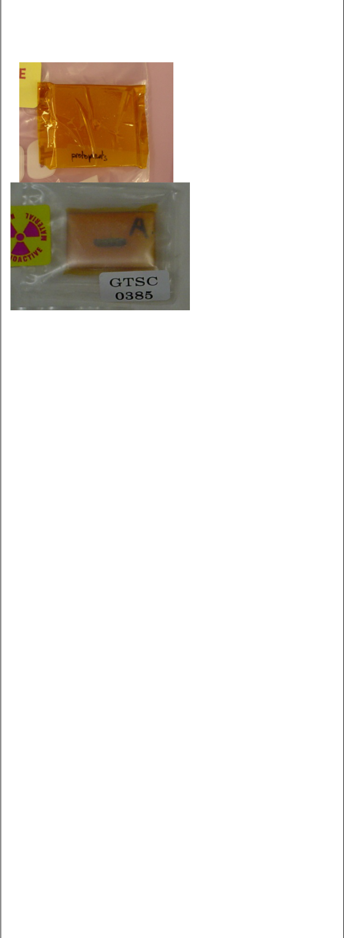

 | Physical Approvals:
 | Ambient temperature
1.b | LANL cryostat sample holder
 | Sample holder with kapton
 | windows and indium seam
 | Layer 1-kapton window with
 | indium seal
 | Layer 2-Aluminum with Kapton
 | tape, screws
 | Layer 3-durable plastic bag or
 | BL11-2 prep room tent inside
 | prep room. Cryostat S Steel
 | housing assembly with kapton
 | windows and bolting rings.
 | outside of BL 11-2 prep room.
 | Physical Approvals:
 | Ambient temp
 | Cryostat under vacuum
1.c | LANL cryostat sample holder with
 | kapton window and indium seal.
 | Layer 1- Aluminum holder with
 | solid sample and kapton windows.
 | Layer 2- Sample bolted on
 | aluminum holder with kapton
 | windows.
 | Layer 3-durable plastic bag or
 | BL11-2 prep room tent inside prep
 | room. Cryostat S Steel housing
 | 1

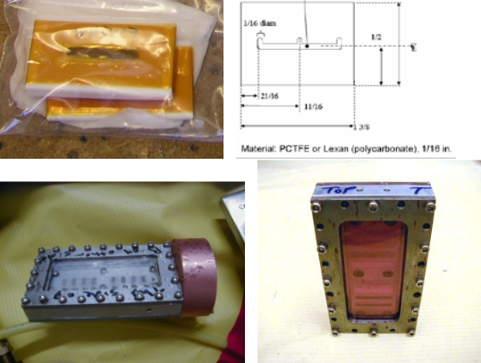

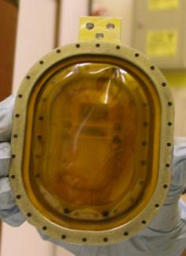
SSRL Radioactive Material sample holder catalog
05/15/2017

 | assembly with kapton windows
 | and bolting rings. outside of BL
 | 11-2 prep room.
 | Physical Approvals:
 | Ambient temp
 | Cryostat cold finger under vacuum
1.d | USGS cryostat holder
 | Layer1-
 | Layer 2-
 | Layer 3-
 | Physical Approvals:
1.e | G-XAS cell One sample per cell = ²³¹Pa
1.e | sorbed onto TiO2 single crystal.
 | Maximum activity : 15000Bq
 | - Doubly contained crystal in two sealed
 | polyethylene envelopes. Check for no
 | contamination of each envelope.
 | - External envelope glued onto the cell
 | surface.
 | - Cell cap (polyamide 0.7 mm thick)
 | sealed with Viton o-ring.
 | - Additional glue in the thread.
 | Layer 1-polyethylene
 | Layer 2-
 | Layer 3- Cell cap (polyamide 0.7
 | mm thick) sealed with Viton o-
 | ring.
 | Physical Approvals:
 | Nominal operating conditions of
 | BL 11-2 at 17 keV (focused
 | beam).
1.f | Diamond anvil cell
 | Layer 1
 | Layer 2-
 | Layer 3-
 | Physical Approval:
 | Pressure
1g | LBNL
 | Triple contained aluminum holders
 | with Kapton or Mylar windows.
 | Fit into cryostats.
 | Layer 1-nested, 1 side is epoxied
 | 2
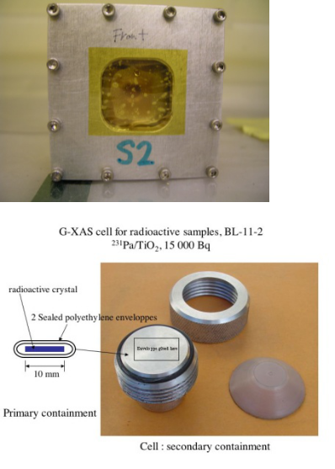
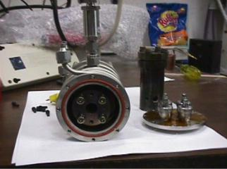
SSRL Radioactive Material sample holder catalog
05/15/2017

 | window, other side is indium
 | wire pressed with lid and cap
 | screws.
 | Layer 2 – nested, 1 side is epoxied
 | window, other side is indium
 | wire pressed with lid and cap
 | screws.
 | Layer 3-Outer 1 side is epoxied
 | window, other side is indium
 | wire pressed with lid and cap
 | screws.
 | Physical Approvals:
 | Ambient temp, Cold
1h. | LANL Conradson
 | Layer 1 polystyrene
 | Layer 2 Stainless Steel Chamber
 | Layer 3 Glovebag
1i | LANL Sample holder- Liquid | Figure 1: Primary Containment
 | samples | Front and Side View
 | Layer 1-liquid cells made of
 | Teflon, with Teflon and Kapton
 | windows and an aluminum shell
 | septa and screws.
 | Layer 2-Aluminum holder, Kapton
 | window with O-ring seal, and
 | screws.
 | Layer 3-Aluminum or Teflon with
 | Kapton tape, oring seal and
 | screws.
 | Physical Approvals:
 | Ambient temp
 | liquids
 | 3
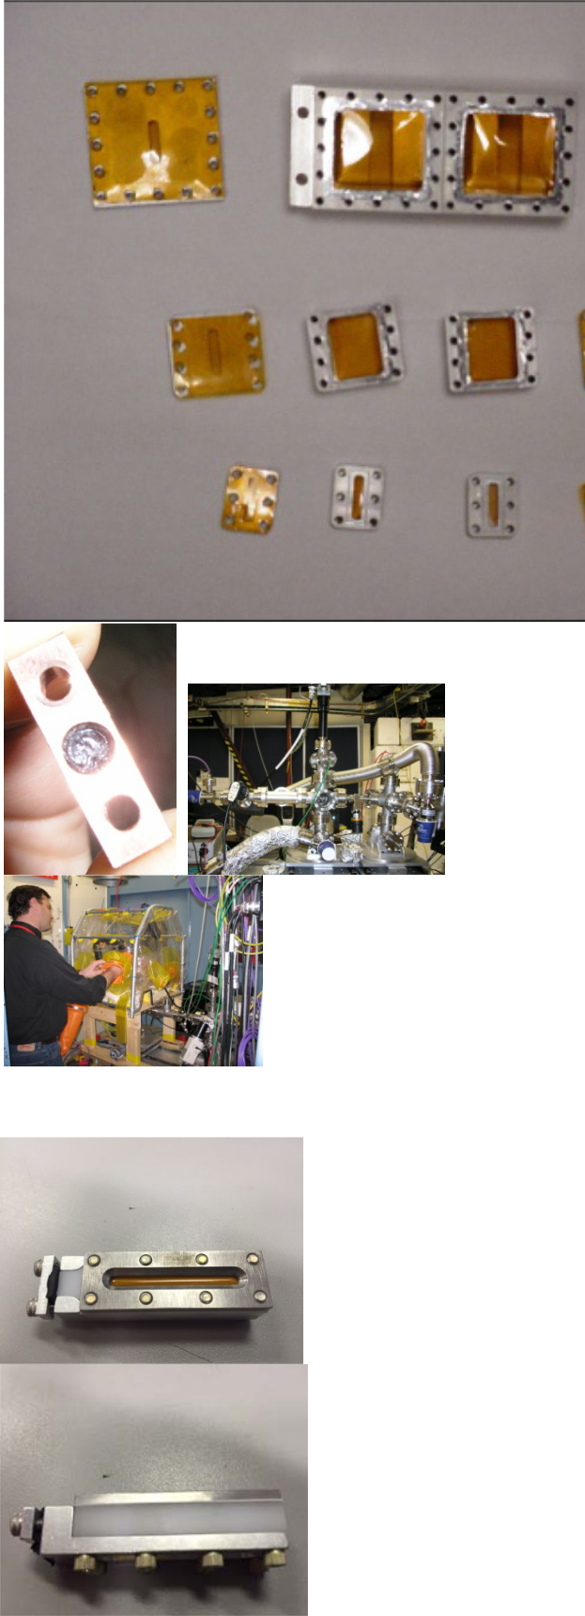
SSRL Radioactive Material sample holder catalog
05/15/2017

 | Drawings available from LANL if
 | desired to build one.
 | Figure 2: Secondary Containment | Figure 2: Secondary Containment
 |  | Figure 3: Tertiary Containment
1j | Epi tube, screw top |  | This image cannot currently be displayed.
 | Layer 1-plastic vial, screw top
 | with rubber gasket.
 | Layer 2-Plastic heat sealed bag
 | secondary.
 | Layer 3-Plastic heat sealed bag
1k | PE Tube
 | Layer 1-plastic vial, screw top
 | with rubber gasket.
 | Layer 2-Plastic heat sealed bag
 | secondary.
 | Layer 3-Plastic heat sealed bag
 | 4
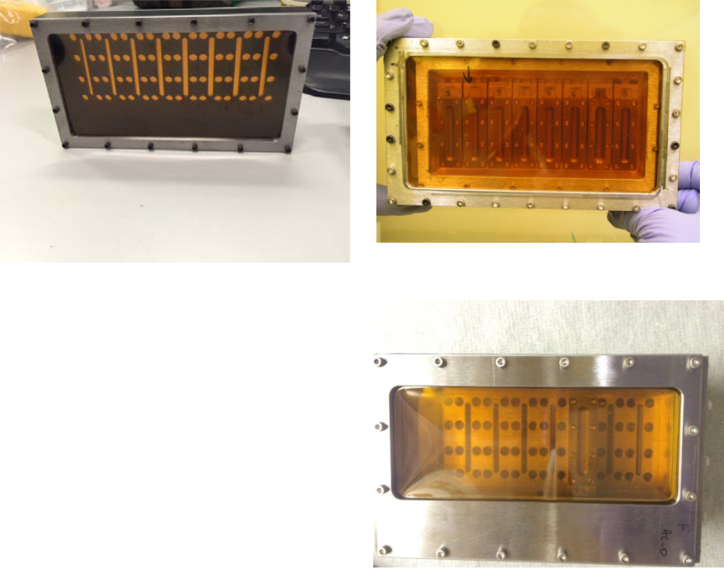
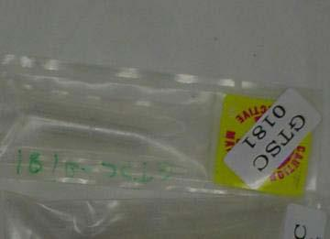
 | SSRL Radioactive Material sample holder catalog
 | 05/15/2017
1l |  | Reserved Conradson, LANL
 |  | BL 10-1, 8-2
 |  | Layer 1- polystyrene
 |  | Layer 2-Stainless Steel vacuum
 |  | structure
 |  | Layer 3- glovebag
1m |  | LBNL, Hu Containment
 |  | Pu239 wet paste
 |  | Layer 1-Scotch Tape
 |  | Layer 2- 1.5 mil polyethylene heat
 |  | sealed bag
 |  | Layer 3-.5 mil polyethylene heat
 |  | sealed bag
 |  | Physical approvals
 |  | Ambient
1n |  | LANL Layers
 |  | 1- polystyrene film with
 |  |  | sample deposited on its
 |  |  | surface
 |  | 2- | Kapton windows
 |  |  | between aluminum
 |  |  | clamps with cap screws
 |  |  | and indium wire.
 |  | 3- | Vacuum shroud
 |  |  | cryostat with kapton
 |  |  | windows with torr seal,
 |  |  | o-ring on stem of cold
 |  |  | fingers (cannot use in
 |  |  | cold environment).
 |  |  | 5
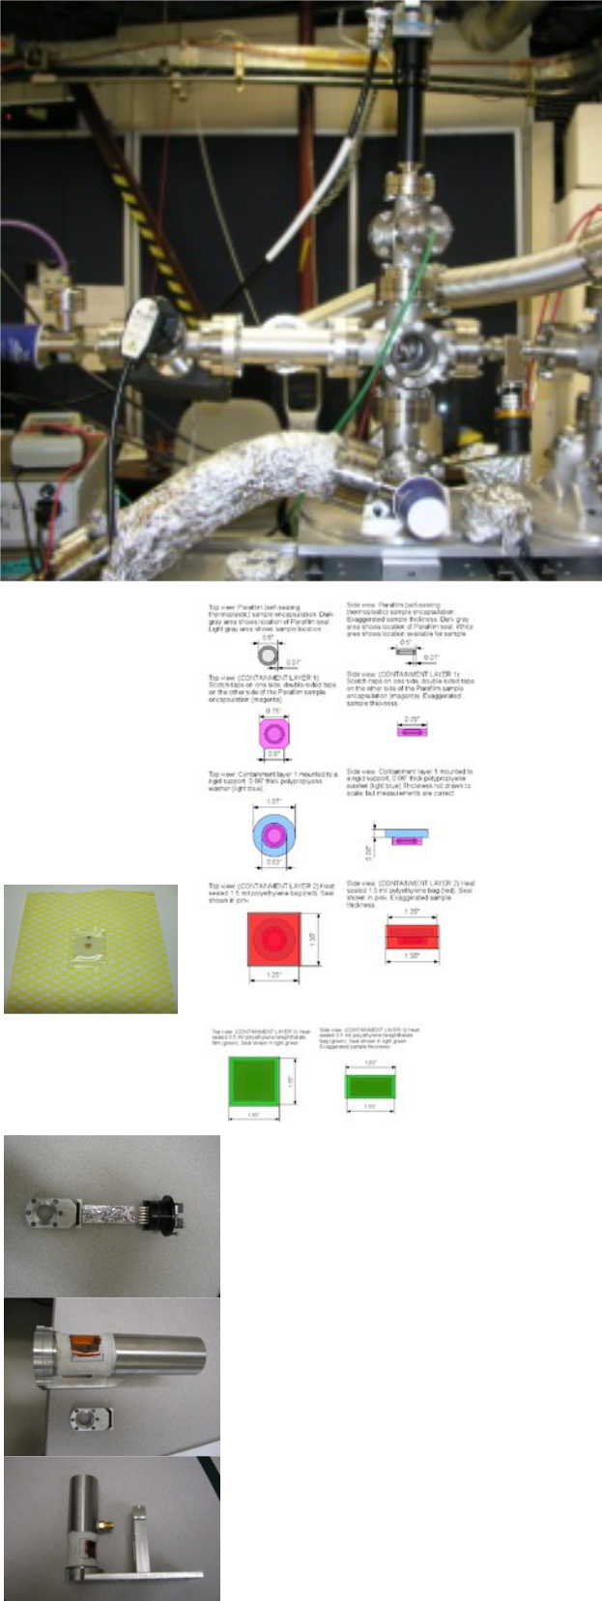
SSRL Radioactive Material sample holder catalog
05/15/2017

Approved to run in BL2-3 only

Physical approvals
Ambient temp and pressure

1o | LANL Holder
 | The primary consists of Pu
 | coupons clamped or glued to an
 | aluminum holder. This fits inside a
 | cylindrical tube with a
 | circumferential cutout (over the
 | samples) that is just over 180
 | degrees in length. A Kapton
 | window is glued over the cutouts
 | with Torr Seal. The ends are
 | sealed with indium or gold wire.
 | The secondary is identical to the
 | primary, except larger, so that the
 | primary is nested inside it.
 | The tertiary is our standard one
 | for diffraction. An aluminum
 | container with two Kapton
 | windows sealed with elastomer o-
 | rings. The secondary mounts on
 | the cold finger of an open cycle
 | liquid He refrigerator. The end of
 | the container and its mount on the
 | refrigerator head are sealed with o-
 | rings.
 | Physical approvals
 | Ambient temp and pressure
1p | LANL Holder
 | A detailed description of the
 | sample containment. The primary
 | Layer 1 polystyrene.
 | Layer | 2- | The | secondary
 | containment system an aluminum
 | holder assembled with screws and
 |  |  |  | 6

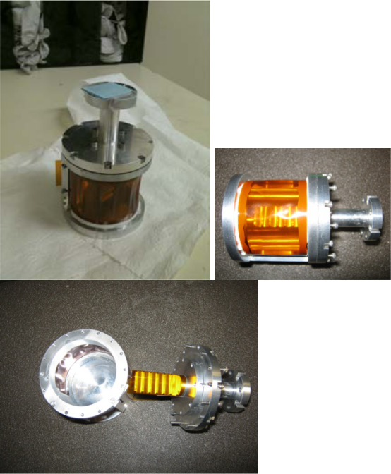

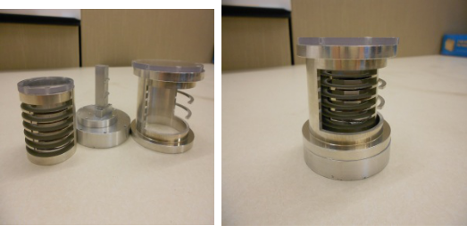
SSRL Radioactive Material sample holder catalog
05/15/2017

 | elastomer o-rings and equipped
 | with Kapton windows (fixed with
 | Torr Seal),
 | Layer 3- housing the first
 | aluminum holder in a second
 | aluminum holder assembled with
 | screws and elastomer o-rings and
 | equipped with Kapton windows
 | (fixed with Torr Seal),
 | Physical properties:
 | ambient pressure and temperature
1q | Primary containment:
 | primary will contain solid
 | samples mounted between two
 | Kapton windows that are sealed to
 | an aluminum holder with Torr
 | Seal.The dimensions of the
 | aluminum holder are 1”x 3”
 | Secondary Containment:
 | The primary is housed within a
 | secondary that consists of two
 | Kaption windows sealed to an
 | aluminum holder with In wire. The
 | dimensions of the secondary
 | aluminum holder are: 4”x2”.
 | Tertiary Containment
 | the secondary is mounted within
 | the tertiary containment, which
 | also consists of two Kapton
 | windows sealed to an aluminum
 | holder with In wire. The three
 | Kapton windows are identical and
 | the kapton thickness will be of 2
 | mil. The dimensions of the
 | secondary aluminum holder are:
 | 5”x3”.
 | The experiment will be
 | conducted at ambient pressure
 | and temperature in the hutch at
 | beam line 6-2.
1r | University of Clemson, Soil matrix | Primary containment- Epo-tek 301 Epoxy
 | spiked with Th-232, Np-232 or Pu | covered by 0.001 in thick Kapton tape. (layer
 | 242. | 1).
 | Limited to 0.2mg | Secondary Heat sealed plastic bag 0.0015 in
 | 7
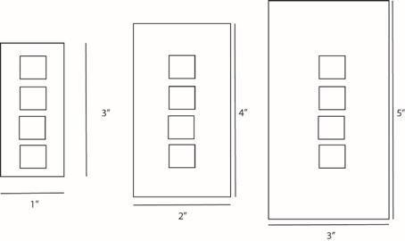
SSRL Radioactive Material sample holder catalog
05/15/2017

thickness.

Tertiary-Heat sealed plastic bag 0.0015 in

thickness

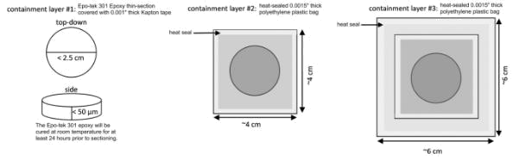

1s | LANL Holder-requested by
 | Kozimor BL 4-3, 14-3
 | Radionuclides approved in limited
 | amounts are: Pu-mixture, Np-
 | 237,Am-241, Am-243, Tc-99, Th-
 | 232 and U-238.
 | Primary containment:
 | The primary containment is a
 | single slotted holder equipped with | Picture above shows the primary layer.
 | at least six layers of tape (1 mil | Picture above shows the primary layer.
 | thickness per piece) on the
 | downstream facing window. A
 | powder of the analyte is painted
 | within the slot. The upstream
 | polypropylene window (4.0 μm
 | thick) is fixed to the holder with
 | double sided tape. The edges of
 | the tape are sealed with nail polish.
 | Secondary Containment:
 | The primary container is nestled
 | within the secondary container. It
 | is a metal slot equipped with
 | polypropylene (4.0 μm) on the
 | upstream side and Kapton tape (2 | The picture above shows the primary, secondary
 | mil) on the downstream side. The | and tertiary layers.
 | top and bottom slots are also | The picture below, show the holder in the protective
 | sealed with Kapton (2mil) tape. | layer, and screwed to the paddle
 | The edges of the tape are sealed
 | with nail polish or epoxy.
 | Tertiary Containment:
 | 8

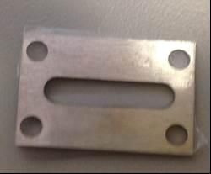

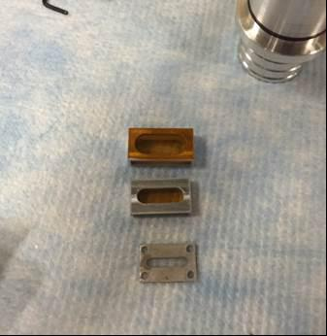
SSRL Radioactive Material sample holder catalog
05/15/2017

The secondary container is nestled within the tertiary container. It is a metal slot equipped with polypropylene (4.0 μm) on the upstream side and Kapton tape (2mil) on the downstream side. The top and bottom slots are also sealed with Kapton tape (2mil). The edges of the tape are sealed with nail polish. The tertiary container is housed within a protective sleeve that is fixed to the sample paddle by screws. The screws avoid the ‘easy to break seal. They also fasten from the bottom, which avoids a ‘slip-of-the-wrench” and an accidental puncture of the windows. Each sample will be protected equipped with a Protective Sleeve at LANL and shipped to SSRL. Under no circumstances will the tertiary be removed from the Protective Sleeve at SSRL. Drawings and approval memo are available per request.
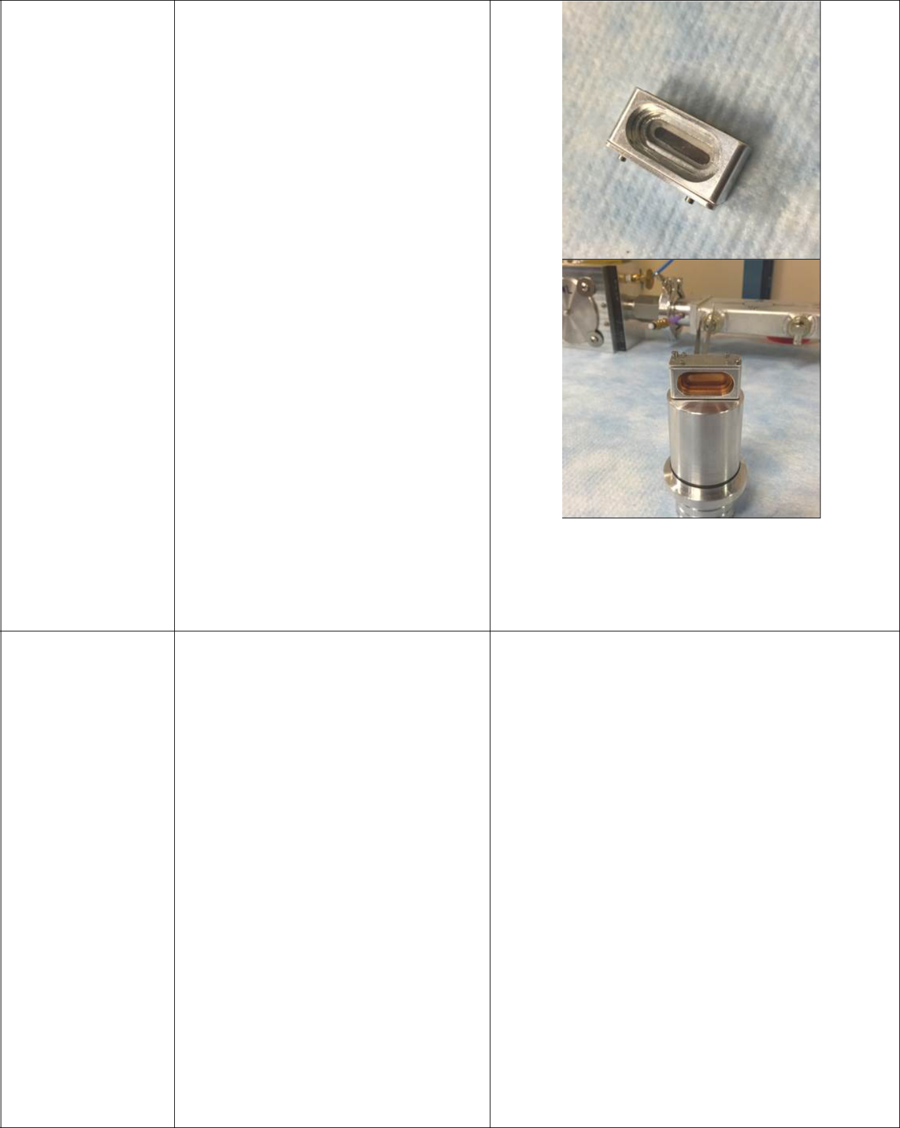
1t | LBNL Pu-242 –liquid form, BL
 | 11-2 Amounts limited up to
 | 5x10⁻⁵g total shipment. This holder
 | has limited exposure in the beam
 | up to 6 hours.
 | Primary containment:
 | The primary containment will
 | consist of one micro-centrifuge
 | tube, such as Neptune brand
 | 37n3.S.X series, where n=3, 4, or
 | 6.The screw cap will be wrapped
 | with Parafilm to prevent cap
 | loosening from handling/shipping
 | and provide additional sealing. | Picture shows template of the holders
 | Secondary containment: | Picture shows template of the holders

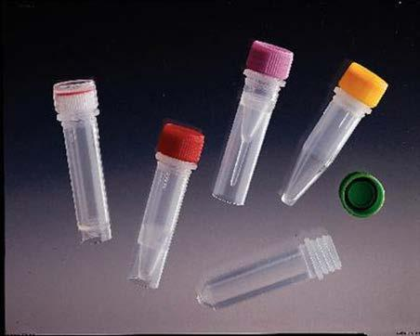
The primary containment shall be
placed into a secondary layer
consisting of a heat sealed plastic bag
into which sufficient absorbent

material to contain the entire sample
volume has been placed.

9
SSRL Radioactive Material sample holder catalog
05/15/2017

 | Tertiary containment:
 | The tertiary containment layer will
 | also consist of heat sealed plastic with
 | absorbent material. Absorbent
 | material shall consist of a
 | commercially available hazmat spill
 | response liquid absorbent pad,
 | compatible with water and other
 | chemicals used in our liquid samples.
 | The experiment will be
 | conducted at ambient pressure
 | and temperatures in the hutch at
 | beam line 11-2
 | 2 Layers containment for Low
 | Radiotoxity (Group 3)
3a | LBNL
 | Lexan or aluminum sample holder
 | with kapton tape.
 | Layer 1- Kapton Tape, sealed
 | Layer 2- sealed plastic bag
3c | LBNL (Tc99)
 | Layer 1-Kapton film with indium
 | seal and cap screws. Mylar film
 | may only be used for ambient
 | conditions.
 | Layer 2- cryostat holder with
 | kapton
 | Physical approvals
 | Ambient, vacuum, cold
3d | 2 Layers
 | Primary containment: Plexiglass (Lexan)
 | holder with sample set into a window,
 | sealed with adhesive tape with the
 | following specifications:
 | Adhesive tape: ISC Helicopter-IG
 | Surface Guard Tape (Indoor Grade) (J"
 | wide) with the following properties:
 | Adhesive: rubber Carrierl Backing:
 | polyurethane film Thickness: 4.5 mils
 | Adhesion: 40 ounces per inch (to stainless
 | steel) Tensile Strength: 48 pounds per
 | inch (longitudinal).
 | 10
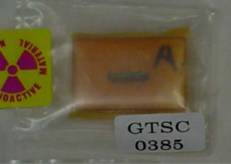
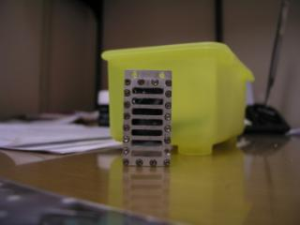
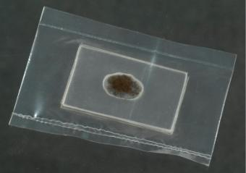
SSRL Radioactive Material sample holder catalog
05/15/2017

3e

3f

Secondary containment: Heat sealed

linear low density polyethylene bag, with
thickness of 2 mil.

- layers Tc99
Two layers of containment for moderate toxicity radioisotope. First containment is polystyrene, the sample is embedded in polystyrene pellets that are cast in 0.1” by 0.5” slots in a 0.1” thick aluminum plate containing 14 of these slots. This is identical to holder 4b for U. The second containment will be to encase the aluminum plate in 5 micron thick polypropylene film. This will be held in place with adhesive.

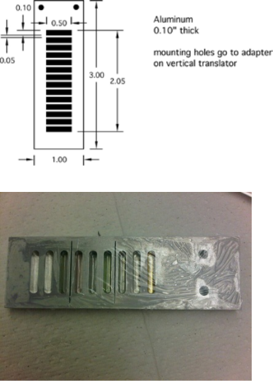

At the beam line this wrapped
plate will be installed into a sealed
aluminum box that includes the
detector system that is also
fastened to the beam port and will
be filled with 1 atm of helium.

Physical approvals
Ambient temperature and pressure.

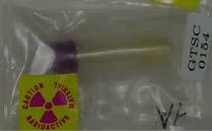
Epi tube, screw top
Layer 1-plastic vial, screw top or pop top with glue with rubber gasket.

Layer 2- Heat sealed Plastic bag

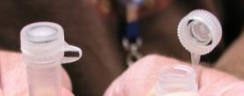

Uses-Liquid sample in 2 mL, screw-top, polypropylene centrifuge tube inside three layers of heat-sealed plastic.

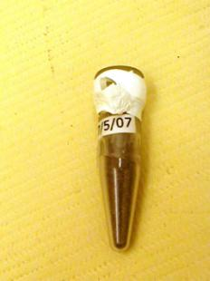

Physical approvals:
Room temperature

11

 | SSRL Radioactive Material sample holder catalog
 | 05/15/2017
3g |  | Uses: Lukins, LBNL
 |  | Layer 1-Sample polyethylene tube
 |  | with gasket epoxy glue.
 |  | Layer 2 in heat sealed plastic bag.
 |  | Powder sample in heat-sealed
 |  | plastic tube (actually a plastic
 |  | pipette in this case although I also
 |  | use heat sealed Epi tubes) inside
 |  | three layers of heat-sealed plastic.
 |  | 1 Layer containment for Low
 |  | Radiotoxicity (Group 4)
4.a |  | LBNL
 |  | Lexan or aluminum sample holder
 |  | with kapton tape.
 |  | Layer 1- Kapton Tape, sealed.
4.b |  | Slotted metal sample holder with
 |  | unpolished polystyrene sample
 |  | material
 |  | Layer 1-polystyrene
4.c |  | Slotted metal Al sample holder
 |  | with kapton tape and bolting ring
 |  | Layer 1-Epoxied sealed kapton
 |  | tape 1 side, indium sealed cap
 |  | screw inside bolting ring, cap
 |  | screws on kapton tape other side.
 |  | Physical approvals:
 | 12
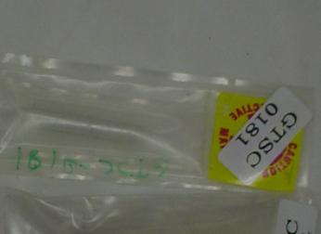
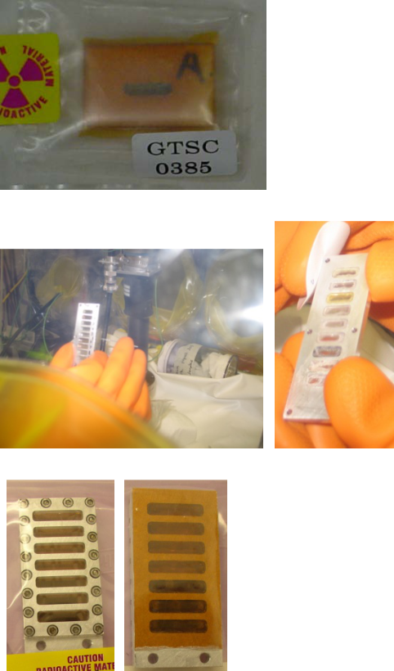
 | SSRL Radioactive Material sample holder catalog
 | 05/15/2017
 |  | Ambient, Cold, vacuum w
4.d |  | Epi tube, screw top
 |  | Layer 1-plastic vial, screw top
 |  | with rubber gasket.
 |  | Plastic seal bag secondary.
 |  | Uses-Liquid sample in 2 mL,
 |  | screw-top, polypropylene
 |  | centrifuge tube inside three layers
 |  | of heat-sealed plastic.
 |  | Physical approvals:
 |  | Room temperature
4.e |  | Epi tube, heat sealed
 |  | Layer 1-Sample polyethylene tube
 |  | with glue sealed cap in plastic bag.
 |  | Uses: Lukins, LBNL
 |  | Powder sample in heat-sealed
 |  | plastic tube (actually a plastic
 |  | pipette in this case although I also
 |  | use heat sealed Epi tubes) inside
 |  | three layers of heat-sealed plastic.
 |  | Physical approvals:
 |  | Room temperature
4.f |  | Layer 1-quartz capillaries with
 |  | flame sealed ends or epoxy.
 |  | Mounted with double back tape
 |  | X-ray scattering.
 |  | Layer 2-Must be used with a
 |  | secondary protective containment
 |  | cylinder.
 |  | Physical approvals:
 |  | Room temperature
 |  | Ambient pressure
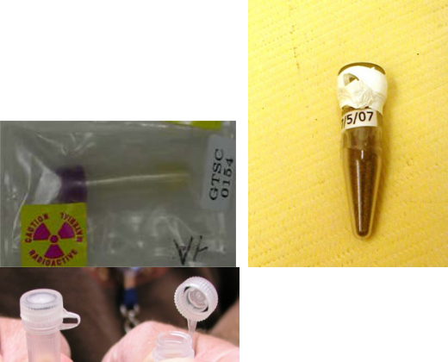
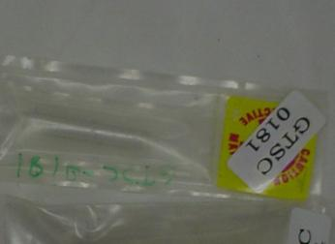
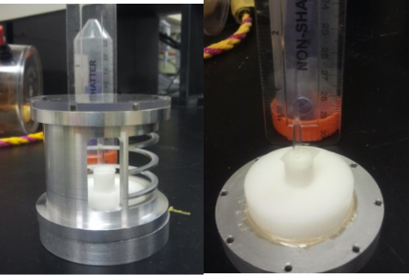

13
SSRL Radioactive Material sample holder catalog
05/15/2017

4.g

4.h

4.i

John Barger Holder
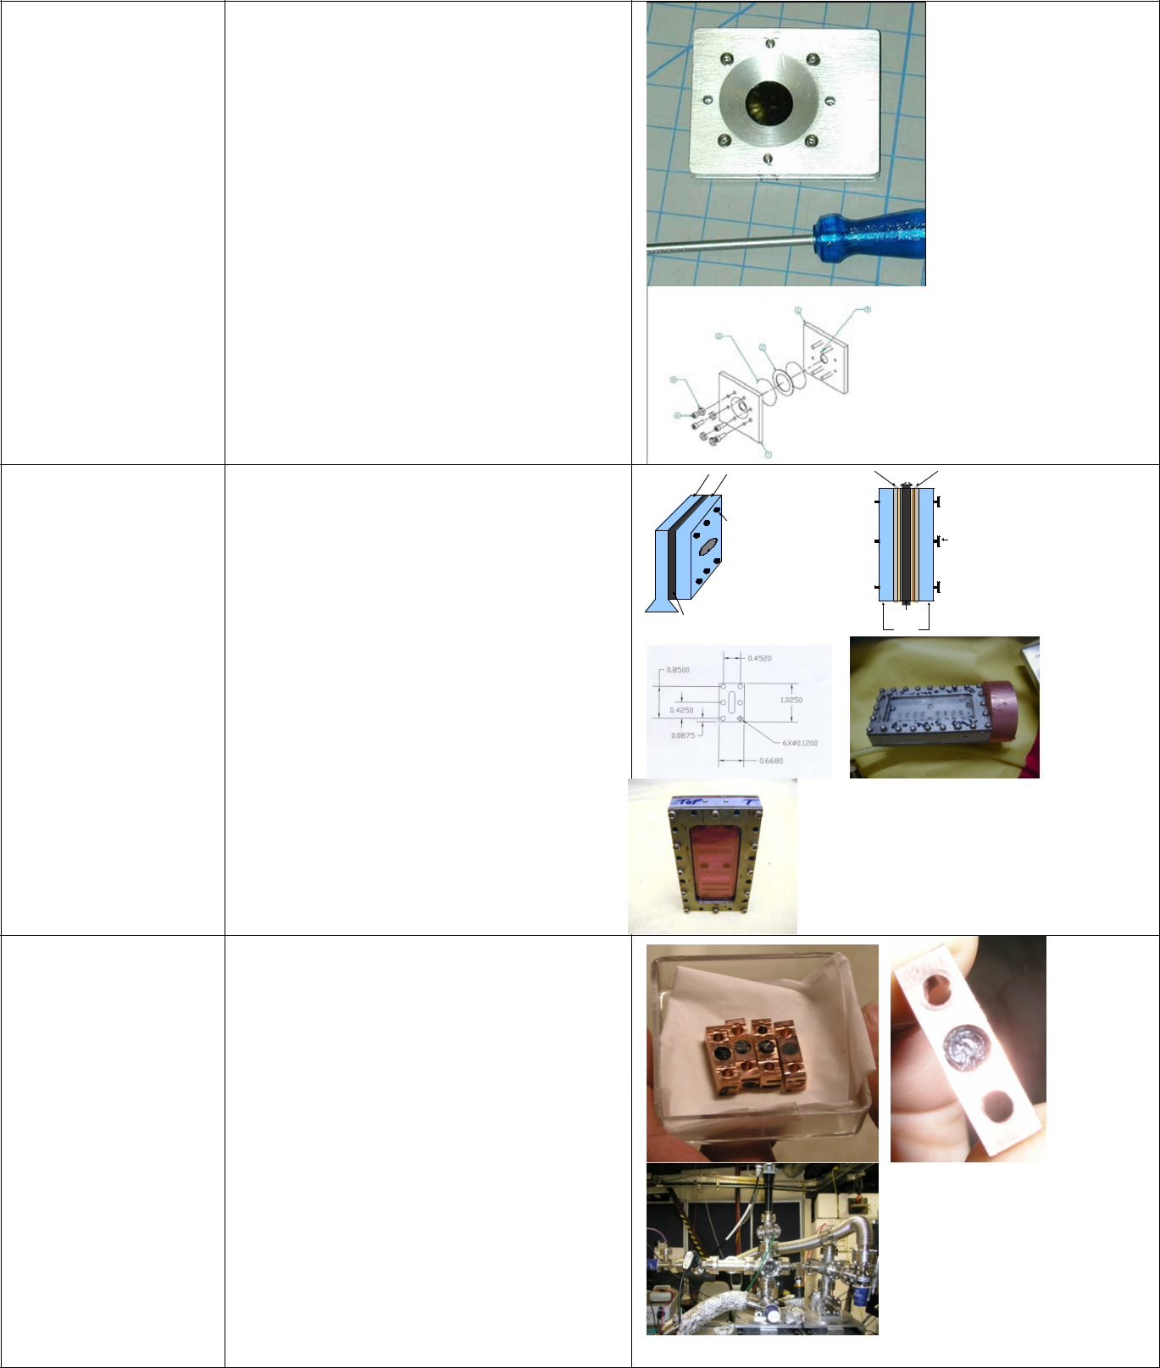
kapton (polyimide) or mylar (PET, polyester) or mica window adhesive - backed film with thickness .0025 to .010 in. Windows will be self-secured (via adhesive backing) to sample holders. A layer of window material will be applied to overlap around the margins of the sample holder to reinforce the seal provided by the adhesive of the primary tape layer.

Layer 1 –Capton , Myl,ar Mica window
Al gasket ID of bolting ring

Bolted Aluminum Holder | Stainless steel sample mounts | Aluminum gasket, mounted and sealed to
 |  | sample mounts
 |  | Kapton tape
Layer 1- Kapton Tape | compress
Aluminum gasket or indium | Bolts to
Aluminum gasket or indium | sample holder | Bolts to
 | between sample | compress
 | mounts | sample holder
 |  | between
 |  | sample mounts
gasket. | Sample window
 | through sample holder
 | and sample mounts.
 |  | Aluminum
 | Aluminum | sample holder
 | sample holder
 |  | Stainless steel
 |  | sample mounts

Physical approvals:
- Room temperature
- Cold in cryostat under vacuum.

Carbon Films, LANL loaded inside vacuum chamber device Uranium

Layer 1-Polished polystyrene inside plastic. (polished polystyrene alone is not approved as primary containment)

Physical Approvals:

14

 | SSRL Radioactive Material sample holder catalog
 | 05/15/2017
4j |  | LBNL
 |  | Kapton film with indium seal and
 |  | cap screws. Mylar film may also
 |  | be used.
 |  | Physical approvals
 |  | Ambient, Cold, vacuum
4k |  | SLAC, Uranium capillary
 |  | Kapton film with plexiglass and
 |  | aluminum/plastic caps. cap screws
 |  | and O- ring on ends.
4l |  | Containment for transport to
 |  | Campus
 |  | Container is stainless steel with
 |  | installed gasket sealing lid to
 |  | container in order to maintain
 |  | anaerobic environment inside.
 |  | This vessel is placed in a PG 1
 |  | package. Inner package of
 |  | radioactive Uranium is contained
 |  | in a sealed plastic bag.
4m |  | LBNL, Singer Containment
 |  | Aneropak Box
 |  | Primary Containment- The lid of the
 |  | Anaeropak box locks down, and tape will
 |  | be wrapped around the lid for additional
 |  | sealing and to prevent the locks from
 |  | opening. On the side of the sample box,
 |  | two windows will be made of Kapton
 |  | film, which will be taped 2X on both
 |  | sides with Kapton tape.
 |  | The base and top part of the sample cell
 |  | are connected by screws, with an O-ring
 |  | seal. The top part of the sample cell has a
 |  | window made of Kapton film, that will be
 |  | 2X taped on both sides with a single
 |  | piece. The sample cell will be housed
 |  | within a modified Aneropak Box:
 |  | Physical approvals
 |  | Ambient
 | 15
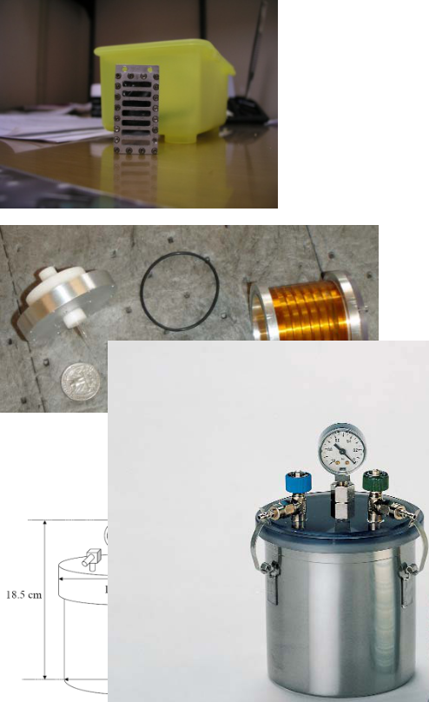
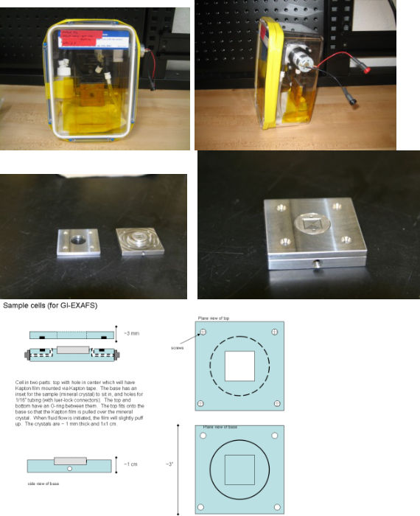
SSRL Radioactive Material sample holder catalog
05/15/2017

4n

4o

4p

LANL containment
Conradson
Physical approvals
Ambient
Dave Singer, LBNL
Magnetite dipped in U238
Primary Containment-Kapton, on
steel housing with cap screws and
o-ring between platform and
window ring. Particulate filter on
inlet and outlet of gas flow tubing.
Relief valve before inlet filter to
avoid kapton window from over
pressurization
Sample holder is machined from | Polycarbonate
polycarbonate sheet (see | Double layer
dimensions in Figure 1). The | Double layer
sample is packed in the recess, | Polypropylene
then capped with 0.2 mil (6 um) | film, 6 um
polypropylene (PP) film attached | Double
polypropylene (PP) film attached | sided
via a piece of double sided tape | adhesive
(Figure 2). The tape has an | Sample
opening removed to allow beam | Polypropylene
impingement on the sample after | film, 6 um
passing through the PP window. | film, 6 um
The film and the holder serve as | Double
primary containment of the sample | Double
primary containment of the sample | sided
material. Samples will be packed | sided
material. Samples will be packed | ^{Sample} adhesive
as a wet paste, then the tape will | Polycarbonate
be applied, followed by the first
layer of PP film. Once the holder
16
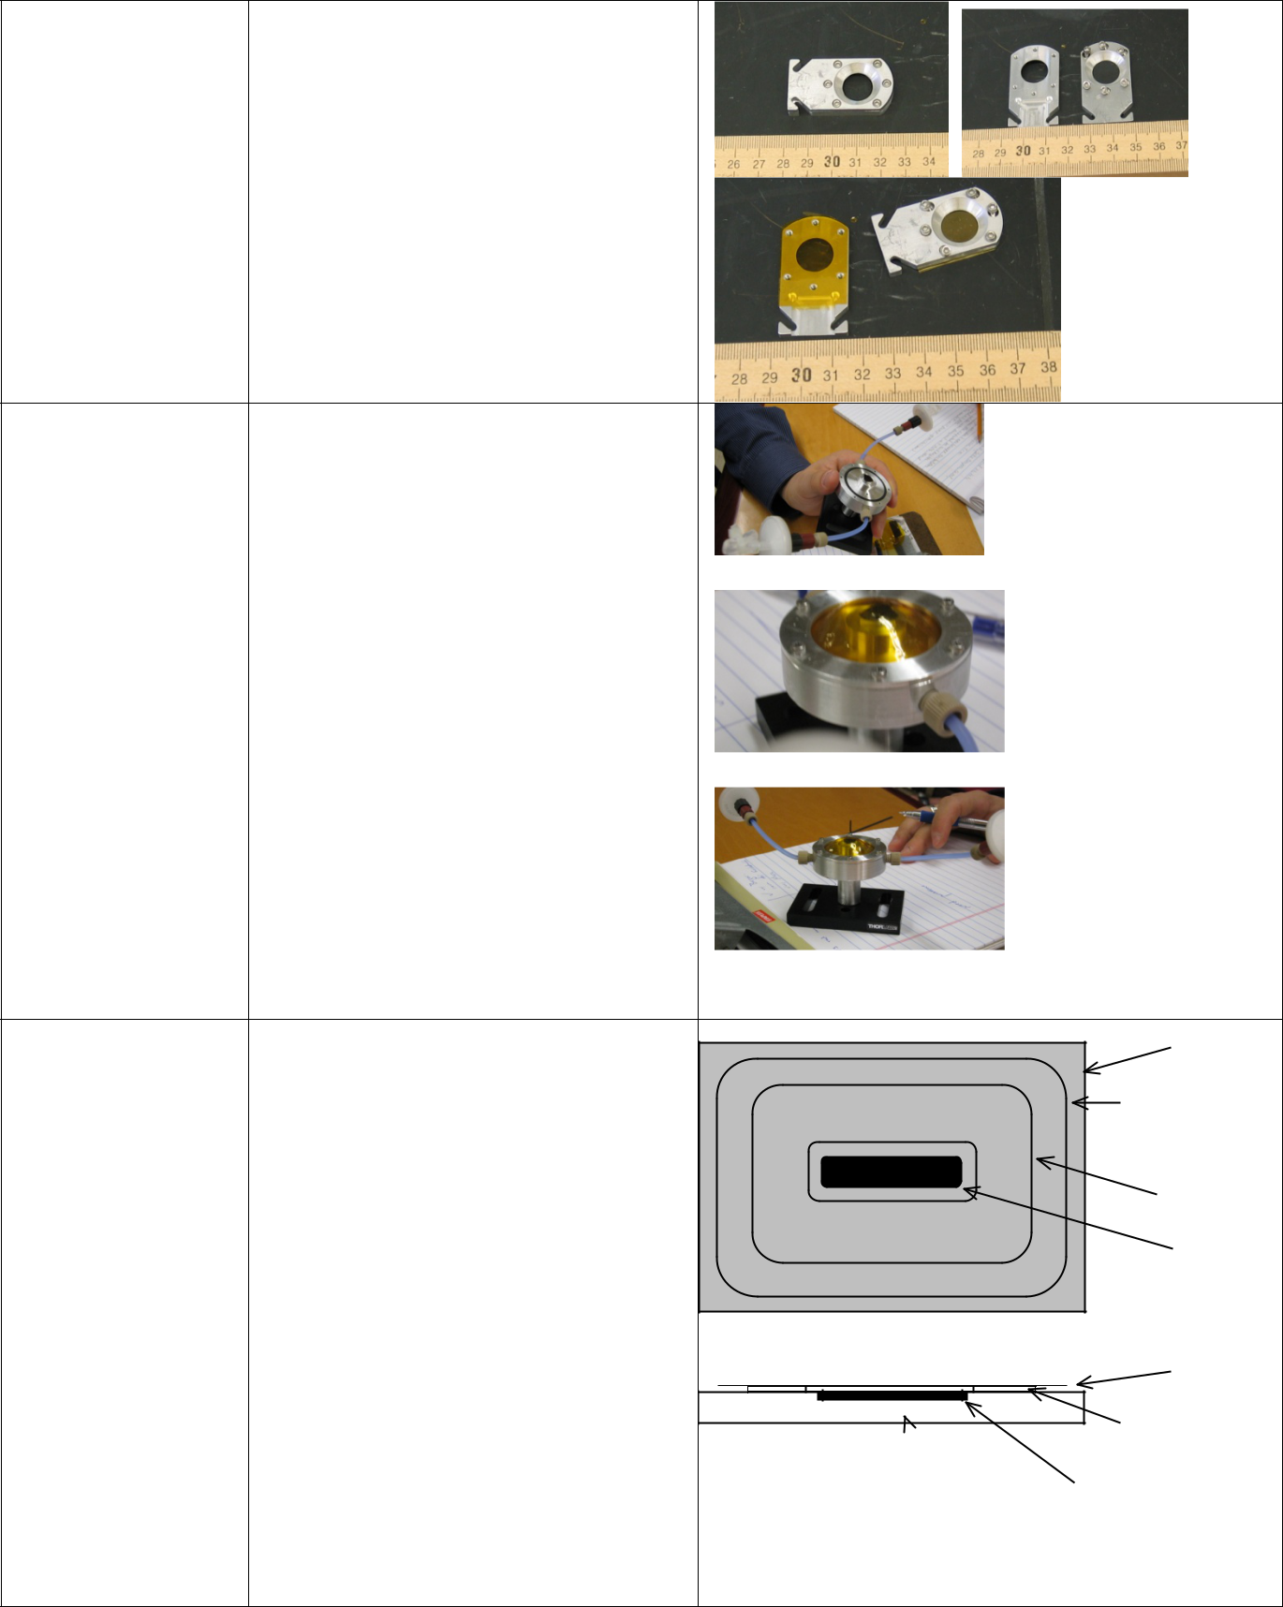

SSRL Radioactive Material sample holder catalog 05/15/2017

is prepared it will then be placed inside a PP film pouch which will be sealed with tape (Figure 3).

Figure 2. A schematic of a loaded sample holder complete with sample, PP film, and adhesive tape.
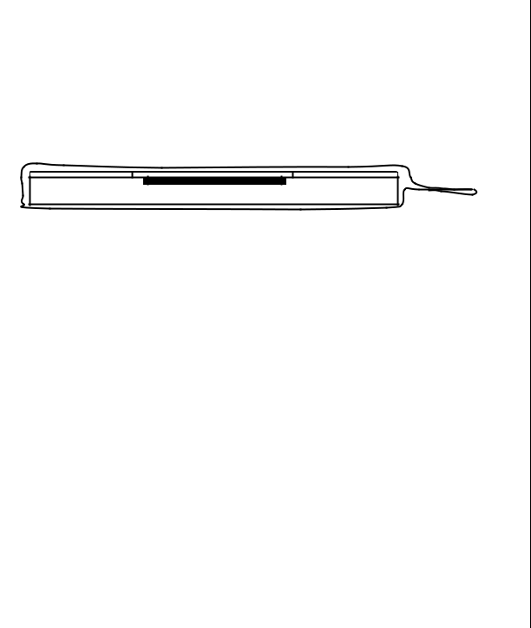

Figure 3. Showing second layer of PP film as an envelope (secondary containment) with a folded and taped tab for closure.

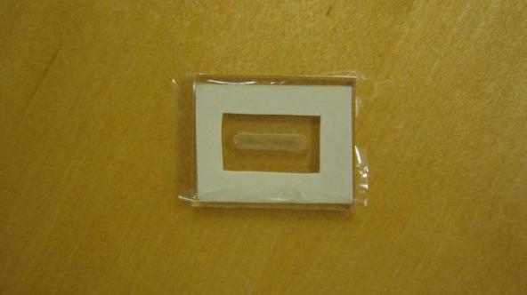

17

 | SSRL Radioactive Material sample holder catalog
 | 05/15/2017
4q | Primary containment:
 | The sample holder is
 | constructed from clear
 | polycarbonate. The space for
 | the sample is a channel 3 cm
 | long, 1 cm wide, and 1 cm
 | deep. See attachment A. The
 | sidewalls are 5 mm thick, and
 | the rear wall is 2.5 mm thick
 | (Figure 1). End-caps of 5 mm
 | thick polycarbonate (Figure 1)
 | are secured with cyanoacrylate
 | adhesive (LocTite formula 401
 | super glue).
 | Secondary containment:
 | Kapton film is secured to the
 | fourth side using LocTite
 | formula 401 super glue to form
 | a watertight seal. A second
 | layer of Kapton (0.3 mm or
 | greater) tape over the Kapton
 | film provides an additional
 | layer of containment.
 | Physical approvals
 | Ambient

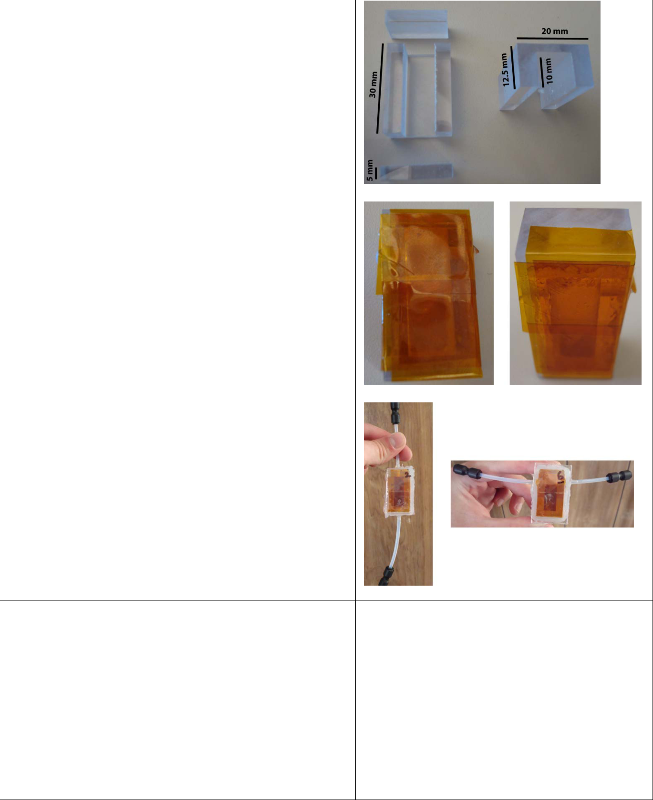

4r | LANL
 | Primary Containment
 | Uranium 238 and Unat only
 | - During shipping is a stainless steel
 | coffin, see Scheme 1.
 | - During chamber loading is a glovebag
 | over the chamber opening.
 | - During the experiment is the chamber.
 | Physical approvals
 | Ambient

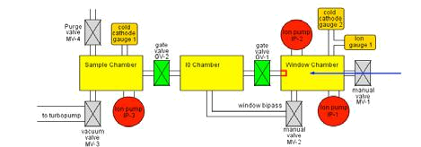

18
SSRL Radioactive Material sample holder catalog
05/15/2017

4s | LANL- Stosh
 | BL 6-2
 | 1st layer – Polystyrene (not the
 | primary containment) in a
 | containment is a cylinder aluminum
 | holder with a top cap made of
 | polycarbonate and bottom cap made
 | of aluminum which is assembled with
 | elastomer o-rings in the groove and
 | screws on top and bottom. On the
 | front window of the cylinder Kapton
 | is adhered to the surface with Torr
 | seal to the aluminum holder
 | 2nd Layer-
 | Kapton and plexiglass
 | U-238, U-nat only
 | Uranium is Powder
 | Room temperature and ambient
 | pressures
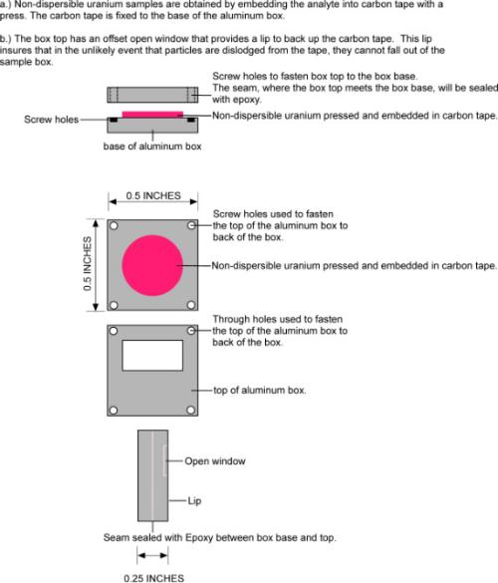
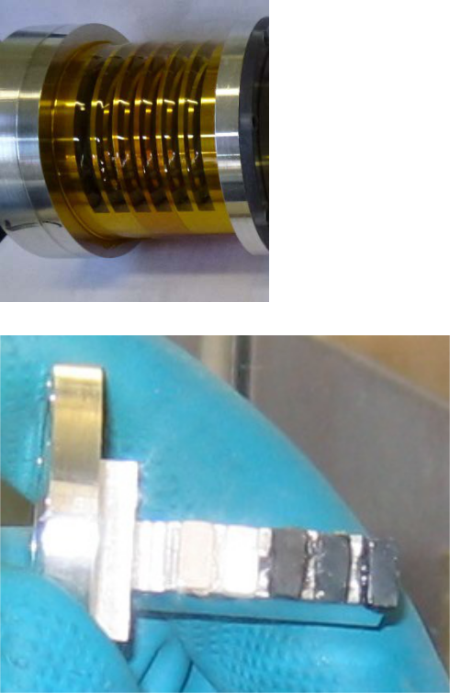

19
 | SSRL Radioactive Material sample holder catalog
 | 05/15/2017
4t |  | Thin sections
 |  | The thin sections will be
 |  | epoxied/glued to a standard
 |  | glass/plastic microscope slide.
 |  | U-nat
 |  | Primary Containment: The
 |  | epoxy will be the containment for
 |  | the thin section.
 |  | Monochromatic beam
 |  | 2 to 38 keV
 |  | Physical approvals
 |  | Ambient
4u |  | Sediments will be adhered to
 |  | sample holders in one of three
 |  | manners. Samples cannot be
 |  | covered with any material because
 |  | of the low energies of x-rays at the
 |  | carbon K-edge and the low
 |  | penetration ability of electrons to
 |  | be detected.
 |  | a. Sediments will be deposited
 |  | onto a clean silicon wafer in water
 |  | or an organic solvent and allowed
 |  | to dry in place.
 |  | b. Sediments will be deposited
 |  | onto carbon tape. c. Sediments will
 |  | be pressed into a metal foil such as
 |  | indium or copper.
 |  | Primary Containment:
 |  | Monochromatic beam
 |  | 2 to 38 keV
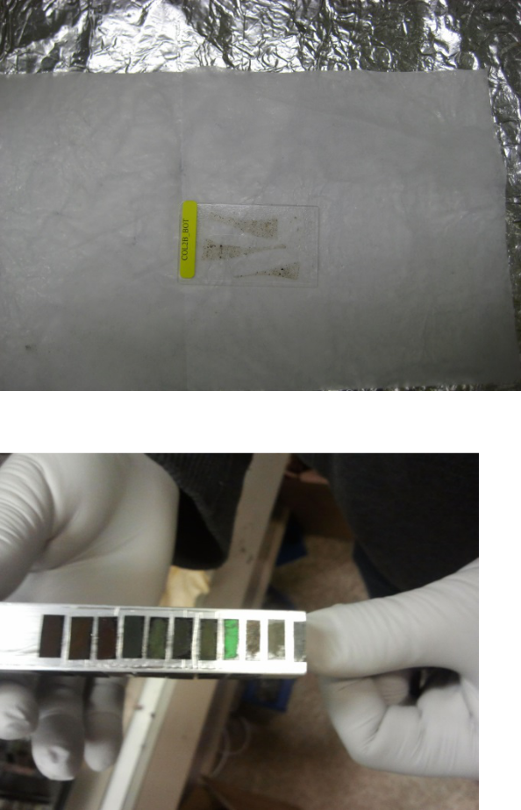

20
 | SSRL Radioactive Material sample holder catalog
 | 05/15/2017
4v | Samples are uranyl fluoride
 | microparticles (~ 1 micron
 | diameter) sealed between two
 | silicon nitride windows with
 | epoxy.
 | 14 µg of UO2F limit.

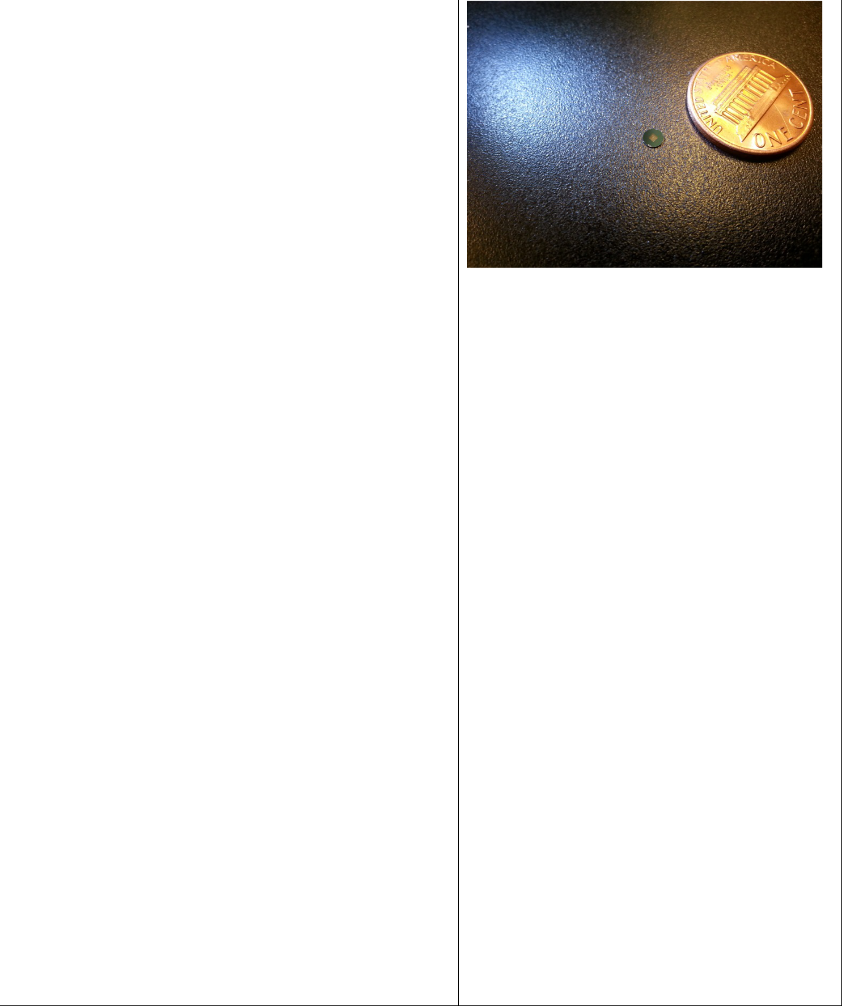

Window frames are 3 mm in diameter, and 200 microns thick, while the windows are 1 mm x 1

- square, and 50 nanometers thick.

 | Only approved for BL 13-1 for
 | PNNL
4w | The primary containment is a
 | Teflon or aluminum block, which
 | is compatible with the solvents.
 | Within the block a sample well has
 | been milled. The window is
 | equipped with at two
 | polypropylene windows and a
 | Viton gasket held in place by a
 | stainless steel plate. There are two
 | ports for sample loading on top,
 | which are closed with screw type
 | plugs.
 | • The holder is only approved
 | for less than 0.1 molar
 | solutions of uranium with a
 | total volume of 1 mL (24 mg
 | U-238; 3.0E+02Bq).
 | • The holder is only approved
 | for | room | temperature
 | measurements |  | at ambient
 | pressure.
 | • Upstream facing (beam side)
 | windows are 4 µm thick and
 | composed of polypropylene.
 | LANL

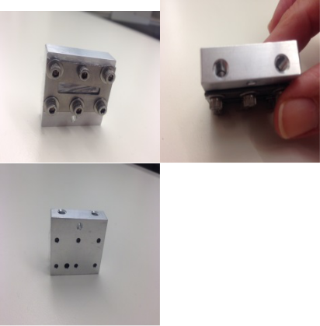

21
 | SSRL Radioactive Material sample holder catalog
 | 05/15/2017
4x |  | Kristin Boye
 |  | The sample pellets will be inserted
 |  | into circular slots in an aluminum
 |  | holder and sealed with a
 |  | Layer 1-single layer of Kapton
 |  | tape on both front and back.
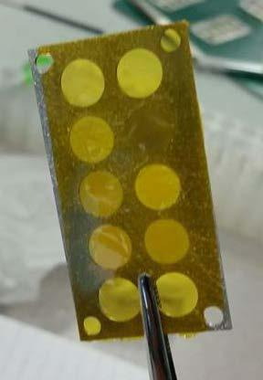

22

