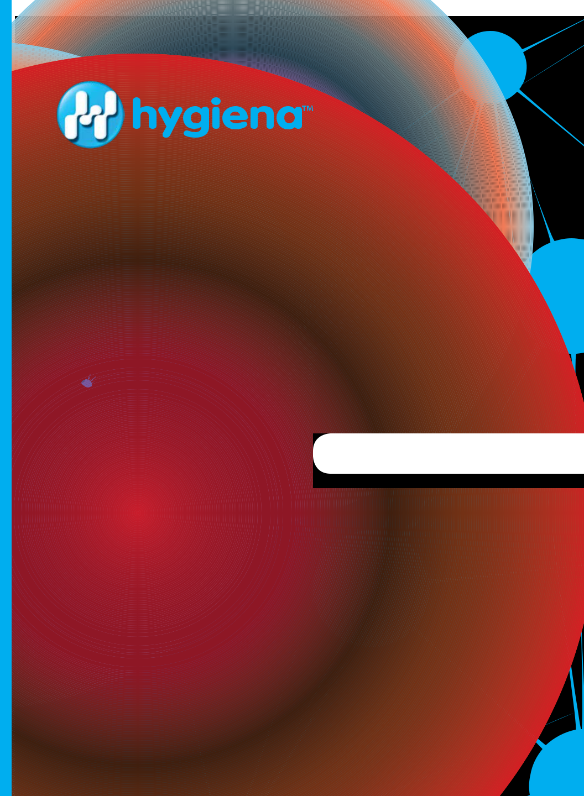

PRODUCT CATALOG


Table of Contents

Introduction................................................... | 2
About Hygiena.............................................. | 3
Monitoring Systems................................. | 4-11
ATP Testing............................................ | 12-19
Allergen Testing...................................... | 20-23
Surface Residue Testing........................ | 24-27
Process Efficiency Testing..................... | 28-29
Indicator Organism Testing.................... | 30-37
Pathogen Testing................................... | 38-41
PCR Pathogen Testing........................... | 44-65
Microbial Identification
& Characterization.............................. | 66-67
Sample Collection.................................. | 68-75
Accessories............................................ | 76-82

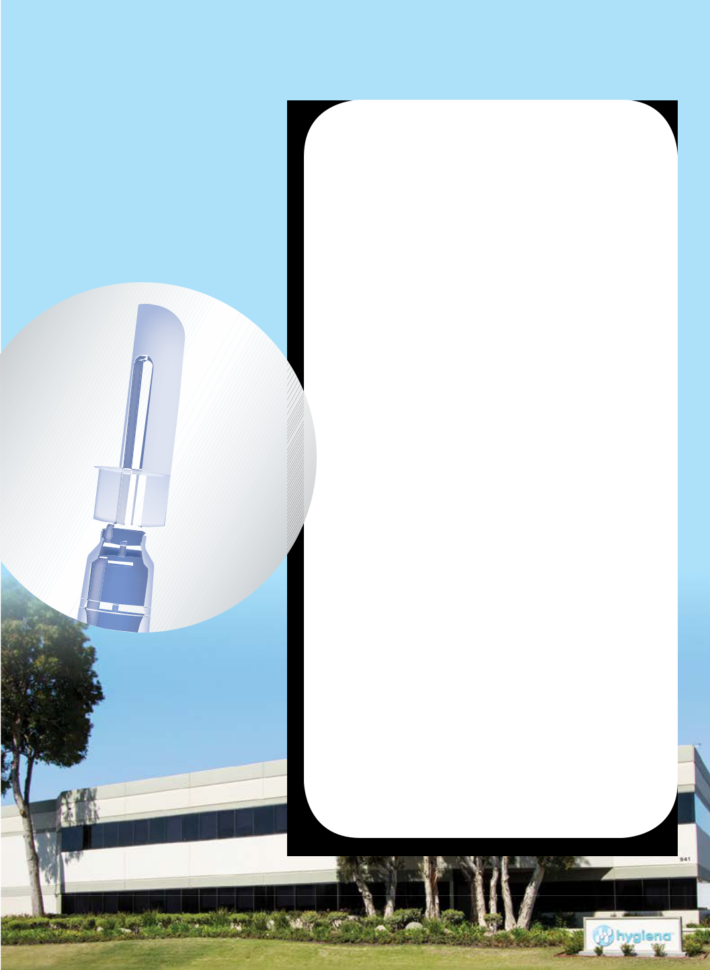
About Hygiena

Hygiena delivers rapid microbial detection, monitoring, and identification solutions to a wide range of industries, including food and beverage, healthcare, hospitality, pharmaceuticals, and personal care products.

Since 2001, Hygiena has been committed to providing customers with high-quality innovative technologies that are easy-to-use and reliable, backed by excellent customer service and support. Headquartered in Camarillo, California, with offices in Wilmington, Delaware, the United Kingdom, Mexico, Canada, and China, and over 80 distributors

in more than 100 countries worldwide, Hygiena products span the globe.

Solution,

Bioluminescent

Reagent



Snap-Valve

Tube

Swab

The technology behind the Hygiena proprietary test design


Hygiena’s portfolio of surface, water, allergen, indicator organism, process efficiency, and protein residue tests incorporate Hygiena’s proprietary Snap-Valve™ device. Each test holds a precise amount of liquid media or reagent, providing consistent and accurate results all with easy, one-handed activation.

The Snap-Valve’s unique design facilitates convenient, reliable testing in numerous formats including ATP, microorganism testing, enzyme detection, and sample collection.

4

www.hygiena.com

What is

ATP Testing?


Adenosine triphosphate (ATP), is the key molecule that provides energy to all living cells. Hygiena’s ATP-based systems bring ATP into contact with luciferase, an enzyme that produces luminescence upon contact with ATP. This luminescence is measured by Hygiena’s luminometers, giving readings in relative light units (RLUs). The higher the RLU, the likely contamination present.
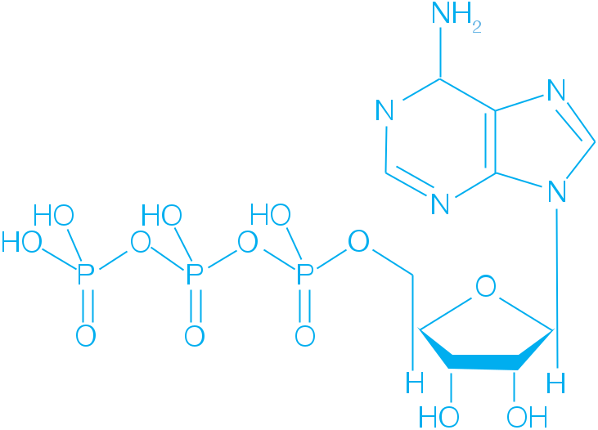

5

monitoring systems


Monitoring System

The EnSURE™ Monitoring System uses one instrument to measure tests for ATP from surface and liquid samples, allergen prevention, total viable count, Enterobacteriaceae, Coliform, E.coli, and other food safety indicators.

- Most sensitive ATP Monitoring System available

- Advanced photodiode sensor offers superior stability, stays in calibration

- Provides real-time results in 15 seconds

- Complimentary SureTrend Data Analysis Software

- AA Battery operated, no charging necessary
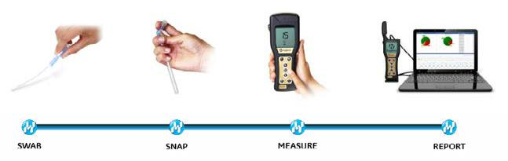

6

www.hygiena.com
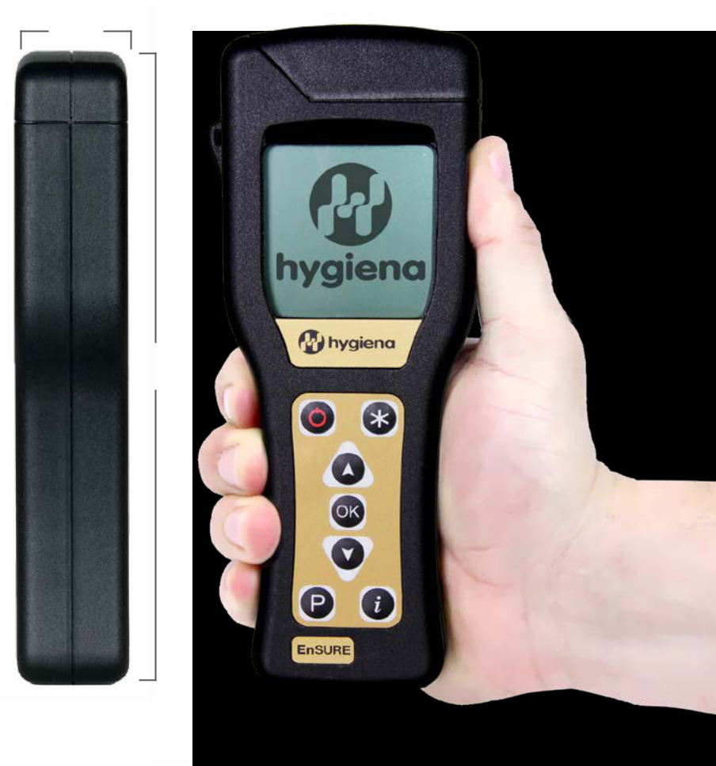

3cm

18cm

Compatible tests: UltraSnap™, SuperSnap™, AquaSnap™ Free, AquaSnap™ Total, MicroSnap™ Total, MicroSnap™ EB, MicroSnap™ Coliform, MicroSnap™ E. coli, ZymoSnap ALP

Catalog No: ENSURE

7

monitoring systems

ATP Sanitation


Monitoring System

The SystemSURE Plus is the world’s best selling ATP Sanitation Monitoring System. From its compact design and easy-to-use software, the SystemSURE Plus is trusted to monitor sanitation and hygiene by manufacturers and facilities in numerous industries.

- Advanced photodiode sensor offers superior stability, stays in calibration

- Provides accurate, real-time results in 15 seconds

- Calibration self-check at start up with optional full diagnostic check mode

- Complimentary SureTrend Data Analysis Software

- AA battery operated, no charging necessary
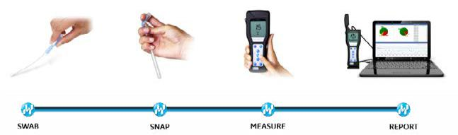

8

www.hygiena.com
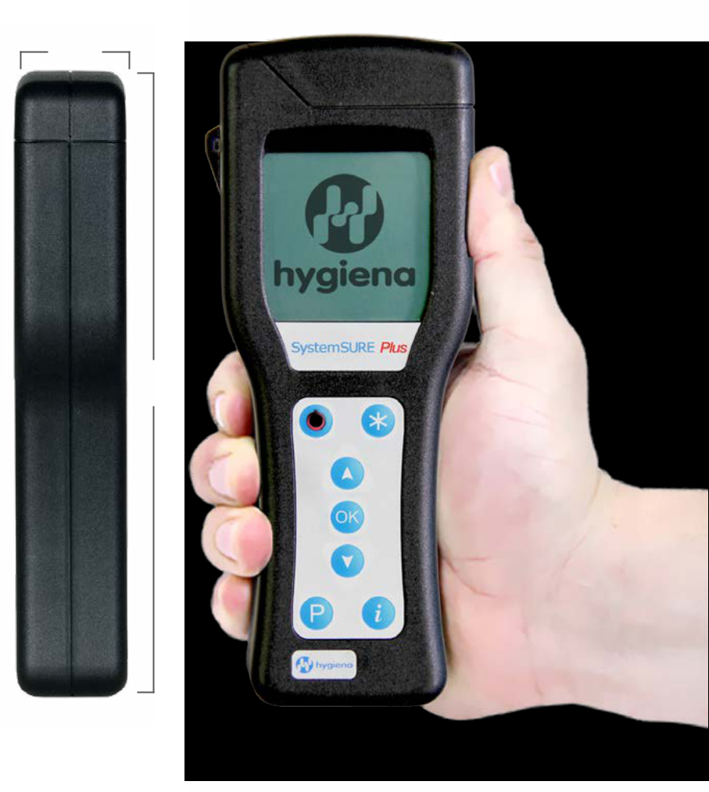

3cm

18cm

Catalog No: SS3

Catalog No: SS3H (for Healthcare)
9
monitoring systems




Data Analysis Software



SureTrend Data Analysis Software takes ATP test results and other data from your Hygiena luminometer and easily converts them into comprehensive reports that illustrate trends and show continuous improvement. SureTrend is easy to use and free with your Hygiena luminometer.

- Helps meet audit requirements

- Identifies problem areas for immediate corrective actions

- Fraud-proof, test results cannot be changed or deleted

- Intuitively track and trend test results, and generate actionable reports

- PC/Windows compatible


Download for free at
www.hygiena.com

10

www.hygiena.com
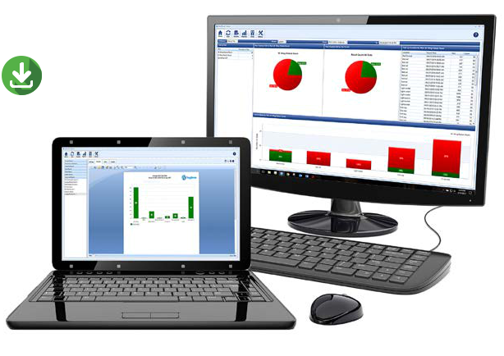

Download for free at
www.hygiena.com
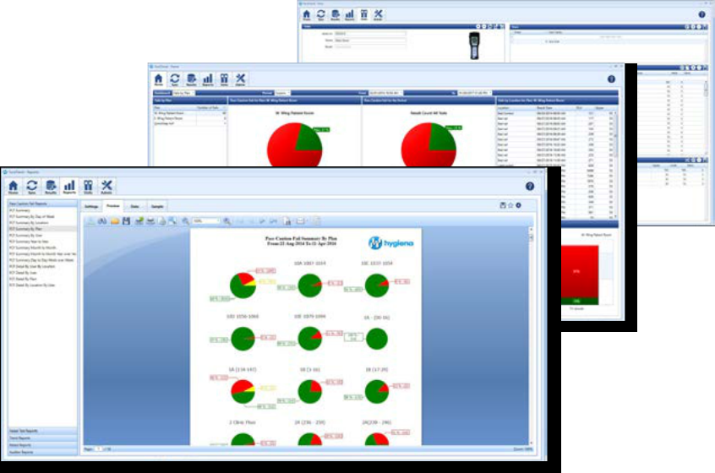

11

atp testing
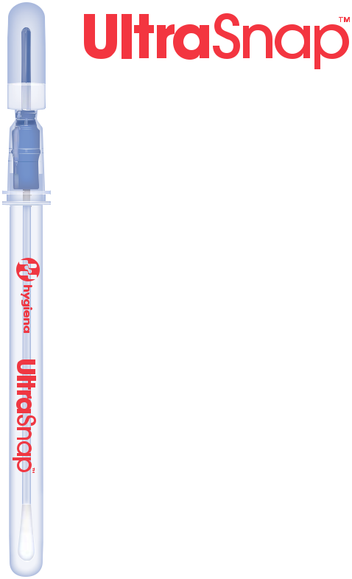

Surface ATP Test

UltraSnap™ is a user-friendly, all-in-one surface ATP Test used with Hygiena luminometers. UltraSnap uses a unique liquid-stable reagent providing superior accuracy, sensitivity, and reproducible results.

- Offers consistent, reliable results in 15 seconds

- Design offers unprecedented accuracy and reproducibility

- Pre-moistened swab bud breaks through biofilms for maximum sample collection

- Compatible with all Hygiena luminometers


Catalog No: US2020 | QTY: 100

12

www.hygiena.com

High-Sensitivity


Surface ATP Test

SuperSnap™ is Hygiena’s most sensitive ATP surface test. Its ability to detect extremely low levels of ATP allows it to be used as an allergen cross-contamination prevention tool. Simply swab a surface, release the reagent, and insert into a Hygiena luminometer for highly accurate, real-time results.

- Most sensitive ATP test validated by a third-party study (4 times as sensitive as UltraSnap)

- Offers consistent, reliable results in 15 seconds

- Robust reagent has superior resistance to sanitizers and extreme pH environments

- Compatible with all Hygiena luminometers

Catalog No: SUS3000 QTY: 100 | QTY: 100

13

atp testing
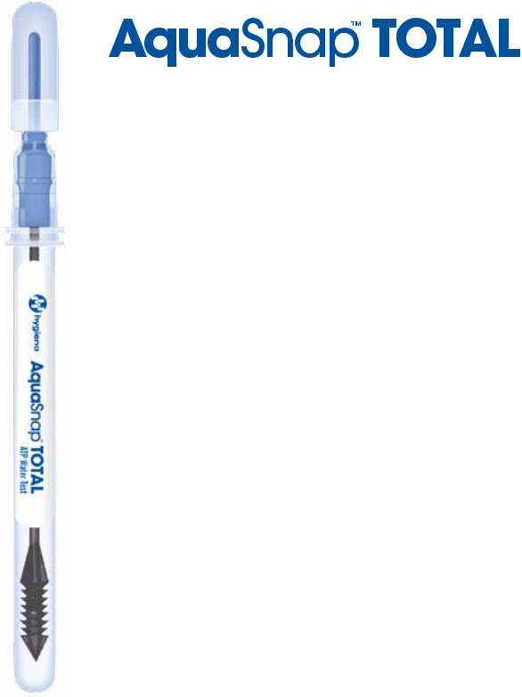

Water ATP Test

AquaSnap™ Total measures both free and microbial ATP in solutions, indicating the total amount of ATP in a water sample.

- Honey dipper collection tip collects consistent 100µl sample

- Detects contamination from both microbial and non-microbial sources

- Offers actionable results in 15 seconds

- Compatible with all Hygiena™ luminometers

Catalog No: AQ-100X | QTY: 100

14

www.hygiena.com


Water ATP Test

AquaSnap™ Free measures ATP that is free in solution. The difference between Total and Free ATP provides an estimate of microbial contamination in a sample.

- Honey dipper collection tip collects consistent 100µl sample

- Can be used with AquaSnap Total to estimate the total bioload of a sample

- Offers actionable results in 15 seconds

- Compatible with all Hygiena™ luminometers

Catalog No: AQ-100FX | QTY: 100

15

atp testing
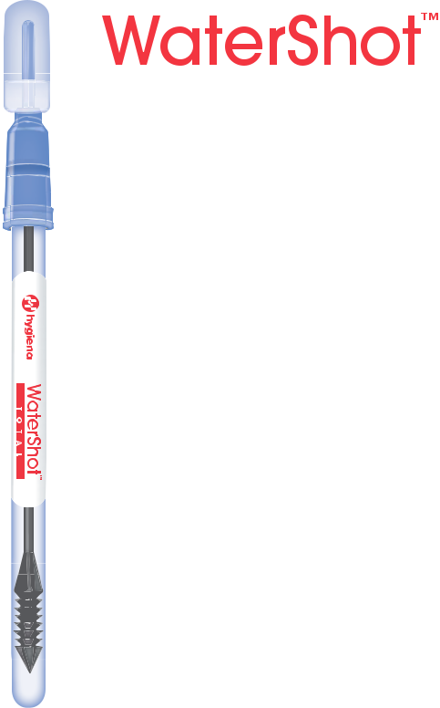

Universal Water

ATP Test

WaterShot Total is designed to replace ATP water test devices compatible with a 3M™ or BioTrace™ luminometer, and reduces cost while providing more accurate and repeatable results.

- Unique device design provides superior accuracy and repeatability

- No need to change Pass/Fail settings

- Honey dipper collection tip collects consistent 100µl sample

- Measures both free (soluble) and microbial ATP in solutions

Catalog No: W-SPXL1333 | QTY: 100

16

www.hygiena.com


Universal Water

ATP Test

WaterShot Free is designed to replace ATP water test devices compatible with a 3M™ or BioTrace™ luminometers, and detects free (soluble) ATP in the sample.

- Unique liquid-stable reagent provides unprecedented accuracy and repeatability

- No need to change Pass/Fail settings

- Honey dipper collection tip collects consistent 100µl sample

- Can be used with WaterShot Total to estimate the total bioload of a sample

Catalog No: WF-SPXL1333 | QTY: 100

17

atp testing
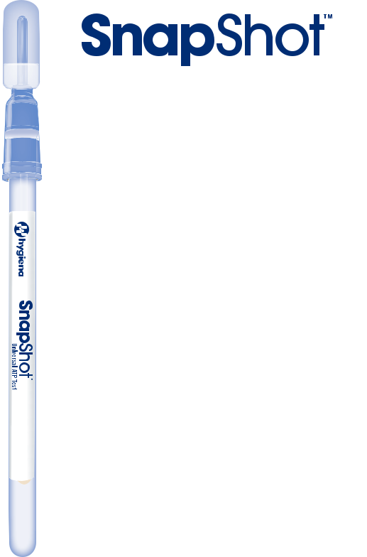

Universal ATP Test

SnapShot Universal ATP Surface Tests are compatible with most manufacturers’ luminometers. Each version is designed to replicate the ATP reaction of the test its replacing, eliminating the need to change pass/fail settings.

- Efficient device design offers superior sample recovery

• Offers increased test repeatability and reliability over competitor swabs

• No need to change Pass/Fail settings


Catalog No: SPXL1333 (3M™ Clean-Trace,

BioTrace Uni-Lite® NG, Uni-Lite® XCEL, Uni-Lite®, Uni-Lite® NG Junior) | QTY: 100

Catalog No: SBC1575 (BioControl Lightning & MVP™) | QTY: 100

Catalog No: SS1211 (Celsis systemSURE) | QTY: 100

18
Catalog No: SHL1414 (Merck Hy-Lite) | QTY: 100

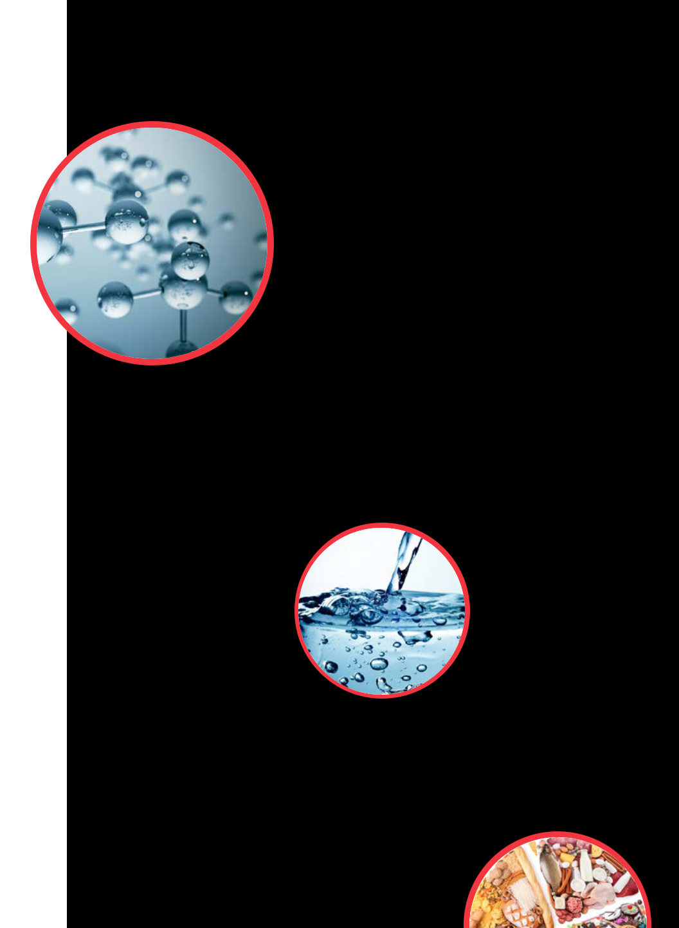

19
allergen tests
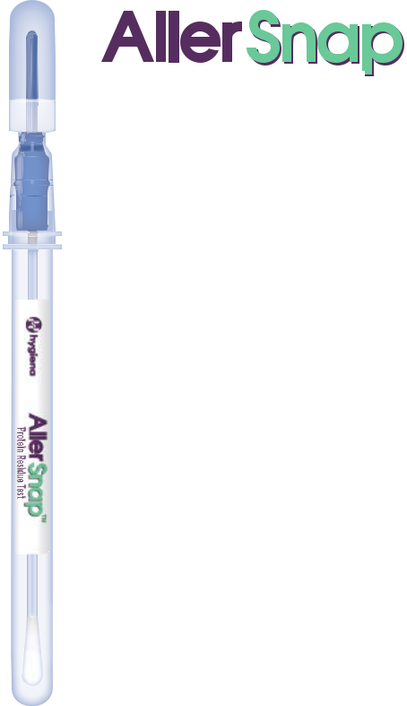

High-Sensitivity Allergen

Prevention Test

AllerSnap™ High-Sensitivity Allergen Prevention Test accurately monitors surface cleanliness and ensures product quality by detecting protein residues left behind after cleaning. Simply swab a surface, release the reagent, and incubate. If the protein residue and potential allergens are present, the reagent turns purple.

- Quickly validates surface hygiene in 15-30 minutes

- Uses broad-range protein detection offering increased speed over specific allergen tests

- Easy-to-interpret color results
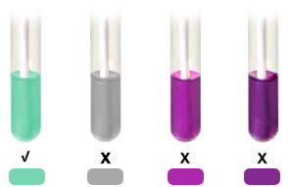

Pass Fail Fail Fail


Incubator
Required

see page 70


Catalog No: ALS-100 | QTY: 100

20

www.hygiena.com
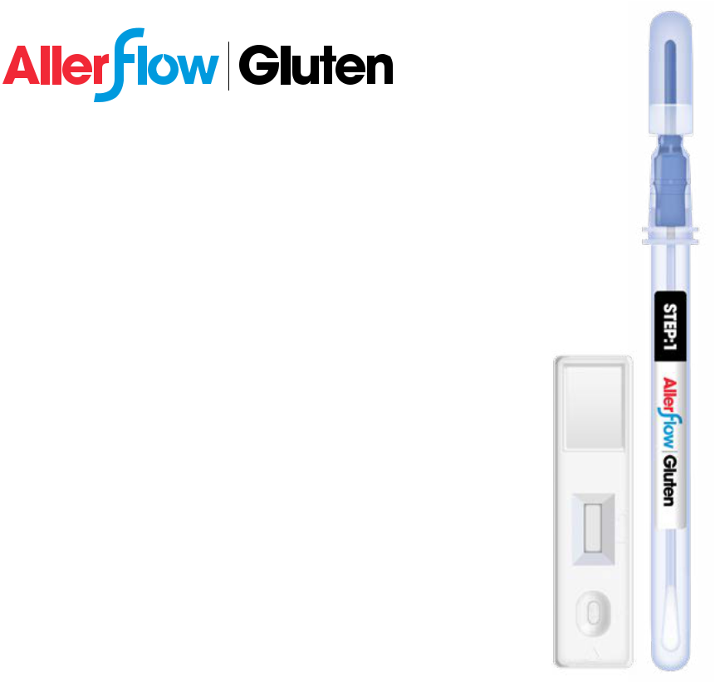

The AllerFlow Gluten Kit rapidly detects gluten residue on surfaces. Combining Hygiena’s convenient sample collection swab design and classic lateral flow technology, the AllerFlow Gluten Kit makes gluten testing easier than ever before.

- Simple two-part kit includes all materials; no pipettes, bottles, or heating blocks required

- Pre-measured, self-contained extraction buffer provides consistent results

- No cross-reactivity with soy, rice, or corn

- Specific to the allergenic fraction of gluten from wheat, barley, rye, and oat

Catalog No: ALF-GL | QTY: 25 kits

21

allergen tests
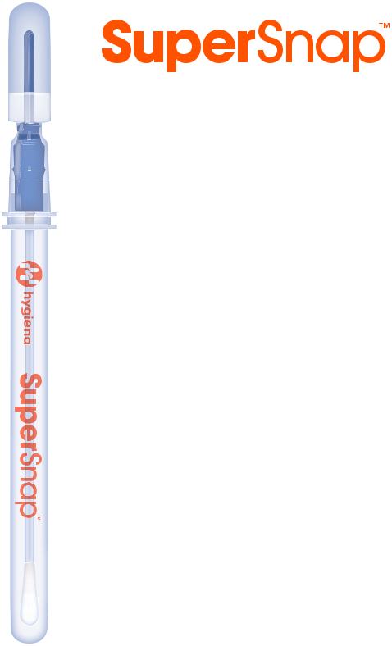

High-Sensitivity

Surface ATP Test

SuperSnap™ is Hygiena’s most sensitive ATP surface test. Its ability to detect extremely low levels of ATP allows it to be used as an allergen cross-contamination prevention tool. Simply swab a surface, release the reagent, and insert into the EnSURE luminometer for highly accurate, real-time results.

- Most sensitive ATP test when used with the EnSURE luminometer

- Offers consistent, reliable results in 15 seconds

- Robust reagent has superior resistance

to sanitizers and extreme pH environments

Catalog No: SUS3000 | QTY: 100

Catalog No: SUS3000X (no azide) | QTY: 100

22

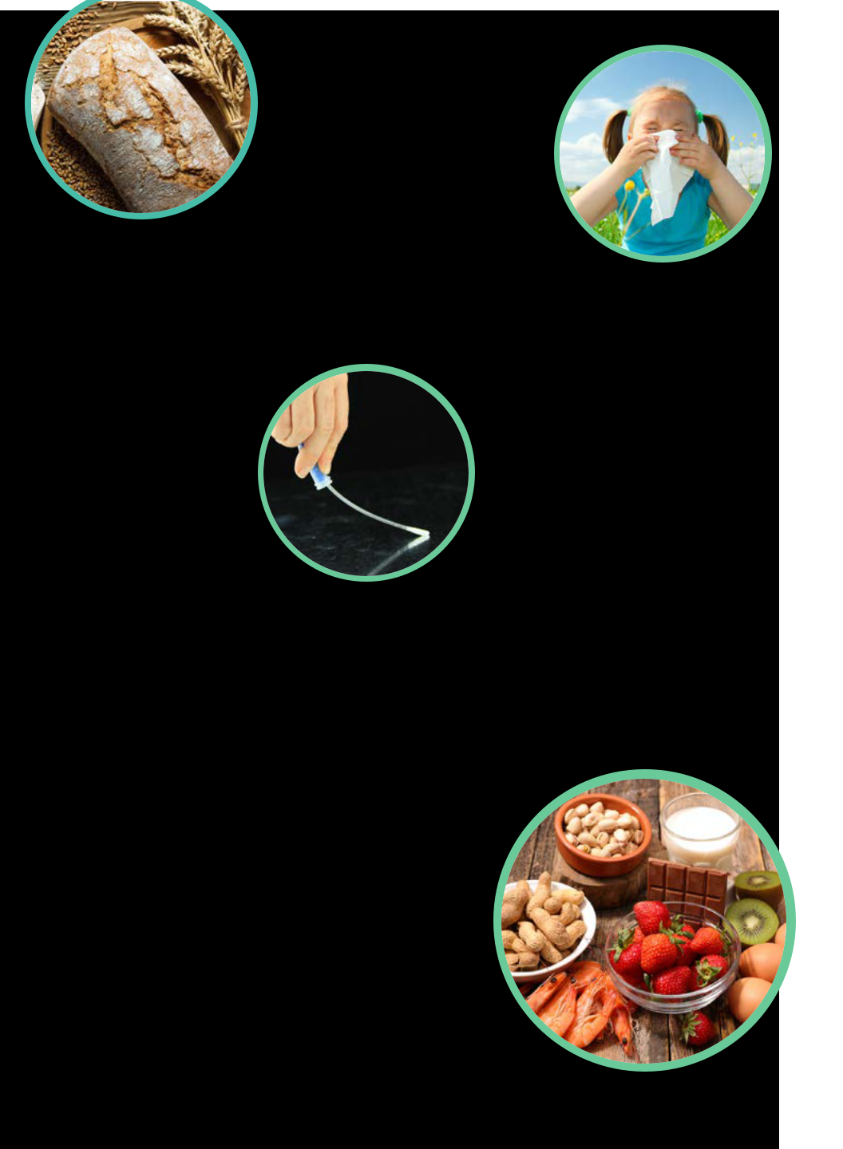

23
surface residue tests
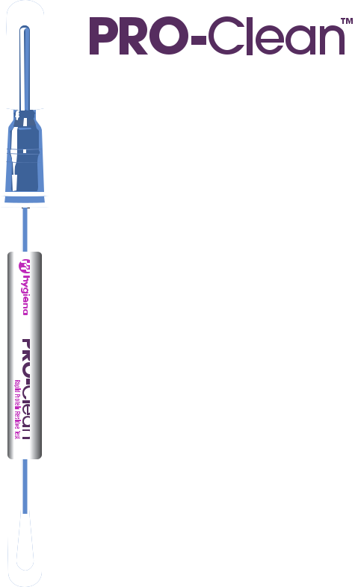

Protein Residue Test

PRO-Clean™ easily monitors the presence of proteins on surfaces, allowing immediate corrective action to be taken when necessary.

- Results in 10 minutes or less

- Easy-to-interpret color change

- No lab equipment required






Pass Fail Fail Fail


Catalog No: PRO-100 | QTY: 100

24

www.hygiena.com

Glucose and Lactose


Detection Device

SpotCheck Plus detects the presence of glucose and lactose on a surface. Simply swab a surface, release the reagent, and if residue containing glucose or lactose is present the reagent will turn green, indicating poor surface hygiene.

- Results in 60 seconds

- Easy-to-interpret color change

- No lab equipment required
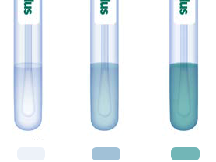

Pass Fail Fail

Catalog No: GL100 | QTY: 100

25

surface residue tests
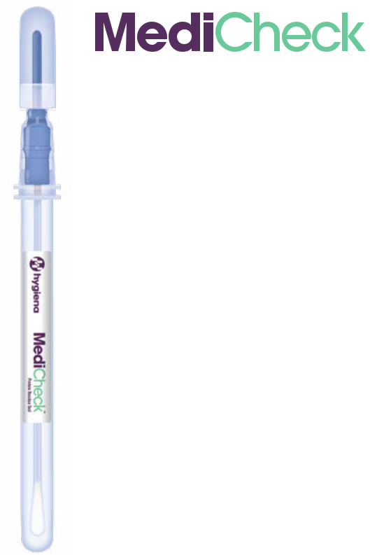

Protein Residue Test

MediCheck Protein Residue Tests verify the cleanliness of washer disinfectors, dental tools, and surgical equipment by detecting proteins left behind after cleaning. Just swab, activate, and incubate the device. The color change shows the protein levels on the surface: green means clean and purple means re-clean.

- Results in 15-30 minutes

- Easy-to-interpret color change

- All-in-one device

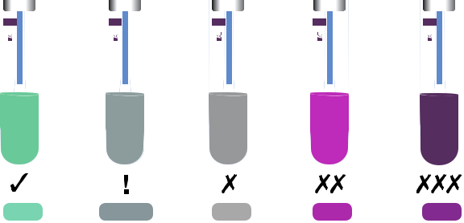

Pass Caution Fail Fail Fail

Incubator
Required

see page 70

Catalog No: MDCK-100 | QTY: 100

26

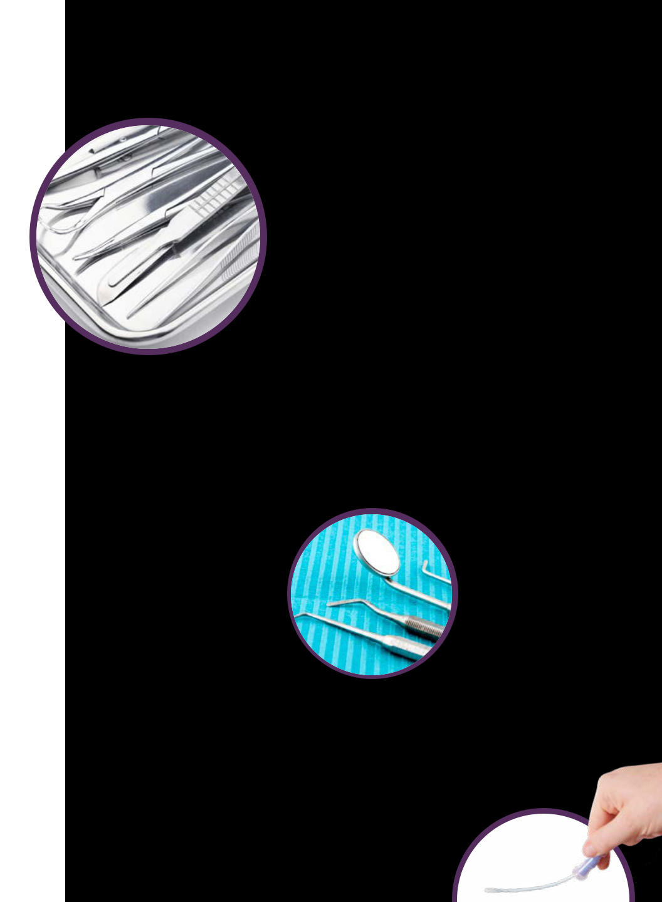

27
process efficiency testing


ACP Cooking

Efficiency Test

CrossCheck measures acid phosphatase activity, a natural enzyme present in raw meat. CrossCheck is used with finished products to verify thermal processing and on food contact surfaces to measure raw meat residues and cross contamination hazards.

• Results in 2-5 minutes

• Determines product and surface safety

• Detects down to 0.1% or less of raw meat or fish

Incubator
Optional

see page 70


Catalog No: CX-3000 | QTY: 100

28

www.hygiena.com

ALP Pasteurization


Verification Test

ZymoSnap ALP measures alkaline phosphatase enzymes in milk and milk-based products to verify pasteurization efficiency.

- Detects below regulatory limits (<350 mU/L)

- Results in 5 minutes

- All-in-one system


Incubator
Required

see page 70

Catalog No: ZS-ALP-100 | QTY: 100

29

indicator organism testing
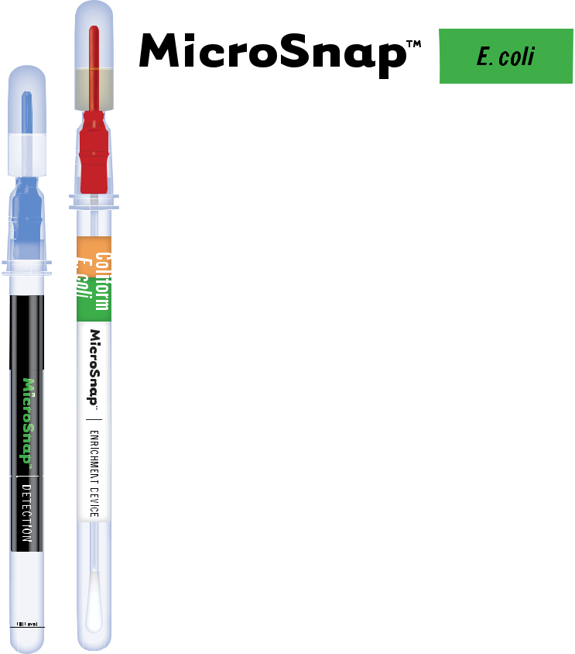

 | MicroSnap™ E. coli is a rapid test for detection
 | and enumeration of E. coli. The test uses a novel
 | bioluminogenic reaction that generates light when
 | enzymes that are characteristic of
 | E. coli bacteria react with specialized substrates.
.E | The light is then quantified in the EnSURE™
coli | luminometer.
 | • Same-day results
 | • Tests a wider dynamic range
 | than traditional testing methods
 | • AOAC-RI Performance
 | Tested MethodSM #071302
 | *Also compatible with Enhanced
 | Broths - see pages 34-35 | LICENSE NUMBER 071302


Incubator
Required

see page 70


Catalog No: MS1-CEC Enrichment Device | QTY: 100

Catalog No: MS2-ECOLI Detection Device | QTY: 100

30

www.hygiena.com
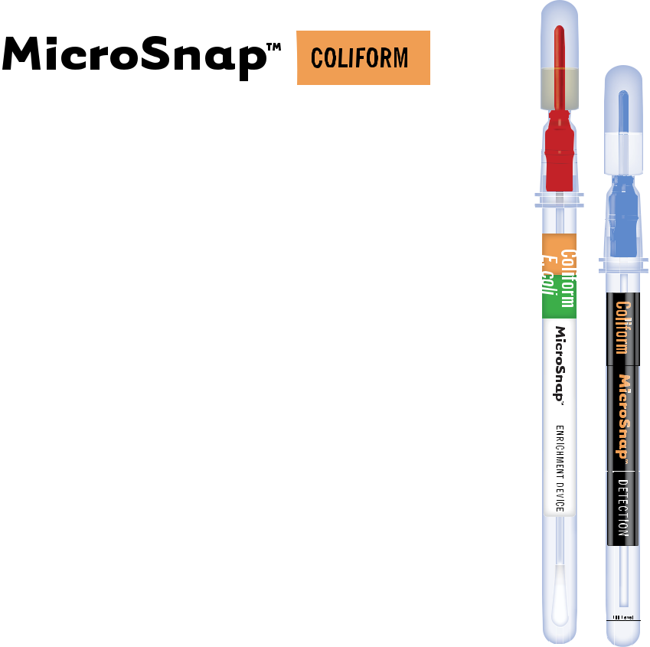

MicroSnap™ Coliform is a rapid test for detection and enumeration of Coliform bacteria. The

test uses a novel bioluminogenic test reaction that generates light when enzymes that are characteristic of Coliform bacteria react with specialized substrates. The light is then quantified in the EnSURE™ luminometer.

• Faster results than traditional testing methods

• AOAC-RI Performance

Tested MethodSM #071302

LICENSE NUMBER 071302


Incubator
Required

see page 70

Catalog No: MS1-CEC Enrichment Device | QTY: 100

Catalog No: MS2-COLIFORM Detection Device | QTY: 100

31

indicator organism testing
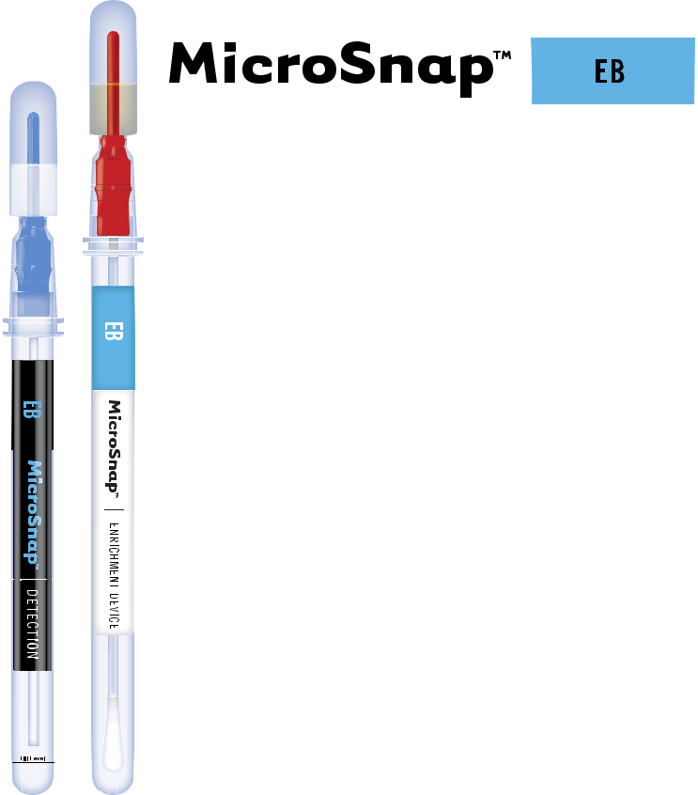

MicroSnap™ EB is a rapid test for detection and enumeration of bacteria in the Enterobacteriaceae (EB) family, including: E. coli, Klebsiella, Citrobacter, Enterobacter, Serratia, Shigella, Salmonella, and Yersinia. The test uses a novel bioluminogenic reaction that generates light when enzymes

that are characteristic of EB bacteria react with specialized substrates. The light is then quantified in the EnSURE™ luminometer.

• Same-day results

• Tests a wider dynamic range than traditional testing methods

Incubator
Required

see page 70

Catalog No: MS1-EB Enrichment Device | QTY: 100

Catalog No: MS2-EB Detection Device | QTY: 100

32

Catalog No: MS1-EB-BROTH-9ML Enhanced EB Broth | QTY: 100

www.hygiena.com
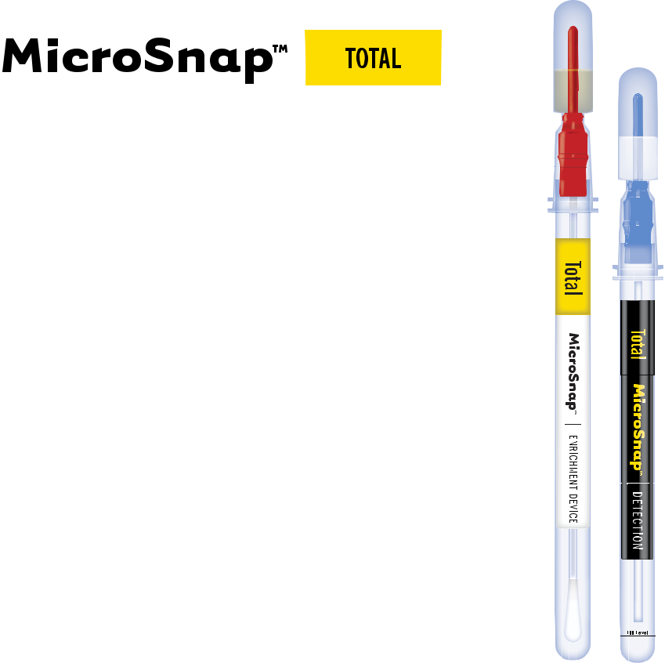

MicroSnap™ Total delivers same-day TVC test results for Gram-positive and negative bacteria, including E. coli, Listeria, Shigella, Vibrio, Bacillus, Staphylococcus, and Pseudomonas. The test uses a novel bioluminogenic test reaction that generates light when enzymes that are characteristic of viable bacteria react with. The light is then quantified with the EnSURE™ luminometer.

• Faster results than traditional testing methods

• AOAC-RI Performance

Tested MethodSM #031501


Incubator
Required

see page 70

Catalog No: MS1-TOTAL Enrichment Device | QTY: 100

Catalog No: MS2-TOTAL Detection Device | QTY: 100

Catalog No: MS1-N-BROTH-9ML Enhanced Nutrient Broth | QTY: 100

33

indicator organism testing
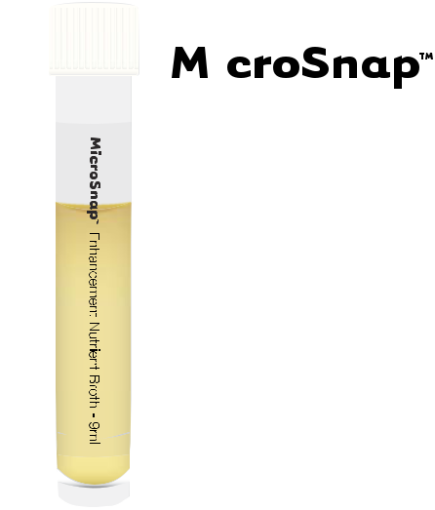

Enhanced Nutrient Broth

MicroSnap™ Enhanced Nutrient Broth is a ready-to-use, non-selective protein solution. The 9 mL broth volume enables low level enumeration of product samples with MicroSnap Total, Coliform, and E. coli.

• Ideal for milk samples

• 9 mL broth volume reduces interference from physical components in the sample

- Robust chemistry reduces interference from chemical interactions

Incubator
Required

see page 70

Catalog No: MS1-N-BROTH-9ML | QTY: 100

34

www.hygiena.com
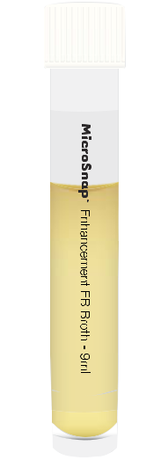


Enhanced EB Broth

MicroSnap™ Enhanced EB Broth is a ready-to-use, non-selective protein solution. The 9 mL broth volume enables low level enumeration of product samples with MicroSnap EB, Coliform, and E. coli.

• Ideal for milk samples

• 9 mL broth volume reduces interference from physical components in the sample

- Robust chemistry reduces interference from chemical interactions


Incubator
Required

see page 70

Catalog No: MS1-EB-BROTH-9ML | QTY: 100

35

indicator organism testing
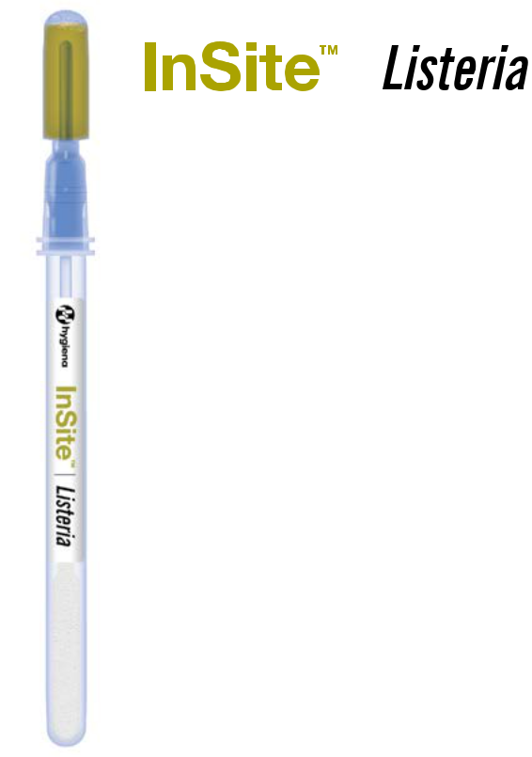

InSite Listeria is an easy-to-use, self-contained, environmental Listeria species test. Each device contains a chromogenic liquid media formulated with antibiotics, growth enhancers, and color-changing compounds specific to Listeria. Simply swab the test area, incubate, and wait.

- Results in 24-48 hours

- Easier to use than other testing methods

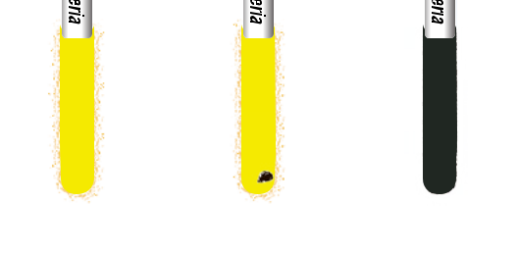

Yellow | Yellow | Black
Amber | Amber | color
color | color

Black

spot

Negative Negative Positive (+)

presumptive positive

Incubator
Required

see page 70

Catalog No: IL050 | QTY: 50

Catalog No: IL100 | QTY: 100

36

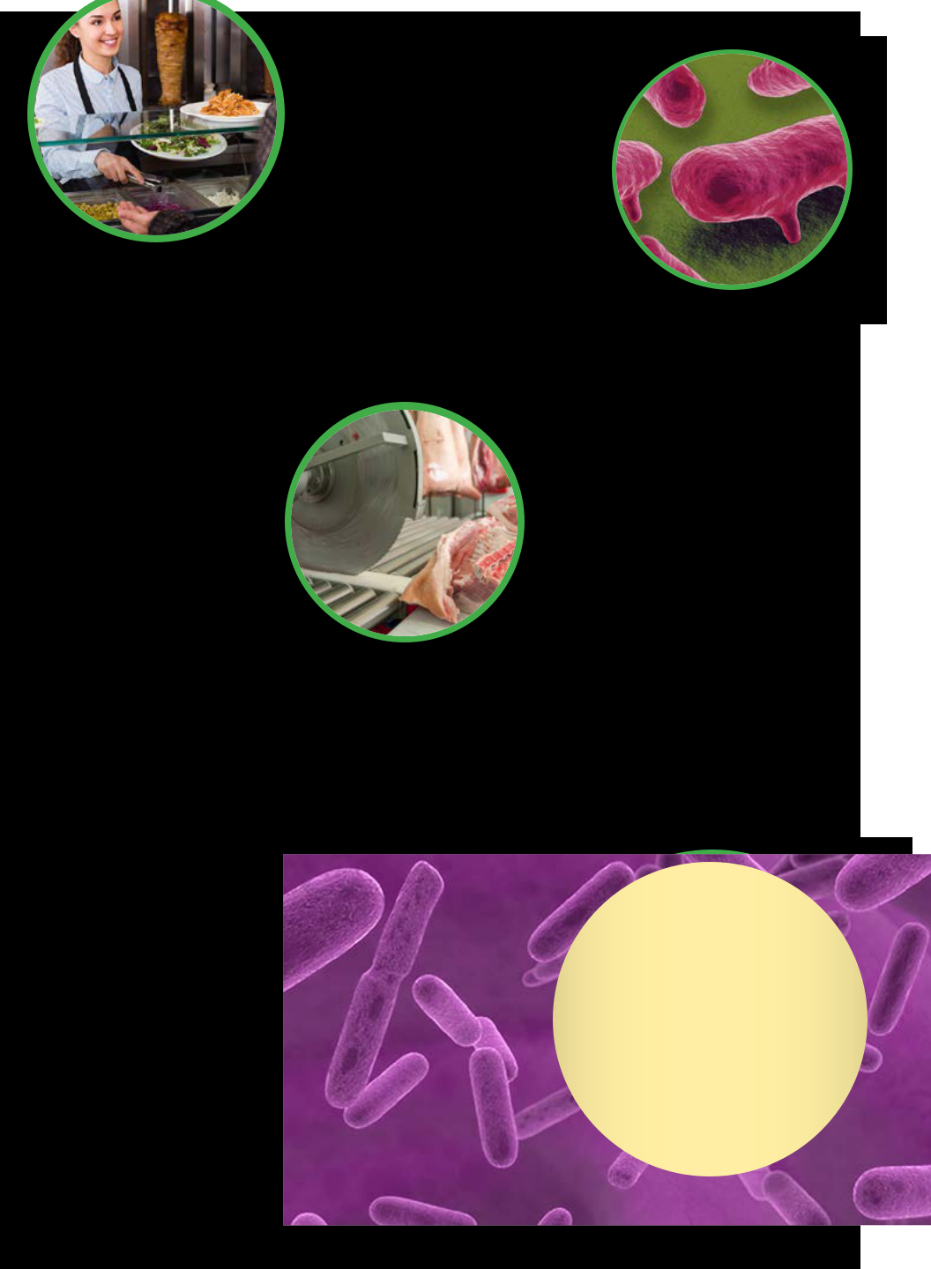

37

pathogen testing
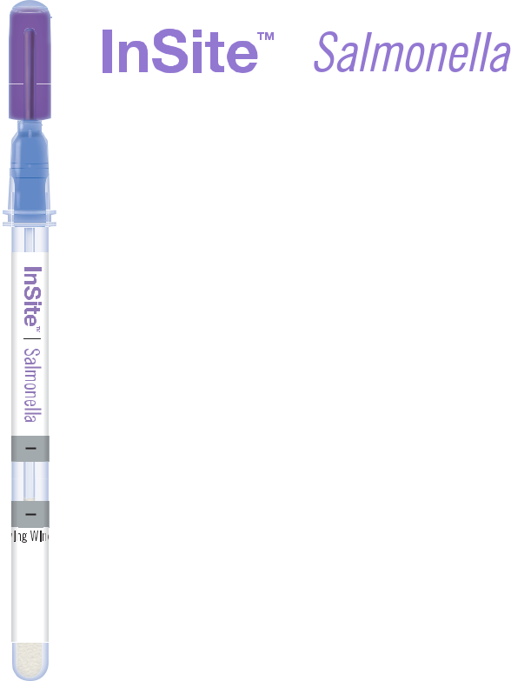

InSite Salmonella is an easy-to-use, self-contained, environmental Salmonella species test. Each device contains a chromogenic liquid media with antibiotics, growth enhancers, and color-changing compounds specific to Salmonella.

• Results in 24-48 hours

• Easier to use than other testing methods
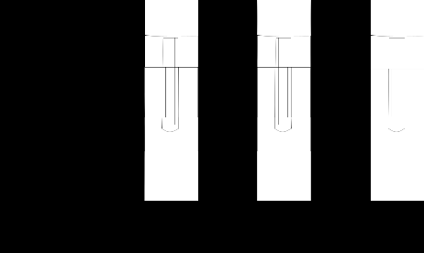
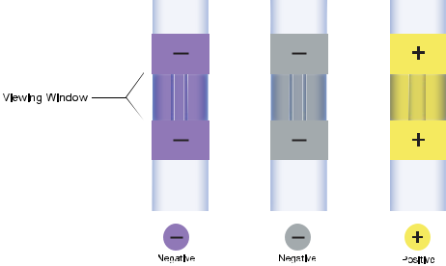

Incubator
Required

see page 70


Catalog No: IS050 | QTY: 50

38

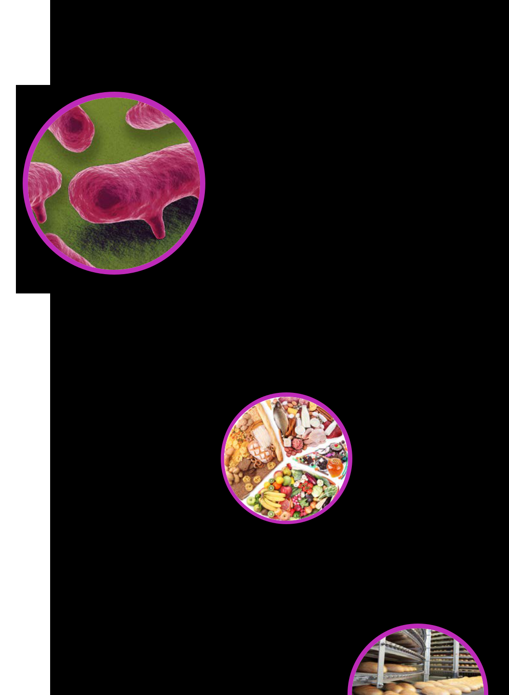
www.hygiena.com

39

pathogen testing

Lateral
Flow

System


The Lateral Flow System is a cost-effective way to screen a wide variety of matrices for pathogens and get results faster than using conventional cell culture.

Used for E. coli O157, Salmonella, and Listeria, the system wicks the test strip by capillary action. In 10 minutes, two red lines appear if the target pathogen is present.

- Rapid, easy-to-interpret results for fast decision making

- Simplified workflow that does not require advanced training

- Long shelf-life, easy to store, and minimal waste production
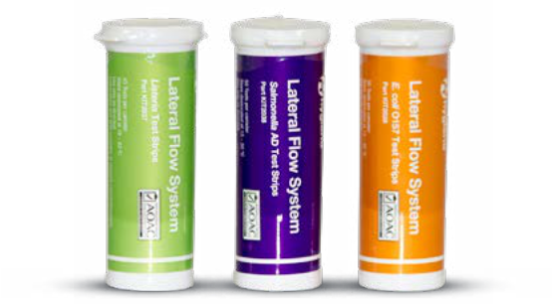

40

Not available in

the United States

www.hygiena.com

Salmonella
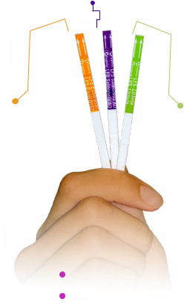

E. coli | Listeria

Catalog No: KIT2028 | LFS E. coli O157 Test Kit | QTY: 50
Catalog No: KIT2037 | LFS Listeria Kit | QTY: 45
 | 41
Catalog No: KIT2038 | 41
Catalog No: KIT2038 | LFS Salmonella Kit | QTY: 50
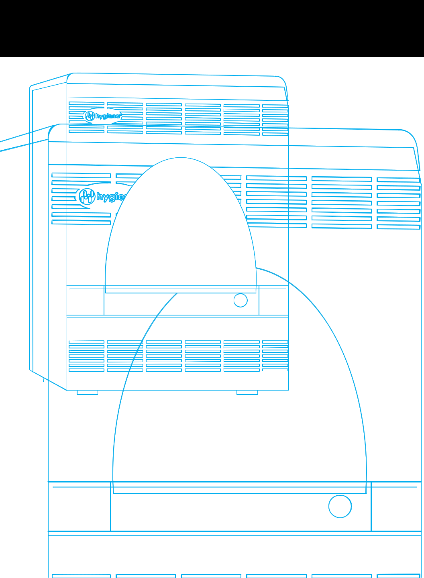

42
www.hygiena.com

The BAX® System
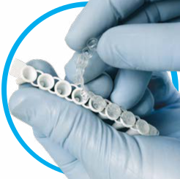

The award-winning BAX® System breaks down samples at the genetic level, using the power of the polymerase chain reaction (PCR) to detect harmful bacteria and other microbes in product and environmental samples with certainty. Customers around the world have made the BAX® System an integral part of their quality control systems. Learn about the benefits of the BAX System at www.hygiena.com

Flexibility to
meet your needs!

Configured for convenience, BAX® System assays contain all the components needed for PCR. Minimize operator handling and improve ease of use, while decreasing false positives. Choose from dozens of assays and enrichment protocols to meet your workflow requirements.

43

pcr pathogen testing


 Molecular Pathogen Detection


The BAX® System Q7 is designed for those who value fastest time to result, flexibility, and throughput in their pathogen detection program.
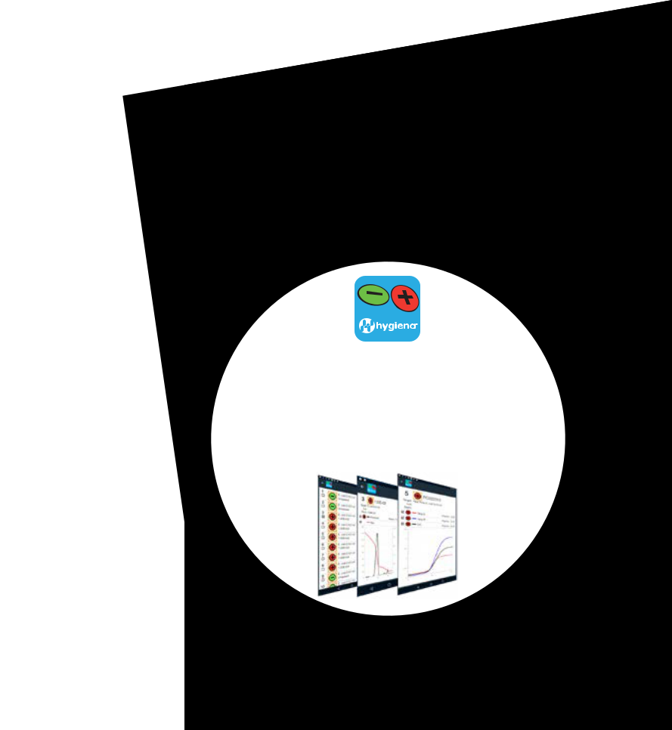

- 96-well format for maximum sample throughput

- Multiwavelength technology allows for

detection of up to three targets in a single reaction well

- Continuous detection during PCR cycling collects data in Real-Time, reducing time to result

- Comprehensive catalog of

validated matrices and assays

(See following pages)

BAXApp

Review your BAX® System

results on your smartphone

or tablet with the free BAXApp.

GooglePlay • AppStore

44

www.hygiena.com
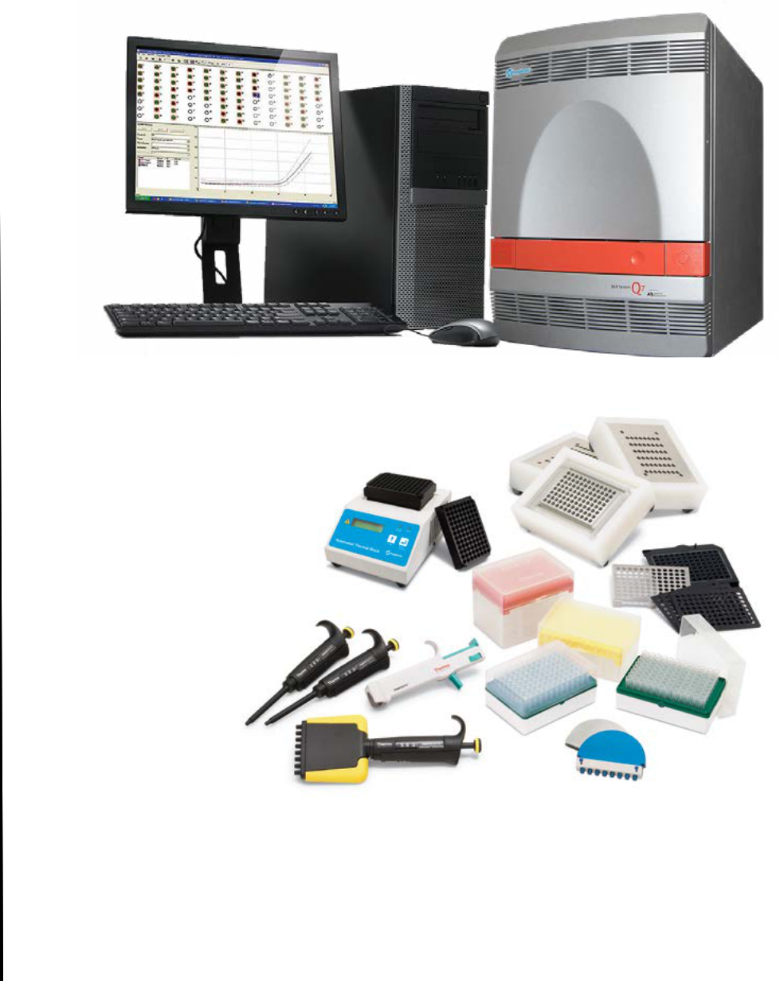

START-UP PACKAGE

- Heating & cooling blocks

- Capping/decapping tools

- Cluster tubes and holders

- Pipettes and tips

- User documentation

Catalog No: ASY2018

45

pcr pathogen testing


BAX® System Q7 Assays

Salmonella

The BAX® System PCR assays for Salmonella produce clear yes-or-no results for Salmonella species with minimal hands-on required. The Salmonella 2 assay features all the benefits of the original Salmonella assay, along with proprietary hot-start technology that helps reduce the effects of human error. The real-time version of this assay reduces processing time by more than half versus traditional assays.

- Results in as soon as 13 hours

- Used worldwide by industry and government labs

- Validated on a wide variety of matrices and surface types Find a complete list at www.hygiena.com

46

www.hygiena.com
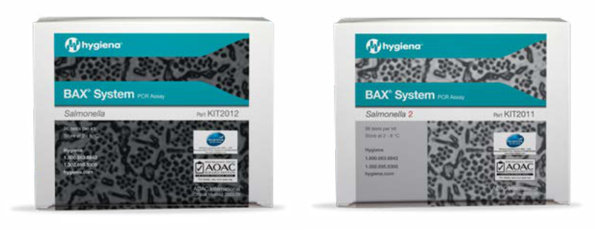

AOAC OMA, AOAC RI, AFNOR, USDA, AOAC OMA, AOAC RI, AFNOR, USDA,

FSIS and Health Canada FSIS and Health Canada
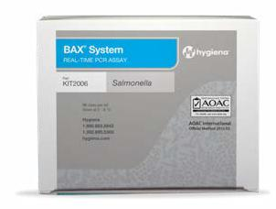

AOAC OMA, AOAC RI, AFNOR


Find a complete list of global validations and approvals at www.hygiena.com

Catalog No: KIT2012 Salmonella | QTY: 96

Catalog No: KIT2011 Salmonella 2 | QTY: 96

Catalog No: KIT2006 Real-Time Salmonella | QTY: 96

47

pcr pathogen testing


BAX® System Q7 Assays

Listeria

The Hygiena™ BAX® System PCR assays for genus Listeria can help companies monitor their environment and products for contamination with Listeria, a common indicator organism for other pathogens. Choose from a variety of available assays and enrichment protocols to meet your workflow and program needs.

- 24E assay facilitates next-day results with 24LEB Complete Media

- Real-time assay reduces processing time by more than half versus traditional assays

- Validated on a wide variety of matrices and surface types Find a complete list at www.hygiena.com

Catalog No: KIT2016 Genus Listeria | QTY: 96

Catalog No: KIT2003 Genus Listeria 24E | QTY: 96

48 | Catalog No: KIT2017 Real-Time Genus Listeria | QTY: 96

www.hygiena.com
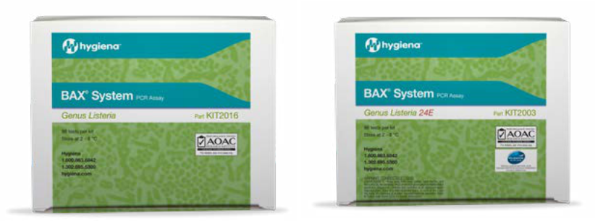

AOAC-RI, Health Canada | AOAC RI and AFNOR
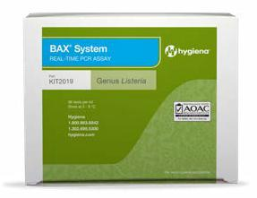

AOAC RI and Health Canada

Find a complete list of global validations and approvals at www.hygiena.com

49

pcr pathogen testing

BAX® System Q7 Assays

L. monocytogenes

The Hygiena™ BAX® System PCR assays for Listeria monocytogenes can help companies monitor their environment and products for contamination with L. mono. Choose from a variety of available assays and enrichment protocols to meet your workflow and program needs.

- 24E assay facilitates next-day results with 24LEB Complete Media

- Real-time assay reduces processing time by more than half versus traditional assays

- Validated on a wide variety of matrices and surface types Find a complete list at www.hygiena.com

Catalog No: KIT2005 Real-Time L. monocytogenes | QTY: 96

Catalog No: KIT2017 L. monocytogenes | QTY: 96

50 | Catalog No: KIT2002 L. monocytogenes 24E | QTY: 96

www.hygiena.com
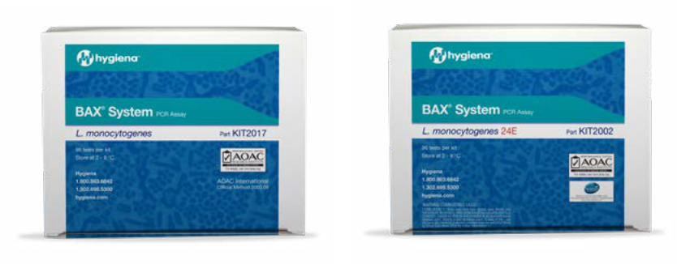

AOAC OMA, AOAC RI, USDA FSIS | AOAC RI and AFNOR
and Health Canada
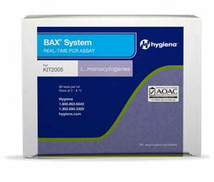

AOAC RI

Find a complete list of global validations and approvals at www.hygiena.com

51

pcr pathogen testing

BAX® System Q7 Assays

Pathogenic E. coli

The BAX® System portfolio of pathogenic E. coli assays offers consistent accuracy, reliability, and convenience with flexibility to meet diverse testing needs.

- Speedy results enable same-day product release decisions

- MP Media shortens enrichment time for

multiplex (MP) assay to as few as eight hours

- Validated on a wide variety of matrices and surface types Find a complete list at www.hygiena.com

Catalog No: KIT2004 E. coli O157:H7 MP | QTY: 96

Catalog No: KIT2000 Real-Time E. coli O157:H7 | QTY: 96

52

www.hygiena.com
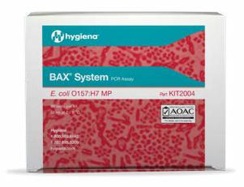

AOAC-RI, AFNOR, USDA FSIS

and Health Canada
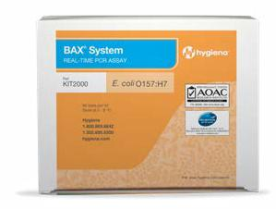

AOAC RI, AFNOR

Find a complete list of global validations and approvals at www.hygiena.com

53

pcr pathogen testing

BAX® System Q7 Assays

Shiga toxin-producing E. coli (STEC)

The BAX® System Real-Time PCR assay suite for STEC is designed to identify the top six non-O157 Shiga toxin producing E. coli (STEC) defined by the USDA Food Safety and Inspection Service (FSIS) as adulterants in the beef industry.

- Genetic screening assay targets virulence traits (stx and eae) to clear negative samples fast and accurately

- Two multiplex panel assays detect and differentiate

the top six STEC serogroups (O26, O111, O121, O45, O103, O145)

- Single stage enrichment in as little as 12 hours

- Validated for raw ground beef, beef trim, and produce

Catalog No: KIT2021 Real-Time STEC Screening | QTY: 96

Catalog No: KIT2008 Real-Time STEC Panel 1 | QTY: 48

54 | Catalog No: KIT2009 Real-Time STEC Panel 2 | QTY: 48

www.hygiena.com
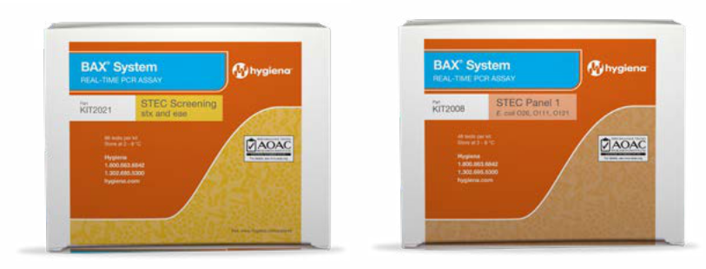

_{AOAC RI, USDA FSIS} AOAC RI, USDA FSIS
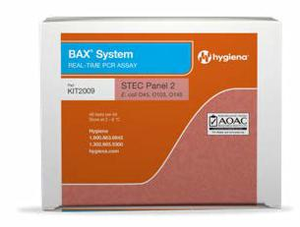

AOAC RI, USDA FSIS

Find a complete list of global validations and approvals at www.hygiena.com

55

pcr pathogen testing


Additional BAX® System Q7 Assays

- Shigella

- Cronobacter (E. sakazakii)

- Vibrio (cholerae, parahaemolyticus, and vulnificus)

- Campylobacter (coli, jejuni, and lari)

- Staphylococcus aureus

- Yeast and Mold

- Validated on a wide variety of matrices and surface types Find a complete list at www.hygiena.com

Catalog No: KIT2007 Shigella | QTY: 96

Catalog No: KIT2001 Cronobacter (E. sakazakii) | QTY: 96

Catalog No: KIT2010 Vibrio (cholerae, parahaemolyticus, and vulnificus) | QTY: 96

Catalog No: KIT2018 Real-Time Campylobacter | QTY: 96

Catalog No: KIT2020 Real-Time Staphylococcus aureus | QTY: 96

56 | Catalog No: KIT2015 Yeast and Mold | QTY: 96

www.hygiena.com
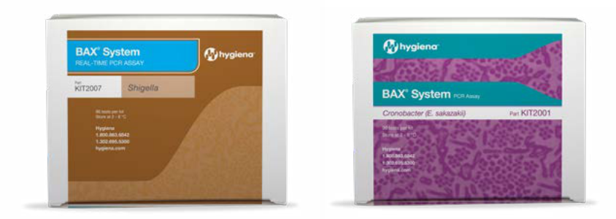

Health Canada and China AQSIQ
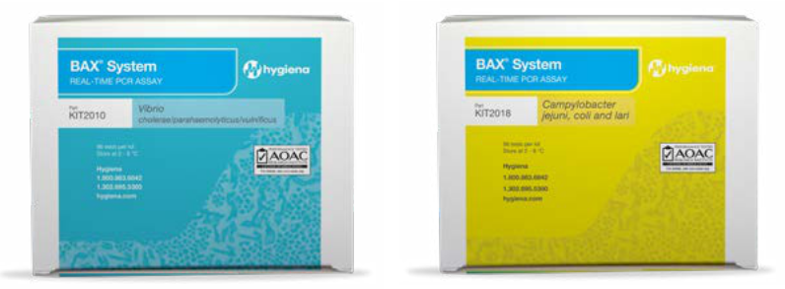

AOAC RI AOAC RI, NordVal
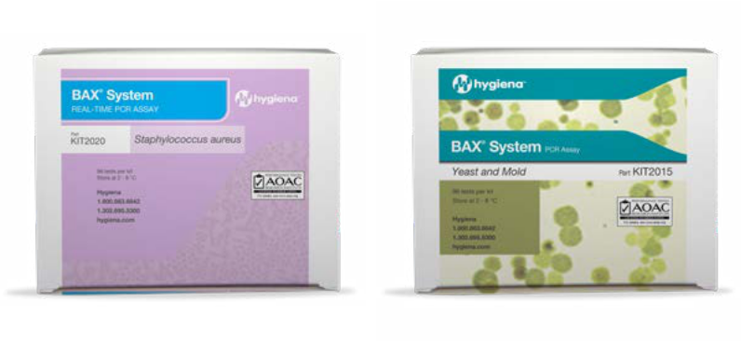

AOAC RI AOAC RI


Find a complete list of global validations and approvals at www.hygiena.com

57

pcr pathogen testing

Enrichment Media

These bulk powder media are available to customers that want to take full advantage of the speed, flexibility, and convenience that select BAX® System assays have to offer.

BAX® System Listeria Enrichment Media

- Enables next-day results for environmental samples tested with the BAX® System PCR Assay for Genus Listeria

BAX® System MP Media

- Optimized for the rapid growth of pathogenic E. coli and Salmonella

- Also available in StatMedia™ Soluble Packets for added convenience

Hygiena Dehydrated Culture Media

(Buffered Peptone Water)

- Standard media for the enrichment of Salmonella, Cronobacter, and other microbes

58

www.hygiena.com
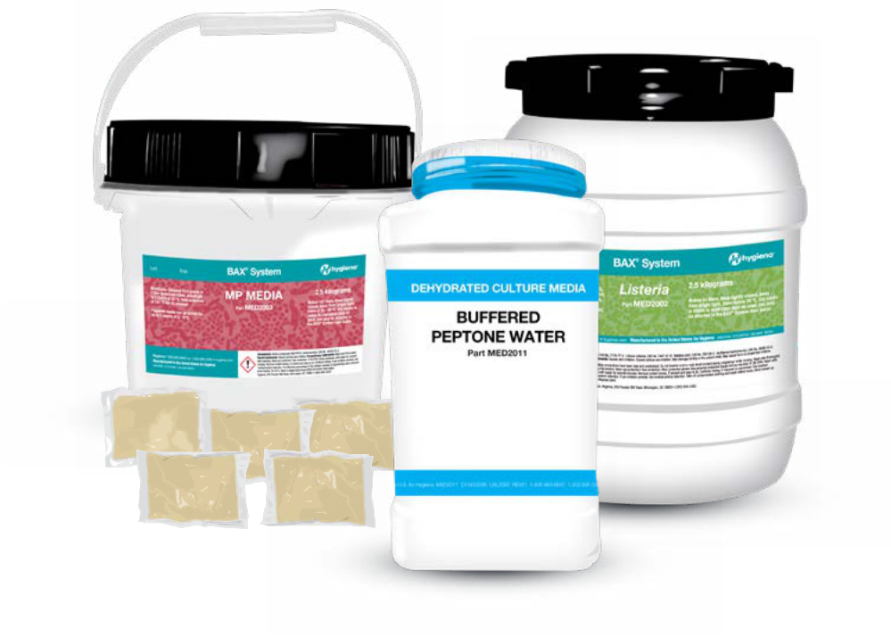

Catalog No: MED2016 StatMedia™ Soluble Packets | QTY: 100 (33.75 g) packets

Catalog No: MED2003 BAX® System MP E. coli Media 2.5kg

Catalog No: MED2010 Hygiena Dehydrated Culture Media (BPW) 2.5kg

Catalog No: MED2011 Hygiena Dehydrated Culture Media (BPW) 500g

59

pcr pathogen testing


Elite Enrichment Media

Actero™ Elite Enrichment Media is a selective bacterial culture medium optimized for the rapid recovery of specific foodborne pathogens from environmental and food samples in a single-step enrichment. When coupled with select real-time assays from the BAX® System portfolio, these enrichment protocols offer some of the fastest, most reliable, and AOAC-approved results available to the industry.

- Single-step enrichment

- Enables faster time-to-results for Listeria (in as little as 20 hours) and Salmonella (in as little as 16 hours)

- Accurate and reliable in the presence of

competing organisms

Available formats:

• Salmonella • Listeria

Compatible assays:

BAX® System Real-Time PCR Assay for Genus Listeria BAX® System Real-Time PCR Assay for L. monocytogenes BAX® System Real-Time PCR Assay for Salmonella

60

www.hygiena.com
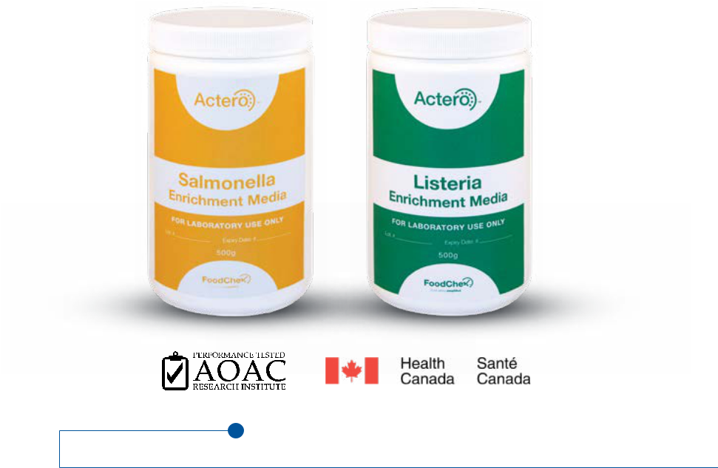

Catalog No: MED2017 ACTERO™ Listeria 500g Dehydrated: FCM-011

Catalog No: MED2018 ACTERO™ Listeria 2KG Dehydrated: FCM-022/4

Catalog No: MED2019 ACTERO™ Listeria (4 x 2kg/ case) Dehydrated: FCM-022

Catalog No: MED2020 ACTERO™ Listeria 10 kg Dehydrated: FCM-023

Catalog No: MED2021 ACTERO™ MediaBox™ Listeria 5: FCM-045

Catalog No: MED2022 ACTERO™ MediaBox™ Listeria 10L: FCM-046

Catalog No: MED2023 Actero™ Salmonella 500g Dehydrated: FCM-009

Catalog No: MED2024 Actero™ MediaBox™ Salmonella 5L: FCM-047

Catalog No: MED2025 Actero™ MediaBox™ Salmonella 10L: FCM-048

61

pcr pathogen testing


PCR Pathogen Detection

Designed with smaller laboratories in mind, the

BAX® System X5 offers the same accurate and reliable DNA-based pathogen detection technology as the BAX® System Q7 with a smaller footprint. Find a complete list of validated matrices and surface types at www.hygiena.com
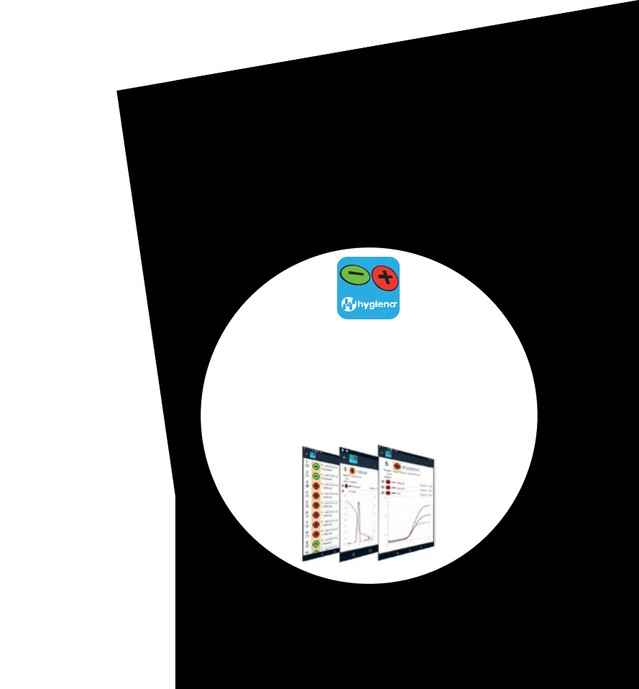

- Smaller footprint than Q7 instrument

- Convenient 32-well format

- Includes all ancillary equipment, along with new fully automated Hygiena Thermal Block for

simplified workflow

- Comprehensive catalog of validated matrices
and assays

(See following pages)

- Major assays for top safety concerns:

  - Genus Listeria

  - L. monocytogenes

  - E. coli O157:H7

BAXApp

Review your BAX® System results on your smartphone or tablet with the free BAXApp. GooglePlay • AppStore

62 • Salmonella

www.hygiena.com
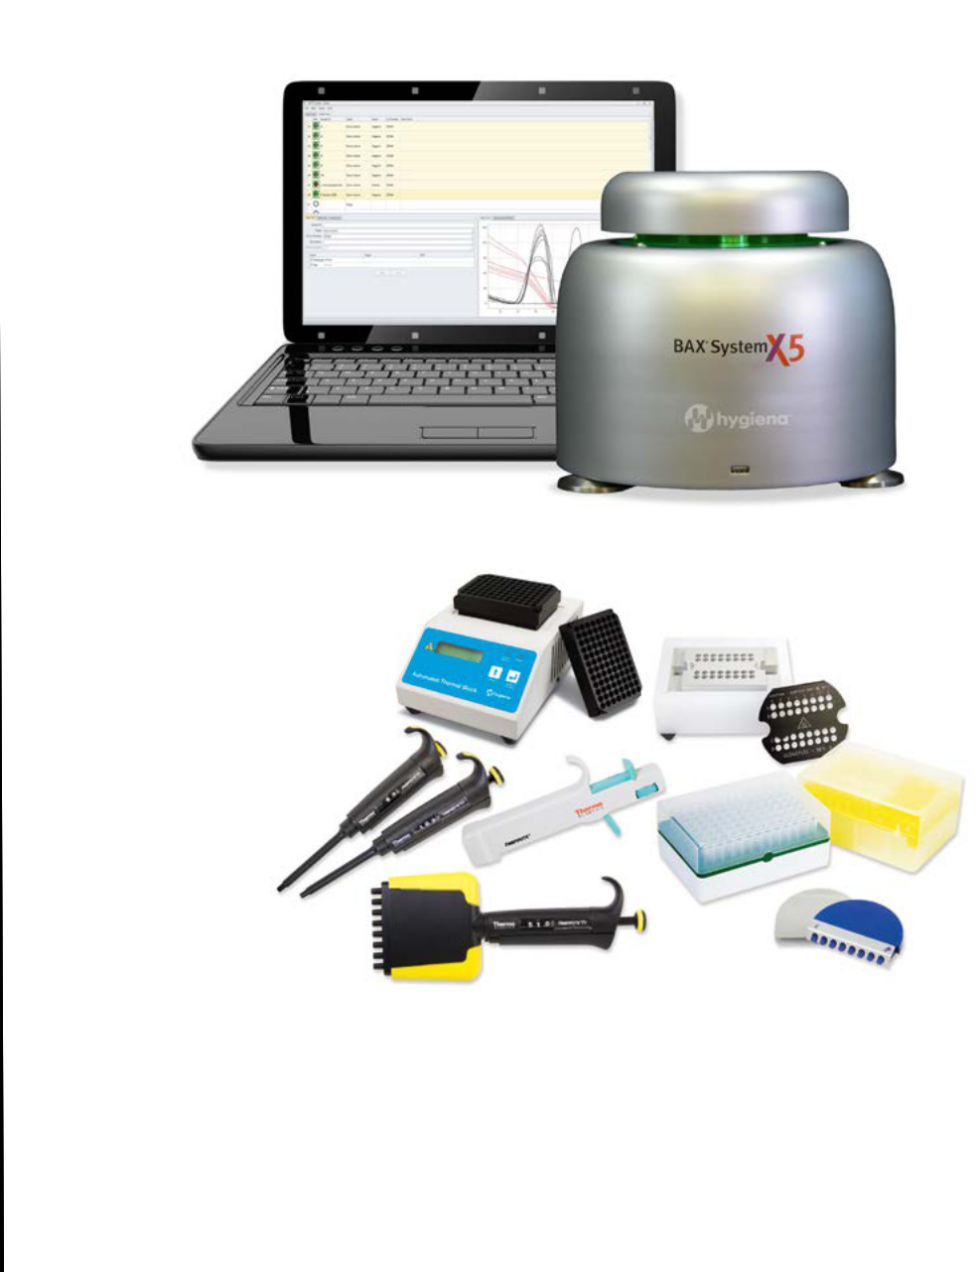

START-UP PACKAGE

- Heating & cooling blocks

- Capping/decapping tools

- Cluster tubes and holders

- Pipettes and tips

- User documentation

Catalog No: ASY2018

63

pcr pathogen testing


BAX® System X5 Assays

Formatted specifically for the BAX® System X5 instrument, these core assays (genus Listeria, L. monocytogenes, E. coli O157:H7, Salmonella) detect foodborne pathogens from a variety of enriched samples, including meat, poultry, fish, seafood, fruit, vegetables, dairy, and environmental surfaces. Find a complete list of validated matrices and surface types at www.hygiena.com

- Speed

Sample prep, amplification, and end-point detection in under 5 hours

- Confidence

Built-in positive control for rapid, reproducible results

- Ease of Use

Does not require advanced training or skill level

- Convenience

Prepackaged PCR tablets for consistency, stability, and reduced operator error

64

www.hygiena.com
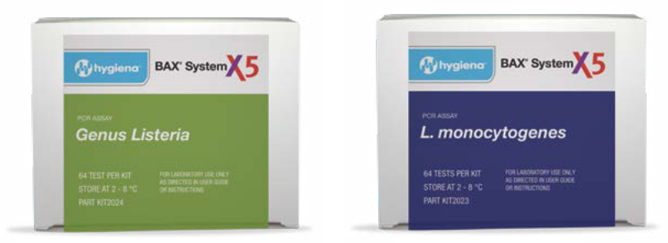

AOAC-RI AOAC-RI
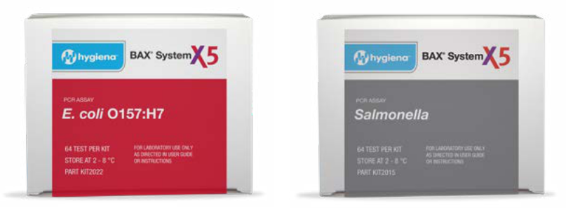

AOAC RI and AFNOR AOAC RI and AFNOR

Catalog No: KIT2024 Genus Listeria | QTY: 64

Catalog No: KIT2023 L. monocytogenes | QTY: 64

Catalog No: KIT2022 E. coli O157:H7 | QTY: 64

Catalog No: KIT2025 Salmonella | QTY: 64

65

molecular identification & characterization


As the world’s only automated ribotyping platform for microbial identification and characterization, the RiboPrinter® System compares genetic fingerprints of side by side bacteria. With simplified workflows and intuitive data management, the RiboPrinter® System does not require expert skill demanded by conventional or next-generation methodologies. The Riboprinter® System provides of sophisticated genetic analysis in a practical and affordable platform.

Applications:

- Food & Beverage: Quickly and accurately identify the nature and source of microbial contamination in products and manufacturing environments

- Pharmaceutical Industry: Monitor sterile environments

and determine the exact organisms present during processing

- Industrial Microbiology: Verify the genetic purity of microorganisms used in products

- Contract Laboratories: Offer high-margin, valued added service through faster, easier workflows and intuitive data management

66

www.hygiena.com
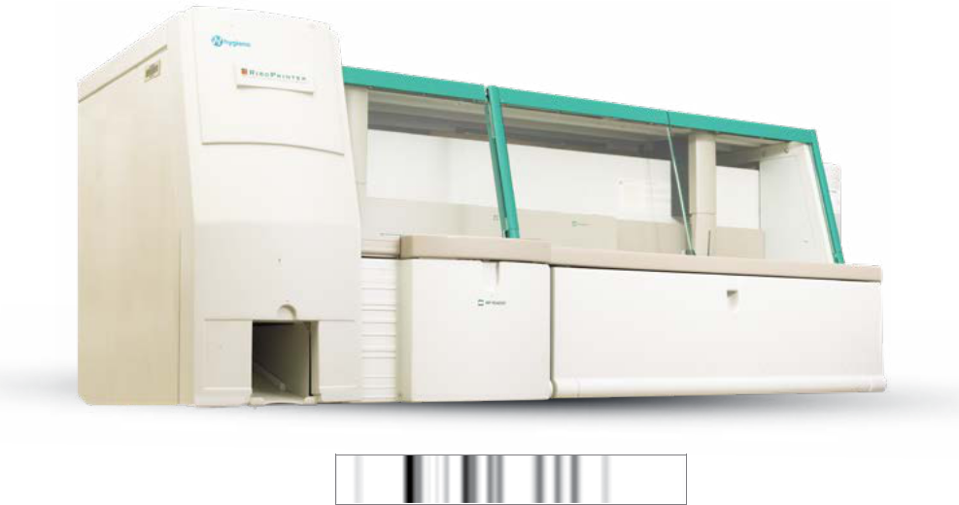

Genetic fingerprints (RiboPrint™ patterns)
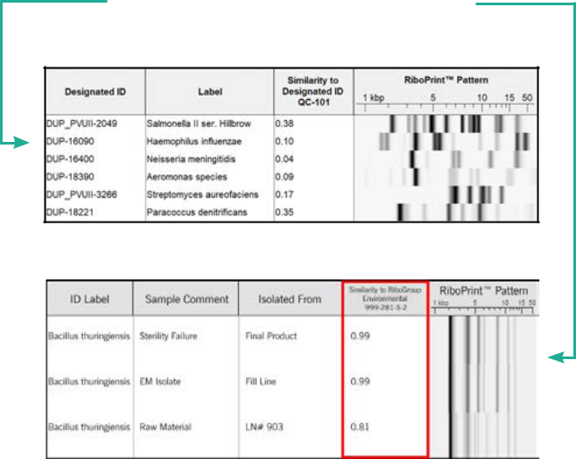
are generated for each sample in 8 hours.

Identification of Genus and Species

Strain Differentiation (Characterization)

Catalog No: ASY2005 | 67

sample collection


Sponge’n Bag is a biocide-free cellulose sponge, supplied in a sterile, leak-proof bag. It provides a simple and convenient way to collect samples from large surface areas.

• Pre-moistened

sample collection

• Leak-proof, tie-off bag
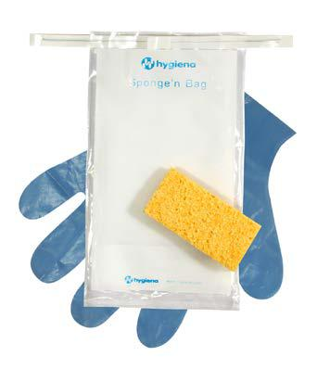

is easy to open

• Optional sterile gloves


Catalog No.

HSB100BPW | QTY: 100 10mL Buffered Peptone Water

HSB100BPWG | QTY: 100
10mL Buffered Peptone Water with gloves

HSB100N | QTY: 100B 10mL Neutralizing Buffer

HSB100NBG | QTY: 100
10mL Neutralizing Buffer with gloves

HSB100LET | QTY: 100
10mL Letheen Broth

HSB100LETG | QTY: 100
10mL Letheen Broth with gloves

68

www.hygiena.com


Stick Sponge is a biocide-free cellulose sponge attached to a plastic handle and supplied in a sterile, leak-proof bag. Stick Sponge allows collection of a sample without directly handling the sponge, making it easier to reach into drains, pipes, and around equipment.

- Pre-moistened sample collection

- Easy-to-release handle

- Optional sterile gloves
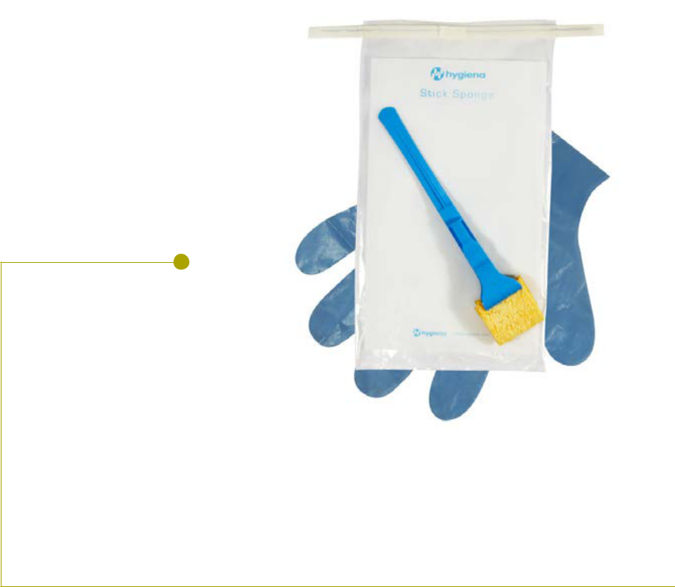

Catalog No.

SS100BPW | QTY: 100
10mL Buffered Peptone Water

SS100BPWG | QTY: 100
10mL Buffered Peptone Water with gloves

SS100NB | QTY: 100 10mL Neutralizing Buffer

SS100NBG | QTY: 100
10mL Neutralizing Buffer with gloves

SS100LET | QTY: 100
10mL Letheen Broth

SS100LETG | QTY: 100
10mL Letheen Broth with gloves

69

accesories

Digital Dry
Block Incubators

The Digital Dry Block Incubator is designed for Hygiena’s variety of test devices. The incubators can be set to any temperature required for Hygiena products, and are capable of up to 105 °C. Interchangeable blocks (sold separately) for the Lab Format Incubator are independently heated, allowing the blocks to be held at different temperatures.

- Auto-stop and sound alerts assist in perfect incubation time

- Flexible configuration accommodates swab test devices or larger tubes

- Heats to maximum temperature in 15 minutes

- Wide, digitally-controlled temperature range (RT+5 °C to 105 °C)

70

www.hygiena.com
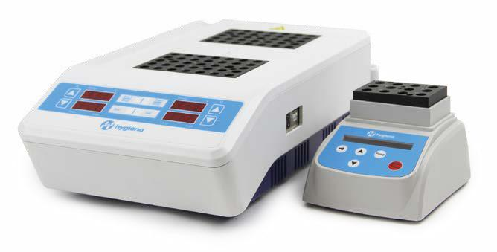

INCUBATOR2 INCUBATOR

Incubators and heat blocks are sold separately
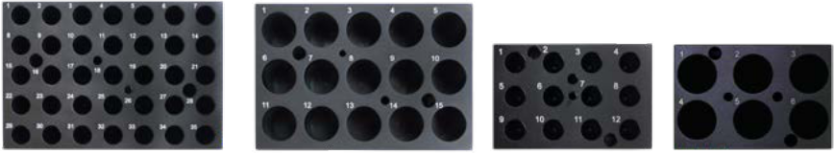

IB001 IB002 IB003 IB004

Catalog No:
INCUBATOR | Small Format Digital Dry Block Incubator
IB003 | 12 Wells Hygiena Swab Tube Block
IB004 | 6 Wells Hygiena Vial Tube Block
INCUBATOR 2 Lab Format Digital Dry Block Incubator
IB001 | 35 Wells Hygiena Swab Tube Block
IB002 | 15 wells Hygiena Vial Tube Block

71

sample collection
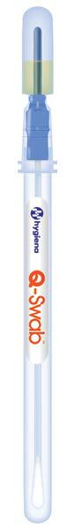

Environmental Sample


Collection Device

Q-Swab is a ready-to-use sample collection and delivery device for surfaces. Simply collect a sample and snap the bulb at the top of the device to release 1 mL of media into the sample.

- Media neutralizes sanitizers

- Available in Letheen and Buffered Peptone Water

- Use on wet or dry surfaces

- Minimize labor and material


Catalog No: QS1000 Buffered Peptone Water | QTY: 250

Catalog No: QS1200 Letheen | QTY: 250

72

www.hygiena.com
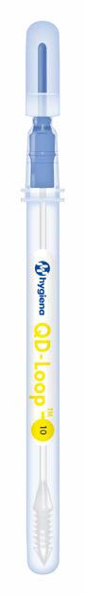


Dilution Device


QD-Loop is a rapid labor-saving system for accurate and convenient volumetric dilutions. The loop or dipper comes attached to a reservoir where our proprietary device design holds 1 mL of Butterfields or Maximum Recovery Diluent (MRD) buffer. Simply break the Snap-Valve after a sample is collected, and immediately a dilution is ready that can be poured onto dry media film or streaked onto an agar plate.

- Available in 1:10, 1:100

or 1:1,000 dilution formats

- Everything you need for easy dilutions
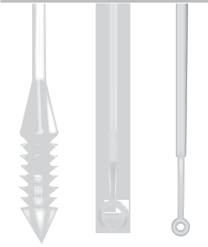

• No buffer preparation or pipettes needed

- Reduces labor and lab equipment expenses

Catalog No: QD0010 1:10 Dilution | QTY: 250

Catalog No: QD0100 1:100 Dilution | QTY: 250

73

Catalog No: QD1000 1:1000 Dilution | QTY: 250

sample collection

Environmental Sample
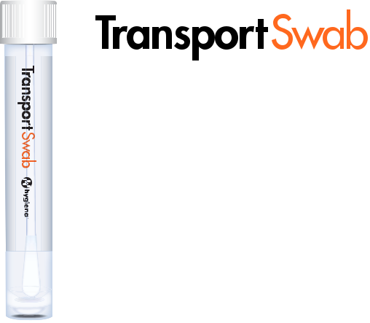

Collection and Dilution

Device

Transport Swab is ideal for collecting environmental samples where multiple tests require larger media volumes. The pre-filled bottles come sterilized and with ample head space for additional sample.

- 4 mL and 10 mL sizes, all with rayon swab

- Easy to swab, recap, test

- Available in Letheen or Buffered Peptone Water

Catalog No: HTS-4 (4mL Letheen Broth) | QTY: 100

Catalog No: HTS-10 (10mL Letheen Broth) | QTY: 100

74 | Catalog No: HTS-10BPW (Buffered Peptone Water) | QTY: 100

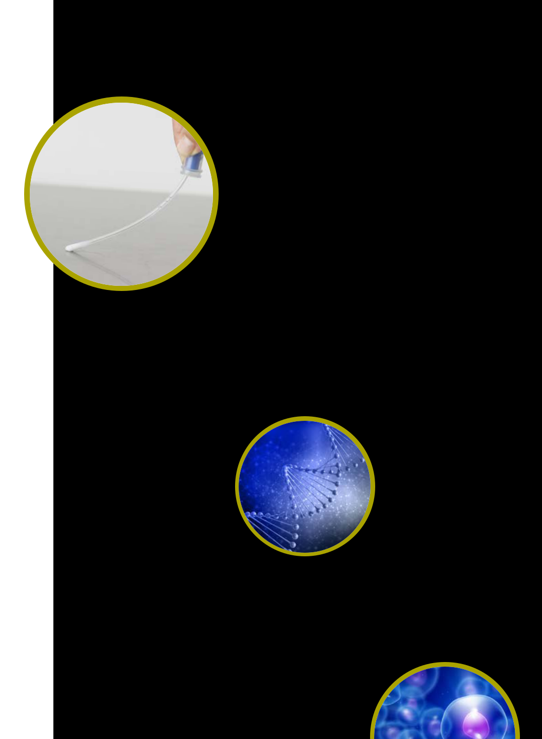
www.hygiena.com

75

accessories

Swab Extenders

Hygiena Swab Extenders easily enable sampling in hard-to-reach test sites like tanks, vents, or hoppers.

- Collapsible, telescoping extension

- Available in two sizes: 48 inches or 13 feet

- Easy-release swab holder

- Compatible with all Hygiena test devices
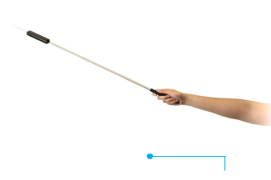

Catalog No: EXT48 or EXT13

76

www.hygiena.com
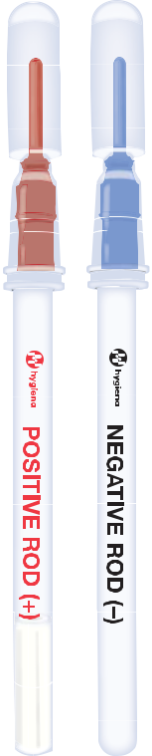

Calibration Control Kit

The Calibration Control Kit allows for on-site luminometer calibration checks, to prove to auditors that your monitoring system is working properly.

• Easy record-keeping

• Measure in Hygiena luminometers

• 5-year shelf life

Catalog No: PCD4000 | QTY: 1 Kit

77

accessories

Positive Control Kit

The Positive Control Kit validates the efficacy and stability of Hygiena ATP test devices. The kit includes known amounts of ATP and sugars validating test device performance.

- Useful for verifying proper temperature storage of test devices

- Contains 25 sealed glass vials

- Compatible with UltraSnap, SnapShot, and SpotCheck Plus
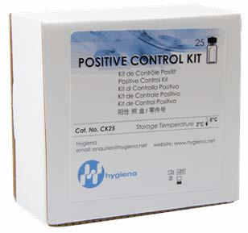


Catalog No: CK25

78

www.hygiena.com


Positive Control Kit

ZymoSnap Positive Control Kit validates the performance of ZymoSnap ALP Pasteurization Verification Tests.

- Each vial contains 350mU/L of ALP

- Includes 5 positive control vials
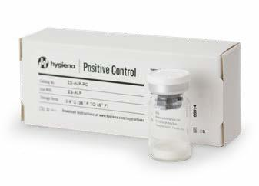

Catalog No: ZS-ALP-PC | QTY: 5 vials

79

accessories

ATP BioMass Kits

The ATP BioMass Kit is a high-precision test for measuring total and free ATP in challenging liquid samples. It is the ideal solution for measuring contamination in process water, wastewater, water tanks, and cooling towers.
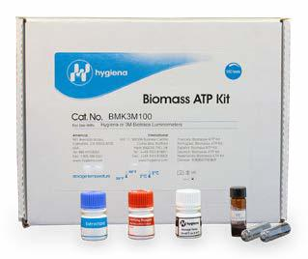

• Kits available for Hygiena and competitor luminometers

Catalog No: CCK4
BioMass Kit for Hygiena Luminometers

Catalog No: BMK3M100 BioMass Kit for 3M or Bio-Trace Luminometers

Catalog No: CCK2
BioMass Kit for Celsis Luminometers

Catalog No: HR001
Hold-Rite Applicator for 3M or Bio-Trace Luminometers

80
80 |  | Catalog No: HR002
 | Hold-Rite Applicator for Hygiena & Celsis Luminometers

www.hygiena.com

ATP Side by Side Comparison Kit

The ATP Side by Side Comparison Kit an objective way to eliminate sampling error and a scientifically based method for comparing surface sampling systems. Just pipette a known amount of ATP onto a testing device and compare results.
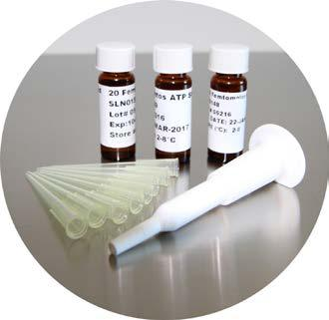

• Objectively compare Hygiena system to a competitor unit

• 3 vials of ATP standards--20, 200, and 2,000 femtomoles

• Easy-to-follow instructions and analysis

Catalog No: SBS-US2020
(Comparison Kit for UltraSnap™ Surface ATP Tests)

Catalog No: SBS-SUS3000
(Comparison Kit for SuperSnap™ High-Sensitivity Surface ATP Tests)

Catalog No: SBS-SPXL1333
(Comparison Kit for SnapShot Universal ATP Tests (3M™)

 |  | 81
Catalog No: SBS-SBC1575 |  | 81
(Comparison Kit for SnapShot Universal ATP Tests (BioControl™)

accessories

Swab Cooler

When you have to transport your test devices or collect samples in above-ideal temperatures, the Hygiena Swab Cooler will ensure your devices are kept cool.
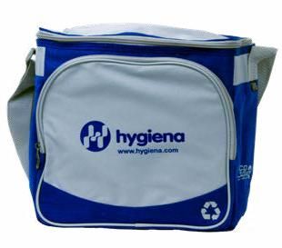

• Vertical side pockets

hold luminometers

• Can hold several bags of Hygiena test devices

• Insulated to keep swabs cool

Catalog No: SSCC03

82


 | Product | Catalog No. | Qty | Page No.
 | EnSURE™ Monitoring System | ENSURE | 1 | 6-7
 | SystemSURE Plus ATP Sanitation Monitoring System | SS3 | 1 | 8-9
 | SystemSURE Plus ATP Cleaning Verification System
 | (for Healthcare) | SS3H | 1 | 8-9
 | UltraSnap™ Surface ATP Test | US2020 | 100 | 12
 | SuperSnap™ High-Sensitivity Surface ATP Test | SUS3000/SUS3000X | 100 | 13, 22
 | AquaSnap™ Total Water ATP Test | AQ-100X | 100 | 14
 | AquaSnap™ Free Water ATP Test | AQ-100FX | 100 | 15
 | WaterShot Total Universal Water ATP Test | W-SPXL1333 | 100 | 16
 | WaterShot Free Universal Water ATP Test | WF-SPXL1333 | 100 | 17
 | SnapShot Universal ATP Test (3M™ Clean-Trace, BioTrace
 | Uni-Lite® NG, Uni-Lite® XCEL, Uni-Lite®, Uni-Lite® NG Junior) | SPXL1333 | 100 | 18
 | SnapShot Universal ATP Test (BioControl Lightning & MVP™) | SBC1517 | 100 | 18
 | SnapShot Universal ATP Test (Celsis® SystemSURE) | SS1211 | 100 | 18
 | SnapShot Universal ATP Test (Merck Hy-Lite®) | SHL1414 | 100 | 18

Product | Catalog No. | Qty | Page No.
AllerSnap™ High-Sensitivity Allergen Prevention Test | ALS-100 | 100 | 20
AllerFlow Gluten Kit | ALF-GL | 25 | 21
Product | Catalog No. | Qty | Page No.
PRO-Clean™ Protein Residue Test | PRO-100 | 100 | 24
SpotCheck Plus Glucose & Lactose Detection Device | GL100 | 100 | 25
MediCheck Protein Residue Test | MDCK-100 | 100 | 26
Product | Catalog No. | Qty | Page No.
CrossCheck ACP Cooking Efficiency Test | CX-3000 | 100 | 28
ZymoSnap ALP Pasteurization Verification Test | ZS-ALP-100 | 100 | 29
Product | Catalog No. | Qty | Page No.
MicroSnap™ E. coli Enrichment Device | MS1-CEC | 100 | 30
MicroSnap™ BAX® Detection Device | MS2-ECOLI | 100 | 30
MicroSnap™ Coliform Enrichment Device | MS1-CEC | 100 | 31
MicroSnap™ Coliform Detection Device | MS2-COLIFORM | 100 | 31
MicroSnap™ EB Enrichment Device | MS1-EB | 100 | 32
MicroSnap™ EB Detection Device | MS2-EB | 100 | 32
MicroSnap™ Enhanced EB Broth | MS1-EB-BROTH-9ML | 100 | 32, 35
MicroSnap™ Total Enrichment Device | MS1-TOTAL | 100 | 33
MicroSnap™ Total Detection Device | MS2-TOTAL | 100 | 33 | 83

MicroSnap™ Enhanced Nutrient Broth | MS1-N-BROTH-9ML | 100 | 33, 34
InSite Listeria Environmental Listeria Species Test | IL050 | 50 | 36
InSite Listeria Environmental Listeria Species Test | IL100 | 100 | 36
Product | Catalog No. | Qty | Page No.
InSite Salmonella Environmental Salmonella Species Test | IS050 | 50 | 38
Lateral Flow System E. coli O157 Test Kit | KIT2028 | 50 | 40-41
Lateral Flow System Listeria Kit | KIT2037 | 45 | 40-41
Lateral Flow System Salmonella Kit | KIT2038 | 50 | 40-41
Product | Catalog No. | Qty | Page No.
BAX® System Q7 Instrument | ASY2018 | 1 | 44-45
BAX® System Q7 PCR Assay for Salmonella | KIT2012 | 96 | 46-47
BAX® System Q7 PCR Assay for Salmonella 2 | KIT2011 | 96 | 46-47
BAX® System Q7 Real-Time PCR Assay for Salmonella | KIT2006 | 96 | 46-47
BAX® System Q7 PCR Assay for Genus Listeria | KIT2016 | 96 | 48-49
BAX® System Q7 PCR Assay for Genus Listeria 24E | KIT2003 | 96 | 48-49
BAX® System Q7 Real-Time PCR Assay for Genus Listeria | KIT2017 | 96 | 48-49
BAX® System Q7 Real-Time PCR Assay for Listeria | KIT2005 | 96 | 50-51
BAX® System Q7 PCR Assay for L. monocytogenes | KIT2017 | 96 | 50-51
BAX® System Q7 PCR Assay for Listeria 24E | KIT2002 | 96 | 50-51
BAX® System Q7 PCR Assay for E. coli O157:H7 MP | KIT2004 | 96 | 52-53
BAX® System Q7 Real-Time PCR Assay for E. coli O157:H7 | KIT2000 | 96 | 52-53
BAX® System Q7 Real-Time PCR Assay for STEC Screening | KIT2021 | 96 | 54-55
BAX® System Q7 Real-Time PCR Assay for STEC Panel 1 | KIT2008 | 48 | 54-55
BAX® System Q7 Real-Time PCR Assay for STEC Panel 2 | KIT2009 | 48 | 54-55
BAX® System Q7 Real-Time PCR Assay for Shigella | KIT2007 | 96 | 56-57
BAX® System Q7 PCR Assay for Cronobacter (E. sakazakii) | KIT2001 | 96 | 56-57
BAX® System Q7 Real-Time PCR Assay for Vibrio
(cholerae, parahaemolyticus, and vulnificus) | KIT2010 | 96 | 56-57
BAX® System Q7 Real-Time PCR Assay for Campylobacter | KIT2018 | 96 | 56-57
BAX® System Real-Time PCR Assay for Staphylococcus aureus | KIT2020 | 96 | 56-57
BAX® System PCR Assay for Yeast and Mold | KIT2015 | 96 | 56-57
BAX® System Listeria Media | MED2002 | 2.5kg | 58-59
BAX® System MP Media | MED2003 | 2.5kg | 58-59
BAX® System StatMedia™ MP media | MED2016 | 100 x 33.75g | 58-59
Hygiena™ Dehydrated Culture Media
(Buffered Peptone Water) (2.5kg) | MED2010 | 2.5kg | 58-59

84

Hygiena™ Dehydrated Culture Media
(Buffered Peptone Water) (500g) | MED2011 | 500g | 58-59
Actero™ Listeria 500g Dehydrated | MED2017 | FCM-011 | 60-61
Actero™ Listeria 2KG Dehydrated | MED2018 | FCM-022/4 | 60-61
Actero™ Listeria (4 x 2kg/ case) Dehydrated | MED2019 | FCM-022 | 60-61
Actero™ Listeria 10 kg Dehydrated | MED2020 | FCM-023 | 60-61
Actero™ MediaBox™ Listeria 5L | MED2021 | FCM-045 | 60-61
Actero™ MediaBox™ Listeria 10L | MED2022 | FCM-046 | 60-61
Actero™ Salmonella 500g Dehydrated | MED2023 | FCM-009 | 60-61
Actero™ MediaBox™ Salmonella 5L | MED2024 | FCM-047 | 60-61
Actero™ MediaBox™ Salmonella 10L | MED2025 | FCM-048 | 60-61
BAX® System X5 Instrument | ASY2018 | 1 | 62-63
BAX® System X5 Assay for Genus Listeria | KIT2024 | 64 | 64-65
BAX® System X5 Assay for L. monocytogenes | KIT2023 | 64 | 64-65
BAX® System X5 Assay for E. coli O157:H7 | KIT2022 | 64 | 64-65
BAX® System X5 Assay for Salmonella | KIT2025 | 64 | 64-65
Product | Catalog No. | Qty | Page No.
RiboPrinter® System | ASY2005 | 1 | 66-67
Product | Catalog No. | Qty | Page No.
Sponge’n Bag 10mL Buffered Peptone Water | HSB100BPW | 100 | 68
Sponge’n Bag 10mL Buffered Peptone Water with gloves | HSB100BPWG | 100 | 68
Sponge’n Bag 10mL Neutralizing Buffer | HSB100N | 100 | 68
Sponge’n Bag 10mL Neutralizing Buffer with gloves | HSB100NBG | 100 | 68
Sponge’n Bag 10mL Letheen Broth | HSB100LET | 100 | 68
Sponge’n Bag 10mL Letheen Broth with gloves | HSB100LETG | 100 | 68
Stick Sponge 10mL Buffered Peptone Water | SS100BPW | 100 | 69
Stick Sponge 10mL Buffered Peptone Water with gloves | SS100BPWG | 100 | 69
Stick Sponge 10mL Neutralizing Buffer | SS100NB | 100 | 69
Stick Sponge 10mL Neutralizing Buffer with gloves | SS100NBG | 100 | 69
Stick Sponge 10mL Letheen Broth | SS100LET | 100 | 69
Stick Sponge 10mL Letheen Broth with gloves | SS100LETG | 100 | 69
Small Format Digital Dry Block Incubator | INCUBATOR | 1 | 70-71
12 Wells Hygiena Swab Tube Block | IB003 | 1 | 70-71
6 Wells Hygiena Swab Tube Block | IB004 | 1 | 70-71
Lab Format Digital Dry Block Incubator | INCUBATOR 2 | 1 | 70-71
35 Wells Hygiena Swab Tube Block | IB001 | 1 | 70-71
15 Wells Hygiena Vial Tube Block | IB002 | 1 | 70-71

85

Q-Swab Environmental Sample Collection Device
Buffered Peptone Water | QS1000 | 250 | 72
Q-Swab Environmental Sample Collection Device Letheen Broth | QS1200 | 250 | 72
QD-Loop Rapid Dilution Device 1:10 Dilution | QD0010 | 250 | 73
QD-Loop Rapid Dilution Device 1:100 Dilution | QD0100 | 250 | 73
QD-Loop Rapid Dilution Device 1:1000 Dilution | QD1000 | 250 | 73
Transport Swab 4mL Letheen Broth | HTS-4 | 100 | 74
Transport Swab 10mL Letheen Broth | HTS-10 | 100 | 74
Transport Swab Buffered Peptone Water | HTS-10BPW | 100 | 74
Product | Catalog No. | Qty | Page No.
Swab Extender 48” | EXT48 | 1 | 76
Swab Extender 13’ | EXT13 | 1 | 76
Calibration Control Kit | PCD4000 | 1 | 77
Positive Control Kit | CK25 | 25 | 78
ZymoSnap Positive Control Kit | ZS-ALP-PC | 5 | 79
ATP BioMass Kit for Hygiena Luminometers | CCK4 | 1 | 80
ATP BioMass Kit for 3M™ or Bio-Trace Luminometers | BMK3M100 | 1 | 80
ATP Bio Mass Kit for Celsis Luminometers | CCK2 | 1 | 80
Hold-Rite Applicator for Hygiena & Celsis Luminometers | HR002 | 1 | 80
Hold-Rite Applicator for 3M™ or Bio-Trace Luminometers | HR001 | 1 | 80
ATP Side by Side Comparison Kit for UltraSnap™
Surface ATP Tests | SBS-US2020 | 1 | 81
ATP Side by Side Comparison Kit for SuperSnap™
High-Sensitivity Surface ATP Tests | SBS-SUS3000 | 1 | 81
ATP Side by Side Comparison Kit for SnapShot™
Universal ATP Tests (3M™) | SBS-SPXL1333 | 1 | 81
ATP Side by Side Comparison Kit for SnapShot™
Universal ATP Tests (BioControl™) | SBS-SBC1575 | 1 | 81
Swab Cooler | SSCC03 | 1 | 82

86

Notes

87

Notes

88

Notes

89

Notes

90

Notes

© Hygiena 2018, AllerSnap™ High-Sensitivity Allergen Prevention Test, AquaSnap™ Total Water ATP Test, AquaSnap™ Free Water ATP Test, BAX® System, EnSURE™ Monitoring System, Hygiena™, MicroSnap™, PRO-Clean™ Protein Residue Test, Qualicon™, RiboPrinter® System, StatMedia™ Soluble Packets, SuperSnap™ High-Sensitivity Surface 91 ATP Test, and UltraSnap™ Surface ATP Test are registered trademarks of Hygiena LLC.


941 Avenida Acaso

Camarillo, CA 93012

www.hygiena.com

 @hygienausa

MPB-022 Rev. A

