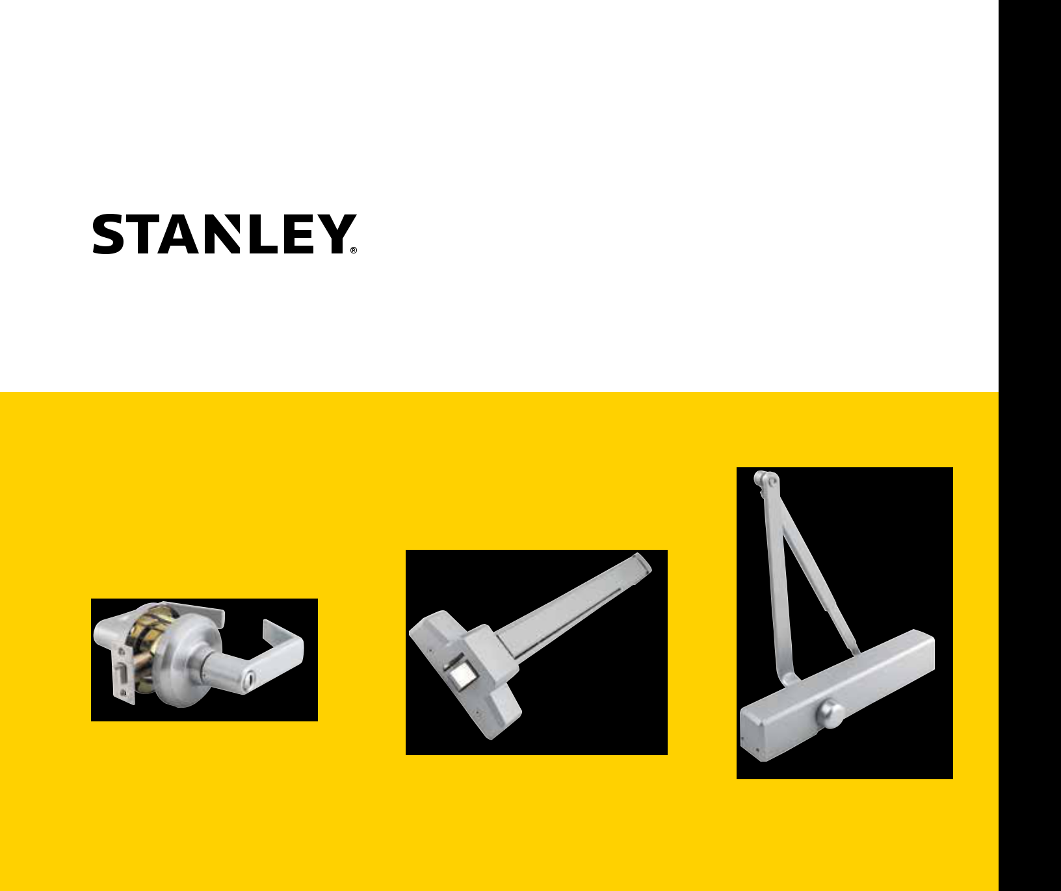
STANLEY COMMERCIAL HARDWARE

Full Line Catalog

STANLEY Commercial Hardware


Trusted experts. Proven reliability. Simply STANLEY.

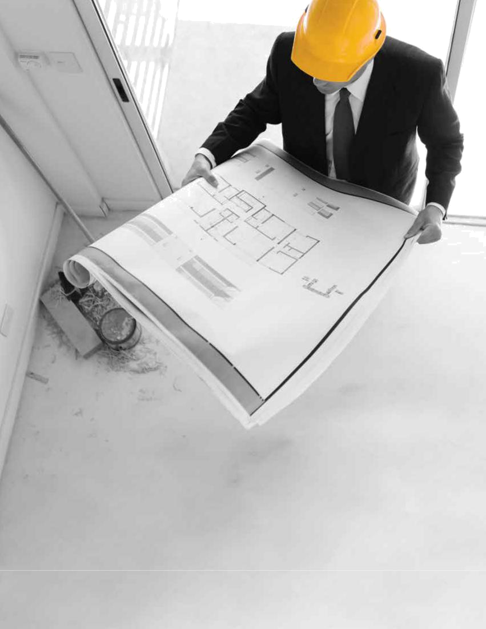

When trust is earned, confidence is secured.

Backed by the strength and trust of our brand, Stanley Commercial Hardware products are designed to fit a variety of commercial applications. The door hardware in retail, banks, multi-family housing, assisted living facilities and other commercial buildings all have constant traffic that need to withstand continuous use and abuse.

The Stanley Commercial Hardware line of mechanical locks, exits, and closers delivers quality and durability at a mid-price point value. We’re easy to do business with, shipping all of our products from a single location and providing the industry’s best lead times. And most importantly, we ensure that trust is always built-in. Trust in the reliable performance our products provide, and in the heritage of the Stanley brand.

Security solutions are among your most important decisions. Make a choice in which you can have total confidence: Stanley Commercial Hardware.
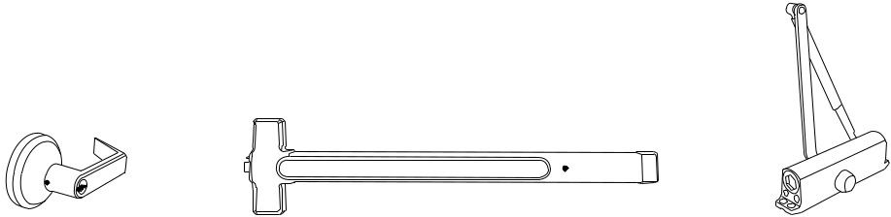

Trusted experts. Proven reliability. Simply STANLEY.

Vertical Markets

Stanley Commercial Hardware products are an ideal fit for a variety of commercial applications and include the following market segments:

Multi-Family/Multi-Use | Medical Office Buildings (MOB)
Retail/Strip Malls | Industrial
Commercial Office Buildings | Banking
Assisted Living/Nursing Homes | Other Commercial

Table Of Contents

Intro 2

Vertical Markets 4

Spec Writing Services 6

Warranty 7

Mechanical Locks 8

Mortise Locks – Grade 1 9

QMS100 – Sectional

QME100 – Escutcheon

QML100 – Deadlock

Cylindrical Locks – Grade 1 15

QCL100 Series

Cylindrical Locks – Grade 2 19

QCL200 Series

Interconnected Locks – Grade 2 22

QCI200 Series

Tubular Locks – Grade 2 25

QTL200 Series

Auxiliary Deadbolts – Grade 1 28

QDB100 Series

Auxiliary Deadbolts – Grade 2 31

QDB200 Series

Keys and Cores 34

Exit Devices 36

Heavy-Duty – Grade 1 37

QED100 Series

QRM100 Series

QET100 Series

Heavy-Duty Narrow Stile – Grade 1 48

QED200 Series

QET200 Series

Standard-Duty – Grade 1 56

QED300 Series

QRM300 Series

QET300 Series

Standard-Duty – Grade 1 65

QRT300 Series

Door Closers 67

Extra Heavy-Duty – Grade 1 68

QDC100 Series

Heavy-Duty – Grade 1 71

QDC200 Series

Standard-Duty – Grade 1 74

QDC300 Series

Miscellaneous 77

Windstorm- & Hurricane-Compliance 78

Competitive Cross-Reference 80

Full Line Catalog STANLEY Commercial Hardware 5

Spec Writing Services

What does the Spec Writing Services division do?

Our staff of Architectural Hardware Consultants (AHC), Application Engineers, and security experts specialize in specification writing, owner specification manual drafting, section coordination, shop drawing and submittal review, and continuing education (American Institute of Architects – Continuing Education Systems).


Our expertise covers many specification sections including the following:

- 08 42 29Automatic Entrances

- 08 42 33Revolving Door Entrances

- 08 42 36Balanced Door Entrances

- 08 42 43ICU/CCU Entrances

- 08 71 00Door Hardware

- 08 71 13Automatic Door Operators

- 08 74 00Access Control Hardware

- 27 52 13Patient Monitoring & Telemetry Systems

- 27 52 23Nurse Call / Code Blue Systems

- 28 13 00Access Control

- 28 16 00Intrusion Detection

- 28 23 00Video Surveillance

- 28 46 00Electronic Detention Monitoring

  - Control Systems

From project review to system design and construction administration, we are equipped to provide the support to accurately and effectively assist you every step of the way with your project's architectural hardware, automatic entrance, and security system requirements.

For more information on how we can assist you, call our office to get in contact with an Architectural Construction Representative near you.

1-855-365-2407

- Full Line Catalog STANLEY Commercial Hardware

Warranty

Limited Lifetime Mechanical Warranty

3-Year Finish Warranty

1-Year Electrical Warranty

This product comes with a limited lifetime mechanical warranty and a three-year finish warranty to the original user of the Stanley Commercial Hardware product against defects in material and workmanship as long as the original user occupies/manages the premises upon which the product was originally installed. The warranty DOES NOT COVER scratches; abrasions; deterioration due to the use of paints, solvents and other chemicals; abuse; or misuse, and DOES NOT COVER US10B/613 “Oil Rubbed Bronze” finish as it is a “Living Finish” and a change in appearance is the natural characteristic of the finish. This warranty DOES NOT COVER 6CS and 7CS products as they have a 3-year warranty from the date of sale. This warranty DOES NOT COVER defects caused by improper installation or field modification. This warranty DOES NOT COVER the cost incurred in removing and installing

a replacement product. Upon return of a defective product, dormakaba may repair or replace the product or refund the purchase price. dormakaba is not liable for incidental or consequential damages. Some states do not allow the exclusion or limitation of incidental or consequential damages, so this may not apply to you. This warranty gives you specific legal rights and you may also have other rights that vary from state to state. If a mechanical or finish defect occurs, please call dormakaba at:

Product Support

6161 E. 75th Street

Indianapolis, IN 46250

1-855-365-2407

Full Line Catalog STANLEY Commercial Hardware 7

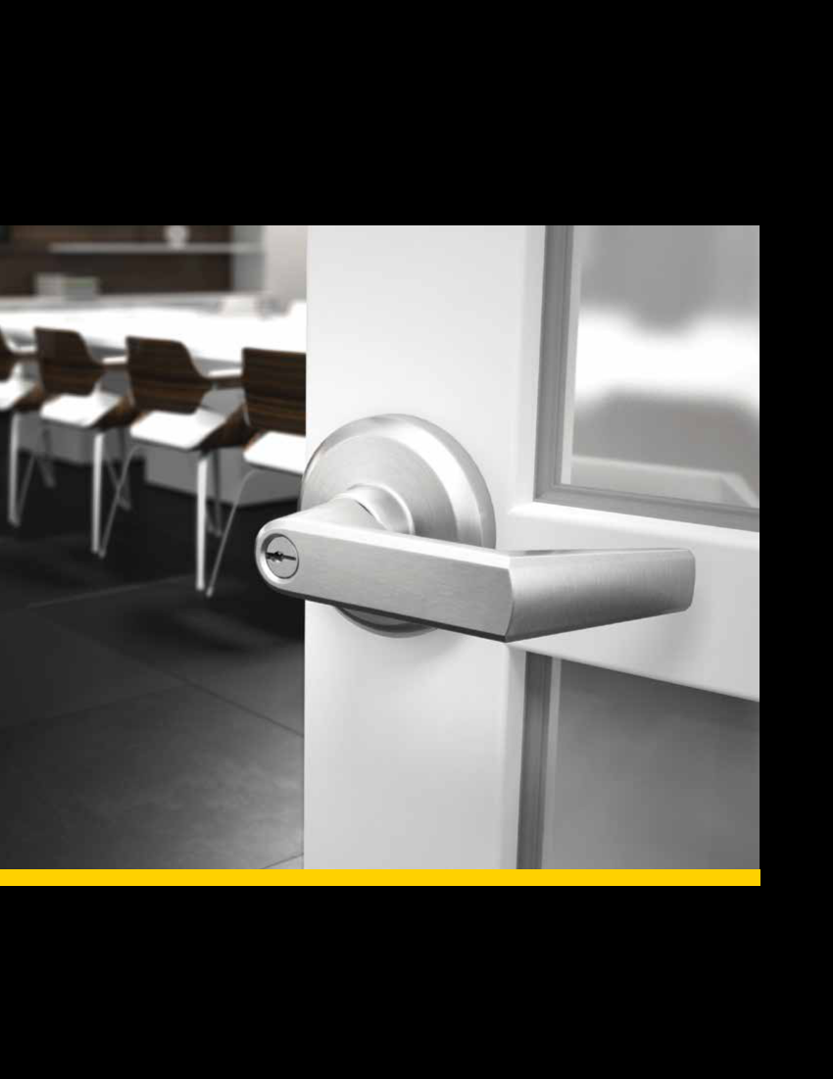
Mechanical Locks

QMS/QME 100 Series: Grade 1 Heavy-Duty Mortise Locks

Performance Features
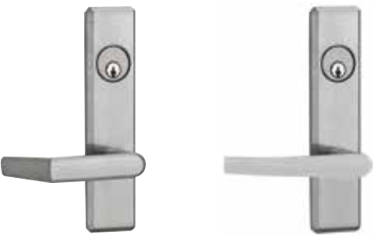

• Tested to meet Grade 1 specification of 1,000,000 cycles.

• Clutching mechanism standard.

• Thru-bolt design and heavy-duty spring tension provides longer performance life and prevents lever sag.

• ADA-compliant thumbturn.

• Mortise case is easily field reversible.

• Pre-assembled trims with spring-loaded spindles automatically adjust to

 | door thickness and reduce installation time.
• | Partial security separator prevents spindle manipulation. | Escutcheon Sierra (E) | Escutcheon Slate (A)
• | Anti-friction throwbolt. | Escutcheon Sierra (E) | Escutcheon Slate (A)
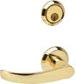

Certifications

- ANSI/BHMA A156.13 – Grade 1

- UL/cUL listed (3 hours) for “A” label single-door applications (4' x 8') (1.219m x 2.438m)

- UL10C/UBC 7-2 (1997) Positive Pressure Rated

- UL10B Pressure Rated

- ADA-Compliant ANSI A117.1 Accessibility Code

- California State Reference Code (formerly Title 19 – Fire Marshal)


Product Specifications

- Template – 3 5⁄8" (92mm).

- Solid forged brass trim construction.

- Dual 8mm spindles.

- 1" (25.4mm) stainless steel deadbolt.

- Floating mounting tabs adjust to door bevel.

- Toggle button locking.

- Heavy gauge steel armor faceplate.

- Door thickness

–Sectional: 1 3⁄4" - 2" (44.5mm-51mm) standard; (57mm) optional

–Escutcheon: 1 3⁄4" - 2 1⁄4" (44.5mm-57mm) standard

Keying

- 6-pin or 5-pin cylinders. Many keying options available from our factory to include, but not limited to, master keying, grand master keying, and construction keying.

- 2 keys per lockset.

- Offered with the following keyway options: BF-BEST "F" SFIC, KW-Kwikset, WE-Weiser, SC-Schlage, GA-Yale, LA-Sargent, & LC-Less Cylinder.
Consult factory for other cylinder options.

Warranty

- Lifetime Mechanical, 3-year finish*, 1-year electrical

*(613/US10B carries no finish warranty)

Sectional Summit (M)

Functions

ANSI | Series | Description
— | QMS/QME120 | Single Dummy
— | QMS/QME122 | Full Dummy
F01 | QMS/QME130 | Passage
F22 | QMS/QME140 | Privacy
F19 | QMS/QME145 | Privacy w/ Deadbolt
F04 | QMS/QME150 | Entry
F13 | QMS/QME152 | Exit
F20 | QMS/QME154 | Corridor
F11 | QMS/QME158 | Dormitory
F05 | QMS/QME160 | Classroom
F32 | QMS/QME162 | Classroom Security
F09 | QMS/QME164 | Apartment
F07 | QMS/QME170 | Storeroom
F30 | QMS/QME172 | Institutional
F14 | QMS/QME174 | Store Door

Finishes

BHMA | US | Description
605 | US3 | Bright Brass
613 | US10B | Oil Rubbed Bronze
619 | US15 | Satin Nickel
625 | US26 | Bright Chrome
626 | US26D | Satin Chrome

MECHANICAL LOCKS

Full Line Catalog STANLEY Commercial Hardware | 9

MECHANICAL LOCKS
QMS/QME 100 Series: Grade 1 Heavy-Duty Mortise Locks
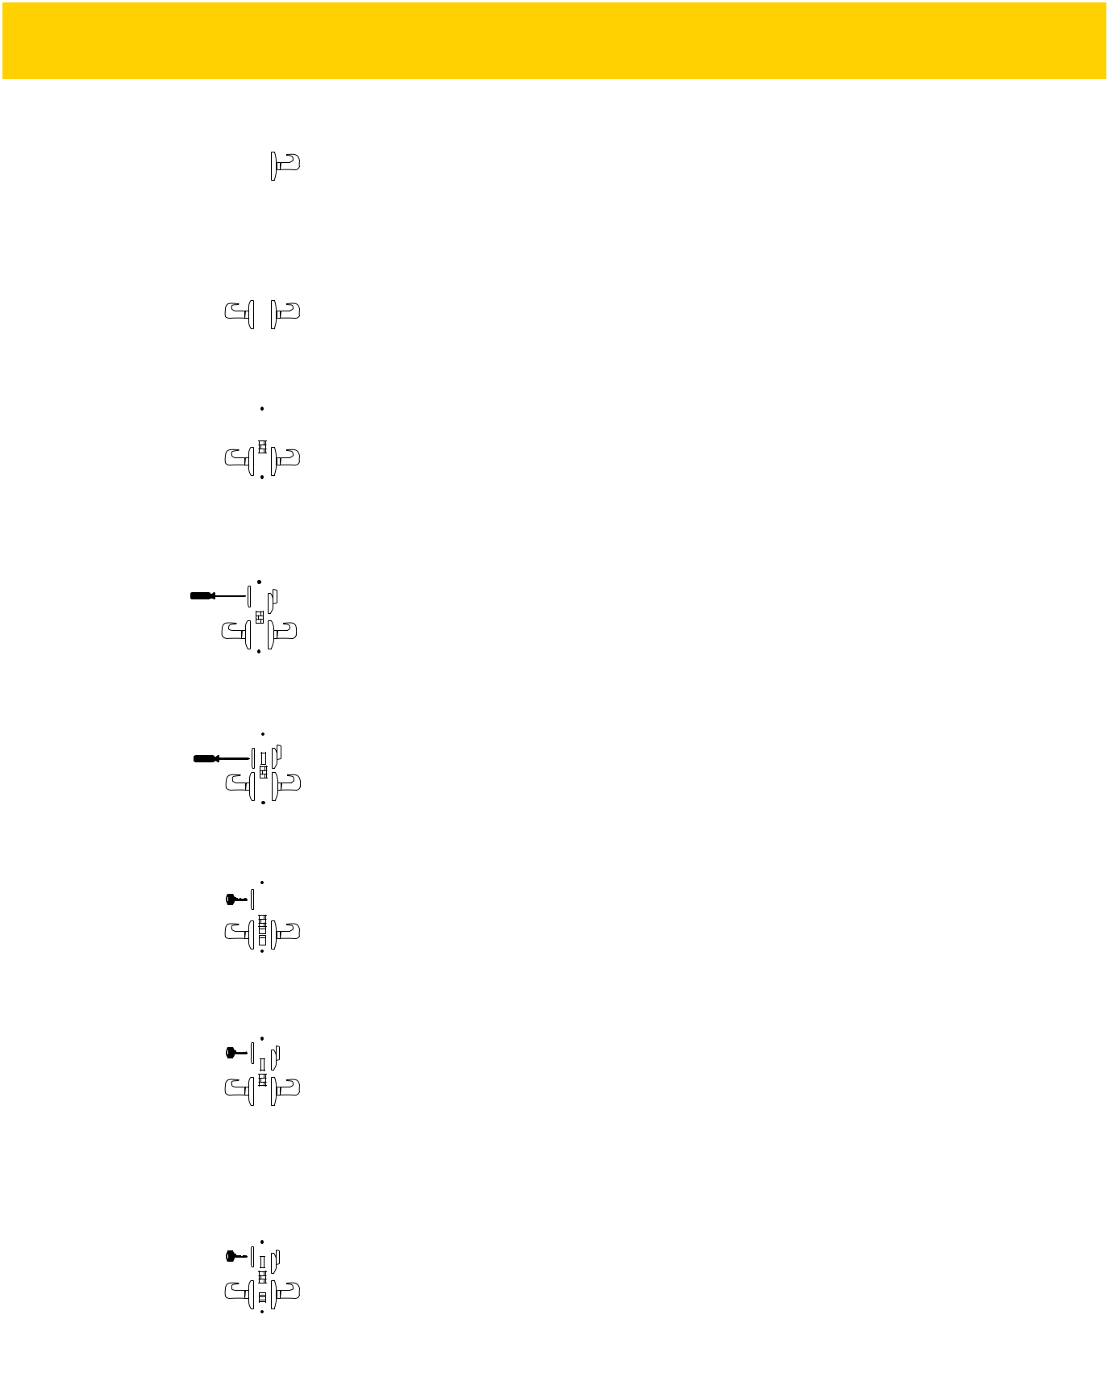

Functions | ANSI |  |  |  |  | Description | Latch | Deadbolt | Auxiliary | Toggle | Cylinders | Case
Functions | ANSI |  |  |  |  | Description | Bolt |  |  |  |  | Qty
 |  |  |  |  |  | Lever trim on one side
QMS/ |  |  |  |  |  | (no mortise case).
QME120 | — |  |  |  |  |  |  |  |  |  |  | 4
Single Dummy
 |  |  |  |  |  | Lever trim on both sides
QMS/ |  |  |  |  |  | (no mortise case).
QME122 | — |  |  |  |  |  |  |  |  |  |  | 4
Full Dummy
 |  |  |  |  |  | Latch bolt operated by lever from
QMS/ |  |  |  |  |  | either side at all times.
QME130 | F01 |  |  |  |  |  | X |  |  |  |  | 4
Passage
 |  |  |  |  |  | Latch bolt operated by lever from
 |  |  |  |  |  | either side except when outside
QMS/ |  |  |  |  |  | lever is locked by inside trim or
QME140 | F22 |  |  |  |  | button. Operating inside lever, | X |  |  |  |  | 4
QME140 | F22 |  |  |  |  | closing door or operating outside | X |  |  |  |  | 4
Privacy |  |  |  |  |  | emergency release (accessible
 |  |  |  |  |  | under emergency cap) unlocks
 |  |  |  |  |  | outside lever.
 |  |  |  |  |  | Latch bolt operated by lever from
QMS/ |  |  |  |  |  | either side. Deadbolt operated by
QMS/ |  |  |  |  |  | turn from inside and emergency
QME145 | F19 |  |  |  |  | release from outside (accessible | X | X |  |  |  | 4
Privacy w/ | F19 |  |  |  |  | under emergency cap). Operating | X | X |  |  |  | 4
Privacy w/ |  |  |  |  |  | inside lever retracts both bolts.
Deadbolt |  |  |  |  |  | inside lever retracts both bolts.
 |  |  |  |  |  | Latch bolt operated by lever
 |  |  |  |  |  | from either side except when
QMS/ |  |  |  |  |  | outside lever is made inoperative
QME150 | F04 |  |  |  |  | by toggle. When outside lever is | X |  | X | X | Sgl | 4
QME150 | F04 |  |  |  |  | locked, latch bolt is retracted by | X
Entry |  |  |  |  |  | key from outside or by operating
 |  |  |  |  |  | inside lever. Auxiliary dead latch
 |  |  |  |  |  | deadlocks latch bolt.
 |  |  |  |  |  | Latch bolt operated by lever from
 |  |  |  |  |  | either side. Deadbolt is projected
QMS/ |  |  |  |  |  | by key from outside and turn
QME152 | F13 |  |  |  |  | piece from inside. Operating | X | X |  |  | Sgl | 4
QME152 | F13 |  |  |  |  | inside lever retracts both bolts and | X | X |  |  | Sgl | 4
Exit |  |  |  |  |  | unlocks outside.
 |  |  |  |  |  | Latch bolt operated by lever from
 |  |  |  |  |  | either side, except when outside
 |  |  |  |  |  | lever is made inoperative by
 |  |  |  |  |  | toggle. Deadbolt operated by key
QMS/ |  |  |  |  |  | outside or turn inside. Key outside
QMS/ |  |  |  |  |  | operates both bolts. Operating
QME154 | F20 |  |  |  |  | inside lever retracts both bolts | X | X |  | X | Sgl | 4
Corridor |  |  |  |  |  | and outside remains locked. Latch
Corridor |  |  |  |  |  | bolt is deadlocked when outside
 |  |  |  |  |  | lever is made inoperative or when
 |  |  |  |  |  | the deadbolt is projected. When
 |  |  |  |  |  | deadbolt is retracted, lever is
 |  |  |  |  |  | unlocked by toggle.

- Full Line Catalog STANLEY Commercial Hardware

QMS/QME 100 Series: Grade 1 Heavy-Duty Mortise Locks
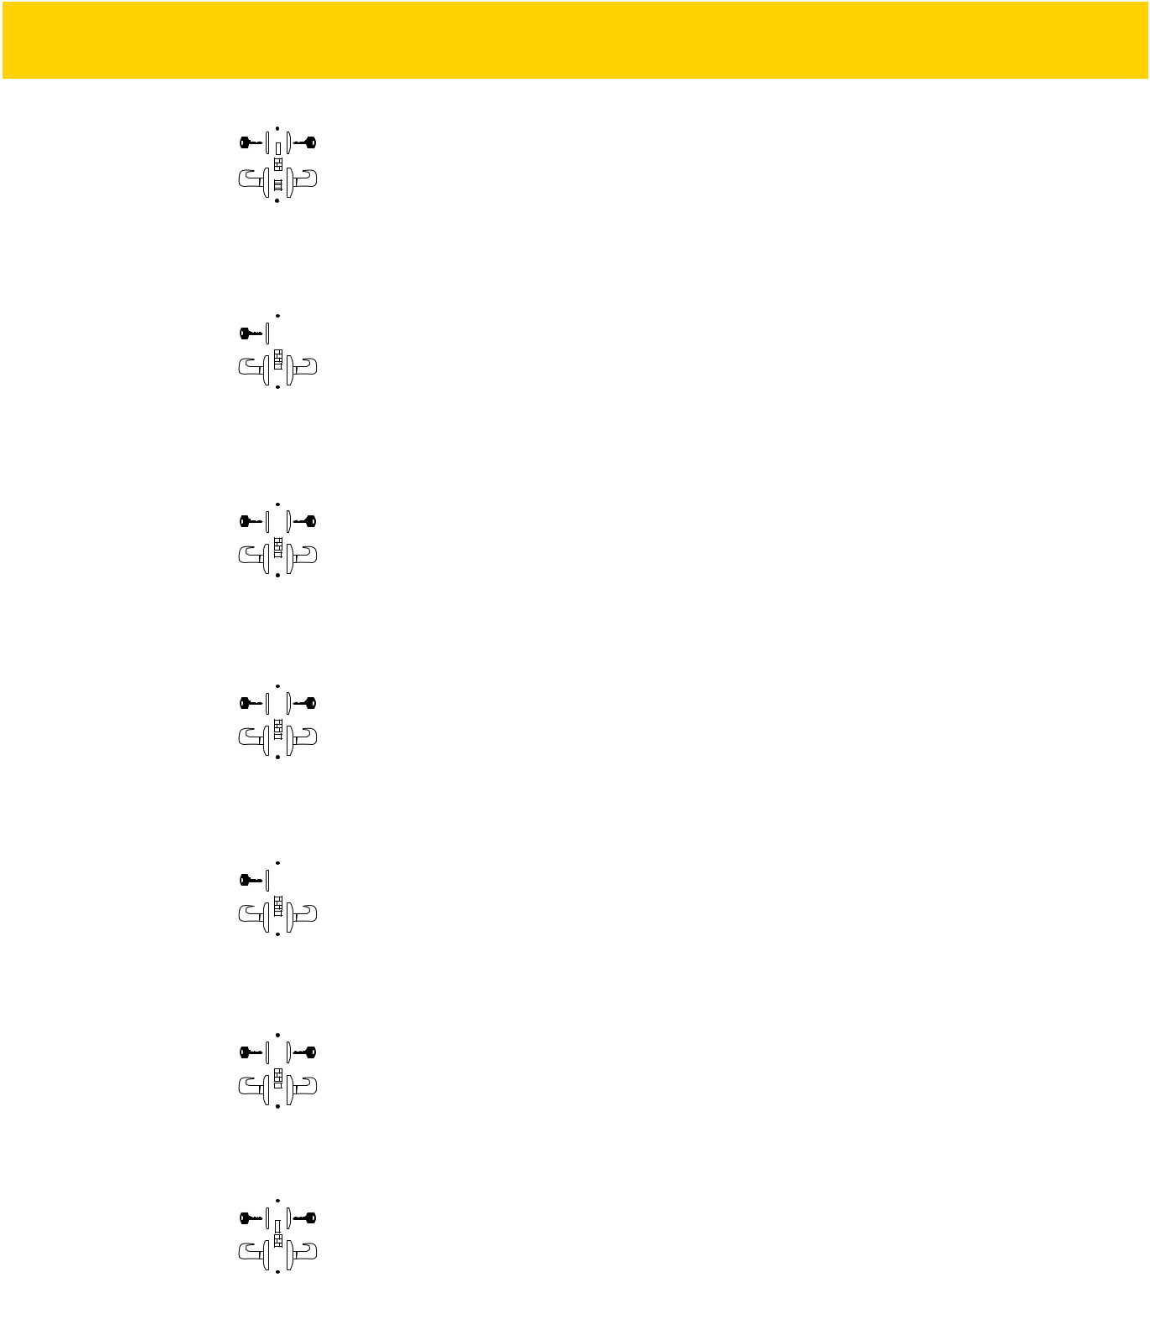

Functions | ANSI |  |  |  | Description | Latch | Deadbolt | Auxiliary | Toggle | Cylinders | Case
Functions | ANSI |  |  |  | Description | Bolt |  |  |  |  | Qty
 |  |  |  |  | Latch bolt operated by lever from
 |  |  |  |  | either side except when outside
QMS/ |  |  |  |  | lever is made inoperative
QMS/ |  |  |  |  | by toggle. Deadbolt projected by
QME158 | F11 |  |  |  | key from either side. Deadbolt | X | X |  | X | Dbl | 4
Dormitory |  |  |  |  | retracted by key from outside.
Dormitory |  |  |  |  | Both bolts retracted by inside
 |  |  |  |  | lever and outside remain locked.
 |  |  |  |  | Latch bolt operated by lever from
 |  |  |  |  | either side except when outside
QMS/ |  |  |  |  | lever is made inoperative
QMS/ |  |  |  |  | by key from outside. Inside lever
QME160 | F05 |  |  |  | always operative. Auxiliary dead | X |  | X |  | Sgl | 4
Classroom |  |  |  |  | latch deadlocks latch bolt.
 |  |  |  |  | Latch bolt operated by lever
 |  |  |  |  | from either side except when
QMS/ |  |  |  |  | outside lever is locked from
QMS/ |  |  |  |  | inside or outside by key. When
QME162 | F32 |  |  |  | outside lever is locked, latch | X |  | X |  | Dbl | 4
Classroom | F32 |  |  |  | bolt is retracted by key from | X |  | X |  | Dbl | 4
Classroom |  |  |  |  | inside or outside or by operating
Security |  |  |  |  | inside or outside or by operating
Security |  |  |  |  | inside lever. Auxiliary dead latch
 |  |  |  |  | deadlocks latch bolt.
 |  |  |  |  | Latch bolt operated by lever from
 |  |  |  |  | either side, except when outside
QMS/ |  |  |  |  | lever is locked by key from inside.
QMS/ |  |  |  |  | When outside lever is locked,
QME164 | F09 |  |  |  | latch bolt is retracted by key | X |  | X |  | Dbl | 4
Apartment |  |  |  |  | from outside or by operating
Apartment |  |  |  |  | inside lever. Auxiliary dead latch
 |  |  |  |  | deadlocks latch bolt.
 |  |  |  |  | Latch bolt operated by key from
 |  |  |  |  | outside or by operating inside
QMS/ |  |  |  |  | lever. Outside lever is always
QMS/ |  |  |  |  | inoperative. Auxiliary dead latch
QME170 | F07 |  |  |  | deadlocks latch bolt. | X |  | X |  | Sgl | 4
Storeroom
 |  |  |  |  | Latch bolt operated by key from
 |  |  |  |  | either side. Both levers always
QMS/ |  |  |  |  | inoperative. Auxiliary dead latch
QMS/ |  |  |  |  | deadlocks latch bolt.
QME172 | F30 |  |  |  |  | X |  | X |  | Dbl | 4
Institutional
 |  |  |  |  | Latch bolt operated by lever from
 |  |  |  |  | either side. Deadbolt operated by
QMS/ |  |  |  |  | key from either side.
QME174 | F14 |  |  |  |  | X | X |  |  | Dbl | 4
Store Door

MECHANICAL LOCKS

Full Line Catalog STANLEY Commercial Hardware 11

How to Order

QMS/QME 100 Series: Grade 1 Heavy-Duty Mortise Locks

MECHANICAL LOCKS

Example

If you ordered: QME160 E626 KW6 KD

You would get: Grade 1 Classroom Mortise Lock, Sierra Lever Escutcheon Trim, Satin Chrome, Kwikset Keyway, Keyed Different.
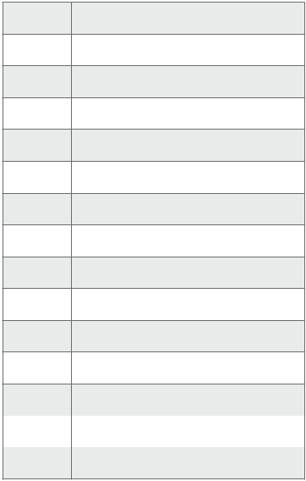

- Single Dummy

- Full Dummy

- Passage

- Privacy

- Privacy w/ Deadbolt

- Entry

- Exit

- Corridor

- Dormitory

- Classroom

- Classroom Security

- Apartment

70 | Storeroom |  | E | Sierra
 |  |  | M | Summit
72 | Institutional |  | M | Summit
 |  |  | A | Slate
74 | Store Door |  | A | Slate

KD | Keyed Different
KA | Keyed Alike
SK | Special Keying
 | -Construction Keyed
 | -Construction Master Keyed
 | -Maison Keyed
 | -Master Keyed
 | -Grand Master Keyed
 | -Great Grand Master Keyed
ZB | Zero Bitted
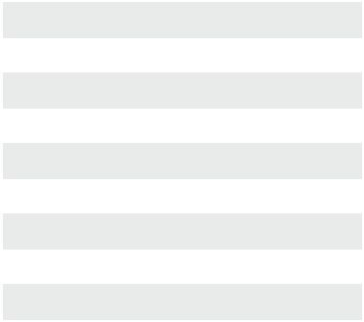

 |  |  |  |  |  |  |  | Base Part Number
 |  | Series |  |  | Function |  |  | Design |  | Finish |  |  |  |  | Keyway |  |  | # of Pins | Keying
 |  | QME1 |  |  | 60 |  |  | E |  | 626 |  |  |  |  | KW |  |  | 6 | KD
Escutcheon Trim |  | QME1 |  |  |  | 605 |  | Bright Brass |  |  |  |  |  |  | BF |  | BEST "F" SFIC
Sectional Trim |  | QMS1 |  |  |  |  |  |  |  |  |  |  |  |  | KW |  | Kwikset “KW”
 |  |  |  |  |  | 613 |  | Oil Rubbed Bronze
 |  |  |  |  |  | 613 |  |  |  |  |  |  |  |  | WE |  | Weiser “E”
 |  |  |  |  |  | 619 |  | Satin Nickel
 |  |  |  |  |  |  |  |  |  |  |  |  |  |  | SC |  | Schlage “C”
 |  |  |  |  |  | 625 |  | Bright Chrome
 |  |  |  |  |  |  |  |  |  |  |  |  |  |  | GA |  | Yale “GA”
 |  |  |  |  |  | 626 |  | Satin Chrome |  |  |  |  |  |  | LA |  | Sargent “LA”
 |  |  |  |  |  |  |  |  |  |  |  |  |  |  | LC |  | Less Cylinder


- Full Line Catalog STANLEY Commercial Hardware

QML 100 Series: Grade 1 Heavy-Duty Mortise Deadlocks
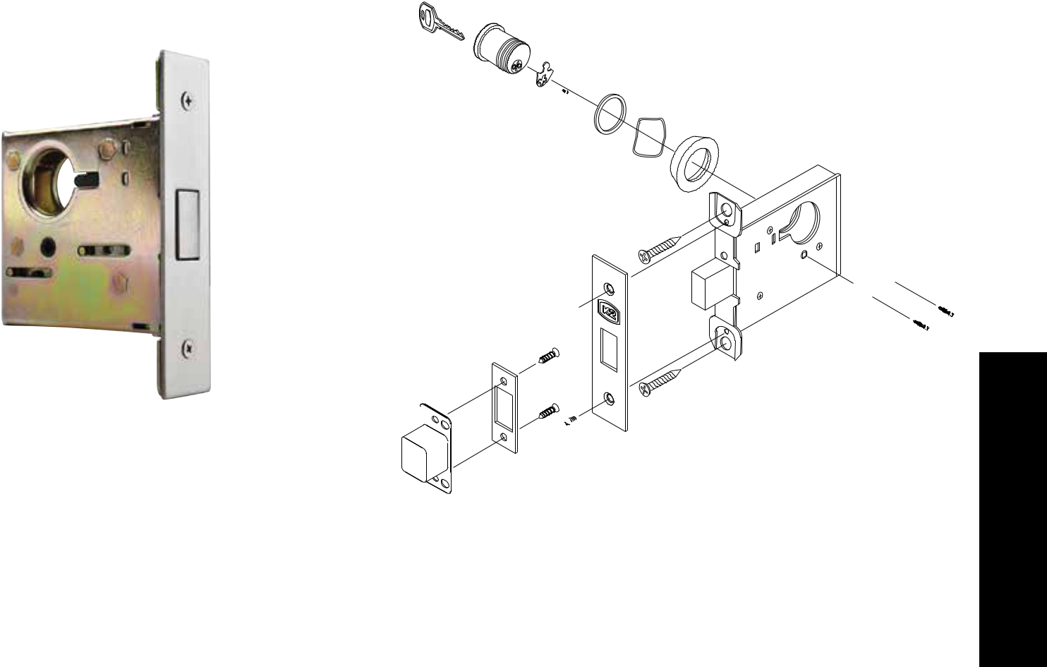

Functions | ANSI | Description | Case Qty
QML180 | E06071 | Deadbolt operated by key from outside and | 10
Single Cylinder | E06071 | by turn from inside. | 10
QML182 | E06061 | Deadbolt operated by key from either side. | 10
Double Cylinder | E06061 | Deadbolt operated by key from either side. | 10
QML184 | E06061 | Deadbolt operated by key from one side only. | 10
Cylinder Only | E06061 | Deadbolt operated by key from one side only. | 10
QML186 | E06061 | Deadbolt operated by key from outside. Turn on inside retracts | 10
Classroom* | E06061 | but does not project the deadbolt. | 10

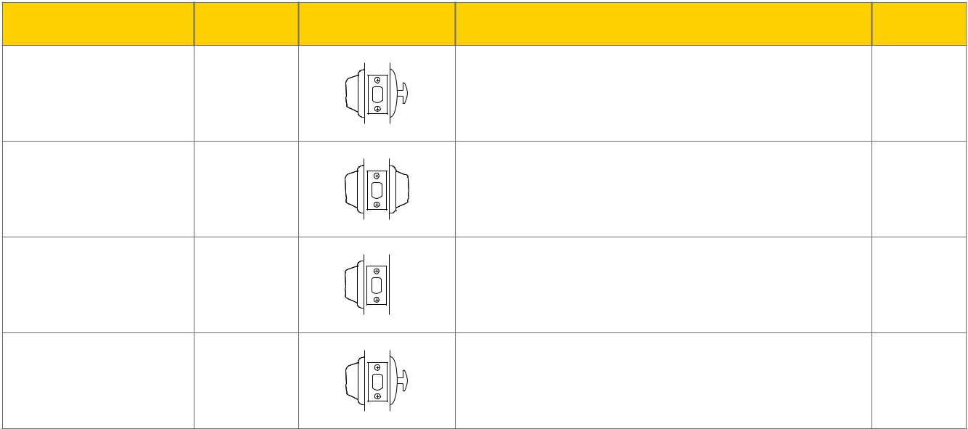

MECHANICAL LOCKS

NOTES: Consult factory for lead times on 605, 619 & 625 finishes.

*Classroom function requires handed cylinder turn. Specify handing when ordering.

Full Line Catalog STANLEY Commercial Hardware 13

How to Order

QML 100 Series: Grade 1 Heavy-Duty Mortise Deadlocks

Example

If you ordered: QML186 626 RH KW6 KD

You would get: Grade 1 Classroom Mortise Lock, Satin Chrome,

Right-Hand, Kwikset Keyway, Keyed Different.
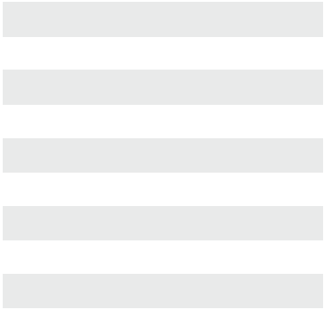

LOCKS

- Single Cylinder

- Double Cylinder

- Cylinder Only

- Classroom


KD | Keyed Different
KA | Keyed Alike
SK | Special Keying
 | -Construction Keyed
 | -Construction Master Keyed
 | -Maison Keyed
 | -Master Keyed
 | -Grand Master Keyed
 | -Great Grand Master Keyed
ZB | Zero Bitted

MECHANICAL

Base Part Number

Series | Function | Finish | Handing* | Keyway | # of Pins | Keying
QML1 | 86 | 626 | RH | KW | 6 | KD
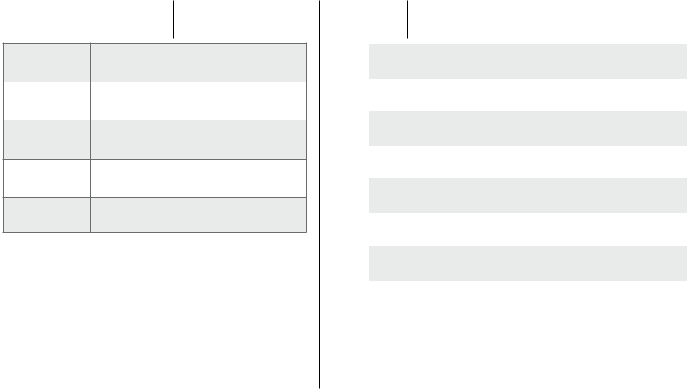

605 | Bright Brass
613 | Oil Rubbed Bronze
619 | Satin Nickel

- Bright Chrome

- Satin Chrome

BF | BEST "F" SFIC
KW | Kwikset “KW”
WE | Weiser “E”
SC | Schlage “C”
GA | Yale “GA”
LA | Sargent “LA”
LC | Less Cylinder
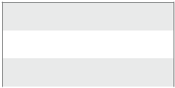

QML186 Only*

RH | Right Hand
LH | Left Hand

NOTES: Consult factory for lead times on 605, 619 & 625 finishes.

*Classroom function requires handed cylinder turn. Specify handing when ordering.

- Full Line Catalog STANLEY Commercial Hardware

QCL 100 Series: Grade 1 Heavy-Duty Cylindrical Locks

Performance Features
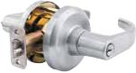

- Tested to meet Grade 1 specification of 800,000 cycles.

- Standard clutching mechanism provides resistance to damage caused by physical force.

- Thru-bolt design and heavy-duty spring tension provides longer performance life and prevents lever sag.
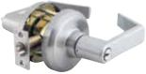
• Concealed mounting screws. _{Sierra (E)} Summit (M)

- Compartmentalized packaging allows for quick and easy installation.
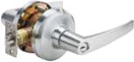

Certifications

- ANSI/BHMA A156.2 Series – Grade 1

- ANSI A117.1 Accessibility Code (ADA Compliant)

- UL/cUL Listed (3 hours) for “A” label single-door applications (4' x 8') (1.219m x 2.438m)

- UL10C/UBC 7-2 (1997) Positive Pressure Rated

- UL10B Pressure Rated

- California State Reference Code (formerly Title 19 – Fire Marshal)

- Hurricane Compliant – Miami-DADE N.O.A. See page 78 for more details.

Product Specifications

- Handing – All QCL100 Series Levers Locksets are non-handed.

- Door thickness – 1 3⁄8" - 2" (35mm-51mm) standard.

- Backset – 2 3⁄4" (70mm) square standard. 2 3⁄8" and 5" (60mm, 127mm) available.

- Exposed trim – Pressure cast zinc, plated to match finish designation.

- Strike – ANSI Strike 1 1⁄4" x 4 7⁄8" (32mm x 124mm) standard. Other strike options also available.

- Door prep – 2 1⁄8" (54mm) diameter cross bore.

- Latch bolt – Keyed/Exterior 1⁄2" (12.7mm) steel throw; Interior 1⁄2" (12.7mm) spring latch.

- Latch faceplate – 1 1⁄8" x 2 1⁄4" (29mm x 57mm) standard.

- Single dummy is surface mounted.

- Electrification options available.

Keying

- 6-pin non-IC brass cylinders. 6 or 7 pin SFIC option available. Many keying options available from our factory to include, but not limited to, master keying, grand master keying and construction keying.

- 2 keys per lockset.

- Offered with the following keyway options: BF-BEST "F" SFIC, KW-Kwikset, WE-Weiser, SC-Schlage, GA-Yale, LA-Sargent, & LC-Less Cylinder. Consult factory for other cylinder options.

Warranty

- Lifetime Mechanical, 3-year finish,* and 1-year electrical

*(613/US10B carries no finish warranty)

Slate (A)

Functions

ANSI | Series | Description
— | QCL120 | Single Dummy
F75 | QCL130 | Passage
F111 | QCL135 | Communicating
F76 | QCL140 | Privacy
F109 | QCL150 | Entry/Office
F109 | QCL151 | Entry/Office SFIC
F90 | QCL154 | Corridor
F90 | QCL155 | Corridor SFIC
F84 | QCL160 | Classroom
F84 | QCL161 | Classroom SFIC
F110 | QCL168 | Classroom Security
F110 | QCL169 | Classroom Security SFIC
F86 | QCL170 | Storeroom
F86 | QCL171 | Storeroom SFIC
— | QCL192 | Electronically Locked
— | QCL193 | Electronically Locked SFIC
— | QCL194 | Electronically Unlocked
— | QCL195 | Electronically Unlocked SFIC

Finishes
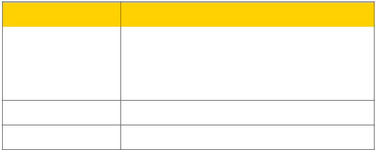

BHMA | Description
605 | Bright Brass
613 | Oil Rubbed Bronze
619 | Satin Nickel

- Bright Chrome

- Satin Chrome

Full Line Catalog STANLEY Commercial Hardware | 15

MECHANICAL LOCKS

MECHANICAL LOCKS
QCL 100 Series: Grade 1 Heavy-Duty Cylindrical Locks

 |  |  |  | A
 |  |  | B
 |  |  |  | D
 |  |  |  | C
 |  |  |  | Dimensions
 |  |  | A | B | C | D
 |  | Sierra | 4.895" | 2.985" | 3.543" | .407"
 |  |  | 124.32mm | 75.82mm | 90mm | 10.34mm
 |  | Summit | 4.929" | 3.034" | 3.543" | .407"
QCL150 |  |  | 125.20mm | 77.06mm | 90mm | 10.34mm
QCL150 |  | Slate | 4.937" | 2.993" | 3.543" | .407"
Sierra
 |  |  | 125.40mm | 76mm | 90mm | 10.34mm
Functions | ANSI | Description |  |  |  | Case Qty
QCL120 | — | Dummy trim for one side of door. Used for door pull or as matching inactive trim. No |  |  |  | 12
Single Dummy | — | mechanical operation. Surface-mounted single dummy trim. |  |  |  | 12
QCL130 | F75 | Both levers always unlocked and always free for immediate ingress & egress. |  |  |  | 6
Passage | F75 |  |  |  |  | 6
QCL135 | F111 | Blank plate outside. Inside lever always unlocked and always free. |  |  |  | 6
Communicating | F111 |  |  |  |  | 6
QCL140 |  | Push-button locking. Can be opened from outside with a small screwdriver. Turning
QCL140 | F76 | inside lever or closing door releases button. Inside lever is always free for immediate |  |  |  | 6
Privacy | F76 | egress. Clutch feature disengages outside lever from latch when locked to prevent |  |  |  | 6
 |  | vandalism.
 |  | Turn/push-button locking; pushing and turning button locks outside lever, requiring
QCL150/151 | F109 | use of key until button is manually unlocked. Push-button locking; pushing button |  |  |  | 6
Entry/Office | F109 | locks outside lever until unlocked by key or by depressing inside lever. Clutch feature |  |  |  | 6
Entry/Office |  | disengages outside lever from latch when locked to prevent vandalism. Inside lever is
 |  | always free for immediate egress.
QCL154/155 |  | Deadlocking latch bolt operates by lever from either side except when outside
QCL154/155 | F90 | lever is locked by key in outside lever, or by push-button on inside. Key in outside |  |  |  | 6
Corridor | F90 | lever locks or unlocks outside lever. Operating inside lever releases push-button. |  |  |  | 6
 |  | Closing door releases push-button. Inside lever always operates latch bolt.
QCL160/161 | F84 | Key required to either lock or unlock outside lever. Inside lever is always unlocked and |  |  |  | 6
Classroom | F84 | free for immediate egress. Clutch feature disengages outside lever from latch when |  |  |  | 6
Classroom |  | locked to prevent vandalism.sdf
QCL168/169 | F110 | Key in either lever required to lock or unlock outside lever. |  |  |  | 6
Classroom Security | F110 | Inside lever is always unlocked for immediate egress. |  |  |  | 6
QCL170/171 | F86 | Outside lever always locked. Entrance by key only. Inside lever unlocked and free for |  |  |  | 6
Storeroom | F86 | immediate egress. Clutch feature disengages outside lever from latch when locked to |  |  |  | 6
Storeroom |  | prevent vandalism.
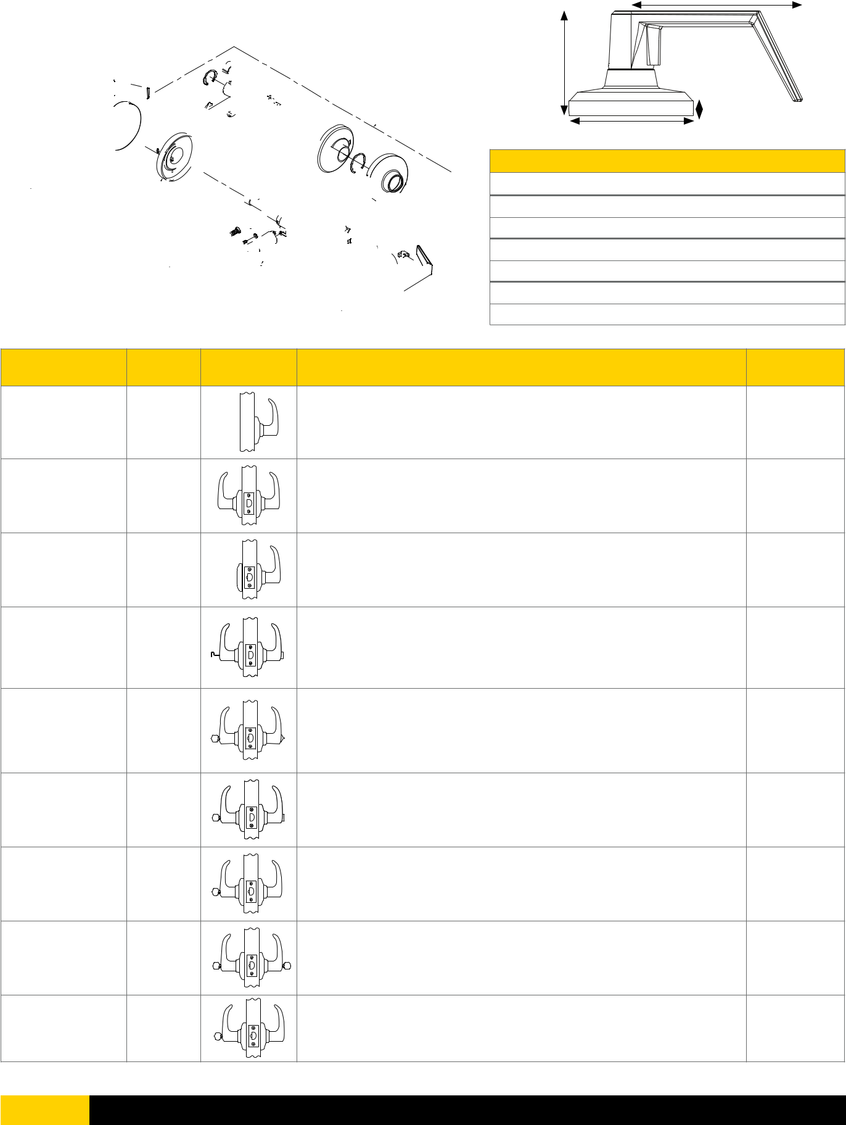

- Full Line Catalog STANLEY Commercial Hardware

QCL 100 Series: Grade 1 Heavy-Duty Cylindrical Locks

Electrified Options (Consult Factory For Lead Times)


Model # | Description

QCL192 | Electronically locked (fail safe). Outside lever continuously locked electrically. Unlocked by key outside, by switch, or by power failure.
QCL193 (SFIC) | Inside always free for immediate egress.
QCL194 | Electronically unlocked (fail secure). Outside lever continuously locked until unlocked by
QCL195 (SFIC) | key or electric current. Inside always free for immediate egress.
QCL170—X | Request to exit. Switch monitors inside lever rotation. Incorporates into alarm systems or
QCL171—X (SFIC) | in conjunction with an electromagnet.
QCL192—X
 | Electronically locked (fail safe) with request to exit. Outside lever continuously locked electrically. Unlocked by key outside, by switch, or by
QCL193—X (SCFIC) | power failure. Inside always free for immediate egress. Ability to tie into alarm systems.
QCL194—X
 | Electronically unlocked (fail secure) with request to exit. Outside lever continuously locked until unlocked by key or electric current.
QCL195—X (SCFIC) | Inside always free for immediate egress. Ability to tie into alarm systems.
8Q00314 | Fail Safe / Fail Secure 24VDC Power Supply

MECHANICAL LOCKS

Electrified Product Specifications

- Consult factory for lead times.

- Electrification prices should be added to list price of lock.

- Standard door prep.

- Deadlocking latch.

- Key override allows key to retract latch bolt momentarily on electronically locked models.

- Inside lever always free for immediate egress.

- Continuous duty solenoids.

- Tie into alarm systems and electromagnetic locks.

- 12V AC/DC with .250 AMP current.

24V AC/DC with .150 AMP current.

- Specify voltage when ordering.

- Lifetime warranty on lock body; 1-year warranty on electric components.

- Uses power supply 8Q00314.

- Warranty: 1-year electrical.
Power Supply Specifications

- Consult factory for lead times.

- Provides power for fail safe or fail secure locking devices.

- UL listed, US & Canada, Class 2.

- Filtered and regulated 24DC constant voltage.

- 2 AMP load capacity.

- Over voltage/short-circuit protection.

- Surge suppression for locking devices.

- Interface relay to isolate the locking device current from the control switch.

- Auxiliary 24V DC constant voltage for powering stand-alone devices such as keypads, motion detectors, status indicators, etc.

- Field terminal block set at 45° for ease of installation.

- Can power up to twelve 24V cylindrical fail safe/ fail secure levers – refer to installation manual for additional details.

Example

If you ordered: QCL192 E626 S4 478S KW5 KA 24V X 625

You would get: Grade 1 Electronically Locked Cylindrical Lock, Sierra Lever, Satin Chrome x Bright Chrome, 2 3/4" Dead Latch Square, ANSI 4 7⁄8" x 1 1/4" Strike, Kwikset Keyway, Keyed Alike.

With options: 24-Volt Power and Request to Exit

Full Line Catalog STANLEY Commercial Hardware 17

How to Order
QCL 100 Series: Grade 1 Heavy-Duty Cylindrical Locks

Example

If you ordered: QCL170 E626 S4 478S F6 KA H

You would get: Grade 1 Hurricane Compliant Cylindrical Storeroom Lock, Sierra Lever,

Satin Chrome, 2 3⁄4" Dead Latch Square, ANSI 47⁄8" x 11⁄4" Strike, Standard “F” Keyway, Keyed Alike.
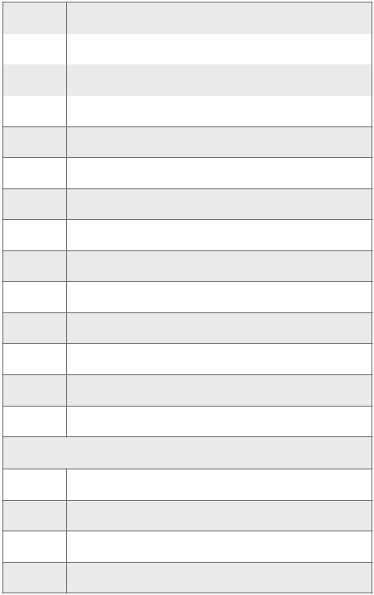

MECHANICAL LOCKS

20 | Single Dummy
30 | Passage
35 | Communicating
40 | Privacy

- Entry/Office

- Entry/Office SFIC

- Corridor

- Corridor SFIC

- Classroom

- Classroom SFIC

- Classroom Security

- Classroom Security SFIC

- Storeroom

- Storeroom SFIC

Added Functions (New)

- Electronically Locked (fail safe)

- Electronically Locked SFIC (fail safe)

- Electronically Unlocked (fail secure)

- Electronically Unlocked SFIC (fail secure)


 |  |  | BF | BEST "F" SFIC
 |  |  | KW | Kwikset “KW”
605 | Bright Brass |  | WE | Weiser “E”
613 | Oil Rubbed Bronze
613 | Oil Rubbed Bronze |  | SC | Schlage “C”
619 | Satin Nickel
619 | Satin Nickel |  | GA | Yale “GA”
625 | Bright Chrome
625 | Bright Chrome |  | LA | Sargent “LA”
 |  |  |  |  |  | 24V | 24 Volt AC/DC
626 | Satin Chrome |  | LC | Less Cylinder
626 | Satin Chrome |  | LC | Less Cylinder |  | 12V | 12 Volt AC/DC


 |  |  |  |  |  |  | Base Part Number |  |  |  |  |  |  |  |  |  |  |  |  |  |  |  |  |  |  |  | Additional Options
Series |  | Function |  | Design |  | Finish |  |  | Latch |  |  | Strike |  |  |  | Keyway | # Of Pins |  |  | Keying |  |  |  |  |  | Hurricane |  | Power |  |  | Request To |  |  | 2nd Finish
Series |  | Function |  |  |  |  |  |  |  |  |  |  |  |  |  | Keyway |  |  |  |  |  |  |  |  |  | Compliant |  |  |  |  |  |  | Exit
QCL1 |  | 71 |  | E |  | 626 |  |  | S4 |  |  | 478S |  |  |  | F | 6 |  |  |  | KA |  |  |  |  | H |  | — |  |  |  |  | — | —
 |  | E | Sierra |  |  |  |  |  |  |  |  |  | 478S |  |  | ANSI 4 7⁄8" x 11⁄4" Strike |  |  |  |  |  |  |  |  |  |  |  |  | 625 |  |  |  | Bright Chrome
 |  |  |  |  |  |  |  |  |  |  |  |  | 118F |  |  | ANSI 11⁄8" x 21⁄4" Strike
 |  | M | Summit
 |  | A | Slate
 |  |  |  |  |  |  | QD1 Latch Table (New) |  |  |  |  |  |  |  |  |  |  |  |  |  | KD |  |  |  |  | Keyed Different
 |  |  |  |  |  |  | FR4 |  | Fire-Rated Radius 2-3/4 |  |  |  |  |  |  |  |  |  |  |  | KA |  |  |  |  | Keyed Alike
 |  |  |  |  |  |  | FS4 |  | Fire-Rated Square 2-3/4 |  |  |  |  |  |  |  |  |  |  |  | SK |  |  |  |  | Special Keying
 |  |  |  |  |  |  | NOL |  | No Latch |  |  |  |  |  |  |  |  |  |  |  |  |  |  |  |  | -Construction Keyed
 |  |  |  |  |  |  | R4 |  | Radius 2-3/4 |  |  |  |  |  |  |  |  |  |  |  |  |  |  |  |  | -Construction Master Keyed
 |  |  |  |  |  |  | R8 |  | Radius 2-3/8 |  |  |  |  |  |  |  |  |  |  |  |  |  |  |  |  | -Maison Keyed
 |  |  |  |  |  |  | S4 |  | Square 2-3/4 |  |  |  |  |  |  |  |  |  |  |  |  |  |  |  |  | -Master Keyed
 |  |  |  |  |  |  | S5 |  | Square 5 |  |  |  |  |  |  |  |  |  |  |  |  |  |  |  |  | -Grand Master Keyed
 |  |  |  |  |  |  | S8 |  | Square 2-3/8 |  |  |  |  |  |  |  |  |  |  |  |  |  |  |  |  | -Great Grand Master Keyed
 |  |  |  |  |  |  |  |  |  |  |  |  |  |  |  |  |  |  |  |  | ZB |  |  |  |  | Zero Bitted



- Full Line Catalog STANLEY Commercial Hardware

QCL 200 Series: Grade 2 Standard-Duty Cylindrical Locks

Performance Features

- Tested to meet Grade 2 specification of 400,000 cycles.

- Standard clutching mechanism provides resistance to damage caused by physical force.

- Thru-bolt design and heavy-duty spring tension provides longer performance life and prevents lever sag.

- Concealed mounting screws.

- Compartmentalized packaging allows for quick and easy installation.

Certifications

- ANSI/BHMA A156.2 Series – Grade 2

- ANSI A117.1 Accessibility Code (ADA Compliant)

- UL/cUL Listed (3 hours) for “A” label single-door applications (4' x 8') (1.219m x 2.438m)

- UL10C/UBC 7-2 (1997) Positive Pressure Rated

- UL10B Pressure Rated

- California State Reference Code (formerly Title 19 – Fire Marshal)

- Hurricane Compliant – Miami-DADE N.O.A. See page 78 for more details.

Sierra (E)
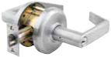
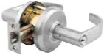

Summit (M)
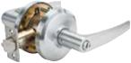

Slate (A)

Product Specifications

- Handing – All QCL200 Series Levers Locksets are non-handed.

- Door thickness – 1 3/8" - 2" (35mm-51mm) standard.

- Backset – 2 3⁄4" (70mm) square standard.

2 3⁄8" and 5" (60mm, 127mm) available.

- Exposed trim – Pressure cast zinc, plated to match finish designation.

- Strike – ANSI Strike 1 1⁄4" x 4 7⁄8" (32mm x 124mm) standard. Other strike options also available.

- Door prep – 2 1⁄8" (54mm) diameter cross bore.

- Latch bolt – Keyed/Exterior 1⁄2" (12.7mm) steel throw; Interior 1⁄2" (12.7mm) spring latch.

- Latch faceplate – 1 1⁄8" x 2 1⁄4" (29mm x 57 mm) standard.

Keying

- 6-pin non-IC brass cylinders. 6 or 7 pin SFIC option available. Many keying options available from our factory to include, but not limited to, master keying, grand master keying and construction keying.

- 2 keys per lockset.

- Offered with the following keyway options: BF-BEST "F" SFIC, KW-Kwikset, WE-Weiser, SC-Schlage, GA-Yale, LA-Sargent, & LC-Less Cylinder. Consult factory for other cylinder options.

Warranty

- Lifetime Mechanical and 3-year finish*

*(613/US10B carries no finish warranty)

Functions

ANSI | Series | Description
— | QCL220 | Single Dummy
F75 | QCL230 | Passage
F111 | QCL235 | Communicating
F76 | QCL240 | Privacy
F109 | QCL250 | Entry/Office
F109 | QCL251 | Entry/Office SFIC
F90 | QCL254 | Corridor
F90 | QCL255 | Corridor SFIC
F84 | QCL260 | Classroom
F84 | QCL261 | Classroom SFIC
F86 | QCL270 | Storeroom
F86 | QCL271 | Storeroom SFIC

Finishes
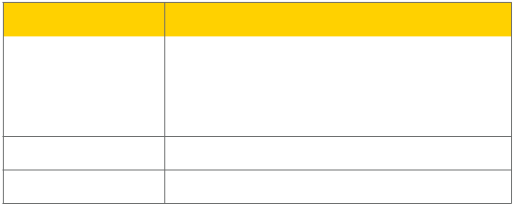

BHMA | Description
605 | Bright Brass
613 | Oil Rubbed Bronze
619 | Satin Nickel

- Bright Chrome

- Satin Chrome

Full Line Catalog STANLEY Commercial Hardware |  | 19
MECHANICAL LOCKS

QCL 200 Series: Grade 2 Standard-Duty Cylindrical Locks

MECHANICAL LOCKS

QCL250
Sierra

 | A |  | Dimensions
 | A |  | A | B | C | D
 |  | Sierra | 4.451" | 2.6" | 3.366" | .269"
B |  |  | 113.06mm | 66.04mm | 85.50mm | 6.84mm
B |  | Summit | 4.533" | 2.744" | 3.366" | .269"
 |  |  | 115.14mm | 69.70mm | 85.50mm | 6.84mm
 | D | Slate | 4.535" | 2.87" | 3.366" | .269"
 | C |  | 115.20mm | 72.90mm | 85.50mm | 6.84mm
Functions | ANSI | Description |  |  |  | Case Qty
QCL220 | — | Dummy trim for one side of door. Used for door pull or as matching inactive trim. No |  |  |  | 12
Single Dummy | — | mechanical operation. Surface-mounted single dummy trim. |  |  |  | 12
QCL230 | F75 | Both levers always unlocked and always free for immediate ingress & egress. |  |  |  | 6
Passage | F75 |  |  |  |  | 6
QCL235 | F111 | Blank plate outside. Inside lever always unlocked and always free. |  |  |  | 6
Communicating | F111 |  |  |  |  | 6
QCL240 |  | Push-button locking. Can be opened from outside with a small screwdriver. Turning
QCL240 | F76 | inside lever or closing door releases button. Inside lever is always free for immediate |  |  |  | 6
Privacy | F76 | egress. Clutch feature disengages outside lever from latch when locked to prevent |  |  |  | 6
 |  | vandalism.
 |  | Turn/push-button locking; pushing and turning button locks outside lever, requiring
QCL250/251 | F109 | use of key until button is manually unlocked. Push-button locking; pushing button |  |  |  | 6
Entry/Office | F109 | locks outside lever until unlocked by key or by depressing inside lever. Clutch feature |  |  |  | 6
Entry/Office |  | disengages outside lever from latch when locked to prevent vandalism. Inside lever is
 |  | always free for immediate egress.
QCL254/255 |  | Deadlocking latch bolt operates by lever from either side except when outside lever is
QCL254/255 | F90 | locked by key in outside lever or by push-button on inside. Key in outside lever locks |  |  |  | 6
Corridor | F90 | or unlocks outside lever. Operating inside lever releases push-button. Closing door |  |  |  | 6
 |  | releases push-button. Inside lever always operates latch bolt.
QCL260/261 | F84 | Key required to either lock or unlock outside lever. Inside lever is always unlocked and |  |  |  | 6
Classroom | F84 | free for immediate egress. Clutch feature disengages outside lever from latch when |  |  |  | 6
Classroom |  | locked to prevent vandalism.
QCL270/271 | F86 | Outside lever always locked. Entrance by key only. Inside lever unlocked and free for |  |  |  | 6
Storeroom | F86 | immediate egress. Clutch feature disengages outside lever from latch when locked to |  |  |  | 6
Storeroom |  | prevent vandalism.

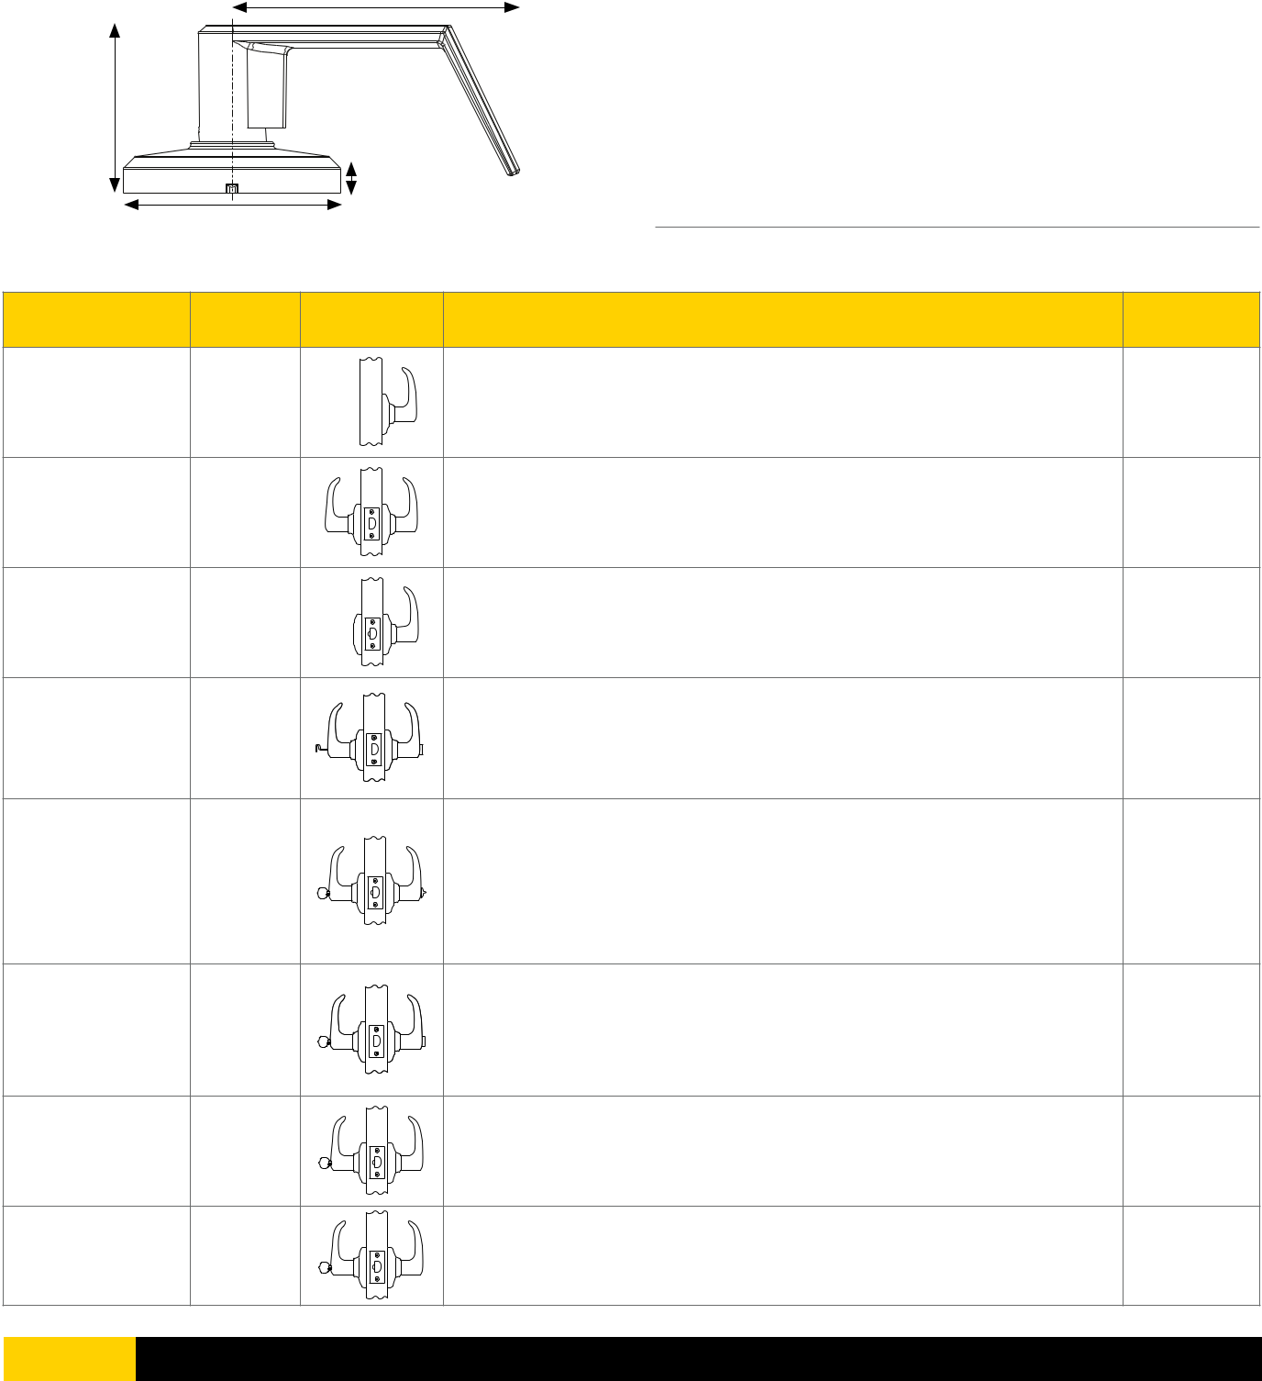

- Full Line Catalog STANLEY Commercial Hardware

How to Order
QCL 200 Series: Grade 2 Standard-Duty Cylindrical Locks

Example

If you ordered: QCL271 E626 S4 478S BF6 KA H 625

You would get: Grade 2 Hurricane Compliant Cylindrical Storeroom Lock, Sierra

Lever, Satin Chrome x Bright Chrome, 23⁄4" Deadlatch Square, ANSI 47⁄8" x 11⁄4"

Strike, SFIC “F” Keyway, Keyed Alike.
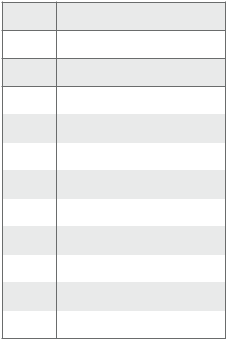

- Single Dummy

- Passage

- Communicating

40 | Privacy
50 | Entry/Office |  |  |  |  | BF | BEST "F" SFIC
 |  |  |  |  |  | KW | Kwikset “KW”
51 | Entry/Office SFIC |  |  |  |  | KW | Kwikset “KW”
54 | Corridor |  |  |  |  | WE | Weiser “E”
54 | Corridor |  | 605 | Bright Brass |  | WE | Weiser “E”
55 | Corridor SFIC
55 | Corridor SFIC |  |  |  |  | SC | Schlage “C”
55 | Corridor SFIC |  | 613 | Oil Rubbed Bronze |  | SC | Schlage “C”
60 | Classroom
60 | Classroom |  |  |  |  | GA | Yale “GA"
60 | Classroom |  | 619 | Satin Nickel |  | GA | Yale “GA"
61 | Classroom SFIC
61 | Classroom SFIC |  | 625 | Bright Chrome |  | LA | Sargent “LA”
70 | Storeroom
 |  |  | 626 | Satin Chrome |  | LC | Less Cylinder
71 | Storeroom SFIC |  | 626 | Satin Chrome |  | LC | Less Cylinder
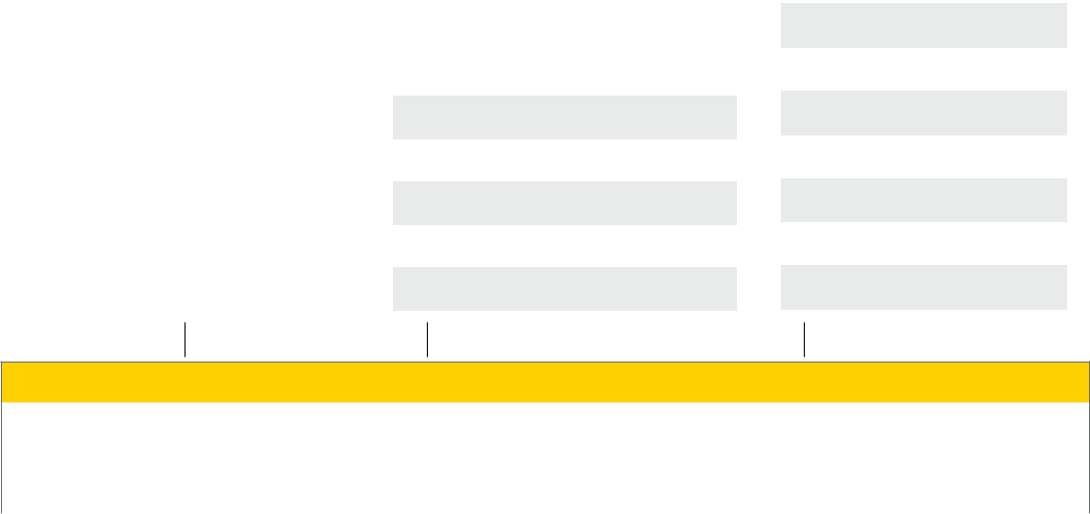

Base Part Number

Series | Function | Design | Finish | Latch | Strike | Keyway | # of Pins | Keying
QCL2 | 71 | E | 626 | S4 | 478S | BF | 6 | KA

Additional Options

Hurricane 2nd
Compliant Finish

H 625

MECHANICAL LOCKS

E | Sierra |  |  |  | 478S |  | ANSI 47⁄8" x 11⁄4" Strike |  |  | 613 | Oil Rubbed Bronze
 |  |  |  |  |  |  |  |  |  | 625 | Bright Chrome
M | Summit |  |  |  |  |  |  |  |  | 625 | Bright Chrome
M |  |  |  |  | 118F |  | ANSI 11⁄8" x 21⁄4" Strike |  |  | 625 | Bright Chrome
A | Slate
A |  |  |  |  | FLS |  | Full Lip Square Corner Strike
 |  |  |  |  | FLR |  | Full Lip 1⁄4" Radius Corner Strike


QCL2 Latch Table (New)

FR4 | Fire-Rated Radius 2-3/4
FS4 | Fire-Rated Square 2-3/4
NOL | No Latch
NR4 | Narrow Radius 2-3/4
NR8 | Narrow Radius 2-3/8
NS4 | Narrow Square 2-3/4
NS8 | Narrow Square 2-3/8
R4 | Radius 2-3/4
R8 | Radius 2-3/8
S3 | Square 3-3/4
S4 | Square 2-3/4
S5 | Square 5
S8 | Square 2-3/8

KD | Keyed Different
KA | Keyed Alike
SK | Special Keying
 | -Construction Keyed
 | -Construction Master Keyed
 | -Maison Keyed
 | -Master Keyed
 | -Grand Master Keyed
 | -Great Grand Master Keyed
ZB | Zero Bitted

Full Line Catalog STANLEY Commercial Hardware 21

QCI 200 Series: Grade 2 Standard-Duty Interconnected Locks

Applications

The QCI200 Series Interconnected Levers are designed for multi-family, assisted living, commercial
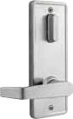
- mixed-use applications where single motion egress is required. These levers deliver premium performance and are designed to withstand the physical abuses of the applied environment.
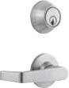

Performance Features

- Tested to meet Grade 2 specification of 400,000 cycles.

- Single-motion egress provides easy emergency exit.

- Full 1" (25mm) throwbolt with saw-resistant hardened steel roller pin.

- Anti-drill design deadbolt – two (2) ball bearings inserted to prevent drill attacks.

• ADA thumbturn. | Sierra (E) – Single-Locking

- Tapered latch bolt to address warped door concerns.
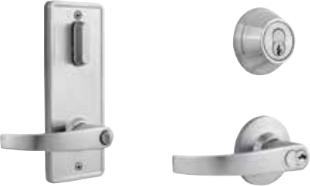

MECHANICAL LOCKS

Certifications

- ANSI/BHMA A156.12 – 1999 Grade 2

- UL/cUL Listed (3 hours) for “A” label single-door applications (4' x 8') (1.219m x 2.438m)

- UL10C/UBC 7-2 (1997) Positive Pressure Rated

- UL10B Pressure Rated

- ANSI A117.1 Accessibility Code (ADA Compliant)

Product Specifications

- Door range – 1 3⁄8" - 1 3⁄4" (35mm-44.5mm).

- Heavy-duty cylindrical lock body.

- 4" center-to-center.

- Backset – 2 3⁄4" (70 mm) standard. 2 3⁄8" (60mm) available.

- Exposed trim – Wrought brass or bronze with cast zinc lever.

- Strikes – “T” strike 1 1⁄8" x 2 3⁄4” standard for lever,

deadbolt strike 1 1⁄8" x 2 3⁄4" standard. Other strike options also available.

- Latch bolt – Keyed 1⁄2" (13mm) steel throw with auxiliary latch, passage 1⁄2" (13mm) spring latch.

- Handing – All QCI200 locksets are non-handed.

- Standard door prep: 2 1⁄8" cross bore (54mm).

- Latch hole – 1" diameter edge bore.

- Rose diameter – 2 1⁄2" (63mm).

- Inside escutcheon – 3" x 8" (82.5mm x 203mm).

Optional exterior escutcheon – 3 1⁄4" x 8" (82.5mm x 203mm).

Keying

- 6-pin non-IC brass cylinders. 6 or 7 pin SFIC option available. Many keying options available from our factory to include, but not limited to, master keying, grand master keying and construction keying. Small format interchangeable core cylinder also available.

- 2 keys per lockset.

- Offered with the following keyway options: SMT-SmartKey, KW-Kwikset, WE-Weiser, SC-Schlage, GA-Yale, LA-Sargent, BF-BEST "F" SFIC, & LC-Less Cylinder. Consult factory for other cylinder options.

Warranty

- Lifetime Mechanical, 3-year finish* and 1-year electrical

*(613/US10B carries no finish warranty)

- Full Line Catalog STANLEY Commercial Hardware

Summit (M) – Double-Locking
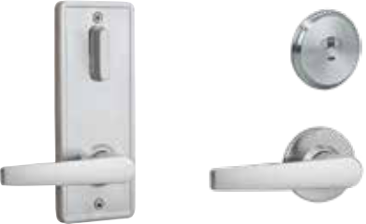

Slate (A) – Indicator

Functions


ANSI | Series | Description
F95 | QCI230 | Single-Locking (Passage Lever)
F95 | QCI231 | Single-Locking SFIC (Passage Lever)
F97 | QCI250 | Double-Locking (Entry Lever)
F97 | QCI251 | Double-Locking SFIC (Entry Lever)

—QCI285 Indicator (Passage Lever)

Finishes
BHMA | Description
605 | Bright Brass
613 | Oil Rubbed Bronze
619 | Satin Nickel
626 | Satin Chrome

QCI 200 Series: Grade 2 Standard-Duty Interconnected Locks
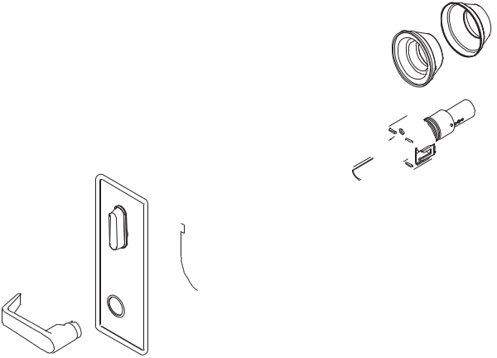

A
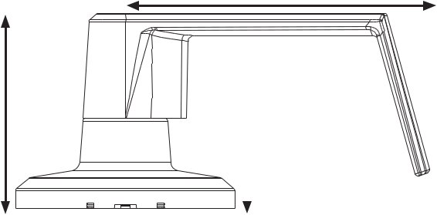

B

D
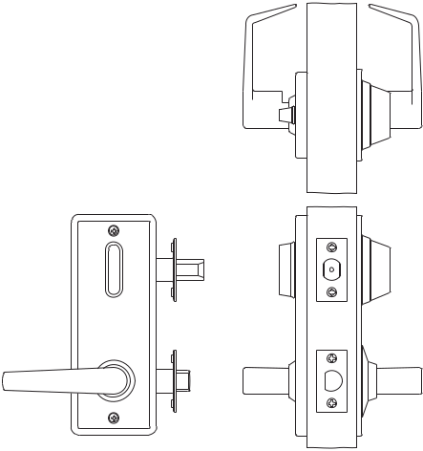

C

Dimensions

 |  |  | A | B | C | D | LOCKS
 |  | Sierra | 3.96" | 2.25" | 2.50" | .375" | LOCKS
 |  |  | 100.58mm | 57.15mm | 63.50mm | 9.52mm | LOCKS
 |  | Summit | 4.0" | 2.20" | 2.50" | .375" | MECHANICAL
 |  |  | 101.60mm | 55.88mm | 63.50mm | 9.52mm
 |  | Slate | 4.47" | 4.67" | 2.50" | .375"
 |  |  | 113.50mm | 118.60mm | 63.50mm | 9.52mm
Functions | ANSI | Description |  |  |  | Case Qty
QCI230/231* |  | Latch bolt operated by lever from either side. Rotating turn from inside or key from
Single-Locking | F95 | outside extends deadbolt to locked position. Both deadbolt and latch bolt are retracted |  |  |  | 6
(Passage Lever) |  | simultaneously to unlock position by operating inside lever.
 |  | Deadlocking latch bolt is operated by lever from either side except when outside lever
QCI250/251** |  | is made inoperable by locking device inside. When outside lever is locked, deadlocking
Double-Locking (Entry | F97 | latch bolt is operated by key outside. Inside locking device is manually operated to |  |  |  | 6
Double-Locking (Entry | F97 | unlock outside lever. Rotating turn from inside or key from outside extends deadbolt to |  |  |  | 6
Lever)
Lever) |  | locked position. Operating inside lever bolt retracts both deadbolt and deadlocking latch
 |  | simultaneously. Closing door shall not release locking device inside.
QCI285 |  | Latch bolt operated by lever from either side. Rotating turn from inside extends deadbolt
Indicator | — | to locked position. Both deadbolt and latch bolt are retracted simultaneously to unlock |  |  |  | 6
Indicator | — | position by operating inside lever. Outside indicator visually shows red closed padlock for |  |  |  | 6
(Passage Lever)
(Passage Lever) |  | locked/in-use, green open door padlock for unlocked/vacant. Emergency key included.

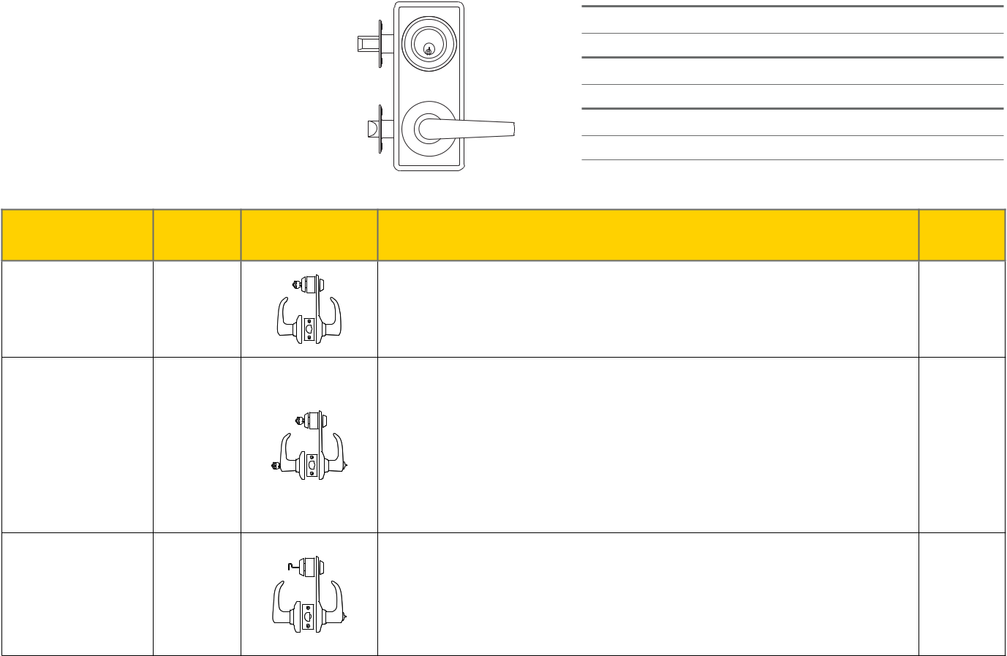

NOTES: *SmartKey available on QCI230 functions only.

**QCI251 available at extended lead time. Consult factory.

Full Line Catalog STANLEY Commercial Hardware | 23

How to Order
QCI 200 Series: Grade 2 Standard-Duty Interconnected Locks

MECHANICAL LOCKS

Example

If you ordered: QCI230 E626 NR4 118F F6 KD

You would get: Grade 2 Interconnect Single Lock, Sierra Lever, Satin Chrome, 23⁄4" Narrow Radius

Latches, “T” Strike with Standard Deadbolt Strike, Standard “F” Keyway, Keyed Different.


 |  |  |  |  |  | BF | BEST "F" SFIC
 |  |  |  |  |  | KW | Kwikset “KW”
 |  |  |  |  |  | WE | Weiser “E”
30 | Single-Locking (Passage Lever) |  |  |  |  | WE | Weiser “E”
 |  |  |  |  |  | SC | Schlage “C”
31 | Single-Locking SFIC (Passage Lever) |  | 605 | Bright Brass |  | SC | Schlage “C”
 |  |  |  |  |  | GA | Yale “GA”
 |  |  | 613 | Oil Rubbed Bronze |  | GA | Yale “GA”
50 | Double-Locking (Entry Lever) |  | 613 | Oil Rubbed Bronze |  | GA | Yale “GA”
51 | Double-Locking SFIC (Entry Lever) |  | 619 | Satin Nickel |  | LA | Sargent “LA”
85 | Indicator (Passage Lever) |  | 626 | Satin Chrome |  | LC | Less Cylinder
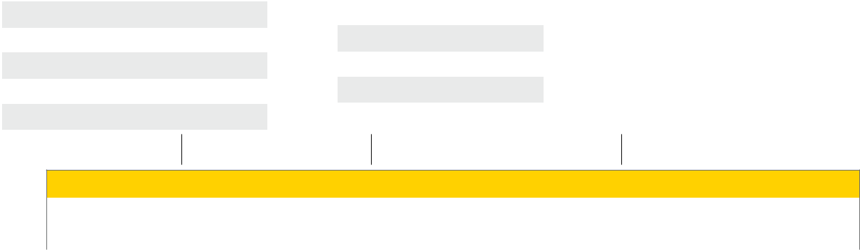

Base Part Number

Series | Function | Design | Finish | Latch | Strike | Keyway | # Of Pins | Keying
QCI2 | 31 | E | 626 | NR4 | 118F | F | 6 | KD
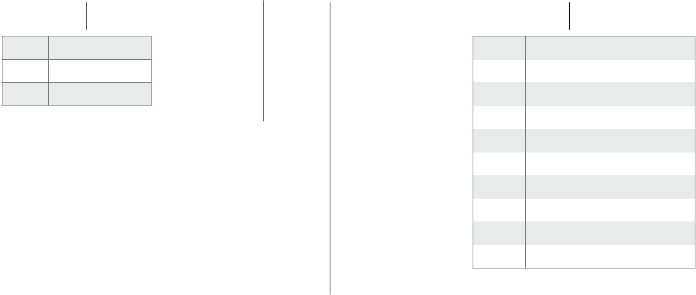

- Sierra

- Summit

ASlate


Order w/Lock | Lever & Deadbolt Latch
NR4 | Narrow Radius 2-3/4
NS4 | Narrow Square 2-3/4
NS8 | Narrow Square 2-3/8
R4 | Radius 2-3/4
S4 | Square 2-3/4
S8 | Square 2-3/8


KD | Keyed Different
KA | Keyed Alike
SK | Special Keying
 | -Construction Keyed
 | -Construction Master Keyed
 | -Maison Keyed
 | -Master Keyed
 | -Grand Master Keyed
 | -Great Grand Master Keyed
ZB | Zero Bitted

Order w/Lock | Lever Latch | Deadbolt Latch
NR8 | Narrow Radius 2-3/8 | Narrow Radius 2-3/4
R8 | Radius 2-3/8 | Radius 2-3/4

Order w/Lock | Lever Strike | Deadbolt Strike
118F | 118F | DBS
478S | 478S | DBS
FLS | FLS | DBS
FLR | FLR | DBS
FLS2 | FLS | FLS
FLR2 | FLR | FLR


- Full Line Catalog STANLEY Commercial Hardware

QTL 200 Series: Grade 2 Standard-Duty Tubular Locks
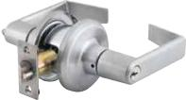

Performance Features

- Tested to meet Grade 2 specification of 400,000 cycles.

- Heavy-duty torsion springs provide longer performance life and prevent lever sag.

- Concealed mounting screws.

- “Anti-Lockout” feature. The entry function will have a free interior. If the door is locked from the inside, it will unlock with the push of the interior side of the lever only or the turn of the button.

- 1/2" (13mm) latch bolt made of stainless steel black powder metallurgy for enhanced durability and strength.Compartmentalized packaging allows for quick and easy installation.

Certifications

- ANSI/BHMA A156.2 Series – Grade 2

- ANSI A117.1 Accessibility Code (ADA Compliant)

- UL/cUL Listed (3 hours) for “A” label single-door applications (4' x 8') (1.219m x 2.438m)

- UL10C/UBC 7-2 (1997) Positive Pressure Rated

- UL10B Pressure Rated

- California State Reference Code (formerly Title 19 – Fire Marshal)

- Hurricane Compliant – Miami-DADE N.O.A. See page 78 for more details.

Product Specifications

- Handing – All QTL200 Series Levers Locksets are non-handed.

- Door thickness – 1 3⁄8" - 1 3⁄4" (35mm-51mm) standard.

- Backset – Universal backset standard, will fit either 2 3⁄8" or 2 3⁄4" backsets (60mm-70mm).

- Exposed trim – Pressure cast zinc, plated to match finish designation.

- Strike – Full-lip strike standard (57mm x 44.4mm). Other strike options also available.

- Latch bolt –1⁄2" (13mm) steel throw.

- Latch faceplate – 1" x 2 1⁄4" (25.4mm x 57mm) standard.

Keying

- 6-pin non-IC brass cylinders. 6 or 7 pin SFIC option available. Many keying options available from our factory to include, but not limited to, master keying, grand master keying and construction keying.

- 2 keys per lockset.

- Offered with the following keyway options: BF-BEST "F" SFIC, KW-Kwikset, WE-Weiser, SC-Schlage, GA-Yale, LA-Sargent, & LC-Less Cylinder. Consult factory for other cylinder options.

Warranty

- Lifetime Mechanical and 3-year finish*

Sierra (E)
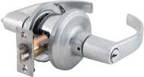

Summit (M)
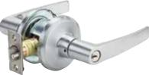

Slate (A)

Functions

ANSI | Series | Description
— | QTL220 | Single Dummy
F75 | QTL230 | Passage
F76B | QTL240 | Privacy
F82 | QTL250 | Entry/Office
F82 | QTL251 | Entry/Office SFIC
F84 | QTL260 | Classroom
F84 | QTL261 | Classroom SFIC
F86 | QTL270 | Storeroom
F86 | QTL271 | Storeroom SFIC

Finishes
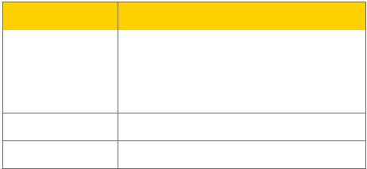

BHMA | Description
605 | Bright Brass
613 | Oil Rubbed Bronze
619 | Satin Nickel

- Bright Chrome

- Satin Chrome

MECHANICAL LOCKS

*(613/US10B carries no finish warranty)

Full Line Catalog STANLEY Commercial Hardware | 25

QTL 200 Series: Grade 2 Standard-Duty Tubular Locks

MECHANICAL LOCKS

 |  |  | QTL250
 |  |  | Sierra
 |  | A |  | Dimensions
 |  |  | A | B | C | D
 |  | Sierra | 4.103" | 2.635" | 2.953" | .443"
B |  |  | 104.21mm | 66.93mm | 75mm | 11.24mm
B |  | Summit | 4.224" | 2.663" | 2.953" | .443"
 |  |  | 107.29mm | 67.64mm | 75mm | 11.24mm
 |  | Slate | 4.488" | 2.728" | 2.953" | .443"
 | D |  | 114mm | 69.30mm | 75mm | 11.24mm
 | C
Functions | ANSI | Description |  |  |  | Case Qty
QTL220 | — | For one side of door. Used for door pull or as matching inactive trim. |  |  |  | 12
Single Dummy | — | No mechanical operation. Surface-mounted single dummy trim. |  |  |  | 12
QTL230 | F75 | Both levers always unlocked and always free for immediate ingress & egress. |  |  |  | 10
Passage | F75 |  |  |  |  | 10
QTL240 | F76B | Turn-button locking. Can be opened from outside with small screwdriver. Turning |  |  |  | 10
Privacy | F76B | inside lever releases turn-button. Inside lever is always free for immediate egress. |  |  |  | 10
QTL250/251 | F82 | Unlocked by key from outside when outside lever is locked by turn-button on inside |  |  |  | 10
Entry/Office | F82 | lever. Inside lever always unlocked and available for immediate egress. |  |  |  | 10
QTL260/261 | F84 | Outside lever locked or unlocked by key. Inside lever is always unlocked and free for |  |  |  | 10
Classroom | F84 | immediate egress. |  |  |  | 10
QTL270/271 | F86 | Outside lever always locked. Entrance by key only. Inside lever always unlocked and free |  |  |  | 10
Storeroom | F86 | for immediate egress. |  |  |  | 10
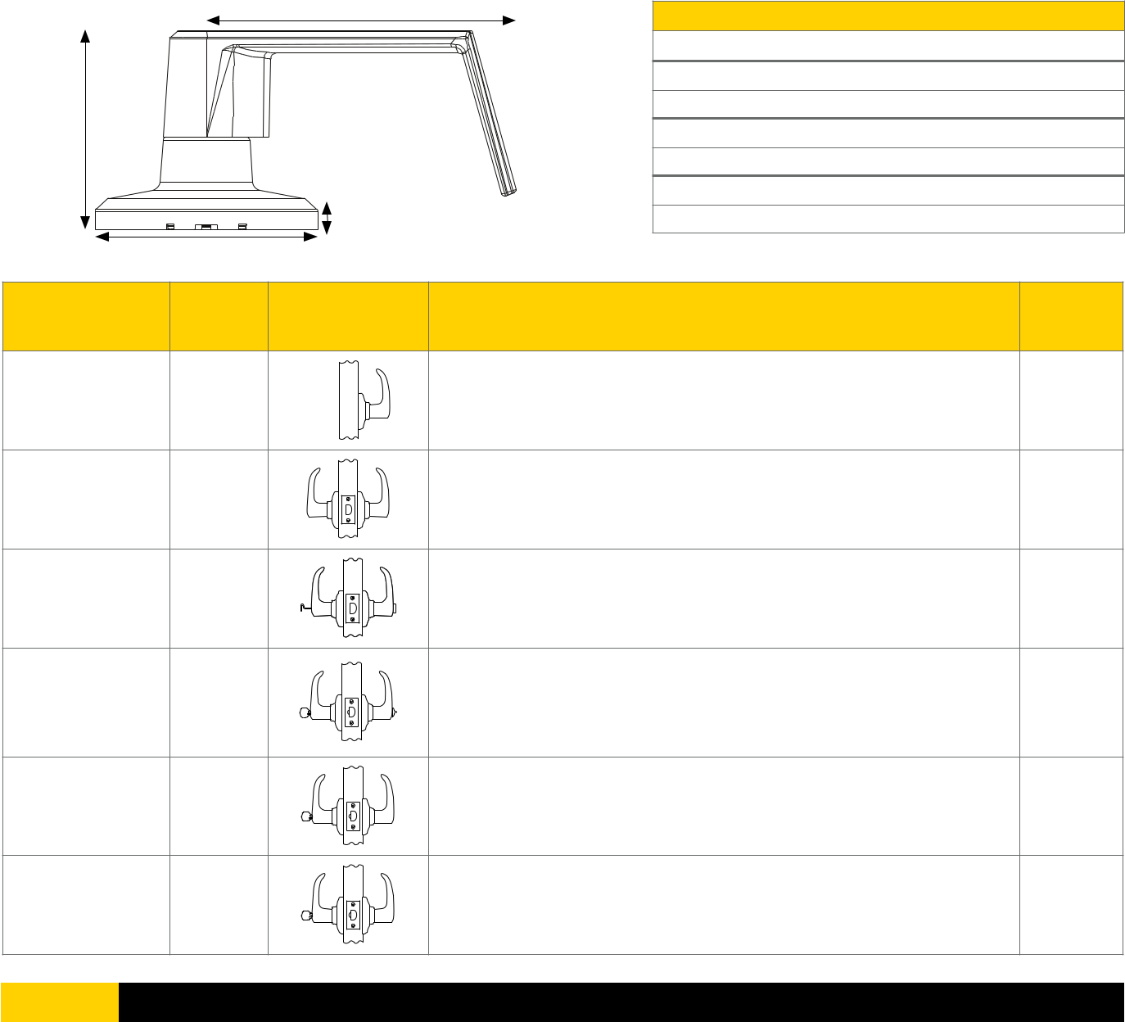

- Full Line Catalog STANLEY Commercial Hardware

How to Order
QTL 200 Series: Grade 2 Standard-Duty Tubular Locks

Example

If you ordered: QTL270 E626 SA FLR F6 KA H 625

You would get: Grade 2 Hurricane Compliant Tubular Storeroom Lock, Sierra Lever, Satin Chrome x Bright Chrome, Adjustable Square Latch, Full Lip 1⁄4" Radius Corner Strike, Standard “F” Keyway, Keyed Alike.
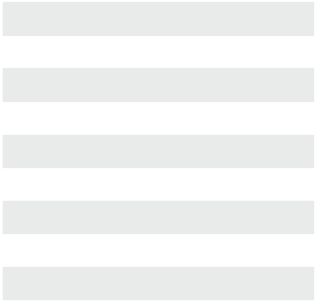

20 | Single Dummy
30 | Passage
 |  |  |  |  |  | BF | BEST "F" SFIC
40 | Privacy |  |  |  |  | BF | BEST "F" SFIC
 |  |  |  |  |  | KW | Kwikset “KW”
50 | Entry/Office |  |  |  |  | KW | Kwikset “KW”
50 | Entry/Office |  | 605 | Bright Brass |  | KW | Kwikset “KW”
 |  |  | 605 | Bright Brass |  | WE | Weiser “E”
51 | Entry/Office SFIC |  |  |  |  | WE | Weiser “E”
51 | Entry/Office SFIC |  | 613 | Oil Rubbed Bronze |  | WE | Weiser “E”
 |  |  | 613 | Oil Rubbed Bronze |  | SC | Schlage “C”
60 | Classroom |  | 613 | Oil Rubbed Bronze |  | SC | Schlage “C”
60 | Classroom |  | 619 | Satin Nickel |  | SC | Schlage “C”
 |  |  | 619 | Satin Nickel |  | GA | Yale “GA”
61 | Classroom SFIC |  | 619 | Satin Nickel |  | GA | Yale “GA”
61 | Classroom SFIC |  | 625 | Bright Chrome |  | GA | Yale “GA”
 |  |  | 625 | Bright Chrome |  | LA | Sargent “LA”
70 | Storeroom |  | 625 | Bright Chrome |  | LA | Sargent “LA”
 |  |  | 626 | Satin Chrome
71 | Storeroom SFIC |  | 626 | Satin Chrome |  | LC | Less Cylinder


 |  |  |  |  |  |  | Base Part Number |  |  |  |  |  |  |  |  |  |  |  |  |  |  |  |  |  |  | Additional Options
Series | Function |  | Design |  |  |  | Finish | Latch |  |  | Strike |  |  |  |  | Keyway | # of Pins |  | Keying |  |  |  |  |  | Hurricane |  |  |  | 2nd
Series |  |  |  |  |  |  | Finish |  |  |  |  |  |  |  |  | Keyway | # of Pins |  |  |  |  |  |  |  | Compliant |  |  |  | Finish
QTL2 | 71 |  |  |  | E |  | 626 |  | SA |  | FLR |  |  |  |  | F | 6 |  | KA |  |  |  |  |  |  |  | H |  | 625
 |  | E | Sierra |  |  |  |  |  |  |  | 478S |  |  |  | ANSI 47⁄8" x 11⁄4" Strike |  |  |  |  |  |  |  |  | 625 |  |  | Bright Chrome
 |  | M | Summit |  |  |  |  |  |  |  | 118F |  |  |  | ANSI 11⁄8" x 21⁄4" Strike
 |  | A | Slate |  |  |  |  |  |  |  | FLS |  |  |  | Full Lip Square Corner Strike
 |  |  |  |  |  |  |  |  |  |  | FLR |  |  |  | Full Lip 1⁄4" Radius Corner Strike
 |  |  |  | QTL2 Latch Table (New) |  |  |  |  |  |  |  |  |  |  |  |  |  |  |  | KD |  |  |  |  | Keyed Different
 |  |  |  | RA |  |  | Adjustable Radius |  |  |  |  |  |  |  |  |  |  |  |  | KA |  |  |  |  | Keyed Alike
 |  |  |  | SA |  |  | Adjustable Square |  |  |  |  |  |  |  |  |  |  |  |  | SK |  |  |  |  | Special Keying
 |  |  |  | NOL |  |  | No Latch |  |  |  |  |  |  |  |  |  |  |  |  |  |  |  |  |  | -Construction Keyed
 |  |  |  |  |  |  |  |  |  |  |  |  |  |  |  |  |  |  |  |  |  |  |  |  | -Construction Master Keyed
 |  |  |  |  |  |  |  |  |  |  |  |  |  |  |  |  |  |  |  |  |  |  |  |  | -Maison Keyed
 |  |  |  |  |  |  |  |  |  |  |  |  |  |  |  |  |  |  |  |  |  |  |  |  | -Master Keyed
 |  |  |  |  |  |  |  |  |  |  |  |  |  |  |  |  |  |  |  |  |  |  |  |  | -Grand Master Keyed
 |  |  |  |  |  |  |  |  |  |  |  |  |  |  |  |  |  |  |  |  |  |  |  |  | -Great Grand Master Keyed
 |  |  |  |  |  |  |  |  |  |  |  |  |  |  |  |  |  |  |  | ZB |  |  |  |  | Zero Bitted




MECHANICAL LOCKS

Full Line Catalog STANLEY Commercial Hardware 27

LOCKS
QDB 100 Series: Grade 1 Heavy-Duty Auxiliary Deadbolts

Performance Features

- Tested to meet Grade 1 specification of 250,000 cycles.

- Solid forged housing provides enhanced strength and durability.

- Full 1" (25.4mm) throwbolt with saw-resistant hardened steel roller pin.

- Anti-drill design – two (2) ball bearings inserted to prevent drill attacks.

- ADA thumbturn.

- Compartmentalized packaging allows for quick and easy installation.
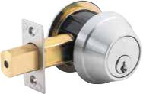

Certifications

- ANSI/BHMA A156.5 Series – Grade 1

• | ANSI A117.1 Accessibility Code (ADA Compliant) | Single Cylinder

- UL/cUL Listed (3 hours) for “A” label single-door applications (4' x 8') (1.219m x 2.438m)

- UL10C/UBC 7-2 (1997) Positive Pressure Rated

- UL10B Pressure Rated

- California State Reference Code (formerly Title 19 – Fire Marshal)

- Hurricane Compliant – Miami-DADE N.O.A. See page 78 for more details.
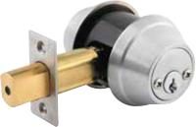

Double Cylinder
Product Specifications

MECHANICAL

- Door range – 1 3⁄8" (35 mm) to 2" (51 mm).

Service part number 8Q00082 spacer rings required for 1 3⁄8" doors.

- Backset – 2 3⁄4" (70mm) square standard.

2 3⁄8" (60mm) available.

- Exposed trim – Solid forged brass, plated to match finish designation.

- Strike – Standard deadbolt strike 1 1⁄8" x 2 3⁄4" (32mm x 70mm). Other strike options also available.

- Door prep – 2 1⁄8" (54mm) diameter cross bore.

- Latch bolt – Full 1" (25.4mm) throw with hardened steel roller; Faceplate – 1 1⁄8" x 2 1⁄4" (29mm x 57mm).

Keying

- 6-pin non-IC brass cylinders. 6 or 7 pin SFIC option available. Many keying options available from our factory to include, but not limited to, master keying, grand master keying and construction keying. Small format interchangeable core cylinder also available.

- 2 keys per lockset.

- Offered with the following keyway options: KW-Kwikset, WE-Weiser, SC-Schlage, GA-Yale, LA-Sargent, BF-BEST "F" SFIC, & LC-Less Cylinder. Consult factory for other cylinder options.

Warranty

- Lifetime Mechanical and 3-year finish*

Functions

ANSI | Series | Description
E0151 | QDB180 | Single Cylinder
E0151 | QDB181 | Single Cylinder SFIC
E0141 | QDB182 | Double Cylinder
E0141 | QDB183 | Double Cylinder SFIC
E0171 | QDB186 | Classroom
E0171 | QDB187 | Classroom SFIC

Finishes
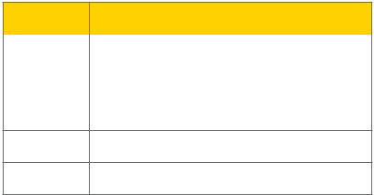

BHMA | Description
605 | Bright Brass
613 | Oil Rubbed Bronze
619 | Satin Nickel

- Bright Chrome

- Satin Chrome

*(613/US10B carries no finish warranty)

- Full Line Catalog STANLEY Commercial Hardware

QDB 100 Series: Grade 1 Heavy-Duty Auxiliary Deadbolts

QDB180

A B
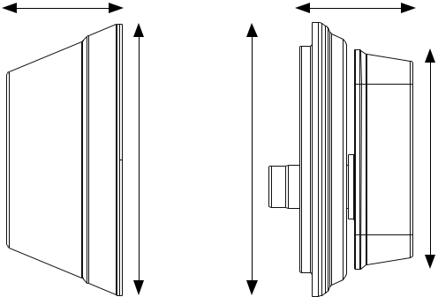

C | D | E

 |  |  |  |  |  | LOCKS
 |  |  |  |  |  | MECHANICAL
 |  | Dimensions |  |  |  | MECHANICAL
A | B | C | D | E
1.06" | .920" | 2.5" | 2.52" | 2.02"
26.90mm | 23.37mm | 63.50mm | 64mm | 51.31mm
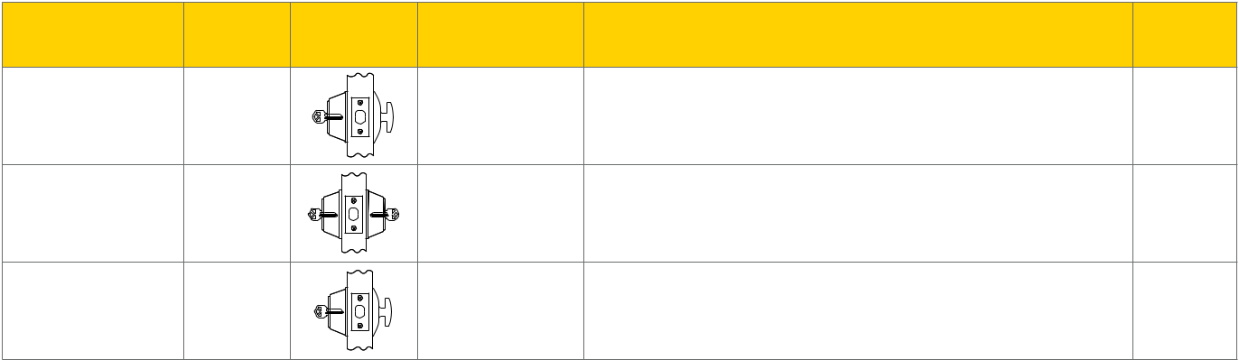

Model/Series | ANSI | Functions | Description | Case
 |  |  |  | Qty

QDB180/181 | E0151 | Single Cylinder | Deadbolt is operated by a key outside and a thumbturn inside. | 12
Single Cylinder
QDB182/183 | E0141 | Double Cylinder | Deadbolt is operated by a key on both sides. | 12
Double Cylinder
QDB186/187 | E0171 | Classroom | Deadbolt is operated by a key from outside. Turnpiece retracts deadbolt | 12
Classroom | E0171 | Classroom | for egress but can not project it. | 12

Full Line Catalog STANLEY Commercial Hardware 29

How to Order
QDB 100 Series: Grade 1 Heavy-Duty Auxiliary Deadbolts

MECHANICAL LOCKS

Example

If you ordered: QDB182 626 S8 DBS F6 KD H

You would get: Grade 1 Double Cylinder Auxiliary Deadbolt, Satin Chrome, 23⁄8" Deadbolt

Latch Square, Standard Deadbolt Strike, Standard “F” Keyway, Keyed Different, Hurricane Compliant.


 |  |  |  |  |  | BF | BEST "F" SFIC
 |  |  |  |  |  | KW | Kwikset “KW”
80 | Single Cylinder |  |  |  |  | KW | Kwikset “KW”
 |  |  | 605 | Bright Brass |  | WE | Weiser “E”
81 | Single Cylinder SFIC |  | 605 | Bright Brass |  | WE | Weiser “E”
 |  |  | 613 | Oil Rubbed Bronze
 |  |  | 613 | Oil Rubbed Bronze |  | SC | Schlage “C”
82 | Double Cylinder |  | 613 | Oil Rubbed Bronze |  | SC | Schlage “C”
 |  |  | 619 | Satin Nickel |  | GA | Yale “GA”
83 | Double Cylinder SFIC |  | 619 | Satin Nickel |  | GA | Yale “GA”
 |  |  | 625 | Bright Chrome |  | LA | Sargent “LA”
86 | Classroom |  | 625 | Bright Chrome |  | LA | Sargent “LA”
87 | Classroom SFIC |  | 626 | Satin Chrome |  | LC | Less Cylinder


 |  |  | Base Part Number |  |  |  |  |  | Additional Options
Series | Function | Finish | Latch | Strike | Keyway | # of Pins | Keying |  | Hurricane Compliant
QDB1 | 83 | 626 | S8 | DBS | F | 6 | KD |  | H
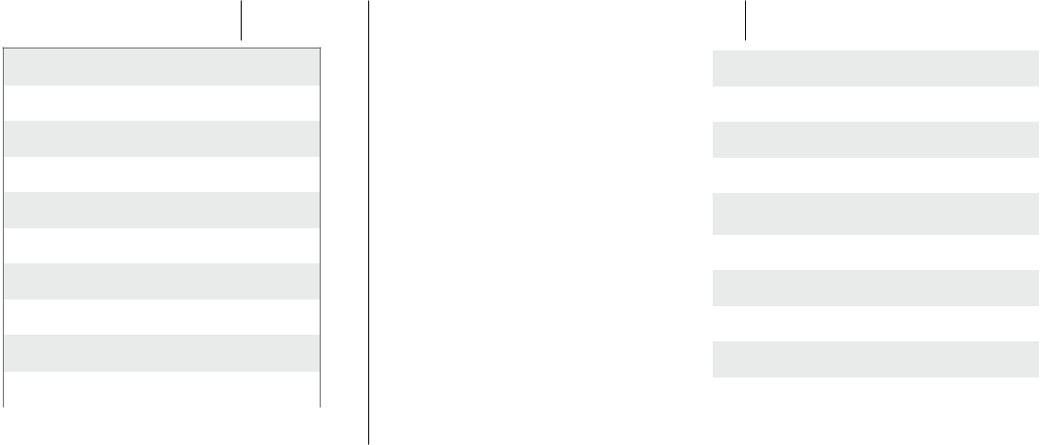

QDB1 LATCH TABLE (New)

NOL | No Latch
NR4 | Narrow Radius 2-3/4
NR8 | Narrow Radius 2-3/8
NS4 | Narrow Square 2-3/4
NS8 | Narrow Square 2-3/8
R4 | Radius 2-3/4
R8 | Radius 2-3/8
S4 | Square 2-3/4
S8 | Square 2-3/8

KD | Keyed Different
KA | Keyed Alike
SK | Special Keying
 | -Construction Keyed
 | -Construction Master Keyed
 | -Maison Keyed
 | -Master Keyed
 | -Grand Master Keyed
 | -Great Grand Master Keyed
ZB | Zero Bitted


478S | ANSI 47⁄8" x 11⁄4" Strike
DBS | Deadbolt Strike 11⁄8" x 2 3⁄4" Square
FLS | Full Lip Square Corner Strike
FLR | Full Lip 1⁄4" Radius Corner Strike

- Full Line Catalog STANLEY Commercial Hardware

QDB 200 Series: Grade 2 Standard-Duty Auxiliary Deadbolts
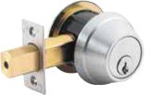

Performance Features
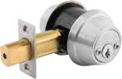

- Tested to meet Grade 2 specification of 150,000 cycles.

- Full 1" (25.4mm) throwbolt with saw-resistant hardened steel roller pin.

- Free-spinning cylinder collar prevents against wrench attacks.

- Anti-drill design – Two (2) ball bearings inserted to prevent drill attacks.

- ADA thumbturn.

- Compartmentalized packaging allows for quick and easy installation.

• Available with SmartKey Technology. Single Cylinder Double Cylinder

Certifications
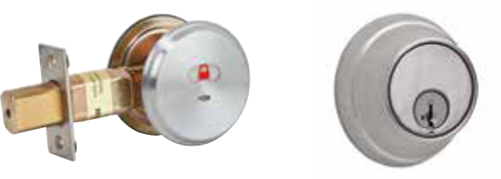

- ANSI/BHMA A156.12 – 1999 Grade 2

- ANSI A117.1 Accessibility Code (ADA Compliant)

- UL/cUL Listed (3 hours) for “A” label single-door applications (4' x 8') (1.219m x 2.438m)

- UL10C/UBC 7-2 (1997) Positive Pressure Rated

- UL10B Pressure Rated

• Hurricane Compliant – Miami-DADE N.O.A. See page 78 for more details. ^{QDB285 Indicator} QDB288 Key Control
LOCKS

Product Specifications

- Door range – 1 3⁄8" (35mm) to 2"(51 mm).

Service part number 8Q00082 spacer rings required for 1 3⁄8" doors.

- Backset – 2 3⁄4" (70mm) square standard. 2 3⁄8" (60mm) available.

- Exposed trim – Stainless steel with iron forged cylinder guard.

- Strike – Standard deadbolt strike 1 1⁄8" x 2 3⁄4" (32mm x 70mm). Other strike options also available.

- Latch bolt – Full 1" (25.4mm) throw with hardened steel roller.

- Faceplate – 1 1⁄8" x 2 1⁄4" (29mm x 57mm) standard. 1" x 2 1⁄4" (25.4mm x 57mm) faceplate available.

Keying

- 6-pin non-IC brass cylinders. 6 or 7 pin SFIC option available. Many keying options available from our factory to include, but not limited to, master keying, grand master keying and construction keying. Small format interchangeable core cylinder also available.

- 2 keys per lockset.

- Offered with the following keyway options: SMT-SmartKey, KW-Kwikset, WE-Weiser, SC-Schlage, GA-Yale, LA-Sargent, BF-BEST "F" SFIC, & LC-Less Cylinder. Consult factory for other cylinder options.

Warranty

- Lifetime Mechanical and 3-year finish*

*(613/US10B carries no finish warranty)

Functions

ANSI | Series | Description
E0152 | QDB280 | Single Cylinder
E0152 | QDB281 | Single Cylinder SFIC
E0142 | QDB282 | Double Cylinder
E0142 | QDB283 | Double Cylinder SFIC
E0193 | QDB284 | Inside Turnbolt
— | QDB285 | Indicator
E0172 | QDB286 | Classroom
E0172 | QDB287 | Classroom SFIC
E0152 | QDB288 | Key Control

Finishes
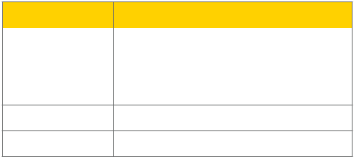

BHMA | Description
605 | Bright Brass
613 | Oil Rubbed Bronze
619 | Satin Nickel

- Bright Chrome

- Satin Chrome

Full Line Catalog STANLEY Commercial Hardware | 31

MECHANICAL

QDB 200 Series: Grade 2 Standard-Duty Auxiliary Deadbolts

QDB280

MECHANICAL LOCKS

A B
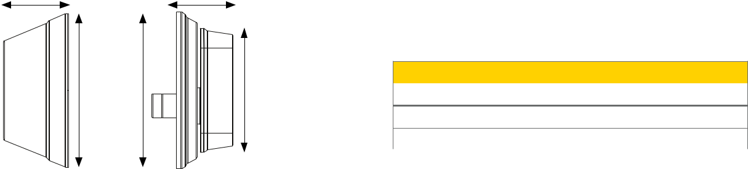

C | D | E |  |  | Dimensions
C | D | E | A | B | C | D | E
 |  |  | 1.06" | .920" | 2.5" | 2.56" | 2.02"
 |  |  | 26.8mm | 23.37mm | 63.5mm | 65mm | 51.31mm
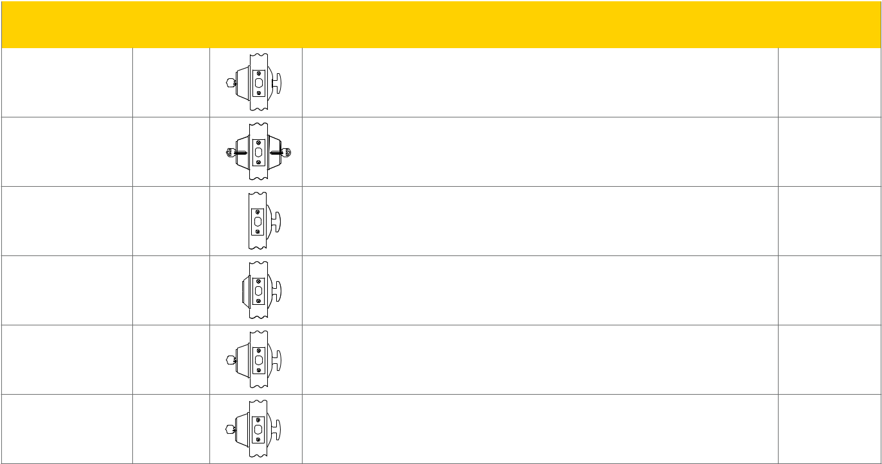

Model/Series | ANSI |  | Description | Case Qty

QDB280/281 | E0152 | Deadbolt is operated by a key outside and a thumbturn inside. | 12
Single Cylinder | E0152 |  | 12
QDB282/283 | E0142 | Deadbolt is operated by a key on both sides. | 12
Double Cylinder | E0142 | Deadbolt is operated by a key on both sides. | 12
QDB284 | E0193 | Deadbolt is operated by a thumbturn inside. | 20
Inside Turnbolt | E0193 | There is no trim on the other side. | 20
QDB285 |  | Deadbolt is operated by turn inside. Occupancy indicator plate on outside. Indicator
Indicator | — | visually shows red closed padlock for locked/in-use, green opened padlock for unlocked/ | 12
Indicator |  | vacant. Emergency key included.
QDB286/287* | E0172 | Deadbolt operated by key from outside. Thumbturn retracts deadbolt for egress but | 12
Classroom | E0172 | cannot project it. | 12
QDB288† | E0152 | Deadbolt operated by either tenant or control key from outside. Thumbturn on inside | 12
Key Control | E0152 | projects and retracts deadbolts. | 12

NOTES: *Classroom indicator deadbolts available in 626 finish at standard lead times. Consult factory for lead times on alternative finishes.

†Key control deadbolt available with SmartKey cylinders only.

- Full Line Catalog STANLEY Commercial Hardware

How to Order
QDB 200 Series: Grade 2 Standard-Duty Auxiliary Deadbolts

Example

If you ordered: QDB282 626 S8 DBS F6 KD H

You would get: Grade 2 Double Cylinder Auxiliary Deadbolt, Satin Chrome, 2 3⁄8" Deadbolt

Latch Square, Standard Deadbolt Strike, Standard “F” Keyway, Keyed Different, Hurricane Compliant.


80 | Single Cylinder
81 | Single Cylinder SFIC
81 | Single Cylinder SFIC |  |  |  |  | BF | BEST "F" SFIC
82 | Double Cylinder |  |  |  |  | BF | BEST "F" SFIC
82 | Double Cylinder |  |  |  |  | KW | Kwikset “KW”
83 | Double Cylinder SFIC |  |  |  |  | KW | Kwikset “KW”
83 | Double Cylinder SFIC |  | 605 | Bright Brass |  | WE | Weiser “E”
84 | Inside Turnbolt
84 | Inside Turnbolt |  | 613 | Oil Rubbed Bronze |  | SC | Schlage “C”
85 | Indicator
85 | Indicator |  | 619 | Satin Nickel |  | GA | Yale “GA”
86 | Classroom
 |  |  | 625 | Bright Chrome |  | LA | Sargent “LA”
87 | Classroom SFIC |  | 625 | Bright Chrome |  | LA | Sargent “LA”
 |  |  | 626 | Satin Chrome |  | LC | Less Cylinder
88 | Key Control† |  | 626 | Satin Chrome |  | LC | Less Cylinder


 |  |  |  | Base Part Number |  |  |  |  |  |  |  |  |  |  |  |  |  |  |  | Additional Options
Series | Function |  | Finish |  | Latch |  |  |  | Strike |  |  | Keyway | # of Pins |  |  | Keying |  |  |  |  | Hurricane
Series |  |  | Finish |  |  |  |  |  |  |  |  | Keyway |  |  |  |  |  |  |  |  | Compliant
QDB2 | 83 |  | 626 |  |  | S8 |  |  | DBS |  |  | F | 6 |  |  | KD |  |  |  |  | H
 |  | QDB2 Latch Table (New) |  |  |  |  |  |  |  |  |  |  |  | KD |  | Keyed Different
 |  |  |  |  |  |  |  |  |  |  |  |  |  | KA |  | Keyed Alike
 |  | 6A | 6-Way Adjustable |  |  |  |  |  |  |  |  |  |  | KA
 |  |  |  |  |  |  |  |  |  |  |  |  |  | SK |  | Special Keying
 |  | NOL | No Latch |  |  |  |  |  |  |  |  |  |  | SK
 |  |  |  |  |  |  |  |  |  |  |  |  |  |  |  | -Construction Keyed
 |  | NR4 | Narrow Radius 2-3/4
 |  |  |  |  |  |  |  |  |  |  |  |  |  |  |  | -Construction Master Keyed
 |  | NR8 | Narrow Radius 2-3/8
 |  |  |  |  |  |  |  |  |  |  |  |  |  |  |  | -Maison Keyed
 |  | NS4 | Narrow Square 2-3/4
 |  |  |  |  |  |  |  |  |  |  |  |  |  |  |  | -Master Keyed
 |  | NS8 | Narrow Square 2-3/8
 |  |  |  |  |  |  |  |  |  |  |  |  |  |  |  | -Grand Master Keyed
 |  | RA | Adjustable Radius
 |  |  |  |  |  |  |  |  |  |  |  |  |  |  |  | -Great Grand Master Keyed
 |  | R4 | Radius 2-3/4
 |  |  |  |  |  |  |  |  |  |  |  |  |  | ZB |  | Zero Bitted
 |  | R8 | Radius 2-3/8 |  |  |  |  |  |  |  |  |  |  | ZB
 |  | SA | Adjustable Square
 |  | S4 | Square 2-3/4
 |  | S8 | Square 2-3/8
 |  | S8 |  |  |  |  |  |  | 478S |  | ANSI 47⁄8" x 11⁄4" Strike
 |  |  |  |  |  |  |  |  | DBS |  | Deadbolt Strike 11⁄8" x 2 3⁄4" Square
 |  |  |  |  |  |  |  |  | DBR |  | Deadbolt Strike 11⁄8" x 2 3⁄4" Radius
 |  |  |  |  |  |  |  |  | FLS |  | Full Lip Square Corner Strike
 |  |  |  |  |  |  |  |  | FLR |  | Full Lip 1⁄4" Radius Corner Strike


NOTES: †Key control deadbolt only available with SmartKey cylinders.

MECHANICAL LOCKS

Full Line Catalog STANLEY Commercial Hardware 33

SFIC and Standard Keys and Cores
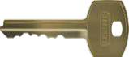

Keying

- Two keys provided with each lockset.

- Keying options available include: masterkeying, grand masterkeying and construction keying.

- Key stamping.

Base Part Number

 | Key |  |  | Key Type |  | Keyway |  |  | Cut Code |  | Pin Size |  | Options
 | 6AQ |  |  | 1 |  | KW |  |  | 1 |  | 7 |  | DND
 | 6AQ - Standard |  | 1 - Operating or blank |  |  | KW - Kwikset |  | 1 | - Blank |  | 6 - 6-pin |  | S - Key Serialization
 |  |  | 2 | - Control |  | WS - Weiser |  | 2 | - Cut |  | 7 - 7-pin |  | DND - Do Not Duplicate
 |  |  | 3 | - Master |  | SC - Schlage C
 |  |  | 4 | - Submaster |  | SE - Schlage E
 |  |  | 5 | - Grand Master |  | GA - Yale
 |  |  |  |  |  | LA - Sargent
 |  |  |  |  |  | AA - Arrow


MECHANICAL LOCKS

Example

If you ordered: 6AQ1KW17DND

You would get: Standard Operating Key, Kwikset Keyway, cut for 7-pin, marked Do Not Duplicate.

SFIC Cores

- A2 keying system offered with multiple levels of master keying.

- Standard keyway BF: BEST “F.”

- Offered in three finishes (626, 605, 690).

- Complies to Buy American Act

- Plastic construction core available.

Base Part Number

Core |  | Lock Body |  | Keyway |  |  | Combination Code |  |  | Finish
Type
6CS |  | 7 |  | BF |  |  |  | 2 |  | 626
6CS - |  | 6 - 6-pin |  | BF - BEST “F” |  |  | 1 | - Uncombinated |  | 605 Bright Brass
SFIC |  | 7 - 7-pin |  | SFIC |  |  | 2 | - Combinated |  | 626 Satin Chrome
 |  |  |  |  |  |  |  |  |  | 690 DK Bronze Powder Coat


626 | 605 | 690
Satin | Bright | Dark Bronze
Chrome | Brass | Powder Coat
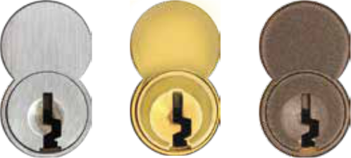

Example

If you ordered: 6CS 7BF2 626

You would get: Small Format Interchangeable Core (SFIC),

7-pin, Best “F” Keyway, Factory Combinated, Satin Chrome.

Warranty

- Lifetime Mechanical, 3-year finish,* 1-year electrical

*(613 carries no finish warranty)

- Full Line Catalog STANLEY Commercial Hardware

How to Order
Standard Cores

Standard Cores
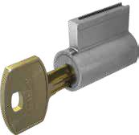

- BF: BEST "F" Keyway.

- Various keyways available include, but are not limited to: Schlage, Sargent and Yale.

- Optional construction keying available.

- Construction use – Prepared at the factory with construction pinning and key.

- Standard use – First use of operating key will supersede all construction keys.

Base Part Number

 | Core Type |  | Core Type |  | Lock Body |  | Keyway |  | Combination Code |  | Finish |  | Tailpiece |  | Length | Options
 | 6EQ |  | L |  | 6 |  | KW |  | 1 |  | 626 |  | QCL160 |  | — | —
 | 6EQ - |  | L - Key-in-Lever |  | 6 - 6-pin |  | KW - Kwikset |  | 1 - Uncombinated |  | 605 - Bright |  | Series/ |  | 118 - 1 1/8" | CC -
 | Standard |  | M - Mortise |  |  |  | SC - Schlage “C” |  | 2 - Combinated |  | Brass |  | Function |  | 138 - 1 3/8" | Construction
 | Core |  | D - Deadbolt |  |  |  | SE - Schlage “E” |  |  |  |  |  |  |  | (Mortise | (Optional)
 |  |  | R - Rim |  |  |  | CB - C4 Corbin |  |  |  | 626 - Satin |  |  |  | Cylinder
 |  |  |  |  |  |  | GA - Yale “GA” |  |  |  | Chrome |  |  |  | only)
 |  |  |  |  |  |  | LA - Sargent “LA”
 |  |  |  |  |  |  | AA - Arrow


Example

If you ordered: 6EQL 6KW1 626 QCL160

You would get: Standard Key-in-Lever Cylinder, 6-pin, Kwikset Keyway,

Uncombinated, Satin Chrome, QCL160 Tailpiece.

Warranty

- Lifetime Mechanical, 3-year finish,* 1-year electrical

*(613 carries no finish warranty)

Full Line Catalog STANLEY Commercial Hardware | 35

MECHANICAL LOCKS

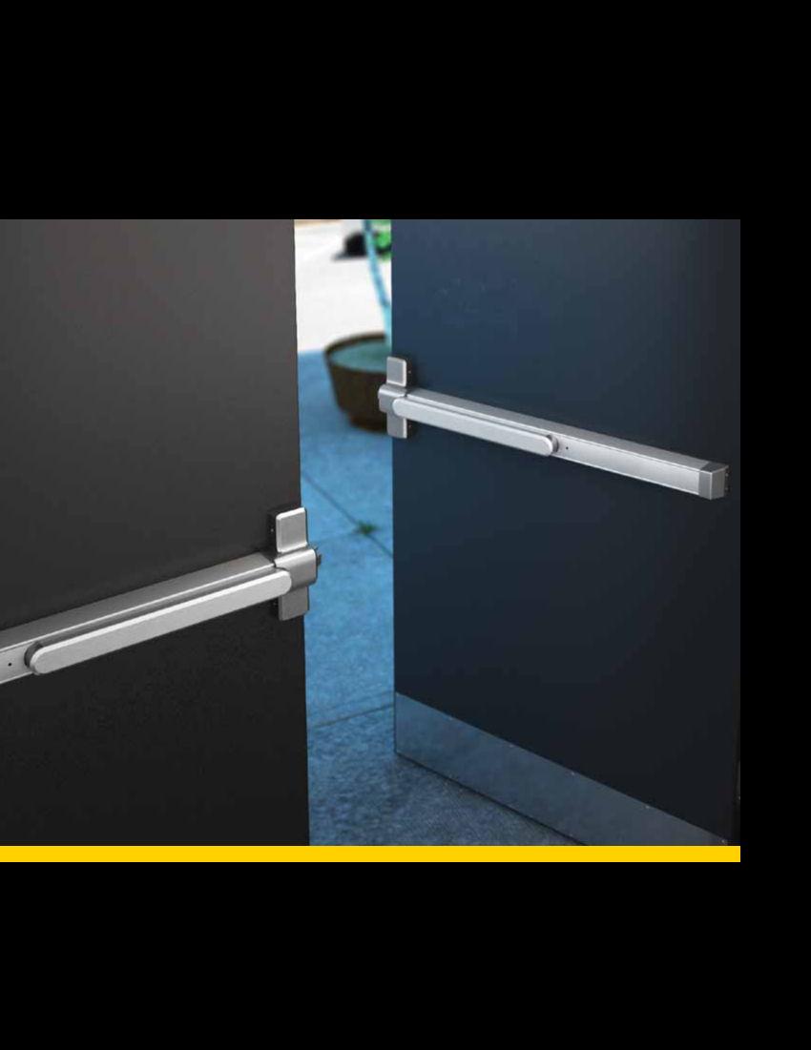
Exit Devices
QED 100 Series: Grade 1 Heavy-Duty Exit Devices
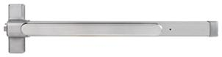

Rim Type

Performance Features

- Tested and certified to significantly exceed 1,000,000 cycles – well above the requirements for Grade 1 certification.

- Thru-bolt trim design for increased security and durability.

- Wide variety of trim options to fit any job.

- Consistent styling allows for harmonization with other STANLEY Commercial Hardware products.

Certifications

- ANSI/BHMA A156.3 – Grade 1

- UL/cUL listed (3 hours) for “A” label door applications (8' x 8')

- ANSI A117.1 Section 404.2.6 Accessibility Code (ADA Compliant)

- Hurricane Compliant – Miami-DADE N.O.A. See page 78 for more details.

QED111
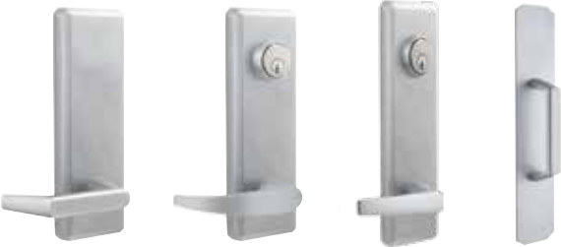

Sierra (E) Summit (M) Slate (A) Pull Plate (L)

Product Specifications

- Handing – All QED100 Series Exit Devices are non-handed.

- Door thickness – 1 3⁄4" standard (44.5mm).

- Latch bolt – Stainless steel 3⁄4" standard (19mm).

- Fasteners – Wood screws, machine screws and sex bolts standard.

- Head cap & end cap – Zinc die-cast.

- Trims – Sierra, Summit and Slate styles available. Escutcheon offering – Dummy, passage, keyed, night latch. Pull plate offering – Dummy, thumbpiece, night latch, flat plate.

- Stile width – 4 1⁄4" minimum (108mm).

- Dogging – Hex key dogging and cylinder dogging available.

- 36" field sizeable to 32" door. 48" field sizeable to 36" door.

- Standard backset – 2 7⁄8" (62mm) to face of doorstop.

- Electrification options available.

Keying

- Offered with the following keyway options: BF-SFIC "F", KW-Kwikset, WE-Weiser, SC-Schlage, GA-Yale, LA-Sargent & LC-Less Cylinder. Consult factory for other cylinder options and for details on Mortise and Rim Cylinder requirements.

Warranty

- Lifetime Mechanical, 3-year finish, 1-year electrical

Functions

Series | Description
QED111 | Rim Hex Dog
QED112 | Rim Cylinder Dog
QED113 | Rim Fire-Rated

Exit Trim Offerings

ANSI | Series | Description
02 | QET120 | Dummy Lever Escutcheon
02 | QET125 | Dummy Pull Plate
14 | QET130 | Passage Lever Escutcheon
08 | QET160 | Keyed Lever Escutcheon
05 | QET165 | Thumbpiece
02 | QET167 | Dummy Thumbpiece
09 | QET170 | Night Latch Lever Escutcheon
03 | QET175 | Night Latch Pull
01 | QET190 | Flat Plate

Finishes

BHMA | Description
605 | Bright Brass
710 | Anodized Duranodic Bronze
626 | Satin Chrome

EXIT DEVICES

Full Line Catalog STANLEY Commercial Hardware 37

QED 100 Series: Grade 1 Heavy-Duty Exit Devices

Surface Vertical Rod (SVR) Type
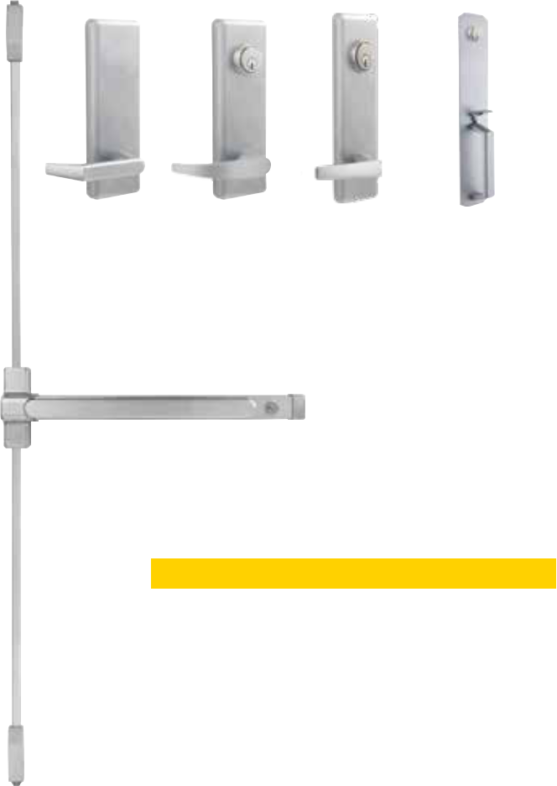

Performance Features

- Tested and certified to significantly exceed 1,000,000 cycles – well above the requirements for Grade 1 certification.

- Thru-bolt trim design for increased security and durability.

- Wide variety of trim options to fit any job.

• Consistent styling allows for harmonization with other STANLEY | Sierra (E) | Summit (M) | Slate (A) | Thumbpiece
Commercial Hardware products. |  |  |  | Plate (L)

Certifications

• | ANSI/BHMA A156.3 – Grade 1
• | UL/cUL listed (3 hours) for “A” label door applications (8' x 8') | QED115

- ANSI A117.1 Section 404.2.6 Accessibility Code (ADA Compliant)

- Hurricane Compliant – Miami-DADE N.O.A. See page 72 for more details.
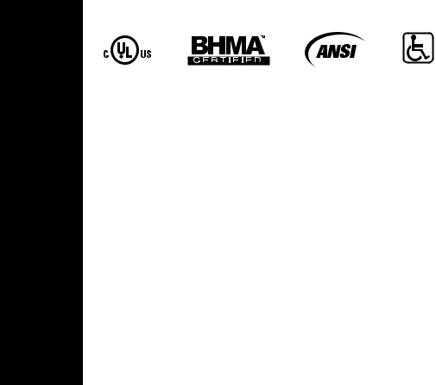

EXIT DEVICES

Product Specifications

- Handing – All QED100 Series Exit Devices are non-handed.

- Door thickness – 1 3⁄4" standard (44.5mm).

- Door height – 7' standard with 84" rods; 8' with 96" rods.

- Latch bolt – Stainless steel 1 ⁄2" throw (12.7mm).

- Fasteners – Wood screws, machine screws and sex bolts standard.

- Head cap & end cap – Zinc die-cast.

- Trims – Sierra, Summit and Slate styles available. Escutcheon offering – Dummy, passage, keyed, night latch. Pull plate offering – Dummy, thumbpiece, night latch, flat plate.

- Stile width – 3 1⁄2" minimum (89mm). Consult installation template for appropriate device length to ensure proper fit.

- Dogging – Hex key dogging and cylinder dogging available.

- 36" field sizeable to 32" door. 48" field sizeable to 36" door.

- Standard backset – 2 7⁄8" (62mm) to face of doorstop.

- Electrification options available.

- QED119 includes bottom fire latch.

Keying

- Offered with the following keyway options: BF-SFIC "F", KW-Kwikset, WE-Weiser, SC-Schlage, GA-Yale, LA-Sargent & LC-Less Cylinder.

Consult factory for other cylinder options and for details on Mortise and Rim Cylinder requirements.

Warranty

- Lifetime Mechanical, 3-year finish, 1-year electrical

Functions

Series | Description
QED114 | SVR Hex Dog
QED115 | SVR Cylinder Dog
QED116 | SVR Fire-Rated
QED117 | SVR Less Bottom Rod – Hex Dog
QED118 | SVR Less Bottom Rod – Cylinder Dog
QED119 | SVR Less Bottom Rod – Fire-Rated

Exit Trim Offerings


ANSI | Series | Description
02 | QET120 | Dummy Lever Escutcheon
02 | QET125 | Dummy Pull Plate
14 | QET130 | Passage Lever Escutcheon

- QET160 Keyed Lever Escutcheon

- QET165 Thumbpiece

02 | QET167 | Dummy Thumbpiece
09 | QET170 Night Latch Lever Escutcheon
03 | QET175 | Night Latch Pull
01 | QET190 | Flat Plate

Finishes
BHMA | Description
605 | Bright Brass
710 | Anodized Duranodic Bronze
626 | Satin Chrome

- Full Line Catalog STANLEY Commercial Hardware

QED 100 Series: Grade 1 Heavy-Duty Exit Devices
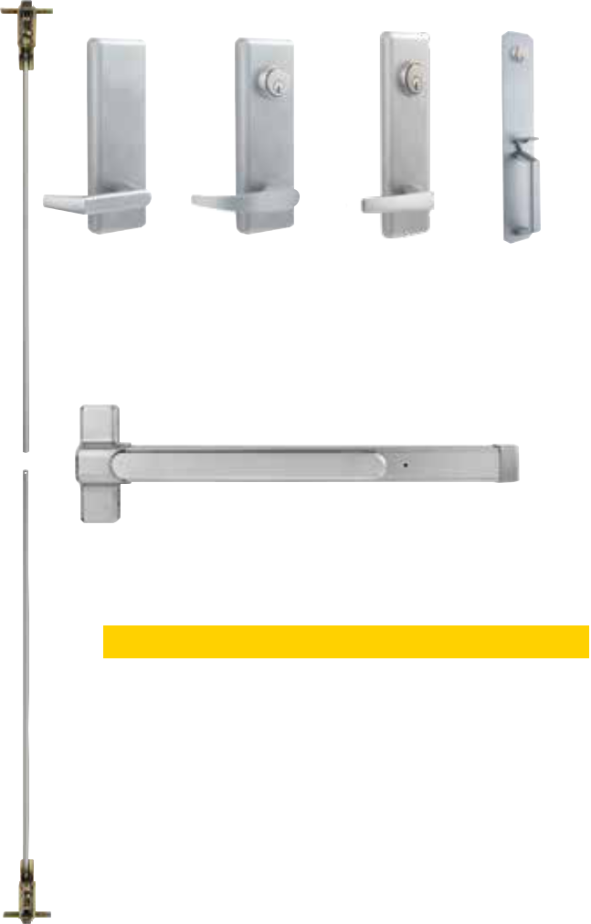

Concealed Vertical Rod (CVR) Type

Performance Features

- Tested and certified to significantly exceed 1,000,000 cycles – well above the requirements for Grade 1 certification.

- Thru-bolt trim design for increased security and durability.

- Wide variety of trim options to fit any job.

- Consistent styling allows for harmonization with other STANLEY Commercial Hardware products.

Certifications

- ANSI/BHMA A156.3 – Grade 1

- UL/cUL listed (3 hours) for “A” label door applications (8' x 8')

- ANSI A117.1 Section 404.2.6 Accessibility Code (ADA Compliant)

Product Specifications

- Handing – All QED100 Series Exit Devices are non-handed.

- Door thickness – 1 3⁄4" standard (44.5mm).

- Door height – 7' standard with 84" rods; 8' with 96" rods.

- Latch bolt – Stainless steel 1⁄2" throw (12.7mm).

- Fasteners – Wood screws, machine screws and sex bolts standard.

- Head cap & end cap – Zinc die-cast.

- Trims – Sierra, Summit and Slate styles available. Escutcheon offering – Dummy, passage, keyed, night latch. Pull plate offering – Dummy, thumbpiece, night latch, flat plate.

- Stile width – 3 1⁄2" minimum (89mm). Consult installation template for appropriate device length to ensure proper fit.

- Dogging – Hex key dogging and cylinder dogging available.

- 36" field sizeable to 32" door. 48" field sizeable to 36" door.

- Standard backset – 2 7⁄8" (62mm) to face of doorstop.

- Electrification options available.

- QED129 includes bottom fire latch.

Keying

- Offered with the following keyway options: BF-SFIC "F", KW-Kwikset, WE-Weiser, SC-Schlage, GA-Yale, LA-Sargent & LC-Less Cylinder. Consult factory for other cylinder options and for details on Mortise andRim Cylinder requirements.

Warranty

- Lifetime Mechanical, 3-year finish, 1-year electrical

Sierra (E) Summit (M) Slate (A) Thumbpiece
Plate (L)

QED124

Functions

Series | Description
QED124 | CVR Hex Dog
QED125 | CVR Cylinder Dog
QED126 | CVR Fire-Rated
QED127 | CVR Less Bottom Rod – Hex Dog
QED128 | CVR Less Bottom Rod – Cylinder Dog
QED129 | CVR Less Bottom Rod – Fire-Rated

Exit Trim Offerings

ANSI | Series | Description
02 | QET120 | Dummy Lever Escutcheon
02 | QET125 | Dummy Pull Plate
14 | QET130 | Passage Lever Escutcheon
08 | QET160 | Keyed Lever Escutcheon
05 | QET165 | Thumbpiece
02 | QET167 | Dummy Thumbpiece
09 | QET170 | Night Latch Lever Escutcheon
03 | QET175 | Night Latch Pull
01 | QET190 | Flat Plate

Finishes

BHMA | Description
605 | Bright Brass
710 | Anodized Duranodic Bronze
626 | Satin Chrome

EXIT DEVICES

Full Line Catalog STANLEY Commercial Hardware 39

EXIT DEVICES
QED 100 Series: Grade 1 Heavy-Duty Exit Devices

C
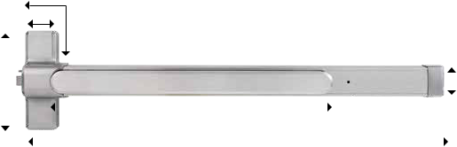

D

E |  |  |  | B |  |  |  | F
 |  |  |  | A


 |  | 36" Device |  |  | 48" Device |  |  | All QED100 Devices
QED100 Series
QED100 Series | Minimum | Device | Pushpad | Minimum | Device | Pushpad | Head Cap | Head Cap | Head Cap | End Cap
 | Door Width | Length | Length | Door Width | Length | Length | Length | Length | Width | Length

Measurement |  |  | A | B |  | A |  | B |  | C | D |  | E | F
Panic-Rated | 30" |  | 33" | 20.5" | 36" | 45" |  | 24.5" |  | 3.625" | 2.75" | 9" |  | 2.5"
(with Dogging) |  | 762mm | 838.20mm | 520.70mm | 914.40mm | 1143mm |  | 622.30mm |  | 92.10mm | 69.90mm | 228.60mm |  | 63.50mm
Fire-Rated or Panic | 29" |  | 33" | 20.5" | 33" | 45" |  | 24.5" |  | 3.625" | 2.75" | 9" |  | 2.5"
(with Dogging |  | 736.60mm | 838.20mm | 520.70mm | 838.20mm | 1143mm |  | 622.30mm |  | 92.10mm | 69.90mm | 228.60mm |  | 63.50mm
Removed)
Model/Series |  | Functions |  |  |  |  |  |  |  |  | Style |  | Case Qty
QED111 |  | Rim Hex Dog |  |  |  |  |  |  |  |  | — |  |  | 1
QED112 |  | Rim Cylinder Dog |  |  |  |  |  |  |  |  | — |  |  | 1
QED113 |  | Rim Fire-Rated |  |  |  |  |  |  |  |  | — |  |  | 1
QED114 |  | SVR Hex Dog |  |  |  |  |  |  |  |  | 7FT |  |  | 1
QED115 |  | SVR Cylinder Dog |  |  |  |  |  |  |  |  | 7FT |  |  | 1
QED116 |  | SVR Fire-Rated |  |  |  |  |  |  |  |  | 7FT |  |  | 1
QED117 |  | SVR Less Bottom Rod (LBR) Hex Dog |  |  |  |  |  |  |  |  | 7FT |  |  | 1
QED118 |  | SVR LBR Cylinder Dog |  |  |  |  |  |  |  |  | 7FT |  |  | 1
QED119 |  | SVR LBR Fire-Rated |  |  |  |  |  |  |  |  | 7FT |  |  | 1
QED124 |  | CVR Hex Dog |  |  |  |  |  |  |  |  | 7FT |  |  | 1
QED125 |  | CVR Cylinder Dog |  |  |  |  |  |  |  |  | 7FT |  |  | 1
QED126 |  | CVR Fire-Rated |  |  |  |  |  |  |  |  | 7FT |  |  | 1
QED127 |  | CVR LBR Hex Dog |  |  |  |  |  |  |  |  | 7FT |  |  | 1
QED128 |  | CVR LBR Cylinder Dog |  |  |  |  |  |  |  |  | 7FT |  |  | 1
QED129 |  | CVR LBR Fire-Rated |  |  |  |  |  |  |  |  | 7FT |  |  | 1
 |  |  |  |  |  | Other Options
 |  |  |  |  |  |  | 8FT |  | Vertical rod kit for 8FT door application
NOTES: All Less Bottom Rod (LBR) fire-rated devices |  |  |  |  |  |  | 48" |  | 48" Device (Consult factory for lead-time)
 |  |  |  |  |  |  | HC |  | Hurricane Compliant
include a bottom fire latch. |  |  |  |  |  |  | HC


- Full Line Catalog STANLEY Commercial Hardware

QED 100 Series: Grade 1 Heavy-Duty Exit Devices

Electrified Options (Consult Factory For Lead Times)
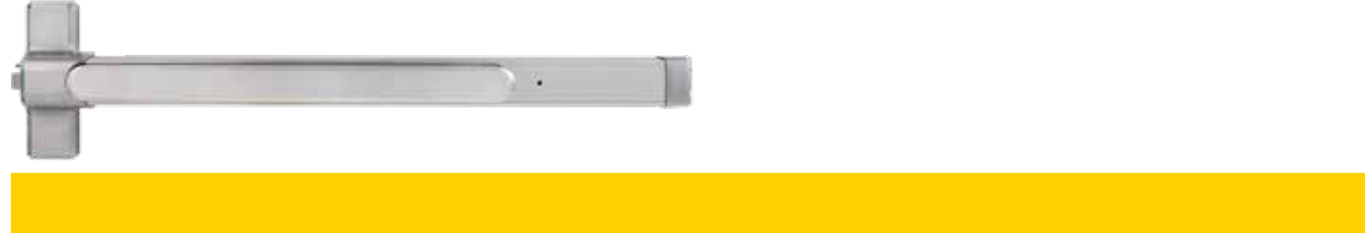

Model # | Description
QED___LR | Electrified Latch Retraction (LR) allows for the remote unlatching of exit devices. Continuous duty solenoids retract latches momentarily or for
QED___LR | extended periods of time. Requires the use of Stanley Commercial Hardware power supply 8Q00312 or 8Q00313.
QED___ED | Electrified Dogging (ED) allows continuous latch retraction and dogging simultaneously. ED requires first-time mechanical activation after which the
QED___ED | push bar will continuously hold the push bar and latch retracted. When power is removed or interrupted from the device, the latch bolt will extend
 | and push bar will release. Uses power supply 8Q00314 (see p. 20).
QED___X | Request to Exit (X) is an SPDT (Single Pole Double Throw) switch which monitors the push bar of the exit device. The X switch can be used to
QED___X | activate a door alarm, control a magnetic locking device, shunt a door alarm or signal a control console when the push bar is depressed.
QED___LRX | Electrified Latch Retraction (LR) device with a Request to Exit (X) switch. Requires the use of Stanley Commercial Hardware power supply 8Q00312
QED___LRX | or 8Q00313.
QED___EDX | Electrified Dogging (ED) device with a Request to Exit (X) switch. Uses power supply 8Q00314 (see p. 20).

Power Supply Options (Consult Factory For Lead Times)

Model # | Description
8Q00312 | Power supply for Electronic Latch Retraction Devices (LR/LRX).
8Q00313 | Power supply with day/night mode for Electronic Latch Retraction Devices (LR/LRX).

EXIT DEVICES

Electrified Product Specifications

- Consult factory for lead times.

- Electrification prices should be added to price of device.

- Continuous duty solenoids.

- Ties into alarm systems and electromagnetic locks.

- 24V AC/DC with .150 amp current.

- Lifetime warranty on exit device; 1-year warranty on electronic components.

- LR or LRX require power supply 8Q00312 or 8Q00313.

- Minimum door width 36."

- LR and ED require the removal of mechanical dogging mechanism.

- Options can be used in any Hex Dog or Fire-Rated QED100 Series Device (How to order example: QED111LR 36" 626).

Power Supply Specifications (10" x 10" x 4.25")

8Q00312

- Provides power for up to two LR or LRX devices.

- Supplied with wiring diagram in detailed instructions.

- Automatic door operator interface.

- Independent control of single exit devices (one or two single-doors) or sequential operation of two devices (pair of doors).

- Field adjustable latch retraction time delay.

- 24V DC or 12V DC auxiliary power, unfiltered and unregulated.

8Q00313

- Same as 8Q00312 with the addition of a day/night mode.

- Provides separate input for retracting one exit device or two exit devices sequentially without activating the auto door operator. While the latches are held retracted, auto operator can be activated independently from a different output.

Full Line Catalog STANLEY Commercial Hardware 41

How to Order

QED 100 Series: Grade 1 Heavy-Duty Exit Devices

EXIT DEVICES

Example

If you ordered: QED115 LR 36" 7FT 313AN KW KD

You would get: Grade 1 Heavy-Duty Architectural Surface Vertical Rod Exit Device with Cylinder Dogging for a 7' Door, in Anodized Duranodic Bronze, Kwikset Keyway, Keyed Different.


 |  |  |  |  |  |  |  | KD | Keyed Different
 |  |  |  |  |  |  |  | KA | Keyed Alike
11 | Rim Hex Dog | 24 | CVR Hex Dog
 |  |  |  |  |  |  |  | CK | Construction Keyed
12 | Rim Cylinder Dog | 25 | CVR Cylinder Dog |  |  |  |  | CK | Construction Keyed
 |  |  |  |  |  |  |  | CMK | Construction Master
13 | Rim Fire-Rated | 26 | CVR Fire-Rated |  |  |  |  | CMK | Construction Master
 |  |  |  |  |  |  |  | CMK | Keyed
14 | SVR Hex Dog | 27 | CVR LBR – Hex Dog
 |  |  |  |  |  |  |  | MAIS | Maison Keyed
15 | SVR Cylinder Dog | 28 | CVR LBR – Cylinder Dog
 |  |  |  |  |  |  |  | MK | Master Keyed
 |  |  |  |  | 605 | Bright Brass |  | MK | Master Keyed
16 | SVR Fire-Rated | 29 | CVR LBR – Fire-Rated |  | 605 | Bright Brass
 |  |  |  |  | 605 | Bright Brass |  | GMK | Grand Master Keyed
17 | SVR LBR – Hex Dog |  |  |  |  | Anodized
17 | SVR LBR – Hex Dog |  |  |  | 313AN | Anodized |  | GGMK | Great Grand Master
 |  |  |  |  | 313AN | Duranodic Bronze |  | GGMK | Great Grand Master
18 | SVR LBR – Cylinder Dog |  |  |  |  | Duranodic Bronze |  | GGMK | Keyed
19 | SVR LBR – Fire-Rated |  |  |  | 626 | Satin Chrome |  | ZB | Zero Bitted


 |  |  |  |  |  |  |  |  |  |  |  |  |  |  |  | Base Part Number
 |  | Series |  |  |  | Function |  |  | Options |  |  |  |  | Size |  |  |  | Height |  |  |  |  | Finish |  |  | Keyway |  |  | Keying |  | Notes
 |  | QED1 |  |  |  | 15 |  |  | LR |  |  |  | 36" |  |  |  |  |  | 7FT |  |  |  | 313AN |  |  | KW |  |  | KD |  | XXXX
 |  | Grade 1 Architectural |  |  |  |  |  |  |  |  |  |  | 36" |  | 36" Device |  |  |  |  |  |  |  |  |  |  | KW |  | Kwikset “KW”
QED1xx
QED1xx |  |  |  |  |  |  |  |  |  |  |  |  | 48" |  | 48" Device
QED1xx |  | Exit Device |  |  |  |  |  |  |  |  |  |  |  |  |  |  |  |  |  |  |  |  |  |  |  | WE |  | Weiser “E”
 |  |  |  |  |  |  |  |  |  |  |  |  |  |  |  |  |  |  |  |  |  |  |  |  |  | SC |  | Schlage “C”
 |  |  |  |  |  |  |  |  |  |  |  |  |  |  |  |  |  |  |  |  |  |  |  |  |  | GA |  | Yale “GA”
 |  |  |  | LR |  | Electrified Latch Retraction |  |  |  |  |  |  |  |  |  |  |  | 7FT |  | 7 ft Rod
 |  |  |  |  |  |  |  |  |  |  |  |  |  |  |  |  |  |  |  |  |  |  |  |  |  | LA |  | Sargent “LA”
 |  |  |  |  |  |  |  |  |  |  |  |  |  |  |  |  |  | 8FT |  | 8 ft Rod
 |  |  |  |  |  | Electrified Latch Retraction |  |  |  |  |  |  |  |  |  |  |  | 8FT
 |  |  |  | LRX |  |  |  |  |  |  |  |  |  |  |  |  |  |  |  |  |  |  |  |  |  | BF |  | SFIC “F”
 |  |  |  |  |  | with Request to Exit
 |  |  |  |  |  |  |  |  |  |  |  |  |  |  |  |  |  |  |  |  |  |  |  |  |  | LC |  | Less Cylinder
 |  |  |  | ED |  | Electrified Dogging
 |  |  |  | EDX |  | Electrified Dogging
 |  |  |  |  |  | with Request to Exit
 |  |  |  | X |  | Request to Exit
 |  |  |  | HC |  | Hurricane Compliant



- Full Line Catalog STANLEY Commercial Hardware

QRM 100 Series: Mullions
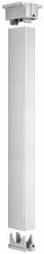
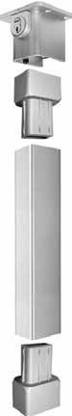

Performance Features

- 2" x 3" steel mullion tube. 1/8" wall thickness.

- Hurricane – 2" x 3" steel mullion tube. 5/16" wall thickness.

- Head cap, bottom sill & hurricane mullion adapters – investment cast steel.

- Size – Standard for openings 8' high, field sizable for openings less than 8.' 9', 10', 11' & 12' also available and are field sizable.

- Mullion is pre-prepped for QED100 Series Exit Devices.

- Fire and Hurricane Rating 8' high max.

- Available finishes – Primer (600), Aluminum (689) and Dark Bronze (695).

Keyed Removable Mullions (Consult Factory For Mullion Lead Times)
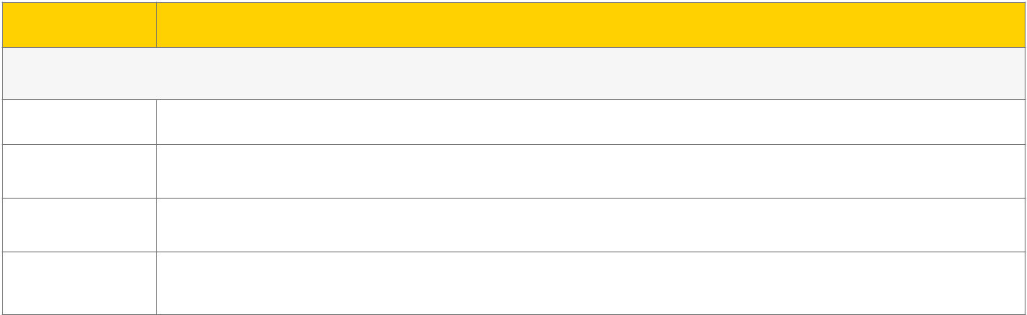

Order Description

Cylinder not included. Keyed removable mullions utilize standard rim cylinders. Reference cylinders, keys & keying section for more details.

QRM111 KR | Keyed Removable Mullion. Includes: Mullion tube, cap, base, fasteners & strike.

QRM111 HC KR Hurricane Compliant, Keyed Removable Mullion. Includes: Mullion tube, cap, base, fasteners & strike interlock.

QRM113 KR | Fire-Rated, Keyed Removable Mullion. Includes: Mullion tube, cap, base, fasteners & strike interlock.

QRM113 HC KR Fire-Rated, Hurricane Compliant, Keyed Removable Mullion. Includes: Mullion tube, cap, base, fasteners & strike interlock.

Removable Mullions (Consult Factory For Mullion Lead Times)

Order | Description
QRM111 | Removable Mullion. Includes: Mullion tube, cap, base, fasteners & strike.
QRM111 HC | Hurricane Compliant, Removable Mullion. Includes: Mullion tube, cap, base, fasteners & strike interlock.
QRM113 | Fire-Rated, Removable Mullion. Includes: Mullion tube, cap, base, fasteners & strike interlock.
QRM113 HC | Fire-Rated, Hurricane Compliant, Removable Mullion. Includes: Mullion tube, cap, base, fasteners & strike interlock.

EXIT DEVICES

Full Line Catalog STANLEY Commercial Hardware 43

How to Order

QRM 100 Series: Mullions

Example

If you ordered: QRM111 HC KR 8FT 600

You would get: Keyed Removable, Hurricane Compliant mullion, 8' height, with

Primer finish. Prepped for QED100 Series strike.


 |  |  |  |  |  | 600 | Primer
 |  |  | HC | Hurricane Compliant
 |  |  |  |  |  | 689 | Aluminum
QRM1 | Mullion Prepped for
QRM1 | QED100 Series |  | KR | Keyed Removable |  | 695 | Dark Bronze
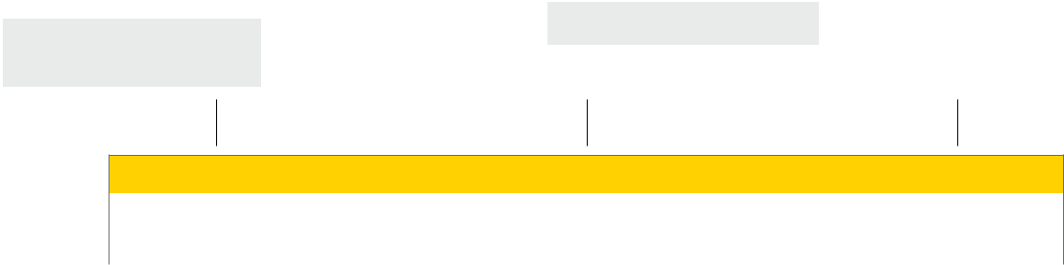

Base Part Number

Series | Function | Options | Height | Finish
QRM1 | 11 | HC KR | 8FT | 600


EXIT DEVICES

- Standard

- Fire-Rated
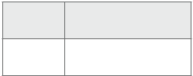

8FT | Standard Height
9FT
10FT | Not Available in Fire-
 | Rated or Hurricane-
11FT | Compliant Options
12FT

- Full Line Catalog STANLEY Commercial Hardware

QET 100 Series: Grade 1 Heavy-Duty Exit Trims

Escutcheon Trims Sierra (E) Escutcheon Trims Summit (M) Escutcheon Trims Slate (A)

• Available in: 605, 613*, 626 • Available in: 605, 613*,, 626 • Available in: 605, 613*, 626
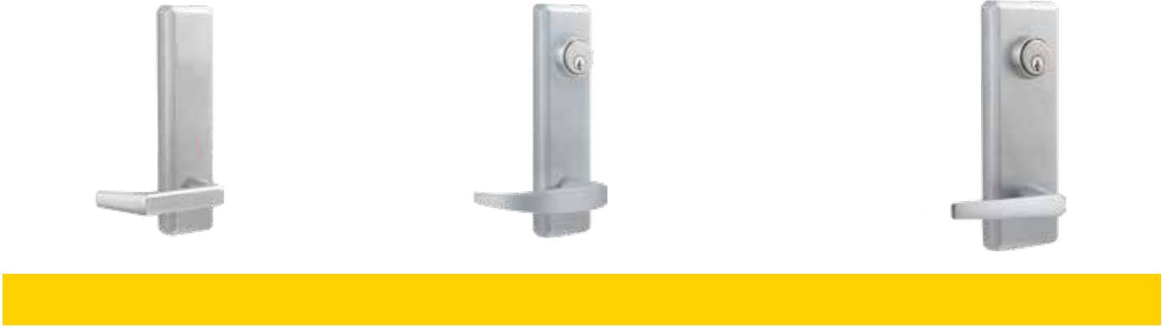

Model/Series | Functions | Style | Cylinder Type | Qty
QET120 | Dummy Lever Escutcheon | E/M/A | — | 6
QET130 | Passage Lever Escutcheon | E/M/A | — | 6
QET160 | Keyed Lever Escutcheon (Classroom) | E/M/A | Mortise | 6
QET170 | Night Latch Lever Escutcheon (Storeroom) | E/M/A | Rim | 6

NOTES: Cylinders ordered separately.

*613 Finish trims match 313 finish exit devices.

Escutcheon Trims Pull & Flat Plates

- Available in: 605, 626, 690

EXIT DEVICES

Dummy Pull | Thumbpiece | Dummy Thumbpiece | Night Latch Pull | Flat Plate
QET125 | QET165 | QET167 | QET175 | QET190

Model/Series | Functions |  | Style | Cylinder Type |  | Qty
QET125 | Dummy Pull Escutcheon |  | L | — |  | 6
QET165 | Thumbpiece Pull Escutcheon |  | L | Mortise |  | 6
QET167 | Dummy Thumbpiece Pull Escutcheon |  | L | — |  | 6
QET175 | Night Latch Pull Escutcheon |  | L | Rim |  | 6
QET190 | Flat Plate Escutcheon |  | L | — |  | 6
NOTES: Cylinders ordered separately.
 |  | Full Line Catalog STANLEY Commercial Hardware |  |  | 45

QET 100 Series: Grade 1 Heavy-Duty Exit Trims

EXIT DEVICES

B
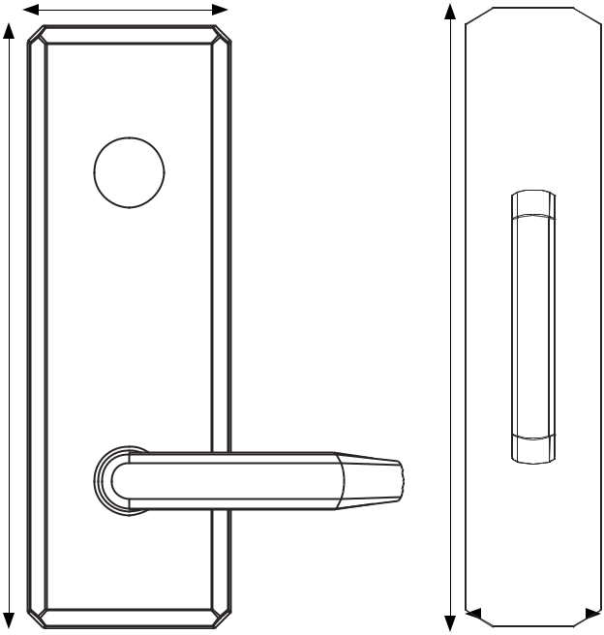

A
C

 |  |  |  |  |  | Dimensions
 |  |  |  |  | A | B | C | D
 |  |  |  |  | 9.78" | 3.28" | 14" | 3"
 |  |  | D
 |  |  |  |  | 248.60mm | 83.31mm | 355.60mm | 76.20mm
Functions | Description
QET120 | Dummy Lever Escutcheon | Used for door pull when device is dogged or as matching inactive trim.
QET120 | Dummy Lever Escutcheon | No mechanical operation.
QET125 | Dummy Pull Escutcheon | Used for door pull when device is dogged or as matching inactive trim.
QET125 | Dummy Pull Escutcheon | No mechanical operation.
QET130 | Passage Lever Escutcheon | Levers always unlocked and always free for immediate ingress.
QET160 | Keyed Lever Escutcheon | Key locks & unlocks lever (operates same as classroom function).
QET165 | Thumbpiece Pull Escutcheon | Key locks & unlocks thumbpiece (operates same as classroom function).
QET167 | Dummy Thumbpiece | Used for door pull when device is dogged or as matching inactive trim. No mechanical operation.
QET167 | Pull Escutcheon | Matches QET165.
QET170 | Night Latch Lever Escutcheon | Lever always locked, key retracts latch for entrance (operates same as
QET170 | Night Latch Lever Escutcheon | storeroom function).
QET175 | Night Latch Pull Escutcheon | Outside always locked, key retracts latch for entrance (operates same as
QET175 | Night Latch Pull Escutcheon | storeroom function).
QET190 | Flat Plate Escutcheon | Blank trim plate—used to cover existing door prep for an exit-only application.

- Full Line Catalog STANLEY Commercial Hardware

How to Order

QET 100 Series: Grade 1 Heavy-Duty Exit Trims

Example

If you ordered: QET160 M 626 KW KD

You would get: Grade 1 Escutcheon Trim Lever, Summit design, Satin Chrome, Kwikset

Keyway, Keyed Different. This trim matches to the QED100 Series Exit Devices.
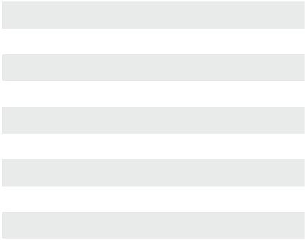

20 | DL – Dummy Trim Lever
25 | DP – Dummy Trim Pull
25 | DP – Dummy Trim Pull |  |  |  |  | KD | Keyed Different
30 | PL – Passage Lever |  |  |  |  | KA | Keyed Alike
60 | KL – Keyed Lever |  |  |  |  | CK | Construction Keyed
 |  |  |  |  |  | CMK | Construction Master Keyed
65 | TP – Thumbpiece Escutcheon |  |  |  |  | CMK | Construction Master Keyed
65 | TP – Thumbpiece Escutcheon |  |  |  |  | MAIS | Maison Keyed
67 | DT – Dummy Thumbpiece Escutcheon |  | 605 | Bright Brass |  | MAIS | Maison Keyed
 |  |  |  |  |  | MK | Master Keyed
70 | NL – Night Latch Lever Escutcheon |  | 613† | Oil Rubbed Bronze |  | MK | Master Keyed
 |  |  |  |  |  | GMK | Grand Master Keyed
75 | NL – Night Latch Pull Escutcheon |  | 626 | Satin Chrome |  | GMK | Grand Master Keyed
 |  |  |  |  |  | GGMK | Great Grand Master Keyed
90 | Flat Plate |  | 690† | Painted Duranodic Bronze
 |  |  |  |  |  | ZB | Zero Bitted


 |  |  |  |  |  |  |  |  |  |  |  |  |  |  |  |  |  |  |  |  |  | DEVICES
 |  |  |  |  |  |  |  |  |  | Base Part Number |  |  |  |  |  |  |  |  |  |  |  | DEVICES
 |  | Series |  |  | Function |  |  | Design |  |  | Finish |  |  |  | Keyway |  |  | Keying |  |  | Notes | EXIT
 |  | QET1 |  |  | 60 |  |  | M |  |  | 626 |  |  |  | KW |  |  | KD |  |  | XXXX | EXIT
QET1xx | Grade 1 Architectural |  |  |  |  |  |  | E |  | Sierra |  |  |  |  | KW |  | Kwikset “KW”*
QET1xx | Exit Trim |  |  |  |  |  |  | M |  | Summit |  |  |  |  | WE |  | Weiser “E”*
 |  |  |  |  |  |  |  | A |  | Slate |  |  |  |  | SC |  | Schlage “C”*
 |  |  |  |  |  |  |  |  |  |  |  |  |  |  | GA |  | Yale “GA”
 |  |  |  |  |  |  |  |  |  |  |  |  |  |  | LA |  | Sargent “LA”
 |  |  |  |  |  |  |  |  |  |  |  |  |  |  | BF |  | Best “F” (SFIC)
 |  |  |  |  |  |  |  |  |  |  |  |  |  |  | LC |  | Less Cylinder



NOTES: †613 finish available for lever escutcheon trims; 690 finish available for escutcheon pull trims.

*Available in 6-pin and 5-pin. 6-pin is standard.

Full Line Catalog STANLEY Commercial Hardware 47

QED 200 Series: Grade 1 Heavy-Duty Narrow Stile Exit Devices

Rim Type
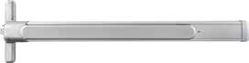

EXIT DEVICES

Performance Features

- Consistent styling allows for harmonization with other STANLEY Commercial Hardware products.

- Thru-bolt trim design for increased security and durability.

- Wide variety of trim options to fit any job.

Certifications

- ANSI/BHMA A156.3 – Grade 1

- UL/cUL listed (3 hours) for “A” label doors (8' x 8') when used with HMS strike

- ANSI A117.1 Section 404.2.6 Accessibility Code (ADA Compliant)

Product Specifications

- Handing – All QED200 Series Exit Devices are non-handed.

- Door thickness – 1 3⁄4" standard (44.5mm).

- Latch bolt – Stainless steel 3⁄4" standard (19mm).

- Fasteners – Wood screws, machine screws and sex bolts standard.

- Head cover & end cap – Zinc die-cast.

- Trims – Sierra, Summit and Slate styles available. Escutcheon offering – Dummy, passage, keyed, night latch. Pull plate offering – Dummy, night latch, flat plate.

- Stile width – 2" minimum (50.8 mm) for ALS strike; 3 1⁄2" minimum (88.9 mm) for HMS strike option.

- Dogging – Hex key dogging and cylinder dogging available.

- 36" field sizeable to 26" door. 48" field sizeable to 36" door.

Keying

- Offered with the following keyway options: BEST 'F' SFIC, KW-Kwikset, WE-Weiser, SC-Schlage, GA-Yale, LA-Sargent and LC-Less Cylinder. Consult factory for details on Mortise and Rim Cylinder requirements.

Warranty

- Lifetime Mechanical and 3-year finish

NOTES: *QED213 available with HMS strike only.

- Full Line Catalog STANLEY Commercial Hardware

QED211
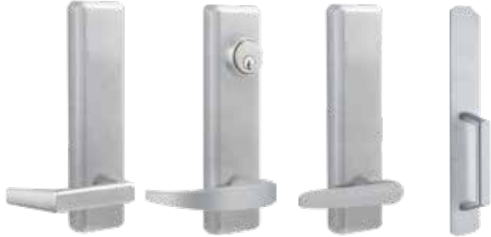

Sierra (E) Summit (M) Slate (A) Pull Plate (L)

Functions

Series | Description
QED211 | Rim Hex Dog
QED212 | Rim Cylinder Dog
QED213 | Rim Fire-Rated*

Exit Trim Offerings

ANSI | Series | Description
02 | QET220 | Dummy Lever Escutcheon
02 | QET225 | Dummy Pull Plate
14 | QET230 | Passage Lever Escutcheon
08 | QET260 | Keyed Lever Escutcheon
03 | QET270 | Night Latch Lever Escutcheon
03 | QET275 | Night Latch Pull
09 | QET280 | Night Latch Lever Escutcheon
01 | QET290 | Flat Plate

Finishes

BHMA | Description
605 | Bright Brass
313AN | Anodized Duranodic Bronze
626 | Satin Chrome

QED 200 Series: Grade 1 Heavy-Duty Narrow Stile Exit Devices

Surface Vertical Rod (SVR) Type

Performance Features

- Consistent styling allows for harmonization with other STANLEY Commercial Hardware products.

- Thru-bolt trim design for increased security and durability.

- Wide variety of trim options to fit any job.

Certifications

- ANSI/BHMA A156.3 – Grade 1

- UL/cUL listed (3 hours) for “A” label for 8' x 8' opening

- ANSI A117.1 Section 404.2.6 Accessibility Code (ADA Compliant)

Product Specifications

- Handing – All QED200 Series Exit Devices are non-handed.

- Door thickness – 1 3⁄4" standard (44.5mm).

- Door height – 7' standard with 84" rods; 8' with 96" rods.

- Latch bolt – Stainless steel 1⁄2" throw (12.7mm).

- Fasteners – Wood screws, machine screws and sex bolts standard.

- Head cover & end cap – Zinc die-cast.

- Trims – Sierra, Summit and Slate styles available. Escutcheon offering – Dummy, passage, keyed, night latch. Pull plate offering – Dummy, night latch, flat plate.

- Stile width – 2" minimum (50.8 mm).

- Dogging – Hex key dogging and cylinder dogging available.

- 36" field sizeable to 26" door. 48" field sizeable to 36" door.

- QED219 includes bottom fire bolt.

Keying

- Offered with the following keyway options: BEST 'F' SFIC, KW-Kwikset, WE-Weiser, SC-Schlage, GA-Yale, LA-Sargent and LC-Less Cylinder. Consult factory for other cylinder options and for details on Mortise and Rim Cylinder requirements.

Sierra (E) Summit (M) Slate (A) Pull Plate (L)
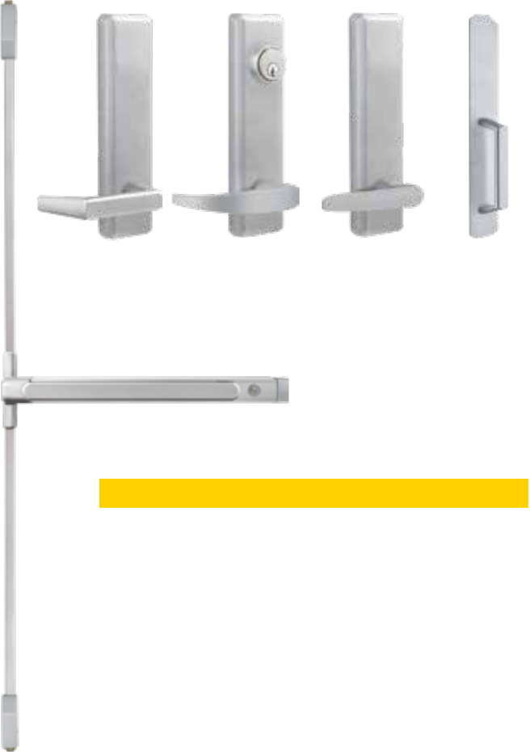

QED215

Functions

Series | Description
QED214 | SVR Hex Dog
QED215 | SVR Cylinder Dog
QED216 | SVR Fire-Rated
QED217 | SVR Less Bottom Rod – Hex Dog
QED218 | SVR Less Bottom Rod – Cylinder Dog
QED219 | SVR Less Bottom Rod – Fire-Rated

Exit Trim Offerings

ANSI | Series | Description
02 | QET220 | Dummy Lever Escutcheon
02 | QET225 | Dummy Pull Plate
14 | QET230 | Passage Lever Escutcheon
08 | QET260 | Keyed Lever Escutcheon
09 | QET280 | Night Latch Escutcheon
01 | QET290 | Flat Plate

EXIT DEVICES

Warranty | Finishes
• Lifetime Mechanical and 3-year finish | BHMA | Description
 | 605 | Bright Brass
 | 313AN | Anodized Duranodic Bronze
 | 626 | Satin Chrome

Full Line Catalog STANLEY Commercial Hardware 49

QED 200 Series: Grade 1 Heavy-Duty Narrow Stile Exit Devices

Concealed Vertical Rod (CVR) Type

Performance Features

- Consistent styling allows for harmonization with other STANLEY Commercial Hardware products.

- Thru-bolt trim design for increased security and durability.

- Wide variety of trim options to fit any job.

Certifications

- ANSI/BHMA A156.3 – Grade 1

- UL/cUL listed (3 hours) for “A” label for 8' x 8' opening

- ANSI A117.1 Section 404.2.6 Accessibility Code (ADA Compliant)

Sierra (E) Summit (M) Slate (A) Pull Plate (L)
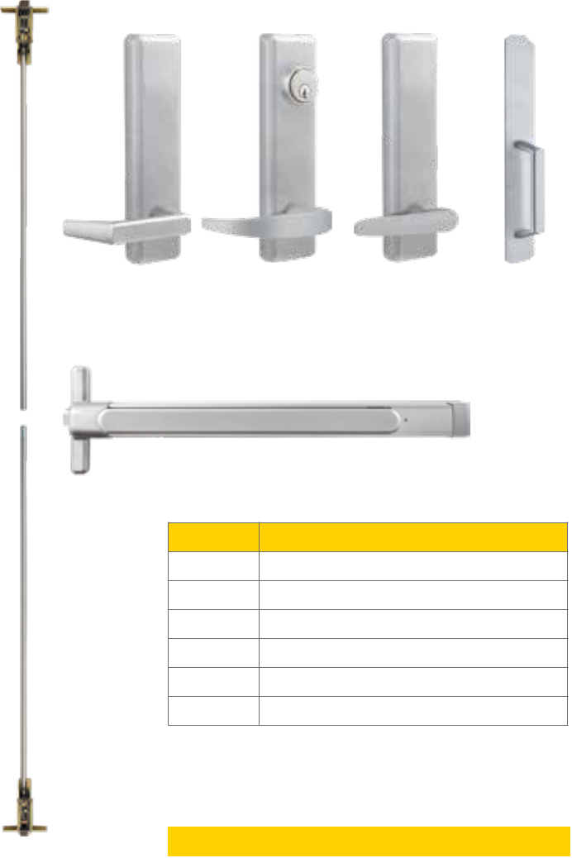

QED224

EXIT DEVICES

Product Specifications

- Handing – All QED200 Series Exit Devices are non-handed.

- Door thickness – 1 3⁄4" standard (44.5mm).

- Door height – 7' standard with 84" rods; 8' with 96" rods.

- Latch bolt – Stainless steel 1⁄2" throw (12.7mm).

- Fasteners – Wood screws, machine screws and sex bolts standard.

- Head cover & end cap – Zinc die-cast.

- Trims – Sierra, Summit and Slate styles available. Escutcheon offering – Dummy, passage, keyed, night latch. Pull plate offering – Dummy, night latch, flat plate.

- Stile width – 3 1⁄2" minimum (50.8 mm).

- Dogging – Hex key dogging and cylinder dogging available.

- 36" field sizeable to 26" door. 48" field sizeable to 36" door.

- QED229 includes bottom fire bolt.

Keying

- Offered with the following keyway options: BEST 'F' SFIC, KW-Kwikset, WE-Weiser, SC-Schlage, GA-Yale, LA-Sargent and LC-Less Cylinder. Consult factory for details on Mortise and Rim Cylinder requirements.

Functions

Series Description

QED224 CVR Hex Dog

QED225 CVR Cylinder Dog

QED226 CVR Fire-Rated

QED227 CVR Less Bottom Rod – Hex Dog

QED228 CVR Less Bottom Rod – Cylinder Dog

QED229 CVR Less Bottom Rod – Fire-Rated

Exit Trim Offerings

ANSI | Series | Description
02 | QET220 | Dummy Lever Escutcheon
02 | QET226 | Dummy Pull Plate
14 | QET230 | Passage Lever Escutcheon
08 | QET260 | Keyed Lever Escutcheon
09 | QET280 | Night Latch Escutcheon
01 | QET291 | Flat Plate

Warranty

- Lifetime Mechanical and 3-year finish

Finishes
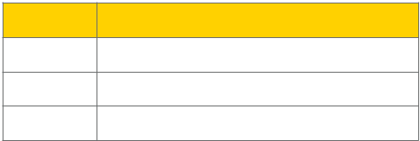

BHMA Description

605 | Bright Brass

313AN Anodized Duranodic Bronze

626 | Satin Chrome

- Full Line Catalog STANLEY Commercial Hardware

QED 200 Series: Grade 1 Heavy-Duty Narrow Stile Exit Devices

C
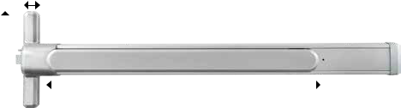

 | D |  |  |  |  |  |  | B |  |  |  |  |  |  |  | E
 |  |  |  |  |  |  |  |  | A
 |  |  |  |  |  |  | 36" Device |  |  |  |  |  |  |  | 48" Device
 | QED200 Series
 |  |  |  |  |  | Minimum |  | Device | Pushpad | Minimum |  |  |  | Device | Pushpad |  | Head Cover |  |  | Head Cover |  |  | End Cap
 |  |  |  |  |  | Door Width |  | Length | Length | Door Width |  |  |  | Length | Length |  | Length |  |  | Width |  |  | Width
 | Measurement |  |  |  |  |  |  | A | B |  |  |  |  | A | B |  |  | C |  | D |  |  | E
 | Panic-Rated |  |  |  |  | 30" |  | 34 11/16" | 20" | 36" |  |  | 46 3/4" |  | 24 1/2" |  | 1.5" |  |  | 8 5/16" |  |  | 2.5"
 | (with Dogging) |  |  |  |  | 762 mm |  | 881 mm | 508 mm | 914.4 mm |  |  |  | 1187.5 mm | 622.3 mm |  | 38.1 mm |  |  | 211.1 mm |  |  | 63.5 mm
 | Fire-Rated or Panic |  |  |  |  | 26" |  | 34 11/16" | 20" | 33" |  |  | 46 3/4" |  | 24 1/2" |  | 1.5" |  |  | 8 5/16" |  |  | 2.5"
 | (with Dogging
 | Removed) |  |  |  |  | 660.4 mm |  | 881 mm | 508 mm | 838.2 mm |  |  |  | 1187.5 mm | 622.3 mm |  | 38.1 mm |  |  | 211.1 mm |  |  | 63.5 mm
 | Model/Series |  |  |  |  | Functions |  |  |  |  |  |  |  |  |  |  |  | Style |  |  |  | Case Qty
 | QED211 |  |  |  |  | Rim Hex Dog |  |  |  |  |  |  |  |  |  |  |  | — |  |  |  | 1
 | QED212 |  |  |  |  | Rim Cylinder Dog |  |  |  |  |  |  |  |  |  |  |  | — |  |  |  | 1
 | QED213 |  |  |  |  | Rim Fire-Rated* |  |  |  |  |  |  |  |  |  |  |  | — |  |  |  | 1
 | QED214 |  |  |  |  | SVR Hex Dog |  |  |  |  |  |  |  |  |  |  |  | 7FT |  |  |  | 1
 | QED215 |  |  |  |  | SVR Cylinder Dog |  |  |  |  |  |  |  |  |  |  |  | 7FT |  |  |  | 1
 | QED216 |  |  |  |  | SVR Fire-Rated |  |  |  |  |  |  |  |  |  |  |  | 7FT |  |  |  | 1
 | QED217 |  |  |  |  | SVR Less Bottom Rod (LBR) Hex Dog |  |  |  |  |  |  |  |  |  |  |  | 7FT |  |  |  | 1
 | QED218 |  |  |  |  | SVR LBR Cylinder Dog |  |  |  |  |  |  |  |  |  |  |  | 7FT |  |  |  | 1
 | QED219 |  |  |  |  | SVR LBR Fire-Rated |  |  |  |  |  |  |  |  |  |  |  | 7FT |  |  |  | 1
 | QED224 |  |  |  |  | CVR Hex Dog |  |  |  |  |  |  |  |  |  |  |  | 7FT |  |  |  | 1
 | QED225 |  |  |  |  | CVR Cylinder Dog |  |  |  |  |  |  |  |  |  |  |  | 7FT |  |  |  | 1
 | QED226 |  |  |  |  | CVR Fire-Rated |  |  |  |  |  |  |  |  |  |  |  | 7FT |  |  |  | 1
 | QED227 |  |  |  |  | CVR LBR Hex Dog |  |  |  |  |  |  |  |  |  |  |  | 7FT |  |  |  | 1
 | QED228 |  |  |  |  | CVR LBR Cylinder Dog |  |  |  |  |  |  |  |  |  |  |  | 7FT |  |  |  | 1
 | QED229 |  |  |  |  | CVR LBR Fire-Rated |  |  |  |  |  |  |  |  |  |  |  | 7FT |  |  |  | 1
 |  |  |  |  |  |  |  |  |  |  | Other Options
 | NOTES: All Less Bottom Rod (LBR) fire-rated devices
 |  |  |  |  |  |  |  |  |  |  |  | 8FT |  |  | Vertical rod kit for 8FT door application
 | include a bottom fire bolt.
 | *QED213 available with HMS strike only. |  |  |  |  |  |  |  |  |  |  | 48" |  |  | 48" Device (Consult factory for lead-time)


EXIT DEVICES

Full Line Catalog STANLEY Commercial Hardware 51

How to Order

QED 200 Series: Grade 1 Heavy-Duty Narrow Stile Exit Devices

Example

If you ordered: QED215 36" 7FT 626 BF KD

You would get: Grade 1 Heavy-Duty Narrow Stile Surface Vertical Rod Exit Device with

Cylinder Dogging for a 7' Door, in Brushed Chrome Finish, SFIC "F" Keyway, Keyed Different.
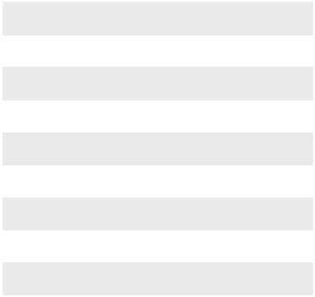

 |  |  |  |  |  |  |  | KD | Keyed Different
11 | Rim Hex Dog | 24 | CVR Hex Dog |  |  |  |  | KD | Keyed Different
 |  |  |  |  |  |  |  | KA | Keyed Alike
12 | Rim Cylinder Dog | 25 | CVR Cylinder Dog |  |  |  |  | KA | Keyed Alike
 |  |  |  |  |  |  |  | SK | Special Keying
13 | Rim Fire-Rated* | 26 | CVR Fire-Rated |  |  |  |  | SK | Special Keying
 |  |  |  |  |  |  |  |  | -Construction Keyed
14 | SVR Hex Dog | 27 | CVR LBR – Hex Dog |  |  |  |  |  | -Construction Keyed
 |  |  |  |  |  |  |  |  | -Construction Master Keyed
15 | SVR Cylinder Dog | 28 | CVR LBR – Cylinder Dog |  |  |  |  |  | -Construction Master Keyed
 |  |  |  |  |  |  |  |  | -Maison Keyed
16 | SVR Fire-Rated | 29 | CVR LBR – Fire-Rated |  |  |  |  |  | -Maison Keyed
17 | SVR LBR – Hex Dog |  |  |  | 605 | Bright Brass |  |  | -Master Keyed
 |  |  |  |  | 313AN | Anodized |  |  | -Grand Master Keyed
18 | SVR LBR – Cylinder Dog |  |  |  | 313AN | Anodized |  |  | -Grand Master Keyed
18 | SVR LBR – Cylinder Dog |  |  |  | 313AN | Duranodic Bronze
18 | SVR LBR – Cylinder Dog |  |  |  | 313AN | Duranodic Bronze |  |  | -Great Grand Master Keyed
19 | SVR LBR – Fire-Rated |  |  |  |  |  |  |  | -Great Grand Master Keyed
19 | SVR LBR – Fire-Rated |  |  |  | 626 | Satin Chrome |  | ZB | Zero Bitted


EXITDEVICES |  |  |  |  |  |  |  |  |  |  |  |  |  | Base Part Number
 |  |  | Series |  | Function |  |  |  | Size |  |  |  | Height |  |  | Finish | Keyway |  |  |  | Keying |  |  | Strike** |  |  |  | Notes
 |  |  | QED2 |  | 15 |  |  |  | 36" |  |  |  | 7FT |  |  | 313AN | BF |  |  |  | KD |  |  | ALS |  |  |  | XXXX
 | QED2xx |  | Narrow Stile Exit Device |  |  |  | 36" |  | 36" Device |  |  |  |  |  |  |  | BF |  |  | BEST “F” SFIC |  |  |  | ALS |  |  | Aluminum Door Strike
 |  |  |  |  |  |  | 48" |  | 48" Device |  |  |  |  |  |  |  | KW |  |  | Kwikset “KW” |  |  |  | HMS |  |  | Hollow Metal Door Strike
 |  |  |  |  |  |  |  |  |  |  |  |  |  |  |  |  | WE |  |  | Weiser “E”
 |  |  |  |  |  |  |  |  |  |  |  |  |  |  |  |  | SC |  |  | Schlage “C”
 |  |  |  |  |  |  |  |  |  |  | 7FT |  | 7 ft Rod |  |  |  | GA |  |  | Yale “GA”
 |  |  |  |  |  |  |  |  |  |  | 8FT |  | 8 ft Rod
 |  |  |  |  |  |  |  |  |  |  |  |  |  |  |  |  | LA |  |  | Sargent “LA”
 |  |  |  |  |  |  |  |  |  |  |  |  |  |  |  |  | LC |  |  | Less Cylinder


NOTES: *QED213 available with HMS strike only.

**Only for Rim devices.

- Full Line Catalog STANLEY Commercial Hardware
QET 200 Series: Grade 1 Heavy-Duty Narrow Stile Exit Trims

Escutcheon Trims Sierra (E) Escutcheon Trims Summit (M) Escutcheon Trims Slate (A)

• Available in: 605, 613, 626 • Available in: 605, 613,, 626 • Available in: 605, 613, 626
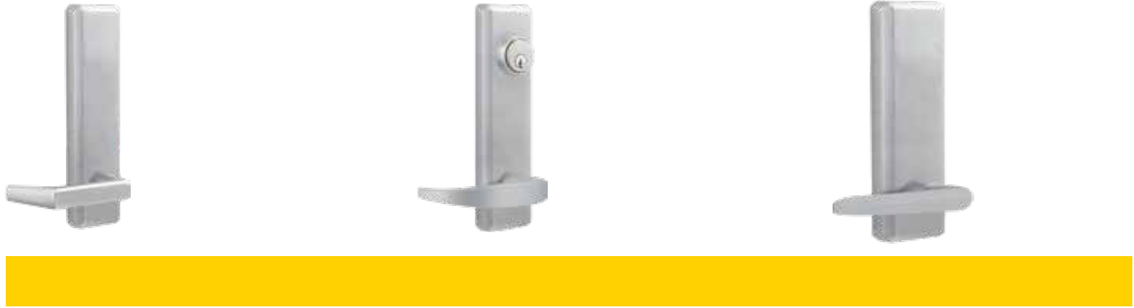

Model/Series | Functions | Style | Cylinder Type | Qty
QET220 | Dummy Lever Escutcheon (ANSI 02) | E/M/A | — | 6
QET230 | Passage Lever Escutcheon (ANSI 14) | E/M/A | — | 6
QET260 | Keyed Lever Escutcheon (Classroom, ANSI 08) | E/M/A | Mortise | 6
QET270* | Night Latch Lever Escutcheon (Storeroom, ANSI 03) | E/M/A | Rim | 6
QET280 | Night Latch Lever Escutcheon (Storeroom, ANSI 09) | E/M/A | Mortise | 6

NOTES: 613 Finish trims match 313AN finish exit devices.

* Not recommended for use on exit devices with vertical rods.

Escutcheon Trims Pull & Flat Plates

- Available in: 605, 613, 626

EXIT DEVICES

Dummy Pull | Night Latch Pull | Flat Plate
QET225 / QET226 | QET275 | QET290 / QET291

 | Model/Series | Functions |  | Style | Cylinder Type |  | Qty
 | QET225 | Dummy Pull Escutcheon (ANSI 02) for Rim and SVR |  | L | — |  | 6
 | QET226 | Dummy Pull Escutcheon (ANSI 02) for CVR |  | L | — |  | 6
 | QET275* | Night Latch Pull Escutcheon (ANSI 03) |  | L | Rim |  | 6
 | QET290 | Flat Plate Escutcheon (ANSI 01) for Rim and SVR |  | L | — |  | 6
 | QET291 | Flat Plate Escutcheon (ANSI 01) for CVR |  | L | — |  | 6
NOTES: * Not recommended for use on exit devices with vertical rods.
 |  |  | Full Line Catalog STANLEY Commercial Hardware |  |  |  | 53

How to Order

QET 200 Series: Grade 1 Heavy-Duty Narrow Stile Exit Trims
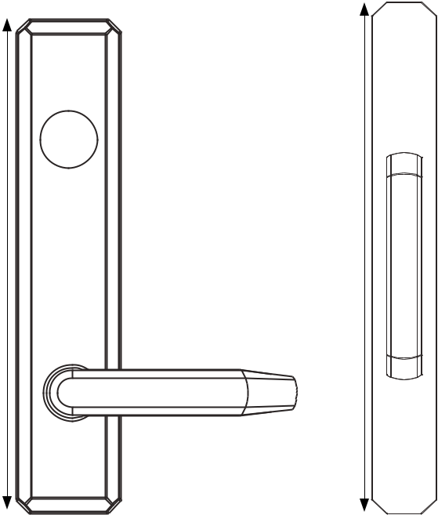

EXIT DEVICES

A
C

 |  |  |  |  |  | Dimensions
 |  |  |  |  | A | B | C | D
 |  |  |  |  | 7.83" | 1.69" | 13.88" | 1.76"
 |  |  |  |  | 198.88mm | 42.93mm | 352.55mm | 44.70mm
 |  |  | D
Functions | Description
QET220 | Dummy Lever Escutcheon | Used for door pull when device is dogged or as matching inactive trim.
QET220 | Dummy Lever Escutcheon | No mechanical operation. (ANSI 02)
QET225 / QET226 | Dummy Pull Escutcheon | Used for door pull when device is dogged or as matching inactive trim.
QET225 / QET226 | Dummy Pull Escutcheon | No mechanical operation. (ANSI 02)
QET230 | Passage Lever Escutcheon | Levers always unlocked and always free for immediate ingress. (ANSI 14)
QET260 | Keyed Lever Escutcheon | Key locks & unlocks lever (operates same as classroom function). (ANSI 08)
QET270* | Night Latch Lever Escutcheon | Lever always locked, key retracts latch for entrance (operates same as
QET270* | Night Latch Lever Escutcheon | storeroom function). (ANSI 03)
QET275* | Night Latch Pull Escutcheon | Outside always locked, key retracts latch for entrance (operates same as
QET275* | Night Latch Pull Escutcheon | storeroom function). (ANSI 03)
QET280 | Night Latch Lever Escutcheon | Key locks & unlocks lever. Device is locked when key is removed. (ANSI 09)
QET290 / QET291 | Flat Plate Escutcheon | Blank trim plate—used to cover existing door prep for an exit-only application. (ANSI 01)

NOTES: * Not recommended for use on exit devices with vertical rods.

- Full Line Catalog STANLEY Commercial Hardware

How to Order

QET 200 Series: Grade 1 Heavy-Duty Narrow Stile Exit Trims

Example

If you ordered: QET230 E 626

You would get: Grade 1 Escutcheon Passage Trim Lever, Sierra Design, Satin Chrome.

This trim matches to the QED200 Series Exit Devices.
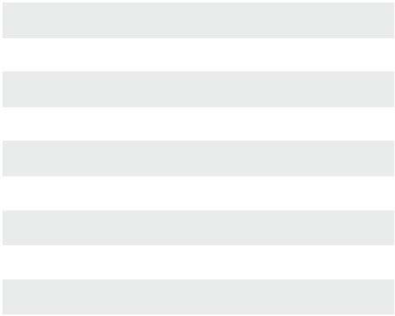

20 | DL – Dummy Trim Lever (ANSI 02)
25 | DP – Dummy Trim Pull (ANSI 02) Rim/SVR |  |  |  |  | KD | Keyed Different
 |  |  |  |  |  | KA | Keyed Alike
26 | DP – Dummy Trim Pull (ANSI 02) CVR |  |  |  |  | KA | Keyed Alike
 |  |  |  |  |  | SK | Special Keying
30 | PL – Passage Lever (ANSI 14) |  |  |  |  | SK | Special Keying
 |  |  |  |  |  |  | -Construction Keyed
60 | KL – Keyed Lever (ANSI 08) |  |  |  |  |  | -Construction Keyed
60 | KL – Keyed Lever (ANSI 08) |  |  |  |  |  | -Construction Master Keyed
70 | NL – Night Latch Lever Escutcheon (ANSI 03) |  |  |  |  |  | -Construction Master Keyed
70 | NL – Night Latch Lever Escutcheon (ANSI 03) |  |  |  |  |  | -Maison Keyed
75 | NL – Night Latch Pull Escutcheon (ANSI 03) |  |  |  |  |  | -Maison Keyed
75 | NL – Night Latch Pull Escutcheon (ANSI 03) |  |  |  |  |  | -Master Keyed
80 | NL – Night Latch Lever Escutcheon (ANSI 09) |  | 605 | Bright Brass |  |  | -Grand Master Keyed
 |  |  | 613 | Oil Rubbed Bronze |  |  | -Grand Master Keyed
90 | Flat Plate (ANSI 01) Rim/SVR |  | 613 | Oil Rubbed Bronze
90 | Flat Plate (ANSI 01) Rim/SVR |  | 613 | Oil Rubbed Bronze |  |  | -Great Grand Master Keyed
 |  |  | 626 | Satin Chrome
91 | Flat Plate (ANSI 01) CVR |  | 626 | Satin Chrome
91 | Flat Plate (ANSI 01) CVR |  | 626 | Satin Chrome |  | ZB | Zero Bitted


 |  |  |  |  |  |  |  |  | Base Part Number
 |  | Series |  |  | Function |  | Design |  |  | Finish |  |  | Keyway* |  |  | Keying** |  | Notes
 |  | QET2 |  |  | 60 |  | M |  |  | 626 |  |  | BF |  |  | KD |  | XXXX
QET2xx | Narrow Stile Exit Trim |  |  |  |  |  | L |  | Pull |  |  |  | BF |  | BEST “F” SFIC
 |  |  |  |  |  |  |  |  |  |  |  |  | KW |  | Kwikset “KW”
 |  |  |  |  |  |  | E |  | Sierra
 |  |  |  |  |  |  |  |  |  |  |  |  | WE |  | Weiser “E”
 |  |  |  |  |  |  | M |  | Summit
 |  |  |  |  |  |  |  |  |  |  |  |  | SC |  | Schlage “C”
 |  |  |  |  |  |  | A |  | Slate
 |  |  |  |  |  |  |  |  |  |  |  |  | GA |  | Yale “GA”
 |  |  |  |  |  |  |  |  |  |  |  |  | LA |  | Sargent “LA”
 |  |  |  |  |  |  |  |  |  |  |  |  | LC |  | Less Cylinder



EXIT DEVICES

NOTES: * Applies to Surface Vertical Rods only

** Applies to Cylinder Dogged only

Full Line Catalog STANLEY Commercial Hardware | 55

QED 300 Series: Grade 1 Standard-Duty Exit Devices
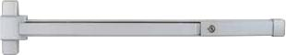

Rim Type

Performance Features

- Tested and certified to significantly exceed 500,000 cycles required for Grade 1 certification.

- Field sizeable. 36" to 32" door application (91.44cm-81.28cm).

- Consistent styling allows for harmonization with other STANLEY Commercial Hardware products.

Certifications

- ANSI/BHMA A156.3 – Grade 1.

- UL/cUL listed (3 hours) for “A” label door applications (8' x 8')

- ANSI A117.1 Section 404.2.6 Accessibility Code (ADA Compliant)
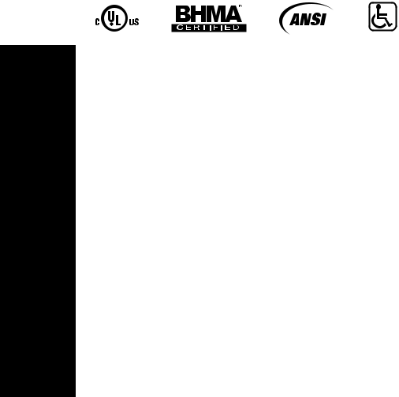

QED311
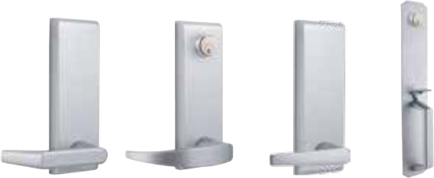

Sierra (E) Summit (M) Slate (A) Thumbpiece
Plate (L)
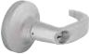
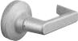

QRT360 M QRT320 E

EXIT DEVICES

Product Specifications

- Handing – All QED300 Series Exit Devices are non-handed.

- Door thickness – 1 3⁄4" standard (44.5mm).

- Latch bolt – Stainless steel 3⁄4" throw (19mm).

- Strike – Stainless steel body with plated steel roller standard fire-rated stainless steel strike, with stainless steel roller standard on QED313.

- Fasteners – Wood and machine screws standard. Sex bolts optional. (Standard on fire-rated device).

- Head cap & end cap – Zinc die-cast.

- Trims – Sierra, Summit and Slate styles available. Escutcheon offering – Dummy, passage, keyed, night latch. Pull plate offering – Dummy, thumbpiece, night latch, flat plate.

- Stile width – 3 7⁄8" minimum (98mm).

- Dogging – Hex key dogging and cylinder dogging available.

- Standard backset – 2 1⁄4" (57mm) to face of doorstop.

Keying

- Offered with the following keyway options: BF-SFIC “F”, KW-Kwikset, WE-Weiser, SC-Schlage, GA-Yale, LA-Sargent & LC-Less Cylinder.

Consult factory for other cylinder options and for details on Mortise and Rim Cylinder requirements.

Warranty

- Lifetime Mechanical and 3-year finish

Functions

Series | Description
QED311 | Rim Hex Dog
QED312 | Rim Cylinder Dog
QED313 | Rim Fire-Rated

Exit Trim Offerings


ANSI | Series | Description
02 | QET320 | Dummy Lever Escutcheon
02 | QET325 | Dummy Pull Plate
14 | QET330 | Passage Lever Escutcheon

- QET360 Keyed Lever Escutcheon

- QET365 Thumbpiece

02 | QET367 Dummy Thumbpiece Pull Escutcheon
03 | QET370 | Night Latch Lever Escutcheon
03 | QET375 | Night Latch Pull

—QET377 Gull Wing Pull Escutcheon

01 | QET390 | Flat Plate
02 | QRT320 | Dummy Round Rose Lever
14 | QRT330 | Passage Round Rose Lever
08 | QRT360 | Keyed Round Rose Lever
03 | QRT370 | Night Latch Round Rose Lever

Finishes
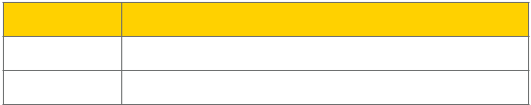

BHMA Description

- Painted Aluminum

- Painted Duranodic Bronze

- Full Line Catalog STANLEY Commercial Hardware

QED 300 Series: Grade 1 Standard-Duty Exit Devices
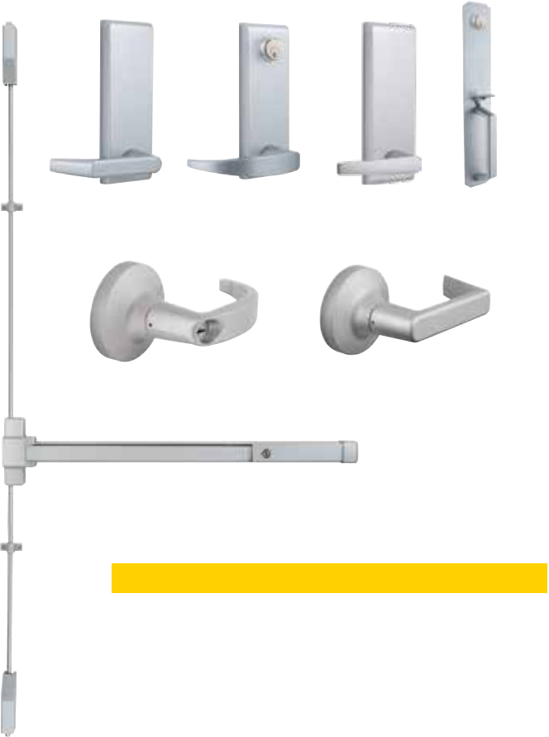

Surface Vertical Rod (SVR) Type

Performance Features

- Tested and certified to significantly exceed 500,000 cycles required for Grade 1 certification.

- Field sizeable. 36" to 32" door application (91.44cm-81.28cm).

- Thru-bolt trim design for increased security and durability.

- Consistent styling allows for harmonization with other STANLEY Commercial Hardware products.

Certifications

- ANSI/BHMA A156.3 – Grade 1.

- UL/cUL listed (1.5 hours) for “A” label door applications (8' x 8')

- ANSI A117.1 Section 404.2.6 Accessibility Code (ADA Compliant)

Product Specifications

- Handing – All QED300 Series Exit Devices are non-handed.

- Door thickness – 1 3⁄4" standard (44.5mm).

- Door height – 7' standard with 84" rods; 8' optional with 96" rods (2.1336m x 2.438m).

- Latch bolt – 1⁄2" (12.7mm) throw on top latch; 3⁄8" (9.53mm) on bottom latch.

- Fasteners – Wood and machine screws standard. Sex bolts optional. (Standard on fire-rated device).

- Head cap & end cap – Zinc die-cast.

- Trims – Sierra, Summit and Slate styles available. Escutcheon offering – Dummy, passage, keyed, night latch. Pull plate offering – Dummy, thumbpiece, night latch, flat plate.

- Stile width – 3 1⁄2" minimum (89mm).

- Dogging – Hex key dogging and cylinder dogging available.

- Standard backset – 2 1⁄4" (57mm) to face of doorstop.

- QED319 includes bottom fire latch.

Keying

- Offered with the following keyway options: BF-SFIC “F”, KW-Kwikset, WE-Weiser, SC-Schlage, GA-Yale, LA-Sargent & LC-Less Cylinder. Consult factory for other cylinder options and for details on Mortise and Rim Cylinder requirements.

Warranty

- Lifetime Mechanical and 3-year finish

Sierra (E) Summit (M) Slate (A) Thumbpiece
Plate (L)

QRT360 M QRT320 E

QED314

Exit Device Functions

Series | Description
QED314 | SVR Hex Dog
QED315 | SVR Cylinder Dog
QED316 | SVR Fire-Rated
QED317 | SVR Less Bottom Rod – Hex Dog
QED318 | SVR Less Bottom Rod – Cylinder Dog
QED319 | SVR Less Bottom Rod – Fire-Rated

Exit Trim Offerings


ANSI | Series | Description
02 | QET320 | Dummy Lever Escutcheon
02 | QET325 | Dummy Pull Plate
14 | QET330 | Passage Lever Escutcheon

- QET360 Keyed Lever Escutcheon

- QET365 Thumbpiece

02 | QET367 | Dummy Thumbpiece Pull Escutcheon
03 | QET370 | Night Latch Lever Escutcheon
03 | QET375 | Night Latch Pull
01 | QET390 | Flat Plate
02 | QRT320 | Dummy Round Rose Lever
14 | QRT330 | Passage Round Rose Lever
08 | QRT360 | Keyed Round Rose Lever
03 | QRT370 | Night Latch Round Rose Lever

Finishes
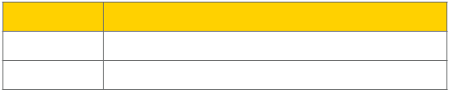

BHMA Description

- Painted Aluminum

- Painted Duranodic Bronze

EXIT DEVICES

Full Line Catalog STANLEY Commercial Hardware 57

EXIT DEVICES
QED 300 Series: Grade 1 Standard-Duty Exit Devices

 |  |  |  |  | C
 |  |  |  |  | D
E |  | F |  |  |  |  |  |  |  |  |  | B |  |  |  |  |  |  |  |  |  | G
 |  |  |  |  |  |  |  |  |  |  |  |  |  | A
 |  |  |  |  |  |  |  |  |  |  |  |  |  |  | 36" Device
QED300 Series
 |  |  |  |  |  |  |  |  |  |  | Minimum | Device |  | Pushpad | Head Cap |  |  | Head Cap | Head Cap |  |  |  | Head Cap |  |  | End Cap
 |  |  |  |  |  |  |  |  |  |  | Door Width | Length |  | Length | Length |  |  | Length | Width |  |  |  | Width |  |  | Length
Measurement |  |  |  |  |  |  |  |  |  |  |  | A |  | B | C |  |  | D |  | E |  |  | F |  |  | G
Panic Rated |  |  |  |  |  |  |  |  |  |  | 30" | 27" |  | 19" | 2.75" |  |  | 1.75" | 6.25" |  |  |  | 3" |  |  | 2"
(with Dogging) |  |  |  |  |  |  |  |  |  |  | 762mm | 685.80mm |  | 482.60mm | 69.90mm |  |  | 44.50mm | 158.80mm |  |  |  | 76.20mm |  |  | 50.80mm
Fire-Rated or Panic |  |  |  |  |  |  |  |  |  |  | 28" | 25" |  | 19" | 2.75" |  |  | 1.75" | 6.25" |  |  |  | 3" |  |  | 2"
with Dogging
Removed |  |  |  |  |  |  |  |  |  |  | 711.20mm | 635mm |  | 482.60mm | 69.90mm |  |  | 44.50mm | 158.80mm |  |  |  | 76.20mm |  |  | 50.80mm
Model/Series |  |  |  |  |  |  |  |  |  |  | Functions |  |  |  |  |  |  |  |  |  |  |  |  |  | Case Qty
QED311 |  |  |  |  |  |  |  |  |  |  | Rim Hex Dog |  |  |  |  |  |  |  |  |  |  |  |  |  | 4
QED312 |  |  |  |  |  |  |  |  |  |  | Rim Cylinder Dog |  |  |  |  |  |  |  |  |  |  |  |  |  | 4
QED313 |  |  |  |  |  |  |  |  |  |  | Rim Fire-Rated |  |  |  |  |  |  |  |  |  |  |  |  |  | 4
QED314 |  |  |  |  |  |  |  |  |  |  | SVR Hex Dog |  |  |  |  |  |  |  |  |  |  |  |  |  | 4
QED315 |  |  |  |  |  |  |  |  |  |  | SVR Cylinder Dog |  |  |  |  |  |  |  |  |  |  |  |  |  | 4
QED316 |  |  |  |  |  |  |  |  |  |  | SVR Fire-Rated |  |  |  |  |  |  |  |  |  |  |  |  |  | 4
QED317 |  |  |  |  |  |  |  |  |  |  | SVR Less Bottom Rod – Hex Dog |  |  |  |  |  |  |  |  |  |  |  |  |  | 4
QED318 |  |  |  |  |  |  |  |  |  |  | SVR Less Bottom Rod – Cylinder Dog |  |  |  |  |  |  |  |  |  |  |  |  |  | 4
QED319 |  |  |  |  |  |  |  |  |  |  | SVR Less Bottom Rod – Fire-Rated (Includes Auxiliary Bottom Fire Latch) |  |  |  |  |  |  |  |  |  |  |  |  |  | 4
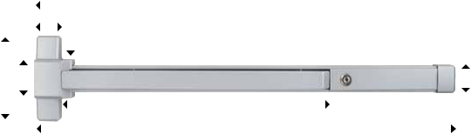

Other Options

8FT | Vertical rod kit for 8FT door application
48" | 48" Device

- Full Line Catalog STANLEY Commercial Hardware

How to Order

QED 300 Series: Grade 1 Standard-Duty Exit Devices

Example

If you ordered: QED315 36" 7FT 689 KW KD

You would get: Grade 1 Standard-Duty Surface Vertical Rod Exit Device 36," with Cylinder Dogging, for a 7' height, in Painted Aluminum finish. Kwikset Keyway, Keyed Different.
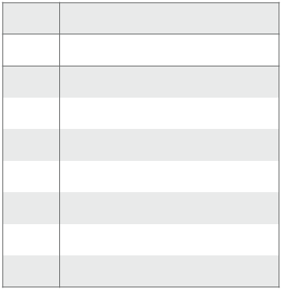

- Rim Hex Dog

- Rim Cylinder Dog


13 | Rim Fire-Rated |  |  |  |  | KW | Kwikset “KW”
14 | SVR Hex Dog |  |  |  |  | WE | Weiser “E”
15 | SVR Cylinder Dog |  |  |  |  | SC | Schlage “C”
16 | SVR Fire-Rated |  |  |  |  | GA | Yale “GA”
17 | SVR LBR – Hex Dog |  |  |  |  | LA | Sargent “LA”
18 | SVR LBR – Cylinder Dog |  |  |  |  | BF | SFIC “F”
18 | SVR LBR – Cylinder Dog |  | 7FT | 7 ft Rod |  | BF | SFIC “F”
19 | SVR LBR – Fire-Rated |  | 8FT | 8 ft Rod |  | LC | Less Cylinder


 |  |  |  |  |  |  |  |  |  |  | Base Part Number
 |  | Series |  |  | Function |  |  | Size |  |  |  | Height |  | Finish |  | Keyway |  |  | Keying |  |  | Notes
 |  | QED3 |  |  | 15 |  | 36" |  |  |  |  | 7FT |  | 689 |  | KW |  |  | KD |  |  | XXXX
QED3xx | Grade 1 Standard-Duty |  |  |  |  | 36" |  | 36" Device |  |  |  | 689 | Painted Aluminum |  |  |  |  |  | KD |  |  | Keyed Different
QED3xx | Exit Device
QED3xx |  |  |  |  |  | 48" |  | 48" Device |  |  |  |  |  |  |  |  |  |  | KA |  |  | Keyed Alike
 |  |  |  |  |  | 48" |  |  |  |  |  | 690 | Painted Duranodic Bronze
 |  |  |  |  |  |  |  |  |  |  |  |  |  |  |  |  |  |  | CK |  |  | Construction Keyed
 |  |  |  |  |  |  |  |  |  |  |  |  |  |  |  |  |  |  | CMK |  |  | Construction Master Keyed
 |  |  |  |  |  |  |  |  |  |  |  |  |  |  |  |  |  |  | MAIS |  |  | Maison Keyed
 |  |  |  |  |  |  |  |  |  |  |  |  |  |  |  |  |  |  | MK |  |  | Master Keyed
 |  |  |  |  |  |  |  |  |  |  |  |  |  |  |  |  |  |  | GMK |  |  | Grand Master Keyed
 |  |  |  |  |  |  |  |  |  |  |  |  |  |  |  |  |  |  | GGMK |  |  | Great Grand Master Keyed
 |  |  |  |  |  |  |  |  |  |  |  |  |  |  |  |  |  |  | ZB |  |  | Zero Bitted


EXIT DEVICES

Full Line Catalog STANLEY Commercial Hardware 59

EXIT DEVICES
QRM 300 Series: Mullions

Performance Features
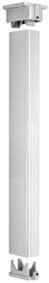

- 2" x 3" steel mullion tube. 1⁄8" wall thickness.

- Size – Standard for openings 8' high, field sizeable for openings less than 8'. 9', 10', 11' & 12' also available and are field sizable.

- Mullion is pre-prepped for QED300 Series Exit Devices.

- Fire Rating 8' high max.

- Available finishes – Primer (600), Aluminum (689) & Dark Bronze (695).

Keyed Removable Mullions (Consult Factory For Mullion Lead Times)
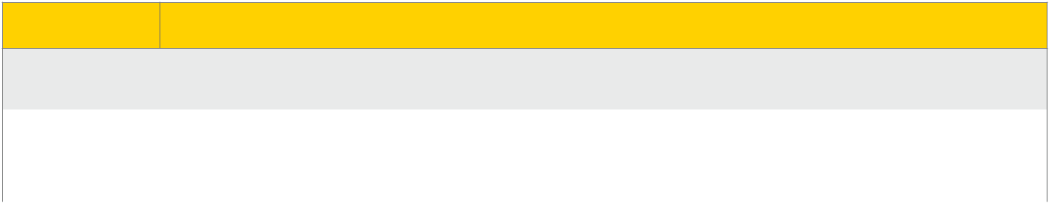

Order Description

Cylinder not included. Keyed removable mullions utilize standard rim cylinders. Reference cylinders, keys & keying section for more details.

QRM311 KR | Keyed Removable Mullion. Includes: Mullion tube, cap, base, fasteners & strike.
QRM313 KR | Fire-Rated, Keyed Removable Mullion. Includes: Mullion tube, cap, base, fasteners & strike interlock.

Removable Mullions (Consult Factory For Mullion Lead Times)


Order | Description
QRM311 | Removable Mullion. Includes: Mullion tube, cap, base, fasteners & strike.
QRM313 | Fire-Rated, Removable Mullion. Includes: Mullion tube, cap, base, fasteners & strike interlock.

- Full Line Catalog STANLEY Commercial Hardware

How to Order

QRM 300 Series: Mullions

Example

If you ordered: QRM313 KR 8FT 689

You would get: Keyed Removable, Fire-Rated Mullion, 8' Height, with

Aluminum finish. Prepped for QED300 Series strike.

 |  |  |  |  |  | 600 | Primer
 |  |  |  |  |  | 689 | Aluminum
QRM3 | Mullion Prepped for |  |  |  |  | 689 | Aluminum
QRM3 | QED300 Series |  | KR | Keyed Removable |  | 695 | Dark Bronze



Base Part Number

Series | Function | Options | Height | Finish
QRM3 | 13 | KR | 8FT | 689

- Standard

- Fire-Rated
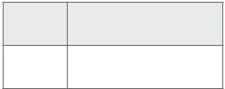

8FT | Standard Height
9FT
10FT | Not Available in
11FT | Fire-Rated Option
12FT


EXIT DEVICES

Full Line Catalog STANLEY Commercial Hardware 61

QET 300 Series: Grade 1 Standard-Duty Exit Escutcheon Trims

Escutcheon Trims Sierra (E) Escutcheon Trims Summit (M) Escutcheon Trims Slate (A)

• Available in: 689, 690 • Available in: 689, 690 • Available in: 689, 690
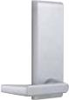
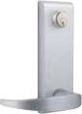
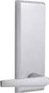

EXIT DEVICES

Model/Series | Functions | Style | Cylinder Type | Qty
QET320 | Dummy Lever Escutcheon | E/M/A | — | 12
QET330 | Passage Lever Escutcheon | E/M/A | — | 12
QET360 | Keyed Lever Escutcheon (Classroom) | E/M/A | Mortise | 12
QET370 | Night Latch Lever Escutcheon (Storeroom) | E/M/A | Mortise | 12

NOTES: Cylinders ordered separately.

Escutcheon Trims Pull & Flat Plates

- Available in: 689, 690
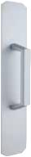
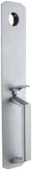
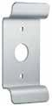
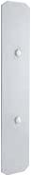
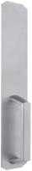
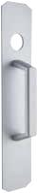

Dummy Pull Thumbpiece Dummy Thumbpiece Night Latch Pull Gull Wing Pull Flat Plate
QET325 QET365 QET367 QET375 QET377 QET390

Model/Series | Functions | Style | Cylinder Type | Qty
QET325 | Dummy Pull Escutcheon | L | — | 12
QET365 | Thumbpiece Pull Escutcheon | L | Mortise | 12
QET367 | Dummy Thumbpiece Pull Escutcheon | L | — | 12
QET375 | Night Latch Pull Escutcheon | L | Rim | 12
QET377 | Gull Wing Pull Escutcheon | Gull Wing | Rim | 12
QET390 | Flat Plate Escutcheon | N/A | — | 12

NOTES: Cylinders ordered separately.

- Full Line Catalog STANLEY Commercial Hardware

QET 300 Series: Grade 1 Standard-Duty Exit Escutcheon Trims

B
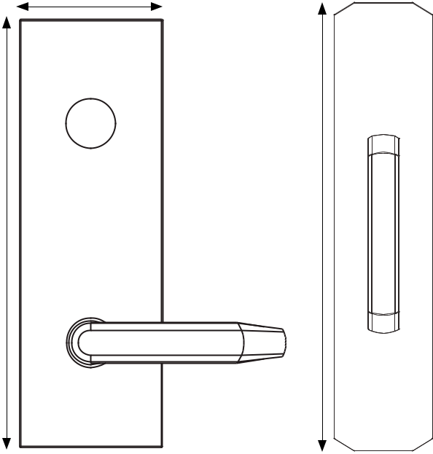

A
C

 |  |  |  |  |  | Dimensions
 |  |  |  |  | A | B | C | D
 |  |  |  |  | 8.0625" | 2.625" | 14" | 3"
 |  |  |  |  | 204.79mm | 66.675mm | 355.60mm | 76.70mm
 |  |  | D
Model/Series | Functions |  | Description
QET320 | Dummy Lever Escutcheon |  | Used for door pull when device is dogged or as matching inactive trim.
QET320 | Dummy Lever Escutcheon |  | No mechanical operation.
QET325 | Dummy Pull Escutcheon |  | Used for door pull when device is dogged or as matching inactive trim.
QET325 | Dummy Pull Escutcheon |  | No mechanical operation.
QET330 | Passage Lever Escutcheon |  | Lever is always unlocked and always free for immediate ingress.
QET360 | Keyed Lever Escutcheon |  | Key locks & unlocks lever (operates same as classroom function).
QET365 | Thumbpiece Pull Escutcheon |  | Key locks & unlocks thumbpiece (operates same as classroom function).
QET367 | Dummy Thumbpiece |  | Used for door pull when device is dogged or as matching inactive trim.
QET367 | Pull Escutcheon |  | No mechanical operation. Matches QET365.
QET370 | Night Latch Escutcheon |  | Lever always locked, key retracts latch for entrance (operates same as
QET370 | Night Latch Escutcheon |  | storeroom function).
QET375 | Night Latch Pull Escutcheon |  | Outside always locked, key retracts latch for entrance (operates same as
QET375 | Night Latch Pull Escutcheon |  | storeroom function).
QET377 | Gull Wing Pull Escutcheon |  | Outside always locked, key retracts latch for entrance (operates same as
QET377 | Gull Wing Pull Escutcheon |  | storeroom function).
QET390 | Flat Plate Escutcheon |  | Blank trim plate—used to cover existing door prep for an exit-only application.

EXIT DEVICES

Full Line Catalog STANLEY Commercial Hardware 63

How to Order

QET 300 Series: Grade 1 Standard-Duty Exit Escutcheon Trims

Example

If you ordered: QET360 E 689 KW KD

You would get: Grade 1 Escutcheon Keyed Lever, Sierra design, Painted Aluminum finish, Kwikset Keyway, Keyed Different. This trim matches the QED300 Series Exit Devices.
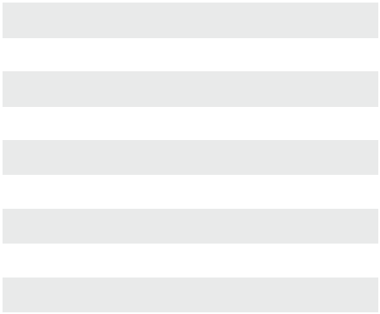

EXIT DEVICES

20 | DL – Dummy Trim Lever
25 | DP – Dummy Trim Pull
 |  |  |  |  |  | KD | Keyed Different
30 | PL – Passage Lever |  |  |  |  | KD | Keyed Different
30 | PL – Passage Lever |  |  |  |  | KA | Keyed Alike
60 | KL – Keyed Lever |  |  |  |  | KA | Keyed Alike
60 | KL – Keyed Lever |  |  |  |  | CK | Construction Keyed
65 | TP – Thumbpiece Escutcheon |  |  |  |  | CK | Construction Keyed
65 | TP – Thumbpiece Escutcheon |  |  |  |  | CMK | Construction Master Keyed
67 | DT – Dummy Thumbpiece Escutcheon |  |  |  |  | CMK | Construction Master Keyed
67 | DT – Dummy Thumbpiece Escutcheon |  |  |  |  | MAIS | Maison Keyed
67 | DT – Dummy Thumbpiece Escutcheon |  |  | Painted |  | MAIS | Maison Keyed
70 | NL – Night Latch Lever Escutcheon |  | 689 | Painted |  | MAIS | Maison Keyed
70 | NL – Night Latch Lever Escutcheon |  | 689 | Painted |  | MK | Master Keyed
70 | NL – Night Latch Lever Escutcheon |  | 689 | Aluminum |  | MK | Master Keyed
75 | NL – Night Latch Pull
75 | NL – Night Latch Pull |  |  |  |  | GMK | Grand Master Keyed
77 | GW – Gull Wing |  |  | Painted
77 | GW – Gull Wing |  |  | Painted |  | GGMK | Great Grand Master Keyed
77 | GW – Gull Wing |  | 690 | Duranodic |  | GGMK | Great Grand Master Keyed
90 | Flat Plate |  |  | Bronze
90 | Flat Plate |  |  | Bronze |  | ZB | Zero Bitted


 |  |  |  |  |  |  |  |  |  |  | Base Part Number
 |  | Series |  |  | Function |  |  | Design |  |  |  | Finish | Keyway |  |  |  | Keying |  | Notes
 |  | QET3 |  |  | 60 |  |  | E |  |  |  | 689 |  | KW |  |  | KD |  | XXXX
QET3xx | Grade 1 Standard- |  |  |  |  | E |  | Sierra |  |  |  |  | KW |  | Kwikset “KW”
QET3xx | Duty Exit Trim
QET3xx |  |  |  |  |  | M |  | Summit
 |  |  |  |  |  | M |  |  |  |  |  |  | WE |  | Weiser “E”
 |  |  |  |  |  | A |  | Slate
 |  |  |  |  |  | A |  |  |  |  |  |  | SC |  | Schlage “C”
 |  |  |  |  |  |  |  |  |  |  |  |  | GA |  | Yale “GA”
 |  |  |  |  |  |  |  |  |  |  |  |  | LA |  | Sargent “LA”
 |  |  |  |  |  |  |  |  |  |  |  |  | BF |  | SFIC “F”
 |  |  |  |  |  |  |  |  |  |  |  |  | LC |  | Less Cylinder


- Full Line Catalog STANLEY Commercial Hardware

QRT 300 Series: Grade 1 Standard-Duty Exit Rose Trims

Round Rose Trims Sierra (E) Round Rose Trims Summit (M)

• Available in: 626, 689, 690 • Available in: 626, 689, 690
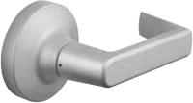
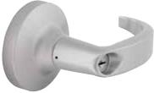

A
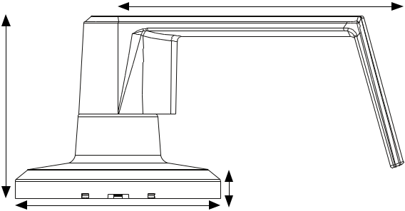

B

D

C

 |  | Dimensions
 | A | B | C | D | DEVICES
Summit | 4.95" | 3.45" | 3.12" | .52" | DEVICES
Sierra | 4.98" | 3.15" | 3.12" | .52"
 | 126.49mm | 80.01mm | 79.25mm | 13.21mm
 |  |  |  |  | EXIT
 | 125.73mm | 87.63mm | 79.25mm | 13.21mm | EXIT

Model/Series | Functions | Description | Style | Case
 |  |  |  | Qty
QRT320 | Dummy Lever | Used for door pull when device is dogged or as matching inactive trim. | E/M | 12
QRT320 | Dummy Lever | No mechanical operation. | E/M | 12
QRT330 | Passage Lever | Levers always unlocked and always free for immediate ingress. | E/M | 12
QRT360/361 | Keyed Lever | Key locks & unlocks lever (operates same as classroom function). Clutch feature disengages | E/M | 12
QRT360/361 | (Classroom) | outside lever from latch when locked to prevent vandalism. | E/M | 12
QRT370/371 | Keyed Lever | Lever always locked, key retracts latch for entrance (operates same as storeroom function). | E/M | 12
QRT370/371 | (Storeroom) | Clutch feature disengages outside lever from latch when locked to prevent vandalism. | E/M | 12

Full Line Catalog STANLEY Commercial Hardware 65

EXIT DEVICES
How to Order

QRT 300 Series: Grade 1 Standard-Duty Exit Rose Trims

Example

If you ordered: QRT360 E 689 KW KD

You would get: Standard-Duty Keyed Lever Round Rose Trim, Sierra design, Painted Aluminum finish, Kwikset Keyway, Keyed Different. This trim matches the QED300 Series Exit Devices.

 |  |  |  |  |  | KD | Keyed Different
 |  |  |  |  |  | KA | Keyed Alike
 |  |  |  |  |  | CK | Construction Keyed
20 | DL – Dummy Lever |  |  |  |  | CK | Construction Keyed
20 | DL – Dummy Lever |  |  |  |  | CMK | Construction Master Keyed
30 | PL – Passage Lever |  |  |  |  | CMK | Construction Master Keyed
30 | PL – Passage Lever |  |  |  |  | MAIS | Maison Keyed
60 | KL – Keyed Lever |  |  |  |  | MAIS | Maison Keyed
60 | KL – Keyed Lever |  |  |  |  | MK | Master Keyed
61 | KL – Keyed Lever SFIC |  | 626 | Satin Chrome
 |  |  |  |  |  | GMK | Grand Master Keyed
 |  |  | 689 | Painted Aluminum |  | GMK | Grand Master Keyed
70 | NL – Night Latch Lever |  | 689 | Painted Aluminum
 |  |  |  |  |  | GGMK | Great Grand Master Keyed
 |  |  | 690 | Painted Duranodic Bronze
71 | NL – Night Latch Lever SFIC |  | 690 | Painted Duranodic Bronze
71 | NL – Night Latch Lever SFIC |  | 690 | Painted Duranodic Bronze |  | ZB | Zero Bitted


 |  |  |  |  |  |  |  |  |  | Base Part Number
 |  | Series |  |  | Function |  |  | Design |  |  |  | Finish |  | Keyway |  |  |  | Keying |  | Notes
 |  | QRT3 |  |  | 60 |  |  | E |  |  | 689 |  |  | KW |  |  |  | KD |  | XXXX
QRT3xx | Standard-Duty Rose |  |  |  |  | E |  | Sierra |  |  |  |  |  | KW |  |  | Kwikset “KW”
QRT3xx | Exit Trim
QRT3xx |  |  |  |  |  | M |  | Summit
 |  |  |  |  |  | M |  |  |  |  |  |  |  | WE |  |  | Weiser “E”
 |  |  |  |  |  |  |  |  |  |  |  |  |  | SC |  |  | Schlage “C”
 |  |  |  |  |  |  |  |  |  |  |  |  |  | GA |  |  | Yale “GA”
 |  |  |  |  |  |  |  |  |  |  |  |  |  | LA |  |  | Sargent “LA”
 |  |  |  |  |  |  |  |  |  |  |  |  |  | BF |  |  | SFIC “F”
 |  |  |  |  |  |  |  |  |  |  |  |  |  | LC |  |  | Less Cylinder


- Full Line Catalog STANLEY Commercial Hardware

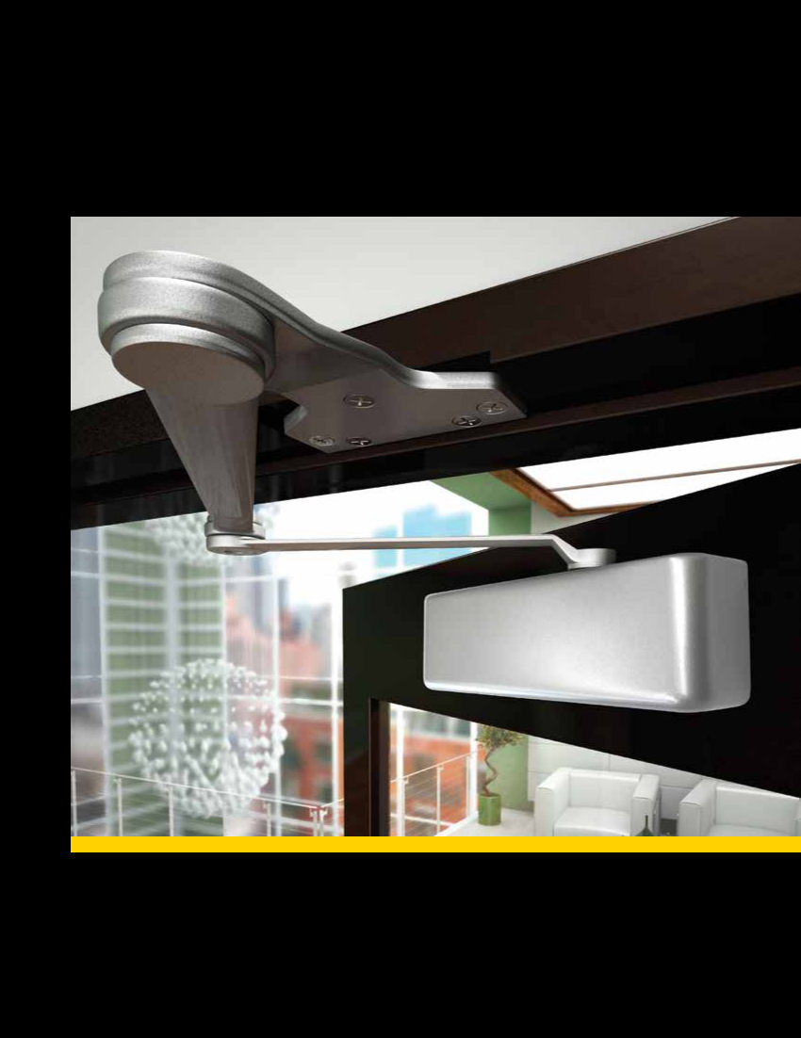
Door Closers
QDC 100 Series: Grade 1 Extra Heavy-Duty Door Closers

DOOR CLOSERS

Performance Features

- Fully adjustable from 1 - 6 allowing for maximum flexibility.

- All-weather fluid ensures optimal operational performance in multiple climate conditions.

- Delayed action and backcheck are standard in the same door closer body.

Certifications

- ANSI/BHMA A156.4 Series – Grade 1

- ANSI A117.1 Accessibility Code (ADA Compliant)

- UL/cUL listed (3 hour) for self closing

- UL10C Positive Pressure Rated

- UL10B Pressure Rated

Product Specifications

- Handing – All QDC100 Series Closers are non-handed (QDC116 arms & metal covers are handed).

- Cast-iron closer body.

- All-weather fluid.

- Stacked valves prevent oil leaks from screws being backed out too far.

- Cover – metal and plastic covers available.

- Arms & brackets – Tri-pack standard, additional arms optional.

- Arm material – Heat-treated carbon steel.

- Springs – High-impact hand-drawn steel wires.

- Pinions – Heat-treated chrome molybdenum steel.

- Cylinder construction – Heat-treated free-cutting carbon steel.

- Fasteners – Wood and machine screws standard; sex nuts and self-reaming, self-tapping screws shipped standard.

- Door weights & sizes:

 |  |  |  |  | Door Width Ranges
Size | Applicable Door Weight |  |  |  | Interior | Exterior
1 | 33 | – 55 LBS (15 – 30 Kg) |  |  | 32" (0.81m) | 28" (0.71m)
2 | 56 | – 99 LBS (30 – 45 Kg) |  |  | 36" (0.91m) | 32" (0.81m)
3 | 99 | – 143 LBS (45 – 65 Kg) |  |  | 42" (1.07m) | 36" (0.91m)
4 | 143 |  | – 187 LBS (65 | – 85 Kg) | 48" (1.22m) | 42" (1.07m)
5 | 187 |  | – 264 LBS (85 | – 120 Kg) | 54" (1.37m) | 48" (1.22m)
6* | 264 |  | – 330 LBS (120 – 150 Kg) |  | 58" (1.47m) | 54" (1.32m)

*50% spring power adjustment over size 6.

Warranty

- Lifetime Mechanical and 3-year finish

QDC111
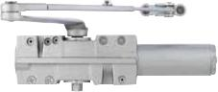
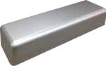

Rounded Plastic Cover (R)
(Ships Standard)
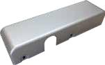

Metal Cover (M)
(Left hand shown)

Door Closer Functions

Series | Description
QDC111 | Tri-Pack Arm
QDC112 | Tri-Pack Arm with Hold-Open
QDC113 | Extra Duty Arm with Compression Stop
QDC114 | Extra Duty Arm with Hold-Open and
QDC114 | Compression Stop
QDC115 | Extra Duty Arm
QDC116 | Extra Duty Arm with Hold-Open (handed)
QDC117 | Extra Duty Arm with Stop
QDC118 | Extra Duty Arm with Hold-Open and Stop
QDC119 | Extra Duty Arm with Spring Stop
QDC120 | Extra Duty Arm with Hold Open and Spring
QDC120 | Stop

Finishes
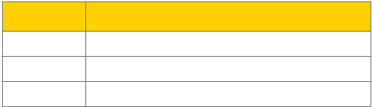

BHMA Description

- Painted Aluminum

- Painted Dark Bronze

696 | Painted Satin Brass

- Full Line Catalog STANLEY Commercial Hardware

QDC 100 Series: Grade 1 Extra Heavy-Duty Door Closers
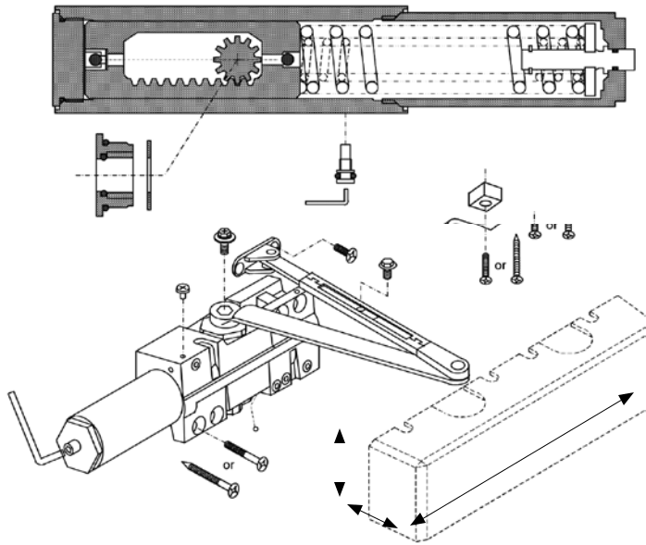

 |  |  |  |  |  |  |  |  | Dimensions
 |  |  |  |  | A |  |  | A | B |  | C
 |  |  |  |  | A |  | C | 3.50" | 2.25" |  | 12.1875"
 |  |  |  |  |  |  |  | 88.90mm | 57.15mm |  | 309.56mm
 |  |  |  |  |  | B
Model/Series |  |  | Functions |  |  |  |  |  |  |  |  | Case Qty
QDC111 |  |  | Tri-Pack Arm |  |  |  |  |  |  |  |  | 3
QDC112 |  |  | Tri-Pack Arm with Hold-Open |  |  |  |  |  |  |  |  | 1
QDC113 |  |  | Extra Duty Arm with Compression Stop |  |  |  |  |  |  |  |  | 1
QDC114 |  |  | Extra Duty Arm with Hold-Open and Compression Stop |  |  |  |  |  |  |  |  | 1
QDC115 |  |  | Extra Duty Arm |  |  |  |  |  |  |  |  | 1
QDC116 |  |  | Extra Duty Arm with Hold-Open (handed) |  |  |  |  |  |  |  |  | 1
QDC117 |  |  | Extra Duty Arm with Stop |  |  |  |  |  |  |  |  | 1
QDC118 |  |  | Extra Duty Arm with Hold-Open and Stop |  |  |  |  |  |  |  |  | 1
QDC119 |  |  | Extra Duty Arm with Spring Stop |  |  |  |  |  |  |  |  | 1
QDC120 |  |  | Extra Duty Arm with Hold Open and Spring Stop |  |  |  |  |  |  |  |  | 1
Order with Closer |  |  |  |  | Description |  |  |  |  | Service Part #
 |  |  |  |  | Sex nuts (Qty 4) (specify finish) |  |  |  |  | 8Q00097
 |  |  |  |  | Self-reaming, self-tapping screws (specify finish) |  |  |  |  | 8Q00547
 |  |  | M |  | QDC100 Series Metal Cover - RH |  |  |  |  | 8Q01140
 |  |  | M |  | QDC100 Series Metal Cover - LH |  |  |  |  | 8Q01141
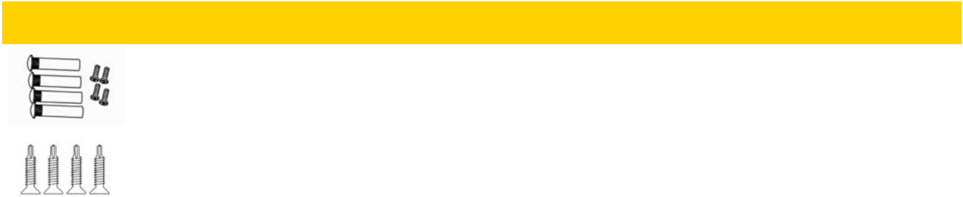

DOOR CLOSERS

Full Line Catalog STANLEY Commercial Hardware 69

How to Order

QDC 100 Series: Grade 1 Extra Heavy-Duty Door Closers

Example

If you ordered: QDC111R 689 BF RH

You would get: Grade 1 Extra Duty Door Closer – Full Adjustable

(Sized 1-6), Tri-Pack Arm, Rounded Plastic Cover, Barrier Free, Painted

Aluminum Finish
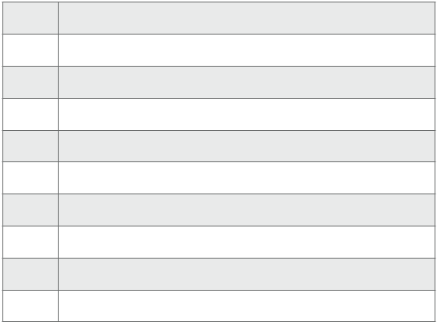

CLOSERS

- Tri-Pack Arm

- Tri-Pack Arm with Hold-Open

- Extra Duty Arm with Compression Stop

- Extra Duty Arm with Hold-Open and Compression Stop

- Extra Duty Arm

- Extra Duty Arm with Hold-Open

- Extra Duty Arm with Stop

- Extra Duty Arm with Hold-Open and Stop

- Extra Duty Arm with Spring Stop

- Extra Duty Arm with Hold Open and Spring Stop

- Painted Aluminum

- Painted Dark Bronze

- Painted Satin Brass
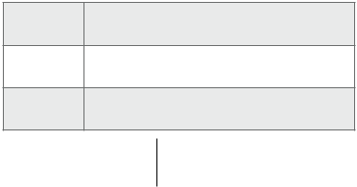

QDC 116 HEDA Arm and Metal Cover Only
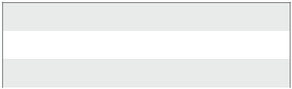

LH | Left Hand
RH | Right Hand

DOOR

 |  |  |  |  |  |  |  | Base Part Number
 |  | Series |  |  | Function |  |  | Trim |  | Finish |  | Options |  |  | Handing
 |  | QDC1 |  |  | 11 |  |  | R |  | 689 |  | BF
QDC1xx | Grade 1 Extra Heavy- |  |  |  |  | R |  | Full-Size Rounded Plastic Cover |  |  |  |  | BF |  | Barrier Free
QDC1xx | Duty Architectural
 |  |  |  |  |  | M |  | Full-Size Metal Cover

- Full Line Catalog STANLEY Commercial Hardware

QDC 200 Series: Grade 1 Heavy-Duty Door Closers
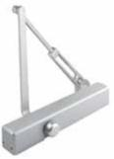

Performance Features

- Fully adjustable from 1 - 6 allowing for maximum flexibility.

- Delayed action and backcheck are standard in the same door closer body.

- All-weather fluid ensures optimal operational performance in multiple climate conditions.

Certifications

- ANSI/BHMA A156.4 Series – Grade 1

- ANSI A117.1 Accessibility Code (ADA Compliant)

- UL/cUL listed (3 hour) for self-closing doors without hold open

- UL10C Positive Pressure Rated

- UL10B Pressure Rated

Product Specifications

- Handing – All QDC200 Series Closers are non-handed.

- Material – Cast aluminum closer body.

- All-weather fluid.

- Cover – Slim-line plastic cover standard. Full, architectural plastic cover also available.

- Arms & brackets – Tri-pack standard (regular, top jamb, parallel configurations). Hold open and dead stop arms also available.

- Arm material – Heat-treated carbon steel.

- Springs – High-impact hand-drawn steel wires.

- Pinions – Heat-treated chrome molybdenum steel.

- Cylinder construction – Heat-treated free-cutting carbon steel.

- Fasteners – Wood and machine screws standard; sex nuts and self-reaming, self-tapping screws shipped standard.

- Door weights & sizes:

 |  |  |  |  | Door Width Ranges
Size | Applicable Door Weight |  |  |  | Interior | Exterior
1 | 33 | – 55 LBS (15 – 30 Kg) |  |  | 32" (0.81m) | 28" (0.71m)
2 | 56 | – 99 LBS (30 – 45 Kg) |  |  | 36" (0.91m) | 32" (0.81m)
3 | 99 | – 143 LBS (45 – 65 Kg) |  |  | 42" (1.07m) | 36" (0.91m)
4 | 143 |  | – 187 LBS (65 | – 85 Kg) | 48" (1.22m) | 42" (1.07m)
5 | 187 |  | – 264 LBS (85 | – 120 Kg) | 54" (1.37m) | 48" (1.22m)
6 | 264 |  | – 330 LBS (120 – 150 Kg) |  | 58" (1.47m) | 54" (1.32m)

Tri-Pack Arm Tri-Pack Arm with
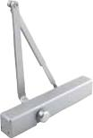
Hold-Open
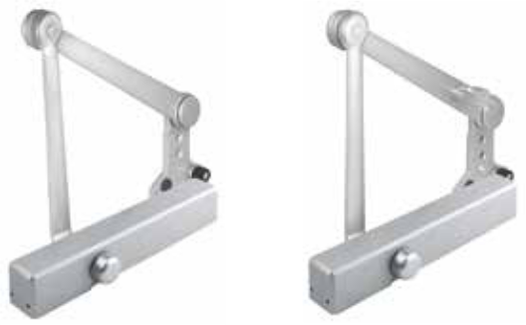

Heavy Duty Arm with Heavy Duty Arm
Compression Stop with Hold-Open and
Compression Stop

Door Closer Functions

Series | Description
QDC211 | Tri-Pack Arm
QDC212 | Tri-Pack Arm with Hold-Open
QDC213 | Heavy Duty Arm with Compression Stop
QDC214 | Heavy Duty Arm with Hold-Open and
QDC214 | Compression Stop

Finishes
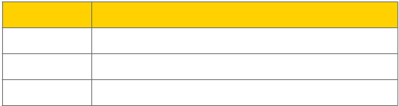

BHMA Description

- Painted Aluminum

- Painted Dark Bronze

696 | Painted Satin Brass

DOOR CLOSERS

Warranty

- Lifetime Mechanical and 3-year finish

Full Line Catalog STANLEY Commercial Hardware 71

How to Order

QDC 200 Series: Grade 1 Heavy-Duty Door Closers
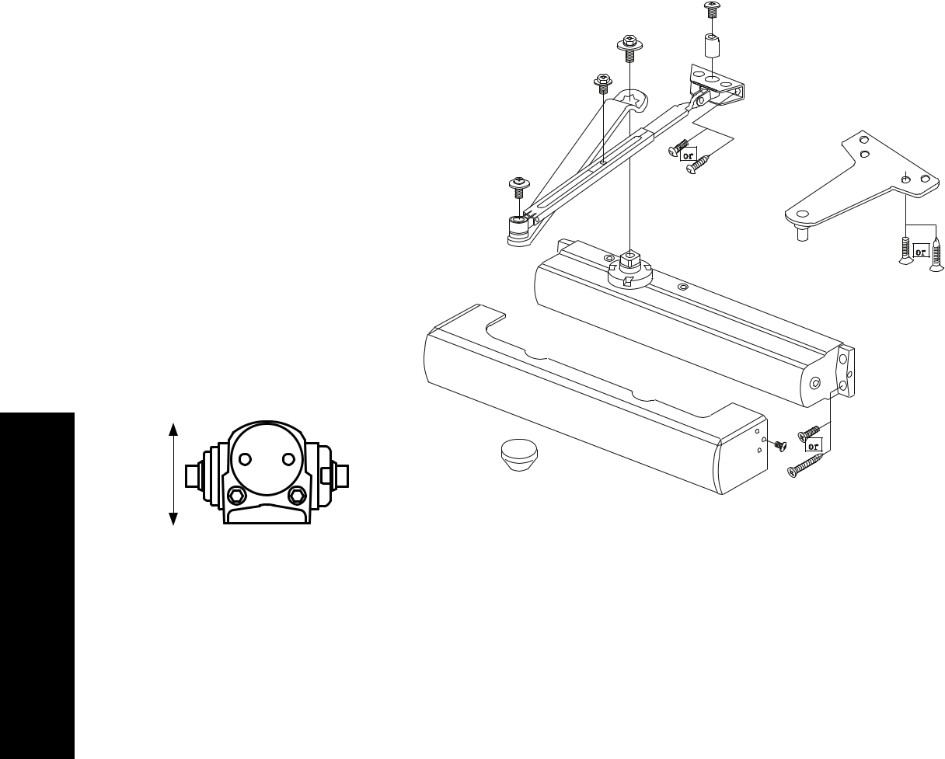

DOOR CLOSERS

A
 | B
 |  |  |  | DIMENSIONS
 |  | A |  | B | C
 |  | 2.05" |  | 3.18" | 12"
 |  | 52.20mm |  | 80.70mm | 305mm
 |  | C
Model/Series | Functions |  |  |  | Qty
QDC211 | Tri-Pack Arm |  |  |  | 6
QDC212 | Tri-Pack Arm with Hold-Open |  |  |  | 6
QDC213 | Heavy Duty Arm with Compression Stop |  |  |  | 3
QDC214 | Heavy Duty Arm with Hold-Open and Compression Stop |  |  |  | 3
Order with Closer |  | Description | Service Part #
 | F | Full-size cover (specify finish) | 8Q00094
 | S | Slim-line cover (specify finish) | 8Q00096
 |  | Sex nuts (Qty 4) (specify finish) | 8Q00097
 |  | Self-reaming, self-tapping screws (Qty 8) (specify finish) | 8Q00436

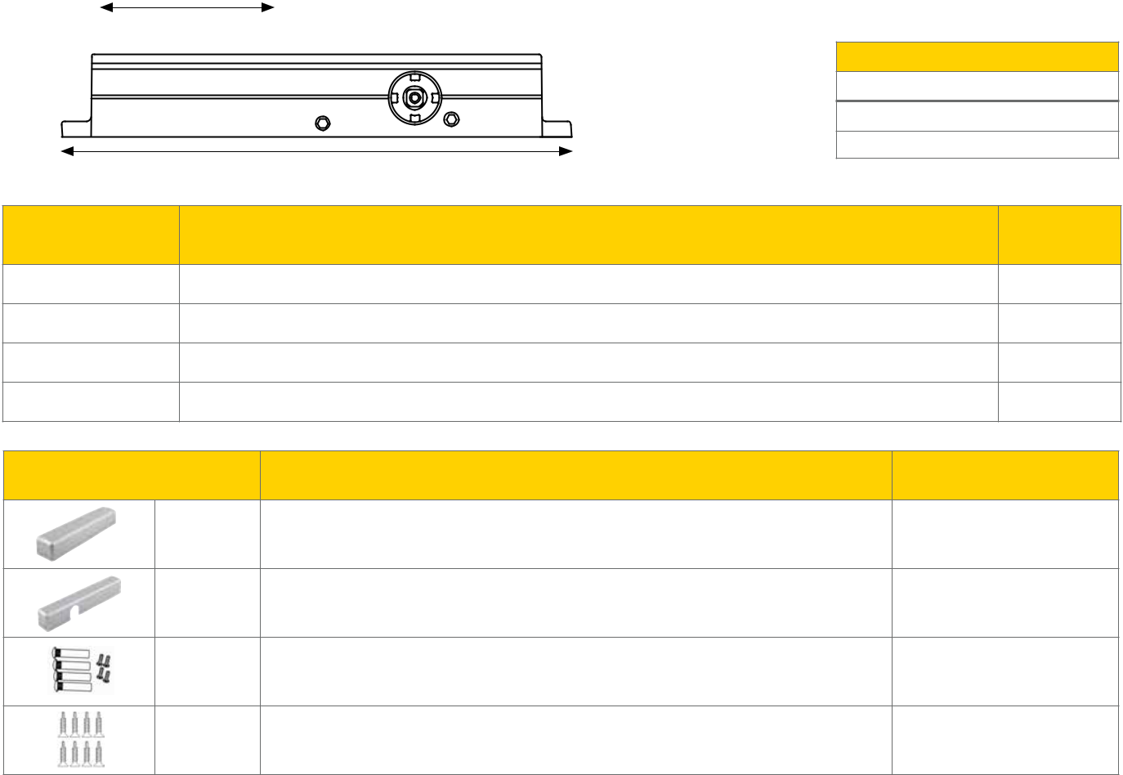

- Full Line Catalog STANLEY Commercial Hardware

How to Order

QDC 200 Series: Grade 1 Heavy-Duty Door Closers

Example

If you ordered: QDC211 F 689

You would get: Grade 1 Heavy-Duty Slim-Line Non-Hold Open Door Closer – Full Adjustable (Sized 1-6), Tri-Packed Arms with both Delayed Action & Backcheck Standard, full-size cover, Painted Aluminum finish.


11 | Tri-Pack Arm
12 | Tri-Pack Arm with Hold-Open |  | 689 | Painted Aluminum
13 | Heavy Duty Arm with Compression Stop |  | 690 | Painted Dark Bronze
14 | Heavy Duty Arm with Hold-Open and Compression Stop |  | 696 | Painted Brass
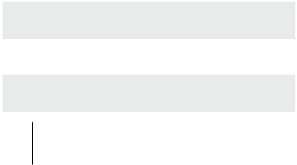

 |  |  |  |  | Base Part Number
 |  | Series |  |  | Function |  |  | Trim |  |  | Finish
 |  | QDC2 |  |  | 11 |  |  | F |  |  | 689
QDC2xx | Grade 1 Heavy-Duty |  |  |  |  | F |  | Full-Size Cover
QDC2xx | Architectural
 |  |  |  |  |  | S |  | Slim-Line Cover


DOOR CLOSERS

Full Line Catalog STANLEY Commercial Hardware 73

QDC 300 Series: Grade 1 Standard-Duty Door Closers
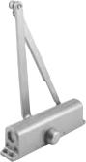
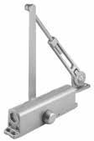

Performance Features

- Fully adjustable from 1 - 6 allowing for maximum flexibility.

- Delayed action and backcheck are standard in the same door closer body.

- All-weather fluid ensures optimal operational performance in multiple climate conditions.

Certifications

- ANSI/BHMA A156.4 Series – Grade 1

- ANSI A117.1 Accessibility Code (ADA Compliant)
• UL/cUL listed (3 hour) for self-closing doors without hold open |  |  |  |  |  | Tri-Pack Arm | Tri-Pack Arm with
 |  |  |  |  |  |  | Hold-Open
• | UL10C Positive Pressure Rated
• | UL10B Pressure Rated
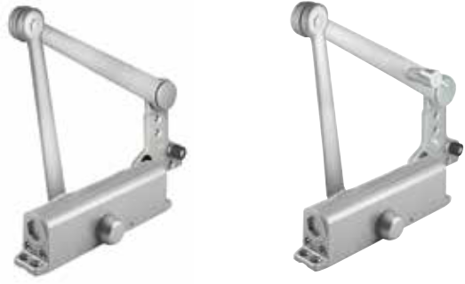
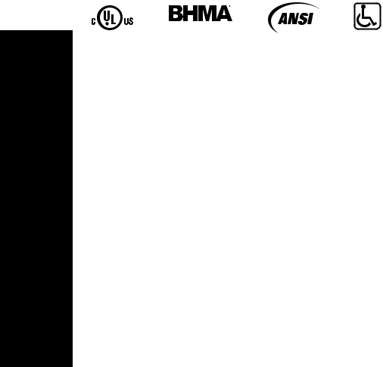

DOOR CLOSERS

Product Specifications

- Handing – All QDC300 Series Closers are non-handed.

- Material – Cast aluminum closer body.

- All-weather fluid.

- Cover – Full, architectural plastic cover also available.

- Arms & brackets – Tri-pack standard (regular, top jamb, parallel configurations). Hold open and dead stop arms also available.

- Arm material – Heat-treated carbon steel.

- Springs – High-impact hand-drawn steel wires.

- Pinions – Heat-treated chrome molybdenum steel.

- Cylinder construction – Heat-treated free-cutting carbon steel.

- Fasteners – Wood and machine screws standard; sex nuts and self-tapping screws shipped standard.

- Door weights & sizes:

 |  |  |  |  | Door Width Ranges
Size | Applicable Door Weight |  |  |  | Interior | Exterior
1 | 33 | – 55 LBS (15 – 30 Kg) |  |  | 32" (0.81m) | 28" (0.71m)
2 | 56 | – 99 LBS (30 – 45 Kg) |  |  | 36" (0.91m) | 32" (0.81m)
3 | 99 | – 143 LBS (45 – 65 Kg) |  |  | 42" (1.07m) | 36" (0.91m)
4 | 143 |  | – 187 LBS (65 | – 85 Kg) | 48" (1.22m) | 42" (1.07m)
5 | 187 |  | – 264 LBS (85 | – 120 Kg) | 54" (1.37m) | 48" (1.22m)
6 | 264 |  | – 330 LBS (120 – 150 Kg) |  | 58" (1.47m) | 54" (1.32m)

Warranty

- Lifetime Mechanical and 3-year finish

Heavy Duty Arm with Heavy Duty Arm
Compression Stop with Hold-Open and
Compression Stop

Door Closer Functions

Series | Description
QDC311 | Tri-Pack Arm
QDC312 | Tri-Pack Arm with Hold-Open
QDC313 | Heavy Duty Arm with Compression Stop
QDC314 | Heavy Duty Arm with Hold-Open and
QDC314 | Compression Stop

Finishes
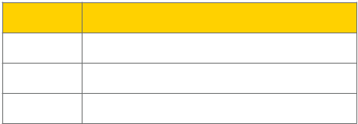

BHMA Description

- Painted Aluminum

- Painted Dark Bronze

696 | Painted Satin Brass

- Full Line Catalog STANLEY Commercial Hardware

QDC 300 Series: Grade 1 Standard-Duty Door Closers
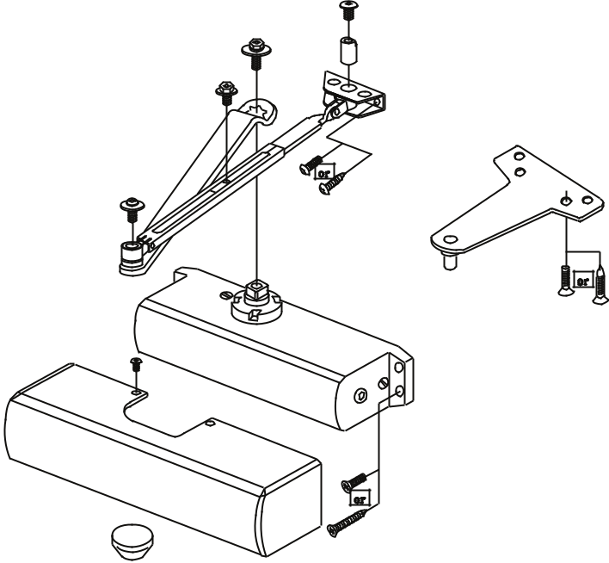

A
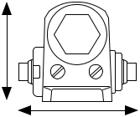

B
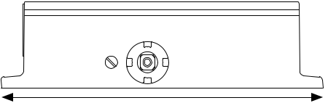

C

 |  |  |  | CLOSERS
 |  |  |  | DOOR
 | Dimensions |  |  | DOOR
A | B | C
2.62" | 3.08" | 9.80"
66.50mm | 78.10mm | 249mm

Model/Series | Functions | Qty
QDC311 | Tri-Pack Arm | 6
QDC312 | Tri-Pack Arm with Hold-Open | 6
QDC313 | Heavy Duty Arm with Compression Stop | 3
QDC314 | Heavy Duty Arm with Hold-Open and Compression Stop | 3

Order with Closer |  | Description | Service Part #
 | F | Full-size cover (specify finish) | 8Q00094
 | S | Slim-line cover (specify finish) | 8Q00096
 |  | Sex nuts (Qty 4) (specify finish) | 8Q00097
 |  | Self-tapping screws (Qty 8) (specify finish) | 8Q00436
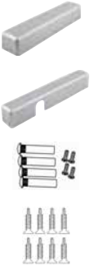

Full Line Catalog STANLEY Commercial Hardware 75

How to Order

QDC 300 Series: Grade 1 Standard-Duty Door Closers

DOOR CLOSERS

Example

If you ordered: QDC311 F 689 BF

You would get: Grade 1 Standard-Duty Non-Hold Open Door Closer – Full Adjustable (Sized 1-6), Tri-Packed Arms with Both Delayed Action & Backcheck Standard, full-size cover, Painted Aluminum finish, and Barrier Free.


11 | Tri-Pack Arm
12 | Tri-Pack Arm with Hold-Open
12 | Tri-Pack Arm with Hold-Open |  | 689 | Painted Aluminum
13 | Heavy Duty Arm with Compression Stop |  | 690 | Painted Duranodic Bronze
14 | Heavy Duty Arm with Hold-Open and Compression Stop |  | 696 | Painted Satin Brass
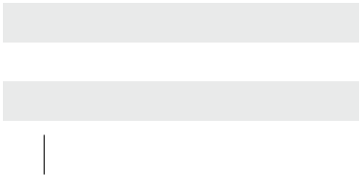

 |  |  |  |  |  | Base Part Number
 |  | Series |  |  | Function |  |  | Trim |  |  | Finish |  |  | Options
 |  | QDC3 |  |  | 11 |  |  | F |  |  | 689 |  |  | BF
QDC3xx | Grade 1 Standard- |  |  |  |  | F |  | Full-Size Cover |  |  |  |  |  | BF |  | Barrier Free
QDC3xx | Duty
 |  |  |  |  |  | S |  | Slim-Line Cover
 |  |  |  |  |  | NC |  | No Cover


- Full Line Catalog STANLEY Commercial Hardware

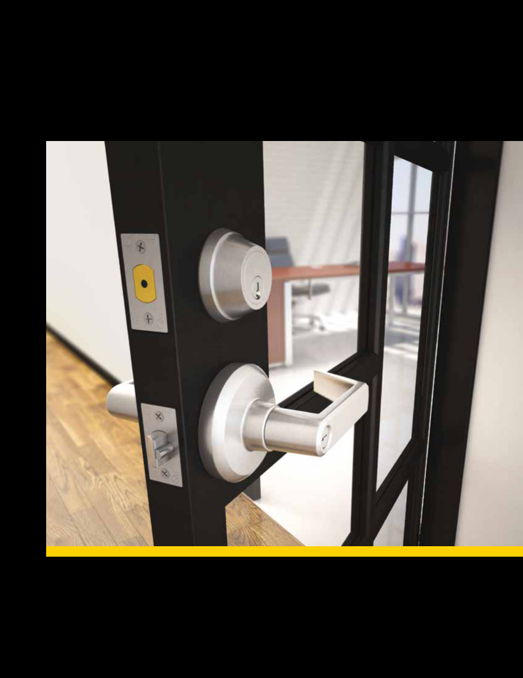
Miscellaneous Information
Windstorm- & Hurricane- Compliant Hardware Tests

MISCELLANEOUS

Windstorm- and Hurricane-Compliant Hardware have passed structural tests as per South Florida Building Code Protocol. These tests are designed to provide sufficient resistance to high-wind forces and windborne debris. The hardware provides a high level of security for door openings even if hurricane-rated door components are not required. A brief description of the test is provided below.

Static Air Pressure Test

Test simulates wind loading by evenly distributing air pressure to the face of the door assembly in positive and negative directions.

The door assembly must not have excessive deflection or deformation and must remain secure in the chamber.

Missile Impact Test

Test simulates impacts created by wind driven debris by impacting the exterior face of the doors with a 2" x 4" x 9' board at 50 feet per second. The board must not pass through the doors and the doors must remain secure in the chamber.

Cyclic Wind Pressure Test

Test simulates wind gusts by repeating cycles of positive and negative air pressure to determine that the integrity of the door assembly is not compromised with the Missile Impact Test. The door assembly must not have excessive deflection or deformation and must remain secure in the chamber.

Component Approval

The hardware listed is approved as components to be used with any 18-gauge single or pair of hollow metal doors with 16-gauge frames holding a current Notice of Acceptance (NOA). The lowest Design Pressure Rating of the doors or components shall apply.

Notice of Acceptance (NOA)

The Miami-Dade County Product Control Division has approved these devices to be used in Miami-Dade County and other areas where allowed by the Authority Having Jurisdiction (AHJ). Product Control NOA Numbers 11-0325.04 (locking products) and 11-0606.02 (exit devices) have been issued and expire on August 18, 2016.

To see the NOA documentation online, visit: http://www.miamidade.gov/building/pc-search.app.asp and type in the NOA numbers referenced above under the Product Search Application link.

- Full Line Catalog STANLEY Commercial Hardware

Windstorm- & Hurricane- Compliant Hardware Charts

 | Locks & Deadbolts
 |  |  |  |  |  |  | Single Door |  |  |  |  | Pair of Doors with Mullion |  |  |  |  |  |  | Pair of Doors with SVR
 |  |  |  |  |  |  |  |  | Max |  |  |  |  |  |  | Max |  |  |  |  |  |  |  |  | Max
 | Product |  | Opening |  |  |  |  |  | Design | Opening |  |  |  |  |  | Design |  |  | Opening |  |  |  |  |  | Design
 |  |  |  |  |  |  | Model #* |  | Pressure |  |  |  | Model # |  |  | Pressure |  |  | Opening |  |  | Model # |  |  | Pressure
 |  |  | Size |  |  |  |  |  | Pressure | Size |  |  |  |  |  | Pressure |  |  | Size |  |  |  |  |  | Pressure
 |  |  |  |  |  |  |  |  | Rating |  |  |  |  |  |  | Rating |  |  | Size |  |  |  |  |  | Rating
 |  |  |  |  |  |  |  |  | (PSF) |  |  |  |  |  |  | (PSF) |  |  |  |  |  |  |  |  | (PSF)
 | Grade 1 |  |  |  |  |  | QCL100 with |  |  |  |  |  | QCL100 with |  |  |  |  |  |  |  |  | QCL100 with
 | Cylindrical
 | Cylindrical |  |  |  |  |  |  |  |  |  |  |  | QDB100/200 & |  |  |  |  |  |  |  | QDB100/200 &
 | with |  |  |  |  |  | QDB100/200
 | with |  |  |  |  |  |  |  |  |  |  |  | QED111/112/113 |  |  |  |  |  |  | QED114/115/116
 | Deadbolt
 | Grade 2 |  | 4' 0" x |  |  |  | QCL200 with |  |  | 8' 0" x |  |  | QCL200 with |  |  |  |  |  | 8' 0" x |  |  | QCL200 with
 | Cylindrical |  |  |  |  |  |  |  | 75 |  |  |  |  |  |  | 75 |  |  | 8' 0" x |  |  |  |  |  | 68
 | Cylindrical |  | 8' 0" |  |  |  |  |  | 75 | 8' 0" |  |  | QDB100/200 & |  |  | 75 |  | 8' 0" |  |  | QDB100/200 & |  |  |  | 68
 | with |  |  |  |  |  | QDB100/200
 | with |  |  |  |  |  |  |  |  |  |  |  | QED111/112/113 |  |  |  |  |  |  | QED114/115/116
 | Deadbolt
 | Grade 2 |  |  |  |  |  | QTL200 with |  |  |  |  |  | QTL200 with |  |  |  |  |  |  |  |  | QTL200 with
 | Tubular with |  |  |  |  |  |  |  |  |  |  |  | QDB100/200 & |  |  |  |  |  |  |  | QDB100/200 &
 | Tubular with |  |  |  |  |  | QDB100/200
 | Deadbolt |  |  |  |  |  |  |  |  |  |  |  | QED111/112/113 |  |  |  |  |  |  | QED114/115/116
* Dummy functions not included.
 | Exit Devices
 |  |  |  |  |  |  |  |  | Single Door |  |  |  |  |  |  |  | Pair of Doors with Mullion
 | Product |  |  |  | Opening Size |  |  |  | Model # |  |  | Max Design |  |  | Opening Size |  |  |  | Model # |  |  |  | Max Design
 |  |  |  |  |  |  |  |  | Model # |  | Pressure Rating |  |  |  |  |  |  |  |  |  |  |  | Pressure Rating
 |  |  |  |  |  |  |  |  |  |  |  |  | (PSF) |  |  |  |  |  |  |  |  |  |  | (PSF)
 |  |  |  |  |  |  |  |  | QED111 |  |  |  |  |  |  |  |  |  | QED111
 |  |  |  |  |  | 4' 0" x 8' 0" |  |  | QED112 |  |  |  | 75 |  | 8' 0" x 8' 0" |  |  |  | QED112 |  |  |  |  | 75
 |  |  |  |  |  |  |  |  | QED113 |  |  |  |  |  |  |  |  |  | QED113
 | Grade 1
 |  |  |  |  |  |  |  |  |  |  |  |  |  |  |  |  |  | Pair of Doors with SVR
 | Heavy-Duty
 |  |  |  |  |  |  |  |  |  |  |  |  |  |  |  |  |  |  | QED114
 |  |  |  |  |  |  |  |  |  |  |  |  |  |  | 8' 0" x 8' 0" |  |  |  | QED115 |  |  |  |  | 68
 |  |  |  |  |  |  |  |  |  |  |  |  |  |  |  |  |  |  | QED116



MISCELLANEOUS

Full Line Catalog STANLEY Commercial Hardware 79

Competitive Cross-Reference

MISCELLANEOUS

Auxiliary Deadbolts

 |  | Arrow | Corbin | Sargent | Yale | Marks | Schlage | Falcon | Hager | Dorma | Cal
 |  | Arrow | Russwin |  |  |  |  |  |  |  | Royal
Grade 1 | QDB100 | DC60 | DL3100 | 480 | 3600 | 140 | B600 | D100 | 3100 | DB800 | CRB800
Deadbolt | Series | Series | Series | Series | Series | Series | Series | Series | Series | Series | Series
Grade 2 | QDB200 | E60 | DL2100 | 470 | 3500 | — | BC100 | D200 | 3200 | DB600 | T300
Deadbolt | Series | Series | Series | Series | Series | — | Series | Series | Series | Series | Series


Mechanical Locksets

 |  | Arrow | Corbin | Sargent | Yale | Marks | Schlage | Falcon | Hager | Dorma | Cal
 |  | Arrow | Russwin |  |  |  |  |  |  |  | Royal
Grade 1 | QML100 | BW | ML2000 | 8200 | 8800 | — | L | MA | 3800 | M9000 | NM
Mortise | Series | Series | Series | Series | Series | — | Series | Series | Series | Series | Series
Grade 1 | QCL100 |  |  |  |  |  |  |  |  |  | Genesys
Grade 1 | QCL100 | Q Series | CL3300 | 10 Line | 5400LN | 95 Line | ND | T | 3400 | CL800 | Series/
Cylindrical | Series | W Series | Series | Series | Series | Series | Series | Series | Series | Series | Calypso
 |  |  |  |  |  |  |  |  |  |  | Series
Grade 2 | QCL200 | ML | CL3800 | 7 Line | 5300LN | 70 Line | AL | B Series | 3500 | CL700 | SL
Cylindrical | Series | Series | Series | Series | Series | Series | Series | W Series | Series | Series | Series
Grade 2 | QTL200 | C Series | CL3700 | DL | 4300LN | — | S Series | Y Series | 3600 | CL600 | SG
Tubular | Series | C Series | Series | Series | Series | — | S Series | Y Series | Series | Series | Series


Exit Devices


Arrow | Corbin | Sargent Yale Marks | Von | Falcon Hager Dorma | Cal
Arrow | Russwin | Sargent Yale Marks | Duprin | Falcon Hager Dorma | Royal

Grade 1
Heavy-Duty | QED100 | 3000 | ED5000 | 80 | 7000 | — | 98/99 | 24 Series | 4500 | 9000 | 7700
Architectural | Series | Series | Series | Series | Series | — | Series | 25 Series | Series | Series | Series
Push Bar
Grade 1
Economy | QED300 | 1000 | ED8000 | 30 | 2100 | — | 22 | 19 | 4700 | 8000 | 2200
Standard | Series | Series | Series | Series | Series | — | Series | Series | Series | Series | Series
Push Bar

Door Closers
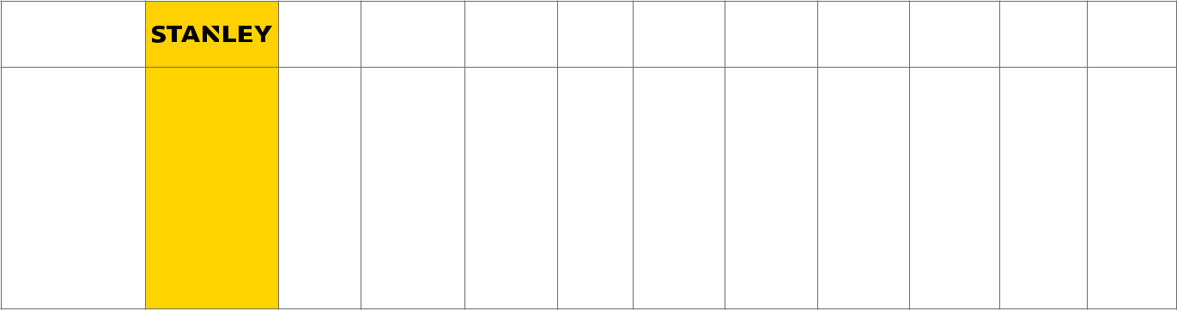

Arrow | Corbin | Sargent Yale Norton | LCN | Falcon Hager Dorma | Cal
Arrow | Russwin | Sargent Yale Norton | LCN | Falcon Hager Dorma | Royal

Grade 1 | QDC100 | DC500 | DC6200 |  | 4400 | 7500 | 4040 | SC70 | 5100 | 8900 | CR441
Extra | QDC100 | DC500 | DC6200 | 281 Series
Extra | Series | Series | Series | 281 Series | Series | Series | Series | Series | Series | Series | Series
Heavy-Duty | Series | Series | Series
Grade 1 | QDC200 | 5000N | DC3000 | 1331 | 3000 | 8000 | 1460 | SC80 | 5200 | 8600 | CR801
Heavy-Duty |  |  |  |  |  |  |  |  |  |  | Series 900
Heavy-Duty | Series | Series | Series | Series | Series | Series | Series | Series | Series | Series | Series 900
(Slim-Line) |  |  |  |  |  |  |  |  |  |  | Series
Grade 1 | QDC300 | 900N | DC4600 | 1130 | 51 | 1601 | 1070 | SC60 | 5300 | 7400
Standard- |  |  |  |  |  |  |  |  |  |  | 300 Series
Standard- | Series | Series | Series | Series | Series | Series | Series | Series | Series | Series | 300 Series
Duty

- Full Line Catalog STANLEY Commercial Hardware

Notes

___________________________________________________________________________________________________________________________

___________________________________________________________________________________________________________________________

___________________________________________________________________________________________________________________________

___________________________________________________________________________________________________________________________

___________________________________________________________________________________________________________________________

___________________________________________________________________________________________________________________________

___________________________________________________________________________________________________________________________

___________________________________________________________________________________________________________________________

___________________________________________________________________________________________________________________________

___________________________________________________________________________________________________________________________

___________________________________________________________________________________________________________________________

___________________________________________________________________________________________________________________________

___________________________________________________________________________________________________________________________

___________________________________________________________________________________________________________________________

___________________________________________________________________________________________________________________________

___________________________________________________________________________________________________________________________

___________________________________________________________________________________________________________________________

___________________________________________________________________________________________________________________________

___________________________________________________________________________________________________________________________

___________________________________________________________________________________________________________________________

NOTES

Full Line Catalog STANLEY Commercial Hardware 81

NOTES
Notes

___________________________________________________________________________________________________________________________

___________________________________________________________________________________________________________________________

___________________________________________________________________________________________________________________________

___________________________________________________________________________________________________________________________

___________________________________________________________________________________________________________________________

___________________________________________________________________________________________________________________________

___________________________________________________________________________________________________________________________

___________________________________________________________________________________________________________________________

___________________________________________________________________________________________________________________________

___________________________________________________________________________________________________________________________

___________________________________________________________________________________________________________________________

___________________________________________________________________________________________________________________________

___________________________________________________________________________________________________________________________

___________________________________________________________________________________________________________________________

___________________________________________________________________________________________________________________________

___________________________________________________________________________________________________________________________

___________________________________________________________________________________________________________________________

___________________________________________________________________________________________________________________________

___________________________________________________________________________________________________________________________

___________________________________________________________________________________________________________________________

___________________________________________________________________________________________________________________________

___________________________________________________________________________________________________________________________

- Full Line Catalog STANLEY Commercial Hardware




6161 East 75th Street

Indianapolis, IN 46250 USA

Phone 855-365-2407

stanleyhardwarefordoors.com

ST-CH-0005 Rev. 7/14/2018

© 2018 dormakaba Holding. All rights reserved.

© 2018 Stanley Black & Decker, Inc. STANLEY® and the STANLEY® Notched Rectangle logo are | dormakaba.com
registered trademarks of Stanley Black & Decker Inc. or one of its affiliates, and are used under license | dormakaba.com

