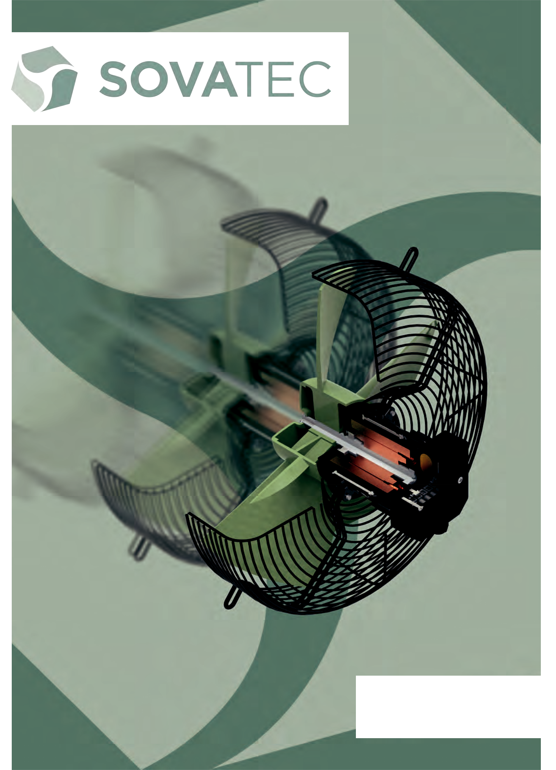

PRODUCT RANGE

PRODUKTREIHEN

WWW.SOVATEC.COM

INTRODUCTION/EINFÜHRUNG
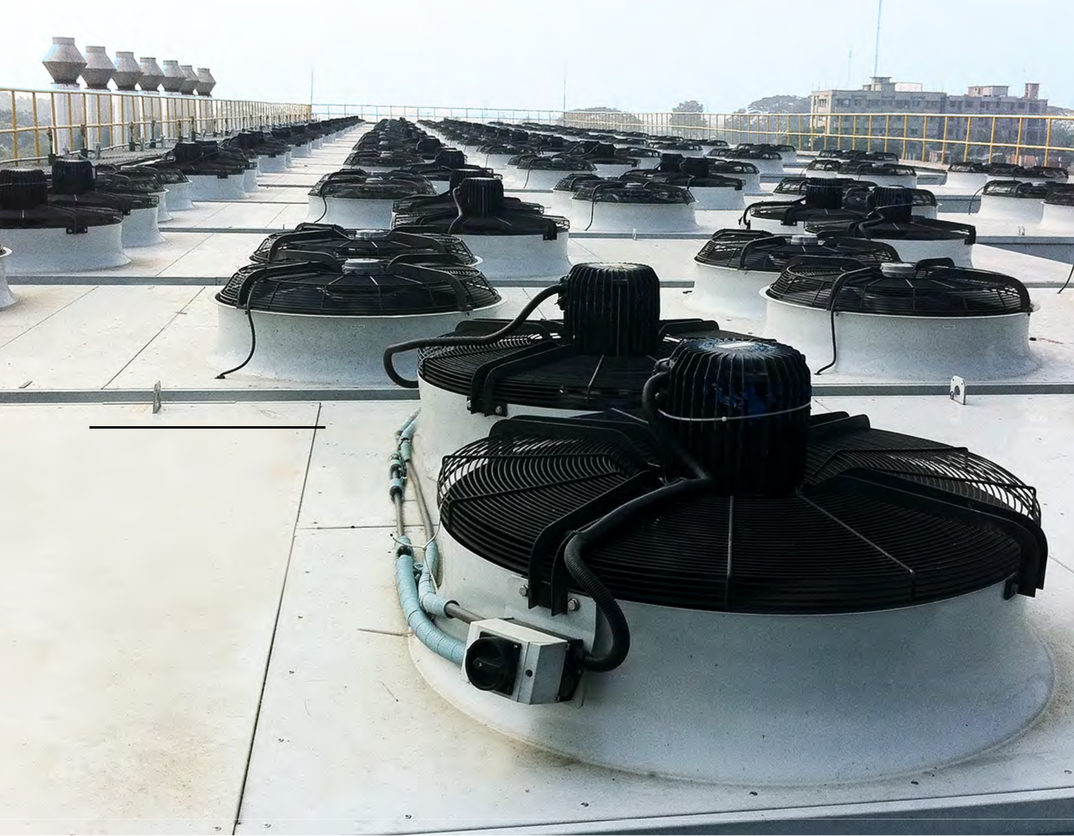

SOVATEC

HIGH EFFICIENCY

FANS

2 SOVATEC PRODUKTIONS GMBH

“WHERE QUALITY RULES, WE ARE NOT AFRAID OF ANY MARKET LEADER!”

SOVATEC Produktions GmbH designs and produces electric motors and axial fans ac-cording to European quality standards.

Whether you are planning a new ventilation con-cept, or looking for a replacement for existing hardware, our Multiple Airflow Direction system provides customized solutions to your needs, by combining ventilation- and drive technology in a modular manner.
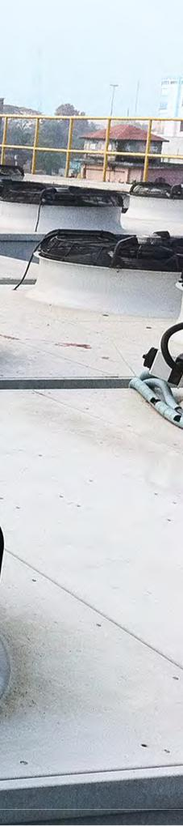

„WO QUALITÄT ENTSCHEIDET, HABEN WIR KEINEN MARKTFÜHRER ZU FÜRCHTEN!“

Die SOVATEC Produktions GmbH entwickelt und produziert Elektromotoren und Axial-ventilatoren nach europäischen Qualitäts-

standards.

Unser langjährig entstandenes Baukastensystem mit Multi Airflow Direction verbindet Ventilations-und Antriebstechnik für Ihre individuellen Kom-plett- und Ersatzlösungen.

The SOVATEC product range provides cost ef-ficient, adaptable systems with high protection classes and fulfills national and international re-quirements (e.g. ErP, CE, UL, ...).Our worldwide op-erating team is looking forward to support you with fast solutions to your ventilation and drive technol-ogy requirements.

We develop electronic motors in AC, DC and EC configuration.

Applying a system of continuous product improve-ment, SOVATEC is dedicated to generating the best customer value in our Austrian production facility, where a high degree of automation and state of the art measurement- and testing equipment ensures a highly competitive manufacturing process.

SOVATEC offers:

- high efficiency

- flexible air flow direction

(puller / pusher)

- high protection classes

- low noise levels

- high durability

- special corrosion-resistant materials

Die SOVATEC Produktreihen bieten kostengüns-tige Effizienz, anpassungsfähige Systeme, hohe Schutzklasse und entsprechen nationalen und internationalen Richtlinien (ErP, CE, UL, ...). Unser weltweit präsentes Team arbeitet in mehreren Ländern und freut sich, schnelle Lösungen für Ihre Aufgaben in der Ventilations- und Antriebstechnik zu finden.

Wir entwickeln Elektromotoren in AC, DC und EC Ausführungen.

SOVATEC arbeitet laufend an der Verbesserung der Produkte, damit der höchste Wert für Ihre Kunden geschaffen wird. Um unseren Produktionsstandort in Österreich wettbewerbsfähig auszurichten, ar-beitet SOVATEC mit den neuesten Mess-und Prü-feinrichtungen.

SOVATEC bietet:

- Hohe Effizienz

- Flexible Luftrichtungen (saugend / drückend)
- Hohe Schutzarten (-IP66)

- Geringe Geräuschentwicklung

- Lange Lebenszeit

- Spezielle korrosionsbeständige Materialen

SOVATEC PRODUKTIONS GMBH 3

EFFICIENCY & QUALITY EFFIZIENZ & QUALITÄT
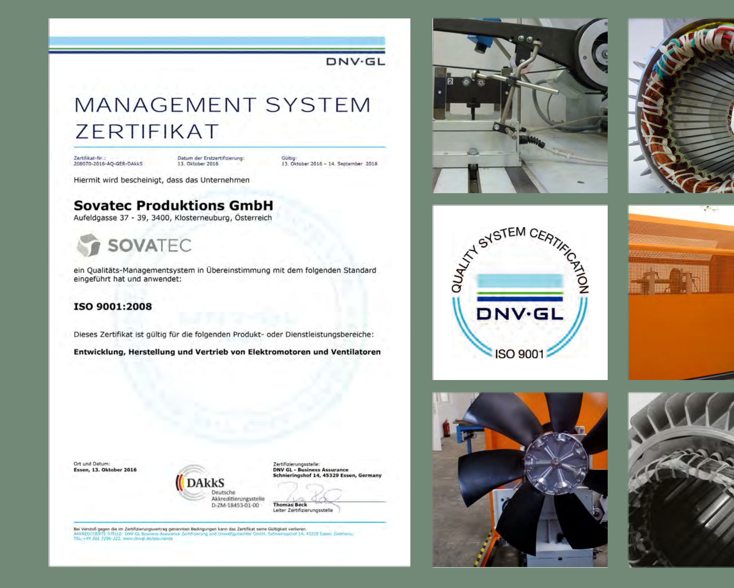

4 SOVATEC PRODUKTIONS GMBH

GUARANTEED GARANTIERT

The product range is continuously being ex-panded according to our own research and development. Performance data of all model ranges is verified and recorded under realistic con-ditions instead of in idealized laboratory environ-

ments.
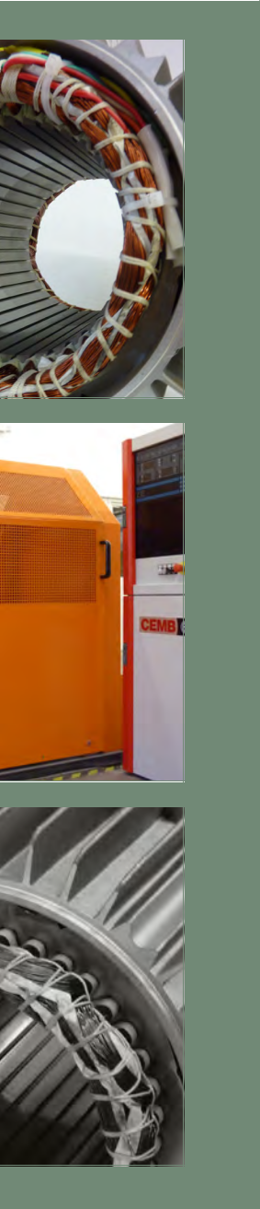

The MAD range consists of an electric motor and fan blades of polyamide 6 with 30% glas fibre with diameters between 250 and 1000mm. The drives are single phase or three phase motors with power ranging from 60W to 3,4kW. The electric motors are configured for temperature class 155 (insulation class F) operating at a frequency of 50Hz and/or 60Hz. The protection class goes up to IP66. The electric motors can be voltage controlled and may also be used in combination with electronic as well as transformer controls.

Special models with increased temperature ranges (-50°C / +80°C) are possible. The required mini-mum efficiency grade specified by the ErP direc-tive 2015 is N=40. Sovatec offers ErP compliant solutions for all common diameters.

Our MED range offers best price-performance ratio. The fans consist of an electric motor and fan blades with diameters between 250mm and 500mm of durable metal. The drives are single phase or three phase external rotor systems. The MED range is characterized by a particularly com-pact design. It is a convenient solution for a diverse field of applications. Special designs for individual requirements are possible.

Das Produktspektrum wird nach eigenen Vorgaben entwickelt und realisiert. Die Leis-tungsdatenerfassung der einzelnen Baurei-hen erfolgt jeweils in einsatznaher Konfiguration

und nicht unter optimierten Laborbedingungen.

Die MAD Baureihe besteht aus einem Elektromo-tor und Flügelblättern mit Durchmessern zwischen 250 und 1000mm aus Kunststoff (Polyamid 6 mit 30% Glasfaser). Die Einphasen- und Drehstrom-motoren haben ein Leistungsspektrum von 60W bis 3,4kW. Sie sind für Isolationsklasse 155 (F) und für einen Betrieb mit 50Hz und/oder 60Hz Netz-frequenz ausgelegt. Die Schutzart ist bis zu IP66 realisierbar. Die Motoren sind spannungsregelbar und können in Verbindung mit elektronischen wie auch transformatorischen Regeleinheiten betrie-ben werden.

Auch Sonderausführungen mit erhöhtem Tempe-raturbereich (-50°C / +80°C) sind möglich. Der von der ErP Norm 2015 geforderte Mindestwert des Effizienzgrades liegt bei N=40. Sovatec bietet für alle gängigen Durchmesser ErP konforme Lösun-gen an.

Die MED Baureihe bietet das beste Preis-Leistungs-verhältnis. Sie besteht aus einem ein- oder dreipha-sigen Außenläufer-Elektromotor und Flügelblättern mit Durchmessern von 250mm bis 500mm aus strapazierfähigem Metall. Die MED Serie zeichnet sich durch eine besonders kompakte Bauart aus. Sie ist eine günstige Alternative für ein vielfältiges Anwendungsgebiet. Sonderausführungen für indi-viduelle Anforderungen sind möglich.

SOVATEC PRODUKTIONS GMBH 5

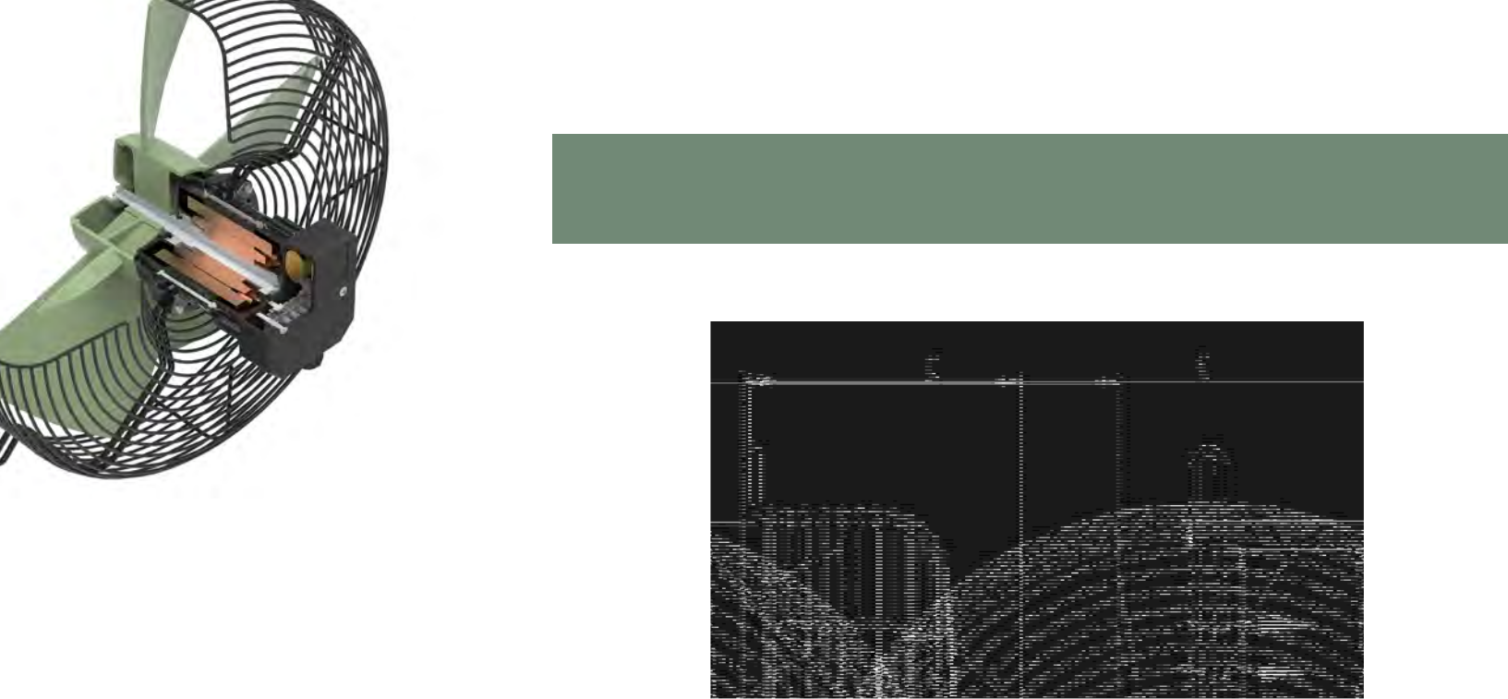
MAD 1 SERIES

DIMENSION CHART / MASSTABELLE [mm]

 | A | B | C | D | E | F | G | 50 Hz | 60 Hz
MAD1-025-A020E4ML-ABC | 250 | 267 | 144 | 171 | 328 | 300-310 | 7 | q | w
MAD1-030-A020E4NL-ABH | 300 | 325 | 122 | 177 | 380 | 360 | 7 | e | "
MAD1-030-A030E4ML-ABH | 300 | 325 | 132 | 187 | 380 | 360 | 7 | y | u
MAD1-030-A030E4ML-AAH | 300 | 325 | 132 | 187 | 380 | 360 | 7 | r | t
MAD1-035-A040E4NL-ACH | 349 | 380 | 138 | 197 | 442 | 422 | 7 | i | "
MAD1-035-A050E4ML-ABH | 349 | 380 | 148 | 207 | 442 | 422 | 7 | o | a
MAD1-040-A065E4ML-ABH | 396 | 430 | 165 | 222 | 490 | 470 | 9 | s | d

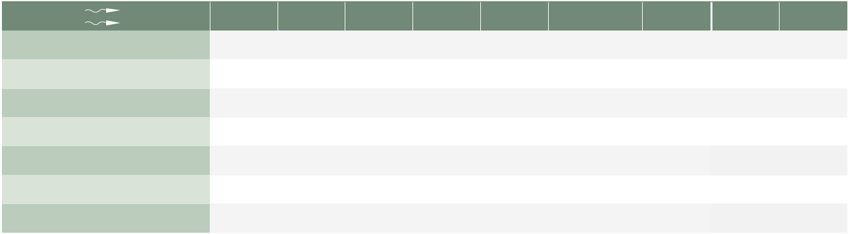

 | A | B | C | D | E | F | G | 50 Hz | 60 Hz
MAD1-025-A020E4ML-BBC | 250 | 267 | 144 | 171 | 328 | 300-310 | 7 | q | w
MAD1-030-A020E4NL-BBC | 300 | 317 | 150 | 177 | 380 | 345-360 | 7 | e | "
MAD1-030-A030E4ML-BBC | 300 | 317 | 160 | 187 | 380 | 345-360 | 7 | y | u
MAD1-030-A030E4ML-BAC | 300 | 317 | 160 | 187 | 380 | 345-360 | 7 | r | t
MAD1-035-A040E4NL-BCC | 349 | 366 | 170 | 197 | 442 | 395-422 | 7 | i | "
MAD1-035-A050E4ML-BBC | 349 | 366 | 180 | 207 | 442 | 395-422 | 7 | o | a
MAD1-040-A065E4ML-BBC | 396 | 415 | 195 | 222 | 490 | 450-470 | 9 | s | d

Copyright Sovatec Produktions GmbH. This data sheet shows a technical overview of our products. Please contact us if more detailed information is needed. As we are constantly improving our products, their characteristics, dimensions and weights
may also change, although we do our best to incorporate these changes continually. The information in this data sheet is intended to be used as a first general guideline only. Sovatec assumes no liability for any information therein, any errors, omissions,
misprints, nor any direct or indirect damages, losses or costs resulting therefrom. The acoustic values given are only valid under the measurement conditions listed and may vary depending on the installation situation. With any deviation to the standard
setup, the specific values have to be checked and reviewed once installed or fitted!
6 | SOVATEC PRODUKTIONS GMBH

MAD 1 SERIES

fa ΔP [Pa]

CHARACTERISTICS CHART / NENNDIAGRAMM
100
90 |  | a
80 |  |  | s
80 |  | o
70 |  | i
60 |  | u | d
60 |  | r ^{t}
50 | y | r ^{t}
50 | e
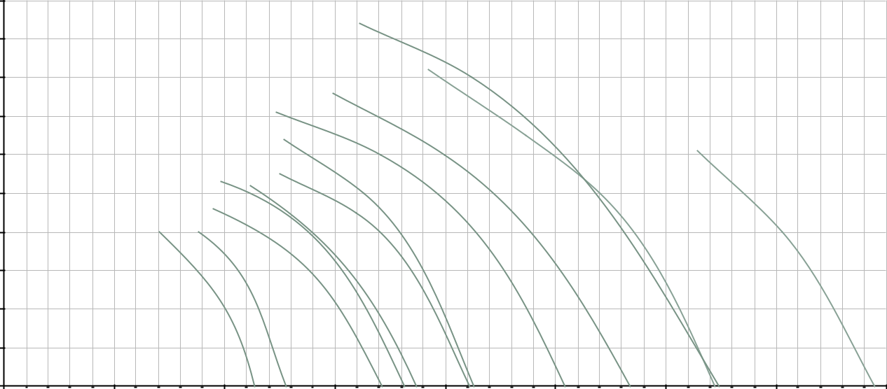
- q w

30

20

10

0

0 | 500 | 1.000 | 5001. | 2.000 | 5002. | 3.000 | 5003. | 4.000
 |  |  |  | Vp [m3/h]

OPTIONS / OPTIONEN

RANGE OF MOUNTING POSSIBILITIES | VARIOUS PROTECTION GRIDS | T_{r} | +60°C
 |  |  |  | ErP |  | IP44-
VERSCHIEDENE GITTERBEFESTIGUNGEN | VERSCHIEDENE GITTERHÖHEN | -40°C |  | READY |  | IP66
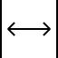

TECHNICAL DATA / |  |  |  |  |  |  |  |  |  |  |  | Further ErP-data available upon request
 |  |  |  |  |  |  |  |  |  |  | Weitere ErP Daten sind auf Anfrage erhältlich
TECHNISCHE DATEN
TECHNISCHE DATEN |  |  | f (Hz) | P1 (W) | I (A) | n (min | -1 | ) | cos φ | C_{B} (μF) | dB(A) |  | kg | T_{r} (°C)
MAD1-025-A020E4ML-BBC/ABC |  | q | 50 | 63 | 0,28 | 1360 |  |  | 0,98 | 2,00 | 62 |  | 2,6 | -30°C/+60°C
MAD1-025-A020E4ML-BBC/ABC |  | w | 60 | 75 | 0,33 | 1550 |  |  | 0,99 | 2,00 | 63 |  | 2,6 | -30°C/+60°C
MAD1-030-A020E4NL-BBC/ABH |  | e | 50 | 85 | 0,38 | 1250 |  |  | 0,97 | 2,50 | 64 |  | 3 | -30°C/+50°C
MAD1-030-A030E4ML-BAC/AAH |  | r | 50 | 95 | 0,42 | 1305 |  |  | 0,98 | 3,00 | 65 |  | 3,4 | -30°C/+60°C
MAD1-030-A030E4ML-BAC/AAH |  | t | 60 | 125 | 0,55 | 1390 |  |  | 0,99 | 3,00 | 67 |  | 3,4 | -30°C/+60°C
MAD1-030-A030E4ML-BBC/ABH |  | y | 50 | 89 | 0,40 | 1340 |  |  | 0,97 | 3,00 | 65 |  | 3,4 | -30°C/+60°C
MAD1-030-A030E4ML-BBC/ABH |  | u | 60 | 120 | 0,53 | 1500 |  |  | 0,99 | 3,00 | 68 |  | 3,4 | -30°C/+60°C
MAD1-035-A040E4NL-BCC/ACH |  | i | 50 | 124 | 0,54 | 1350 |  |  | 0,98 | 4,00 | 70 |  | 4,2 | -30°C/+45°C
MAD1-035-A050E4ML-BBC/ABH |  | o | 50 | 150 | 0,67 | 1330 |  |  | 0,97 | 5,00 | 68 |  | 4,5 | -30°C/+55°C
MAD1-035-A050E4ML-BBC/ABH |  | a | 60 | 200 | 0,88 | 1525 |  |  | 0,99 | 5,00 | 72 |  | 4,5 | -30°C/+55°C
MAD1-040-A065E4ML-BBC/ABH |  | s | 50 | 185 | 0,81 | 1300 |  |  | 0,99 | 6,50 | 74 |  | 5,3 | -40°C/+45°C
MAD1-040-A065E4ML-BBC/ABH |  | d | 60 | 255 | 1,13 | 1470 |  |  | 0,98 | 6,50 | 74 |  | 5,3 | -40°C/+45°C
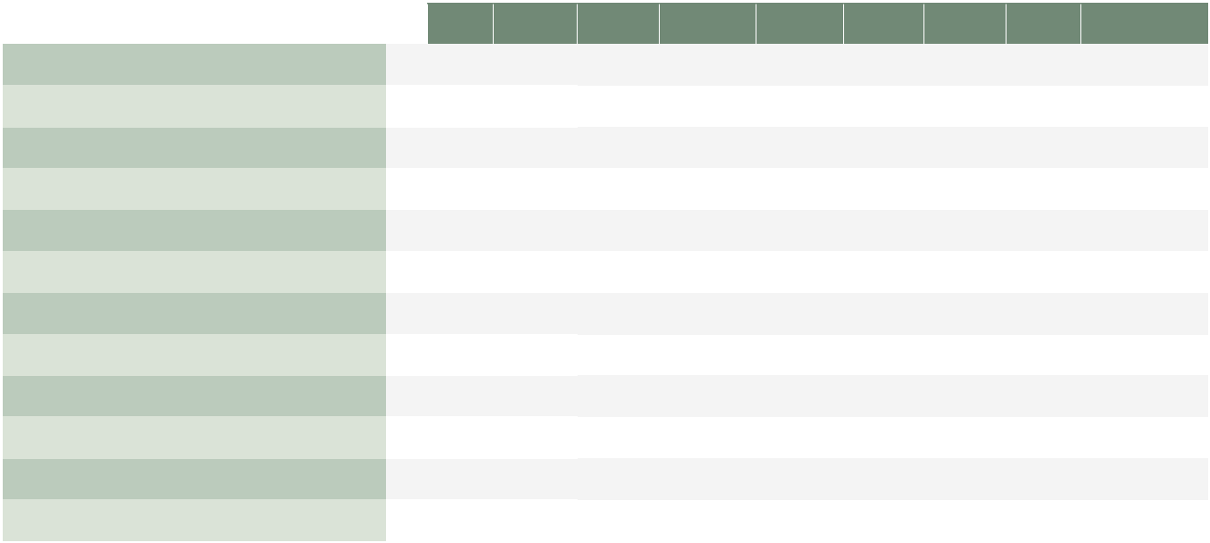

Copyright Sovatec Produktions GmbH. This data sheet shows a technical overview of our products. Please contact us if more detailed information is needed. As we are constantly improving our products, their characteristics, dimensions and weights
may also change, although we do our best to incorporate these changes continually. The information in this data sheet is intended to be used as a first general guideline only. Sovatec assumes no liability for any information therein, any errors, omissions,
misprints, nor any direct or indirect damages, losses or costs resulting therefrom. The acoustic values given are only valid under the measurement conditions listed and may vary depending on the installation situation. With any deviation to the standard
setup, the specific values have to be checked and reviewed once installed or fitted! | 7
SOVATEC PRODUKTIONS GMBH | 7

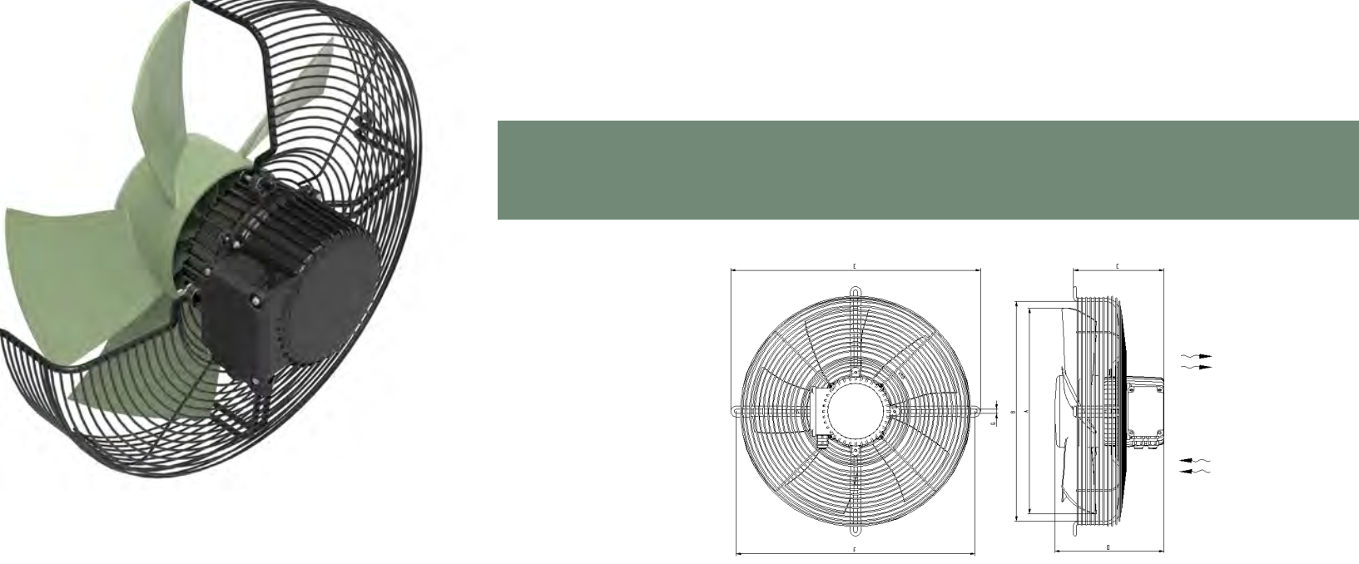
MAD 2 SERIES

DIMENSION CHART / MASSTABELLE [mm]

 | A | B | C | D | E | F | G | 50 Hz | 60 Hz
MAD2-045-C025D4NH-ABH | 445 | 474 | 165 | 235 | 539 | 515 | 9 | q | "
MAD2-045-C035D4NH-AAH | 445 | 474 | 165 | 235 | 539 | 515 | 9 | w | "
MAD2-050-C035D4NH-ABH | 497 | 524 | 165 | 235 | 589 | 565 | 9 | e | "
MAD2-050-C045D4NH-AAH | 497 | 524 | 165 | 235 | 589 | 565 | 9 | r | "
 | A | B | C | D | E | F | G | 50 Hz | 60 Hz
MAD2-045-C025D4NH-BBC | 445 | 474 | 195 | 235 | 539 | 515 | 9 | q | "
MAD2-045-C035D4NH-BAC | 445 | 474 | 195 | 235 | 539 | 515 | 9 | w | "
MAD2-050-C035D4NH-BBC | 497 | 524 | 195 | 235 | 589 | 565 | 9 | e | "
MAD2-050-C045D4NH-BAC | 497 | 524 | 195 | 235 | 589 | 565 | 9 | r | "


fa ΔP [Pa]

 | CHARACTERISTICS CHART / NENNDIAGRAMM |  |  |  |  |  |  |  |  |  | OPTIONS / OPTIONEN
160
140 |  |  |  |  |  | r |  |  |  |  |  |  | RANGE OF MOUNTING POSSIBILITIES
140 |  |  |  | w | e
 |  |  |  | w |  |  |  |  |  |  | VERSCHIEDENE GITTERBEFESTIGUNGEN
120 |  |  |  | q
100 |  |  |  |  |  |  |  |  |  |  |  |  | VARIOUS PROTECTION GRIDS
80 |  |  |  |  |  |  |  |  |  |  |  | VERSCHIEDENE GITTERHÖHEN
60
40
40 |  |  |  |  |  |  |  |  |  |  |  | T_{r} | +60°C
 |  |  |  |  |  |  |  |  |  |  |  | T_{r} | +60°C | ErP
20 |  |  |  |  |  |  |  |  |  |  |  |  |  | ErP |  | IP66
20 |  |  |  |  |  |  |  |  |  |  | -40°C |  |  | READY |  | IP66
0
0 |  | 1.000 | 0002. | 0003. | 0004. | 0005. | 6.000 | 7.000 | 8.000 | 9.000
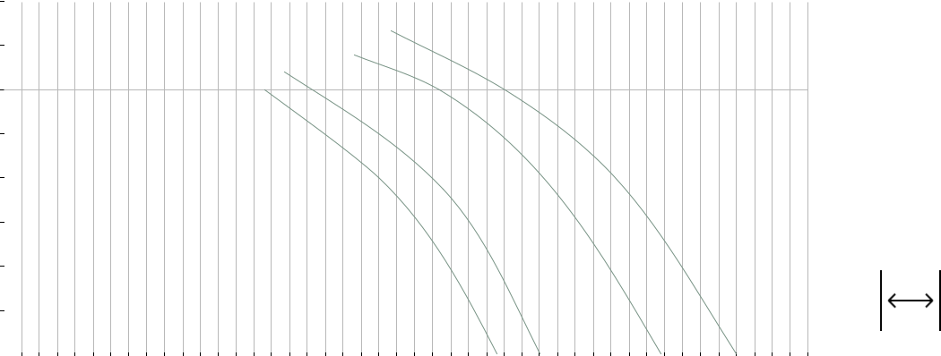

Vp [m3/h]

TECHNICAL DATA / |  |  |  |  |  |  |  |  |  |  |  | Further ErP-data available upon request
 |  |  |  |  |  |  |  |  |  |  |  | Weitere ErP Daten sind auf Anfrage erhältlich
TECHNISCHE DATEN |  | f (Hz) | P1 (W) | I (A) | n (min-1) | cos φ | C | B | (μF) | dB(A) | kg | T (°C) | ηges | Eff.-Grad N
 |  |  |  |  |  |  |  | B |  |  |  | r
MAD2-045-C025D4NH-BBC/ABH | q | 50 | 425 | 0,83 | 1355 | 0,74 |  |  | - | 76 | 8,7 | -40°C/+60°C | 32,3 | 41,7
MAD2-045-C035D4NH-BAC/AAH | w | 50 | 460 | 0,92 | 1385 | 0,73 |  |  | - | 80 | 9,6 | -40°C/+60°C | - | -
MAD2-050-C035D4NH-BBC/ABH | e | 50 | 535 | 1,05 | 1350 | 0,77 |  |  | - | 79 | 10 | -40°C/+60°C | 38,0 | 46,8
MAD2-050-C045D4NH-BAC/AAH | r | 50 | 710 | 1,30 | 1375 | 0,79 |  |  | - | 82 | 11 | -40°C/+60°C | 34,4 | 42,6


Copyright Sovatec Produktions GmbH. This data sheet shows a technical overview of our products. Please contact us if more detailed information is needed. As we are constantly improving our products, their characteristics, dimensions and weights
may also change, although we do our best to incorporate these changes continually. The information in this data sheet is intended to be used as a first general guideline only. Sovatec assumes no liability for any information therein, any errors, omissions,
misprints, nor any direct or indirect damages, losses or costs resulting therefrom. The acoustic values given are only valid under the measurement conditions listed and may vary depending on the installation situation. With any deviation to the standard
setup, the specific values have to be checked and reviewed once installed or fitted!
8 | SOVATEC PRODUKTIONS GMBH

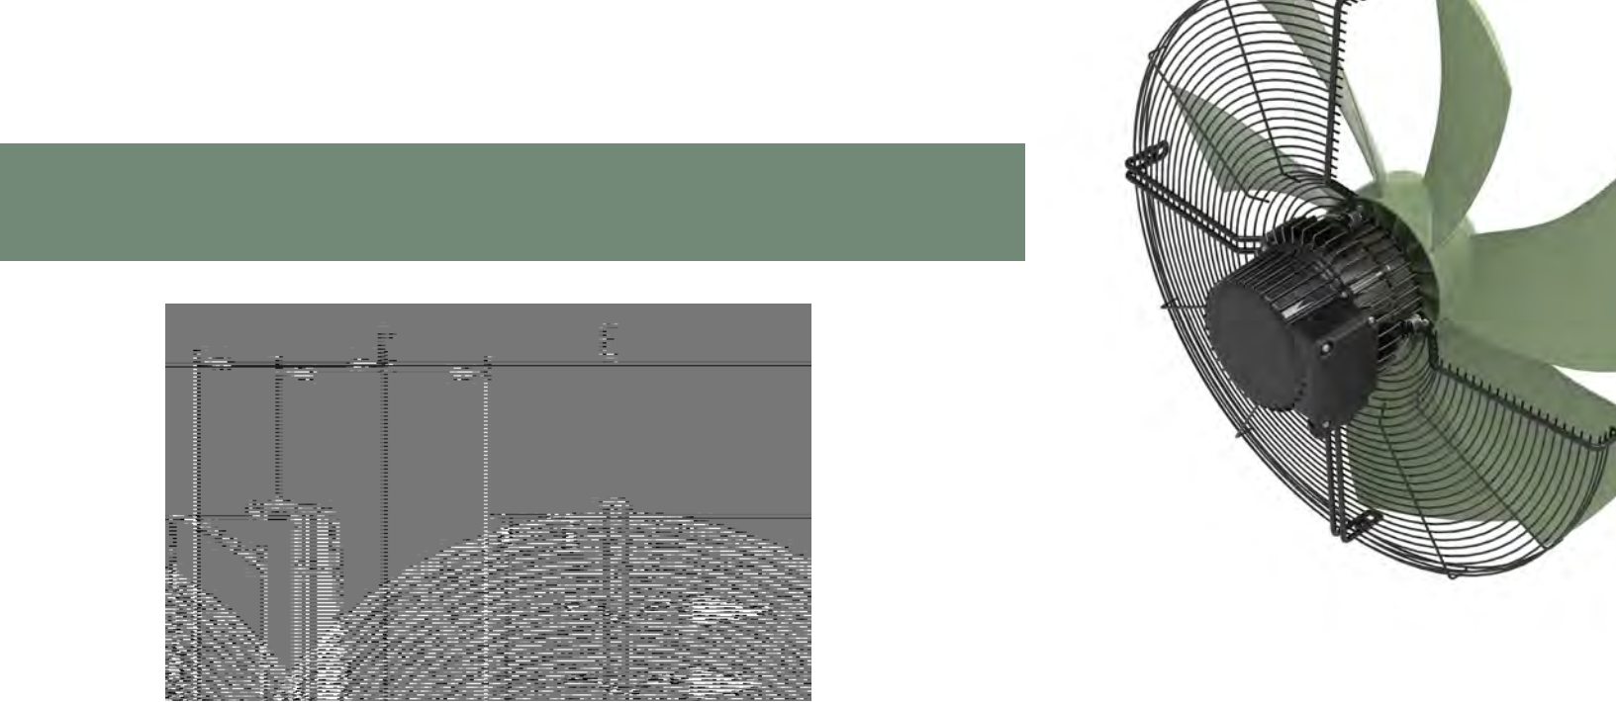
MAD 3 SERIES

DIMENSION CHART / MASSTABELLE [mm]


 | A | B | C | D | E | G | 50 Hz | 60 Hz
MAD3-063-C065DSNH-BBV | 627 | 655 | 165 | 258 | 669 | Ø 655/4*9,5 | w | "
MAD3-063-C085D4NH-BBV | 627 | 655 | 165 | 258 | 669 | Ø 655/4*9,5 | q | "

fa ΔP [Pa]

 | CHARACTERISTICS CHART / NENNDIAGRAMM |  |  |  |  |  |  |  |  |  | OPTIONS / OPTIONEN
300
270 |  |  |  |  |  |  |  |  |  |  |  |  | RANGE OF MOUNTING POSSIBILITIES
240 |  |  |  |  |  |  |  |  |  |  | VERSCHIEDENE GITTERBEFESTIGUNGEN
240 |  |  |  |  |  | e
210 |  |  |  |  |  | e
180 |  |  |  |  |  |  |  |  |  |  |  |  | VARIOUS PROTECTION GRIDS
150 |  |  |  |  |  |  |  |  |  |  |  | VERSCHIEDENE GITTERHÖHEN
120
120 |  |  |  | q
90
90 |  |  | w |  |  |  |  |  |  |  |  | T_{r} | +60°C
60 |  |  | w |  |  |  |  |  |  |  |  | T_{r} | +60°C
60 |  |  | w |  |  |  |  |  |  |  |  | T_{r} | +60°C | ErP
60 |  |  |  |  |  |  |  |  |  |  |  | T_{r} |  | ErP |  | IP66
30 |  |  |  |  |  |  |  |  |  |  |  |  |  | READY |  | IP66
30 |  |  |  |  |  |  |  |  |  |  | -40°C |  |  | READY
0
0 |  | 2.000 | 0004. | 6.000 | 8.000 | 00010. | 12.000 | 14.000 | 00016.
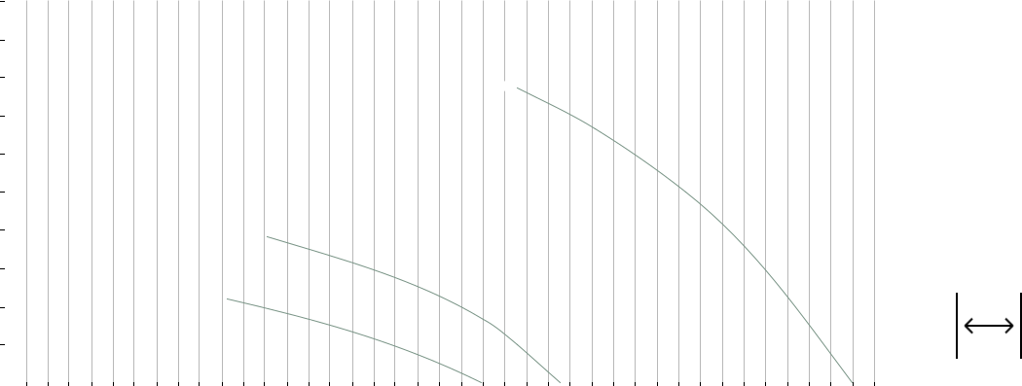

Vp [m3/h]

TECHNICAL DATA / |  |  |  |  |  |  |  |  |  | Further ErP-data available upon request
TECHNICAL DATA / |  |  |  |  |  |  |  |  |  | Weitere ErP Daten sind auf Anfrage erhältlich
TECHNISCHE DATEN |  | f (Hz) | P1 (W) | I (A) | n (min-1) | cos φ | C (μF) | dB(A) | kg | T (°C) | ηges | Eff.-Grad N
 |  |  |  |  |  |  | B |  |  | r
MAD3-063-C065DSNH-BBV | q | 50-D | 575 | 1,4 | 900 | 0,6 | - | 75 | 14,5 | -40°C/+60°C | 32,4 | 40,6
MAD3-063-C065DSNH-BBV | w | 50-Y | 340 | 0,7 | 670 | 0,7 | - | 68 | 16 | -40°C/+60°C | 32,4 | 40,6
MAD3-063-C085D4NH-BBV | e | 50 | 1675 | 3,5 | 1375 | 0,7 | - | 82 | 16,5 | -40°C/+60°C | 39,8 | 45,0


Copyright Sovatec Produktions GmbH. This data sheet shows a technical overview of our products. Please contact us if more detailed information is needed. As we are constantly improving our products, their characteristics, dimensions and weights
may also change, although we do our best to incorporate these changes continually. The information in this data sheet is intended to be used as a first general guideline only. Sovatec assumes no liability for any information therein, any errors, omissions,
misprints, nor any direct or indirect damages, losses or costs resulting therefrom. The acoustic values given are only valid under the measurement conditions listed and may vary depending on the installation situation. With any deviation to the standard
setup, the specific values have to be checked and reviewed once installed or fitted! | 9
SOVATEC PRODUKTIONS GMBH | 9

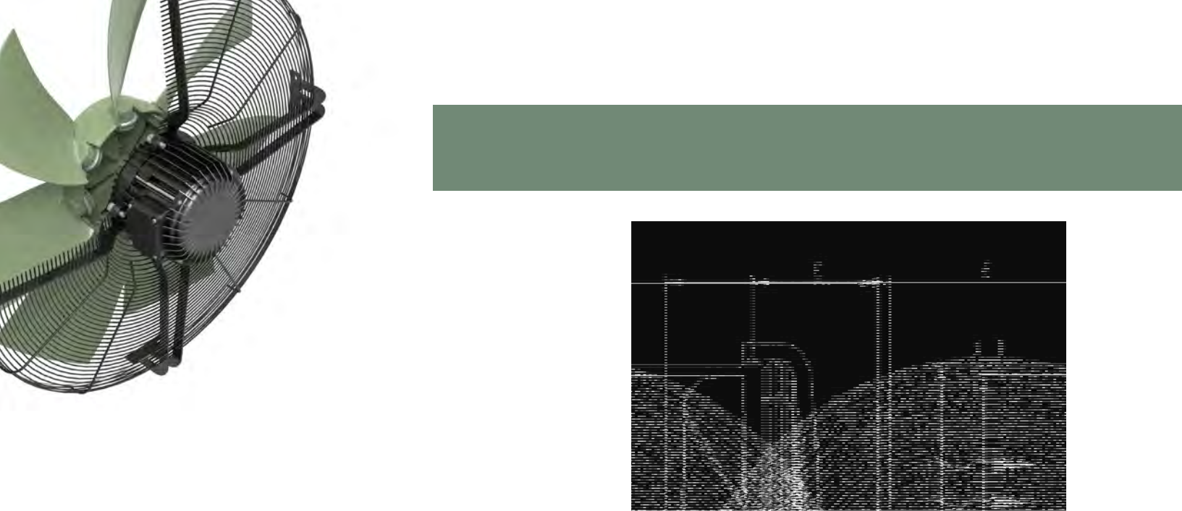
MAD 5 SERIES

DIMENSION CHART / MASSTABELLE [mm]

 | A | B | C | D | E | G | 50 Hz | 60 Hz
MAD5-100-D160DANH-BBC | 990 | 1018 | 272 | 414 | 1078 | 4* double Ø 9 – 80 mm | qw | "

fa ΔP [Pa]

CHARACTERISTICS CHART / NENNDIAGRAMM |  |  |  |  |  |  |  |  |  |  |  |  | OPTIONS / OPTIONEN
175
150 |  |  |  |  |  |  | q |  |  |  |  |  |  | RANGE OF MOUNTING POSSIBILITIES
 |  |  |  |  |  |  | q |  |  |  |  |  | VERSCHIEDENE GITTERBEFESTIGUNGEN
125
100 |  |  |  |  | w |  |  |  |  |  |  |  |  | VARIOUS PROTECTION GRIDS
 |  |  |  |  | w |  |  |  |  |  |  |  | VERSCHIEDENE GITTERHÖHEN
75
50 |  |  |  |  |  |  |  |  |  |  |  |  | T_{r}
 |  |  |  |  |  |  |  |  |  |  |  |  | T_{r} | +60°C | ErP
25 |  |  |  |  |  |  |  |  |  |  |  |  |  |  | ErP | IP66
25 |  |  |  |  |  |  |  |  |  |  |  |  |  |  | READY | IP66
 |  |  |  |  |  |  |  |  |  |  |  |  | -40°C |  | READY
0
0 | 2.500 | 0005. | 5007. | 10.000 | 50012. | 00015. | 17.500 | 00020. | 50022. | 25.000 | 27.500 | 00030. | 32.500
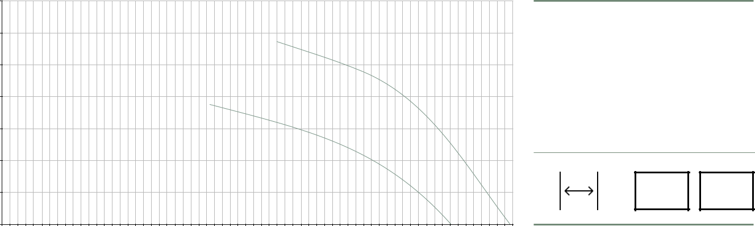

Vp [m3/h]

TECHNICAL DATA / |  |  |  |  |  |  |  |  |  |  |  | Further ErP-data available upon request
TECHNICAL DATA / |  |  |  |  |  |  |  |  |  |  | Weitere ErP Daten sind auf Anfrage erhältlich
TECHNISCHE DATEN |  | f (Hz) | P1 (W) | I (A) | n (min-1) | cos φ | C | (μF) | dB(A) | kg | T (°C) |  | ηges | Eff.-Grad N
 |  |  |  |  |  |  | B |  |  |  | r
MAD5-100-D160DANH-BBC | q | 50-D | 2375 | 5,30 | 665 | 0,65 |  | - | 83 | 53 | -40°C/+60°C |  | 36,8 | 41,0
MAD5-100-D160DANH-BBC | w | 50-Y | 1540 | 2,95 | 515 | 0,75 |  | - | 78 | 53 | -40°C/+60°C |  | 36,8 | 41,0


Copyright Sovatec Produktions GmbH. This data sheet shows a technical overview of our products. Please contact us if more detailed information is needed. As we are constantly improving our products, their characteristics, dimensions and weights
may also change, although we do our best to incorporate these changes continually. The information in this data sheet is intended to be used as a first general guideline only. Sovatec assumes no liability for any information therein, any errors, omissions,
misprints, nor any direct or indirect damages, losses or costs resulting therefrom. The acoustic values given are only valid under the measurement conditions listed and may vary depending on the installation situation. With any deviation to the standard
setup, the specific values have to be checked and reviewed once installed or fitted!
10 | SOVATEC PRODUKTIONS GMBH

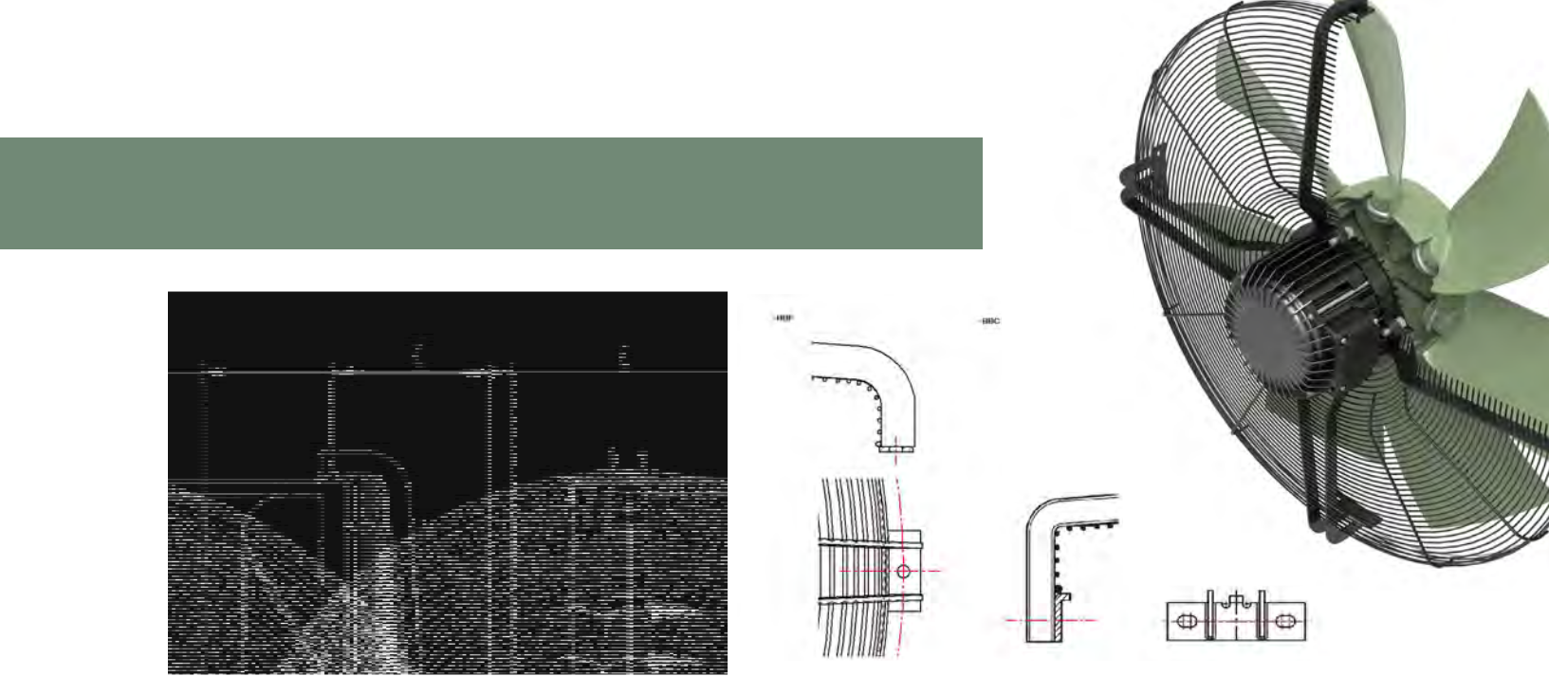
MAD 6 SERIES

DIMENSION CHART / MASSTABELLE [mm]
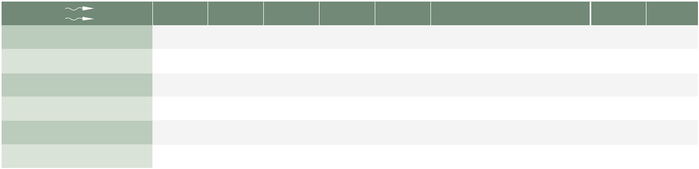

 | A | B | C | D | E | G | 50 Hz | 60 Hz
MAD6-080-D100DSNH-BBC | 788 | 816 | 205 | 347 | 866 | 4 * double Ø 9 – 80 mm | qw | "
MAD6-080-D100DSNH-BBF | 788 | 816 | 205 | 347 | 866 | 4 * Ø 9 – Ø 835 mm | qw | "
MAD6-090-D120DANH-BBC | 904 | 932 | 272 | 414 | 992 | 4 * double Ø 9 – 80 mm | er | "
MAD6-090-D120DANH-BBF | 904 | 932 | 272 | 414 | 992 | 4 * Ø 9 – Ø 954 mm | er | "
MAD6-090-D160DSNH-BBC | 904 | 932 | 272 | 414 | 992 | 4 * double Ø 9 – 80 mm | tyu | "
MAD6-090-D160DSNH-BBF | 904 | 932 | 272 | 414 | 992 | 4 * Ø 9 – Ø 954 mm | tyu | "

fa ΔP [Pa]

 |  | CHARACTERISTICS CHART / NENNDIAGRAMM |  |  |  |  |  |  |  |  |  |  |  |  |  |  |  |  |  |  |  |  |  |  | OPTIONS / OPTIONEN
225
225 |  |  |  |  |  |  |  |  |  |  |  |  | t |  |  |  |  |  |  |  |  |  |  |  |  |  |  | RANGE OF MOUNTING POSSIBILITIES
200 |  |  |  |  |  |  |  |  |  |  |  |  | t
200 |  |  |  |  |  |  |  |  |  |  | y
 |  |  |  |  |  |  |  |  |  |  | y |  |  |  |  |  |  |  |  |  |  |  |  |  | VERSCHIEDENE GITTERBEFESTIGUNGEN
175
175 |  |  |  |  |  |  | q
150 |  |  |  |  |  |  |  |  |  |  |  |  |  |  |  |  |  |  |  |  |  |  |  |  |  |  |  | VARIOUS PROTECTION GRIDS
125
125 |  |  |  |  |  | w | u |  | e |  |  |  |  |  |  |  |  |  |  |  |  |  |  |  |  |  |  | VERSCHIEDENE GITTERHÖHEN
100 |  |  |  |  |  | w
75 |  |  |  |  |  |  |  | r
75 |  |  |  |  |  |  |  |  |  |  |  |  |  |  |  |  |  |  |  |  |  |  |  |  |  |  | T_{r} | +60°C
50 |  |  |  |  |  |  |  |  |  |  |  |  |  |  |  |  |  |  |  |  |  |  |  |  |  |  | T_{r} | +60°C
50 |  |  |  |  |  |  |  |  |  |  |  |  |  |  |  |  |  |  |  |  |  |  |  |  |  |  | T_{r} |  | ErP |  |  | IP66
25 |  |  |  |  |  |  |  |  |  |  |  |  |  |  |  |  |  |  |  |  |  |  |  |  |  |  |  |  | READY |  |  | IP66
25 |  |  |  |  |  |  |  |  |  |  |  |  |  |  |  |  |  |  |  |  |  |  |  |  | -40°C |  |  |  | READY
0
0 |  |  | 5002. | 0005. | 7.500 | 00010. | 50012. |  | 15.000 |  | 17.500 | 00020. |  | 50022. |  |  | 25.000 | 27.500 | 00030. | 32.500 | 35.000 |  | 50037.
 |  |  |  |  |  |  |  |  |  |  |  | Vp [m3/h]
 |  | TECHNICAL DATA / |  |  |  |  |  |  |  |  |  |  |  |  |  |  |  |  |  |  |  |  |  |  |  |  |  | Further ErP-data available upon request
 |  |  |  |  |  |  |  |  |  |  |  |  |  |  |  |  |  |  |  |  |  |  |  |  |  |  |  | Weitere ErP Daten sind auf Anfrage erhältlich
 |  | TECHNISCHE DATEN |  |  |  |  |  |  |  |  | f (Hz) |  | P1 (W) | I (A) |  | n (min-1) |  |  | cos φ | C (μF) |  |  | dB(A) |  |  | kg |  | T (°C) | ηges |  | Eff.-Grad N
 |  |  |  |  |  |  |  |  |  |  |  |  |  |  |  |  |  |  |  | B |  |  |  |  |  |  |  | r
 |  |  | MAD6-080-D100DSNH-BBC/BBF |  |  |  |  |  | q |  | 50-D |  | 1950 | 4,5 |  |  |  | 915 | 0,68 | - |  |  | 85 |  | 37 |  | -40°C/+60°C |  | 35,3 |  | 40,1
 |  |  | MAD6-080-D100DSNH-BBC/BBF |  |  |  |  |  | w |  | 50-Y |  | 1400 | 2,5 |  |  |  | 730 | 0,81 | - |  |  | 78 |  | 37 |  | -40°C/+60°C |  | 35,3 |  | 40,1
 |  |  | MAD6-090-D120DANH-BBC/BBF |  |  |  |  |  | e |  | 50-D |  | 1550 | 3,9 |  |  |  | 710 | 0,57 | - |  |  | 81 |  | 45 |  | -40°C/+60°C |  | 35,7 |  | 41,0
 |  |  | MAD6-090-D120DANH-BBC/BBF |  |  |  |  |  | r |  | 50-Y |  | 1140 | 2,4 |  |  |  | 565 | 0,69 | - |  |  | 76 |  | 45 |  | -40°C/+60°C |  | 35,7 |  | 41,0
 |  |  | MAD6-090-D160D6NH-BBC/BBF |  |  |  |  |  | t |  | 50 |  | 3450 | 6,2 |  |  |  | 910 | 0,80 | - |  |  | 90 |  | 51 |  | -40°C/+60°C |  | 37,7 |  | 40,7
 |  |  | MAD6-090-D160DSNH-BBC/BBF |  |  |  |  |  | y |  | 50-D |  | 2850 | 5,3 |  |  |  | 870 | 0,79 | - |  |  | 89 |  | 51 |  | -40°C/+60°C |  | 37,9 |  | 41,5
 |  |  | MAD6-090-D160DSNH-BBC/BBF |  |  |  |  |  | u |  | 50-Y |  | 1850 | 3,3 |  |  |  | 640 | 0,81 | - |  |  | 80 |  | 51 |  | -40°C/+60°C |  | 37,9 |  | 41,5

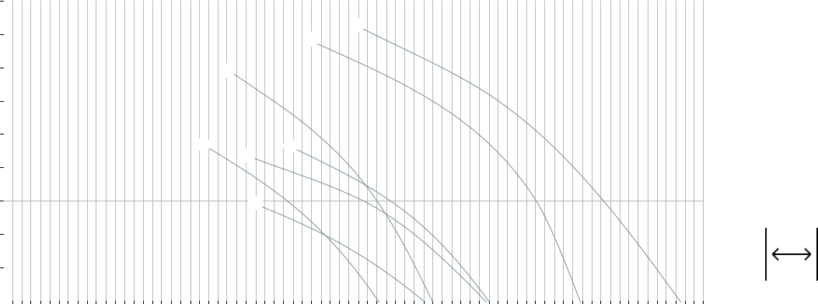

Copyright Sovatec Produktions GmbH. This data sheet shows a technical overview of our products. Please contact us if more detailed information is needed. As we are constantly improving our products, their characteristics, dimensions and weights
may also change, although we do our best to incorporate these changes continually. The information in this data sheet is intended to be used as a first general guideline only. Sovatec assumes no liability for any information therein, any errors, omissions,
misprints, nor any direct or indirect damages, losses or costs resulting therefrom. The acoustic values given are only valid under the measurement conditions listed and may vary depending on the installation situation. With any deviation to the standard
setup, the specific values have to be checked and reviewed once installed or fitted! | 11
SOVATEC PRODUKTIONS GMBH | 11

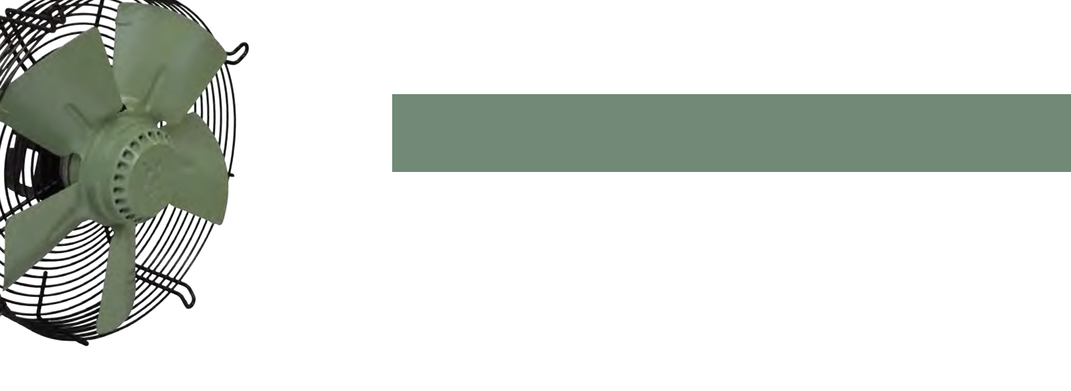
MED SERIES

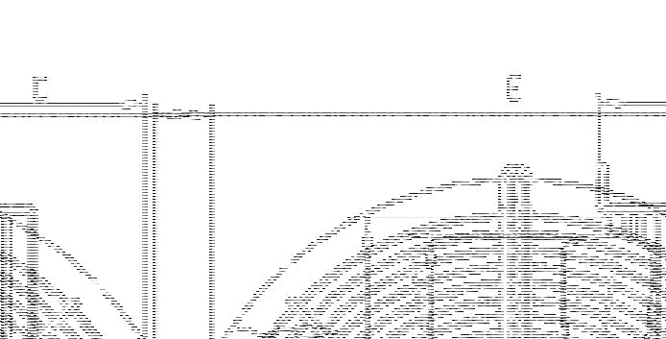

DIMENSION CHART / MASSTABELLE [mm]
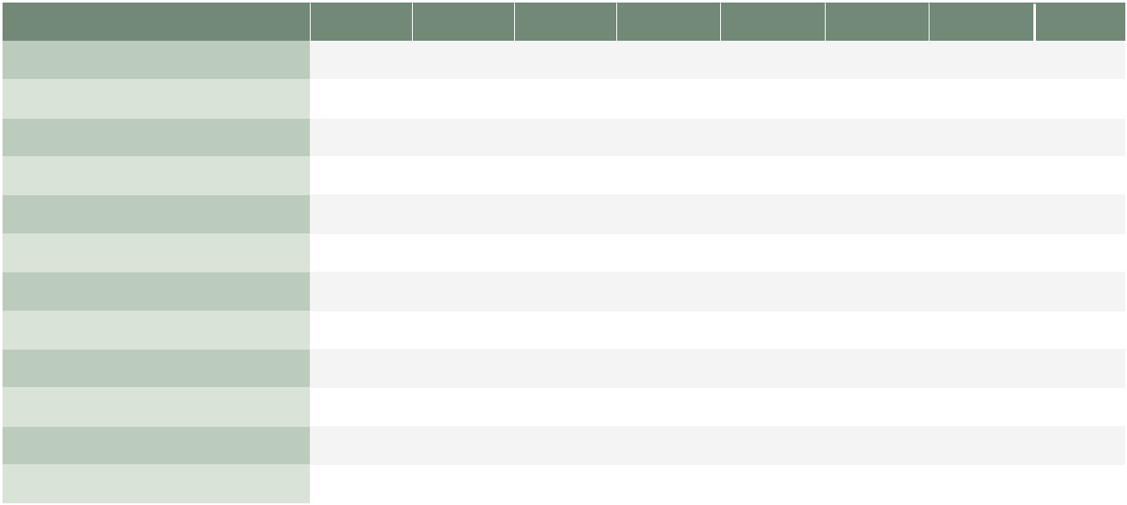

 | A | B | C | D | E | F | G | 50 Hz
MED2-025-A025E2NL-BBC | 250 | 275 | 115 | 135 | 335 | 320 | 7 | q
MED2-025-A025E4NL-BBC | 250 | 270 | 115 | 135,5 | 335 | 320 | 7 | w
MED2-030-A035E2NL-BBC | 300 | 320 | 110 | 146 | 375 | 360 | 7 | e
MED2-030-A035E4NL-BBC | 300 | 320 | 110 | 150 | 375 | 360 | 7 | r
MED2-031-A035E4NL-BBC | 315 | 335 | 115 | 146 | 405 | 390 | 7 | t
MED2-035-B034E4NL-BBC | 350 | 370 | 110 | 169 | 441,5 | 422 | 9,5 | y
MED2-040-B047D4NL-BBC | 400 | 420 | 126 | 182 | 489,5 | 470 | 9,5 | u
MED2-040-B047E4NL-BBC | 400 | 420 | 126 | 182 | 489,5 | 470 | 9,5 | i
MED2-045-B060D4NL-BBC | 450 | 470 | 126 | 195 | 543,5 | 522 | 9,5 | o
MED2-045-B060E4NL-BBC | 450 | 470 | 126 | 195 | 543,5 | 522 | 9,5 | a
MED2-050-C035D4NL-BBC | 500 | 520 | 126 | 184 | 586,5 | 570 | 10,5 | s
MED2-050-C035E4NL-BBC | 500 | 520 | 126 | 184 | 586,5 | 570 | 10,5 | d

OPTIONS / OPTIONEN

RANGE OF MOUNTING POSSIBILITIES | VARIOUS PROTECTION GRIDS | T_{r} | +60°C
 |  |  |  | ErP |  | IP44
VERSCHIEDENE GITTERBEFESTIGUNGEN | VERSCHIEDENE GITTERHÖHEN |  |  | READY |  | IP44
VERSCHIEDENE GITTERBEFESTIGUNGEN | VERSCHIEDENE GITTERHÖHEN | -30°C |  | READY
IP54

Copyright Sovatec Produktions GmbH. This data sheet shows a technical overview of our products. Please contact us if more detailed information is needed. As we are constantly improving our products, their characteristics, dimensions and weights
may also change, although we do our best to incorporate these changes continually. The information in this data sheet is intended to be used as a first general guideline only. Sovatec assumes no liability for any information therein, any errors, omissions,
misprints, nor any direct or indirect damages, losses or costs resulting therefrom. The acoustic values given are only valid under the measurement conditions listed and may vary depending on the installation situation. With any deviation to the standard
setup, the specific values have to be checked and reviewed once installed or fitted!
12 | SOVATEC PRODUKTIONS GMBH

MED SERIES

fa ΔP [Pa]

CHARACTERISTICS CHART / NENNDIAGRAMM

150
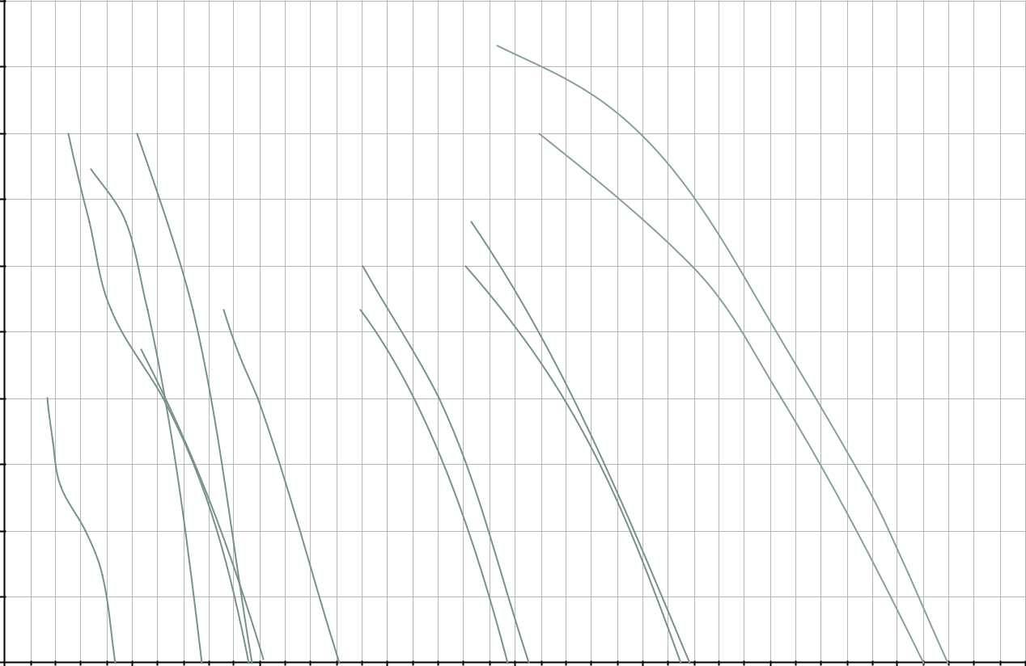

 |  |  | s
135
120 | r e |  | d
 | q
105 |  |  | o
90 |  | u | a

- i

 | 75 | t
 | 60 | w
 | 45
 | 30
 | 15
 | 0
0 |  |  | 1.000 |  |  | 0002. |  | 3.000 |  | 4.000 |  |  | 0005. |  | 6.000 | 0007. |  | 8.000
 |  |  |  |  |  |  |  |  |  | Vp [m3/h]
TECHNICAL DATA / |  |  |  |  |  |  |  |  |  |  |  |  |  |  |  | Further ErP-data available upon request
 |  |  |  |  |  |  |  |  |  |  |  |  |  |  | Weitere ErP Daten sind auf Anfrage erhältlich
TECHNISCHE DATEN |  |  |  |  |  | f (Hz) | P1 (W) | I (A) | n (min-1) |  | cos φ | C (μF) | dB(A) | kg | T (°C) |  | ηges |  | Eff.-Grad N
 |  |  |  |  |  |  |  |  |  |  |  | B |  |  | r
MED2-025-A025E2NL-BBC |  |  |  |  | q | 50 | 110 | 0,48 | 2250 |  | 0,99 | 4 | 60 | 2,5 | -30°C/+60°C |  | < 125 W, keine ErP
MED2-025-A025E4NL-BBC |  |  |  |  | w | 50 | 50 | 0,25 | 1440 |  | 0,99 | 2 | 55 | 2,5 | -30°C/+60°C |  |  | Vorgabe
MED2-030-A035E2NL-BBC |  |  |  |  | e | 50 | 160 | 0,75 | 1587 |  | 0,99 | 4 | 60 | 3,0 | -30°C/+60°C |  | 28,73 |  | 40,46
MED2-030-A035E4NL-BBC |  |  |  |  | r | 50 | 110 | 0,51 | 1330 |  | 0,92 | 4 | 60 | 3,0 | -30°C/+60°C |  | < 125 W, keine ErP
MED2-031-A035E4NL-BBC |  |  |  |  | t | 50 | 105 | 0,50 | 1407 |  | 0,96 | 4 | 60 | 3,0 | -30°C/+60°C |  |  | Vorgabe
MED2-035-B034E4NL-BBC |  |  |  |  | y | 50 | 130 | 0,66 | 1429 |  | 0,9 | 4 | 64 | 5,0 | -30°C/+60°C |  | 29,31 |  | 41,23
MED2-040-B047D4NL-BBC |  |  |  |  | u | 50 | 210 | 0,53 | 1363 |  | 0,58 | 8 | 67 | 6,0 | -30°C/+60°C |  | 33,61 |  | 44,23
MED2-040-B047E4NL-BBC |  |  |  |  | i | 50 | 190 | 0,87 | 1391 |  | 0,70 | 6 | 67 | 6,0 | -30°C/+60°C |  | 33,16 |  | 44,08
MED2-045-B060D4NL-BBC |  |  |  |  | o | 50 | 300 | 0,64 | 1303 |  | 0,69 | - | 69 | 8,0 | -30°C/+60°C |  | 34,44 |  | 44,11
MED2-045-B060E4NL-BBC |  |  |  |  | a | 50 | 300 | 1,31 | 1330 |  | 0,99 | 8 | 69 | 8,0 | -30°C/+60°C |  | 31,37 |  | 41,11
MED2-050-C035D4NL-BBC |  |  |  |  | s | 50 | 500 | 1,11 | 1311 |  | 0,77 | - | 75 | 9,0 | -30°C/+60°C |  | 34,81 |  | 43,17
MED2-050-C035E4NL-BBC |  |  |  |  | d | 50 | 490 | 2,50 | 1210 |  | 0,93 | 10 | 71 | 9,0 | -30°C/+60°C |  | 31,48 |  | 40,06


Copyright Sovatec Produktions GmbH. This data sheet shows a technical overview of our products. Please contact us if more detailed information is needed. As we are constantly improving our products, their characteristics, dimensions and weights
may also change, although we do our best to incorporate these changes continually. The information in this data sheet is intended to be used as a first general guideline only. Sovatec assumes no liability for any information therein, any errors, omissions,
misprints, nor any direct or indirect damages, losses or costs resulting therefrom. The acoustic values given are only valid under the measurement conditions listed and may vary depending on the installation situation. With any deviation to the standard
setup, the specific values have to be checked and reviewed once installed or fitted! | 13
SOVATEC PRODUKTIONS GMBH | 13

APPLICATION AND CALCULATION / ANWENDUNG UND BERECHNUNG

Verwendete Symbole / Symbols used
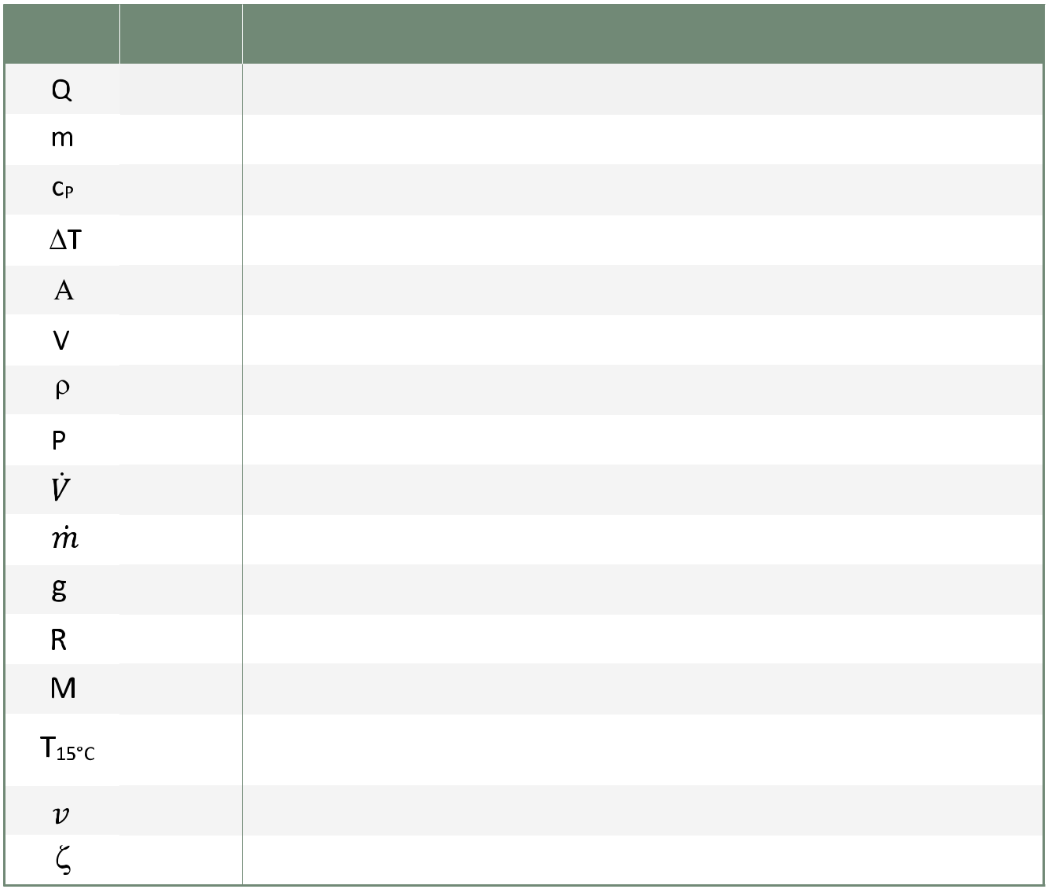

Symbol |  |  | Einheit /
 |  |  | Unit
 |  |  | J
 |  |  | kg
 |  |  | J/(kg·K)
 |  |  | K
 |  |  | m2
 |  |  | _{m}3
 |  |  | kg/m3
 |  |  | W
 |  |  | m3/s
 |  |  | kg/s
 |  |  | m/s2
 |  |  | J/(K·mol)
 |  |  | kg/mol
 |  |  | K
 |  |  | m/s
 |  |  | -

Bedeutung / Meaning

Wärmeinhalt / Heat content

Masse / Mass

Spezifische Wärmekapazität / Specific heat capacity

Temperaturunterschied / Temperature differential

Durchströmte Fläche / Surface area through which air passes perpendicularly

Volumen / Volume

Dichte / Density

Leistung / Power

Volumenstrom (1 l/min=0.06 m3/h) / Volume flow (1 l/min=0.06 m3/h)

Massenstrom / Mass flow

Erdbeschleunigung, g=9.80665 m/s2 / Standard gravity, g=9.80665 m/s²

Gaskonstante, R=8.314 J/(K·mol) / Gas constant, R=8.314 J/(K·mol)

Molare Masse / Molar mass

Normatmosphäre, T=288.15 K / International Standard Metric Conditions for natural gas and similar

fluids, T=288.15 K

Mittlere Geschwindigkeit / Average speed

Widerstandskoeffizient Zeta / Resistance coefficient Zeta, flow loss coefficient

Tabelle 1 / Table 1
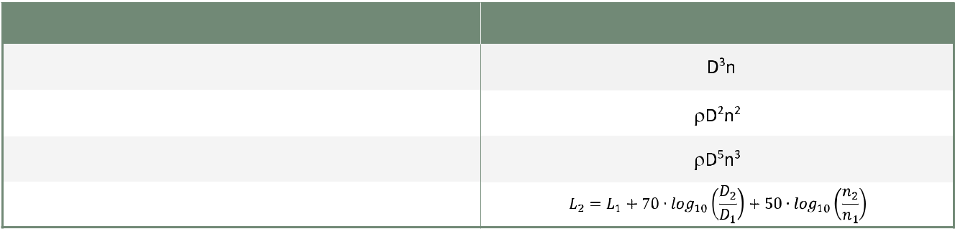

Beziehung / Relation

Volumenstrom / Volume flow

Statischer Druck / Static pressure

Leistung / Power

Lärmpegel (in dB) / Noise (sound power level in dB)

14 SOVATEC PRODUKTIONS GMBH

FAN LAWS
The basic performance of a fan can be described with a small number of fundamental laws. Pro-perly applied, these relations provide assistance

in selecting a fan of proper size and speed. Two of the most important values describing the performance of a fan are the volume flow and the static pressure increase that it is capable of generating. Table 1 shows how the-se values depend on the size D and speed n of the fan.

In essence, these relations indicate that a large volume flow can best be realized by choosing a large fan, since the diameter enters in the third power, but the speed only enters linearly. Conversely, high pressure requirements can best be met with a rapidly turning fan, since its speed enters quadratically.

During operation, the fan needs to generate an increase in static pressure to overcome the systemic resistance from ducts, grids, filters and various other contributions to pres-sure loss.

Eq. (1)
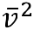
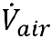

with
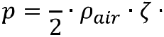
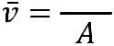

It is important to use a fan that is well-suited to a specific application (impedance-matched), because using an over-ly low fan pressure will not permit sufficient flow through the obstructing structure, whereas an overly high fan pres-sure will lead to wasteful excess flow, thus reducing the efficiency of the system.

In general, the fan will have its most efficient point of ope-ration at 60-70% of its maximum volume flow, so that if one actually needs a volume flow of 2000 m3/h (at a cer-tain static pressure) for example, it is prudent to choose a fan with a maximum volume flow of 3000 m3/h.

The noise from a rotating fan increases by its size and its speed. Because most applications require a specific volu-me flow value (e.g. 3000 m3/h), and a large fan will meet this volume flow at a lower rotational speed than a smal-ler fan, the larger fan will be significantly quieter than the smaller fan for the same volume flow.
VENTILATOR ÄHNLICHKEITSGESETZE
Die Performance eines Ventilators kann mittels ei-niger weniger Grundgesetzmäßigkeiten beschrie-ben werden. Diese Relationen stellen eine wich-

tige Hilfe bei der Dimensionierung und Auswahl eines Ventilators dar. Zwei der wichtigsten beschreibenden Größen sind der Volumenstrom und die Erhöhung des statischen Drucks. Tabelle 1 zeigt, wie diese Größen vom Ventilatordurchmesser D und der Drehzahl n abhängen.

Im Wesentlichen besagen diese Gesetzmäßigkeiten, dass ein hoher Volumenstrom am besten durch einen großen Ventilator realisiert werden kann, da der Durchmesser in der dritten Potenz eingeht, die Drehzahl jedoch nur linear. Um jedoch einen hohen Druckaufbau zu generieren, ist es wichtig, einen schnell drehenden Ventilator zu verwenden, da die Drehzahl hierbei quadratisch eingeht.
Im Betrieb muss der Ventilator eine Druckerhöhung erwir-ken, die die Druckverluste durch den Systemwiderstand von Rohren, Gittern, Filtern und anderen dazu beitragenden Komponenten kompensiert.

Eq. (1)

mit

Es ist wichtig, einen Ventilator zu verwenden, der für die Anwendung gut abgestimmt ist (Impedanz- angepasst), da ein zu geringer Druckaufbau keinen ausreichenden Luft-strom durch die Struktur ermöglicht. Ein zu hoher Druck hingegen, führt zu großen Strömungsverlusten, sodass die Effizienz des Systems darunter leidet.

Im Allgemeinen arbeiten Ventilatoren am effizientesten bei 60-70% ihres maximalen Volumenstroms, sodass man, wenn man z.B. einen tatsächlichen Volumenstrom von 2000 m3/h benötigt (bei einem bestimmten Druck), einen Ventilator mit einem Maximalvolumenstrom von 3000 m3/h verwenden sollte.

Das Geräusch eines rotierenden Ventilators steigt mit des-sen Durchmesser und Drehzahl. Weil die meisten Anwen-dungen einen bestimmten Volumenstrom erfordern (z.B. 3000 m3/h), und ein großer Ventilator diesen Strom bei deutlich niedrigerer Drehzahl als ein kleiner Ventilator er-reicht, ist ein großer Ventilator deutlich leiser als ein kleiner.

SOVATEC PRODUKTIONS GMBH 15

EXEMPLARY LAYOUT AND BEISPIELHAFTE AUSLE-

SELECTION OF A VENTILATOR GUNG EINES VENTILATORS

FAN FOR LIQUID-COOLING FÜR DIE VERWENDUNG IN

APPLICATIONS FLUID-DURCHSTRÖMTEN

KÜHLERN

When the temperature of a mass of air is increased by a certain

amount due to thermal contact with a hot fluid (e.g. water, glycol, oil, etc.), its energy content changes as per:

Eq. (2)

with , this equation becomes:

Eq. (3)

Taking the first derivative of time and assuming that the tempera-ture differential between the fluid and air remains constant, this equation becomes:

Eq. (4)

When this equation is expressed in terms of the volume flow, one can calculate the required volumetric flow of air to carry away a
certain amount of energy per time (power ).

Eq. (5)
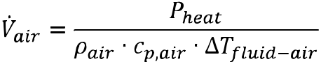

The supplied heating power comes from the hot fluid flowing through the cooler and, if it is not known outright, can be ex-pressed as:

Eq. (6)

which is equivalent to

Wenn die Temperatur einer Luftmasse aufgrund eines ther-mischen Kontakts mit einem heißen Fluid (z.B. Wasser, Glykol, Öl,

etc.) um den Betrag ansteigt, ändert sich ihr Energieinhalt:

Eq. (2)

mit , wird diese Gleichung zu:

Eq. (3)

Nimmt man nun die erste Ableitung nach der Zeit und nim-mt dabei an, dass die Temperaturdifferenz zwischen dem Fluid und Luft konstant bleibt, ergibt sich die Gleichung:

Eq. (4)

Durch Umformung dieser Gleichung kann man den Volumen-strom errechnen, der erforderlich ist, um eine gewisse Energie-
menge pro Zeiteinheit (Heizleistung ) abzuführen.

Eq. (5)

Diese zugeführte Heizleistung stammt vom heißen Fluid, das durch den Kühler fließt, und kann, falls sie nicht unmittelbar bekannt ist, ausgedrückt werden als:

Eq. (6)

was äquivalent ist zu

16 SOVATEC PRODUKTIONS GMBH

CONTINUE: EXEMPLARY FORTSETZUNG: BEISPIEL-

LAYOUT AND SELECTION OF HAFTE AUSLEGUNG EINES

A VENTILATOR FAN FOR LIQ- VENTILATORS FÜR DIE VER-

UID-COOLING APPLICATIONS WENDUNG IN FLUID-DURCH-

STRÖMTEN KÜHLERN

Eq. 6 allows calculation of the heating power as function of the fluid flow and the difference in inlet and outlet temperature.

The air density in Eq. 4 and Eq. 5 depends on elevation h[m] and (absolute) temperature T[K] (see also Table 2):

Eq. (7)
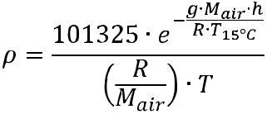

Once one has calculated the required volume flow (Eq. 5), all that remains is to choose a fan that operates efficiently in this range and generates sufficient pressure for the desired application. This is straightforward if one knows at what volume flow the fan operates at its maximum efficiency (see appropriate tables). Oth-erwise, as a rule of thumb, choose a fan that has a maximum volume flow of 1.5 times the required volume flow.

Pressure estimations either require former experience with the system, experimentally obtained values, or knowledge of the systems resistance coefficient Zeta which can then be used in Eq.1. A typical value for heat exchangers of the plate-and-bar type lies between 3 and 4. Zeta values are available in tabulated forms for a multitude of geometries (pipes, bends, valves, etc.) for example in [Idel’chik, Handbook of hydraulic resistance] and [VDI-Gesellschaft Verfahrenstechnik und Chemieingenieurwe-sen, VDI-Wärmeatlas].

Gleichung 6 erlaubt die Berechnung der Heizleistung als Funktion des Flusses und der Differenz der Ein- und Auslasstemperaturen. Die Luftdichte in Gleichungen 4 und 5 hängt von der Seehöhe h[m] und der absoluten Temperatur T[K] ab (siehe auch Tabelle 2):

Eq. (7)

Nachdem man den benötigten Volumenstrom berechnet hat, muss man nur noch einen Ventilator aussuchen, der in diesem Bereich effizient arbeitet und einen ausreichend hohen Druck aufbaut. Das ist unkompliziert, wenn man weiß wo der Ventila-tor sein Effizienzmaximum hat (siehe Tabellen), ansonsten wählt man in der Regel einen Ventilator dessen Maximalvolumenstrom das 1.5-fache des benötigten Wertes beträgt.

Druckabschätzungen erfordern aufgrund der Komplexität ent-weder vorangehende Erfahrungswerte, experimentell bestimmte Werte oder Kenntnis der Systemwiderstandszahl Zeta , welche dann in Gleichung 1 verwendet werden kann. Ein typischer Wert für Wärmetauscher des Platten/Leisten Typs liegt zwischen 3 und 4. Zeta Werte sind für eine Vielzahl von Geometrien (Rohre, Krümmer, Ventile, etc.) tabelliert, so z.B. in [Idel’chik, Handbook of hydraulic resistance] und [VDI-Gesellschaft Verfahrenstechnik und Chemieingenieurwesen, VDI-Wärmeatlas].

SOVATEC PRODUKTIONS GMBH 17

Tabelle 2: Luftdichte als Funktion der Temperatur und Seehöhe.

Table 2: Air density as function of temperature and elevation above sea level.
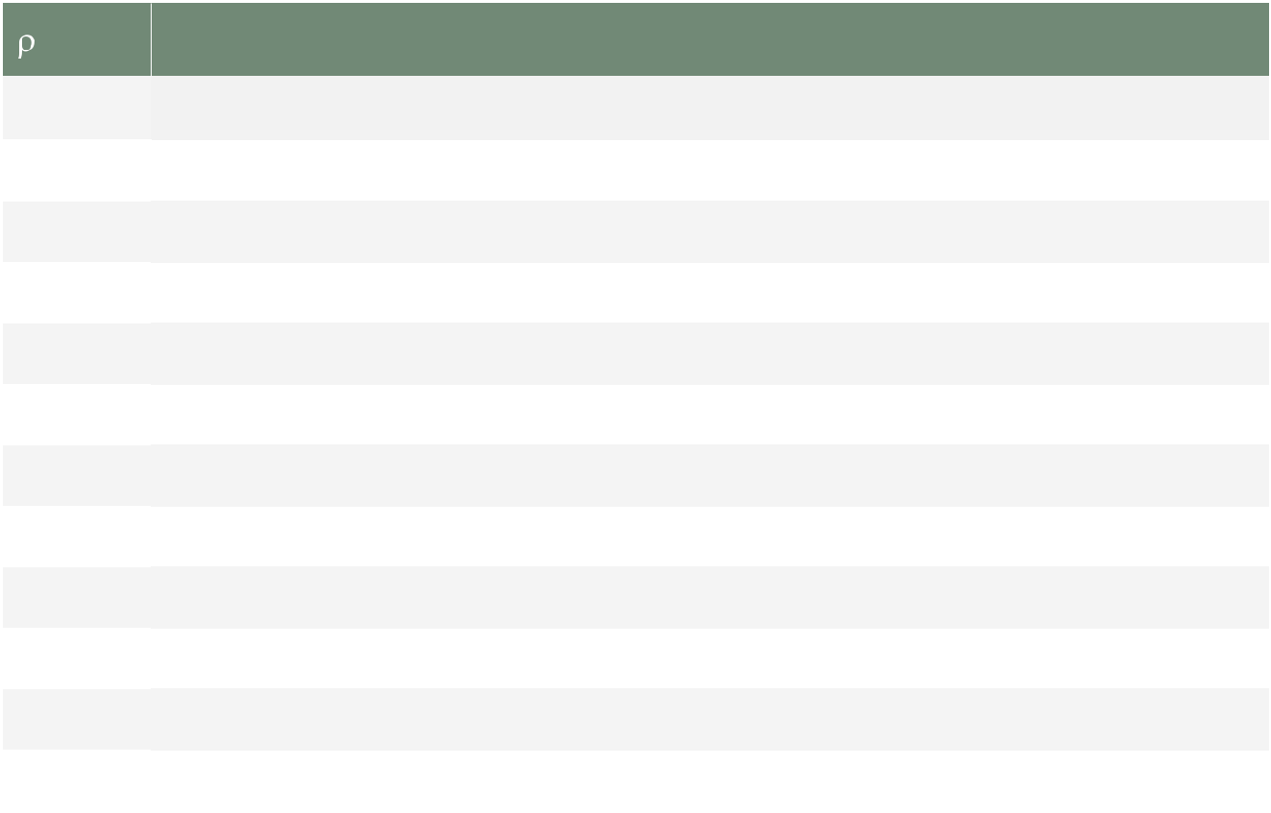

[kg/m³] |  |  |  |  |  |  |  |  |  | T [°C]
h [m] |  | -40 |  | -30 |  | -20 |  | -10 |  | 0 |  | 10 |  | 20 |  | 30 |  | 40 |  | 50
h [m] | -50 | -40 |  | -30 |  | -20 |  | -10 |  | 0 |  | 10 |  | 20 |  | 30 |  | 40 |  | 50
0 | 1,58 | 1,51 |  | 1,45 |  | 1,39 |  | 1,34 |  | 1,29 |  | 1,25 |  | 1,20 |  | 1,16 |  | 1,13 |  | 1,09
500 | 1,49 | 1,43 |  | 1,37 |  | 1,31 |  | 1,26 |  | 1,22 |  | 1,17 |  | 1,13 |  | 1,10 |  | 1,06 |  | 1,03
1000 | 1,40 | 1,34 |  | 1,29 |  | 1,24 |  | 1,19 |  | 1,15 |  | 1,11 |  | 1,07 |  | 1,03 |  | 1,00 |  | 0,97
1500 | 1,32 | 1,27 |  | 1,21 |  | 1,17 |  | 1,12 |  | 1,08 |  | 1,04 |  | 1,01 |  | 0,97 |  | 0,94 |  | 0,91
2000 | 1,25 | 1,19 |  | 1,14 |  | 1,10 |  | 1,06 |  | 1,02 |  | 0,98 |  | 0,95 |  | 0,92 |  | 0,89 |  | 0,86
2500 | 1,18 | 1,13 |  | 1,08 |  | 1,04 |  | 1,00 |  | 0,96 |  | 0,93 |  | 0,89 |  | 0,87 |  | 0,84 |  | 0,81
3000 | 1,11 | 1,06 |  | 1,02 |  | 0,98 |  | 0,94 |  | 0,91 |  | 0,87 |  | 0,84 |  | 0,82 |  | 0,79 |  | 0,77
3500 | 1,04 | 1,00 |  | 0,96 |  | 0,92 |  | 0,89 |  | 0,85 |  | 0,82 |  | 0,79 |  | 0,77 |  | 0,74 |  | 0,72
4000 | 0,98 | 0,94 |  | 0,90 |  | 0,87 |  | 0,83 |  | 0,80 |  | 0,78 |  | 0,75 |  | 0,72 |  | 0,70 |  | 0,68
4500 | 0,93 | 0,89 |  | 0,85 |  | 0,82 |  | 0,79 |  | 0,76 |  | 0,73 |  | 0,71 |  | 0,68 |  | 0,66 |  | 0,64
5000 | 0,87 | 0,84 |  | 0,80 |  | 0,77 |  | 0,74 |  | 0,71 |  | 0,69 |  | 0,67 |  | 0,64 |  | 0,62 |  | 0,60

Tabelle 3: Typische Werte / Table 3: Typical values
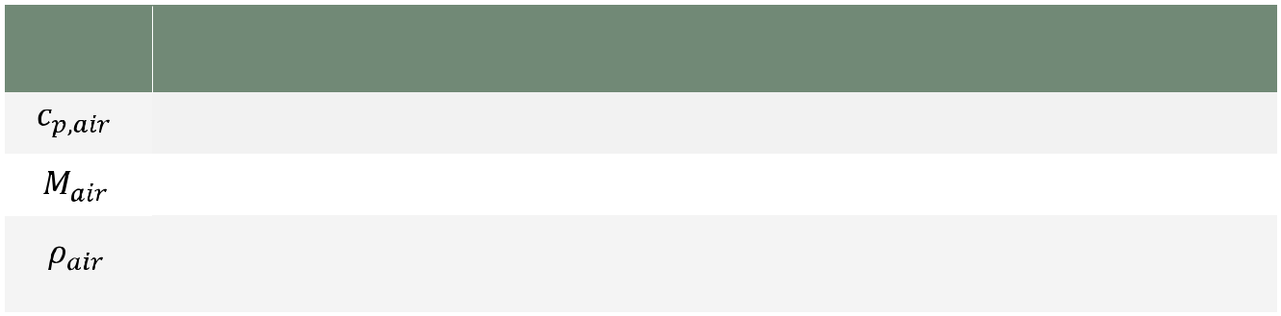

Symbol | Beschreibung / Description | Typischer Wert / | Einheit /
Symbol | Beschreibung / Description | Typical value | Unit
 | Spezifische Wärmekapazität von trockener Luft / Specific heat capacity of dry air | 1005 | J/(kg·K)
 | Molare Masse von trockener Luft / Molar mass of dry air | 0.028949 | kg/mol
 | Luftdichte (abhängig von Temperatur und Seehöhe*) / Density of air (depends on elevation | 1,2* | kg/m³
 | and temperature*) | 1,2* | kg/m³

18 SOVATEC PRODUKTIONS GMBH

SALES CONTACTS / VERTRIEBSKONTAKTE

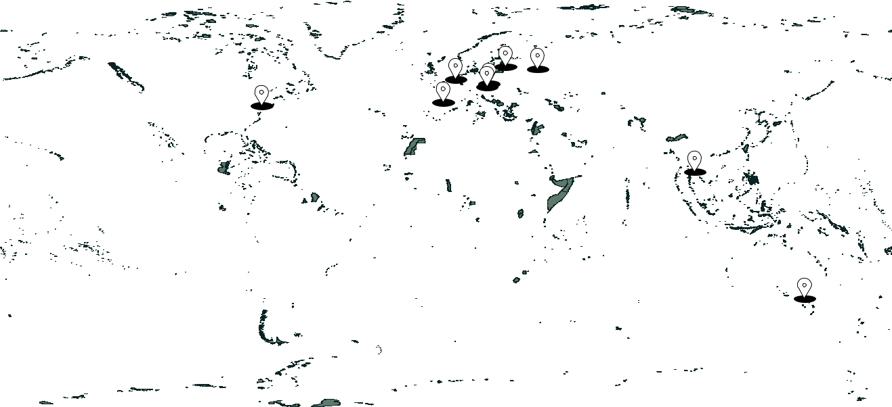

 |  | AUSTRIA |  |  |  | NETHERLANDS |  | CZECH REPUBLIC
Sovatec Produktions GmbH |  |  |  |  |  | Kanaalpark 16 |  |  |  | Druzstevni 9
Prager Strasse 241–243 |  |  |  |  |  | 4553EC Philippine |  |  |  | 742 35 Odry
 |  | 1210 Wien
 |  | LATVIA |  |  |  | RUSSIA |  |  |  | THAILAND
 |  | DBF Technic, SIA |  |  | Ostrovityanova str. 53k3-71 |  |  |  |  | Kalapaprueg Road
LV 1004 Bauskas 20, Riga |  |  |  |  |  | Moscow 117342 |  |  |  | Metropark 194/193
 |  |  |  |  |  |  |  |  |  | 10160 BANGKOK
 |  | USA |  |  |  | SPAIN |  |  |  | AUSTRALIA
 |  | Sovatec USA Inc. |  |  | San Vicente de Paul, 44 |  |  |  |  | 4/15 Bentley street
235 Saint Nicholas Avenue |  |  |  |  |  | 50001 Zaragoza |  | Williamstown ,Vic 3016
South Plainfield, NJ 07080

CONTACT

Email: support@sovatec.com

Web: www.sovatec.com

Phone: (+43) 2243 208 060

SOVATEC PRODUKTIONS GMBH 19



SOVATEC PRODUKTIONS GMBH

AUSTRIA: Prager Strasse 241–243, A-1210 Vienna, Austria, Europe Phone +43 1 8909941 | support@sovatec.com | www.sovatec.com

