109A.

Minton Porcelain White Enamel Vase, England, c. 1875, gilt trim to a blue ground decorated with birds, insects, and flowering branches, printed mark of T. Goode & Co., impressed mark, ht. 7 1/4 in.
$600-800

109B.

Art Nouveau Style Earthenware Low Bowl, England, early 20th century, decorated by Walter Slater, lustrous blue ground with yellow flowers and green foliage, artist signed, dia. 12 1/4 in.

Note: Slater trained at Mintons, apprenticed at Doulton, and succeeded F.A. Rhead as art director of the Foley Potteries.
$600-800

110.

Continental School, 19th Century

In the Shelter of the Cottage Door/A Farmyard View.

Signed “A. Adolph” l.l. Oil on canvas, 20 x 30 in., framed.
Condition: Surface grime, craquelure.
$300-500

110A.

Attributed to James Francis Danby (British, 1816-1875)

Sheep in a Mountain Meadow. Inscribed on the reverse. Oil on canvasboard, 16 x 20 in., framed. Condition: Retouch (primarily to sky), surface grime, craquelure.
$800-1,200

111.

Pair of European Bronze Figures of Cherubic Children, late 19th century, a little girl in rose wreath, holding a nest of eggs, and a Dionysian boy with grape wreath, both on sienna marble plinths, ht. 7 1/2 in.
$400-600

112.

Karl Hackstock (German, 1855-1919)

Bronze Figure of a Boy Smoking/A Spurt, the figure striking a match to light a cigarette, with mold incised signature and Hadstock seal, on green marble base, ht. 12 3/8 in.
$800-1,200

113.

Three Small European Bronzes, early 20th century, a figure of lizard, set with black onyx bead eyes, lg. 6 7/8, a desk weight with stag beetle on oak leaf, mounted on oval onyx base, lg. 5 1/2, and a miniature Art Nouveau bud vase, ht. 2 1/2 in.

$250-350

114.

Staffordshire Lead Glazed Creamware Figure of St. George and the Dragon, late 18th century, the figure on horseback, stabbing a prone dragon on naturalistic ovoid base, with ochre and green glaze detailing, ht. 11 in., (significant old restoration, losses, lance replaced).
$150-250

116
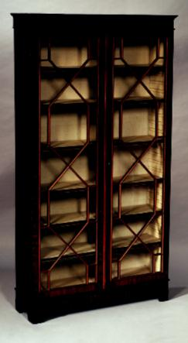

115.

Dutch School, 18th/19th Century

The Surgeon’s Shop. Unsigned. Oil on tin, in giltwood frame, sight size 9 3/8 x 8 in. Condition: Losses, restoration, retouch.
$200-400

116.

Georgian Carved Mahogany and Mahogany Veneer Glazed Cabinet, late 18th/early 19th century, cornice with blind fret frieze, the glass doors with shelved interior, on conforming carved bracket base, ht. 85, wd. 44 1/2, dp. 12 in.

$2,500-3,500

21

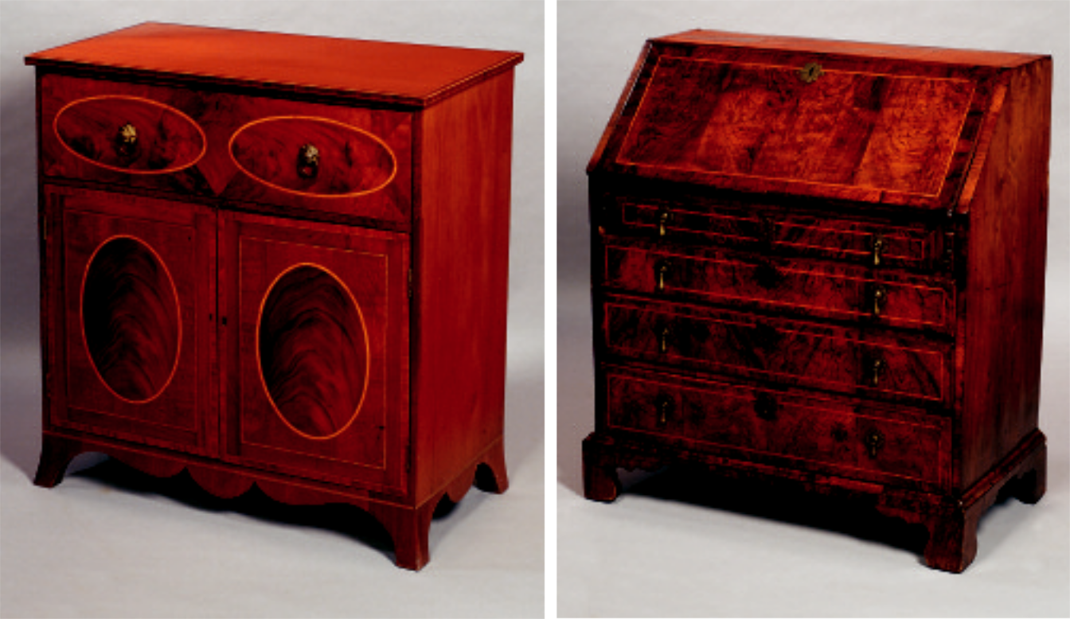

117 126

117.

American Federal Inlaid Mahogany Butler’s Cabinet, second quarter 19th century, likely Middle Atlantic States, rectangular case with fitted secretaire drawer above two doors enclosing sliding linen shelves, French feet, inlaid with crossbanding and oval panels of satinwood, ht. 43 1/2, wd. 42, dp. 22 in.

$2,500-3,500

118.

Victorian Hand-printed and Painted Heraldic Family Tree, late 19th century, fan-shaped, depicting four generations of the Hervey-Pechell family c. 1713-1880, on gold ground, matted and framed in conforming giltwood ribbon-form frame, wd. 20 3/4 in.
$150-250

119.

Continental School, 19th/20th Century

Eastern Monastery in the Mountains. Monogrammed l.l. Watercolor with graphite and gouache on paper/board, sight size 9 3/8 x 13 1/4 in., framed. Condition: Not examined out of frame.
$300-500

120.

Pair of Staffordshire-type Earthenware Recumbent Lion Figures, late 19th century, white bodies with gilt accenting, on rectangular bases, lg. 7 3/4 in.
$400-600
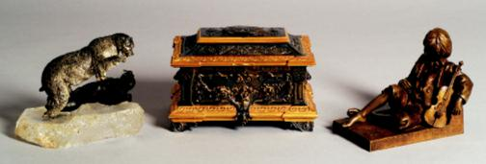

122 182 205

22

127

121.

Maiolica Fish Decorated Bowl, Europe, 19th century, oval, with slightly everted rim, molded inside and out with two rows of fish, with mottled green, yellow, and tan glazes, dia. 14 in.

$400-600

122.

Silver, Bronze and Rock Crystal Figural Group of a Polar Bear and Walrus, possibly Russian, late 19th century, depicting a realistically modeled silver polar bear attacking a bronze walrus, on naturalistic rock crystal base, ht. 7 1/4, lg. 9 in.

$400-600

123.
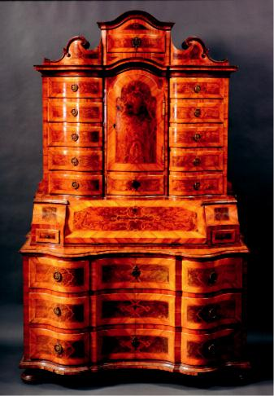
Set of Eight Framed Botanical Color Lithographs, late 19th century, after Van Houtteano, by Hook & Thomas, French matted, in modern green wood frames, sight size 9 1/2 x 6 1/8, frames 21 3/8 x 18 in.
$600-800

124.

Three Miniature Austrian Cold Painted Bronze Dog Figures, early 20th century, a seated poodle, ht. 2 1/2, and two walking terriers, lg. 3 and 3 1/2 in.
$200-250

23

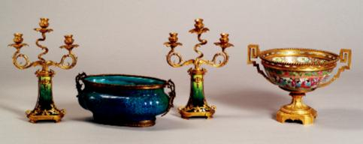

128 129 128 166

125.

Group of Thirteen Miniature Czechoslovakian Glass Dog Figures, late 19th/early 20th century, mold formed, comprising a pair of colorless bulldogs, pair of colorless dachshunds, pair of purple dachshunds, pair of green dachshunds, two recumbent hounds (one amber, one light blue), and three small single bulldogs (amber, dark yellow, and green), some set with bead eyes, or with metal collars, ht. 3/4 to 1 1/2 in.

$300-500

125A.

Sarouk Rug, West Persia, second quarter 20th century, (very slight end fraying), 5 ft. x 3 ft. 5 in.
$400-600

126.

Early Georgian Crossbanded and Inlaid Walnut Slant-lid Desk, second quarter 18th century, fitted interior of drawers, pigeonholes and a prospect door, case with four graduated drawers, bracket feet, boxwood stringing throughout, ht. 41 1/2, wd. 36, dp. 21 in.
$2,000-4,000

127.

South German Baroque Parquetry Inlaid Walnut Desk, 18th century, boldly scrolled serpentine upper section fitted with eleven drawers and a door enclosing a fitted interior of drawers; lower section with interior enclosed by a slant lid and three drawers on flattened ball feet, inlaid with scrolling strapwork throughout, ht. 84 1/2, wd. 52, dp. 27 in.
$10,000-15,000
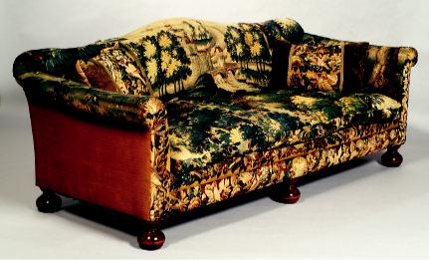

133

24

128.

Pair of French Gilt Bronze and Earthenware Three-Light Candelabra, late 19th/early 20th century, the central corkscrew candle arm flanked by serpentine candle arms, on flattened trumpet-form mottled green glazed earthenware stem topped by lion masks, base with laurel leaves, ht. 14 in.
$800-1,200

129.

Boch Earthenware Ormolu-Mounted Centerbowl, France, early 20th century, bulbous ovoid form with mottled blue, green, and turquoise glazes, gilt-metal rims, and bifurcate leaf handles, lg. 14 1/2 in.
$250-350

130.

Manner of John Singleton Copley (American, 1737-1815)

Portrait of a Lady in Gold and Rose. Unsigned, identified on a label from the Museum of Fine Arts. Oil on canvas, 30 x 25 in., unframed. Condition: Lined, punctures l.l., retouch, losses, craquelure.
$600-800

131.

Pair of Staffordshire Figures of Queen Victoria and Prince Albert, late 19th century, with blue underglaze, and polychrome over glazes, both modeled standing, wearing tartan sashes, ht. 8 3/8 in.
$150-250

132.

Three Royal Doulton Bone China Dog Figures, 20th century, all modeled standing, a fox terrier, an Airedale terrier, and a setter, ht. to 5 1/4 in.
$250-350

133.

Continental Tapestry Upholstered Beechwood Sofa, the upholstery Brussels, likely 18th century, depicting a lush landscape, with two tapestry upholstered pillows, lg. 86 in.
$1,500-2,500

134.
No lot.

135.

Bing & Grondahl Porcelain “Seagull” Dinner Service for Twelve, Denmark, modern, comprising twelve dinner plates (dia. 9 1/2), twelve luncheon plates (dia. 8 1/4), twelve soup plates, twelve saucers, twelve side plates, twelve teacups, two serving bowls (dia. 9 7/8 and 8), pair of oval serving dishes (lg. 9 1/8), a gravy boat, small footed bowl, covered butter dish, two oval serving dishes (lg. 13 1/2 and 10), rectangular serving dish (9 7/8 in.), coffeepot, teapot, hot water pot, pair of covered sugars, creamer, and milk jug, (89 pieces total).
$1,200-1,800

136
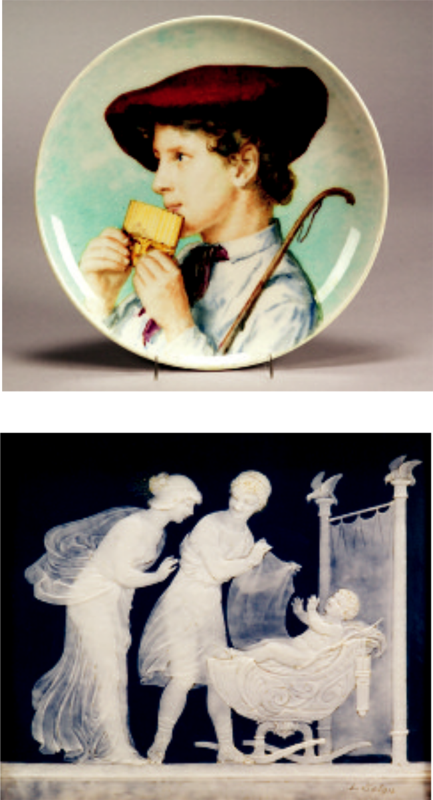

137

136.

Theodore Deck Porcelain Portrait Charger, France, c. 1875, polychrome enamel decorated of a male youth, artist signed Loire, impressed mark, dia. 15 1/2 in.
$1,200-1,500

137.

Louis Solon Decorated Pate-sûr-Pate Porcelain Plaque, France/England, 19th century, teal blue ground rectangular shape with white paste design of a man and woman by Cupid lying in a cradle, incised artist signature, sight 6 3/8 x 7 1/4 in.; mounted in a contemporary frame.
$2,000-3,000

25

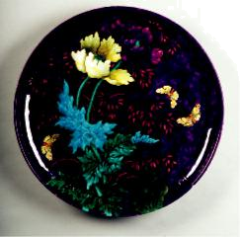

138

138.

Theodore Deck Earthenware Charger, France, c. 1865, modeled and polychrome enameled foliate and insect design to a deep purple ground, raised initials E.L to the front side, impressed Deck mark on the reverse, dia. 24 in.
$4,000-6,000
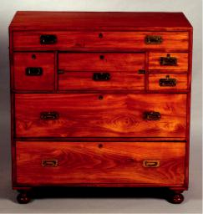

141
139.

After Marie Louise Elisabeth Vigee LeBrun (French, 1755-1842)

Self Portrait. Identified in inscription on the reverse. Oil-enhanced print on board, oval format 8 1/2 x 6 1/2 in., framed. Condition: Surface grime, craquelure.
$500-700

140.

Chippendale Mahogany Four-drawer Chest, third quarter 18th century, rectangular top and case with graduated drawers, bracket feet, ht. 32, wd. 29, dp. 17 in.
$1,000-1,500

141.

Anglo-Indian Camphorwood Campaign Chest, mid-19th century, the rectangular case split into two parts; upper section fitted with two shallow, one long, one deep drawers and fitted with a sliding desk drawer; the lower section fitted with two long drawers on turned feet, with flush brass mounts, ht. 43 1/4, wd. 42 1/2, dp. 19 in.
$1,500-2,000

142.

Small French Enamel Plaque, late 19th century, rectangular, depicting a classical couple in flight, signed l.l. Doisteau, framed, plaque size 2 5/8 x 2 in.
$500-700

143.

Two Portrait Miniatures of Ladies, late 19th century, oval format, a Victorian portrait of a brunette on ivory/ivorine, signed r. Renner, in bale-topped gilt-metal surround, lg. 3 1/4, the other on porcelain, depicting an elegant 18th century lady, in square velvet frame, sight lg. 3 3/8 in.
$300-500

144.

Three Portrait Miniature on Ivory of Ladies, 18th/19th century, oval format in all gilt-metal surrounds, one depicting an 18th century lady in powdered wig, signed l.l. Laugen, lg. 3 1/4, a sixteenth century noblewoman, lg. 2 1/2, and an 18th century brunette in elaborate gown, lg. 2 5/8 in.
$500-700

145.

Two Framed Portrait Miniatures on Ivory of Ladies, 18th/19 century, oval format, an 18th century portrait of a girl in white, signed l.r. Plimer, and dated 1787, sight lg. 3 1/2, the other a 19th century portrait of a woman in jeweled blue bodice, sight lg. 3 3/8 in., both in ribbon-topped gilt-metal frames.

$500-700

146.

Continental Portrait Miniature on Ivory of Gentleman, late 18th century, the young man with powdered hair, high-collared blue coat, sight lg. 3 1/8, on shell-molded gilt-metal frame monogrammed MAM.
$300-500

26

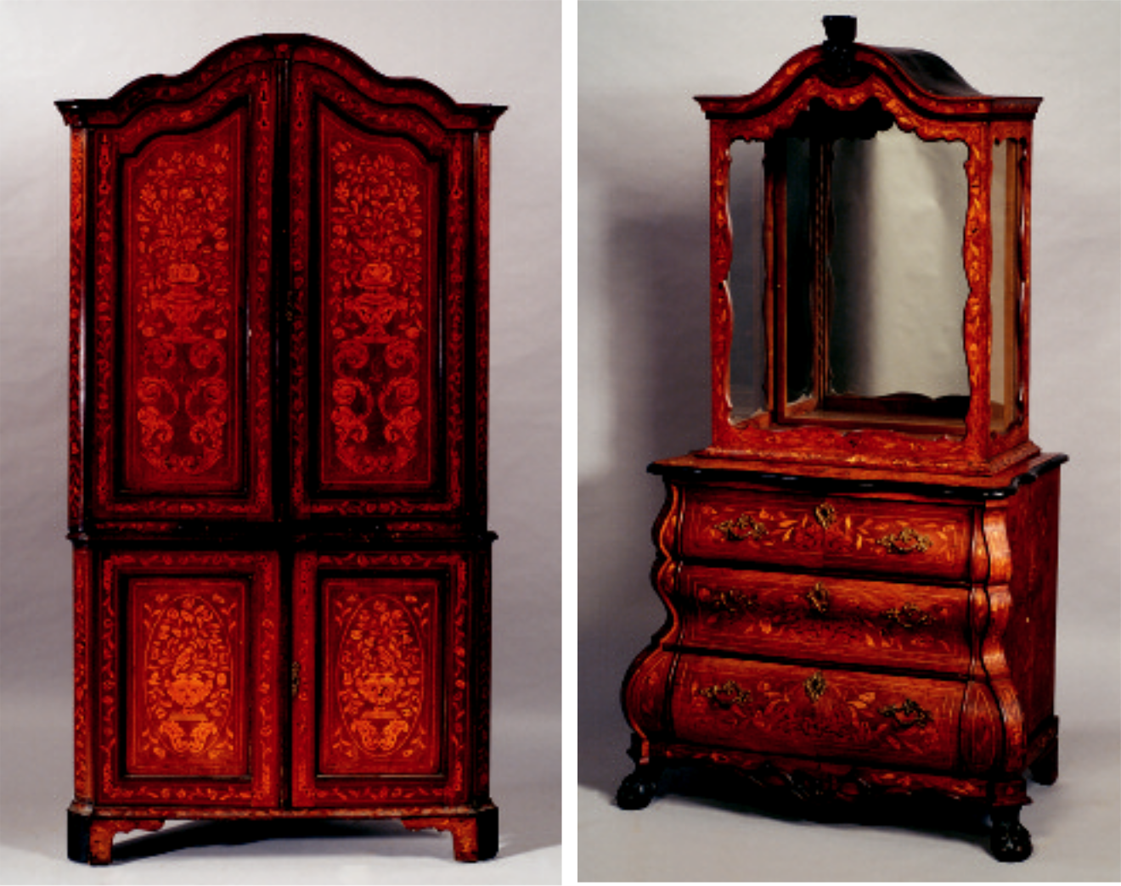

148 149

147.

Continental Portrait Miniature on Ivory of an Elegant Royal Lady, late 18th century, rectangular, the lady in powdered wig, wearing sash and jewels, signed l.r. Romanol, in gutta percha surround and wood frame, sight size 4 3/8 x 3 in.

$250-350

148.

Dutch Fruitwood Marquetry Inlaid Two-Part Corner Cabinet, 19th century, with serpentine cresting above a pair of shaped doors, the lower section with a pair of doors, ht. 88 1/2, wd. 47, dp. 24 in.
$2,500-3,500

149.

Dutch Fruitwood Marquetry Inlaid Walnut Cabinet, 18th century, with foliate carved cornice above glass enclosed shelves, lower section with bombé base fitted with three drawers on paw feet, ht. 73, wd. 36, dp. 25 in.
$5,000-8,000

149A.

Hereke Pictorial Silk Rug, West Anatolia, late 20th century, 4 ft. 8 in. x 3 ft.
$400-600

150.

Continental School, 19th Century

La Youngfrau et le Stanbbach Vue de Lauterbrunnen. Unsigned, identified in an inscription on the reverse. Oil on board, 11 1/2 x 16 in., framed. Condition: Losses, surface grime, craquelure.
$300-400

150A.

After Rembrandt van Rijn (Dutch, 1606-1669)

Man in a Gold Helmet. Unsigned. Oil on canvas, 34 x 26 1/2 in., framed. Condition: Retouched, surface grime, craquelure.

N.B. The original hangs in the collection of the Gemäldegalerie, Berlin.
$500-700

27

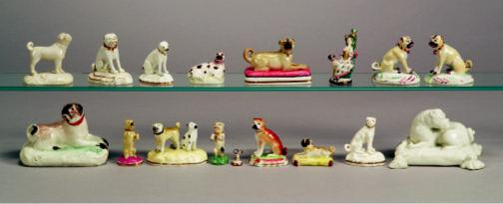

Top row: 151 (4), 151A, 152, 152A

Bottom row: 153, 154 (7), 154A

150B.

Otto Kirberg (German, 1850-1926)

Goat Herder on Horseback. Signed and inscribed “Otto Kirberg 10 Jahre...” l.r. Graphite on paper, 10 x 14 in., unmatted, unframed. Condition: Toning, soiling, staining, nicks and tears to edges.
$300-350

151.

Four Porcelain Pug Figures, England, early 19th century, attributed to Derby, a polychrome decorated recumbent dog, ht. 1 3/4; a white glazed seated dog on a rococo base with gilt trim, ht. 2 3/4; a white glazed seated dog on an oval molded base with touches of enamel and gilt trim, ht. 2 3/8; and a white glazed standing dog on a rectangular base with molded flowers, ht. 2 3/4 in.

Provenance: D.M. & P. Manheim.
$500-700

151A.

Porcelain Figure of a Reclining Pug Dog, England, early 19th century, attributed to Derby, polychrome enamel decorated with a light brown dog on a pinkish-red sponged rectangular base, gilt trim line, ht. 2 3/8 in.

Provenance: D.M. & P. Manheim.
$200-400

152.

Porcelain Figural Perfume of a Lady and a Pug Dog, England, late 18th/early 19th century, possibly Chelsea, polychrome enamel decorated, modeled with a lady napping by a floral decorated tree, a large pug standing watch, titled “Fidelle Me Garde” and with silver frame, floral painted to underside, ht. 2 7/8 in.

Provenance: Purchased at Manheim.
$400-600

152A.

Pair of Polychrome Enamel Decorated Porcelain Pug Dogs, England, c. 1800, attributed to Derby, each modeled seated atop an oval molded base, ht. 2 5/8 in.

Provenance: D.M. & P. Manheim.
$500-700

153.

Porcelain Model of a Recumbent Pug Dog, England, c. 1800, attributed to Derby, brown enamel decorated with a red collar and modeled on a translucent green glazed raised rectangular base, ht. 3 in.

Provenance: D.M. & P. Manheim. Purchased at Manheim. $400-600

154.

Seven Porcelain Pug Dog Figures, England, 18th/19th century, a Chelsea miniature in the form of a seal, inscribed “Je suis Fidelle,” the seal itself of carnelian with depiction of a bird and inscribed “Fidelle,” ht. 3/4; a Rockingham white glazed seated pug on rococo base, gilt trim, ht. 2 1/2; a brown painted pug on a green and pink enamel base, ht. 2 1/2; a reclining pug on yellow pillow with puce tassels, ht. 1 1/4; a begging pug on a round purple base, ht. 2 1/2; a begging pug on an oval green base, ht. ht. 2 1/4; and a group with two dogs, one a pug, ht. 2 3/8 in.

Provenance: D.M. & P. Manheim.
$1,000-1,500

154A.

White Glazed Porcelain Figure of a Reclining Pug Dog, England, late 18th century, modeled on a tasseled pillow, ht. 3 in.

Provenance: D.M. & P. Manheim. Purchased at Manheim. $400-600

28

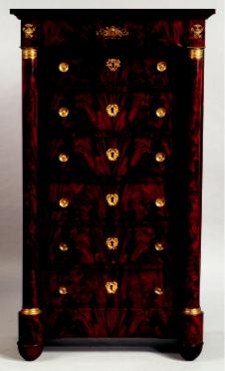

155 162

155.

French Empire Gilt-Bronze Mounted Mahogany Tall Chest, early 19th century, with projecting drawer over six recessed drawers flanked by columns on turned feet, ht. 59, wd. 33, dp. 18 1/2 in.
$6,000-8,000

156.

Georgian-style Inlaid Mahogany Sideboard, 20th century, serpentine case fitted with three drawers and four doors on square, tapered legs, ht. 37 1/2, lg. 49, dp. 20 in.
$1,200-1,500

157.

Two Groups of Cobalt Blue and Gilt Decorated Porcelain Service Plates, 20th century, comprising a set of eleven Royal Worcester, with cobalt and gilt rim, dia. 10, and set of six Hutschenreuther, transfer printed with floral bouquets to center, cobalt rim with gilt Greek key, dia. 10 3/8 in.
$200-250

158.

Small “Grant Tour” Bronze Figure of a Dying Gladiator, late 19th century, the reclining figure on oval tiered marble and slate base, wd. 7 in.
$250-350

159.
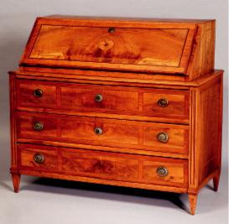
Dutch School, 19th Century

Enjoying a Good Smoke/A Tavern Scene. Unsigned. Oil on canvas, 10 1/2 x 12 5/8 in., framed. Condition: Repaired punctures, flaking and losses c.r., retouch, surface grime, craquelure.
$300-500

160.

Miniature Bronze Bust of Young Dutch Woman, late 19th century, on navette-shaped base, ht. 2 1/4 in.
$75-100

161.
Carl Kauba (German, 1865-1922)

Small Bronze Bust of a Woman, in a wimple, on a brown marble base, ht. 5 1/4 in.
$500-700

162.

Swiss Ebony and Fruitwood Inlaid Walnut Slant-lid Desk, third quarter 18th century, with fitted interior of drawers and pigeonholes; lower case fitted with three long drawers on square tapered feet, ht. 45, wd. 50, dp. 23 in.
$3,000-5,000

29

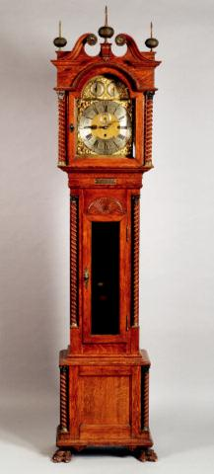

163

163.

Chippendale-style Oak Long Case Clock, works signed Walter Durfee, Providence, three-train movement chiming on a nest of bells and gongs, chime/silent and Westminster in other dial; case with swan’s neck cresting, three spire and ball finials, glass-fronted mid-case with presentation plaque and carved with a fan and twist-turned columns, on paw feet, ht. 93 in.

$3,000-5,000

164.

Eighteen Meissen Porcelain Table Articles, 20th century, enamel decorated with central flower stems, ozier rim, eight dinner plates (dia. 9 3/4), six soup plates (dia. 9 1/4), and four dessert plates (dia. 7 7/8), sold together with a similar Herend platter (wd. 14 5/8 in.), (19 pieces total).
$1,500-2,000

165
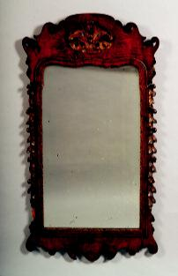

165.

Queen Anne Style Burl Walnut and Parcel-gilt Mirror, 19th century, the scrolled crest pierce-carve with gilt shell, rectangular mirror plate in giltwood surround, sides of frame with foliate swags, scrolled base, lg. 44 3/4, wd. 24 in.
$1,200-1,500

166.

Ormolu Mounted Chinese Rose Mandarin Porcelain Bowl, late 19th century, with guilloche ormolu rim with angular handles, on fluted trumpet stem, and square base with rounded corners, ht. 10 in.
$2,000-3,000

167.

Set of Six Framed English Hunting Prints, late 19th century, titled “Bachelor’s Hall,” depicting various stages of the hunt, hand-tinted, plate size 15 x 11 3/4, sight size 17 1/2 x 14 3/4 in., (toning, scattered foxing, paper burn).
$500-700

168.

Three Bone China and Porcelain Dog Figures, 20th century, a Meissen porcelain figure of a standing Collie, ht. 4, a Royal Worcester bone china figure of a seated white shepherd, ht. 5 1/8, and a Royal Worcester whistle formed as the head of a beagle, lg. 2 in.
$250-300

30

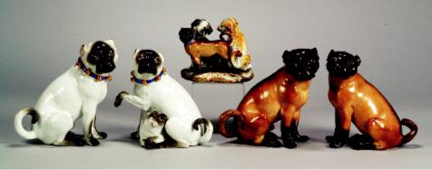

174 175 176

169.

Northern School, 19th Century

Polling the Boat to the Distant Windmill. Unsigned. Oil on board, 10 x 12 1/4 in., framed. Condition: Surface grime, scattered retouch, craquelure.
$700-900

170.

George III Style Mahogany Display Cabinet, 20th century, with open swan’s neck cresting with floral terminals, foliate carved and mullioned glass doors and silk lined interior and shelves, foliate carved apron, cabriole legs and claw and ball feet, ht. 101, wd. 55, dp. 16 in.
$2,500-3,500

171.

Continental Fruitwood Blanket Chest, 18th century, rectangular with hinged lid, ogee shaped skirt on cabriole feet.
$200-300

172.

Meissen Porcelain Pug Figural Group, Germany, late 19th/early 20th century, enamel decorated in browns and greens, modeled as two pugs on a grassy freeform base, each adorned with blue ribbons and bells, underglaze crossed swords mark, ht. 2 5/8 in.

Provenance: D.M. & P. Manheim.
$400-600

173.

Two Meissen Porcelain Pug Paperweights, Germany, late 19th/early 20th century, each similarly shaped with a seated dog atop an elongated rectangle with rounded end, one with white dog to a blue strawflower pattern, the other with a brown dog to a polychrome decorated flowers in a fenced garden pattern, underglaze crossed swords marks and incised shape number 1645, lg. 7 1/2 in.
$300-500

174.

Large Pair of Meissen Porcelain Pug Figures, Germany, late 19th century, each white glazed with black face and tips, blue ribbon collars adorned with bells, modeled as a seated male, ht. 9 1/2; and a female with pup, ht. 8 3/4 in.; underglaze blue crossed swords marks.
$1,000-1,500

175.

Meissen-type Porcelain Dog Group, Germany, 19th century, modeled as three dogs in various poses on a grassy rococo base, one a pug, decorated in polychrome enamels and with gilt trim, underglaze blue mark, ht. 5 3/8 in.
$400-600

176.

Pair of Meissen-type Porcelain Pug Dogs, Germany, late 19th century, each brown and black enamel decorated and modeled seated, underglaze blue marks, ht. 8 7/8 in.
$700-900

177.

Louis XVI Parquetry Inlaid and Ormolu-Mounted Collector’s Cabinet, top with sloped and beveled glass top opening to a velvet-lined interior, over two doors enclosing shelves and with base drawer, reeded feet, ht. 51 3/8, wd. 28 3/4, dp. 16 1/2 in.
$4,000-6,000

178.

Dutch Oak Bureau Bookcase, 18th century, with arched cresting above a pair of arched and paneled doors enclosing an interior of serpentine shelves; lower section with paneled slant-lid enclosing an interior fitted with serpentine drawers and pigeonholes all above a pair of doors, ht. 98, wd. 39, dp. 21 in.

$4,000-6,000

31

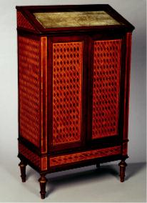

177

179.
Scottish School, 19th Century

Portrait of Mary Fairrie. Unsigned, identified and dated “...by Fleming in 1833” on a label affixed to the stretcher. Oil on canvas, 14 1/2 x 12 1/4 in., framed (in a liner). Condition: Several small punctures, retouch, craquelure.

Provenance: Descended within the family of the sitter.
$800-1,200

179A.
German School, 19th Century

Hay Wagon on the Road to Market. Signed “Geof. Scholtz.” l.l. Watercolor and graphite on paper, sight size 12 x 19 in., framed (in a liner). Condition: Toning, fading, fox marks, not examined out of frame.
$600-800

179B.
Lot of Two Images of Putti:

Cupid Reclining in Thought and Two Putti/A Study. The latter signed “J. Garcia” l.r. Oil on canvas, sizes approximately 18 x 15 in., framed. Condition: Surface grime, craquelure, scattered retouch to latter.

Provenance: A Massachusetts library.
$300-400

180.

Three Staffordshire-type Earthenware Figures, late 19th century, two with granulation, Prince of Wales, ht. 6, and a mother with child, ht. 5 1/2, and a standing lad, ht. 6 1/4 in.
$150-250

184
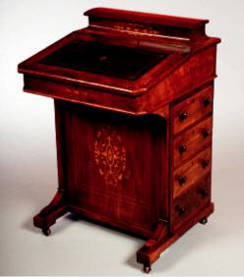

181.

Continental School, 18th/19th Century

Peasants in a Pastoral Landscape. Unsigned. Oil on tin, sight size 13 3/4 x 9 1/2 in., in giltwood frame. Condition: Alligatoring, with surface loss, heavy restoration.
$200-400

182.

French Silvered Bronze and Bronze Dore Renaissance Revival Jewel Casket, late 19th century, rectangular, lid with cast central panel of sea god, over foliate panels, with dore trefoil leaf borders, sides cast in high relief with fruit swags and lion masks, on scrolled bracket feet, interior with tufted blue satin lining, wd. 10 1/4, ht. 7, dp. 6 3/4 in.
$800-1,200

183.

Six Framed English Hand-tinted Engravings of Coats of Arms, late 18th century, from Jacobs, French matted, in modern parcel-giltwood frames, sight size 11 x 7 1/2, frames 21 1/2 x 18 in.
$700-900

184.

Early Victorian Fruitwood Inlaid Walnut Diminutive Davenport Desk, third quarter 19th century, of typical form with covered box and slant lid enclosing a interior of pigeonholes, pedestal base fitted with four drawers, trestle base on casters, with foliate inlay throughout, ht. 31 1/2, wd. 21, dp. 20 1/2 in.

$800-1,000

32

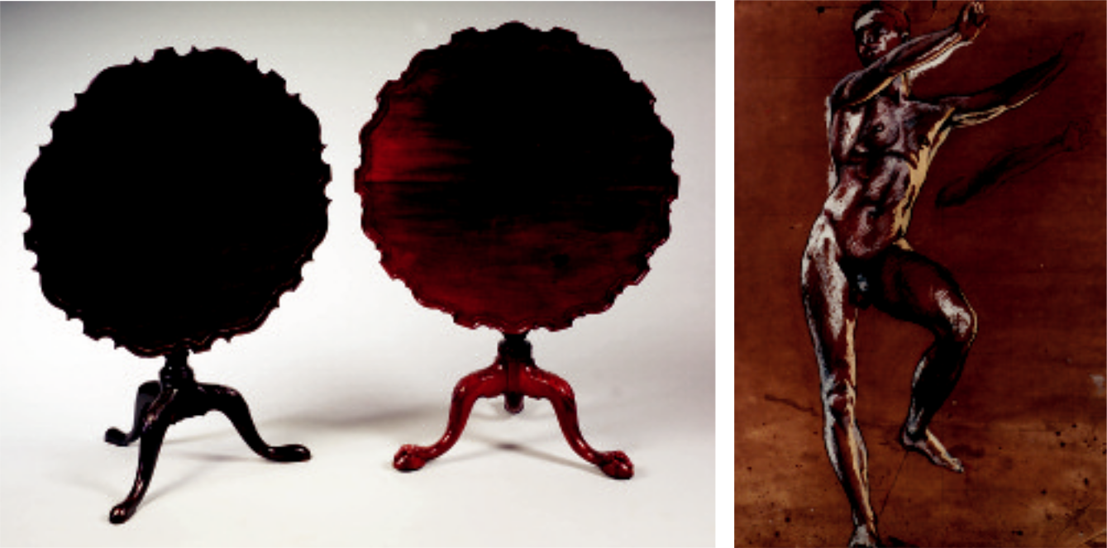

276 185 190

185.

English Chippendale Carved Mahogany Tea Table, 18th century, piecrust top on acanthus carved urn-form turned and reeded support on tripod cabriole leg base with carved knees and ball and claw feet, ht. 28 1/2, dia. 33 1/2 in.
$2,500-3,500

185A.

Pair of Polychrome Decorated Porcelain Pug Dogs, England, early 19th century, possibly Derby, each seated dog enameled in a pale orange with trim in black and gold, modeled atop a green decorated rectangular base, ht. 3 1/4 in.

$300-500
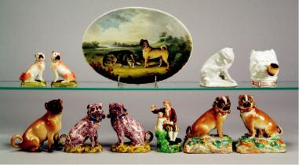

186.

Polychrome Enamel Decorated Porcelain Plaque, England, early 19th century, oval shape with two dogs in a landscape, one a pug, a marker to the right signed “Powell 1807,” lg. 11 in.

Provenance: D.M. & P. Manheim.

Note: John Powell appears to have been an independent china painter, setting up shop at 91 Wigmore Street. His name and address appear on Coalport, Swansea, and some French porcelains used as blanks.
$500-700

186A.

Tin-Glazed Earthenware Figure of a Scratching Pug, Continental, 18th century, all-over white glaze, ht. 4 in.
$300-500

Top row: 185A-187

Bottom row: 187A-189

33

192

187.

Wedgwood Bone China Smoking Pug Dog Head, England, 1880, the white glazed head modeled smoking a shaded yellow pipe and wearing a gilt-trimmed pink collar, printed mark, ht. 3 1/2 in.
$200-300

187A.

Meissen Porcelain Model of a Seated Pug, Germany, late 19th century, enamel decorated in brown and black, underglaze blue crossed swords mark, ht. 5 1/4 in.
$300-500

188.

Pair of Polychrome Decorated Tin Glazed Figures of Pug Dogs, possibly Belgium, late 18th century, attributed to Brussels, modeled seated and painted in a manganese with yellow and green to oval bases, blue ribbons and yellow bells about neck, ht. 5 in.

Provenance: D.M. & P. Manheim. Purchased from Manheim.
$1,500-2,500

188A.

Derby Porcelain Figure of a Man with Pug, England, c. 1800, polychrome enamel decorated and modeled as a seated man doing tricks with his dog, gilt trim, ht. 5 1/4 in.

Provenance: D.M. & P. Manheim.
$500-700

189.
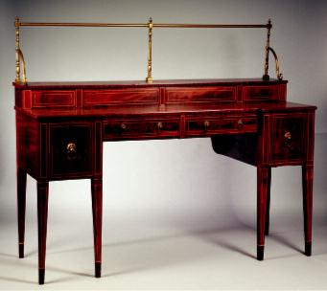
Pair of Porcelain Pug Dogs, Belgium or Germany, 18th/19th century, possibly Tournai in the Meissen style, each polychrome enamel decorated and modeled seated atop a raised rectangular shaped rocky base with applied flowers and grass, each dog with a large bow applied to a bell-adorned collar, the female with a suckling pup, blue marks, ht. 5 3/4 in.

$500-700

190.

Continental School, 19th Century

Standing Male Nude. Unsigned. Charcoal with conté crayon and whiting on paper, sight size 24 x 17 3/4 in., frame accompanies the lot. Condition: Staining, toning, foxing, tear l.r.
$800-1,000

191.

Six Framed Hand-tinted Botanical Engravings, Austria/Germany, late 18th century, from Plenck, French matted, in modern green wood frames, sight size 17 1/2 x 11, frames 28 1/4 x 22 in.
$800-1,000

192.

Scottish Regency Inlaid Mahogany Stage-top Sideboard, early 19th century, line inlaid stage with brass gallery and two short drawers, the lower section with plinth drawers, one with bottle compartments, on plain, square section tapering feet, ht. to gallery 64, wd. 76, dp. 25 in.
$3,000-5,000

34

193

193.

Regency Mahogany Boxwood Inlaid Bowfronted Sideboard, early 19th century, fitted with three shallow drawers, a silver drawer and a deep drawer, on square, tapered legs ending in spade feet, ht. 36, wd. 66, dp. 28 in.
$3,000-5,000

193A.

Armenian Karabagh Rug, South Caucasus, early 20th century, (small crude repairs, small corner gouge), 9 ft. x 4 ft. 8 in.

$700-900

194.
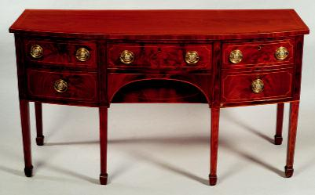
Three Continental Etched and Cut Colorless Glass Beakers, first half 19th century, with bead-cut and swag-etched rim, over elaborate crowned coat of arms and crest, fluted cuts to base, ht. 4 7/8 in.
$200-250

195.

Four Continental Colorless Glass Vessels, 19th century, two enamel decorated heraldic beakers, ht. 4 3/4, an etched and cut waisted wine with faceted trapped bubble baluster stem and folded foot, ht. 7 5/8, and an etched lipped round funnel wine with double baluster and knopped stem, ht. 8 1/4 in.

$200-300
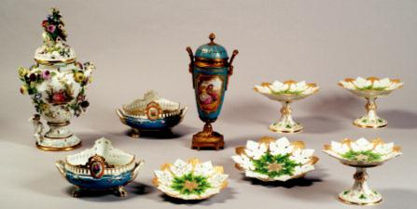

201

197

220 197 308

35

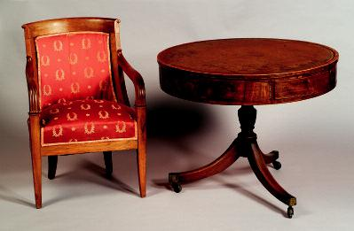

199 200

196.

Three Royal Worcester Bone China Figures of Dogs, 20th century, a group of seated beagle puppies, ht. 2 3/8, a black Labrador retrieving a mallard, ht. 3 3/4, and a hound on point, ht. 3 4/4 in.
$200-300

197.

Pair of Le Rosey Porcelain Fruit Bowls, Paris, late 19th century, squat ovoid, with reticulated rim accented with two roundels enamel decorated with fruit and flowers, short handles, the body with cerulean blue ground with ribbons and roseheads, on paw feet, gilt detailing throughout, wd. 11 in.
$400-600

198.

Northern School, 17th Century Style

Portrait of Peter Paul Rubens. Unsigned. Oil on canvas, 30 x 25 in., framed (in a liner). Condition: Punctures, losses, scattered retouch, surface grime, craquelure.
$600-800

199.

French Restoration Fruitwood Fauteuil, c. 1820, with concave backrest and molded arms, overupholstered seat on square, tapered and flared legs, seat ht. 18 in.
$300-500

200.

Regency Mahogany and Leather-top Drum Table, early 19th century, gilt-tooled green leather top above four working and four sham drawers, tripod base with brass cap casters, ht. 29, dia. 36 in.

$1,500-2,500

201.

Serves Porcelain Ormolu-Mounted Potpourri Urn, late 19th century, with Chateau des Tuileries mark, tapered ovoid, with reticulated domed lid with berry finial, reticulated ormolu neck and short loop handles ending in Demetre masks, the cerulean blue body enamel decorated with courting couple signed Lidoz, recto, and landscape scene verso, on fluted trumpet foot, ht. 16 1/2 in.

$400-600

202.

Set of Ten French Art Nouveau Porcelain Dessert Plates, Limoges, early 20th century, transfer printed and gold enamel decorated with sinuous yellow and green nasturtium flowers, molded gilt rim, dia. 7 /4 in.
$150-250

203.

Pair of Rouge Marble Egyptian Revival Obelisks, late 19th century, with incised faux hieroglyphics to front accented in gold and silver enamel, on tiered base accented with black slate/marble, ht. 20 in.
$1,500-1,800

204.

Leon Pilet (French, fl. 1840-1910)

Egyptian Revival Bronze and Parcel-gilt Figure of Cleopatra, the figure seated in a gilt chair decorated with pseudo hieroglyphics, in gilded headdress, carrying staff of rank, ht. 11 1/2 in.
$500-700

36

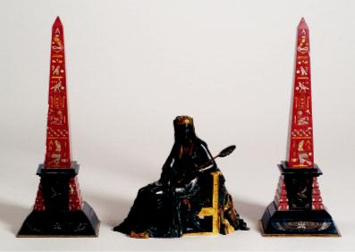

203 204 203

205.
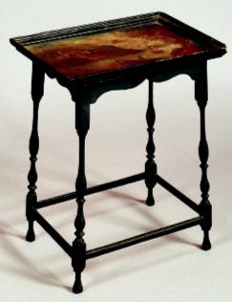
Leon Tharel (French, c. 1858-1902)

Idle Fiddle/Bronze Figure of a Napping Boy with a Violin, light goldish-brown patina, ht. 7 3/8, base lg. 7 3/4 in.

$1,500-2,000

206.

Louis Vuitton Wood-Strapped and Leather-Covered Steamer Trunk, early 20th century, of typical form, stamped number 794156 (?), interior with removable cloth basket, ht. 22, wd. 31, dp. 20 in.
$1,500-2,000

207.

William and Mary Style Small Painted and Turned Table, 19th century, rectangular dished top painted with a lake scene with a castle, on delicately turned legs joined by a box stretcher, ht. 25 1/2, wd. 19, dp. 14 in.
$1,000-1,500

208.

Indian Miniature Scenic Painting of a Mansion, late 19th century, rectangular, depicting a stately Indian home with formal gardens, in giltwood frame with Rowley Gallery, Kensington label, sight size 10 1/4 x 4 1/4 in.
$2,500-3,500

207

37

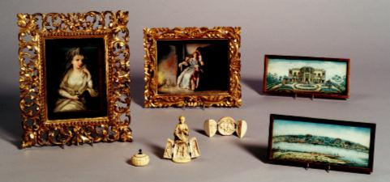
255

208

256 250 209

209.

Indian Miniature Landscape Painting on Ivory, late 19th century, rectangular, depicting Indian mansions overlooking a river, in giltwood frame with Rowley Gallery, Kensington, label, sight size 10 1/4 x 4 1/4 in.
$2,000-3,000
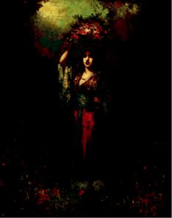

210

210.

Frederick Borgella (French, 19th Century)

Peasant Girl with Flower Basket Before a Wooded Path. Signed “Borgella” l.r. Oil on panel, 20 1/4 x 16 in., unframed. Condition: Surface rubs, scattered retouch and craquelure.

$1,000-1,500

210A.

Continental School, 19th Century

Reading the News in the Coppersmith’s Workshop.

Unsigned. Oil on canvas, 12 1/2 x 10 1/2 in., framed.
Condition: Retouched, surface grime, craquelure with lifting.
$500-700

211.

Set of Twelve Gilt and Transfer Decorated Porcelain Service Plates, Heinrich & Co., Bavaria, 20th century, printed to center with bouquet of flowers, with maroon and gold printed rim, with gold inner and outer borders, dia. 11 in.

$300-400

212.

Pair of English Brass Horse-form Doorstops, late 19th century, the prancing horses on oblong bases, ht. 11 in.
$300-500

213.

Four Royal Doulton Bone China Figures of Dogs, 20th century, all modeled standing, a greyhound, an Irish Setter, a bulldog, and a beagle, ht. 6 to 4 in.
$400-600

38

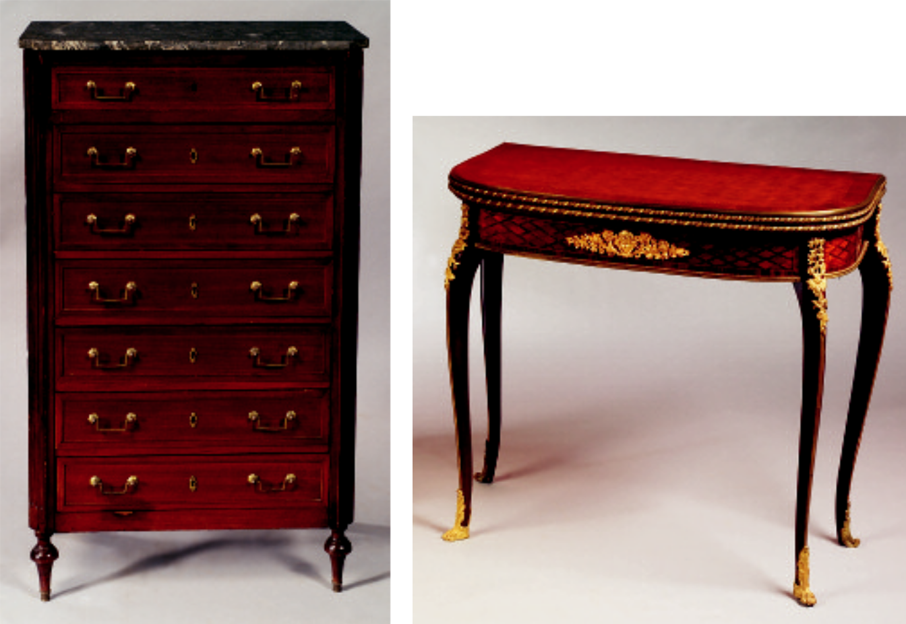

214 215

214.

Directoire Marble-top and Brass-Mounted Mahogany Semainiere, 19th century, rectangular gray and white top with cut corners above a conforming case fitted with seven drawers flanked by fluted stiles continuing to turned feet, ht. 53 1/2, wd. 31, dp. 17 in.
$800-1,000

215.

Louis XV Style Ormolu-Mounted Tulipwood Parquetry Game Table, possibly Francois Linke, with bowfront and conforming frieze on angular cabriole legs headed by chutes and ending sabots.
$6,000-8,000

216.

Assembled Group of Meissen Porcelain Table Articles, late 19th/early 20th century, all with enamel decoration of flower bouquets, comprising ten soup plates with single gilt rim band, and group with scalloped gilt rims including four soup plates, four dessert plates, and three side plates.
$800-1,200

217.

Miniature Georgian-style Mahogany Veneered Chest of Drawers, late 19th century, slight bow front, with two short over three long graduated drawers with faux ivory pulls, on turned feet, ht. 11 5/8, wd. 11, dp. 5 1/4 in.
$800-1,200

218.

Attributed to Frits Thaulow (Norwegian, 1847-1906)

House and Stream. Signed “Frits Thaulow” l.l., identified on a label from the Vose Galleries of Boston on the reverse. Oil on canvas, 24 1/2 x 30 1/4 in., framed. Condition: Lined, retouch, craquelure.
$5,000-7,000

219.

Two Viennese Porcelain Figures of Lipizzaner Stallions, late 20th century, a figure of horseback, oval base titled “Trab-Spanische Reitschule,” ht. 5, the other a horse on hind legs, titled on base “Levade-Spanische Reitschule,” ht. 8 1/2 in., both titled on other side of base “Hofburg Wien,” one with date 1925, gilt accenting.
$100-200

39

221

220.

Large Meissen Porcelain Covered Potpourri Jar, late 19th/early 20th century, inverted pear-shaped body, with short handles, encrusted with flower stems, and mounted with a pair of putti, enamel decorated to one side with courting couple, and with bouquet to other, on domed foot, the reticulated lid with elaborate clustered floral finial, ht. 20 3/4 in.

$2,500-3,500

221.
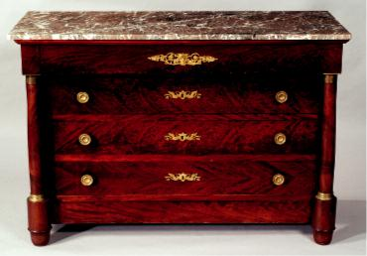
French Empire Mahogany and Marble-top Commode, early 19th century, with rectangular top and conforming case having a projecting drawer above three long drawers flanked by columns, on turned feet, with cast bronze mounts, ht. 36, wd. 54, dp. 22 in.

$4,000-6,000
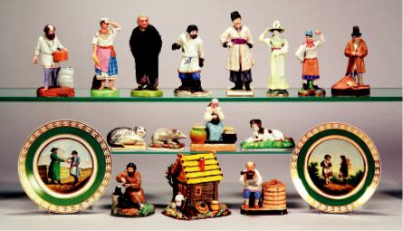

Top row: 223, 224, 225, 226, 227, 231, 232, 233

Middle row: 234, 235, 240A, 241

Bottom row: 242-245A

40

