Page 1 of 3

PLANT CATALOG TEMPLATE
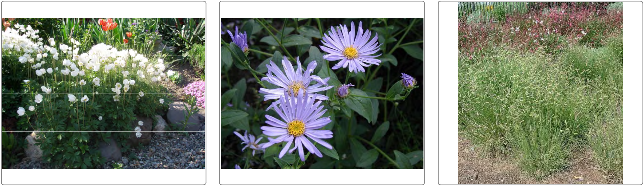

WINDFLOWER SUMMER ASTER BLUE GRAMMA GRASS

Anenome sylvestris Aster frikartii Bouteloua gracilis
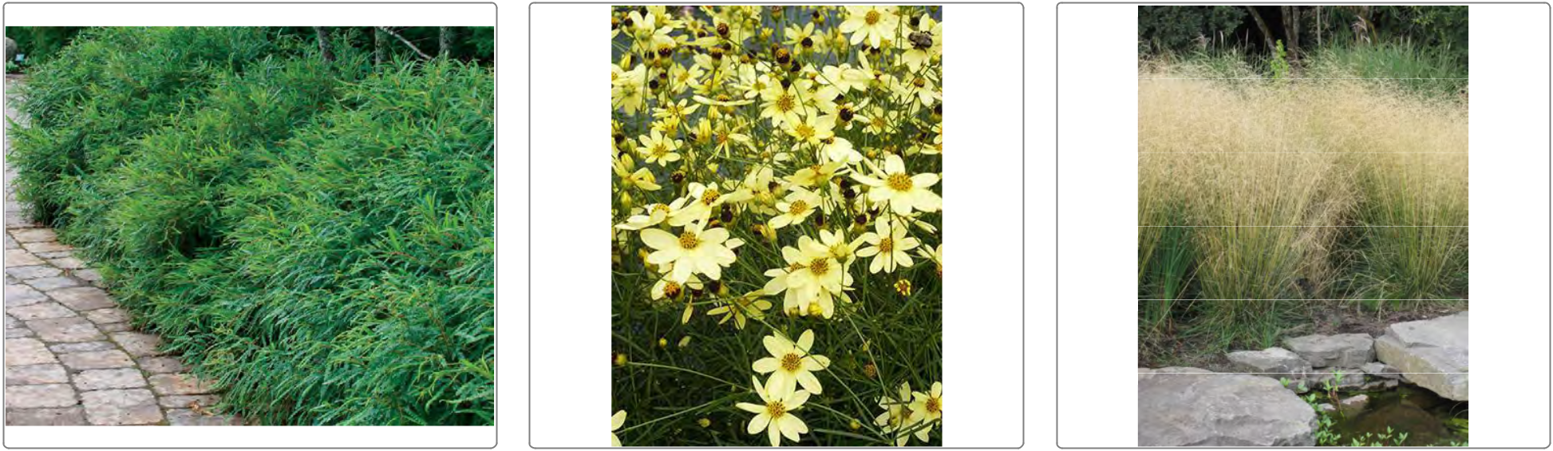

SWEET FERN MOONBEAM COREOPSIS BRONZE VEIL TUFTED HAIR GRASS

Comptonia peregrina Coreopsis verticillata 'Moonbeam' Deschampsia caespitosa 'Bronzschlier'

©2009 DynaSCAPE Software, All rights reserved - ©2009 Horticopia, Inc., All rights reserved.

Page 2 of 3
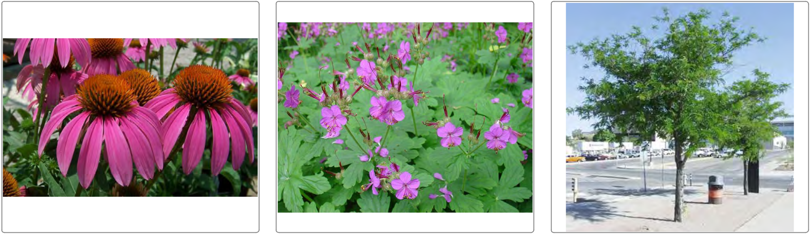

RUBY STAR CONEFLOWER BIGROOT CRANESBILL THORNLESS HONEY LOCUST

Echinacea purpurea 'Ruby Star' Geranium macrorrhizum Gleditsia triacanthos f. inermis
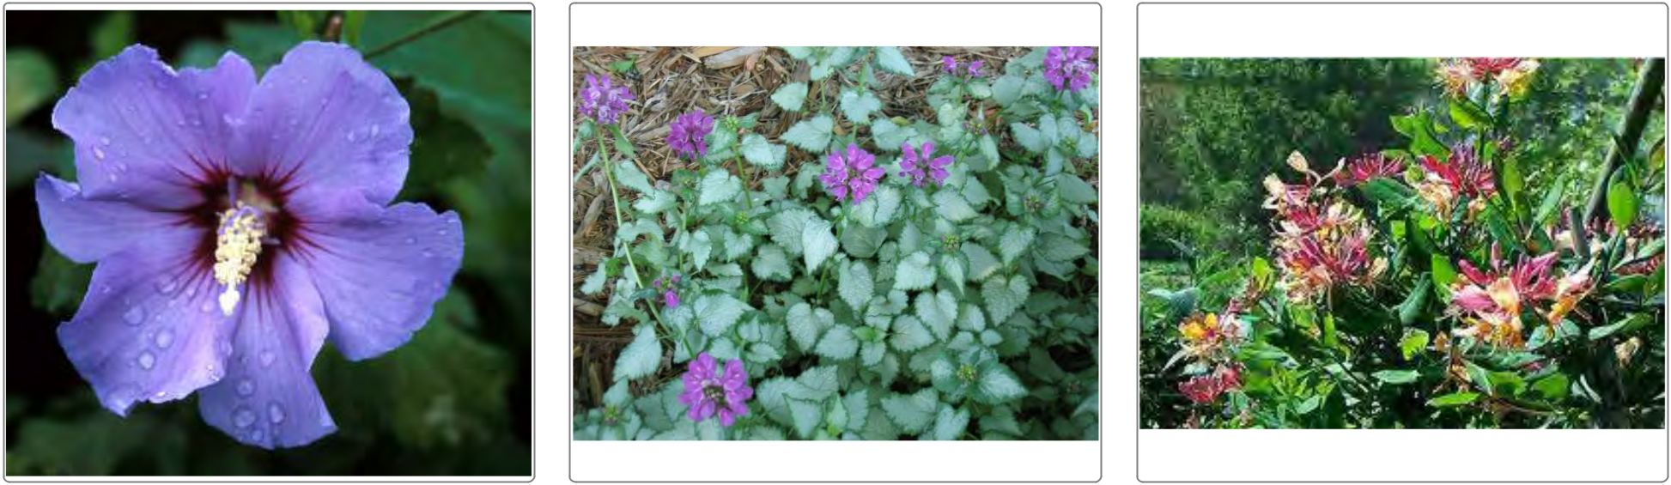

ROSE OF SHARON BLUE SATIN LAMIUM BEACON SILVER GOLDFLAME HONEYSUCKLE

Hibiscus syriacus 'Blue Satin' Lamium 'Beacon Silver' Lonicera heckrotti 'Goldflame'

©2009 DynaSCAPE Software, All rights reserved - ©2009 Horticopia, Inc., All rights reserved.

Page 3 of 3
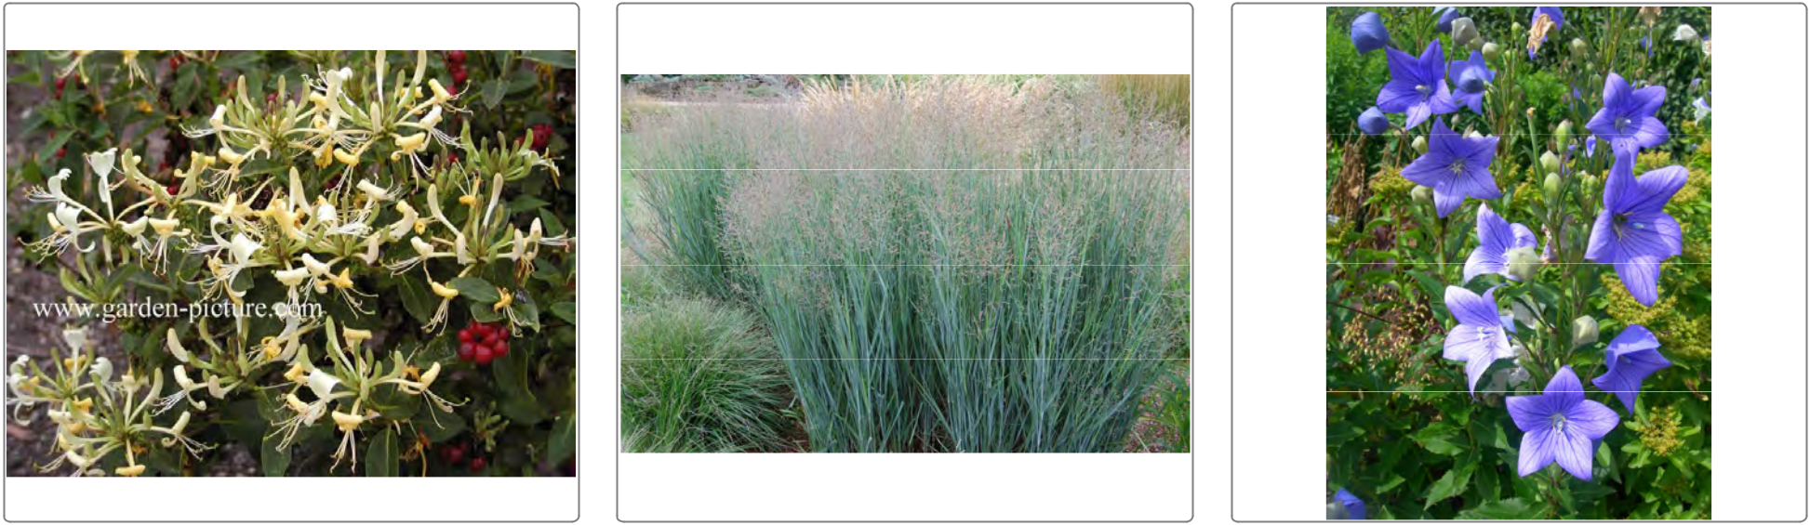

HONEY BABY HONEYSUCKLE HEAVY METAL SWITCH GRASS BALLOON FLOWER

Lonicera x 'Novso' PPAF Panicum virgatum 'Heavy Metal' Platycodon grandiflorus
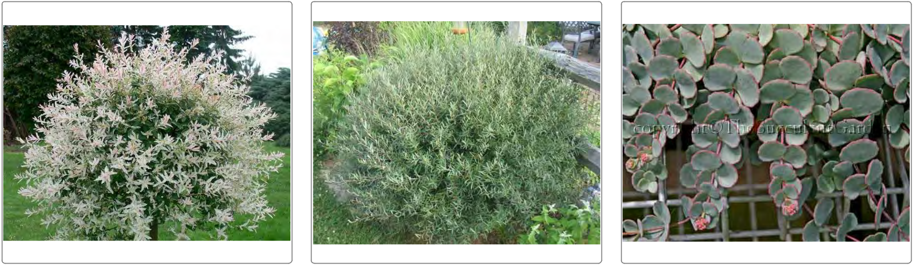

TRI COLOR WILLOW DWARF ARCTIC WILLOW SEDUM DRAGON

Salix integra 'Hakura Nishiki' Salix purpurea 'Nana' Sedum sieboldii dragon

©2009 DynaSCAPE Software, All rights reserved - ©2009 Horticopia, Inc., All rights reserved.

