

Learn

Eat

Buy

What is Kyoyasai Land?

Kyoyasai are vegetables that are grown in Kyoto. Kyoyasai Land is a venue where you can experience the benefits of Kyoyasai vegetables by learning about them and how they are grown and is also where you can buy Kyoyasai vegetables and their products. We are registered with Kyoto Prefecture and are promoting ourselves widely through maps and other means.

Yabunouchi-cho, Shinmachi- Nishiiru, Shimodachiuri-dori, Kamigyo-ku, Kyoto-shi, 602-8570 JAPAN
075-414-5656
075-414-4982
Saturday, Sunday & National holiday

- Satonoeki Ohara●●●

1012 Nomura-cho, Ohara,
Sakyo-ku, Kyoto-shi
075-744-4321
9am－5pm(Restaurant－4pm) Mondays

http://www.satonoeki-ohara.com/

- Michinoeki Woody Keihoku●●●

1-1 Kamiterada, Shuzan-cho, Keihoku, Ukyo-ku, Kyoto-shi
075-852-1700
9am－6pm
Dec.29th-Jan.3rd http://fuw.jp/woody/
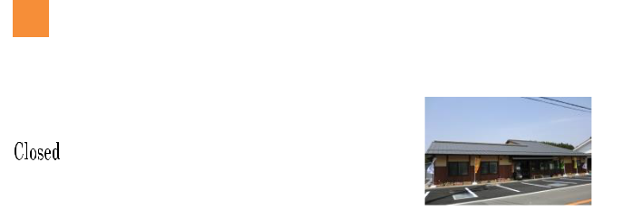

³ Yamaguni Sakigake Center●●●
23 Miyanomae, To-cho, Keihoku,
Ukyo-ku, Kyoto-shi
075-853-0572
9am－5pm
Sat, Sun, and public holidays
http://www.sakigake.net


- Jinento Ichiba●●●
125 Aoike-cho, Takeda,
Fushimi-ku, Kyoto-shi
075-646-0831
10am－6pm
New Year’s season
http://jinento.com/
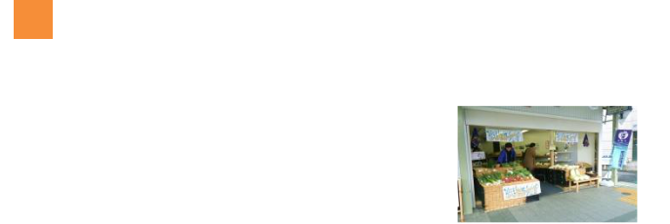

5 Kyoyasai Tokimachi Shoku● ●
41 Kitakamifusa-cho, Koyama, Kita-ku, Kyoto-shi
075-491-5920
11am－6pm
Sundays
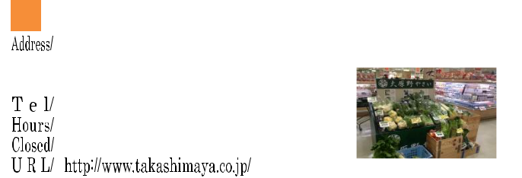

⁶ (Takashimaya Rakusai store)

2-5-5 Higashi Sakaidani-cho, | ●●●
Oharano, Nishikyo-ku, | ●●●
Kyoto-shi
075-332-1111
10am－6:30pm
Jan. 1st.
- Shimin Nouen Kazamidori●●●
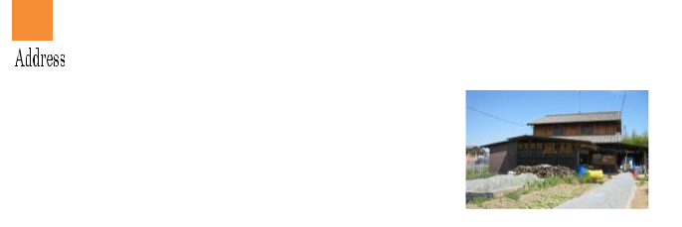
7-1 Yama-cho, Shinshuin,
Fukakusa, Fushimi-ku,
Kyoto-shi
090-2286-6972
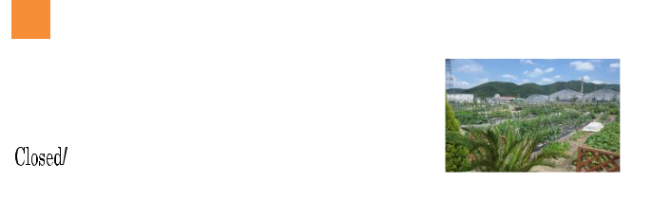

- Sukoyaka Farm Otowa●●●
43 Narano-cho, Shinomiya, Yamashina-ku, Kyoto-shi
075-582-0108 / 090-8750-3938
9am－5pm
If raining
https://sukoyakafotowa.jimdo.com/
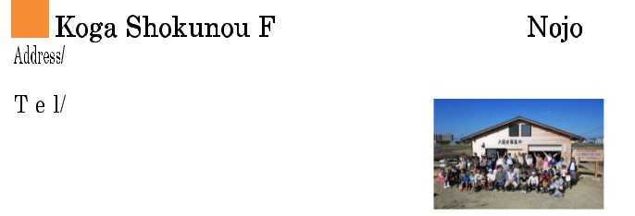

9
7-19 Otabi-cho, Koga, | ●●
Fushimi-ku, Kyoto-shi | ●●
075-641-4340

- Organic Tsuchi no Juku●●●
Rakusai Oharano Takenoko Farm
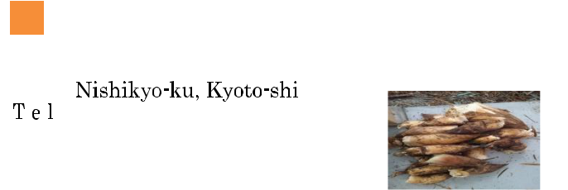
128-2 Minamino-cho, Kamizato,

090-7491-5504
http:// www.organic-tuti.org/

- JA Kyoto Yamashiro Farmers Market

Seika store “Green Market Seika”●●●

1-31-5 Hosono Nishi, Seika-cho, Soraku-gun
0774-94-5698
9:30am－4:30pm
New Year’s season

12 JA Kyoto Yamashiro Farmers Market

Yamadaso store “Aisaikan” ●●●
3-2 Kanahori, Nuidani, Seika-cho, Soraku-gun
0774-72-5459
9:30am－4:30pm
New Year’s season

- JA Kyoto Yamashiro Farmers Market
Tawara store “Ujicha no Sato” ●●●
12 Nakabayasi, Yanaginokuchi,
Ujitahara-cho, Tsuzuki-gun
0774-88-2629
9:30am－4:30pm
New Year’s season

- JA Kyoto Yamashiro Farmers Market
Kizu store “Hanayakaichi”●●●
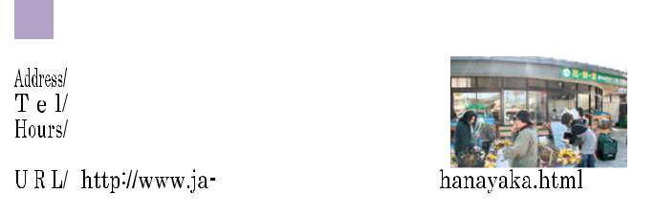
18-7 Yairo, Kizu, Kizugawa-shi
0774-72-0080

9:30am－4:30pm New Year’s season

- JA Kyoto Yamashiro Farmers Market Joyo store “Gorigoriichi” ●●●
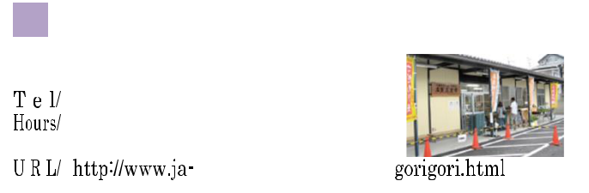
56 Kitagaito, Tono, Joyo-shi
0774-53-0072
9:30am－4pm
New Year’s season

- JA Kyoto Yamashiro Farmers Market Idecho store “Nagoyakaichi” ●●●
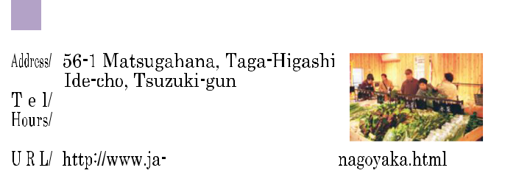

0774-82-2046 9am－3:30pm New Year’s season

- JA Kyoto Yamashiro Farmers Market

Kyotanabe store “Nikonikoichi” ●●●
65-2 Yanaga-machi, Miyamaki
Kyotanabe-shi
0774-63-6677
9:30am－4pm
New Year’s season

18 JA Kyoto Yamashiro Farmers Market
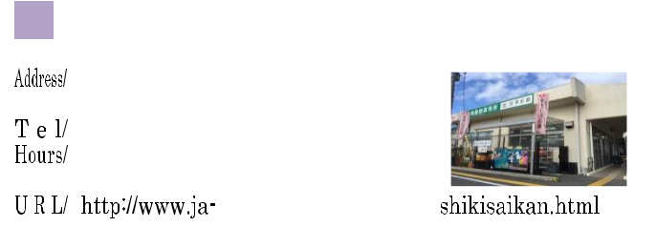
Yawata store “Shikisaikan” ●●●
56-1 Satogaito, Kouzuya Yawata-shi
075-983-8181

9:30am－4:30pm New Year’s season

- Minamiyamashiro-mura Farmers Market●●●
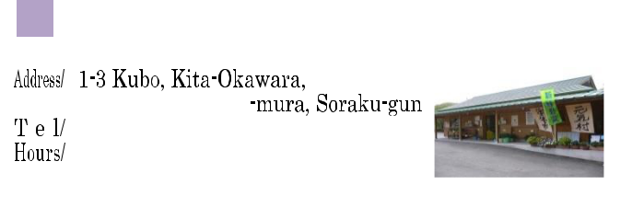

0743-93-1000
8:30am－4pm(Apr-Sep) 9am－3pm(Oct-Mar) New Year’s season

20 Joyo Syunsaiichi
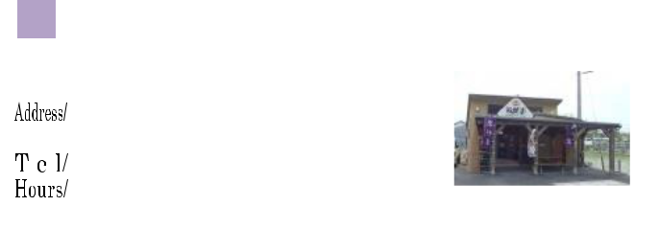
Farmers Market●●●

73-6 Shimagaito, Terada,
Joyo-shi
0774-52-0382
8:45am－4pm
Mondays

21 Michinoeki Ochano Kyoto ●●
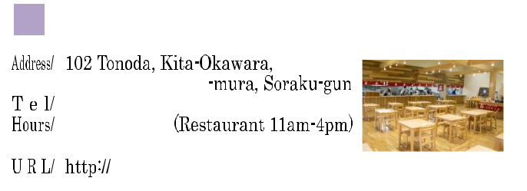
Minamiyamashiro-mura

0743-93-1392
9am－6pm
Every third Wednesday
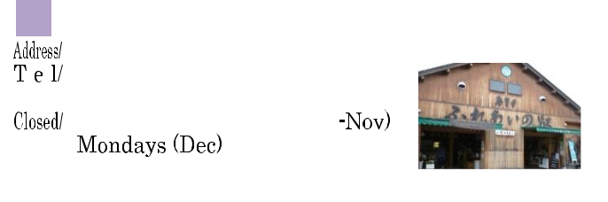

- Fugenji Fureainoeki●●●
- Odagaito, Fugenji, Kyotanabe-shi 0774-62-4250
8am－3pm

http://fureai-st.com/

23 Kumiyama-cho Farmers Market● ●
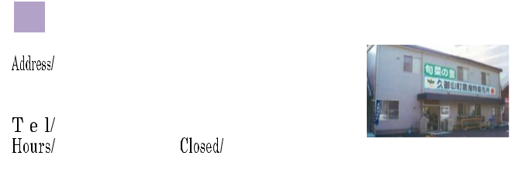
“ Syunsainosato”

156-1 Minamiouchi, Mori,
Kumiyama-cho, Kuse-gun 075-632-7777

9am－5pm New Year’s season https://www.facebook.com/shunsainosato
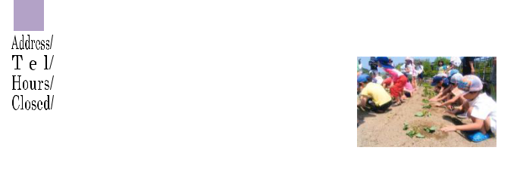

- Keihanna Kinenkoen●●
6-1 Seikadai, Seika-cho, Soraku-gun
0774-93-1200
9am－5pm

Dec 28th-Jan.4 th https://keihanna-park.net/
- Organic Tsuchi no Juku
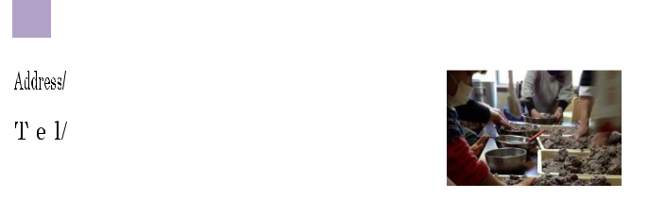
Higashi Kasatori Farm●●●
14 Bessyode,
Higashi-Kasatori, Uji-shi
090-7491-5504
http://www.organic-tuti.org

- Michinoeki Galleria Kameoka Galleria Asaichi● ●
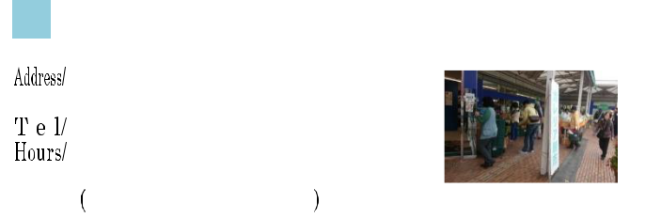
1-1 Takarakubo, Amarube-cho, Kameoka-shi
0771-24-8888 (Atrio)
9am－6pm
Every fourth Thursday


27 Mizuho Farm Nishibetsuin store ●●
- Mitarashi, Koji, Nishibetsuin-cho, Kameoka-shi
0771-27-7118
8am－6pm(summer) 8am－5:30pm(winter)
Jan 1st -3rd
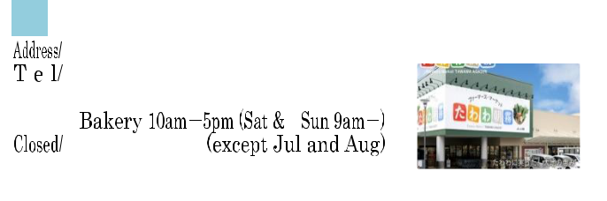

- Farmers Market Tawawa Asagiri●●●
- Nojo Uemata, Shino-cho, Kameoka-shi 0771-23-8318
9am－5pm

Wednesday
The beginning of the year http://www.jakyoto.com/tawawa/index/php
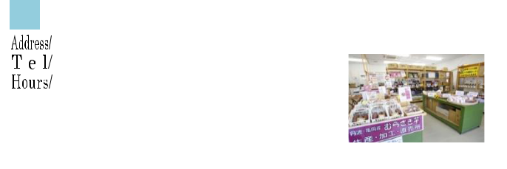

- Sanko Agri Brain System● ●
- Mizonomukai, Kamiyada-cho, Kameoka-shi 0771-29-6133

9am－5pm
Saturdays and Sundays

- Michinoeki Kyoto Shinkouetsumura
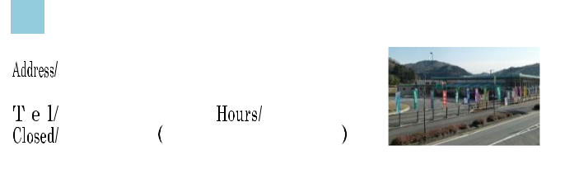
Anshin Anzen Yasaiichi
15-3 Nawate, Sogaya, ●●● Sonobe-cho, Nantan-shi
0771-68-1100 9am－6pm
Monday
http://www.canz.zaq.ne.jp/ekikouetsu/
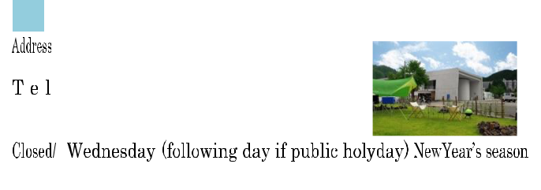
- Michinoeki Springs Hiyoshi Saikasaien
8 Nakamiyanomukai, ●●●
Hiyoshi-cho, Nantan-shi
0771-72-1526
10am－8pm(Mar-Nov)
10am－7pm(Dec-Feb)

http//www.springs-hiyoshi.co.jp


32
23-2 Agakeshimo, Miyama-cho, Nantan-shi
0771-75-0190 ●●●
8:30am－6pm(Apr-Sep)
8:30am－5pm(Oct-Mar)

New Year’s season Wednesday, Jan to Mar http://www.fmiyama.com/


- Michinoeki Tanba Markes
Tanbakogen Asadoriyasaiichi●●●
1-1 Shikishiden, Shuchi,
Kyotanba-cho, Funai-gun
0771-82-1125
8am－noon
Mon, Wed, and Fri

- Michinoeki Mizuhonosato Sarabiki Shinsen Toretore Yasaiichi●●●
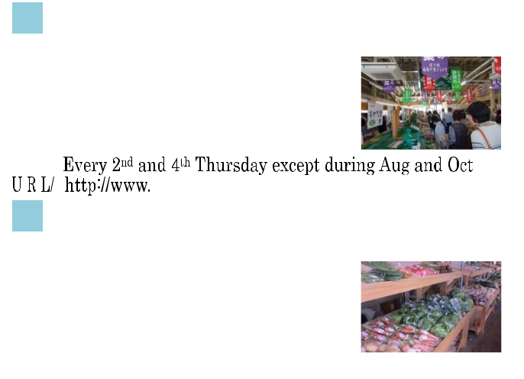
10-1 Yasumiishi, Oboso,
Kyotanba-cho, Funai-gun
0771-88-9350
9am－6pm
New Year’s season

³⁵ Michinoeki Nagomi Wachifureai Asaichi
11 Mojiri, Sakahara, Kyotanba-cho, Funai-gun
0771-84-1008 ●●
8:30am－6:30pm
Days not set
http://www.wachi-nagomi.com/


36
16 Kimizuka, Shimoyada-cho, Kameoka-shi
0771-21-0154 ●●●
8:30am－5pm(summer－6pm)

Dec 31th-Jan 4th http:// yadanosato.com/

37 Inukanno Fudokan“Kira” ●●●
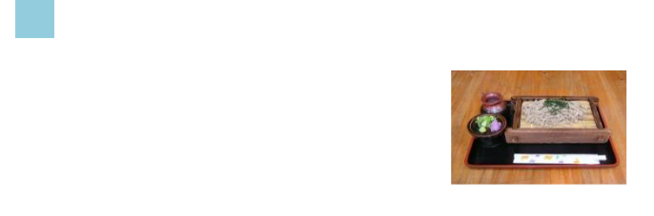
1-2 Hinoguchi, Inukanno, Nishibetsuin-cho Kameoka-shi
0771-27-2300 9am－5pm (Restaurant 10am-4pm) http://www.inukanno.jp/
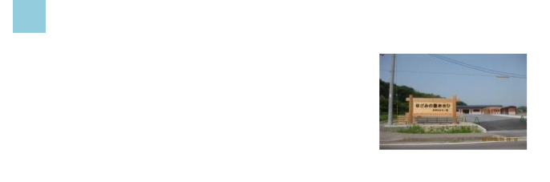

- Nagominosato Asahi●●●
105 Nakata, Asahi-cho, Kameoka-shi
0771-25-7537
9am－5pm(Apr-Oct) 9am－4pm(Nov-Mar) Wednesdays

- Gomachiiki Sinkokai●●●
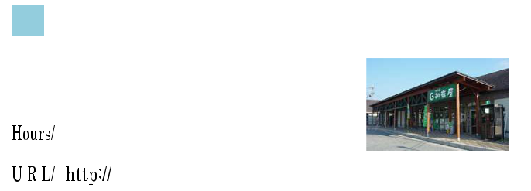
“Satonoeki Gomaya”

1-2 Matoba, Goma, Hiyoshi-cho, Nantan-shi
0771-74-0460
9am－6pm
New Year’s season


- Mizuho Farm Mizuho store●●
1-1 Koine, Wada, Kyotanba-cho, Funai-gun
0771-88-9988
9:30am－5pm
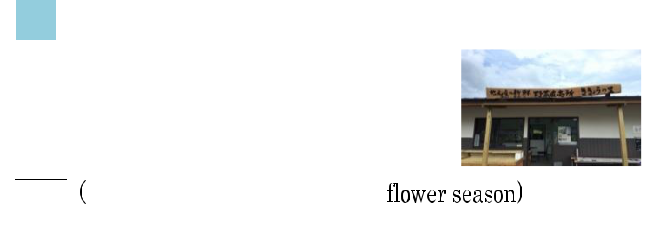

- Kikyo no Sato Farmers Market●●
20 Yasuba, Inokura, Miyazaki-cho, Kameoka-shi
0771-26-3753
8am－noon
Sundays

http://www.kameoka.info/user/kikyounosato/
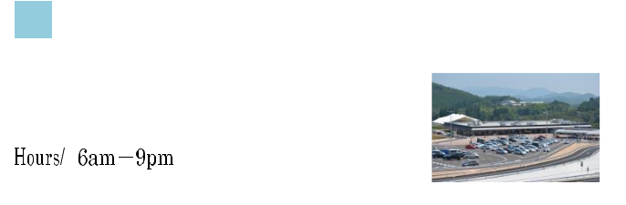

42 Michinoeki ●●

65-1 Fukashino, Sone,
Kyotanba-cho, Funai-gun
0771-89-2310 http://ajimu.info/

- Hozugawa Suitan Farm●●
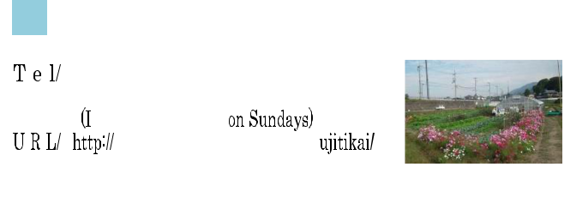
Hachinotsubo, Hozugawa-cho, Kameoka-shi
090-3820-7510
Year-round
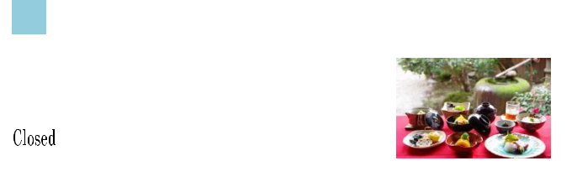

44 Kyoryori Matsusho ●●
91-1 Kamikitaura, Shino,
Shino-cho, Kameoka-shi
0771-24-0567
11am－2pm, 5pm-9pm
Wedndays
http:// matsusyo.jp/
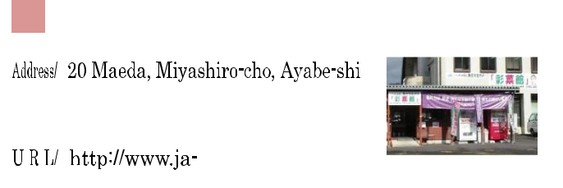

- JA Kyoto Ninokuni Farmers Market
「Aisaikan」Ayabe store● ●

0773-43-0831
9am－4:30pm
New Year’s season

- JA Kyoto Ninokuni Farmers Market
「Aisaikan」Fukuchiyama store● ●
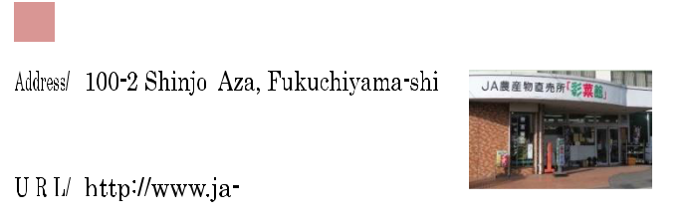

0773-22-2444
9am－5pm
New Year’s season

- JA Kyoto Ninokuni Farmers Market
「Aisaikan」Nishimaizuru store ● ●
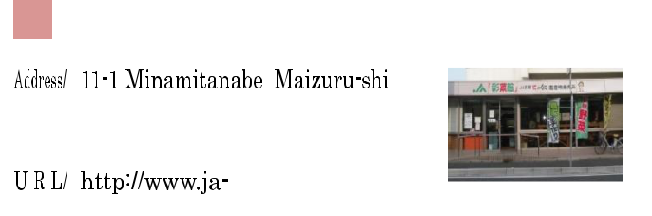

0773-75-9330 9am－4:30pm New Year’s season
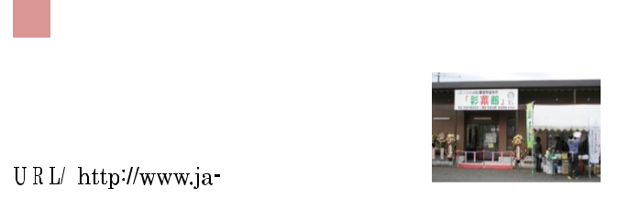

- JA Kyoto Ninokuni Farmers Market
「Aisaikan」Higashimaizuru store
10-1 Hama-cho, Maizuru-shi
0773-65-3131 ● ●
9am－4:30pm New Year’s season

49 | Michinoeki Noushou no Sato Yakuno | 55 | Tsuneyoshi Hyakkaten● ●
 | Yakuno Kogen ichi● ● |  | 123-2 Kamitsuneyoshi, Omiya-cho,
 | 2171 Hirano, Yakuno-cho, |  | Kyotango-shi
 | Fukuchiyama-shi | 0772-68-1819
0773-38-0543 |  |  | 10am－6pm
 | 9:30am－5pm |  | Tuesdays
 | Every third Wed & Jan 1st-3rd
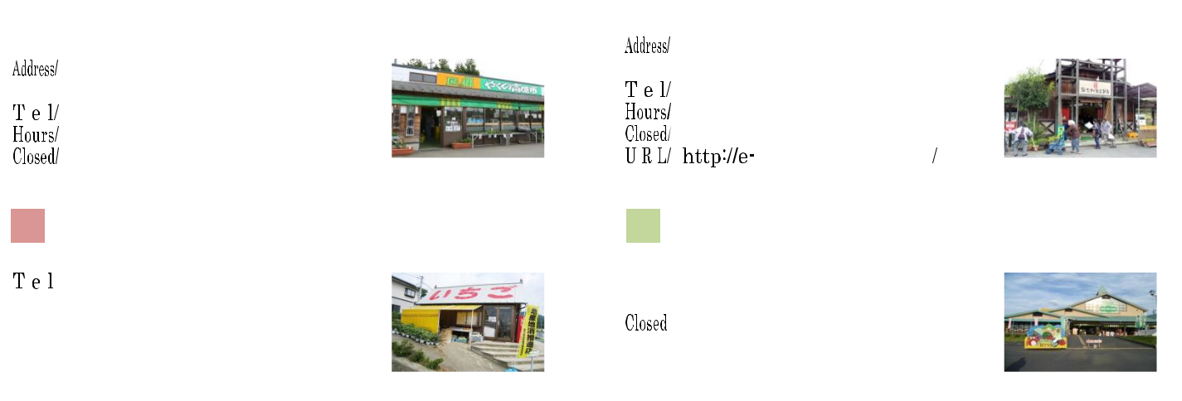

61 Yoshino no sato ●●
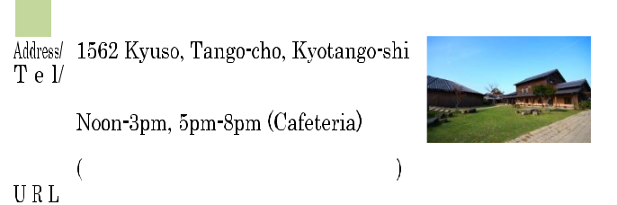

0772-76-1000
10am－9pm (last enter 8:30pm)

Thursday

http://ukawaonsen.jp
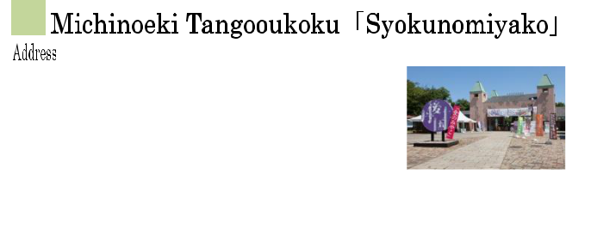

⁵⁰ Fukuyama Farm● ●
307-1 Toda, Aza, Fukuchiyama-shi
0773-27-0954 9am－6pm
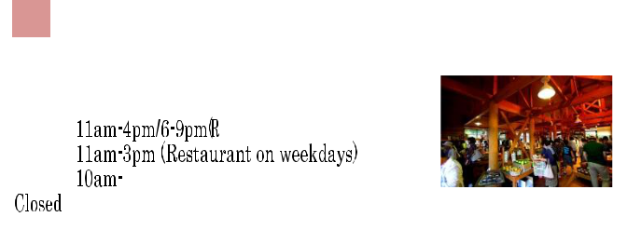

- Maizuru Fururu Farm●●●
60 Sezaki, Aza, Maizuru-shi
0773-68-0233
9am－4pm(Market)

Tuesdays
http://www.fururufarm.com/

⁵⁶ Michinoeki Kumihama SANKAIKAN
1709 Urake, Kumihama-cho, Kyotango-shi
0772-83-2000 ●●●
8am－5pm
-
http://www.sankaikan.net
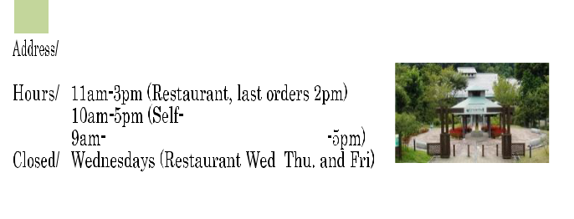

- Refre Kayano sato ●●
1730 Kanaya, Aza, Yosano-cho, Yosa-gun
0772-43-1730

http:// refre.yosanoumi-fukushikai.or.jp/

62
123 Tottori, Yasaka-cho, Kyotango-shi ●●●
0772-65-4193
Farmers Market 9am－5pm Roadside station
9am－9pm
Tuesdays
http://tango-kingdom.com/
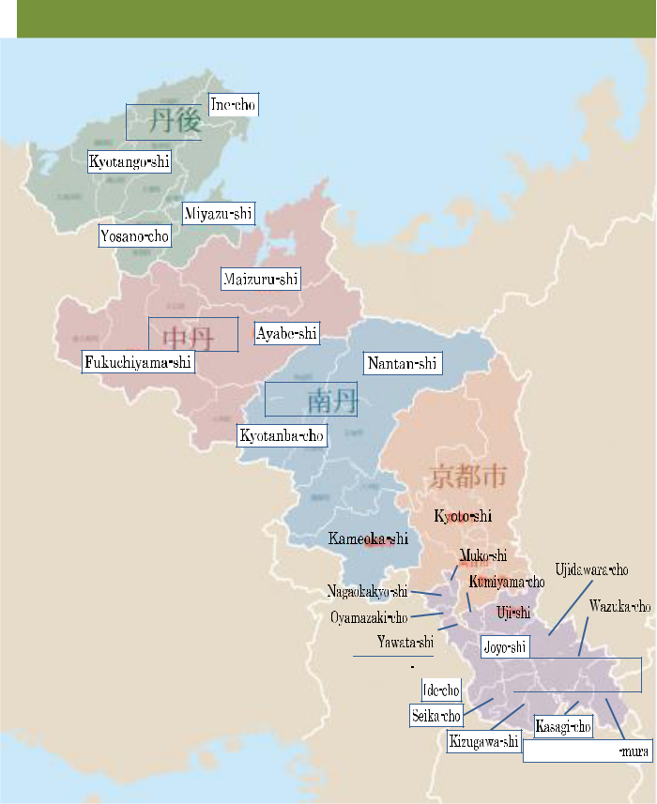

Kyoto Prefecture Area Map

Tango

52 | Budoubatake no Marche & Restaurant |  | 58 | Atsue Saisaikan ●
 | 123 Kokubu, Aza, Miyazu-shi ●● |  |  |  | 490 Atsue, Aza, Yosano-cho, Yosa-gun
0772-27-2222 |  | 0772-42-6570
 | 10am－5pm |  |  |  | 9am－noon
 | 11am－5pm |  |  |  | Saturdays & Sundays
 | Wednesdays
 | http://www.amanohashidate.org/wein/
 | Azekura(Tangoji Taniuchi Farm) ●●●
53 | Azekura(Tangoji Taniuchi Farm) ●●● |  | 59 | Tango Yasai-kan Kichari-na ●●
 | 2349 Taniuchi, Omiya-cho, Kyotango-shi |  |  |  | 397 Arayama, Mineyama-cho, Kyotango-shi
0772-68-1398 |  | 0772-62-7820
 | 9am－5pm |  |  |  | 9am－6pm
 | Thursdays |  |  |  | Wednesdays
 | Nogigen●●●
54 | Nogigen●●● |  | 60 | Miyazu Magokoro ichi● ●
 | 1011 Ooyama, Tango-cho, Kyotango-shi |  |  |  | 3008 Hama-machi, Aza, Miyazu-shi
0772-75-1939 |  | 0772-22-6123
 | 10am－noon, 3pm－6pm |  |  |  | 9am－5pm
 | Wed & Sun |  |  |  | New Year’s Season
 | http://www.nogigen.me/ |  |  |  | http:// magokoroichi.com/
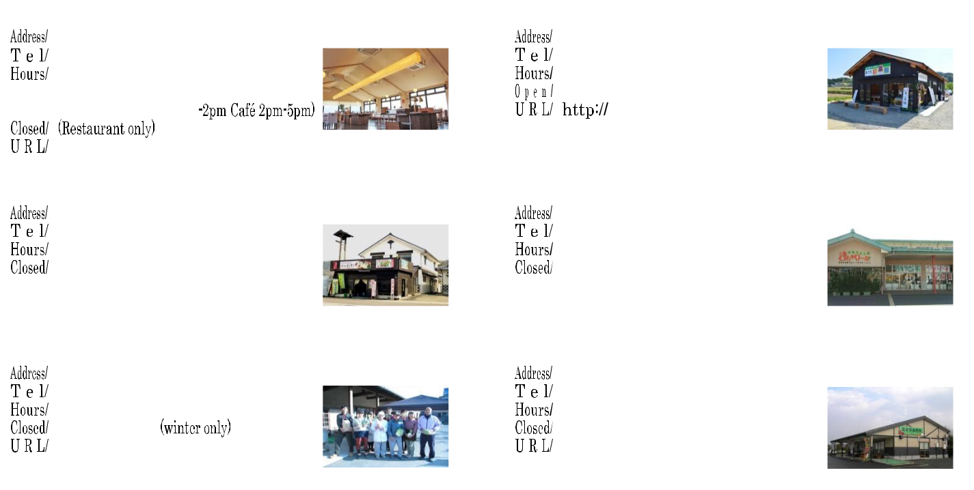

Fukui Pref.

Chutan

Nantan

Siga Pref.

Hyogo Pref. |  |  | Kyoto-shi
Yamashiro

This information may change.

Please contact each facility for more details.

