Industry Analysis
1

Nikolaos Lionis
University Of Athens

( R e v i s e d : O c t o b e r 20 1 4 )

Setting the Stage
2

Porter’s
Five Forces
Market Structure Conduct Performance

Brandenburger Nalebuff Value Net

Macro Analysis
Industry Analysis

Internal
Analysis

Strategic Analysis

Industry Analysis

3

Industry analysis is useful for understanding a firm's economic context

- Industry analysis helps in
  - Assessing the profitability of an industr
  - Identifying the strategies that are most likely to be profitable
  - Forecasting the likely behaviour of rivals

- Industry analysis provides the context in which strategy is formulated

Industry Analysis

4
- Porter’s Five Forces and Brandenburger – Nalebuff Value Net provide a
structure for performing an industry analysis.

- Porter’s Five Forces and Brandenburger – Nalebuff Value Net are primary useful
  - For identifying the relevant participants in the market and
  - Assessing their influence on the market outcome

- Structure – Conduct – Performance model, as part of Industrial Organization, is somehow more general and includes also
  - Traces relationships among the three market elements
  - Provides a structure for analyzing and evaluating strategic choices

- Note:
  - In managerial economics, the emphasis is upon the firm, the environment in which the firm
finds itself, and the decisions which individual firms have to take.
  - In industrial economics (or industrial organization), the emphasis is upon the behavior of the whole industry, in which the firm is simply a component.

Market Definition

5

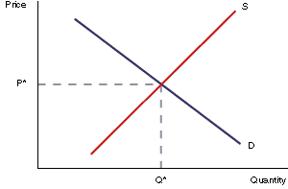
Market Definition

6
- Market and industry are terms often used interchangeably

- What is a market?

- A market is the collection of buyers (demand) and sellers (supply) that, through their actual or potential interactions, determine the price of a product or set of products. In other words, a market is the “place” where price is determined.

Market Definition

7

- But what is really a market?
  - Which demand and which supply?

- What products one should include?
  - The market for automobiles
 Should we include light trucks, SUVs?
  - The market for soft drinks
 What are the competitors for Coca Cola and Pepsi?
  - With whom do McDonalds and Goodies compete?
 Hilton’s Byzantino?

- Is geography (location) important?
  - Some products are too expensive to transport
 Hence geography may set market’s boundaries
  - But customers can move
 What is the relevant market for a beach or ski resort?

Market Definition
8
To answer these questions, we need to consider both demand and supply substitutability

Demand Substitutability
- When deciding whether Product B is in the same market as Product A, one should start by asking whether buyers of Product A might instead purchase Product B if the price of A rises substantially above that of Product B.
- In other words, are Products A and B close substitutes from the point of view of consumers?
- If the answer is yes, then the prices of Products A and B will be determined together (at the same market)

- Cross price elasticity of demand
D = PB ∂QA
AB Q ∂P
ε

B B

  - High demand substitutability means that this cross price elasticity is high

Supply Substitutability
- Even if there is little or no demand substitutability, two products could be in the same market if there
is a high supply substitutability.
- Why? Because high supply substitutability between Products A and B means that an increase in the price of Product A would lead producers of Product B to shift some of their production to Product A, and thereby limit the price increase.

- Cross price elasticity of supply
S = PB ∂QA
AB Q ∂P
ε

B B

  - High supply substitutability means that this cross price elasticity is high

Market Definition

9
- But by defining a market by closeness in substitutability implies another question
“How close is close?”
  - If we define a market in a narrow sense, it is likely that there will be fewer producers
 e.g. the market for air travel to Santorini
  - A broader definition of the market often gives us more choice
 e.g. the air transport industry

- In sum, market definition poses real problems
  - Existing methods represent a reasonable compromise

- After all why one needs to define strict and consistent market boundaries?
  - Academic research
 Intellectual organization of the way one thinks about economic activity
  - Public policy (antitrust)
 Mergers’ licensing
 Imposing fines for illegal behavior
  - But firms’ managers may just need a rather rough definition of their market
 Understand actual competitors
… but also potential competitors
 Understand product characteristic boundaries and geographical boundaries to set prices, advertising budget, investment decision
… but technology that affects these boundaries is evolving

Structure – Conduct – Performance Model
10

Structure – Conduct – Performance Model

11

Industrial Organization’s model to trace the relationship between the structure of a market, the behavior of the firms and their performance in that market.

- Markets have three elements:
  - Market structure
  - Market conduct
  - Market performance

Structure – Conduct – Performance Model

12

Basic Conditions

Structure Conduct Performance

Basic Market Conditions

13
Market Demand
Market Supply

- Raw materials
- Technology
- Product durability
- Value/weight
- Business attitudes
- Unionization
- Price elasticity
- Rate of growth
- Substitutes
- Marketing type
- Purchase method
- Cyclical and seasonal demand

Market Structure

14
- The structure of a market is the set of conditions and characteristics
that describe and define the market type.
  - i.e. organisational and other characteristics of the market

- Focus on those characteristics of a market which affect the degree of competition between firms and their strategic decisions (e.g. Pricing etc)

- To describe market structure economists consider:
  - Number of sellers and buyers
  - Size distribution of sellers and buyers
  - Extent of product differentiation
  - Barriers to entry
  - Degree of vertical integration
  - Cost structures
  - etc.

Product Homogeneity or Differentiation

15

- Homogeneous goods
  - Essentially the same physical characteristics
  - Associated with perfect competition
  - Potential for different grades
 E.g. steel, cement, coal, fresh fruit

- Differentiated (non – homogeneous) goods
  - Products differentiated (on their physical characteristics) from their
competitors
  - Branding
  - Packaging and marketing

- Strong product differentiation and brand loyalty allows firms to charge
higher prices
  - Demand become less price elastic
  - Reduction in the cross – price elasticity of demand

Nature of Costs

16

- Entry costs into a market
  - Capital costs will vary from industry to industry
  - e.g. a natural monopoly

- Sunk costs
  - These are costs that are not recoverable
 Advertising and marketing
 Depreciation of capital equipment
  - High sunk costs makes a market less contestable

- Natural cost advantages
  - Location advantages
 Close to ports, access to cheaper labour
  - Ownership of important raw materials
  - Control of the supply chain through vertical integration

Market Structures in Economic Theory

17

 | Perfect Competition | Monopolistic Competition | Oligopoly | Monopoly
Number of Firms | Many | Many | Few | One
Product  Differentiation | Identical | Different | Identical or Different | No  Close  Substitute
Entry Barriers | None | None | Moderate to Difficult | Blocked

Market Structures in Practice
18

Fragmented
- Many small firms usually owner operated ones with a small number of employees
- e.g. jewelleries; restaurants
- Monopolistic Competition (and Perfect Competition ?)

Loose Oligopoly

  - Five or more major players
  - e.g. cigarettes; mobile phones; TV sets; stereo electronics
  - Oligopoly

Tight Oligopoly

  - Two or three major firms
  - e.g. Coke and Pepsi; Boeing and Airbus; Cosmote, Vodafone and Wind
  - Oligopoly

Dominant Firm

- A single large firm and, perhaps, a fringe of small competitors
- e.g. Microsoft in OS; De Beers in diamonds; PPC
- Oligopoly (and Monopoly?)

Market Conduct

19
- Conduct refers to the behaviour, policies, and strategies used by the firms in the industry.

- To describe firms’ conduct economists consider:
  - Pricing behaviour
  - Product strategy and production
  - Research and development
  - Advertising
  - Promotion and marketing
  - Distribution
  - Legal tactics
  - Merger activity
  - etc.

- Types of firms’ conduct
  - Price competition
  - Non price competition
 Product Line
 Product quality
 Advertising
 Research and Development
 Other marketing variables

Market Conduct and Firms’ Strategic Decisions

20

Some of the strategic variables in firms’ portfolios
Product features and quality | Vertical integration
Product marketing and positioning | Mergers and acquisitions
Product line | Service provision
Product standardization | Warranties
Production technology | Financial leverage and debt
Research and development | Government relations
Cost reduction investments | Corporate divisions and internal organization
Branding | Flow of internal communications
Geographical market | Accounting system
Distribution channels | Inventory levels
Pricing | Advertising
Legal tactis | etc.

Market Performance

21

Performance refers to the economic outcomes that result from the market structure and the firms’ conduct.

- To evaluate an industry’s performance economists consider
  - Productive efficiency
  - Allocative efficiency
  - Equity
  - Technological advancement
  - Employment
  - etc.

Market Performance Indicators

22

Price indexes
  - Trends in real price levels over time
- Level of business profits
  - Evidence of excess profits
- Spending on research and development
  - Pace of technological advance and innovation
- Labour productivity in the industry

The Causal View of S-C-P Model
23

Basic Conditions

Supply: Raw materials, Technology, Product durability, Product value, Other
product attributes (weight etc), Business attitudes, Unionization

Demand: Price elasticity, Rate of growth, Substitutes, Marketing type, Purchase
method, Cyclical and seasonal demand

Market
Structure
Conduct Performance

Number of sellers & buyers Product differentiation Barriers to entry

Cost structures Vertical integration
Pricing behaviour Product strategy Research & development Advertising
Legal tactics
Productive efficiency Allocative efficiency Technological progress Full employment Equity

The Feedback Critique of S–C–P Model
24

Basic Conditions

Market
Structure
Conduct Performance

- The conduct of firms in a market can affect market structure
  - e.g. merger and takeover activity
- The actual performance of firms in the market affects conduct as well as market structure
  - e.g. rising dominance of best performing firms

Public Policy and the S–C–P Model
25

Basic Conditions

Market
Structure
Conduct Performance

Government

Public Policy

26

Government can directly affect market structure
  - By limiting entry (taxi, notaries etc)
  - By granting monopoly rights (lignite extraction)
  - By patent protection

- Government can directly affect market conduct
  - By price controls (drugs)
  - By regulating advertising (drugs, toys)

- Government can directly affect market performance
  - By taxation on firms’ profits

Public Policy

27

Competition (antitrust) policies
- Regulation policies
- Taxation and subsidizations
- Trade regulations
- Price and wage controls
- Investment incentives
- Employment incentives
- Macroeconomic policies
- etc.

Porter’s Five Forces Model
28

Porter’s Five Forces Model

29
- Porter’s Five Forces is a tool to understand the profitability of an
industry

- What is the threat to profits from...?
  - Competitors
  - Suppliers
  - Buyers
  - Substitutes
  - Entrants

- All these forces attempt to capture the ability of others to
expropriate some or all of a firm’s profits
  - … by aiming at the prices in the industry

- Note: Competitors is an internal force that affect prices, while
suppliers, buyers, substitutes and entrants are external forces

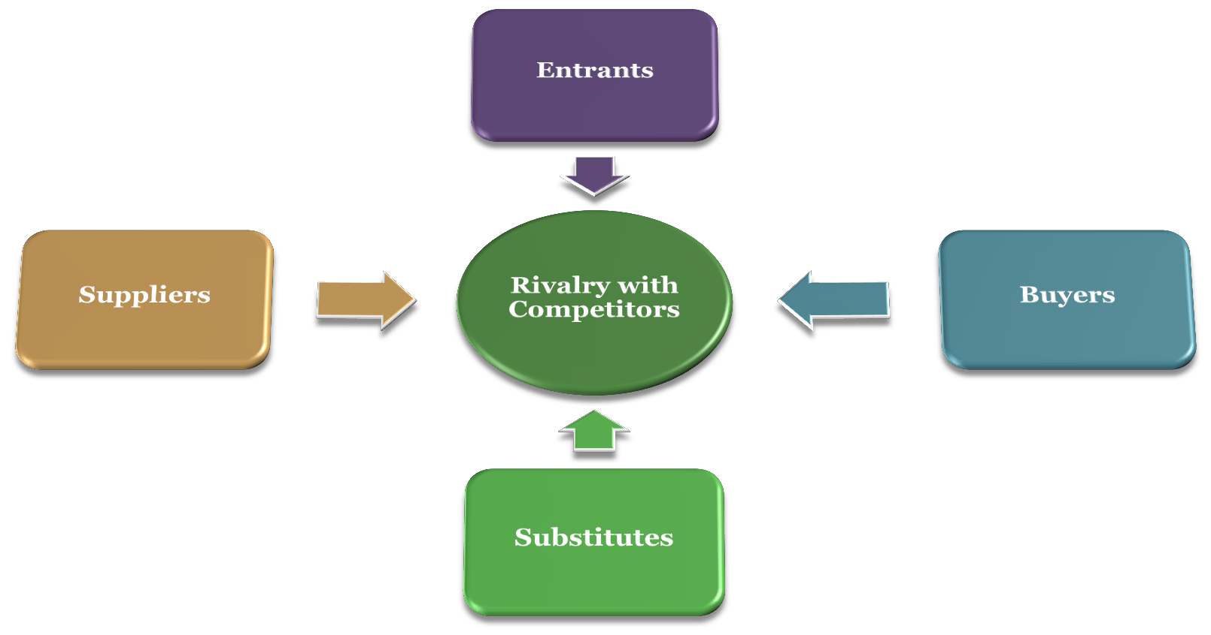
Porter’s Five Forces Model

30

Force 1: Rivalry with competitors

31

- Rivalry with competitors dissipates industry profits through low prices

- Characteristics of the market that threaten profits through fierce
rivalry:
  - Many sellers
  - Homogeneous products
  - Low buyer switching costs
  - Low buyers search costs (shop for price)
  - Large and infrequent sales (lumpy sales)
  - Excess industry capacity and/or declining demand
  - Cost structure with high fixed costs and low marginal costs

- Measures of rivalry
  - k-firm Concentration Ratio
  - Herfindahl - Hirschmann Index (HHI)

Force 2: Threat of New Entrants

32
- Entry lowers market share and affects rivalry

- Characteristics of the market that threaten profits by making entry easy:
  - No economies of scale and/or low minimum efficient scale relative to the size of the market
  - No learning or experience curve
  - Easy access to inputs materials
  - Necessary technology is readily available (patents and intellectual property not important)
  - No strong brand identity or reputation for incumbents
  - Low consumers’ switching costs
  - Low exit and sunk costs
  - No governmental regulations

- Note: A large entry cost is not an entry barrier. Large costs often reinforce
other entry barriers, by making the risks larger

- Measures of ease of entry
  - Estimated cost of entry at minimum efficient scale
  - Time to recoup initial investment

Force 3: Threat of Substitutes

33

Substitutes are analogous to entry, but with a different
product instead of a different producer

- Characteristics of a product that threatens profits by
substitutability:
  - Fulfils the same customer need (whether or not a similar product)
  - Similar performance characteristics, availability, ease of use, etc.
  - Similar cost per unit of usage

Measures of substitutability
  - Cross price elasticity: %Δ𝑄𝑌/%Δ𝑃𝑋
 If the cross price elasticity is positive, X and Y are substitutes.
 If the cross price elasticity is negative, X and Y are complements
  - SSNIP test (antitrust): Would a 5-10% increase in the price of good X
increase the demand for Y? If so, the products are substitutes.

Force 4: Power of Suppliers

34
- Suppliers’ power is the ability of suppliers to extract profits by
obtaining high prices

- Characteristics of the market that threaten profits through supplier
power:
  - Relatively few suppliers
  - Inputs are difficult to substitute
  - Firm must make specific investments in order to use inputs purchased from
supplier
  - Supplier has the ability to integrate forward

- Note: Just because an input is vital or critical does not mean that there is supplier power

- Measures of suppliers’ power
  - Price - cost margin of supplier

Force 5: Power of Buyers

35
- Buyers’ power is the ability of buyers to extract profits by obtaining low
prices
  - If buyers can switch to alternate suppliers, they can negotiate favourable terms through the threat of switching
  - If buyers don’t value the good highly, they can credibly threaten not to buy the good at
all

- Characteristics of the market that threaten profits through buyer power:
  - Relatively few buyers (each a large fraction of sales)
  - Firm must make specific investments in order to serve the needs of the buyers
  - Buyers have the ability to integrate backward into supplying their own inputs

- Note: Buyer power is related to rivalry with competitors (lumpy sales, low
switching cost, low search costs, etc. tend to increase buyer power).

- Measures of buyers’ power
  - Conceptually, would like to measure difference between willingness to pay and price.
  - Practically, no general way to do this.

The Brandenburger – Nalebuff Value Net

36

CO - O P E T I T I O N

Brandenburger – Nalebuff Value Net

37

The Value Net is an analytical strategy tool based on added value and game theory
  - What are the sources of value in a firm’s interactions?
  - How can a firm increase the total value created?
  - How can a firm increase its own added value, and the share it gets as
profits?

Brandenburger - Nalebuff six forces are:
  - Suppliers
  - Buyers
  - Competitors
 Sellers of substitutes
 Potential entrants
  - Complementors

Brandenburger – Nalebuff Value Net
38

Suppliers

Competitors
(Substitutes & Entrants)
Company
Complementors

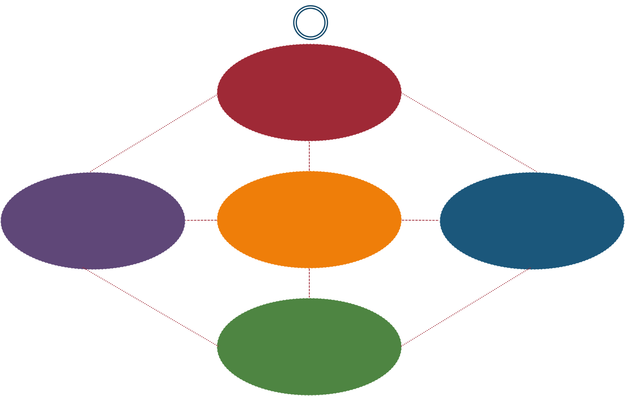

Customers

Brandenburger – Nalebuff Value Net
39
The vertical axis (suppliers-company-customers) is the basic
source of value (or economic surplus) creation
- Total economic surplus along this axis is the customers valuation, minus suppliers’ costs of production, minus firm’s production costs (not counting input costs)
- The price the firm charges its customers and the price suppliers charges the firm determines how this surplus is divided

Suppliers

Competitors

Company

Complementors

Customers

Brandenburger – Nalebuff Value Net
40
Competitors reduce firm’s added value along the vertical axis
- A competitor reduces firm’s added value to customers
  - Another airline serving the same route (same product)
  - Aluminium recycling and extraction (different products)

- A competitor reduces firm’s added value to suppliers
  - Two pharmaceutical firms competing to license from a biotech firm
  - Electric utilities and coal contracts

Suppliers

Competitors

Company

Complementors

Customers

Brandenburger – Nalebuff Value Net
41
Complementors increase firm’s added value along the vertical axis
- A complementor increases firm’s added value to customers
  - Game developers are complementors for video game systems
  - Nearby restaurants are complements for a ski resort

- A complementor increases firm’s added value to suppliers
  - If two airlines buy the same planes from Boeing, they share the R&D expense
  - When there are two gas stations with the same brand in a island, its cheaper for the the
supplier to serve them

Suppliers

Competitors

Company

Complementors

Customers

Concept of Competition

42

Concept of Competition

43

Two concepts of competition
- “Real” concept of competition is defined in behavioral terms, i.e. as a
progress of rivalry
- Analytical concept of perfect competition refers to a given state or situation

Stigler (1987) describes competition as:
- “a rivalry between individuals (or groups or nations), and it arises whenever two or more parties strive for something that all cannot obtain”

Breadth of Competition

44

Its breadth encompasses all sorts of:

- Forms of rivalry
  - market trading, auctions, races, wars of attrition etc

Instruments of rivalry
  - prices, advertising, R & D, takeover bids, effort levels etc

Objects of rivalry
  - profits, market share, corporate control, promotion, prizes, survival etc

Types of rivals

Effects of Competition

45

Competition was shown to improve efficiency in many circumstances

- Makes organizations internally more efficient by sharpening incentives
to avoid sloth and slack

- Causes efficient organizations to prosper at the expense of inefficient ones

- Competition to innovate is the major source of gains in productive
efficiency over time

“More Competition”

46

The identification of competition with rivalry does not in any way presume that “more competition” is necessarily good or an end in itself
  - The existence of scale economies provide a possible case for limiting
competition (e.g. telecommunications, energy)

Meanings of “more competition”
  - Greater freedom of rivals
  - Increase in the number of rivals
  - Move away from collusion towards independent behavior between
rivals
  - The reward for obtaining the thing for which all are striving, or the penalty for failing to obtain it, is increased

Economic Efficiency

47

Economic Efficiency

48

- The fundamental economic problem is a scarcity of resources

- Economic efficiency is about a society making optimal use of these
scarce resources to satisfy wants and needs
  - Optimal production and distribution of these scarce resources

- Normally the market mechanism is good at allocating optimally these
inputs
  - … but there are occasions when the market can fail (market failures)

- There are several types (concepts) of efficiency
  - All concepts link to how well a market allocates the scarce resources to satisfy society

Types of Economic Efficiency

49

Productive efficiency
- Is achieved when producers minimise the wastage of resources in their
production processes
  - i.e. the maximum number of goods and services are produced at the lowest possible cost
- Occurs when the output is produced at minimum average total cost

Allocative efficiency
- Is concerned with whether society is producing the goods and services that
match its needs and preferences and which it places the greatest value on
  - i.e. goods and services are produced according to consumer preferences
- Occurs when the value that consumers place on a good or service (reflected in the price they are willing and able to pay) equals the cost of the resources used up in production
  - … i.e. the required condition is that the price of the good equals marginal cost of production
(p=MC)

Types of Economic Efficiency

50

Dynamic efficiency
- Refers to efficiency over time
  - e.g. a factory in 1920 would be very efficient for that time period, but by
comparison would now be inefficient
- Dynamic efficiency involves the introduction of new technology and working practices to reduce costs over time

Static efficiency
- Efficiency at a given point in time

Types of Economic Efficiency

51

X efficiency (Liebenstein)
- Is concerned with the motivation (incentives) of management to achieve
the best results in the most economic way
- Occurs when the output of firms is the greatest it can be, given inputs
  - e.g. in highly competitive markets managers are motivated to produce as much as possible at
the lowest cost
- Occurs when firms do not have incentives to cut costs,
  - e.g. a monopoly which makes supernormal profits may have little incentive to get rid of
excess labour
  - Therefore, a firms average cost may be higher than necessary

Technical efficiency
- Refers to how much output can be obtained from a given input or a specific
combination of inputs
  - Maximum technical efficiency occurs when output is maximised from a given quantity of inputs
  - Note: The simplest way to differentiate productive and technical efficiency is to think of productive efficiency in terms of cost minimisation by adjusting the mix of inputs, whereas technical efficiency is output maximisation from a given mix of inputs.

Types of Economic Efficiency

52

Pareto efficiency
- Is concerned with the distribution of the scarce resources
- It is defined as a situation where it is not possible to redistribute resources and make one party better off without making another party worse off

Kaldor–Hicks efficiency
- Captures some of the intuitive appeal of Pareto efficiency, but
has less stringent criteria
- Under Kaldor–Hicks efficiency, an outcome is more efficient if those that are made better off could in theory compensate those that are made worse off and lead to a Pareto optimal outcome
- The compensation does not actually have to occur (there's no presumption in favour of status-quo) and thus, a more efficient outcome can in fact leave some people worse off

Types of Economic Efficiency

53

Distributive efficiency
- Is concerned with allocating goods and services according to who needs
them most
- Therefore, requires an equitable distribution

Social efficiency
- Takes externalities, i.e. consequences of an economic activity (costs or benefits) that are experienced by unrelated third parties, into consideration
- Occurs at an output where the social cost of production equals the
social benefit

Measure of Market Concentration

54

Market Concentration

55

Concentration refers to the amount of market power held in the hands of a few firms

- Factors Influence Concentration
  - Number of firms
  - Distribution of output among firms

- Reason for concentration measures
  - Compare concentration among industries
  - Regulation and antitrust
  - Optimal managerial decisions

N-Firm Concentration Ratio

56

The sum of market shares of the top firms in the defined industry.
𝑘
𝐶𝑅𝑁 = 𝑠𝑖
𝑖=1

N is normally taken to be 3, 4 or 8.

- Linear function of firms’ market shares
- Insensitive to unequal market shares

Herfindahl – Hirshman Index

57

The sum of the squared market shares of all firms in a given industry

𝑘

HH = (𝑠𝑖)²
𝑖=1

Convex function of firms’ market shares
- Sensitive to unequal market shares

CR4 vs. HH: An Example

58

Industries 1 and 2
- CR4 suggests that they are concentrated equally
- HH identifies that industry 1 is more concentrated than industry 2

Industries 3 and 4
- CR4 suggests that industry 3 is more concentrated than industry 4
- HH identifies that industry 4 is more concentrated than industry 3

Other Concentration Measures
59

Lorenz curve and the Gini coefficient
- A Lorenz curve is used to show the share of the industry accounted for by various proportions of firms. The Gini coefficient can be derived form the Lorenz curve, i.e.

𝑁 𝑖

𝑖=1 𝑗=1
𝑠𝑗

𝐺 = 1 − 0.5𝑁 ^{𝑁}
𝑖=1
𝑠𝑖

The value of G is determined by the extent to which the Lorenz curve deviates from the line of absolute equality (G = 0 indicates that all firms are of equal size, while G = 1 indicates that a single firm dominates the industry).

Hannah and Kay index
- where is a parameter that depends on the importance one wishes to attach to the larger firms in the industry
(larger a implies more importance to larger firms).

𝑘
HK = (𝑠𝑖)^{𝑎}
𝑖=1

where is a parameter that depends on the importance one wishes to attach to the larger firms in the industry
(larger a implies more importance to larger firms).

Other Concentration Measures
60

Entropy coefficient
𝑘
1
E = 𝑠𝑖𝑙𝑜𝑔 𝑠
𝑖=1 𝑖

is a measure that quantifies the degree of uncertainty in a given industry (the lower the value of E, the greater is the certainty of the established firms that the have a captive market).

Variance of logarithms of firm sizes

VL =
𝑁
𝑖=1

(𝑙𝑜𝑔𝑠𝑖−𝑠)
𝑁

where VL measures the inequality in firm sizes (many industries have firm size distributions that correspond closely to the log normal distribution).

Limitations of concentration measures

61

Correct definition of the industry
  - National, regional, or local?
  - University’s refectory, restaurants in islands

- Global Market
  - Foreign producers excluded
  - Beer producers, oil refineries

