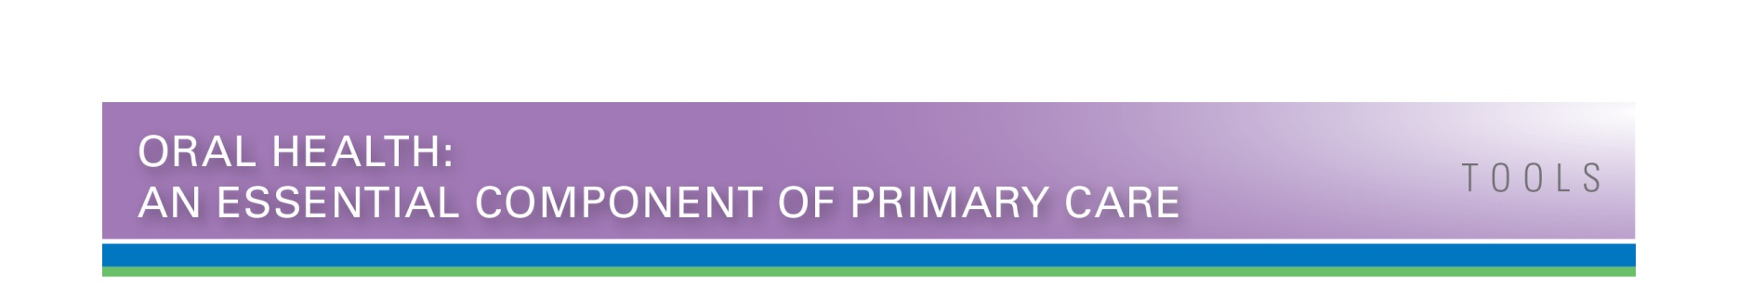
Referral Agreement Template
Use the framework below to draft your referral agreements with your dental partners. This is a comprehensive listing of issues that may arise in referral arrangements. Feel free to customize to your patients, organization, and dental partners. This will require communicating with your dental partner for the sections pertinent to their preferences and requirements. Change all instances of “Primary Care Medical Clinic” and “Dental Clinic” to the names of your clinic and dental partner organization. Delete this text box and contents once you have completed drafting the below content.

Primary Care—Dental Partner Referral Agreement

Primary Care-Dental Partner Referral Agreement
This agreement is between Primary Care Clinic and Dental Clinic and serves to maximize the quality, safety, and efficiency of referrals for patients for whom we share care in a collaborative fashion. This is not a legally binding agreement.

Patient and Procedure Information
Discuss Dental Clinic criteria for patients they are willing to accept. Include whether there are any specifications or restrictions around insurance types (e.g., Medicaid), age, or disease status.

Discuss Dental Clinic fee structure for typical procedures (fillings, sealants, etc.), so Primary Care Clinic can advise patients when referring.

Information Exchange
Primary Care Clinic will provide the following patient information by secure electronic transmission or fax within three business days of contacting Dental Clinic for a patient appointment or notification of referral:
  - Demographics.
  - Medical and dental insurance information.
  - Clinician-written request for referral.
  - Relevant clinical information (medication list, problem list, etc.).

The referral order indicates that the patient has no medical barriers to receiving dental treatment, and Dental Clinic clinicians have medical clearance to treat.

Dental Clinic will provide a report of the dental findings (including date seen, impression, treatment, and follow-up plan) to Primary Care Clinic within 10 business days of patient visit by secure electronic transmission or fax.

Clinician Referral Note Content
  - Oral health/dental problem, medication and medical allergy lists.
  - Reason for consult/referral.
  - Specific patient needs (e.g., language, transportation, cognitive impairment, etc.).
  - Contact information of referring clinician in case dentist needs clarification or more information regarding the referral or patient.

Patient Engagement
In addition to sending a referral form directly to Dental Clinic, Primary Care Clinic will provide a copy of the referral request to patient to bring to referral visit and will ensure patient is clear on the reason for the referral, along with expectations.

Primary Care Clinic will advise patient on how the specialist appointment will be made, along with expectations for timing (e.g., Primary Care Clinic to schedule, patient to schedule, Dental Clinic to call patient and schedule).

Primary Care Clinic will advise patient to request that Dental Clinic communicate back to referring clinician.

Dental Clinic will provide patient with information regarding insurance coverage and expected out-of-pocket expenses prior to visit.

Dental Clinic will give patient a visit summary including appropriate follow-up information.

Pain Management
Pain management for oral pain will be managed primarily by the primary care clinician/dentist, and information related to pain management when prescribed will be included in the referral order in order to prevent overprescribing.

Phone/Email Consults
Brief phone/email consults on a specific question about a potential clinical issue is/is not permitted by Dental Clinic. If permitted, list appropriate times and communication methods (e.g., specialist mobile number or secure email address).

Consultation Report Content and Timeliness
Dental Clinic agrees to see patient within 30 days of referral request.

Dental Clinic agrees to provide consultation report to Primary Care Clinic within 10 business days of patient appointment.

If a follow-up appointment is needed, Dental Clinic agrees to schedule the appointment before the patient leaves the dental office, and to send the reminder email/text/calls to patient prior to the follow-up appointment. If the follow-up appointment results in an updated treatment or care plan, Dental Clinic will send an updated consultation note back to the primary care clinic.

No-Shows
Dental Clinic’s procedure for when a patient no-shows [it’s important to know if and how many times
the specialist office will attempt to reschedule the patient]. Dental Clinic will notify Primary Care Clinic of no-shows.

Dental Clinic will notify Primary Care Clinic of any patients who no-show and are unable to reschedule.

Primary Care Clinic will manage referral tracking and will follow up with the patient if Dental Clinic is unable to schedule the referral.

Urgent Referrals
Dental Clinic has agreed to receive urgent or expedited referrals provided the referring clinician calls the specialist at xxx-xxxx, preferably on these dates/times:

Dental Clinic has agreed that patients requiring after-hours care and support can be managed by calling xxx-xxxx.

Conflict Resolution
Primary Care Clinic and Dental Clinic agree to communicate openly to arrive at solutions if there are issues or misunderstandings on either end of the relationship.

Source: Developed by Qualis Health for the Washington Dental Service Foundation “Oral Health Preventive Services in Primary Care Project.” 1st ed. Seattle, WA. April 2016.

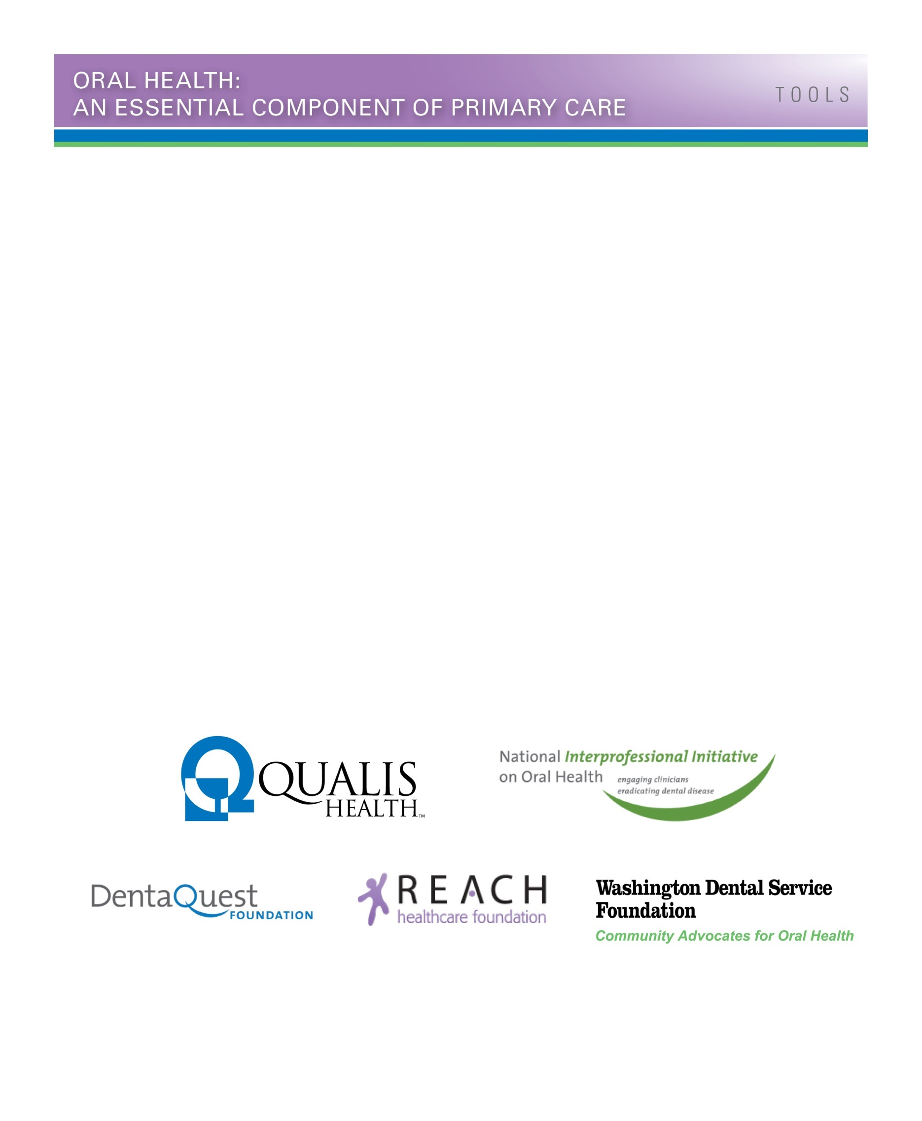
About the Oral Health Integration in Primary Care Project
Organized, Evidence-Based Care Supplement: Oral Health Integration joins the Safety Net Medical Home Initiative Implementation Guide Series.
The goal of the Oral Health Integration in Primary Care Project was to prepare primary care teams to address oral health and to improve referrals to dentistry through the development and testing of a framework and toolset. The project was administered by Qualis Health and built upon the learnings from 19 field-testing sites in Washington, Oregon, Kansas, Missouri, and Massachusetts, who received implementation support from their primary care association. Organized, Evidence-Based Care Supplement: Oral Health Integration built upon the Oral Health Delivery Framework published in Oral Health: An Essential Component of Primary Care, and was informed by the field-testing sites’ work, experiences, and feedback. Field-testing sites in Kansas, Massachusetts, and Oregon also received technical assistance from their state’s primary care association.
The Oral Health Integration in Primary Care Project was sponsored by the National Interprofessional Initiative on Oral Health, a consortium of funders and health professionals who share a vision that dental disease can be eradicated, and funded by the DentaQuest Foundation, the REACH Healthcare Foundation, and the Washington Dental Service Foundation.
For more information about the project sponsors and funders, refer to:
National Interprofessional Initiative on Oral Health: www.niioh.org.
DentaQuest Foundation: www.dentaquestfoundation.org.
REACH Healthcare Foundation: www.reachhealth.org.
Washington Dental Service Foundation: www.deltadentalwa.com/foundation.

The guide has been added to a series published by the Safety Net Medical Home Initiative, which was sponsored by The Commonwealth Fund, supported by local and regional foundations, and administered by Qualis Health in partnership with the MacColl Center for Health Care Innovation.
For more information about the Safety Net Medical Home Initiative, refer to www.safetynetmedicalhome.org.

