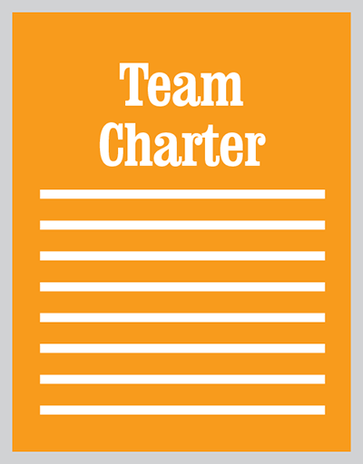
Template:
Agile Team Charter

Background & Introduction
What is this?
How do you use the Google Doc?
I use (or will use) Google Doc’s
I don’t use Google Doc’s
Are there any restrictions on using this template?
Team Charter
What problems do we solve? What jobs do we do for our user?
How do we measure progress on outcomes?
Who’s on the team and in what roles?
What agile methodologies and practices do we use? How?
What systems do we use for what jobs?
What coding conventions and practices do we use? How?
Appendix A: Change Log

Background & Introduction

What is this?
This template supports my Coursera specialization ‘Agile Development’, and the Venture Design curriculum in general.

For a tutorial on agile team charters, see Agile Team Charters- the Basics.

How do you use the Google Doc?

I use (or will use) Google Doc’s
If you have Google Doc’s, you can just save a copy of this file into your own domain: File >> Make a Copy. If you don’t have Google Doc’s (Apps) and want it, you can see about setting up here. That said you absolutely do NOT need to set up Google App’s to use the template.

I don’t use Google Doc’s
If you do not have Google Doc’s just go to File >> Download As and from there you can save it to MS Word, etc.

Are there any restrictions on using this template?
The template’s primary purpose is to help practitioners create better products. You’re free to use it and adapt it for internal purposes- building your company and/or product, basically.

You’re not free to take it and re-post it elsewhere or create derivative work for general consumption outside the context of your company’s internal operations. (You are, of course, free to link here to the original item- sharing is caring.) For the full terms and conditions, please see www.alexandercowan.com/legal.

Team Charter

What problems do we solve? What jobs do we do for our user?
[ADD]

How do we measure progress on outcomes?
[ADD]

Who’s on the team and in what roles?
Name | Role(s) | Notes
[add] | [add] | [add]
[add] | [add] | [add]
[add] | [add] | [add]
[add] | [add] | [add]
[add] | [add] | [add]
[add] | [add] | [add]
[add] | [add] | [add]
[add] | [add] | [add]

What agile methodologies and practices do we use? How?
[ADD] e

What systems do we use for what jobs?
Job | System (name, URL) | Notes
[add] | [add] | [add]
[add] | [add] | [add]
[add] | [add] | [add]
[add] | [add] | [add]
[add] | [add] | [add]
[add] | [add] | [add]
[add] | [add] | [add]
[add] | [add] | [add]

What coding conventions and practices do we use? How?
[ADD]

Appendix A: Change Log
Date | Change | Notes
[add] | [add] | [add]
[add] | [add] | [add]
[add] | [add] | [add]
[add] | [add] | [add]
[add] | [add] | [add]
[add] | [add] | [add]

