STUDENTS: KEEP THIS FOR YOUR RECORDS

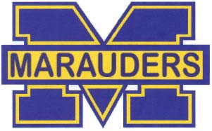MIRA MESA HIGH SCHOOL COMMUNITY SERVICE CERTIFICATE
Mira Mesa High School recommends that all students accumulate 75 hours or more of community service before graduation. Please help us verify this
Student’s volunteer hours for your agency. Thank you for your help.

Student Name: Grade:

Community Agency: Hours Credited

Type of service or agency activity:

Date of Service:

Name of Supervisor: And
Phone:

Signature:

STUDENTS: KEEP THIS FOR YOUR RECORDS

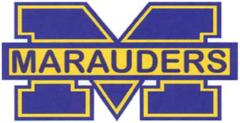MIRA MESA HIGH SCHOOL COMMUNITY SERVICE CERTIFICATE
Mira Mesa High School recommends that all students accumulate 75 hours or more of community service before graduation. Please help us verify this
student’s volunteer hours for your agency. Thank you for your help.

Student Name: Grade:

Community Agency: Hours Credited

Type of service or agency activity:

Date of service:

Name of Supervisor: And
Phone:

Signature:______________________________________________________

