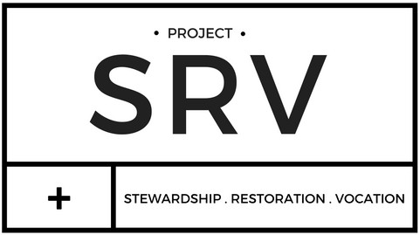

**JUPITER CHRISTIAN SCHOOL COMMUNITY SERVICE FORM**

**Student Information**

Print Name

Grade

I understand that all community service hours are unpaid activities-time given freely of my own free will and not

because it was required to do so. Community service is designed to improve the quality of life for others individually or through an organization. The service may not be done for a family member and must be done after school hours.

Student Signature

**Site Supervisor Name & Title**

**Site Supervisor Signature**

1.

2.

3.

4.

**Date**

**Organization Name**

**Project Description**

**# of hours**

1.

2.

3.

4.