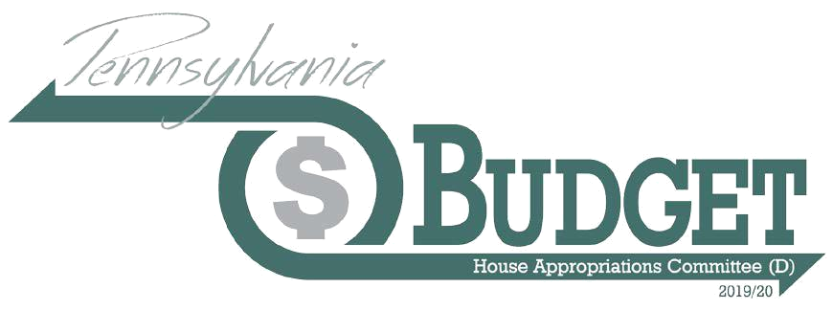

Governor Wolf’s 2019/20 Executive Budget Proposal

4/8/2019 3:38 PM – Version 3

This document is an overview of Gov. Wolf’s 2019/20 executive budget proposal, delivered Feb. 5 to a joint session of the General Assembly. Watch for updated versions of this briefing and more in-depth publications about specific issues and program areas, as the Democratic House Appropriations Committee continues to review his request.

Visit the Department of Education’s website for spreadsheets detailing, by school district, the estimated basic and special education funding.

Introduction

Gov. Wolf proposes a balanced budget that makes significant investments in many important areas including education and workforce development, while facing a long-term structural deficit that continues to decline under his leadership but remains to be fully addressed. The governor proposes no tax increases, while keeping overall growth in the state General Fund budget to 2.8 percent.

The governor focuses on six key themes in his 2019/20 proposed budget:

- Building the Nation’s Strongest Workforce,
- Making Pennsylvania a Better Place for Workers and Businesses,
- Securing the Future of Pennsylvania’s Agricultural Industry,
- Keeping Pennsylvania Safe,
- Protecting Elections and Restoring Trust in Government, and
- Protecting the Most Vulnerable

To build the nation’s strongest workforce, Gov. Wolf is introducing the Statewide Workforce, Education and Accountability Program, or SWEAP, to comprehensively address workforce needs from birth through retirement, by coordinating education, workforce development, and human services across the commonwealth.

The governor proposes to make Pennsylvania a better place for workers and businesses by raising the minimum wage to $12 per hour, effective July 1, 2019, up to $15 per hour on July 1, 2025. This proposal assumes that the change would both generate $120.2 million in new revenue from increased personal income tax and sales and use tax and estimated savings of $36 million in 2019/20 and $120 million in 2020/21 from a decreased demand for public benefits.

Twenty-nine states, plus Washington D.C., have a higher minimum wage than Pennsylvania, which has not increased in this state in 10 years.

Building upon the plan released by the governor in August, the proposed budget focuses on securing the future of Pennsylvania’s agricultural industry by investing in a comprehensive package of funding opportunities to support and strengthen the industry.

As the governor has proposed in prior budgets, he is requesting the legislature to impose a fee on municipalities who choose to rely on State Police coverage to achieve his goal of keeping Pennsylvania safer.

House Appropriations Committee (D) 717-783-1540 www.hacd.net  HDAPPROPS@hacd.net
2019/20 Executive Budget Proposal - V3: Budget Briefing

April 8, 2019 - Page 1
To protect elections and restore trust in government, the governor has proposed an investment to help counties modernize their election systems. Additionally, the governor again expects to transfer funds to the Rainy Day Fund from a surplus at the end of 2019/20.

Finally, the governor intends to protect the most vulnerable of the commonwealth by investing in services for individuals with intellectual disabilities and autism, increasing rates for early intervention providers and continuing targeting funding to fight the opioid epidemic.

Under Gov. Wolf’s leadership, lawmakers have made progress toward reducing the structural deficit but work remains to be done because current year revenue does not support current year expenditures. We have reigned in spending, made programs run more efficiently, and shored up our revenue base. But in the proposed budget year, we rely on just under a billion in questionable budget balancing measures. And that is before the General Assembly restores spending for bare bones programs traditionally expected each year. Every day in legislative offices we hear from constituents about the need to shore up support for key programs impacting education, property taxes, the environment, long term care for seniors and the disabled, to name just a few. Most importantly, policymakers must guard against the temptation to revert to old ways, reversing progress made as we negotiate a final budget solution.

Earlier this week, in a Memo from the Chair, the House Democratic Appropriations Committee released an analysis of the structural challenges the governor faced as he assembled his budget proposal for the new fiscal year.

As more detailed information becomes available, the committee will provide more complete information about how these challenges are addressed in his 2019/20 proposal. In the meantime, this initial version of our analysis points to remaining pockets of time-limited measures used to balance the budget that have been identified in a first-read.

House Appropriations Committee (D) 717-783-1540 www.hacd.net  HDAPPROPS@hacd.net
2019/20 Executive Budget Proposal - V3: Budget Briefing

April 8, 2019 - Page 2

Table of Contents

Introduction ............................................................................................................................................................................ |  | 1
Overview ................................................................................................................................................................................. |  | 4
Combined Operating Budget .............................................................................................................................................. |  | 4
General Fund Revenue ........................................................................................................................................................ |  | 4
Proposed Tax Modifications ............................................................................................................................................... |  | 5
Rainy Day Fund.................................................................................................................................................................... |  | 5
Complement ....................................................................................................................................................................... |  | 5
Education ................................................................................................................................................................................ |  | 5
K-12 ..................................................................................................................................................................................... |  | 5
Basic Education Funding ..................................................................................................................................................... |  | 6
Special Education Funding .................................................................................................................................................. |  | 8
Early Childhood Education Funding .................................................................................................................................... |  | 8
Workforce Development ..................................................................................................................................................... |  | 9
School Safety ....................................................................................................................................................................... |  | 9
Early Intervention ................................................................................................................................................................ |  | 9
School Construction (PlanCon) ............................................................................................................................................ |  | 9
Higher Education ............................................................................................................................................................... |  | 10
Pensions ................................................................................................................................................................................ |  | 10
Human Services ..................................................................................................................................................................... |  | 11
2018/19 Supplemental Appropriations - UPDATED ........................................................................................................... |  | 11
2019/20 Highlights - UPDATED .......................................................................................................................................... |  | 11
Lottery Fund .......................................................................................................................................................................... |  | 13
Tobacco Settlement Fund ..................................................................................................................................................... |  | 15
Health .................................................................................................................................................................................... |  | 16
Resources to Respond to the Opioid Crisis ....................................................................................................................... |  | 17
Insurance ............................................................................................................................................................................... |  | 17
Labor and Industry ................................................................................................................................................................ |  | 17
Minimum Wage ................................................................................................................................................................ |  | 18
Community and Economic Development ............................................................................................................................. |  | 18
Environmental Protection - UPDATED................................................................................................................................... |  | 18
Conservation and Natural Resources - UPDATED ................................................................................................................. |  | 19
Agriculture - UPDATED .......................................................................................................................................................... |  | 19
Transportation - UPDATED .................................................................................................................................................... |  | 20
Law Enforcement, Public Safety and Criminal Justice .......................................................................................................... |  | 21
House Appropriations Committee (D) | 717-783-1540 |  | www.hacd.net  HDAPPROPS@hacd.net
 |  | 2019/20 Executive Budget Proposal - V3: Budget Briefing

April 8, 2019 - Page 3

State Police 21

Criminal Justice 22

Judiciary 22

Commissions 23

PCCD 23

JCJC 23

Pennsylvania Emergency Management Agency 23

Military and Veterans Affairs 23

Department of State 23

Protecting Pennsylvania’s Elections 23

Executive Offices/Human Relations Commission 23

General Fund Budget Balancing Measures to Monitor - NEW 24

Overview

Combined Operating Budget

While the General Fund is the focus of legislative budget balancing, it is important to understand the scope of the total operating budget, which includes federal funds and other special funds. The total 2019/20 proposed operating budget for the commonwealth is $85.8 billion, a decrease of $733.6 million, or .8 percent, from 2018/19. Significant reductions in non-General Funds will be more fully explained in later sections and a subsequent update to this budget briefing. The total operating budget consists of:

- $34.1 billion in state General Fund expenditures, an increase of $927.4 million, or 2.8 percent,

- $2.9 billion in Motor License Fund expenditures, a decrease of $238.1 million, or 7.7 percent,

- $2.0 billion in Lottery Fund expenditures; a decrease of almost $40 million, or 2 percent,

- $29.6 billion in federal fund expenditures, a decrease of $797.8 million or 2.6 percent, and

- $17.3 billion in other special fund expenditures, a decrease of $585 million or 3.3 percent.

General Fund Revenue

The governor’s budget proposal adds $424.9 million to the official General Fund revenue estimate for 2018/19, of $33.975 billion, for a revised estimate of $34.400 billion. This change is primarily due to higher corporate net income tax receipts attributable to timing shifts associated with federal tax changes and strong sales and use tax receipts from higher than expected compliance with online marketplace requirements enacted last year. However, gains in these categories are offset by a reduction to the personal income tax estimate, which has shown a trend of estimated payments below expectations so far this year.

Total state General Fund revenue in 2019/20 is expected to be $35.3 billion, which shows growth of $896.6 million, or 2.6 percent, and includes non-tax revenues. Growth is suppressed partly because significant one-time, non-tax revenue from recently expanded gaming disappears in 2019/20. The 2019/20 executive budget shows expected state General Fund tax revenue of $34.8 billion, an increase of $1.1 billion, or 3.3 percent, over the prior year. Of that amount, over $56 million reflects one-time revenue from gaming related licensing fees. The governor’s proposal expects the three major tax types to grow modestly with corporate net income tax growing at 2.4 percent, sales and use tax growing at 3.1 percent and personal income tax growing at 4.2 percent.

These estimates already assume the proposed tax changes (discussed below), new revenue expected from the minimum wage increase and the following transfers out of the General Fund, totaling $187.2 million:

House Appropriations Committee (D) 717-783-1540 www.hacd.net  HDAPPROPS@hacd.net
2019/20 Executive Budget Proposal - V3: Budget Briefing

April 8, 2019 - Page 4

- Transfer to the Tobacco Settlement Fund of $115 million from sales and use tax for the commonwealth’s Tobacco Settlement Fund debt service payments,

- Transfer to the Commonwealth Financing Authority of $20 million from the sales and use tax for school construction (PlanCon) debt service payments,

- Transfer to a restricted receipt account of $20 million from the personal income tax for Growing Greener debt service payments, currently an expenditure in the Environmental Stewardship Fund.

- Transfer to the Farm Show Lease Fund of $13.3 million from the personal income tax for Farm Show lease payments,

- Transfer to School Safety and Security Fund of $15 million from the personal income tax for school safety and security grants, and

- Transfer to SERS Defined Contribution Fund of $3.9 million from the personal income tax for costs associated with the SERS defined contribution plan established under Act 5 of 2017.

Proposed Tax Modifications

Gov. Wolf proposes no new taxes in the 2019/20 budget. He does, however, propose modifications to the corporate net income tax (CNI). As in the governor’s previous budgets, the corporate net income tax base would be changed to require mandatory unitary combined reporting (known, as closing the Delaware loophole) for tax years beginning after Dec. 31, 2019. To offset this change, he proposes lowering CNI rates beginning Jan. 1, 2020, to 8.99 percent, with a gradual phase down to 5.99 percent by 2024. These proposed base and rate changes are expected to be revenue neutral in the long term, but are estimated to cost $7.2 million in 2019/20.

The CNI net operating loss cap is scheduled to increase from 35 percent of taxable income (for tax year 2018) to 40 percent of taxable income for tax year 2019 and thereafter, per Act 43 of 2017.

Gov. Wolf is proposing an increase to the annual cap of the Resource Enhancement Tax Credit from $10 million to $13 million.

Rainy Day Fund

Revenue shortfalls during the great recession led to the complete emptying of the Rainy Day Fund in 2009 with a transfer of $755 million to balance the budget. No substantial deposits were made for almost a decade until $22.4 million was transferred from the surplus from the 2017/18 fiscal year. The transfer represented 50 percent of the surplus, whereas current law requires only 25 percent.

The governor is again proposing a 50 percent transfer of the 2018/19 General Fund surplus, which would be a transfer of $3.1 million. This would bring the balance of the Rainy Day fund to $26.9 million at the end of 2019/20. Gov. Wolf intends to continue strengthening the Rainy Day Fund with plans to increase the balance to $278 million by 2024.

Complement

The governor’s proposal would increase the total authorized complement by 160 full-time equivalents, from 76,789 to 76,949. Many of the new proposed positions are associated with the governor’s initiatives. As of January 2019, the filled complement was 72,835, which is down 375 from December 2017.

Education

K-12

In Gov. Wolf’s first term, the Republican-controlled General Assembly funded $838 million, or 65 percent, of the $1.3 billion the governor requested for basic, special, and early childhood education. These funds helped restore the previous administration’s cuts to education, invest in classroom learning, reduce inequities, and lessen the reliance on local property taxes.

Yet, there is plenty of evidence that more investments were – and are – needed. Pennsylvania’s rank of 46th in state support for education is a leading cause for property tax burdens and funding inequities. According to the January 2019

House Appropriations Committee (D) 717-783-1540 www.hacd.net  HDAPPROPS@hacd.net
2019/20 Executive Budget Proposal - V3: Budget Briefing

April 8, 2019 - Page 5

PASBO/PASA Budget Report, school districts are struggling with the rising costs of pensions, special education, charter school tuition, healthcare, maintenance, and transportation. Absent additional state support, school districts are forced to increase property taxes or engage in cutback management measures such as increasing class sizes and eliminating elective courses.

In his first budget of his second term, Gov. Wolf is calling for a $282 million investment in basic, special, and early childhood education. Pennsylvania’s perpetual structural deficit continues to make it difficult to invest substantial state resources to help school districts pay for their cost drivers without resorting to property tax increases. Additionally, the 2019/20 budget proposal builds upon the workforce development and school safety investments made in 2018/19.

Basic Education Funding

The 2019/20 budget proposal provides a net $182 million, or 2.9 percent, increase in basic education subsidies. During Gov. Wolf’s first term, basic education subsidies increased by $633 million, or 11 percent.

The 2019/20 Ready to Learn Block Grant appropriation contains $8 million, reflecting only the portion that charter schools received in 2018/19 (they will be flat-funded in 2019/20). The remaining $260 million from the 2018/19 Ready to Learn Block Grant appropriation level is merged into the basic education funding appropriation.

Each school districts’ 2018/19 Ready to Learn Block Grant allocation will be added to its base amount under the basic education funding formula. Under the school code, the Ready to Learn Block Grant funds had to be used for specific programs, including pre-k, kindergarten, tutoring assistance, social and health services, school libraries, career awareness, professional development, teacher training, etc.

With the roll-in of the Ready to Learn Block Grant, the proposed 2019/20 budget includes $6.54 billion for basic education funding. Each school district receives a base amount equal to its 2014/15 allocation with adjustments, now including the amount of 2018/19 Ready to Learn Block Grant funds. The remaining balance -- $704.8 million or 10.8 percent of the 2019/20 total for school districts – will be distributed through the fair funding formula. This represents a $166 million increase in formula-driven funds over 2018/19.

2019/20 will be the fifth year of operation for the fair funding formula. Other base adjustments in 2019/20 include $2 million for distressed schools and an estimated $14 million to raise the statutory minimum starting salary for teachers from $18,500 to $45,000 per year.

House Appropriations Committee (D) 717-783-1540 www.hacd.net  HDAPPROPS@hacd.net
2019/20 Executive Budget Proposal - V3: Budget Briefing

April 8, 2019 - Page 6

House Appropriations Committee (D)

717-783-1540

www.hacd.net  2019/20 Executive Budget Proposal

HDAPPROPS@hacd.net - V3: Budget Briefing April 8, 2019 - Page 7

The 2019/20 Budget Proposal Calls for a $182 Million, or 2.9 Percent, Net Increase in Basic Education Subsidies
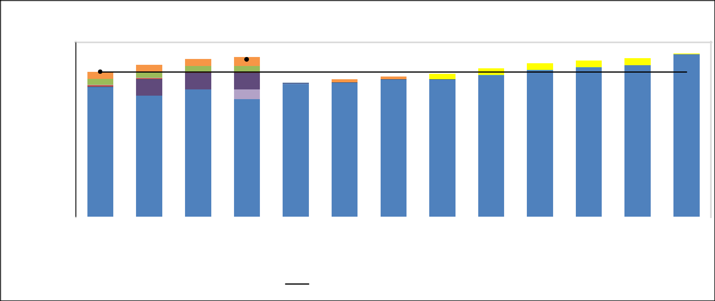

Gov. Wolf increased basic education subsidies by $633 million, or 11 percent, in his first term.
$7,000,000,000

$6,000,000,000
$5,000,000,000
$4,000,000,000
$4,000,000,000 | $5.81 B |  |  |  | $6.09 B |  | $6.32 B |  |  |  |  |  |  |  |  |  |  |  | $5.95 B
$3,000,000,000 |  |  |  |  |  |  |  |  |  |  | $6.41 B |  | $5.37 B |  |  | $5.51 B | $5.63 B | $5.73 B |  |  |  |  | $6.15 B |  |  | $6.27 B |  | $6.36 B | $6.55 B
$2,000,000,000
$1,000,000,000
$1,000,000,000 | Rendell |  |  | Rendell |  |  | Rendell |  |  | Corbett |  |  | Corbett |  |  | Corbett | Corbett | Corbett | Wolf |  |  |  | Wolf |  |  | Wolf |  | Wolf | Wolf
$- |  |  |  |  |  |  |  |  |  |  |  |  |  |  |  |  |  |  |  |  |  |  |  |  |  |  |  | Wolf
$- | FY08-09 |  |  | FY09-10 |  |  | Enacted |  |  |  | Actual |  | FY11-12 |  |  | FY12-13 | FY13-14 | FY14-15 | FY15-16 |  |  | FY16-17 |  |  | FY17-18 |  |  | Available | Budget
 |  |  |  |  |  |  | FY10-11 |  |  | FY10-11 |  |  |  |  |  |  |  |  |  |  |  |  |  |  |  |  |  | FY18-19 | FY19-20
 |  | Basic Education Funding |  |  |  |  |  |  |  |  |  |  |  |  |  | Education Jobs Fund (federal) |  |  |  |  |  | ARRA - Fiscal Stabilization - Basic Education
 |  | Basic Ed Formula Enhancements |  |  |  |  |  |  |  |  |  |  |  |  |  | Education Access Programs |  |  |  |  |  | Ready to Learn Block Grant
 |  | Education Assistance Program |  |  |  |  |  |  |  |  |  |  |  |  |  | School Improvement Grants |  |  |  |  |  | Reimbursement of Charter Schools
 |  | Pennsylvania Accountability Grants |  |  |  |  |  |  |  |  |  |  |  |  |  | 2008/09 Comparison Line: |  |  |  |  |  | 2010/11 Comparison Line:

Note: The 2011/12 budget provided a $100 million supplemental appropriation recorded in 2010/11 (Accountability Block Grant). However, those funds were spent in 2011/12, so comparison line backs it out.
Special Education Funding

Special education funding receives a $50 million, or 4.4 percent, increase in the 2019/20 budget proposal. This increase builds on the $90 million, or 8.6 percent, invested in special education over the past four years.

The governor recommends that $ 300,000 of the 2019/20 special education appropriation be used for Keystone Telepresence Education Grants. This funding will be allocated to intermediate units to purchase the necessary equipment to enable children with serious illnesses or injuries to attend class using telepresence technologies.

In the PASBO/PASA Budget Report, 53 percent of school districts responding to the survey identified special education as one of the top three areas of cost growth. The top three reasons cited for the growing special education costs were an increase in the need for outside placement, an increase in special education enrollment, and the need to hire special education staff. The state appropriation for special education has not kept pace with these cost increases causing the state share to fall from 32 percent in 2008/09 to 23 percent in 2016/17.
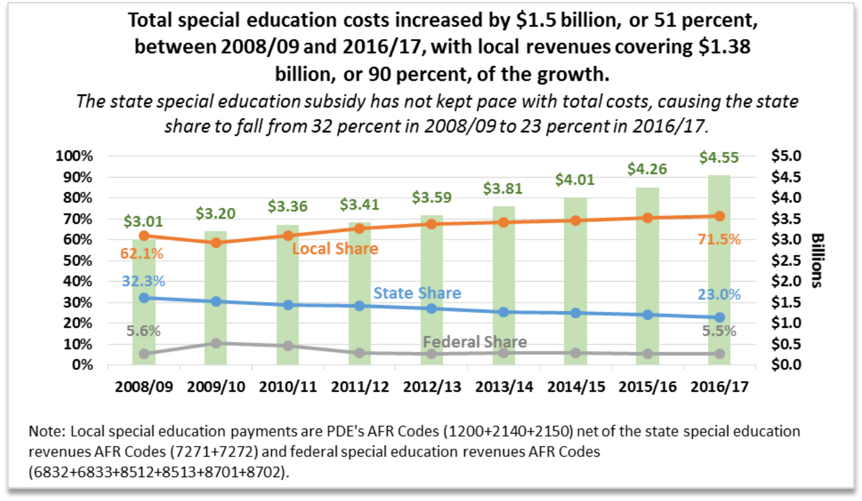

Early Childhood Education Funding

Gov. Wolf continues to make funding for early childhood education a priority. His 2019/20 budget proposal calls for a $50 million, or 20 percent, increase in high quality early learning, which would add 5,530 state-funded slots (19 percent increase) to the nearly 11,000 (60 percent increase) added during his first term.


Gov. Wolf’s 2019/20 budget proposal calls for a $50 million, or 20 |  | Actual | Actual | Available | Budget | FY19-20 Less FY18-19FY18-19 Less FY14-15
percent, increase in high quality early learning, which would add
5,530 state-funded slots to the nearly 11,000 added during his first |  | FY14-15 | FY17-18 | FY18-19 | FY19-20 |  | %Δ |  | %Δ
Pre-K Counts | Funding Level | $97.3 M | $172.3 M | $192.3 M | $232.3 M | $40.0 M | 20.8% | $95.0 M | 97.7%
Pre-K Counts | Estimated # of State-Funded Students | 13,456 | 21,029 | 23,070 | 27,670 | 4,600 | 19.9% | 9,614 | 71.4%
Head Start | Funding Level | $39.2 M | $54.2 M | $59.2 M | $69.2 M | $10.0 M | 16.9% | $20.0 M | 51.0%
Supplemental | Estimated # of State-Funded Students | 4,781 | 5,549 | 6,070 | 7,000 | 930 | 15.3% | 1,289 | 27.0%
Early Childhood | Funding Level | $136.5 M | $226.5 M | $251.5 M | $301.5 M | $50.0 M | 19.9% | $115.0 M | 84.3%
Education Subtotal: | Estimated # of State-Funded Students | 18,237 | 26,578 | 29,140 | 34,670 | 5,530 | 19.0% | 10,903 | 59.8%
Source: HACD analysis of Governor's Executive Budget 2019-2020, page E14-11

House Appropriations Committee (D) 717-783-1540 www.hacd.net  HDAPPROPS@hacd.net
2019/20 Executive Budget Proposal - V3: Budget Briefing

April 8, 2019 - Page 8

Workforce Development

The 2019/20 career and technical education appropriation contains a proposed $10 million increase for an initiative to establish and strengthen programs that prepare students for high-skill careers. The governor envisions $4 million of the $10 million to be granted to companies to train and advance a skilled workforce. The remaining $6 million will target programs for adult workers and non-traditional students to help them become career ready.

These proposed investments build upon the $10 million career and technical education subsidy increase and the $30 million provided for the PA Smart initiative in the enacted 2018/19 budget. The 2018/19 PA Smart funds ($20 million earmarked in the career and technical education appropriation, $7 million from apprenticeship training, and $3 million of the industry partnerships funds) are level funded in the governor’s 2019/20 proposal.

School Safety

The governor’s 2019/20 budget proposes $45 million for the School Safety and Security Fund, which debuted in 2018/19 to provide grants to school entities and community organizations for security equipment and programming, including behavior health.

These funds are not appropriated: the $60 million allocated in 2018/19 was funded through two one-time transfers ($15 million off the top of the personal income tax and $30 million from restored vetoed legislative appropriations) and one annually recurring source ($15 million in fees diverted from the judicial computer system augmentation account). The 2019/20 budget uses the recurring $15 million in judicial system fees along with $15 million from the personal income tax and $15 million in legislative transfers. Under Article XIII-B of the school code, each school district submitting a meritorious application is guaranteed to receive at least $25,000.

Early Intervention

As indicated in our cost-to-carry analysis, costs for early intervention continue to rise. The 2019/20 budget proposal identifies the need for a $15 million increase on top of a $14 million supplemental appropriation for the early intervention program for 3- to 5-year olds.

Federal and state laws require providers to identify and serve students with disabilities or developmental delays who need additional learning supports. The state costs for this program are climbing in conjunction with the number of children being served, the increasing needs of the children being served, and the rising costs of the services.

School Construction (PlanCon)

The $10.5 million in the authority rentals and sinking fund requirements appropriation (funds the school construction reimbursement program known as PlanCon) reflects the annual costs of the charter school lease reimbursement program. The 2019/20 budget proposal does not include any appropriation support for the already-approved PlanCon legacy projects. Instead, the proposed 2019/20 budget continues to rely upon school construction bonds as a replacement for the traditional General Fund appropriation.

Act 25 of 2016 authorized the Commonwealth Financing Authority to issue up to $2.5 billion in school construction bonds to pay for the PlanCon projects already in the pipeline. By the end of 2018/19, nearly $1.6 billion in school construction bonds will have been issued. Another $800 million are planned to be issued in future years, leaving an estimated $ 116 million, out of the $2.5 billion cap, in unused school construction bond authority. In other words, unless the cap on the school construction bonds is raised, the 2020/21 budget will require the return of the traditional PlanCon appropriation. Without relying on the $116 million in remaining, unaccounted for bond authority, the estimated 2020/21 appropriation for PlanCon legacy projects needs to be $191 million. Our January cost-to-carry analysis for 2019/20 assumed the return of the traditional appropriation in 2019/20.

Using bond revenues in place of General Fund appropriations served the purpose of eliminating the PlanCon backlog, but it also showcases the Republican majority’s preference for short-term budget solutions. Once all the school construction bonds are issued, the total debt service is estimated to be $4.3 billion paid over the next 26 years. The debt service

House Appropriations Committee (D) 717-783-1540 www.hacd.net  HDAPPROPS@hacd.net
2019/20 Executive Budget Proposal - V3: Budget Briefing

April 8, 2019 - Page 9

amounts, which are paid from a dedicated revenue source, are estimated to be $46.5 million in 2018/19 and $66.4 million for 2019/20.

A moratorium on new PlanCon applications has been in place since May 2016 but is set to expire at the end of 2018/19 unless renewed. The May 2018 recommendations of the PA Public School Building Construction and Reconstruction Advisory Committee await action by the General Assembly.

Higher Education

The executive budget tries to address a critical issue affecting college aid grants to students under the Pennsylvania Higher Education Assistance Agency (PHEAA) . For several years, PHEAA provided additional funds from its business earnings to support student financial aid grants, reducing the burden on the General Fund. However, due to changing business dynamics, the PHEAA board indicated it will not be able to continue this practice in 2019/20.

The budget proposes to address this problem, in part, by increasing the PHEAA grant appropriation by $36.8 million to $310.2 million. In addition, the executive budget still assumes $58 million from PHEAA resources will be available next fiscal year to help pay for student grants. Our cost-to-carry budget assumed that PHEAA grants would be paid entirely through the General Fund appropriations, which would require a $94.8 million increase to maintain the program. The General Assembly must carefully weigh the impacts to Pennsylvania’s students, the General Fund and PHEAA’s financial health when deciding how to balance appropriations and PHEAA resources to fund student aid grants.

Besides state grants, the budget recommends using General Fund dollars to fund the PA -TIP program and the primary health care practitioner loan forgiveness program, both of which were 100 percent funded by PHEAA business earnings in 2018/19.

Gov. Wolf proposes a $112,000, or 5 percent, increase for the Act 101 program, which helps colleges and universities provide advising, tutoring, counselling and other services to academically at-risk and disadvantaged students. Additionally, the budget includes a $103,000 increase for the Bond-Hill scholarships, which support alumni of Lincoln and Cheyney universities who are pursuing graduate or professional degrees at state-related or PASSHE institutions. The governor also allocates an additional $1.7 million for the Cheyney Keystone Academy, the honors program at Cheyney University.

Under the Department of Education, Gov. Wolf proposes to provide one-time grants of $2,500 to students or graduates of Pennsylvania community colleges as an incentive to stay and work in the commonwealth. The budget includes a new $8 million appropriation for this program.

On the institutional support side of the higher education budget, the governor proposes a $7 million, or 1.5 percent, increase for the Pennsylvania State System of Higher Education (PASSHE). Other appropriations to institutions of higher education are level-funded in the executive budget.

Pensions

Gov. Wolf’s 2019/20 budget proposes to again fully pay the state’s annual required contribution (ARC) to both pension systems, in line with the assumptions in our cost-to-carry analysis. This is noteworthy because it is the third time in 17 years for the State Employees’ Retirement System (SERS) and the fourth time in as many years for the Public School Employees’ Retirement System (PSERS).

Each system’s respective increase reflects the multi-year and predictable adjustments in employer funding to pay down the state’s unfunded pension liability debt pursuant to the funding schedule provided for by the Act 120 reforms of 2010 and continued with Act 5 of 2017.

While the contribution amount increased, the magnitude of the increase is beginning to rapidly diminish as more of the contribution goes directly to paying down the debt (for PSERS, 75 percent of the employer contribution goes to the pension debt and for SERS, 85 percent of the employer contribution goes to the debt).

For the annually required employer contribution made to the PSERS Fund, the governor’s 2019/20 budget proposal requests $2.648 billion in state General Funds, which would represent an increase of $160.5 million, or 6.5 percent, from

House Appropriations Committee (D) 717-783-1540 www.hacd.net  HDAPPROPS@hacd.net
2019/20 Executive Budget Proposal - V3: Budget Briefing

April 8, 2019 - Page 10

2018/19. For the fourth time in 17 years, the employer contribution made by the state would provide 100 percent of the actuarially required contribution.

The annually required employer contribution made to the SERS Fund is not provided in a single appropriation, but rather is allocated throughout every appropriation that includes personnel expenditures. Across the multitude of appropriations, it is estimated that the governor’s 2019/20 budget proposal would include roughly $668 million in state General Funds for offices under the governor’s jurisdiction, which would represent an estimated increase of $8 million, or 1.3 percent, from 2018/19. For the third time in 17 years, the employer contribution made by the state will provide 100 percent of the actuarially required contribution.

In order to provide funding for the ongoing development and service of the defined contribution plan created by Act 5 of 2017 for SERS, the budget proposal includes a transfer of $3.9 million from the General Fund to a restricted account for related expenditures.

Additionally, we will continue to evaluate how well the estimates generated in the fiscal note prepared for Act 5 align with actual costs incurred (and savings that were projected) in the June 3, 2017, actuarial analysis prepared by the Independent Fiscal Office. As expected, the enactment of the legislation will not provide budgetary savings for 2019/20 but will actually have a net cost as the systems implement various new provisions required by law.

Human Services

The executive budget proposes nearly $12.3 billion in state General Funds for the Department of Human Services (DHS), a potential increase of $403 million from 2018/19, which includes a $431 million net increase in supplemental appropriations

2018/19 Supplemental Appropriations - UPDATED

A large part of the requested 2018/19 supplemental increase for Medical Assistance capitation is needed to address adjustments made to savings that were assumed in the enacted budget but did not occur.

The supplemental increase in the cash grants appropriation is due to a PA Supreme Court decision that effectively reinstated the General Assistance cash program. The department began issuing benefits in November; consequently, the executive budget includes $17.8 million to support eight months of payments to Pennsylvanians who qualify for General Assistance.

The governor is also requesting a number of supplemental appropriations to address increasing Medicaid expenditures. For example, $76.5 million is requested for intellectual disabilities programs and $77 million for long-term living programs that serve the elderly and adults with physical disabilities.

Additionally, the governor proposes to cover another $80.3 million of increasing long-term living expenditures with revenue from the Lottery Fund ($64 million) and Tobacco Settlement Fund ($16.3 million) . The recommended state appropriation decrease in Medical Assistance for workers with disabilities, or MAWD, reflects the use of $11.2 million of Tobacco Settlement Fund revenue to pay for program expenditures. Were it not for these proposed revenues, the state General Fund supplemental increase would be $526 million. The requested special fund supplementals are addressed later in this document.

2019/20 Highlights - UPDATED

The factors that drive 2019/20 state spending fall into four general categories: replacing non-recurring revenue, increasing service utilization and costs, decreasing federal matching funds, and new initiatives.

Non-Recurring Revenue - UPDATED The need to replace revenue used in 2018/19 to pay for Medicaid expenditures, but is no longer available in 2019/20, totals $975 million, including:

- Managed Care Gross Receipts Tax payments dating back to March 2017 ($351.7 million),

- Philadelphia hospital assessment revenue accumulated from prior years ($79 million),

House Appropriations Committee (D) 717-783-1540 www.hacd.net  HDAPPROPS@hacd.net
2019/20 Executive Budget Proposal - V3: Budget Briefing

April 8, 2019 - Page 11

- Tobacco payments received by the commonwealth as a result of the Attorney General’s settlement with manufacturers regarding prior year disputed payments ($344 million), and

- Transfer from the Pennsylvania Professional Liability Joint Underwriting Association, or JUA ($200 million).

Service Utilization and Costs. The executive budget assumes Medical Assistance (MA) will average 2,972,500 recipients per month during 2019/20, an increase of roughly 37,000 people (or 1.3 percent) over the current year caseload. This projection includes a slight uptick in the number of adults who qualify for MA under Medicaid expansion (and whose coverage receives enhanced federal match)—the budget assumes about 785,700 newly eligible adults in 2019/20 and 785,400 in 2018/19.

Managed care rate increases are budgeted for physical health, behavioral health and Community HealthChoices plans. No additional rate increase is proposed for nursing facilities.

Other mandated cost increases funded in the budget include:

- $43.4 million for county needs-based budgets as required by Act 30-1991,

- $38.2 million in the cash grants appropriation to fund 12 months of General Assistance cash payments, and

- $34.7 million in the mental health services appropriation to fund costs associated with the American Civil Liberties Union Settlement, including staffing support at Norristown State Hospital ($4.7 million) and certain one-time costs ($30 million).

The proposed budget reflects the statewide expansion of the Community HealthChoices (CHC) managed care program for older Pennsylvanians and adults with physical disabilities. CHC, first implemented Jan. 2018 in southwest PA, expanded to the five-county southeast zone Jan. 1, 2019. Community HealthChoices currently has about 213,000 enrollees and is expected to cover 420,000 people when it operates in all 67 counties, beginning Jan. 1, 2020.

As CHC expands across the commonwealth, funding is being transferred from six Medicaid appropriations – namely long term care, home and community-based services, services to persons with disabilities, attendant care, medical assistance capitation, and medical assistance fee-for-service -- to the Community HealthChoices appropriation to support MA recipients who transition to the program.

Federal Medicaid Funds. Decreasing federal Medicaid funds, due to reductions in the federal matching rate (or FMAP) for Medicaid expansion and the Children’s Health Insurance Program, account for $132.7 million of the proposed increase in state spending.

- As stipulated in the Affordable Care Act (ACA), the FMAP for Medicaid expansion will decrease from 93 percent for calendar year 2019 to 90 percent for calendar year 2020 and each year thereafter. The reduction of the ACA FMAP to 90 percent, effective Jan. 1, 2020, increases state spending by $94.9 million.

- The ACA increased the CHIP FMAP by 23 percentage points; current federal law reduces the enhancement to 11.5 percentage points effective Oct. 1, 2019, and ends it on Sept. 30, 2020. Pennsylvania currently receives an FMAP that covers 89.58 percent of CHIP expenditures. The phase-out of the ACA enhanced match increases state spending by $37.8 million in the proposed budget.

Initiatives. The executive budget reflects Gov. Wolf’s proposed increase in Pennsylvania’s minimum wage to $12 per hour, effective July 1, 2019. The higher minimum wage is estimated to save the state General Fund $36 million in 2019/20. This reflects reduced spending on public assistance programs after netting out increased wages for child care and direct care workers.

Gov. Wolf is also seeking $34.8 million in state funds for the following initiatives:

- Home- and community-based services for individuals with intellectual disabilities, including consolidated waiver services for 100 individuals currently on county emergency waiting lists and community living waiver services for 765 individuals on the emergency waiting list ($15 million),

- A three percent rate increase for early intervention services to help providers hire and retain qualified staff that meet the developmental needs of infants and toddlers with disabilities ($5 million),

House Appropriations Committee (D) 717-783-1540 www.hacd.net  HDAPPROPS@hacd.net
2019/20 Executive Budget Proposal - V3: Budget Briefing

April 8, 2019 - Page 12

- A new Parent Pathways initiative comprised of five to seven pilot programs which support parents pursuing college or other post-secondary training that will enable them to obtain the necessary skills for family-sustaining jobs ($5 million),

- Evidence-based home visiting services to an additional 800 families affected by the opioid epidemic ($5 million),

- Home and community-based services for 45 people currently residing in state mental hospitals ($2.8 million), and

- Additional support for the disability advocacy program, which assists disabled public assistance clients through the Social Security Administration’s application and appeal process for federal disability benefits ($2 million).

Additionally, the governor proposes using federal funds to support the following child care initiatives:

- $15 million federal funding to serve an additional 970 infants and toddlers in high-quality STAR 3 and STAR 4 child care programs,

- $10 million federal funding to increase tiered reimbursement rates for STAR 2, STAR 3 and STAR 4 programs to improve access to high quality child care, and

- $2 million federal funding for an Early Childhood Career Pathways initiative, which supports career advancement and skills improvement for professionals working in early child care and education programs.

Expenditures Offsets, Transfers and Cuts. – UPDATED The executive budget uses a combination of expenditure offsets, transfers and cuts to contain the growth in state General Fund spending. The measures summarized below reduce state spending by $723 million.

The governor is proposing to generate additional revenue from other funding sources to pay for Medicaid programs. The following proposals are assumed to save the state $130 million in 2019/20:

- Increasing the assessment levied on managed care organizations ($100 million),

- Reauthorizing the Philadelphia hospital assessment at a higher amount ($12.5 million),

- Implementing a new assessment on ambulatory surgical centers ($12.5 million),

- Establishing a new emergency ambulance service intergovernmental transfer ($5 million), and

To further reduce state spending, the proposed budget assumes $458 million one-time savings from the following measures:

- Realigning managed care payments so that all managed care organizations are on the same payment schedule ($216 million of payments pushed to 2020/21),

- Using prior year funds to pay for 2019/20 expenditures ($145 million), and

- Rolling 2019/20 expenditures back to 2018/19 ($96.5 million).

Medicaid expenditures shifted to the Lottery Fund total $92 million. This includes the $64 million built into the baseline (as a result of the proposed supplemental appropriations for 2018/19) and the additional $28 million proposed for 2019/20.

The executive budget eliminates earmarks added by the legislature in 2018/19 budget, including funding targeted to specific nursing facilities, hospitals, medical schools and entities providing autism services. The eliminated earmarks decrease state spending by $43 million.

Lottery Fund

Governor Wolf proposes total Lottery Fund spending of $1.95 billion in 2019/20, including a $69 million request for supplemental appropriations in 2018/19. These funds would be used to pay for lottery operations, commissions paid to vendors and retailers, prizes paid to winning ticket holders, and programs that benefit Pennsylvania’s seniors.

House Appropriations Committee (D) 717-783-1540 www.hacd.net  HDAPPROPS@hacd.net
2019/20 Executive Budget Proposal - V3: Budget Briefing

April 8, 2019 - Page 13

The executive budget presumes net lottery collections remain relatively flat at $1.81 billion, which is only $4.9 million above 2018/19 projections. At this time, we do not know the revenues expected from Keno and the online games which rolled out last May.

The proposed budget would leave the Lottery Fund with positive ending balances of $2.8 million in 2018/19 and $9.4 million in 2019/20.

The table, on the following page, details spending for senior programs as originally enacted for 2018/19, with a comparison to the spending proposed in the executive budget. Between the requested supplemental appropriations for 2018/19 and the 2019/20 budget request, Medicaid expenditures in the Department of Human Services consume $156 million of new Lottery spending. In other words, the executive budget shifts $156 million of DHS expenditures to the Lottery Fund across two years.

The governor is seeking to increase 2018/19 spending via the following supplemental appropriations. Most of the requested Lottery Fund supplemental ($64 million) helps to pay for increasing Medicaid expenditures in DHS and reduces the amount of supplemental increase that otherwise be required from the General Fund.

- $4.9 million supplemental increase requested for PENNCARE,

- $50.3 million supplemental increase for home- and community-based services in the Department of Human Services (DHS), and

- $13.7 million supplemental increase for Community HealthChoices in DHS.

Proposed 2019/20 spending for senior programs totals $1.32 billion, of which $400.5 million is for Medicaid programs in DHS. The $1.32 billion requested for all senior programs is $11.2 million below the 2018/19 revised spending and reflects the following changes:

- The decrease in PENNCARE expenditures is due primarily to the transfer of attendant care users to the Community HealthChoices program during 2019/20. The transfer to CHC ($49 million) more than offsets increased PENNCARE expenditures for attendant care services provided to seniors who are not eligible for Community HealthChoices, increased protective service investigations, paying direct care workers a $12 per hour minimum wage, and other costs in the PENNCARE program.

- The elimination of Lottery Fund appropriations for Medical Assistance long term care ($81.4 million) and home-and community-based services ($120.8 million) reflects the impact of Community HealthChoices going statewide. These funds are, in turn, shifted to CHC.

- The increased appropriation for Community HealthChoices is requested to support the expanded program and reduce the need to spend General Fund revenue.

- Increased funding for the property tax and rent rebate program is based on current estimates for participation.

- Reduced funding for the shared ride program is based on current ridership estimates.

House Appropriations Committee (D) 717-783-1540 www.hacd.net  HDAPPROPS@hacd.net
2019/20 Executive Budget Proposal - V3: Budget Briefing

April 8, 2019 - Page 14

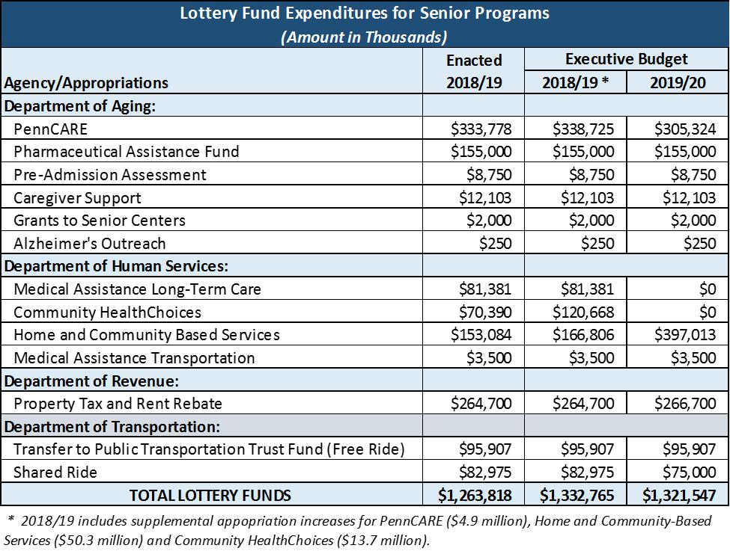

Tobacco Settlement Fund

The executive budget proposes spending $377.2 million from the Tobacco Settlement Fund on health-related programs in 2019/20. It also proposes increasing current year spending to $410.8 million, which is $59.7 million above the enacted 2018/19 budget.

The following table lists program expenditures in the enacted 2018/19 budget and shows the revised 2018/19 spending and proposed 2019/20 spending in the executive budget.
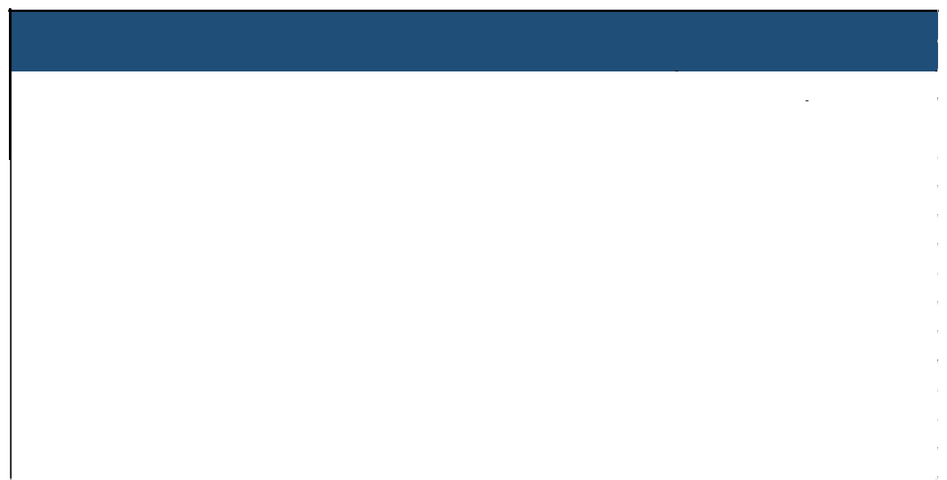

Tobacco Settlement Fund Expenditures for Health-Related Programs

(Amount in Thousands)
 |  |  | Executive Budget
 |  | 2018/19 | 2018/19 | 2019/20
 | Program (Agency) | Enacted | Revised | Proposed
 | Medical Assistance for Workers with Disabilities (DHS) | $103,594 | $114,795 | $113,165
 | CURE Health Research - Health Priorities (Health) | $43,509 | $48,214 | $47,529
 | CURE Health Research - Cancer (Health) | $3,453 | $3,826 | $3,772
 | Prevention and Cessation (Health) | $15,539 | $17,219 | $16,975
 | Uncompensated Care (DHS) | $28,246 | $31,301 | $30,856
 | Health-Related Purposes:
 | Life Sciences Greenhouses (DCED) | $3,000 | $3,000 | $3,000
 | Medical Assistance - Long Term Care (DHS) | $20,908 | $20,908 | $0
 | Community HealthChoices (DHS) | $132,878 | $149,201 | $161,920
 | Home and Community-Based Services (Aging) | $0 | $22,363 | $0
 | TOTAL PROGRAM EXPENDITURES | $351,127 | $410,827 | $377,217

House Appropriations Committee (D) 717-783-1540 www.hacd.net  HDAPPROPS@hacd.net
2019/20 Executive Budget Proposal - V3: Budget Briefing

April 8, 2019 - Page 15
The requested revision to 2018/19 includes one-time expenditures of $22.4 million for home and community based services in the Department of Aging. This governor is seeking this amount to repay the federal government for prior year reimbursements previously claimed by the department, per a recent settlement. The revision also includes $37.3 million in supplemental increases across all but two programs (the exceptions being life sciences greenhouses and Medical Assistance long term care).

For 2019/20, the governor proposes to use the statutory formula used in the enacted 2018/19 budget (per Act 42-2018)
to allocate $377.2 million of tobacco payments anticipated in April 2020:

- 30 percent for Medicaid benefits for workers with disabilities,

- 12.6 percent to CURE for broad-based health research,

- 1 percent to CURE for cancer research,

- 4.5 percent for tobacco use prevention and cessation programs,

- 8.18 percent for uncompensated care hospital payments, and

- 43.72 percent to be separately appropriated by the General Assembly for health-related purposes in the General fund budget. Within this allocation, the governor’s proposes flat-funding the life sciences greenhouses and using the remainder for Community. The elimination of fund for Medical Assistance long term care reflects the impact of Community HealthChoices (CHC) expanding statewide on Jan. 1, 2020 -- as nursing home residents transfer to CHC, funding for long term care is moved to CHC to support the program.

Pursuant to Act 43 of 2017, the commonwealth securitized $1.5 billion of future Master Settlement Agreement payments to be repaid over 20 years. However, rather than divert MSA payments, the annual debt service payments of $115 million on these bonds will be repaid by revenues from the Sales and Use Tax that would otherwise be deposited in the General Fund.

Health

The governor’s 2019/20 budget proposal includes modest increases in line with continuing program and personnel costs within the Department of Health, as well as a proposed consolidation of some smaller disease- and research-specific appropriations.

The budget proposal maintains the significant funding increase directed to the department’s Division of Vital Statistics last year, in response to ongoing delays in the processing of birth and death records. Additionally, the proposal puts forth an increase – $4.5 million or 25 percent – for the State Health Care Centers as the department continues to reestablish and staff these facilities following closure efforts under both the Wolf and Corbett administrations.

The numerous disease- and research-specific appropriations within the department are again significantly reduced or eliminated in the proposal in line with past precedent. The governor is also proposing to consolidate many of these items under a single appropriation – Disease Management and Education Programs – as he has put forth in prior year proposals.

House Appropriations Committee (D) 717-783-1540 www.hacd.net  HDAPPROPS@hacd.net
2019/20 Executive Budget Proposal - V3: Budget Briefing

April 8, 2019 - Page 16

  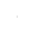 | Consolidated Deptartment of Health Appropriations |  | 2018/19 |  | Standard | 2019/20
 | (amounts in 1000s) |  | Enacted |  | Inclusions | Proposed
 | Diabetes Programs |  | 100
 | Regional Cancer Institutes |  | 700
 | Adult Cystic Fibrosis & Chronic Respiratory Illnesses |  | 750 |  | 350
 | Cooley's Anemia |  | 100 |  | 100
 | Hemophilia |  | 959 |  | 959
 | Lupus |  | 100
 | Sickle Cell |  | 1,260 |  | 1,260
 | Regional Poison Control Centers |  | 700
 | Trauma Prevention |  | 460
 | Epilepsy Support Services |  | 550
 | Bio-Technology Research |  | 5,875
 | Tourette Syndrome |  | 150
 | Amyotrophic Lateral Sclerosis (ALS) Support Services |  | 750
 | Leukemia/Lymphoma |  | 200
 | Subtotal - Existing Dept. of Health Appropriations |  | 12,654 |  | 2,669
 | These disease- and research-specific appropriations in the Department of Health would be
 | consolidated under a single, new appropriation - Disease Management and Education Programs.
 | Disease Management and Education Programs |  |  |  |  | 2,669
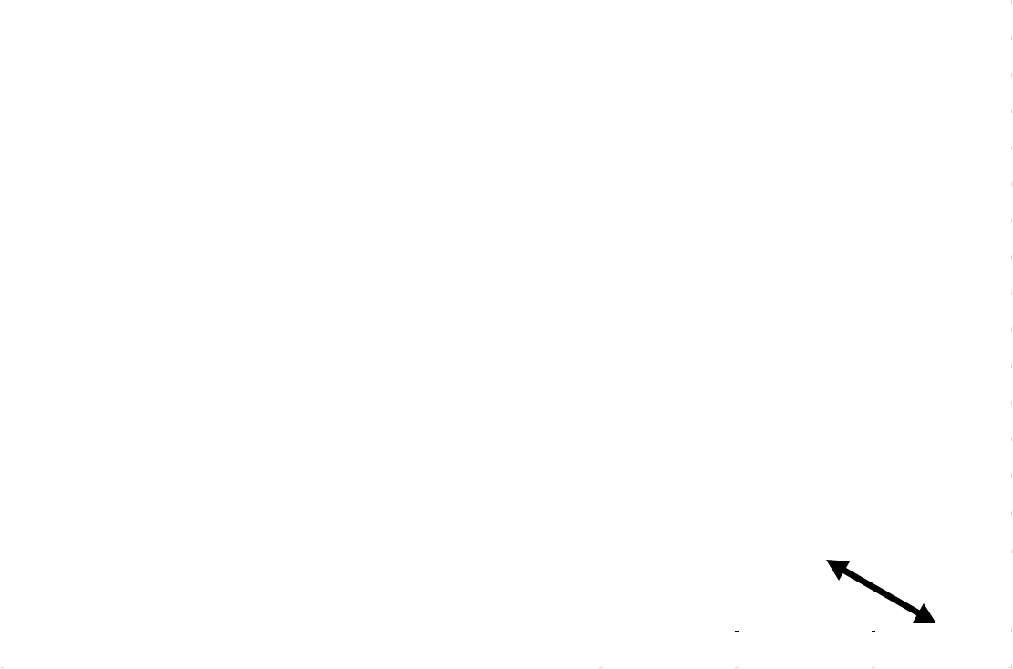

Resources to Respond to the Opioid Crisis

The scourge of heroin and opioids – including fentanyl – continues to afflict individuals, families and communities across the commonwealth. The Wolf administration has worked with the legislature to develop, implement and expand a variety of programs across numerous state agencies to address this crisis.

Aside from issuing – and subsequently renewing – an unprecedented statewide disaster declaration to coordinate amongst various agencies, the governor also worked with the legislature to provide an additional $100 million in state funds during his first term in office.

The 2019/20 budget proposal maintains these investments across numerous departments, while also providing an additional $1.5 million in state funding to expand access to naloxone for first responders seeking to save lives and get people into treatment.

Insurance

The Pennsylvania Insurance Department regulates the state’s insurance marketplace, which is the fifth largest in the country.

Since the enactment of Act 46 of 2013, a portion of all funds collected through licenses, fees and fines has been utilized to fund the department’s operations through the Insurance Regulation and Oversight Fund. As a result, the only state General Fund appropriation directed towards the department in the 2019/20 budget proposal is a partial, ongoing repayment of a previous loan made to the General Fund from the Underground Storage Indemnification Fund (USTIF) in the 2002/03 enacted budget.

Labor and Industry

The Department of Labor and Industry helps keep Pennsylvanians safe by inspecting many elevators, boilers, and building plans throughout the state. In 2017/18, the General Assembly raised many of the fees charged by the department for its inspection services, and directed a portion of this revenue to the Bureau of Occupational and Industrial Safety to offset its costs. This year, the budget proposes to hire six additional elevator and boiler inspectors. At the same time, the budget

House Appropriations Committee (D) 717-783-1540 www.hacd.net  HDAPPROPS@hacd.net
2019/20 Executive Budget Proposal - V3: Budget Briefing

April 8, 2019 - Page 17

would increase the amount of fees retained by the department by $3 million, resulting in a net reduction to the General Fund appropriation of $2.1 million.

The governor proposes a $2.3 million, or 5.1 percent, increase for the Office of Vocational Rehabilitation, which helps Pennsylvanians with disabilities get jobs and maintain employment.

Minimum Wage

Gov. Wolf is proposing to raise the minimum wage to $12 an hour effective July 1, 2019, followed by 50 cent increases annually until 2025, when the minimum wage would reach $15/hour.

The executive budget assumes that raising the minimum wage will increase 2019/20 General Fund revenues by $120 million and will also provide $36 million in net savings to the commonwealth spread across several appropriations.

Community and Economic Development

The governor’s $131.7 million 2019/20 proposal for the Department of Community and Economic Development (DCED) reflects cost-to-carry funding absent appropriations customarily added back during negotiations and a shift of marketing related expenditures to a recently established funding stream.

The 2019/20 budget proposal includes an additional $5 million for PA First as part of its core program. PA First is a comprehensive program to attract increased investment and job creation in the commonwealth through the use of grants and Pennsylvania’s workforce development program – WEDnet. Also under PA First, proposed budget provides additional $12 million in grants as part of public-private partnership through Team PA and DCED. The proposed $32 million for PA First, represents a $17 million, or 113 percent, increase, if approved, and restores funding to its highest level since 2013/14.

The executive budget proposal would utilize funds from the Tourism Promotion Restricted Fund, established under Act 109 of 2018, for the “Marketing to Attract Tourists” and “Marketing to Attract Business” programs.

Gov. Wolf’s 2019/20 budget includes no funding for Intergovernmental Cooperation Authority – 3rd class cities (Harrisburg ICA) created by Act 124 of 2018.

The 2019/20 proposal does assume the continuation of the $5 million for the Pennsylvania Dairy Investment Program through the Commonwealth Financing Authority.

Environmental Protection - UPDATED

The total proposed budget, including special and federal funds, for the Department of Environmental Protection (DEP) is $786.4 million, a $60.4 million increase over 2018/19 of which $28.2 million is federal funds. DEP’s state General Fund proposed budget of $137.7 million declines by $ 20.8 million, or 13 percent, compared to 2018/19. That reduction is more than offset by a proposed shift of expenditures to special funds - the Environmental Stewardship Fund and the Recycling Fund.

Altogether, expenditures shifted from the General Fund to the Environmental Stewardship Fund (ESF) total $15.5 million. That increase supports environmental protection operations, various interstate commissions including the Delaware River Master, Interstate Commission on the Potomac River, Delaware River Basin, Susquehanna River Basin, and Ohio River Valley Water Sanitation. The “Transfer to Conservation District Fund” and the Chesapeake Bay agricultural abatement are also shifted from the General Fund to the ESF.

Similarly, expenditures shifted from the General Fund to the Recycling Fund total $10 million for DEP-related operations.

As in prior years, revenue flows from the Oil & Gas Lease Fund to the Marcellus Legacy Fund and then to the Environmental Stewardship Fund. The proposal reduces that revenue source by $20 million and shifts a $26 million expenditure for Growing Greener II debt service out of the Environmental Stewardship Fund. Revenue from the personal income tax is diverted from the General Fund to pay that debt service.

Statewide radio upgrade: $218,000 from Environmental Protection Operations would be devoted to this upgrade.

House Appropriations Committee (D) 717-783-1540 www.hacd.net  HDAPPROPS@hacd.net
2019/20 Executive Budget Proposal - V3: Budget Briefing

April 8, 2019 - Page 18

Conservation and Natural Resources - UPDATED

The total proposed budget, including special and federal funds, for the Department of Conservation and Natural Resources (DCNR) is $391.9 million, which would be a $9.2 million increase over 2018/19. DCNR’s state General Fund proposed budget of $85.3 million constitutes a decrease of $37.4 million, or 30.5 percent. That reduction is more than offset by a partial expenditure shift from the General Fund to other special funds. Altogether, across all funds, the proposed changes compared with prior year are as follows:

General Gov't Operations |  | $3.1 million
State Parks Operations |  | $9.3 million
State Forests Operations |  | $6.6 million
Heritage & Other Parks |  | ($0.8) million
 | Net Change $18.3 million

The increase is possible due to shifting $53.226 million of these appropriations from the General Fund to the following special funds:

Keystone Park & Conservation Fund | $30.00 million
Environmental Stewardship Fund |  | $2.25 million
Oil & Gas Lease Fund | $20.97 million
Total Shift |  | $53.2 million

The budget proposal also eliminates “parks & forests infrastructure projects” appropriation.

Statewide radio upgrade: $6.83 million total from the appropriations for state parks and state forests operations ($3.67 million and $3.16 million, respectively), would be devoted to this upgrade.

Agriculture - UPDATED

Gov. Wolf’s 2019/20 state General Fund budget proposal includes $163.2 million for the Department of Agriculture, a potential $11.4 million, or 7.5 percent, increase. If approved, the governor would eliminate funding for agricultural research, livestock & dairy shows, and marketing & promotion which are traditionally added back during budget negotiations.

Because of the ongoing threats of avian influenza and the Spotted Lanternfly, $5 million is included in the executive budget for “Agricultural Preparedness & Response.” Thirteen counties in Pennsylvania’s east and southeast are under quarantine to stop the spread of the invasive insect.


(Image source: https://www.certifiedtraininginstitute.com/tree-of-heaven-attracts-devilishly-destructive-spotted-lanternfly/)

The 2019/20 executive budget proposal includes a $2.6 million increase for PA Preferred, which would bolster the state’s status as a leader in food and agriculture, and enhance the growth of Pennsylvania’s burgeoning organic industry. Another $1 million would support urban agriculture collaboratives and industries like hemp, hops, and hardwoods.

With the $4.5 million “Agricultural Business and Workforce Investment” proposal, the department would spend $2 million to establish the Pennsylvania Agricultural Business Development Center, $1 million to increase awareness of and exposure to agriculture, and $1.5 million to assist small animal agricultural operations.

The 2019/20 budget also proposes to expand Resource Enhancement and Protection (REAP) tax credits by $3 million. In order to continue reducing regulatory burdens on farmers and incentivize best practices for farmers to become more competitive, the Executive Budget proposes $2.5 million expansion of the Conservation Excellence Grant Program and $500,000 to re-establish Agriculture Linked Investment Program.

House Appropriations Committee (D) 717-783-1540 www.hacd.net  HDAPPROPS@hacd.net
2019/20 Executive Budget Proposal - V3: Budget Briefing

April 8, 2019 - Page 19

Transportation - UPDATED

The 2019/20 budget proposal includes $6.4 billion in state funding for the Department of Transportation, which would reflect a decrease of $366 million, or roughly 5.4 percent, if approved.

The request for a reduction in spending is a function of: (1) returning to “normal” spending after disproportionately higher 2018/19 expenditures; (2) lagging fuel consumption and lower projected opt-in rates for biennial vehicle registrations; and (3) planned reductions to reinvestment in facilities, rural commercial routes, and infrastructure loans.
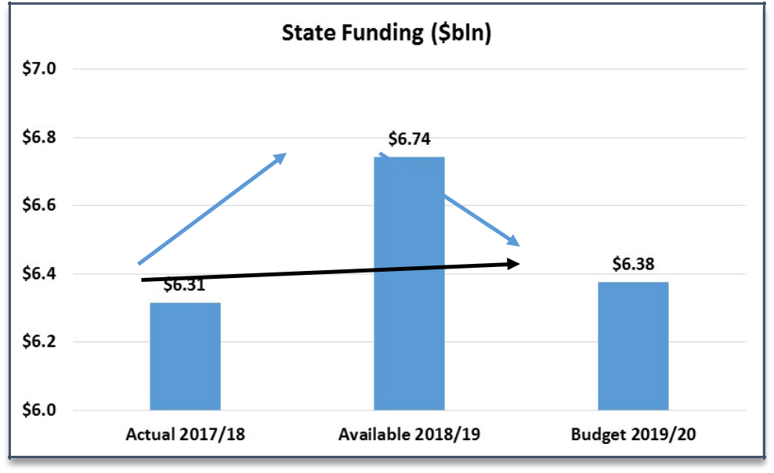

Up 6.8% Down 5.4%

Up 1.0%

Year-over-year reductions include $275 million less for road and bridge projects and $103 million less for public transportation, but is offset by a small inflation-adjusted increase of $12 million for multimodal projects. Below is a table which reflects the year-over-year adjustments in state funding.


 |  |  |  |  |  |  |  |  |  |  |  |  |  | Vs. Current Year
 | $ million |  |  | Available |  |  |  |  | Budget |  |  |  |  | Budget vs. Available
 |  |  |  | 2018/19 |  |  |  |  | 2019/20 |  |  |  |  | Var $ |  |  | Var %
 | Total State Funding |  | $ | 6,742 |  |  | $ |  | 6,375 |  |  |  | $ | (366) |  |  | (5%)
 | Road & Bridge |  |  | 3,681 |  |  |  |  | 3,447 |  |  |  |  | (234) |  |  | (6%)
 | Highway Construction |  |  | 1,008 |  |  |  |  | 819 |  |  |  |  | (189) |  |  | (19%)
 | Bridges |  |  | 283 |  |  |  |  | 280 |  |  |  |  | (3) |  |  | (1%)
 | Maintenance |  |  | 1,701 |  |  |  |  | 1,687 |  |  |  |  | (13) |  |  | (1%)
 | Local Highway & Bridge |  |  | 690 |  |  |  |  | 661 |  |  |  |  | (29) |  |  | (4%)
 | Mass Transit Grants |  |  | 2,126 |  |  |  |  | 2,015 |  |  |  |  | (111) |  |  | (5%)
 | Multimodal Transportation |  |  | 189 |  |  |  |  | 202 |  |  |  |  | 13 |  |  | 7%
 | Commonwealth Financing Authority |  |  | 56 |  |  |  |  | 67 |  |  |  |  | 11 |  |  | 19%
 | Rail Freight Grants |  |  | 41 |  |  |  |  | 42 |  |  |  |  | 0 |  |  | 1%
 | PennDOT statewide grants |  |  | 40 |  |  |  |  | 40 |  |  |  |  | 0 |  |  | 0%
 | Aviation |  |  | 22 |  |  |  |  | 23 |  |  |  |  | 1 |  |  | 4%
 | Administration & Operations |  |  | 17 |  |  |  |  | 18 |  |  |  |  | 0 |  |  | 2%
 | Ports & Waterways |  |  | 10 |  |  |  |  | 11 |  |  |  |  | 0 |  |  | 4%
 | Bike & Pedestrian |  |  | 2 |  |  |  |  | 2 |  |  |  |  | 0 |  |  | 5%
 | Other (Safety Admin, Licensing, Misc.) |  |  | 746 |  |  |  |  | 711 |  |  |  |  | (34) |  |  | (5%)
 | Complement (non-add) |  |  | 11,522 |  |  |  |  | 11,522 |  |  |  |  | 0 |  |  | 0%
House Appropriations Committee (D) |  | 717-783-1540 |  |  |  |  |  |  |  |  |  |  |  | www.hacd.net  HDAPPROPS@hacd.net
2019/20 Executive Budget Proposal - V3: Budget Briefing

April 8, 2019 - Page 20

Nearly two-thirds of the proposed reduction in state funding (approximately $234 million) impacts roads and bridges; this includes a revenue reduction of $120 million due to reductions in fuel consumption, lower than expected opt -in rates for biennial vehicle registrations, and other unplanned contingencies. The decrease also counts $55 million in planned reductions for one-time funding outlays in 2018/19.

The budget proposal includes a $111 million, or five percent, reduction to mass transit grants, which reflects a return to normal spending levels following a disproportionately higher spend from fund balances in 2018/19 and a contingency plan for the pending lawsuit against the PA Turnpike Commission.

Pursuant to Act 89 of 2013 -- and beginning in 2022/23 -- the PA Turnpike’s annual $450 million payment that supports mass transit will drop to $50 million and the balance will be supplanted by sales and use taxes on motor vehicles, trailers and semi-trailers. As we evaluate the 2019/20 budget proposal submitted by the governor, we will closely monitor the discussion on the out-year funding for transportation.

It is important to note that Act 89 funding has been fully implemented at this point in time and markedly large increases in funding for any of the modes of transportation is no longer expected. We will continue to monitor the transportation budget and will provide an update once additional information is gathered.

Law Enforcement, Public Safety and Criminal Justice State Police

The budget proposal provides $1.34 billion for Pennsylvania State Police, a $33.4 million, or 2.55 percent, increase over 2018/19.

PSP draws funding from the General Fund, Motor License Fund, and other funds. The governor’s budget proposal continues a multi-year effort to shift away from the commonwealth’s reliance on the Motor License Fund. Appropriations from the MLF to PSP are restricted by a statutory cap – $737.6 million in 2019/20 – that decreases by $32 million annually until it reaches $500 million in 2027/28.

The proposed budget achieves the required reduction in MLF spending, and decreases General Fund appropriations by $35.3 million, or 11.5 percent, erasing more than half of the 2018/19 increase in GF spending.

Instead, the budget proposal assumes a $103.9 million increase in augmentation revenue from a fee on municipalities that provide no local law enforcement, relying instead on state police for full-time coverage.

The fee would range from $8 to $166 per capita, depending on the size of the municipality. The smallest municipalities would pay less than $ 100 each while the largest municipalities relying on PSP for full-time patrol services would pay more than $3 million each. The fee would only affect municipalities with no local, regional, or contracted police; shown as the gray area of the map. State police currently provides full- or part -time coverage in two-thirds of municipalities covering 82 percent of the commonwealth land mass and 26 percent of its population.

House Appropriations Committee (D) 717-783-1540 www.hacd.net  HDAPPROPS@hacd.net
2019/20 Executive Budget Proposal - V3: Budget Briefing

April 8, 2019 - Page 21

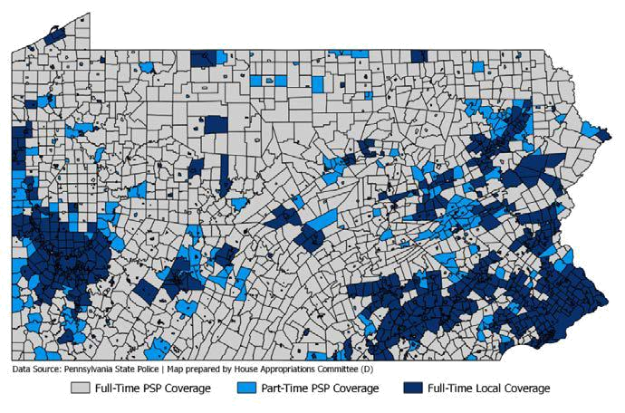

The proposed budget would invest $9.7 million in three cadet classes in 2019/20, and would continue investments in the statewide public safety radio system to implement the new P25 system. The proposal would spend just under $50 million on the new radio system, half within the state police budget and half spread across other executive agencies.

In 2019/20, Gov. Wolf proposes a $4.4 million appropriation to support the gun checks system (PICS). PICS is also funded by a restricted account, although the account’s revenue is less than half the annual cost of the program. Gov. Wolf has included the gun checks appropriation in each of his five budget proposals, but it has been zeroed out in enacted budgets in the past three years.

Criminal Justice

Corrections continues as the third largest expenditure in the state budget after human services and education. This budget proposal includes $2.62 billion in state general funds for the Department of Criminal Justice, which is 7.67 percent of total proposed General Fund spending.

The one -year increase for the department, if approved, is contained at $17.3 million, or 0.67 percent – the smallest increase Corrections has seen in recent years without a prison closure or federal stimulus money.

The budget proposal assumes a $50 million supplemental appropriation in 2018/19 for inmate medical care and state correctional institutions. The supplemental appropriation would include funding for one -time costs associated with transferring inmates from SCI Graterford to SCI Phoenix and the lockdown in August, both of which contributed to a spike in overtime during the first quarter of 2018/19.

Beginning with Act 1A of 2017, funding for the Department of Corrections and the Pennsylvania Board of Probation and Parole has been appropriated jointly to the Department of Criminal Justice, reflecting ongoing efforts supported by Gov. Wolf to consolidate the two agencies.

Grants to support county probation are level funded in this proposal, which would make this the ninth year at the current funding level of $16.2 million.

Judiciary

The budget proposal maintains level funding for all appropriations in the Judiciary.

Act 42 of 2018 (the Fiscal Code) established a recurring transfer of $15 million in fee revenue (which otherwise would be directed to the Judicial Computer System Augmentation Account) to the School Safety and Security Fund. 2019/20 will be the second year of the transfer.

House Appropriations Committee (D) 717-783-1540 www.hacd.net  HDAPPROPS@hacd.net
2019/20 Executive Budget Proposal - V3: Budget Briefing

April 8, 2019 - Page 22
Commissions

PCCD

Funding to the Pennsylvania Commission on Crime and Delinquency would be increased $1.1 million, or 15.6 percent. The proposed increase would support a $1.5 million investment in naloxone – part of the statewide effort to address the opioid epidemic.

Support for grants to local criminal justice agencies and non-profits, including programs to divert low-level offenders from incarceration, support drug courts, and provide for victim services, are all level funded in the governor’s proposal.

JCJC

The budget proposal increases funding for the Juvenile Court Judges’ Commission by $79,000, or 2.6 percent. Grants for juvenile probation services are maintained at $18.9 million.

Pennsylvania Emergency Management Agency

The budget proposal provides level funding for general operations and grant programs within the Pennsylvania Emergency Management Agency. Non-recurring costs related to disaster relief and hazard mitigation, which vary substantially year-to-year, are returned to zero.

Military and Veterans Affairs

The executive budget would increase funding for the Department of Military and Veterans by $16.7 million, or 5.1 percent.

Among other things, this increase would establish the Military Family Education Program. The federal Post-9/11 GI Bill established education programs covering up to 100 percent of tuition for eligible National Guard service members, and the benefits are transferable to the eligible dependents of qualifying service members.

The governor would allocate $2.7 million for new computer systems and support to connect eligible service members and their dependents with these federal education benefits and maximize educational opportunities for Pennsylvania National Guard members and their families.

Department of State

Protecting Pennsylvania’s Elections

Updating and protecting Pennsylvania’s election infrastructure is a major priority. While the total cost to upgrade the commonwealth’s voting systems is estimated at $125 million, the governor’s budget would allocate as a down payment $15 million in state funds for grants to counties. The governor would also disburse $20 million in federal funds received for election reform, approximately half of which would be utilized to defray the cost to counties of replacing antiquated voting machines.

The executive budget also proposes $2 million for upgrades to the Statewide Uniform Registry of Electors (SURE) system to improve analytical and reporting capabilities of the department.

Executive Offices/Human Relations Commission

Building on the major additional funds included in the 2018/19 budget, the 2019/20 executive budget proposes to hire 12 additional staff at the Pennsylvania Human Relations Commission. The commission helps protect Pennsylvanians’ civil rights, investigates complaints of discrimination of ethnic intimidation under the Human Relations Act, and helps investigate employment and housing discrimination on behalf of federal agencies.

With additional personnel, the commission can more aggressively enforce the act and protect Pennsylvanians from discrimination. The executive budget contains a 2 percent increase in funding for the commission’s budget.

House Appropriations Committee (D) 717-783-1540 www.hacd.net  HDAPPROPS@hacd.net
2019/20 Executive Budget Proposal - V3: Budget Briefing

April 8, 2019 - Page 23

General Fund Budget Balancing Measures to Monitor - NEW

General Fund Budget Balancing Measures to Monitor

($ Amounts in Millions)

 | EXPENDITURES | 2018/19 | 2019/20
 | General Fund Expenditures Shifted Offline or to Special Funds | $64.0 | $92.2
 | Increase in MA expenditures funded through Lottery Fund (compared to enacted 2018/19) | $64.0 | $92.2
 | Other Questionable/Unsustainable Budget Savings | $887.2 | $707.1
 | MA expenditures funded with one-time revenue received March 2017 from Managed Care Organization | $351.7 | $0.0
 | MA savings from one-time revenues pursuant to Tobacco Master Settlment Agreement litigation | $344.1 | $0.0
 | MA expenditures rolled-back to 2018/19 | $0.0 | $96.5
 | MA expenditures paid with prior year funds | $0.0 | $145.0
 | One-time savings from managed care payment change | $0.0 | $216.6
 | Department of Human Services expenses funded with one -time surplus from assessment on Philadelphia | $79.0 | $0.0
 | Authority Rentals & Sinking Fund Requirements (PlanCon) reduced reliance on bond proceeds | $0.0 | $191.0
 | Use of PHEAA resources to reduce General Fund expenditures on higher education - this multi-year
 | support will need to be redcued in 2019/20 | $112.4 | $58.0
 | Subtotal Expenditures | $951.2 | $799.3
 | REVENUES
 | Transfers | $74.6 | $78.7
 | Miscellaneous revenues and loan repayments to the General Fund | $33.4 | $0.0
 | Use of premium proceeds from capitalized debt service to the General Fund | $41.2 | $0.0
 | Use of special funds to offsett General Funds needed for DCNR/DEP | $0.0 | $78.7
 | Other Questionable/Unsustainable General Fund Revenue Raisers | $403.5 | $56.3
 | Gaming expansion (Act 42 of 2017) - Interactive gaming (iGaming) license fees | $106.0 | $0.0
 | Gaming Expansion - Interactiving gaming (iGaming) license fees at airports | $0.0 | $3.8
 | Gaming Expansion - Sports wagering license fees at $10 million per license ($70 million in 18/19 has
 | already been paid. The 2019/20 estimate is currently not supported by any pending applications.) | $70.0 | $40.0
 | Gaming Expansion - Category 4 (satellite casinos) table games | $0.0 | $12.5
 | Gaming Expansion - Category 3 additional slot machines and table games | $3.5 | $0.0
 | Change of ownership fees for casinos | $8.9 | $0.0
 | Repayment of gaming loans to the General Fund | $15.1 | $0.0
 | Use of funds from Joint Underwriters' Association | $200.0 | $0.0
 | Subtotal Revenues | $478.10 | $135.00
 | TOTAL | $1,429.30 | $934.30

House Appropriations Committee (D) 717-783-1540 www.hacd.net  HDAPPROPS@hacd.net
2019/20 Executive Budget Proposal - V3: Budget Briefing

April 8, 2019 - Page 24

