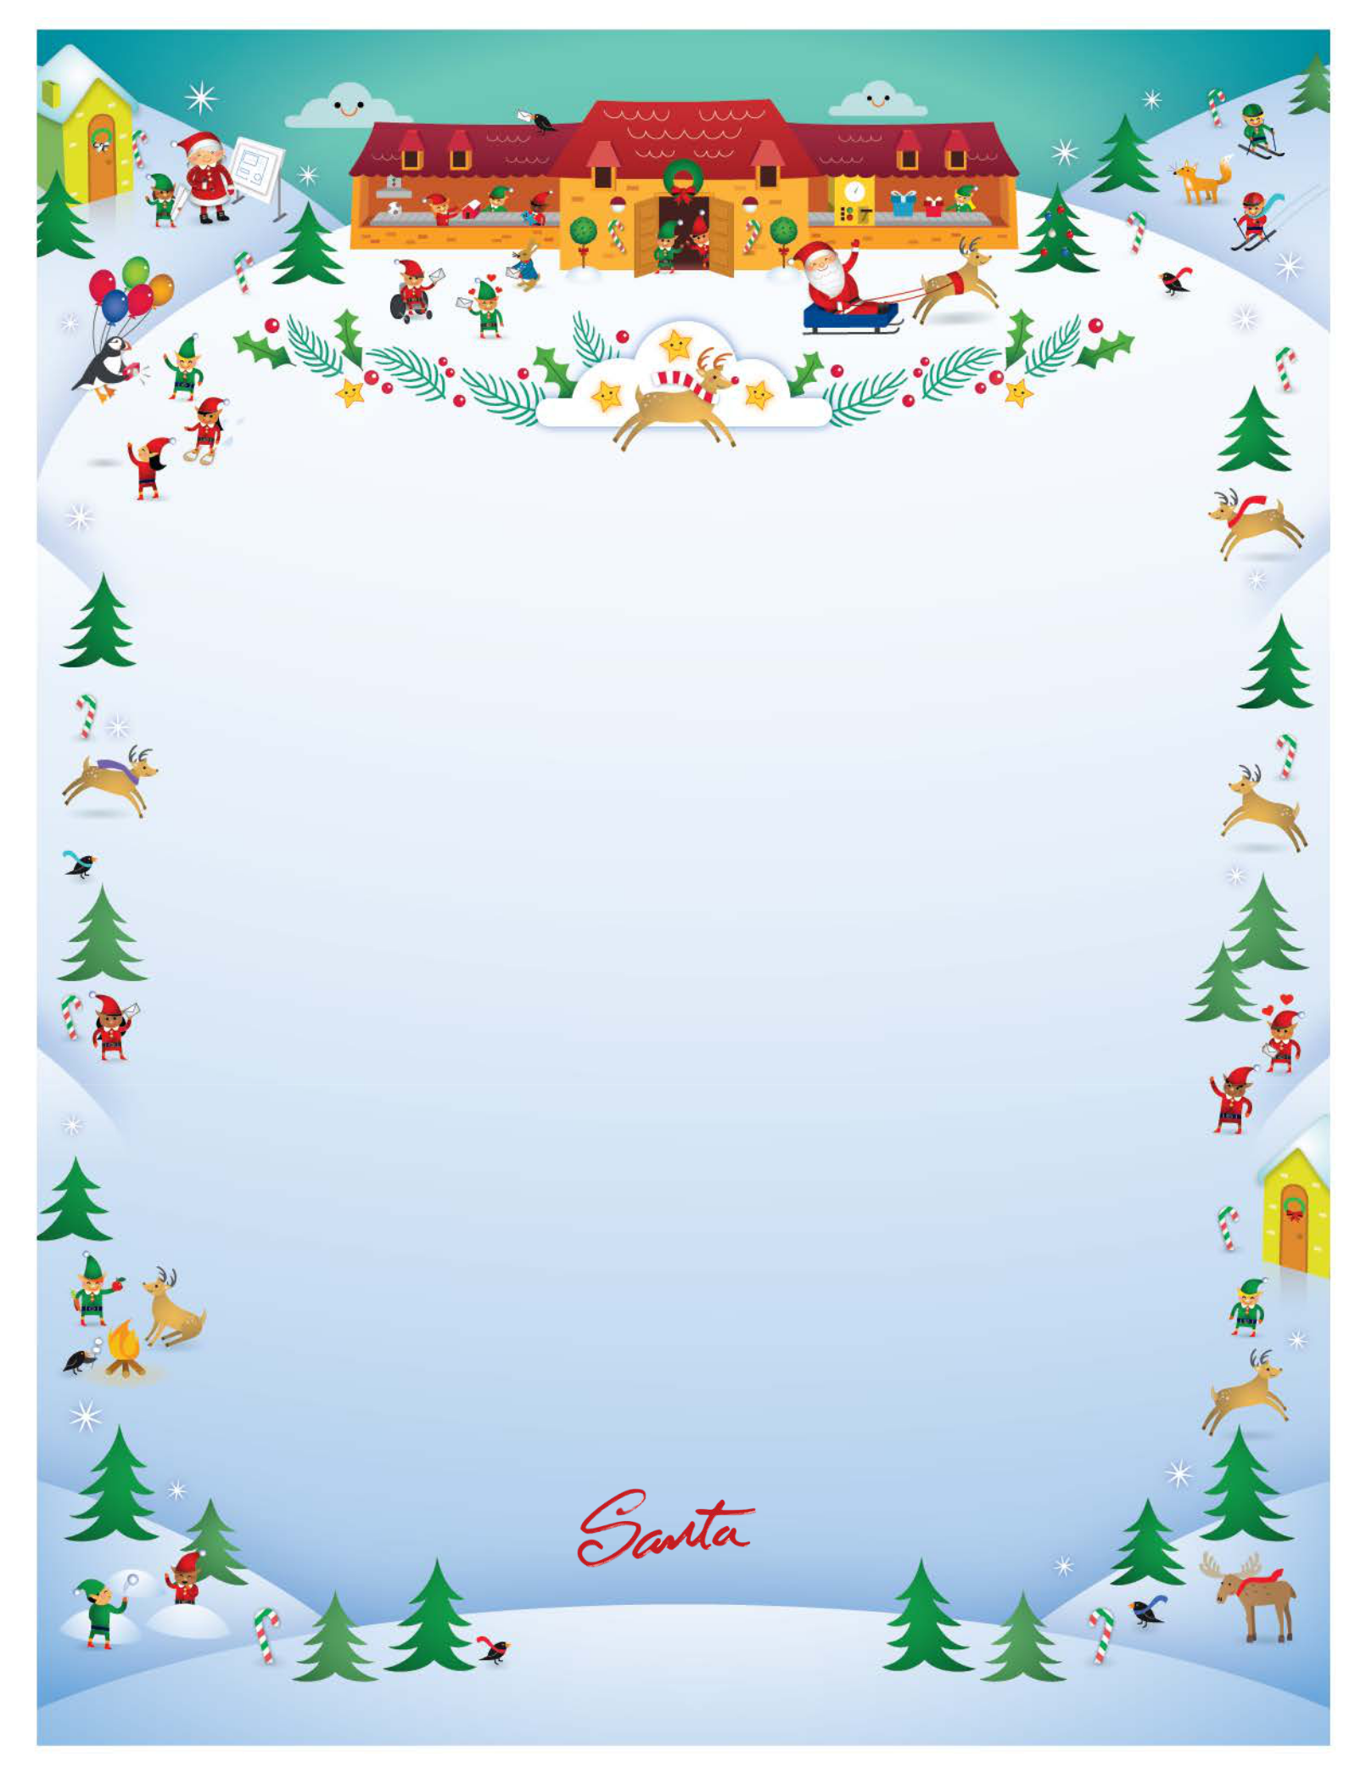

December 26, 2019

HO HO HO Hello!

I am just waking after sleeping like a log after we got home last night. I know I say this every year, but I really do think last night’s trip was our best yet.

We had an incredible journey with some skies as clear as I’ve ever seen them. But there were also a few stormy pockets, so I’m glad to be home with everyone safe and sound. We flew through a sandstorm over Egypt, but when you’re flying over the Sahara Desert you have to expect a little sand here and there…

I’m as happy as a dolphin after seeing you and all my other friends. You were asleep when I arrived at your place in the wee hours of the morning. You were dreaming and snoring (yes, snoring!) and smiling in your sleep. HO HO HO!

I wanted to say a hearty HO HO HO and thank you to everyone who wrote to me this year. Reading letters from all the boys and girls is the best part of our day. Mrs. Claus loves all the drawings that are sent and the elves love reading all the jokes and stories. Letters truly are the most magical thing that happens at the North Pole! We all hope you write to us again next year. Any time after November 1 will find the North Pole Post Office open and ready to go!

With our work done for now and everyone together, it’s time to enjoy each other’s company. I hope that you, like me, count your blessings and enjoy quality time with your friends and family. I sprinkled some magical North Pole snow over your home when we flew by on Christmas Eve. It will bring you and your family a wonderful and joyous 2020. May peace be with you, today and throughout the rest of the year. Bless you all, and to all a good night. Your friend,

