Uses of Genogram: Medical
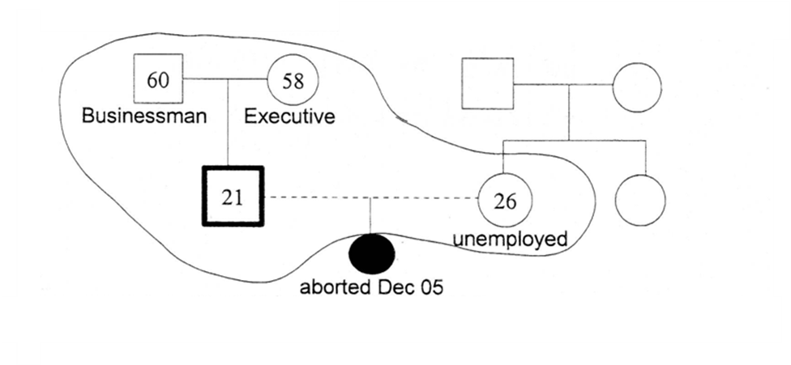
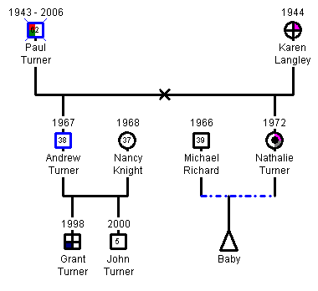

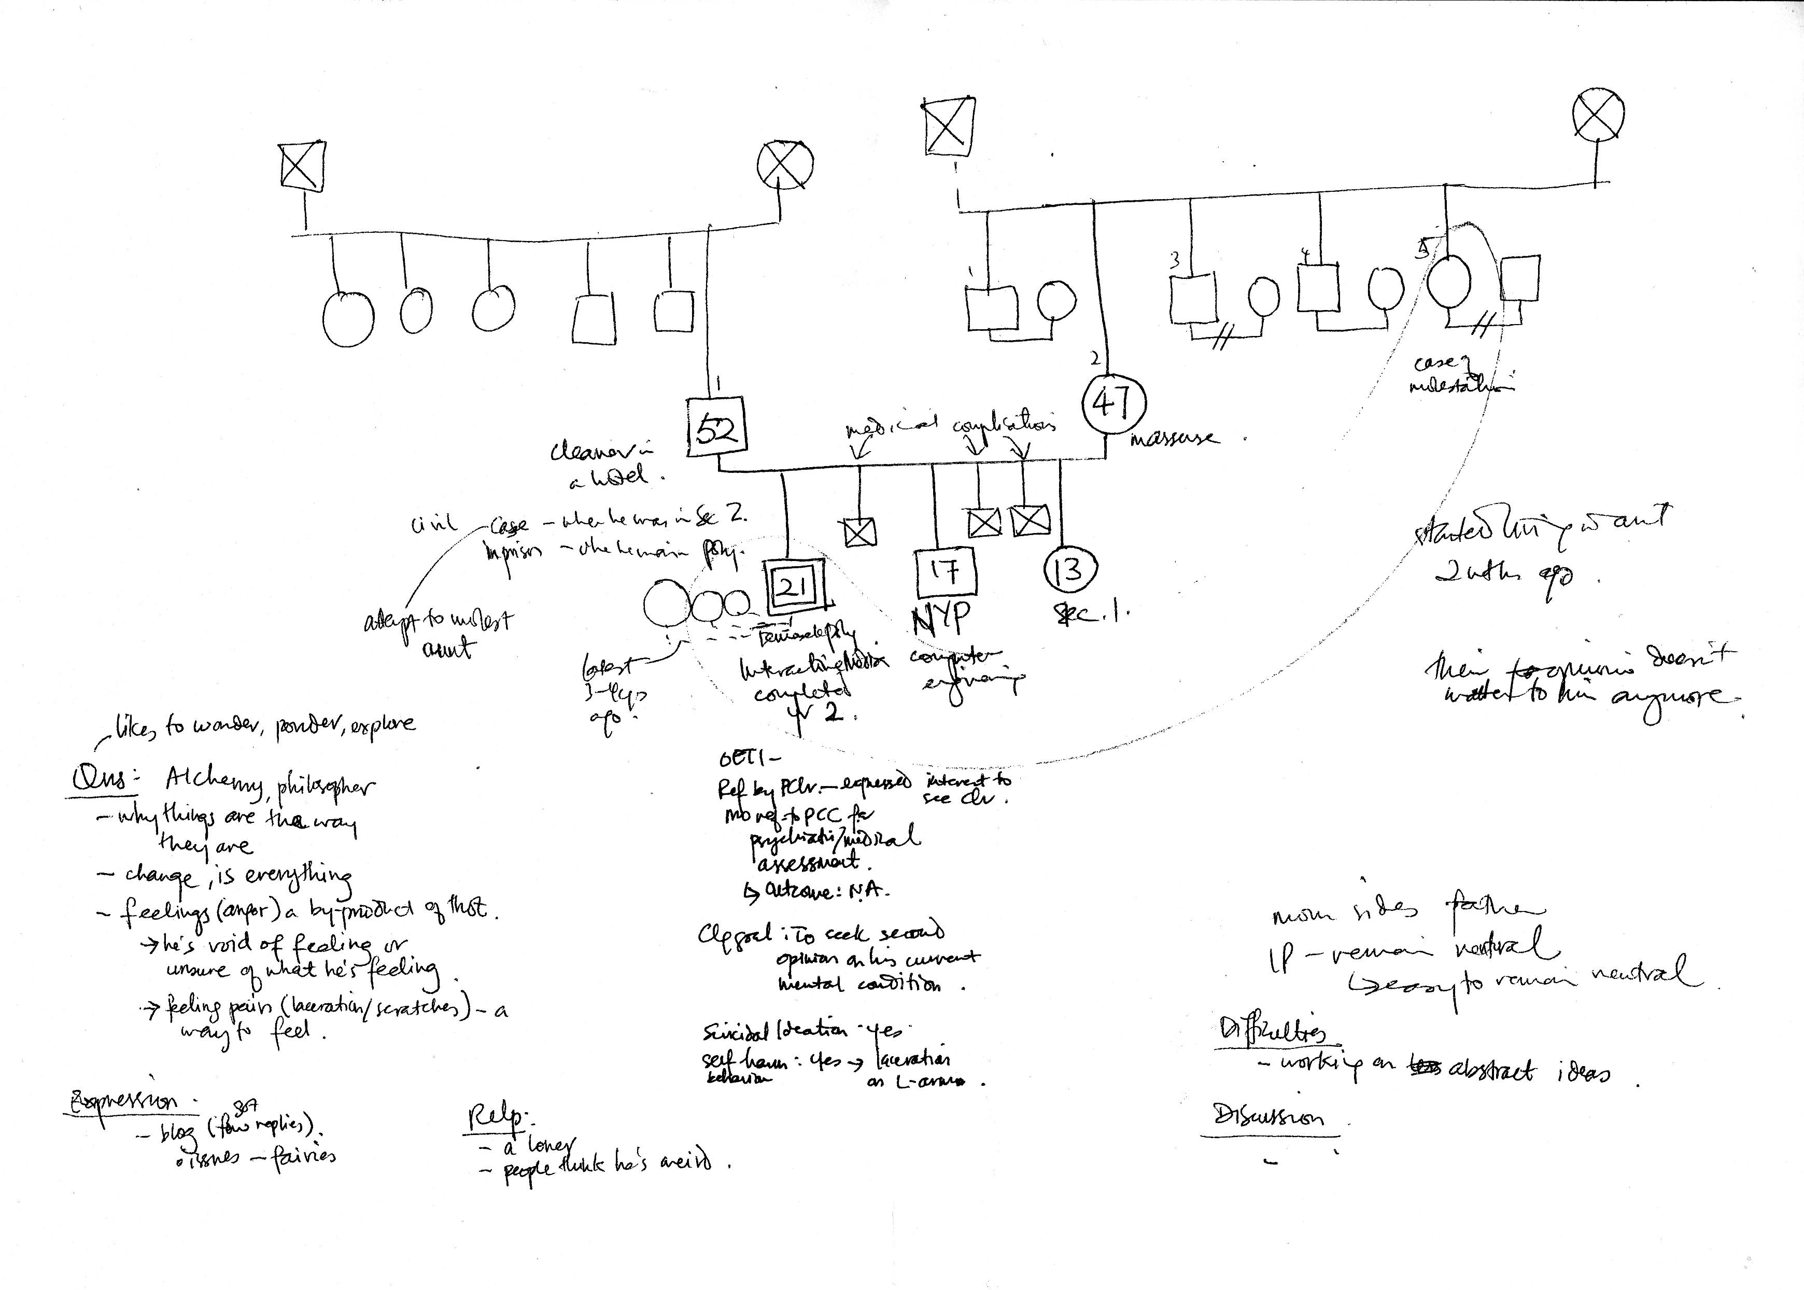

Commonly drawn genogram (e.g. 2)
2 generations

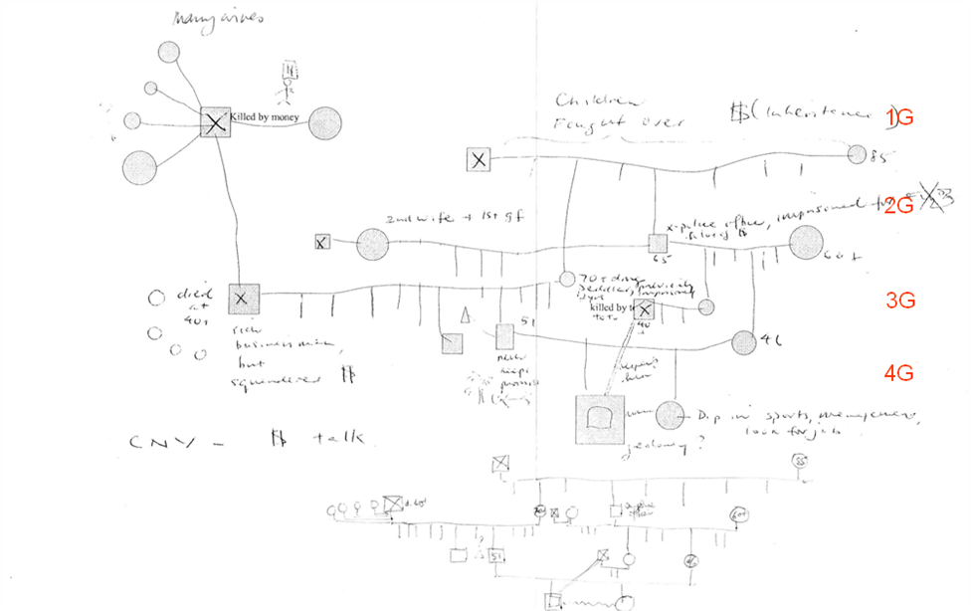

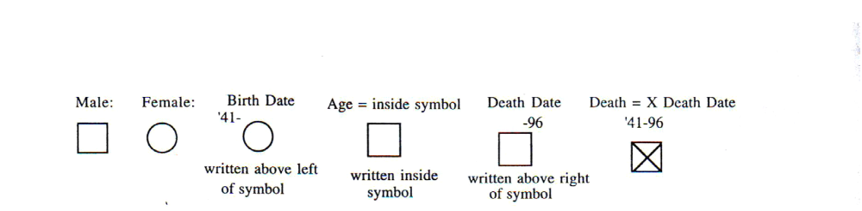
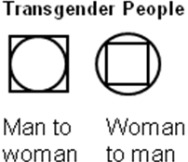

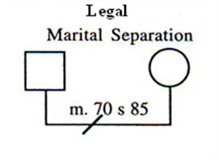
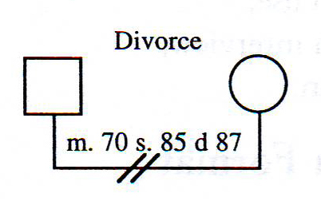
Types of Relationships:
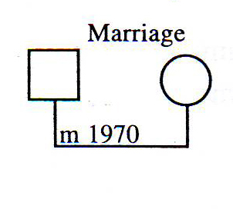
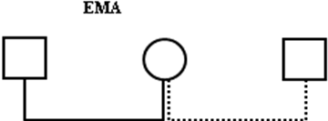

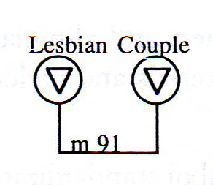
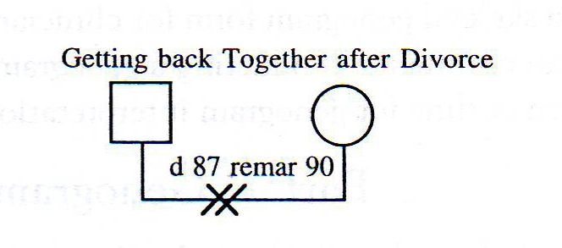
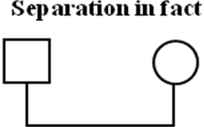

Types of Relationships: Not Married
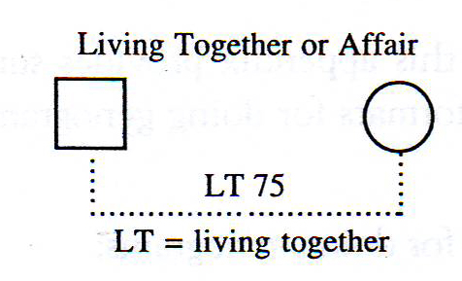
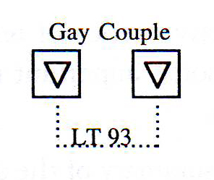
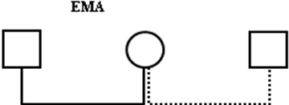

Basic Symbols for Order and Type of Birth
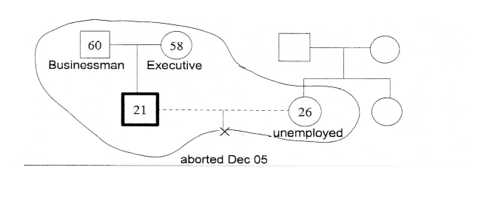
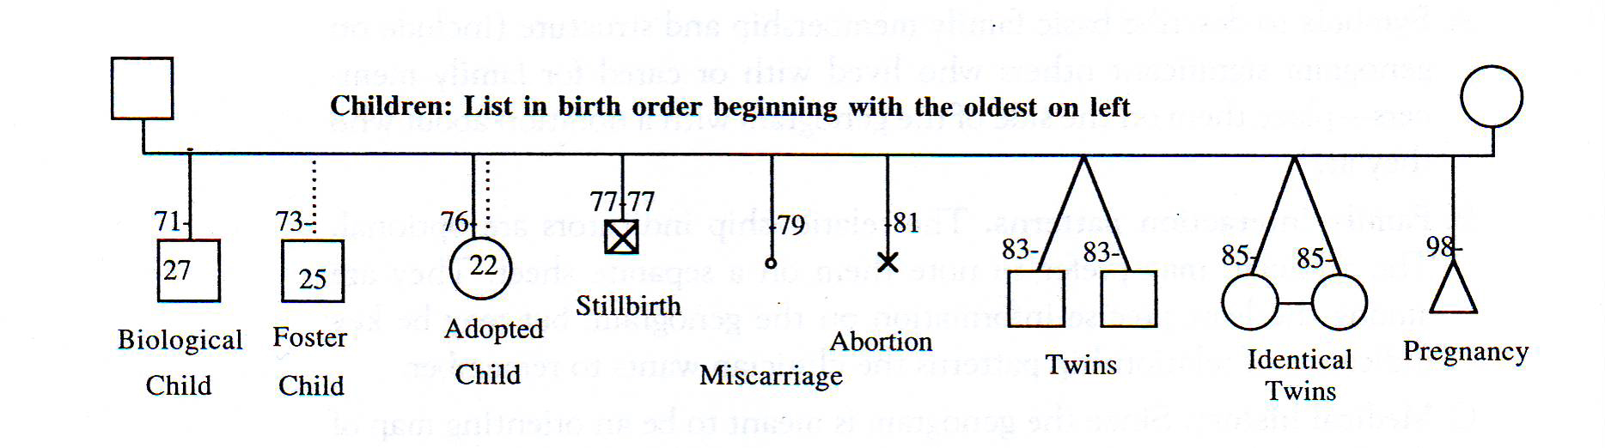
Children: List in birth order beginning with the oldest on left

Basic Symbols for Order of Birth

Artificial Insemination
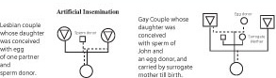

Multiple marriages and Divorces
How do you reflect a family where parents are divorced and remarried?
Sample 1: genogram showing multiple marriages

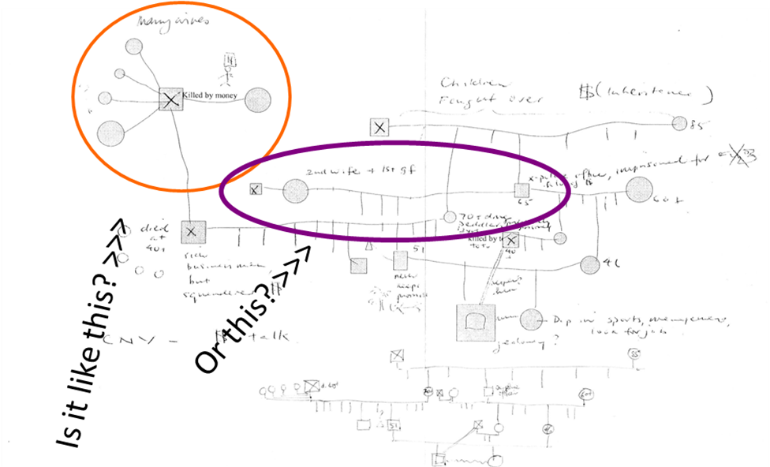
Sample 2: genogram showing multiple marriages

Multiple marriages and Divorces (complex genogram)
- Husband who has two previous failed marriages
- Wife with two previous marriages and has one child from each marriage, including current marriage
Husband with current and ex-wives
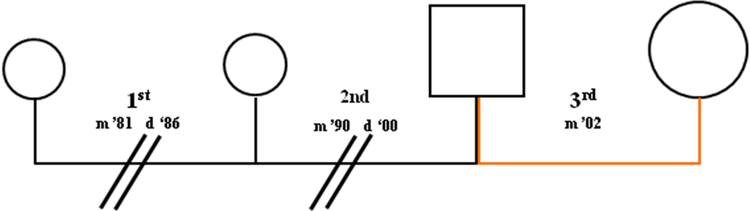

Husband , his current wife and his ex-wives (who are shown lower and smaller). Husband’s wives may go on left to be closest to him. Indicators “1st “, “2nd” and “3rd” etc make clear the order of his marriages.
Wife with current and ex-husbands
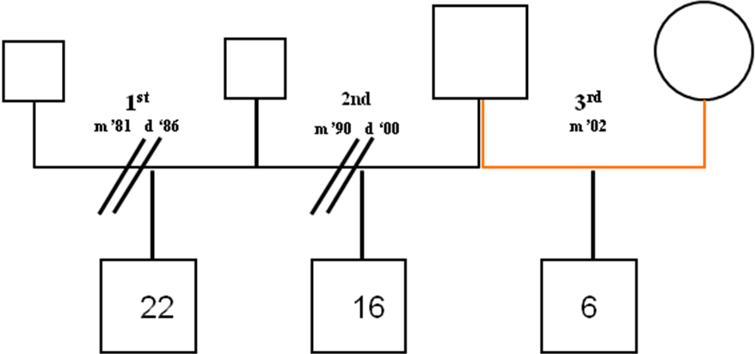

Wife, her current husband and her ex-husbands (who are shown lower and smaller). Wives’ previous relationship are shown on left to keep children in birth order, since they remained in her custody.

How do you reflect a family where parents are divorced and remarried?
- Both spouses have history of remarriages
  - Wife has previous two failed marriages , has one child in each marriage, age 14 (M ) and 9 (M) while husband has one failed marriage with a son age 8. They have a son, age 3, from current marriage. They were married in 2002.
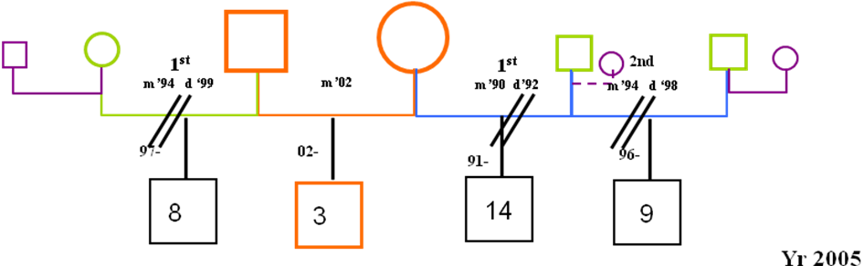
Couple with three year old son, showing their previous spouses (smaller symbols) and those spouses’ new partners (even smaller symbols)

- Wife has three failed marriages and only one son from the 3rd marriage. Husband has 4 failed marriages , one child each from 2nd (26/M), 3rd (16/M) and 4th (11/M) marriage. From their current marriage, they have a 2 yr old son. Married in 2002.
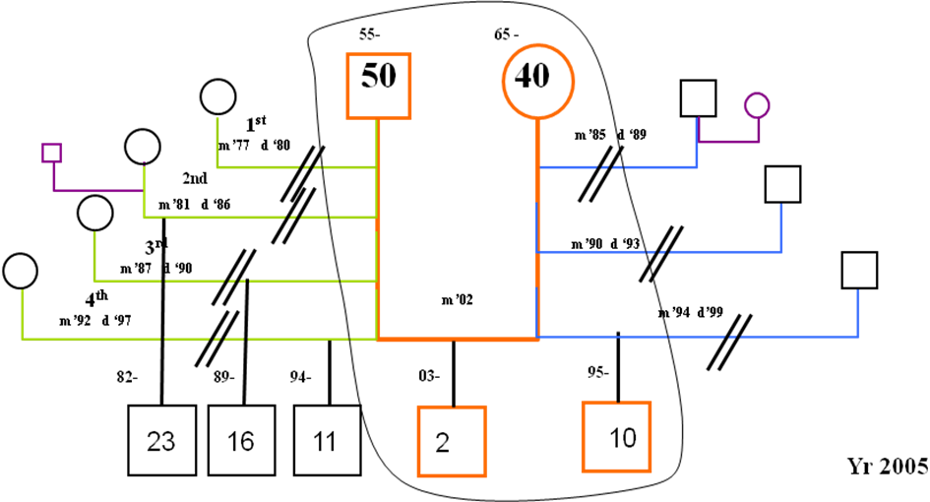
Couple living with their joint child and wife’s child from previous marriage. The other spouses of the partners are shown smaller and lower on either side of the present household. How do we show custody over children?

Sample – how to redraw this genogram

Adding more information:
Income, education, occupation and place of living
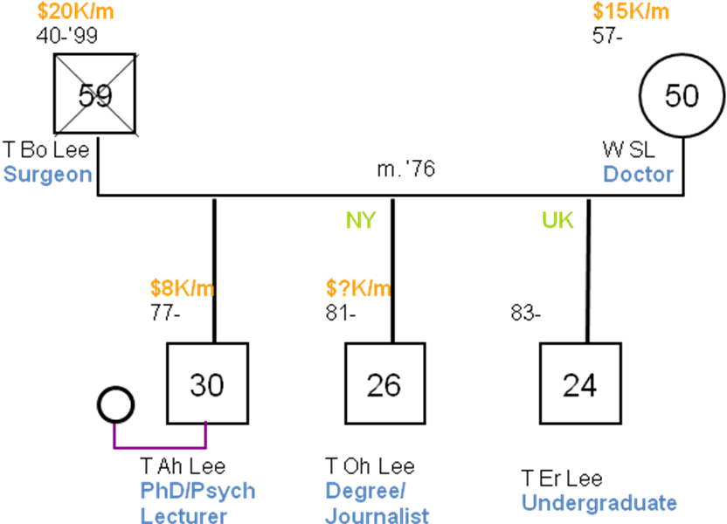

Income is written above the birth and death date. (my preference: to state it below the occupation)
Include the education and occupation near the name.
The person’s place of living should be written at the top of the line connecting the symbols.

Stages in drawing genogram

Symbols denoting addiction/substance abuse and medical or physical illness
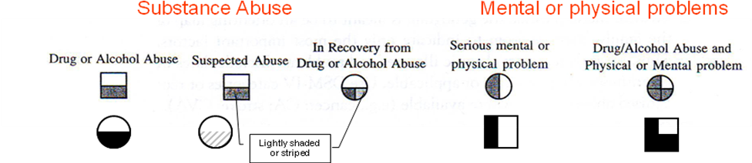

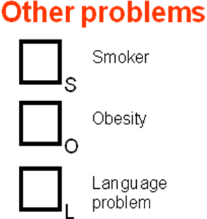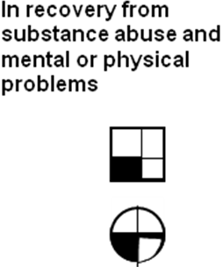

Types of Medical Conditions:
just for information only
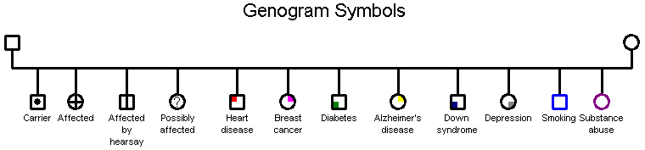

Other information: Significant Institutional relationship
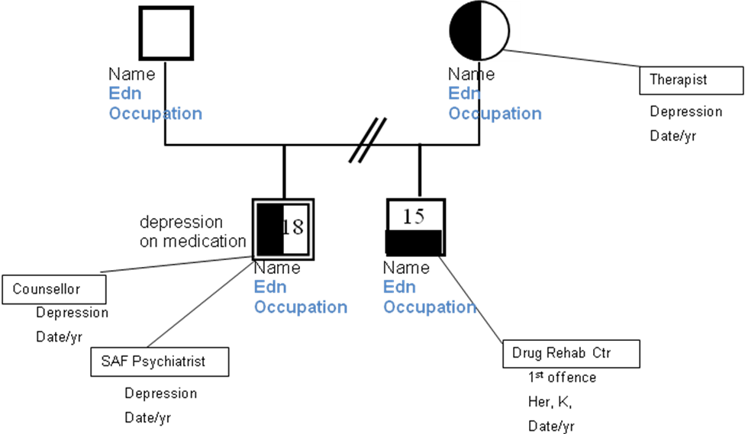
Sample of genogram with substance, medical and physical problems
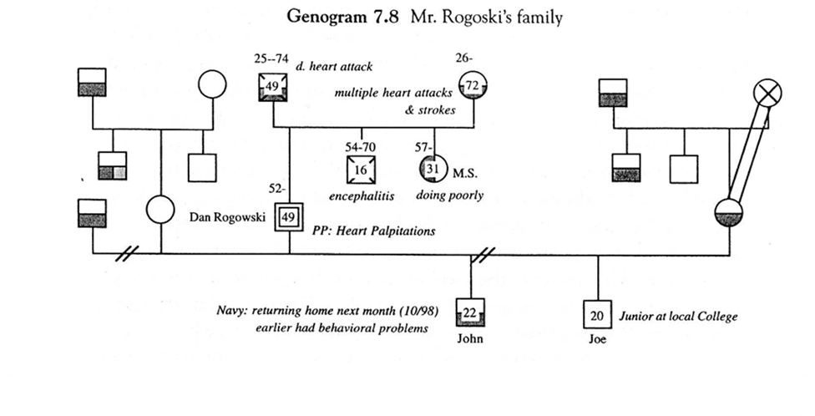

Sample
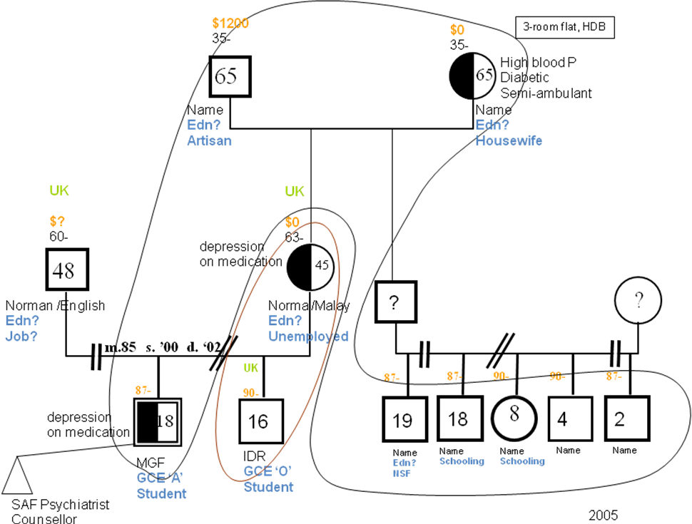

Drawing the relationships and roles

Types of Family Relationship
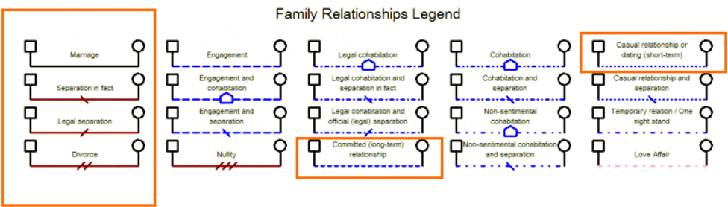

Interactional Relationship Patterns Between People
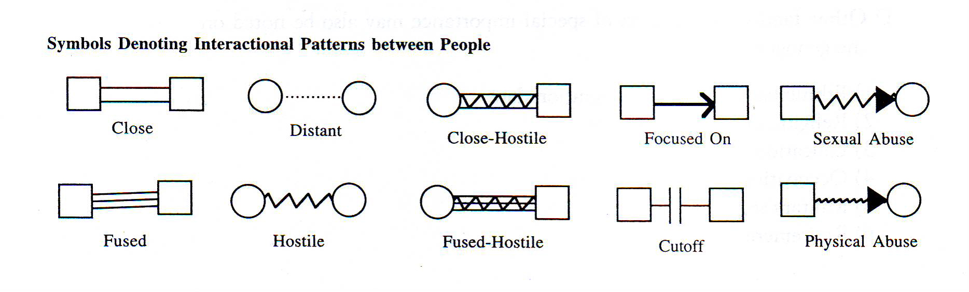

Slight variation
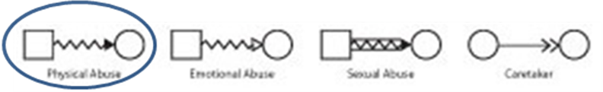

Type of Emotional Relationship

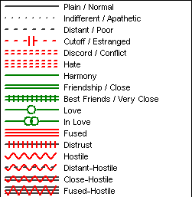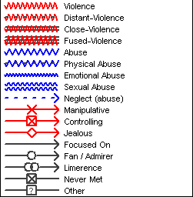

Sample
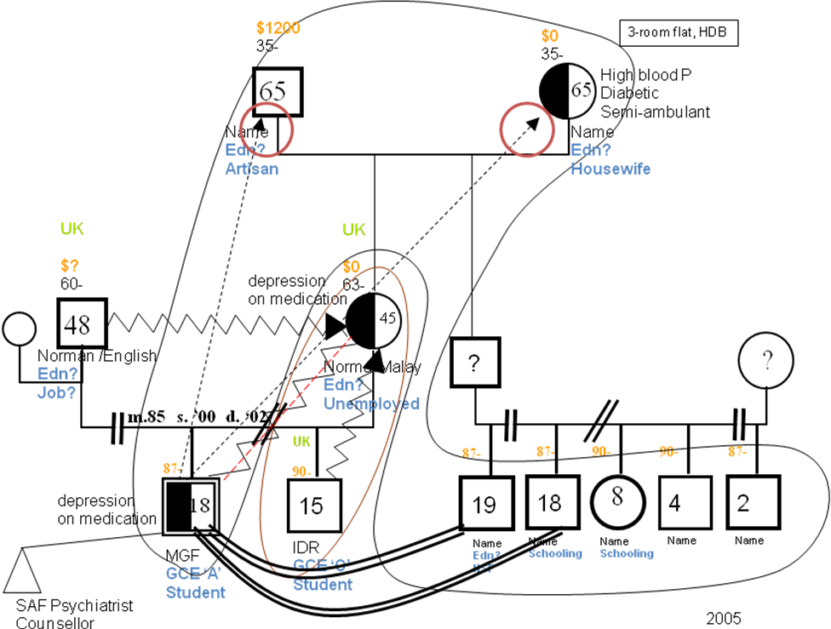

Genogram + Ecomap
It is common to supplement the use of genogram with ecomap. This will provide more richer information, involving the greater social circles
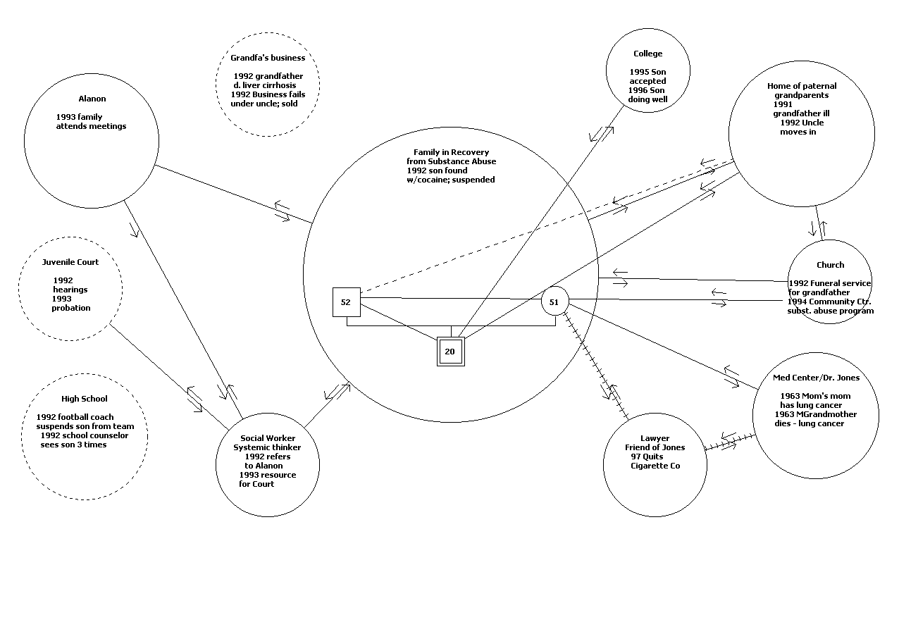

Points to note
- Making genogram may not be a one-time exercise
- Gradual improvements will have to be made over time as more information are gathered
- A template should be made. New genograms depicting different themes should be made to reflect and see any significance (resource, medical history, etc).

Genogram as an interviewing tool
- The three stages has covered a substantial part of the genogram interview. For a detailed outline, see part 2 of the handout.
- It depends on the ‘factual’ information shared by clients and counsellor’s knowledge in identifying composition, themes, patterns, counsellor’s perspective, etc and work with the client to generate discussion and understanding on the issue(s) raised.

Practice
- A remake of a genogram (individual)
- A new construction of a new genogram (in group of four)
- Duration: 25 minutes
- Exercise material – for individual

Softwares available
GenoPro is a unique software perfectly suited for creating quick computer-generated genograms.
By entering key information, such as names of family members, key life events, emotional relationships, and social relationships, the user can easily create a multi-generational genogram of their family system or of their patient's family system.
The genogram thus created becomes a graphical picture of the family, helping the user to identify patterns of behavior and dysfunctions that need to be addressed.

Constructing own genogram
Our perspectives can be influenced by our own family system dynamics.

Genogram – sample answer
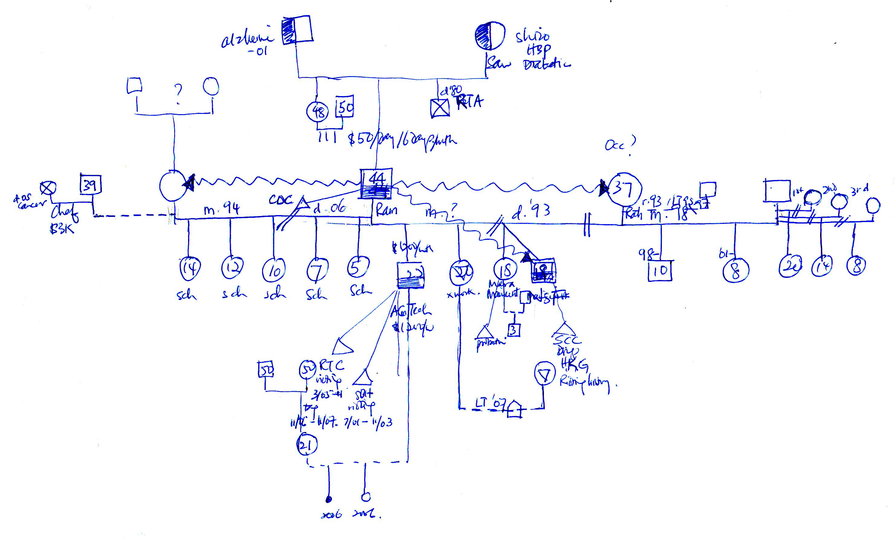

TEMPLATES

Income
DOB
Income
DOB

Age
Age
Name
Edn
Work
Name
Edn
Work
m. ,00
Place
Place

Income
DOB
Income
DOB

Age
Age
Name
Edn
Work
Name
Edn
Work

Nuclear family – one child

One child – male / female
Name
Edn
Work
Name
Edn
Work
Name
Edn
Work
Income
DOB
Income
DOB
Income
DOB
Place
m. ,00
Age
Age
Age
Name
Edn
Work
Name
Edn
Work
Name
Edn
Work
Income
DOB
Income
DOB
Income
DOB
Place
m. ,00
Age
Age
Age

Multiple children (2 generations/ 3 generations)
Name
Edn
Work
Name
Edn
Work
Name
Edn
Work
Name
Edn
Work
Income
DOB
Income
DOB
Income
DOB
Place
m. ’00
Age
Age
Age
Name
Edn
Work
Income
DOB
Place
Age
Name
Edn
Work
Income
DOB
Place
Age
Name
Edn
Work
Name
Edn
Work
Income
DOB
Income
DOB
Income
DOB
Place
m. ,00
Age
Age
Age
Name
Edn
Work
Income
DOB
Place
Age
Name
Edn
Work
Income
DOB
Place
Age

Name
Edn
Work

Multiple generations (3) - grandparents
Name
Edn
Work
Name
Edn
Work
Place
m. ’00
Age
Age
Age
Name
Edn
Work
Name
Edn
Work
Income
YOB-D
Income
YOB-D
Place
m. ’00
Age
Age
Name
Edn
Work
Name
Edn
Work
Income
YOB-D
Income
YOB-D
Place
m. ’00
Age
Age
Place
Age
Place
Age
Place
Place
Place
Place
Name
Edn
Work
Name
Edn
Work
Name
Edn
Work
Name
Edn
Work

Income
YOB-D
Age
Age
Age
Age
Age
Age
Age
Age
Income
YOB-D

Income
YOB
Income
YOB
Income
YOB

Name
Edn
Work
Age
Age
Name
Edn
Work
Name
Edn
Work
Name
Edn
Work
Name
Edn
Work

Multiple generations (4) – grandparents and grandchildren

Name
Edn
Work
Name
Edn
Work
Name
Edn
Work
Income
YOB-D
Income
YOB-D
Income
YOB
Place
m. ’00
Age
Age
Age
Name
Edn
Work
Name
Edn
Work
Income
YOB-D
Income
YOB-D
Place
m. ’00
Age
Age
Name
Edn
Work
Name
Edn
Work
Income
YOB-D
Income
YOB-D
Place
m. ’00
Age
Age
Name
Edn
Work
Income
YOB
Place
Age
Name
Edn
Work
Income
YOB
Place
Age
Place
Place
Place
Place
Name
Edn
Work
Name
Edn
Work
Name
Edn
Work
Name
Edn
Work
Name
Edn
Work
Name
Edn
Work
Age
Age
Age
Age
Age
Age
Age
Age
Age
Age

Inc
Yob-d
Inc
Yob-d
Inc
Yob-d
Inc
Yob-d

Name
Edn
Work
Name
Edn
Work
Name
Edn
Work
Income
DOB
Income
DOB
Income
DOB
Place
m. ’00
Age
Age
Age
Name
Edn
Work
Income
DOB
Place
Age
Name
Edn
Work
Income
DOB
Place
Age

Inc
Yob-d
Inc
Yob-d
Age
Age
Multiple generations (4) – uncles, aunties, grandparents and grandchildren
Name
Edn
Work
Income
YOB-D
Age
Name
Edn
Work
Income
YOB-D
Age
Name
Edn
Work
Income
YOB-D
Age
Name
Edn
Work
Income
YOB-D
Age
Place
Name
Edn
Work
Age
Age
Inc
Yob-d
Place
Name
Edn
Work
Age
Age
Inc
Yob-d

m. ’00
m. ’00
Place
Name
Edn
Work
Age
Age
Inc
Yob-d
Place
Name
Edn
Work
Age
Age
Inc
Yob-d
Place
Age
Age
Inc
Yob-d
Place
Name
Edn
Work
Age
Age
Inc
Yob-d
m. ’00
Name
Edn
Work
Income
YOB
Place
Age
Name
Edn
Work
Income
YOB-D
Age
Place
Name
Edn
Work
Income
YOB-D
Age
Place
Name
Edn
Work
Income
YOB
Place
Age
Inc
Yob-d
Age
Name
Edn
Work
Age
m.’00
Name
Edn
Work
Income
YOB
Place
Age
Name
Edn
Work
Age
Inc
Yob-d
Age
m.’00

Multiple generations (4) – uncles, aunties, grandparents and grandchildren, multiple marriages
Name
Edn
Work
Income
YOB-D
Age
Name
Edn
Work
Income
YOB-D
Age
m. ’00
Name
Edn
Work
Income
YOB-D
Age
Name
Edn
Work
Income
YOB-D
Age
Place
Name
Edn
Work
Age
Age
Inc
Yob-d
Place
Name
Edn
Work
Age
Age
Inc
Yob-d
Place
Name
Edn
Work
Age
Age
Inc
Yob-d
Place
Age
Age
Inc
Yob-d
Place
Name
Edn
Work
Age
Age
Inc
Yob-d
m. ’00
Place
Name
Edn
Work
Age
Age
Inc
Yob-d

Name
Edn
Work
Income
YOB-D
Age
Place
Name
Edn
Work
Income
YOB-D
Age
Place

m. ’00

Name
Edn
Work
Income
YOB
Place
Age
Name
Edn
Work
Income
YOB
Place
Age
Place

Income
YOB
Name
Edn
Work
Age
Age
dt.’00
Name
Edn
Work
Age
Inc
Yob-d
Age
m.’00
Name
Edn
Work

Inc
Yob-d
Age

