

EDP-21 (Rev 05/19)

Page **1** of **9**

**Personal Information**

**Name** (Last, First, MI)

Alias/Maiden Name

Sex

Social Security #

**XXX-XX-**

**DOB** (mm/dd/yyyy)

**Place of Birth** (City or County)

State or Province

**Country** (If other than US)

**Physical Address** (Number & Street)

City

State

Zip

**Mailing Address** (If different from above)

City

State

Zip

Home Phone #

Business Phone #

Father’s Full Name

**Mother’s Name** (Maiden)

**Previous Physical Addresses - Past 5 Years** (Include college housing. Use "**Remarks**" if more space needed.)

**Physical Address** (Number & Street)

City

State

Zip

**Physical Address** (Number & Street)

City

State

Zip

**FALSE STATEMENTS MADE ON THIS FORM ARE PUNISHABLE AS A CLASS A MISDEMEANOR AS DEFINED IN**

**SECTION 210.45 OF THE NEW YORK STATE PENAL LAW. In accordance with the Federal Privacy Act of 1974, you are hereby notified that your Social Security Number is not mandated by law. It is required by the agency as part of the standard application process for the New York State Police. Failure to disclose your Social Security Number will prohibit your application from being processed. The State Police will release your Social Security Number only for reasons required by law or with your written consent.**

**Consultant/Applicant Instructions**

Complete all forms in their entirety. The Standard Clauses for Consultant/Contractor/Vendor Services and Authorization for Release of Information must be complete and the signature witnessed. These forms can be witnessed by anyone who will verify your identity.

***Only original copies will be accepted.***

**You or your agency should mail all documents in the same envelope to the CJIS Audit and Compliance Unit at the address below.** (You may place several transactions in the same envelope; however, it is recommended that you keep a record of the fingerprint transactions you mail for your reference.)

**Attn: CJIS Audit and Compliance Unit**

**New York State Police 1220 Washington Ave, Bldg. 22**

**Albany, NY 12226**

**Checklist**

Submit the following items to the CJIS Audit and Compliance Unit: Completed Security Background Document

Copy of current Driver’s License or State Identification Pre-enrollment IdentoGo form

**Fingerprint Card **For NYS Non-Residents ONLY \*\*** (Applicant must be printed on the FBI non-criminal card.)

**Copy of Birth Certificate or Passport** (If born outside NYS.)

**Security Background Document**

Date:



EDP-21 (Rev 05/19)

Page **2** of **9**

**Employment History - Past 5 Years**

**Instructions: List current employer. Consultants, list the consultant company information, not the agency worked for.** (Use “**Remarks**” if more space needed.)

**Title & Dates** (From/To)

Employer’s Name, Address, and Phone #

Title

To

Current Employer: Address:

Phone #: SUPERVISOR:

Title

To

Current Employer: Address:

Phone #: SUPERVISOR:

**Education & Training** (Use “**Remarks**” if more space needed.)

Name of Institution

Location

Dates Attended

Major/Course

Diploma/Degree Earned

Do you have a High School Equivalency Diploma (GED)? Yes No If yes, specify certificate number

**Additional Information** (Answer all questions.)

1. Do you possess a current Driver’s License? If yes, Issuing State License #

Yes No

**2. Except for minor traffic violations, have you ever been convicted of a crime** (misdemeanor or felony)**, including DWI?** (Explain in “**Remarks**” below.)

Yes No

**3. Are there current pending charges against you for any crime** (misdemeanor or felony)**, including DWI?** (Explain in “**Remarks**” below.)

Yes No

4a. Are you a citizen of the United States?

1. Do you have the legal right to accept employment in the United States?
2. If you are not a US citizen, specify INS #

Yes No

Yes No

5. Were you ever discharged from any employment due to something other than a lack of work or funds? (Explain in “Remarks” below.)

Yes No

6. Have you ever resigned from any employment in lieu of disciplinary action or termination? (Explain in “Remarks” below.)

Yes No

**7. Have you ever had any professional license suspended, modified, or revoked?** (Explain in “**Remarks**” below.)

Yes No

**Remarks** (Attach additional sheets if necessary.)

**Affirmation**

By my signature, I agree to be fingerprinted and have my prints processed by the Division of Criminal Justice Services (DCJS) and the National Crime Information Center (NCIC). Furthermore, I understand that local law enforcement agencies will be contacted, and if there are any open questions, I will be contacted.

I hereby certify that all questions answered and all information provided by me on this form are true and correct. Knowingly providing false information could result in the disqualification of this application and may exclude me from the position. I agree to and authorize investigation and verification of all information provided.

**Signature** (If handwriting, print and sign your name.)

**Date** (mm/dd/yyyy)

**Security Background Document**

Date:



EDP-21 (Rev 05/19)

Page **3** of **9**

**Authorization for Release of Information - Applicant for Employment with New York State**

To: The US Armed Forces, Maritime Service, Veteran’s Administration, Selective Service Administration;

Any Academic Dean, Registrar, Principal, Guidance Counselor, or authorized person at any School, College, University, Business School, Trade School, Elementary, or High School;

Any Local, State, or Federal Law Enforcement Agency; Any past or present Employer;

Any Credit Bureau or Retail Merchants Association; Any Bank or Financial Institution;

Any Insurance Company;

Any State, County, or Municipal Bureau of Vital Statistics Office; Any State or Local Civil Service Agencies;

Any Grievance Committee or Disciplinary Committee;

Other:

I, ,

**(First Name, Full Middle, Last Name)**

have applied for employment with the State of New York or other public employer. I am aware that my entire background will be thoroughly investigated. I hereby authorize and request the release to an authorized representative of the New York State, any and all information you have that concerns me, including academic transcripts, disciplinary matters, and if the position for which I am applying is that of a peace office or police officer, sealed records pursuant to Section 160.50(1)(d) of the NYS Criminal Procedure Law. This authorization, or a reproduction thereof, shall remain in effect for a period of one year from the date of execution of this document.

The position for which I am applying is that of a peace office or police officer.

**(Initials)**

Previous Names Used:

**(First Name, Full Middle, Last Name)**

**(First Name, Full Middle, Last Name)**

Date of Birth: Place of Birth:

*In accordance with the Federal Privacy Act of 1974, you are hereby notified that your Social Security Number is not mandated by law. It is required by the New York State Police for this application process. Failure to disclose your Social Security Number will prohibit your application from being processed.*

*The State Police will release your Social Security Number only for reasons required by law or with your written consent.*

**Social Security #: XXX-XX-**

Military Branch: Dates of Service: Given under my hand this day of , 20 .

**(Signature of Witness) (Applicant Signature)**

**(Street Address)**

**(City, State, and Zip)**

**Security Background Document**

Date:



EDP-21 (Rev 05/19)

Page **4** of **9**

**Standard Clauses for Consultant/Contractor/Vendor Services**

Security, Non-Disclosure, Confidentiality, and Press Releases

The consultant/contractor/vendor shall maintain the security, non-disclosure, and confidentiality of all information in accordance with the following clauses in performance of its activities under this Agreement:

Security Procedures

Consultant/contractor/vendor agrees to comply fully with all security procedures of the State in relation to providing services and agrees that its officers, agents, employees, and subcontractors shall be required to undergo the same security clearances as are required of the employees of NYSP. Specifically, each prospective and current employee of Contractor designated to work under this Agreement with NYSP shall submit identifying information and may be fingerprinted.

Non-Disclosure and Confidentiality

Except as may be required by applicable law or a court of competent jurisdiction, the Contractor, its officers, agents, employees, and subcontractors shall maintain strict confidence with respect to any Confidential Information to which the Contractor, its officers, agents, employees, and subcontractors have access. This representation shall survive termination of this Agreement. For purposes of this Agreement, Contractor, its officers, agents, employees, and subcontractors agree to treat all information (oral, visual, or written) gathered in the course of their employment for NYSP as Confidential Information, unless provided written release from this designation for specified information by authorized NYSP staff.

Press Releases

Contractor agrees that no brochure, news/media/press release, public announcement, memorandum, or other information of any kind regarding this Agreement shall be disseminated in any way to the public, nor shall any presentation be given regarding this Agreement without the prior written approval by the undersigned or the undersigned’s designee from NYSP, which written approval shall not be unreasonably withheld or delayed provided, however, that Contractor shall be authorized to provide copies of this Agreement and answer any questions relating thereto to any State or Federal regulators or, in connection with its financial activities, to financial institutions for any private or public offering.

Public Information

Disclosure of items related to this Agreement shall be permitted consistent with the laws of the State of New York and specifically the Freedom of Information Law (FOIL) contained in Section 87 of the Public Officers Law. The State shall take reasonable steps to protect from public disclosure any of the records relating to this procurement that are otherwise exempt from disclosure under that statute. Information constituting trade secrets, for purposes of FOIL, must be clearly marked and identified as such upon submission. If the Contractor intends to seek an exemption from disclosure of these materials under FOIL, the Contractor shall, at the time of submission, request the exemption in writing and provide an explanation of why the disclosure of the identified information would cause substantial injury to the competitive position of the Contractor. Acceptance of the identified information by the State does not constitute a determination that the information is exempt from disclosure under FOIL. Determinations as to the availability of the identified information will be made in accordance with FOIL at the time a request for such information is received by the State.

Administrative Obligation

Consultant/contractor/vendor agrees not to use NYSP or State provided equipment to engage in non NYSP related activities while on NYSP time.

Consultant/contractor/vendor will be held accountable for reporting work hours and/or work activity consistent with the terms of the consultant/contractor/vendor engagement. In the case of consultants/contractors/vendors working in a staff augmentation capacity, daily time records showing actual hours worked will be maintained by the consultant/contractor/vendor and provided to the direct NYSP supervisor in a format specified by the NYSP supervisor.

Sexual Harassment

1. Civil Rights Act Violation

Title VII of the Civil Rights Act of 1964 as amended prohibits discrimination on the basis of race, color, religion, sex, and national origin. The Equal Employment Opportunity Commission has amended its Guidelines on Discrimination Because of Sex to include Sexual Harassment as an unlawful employment practice and thereby a violation of Section 703 of Title VII of the Civil Rights Act.

2. Policy

NYSP, as an Agency of the Executive Department of the State of New York, is committed to a philosophy which prohibits sexual harassment in the workplace.

Unwelcome sexual advances, requests for sexual favors, or other verbal or physical conduct of a sexual nature will constitute sexual harassment when:

* Submission to the conduct is either explicitly or implicitly a term or condition of an individual’s employment, or
* Submission to or rejection of such conduct by an individual is used as the basis for the employment decisions affecting such individuals, or
* The conduct has the purpose or effect of unreasonably interfering with an affected person’s work performance, or creating an intimidating, hostile, or offensive work environment.

**Security Background Document**

Date:



EDP-21 (Rev 05/19)

Page **5** of **9**

**Standard Clauses for Consultant/Contractor/Vendor Services Cont’d**

3. Procedure

The Equal Employment Opportunity Section of the Office of Human Resources will process such complaints. Complaints may be referred in writing or by direct contact with staff assigned to the Equal Opportunity Employment Section of the Office of Human Resources or reported to an appropriate supervisor as circumstances warrant.

All allegations of sexual harassment shall be promptly, thoroughly, and confidentially investigated as set forth in the New York State Police Administrative Manual, Article 9: Complaints Against Personnel, and shall be resolved without reprisal or threat of reprisal to the employee making such allegation.

In each case, when an allegation of sexual harassment is substantiated, it may result in disciplinary action against the consultant/contractor/vendor engaging in such misconduct, as well as against supervisory personnel who knowingly allow such behavior to continue.

4. Right of Redress

* All consultants/contractors/vendors have the right of redress.
* Complaint resolution channels have been established to investigate incidents of sexual harassment.
* The Division Affirmative Action Officer under the Office of Employee Relations will process such complaints.
* Complaints may be referred in writing or by direct contact with the Division Affirmative Action Officer or reported to the appropriate supervisor as circumstances warrant.

Consultant/contractor/vendor agrees to follow generally accepted business standards for selecting a wardrobe suitable for the workplace.

In circumstance where the signer of this document represents a consultant/contractor/vendor with more than one employee assigned to NYSP, consultant/contractor/vendor agrees that all consultant/contractor/vendor staff now working for NYSP and all future staff who may be assigned to NYSP have been and will be instructed in the requirements of this agreement.

Certification

* I have read and understand the contents of this document.

**Consultant/Contractor/Vendor Signature** (If handwriting, print and sign your name.)

**Date** (mm/dd/yyyy)

**Witness Signature** (If handwriting, print and sign your name.)

**Date** (mm/dd/yyyy)

**Security Background Document**

Date:



EDP-21 (Rev 05/19)

Page **6** of **9**

**Federal Bureau of Investigation Criminal Justice Information Services Security Addendum**

**Certification**

I hereby certify that I am familiar with the contents of (1) the Security Addendum, including its legal authority and purpose; (2) the NCIC Operating Manual; (3) the CJIS Security Policy; and (4) Title 28, Code of Federal Regulations, Part 20, and agree to be bound by their provisions.

I recognize that criminal history record information and related data, by its very nature, is sensitive and has potential for great harm if misused. I acknowledge that access to criminal history record information and related data is therefore limited to the purpose(s) for which a government agency has entered into the contract incorporating this Security Addendum. I understand that misuse of the system by, among other things: accessing it without authorization; accessing it by exceeding authorization; accessing it for an improper purpose; using, disseminating or re-disseminating information received as a result of this contract for a purpose other than that envisioned by the contract, may subject me to administrative and criminal penalties. I understand that accessing the system for an appropriate purpose and then using, disseminating or re-disseminating the information received for another purpose other than execution of the contract also constitutes misuse. I further understand that the occurrence of misuse does not depend upon whether or not I receive additional compensation for such authorized activity. Such exposure for misuse includes, but is not limited to, suspension or loss of employment and prosecution for state and federal crimes.

Printed Name/Signature of Contractor Employee Date

Printed Name/Signature of Contractor Representative (Supervisor) Date

Organization and Title of Contractor Representative

08/16/2018 H-7

CJISD-ITS-DOC-08140-5.7

**Security Background Document**

Date:



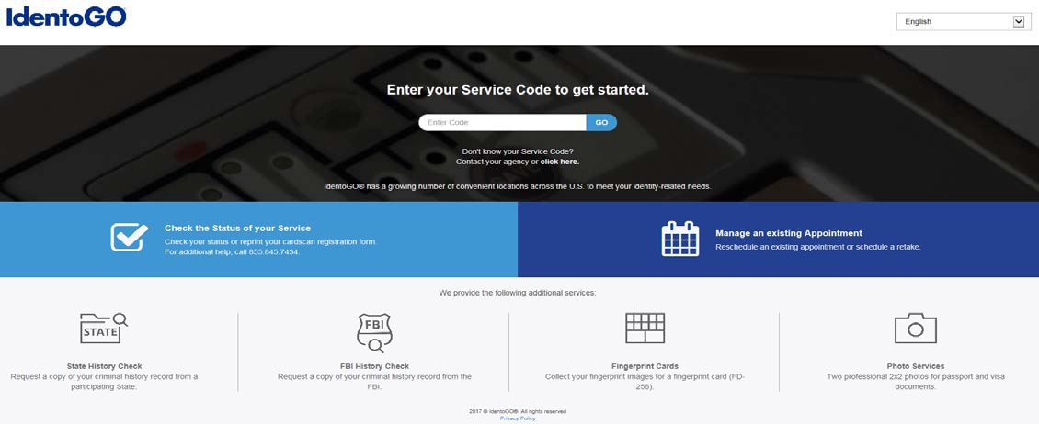

EDP-21 (Rev 05/19)

Page **7** of **9**

**Completed Military Service (DD-214)**

If you need to request your DD-214, follow the instructions below. If you already have a copy, please forward with your background packet.

**The consultant/applicant will request his/her records by using the following website:** https://vetrecs.archives.gov/VeteranRequest/home.html**. Once you have entered the above website, the following sections will need to be completed in the following manner:**

* **“Records Locator Information” tab: Ensure you enter the branch of service they last completed.** (If applicant has served in other branches, this information can be entered in the next section.)
* “Documents Requested” tab: Ensure you select “an undeleted report of separation” as this will have the reason of separation deleted. Within this section, is a “comments box” where you can request further documents from other service. Do NOT create a separate request as this may delay a response.
* “Return Address” tab: List your name and address.

After submission, print a “signature verification” page which must be signed and faxed to (314) 801-9049. Keep the original “signature verification” page for proof of transaction.

Once the DD-214 is received, a copy must be submitted with your paperwork as part of the background packet.

**Fingerprint Cardscan**

Fingerprints are required for ALL consultants/applicants to confirm identify and determine employment suitability. Consultants/applicants will need to pre-enroll with IdentiGo and provide basic demographic and payment information.

NY Residents

Schedule an appointment for fingerprinting at an IdentoGo location. Follow the “Directions for Pre-Enrollment and Payment Process” below.

Non-Residents of NY

Cardscan processing is available for those consultants/applicants residing outside of New York or physically unable to visit an IdentoGo location. In order to complete the process, applicants must complete the following steps:

1. Obtain fingerprints on a FBI (FD-258) fingerprint card and complete personal information fields on the fingerprint card.
2. Pre-enroll for cardscan submission at [http://uenroll.identogo.com](http://uenroll.identogo.com/) all processing fees will be collected during the pre-enrollment process. A pre-enrollment confirmation page will be provided once registration is complete.
3. Print and sign the completed pre-enrollment confirmation page, which includes the barcode printed on the top right of the page. Mail the signed pre-enrollment confirmation page and the completed fingerprint card to the mailing address provided by your agency. For mailing address or further instructions, each applicant should contact their employer or agency contacts for those details.

**Directions for Pre-Enrollment and Payment Process – Required for ALL Fingerprint Cards**

1. Visit [http://uenroll.identogo.com](http://uenroll.identogo.com/) and enter your 6-character Service Code. For IT hires, use code 15427V. For Non-IT hires, contact the State Police section who is responsible for releasing their service code. Click the “GO” button.

**Security Background Document**

Date:



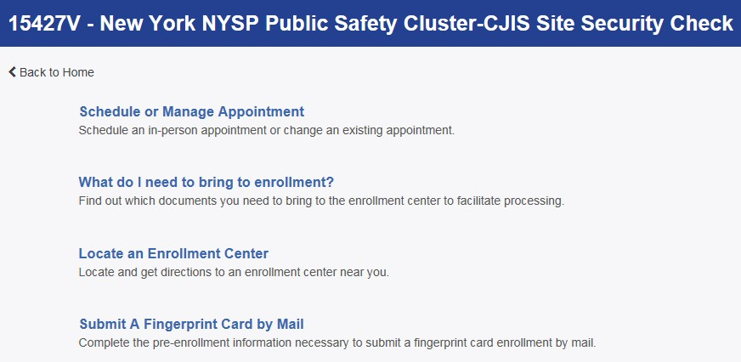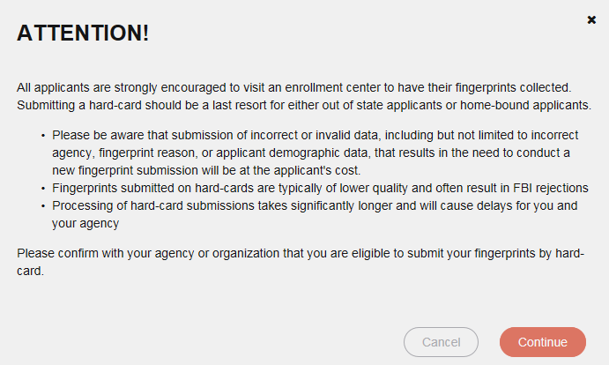

EDP-21 (Rev 05/19)

Page **8** of **9**

1. The next screen is where NY residents are going to select “Schedule or Manage Appointment” or NY Non-Resident will select “Submit a Fingerprint Card by Mail.”
2. You will need to confirm that you would like to proceed with submitting a fingerprint card for processing. Select “Continue” to proceed to the next page.

**Security Background Document**

Date:



EDP-21 (Rev 05/19)

Page **9** of **9**

1. The next few screens will collect essential information such as name, date of birth, address, etc. You will need to complete all required information.
2. Pay for your service using an Authorization Code or Credit Card. If the Service is Auto-Billed to your Agency, payment will not be required.
3. Once you have submitted your payment, you will be directed to the final registration page. You will need to complete sections 2 and 3 and submit this page along with your fingerprint card for processing.

If your agency needs to contact IdentoGo to check on the processing status of a particular fingerprint transaction, the IdentoGo call center staff may be reached toll free at (877) 472-6915.

Should the fingerprint submission be rejected due to image quality reasons, IdentoGo will contact the applicant via US Mail and advise that he/she must be reprinted. There is no additional cost for resubmission. There will be a small percentage of the population (3-5%) that have difficulties in providing a good set of prints due to the quality of their skin/fingerprint ridges. In the event that you have an applicant who has been rejected multiple times by NYS Department of Criminal Justice Services (DCJS), please contact DCJS for assistance at (800) 262-3257, and ask to speak to someone in the Civil Identification Bureau. DCJS is willing to review the most recent transmission and determine if we can accept the transaction for processing, taking into consideration any additional information you may be able to provide to indicate that a better set of prints may not be obtainable.

**Security Background Document**

Date: