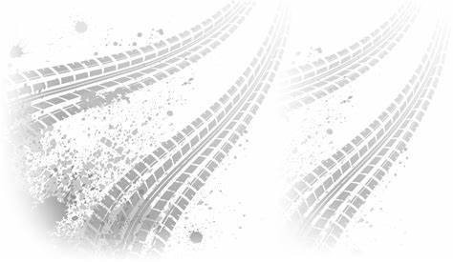 |  |  |  |  |  | TRUCK MAINTENANCE LOG
FORD |  |  | F-650 |  | <YEAR> | <PLATE NO.> |  |  |  | MM/DD/YYYY
BRAND |  |  | MAIKE |  | YEAR | PLATE NO. |  |  |  | DATE UPDATED
Date | Odometer |  |  | Maintenance Performed |  |  | Performed By |  | Tested By
mm/dd/yyyy | 83795876 |  |  | Replaced Brake Pads |  |  | John Smith |  | Arnold Hunt

