 | 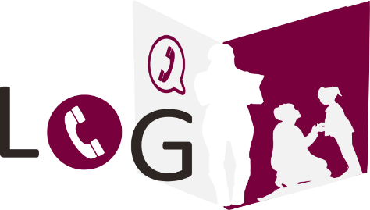
 |  | SCHOOL: | Central Valley High | GRADE: | 6TH
 |  | TEACHER: | Jeremiah Brooks | SCHOOL YEAR: | 2020/2021
Child:
Eric Johnson
 |  | DATE: | 20/05/2020 | PHONE: |  |  | EMAIL:
 |  | PARENT: | Kenneth Johnson | 111 2345 6789 |  |  | kenneth1975@madeupmail.com
 |  | ☐ | Learning activities | SUMMARY:
 |  | ☒ | Child's accomplishments | Calling Mr. Johnson to inform him about improved efforts from Eric.
 |  | ☐ | Help at home
 |  | ☒ | Grades
 |  | ☒ | Child's behaviour
 |  | ☐ | Special needs
 |  | ☐ | Other:_________________
Child:

Child:

 |  | DATE: |  | PHONE: |  |  | EMAIL:
 |  | PARENT:
 |  | ☐ | Learning activities | SUMMARY:
 |  | ☐ | Child's accomplishments
 |  | ☐ | Help at home
 |  | ☐ | Grades
 |  | ☐ | Child's behaviour
 |  | ☐ | Special needs
 |  | ☐ | Other:_________________
 |  | DATE: |  | PHONE: |  |  | EMAIL:
 |  | PARENT:
 |  | ☐ | Learning activities | SUMMARY:
 |  | ☐ | Child's accomplishments
 |  | ☐ | Help at home
 |  | ☐ | Grades
 |  | ☐ | Child's behaviour
 |  | ☐ | Special needs
 |  | ☐ | Other:_________________
 |  |  |  |  |  |  |  | © TemplateLab.com

