

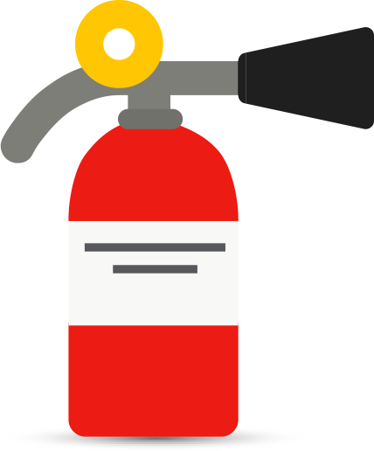

FIREMEN ORGANIZATIONAL CHART

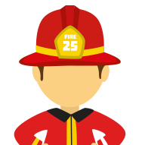

Paul Dirac

Fireman

Claude Bernard

Fireman

Nikola tesla

Fireman

Louis Pasteur

Fireman

Ada Lovelace

Firemanv

Lisa Meitner

Fireman

Marie Curie

Fireman

Emy Noether

Fireman

Charles Darwin

Fireman

James Watt

Fireman

Alessandro Volta

Fireman

Isaac Newton

Fireman

Carl Gauss

Fireman

Will Thomson

Fireman

Blaise Pascal

Fireman

Maxwell Clerk

Fireman

Nikola Tesla

Chief Deputy

Johan Kepler

Chief Deputy

Thomas Edison

Fire Chief