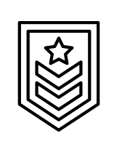

**ARMY** ORGANIZATIONAL CHART



Louis Pasteur

Officer

Nikola Tesla

Officer

Claude Bernard

Officer

Paul Dirac

Officer

Ada Lovelace

Armored Command

Lisa Meitner

Aircraft Command

Marie Curie

Tank Destroyer Center

Emy Noether

Mountain Training Center

Isaac Newton

Ground General

Alessandro Volta

Ground Surgeon

James Watt

Ground Officer

Charles Darwin

Ground Signal Officer

Carl Gauss

Training

Will Thomson

Military Intelligence

Blaise Pascal

Personnel

Maxwell Clerk

Plan

Michale Ernest

Chieff of Staff

Thomas Scott

Commander General