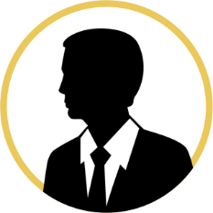



James Watt

Employee

Paul Dirac

Employee

Louis Past

Employee

Emi Noether

Employee

Carl Gauss

Employee

Louis Past

Employee

Claude Bernard

Employee

Paul Dirac

Employee

Will Thomson

Employee

Nikola Doe

CTO

Marie Crue

CIO

Isaac Smith

CFO

Ada Lace

COO

Blaise Pitt

CMO

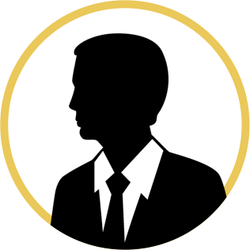

Thomas Scott

CEO



**HOTEL ORGANIZATIONAL CHART**

